CONFIDENTIAL
From Automation to Digital Labour
Proposed Response Structure for WPP’s Enterprise Agent Capability Framework RFP

Microsoft | April 2026
Classification: Internal – For Team Review

Table of Contents
This document outlines the proposed macro structure and narrative strategy for Microsoft’s response to WPP’s Enterprise Agent Capability Framework RFP. Each section includes guidance on tone, narrative arc, and strategic intent.

Table of Contents
Table of Contents 2
0. Executive Letter — A Partner for WPP’s Most Ambitious Decade 5
1. Response navigator 6
1.1 Mapping WPP’s Vision to Our Response 6
2. The Paradigm Shift: Agents as Digital Labour 6
2.1 Why this moment is different 6
2.2 What digital labour means for the enterprise 6
2.3 Why platform, not point solution 7
3. Reading WPP’s Ambition: Our Understanding of Project Apex 8
3.1 The Unstated Need 8
3.2 Reframing the Evaluation 8
The Ask of WPP 9
Microsoft Frontier Firm 9
WPP Strategic Context 10
Five-Layer Enterprise AI Stack 11
Alignment with Microsoft’s Frontier Strategy 11
How Microsoft Can Extend the ET Platform for Enterprise Agents 12
L0: User Experience 13
L5: Human and Agent Governance 13
L3: Agent Framework 13
L1: Agentic Intelligence 13
Attributes of teams: 13
Collaboration 13
Communication 13
Control & Oversight 13
Clarity of Role 14
Shared context 14
Agent Surface – In the Flow of Work 14
The Broader Ecosystem – Beyond the 5 Layers 14
Human + Agent Collaboration 14
4. Reference Architecture: The Frontier AI Agent Platform 15
4.1 Design Philosophy: Three Principles 15
Principle 0: Embrace Constant Change 15
Principle 1: Support Choice in Agent Framework 15
Principle: Embrace Open Standards & Deploy Agents that are cloud, surface and model agnostic 16
4.1.1 Principle 1: Agents are identity-bearing entities 16
4.1.2 Principle 2: The agentic loop is the unit of work 16
4.1.3 Principle 3: The control plane governs the fleet 16
4.2 Architecture Layers (Mapped to WPP’s Apex Five-Layer Model) 16
5. Control Plane – Controlling agent fleets 18
6. Multi-Agent Orchestration and Durable Execution 18
7. Governance as a First-Class Capability 18
8. System integration and protocols support 19
9. Development Experience (All Builder Personas) 19
10. Bringing It to Life: POC Approach 19
10.1 POC 1 - Finance: Intelligent Procure-to-Pay (Foundational) 19
10.2 POC 2: People: Advanced Talent Lifecycle Agent Team (Frontier) 20
11. Non Functional requirements 20
12. Commercial and Partnership - A Partnership for the Long Game 20
12.1 Joint Governance Model 20
12.2 Commercial model and TCO 20
12.2.1 POC Investment 20
12.2.2 Platform Licensing 20
12.2.3 Scaling Economics 20
12.3 Partnership Tiers 21
12.4 Innovation Pipeline 21
12.5 Talent & Enablement 21
12.6 The “Becoming Frontier” Commitment 21
13. Portability and exit strategies 21
14. Appendices 21
14.1 Appendix A: Completed Assessment Questionnaire 21
14.2 Appendix B: Detailed POC Technical Designs 21
14.3 Appendix C: Architecture Diagrams 21
14.4 Appendix D: Customer Stories & Proof Points 22
14.4.1 Industry Benchmarks 22
Financial/People AI Transformation Reference Points 25
Competitive Positioning: Why This Structure Wins (remove this) 26

0. Executive Letter — A Partner for WPP’s Most Ambitious Decade
NARRATIVE GUIDANCE
Personal, principal-to-principal. Short (1 page max). Not a summary of the document — a direct statement from Microsoft leadership to WPP leadership.

This opening letter sets the tone for the entire response. It should signal three things:
- Scale of ambition: We understand that Project Apex is not an IT initiative — it is a workforce transformation programme that will define WPP’s competitive position for the next decade.
- Workforce transformation, not technology procurement: We see agents as digital colleagues joining WPP’s workforce, not as software being deployed. This reframes the entire conversation.
- Senior commitment to the long game: Name specific Microsoft executives who will be personally engaged in the partnership. This is about people, not just platforms.

Reference WPP’s own vision statement (“the most AI-empowered enterprise on the planet”) and reflect it back with conviction. Close with a forward-looking statement about what the partnership will look like in Year 3.

- Response navigator
This section explains how the response is structured to align precisely with WPP’s brief, evaluation criteria, and scoring model. It provides explicit traceability from WPP requirements to response sections and evidence, enabling evaluators to quickly verify completeness, honesty (GA vs preview vs roadmap), and alignment to scoring priorities.

1.1 Mapping WPP’s Vision to Our Response
Explicitly map WPP’s scoring priorities to show our response has been structured around what matters most to them:
Evaluation Domain | Weight | Our Section(s)
Control Plane & Human Supercharger | 20% | §5 (Control Plane), §9 (Development Experience), §10.1/10.2 (POC Control Plane demos), §14.3 Appendix C
Multi-agent orchestration & durability | 20% | §6 (Multi-Agent Orchestration), §4.1 (agentic loop), §10 (POC orchestration evidence)
Governance, security & compliance | 20% | §7 (Governance), §4.2 (Governance layer), §11 (NFRs on compliance)
System integration & protocol support | 15% | §8 (System Integration & Protocols), §4.2 (Integration layer)
Advanced capabilities (POC 2 scope) | 15% | §10.2 (POC 2 HR), §14.2 Appendix B (POC 2 technical design)
Vendor partnership & commercial model | 10% | §12 (Commercial & Partnership), §12.5 (Talent & Enablement), §12.6 (Becoming Frontier)
- The Paradigm Shift: Agents as Digital Labour
NARRATIVE GUIDANCE
Thought-leadership essay. Educate first, sell second. This section frames the evaluation before WPP reads any other vendor’s response.

This section frames the strategic context for the evaluation by articulating the shift from task-based automation to governed digital labour. It establishes why autonomy, identity, governance, and fleet-level control are the defining challenges of agentic transformation—and why a Control Plane is required to safely scale beyond isolated AI use cases.

2.1 Why this moment is different
Articulate the shift from “automation” (scripted, fragile, task-scoped) to “digital labour” (reasoning, durable, identity-bearing, governable). Foundation models combined with tool use, persistent memory, and multi-agent coordination have crossed a threshold where agents can hold accountability for outcomes, not just execute steps.
This is a market-shaping argument. Cite the convergence of capabilities: reasoning models, function-calling, durable execution, and enterprise identity integration. Position Microsoft as the company that saw this convergence coming and built for it.

2.2 What digital labour means for the enterprise
Agents need the same things human workers need:
- An identity (who they are)
- A set of permissions (what they can access)
- A manager (who oversees them)
- An audit trail (what they did and why)
- A performance review cycle (are they effective?)

The enterprises that win will be those that extend their existing workforce governance to this new class of worker — not those that build a parallel shadow system. This directly validates WPP’s two-plane operating model.

2.3 Why platform, not point solution
WPP has hundreds of platforms across CRM, Finance, HR, and Marketing. The fragmentation WPP already faces with human workflows will be exponentially worse with ungoverned agents. The platform is the governance.
This section earns us the right to present architecture in Section 3 not as “our technology stack” but as “the answer to the question we just posed.”

- Reading WPP’s Ambition: Our Understanding of Project Apex
NARRATIVE GUIDANCE
Mirror-back with insight. Show we have listened harder than anyone. Build trust by demonstrating understanding before presenting solutions.

This section demonstrates deep understanding of WPP’s stated and unstated objectives by mirroring Project Apex, the five-layer enterprise model, and the “Team not Tools” vision. It clarifies scope boundaries for this RFP and surfaces the central organisational challenge: enabling existing managers to govern hybrid human-agent teams at scale.
This is a critical trust-builder. Reflect WPP’s own five-layer Apex model and demonstrate deep understanding of both the stated and unstated needs.

3.1 The Unstated Need
Identify what WPP wants but hasn’t fully articulated: the Control Plane is not just a dashboard. It is the mechanism that lets WPP’s existing managers become managers of hybrid human-agent teams. This is the “Human Supercharger” concept in their scoring. We should own this narrative.

3.2 Reframing the Evaluation
Acknowledge the competitive landscape honestly: WPP is right to evaluate multiple vendors. Then subtly reframe the question: it is not about who has the best AI models — it is about who can extend WPP’s existing enterprise governance to a new type of worker without creating a parallel universe of tooling.

The Ask of WPP
WPP is selecting an Enterprise Agent Capability Partner: the core orchestration, runtime, governance and platform layer to power our agentic workforce over the next 3–5 years. This is not an AI tool procurement. It is a foundational architecture decision that will shape how 85,000+ people across WPP work alongside AI.

The WPP AI Centre of Excellence has outlined a compelling vision and a North Star of Autonomy:
- Team not Tools: AI agents are first-class members of the team: entrusted with tasks along value chains to elevate our humans
- WPP are building a software-defined enterprise workforce built and supervised by expert practitioners, not simply adding AI tools to existing workflows
- The shift is from "practitioners using tools" (1–2x productivity) to "experts supervising agent teams" (10–100x productivity)

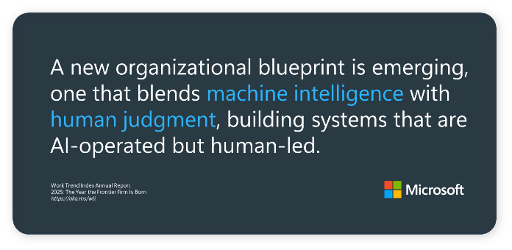
Microsoft Frontier Firm
Microsoft believes in a new organisational blueprint for AI first businesses – the Frontier Firms. Structured around on-demand intelligence and powered by “hybrid” teams of humans + agents, these companies scale rapidly, operate with agility, and generate value faster.

At the simplest level Microsoft has identified 3 core patterns to deliver business advantage through AI, as outlined below:

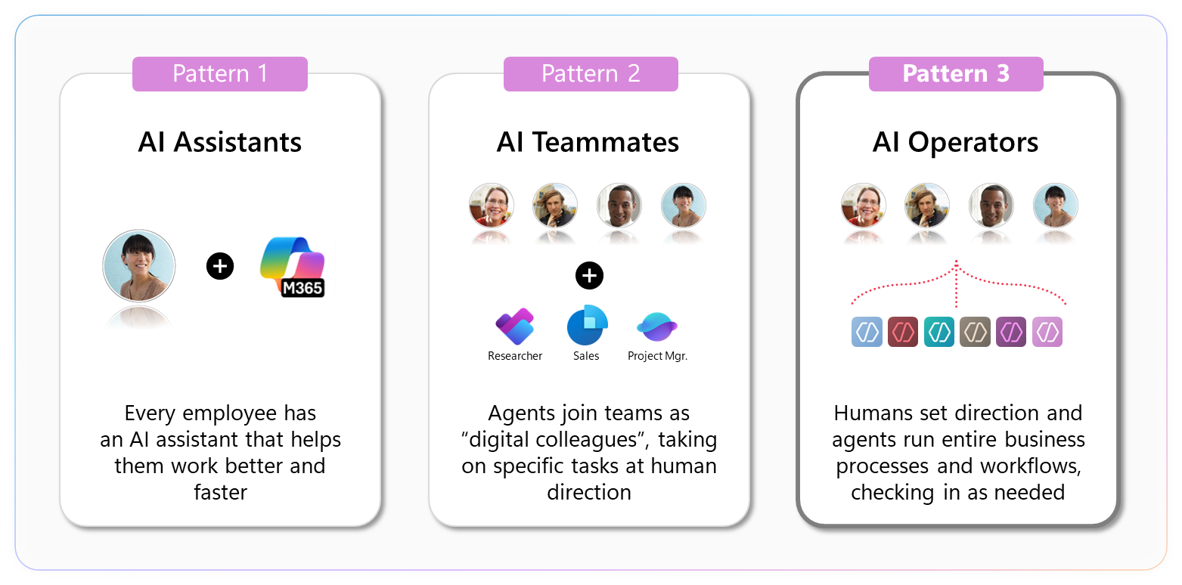

Patterns 1 and 2 deliver significant value to organisations, however it is Pattern 3 where organisations will realise the true transformative power of AI. This is the scope of the RFP, and where Microsoft has been focused.
In Pattern 3 Microsoft has introduced the concept of “digital labour” where Agents can reason, plan and act as digital team mates with clear skills, responsibilities, and measurable performance.
However it is important to not dismiss Patterns 1 and 2 as they do remove friction from the work experience and amplify the capabilities of individuals and teams. As such it is critical that Pattern 1, 2 and 3 are a cohesive set of capabilities that colleagues can access from their kitbag as and when required.

WPP Strategic Context

WPP's three-year strategic plan, Elevate28, is structured around four objectives:
- Deliver superior growth for clients
- Become a simpler, integrated company
- Unlock the advantage of WPP Open
- Create firm foundations for the future
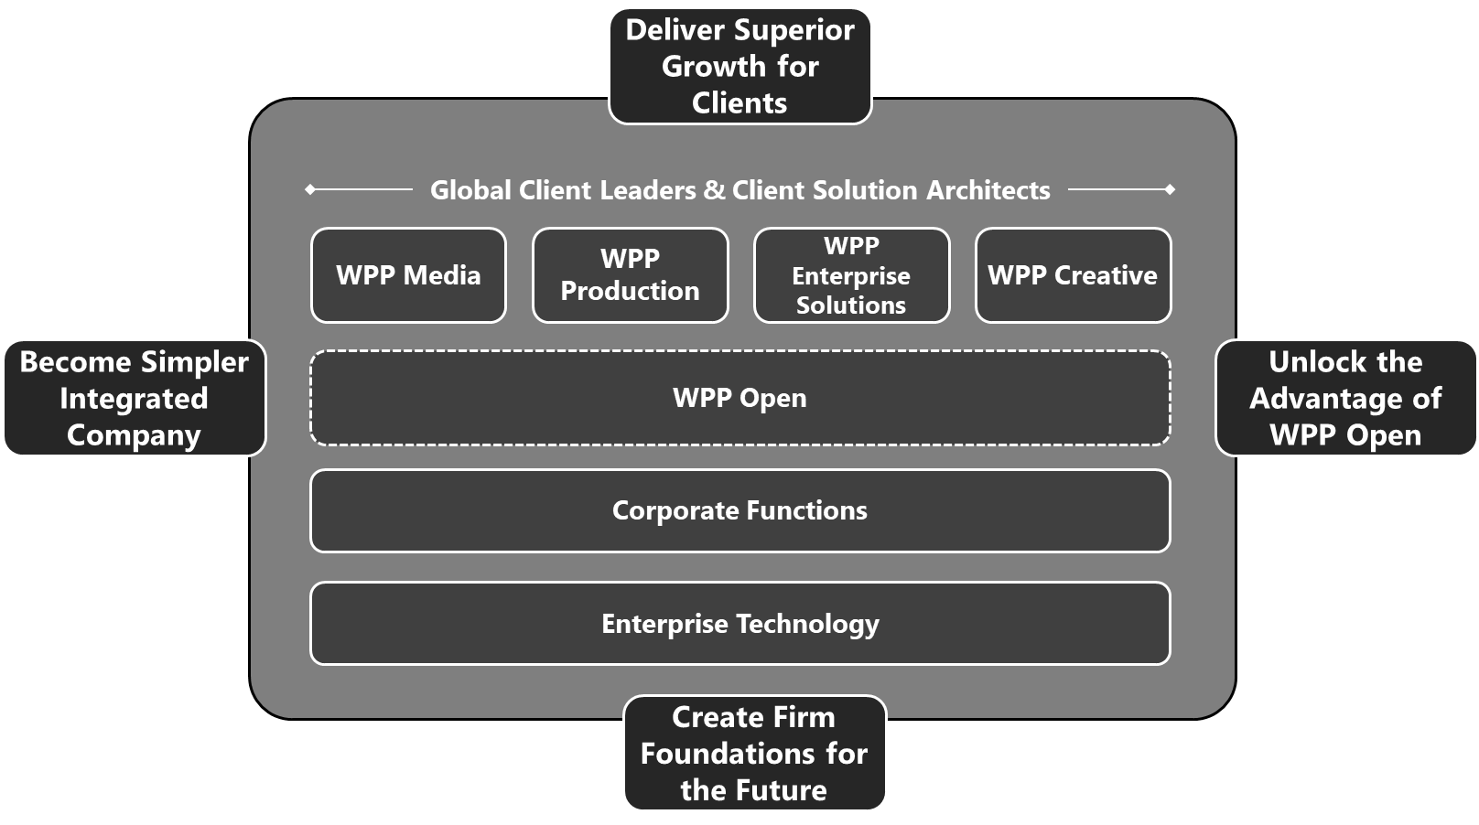

Enterprise Technology enables Elevate28 through three layers:
- Cross-WPP: Agentic overlay, data layer, analytics, pipeline/clients, finance, people, work management
- Opco-Specific: Creative, media, production/PR & speciality integration and modernisation
- Enterprise Tech: AI capabilities, process optimisation, controls & security, technology operations, people/finance partnerships

Five-Layer Enterprise AI Stack
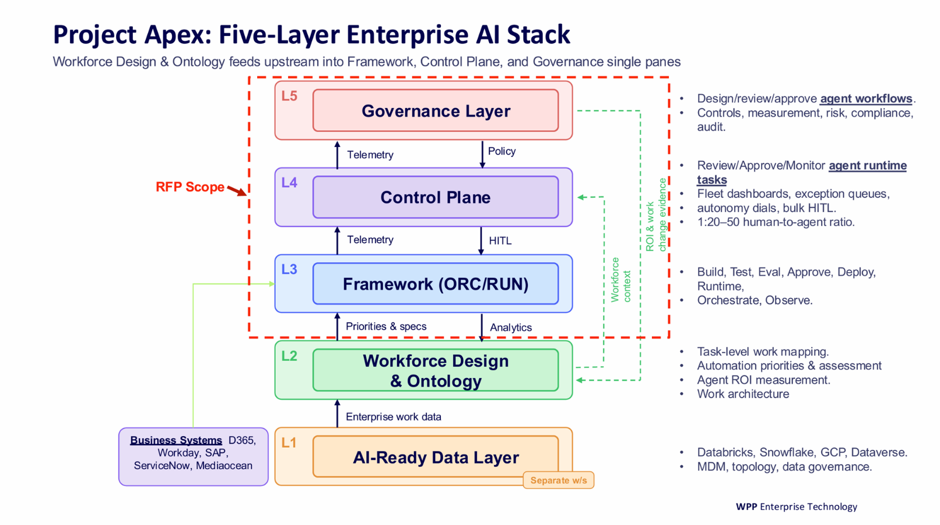
The 5-layer stack outlined in the RFP provides a logical view of the core architectural capabilities that are critical to enabling an autonomous enterprise or Frontier Firm.

At the heart of the stack is the Control Plane (L4), that enables humans to manage agents at massive scale, and the Governance Layer (L5) that manages agentic compliance, security, identity etc.

A key tenant of the North Star is for AI Agents to be first class members of the team, within a software-defined enterprise workforce. The control and governance layers must support Human and Agentic team members.

As WPP extend the concepts of a team to include agentic members it is important to recognise the value from leveraging and extending existing investments in the tools that provide control, governance, collaboration and intelligence for the human workforce in WPP. There is direct financial benefit from reusing existing tools, but importantly this also aligns with the Elevate28 outcome of a “simpler, integrated company” – avoiding introducing new parallel tools and capabilities where it can be avoided. In addition building on, rather than reinventing, key control mechanisms reduces risk across the business.

Agents need the same things human workers need:
- An identity (who they are)
- A set of permissions (what they can access)
- A manager (who oversees them)
- An audit trail (what they did and why)
- A performance review cycle (are they effective?)
- A method to collaborate and communicate

Alignment with Microsoft’s Frontier Strategy
The Enterprise Agent Capability Framework builds upon and extends an established WPP platform strategy that has intentionally evolved over a number of years.

WPP has embraced a multi-cloud strategy that leverages the best of Azure (primary), GCP (primary) and AWS for general cloud services as well as best in class SaaS platforms such as ServiceNow, Workday HCM and D365 (CRM and F&O).
The primary collaboration platform across WPP is Microsoft 365 (Teams + Office 365 including SharePoint).

WPP have invested in the Power Platform across WPP enabling low-code application and agent development as well as automation and workflow capabilities – supporting the needs of both the professional and “citizen” developer communities.

The core enterprise financial reporting platform is built upon Databricks on Azure – augmented by extensive usages of Google, Snowflake and SQL data platforms. PowerBI is the primary BI platform across WPP.

WPP Open represents the core client facing data and AI platform – primarily hosted on GCP. Whilst outside of the scope of the RFP it is critical to recognise the importance of this platform and the need to provide seamless integration with the Agent Framework and Control Plane.

The existing Microsoft governance stack that WPP already operates — Entra ID, Purview, Defender, APIM — was designed for humans and extended for agents without a parallel control system. Entra provides first-class agent identity (Entra Agent ID) with the same Conditional Access, RBAC, and audit semantics WPP uses for its 85,000+ employees. Purview extends DLP, sensitivity labels, retention, and eDiscovery to agent interactions. Defender provides threat detection across agent activity. APIM AI Gateway governs every model call, tool call, and A2A handoff with policy-as-code via APIOps. Governance changes are PR-reviewed, audit-trailed, and environment-scoped — the same engineering discipline WPP applies to any production system. There is no "agent shadow governance" to build; there is only the existing estate, extended.

The Enterprise Technology architecture has evolved to be heavily Microsoft centric.

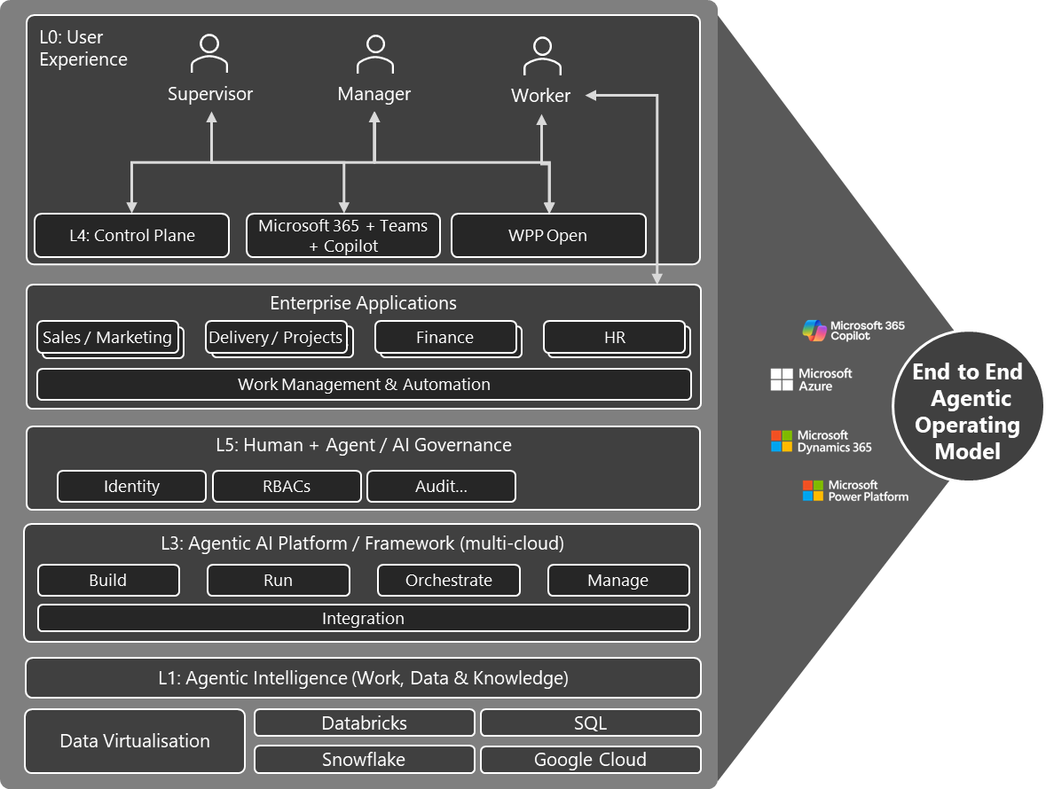
Figure 1: Conceptual (Agentic Powered) WPP Operating Platform

How Microsoft Can Extend the ET Platform for Enterprise Agents
WPP have defined a North Star where “AI Agents are first class members of the team – entrusted with tasks along the value chains to elevate humans”. This North Star aligns with Microsoft’s vision of the AI Frontier Firm, one that blends machine intelligence with human judgement, building systems that are AI-operated but human-led.
Microsoft’s Agentic strategy is based on extending, not duplicating, existing human-centric capabilities to support the agentic future, realising a number of benefits

- Avoiding introduction of shadow capabilities to manage and control AI agents – with the associated costs and complexity
- building on, rather than reinventing, key control mechanisms reduces risk across the business.

L0: User Experience
In the future, as WPP move towards autonomy, the balance of work for humans will shift from “practitioners using tools” to “experts supervising agent teams”. The “Control Plane” – will be the primary surface through which colleagues operate and manage fleets of Agents at massive scale driving productivity benefits of 10x-100x. Additional detail is provided in Section 999 below.

There will, however, continue to be value from using AI tools at the individual layer - supporting what Microsoft defines as patterns 1 and 2 (i.e. AI assistants and Agent teammates). In this case the user experience is through an Agent Surface such as Microsoft Copilot.

A fundamental design philosophy for Microsoft is that the optimal work experience is delivered “in the flow of work” – e.g. users work and collaborate with other humans, agents and applications where they are, in context, in the moment – not continually “alt-tabbing” between applications.

Users will continue to access line of business applications to initiate work, e.g. capture an expense claim, however, once the core system of record is updated the need to return to the LoB will be minimised in the Control Plane – and human approvals, reviews etc will be completed in the flow of work within the Control Plane.

Copilot is the primary Agent Surface within the Microsoft landscape. However, it is important to recognise that Copilot is no longer simply a standalone application, but it is an Agent Surface integrated into multiple applications, e.g. Teams + Meetings, Office tools such as Word, PowerPoint and Excel, Power Apps and more. Indeed, WPP have already delivered the integration of the Copilot surface into WPP Open via the Copilot APIs.

Microsoft Teams is currently one of the most common ways in which colleagues communicate within WPP – and with Clients and partners. As Agents become increasingly core to how we work – agents will be able to interact and collaborate as a first class team mates in Teams – but this is another Agent Surface, and NOT a replacement for the core Control Plane.

Enterprise Applications
There are a broadest of enterprise applications leveraged across WPP
WPP's enterprise estate includes M365 (7 tenants, 95%+ employee coverage), Dynamics 365 (CRM and F&O), Workday HCM as staff identity source-of-truth, ServiceNow for ITSM, SAP BFC and Deltek Maconomy for finance, and the Power Platform (Dataverse, Power Apps, Cloud Flows, Power Automate Desktop, Copilot Studio) for low-code application and agent development. Okta is the federated identity broker. The agent framework integrates into all of these via MCP servers governed through APIM AI Gateway — no agent has a privileged path around the gateway, regardless of which surface invoked it.

WPP have an existing investment in Power Platform – which enables a set of “low code” capabilities to build applications, agents and workflows / automations.

Not all automation and integration requires, or even benefits from, AI and agentic capabilities.
- Power Automate workflows execute explicit, predefined steps with known inputs, outputs, and transitions—ideal for finance processes where the same action must always produce the same outcome.
- This contrasts with agentic workflows, which may involve probabilistic reasoning, dynamic tool selection, or context interpretation— which can be undesirable for regulated financial operations.

The combination of Power Automate (deterministic, rule-driven) and agentic workflows (probabilistic, reasoning-driven) is not a choice between tools — it is a layered composition. Power Automate workflows execute explicit, predefined steps where the same input must always produce the same outcome; they are suited to finance operations and regulated processes. Agentic workflows handle cases that require reasoning over unstructured input, judgment, or dynamic tool selection. In Microsoft's framework both coexist: a Power Automate flow is exposed as an MCP tool callable from an agent executor, and an agentic workflow can invoke a Power Automate flow when a deterministic sub-step is required. The integration surface is APIM, so governance, audit, and cost attribution are uniform across both.

L5: Human and Agent Governance

Microsoft has approached agent governance by extending the same identity, security, compliance, and oversight mechanisms originally designed for humans to also cover AI agents, rather than creating a parallel control system.

At the identity and access layer, Microsoft Entra provides the foundation. Agents are treated as first‑class identities with managed authentication, role‑based access control, conditional access, and least‑privilege permissions—mirroring how human users are governed, but adapted for non‑human actors. This ensures agents only act within explicitly authorised scopes and can be audited like any other identity.

Through Copilot and Agent frameworks (often referred to as Agent 365 concepts), Microsoft introduces operational controls such as agent lifecycle management, environment boundaries, human‑in‑the‑loop approvals, and execution logs. These controls translate familiar management patterns—supervision, delegation, escalation, and accountability—into agentic workflows, enabling teams to oversee fleets of agents in much the same way as distributed human teams.

On the data and compliance side, Microsoft Purview extends information protection and governance policies directly to agent activity. Data Loss Prevention (DLP), sensitivity labels, retention rules, eDiscovery, and audit all apply to how agents access, generate, transform, and share data. This ensures agents cannot inadvertently exfiltrate sensitive information or operate outside regulatory constraints, and that all actions remain inspectable and defensible.

Across security, compliance, and risk, Defender, Purview, and Entra collectively enable continuous monitoring, anomaly detection, and policy enforcement for agents—again reusing trusted, enterprise‑grade systems rather than inventing agent‑specific silos.

In short, Microsoft’s strategy treats agents as governed digital workers: subject to the same identity controls, policy enforcement, auditability, and compliance expectations as people—while adding agent‑specific safeguards such as task constraints, approval checkpoints, and runtime supervision to reflect their autonomous nature.

L3: Agent Framework

The world of AI is changing constantly – rarely in the world of technology has the state of the art been “obsolete” a couple of months later – but that is the reality today.

As such Microsoft recommends that WPP adopt an agentic architecture that embraces fundamental change as capabilities evolve at pace. In addition, the Agent Framework needs to support business and architectural choices and trade-offs.

Key trade-offs include deterministic vs probabilistic generative workflows – there is no “one-size fits all” approach to this debate. Deterministic approaches provide repeatability and control, critical for certain business processes, e.g. financial reporting, whereas other processes benefit for a probabilistic approach through faster development and less brittle processes.
Microsoft has outlined a layered architecture based on Azure Durable Functions, Microsoft Agent Farmwork and Github Copilot SDK, where it is not necessary to invoke each layer of the architecture but complex, business critical, long running workflows benefit from the full stack.

- Azure Durable Functions — long-running envelope, HITL at zero compute, days/weeks of durability, survives restarts (via MAF's durable task extension)
- MAF workflow — deterministic graph shape of a phase (or of the whole process if simple enough), all executors typed, most of them plain functions
- GHCP SDK session — invoked only from agent executors, where LLM reasoning + hooks + MCP + skills actually happen

The stack leverages open standards and protocols, e.g. MCP, OpenTelemetry, A2A and AG-UI.

The separation of the Control Plane, Governance and Data layers enable the Agent Framework to evolve over time.

V2 – passed through Copilot – better but some manual tweaks still required! See below…

The pace of AI innovation means that enterprise architectures must be designed for continuous evolution, not static optimisation. Microsoft’s recommendation is that WPP adopt an agentic framework deliberately engineered for change—one that supports durable enterprise workflows today while remaining adaptable as models, patterns, and capabilities evolve.

To achieve this, Microsoft proposes a layered, composable agent framework that allows WPP to make explicit, context-dependent trade-offs between deterministic automation and probabilistic, generative orchestration.

There is no single correct approach.
- Deterministic, stateful workflows provide repeatability, auditability, and control—critical for high-risk, high-volume processes such as finance, compliance, and enterprise operations.
- Probabilistic, generative agents accelerate development, reduce brittleness, and are well suited to knowledge work, exception handling, and unstructured decision-making.

Microsoft’s architecture enables both modes to coexist within a single framework, rather than forcing WPP into a one-size-fits-all model.

Layered Agent Framework Architecture
The proposed framework consists of three complementary layers. Workflows may use only the layers they require, while business-critical, multi-step, long-running processes benefit from the full stack:
- Azure Durable Functions
Provides the long-running, resilient execution envelope for enterprise workflows.
  - Supports workflows lasting days or weeks
  - Survives infrastructure restarts and failures
  - Enables Human-in-the-Loop (HITL) intervention with zero compute cost while paused
  - Acts as the durable backbone for high-scale, high-reliability agent orchestration
- Microsoft Agent Framework (MAF) Workflows
Defines deterministic, graph-based orchestration for agent phases or end-to-end processes.
  - Typed, inspectable workflow graphs
  - Explicit routing, branching, retries, and exception handling
  - Clear separation of orchestration logic from reasoning execution
  - Suitable for enterprise governance, audit, and policy enforcement
- GitHub Copilot SDK Sessions
Invoked only within agent execution steps where probabilistic reasoning is required.
  - LLM-based reasoning, tool use, and skills execution
  - Model-agnostic and extensible
  - Integrated via MCP and skills interfaces rather than embedded directly into workflow logic

This separation ensures that generative workflows are used where it adds value, without compromising control, reliability, or enterprise governance.

Open, Governed, Enterprise-Grade by Design
The framework is built on open standards and protocols, including MCP, OpenTelemetry, A2A, and AG-UI, ensuring interoperability, observability, vendor flexibility, and long-term portability.

Critically, the architecture enforces a clear separation between:
- Data Plane (agents, workflows, integrations)
- Governance Plane (policy, identity, compliance, lifecycle management)
- Control Plane (human oversight, fleet monitoring, exception handling)

This separation enables WPP to operate agents at scale supporting 1:20–50 human-to-agent workflow ratios while allowing the underlying technology stack to evolve without disrupting business operations.

The same agent workflow can be invoked from Teams, Power Apps, enterprise applications, APIs, or other agents, while all execution, governance, and human oversight are managed centrally through a dedicated Control Plane.

L4: Control Plane

Two layers.
Foundry Control Plane (existing product, not custom build): fleet health dashboards, agent inventory, model registry, guardrails configuration, continuous evaluation, Defender and Purview integration. This covers WPP Refs 8.1,
8.5, 8.14, 22.3.
Custom Control Plane UI (React application powered by Fleet Manager agents): this is where WPP's operatorspecific requirements are met. No vendor ships what WPP is asking for — a fleet management interface where 1 human governs 20–50 concurrent workflows with intelligent exception surfacing. This is custom build.
Capability | What it does | WPP  Ref
Fleet Dashboard | Fleet Manager composes workflow-level status, SLA tracking, agency/market/jurisdiction filtering. Not raw telemetry — the Fleet Manager's assessment. | 31.1
Exception-Only  Queue | Of N active workflows, the operator sees only the 2–3% needing attention. Fleet Manager composes this based on business impact, confidence, SLA urgency. | 31.2
Instant Situational  Awareness | Click any workflow → what happened, why it stopped, what was tried, what the Fleet Manager recommends, options. Pre-composed by Fleet Manager.  <5 seconds. | 31.3
Bulk HITL | Batch similar decisions (8 interview schedules, all low-risk). Approve in one action. Raises events on all waiting Durable Functions instances simultaneously. | 31.4
Autonomy Dials | Per-workflow threshold sliders. Writes to config store, effective immediately, audit-logged. | 21.1
Skill Amplification | Fleet Manager proactively surfaces policy, precedents, recommended approach when operator is uncertain. | 31.5
Role-Based Views | HR BP sees hiring. Finance BP sees budget gates. Entra RBAC. | 10.1
Cost Dashboard | Per-workflow cost attribution from OTEL + APIM token metrics. | 26.4
Data sources for the custom UI: Application Insights APIs (traces, cost), Foundry REST APIs (agent inventory), APIM metrics (token consumption), workflow state store in Cosmos DB (phase status, approvals, action ledger), Fleet Manager assessments (SignalR real-time).

L1: Agentic Intelligence
Microsoft has identified three layers that form a cohesive intelligence architecture for agents:
- Work IQ provides context into how people work – extending the existing Microsoft Graph
- Fabric IQ adds semantic understanding to structured enterprise data building on the existing PowerBI semantic models utilized across WPP.
- Foundry IQ grounds AI agents in trusted knowledge sources for secure, governed reasoning.

Work IQ is the intelligence layer within Microsoft 365 that captures how work actually happens in an organization. It analyzes documents, emails, chats, meetings, and collaboration patterns to model human workflows and organizational behavior. By learning user habits, preferences, and informal networks, Work IQ provides a personalized context for AI agents, helping them understand who you work with, what tasks you focus on, and how work is accomplished. It powers Microsoft apps like Teams, Outlook, and Word, and serves as the user-context layer for AI, connecting human workflow signals to intelligent actions.

Fabric IQ sits atop Microsoft Fabric and provides a semantic intelligence layer for structured enterprise data. It transforms raw datasets into entities, relationships, metrics, and operational context, allowing AI to reason over trusted, governed data rather than disconnected spreadsheets. It serves as the data-context layer, essential for building analytics solutions, operational AI pipelines, and decision systems.

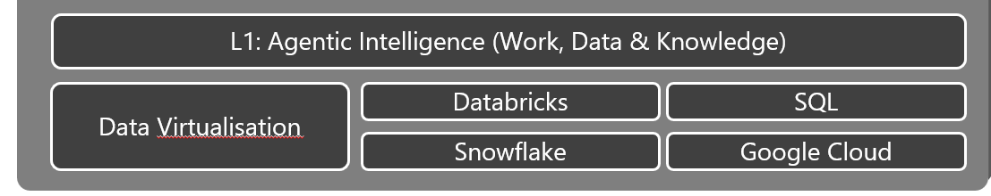

It is critical to understand that Fabric does not require WPP to move data from existing stores – even if the data is in Google or Snowflake. Fabric provides a native “data virtualisation layer” that enables Fabric IQ (and other tools) to access data in-situ greatly simplifying the consolidation of intelligence based on distributed data.

Foundry IQ is the knowledge grounding layer in Azure AI Foundry. It provides a unified knowledge system that connects AI agents to policy-governed knowledge sources across Microsoft 365, Fabric, custom applications, and the web. Foundry IQ simplifies knowledge retrieval by offering reusable, topic-centric knowledge bases through a single API. This layer ensures secure, permission-aware access and allows agents to reason across multiple sources, perform iterative searches, and act with context-aware intelligence. It is particularly useful for custom agents, pro-code development, and multi-agent collaboration.

- Reference Architecture: The Frontier AI Agent Platform
NARRATIVE GUIDANCE
Technical authority with visual storytelling. Architecture diagrams supported by clear explanatory prose. No jargon without definition. This is the heavyweight section.

This section anchors on the three strategic pillars agreed by the team: the Frontier AI Platform thinking (Scott Adams), the agentic loop as the core runtime concept, and the control plane as the extension of human workforce governance to digital workers.
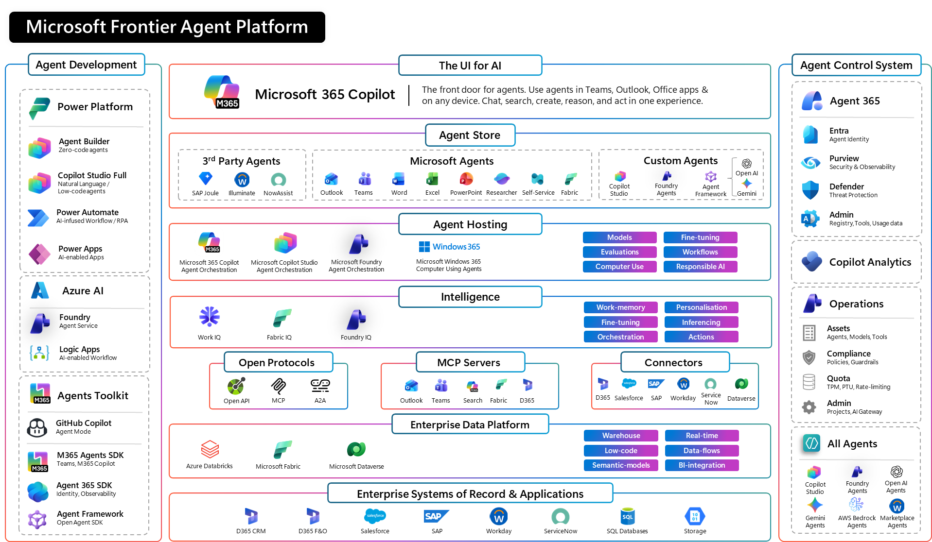

4.1 Design Philosophy: Three Principles

Principle 0: Embrace Constant Change
AI evolves rapidly. To stay ahead, WPP’s platform must be built for change and agility. Each of the five layers should be loosely coupled, allowing components to evolve with minimal risk. Internal designs of each individual layer must support easy adoption of new approaches, keeping the platform adaptable and reliable.

Principle 1: Support Choice in Agent Framework
The Framework must enable the agentic Builders to make key trade-offs depending upon the business scenario – e.g. choosing between deterministic or probabilistic workflows, adopting an agentic loop vs multi-agent orchestration.

Principle: Embrace Open Standards & Deploy Agents that are cloud, surface and model agnostic

4.1.1 Principle 1: Agents are identity-bearing entities
Every agent receives a Microsoft Entra identity, just like every employee. Permissions, access policies, and audit trails flow through the same infrastructure WPP already uses for 100,000+ humans. No shadow identity system. No parallel governance.

4.1.2 Principle 2: The agentic loop is the unit of work
Not a pipeline. Not a directed acyclic graph. A reasoning loop: perceive → plan → act → observe → reflect. This loop can be paused, resumed, escalated to a human, and audited at every step. It is durable by design (Azure Durable Functions for state persistence, not in-memory).

4.1.3 Principle 3: The control plane governs the fleet
Extend existing IT administration and HR governance tooling to agents. Fleet dashboards, per-workflow autonomy dials, bulk human-in-the-loop approvals, exception queues, and SLA monitoring. The control plane is how WPP’s managers supervise their digital team members.

4.2 Architecture Layers (Mapped to WPP’s Apex Five-Layer Model)
Present a clear architecture diagram mapping Microsoft services to each layer of WPP’s Apex model:
Apex Layer | Microsoft Services | Narrative Focus
Experience Layer | WPP Open + M365 Copilot (Teams, Outlook) + WPP Control Plane UI | Where WPP’s 85K+ people already work, zero adoption friction
Control Plane | Agent365, Entra, Purview, Defender | Fleet management, autonomy dials, HITL, identity governance
Orchestration & Runtime | Microsoft Foundry, Copilot Studio, Durable Functions | Agentic loop, multi-agent coordination, system triggers
Integration Layer | APIM AI Gateway, MCP, Connectors | Model management, tool access, existing system connectivity
Data & Intelligence | Microsoft Fabric, Azure AI Services, Azure OpenAI | Data foundation, model flexibility, document intelligence

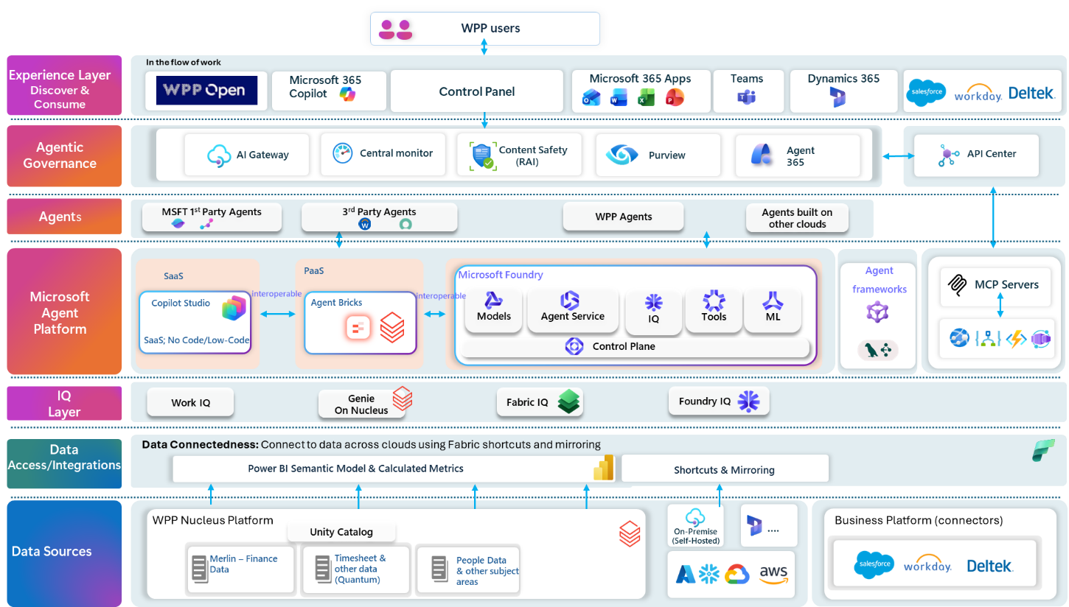

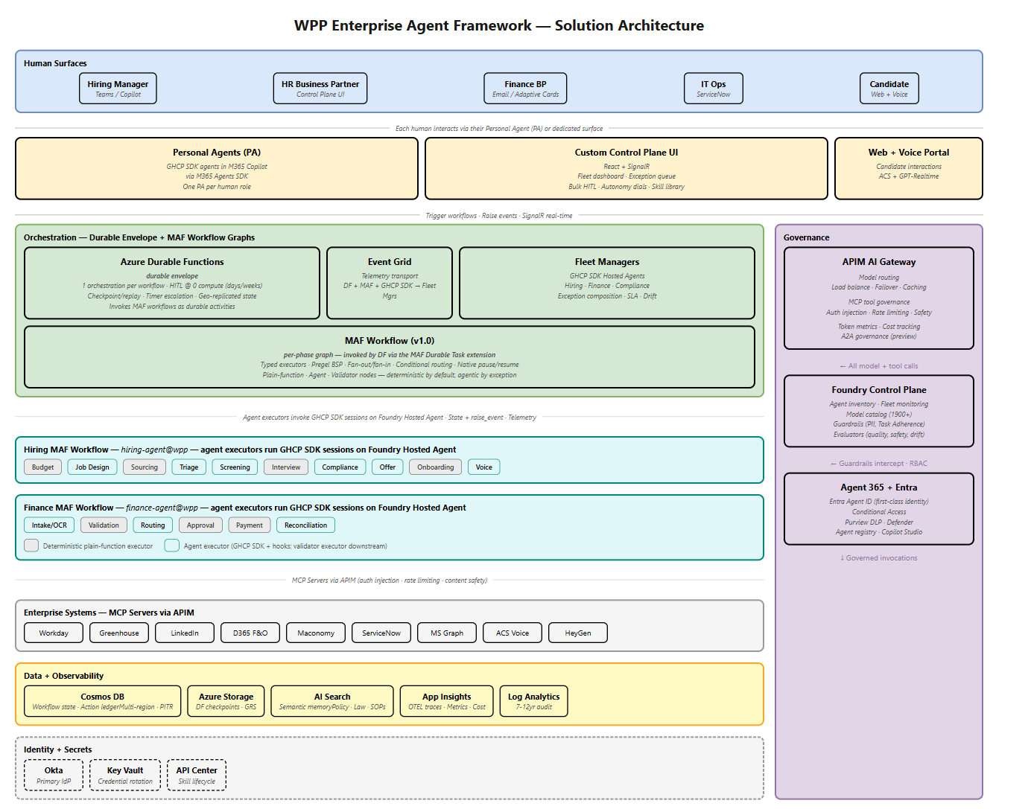

WPP's processes span a spectrum. Some phases are rule-driven and must be deterministic — three-way PO match, jurisdiction routing, payment file generation, JML provisioning. Others require reasoning over unstructured input — CV triage, voice screening, compliance narrative review. A 12-week hiring process is a sequence of deterministic scaffolding gates with agentic reasoning inside specific steps. The architecture expresses this spectrum explicitly across three cooperating execution layers, with a Fleet Manager observing from above, a central governance layer, and a custom Control Plane UI. Deterministic by default, agentic by exception. (Solution §1.)

Three-layer execution model
A WPP workflow is a Durable Functions orchestration that coordinates Microsoft Agent Framework (MAF) workflow graphs whose agent nodes invoke GHCP SDK sessions. DF provides long-running durability at zero compute; MAF provides the deterministic graph shape of a phase with typed data flow; GHCP SDK is the LLM runtime with hooks, MCP, skills, and OTEL. (Solution §1, §7.)
Layer 1 — Durable envelope. Azure Durable Functions (GA): one orchestration instance per workflow. Owns phase boundaries, HITL waits at zero compute for days or weeks, timer escalation, parallel fan-out/fan-in, and checkpoint/replay with geo-replicated state in Azure Storage. Durable Functions is event-sourced and replay-based — the Azure-native equivalent of Temporal, with identical checkpointing semantics. Where WPP's Apex diagrams reference Temporal as the expected state store, Durable Functions provides the same guarantees natively on Azure and composes with MAF via Microsoft's productised Durable Agent Orchestration pattern.
Layer 2 — Workflow graph. MAF workflows (v1.0 GA) connect to DF through the MAF durable task extension. Each phase is a graph of typed executors: plain-function executors for deterministic operations, agent executors where LLM reasoning is required, and validator executors between them. The judge/executor pattern is expressed as two nodes and an edge — the judge does not share the executioner's context. Pregel BSP execution. MAF's native pause, resume, and checkpointing are preserved across DF replay.
Layer 3 — Agent executor contents. Ephemeral GHCP SDK sessions, invoked only from MAF agent executor nodes. Each session loads SKILL.md skills and MCP tools, reasons, calls tools through pre/post hooks, writes state to Cosmos DB, emits OTEL, and returns a typed result. Primary runtime is Foundry Hosted Agents (preview). Where Hosted Agents preview constraints apply, the same GHCP SDK + MAF composition runs on Azure Container Apps (GA) with Foundry telemetry — functional difference is negligible, and the runtime layer remains replaceable.
| Layer | Substrate | Determinism |
|---|---|---|
| Durable envelope | Azure Durable Functions (GA) | Fully deterministic; event-sourced replay |
| Workflow graph | MAF workflows + durable task extension (GA) | Deterministic by default, agentic by exception |
| Agent executor | GHCP SDK sessions (Hosted Agents or Container Apps) | Probabilistic reasoning sandboxed, wrapped by hooks |

Skill crystallisation
Proven patterns move left along the spectrum. A phase that starts as an agent executor, is validated downstream, and is stable over N completed workflows is crystallised: promoted from LLM-generated to deterministic code, versioned as a skill in Azure API Center (Design → Preview → Production → Deprecated), and swapped into the MAF graph as a plain-function executor. The agent executor remains as exception fallback. The system gets cheaper, faster, and more predictable as it matures — without re-architecting. Skills are SKILL.md files in Git, registered via GitHub Actions; every step is PR-reviewable and auditable. (Solution §1, §3.)

Central governance
Governance sits alongside all three tiers.
API Center + APIM AI Gateway (GA). One control point for everything addressable by an agent. API Center: registry, lifecycle, GitHub Actions sync, cross-cloud discovery (Azure, GCP, AWS, on-prem). APIM AI Gateway: model load balancing, failover, token rate limits, per-workflow budgets, semantic caching, jurisdiction-based routing, MCP governance (auth, rate limiting, content safety), A2A governance (preview), REST-to-MCP auto-generation.
Foundry Control Plane (GA). Agent fleet inventory, model registry over the Foundry catalogue, Guardrails (PII, Task Adherence), built-in evaluators for quality, safety, drift. Platform governance; sits alongside the custom operator Control Plane UI that delivers WPP's one-to-fifty fleet management requirement.
Agent 365 + Entra (GA May 2026). Entra Agent ID, agent registry, lifecycle, Conditional Access, Purview DLP, Defender. Entra Agent ID is usable independently today; full Agent 365 integration lands May 2026 and is scoped accordingly in the delivery plan.

Intelligence Layer
Agents need three kinds of grounding — enterprise documents, business semantics, and work context. Microsoft has a purpose-built product for each. All three are MCP-addressable and sit behind APIM AI Gateway, governed identically to any other tool.
Foundry IQ (preview) — unified agentic retrieval over enterprise corpora. Self-reflective query planner. Federates SharePoint, Fabric, OneLake, Blob, AI Search, web, and MCP behind one permission-aware endpoint. Built on Azure AI Search.
Fabric IQ (preview) — semantic layer over WPP's Fabric and OneLake estate. Business ontology, semantic model, graph engine for multi-hop reasoning. Federates WPP's Databricks and Snowflake data via OneLake shortcuts with Unity Catalog access control preserved.
Work IQ MCP (preview) — Microsoft 365 work graph and memory layer. Consumed by Personal Agents and escalation routing.
The stack separates a GA foundation from a replaceable agent runtime. The foundation — Durable Functions, APIM AI Gateway, API Center, Cosmos DB, Foundry runtime, MAF v1.0, Entra, Log Analytics, Application Insights — is GA and production-proven. The agent runtime is GHCP SDK today. Because skills are SKILL.md files and tools are MCP servers (both open standards), the runtime is replaceable without redesigning the stack. If GHCP SDK stalls or WPP prefers a different runtime, the runtime swaps; skills, tools, workflow graphs, governance, data layer, and Control Plane remain. Preview-layer risk is confined to the agent runtime, not distributed across the stack. (Response-technical-sections §4.1 Appendix.)
- Control Plane – Controlling agent fleets
This section brings to life how humans supervise large fleets of autonomous agents through a purpose-built Control Plane. It demonstrates, with concrete operator journeys, how WPP’s target ratios (1 human to 20–50 agent workflows) are achieved via fleet dashboards, exception-only views, bulk human-in-the-loop actions, and runtime autonomy controls.

5.1 Why the Control Plane is the product
WPP's brief is explicit: "Vendors who demonstrate only single-agent, single-session surfaces (Teams chat, Copilot Studio bots, email approval flows) will score 0 on Control Plane criteria. These channels are trigger and response mechanisms, not Control Planes. We require a demonstrated fleet management interface." The Control Plane is the operator experience where WPP's Business Partners supervise digital labour at the stated 1:20–50 human-to-agent ratio. It is not a chat client, an Adaptive Card in an email, or a notification channel.
WPP's own Apex diagram pack makes the same point in architectural form. Apex Diagram 1 ("3 Humans x 1 Agent: Chat Surface") is drawn as the anti-pattern. Its stated LIMITATIONS OF CURRENT MODEL block enumerates:
No fleet-wide view
No bulk approval
No cross-workflow context
No autonomy adjust at runtime
Sub-agents must be hand-coded in Studio
Each human must poll for updates
Single human cannot govern 20+ concurrent workflows
It is a notification and point-interaction channel only — not a Control Plane
Apex Diagrams 2, 3, and 4 describe the positive operating model: a Fleet Dashboard with Exception Queue, Autonomy Engine, and Bulk HITL sitting above an orchestration layer; a shared Fleet Dashboard with role-filtered views for multi-operator governance; and aggregated oversight of N parallel instances of a single agent type with per-instance autonomy and per-agency auth scope. Our architecture answers these three diagrams directly. The Control Plane described below is the product, and the operator experience is its primary surface.

5.2 Two-layer architecture
The Control Plane has two layers that cover different requirements and are delivered by different components.
Foundry Control Plane (existing Microsoft product, GA). Platform-level management: fleet health dashboards, agent inventory, model registry, Guardrails configuration, continuous evaluation, Microsoft Defender for AI Services and Purview integration. This covers WPP Refs 8.1 (model registry), 8.5 (agent registry), 8.14 (observability), and 22.3 (agent lifecycle). It is consumed; it is not custom built.
Custom Control Plane UI (React single-page application powered by Fleet Manager agents). The operator experience where WPP's 1:20–50 fleet management requirement is met. Exception-only queue, bulk HITL, autonomy dials, skill amplification, role-based views, cost dashboard, AG-UI dynamic components. This covers WPP Refs 31.1–31.5, 21.1, 10.1, 26.4, and 5.3. No vendor ships this as a product. It is custom build, delivered as a co-creation partnership (see §5.15).

5.3 Fleet Manager agents
The Fleet Manager is the intelligence layer between raw telemetry and the operator surface. It is not a pass-through dashboard feed. It is an always-on GHCP SDK Hosted Agent on Azure AI Foundry, domain-scoped (Hiring, Finance, Compliance), that consumes telemetry via Azure Event Grid and reasons over fleet state.
On each incoming signal the Fleet Manager evaluates SLA risk, anomaly patterns, business impact, and cross-workflow context. It composes the exception queue, pre-composes situational summaries for each flagged workflow, and surfaces crystallisation candidates. Its assessments are pushed to the Custom CP UI via Azure SignalR as AG-UI-shaped JSON payloads.
This is agentic governance. Human-eye governance does not scale to a 1:20–50 ratio — an operator cannot manually scan 50 concurrent workflow telemetry streams and identify the three that need intervention. The Fleet Manager performs that triage continuously.

5.4 Capability table
| Capability | What it does | WPP Ref |
|---|---|---|
| Fleet Dashboard | Fleet Manager composes workflow-level status, SLA tracking, agency/market/jurisdiction filtering. Fleet Manager assessment, not raw telemetry. | 31.1 |
| Exception-Only Queue | Of N active workflows, the operator sees only the 2–3% needing attention. Prioritised by business impact x confidence x SLA urgency. | 31.2 |
| Instant Situational Awareness | Click any workflow: what happened, why it stopped, what was tried, what the Fleet Manager recommends, available options. Pre-composed. <5 second comprehension target. | 31.3 |
| Bulk HITL | Batch similar decisions (e.g. eight interview schedules, all low-risk). Single approval raises events on all waiting Durable Functions instances simultaneously. | 31.4 |
| Autonomy Dials | Per-workflow, per-phase, per-agent-type threshold adjustment. Writes to Cosmos DB config store. Effect on next phase boundary. Audit-logged. See §5.5 on production hardening. | 21.1 |
| Skill Amplification | Fleet Manager proactively surfaces policy, precedents, recommended approach when operator is uncertain. Grounded via Foundry IQ over WPP corpora. | 31.5 |
| Role-Based Views | HR BP sees hiring. Finance BP sees budget gates. IT Ops sees provisioning. Entra RBAC-filtered. | 10.1 |
| Cost Dashboard | Per-workflow, per-phase, per-model, per-consumer cost attribution. Sourced from OTEL spans and APIM token metrics. | 26.4 |
| AG-UI Dynamic Components | UI consumes AG-UI event streams over SSE emitted by MAF agent executors and Fleet Manager. Dynamic approval forms, charts, wizards per workflow type, no hardcoded UI. APIM-mediated. | 5.3 |

5.5 Autonomy dials — the runtime-adjustability question
WPP's brief requires autonomy dials "adjustable at runtime without redeployment". We meet that requirement. Autonomy thresholds are stored in Cosmos DB config documents, scoped per-agent-type, per-workflow, and per-phase. An operator adjusts a dial in the Custom CP UI; the UI writes the new value to Cosmos DB; the next MAF phase reads the new threshold at its conditional-routing node and takes effect at the next phase boundary with no redeployment. Every change is audit-logged with operator identity, timestamp, previous value, and new value.
We explicitly recommend that runtime adjustment is not enabled on production systems, or is enabled only under tightened governance. This is sound governance advice that flows from the audit and dual-control principles emphasised elsewhere in the response — not pushback on the requirement. Three options, ordered by preference:
Disable runtime adjustment in production; use change-request workflow. Threshold changes land via PR into the config repository, promoted through Design -> Preview -> Production via APIOps, with approvals and full Git history. Runtime dials remain fully functional in Development and Staging for operator training and exception tuning.
Runtime adjustment in production with dual-control. Threshold changes in the production tenant require a second operator's approval recorded in the action ledger before the Cosmos DB write is committed. Pair with tight Conditional Access scoping.
Runtime adjustment in production with PR-gated promotion between environments. Operator changes a threshold in Staging; an APIOps pipeline raises a PR that, on approval, promotes the config value into Production.
The mechanism is in the platform. The governance posture is a deployment decision per tenant and per workflow.

5.6 AG-UI
MAF agent executors and the Fleet Manager emit AG-UI events over Server-Sent Events. The Custom CP UI consumes and renders them as interactive Adaptive Card-style React components: per-workflow approval forms, workflow visualisations, autonomy dial states, charts, and wizards. APIM mediates the SSE stream for authentication, rate limiting, and audit. There is no hardcoded UI per workflow type — the UI is rendered by the agent layer. This addresses WPP §5.3 "AG-UI or equivalent: Must support".

5.7 Data sources for the custom UI
The Custom CP UI is a thin render layer over five telemetry and state surfaces:
Application Insights REST API — OTEL spans (traces, token consumption, latency, cost attribution), KQL-based historical dashboards and drill-down.
Foundry REST API and Foundry SDK — agent inventory, model registry, evaluator results (quality, safety, task adherence, tool call accuracy).
APIM metrics — token consumption per model/tool/agent, latency percentiles, error rates, rate limit hits, content safety blocks, cache hit ratio.
Cosmos DB REST API — workflow state store: phase status, action ledger (revocable vs non-revocable entries), approval records, autonomy threshold values, jurisdiction context.
Fleet Manager assessments — AG-UI-shaped payloads pushed over Azure SignalR in real time (SignalR primary, Cosmos DB polling at 30s as fallback).

5.8 Cross-references
See §9 (Builder Experiences) for how Copilot Studio and GHCP SDK agents both appear in the Control Plane through the same telemetry contract; §10 (POC demos) for the live demonstrations of fleet management, bulk HITL, and exception-only queue at scale; and §14.3 Appendix C for Control Plane UI wireframes.

5.9 Telemetry ingestion pathways
The Control Plane consumes nine telemetry streams, each originating from a different architectural layer or Azure platform service. Each source is mapped to a specific transport mechanism, data points, delivery latency, and downstream consumer.
| Source | Transport | Data Points | Latency | Consumer |
|---|---|---|---|---|
| GHCP SDK sessions (agent executors) | OTEL TracerProvider -> App Insights | Model calls, tool calls, tokens, latency, cost, reasoning chain, skill loaded, structured output | Near real-time (seconds) | Custom CP UI via App Insights REST API (trace drill-down). Fleet Manager receives context via Event Grid when hooks publish state-change events alongside Cosmos DB writes (see Hook 1). |
| MAF workflow graph (executor lifecycle) | OTEL spans -> App Insights | Executor start/complete/fail, phase transitions, fan-out/fan-in, validator pass/fail, conditional routing decisions | Near real-time | Custom CP UI via App Insights REST API (workflow analytics). Fleet Manager receives MAF context via Event Grid (Hook 2). |
| Durable Functions (orchestration envelope) | Dual-path: (1) Azure Event Grid (push); (2) OTEL spans -> App Insights (query) | Workflow started/completed/failed, HITL wait entered, timer escalation fired, checkpoint written, phase boundary crossed | Sub-second (Event Grid); near real-time (App Insights) | Fleet Manager (Event Grid push for real-time reasoning); Custom CP UI (App Insights REST API for historical dashboards, KQL drill-down, SLA tracking) |
| APIM AI Gateway (model + tool governance) | APIM metrics -> App Insights | Token consumption per model/tool/agent, latency percentiles, error rates, rate limit hits, content safety blocks, cache hit ratio | Near real-time | Custom CP UI (Cost Dashboard, SLA views, token cost via App Insights REST API) |
| Cosmos DB (workflow state store) | REST API (queried by CP UI) | Phase status updates, action ledger entries (revocable/non-revocable), approval records, autonomy threshold values, jurisdiction context | On-demand (query) | Custom CP UI (state queries, action ledger drill-down, approval audit). Fleet Manager receives state-change events via Event Grid and queries Cosmos DB on-demand for context enrichment. |
| Foundry Agent Service (agent + model registry) | Foundry REST API (polled) | Agent inventory (list, status, metadata), model registry (deployed models, versions, lifecycle, capabilities) | Polled | Custom CP UI (inventory views, model deployment dashboards) |
| Foundry Evaluations (quality + safety scoring) | Foundry SDK (project-level API, polled) | Evaluator results: quality (coherence, fluency, groundedness, relevance), safety (violence, hate, self-harm), agent-specific (task adherence, tool call accuracy) | Polled (on evaluation completion) | Custom CP UI (evaluator dashboards, quality gates, drift tracking) |
| Content Safety / Guardrail config | Azure ARM Management API (polled) | RAI policy definitions: content filter categories, severity thresholds (per prompt/completion), blocklists, Prompt Shield configuration | Polled (low frequency) | Custom CP UI (guardrail config views, policy audit) |
| Microsoft Defender for AI Services | Defender for Cloud REST API (ARM, polled or alert-triggered) | Security alerts: prompt injection, jailbreak, data leakage, tool misuse, privilege compromise, identity spoofing | Near real-time (alert-triggered via Defender XDR) | Custom CP UI (security dashboard, alert feed); Defender XDR portal (primary SOC surface) |
Correlation attributes. A standard set of attributes is propagated across all telemetry surfaces — OTEL spans, Cosmos DB action ledger entries, and Event Grid event payloads: workflow_id, phase, jurisdiction, model, agent_identity, skill, token_count. These are set by the GHCP SDK TracerProvider at session creation and included in Event Grid event payloads and Cosmos DB action ledger entries by the hook layer. The Fleet Manager uses them for domain scoping and fleet-level aggregation; the Custom CP UI uses the same attributes for filtering, drill-down, and cost attribution.

5.10 Integration hooks
The framework-to-Control-Plane integration is not ad-hoc. It uses three well-defined hook points, each at a different architectural layer. All three write state to Cosmos DB for persistence and CP UI queries, and publish events to Event Grid for real-time Fleet Manager consumption.
Hook 1 — GHCP SDK session hooks (agent-executor level). Every GHCP SDK session emits OTEL spans via its configured TracerProvider. The GHCP SDK hook mechanism additionally intercepts tool calls, model calls, and non-revocable action attempts. On each intercepted event the hook writes an action-ledger entry to Cosmos DB classified as revocable or non-revocable, and emits a corresponding OTEL span. On anomaly — for example, a non-revocable action attempted without validator approval — the hook writes a violation entry to the action ledger and publishes a violation event to Event Grid; the Fleet Manager immediately surfaces it in the exception queue. Non-revocable gating blocks the action until explicit approval via HITL or validator executor. This is the first enforcement boundary — the agent cannot bypass it.
Hook 2 — MAF workflow event callbacks (workflow-graph level). MAF workflows emit executor lifecycle events as OTEL spans: start, complete, fail, pause, resume for each executor node. Validator rejection events are emitted with the rejection reason, the input that was rejected, and the policy that triggered rejection. Rejections are written to the Cosmos DB action ledger and published as Event Grid events; the Fleet Manager composes them into the exception queue with pre-built context: what was attempted, why it was rejected, what acceptance criteria failed. The CP UI queries App Insights for trend analysis and drill-down. MAF phase-boundary spans feed the Fleet Dashboard's workflow progress view.
Hook 3 — Durable Functions external events (orchestration level), dual-path. DF orchestrations emit telemetry via two parallel paths.
Path 1 — Event Grid (real-time push). DF publishes lifecycle events to Azure Event Grid: workflow_started, phase_boundary, hitl_wait_entered, timer_escalation, workflow_completed, workflow_failed. The Fleet Manager subscribes via an Event Grid Azure Functions trigger. This is the primary real-time signal for fleet situational awareness — the Fleet Manager knows within sub-seconds when any workflow changes state.
Path 2 — OTEL spans to App Insights (query/analytics). DF emits orchestration spans natively to Application Insights with the same correlation attributes. These power historical SLA tracking, KQL alert rules, trace drill-down, and audit. The Custom CP UI queries App Insights REST API for dashboards and historical views.
Why both paths. The Fleet Manager needs sub-second push to reason over live fleet state and compose the exception queue in real time. The Custom CP UI needs queryable, indexed telemetry for dashboards, trend analysis, and audit drill-down. Event Grid delivers the first; App Insights delivers the second.
Capacity. At 50 concurrent workflows, Event Grid carries approximately 200–500 events per hour and auto-scales transparently at any volume. App Insights scales in ingestion capacity but requires capacity planning: commitment tier selection, adaptive sampling configuration, and daily cap management.
Cosmos DB is the persistent state store, not a telemetry transport. Hooks 1–3 write state to Cosmos DB (action ledger, approvals, phase status) and simultaneously publish events to Event Grid. The Fleet Manager consumes Event Grid for real-time reasoning and queries Cosmos DB on-demand for context enrichment. The CP UI queries Cosmos DB directly for state drill-down and approval history.

5.11 Fleet Manager internals
The Fleet Manager is a domain-scoped GHCP SDK Hosted Agent that reasons over incoming signals and produces structured assessments.
Inputs (Event Grid — single push channel). The Fleet Manager's primary input channel is Azure Event Grid. It reacts to events pushed to it in real time; it does not poll App Insights or subscribe to change feeds. For context enrichment (composing situational summaries that require accumulated workflow history), it queries Cosmos DB on-demand. This keeps the hot path real-time while allowing full context in the exception queue.
DF lifecycle events: workflow started, phase boundary, HITL wait entered, timer escalation, workflow completed, workflow failed. Published natively by Durable Functions.
Hook state-change events: action-ledger entries (attempted actions, violations, rejection reasons), approval records, validator rejections, phase status updates. Published by GHCP SDK hooks and MAF callbacks at the point of Cosmos DB write.
Operator config-change events: autonomy threshold changes, agent block/unblock. Published by the CP UI when it writes enforcement actions to Cosmos DB or APIM.
Outputs.
Fleet health assessment: aggregated workflow status, SLA tracking per domain/jurisdiction/agency. "47 of 50 hiring workflows on track. 3 require attention."
Exception queue: prioritised by business impact x confidence x SLA urgency. Of N active workflows, the operator sees only the 2–3% needing intervention.
Situational context per workflow: pre-composed for <5 second operator comprehension — what happened, why it stopped, what was tried, what the Fleet Manager recommends, available options. Includes links to OTEL trace spans and action ledger entries.
Crystallisation candidates: patterns across completed workflows suitable for deterministic graduation. "The CV triage skill has been consistent for 50 workflows — recommend crystallisation to deterministic classifier."
Delivery (SignalR push). Azure SignalR delivers structured JSON payloads to the Custom CP UI in real time. Channels are scoped by domain (hiring, finance, compliance) and role (HR BP, Finance Controller, IT Ops) — operators receive only signals relevant to their scope. Payloads follow the AG-UI pattern (exception cards, approval forms, workflow visualisations, autonomy dial states) and are rendered as interactive components. If the SignalR connection drops, the Custom CP UI falls back to polling the Fleet Manager's assessment store in Cosmos DB at a 30-second interval; no data is lost because assessments are persisted before push.

5.12 Enforcement pathways
The Control Plane is a control surface, not a monitoring dashboard. Operator actions flow back into the runtime through defined enforcement channels. Each has a specific mechanism, target, and observable effect.
| Operator Action | Mechanism | Target | Effect |
|---|---|---|---|
| Approve / reject HITL decision | CP UI -> DF raise_external_event | DF orchestration instance (by workflow_id) | Waiting DF instance resumes from zero-compute state. Approved: next phase fires. Rejected: DF triggers compensating action sequence via action ledger. |
| Bulk approve batch | CP UI -> DF raise_external_event (batch) | Multiple DF instances | All waiting instances in the batch resume. Single API call raises events on N instances via Azure Storage queue fan-out. |
| Adjust autonomy dial | CP UI -> Cosmos DB config write | Workflow config store (per-agent-type, per-workflow, or per-phase) | Threshold written. Next MAF phase evaluates the new threshold at its conditional-routing node. Takes effect on next phase boundary — no redeployment. Change audit-logged. |
| Trigger rollback | CP UI -> DF raise_external_event (rollback) | DF orchestration instance | DF reads action ledger from Cosmos DB. Identifies revocable steps. Fires compensating actions (reverse API calls) in reverse order. Non-revocable steps flagged for manual resolution. |
| Override model / tool | CP UI -> APIM policy update (via APIOps) | APIM AI Gateway policy | Routing rule updated. Next agent executor invocation uses overridden model/tool. Audit-logged. Requires operator confirmation. |
| Block / unblock agent | CP UI -> Agent 365 API (or API Center) | Agent registry | Agent status set to blocked/active. Blocked agents cannot start new workflows. In-flight workflows routed to exception queue. |
Bidirectional data-flow summary. Telemetry flows IN — read-only, high-volume, real-time — via OTEL spans to App Insights and Event Grid events to Fleet Manager. Enforcement flows OUT — write, low-volume, operator-initiated, audit-logged — via DF raise_external_event, Cosmos DB writes, and APIM policy updates. The two paths are architecturally separated: the telemetry pipeline cannot be affected by enforcement actions, and enforcement actions produce their own Event Grid events for audit.

5.13 Infrastructure topology
The Control Plane infrastructure is a set of stable Azure PaaS resources, provisioned per WPP tenant, that scale independently of agent runtime workloads.
| Component | Role in Control Plane | Provisioning |
|---|---|---|
| Azure SignalR Service | Real-time push channel from Fleet Manager to Custom CP UI. Supports 100K+ concurrent connections. WebSocket-based. | Shared instance, auto-scaled. Domain-scoped channels (hiring, finance, compliance). |
| Azure Event Grid (namespace) | Single event transport to Fleet Manager. Carries DF lifecycle events, GHCP SDK hook events, MAF callback events, operator config-change events. Push-based, sub-second delivery. | Shared namespace with topic-per-domain. Auto-scales transparently with event volume. |
| Fleet Manager Hosted Agents | Always-on GHCP SDK agents that consume telemetry and produce structured assessments. One per domain. | One Foundry Hosted Agent deployment per domain (hiring, finance, compliance). Multiple replicas. Azure Container Apps is available as GA-today fallback where Hosted Agent preview constraints apply; functional parity, same MAF + GHCP SDK composition. |
| Application Insights workspace | OTEL span storage. KQL query engine for cost/trace analysis. Alert rules for validator rejections and SLA breaches. | Shared workspace. Role-based access. Requires capacity planning at scale: commitment tier selection, adaptive sampling, daily cap configuration. 90-day hot, 2-year warm, 7–12 year archive tier. |
| Cosmos DB (config + state) | Persistent state store: workflow state, action ledger, autonomy config, approval records. Queried by CP UI for drill-down and audit. Not a telemetry transport — hooks publish to Event Grid separately. | Regional deployment per data residency. Auto-scaled RU throughput. Continuous backup with PITR. |
| Azure Functions (triggers) | Lightweight functions routing Event Grid events to Fleet Manager. | Consumption plan. Zero cost at idle. Scales automatically with event volume. |
| Custom CP UI (React SPA) | Operator-facing fleet management dashboard. Consumes SignalR (Fleet Manager assessments), App Insights REST API (OTEL traces, cost), Cosmos DB REST API (state queries), Foundry REST API (agent inventory), Foundry SDK (evaluator results), ARM API (guardrail config, Defender alerts). | Azure Static Web Apps. CDN-fronted. Regional deployment. |
| Foundry resource + projects | Agent inventory (list, status), model deployments (versions, lifecycle, capabilities), quality and safety scoring (coherence, fluency, groundedness, relevance, violence, hate, task adherence). | Foundry resource (Microsoft.CognitiveServices/account, kind AIServices) provisioned per WPP tenant/region. Projects as child resources. Model deployments at resource level (PTU or pay-as-you-go). Hosted Agent deployments within projects. Evaluations run as managed compute within projects. |
| Azure AI Content Safety | Content filter policies (RAI policies), blocklists, Prompt Shield configuration. Consumed via ARM Management API. | Configured per Foundry resource. Polled by Custom CP UI for config audit. |
| Microsoft Defender for AI Services | Runtime security alerts: prompt injection, jailbreak, data leakage, tool misuse. GA for Foundry agents. | Enabled at subscription level via Defender for Cloud. Alerts surfaced in Defender XDR and polled by Custom CP UI via ARM Security API. |
Scaling independence. Adding concurrent workflows scales the runtime layer (more DF instances, more Hosted Agent replicas, more APIM throughput). It does not change the Control Plane infrastructure topology. Event Grid and SignalR auto-scale transparently. Cosmos DB auto-scales RU throughput. App Insights scales in capacity but requires operational attention as volume grows: commitment tier upgrades, adaptive sampling tuning, daily cap adjustments to balance cost against telemetry completeness. The infrastructure footprint is the same from 50 to 50,000 concurrent workflows — though App Insights configuration must be right-sized for the volume.

5.14 Platform plug-in model — framework-agnostic onboarding
When WPP adds a new domain agent (e.g. Legal, Marketing) or integrates a third-party framework (e.g. Copilot Studio bots via Agent 365, WPP Open agents via A2A), the new agent type must fulfil a minimum telemetry contract to appear in the Control Plane. Any agent type that meets three requirements is visible and governable:
OTEL spans with standard correlation attributes (workflow_id, phase, agent_identity, model, skill, token_count) to the shared Application Insights workspace.
Event Grid lifecycle events (workflow_started, phase_boundary, workflow_completed) to the shared Event Grid namespace.
Cosmos DB state writes using the standard schema (phase status, action ledger entries) to the shared container.
Integration effort by agent type:
| Agent Type | Contract Fulfilment | Integration Effort |
|---|---|---|
| Foundry Hosted Agent (GHCP SDK) | Automatic. GHCP SDK emits OTEL via TracerProvider. DF publishes to Event Grid natively. Cosmos DB writes are part of the standard workflow pattern. | Zero additional work. Deploy and it appears in the Control Plane. |
| Copilot Studio agent (via Agent 365) | Partial automatic. Agent 365 registration makes the agent visible in Foundry Control Plane inventory. For deeper integration (HITL, exception queue), a thin adapter publishes lifecycle events to Event Grid and writes state to Cosmos DB. | Thin Azure Functions adapter per agent type. Standard pattern, reusable template provided. |
| External agent (A2A via APIM) | APIM logs all A2A interactions as OTEL spans automatically. AgentCard registered in API Center for discovery. APIM-generated telemetry provides minimum data points for fleet-level visibility. | AgentCard registration + optional Event Grid webhook for deeper integration. |
| Custom / third-party runtime | Must implement the telemetry contract explicitly: emit OTEL spans, publish Event Grid events, write to Cosmos DB state store. | SDK-agnostic. Any runtime that can emit OTEL and call REST APIs can integrate. Reference adapter provided. |
The Control Plane infrastructure is framework-agnostic. It consumes telemetry via open standards (OTEL, Event Grid, Cosmos DB) and does not require agents to use a specific SDK or runtime. The GHCP SDK path is zero-effort; any agent fulfilling the contract is visible and governable.

5.15 Co-creation partnership
"WPP's Control Plane requirements exceed any out-of-the-box product available today. The 1:20–50 human-to-agent ratio, fleet-level exception surfacing, and intelligent autonomy management represent frontier capabilities that no vendor ships as a product. This is not a product procurement. It is a co-creation partnership."
| Dimension | What Microsoft Provides | What WPP Provides | Outcome |
|---|---|---|---|
| Platform infrastructure | Event Grid, SignalR, App Insights, Cosmos DB, Foundry Control Plane, APIM — GA, SLA-backed Azure services | Azure tenancy, subscription, data residency requirements | Stable, scalable foundation. Not custom. |
| Custom Control Plane UI | Microsoft Services (CSU/MCS) engineering for React UI, Fleet Manager agent logic, SignalR integration | Domain expertise: what "exception" means in hiring vs finance, operator workflow requirements, UX feedback | Purpose-built fleet management surface co-designed with operators |
| Fleet Manager agents | GHCP SDK agent development, OTEL integration patterns, Event Grid subscription design | Business rules: SLA definitions, escalation policies, exception classification criteria | Domain-scoped intelligence layer encoding WPP's operational knowledge |
| Codebase ownership | Initial build + knowledge transfer | Long-term maintenance, CI/CD, feature evolution | WPP owns the code. Standard React + Azure PaaS. No proprietary lock-in. |
| Productisation | Evaluates proven patterns for Foundry Control Plane roadmap (H2 2027 candidates: exception-only queuing, bulk HITL, autonomy dials) | Production validation at enterprise scale | WPP gets early access when the platform absorbs the custom build. Microsoft gets pattern validation. |
WPP gets a Control Plane purpose-built for its operating model today, with a clear path to platform-supported capabilities as the market matures. Microsoft gets production validation of frontier fleet management patterns at enterprise scale. See §12 (Commercial & Partnership) for engagement model and §13 (Portability) for exit strategy detailing WPP's ownership of the codebase and substitutability of each Azure PaaS component.
- Multi-Agent Orchestration and Durable Execution
This section explains how complex business processes are executed through multi-agent orchestration that is durable, inspectable, and interruptible. It focuses on workflow graphs, parallel execution, fault recovery, and human intervention points—demonstrating how autonomy is safely increased over time without loss of control or auditability.

Section 6 — Multi-Agent Orchestration and Durability
WPP's POC 2 brief describes a "9+ specialist agents" hiring team; the Apex reference diagrams name Temporal as the expected workflow state store. This section addresses multi-agent coordination and long-running durability on the Azure-native stack WPP has standardised on.

6.1 Two coordination substrates, layered
Within a phase — MAF workflow graph. Microsoft Agent Framework workflows (v1.0 GA) execute each phase as a graph of typed executors under Pregel BSP semantics. Typed edges; first-class fan-out and fan-in; conditional routing into recovery branches; validator executors between agent output and any non-revocable action; native pause/resume. The stable MAF orchestration patterns — sequential, concurrent, handoff, group chat, Magentic-One — cover the multi-agent topologies WPP requires.
Across phases — Azure Durable Functions. A single DF orchestration owns the long-running envelope: phase boundaries, HITL waits at zero compute for days or weeks, timer-driven escalation, checkpoint/replay, geo-replicated state in Azure Storage. Each phase's MAF workflow is invoked as a durable activity via the MAF Durable Task extension; MAF's own pause/resume and checkpointing are preserved across DF replay.

6.1a Durable Functions as the Azure-native equivalent of Temporal
WPP's Apex diagrams (WPPET-4-Apex-diagrams.pdf) reference Temporal as the expected workflow state store: "e.g. Temporal · Durable · Checkpointed". Durable Functions provides the same execution model: event-sourced history, deterministic replay-based recovery, checkpointed state in geo-replicated Azure Storage, zero-compute waits for external events, timer-driven escalation, and compensating-action patterns for sagas.
The differences are cloud-native integration and licensing. DF is first-class in Azure Functions, co-deployed with APIM, Event Grid, and SignalR without additional workflow infrastructure. It is GA and bundled with the Azure Functions consumption plan — no separate Temporal Cloud subscription and no self-hosted Temporal cluster to operate. For WPP's Temporal mental model, DF is a drop-in conceptual equivalent on the Azure surface already in place.

6.2 The Durable Agent Orchestration pattern
Microsoft productised the DF + MAF + SignalR composition in February 2026 as the Durable Agent Orchestration pattern, documented in the Microsoft Learn tutorial "Orchestrate durable agents". It is the architectural backbone of this response: DF as the long-running envelope, MAF workflows as the phase-internal graph, SignalR as the real-time channel to humans and the Control Plane. The integration points — MAF Durable Task extension, checkpoint interleaving, external-event plumbing — are maintained by Microsoft.

6.3 Agent executors and GHCP SDK sessions
GHCP SDK sessions on Foundry Hosted Agents are invoked only from MAF agent executor nodes. They are ephemeral: each session loads the required skills and MCP tools, reasons, calls tools through hooks, emits OpenTelemetry spans, and returns a typed result to its MAF executor. Identity comes from the Hosted Agent container — on-behalf-of the triggering human for human-initiated phases, app-only for autonomous phases. Hosted Agents are preview with a five-replica cap; Azure Container Apps is the GA fallback with the same governance posture.

6.4 Skills, not separate agents — the architectural choice
POC 2 names Budget, Job Design, Sourcing, Triage, Screening, Interview Coordinator, Compliance, Offer, Onboarding, and Voice Screening. The brief's mental model is one independent agent process per role with inter-agent protocol between them.
We implement the same capabilities with a different topology: one domain-scoped Hosted Agent per domain (Hiring, Finance, Compliance) running ephemeral GHCP SDK sessions from MAF agent executors, each loading a different skill per phase. Each skill declares its own role, tool allow-list, model assignment, and governance rules. Specialisation is preserved; the coordination substrate is a MAF workflow graph with typed edges and validator nodes, not an A2A protocol between separate processes.
| Dimension | 9 separate specialist agents | Skills-based (our approach) |
|---|---|---|
| Specialisation | 1 agent per role, distinct identity per role | 1 skill per role, distinct role definition + tool allow-list + model per skill |
| Coordination substrate | A2A protocol between agents (JSON-RPC / SSE) on every handoff | MAF workflow graph edges — in-process, typed, deterministic |
| Identity surface | 9 Entra Agent IDs per domain, 9 Conditional Access policies, 9 audit identities | 1 domain Entra Agent ID; policy + audit segmentation at the skill layer via APIM |
| Context sharing | Each agent re-grounds or serialises context across the A2A boundary | Shared workflow state in the MAF graph; no re-grounding |
| Latency | N × retrieval + N × inference + N × network hops | 1 × shared retrieval + N × inference; zero inter-agent network hops within the graph |
| Cost | N × working-memory tokens; every A2A handoff re-establishes context | Amortised working memory; context flows down MAF edges |
| Failure modes | Network partition between agents; protocol version drift; handoff races | In-process graph execution; Pregel BSP guarantees deterministic fan-in |
| Debuggability | N separate OTEL traces per workflow; stitching via correlation IDs | Single MAF workflow trace per phase; natural parent-child span hierarchy |
| Governance surface | Per-agent governance — 9 APIM policy sets to keep aligned | Per-skill governance with one shared domain identity; fewer drift points |
| Operationalisation at fleet scale | 9 × N workflows of agent instances to monitor, scale, restart | N workflows × one domain pool of Hosted Agents; skills load in ~ms |
| Matches "specialist team" mental model | Yes | Yes — skills are the specialists; the graph is the team |
What WPP gets either way: heterogeneous expertise per phase (skills with distinct models and tools); role-based authority and tool access (skill-declared allow-lists enforced at APIM); auditability per role (skill-tagged OTEL spans and audit ledger entries); independent evolution per role (skill-versioned artefacts in API Center).
What WPP avoids: 9× identity, governance, and operational overhead per domain; inter-agent protocol failure modes; latency and cost of re-grounding across every handoff; debugging a correlation-ID graph instead of a single workflow trace.
If WPP evaluators prefer the separate-agent topology after review, both are supported by MAF; a hybrid is supported (skills inside a domain, A2A across domains).

6.5 A2A where it belongs
Agent-to-agent protocols are the right choice when an agent is genuinely off-platform. Partner candidate agents, supplier pricing agents, and jurisdictional compliance authorities owned by another organisation interact through APIM A2A governance (AgentCards, JSON-RPC task lifecycle, SSE streaming). Agent-process separation applies at the organisational boundary; skill-based specialisation applies at the domain boundary.

6.6 HITL pattern in detail
For long waits across phase boundaries, the MAF agent executor detects that human input is required, composes the message or Adaptive Card, and routes it via the human's preferred surface through their Personal Agent. The executor signals the DF orchestration to suspend; DF issues wait_for_external_event and holds at zero compute until the human responds. The response reaches DF as a raise_event call, unblocking the orchestration into the next phase. Bulk approval raises events on multiple DF instances simultaneously from a single operator action in the Control Plane. For shorter-lived HITL within a phase, MAF's native pause/resume handles the wait without descending into the DF layer.

6.7 Supported topologies
Both substrates adapt based on runtime data, not static DAGs. Supported end-to-end: sequential (interview coordination after CV screening); parallel fan-out / fan-in (sourcing and job design concurrently, results joined downstream); conditional (a compliance flag from a validator executor triggers an additional review branch without modifying the base workflow); timer escalation (DF timers escalate unresolved HITL waits to a second approver or the Fleet Manager queue); bulk HITL (one operator decision raises events on many DF instances in parallel).
- Governance as a First-Class Capability
This section shows how enterprise governance is extended seamlessly to agents as first-class actors. It covers agent identity, lifecycle management, observability, and compliance, with a specific focus on Code-as-Truth: all agent definitions, orchestration logic, and policies are version-controlled, auditable, and reviewable using standard enterprise engineering practices.
This subsection addresses WPP’s 20% scoring weight on governance, security, and compliance. Governance is not an afterthought bolted onto the architecture — governance IS the architecture.
- Agent lifecycle management: provisioning, versioning, decommissioning — mirroring HR lifecycle processes
- Autonomy levels: configurable from “human approves every step” to “fully autonomous with exception-based escalation” — with runtime-adjustable dials per workflow
- Compliance and audit: Microsoft Purview for data governance, Defender for threat detection, full audit trails on every agent action
- The “autonomy dial” concept: per-workflow threshold sliders that allow WPP to gradually increase agent autonomy as trust is established — a practical, low-risk adoption path

Section 7 — Governance, Security and Compliance
This section addresses WPP's §5.2 governance requirements and the §6.3 Enterprise Non-Negotiables. Governance is enforced externally and structurally; the LLM cannot bypass the layers below.

7.1 Agent identity and governance
WPP requires every agent to carry a first-class enterprise identity, distinct from service accounts, with RBAC-enforced access to downstream tools. Each Hosted Agent has a dedicated Entra Agent ID — domain-scoped and attached to the container, not to individual sessions.
| Hosted Agent | Entra Agent ID | Tool Access |
|--------------|----------------|-------------|
| Hiring Agent | hiring-agent@wpp | Greenhouse, LinkedIn, Workday (hiring), Microsoft Graph, Azure Communication Services |
| Finance Agent | finance-agent@wpp | Workday (finance), D365 F&O, Maconomy |
| Fleet Manager | fleet-manager@wpp | Read-only: telemetry, state store. No downstream tool invocation. |
When a human triggers an action the loop acts on-behalf-of that human via OAuth OBO; autonomous phases use the Hosted Agent's app-only identity. Every action is attributed to the correct identity in the audit trail.
Entra Agent ID is usable in preview today. The Agent 365 umbrella — admin-centre lifecycle management (activate, block, delete), cross-service Conditional Access for agents, Purview DLP on agent interactions, and Defender threat detection — reaches general availability in May 2026. The identity primitive is present today; Agent 365 layers on governance flows at GA without re-platforming.

7.2 Per-skill tool allow-list (APIM-enforced)
Each SKILL.md declares its allowed tools in frontmatter. On promotion from Design to Production, the allow-list is compiled into an APIM policy fragment. Tool calls from an agent executor carry skill context — skill ID, version, workflow phase, jurisdiction — as JWT claims issued by the Hosted Agent's managed identity; APIM validates these claims against the declared allow-list before forwarding. Enforcement sits in the gateway, outside the agent runtime, and cannot be bypassed by a prompt-injected tool call.

7.3 Non-revocable operations catalogue
Each MCP tool declares revocable: true|false. Non-revocable invocations route through a hook-enforced HITL gate regardless of skill or workflow. The catalogue is Git-committed and PR-reviewed. Revocability is a property of the tool, not of the skill.
| Operation | Domain | Enforcement |
|-----------|--------|-------------|
| Send email to external recipient | Hiring, Finance, Onboarding | GHCP SDK hook blocks send; HITL approval via Power Automate |
| Extend offer letter | Hiring | Hook + MAF validator + dual-control |
| Submit payment / release funds (amount above threshold) | Finance | Hook + MAF validator + dual-control |
| Create ServiceNow JML ticket | IT Ops | Hook + HITL approval |
| Post outbound A2A message to external agent | Multi-domain | Hook + validator; allow-listed destinations only |
| Write to Workday / D365 F&O master data | HR, Finance | Hook + dual-control + audit link to operator |
| Commit compliance attestation | Compliance | Dual-control mandatory |
| Publish external content | Marketing, Comms | Hook + HITL approval; allow-listed channels |

7.4 Dual-control (four-eyes)
High-risk operations require two approvals from two distinct Entra identities in two distinct operator groups. Durable Functions enforces the gate: the orchestration does not advance until two raise_event calls arrive from two distinct operators. APIM validates group claims against Entra groups; the second approver cannot be the first. Both identities are audit-logged against the orchestration instance.

7.5 Five enforcement layers
Compliance is enforced across five layers. The LLM cannot bypass any of them.
| Layer | Technology | Status | Enforcement |
|-------|------------|--------|-------------|
| MAF workflow validators | Validator executors in the MAF workflow graph | GA (MAF v1.0) | Structural and policy enforcement inside the graph. A validator asserts schema, checks policy tables, runs rule engines, and routes to a rejection branch if violated. Judge/executor separation as two nodes and an edge. |
| Foundry Guardrails | Tool-call/response interception, PII detection, Task Adherence | Preview | Four intervention points — input, output, tool-call (preview), tool-response (preview). PII redaction. Task Adherence detects drift from system-message policy. Complements MAF validators (inside vs. outside the executor). |
| APIM AI Gateway | Model routing, content safety, token limits | GA | Jurisdiction-based model routing (a DE workflow reaches EU endpoints only). llm-content-safety policy. Token rate limiting. Semantic caching. All MCP tool calls governed. |
| Agent 365 + Entra | Identity, access control, Purview DLP, Defender | GA May 2026 (Entra Agent ID in preview today) | Per-agent RBAC on downstream resources. Conditional Access on agent identities. Purview DLP on interactions. Defender threat detection. |
| Runtime isolation | Private Endpoints + VNet + Firewall Premium egress allow-list + APIM sole public edge | GA | East/west traffic over Private Link; SaaS egress restricted to named FQDNs; no direct internet from Hosted Agents or DF workers. Residency enforced by APIOps CI gate. |

7.6 Observability and OpenTelemetry
Three layers:
Foundry Tracing. Every GHCP SDK session (inside a MAF agent executor) emits OTEL spans via the GHCP SDK OTEL TracerProvider; MAF emits executor-lifecycle spans natively; Durable Functions emits orchestration spans. Model calls, tool calls, tokens, latency, and cost are captured. Spans carry workflow ID, phase, jurisdiction, model, and token count.
APIM metrics. Token usage, latency, and errors per model, tool, and agent. Central cost tracking.
Fleet Manager assessment. Event-driven reasoning over telemetry: fleet health, anomaly detection, SLA risk, exception prioritisation. This is the default Control Plane view.
Cost attribution is per workflow, per phase, per model, per consumer.
Telemetry data classification. OTEL span attributes carry workflow ID, phase, jurisdiction, model, and token counts — no prompt or response bodies in Application Insights. Bodies are redacted by Foundry Guardrails and held in Log Analytics only. Reasoning chain and action ledger sit in separate tables; a non-revocable action's audit record carries the span ID that produced it, not the reasoning tokens.

7.7 Network and runtime isolation
Principle: APIM is the only public edge. Everything behind it — Foundry Hosted Agents, Durable Functions, MAF executors, MCP servers, Cosmos DB, Key Vault, AI Search, Log Analytics, Event Grid — is reachable only over Private Endpoints or VNet-integrated paths. Agents have no direct internet access; SaaS egress traverses Azure Firewall Premium with an FQDN allow-list.
| Boundary | Control | Notes |
|----------|---------|-------|
| Public ingress | Azure Front Door Premium (WAF, DDoS) → APIM Private Endpoint | Single external entry. WAF blocks OWASP Top-10. APIM gateway has no public IP; Front Door reaches it over Private Link. |
| East/west (agent ↔ model/tool) | APIM AI Gateway sole addressable endpoint; backends on Private Endpoint | Foundry model endpoints, Cosmos DB, Key Vault, AI Search, Log Analytics, Event Grid — all private endpoints. |
| Egress (agent → SaaS) | Azure Firewall Premium with FQDN allow-list | Named destinations only: Workday, LinkedIn, Greenhouse, HeyGen, Dynamics 365 SaaS, Okta, Maconomy. Everything else blocked. |
| Compute isolation | Functions VNet integration; Hosted Agents in dedicated subnets; no public IPs on compute | DF workers and MAF executors resolve APIM and data-plane dependencies via Private DNS only. Subnet NSGs enforce least-privilege. |
| Cross-region | Region-pinned deployments per jurisdiction | EU workflows never resolve US-region endpoints. Log Analytics, Cosmos DB, and Hosted Agent pools are regional. |
| Residency CI gate | APIOps pipeline validation | PRs registering a non-EU backend against a DE-tagged skill fail CI. Jurisdiction is an enforced boundary, not a runtime decision. |
Four data classes, each with distinct residency and redaction policy:
| Class | Where it lives | Retention | Residency |
|-------|----------------|-----------|-----------|
| Workflow state (phase state, action ledger, approvals, business data) | Cosmos DB → Storage immutable export | Workflow lifetime + 90 days hot; archive thereafter | Region-pinned to jurisdiction |
| Model context (prompts, tool calls, reasoning chain within a session) | In-memory during the GHCP SDK session | Ephemeral — discarded at session end | Never crosses region |
| Audit ledger (every tool call, model call, enforcement decision, human interaction) | Log Analytics → Azure Storage immutable export | 7–12 years, immutable | Regional workspace per jurisdiction |
| Telemetry (OTEL spans, metrics, cost attribution) | Application Insights | 90 days (configurable to 2 years); IDs only, no bodies | Regional instance |

7.8 Data protection and compliance
Three enforcement layers apply continuously: Foundry Guardrails (input, output, tool-call, tool-response; PII; Task Adherence); APIM AI Gateway (jurisdiction-based model routing, content-safety filtering, token rate limiting); Agent 365 and Entra (per-agent RBAC, Conditional Access, Purview DLP, Defender threat detection).
Policy-as-code via APIOps: APIM policies, Foundry Guardrails configurations, and jurisdiction-specific skills are Git-committed and PR-reviewable.
Jurisdiction switching is declarative. Workflow state carries jurisdiction; APIM routes to the region-appropriate model endpoint; jurisdiction-specific skills (right-to-work, works council, GDPR consent) load automatically from workflow context. Adding a jurisdiction means adding skill files — not modifying agent code.
Audit. Azure Log Analytics with 7–12 year retention; immutability via Azure Storage export with immutability policies. Every tool call, model call, enforcement decision, and human interaction is logged. Queryable via KQL and Microsoft Sentinel.
Platform certifications. The Azure services in this architecture inherit SOC 1 / SOC 2 Type II / SOC 3, ISO/IEC 27001, ISO/IEC 27017, ISO/IEC 27018, ISO/IEC 27701, HIPAA, PCI DSS Level 1, FedRAMP High, GDPR, and BSI C5 (Germany). EU AI Act alignment is maintained through Microsoft's Responsible AI Standard, Foundry Guardrails' classifier coverage of high-risk categories, and Foundry built-in evaluators for bias and safety. The authoritative matrix sits in the Microsoft Trust Center. WPP's SOC 2 readiness and GDPR evidence inherit from these attestations — no bespoke security certification is required at the WPP application layer.

7.9 Encryption, MFA, and secret management
Encryption. TLS 1.2+ on all ingress and east/west traffic; TLS 1.3 where supported. At-rest encryption defaults to Microsoft-managed keys; Customer-Managed Keys via Azure Key Vault are available for Cosmos DB, Log Analytics, AI Search, Storage, and Foundry — recommended for regulated jurisdictions. Azure Storage supports double encryption (service plus infrastructure layer) for the immutable audit export. Key rotation is automated via Key Vault; agent code never sees raw credentials — APIM injects them at request time from Key Vault references.
Multi-factor authentication. Enforced by Entra Conditional Access on every human path — operators accessing the Control Plane UI, business partners approving via Power Automate, and platform engineers making governance changes. Phishing-resistant methods (FIDO2, Windows Hello, Microsoft Authenticator with number matching) are required; SMS and voice MFA are blocked via Authentication Strengths policy. Agent actions use managed identities, not interactive credentials — no shared secret to phish.
- System integration and protocols support
This section demonstrates how the agent framework integrates into WPP’s existing enterprise technology estate without fragmentation. It covers line-of-business application integration and open protocol support, ensuring a single agent definition can be invoked consistently across Microsoft 365, custom applications, APIs, and agent-to-agent collaboration.
WPP's §5.3 names four protocols as Must-Have and §3.6 enumerates a LOB and surface matrix with MoSCoW priorities. One invariant runs through this section: the agent runtime is invoked through APIM, governed identically regardless of surface, and integrated with LOB systems through MCP with auth abstracted at the platform level. No surface is privileged; no integration bypasses the gateway. (Response §7, §8; Solution §4.)

8.1 Protocol support
All four WPP Must-Have protocols plus Structured Outputs are supported. (Response §7.)
| Protocol | Status | Implementation |
|---|---|---|
| MCP | GA | Primary integration pattern. GHCP SDK natively supports MCP. All enterprise systems exposed as MCP servers. APIM provides a REST-to-MCP gateway that auto-generates tool definitions from OpenAPI specs. Governance (auth injection, rate limiting, content safety, audit) sits in APIM. |
| A2A | Preview | APIM A2A governance covers AgentCards, JSON-RPC task lifecycle, and SSE streaming. Agents act as both clients and servers. Used for cross-organisation interactions with external agents. |
| OpenTelemetry | GA | Native throughout. GHCP SDK OTEL, MAF executor-lifecycle spans, and Durable Functions orchestration spans share one trace graph. Application Insights, Log Analytics, and any OTEL-compatible backend are consumers. |
| AG-UI | GA (MAF native) | MAF agent executors emit AG-UI events over SSE. The Control Plane UI renders dynamic approval forms, scorecards, and wizards per workflow type — no hardcoded UI per workflow. APIM mediates the SSE stream (auth, rate limit, audit). |
| Structured Outputs | GA | Type-safe, schema-validated responses. GHCP SDK skills declare output JSON Schemas. MAF workflow executors are typed end-to-end. APIM validates every response against the declared schema before forwarding. Violations are rejected at the gateway and surfaced to the Fleet Manager. |

8.2 LOB application integration
Every LOB system is reached through an MCP server governed by APIM. Credentials live in Azure Key Vault. APIM injects auth at request time from Key Vault references. Rotation is automated and does not require agent downtime. Agent developers never handle tokens. (Response §8.1; Solution §4.)
| System | Auth method | MCP integration |
|---|---|---|
| Workday | SAML-bridged via Okta | MCP server, APIM-governed |
| LinkedIn Recruiter | OAuth 2.0 Authorization Code | MCP server, APIM-governed |
| Greenhouse ATS | API app credentials | MCP server, APIM-governed |
| Microsoft Graph | OBO (On-Behalf-Of) flow | MCP server, APIM-governed |
| ServiceNow | API key | MCP server, APIM-governed |
| Dynamics 365 F&O | Native | MCP server, APIM-governed |
| Deltek Maconomy | REST adapter via APIM REST-to-MCP gateway | Auto-generated from OpenAPI spec |
| Azure Communication Services | Managed identity | MCP server, APIM-governed |
| HeyGen | API key | MCP server, APIM-governed |
| Citizen-dev integrations (SharePoint, Outlook, Dataverse, 1,400+) | Logic Apps connectors | Logic App exposed as MCP tool via APIM REST-to-MCP gateway |
Supported OAuth 2.0 grant types: Authorization Code, Client Credentials, SAML-bridged (Okta), PKCE, Device Flow, and On-Behalf-Of. All flows federate through Entra External ID with Okta as the primary IdP — matching WPP's stated identity posture. (Response §8.1.)

8.3 Surface-side integrations
§8.2 covers backend systems. This section covers the surfaces from which agents are invoked. The invariant: the agent runtime is invoked through APIM, governed identically regardless of surface. No surface bypasses MFA, RBAC, content safety, or audit. (Response §8.2.)
| Platform | MoSCoW | Invocation pattern | Status |
|---|---|---|---|
| M365 Copilot (Teams, Outlook, Word, Excel) | Must | Personal Agent surfaced via M365 Agents SDK. Primary surface for most WPP users. | GA |
| Custom Control Plane UI (React) | Must | First-class surface. AG-UI over SSE, SignalR for real-time Fleet Manager pushes, REST for fleet queries — all through APIM. | Custom build |
| Web Portal (Angular / React) | Nice-to-have | Candidate-facing portal consumes the same AG-UI SSE streams and REST endpoints via APIM. An Angular AG-UI client is a routine SSE consumer. | Custom build |
| SharePoint (SPFx) | Should | SPFx web part embeds the PA via the M365 Agents SDK chat surface and invokes named skills through a pre-registered APIM endpoint. Bidirectional: SharePoint as invocation surface and as a Foundry IQ knowledge source. | GA (SPFx, Graph MCP); custom SPFx web part |
| Power Apps (connector / PCF) | Must | A custom connector to APIM exposes named agent skills to Power Apps formulas and flows; a PCF control embeds the PA chat into model-driven apps. Copilot Studio is available as the flagship low-code path; for the workflow topology in scope the recommended approach is MAF workflows plus skills (see §9). Governance is identical either way. | GA (connector, PCF); skill registration custom |
| Dynamics 365 (forms, workflows, plugins) | Must | D365 is both backend (via MCP) and surface. Forms embed the PA via the Power Platform embedded Copilot surface; workflow steps invoke named skills via a custom connector to APIM; plugins call APIM for synchronous invocation. | GA (D365, connector); custom D365 resources per workflow |
| .NET SDK | Should | MAF ships with full .NET parity — agent executors, workflow graphs, and durable task integration available in C#. Artefacts serialise identically (SKILL.md, MAF workflow definitions). | GA (MAF .NET, Durable Functions .NET) |
| ServiceNow | Must | ServiceNow invokes the PA via the ServiceNow MCP server, governed through APIM. IT Ops works in its existing surface; the PA writes back provisioning tickets. | Custom MCP server |
| Voice (ACS + GPT-Realtime) | Must | Speech-to-speech front end via GPT-Realtime; tool calls to GHCP SDK sessions for reasoning. ACS handles telephony and PSTN. | GA |
| Email (Adaptive Cards) | Must | The PA composes Adaptive Cards; responses route back through the PA. | GA |

8.4 One agent, many surfaces
WPP's §3.6 invariant is explicit: a single agent definition must be deployable to any supported surface via configuration or thin adapter, not by duplicating agent logic. A domain-scoped Hosted Agent (e.g. hiring-agent@wpp) contains skills addressable from any surface; the surface contributes only rendering and invocation.
Concrete example. The Hiring Agent's Interview Coordinator skill is invokable from the HR BP's Control Plane UI, from the Hiring Manager's PA in Teams, from a ServiceNow form raised by IT Ops, and from an external candidate agent via A2A. The same MAF workflow executor handles all four. Each surface supplies a thin adapter: AG-UI components for the Control Plane, a Teams card for the PA, a ServiceNow connector call, and a JSON-RPC AgentCard for A2A. Skill code, tool allow-lists, model assignment, governance rules, and audit trail are unchanged across surfaces. (Response §8.2; Solution §4.)

8.5 Cross-cloud discovery via API Center
WPP's stated posture is multi-cloud — Azure primary, GCP primary, AWS. Azure API Center registers MCP servers, skills, APIs, and A2A agent cards hosted anywhere: Azure-hosted Foundry models, GCP-hosted Vertex agents, AWS-hosted internal APIs, on-prem SAP. A single registry, a single discovery endpoint. APIM provides uniform governance regardless of backend cloud — no second control plane, no migration. (Solution §4; Response §4.1.)
- Development Experience (All Builder Personas)
This section shows how the framework supports WPP’s full spectrum of builders—from platform engineers to citizen developers—without creating parallel runtimes. It demonstrates parity between pro-code and low-code artefacts, a realistic 60-minute agent build benchmark, and a credible path toward agent-generated agents under human supervision.

9.1 One truth for how an agent is defined
WPP §6.5 sets an anti-requirement: "Low-code artefacts must serialise to the same code/config format as pro-code artefacts. No divergent runtimes." Every builder path in this architecture — pro-code, low-code, Threadlight-generated, runtime-spawned — produces declarative, Git-committable artefacts that flow through a single APIOps pipeline, register in Azure API Center, are governed by APIM, and carry Entra Agent IDs. There is one artefact shape, one governance pathway, one runtime. The builder surface changes; the serialised output and its lifecycle do not.
This is also the Phase 0 position on low-code agent construction. Microsoft Copilot Studio is the low-code answer available if WPP requires one; however, for this engagement the recommended path is MAF plus skills pro-code, because skills compose into more skills and the agentic loop expands itself. §9.3 makes the framing explicit.

9.2 Builder modes
| Mode | Persona | Solution |
|------|---------|---------|
| Pro-code | Platform engineers, full-stack developers | GHCP SDK Python (primary) plus TypeScript / .NET / Go for skills, MCP servers and hooks. MAF for workflow graphs in Python or .NET. MIT open-source. Recommended for complex autonomous multi-step workflows. |
| Low-code visual builder — Microsoft Copilot Studio | Citizen developers, domain experts | Microsoft's flagship low-code agent builder. Visual drag-and-drop designer with conditional branching, tool bindings (Power Platform connectors plus MCP), HITL touchpoints and knowledge grounding. Exports as declarative YAML / JSON within Power Platform solutions, Git-committable via Power Platform ALM, versioned through environments (Dev → Test → Prod), registered with Entra Agent ID under the Agent 365 umbrella (preview today, GA May 2026), governed by APIM, Purview and Defender. For this engagement, MAF plus skills pro-code is the recommended agent-construction path. |
| Low-code MCP tools — Azure Logic Apps | IT teams adding integrations without writing Python | Visual workflows chaining 1,400+ prebuilt connectors. Each Logic App is exposed as an MCP tool via the APIM REST→MCP gateway. Governed identically to hand-written MCP servers. |
| Low-code config — Custom Control Plane UI | Operators, process owners | Skill library (browse, fork, customise templates backed by Azure API Center), tool catalogue, governance editor, autonomy dials. For operational tuning, not agent construction. All changes written back to Git through APIOps. |
| 60-minute build (§6.4 benchmark) | Junior developers, seasoned UI users | Copilot Studio hits this benchmark natively: template plus 3 MCP tool connectors (pre-wired auth, rate limits, content safety) plus 3 Foundry IQ knowledge sources, then publish. End-to-end build time under 30 minutes. Scripted as an observable task for POC evaluation. |
| Agentic builder (§6.2 design-time) | Domain experts | A MAF agent executor generates SKILL.md files from natural-language specifications. Output is a typed skill definition with declared tools, model assignment and governance rules. Registered in API Center in Design state. A human reviews and approves to promote to Production. Built and demonstrated. |
| Runtime agent assembly (§6.2 runtime) | Supervising agents spawning sub-agents | MAF supports dynamic executor creation at runtime. A supervising agent executor can spawn a sub-workflow or a persistent sub-agent within a domain's Hosted Agent scope. Persistent spawned agents auto-register in Entra Agent ID and API Center (Design state) via a governance-gate callback; the spawning decision is written to the audit ledger. The agent runs in Design state until a human operator promotes it to Production — no runtime escape from governance. |
| Threadlight knowledge extraction | Transitioning staff, SMEs | Microsoft delivery accelerator, built and demonstrated. An interview-capture agent runs alongside an SME, transcribes and structures the conversation, and produces executable SKILL.md files, MAF workflow graphs and MCP tool stubs. Output enters the same API Center governance pathway as hand-written skills. All artefacts are Git-inspectable. Not a black box. |

9.3 Copilot Studio as primary low-code (when low-code is required)
Copilot Studio is Microsoft's flagship low-code agent builder and is the low-code answer available in this architecture. It is suitable for citizen developers and domain experts building conversational and workflow agents — assistants, approval flows, knowledge Q&A, form-driven agents — with conditional branching, Power Platform and MCP tool bindings, HITL touchpoints and knowledge grounding. Its artefacts serialise to declarative YAML / JSON within Power Platform solutions, are Git-committable through Power Platform ALM, and register with Entra Agent ID under the Agent 365 umbrella (preview today, GA May 2026), which satisfies §6.5 parity. For this engagement, MAF plus skills pro-code is the recommended path for the core WPP agent fleet: skills compose into more skills, the agentic loop expands itself through the agentic builder (§9.5) and runtime assembly (§9.6), and the deterministic graph primitives of MAF are required for the multi-step workflows described in §6.2. Copilot Studio fulfils WPP's §6.4 low-code MoSCoW requirement; it is not the recommended construction surface for the autonomous multi-phase workflows that dominate WPP's POCs.

9.4 60-minute build benchmark (§6.4)
Copilot Studio hits the §6.4 benchmark natively. A citizen developer picks a template, adds 3 MCP tool connectors from the APIM-governed catalogue (pre-wired authentication, rate limits and content safety), adds 3 knowledge sources from Foundry IQ, and publishes. End-to-end build time is under 30 minutes for a junior developer or seasoned UI user. The task is scripted as an observable exercise for POC evaluation, with the deployed agent registered, identity-scoped, observable and reachable from at least one surface — as required by WPP.

9.5 Agentic builder (design-time, §6.2)
A MAF agent executor generates SKILL.md files from natural-language specifications supplied by a domain expert. The output is a typed skill definition with declared tools, model assignment and governance rules, registered in Azure API Center in Design state. A human operator reviews the generated skill and approves it for promotion to Production. This is the mechanism by which skills build more skills within the governance pathway. Built and demonstrated.

9.6 Runtime agent assembly (§6.2)
MAF supports dynamic executor creation at runtime. A supervising agent executor can spawn a sub-workflow or a persistent sub-agent inside its domain's Hosted Agent scope. For persistent spawned agents, a governance-gate callback auto-registers the new agent in Entra Agent ID and Azure API Center in Design state, and writes the spawning decision to the audit ledger. The spawned agent runs in Design state until a human operator promotes it to Production. This enforces the RFP requirement that "persistent agents must be elevated into the same Data Plane storage schema as human-built agents, along the governance pathway." There is no runtime escape from governance.

9.7 Threadlight accelerator
Threadlight is a Microsoft delivery accelerator, built and demonstrated. An interview-capture agent runs alongside a subject-matter expert, transcribes and structures the conversation, and produces executable artefacts: SKILL.md files, MAF workflow graphs and MCP tool stubs with declared schemas. Output enters the same Azure API Center governance pathway as hand-written skills — Design state, human review, promotion to Production. All artefacts are SKILL.md, Python or YAML, fully Git-inspectable. Not a black box.

9.8 Code-as-Truth in practice
All agent artefacts are Git-committable and version-controlled:
Skills: SKILL.md files in Git. Registered in Azure API Center with lifecycle management (Design → Preview → Production → Deprecated). GitHub Actions integration for syncing from repositories.
APIM policies: version-controlled via APIOps CI/CD. PR review gates. Per-environment policy sets.
Orchestrations: Durable Functions code in Git. CI/CD deployment with environment-specific configuration.
Governance rules: autonomy thresholds, compliance rules and jurisdiction skills in version-controlled configuration stores with change tracking (who, when, why).
Traceability: every routing decision, model selection and tool call is fully traceable in OTEL spans and audit logs. Every action ledger entry links to the OTEL span that produced it, including the reasoning chain and tool call that triggered it.
A team of 5 developers manages 50 agents across dev, staging and production using CI/CD pipelines with PR review gates. Non-technical auditors inspect agent authorisations, actions and rationale via the Foundry Control Plane compliance dashboard and Log Analytics KQL queries. This is the operational expression of §6.5: one artefact shape, one governance pathway, one runtime — regardless of which builder surface produced the agent.
- Bringing It to Life: POC Approach
NARRATIVE GUIDANCE
Execution confidence. Sprint-level specificity. Visual timelines. This section answers: “Can you actually deliver, or is it PowerPoint?”

This section demonstrates execution credibility by applying the framework to two concrete WPP use cases. It shows how foundational and frontier capabilities are delivered in practice, how the Control Plane operates under real workloads, and how success is measured against operational, governance, and autonomy outcomes.
Structure this in three phases that mirror how WPP thinks about risk: prove it works, prove it’s safe, prove it scales.

10.1 POC 1 - Finance: Intelligent Procure-to-Pay (Foundational)

10.1 POC 1 — Finance: Intelligent Procure-to-Pay
WPP manages employee expense claims across 15+ expense management systems (Workday, SAP Concur, Chrome River, and local tools), governed by 100+ local policies spanning markets and agencies, and reviewed by ~130 FTEs conducting manual checks. Non-compliant spend is significant and detection is reactive. The August 2025 VML North America pilot established the internal benchmark: 3,430 claims and USD 839K of spend processed through Workday with 97.6% classification accuracy using a Red/Amber/Green policy model. That benchmark was single-EMS. POC 1 must reproduce the capability across multiple underlying systems behind a system-agnostic operator experience.
The core architectural principle is stated in WPP's brief and is preserved in our design:
> "Agents operate the expense systems; humans operate the Control Plane. The Finance Controller never logs into Workday or Concur. They govern the agent fleet."
Every design choice below follows from that principle.

Duration, operator, concurrency
Eight-week sprint. A single Finance Controller (London) operates the Control Plane across 30–50 concurrent invoice and expense workflows spanning multiple EMS platforms. The Controller sees policies, violations, trends, and exceptions — not the EMS from which a claim originated.

Architecture
A domain-scoped Hosted Agent, `finance-agent@wpp`, anchors the solution. It is registered in Entra Agent ID (GA today) as the workload identity; Agent 365 platform-level primitives are adopted when GA in May 2026. The hosting component is an Azure AI Foundry Hosted Agent where available; until that service is generally available, Azure Container Apps provides the equivalent runtime without changing the agent contract.
Skills:
Intake/OCR — Azure Document Intelligence
Validation — three-way match, duplicate detection
Routing — GL coding, cost-centre allocation
Approval — threshold-based routing with HITL gates
Payment — payment file generation
Reconciliation — statement matching, exception identification

Execution shape
Each invoice is a Durable Functions orchestration. Each phase (intake, validation, routing, approval, payment, reconciliation) is a MAF workflow graph invoked as a durable activity. Most executors are plain functions. Agent executors are used only where genuine reasoning is needed — low-confidence OCR extraction, GL coding, exception classification. A validator executor sits between any agent output and any downstream non-revocable action. Deterministic logic is deterministic; probabilistic logic is bounded and gated.

MCP integrations
Workday, Dynamics 365 F&O, and Deltek Maconomy are integrated via MCP servers. All MCP traffic is brokered by APIM AI Gateway. Sandbox and mock APIs for the POC are provided by WPP. EMS endpoints are reached over Azure Private Endpoints; outbound SaaS egress goes via Azure Firewall with an FQDN allow-list; APIM is the sole public edge.

What the POC demonstrates
Each capability below maps to a WPP POC 1 acceptance criterion or evaluation dimension.
Fleet Manager monitoring 30–50 concurrent workflows — single Finance Controller view (acceptance #1).
Exception-only Control Plane view — routine Green claims hidden from the default view; live demo runs 20 workflows with 3 exceptions surfaced (acceptance #2).
Bulk approval of batched low-risk items — 10+ items approved in a single action with per-item audit (acceptance #3).
≥95% classification accuracy with per-line policy reasoning — policy-driven R/A/G model; updating the policy document changes classification behaviour without redeployment (acceptance #4; covers the 40% accuracy scoring weight — see Success metric below).
Receipt cross-validation — receipt image compared to structured data for mismatch, missing-receipt, and anomaly detection (acceptance #5).
Progressive enforcement — warning, escalation, major-violation flow for repeat offenders across time windows (acceptance #6).
Autonomous learning — Arbitration skill observes SSC Reviewer decisions and recommends autonomy changes; live demo shows the initial (all-to-human) to steady-state (agent recommends, human spot-checks) curve. Changes are proposed as governance change-requests requiring Finance Controller sign-off; they do not auto-apply (acceptance #7).
SSC Reviewer operational interface — a purpose-built queue view for the Manila reviewer, sorted by severity, value, and SLA urgency, with status feeding back to the Control Plane in real time (acceptance #8).
System-agnostic Control Plane — claims from Workday and at least one additional EMS appear identically; the default view gives no indication of source system (acceptance #9; see System-agnostic proof below).
Integration extensibility — a new EMS is added by registering its MCP server in APIM and declaring it as a skill tool; no agent logic or Control Plane changes (acceptance #10; see Integration extensibility below).
Workflow recovery after simulated region failure — mid-workflow platform restart with Durable Functions replay and MAF workflow checkpoint resume; zero data loss, resume from last checkpoint within RTO (acceptance #11).
Immutable audit trail — every agent action (agent, system, decision, data, policy applied, approver) logged; queryable for compliance reporting during the demo (acceptance #12).
OTEL cost-per-task report — cost attribution per invoice across all three execution layers (Durable Functions, MAF, agent); weekly report generated by the Orchestrator on the Control Plane (acceptance #13).
HITL approval gates — the Finance BP interacts via an Adaptive Card in Outlook, routed through the Personal Assistant; Durable Functions wait_for_external_event holds the workflow at zero compute cost until the human responds.
Deterministic-by-default MAF graphs — three-way match, payment file generation, and routing are plain functions with no LLM in the path.
Rollback and compensating transactions — non-revocable actions gated by GHCP SDK hooks inside agent executors and by MAF validator executors.
Foundry Guardrails inside agent executors — PII detection and content safety applied to every LLM invocation.
Private network posture — MCPs over Private Endpoints; egress via Azure Firewall FQDN allow-list; APIM sole public edge.
Non-revocable operations demo — payment file generation gated by an explicit dual-control requirement (Finance Controller plus Finance BP, distinct Entra identities in distinct groups); the non-revocable-operations catalogue is visible in the Control Plane.
60-minute build close-out — scripted demo in which a junior developer builds, tests, and deploys a new agent with three MCPs and three knowledge sources via Copilot Studio in under 30 minutes (WPP §6.4 benchmark). Copilot Studio is used here only as the rapid-build surface; production authoring uses the GHCP SDK.

Success metric
POC 1 scoring allocates 40% to accuracy and policy reasoning. The primary success metric is to match or exceed the 97.6% VML NA classification benchmark on the synthetic 3,430-line dataset WPP provides. Output is reported with per-line policy-based reasoning per R/A/G verdict, confidence scores on ambiguous Amber cases, and competing interpretations where present. The policy document is treated as a first-class artefact — when it is updated, classification behaviour changes without code changes.

System-agnostic Control Plane proof
Claims from Workday and at least one additional EMS are loaded concurrently. In the Finance Controller's default view they are indistinguishable: identical fields, identical affordances, identical bulk actions. The source system is available only on drill-down for forensic audit purposes.

Integration extensibility
Adding a third EMS — Maconomy, Rippling, or an agency-local tool — requires three steps: register the EMS MCP server in the APIM AI Gateway registry; declare the new tool in the relevant skill manifest; publish. No agent logic changes. No Control Plane changes. This is walked through on-screen during the architecture segment of the demonstration.

10.2 POC 2: People: Advanced Talent Lifecycle Agent Team (Frontier)

10.2 POC 2 — People: Advanced Talent Lifecycle Agent Team
POC 2 is the flagship frontier POC. It addresses the 15% Advanced capabilities weight and stress-tests the full 22-capability catalogue across a multi-jurisdiction hiring workflow. WPP's framing sets the scoring posture:
> "This is not a HR chatbot. We are asking you to demonstrate an agentic operating model for HR, where agents perform the bulk of operational work and humans supervise, intervene, and decide at critical moments via a Control Plane, not a chat interface."
> "A vendor who demonstrates 22 of 23 capabilities brilliantly but fails to propose a Control Plane solution will struggle to pass this POC."
The operating model is one HR Business Partner supervising 15–20 concurrent hiring workflows through the Control Plane, spanning multiple agencies, markets, and jurisdictions. Cycle time is compressed from 45–60 days to days, not months. The reference scenario is a Senior Data Engineer hire at a US WPP agency with five humans across four timezones: Hiring Manager (Los Angeles, Teams); HR BP (London, Control Plane); Finance BP (Mumbai, email); IT Ops (Chennai, ServiceNow); Candidate (external, web and voice). All surface inputs converge on a single workflow view. The shape corresponds to Apex Diagram 3/4 — a shared Fleet Dashboard with role-filtered views over N parallel workflow instances, jurisdiction-scoped, with per-instance autonomy and per-agency authentication scope.

Duration, operator, concurrency, cast
Twelve-week sprint following POC 1. One HR BP (London) operates the Control Plane. 15–20 concurrent hiring workflows. Five humans as above.

Architecture
One domain-scoped Hosted Agent: hiring-agent@wpp. Skills: Budget and Approvals, Job Design, Sourcing, Triage, Screening, Interview Coordinator, Compliance (jurisdiction-aware), Offer, Onboarding, Voice Screening. Each skill declares its own role, tool allow-list, model assignment, and governance rules. The specialist team in the brief is preserved as skills; the coordination substrate is a typed MAF workflow graph, with A2A used at the organisational boundary where a candidate's external AI assistant participates. Rationale in §18. Entra Agent ID provides workload identity today; Agent 365 primitives are adopted on GA in May 2026. Nothing in the POC is blocked on that milestone.

MCP integrations
Greenhouse ATS, LinkedIn Recruiter, Workday (hiring), Microsoft Graph (calendar and email), ServiceNow (IT provisioning), Azure Communication Services (voice), HeyGen (avatar). All MCP traffic is brokered by APIM AI Gateway. REST-only systems (Greenhouse, HeyGen) are exposed through the APIM REST-to-MCP gateway. Private egress, FQDN allow-list, and per-jurisdiction routing are enforced at the gateway.

Execution shape
Each hire is a Durable Functions orchestration spanning weeks. The ten phases — budget and approvals, job design, sourcing, CV triage, voice screening, interview coordination, compliance, offer, JML onboarding, avatar welcome — are each a MAF workflow graph. Deterministic executors dominate: sourcing queries, interview scheduling, JML provisioning tickets, offer letter templating, HeyGen video generation. Agent executors are bounded: JD drafting, CV scoring, voice screening, compliance narrative, offer personalisation. Validator executors sit between any agent output and any downstream non-revocable action.

What the POC demonstrates
Every POC 1 capability is present. The following items additionally demonstrate the 22 WPP Advanced Capability criteria (§4.1–§4.22).
Layered orchestration (§4.1, §4.3) — Durable Functions envelope across 12 weeks; MAF workflow graphs per phase; ephemeral GHCP SDK sessions inside agent executors. State survives platform restart; all concurrent workflows resume from last checkpoint with no context loss.
Deterministic-by-default graphs — phase graphs are annotated with code-vs-LLM boundaries. What is deterministic is visibly deterministic; what is probabilistic is bounded and gated by a validator.
Multi-surface convergence (§4.2) — Hiring Manager on Teams/Copilot 365 for focused prompts; Finance BP on email Adaptive Cards for one-click approval; Candidate on web, email, phone; IT Ops on ServiceNow webhooks; HR BP on the Control Plane. A single workflow session ingests all surfaces concurrently.
Revocable vs non-revocable actions (§4.4) — offer retraction releases the Workday headcount hold, notifies the hiring manager, re-activates the shortlist. Non-revocable actions — background check, GDPR consent, outbound candidate emails and calls — surface on the Control Plane for HITL approval before execution.
Voice screening with structured scoring (§4.5) — GPT-Realtime over Azure Communication Services performs the agent-led screen with live STT, structured questioning, and scoring. A validator executor checks completeness and policy alignment before any downstream action.
Avatar onboarding video (§4.5) — HeyGen API MCP generates a personalised, branded welcome video, queued on the Control Plane for HR BP approval before release.
CV parsing with crystallisation pipeline (§4.6) — an agent CV scorer is observed over repeated runs; after a success threshold the pipeline proposes promotion to a deterministic classifier in API Center. Promotion requires Control Plane approval; the agent implementation is preserved as a fallback.
Episodic memory (§4.7) — the workflow state store plus Fabric IQ recall that the last three Data Engineer hires at this agency were levelled too low and re-levelled within six months. The recall feeds a procedural rule visible on the Control Plane. Memory conflicts — Screening skill and human reference-check validator updating the same record — are detected, resolved, and audited.
Analytics and data federation (§4.8) — Budget and Approvals combines Workday headcount with Databricks forecast for cost-impact analysis on the Control Plane. Fabric IQ queries levelling-history data in Databricks Unity Catalog through OneLake shortcuts; the recall above runs against WPP's existing data estate with no migration.
Synthetic CV evaluation (§4.9) — 500 synthetic CVs with controlled attributes run through Foundry Evaluators for bias, accuracy, and edge-case testing. A simulation gym replays the workflow at elevated speed to surface failure modes.
Three build modes (§4.10) — pro-code Python SDK graph; low-code visual designer; agentic builder NL-to-orchestration. The scenario ships as a forkable Talent Acquisition template.
A2A and MCP interop (§4.11) — the candidate's external AI assistant negotiates interview times with the Interview Coordinator skill via A2A AgentCards and JSON-RPC, governed through APIM. The Sourcing skill discovers an approved LinkedIn MCP tool from the MCP registry.
Jurisdiction-aware compliance (§4.12, Appendix B) — USA vs Germany enforcement switches by APIM routing, jurisdiction-specific skill loading, Foundry Guardrails, and MAF validators for GDPR consent and EU AI Act classification. A governance-as-code rule — no automated rejection in Germany or France without works council notification — is platform-enforced, version-controlled, audit-trailed. A Control Plane policy dry-run answers if we lower auto-shortlist from 85% to 75%, how many of last quarter's candidates would have been affected?
Autonomy dials (§4.12) — Screening auto-shortlist thresholds are runtime-adjustable through the Control Plane and demonstrated live. Our production recommendation is tightened governance: PR-gated APIOps promotion, dual-control on writes, or runtime adjustment disabled in production tenants with a change-request workflow. The mechanism is in the platform; the governance posture is a per-tenant deployment decision. §5.5 sets out the options.
Auth matrix and REST-to-MCP (§4.13) — Workday (SAML-Okta), LinkedIn Recruiter (OAuth 2.0 Authorization Code), Greenhouse (API App Credentials via REST-to-MCP), Microsoft Graph (OBO), ServiceNow (API key). Platform-level auth abstraction, auto token refresh, per-environment models and credentials across dev/staging/prod.
Institutional knowledge capture (§4.14) — Threadlight interviews an HR SME mid-POC, captures a jurisdiction-specific compliance pattern, and produces executable skills in the MAF graph. Drift detection flags behavioural divergence from the living process model.
Agent identity and delegated authority (§4.15) — Budget and Approvals holds delegated authority up to £10k from the Finance BP, time-bound, revocable from the Control Plane, audit-logged. The Hiring Agent appears in the organisational directory with a stated reporting line.
Org topology and escalation (§4.16) — the platform selects the right human by timezone, availability, and authority across Berlin, London, and Mumbai. Cross-entity approval chains — role in Media, budget from WPP Corp — render on the Control Plane.
Economic reasoning (§4.17) — tiered model usage: cheap model keyword-filters 200 CVs, frontier model scores the top 30. Per-workflow cost on the Control Plane, per-hire ROI report at completion.
Process evolution (§4.18) — after ten completed workflows the Fleet Manager identifies that works council notification consistently causes three-day delays and proposes submitting earlier. Proposals surface on the Control Plane for HR BP approval; they are not auto-implemented.
Multi-modal work (§4.19) — Screening performs visual reasoning over candidate portfolio PDFs; Budget flags salary anomalies against benchmark history.
Trust and verification (§4.20) — 10% of successfully screened CVs sampled for HR BP spot-check; an independent agent-auditing-agent re-scores the Triage sample with a different model and produces a discrepancy report. Candidate-facing artefacts are labelled Prepared by AI Agent; reviewed and approved by [HR BP name]. Model failover to an alternative of acceptable quality is demonstrated with Control Plane visibility.
AG-UI dynamic components and skill amplification (§4.21) — bulk-approval forms, interview scorecards, and escalation cards render dynamically per workflow type from MAF agent executors emitting AG-UI event streams over SSE. No UI is hardcoded per workflow. When the operator is uncertain — for example on German works council requirements — the Fleet Manager proactively surfaces relevant policy, precedents, and recommended approach, grounded through Foundry IQ over WPP corpora.
Runtime agent assembly — in a single demonstrated flow, Threadlight captures a jurisdiction-specific compliance pattern from an SME interview, generates a SKILL.md, and auto-registers it in Entra Agent ID and API Center in Design state. The operator reviews and promotes to Production; the new capability is live in the next workflow without a redeploy.
Infrastructure resilience and residency (§4.22) — a German workflow routes only to EU model endpoints and an EU Log Analytics workspace. The APIOps CI pipeline rejects a deliberate PR that registers a US backend to the DE skill — the gate is demonstrated live. Region-down recovery with in-flight workflows is demonstrated; the Control Plane shows the event and resumes from the last checkpoint. Observability is filtered by market, agency, and agent type.

On the Regional Sovereignty Exercise (Appendix B)
Appendix B is a tie-breaker issued to shortlisted vendors and is not required in the initial response. Readiness is stated briefly; §7.8 holds the compliance detail.
Data residency enforced at runtime — Foundry Guardrails, APIM routing, and the APIOps CI gate enforce residency for inference, tool calls, state, and logs. Platform-level, not developer configuration.
German employment law — the Compliance skill carries a BetrVG sub-skill; Foundry IQ is grounded over a DE legal corpus. Rules declaratively configured per jurisdiction.
Jurisdiction switching — state- and skill-driven; the Control Plane displays jurisdiction context per workflow and switches UK vs DE rules without manual reconfiguration.
EU AI Act conformity — automated candidate screening is classified high-risk in the agent registry. Mandatory human oversight on the Control Plane, technical documentation generation, and Foundry Evaluators provide the conformity evidence base.
Runtime compliance monitoring — the Fleet Manager and Microsoft Defender for AI raise near-real-time alerts on sovereignty-boundary crossings, endpoint-region changes, or routing through non-compliant intermediaries.
Cross-reference §7.8 for the compliance detail.
- Non Functional requirements
This section provides a clear, auditable response to WPP’s non-functional requirements, including availability, scale, resiliency, observability latency, and data residency. Each item is explicitly tagged as GA, preview, or roadmap to enable informed risk assessment.
| NFR | Target | How |
|---|---|---|
| Availability | 99.9% per region | Azure SLA-backed across all services in the stack |
| RTO | <5 minutes | Azure Traffic Manager + Cosmos DB automatic failover + Durable Functions replay |
| RPO | Near-zero | Cosmos DB continuous backup with point-in-time restore; Durable Functions checkpoints in geo-redundant Azure Storage |
| Control Plane latency | <5 seconds | Fleet Manager pre-composes situational context; SignalR push to the operator UI |
| Concurrent workflows (pilot) | 5,000+ | Durable Functions auto-scaling; Cosmos DB horizontal partitioning; multiple Hosted Agent deployments |
| Concurrent workflows (production) | 50,000+ | Same architecture, scaled; tiered model usage and skill crystallisation reduce inference bottleneck |
| Audit log retention | 7–12 years | Azure Log Analytics archive tier; immutability via Azure Storage export with immutability policies |
| Data residency | Enforced at platform level | APIM routes by jurisdiction; Cosmos DB regional deployment; Log Analytics regional workspaces; not developer-configured |
| Workflow state | Survives full restart | Durable Functions replays from checkpoint; Cosmos DB serves from geo-replica; maximum loss is the current in-flight phase which replays from its start |
Three additional operational notes:
99.9% per region is delivered by Azure's financially-backed SLAs across all services in the architecture. Multi-region disaster recovery combines Azure Traffic Manager, Cosmos DB automatic failover, and Durable Functions replay.
Cost attribution is operational risk at scale. 500 concurrent workflows × 30 markets × mixed model usage produces material token spend. APIM AI Gateway meters tokens per model, per team, and per workflow, with budget enforcement exposed in the Control Plane cost dashboard. Semantic caching reduces redundant inference cost.
Jurisdictional residency is platform-enforced, not developer-configured. An APIOps CI gate rejects any pull request that registers a cross-region backend against a jurisdiction-tagged skill or model before deployment. Reference architectures for 50,000+ concurrent workflows are available on request — the same stack, scaled via Durable Functions auto-scaling, Cosmos DB horizontal partitioning, multiple Hosted Agent deployments, tiered model selection, and skill crystallisation to reduce inference volume.
- Commercial and Partnership - A Partnership for the Long Game
NARRATIVE GUIDANCE
Relationship-first. Forward-looking. Concrete commitments, not vague promises. WPP is buying a partner, not a platform.

WPP’s RFP is for a platform, but what they are really buying is a partner who will keep them at the frontier as the technology evolves quarterly.

12.1 Joint Governance Model
Propose a standing WPP–Microsoft Agentic Platform Council with quarterly executive reviews, shared roadmap influence, and early access to preview features (Agent365, Azure AI Foundry updates, new M365 agent capabilities).

12.2 Commercial model and TCO
NARRATIVE GUIDANCE
Clear, modular, tied to value. Avoid the impression of a complex licensing trap. Show skin in the game.

12.2.1 POC Investment
Fixed-scope, fixed-cost for the two proof-of-concept engagements. Signal confidence by offering a meaningful co-investment from Microsoft. When we put our own resources on the line, it demonstrates conviction in the outcome.

12.2.2 Platform Licensing
Modular structure: WPP pays for what it uses (compute, agent runtime, control plane seats) with clear unit economics. Map directly to WPP’s existing Azure and M365 commitments (MACC). No surprises, no hidden costs.

12.2.3 Scaling Economics
Show how unit costs decrease as agent volume increases. The platform economics should favour scale, which directly aligns with WPP’s ambition to deploy enterprise-wide. Include a simple model showing cost-per-agent-workflow at 10, 100, and 1,000 concurrent agents.

12.3 Partnership Tiers
Propose tiered engagement options (e.g., Standard vs. Strategic) so WPP can see both the floor and the ceiling of the relationship. Make it easy to say yes now and expand later.

12.4 Innovation Pipeline
Commit to a cadence: every quarter, Microsoft brings WPP the top 3 platform advancements relevant to their deployment, pre-assessed for adoption readiness. WPP should never have to chase what’s new — it should come to them.

12.5 Talent & Enablement
WPP’s AI CoE (“Formalise, Focus, Scale”) needs enablement, not dependency. Propose:
- Year 1: Embedded Microsoft engineering support alongside WPP’s team — building together, not building for them.
- Year 2: Transition to WPP self-sufficiency with ongoing Microsoft advisory and architecture reviews.
- Year 3+: WPP as a reference customer and co-innovation partner, with influence over Microsoft’s agent platform roadmap.

12.6 The “Becoming Frontier” Commitment
Frame the partnership using the Becoming Frontier language: WPP is not buying a static platform. They are joining a co-evolution programme where Microsoft’s own AI workforce investments — the same ones we deploy internally — flow directly to them.

13. Portability and exit strategies
This section ensures WPP retains strategic control by describing how agent definitions, workflows, state, and observability data can be exported or migrated. It reinforces the use of open standards and avoids architectural lock-in while preserving enterprise-grade governance.
Lock-in is mitigated at every layer of the stack. The architecture separates a GA foundation — Azure Durable Functions, APIM AI Gateway, Azure API Center, Cosmos DB, the Azure AI Foundry runtime, Microsoft Agent Framework v1.0, Entra, Log Analytics, Application Insights — from a replaceable agent runtime layer. The foundation is production-proven; the agent runtime layer is GHCP SDK today. Because skills are SKILL.md files and tools are MCP servers (both open standards), the agent runtime can be replaced without redesigning the stack. If GHCP SDK stalls or WPP prefers a different runtime, the runtime swaps and skills, tools, workflow graphs, governance, the data layer, and the Control Plane all remain. Preview-layer risk is confined to the agent runtime, not distributed across the stack.
| Layer | Portability |
|---|---|
| Agent logic | GHCP SDK is open-source (MIT). Skills are SKILL.md markdown files. WPP retains the ability to self-host, fork, or migrate. |
| Models | GHCP SDK works with any model in the Foundry catalog (1,900+, including OpenAI, Anthropic, Google, Meta, Mistral, and open-source models). Switching a model is an APIM configuration change. |
| Tool layer | MCP is an open standard. All enterprise integrations are MCP servers, portable to any MCP-compliant platform. |
| Interoperability | A2A is an open standard. Agent definitions using A2A are portable across platforms. |
| Telemetry | OpenTelemetry is an open standard. Traces are portable to any OTEL-compatible backend. |
| State | Workflow state is JSON in Cosmos DB, exportable via standard APIs. Durable Functions state in Azure Storage is extractable. |
| Orchestration | Durable Functions is Azure-specific. The pattern (event-driven workflow orchestration with event-sourced replay) is reproducible on Temporal, AWS Step Functions, and similar substrates. |
| Policies | APIM policies are exportable. Governance rules are in version-controlled configuration. |
Exit strategy: export skills (Git), export MCP servers (code), export state (Cosmos DB export), export policies (APIM export). The agentic logic lives in portable artefacts.
The preview-dependency position stated honestly: the GA foundation listed above is the load-bearing layer. The agent runtime is preview today and replaceable. The table below lists known constraints and their mitigations.
| Constraint | Impact | Mitigation |
|---|---|---|
| GHCP SDK in tech preview | API surface may change | Core patterns (skills, MCP, hooks) are proven in production inside GitHub Copilot, which serves millions of developers daily. MIT open-source. Skills and MCP tools port to any MCP-native runtime without redesign. |
| Microsoft Agent Framework v1.0 (released Oct 2025) | Framework is young | Core runtime and workflows are GA. The MAF Durable Task extension for Azure Functions is productised by Microsoft as the Durable Agent Orchestration pattern (Feb 2026). Orchestration patterns are stable. Fallback: GHCP SDK + Durable Functions combination works without MAF. |
| Foundry Hosted Agents: not GA (max 5 replicas in preview) | Scaling ceiling | Azure Container Apps + GHCP SDK + MAF Workflow provides a GA-today alternative with equivalent functionality. Difference vs Foundry Hosted Agents is negligible at the architectural level. |
| Foundry Guardrails tool-call / tool-response interception (preview) | May not be GA by POC | GHCP SDK session hooks provide equivalent enforcement at code level. Guardrails are additive. |
| APIM A2A governance (preview) | A2A features maturing | Not required for core architecture; used in POC2 for external candidate agent demo. HTTP gateway primitives work today. |
| API Center skill registry (preview) | No native Git sync | GitHub Actions workflows synchronise SKILL.md files. Core skill execution is GHCP SDK native. |
| GHCP SDK + Foundry Hosted Agents integration | Hosting adapter needs custom work | Primary integration engineering task for the POC. Container Apps path avoids this adapter entirely. |
| Agent 365 GA: May 2026 | Not GA today; integration with Hosted Agents unclear | Entra Agent ID is usable independently; the Agent 365 umbrella (admin-center lifecycle, cross-service governance flows) GAs in May 2026. |
| Foundry IQ / Fabric IQ / Work IQ in public preview | Intelligence Layer APIs evolving | All three are MCP-addressable with fallbacks to direct Azure AI Search + Fabric SQL + Graph API queries. Upgrade path, not single point of failure. |
| MAI-Transcribe-1 and MAI-Voice-1 (preview, GA Q4 2026) | No SLA | GPT-Realtime (GA) is the primary voice path. MAI models are additive. |
| Copilot Studio on Foundry Hosted Agents | Not supported | Copilot Studio agents are governed via Agent 365 with Entra Agent ID and full Purview/Defender coverage. Copilot Studio artefacts (declarative YAML, Power Platform solutions) are Git-committable via Power Platform ALM and meet §6.5 serialisation parity through the shared governance pathway. |

14. Appendices

14.1 Appendix A: Completed Assessment Questionnaire
The full Excel questionnaire with each answer cross-referenced to the architecture in Section 3. Every response should trace back to a specific capability or service in our reference architecture.
The completed assessment questionnaire is submitted separately as wppetai-agentic-framework-assessment-questionnaire-microsoft-response.xlsx. Every answer cross-references by Ref ID to WPP's questionnaire and traces to a specific capability or service described in §4.

14.2 Appendix B: Detailed POC Technical Designs
Detailed technical designs for both POCs, cross-referenced to the WPP addendum briefs (WPPET-POC1 and WPPET-POC2). Include agent topology diagrams, data flow, HITL patterns, and success metrics.

Appendix B — Detailed POC Technical Designs
This appendix elaborates the foundations referenced in sections 10.1 (POC 1) and 10.2 (POC 2), restating the architectural principles, identity and network boundaries, and known constraints that govern both POCs.

B.1 Principles

B.1.1 The determinism to agentic spectrum
WPP's processes span a spectrum. Some phases are rule-driven and must be deterministic (three-way PO match, jurisdiction routing, payment file generation, IT provisioning tickets); others require reasoning and judgement over unstructured input (CV triage, voice screening, compliance narrative review). A 12-week hiring process is a sequence of deterministic scaffolding gates with agentic reasoning inside specific steps. The architecture expresses this through three execution layers, each with a different substrate, failure model and cost profile.

B.1.2 Three-layer execution model
| Layer | Substrate | Role | Determinism |
|-------|-----------|------|-------------|
| 1. Durable envelope | Azure Durable Functions (GA) | One orchestration per workflow. Phase boundaries, HITL waits at zero compute (days/weeks), timer escalation, checkpoint/replay, geo-replicated state. | Fully deterministic, event-sourced replay. |
| 2. Workflow graph | MAF workflows + durable task extension | Each phase as a graph of typed executors with fan-out/fan-in, conditional routing, HITL hooks. Validator executors between agent executors. | Deterministic by default, agentic by exception. |
| 3. Agent executor | GHCP SDK sessions on Foundry Hosted Agents | Invoked from MAF agent nodes. Load skills and MCP tools, reason, call tools through hooks, emit OTEL, exit. | Probabilistic LLM reasoning wrapped by deterministic pre/post hooks. |
A WPP workflow is therefore a Durable Functions orchestration coordinating MAF workflow graphs whose agent nodes invoke GHCP SDK sessions. Durable Functions provides zero-compute long-running durability (the Azure-native equivalent of Temporal for event-sourced state); MAF provides the deterministic graph shape of a phase with HITL and typed data flow; GHCP SDK provides the LLM runtime with hooks, MCP, skills and OTEL.

B.1.3 Deterministic by default, agentic by exception
Most executors in a MAF workflow are plain Python or C# functions that fetch data, validate, route and emit events. Agent executors are used only where LLM reasoning is genuinely required. Between agent executors, validator executors assert structural and policy constraints before output propagates — the "judge catches executioner" pattern made explicit in the graph rather than delegated to the model. The consequence for governance is that the majority of the graph is literally code. The LLM is contained inside specific executors, wrapped in GHCP SDK hooks (pre/post tool-use), with Foundry Guardrails intercepting at four points, external validators between nodes, and APIM AI Gateway governing every model and tool call. Probabilism is bounded.

B.1.4 Skill crystallisation — the migration path
Proven patterns move left along the spectrum. A phase that starts as an agent executor producing structured output, validated by a downstream executor and found stable over N completed workflows can be crystallised — promoted from LLM-generated to deterministic code, versioned as a skill in Azure API Center, and swapped into the MAF graph as a plain function executor. The agent executor remains available as an exception fallback. This is how the system becomes cheaper, faster and more predictable as it matures, without re-architecting anything.

B.1.5 Why GHCP SDK for agent executors
The agentic loop pattern is well understood; the hard part is the runtime around it — session management, skill resolution, MCP client lifecycle, hook interception, OTEL instrumentation, model failover, structured outputs, sub-agent delegation, prompt caching. GHCP SDK is that runtime, MIT-licensed (Python, TypeScript, Go, .NET), battle-tested behind GitHub Copilot at scale. Adopting it inside a MAF agent executor means:
Scaled, not DIY. The loop, hooks, skills and MCP client are battle-tested at GitHub Copilot scale, not bespoke code WPP maintains.
Composable governance. Hooks intercept tool calls deterministically; non-revocable actions route to humans without LLM intervention in the send path.
Open standards native. MCP, A2A and OTEL are first-class, not bolted on.
Portable. The same SDK code runs on Foundry Hosted Agents, Container Apps, AKS, or local dev. No lock-in.
Specialisation via skills, not via separate agents. One domain-scoped Hosted Agent (one Entra Agent ID, one tool allow-list, one audit identity) runs many phase-specific executors by loading different SKILL.md files, avoiding the "300 agents to manage" anti-pattern.
Everything else (Foundry, APIM, MAF workflows, Durable Functions, Fleet Managers, Control Plane, IQ products) is the enterprise envelope around these three layers.
---

B.2 Approach
Azure Durable Functions provides the long-running durable envelope around each workflow. Inside each phase, a MAF workflow graph — wired to Durable Functions via the MAF durable task extension — defines the deterministic execution path, with most nodes as plain functions and agent nodes invoking GHCP SDK sessions on Foundry Hosted Agents. The stack is governed by Fleet Manager agents, grounded by Foundry IQ, Fabric IQ and Work IQ, centrally managed through API Center and APIM AI Gateway, and surfaced through Foundry Control Plane.

B.2.1 Skills
SKILL.md files define capabilities declaratively; a new capability is a new skill file. Skills are the specialisation mechanism — instead of separate agents for screening, sourcing, compliance and so on, a single domain-scoped Hosted Agent loads different skills per MAF agent executor. Each skill defines its own role, allowed tools, model assignment and governance rules. Skills are also crystallisation artefacts: proven agentic patterns graduate to deterministic code, versioned as skills, and are swapped into the MAF graph as plain-function executors (agent executor kept as exception fallback). Skills are registered in Azure API Center with lifecycle management (Design, Preview, Production, Deprecated) and governed via APIM AI Gateway.

B.2.2 MCP tools
Enterprise system integrations (Workday, Greenhouse, LinkedIn, ServiceNow, Microsoft Graph, Dataverse) are exposed as MCP servers, governed through APIM AI Gateway with auth, rate limiting and content safety policies. APIM provides a REST-to-MCP gateway that auto-generates MCP tool definitions from OpenAPI specifications, giving WPP IT teams a supported path to expose existing REST APIs without bespoke server work.

B.2.3 Hooks
GHCP SDK session hooks (onPreToolUse, onPostToolUse) provide operational governance inside each agent session. Non-revocable actions (send email, submit background check, extend offer, execute payment) are intercepted, blocked from immediate execution and routed to the human's PA for approval. After approval, execution is deterministic — no LLM in the send path. Hooks also handle audit logging and per-skill tool allow-listing. They complement MAF validator executors: hooks operate inside the session; validators operate on its typed output.

B.2.4 Structured outputs
Agent executors produce type-safe, schema-validated results. GHCP SDK skills declare output schemas; MAF executors are typed; APIM validates every response against the declared schema before propagation. Schema violations are rejected at the gateway and surfaced to Fleet Manager.

B.2.5 AG-UI protocol
Dynamic, agent-rendered UI components are emitted by MAF agent executors as AG-UI events (SSE) and consumed by the custom Control Plane UI. An agent can render a per-workflow approval form, a contextual chart or a multi-step decision wizard without hardcoded UI per workflow type. AG-UI streams are APIM-mediated for auth, rate-limiting and audit.

B.2.6 Human interaction
Humans interact with their personal agent (PA) through M365 Copilot (Teams, Outlook) via the M365 Agents SDK, and through the Control Plane UI for fleet management. There is always an agentic layer between humans and the system.
---

B.3 Architecture

B.3.1 Layers
| Layer | Component | Role |
|-------|-----------|------|
| Fleet Manager | Always-on GHCP SDK Hosted Agent | Consumes telemetry from all workflows. Reasons about fleet health, SLA risk, anomalies. Composes the exception queue and monitors compliance enforcement events. |
| Durable envelope | Azure Durable Functions (GA) | One orchestration per workflow. HITL waits at zero compute for days or weeks, timer escalation, checkpoint/replay, geo-replicated state. |
| Workflow graph | MAF workflow via durable task extension | Deterministic graph of typed executors per phase. Plain functions for data mapping, validation and routing; agent executors where reasoning is required; validator executors between agent executors. Pregel BSP execution, fan-out/fan-in, conditional routing, HITL hooks. |
| Agent executor contents | Ephemeral GHCP SDK sessions | Invoked only from agent executor nodes. Load skills and MCP tools, reason, write state, emit OTEL, exit. |

B.3.2 Identity and Access
The Entra Agent ID lives on the Hosted Agent container, not on individual sessions. A GHCP SDK session invoked from a MAF agent executor is a unit of work inside that container and uses the container's identity when calling tools. Agent 365 (GA May 2026) provides the lifecycle and policy layer over these identities.
Hosted Agent topology for the POCs:
| Hosted Agent | Entra Agent ID | Tool Access | Hosts Agent Executors For |
|-------------|---------------|-------------|---------------|
| Hiring Agent | hiring-agent@wpp | Greenhouse, LinkedIn, Workday (hiring), Graph, ACS | All hiring agent executors (screening, sourcing, compliance, offer, onboarding) |
| Finance Agent | finance-agent@wpp | Workday (finance), D365 F&O, Maconomy | All P2P agent executors (intake, validation, routing, payment, reconciliation) |
| Fleet Manager | fleet-manager@wpp | Read-only: Foundry Tracing, Event Grid, workflow state store. No downstream tool invocation. | Fleet monitoring, exception composition, compliance oversight |
Each Hosted Agent is domain-scoped and has only the tool access its domain requires. Sessions invoked inside it inherit that scope.
OBO versus app-only: when a MAF workflow is triggered by a human action, the GHCP SDK session can act on-behalf-of that human; audit attributes the decision to them and downstream access uses their delegated permissions. For autonomous phases (for example screening 200 CVs), the session uses the Hosted Agent's app-only identity.
Skill and policy governance: skill promotion (Design to Production) goes through Azure API Center lifecycle gates. API Center integrates with GitHub Actions for SKILL.md sync. Governance changes require PR review and deploy via APIOps CI/CD. Autonomy threshold changes are audit-logged with operator identity.
Per-skill tool allow-list (APIM-enforced): each SKILL.md declares its allowed tools in frontmatter. On skill promotion, the allow-list is compiled into an APIM policy fragment. APIM rejects any tool call from a session loading skill.X to tool.Y if the allow-list does not permit it. Enforcement sits in the gateway, outside the runtime, and cannot be bypassed by the LLM.

B.3.3 Authorisation and Non-Revocable Actions
Authorisation is layered: identity (who is acting) is resolved by Entra; capability (what tools the session may call) is constrained by skill allow-lists at APIM; reversibility is classified per tool in a version-controlled catalogue. Each MCP tool declares revocable: true|false. Non-revocable invocations route through a hook-enforced HITL gate regardless of which skill or workflow invokes them. The catalogue is Git-committed and PR-reviewed.
| Operation | Domain | Enforcement |
|-----------|--------|-------------|
| Send email to external recipient | Hiring, Finance, Onboarding | Hook blocks send; HITL approval via PA |
| Extend offer letter | Hiring | Hook + MAF validator + dual-control |
| Submit payment / release funds (above threshold) | Finance | Hook + MAF validator + dual-control |
| Create ServiceNow JML ticket | IT Ops | Hook + HITL approval |
| Post outbound A2A message to external agent | Multi-domain | Hook + validator; allow-listed destinations only |
| Write to Workday / D365 F&O master data | HR, Finance | Hook + dual-control + audit link to operator |
| Commit compliance attestation | Compliance | Dual-control mandatory |
| Publish content to external channels | Marketing (future) | Hook + HITL |
Revocability is a property of the tool, not of the skill: the same tool is non-revocable regardless of which skill invokes it.
Dual-control: high-risk operations require two operator approvals from two distinct Entra identities in two distinct operator groups. Enforced by Durable Functions — the orchestration does not advance until two distinct raise_event calls arrive from two distinct operators. The second approver cannot be the first. All four-eyes approvals are audit-logged with both identities.
Prompt-injection hardening: tool calls carry skill context (skill ID, version, workflow phase, jurisdiction) as JWT claims issued by the Hosted Agent's managed identity. APIM validates these claims against the skill's declared allow-list and destination. A prompt-injected attempt to call a tool not in the current skill's allow-list is rejected at the gateway — the LLM cannot elevate its own capability.

B.3.4 Network and Data Boundaries
APIM is the only public edge. Everything behind it — Hosted Agents, Durable Functions, MAF executors, MCP servers, Cosmos DB, Key Vault, AI Search, Log Analytics, Event Grid — is reachable only over Private Endpoints or VNet-integrated paths. Agents have no direct internet access; outbound calls to third-party SaaS traverse Azure Firewall with an FQDN allow-list.
| Boundary | Control | Notes |
|----------|---------|-------|
| Public ingress | Azure Front Door Premium (WAF, DDoS) to APIM Private Endpoint | Single external entry point. WAF blocks OWASP Top-10. Front Door reaches APIM over Private Link; the APIM gateway has no public IP. |
| East/west (agent to model/tool) | APIM AI Gateway as the only addressable endpoint; backends via Private Endpoint | Hosted Agents, Durable Functions workers and MAF executors resolve APIM via Private DNS. Foundry model endpoints, Cosmos DB, Key Vault, AI Search, Log Analytics and Event Grid all sit on private endpoints. |
| Egress (agent to SaaS) | Azure Firewall Premium with FQDN allow-list | Named destinations only: Workday, LinkedIn, Greenhouse, HeyGen, Dynamics 365 SaaS, Okta, Maconomy. Everything else blocked. Egress logs flow to Log Analytics. |
| Compute isolation | Functions VNet integration; Hosted Agents in dedicated subnets; no public IPs on compute | Communication with APIM and data-plane dependencies is over Private DNS only. Subnet NSGs enforce least-privilege flow. |
| Cross-region | Region-pinned deployments per jurisdiction | EU workflows never resolve US-region endpoints. Log Analytics workspaces, Cosmos DB accounts and Hosted Agent pools are regional. Cross-region replication is opt-in per workload for DR only. |
| Residency CI gate | APIOps pipeline validation | PRs registering a non-EU backend against a DE-tagged skill or model fail CI before deployment. Jurisdiction is an enforced boundary, not a runtime hope. |
Data is classified into four categories, each with distinct retention, residency and redaction policy:
| Class | Where it lives | Retention | Residency and redaction |
|-------|---------------|-----------|-----------|
| Workflow state (phase state, action ledger, approvals, candidate/invoice data) | Cosmos DB (hot) to Azure Storage immutable export (cold) | Workflow lifetime + 90 days hot; archive thereafter | Region-pinned; Customer-Managed Keys via Key Vault; per-field sensitivity labels via Purview |
| Model context (prompts, tool calls, reasoning chain in a GHCP SDK session) | In-memory during session; never persisted by default | Ephemeral — discarded at session end | Never crosses region. Foundry Guardrails redact PII at input, output, tool-call and tool-response intervention points before egress |
| Audit ledger (every tool call, model call, enforcement decision, human interaction) | Log Analytics to Azure Storage immutable export | 7 to 12 years, immutable via Storage immutability policies | Regional Log Analytics per jurisdiction. Prompt/response bodies stored with Guardrails PII redaction; reasoning chain stored separately from the action ledger |
| Telemetry (OTEL spans, metrics, cost attribution) | Application Insights | 90 days (configurable to 2 years) | Regional App Insights. Span attributes carry workflow/phase/jurisdiction/model/token counts — no prompt or response bodies |
The reasoning chain is never co-located with the action ledger: a non-revocable action's audit record carries the span ID that produced it, not the model's reasoning tokens. Prompt and response bodies are never stored in Application Insights; they land in Log Analytics only, after Guardrails redaction, and are accessible only to compliance operators via Sentinel with access logging.

B.3.5 Human Interaction Model
Every human has a personal agent (PA) — a GHCP SDK agent surfaced in M365 Copilot via the M365 Agents SDK. The PA is a capability layered on M365 Copilot, not a replacement: where Copilot 365 entitles the user, the PA is available inside that Copilot experience. No new agent surface, no additional per-user licence beyond WPP's existing Copilot 365 entitlement. The PA knows the human's role, permissions and context; it surfaces information, recommends actions, drafts outputs and triggers workflows on behalf of the human. Humans decide; the PA prepares and executes.
| Surface | How | Who |
|---------|-----|-----|
| M365 Copilot (Teams) | Each user's PA. Understands role context, surfaces information proactively, triggers workflows OBO the user when instructed. | All WPP users |
| Email (Adaptive Cards) | PA composes Adaptive Card with context and recommendation; response routes back through PA. | Finance BP, approvers |
| Control Plane UI | Richer surface for fleet view, bulk approvals and drill-downs. The HR BP's PA is the Fleet Manager. | HR BP, Fleet operators |
| ServiceNow | PA writes provisioning tasks via ServiceNow MCP. | IT Ops |
| Web portal | Custom web surface for external participants. | Candidates |
| Voice | GPT-Realtime as speech-to-speech front end; tool calls to GHCP SDK backend for reasoning. | Candidates (screening) |

B.3.6 Flow (Hiring Workflow)
The walkthrough below illustrates how the layers compose for a hiring workflow and is the canonical flow referenced from POC 2.
The Hiring Manager's PA surfaces a headcount gap from Workday/Dataverse data and offers to kick off the hiring workflow.
The Hiring Manager approves. The PA triggers the Durable Functions orchestration, acting OBO the manager.
Durable Functions starts the Budget and Job Design phase by invoking the corresponding MAF workflow as a durable activity. The MAF graph runs: a deterministic fetch_headcount_context executor pulls Workday/Dataverse data; an agent_job_design executor (GHCP SDK with job-design skill) drafts the JD; validate_jd_schema asserts structure; compute_budget_envelope finalises the numbers. State is emitted back to Durable Functions.
Durable Functions detects the budget needs Finance BP approval and issues wait_for_external_event (zero compute, preserved across MAF checkpoints via the durable task extension).
The Finance BP's PA presents the request in Teams or Adaptive Card with context and recommendation. The Finance BP approves.
The PA writes the decision to state and calls raise_event. Durable Functions resumes and invokes the next-phase MAF workflow.
The HR BP's PA (Fleet Manager) monitors all workflows and proactively surfaces exceptions — for example "2 of your 20 workflows need attention; Workflow-456 has a compliance flag — here's my recommendation."
The HR BP acts via Control Plane UI or directly in Teams. The other 18 workflows run autonomously.
---

B.4 POC 1 Technical Design — Finance Procure-to-Pay
Scope: 30-50 concurrent invoice workflows managed by a Finance Controller via the Control Plane. A Durable Functions orchestration coordinates phase boundaries and HITL waits. Each phase is a MAF workflow graph; most executors are plain functions, with agent executors used only where reasoning is required.
Phases and executor types:
| Phase | Type | Notes |
|-------|------|-------|
| Intake / OCR | Hybrid | Azure Document Intelligence as deterministic executor; agent_field_extractor only for low-confidence fields. Validator asserts schema before forwarding. |
| Three-way match | Deterministic | PO, GRN and invoice matching against tolerance rules. No LLM. |
| GL coding and cost centre | Hybrid | agent_gl_coder reasons over vendor, description, agency context; validator confirms GL exists and cost centre is active. |
| Routing and approval gate | Deterministic | Threshold-based routing. HITL event raised to Durable Functions; zero-compute wait. |
| Payment file generation | Deterministic | Format-driven code. Non-revocable action: GHCP SDK hook gates execution until a human confirms. |
| Reconciliation | Hybrid | Deterministic bank statement match; agent_exception_classifier only for unmatched items. |
MCP integrations: Workday, Dynamics 365 F&O, Maconomy, all governed through APIM AI Gateway.
Grounding: Fabric IQ for cost-centre, agency hierarchy and budget semantics; Foundry IQ for vendor master data, purchasing policy and tax-rule corpora.
The POC demonstrates a deterministic-by-default MAF workflow graph with HITL approval gates; the Finance BP interacting via Adaptive Card in Outlook routed through their PA; bulk approval for batched low-risk items raising events on multiple Durable Functions instances simultaneously; rollback and compensating actions for failed phases; Fleet Manager monitoring 30-50 concurrent workflows with an exception-only Control Plane view; OTEL cost attribution per invoice; Foundry Guardrails inside agent executors and MAF validator executors between agent and non-revocable executors; and Durable Functions replay across restart.
---

B.5 POC 2 Technical Design — HR Talent Lifecycle
Scope: 15-20 concurrent hiring workflows managed by an HR Business Partner via the Control Plane. Five human participants across four timezones.
Execution shape: the 12-week hiring process is a Durable Functions orchestration with approximately 10 phases. Each phase is a MAF workflow graph — mostly deterministic executors, agent executors where reasoning is genuinely required, validator executors between them. Durable Functions owns the long waits between phases; MAF owns the graph shape within a phase.
Phases and executor types:
| Phase | Type | Notes |
|-------|------|-------|
| Budget and approvals | Deterministic | Threshold routing, Fabric IQ lookups. HITL gate to Finance BP via wait_for_external_event. |
| Job design | Hybrid | agent_jd_drafter (GHCP SDK + Foundry IQ for comp benchmarking); validate_jd_completeness asserts structure. |
| Sourcing | Deterministic | Greenhouse and LinkedIn MCP queries by criteria. No LLM required. |
| CV triage / screening | Agentic with validator | agent_cv_scorer reasons over CV; validate_bias_markers runs deterministic bias checks and flags to Fleet Manager. Crystallisation target: after N workflows, promote to a deterministic classifier with agent fallback for low-confidence cases. |
| Voice screening | Agentic | GPT-Realtime plus ACS as the executor; structured scoring validator downstream. |
| Interview coordination | Deterministic | Work IQ for timezone/calendar; plain scheduling logic. |
| Compliance (jurisdiction-aware) | Hybrid | agent_compliance_narrative for right-to-work and works council interpretation; deterministic rule executors (GDPR consent checklist, EU AI Act classifier); Task Adherence guardrail detects drift from jurisdiction policy. |
| Offer letter | Hybrid | Template-based generation; agent_personaliser for narrative sections only. Non-revocable send gated by GHCP SDK hook pending human approval. |
| JML onboarding | Deterministic | ServiceNow ticket creation via MCP. |
| Avatar welcome video | Hybrid | Agent drafts script; HeyGen MCP handles deterministic generation. |
MCP integrations: Greenhouse ATS, LinkedIn Recruiter, Workday (hiring), Microsoft Graph (calendar/email), ServiceNow (IT provisioning), Azure Communication Services (voice), HeyGen (avatar), all governed through APIM AI Gateway.
Grounding: Foundry IQ for jurisdiction-specific employment law (US and DE corpora), GDPR consent guidance, WPP people handbooks; Fabric IQ for headcount, comp bands, agency hierarchy, levelling history (episodic memory of past hires); Work IQ for calendar, timezone, availability and org topology (escalation routing).
Human surfaces: Hiring Manager via M365 Copilot in Teams; Finance BP via email Adaptive Cards; candidate via web portal and voice; IT Ops via ServiceNow; HR BP via Control Plane.
The POC demonstrates all POC 1 capabilities plus: voice screening with structured scoring; CV parsing with the crystallisation pipeline (agent executor to deterministic classifier in API Center); episodic memory from the workflow state store and Fabric IQ (for example recall of past hires levelled too low); A2A interoperability with an external candidate agent governed via APIM; jurisdiction-aware compliance (USA versus Germany enforcement switching via APIM routing, jurisdiction-specific skills, Foundry IQ corpora and Foundry Guardrails); MAF validator executors separating agent judgement from downstream action; autonomy dials (configurable auto-shortlist thresholds); skill amplification (Fleet Manager surfaces policy and precedents via Foundry IQ); process evolution (Fleet Manager proposes crystallisation candidates after completed workflows); synthetic CV evaluation (500 CVs via Foundry Evaluators); avatar onboarding video; and Threadlight knowledge extraction (interview HR SME, produce executable skills).
---

B.6 Known Constraints
The stack separates a GA foundation from a replaceable agent runtime. The foundation — Azure Durable Functions, APIM AI Gateway, Azure API Center, Cosmos DB, Foundry runtime, MAF v1.0, Entra, Log Analytics, Application Insights — is GA and production-proven. The runtime layer is GHCP SDK today; because skills are SKILL.md files and tools are MCP servers (open standards), the runtime is replaceable without redesigning the stack. If GHCP SDK stalls or WPP later prefers a different runtime, the runtime can be swapped while skills, tools, workflow graphs, governance and data layers remain in place. This is the honest framing of the preview-dependency question.
| Constraint | Impact | Mitigation |
|-----------|--------|-----------|
| GHCP SDK in tech preview | API surface may change. | Core patterns (skills, MCP, hooks) are GA inside GitHub Copilot's production runtime. The SDK is the same code, MIT-licensed. Skills and MCP tools port to any MCP-native runtime without redesign. |
| MAF v1.0 released Oct 2025 | Framework is young. | MAF v1.0 is GA for core runtime and workflows. The durable task extension is productised as the Durable Agent Orchestration pattern. Orchestration patterns (sequential, concurrent, handoff, group chat, Magentic-One) are stable. Fallback: GHCP SDK plus Durable Functions works without MAF. |
| Foundry Hosted Agents: max 5 replicas per deployment (preview); not yet GA | Scaling ceiling and GA timing risk. | Multiple deployments, or fall back to Azure Container Apps (GA) with Foundry telemetry. Container Apps GA is the Phase 0 decision-#4 fallback and runs the same GHCP SDK image. Replica limit expected to increase at Hosted Agents GA. |
| Foundry Guardrails tool call interception (preview) | May not be GA for POC. | GHCP SDK session hooks provide equivalent enforcement at code level. Guardrails are additive. |
| APIM A2A agent governance (preview) | A2A features still maturing. Only required for the POC 2 external candidate agent demo. | HTTP gateway primitives work today. Purpose-built A2A policies are emerging. |
| Skills in Azure API Center (preview) | Skill registry is new; no native Git sync (uses GitHub Actions). | Core skill execution is GHCP SDK native. API Center adds a governance layer. |
| GHCP SDK and Foundry Hosted Agents integration not documented | Hosting adapter needs custom work. | Hosted Agents accept any container image exposing the Responses API protocol. The adapter translates between Responses API and GHCP SDK session management — the primary integration task for the POC. |
| Agent 365 GA: May 2026 | Not yet GA; integration with Foundry Hosted Agents unclear. | Preview. Whether Hosted Agents auto-register or require manual onboarding requires validation. Entra Agent ID (identity layer) is usable independently of Agent 365. Agent 365 natively supports Copilot Studio agents; the Control Plane supports both. |
| Foundry IQ, Fabric IQ, Work IQ in public preview | APIs evolving. | All three are MCP-addressable — direct Azure AI Search, Fabric SQL and Graph API queries remain as fallback. Upgrade path, not a single point of failure. |
| MAI-Voice-1 preview, East US only | No SLA; region-restricted. | Screening calls use GPT-Realtime (GA) as primary. MAI-Voice-1 is additive for TTS quality. |
| MAI-Transcribe-1 | Preview today, GA targeted Q4 2026 (Phase 0.10 verification). | Screening pipelines consume transcription output behind a validator; any regression at GA is absorbed by the MAF validator layer. |
| Copilot Studio on Foundry Hosted Agents | Not supported. | Copilot Studio agents are supported via Agent 365. For this engagement MAF plus skills is recommended; Copilot Studio remains available as the low-code answer if WPP insists, for citizen-developer scenarios. The Control Plane UI supports both Copilot Studio and GHCP SDK agents. |

14.3 Appendix C: Architecture Diagrams
Evolved Apex diagrams showing Microsoft services mapped to each layer. Include the Control Plane fleet dashboard wireframe, the agentic loop state diagram, and the integration topology.
Architecture diagrams are supplied as a separate PDF deliverable, covering the Enterprise Architecture Diagram, the C4 Context / Container / Component views, the Control Plane fleet dashboard wireframe, and the agentic loop state diagram.

14.4 Appendix D: Customer Stories & Proof Points

14.4.1 Industry Benchmarks
Microsoft are leaders in multiple benchmarks across the capabilities demonstrated in this proposal and a selection are included below:
Microsoft has been listed as a Leader for Low-Code Application Platforms for several years:
Leader in all the following:
Gartner MQ 2025
Forrester Wave Q2 2025
IDC MarketScape 2025
Gartner Magic Quadrant for Enterprise Low-Code application platforms
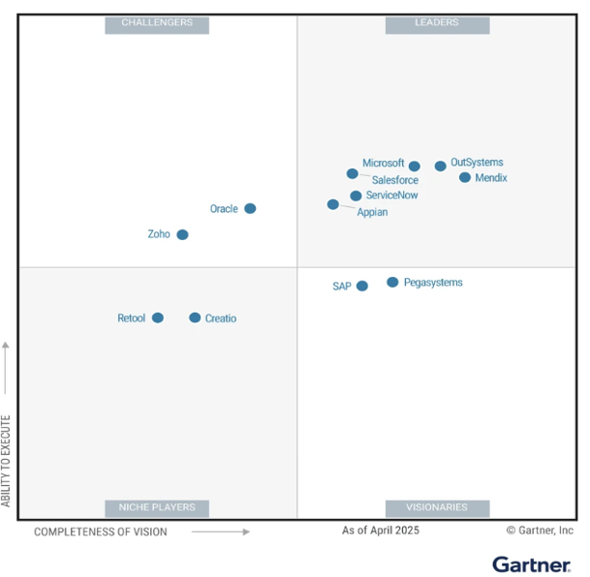
Figure xx:- Gartner Magic Quadrant for Enterprise Low-Code Application Platforms
Gartner Magic Quadrant for AI Application Development
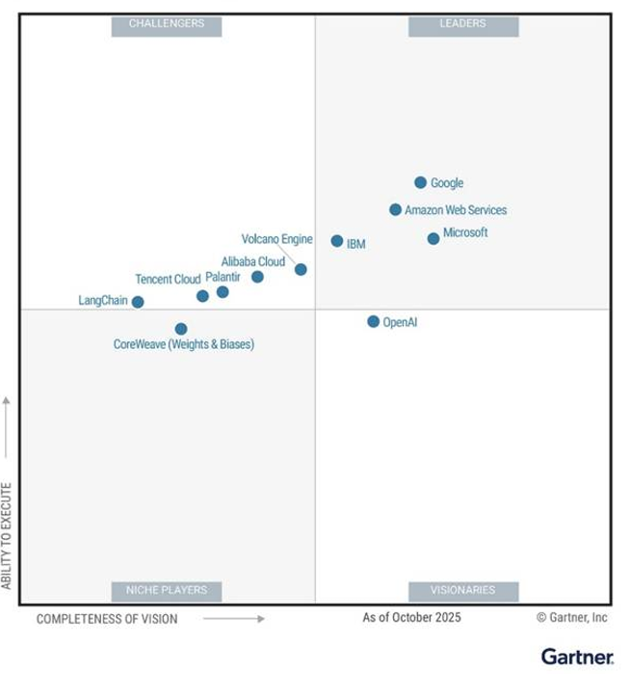
Figure xx:- Gartner Magic Quadrant for AI Application Development

IDC Marketscape Worldwide Unified AI Governance Platforms
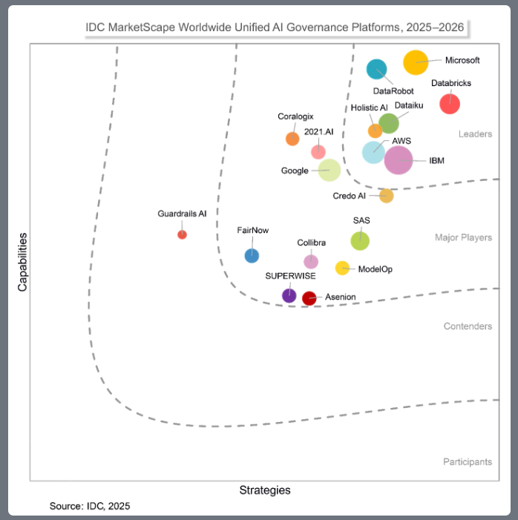
Figure xx:- IDC Marketscape Worldwide Unified AI Governance Platforms

GitHub recognised as a Leader in the Gartner® Magic Quadrant™ for AI Code Assistants
“GitHub remains a Leader in this Magic Quadrant, with its flagship product (GitHub Copilot) focused on enhancing developer productivity across the software development life cycle. Copilot offers AI-driven code completion, generation and translation, runtime awareness (i.e., analysis of code behaviour during execution), context enrichment, and automated documentation using models from Anthropic, Google, and OpenAI. GitHub serves a global client base of 77,000 enterprises, with 20 million GitHub Copilot users. It continues to invest in Copilot’s agentic capabilities like Agent Mode for autonomous tasks and intends to embed AI throughout developer workflows.” (Source: Magic Quadrant for AI Code Assistants 2025)
https://github.com/resources/whitepapers/gartner-magic-quadrant-and-critical-capabilities-for-ai-code-assistants
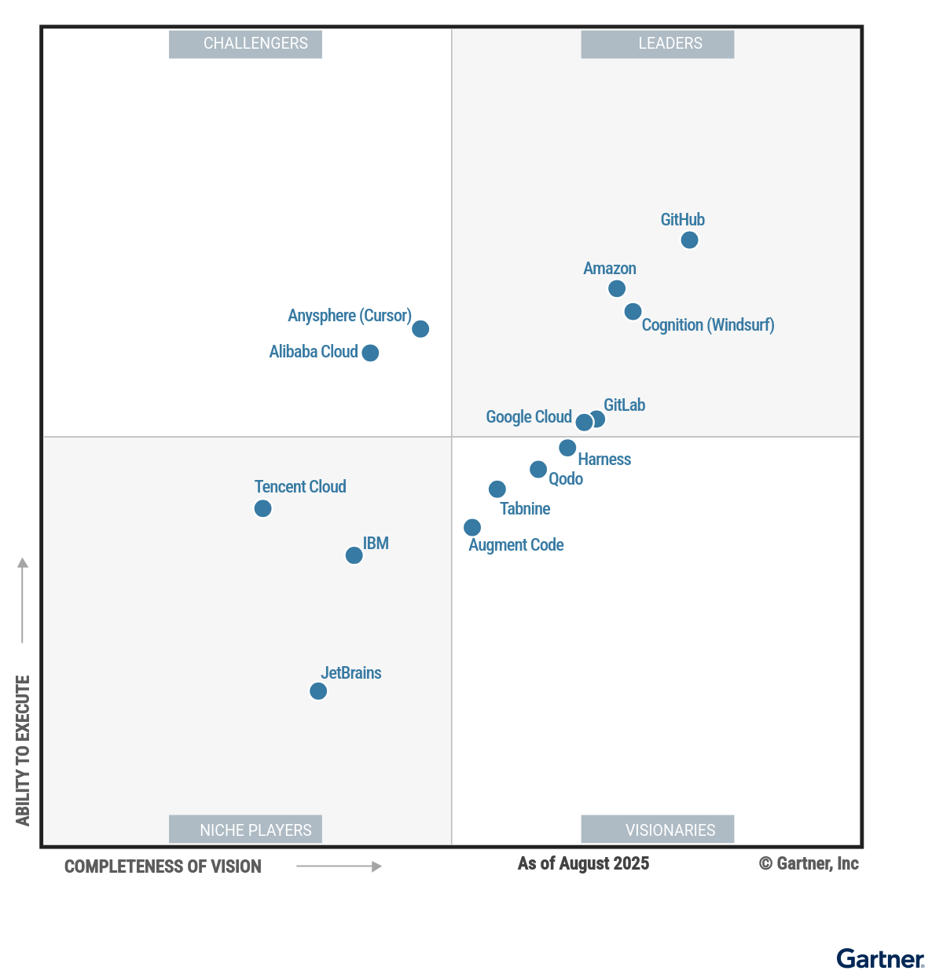
Figure xx:- Gartner Magic Quadrant for AI Application Development

Financial/People AI Transformation Reference Points

Competitive Positioning: Why This Structure Wins (remove this)

The following matrix summarises how our response structure is designed to differentiate against the most likely competitive approaches:

Dimension | Google’s Likely Approach | Palantir’s Likely Approach | Our Approach
Opening frame | “We have the best models and infrastructure” | “We have the best ontology and data platform” | “Agents are digital workers — here’s what that means for your enterprise”
Architecture story | Bottom-up: GCP → Vertex → Agents | Middle-out: Ontology → AIP → Agents | Top-down: Enterprise governance → extended to agents → technical implementation
Control plane | Build-your-own on GCP | AIP Foundry (strong but proprietary) | Agent365 + Entra + Purview — extends tools WPP already uses
Human interaction | Custom UI required | AIP UI (powerful but separate) | M365 — where WPP’s 100K+ people already work
Partnership depth | Cloud provider relationship | Software vendor relationship | Embedded strategic partner (already in WPP’s fabric)

The core bet: we lead with the “why” (digital labour, workforce transformation) before the “what” (architecture, services). That framing forces WPP’s evaluators to score every other response against the question we planted:

“Does this vendor understand that we’re building a new kind of workforce, or are they just selling us AI infrastructure?”

