**Instituto Superior Técnico**

**DM4iRetail – 2ª Entrega – 23 de Novembro de 2015**

**Turno: 5ª 17h30 – Prof. Alberto Silva**

Tiago Nascimento, nº70493

Artur Fonseca, nº 75456

Miguel Cruz, nº 76102

**Time plan**

**Summarized Gantt chart**

Put the collapsed chart here

**Complete Gantt chart**

* Put the complete chart here

**Organization plan**

**Organization Breakdown Structure**

Put the collapsed chart here

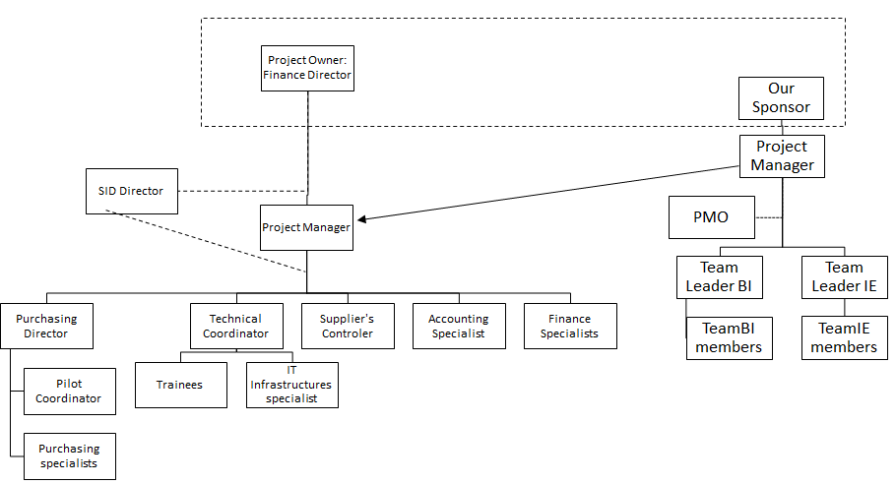

**Responsibility Assignment Matrix**

|  |  |  |  |  |  |  |  |  |  |  |  |  |  |  |  |  |
| --- | --- | --- | --- | --- | --- | --- | --- | --- | --- | --- | --- | --- | --- | --- | --- | --- |
|  | Finance Director | SID Director | Purchasing Director | Project manager | Pilot Coordinator | Purchasing specialists | Technical Coordinator | Trainees | IT Infrastructures specialist | Suppliers Controler | Accounting Specialist | Finance Specialists | Sponsor | Project Manager | Team Leader BI | Team Leader IE |
| Start-up | d | C | C | I |  |  |  |  |  | A | A |  | d | X | C | C |
| Control |  |  |  | I |  |  |  |  |  | A | A |  |  | X |  |  |
| Close | d |  |  | I |  |  |  |  |  | A | A |  | d | X |  |  |
| Requirement Spec. | d |  |  | I |  |  |  |  |  |  |  |  | d | P | X |  |
| Test Spec. |  | C | C | I | A |  |  |  |  |  |  |  |  | P | X |  |
| Sprint 1 |  |  |  | I |  |  |  |  |  |  |  |  |  | I | XP |  |
| Sprint 2 |  |  |  | I |  |  |  |  |  |  |  |  |  | I | XP |  |
| Integration |  | A |  |  |  |  |  |  |  |  |  | T |  | I |  | XP |
| Deployment |  |  |  |  |  |  |  |  |  |  |  |  |  |  |  |  |
| Training |  |  |  |  |  |  | P | X | X |  |  |  |  |  | T |  |
| Operationalization |  |  |  |  |  |  |  |  |  |  |  |  |  |  |  |  |
| Acceptance | D |  |  |  |  |  |  |  |  |  |  |  |  | P | d | d |
| Pilot |  |  |  |  | P | X |  |  |  |  |  | X |  | I |  |  |
| Warranty | X |  |  |  |  |  |  |  |  |  |  |  | I |  |  |  |

**Communication Plan**

**Communication flow**

Put the collapsed chart here

**Meetings plan**

Put the complete chart h

|  |  |  |
| --- | --- | --- |
| Meeting type | Who | When |
| Steering | Finance Director (PO)  Our Sponsor | Monthly |
| Progress | Project Manager (Supplier)  Team Leaders BI and IE | Weekly |
| Kick-off | Finance Director (PO)  Our Sponsor | Beginning of the project |
| Requisites specification approval | Finance Director (PO)  Our Sponsor  Both PM | After requirements gathering |
| Tests specification approval | Project Manager (Supplier)  Finance Specialists  Team Leaders BI and IE | After tests specification |
| Plan specification and tasks attribution | Project Manager (Supplier)  Team Leaders BI and IE | In the start of the dev phase |
| Planning | Team BI  Team BI members | Daily (in every sprint) |
| Revision | Project Manager (Supplier)  Team BI  Team BI members | Weekly (in every sprint) |
| Retrospective | Team BI  Team BI members | By the end of every sprint |
| Dev progress | Project Manager (Supplier)  Team Leaders BI and IE | During dev phase  (every 15days) |
| Acceptance tests approval | Finance Director (PO)  Project Manager (Supplier)  Finance Specialists  Team Leaders IE | After doing acceptance tests |
| Pilot meeting | Finance Director (PO)  Both PM  Finance Specialists | Before the go live of the system |
| Project closing | Finance Director (PO)  Project Manager (Supplier) | After pilot test |

**Corrected WBS (appendix)**

**Improved from the 1st delivery**

Matches the Gantt chart at work-package level

