**Instituto Superior Técnico**

**DM4iRetail – 3ª Entrega – 20 de Novembro de 2015**

**Turno: 5ª 17h30 – Prof. Alberto Silva**

Tiago Nascimento, nº70493

Artur Fonseca, nº 75456

Miguel Cruz, nº 76102

**Introduction**

GPIGrupo2 is a spinoff from Instituto Superior Técnico specialized in deploying Document Management Systems.

This Final Proposal…

**Description of the project**

**What?**

From the developer’s side, our corporation, this project is to develop a new information system for the company iRetail, made of the following modules:

* Document management and workflow;
* Invoices approval;
* Purchasing management

The project will also include the management, design and conception of the product, and the phases of deployment and operationalization.

**Why?**

For the client company, iRetail, the purpose is to keep up with its fast growth, which caused problems related to the limitations of paper documents: saturation of the information flows, difficulty of storing documents and lack of control over information including loss.

**Success Factors**

* Requirements shall be clearly defined to avoid wrong or unneeded operations;
* There should be clear and concise means of communication between the two companies;
* The documentation and manuals must be accurate and complete to be useful;
* The training should be effective so it allows K-users and technicians to adapt to the new system and work more efficiently;
* Roles and responsibilities must be clearly defined;
* There should be a common technical language between the team established beforehand by the team leaders;
* The testing (pilot and acceptance) should verify the efficacy of the product and that it complies with the established required functionality;
* The design and architecture of the system should be done with all the required functionality in mind.

**Success Criteria**

* Time
  + The Pilot must not last more than one month;
  + The system should be operational five months after the approval of the project plan, with less than two weeks tolerance;
  + The external supplier shall offer a minimum warranty period of three months;
* Cost
  + Do not exceed the € 400 000 budget for the whole project (excluding network structures and hardware) with a variance of 6%;
* Quality
  + The number of non-conformities during acceptance tests should not be greater than 10%;
  + The time for correction of conformities should be less than 48 hours;
  + The evaluation of the training sessions shouldn't score lower than 3.75, from 0 to 5.

**Expected Benefits**

After one year:

* Reduction by 50% of employees’ complaints, considering the expected overall employees satisfaction, ensuring the reimbursement of expenses no later than 5 working days after submission;
* Ensure supplier’s invoices get approved less than 10 working days after reception;
* Based on the previous benefit, allow iRetail to negotiate better discounts from suppliers;
* Allow classification and search of documents, based on content attributes;
* Reduce paper costs and physical space for archiving paper by 50%;
* Reduce administrative and post costs by 20%.

**Total Price**

**Total Project Duration**

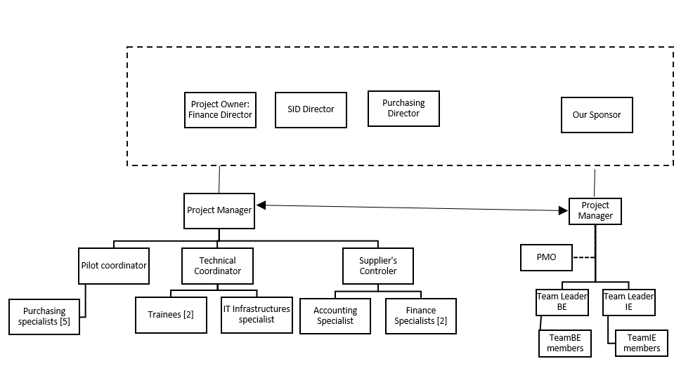Organization Breakdown Structure

Responsibility Assignment Matrix

|  |  |  |  |  |  |  |  |  |  |  |  |
| --- | --- | --- | --- | --- | --- | --- | --- | --- | --- | --- | --- |
|  |  |  |  |  |  |  |  |  |  |  |  |
|  | PO:  Finance  Director | SID Director | Purchasing Director | Pilot coord. | Technical Coord. | Supplier Control | PM | Sponsor | PM | Team Leader BE | Team Leader IE |
| Start-up | D | C | C |  |  | A | I | d | XP | C | C |
| Control |  |  |  |  |  | A | I |  | XP |  |  |
| Close | D |  |  |  |  | A | I | d | XP |  |  |
| Requirement Spec. | D |  |  |  |  |  | I | C | P | X |  |
| Test Spec. |  | C | C | A |  |  | I |  | P | X |  |
| Sprint 1 |  |  |  |  |  |  | I |  | P | X |  |
| Sprint 2 |  |  |  |  |  |  | I |  | P | X |  |
| Integration |  | A |  | C | A | T |  |  | P |  | X |
| Deployment |  |  |  |  | A |  | I |  | P | X | C |
| Training |  |  |  |  | X |  |  |  | P | T |  |
| Acceptance | D |  |  |  | X |  | I |  | P | d | d |
| Pilot |  |  |  | X |  | C | P |  | I | A | A |
| Warranty |  |  |  |  |  |  |  |  | I | X |  |

Communcation Plan

Communcation Flow

|  |  |  |  |  |
| --- | --- | --- | --- | --- |
| **From** | **To** | **What** | **When** | **How** |
| Project Manager | Finance Director (PO)  Sponsor (Supplier) | Status Report | Every Month  Weekly (test phase) | Email |
| Team Leaders (BE and IE) | Project Manager  (Supplier) | Progress Report | Weekly | Collaborative Tool |
| Team Leaders (BE and IE) | Project Manager(Supplier) | Estimative Report | Weekly | Collaborative Tool |
| Project Manager  (Supplier) | Team Leader BE  Scrum Master | Tasks Specification | Every 2 Weeks | In person |
| Project Manager  (Supplier) | Team Leaders | Planning Documents | Beginning of project | Collaborative Tool |
| Project Manager  (Supplier) | Finance Director  (PO) | Functional Specification document | After requisites revision | Collaborative Tool |
| Project Manager  (Supplier) | Finance Director  (PO) | Technical documentation for each module | After system specification | Collaborative Tool |
| Team Leader BE | Project Manager (Supplier) | Test Specification Document | After approval of tests specification | Collaborative Tool |
| Team Leader BE | Team BE members | Tasks Distribution | Weekly | In Person |
| Team Leader IE  Two Finance Specialists | Project Manager (Supplier) | Integration Report | After System Integration | Email |
| Team Leader BE | Project Manager (Supplier) | Acceptance tests report | After acceptance tests | Collaborative Tool |
| Pilot Coordinator | Project Manager (Supplier) | Pilot Report | After doing Pilot | Email |
| Team Leader BE | Project Manager (supplier)  Finance Director (PO) | User Manual | After acceptance tests | Collaborative Tool |
| Team Leader BE | Project Manager (supplier)  Finance Director (PO) | Installation Manual | After acceptance tests | Collaborative Tool |
| Team Leader BE | Project Manager (supplier)  Finance Director (PO) | Configuration  Manual | After acceptance tests | Collaborative Tool |
| Team Leader BE | Project Manager (supplier)  Finance Director (PO) | Training Materials | After acceptance tests | Collaborative Tool |
| Project Manager  (Supplier) | Finance Director (PO) | DM4iRetail | After acceptance tests | Collaborative Tool |
| Sponsor | Finance Director (PO) | Warranty | After acceptance tests | Email |

Meetings Plan

|  |  |  |
| --- | --- | --- |
| Meeting type | Who | When |
| Steering | Finance Director (PO)  Our Sponsor | Monthly |
| Progress | Project Manager (Supplier)  Team Leaders BI and IE | Weekly |
| Kick-off | Finance Director (PO)  Our Sponsor | Beginning of the project |
| Requisites specification approval | Finance Director (PO)  Our Sponsor  Both PM | After requirements gathering |
| Tests specification approval | Project Manager (Supplier)  Finance Specialists  Team Leaders BI and IE | After tests specification |
| Plan specification and tasks attribution | Project Manager (Supplier)  Team Leaders BI and IE | In the start of the dev phase |
| Planning | Team BI  Team BI members | Daily (in every sprint) |
| Revision | Project Manager (Supplier)  Team BI  Team BI members | Weekly (in every sprint) |
| Retrospective | Team BI  Team BI members | By the end of every sprint |
| Dev progress | Project Manager (Supplier)  Team Leaders BI and IE | During dev phase  (every 15days) |
| Acceptance tests approval | Finance Director (PO)  Project Manager (Supplier)  Finance Specialists  Team Leaders IE | After doing acceptance tests |
| Pilot meeting | Finance Director (PO)  Both PM  Finance Specialists | Before the go live of the system |
| Project closing | Finance Director (PO)  Project Manager (Supplier) | After pilot test |

D1 .req for prosal

Invoince . fatures

Payment -30 dias etc

Risk register – tryskell template

D2

Usar resources para fzer evaluation