**Instituto Superior Técnico**

**DM4iRetail – 1ª Entrega – 2 de Outubro de 2015**

**Turno: 5ª 17h30 – Prof. Alberto Silva**

Tiago Nascimento, nº70493

Artur Fonseca, nº 75456

Miguel Cruz, nº 76102

**Description of the project**

**What?**

From the developer’s side, our corporation, this project is to develop a new information system for the company iRetail, available to every worker in it, made of the following modules:

* Document management and workflow;
* Invoices approval;
* Purchasing management

The project will also include the preparation of the current resource plan and workers, and testing the system:

* Integration with the existing resource planning;
* Training of K-users and IT engineers;
* A pilot test of the system.

**Why?**

For the client company, iRetail, the purpose is to overcome the limitations of paper documents and their flow and thus:

* Improve the quality of the information;
* Increase the satisfaction of the employees;
* Optimize the purchasing processes;
* Increase the level of the clients’ satisfaction;
* Reduce the paper flows;
* Reduce the administrative costs.

**Success Factors**

* Goals shall be clearly defined to avoid wrong or unneeded operations;
* All the needed requirements should be clearly defined;
* Workers should be willing to use a much different system, from paper to a computer system;
* The documentation and manuals must be accurate and complete to be useful;
* The training should be sufficient to make users and technicians able to work;
* Roles and responsibilities must be clearly defined;
* There should be a common language between the team;
* The pilot test should cover most or all the operations the system offers.
* The acceptance tests should be enough to find errors;
* The system should be designed to allow for all the required functionality.

**Success Criteria**

* Time
  + The project plan shall be approved until November 20th;
  + The Pilot must not last more than one month;
  + The system should be operational five months after the approval of the project plan, with less than two weeks tolerance;
  + The external supplier shall offer a minimum warranty period of three months;
* Cost
  + Do not exceed the € 400 000 budget for the whole project (excluding network structures and hardware) ;
  + The accepted budget variance shall be less than 6%;
* Quality
  + The number of non-conformities during acceptance tests should not be greater than 10%;
  + The time for correction of conformities should be less than 48 hours;
  + The evaluation of the training sessions shouldn't score lower than 3.75, from 0 to 5.

**Expected Benefits**

After one year:

* Reduction by 50% of employees’ complaints, considering the expected overall employees satisfaction, ensuring the reimbursement of expenses no later than 5 working days after submission;
* Ensure supplier’s invoices get approved less than 10 working days after reception;
* Based on the previous benefit, allow iRetail to negotiate better discounts from suppliers;
* Allow classification and search of documents, based on content attributes;
* Reduce paper costs and physical space for archiving paper by 50%;
* Reduce administrative and post costs by 20%.

**Work Breakdown Structure**

**DEPOIS APAGO ESTA PÁGINA**

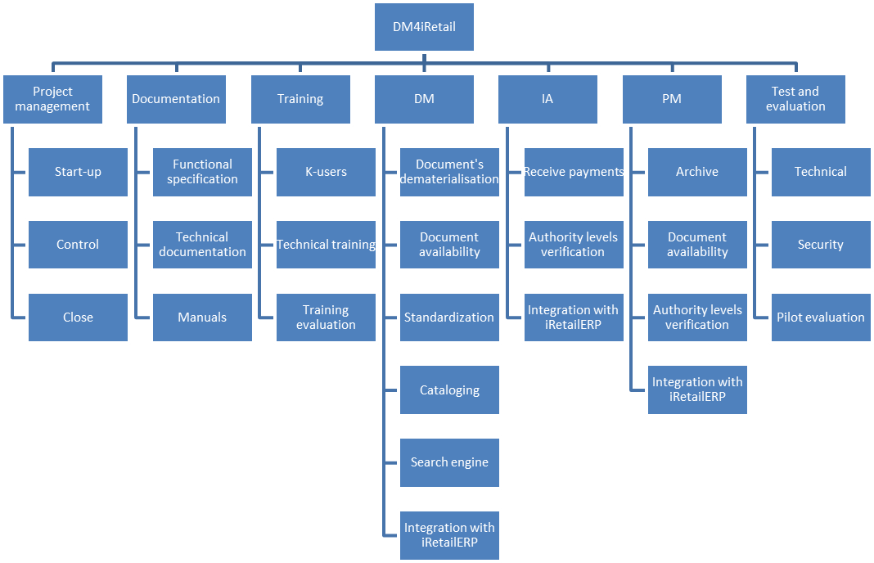

**Work Package Description**

|  |  |  |  |  |  |  |  |
| --- | --- | --- | --- | --- | --- | --- | --- |
| **Main Package** | **ID** | **Subpackage** | **Description** | **ID** | **Milestones** | **ID** | **Deliverable** |
| **Project Management** | 1.1. | Start-up | The requirements document  The plan of the project development  Appointing the project manager and team | M1 | Approve the team and the plan by 20th November | D1 | Plan |
| 1.2. | Control | Make sure milestones and deliverables are successful | ____ | _____________ | ____ |  |
| 1.3. | Close | The warranty offered by the supplier | ____ | _____________ | ____ |
| **Documentation** | 2.1. | Functional Specification | The document with the functionalities developed | M2 | Complete the specification of all the functionalities | D2 | Documentation |
| 2.2. | Technical Documentation | The documentation of all the modules | M3 | Document the whole system |
| 2.3. | Manuals | The manuals for using the system | M4 | Complete the manuals |
| **Training** | 3.1. | K-Users | Training K-users in Lisbon and Oporto | M5 | Finish the training | ____ | _____________ |
| 3.2. | Technical Training | Training technical engineers in Lisbon | ____ |
| 3.3. | Training Evaluation | Evaluation of the training sessions | M6 | Finish the evaluation | ____ |
| **Document Management** | 4.1. | Document’s Dematerialisation | Transform paper into electronic documents | M7 | Complete the functionality | D3 | Document Management |
| 4.2. | Document Availability | Make documents available, classified according to criteria |
| 4.3. | Standardization | Standardising documents based on classifications and standards |
| 4.4. | Cataloging | Catalog and index documents based on classifications |
| 4.5. | Search Engine | Make a search engine |
| 4.6. | Integration with iRetail | Integrate with iRetail | M8 | Complete the integration |
| **Invoices Approval Module** | 5.1. | Receive Payments | Receive payment information | M9 | Complete the functionality | D4 | Invoices Approval Module |
| 5.1. | Authority Levels Verification | Verifying copies of invoices for approval |
| 5.2. | Integration with iRetail | Integrate with iRetail | M10 | Complete the integration |
| **Purchase Module** | 6.1. | Archive | Archiving purchase documents | M11 | Complete the functionality | D5 | Purchase Module |
| 6.2. | Document Availability | Making documents available based on iRetail rules |
| 6.3. | Authority Levels Verification | Verify authority levels to approve an order | M12 |
| 6.4. | Integration with iRetail | Integrate with iRetail | M13 | Complete the integration |
|  |  |  |  |  |  |  |  |
| **Test and Evaluation** | 7.1. | Technical | Acceptance tests | M14 | All the tests are accepted | ____ | _____________ |
| 7.1. | Security | Security features implemented to follow regulations | M15 | The required security is verified | ____ |
| 7.2. | Pilot Evaluation | Pilot test to evaluate the system operability | M16 | The behavior of the system is accepted | ____ |