DIQQAT! TO‘LOV — FAQAT OFISDA YOKI KOMPANIYA HISOB RAQAMIGA
IMPORTANT! PAY ONLY AT THE OFFICE OR TO THE COMPANY’S BANK ACCOUNT
«MOSSAD» MChJ · INCOMING UZBEKISTAN TRAVEL AGENCY · Litsenziya / Licence № 000000

Turga faqat quyidagicha to‘lang:  • shartnoma va to‘lov hisobidagi rekvizitlar bo‘yicha «MOSSAD» MChJning hisob raqamiga bank o‘tkazmasi orqali (rekvizitlar QR-kod orqali ham mavjud);  • kompaniya ofisida — kassa cheki yoki kvitansiya berilgan holda.  Pulni xodimlarga ofisdan tashqarida shaxsan bermang, shaxsiy kartalar, elektron hamyonlar va hisobvaraqlarga o‘tkazmang, shaxsiy QR-kodlar va messenjerlar orqali to‘lamang.  Kompaniya xodimlari ofisdan tashqarida to‘lovni qabul qilishga vakolatli emas. Ushbu tartibni chetlab o‘tib kiritilgan to‘lov kompaniya tomonidan qabul qilinmaydi va hisobga olinmaydi.  Xizmatlar faqat kompaniya shartnomasi bo‘yicha ko‘rsatiladi. Shartnoma va to‘lov hisobini talab qiling. Vaucher to‘lov kelib tushgandan keyin beriladi.  Sizdan boshqa usulda to‘lashni so‘rashsa — bizga xabar bering: +998 71 000 00 00, info@mossad.example. | Pay for your tour only:  • by bank transfer to the bank account of MOSSAD LLC, as stated in the contract and the invoice (bank details are also available via the QR code);  • at the company’s office - against a cash receipt or a payment receipt.  Do not hand over money to employees in person outside the office, do not transfer it to personal cards, e-wallets or accounts, and do not pay through personal QR codes or messengers.  Company employees are not authorised to accept payments outside the office. A payment made in breach of this procedure is not accepted by the company and is not credited.  Services are provided only under the company’s contract. Ask for the contract and an invoice. The voucher is issued after the payment is received.  If you are asked to pay in any other way, please tell us: +998 71 000 00 00, info@mossad.example.

SKANERLANG — kompaniyaning rekvizitlari, litsenziyasi va hujjatlari
SCAN - bank details, licence and company documents
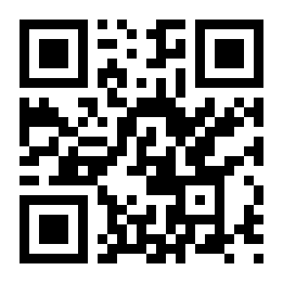
+998 71 000 00 00 · info@mossad.example · www.mossad.example
Litsenziya № 000000 · STIR 300123456 · Toshkent sh., Mirobod tumani, Namuna ko‘chasi, 1

