

IBM Global Services

Creating the Measurement Model Work Product

Technique Paper (TP)

© Copyright International Business Machines Corporation 2000, 2001
All Rights Reserved
Version 4.0 September 2001
- Description
This document describes the process for creating the measurement model as part of the requirements phase of establishing or improving a measurement program. This technique relies on input from the capability model and provides critical input into the measurement gap analysis. The measurement model represents the core of requirements and is used as the basis for developing process and organizational linkages, and many other technical work products to support its implementation within the IT organization.
- Context
A measurement model is typically produced in the early stages of an engagement to establish a sound measurement program at an account. The measurement model process is depicted in the graphic in Figure 1. The Measurement Model Development Process.
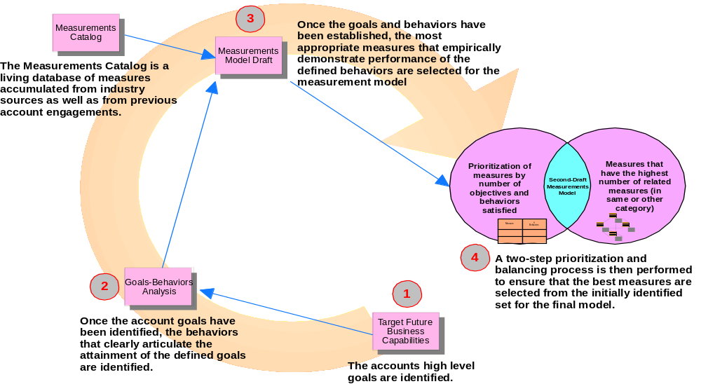
Figure 1. The Measurement Model Development Process
- Steps
The following sections describe the steps of the process and associated techniques necessary to ensure adequate completion of each step.
Step 1 – Define IT organization goals
The IT organization goals are defined in the capability model. Typically the goals of the organization are broken out into one or more categories of measures. From a Global AMS Delivery perspective, there are six categories that should be used. Those six are identified in Figure 2. Measurement Categories below:
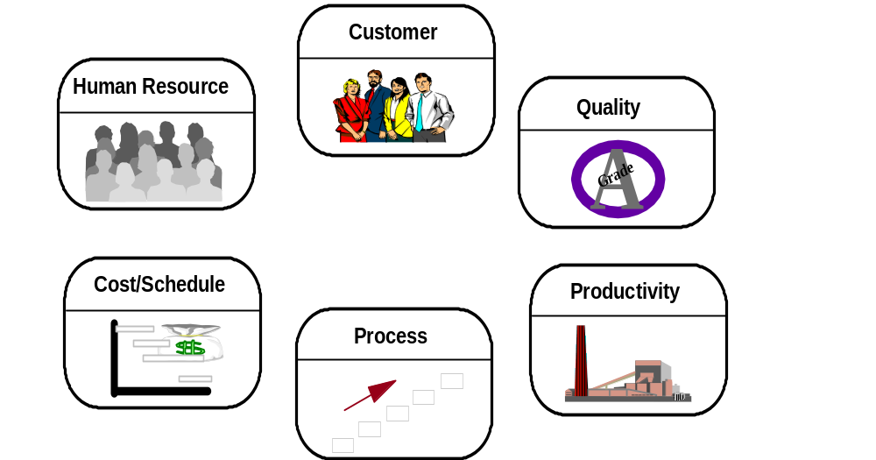
Figure 2. Measurement Categories
Step 2 – Define associated behaviors
For each of the organization goals defined in the capability model, one or more behaviors should be defined. Similar in concept to the Question aspects of the Goals-Question-Metric (GQM) approach, behaviors are defined to represent those characteristics the IT organization should foster as part of its normal operations. Behaviors identify an end state that should be directly tied to the organization goals.
As an example, if the organization goal is in the area of ensuring that appropriate processes exist in the IT department, several behaviors might be identified:
- Ability of the organization to forecast process needs (processes that should exist today but do not)
- Knowledge of existing processes by IT staff
- Management to process gaps
- Consistent use of documented processes
Behaviors are typically simple sentence structures and may even be incomplete sentences. They are short statements that represent ideas, actions or activities that demonstrate commitment and refinement of the organization goals. Typically, the organizations goals are expressed as high level statements or highly summarized notions. Behaviors are intended to be a level or two below the organization goals and bring about a level of granularity low enough to support identification of measures that might empirically demonstrate achievement of the desired behaviors.
A sample table for capturing the results of this analysis is included below.
Goals | Behaviors | Measurement Entity
Goal 1  Goal 2 | - Behavior 1  - Behavior 2 | Measurement 1  Measurement 2  (Identified in step 3 of the process)
Step 3 – Map behaviors against the measurements catalog
The measurements catalog database provides a facility to search for measures associated with given behaviors.
Alternative Approach for steps two and three:
For accounts that have existing measurements in place, an alternative approach is to identify the account goals (step 1), map their existing measurements back to the goals they satisfy and then derive the behaviors that logically would result from the current measurements being produced. Document the behaviors using the sample table above linking the existing measurements to the account goals. The results should then be reviewed with the account team to either confirm or revise the behaviors to conform to the account’s requirements.
Step 4 – Build the first draft measurement model
The results of Step 3 are then documented in the Goals-Behaviors Table in the measurements column and in the measurement model. In addition, other attributes of the measures should be captured in the measurement model. The base values for those attributes should come from the measurements catalog.
Computed Metric Name | Computed Metric Definition | Primitive Metrics | Calculation | Frequency of Data Capture | Frequency of Reporting | Reporting Process | Organization Owner
Name of the Measure | It’s definition | What are the elemental data required to calculate the measure? | How is the measure calculated? | How often is data for this measure collected? | How often are the results of this measure reported? | What IT process typically reports this data? | Who owns the IT process?
Step 5 – Prioritize measures by number of behaviors satisfied
For each of the measures identified in step 3, a table is built that describes the relationship with each of the behaviors it may satisfy. It is important to note that in many cases, a single measure may actually satisfy more than one behavior. This is important in the identification and selection of measures, since it is most desirable to keep the final number of measures to a minimum. This prioritization process is done for each of the categories of the measurement model.
A sample table is included below to show how to capture the prioritization in this step:
 | People Measurements
Behaviors/ Measurements | Job Satisfaction | Turnover Rate | Reasons for Exit | Certification Program Effectiveness | Contractor Engagement Duration | Contractor Usage | Unfilled Positions | Job Offer Acceptance Rate
People Behaviors
Forecast skill need on a rolling x month basis |  | X
Know/monitor the current skills |  | X |  |  | X | X | X
Manage to the skills gap |  |  |  |  |  | X | X
Actively manage environmental issues | X |  | X
Plan and manage to short-term and long-term usage of contractors |  |  |  |  | X | X
Manage to the reduction of long-term contractor dependencies |  |  |  |  | X | X
Recruit entry level staff to meet a portion of future skills need |  |  |  |  |  |  | X
Hire experienced people to fill immediate skill needs, which are long-term in nature |  |  |  |  | X |  | X
Proactively manage recruitment until new hires are on-board |  |  |  |  |  |  |  | X
Proactively foster long-term relationships with local recruitment sources
Create an environment attractive to targeted recruits | X |  | X
Measurement Subtotal | 2 | 2 | 2 | 0 | 4 | 4 | 4 | 1
The measurement subtotal scores are derived from simple counts of the number of X’s in each of the columns. Those measures with the highest scores satisfy the most number of behaviors and are more desirable as measures in the model since they provide more knowledge and insight for the cost of implementation.
Step 6 – Prioritize measures based on number of related measures
For each of the measures identified in step 3, a table is built that describes the related measures. It is important to note that in many cases, a single measure may actually be related to more than one other measure. This is important in the identification and selection of measures, since it is most desirable to keep the final number of measures to a minimum. This prioritization process is done for each of the categories of the measurement model.
A sample table is included below to show how to capture the prioritization in this step:
 | People Measurements
Measurements | Job Satisfaction | Turnover Rate |  |  | Reasons for Exit |  | Certification Program Effectiveness |  | Contractor Engagement Duration |  | Contractor Usage |  | Unfilled Positions |  | Job Offer Acceptance Rate
People Measurements
Job Satisfaction |  |  | X | X |  | X |  |  |  | X
Turnover Rate |  |  |  | X |  | X |  | X |  | X
Reasons for Exit | X
Certification Program Effectiveness | X |  | X
Contractor Engagement Duration | X |  |  |  |  |  |  |  |  |  |  | X
Contractor Usage | X |  |  |  |  |  |  |  |  |  |  | X |  | X
Unfilled Positions | X |  |  |  |  |  |  |  |  |  |  |  |  | X
Job Offer Acceptance Rate |  |  |  |  |  | X |  | X |  | X
Measurement Subtotal | 5 |  | 2 | 2 |  | 3 |  | 2 |  | 3 |  | 2 |  | 2
The measurement subtotal is derived from the sum of X’s in each of the columns. Those measures that have the highest scores also have the highest number of related measures, making them desirable as measurements for the base model. When prioritized against the results of the behaviors to measurement matrix, an initial set of measurements can be identified.
The blacked out cells indicate a same measure to same measure condition that should not be considered in the matrix, because a measure cannot be related to itself.
Step 7 – Build the second draft measurement model
The results from Step 6 and 7 should then be used to select those measures that should be included in the final measurement model. The simplest approach is to use the mean (average) for each table built from Steps 6 and 7 and to select those measures that have scores greater than or equal that average.
As an example, in Step 5, the mean score is 2.375 [(2+2+2+0+4+4+4+1)/8)]. As a result, the following measures would be selected:
- Contractor Engagement Duration
- Contractor Usage
- Unfilled Positions
It is important to note that some measures may need to be included in the measurement model in exception of this prioritization process either because of specific customer need or because it may be the only measure that satisfies a particular behavior and/or goal.
Those measures selected are then captured in the format described in Step 4.
Step 8 – Perform gap analysis
Once the final set of measures have been documented, a gap analysis needs to be performed. In addition, any time a change that results in the addition or deletion of a measurement in the model occurs, the gap analysis step should be performed.
- Appendix
The main steps of the measurement model technique are summarized in Table 1.
Step | Name | Activity
1 | Define IT organization goals | IT organization goals are identified during the creation of the capability model
2 | Define associated behaviors | Define the behaviors that best demonstrate achievement of a particular organization goal
3 | Map behaviors against the measurements catalog | Identify those measurements from the measurements catalog that best satisfy the identified behaviors
4 | Build first draft measurement model | First draft of the measurement model is built
5 | Prioritize measures by number of behaviors satisfied | The first prioritization exercise is performed on the measures in the first draft measurement model
6 | Prioritize measures based on number of related measures | The second prioritization exercise is performed on the measurements in the first draft measurement model
7 | Build second draft measurement model | The results of the prioritization processes is the second draft of the measurement model
8 | Perform gap analysis | The gap analysis technique is performed to ensure linkages are in placed between the measurements, processes and organization.
Table 1. Steps of Measurement Model Technique
- Revision History
Revision Number | Revision Date | Summary of Changes | Changes Marked?
Version 1.0 | August 99 | Base version
Version 2.0 | December 00 | - Removed Related Measures and Event Trigger from the measurement model table  - Updated Categorization Schema and Development Approach  - Added Alternative Approach to Section 2.3  - Changed Target Future System Capabilities to Capability Model  - Changed AMS to Global AMS Delivery
Version 3.0 | March 2001 | Updated style, spelling and grammar check.
Version 4.0 | September 2001 | Applied new template and style, spelling and grammar check.
 |  |  | NO

