Global AMS Delivery
Account Measurements


Preface
Global AMS Delivery is the sponsor of a measurements program established to achieve the following goals:

- Define a minimum and consistent set of measurements that can be used to properly manage Global AMS Delivery accounts.

- Define the business policies associated with the selected measurements as well as the procedures for data collection and measurement reporting. These policies and procedures are intended to enable metrics to be collected in a uniform manner across Global AMS Delivery contracts.
- Automate the collection of the primitive and computed metrics data and provide appropriate reporting capability to reduce the effort involved in managing contracts.
- Provide a measurement model that can be tailored to meet specific customer requirements with minimal impact to the defined business policies and measurement definitions.
This document addresses the second goal stated, in that it defines the business policies associated with the selected measurements as well as the procedures for data collection and measurement reporting.
The audience for this document includes I/T professionals interested in using application development and maintenance measurements to manage the performance of their organization. Specifically, this would include project executives, project managers, professional development managers, and business and financial analysts.

Introduction

Measurement Model

For a Global AMS Delivery contract, a set of measurements has been defined to help manage IBM’s performance. In addition, a measurement reporting system has been defined to assist in the collection and reporting of these measurements. These measurements and the measurement reporting system will provide the following value:

- Management will be able to better manage the performance of the contract, enabling them to reduce costs and improve productivity.
- Management can compare their performance results against other contracts and industry averages to determine where improvement might be warranted.
- IBM Global Services will be able to use the data from the achieved results in marketing to future prospects.
- Automation of the data collection process will improve the accuracy of the data and reduce the manual effort involved and the associated administrative costs.

Global AMS Delivery has developed a measurement model to enable the classification of measurements. This model defines at the highest level a set of six measurement categories. For each of these six categories a set of measurements has been defined. Each computed metric chosen by a particular account is classified by assigning it a measurement within a measurement category. The model is illustrated in the chart below:

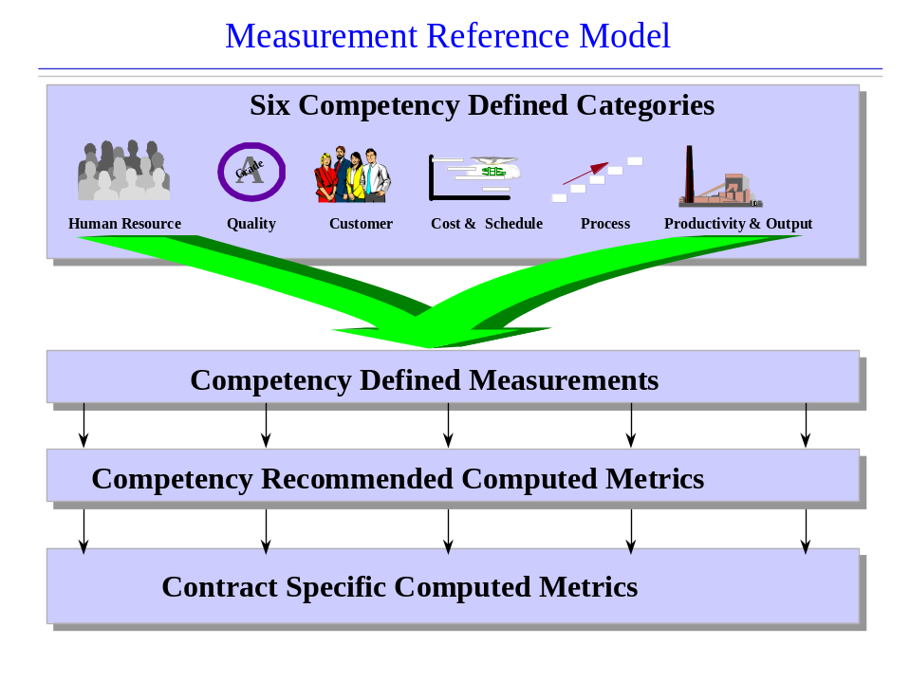

The following table shows all six measurement categories and the measurements included in this set of measurements.

MEASUREMENTS
Cost & Schedule Measurements | Process Measurements
Percent Project Cost Variance (Labor Hours) | Percent SEI Milestones Met
Percent Project Schedule Variance (Labor Hours)
Customer Measurements | Quality (Select K-FP of KLOC)
Tier 3 Customer Satisfaction Rating | Project Defects Found in Production by Thousand Function Points Developed
 | Project Defects Found in Production per Thousand Lines of Code Maintained
HR Measurements | Productivity (Select FP or LOC)
Percent IBM Personnel YTD Utilization | Function Points Developed per Labor Hour
Percent Subcontractor Labor Hours (or) | Function Points Maintained per Labor Hour
Percent Subcontractor Head Count | Lines of Code Developed per Labor Hour
Percent Budgeted Labor Hour Variance | Lines of Code Maintained per Labor Hour

This document defines the detailed business rules governing the above measurements.

Measurement System Hierarchical Model

A measurement system hierarchical model establishes the levels within an organization that measurement data can be collected and reported. Lower levels within the hierarchy allow a business to be managed at a more granular level. However, lower levels of granularity usually require a higher investment in time or tooling to enable lower levels of data to be captured and reported. Therefore, a business decision needs to be made for each computed metric to determine the lowest level of applicability based on business needs. In addition a business decision needs to be made for each computed metric to determine how performance results will be rolled-up from the lowest applicable level within the hierarchy to the higher levels within the hierarchy for reporting purposes.

The hierarchical model has two main views, the Business View, and the Contract View. These two views enable measurements to be managed from two different perspectives. The following chart depicts this hierarchy.

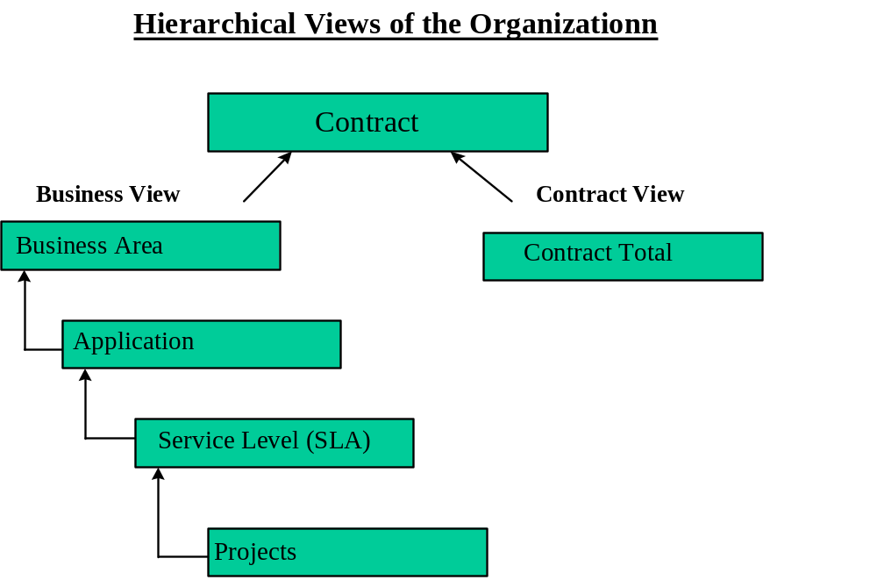

It is important to realize that computed metrics might not be applicable at the lower levels within the hierarchy. For example, SEI/CMM Attainment would not be applicable at the Application Level but would more aptly apply at the Contract Level. However, as the diagram depicts, measurement data is rolled-up to all of the higher levels within the hierarchy from the lowest level for which measurement data is collected. Within the measurements definition section of this document, the lowest level for which a computed metric exists is documented for each of the computed metrics. The definition for each of the levels within the hierarchy is as follows:

Contract Level: This is the highest level in the hierarchy and represents the overall performance on the contract. This is the level that would generally be managed by the project executive for the contract.
Business Area Level: Applications are generally owned by business managers within the client organization. This level provides a view of all the applications owned by the business managers and enables the business manager to ensure specific business unit goals are met.

Application Level: This is the level at which application related data is collected such as the number of maintenance labor hours worked on an application, or the number of impacted user minutes there were for an application.

Service Level (SLA): This is the level at which the account must deliver agreed upon service levels of performance as per the contract. The service levels are within applications and role up to the business area.

Project Level: The project level is the lowest level in the hierarchy. This level applies to managed projects being performed for specific applications. For example Function Points developed for Release 1 of an application would be collected at the application/project level.

For each of the computed metrics the following information is provided:
- Frequency of Data Capture: The base period for which primitive metric data is collected.
- Frequency of Measurement Reporting: The base period for which primitive metric data and computed metrics are reported.
- Reporting Level: The base level within the measurement system hierarchy for which primitive metrics data is collected and computed metrics are reported. (i.e. Contract Level, Portfolio Level, Application Level, Application/Project Level).
- Aggregation Rules: The rules used to calculate and report the value of the computed metric for a period extending beyond the base period (e.g., if the base reporting period is monthly, the aggregation rule would be used to generate a value of the metric for a quarter, a year, etc.).
- Associated Business Policy: Business policies that prevail with respect to the computed metric.
- Scorecard Scoring: Information associated with performance results, such as grading and weighting, used in generating the scorecard.
- Event Trigger: Event that triggers the collection of data and reporting of the metric.

Cost and Schedule Measurements

Introduction
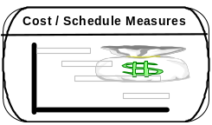

The purpose of the measurements in the Cost and Schedule Measurements category is to measure the performance of an organization in the areas of cost and schedule. These measurements help an organization understand the accuracy of its cost and schedule estimates and provide the organization with cost and schedule status throughout a project’s life cycle to help manage business impacts associated with cost and schedule variances. These measurements also help an organization understand its effectiveness in reducing the unit cost of deliverables and the overall cycle time of producing deliverables. These measurements will provide data that will help management answer the following types of questions:
- What were the problems encountered that caused schedule or cost slippage?
- What projects are at schedule or cost risk?
- What is the project completion cost and date based on current status?

Cost and Schedule Metric Definitions

Percent Project Cost Variance

Percent Project Cost Variance (Labor Hours): The difference between the Budgeted Cost of Work Performed (Labor Hours) and the Actual Cost of Work Performed (Labor Hours) as a percentage of the Budgeted Cost of Work Performed (Labor Hours) for the project.
Primitive Metric:
X = BCWP – Budgeted Cost of Work Performed
Y = ACWP – Actual Cost of Work Performed

Calculation: Percent Project Cost Variance (Labor Hours) = ((X- Y) / X) * 100
Frequency of Data Capture: Monthly
Frequency of Measurement Reporting: Monthly
Reporting Level: Account
Aggregation Rules: Total across account
Associated Business Policy:
- Project Management system data source (MUST DEFINE)
- Completed projects for the month (MUST DEFINE)

Scorecard Scoring:
Target: 90
Grading:
Performance Results | Grade
90% < Result | A
85% < Result < 90% | B
80% < Result < 85% | C
75% < Result < 80% | D
Result < 75% | F
Weighting: 50%
Event Trigger:

Percent Project Schedule Variance (Labor Hours)

Percent Project Schedule Variance (Labor Hours): The difference between the Budgeted Cost of Work Performed (Labor Hours) and the Budgeted Cost of Work Scheduled (Labor Hours) as a percentage of the Budgeted Cost of Work Scheduled (Labor Hours) for the project.
Primitive Metric:
X = BCWP – Budgeted Cost of Work Performed
Y = BCWS – Budgeted Cost of Work Scheduled

Calculation: Percent Project Schedule Variance (Labor Hours) = ((X- Y) / Y) * 100

Frequency of Data Capture: Monthly
Frequency of Measurement Reporting: Monthly
Reporting Level: Account
Aggregation Rules: Total across account
Associated Business Policy:
- Project Management system data source (MUST DEFINE)
- Completed projects for the month (MUST DEFINE)

Scorecard Scoring:
Target: 90
Grading:
Performance Results | Grade
90% < Result | A
85% < Result < 90% | B
80% < Result < 85% | C
75% < Result < 80% | D
Result < 75% | F
Weighting: 50%
Event Trigger:

Customer Measurements

Introduction



The purpose of the measurements in the Customer Measurements category is to establish IBM’s overall contract performance as it relates to meeting the business needs of the client. These measurements characterize not only the true value of performed activities but also include the perceived value from the view of the client. These measurements help characterize the working relationship between the vendor and the customer with specific focus on contractual performance, the ability to smoothly transition the client to a new environment, and whether deliverables meet business needs. These measurements will provide data that will help management answer the following types of questions:
- What level of customer satisfaction was planned for and what was actually achieved?
- How well was the transition handled at contract start up?
- Are project deliverables meeting customer objectives?

Customer Metrics Definitions

Tier 3 Percent Customer Satisfaction

Tier 3 Percent Customer Satisfaction: Overall percent satisfaction of the customer based on Tier 3 survey.
Primitive Metrics:
X = Tier 3 Percent Customer Satisfaction

Calculation: Tier 3 Percent Customer Satisfaction = X

Frequency of Data Capture: Yearly
Frequency of Measurement Reporting: Yearly
Reporting Level: Contract
Aggregation Rules: No aggregation
Associated Business Policy:
- Results of the IBM Customer Satisfaction Survey Process
- Manual data entry

Scorecard Scoring:
Target: 90
Grading:
Performance Results | Grade
90% < Result | A
88% < Result < 89% | B
87% < Result < 88% | C
86% < Result < 87% | D
Result < 86% | F
Weighting: 100%
Event Trigger: Upon Request

Human Resource Measurements

Introduction


The purpose of the Human Resource set of measurements is to understand the human resource demographics of an organization, such as size of an organization, the resource types (i.e. subcontractors vs. regular employees), cost competitiveness of resources, and job satisfaction. These measurements will provide data that will help management answer the following types of questions:
- How competitive is the cost of resources on the contract with industry averages, or with resources in the same geographic area?
- What is the attrition rate of the contract, and how does it compare with turnover rates within the same geographic location or for contracts with similar work efforts?
- How quickly can skills be attained to meet future demands or to offset attrition?

Human Resource Metric Definition

Percent IBM Personnel Utilization

Percent IBM Personnel Utilization: Number of billable labor hours worked by IBM personnel on a contract as a percentage of the number of regular labor hours reported by IBM personnel.
Primitive Metrics:
X = IBM Billable Labor Hours = The number of billable labor hours worked by IBM personnel on the contract roster.
Y = IBM Regular Labor Hours Claimed = Number of regular labor hours reported by IBM personnel on the contract roster.
Calculation: Percent IBM Personnel Utilization = (X / Y) * 100
Frequency of Data Capture: Monthly
Frequency of Measurement Reporting: Monthly
Reporting Level: Contract
Aggregation Rules: No aggregation
Associated Business Policy:
- Derived from Claim

Scorecard Scoring:
Target: 91
Grading:
Performance Results | Grade
91% < Result | A
89% < Result < 91% | B
88% < Result < 89% | C
87% < Result < 88% | D
Result < 87% | F
Weighting: 25%
Event Trigger: End of accounting period.

Percent Subcontractor Labor Hours

Percent Sub-contractor Utilization: Number of billable labor hours worked by subcontractors on a contract as a percentage of the number of labor hours worked by subcontractors.
Primitive Metrics:
X = Subcontractor Billable Labor Hours = The number of billable labor hours worked by subcontractors on the contract roster.
Y = Subcontractor Labor Hours = The number of labor hours worked by subcontractors reported for the contract population.
Calculation: Percent Sub-contractor Utilization = (X / Y) * 100
Frequency of Data Capture: Monthly
Frequency of Measurement Reporting: Monthly
Reporting Level: Contract
Aggregation Rules: No Aggregation
Associated Business Policy:
- Derived from Claim

Scorecard Scoring:
Target: 40
Grading:
Performance Results | Grade
40% < Result | A
35% < Result < 40% | B
30% < Result < 35% | C
25% < Result < 30% | D
Result < 25% | F
Weighting: 25%
Event Trigger: End of Accounting Period

Percent Subcontractor Head Count

Percent Sub-contractor Head Count: Number of subcontractors reported as a percentage of the contract population.

Primitive Metrics:
S = Subcontractor Head Count
I = IBM Head Count

Calculation: Percent Subcontractor Head Count = (S / (I + S)) * 100

Frequency of Data Capture: Monthly
Frequency of Measurement Reporting: Monthly
Reporting Level: Contract
Aggregation Rules: No aggregation
Associated Business Policy:
- Supplied via personnel roster

Scorecard Scoring:
Target: 40
Grading:
Performance Results | Grade
40% < Result | A
35% < Result < 40% | B
30% < Result < 35% | C
25% < Result < 30% | D
Result < 25% | F
Weighting: 25%
Event Trigger: End of Accounting Period

Percent Budgeted Labor Hours Variance

Percent Budgeted Labor Hour Variance: The percent variance between the actual number of labor hours utilized by the contract and the budgeted labor hours.
Primitive Metrics:
I = IBM Labor Hours = The number of labor hours worked by IBM employees reported for the contract population.
S = Subcontractor Labor Hours = The number of labor hours worked by subcontractors reported for the contract population.
B = Budgeted Labor Hours = The budgeted labor hours.

Calculation: X = Actual Labor Hours = I + S
Percent Budgeted Labor Hour Variance = ((X - B) / B) * 100
Frequency of Data Capture: Monthly
Frequency of Measurement Reporting: Monthly
Reporting Level: Contract
Aggregation Rules: No Aggregation
Associated Business Policy:
- Derived from Claim

Scorecard Scoring:
Target: 95
Grading:
Performance Results | Grade
95% < Result | A
93% < Result < 95% | B
91% < Result < 93% | C
89% < Result < 91% | D
Result < 89% | F
Weighting: 50%
Event Trigger: End of Accounting Period

Quality Measurements

Introduction
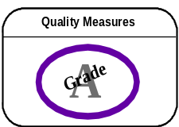

The purpose of the Quality set of measurements is to understand key quality indicators such as the time it takes for a product to fail for the first time, the defects delivered per unit of code, the defect density and failure rates compared to industry trends for similar systems. These measurements will provide data that will help management answer the following types of questions:
- Am I producing quality code and meeting quality objectives?
- How does the quality of software produced compare against the industry?
- How effective are quality assurance and test programs?

Quality Metric Definitions

Project Defects Found in Production per 1000 FPs Developed

Project Defects Found in Production per 1000 Function Point Developed: Number of defects found in production as a percentage of the 1000 function points developed.

Primitive Metrics:
X = Production Defects = Number of defects found in production.
Y = Function Points Developed = Function points associated with development projects moved to production which IBM is responsible for.

Calculation: Project Defects Found in Production per Function Point Developed = (X / (Y/1000)) * 100

Frequency of Data Capture: Monthly
Frequency of Measurement Reporting: Monthly
Reporting Level: Account
Aggregation Rules: Total across account
Associated Business Policy:
- Valid defects (MUST DEFINE)
- Production K-FPs (MUST DEFINE)

Scorecard Scoring:
Target: 99
Grading:
Performance Results | Grade
99% < Result | A
98% < Result < 99% | B
97% < Result < 98% | C
96% < Result < 97% | D
Result < 96% | F
Weighting: 100%
Event Trigger:

Project Defects Found in Production by KLOC Developed

Project Defects Found in Production per KLOC Developed: Number of defects found in production as a percentage of the KLOC developed.

Primitive Metrics:
X = Production Defects = Number of defects found in production.
Y = KLOC Developed = KLOC associated with development projects moved to production which IBM is responsible for.

Calculation: Project Defects Found in Production per KLOC Developed = (X / Y) * 100

Frequency of Data Capture: Monthly
Frequency of Measurement Reporting: Monthly
Reporting Level: Account
Aggregation Rules: Total across account
Associated Business Policy:
- Valid defects (MUST DEFINE)
- Production KLOCs (MUST DEFINE)

Scorecard Scoring:
Target: ?????
Grading:
Performance Results | Grade
Weighting: 100%
Event Trigger:

Process Measurements

Introduction

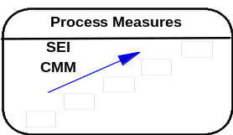

The purpose of Process measurements is to measure the capability maturity of an organization based on the processes the organization has put in place to perform software development. These measurements measure whether processes are well defined and stable, well understood and followed, measured and controlled, and whether the processes lead to continuous improvement. These measurements are based on Software Engineering Institute’s (SEI) Capability Maturity Model and are intended to answer the following types of questions:

- Has the capability of the organization to produce improved?

- What are the SEI/CMM commitments of the organization and what has been achieved against these commitments?

Process Metric Definitions

Percent SEI Milestones Met

Percent SEI Milestones Met: The number of SEI milestones met as a percent of the number of SEI milestones committed.

Primitive Metrics:
X = SEI Milestones Met - Number of SEI milestones met.
Y = SEI Milestones Committed - Number of SEI milestones met.

·Calculation: Percent SEI Milestones Met = (X / Y) * 100

Frequency of Data Capture: Monthly
Frequency of Measurement Reporting: Monthly
Reporting Level: Contract
Aggregation Rules: Year to Date
Associated Business Policy:
- Project Management system data source (MUST DEFINE)
- Manual data entry

Scorecard Scoring:
Target: 90
Grading:
Performance Results | Grade
90% < Result | A
85% < Result < 90% | B
80% < Result < 85% | C
75% < Result < 80% | D
Result < 75% | F
Weighting: 100%
Event Trigger:

Productivity Measurements

Introduction

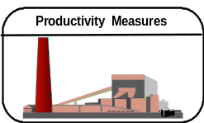

Productivity measurements can be applied to organizations doing development work as well as organizations doing maintenance work. The purpose of the Productivity measurements for the development organization is to measure amount of output that the organization generates and the effort required to generate the output. For the maintenance organization, the measurements measure the quantity of work supported and the amount of effort required for the support. These measurements will provide data that will help management answer the following types of questions:
- What are the productivity measures for projects by work type, business unit, and location?
- What are the processes being used for each development platform and the relative effectiveness of each?
- How much time is being spent in different phases of development?

Productivity Metrics Definitions

Function Points Developed per Labor Hour

Function Points Developed Per Labor Hour: The number of function points developed per labor hour of effort.

Primitive Metrics:
X = Function Points Developed = Function points associated with development projects moved to production which IBM is responsible for.
I = IBM Labor Hours = The number of labor hours worked by IBM employees reported for the contract population.
S = Subcontractor Labor Hours = The number of labor hours worked by subcontractors reported for the contract population.
H = Historical Labor Hours = The project labor hours to date for a project which began prior to a specified date.

Calculation:
Y = Project Labor Hours = I + S + H
Function Points Developed Per Labor Hour = X / Y

Frequency of Data Capture: Upon Monthly
Frequency of Measurement Reporting: Monthly
Reporting Level: Contract
Aggregation Rules: Total across account
Associated Business Policy:
- FPs Developed (MUST DEFINE)
- Completed projects (MUST DEFINE)
- Labor Hours from Claim system

Scorecard Scoring:
Target: ?????
Grading:
Performance Results | Grade
Weighting: 50%
Event Trigger:

Lines of Code Developed per Labor Hour

Lines of Code Developed Per Labor Hour: The number of lines of code developed per labor hour of effort.

Primitive Metrics:
X = Lines of Code Developed = Lines of Code associated with development projects moved to production which IBM is responsible for.
I = IBM Labor Hours = The number of labor hours worked by IBM employees reported for the contract population.
S = Subcontractor Labor Hours = The number of labor hours worked by subcontractors reported for the contract population.
H = Historical Labor Hours = The project labor hours to date for a project which began prior to a specified date.

Calculation:
Y = Project Labor Hours = I + S + H
Lines of Code Developed Per Labor Hour = X / Y

Frequency of Data Capture: Upon Monthly
Frequency of Measurement Reporting: Monthly
Reporting Level: Contract
Aggregation Rules: Total across account
Associated Business Policy:
- LOC Developed (MUST DEFINE)
- Completed projects (MUST DEFINE)
- Labor Hours from Claim system

Scorecard Scoring:
Target: ?????
Grading:
Performance Results | Grade
Weighting: 50%
Event Trigger:

Function Points Maintained per Labor Hour

Function Points Maintained Per Labor Hour: The number of function points that are in production and are maintained by the asset base per labor hour.

Primitive Metrics:
F = Base Function Points = Number of function points maintained at the beginning of a defined reporting period.
C = Production Function Point Delta = Number of function points added to or deleted from an application as the result of a project or enhancement.
Z = Maintenance Labor Hours = Labor hours associated with the maintenance of the installed function points for the defined period.

Calculation:
Y = Function Points Maintained = F + C
Function Points Maintained per Labor Hour = Y / Z

Frequency of Data Capture: Monthly
Frequency of Measurement Reporting: Monthly
Reporting Level: Contract
Aggregation Rules: Total across account
Associated Business Policy:
- FPs/LOCs Developed (MUST DEFINE)
- Completed projects (MUST DEFINE)
- Labor Hours from Claim system

Scorecard Scoring:
Target: ?????
Grading:
Performance Results | Grade
Weighting: 50%
Event Trigger:

Lines of Code Maintained per Labor Hour

Lines of Code Maintained Per Labor Hour: The number of lines of code maintained per labor hour of effort.
Primitive Metrics:
X = Lines of Code Maintained - Lines of code in production which IBM is responsible for
Y = Maintenance Labor Hours - Labor hours associated with the maintenance of the installed function points for the defined period.

Calculation:
Lines of Code Maintained Per Labor Hour = X / Y

Frequency of Data Capture: Monthly
Frequency of Measurement Reporting: Monthly
Reporting Level: Contract
Aggregation Rules: Total across account
Associated Business Policy:
- LOCs Developed (MUST DEFINE)
- Completed projects (MUST DEFINE)
- Labor Hours from Claim system
Scorecard Scoring:
Target: ?????
Grading:
Performance Results | Grade
Weighting: 50%
Event Trigger:

