Global AMS Delivery
Measurement and Performance Management Business Processes & Policies



Introduction

The Measurement Business Policy establishes the business policies that are necessary to support a contract level measurement implementation effort. This document establishes policies on three levels: the IBM corporate level, the contract level, and at a level that supports the implementation of measurement categories or individual measurements. The following sections describe these policies. All contract personnel are expected to become familiar with and conform to these policies.

Corporate Policies for Global AMS Delivery Measurement
Global AMS Delivery defines the basic corporate policies for measurement for IBM Global Services’ contracts having in-scope application management outsourcing work (Global AMS Delivery contracts). These policies are designed to provide IBM senior management with information that imparts an understanding of outsourcing contracts and their needs. The data collected from the Global AMS Delivery contracts’ measurement systems are used in establishing a fact-based, defensible performance history from those contracts. This performance data is ultimately used to prove IBM’s performance to new customers in pursuit of new business.
Global AMS Delivery reserves the authority to define categories of measurement for outsourcing contracts. It also reserves the authority to govern the set of approved operational measurements for these contracts. (Operational measurements as a class are one of a set of possibly many classes of measurements, other examples being business value/performance, industry-related, and diagnostic measurements.) The categories of operational measurements are the following:
- Human Resources
- Quality
- Cost and Schedule
- Customer
- Process
- Productivity

The Global AMS Delivery measurements catalog contains the currently approved set of operational measurements.

Requesting a New Measurement with a new Computed Metric

A Global AMS Delivery contract can legitimately require the definition of an operational measurement that is not currently in the measurements catalog. Contracts requiring a measurement that is not in the currently approved list of operational measurements must do the following:
- Fully define the measurement according to the content scheme established in the measurements catalog
- Classify the measurement into one of the approved measurement categories
- Provide a full specification of the computed metric for which the measurement is being created
- Request approval and registry of the measurement with Global AMS Delivery.
Global AMS Delivery staff supporting measurements will assist in the semantic analysis, definition, and classification of any new measurement.
Requesting a New Computed Metric
Each computed metric defined in the measurements catalog has a unique method for acquiring or calculating the computed metric. An outsourcing contract can legitimately require a computed metric whose method for data acquisition or calculation differs from the currently approved set of methods. Contracts requiring a new computed metric must do the following:
- Fully define the method for acquiring data and for calculating the computed metric, according to the content scheme established in the measurements catalog
- Classify the computed metric into one of the approved measurement types
- Request approval and registry of the computed metric with Global AMS Delivery.
A contract cannot request the establishment of a new computed metric in a category that differs from the category already established for the measurement to which the new computed metric will be assigned. Global AMS Delivery staff supporting measurements will assist in the semantic analysis and definition of the new computed metric to help establish the measurement and category classification of the new computed metric.

Contract Policies Supporting Global AMS Delivery Measurement
The policies expressed in this section are primarily designed to establish expected behaviors and norms of contract personnel with respect to the measurement system. The secondary purpose of these policies is to establish boundary and timing conditions for acquiring and collecting measurement data.
Appropriate elements of these contract measurement business policies can be reflected in employees’ Personal Business Commitments as an end for ensuring management oversight and reinforcing commitment of individual employees towards the behaviors and goals required of these policies and of the contract’s measurement system.
The following sections define business policies that prevail in several areas that support measurement systems.

Contract Initiation Policies
- IBM will establish a regular and systematic Reporting Period to demonstrate performance against the agreed to Service Level Agreements (SLAs). The dates upon which Reporting Period events occur will be captured in IBM’s measurement system and will be known to all contract personnel.
- IBM will set up its labor tracking and claiming process against a chart of accounts that is established from contract onset and continued through the life of the contract. Changes to the chart of accounts occur through contract amendments and/or re-negotiation. These accounts will establish the type of work performed by IBM that is billable to a customer IBM’s CLAIM system will be used to collect this data.
- IBM will establish a defect management process to capture defect data such as number of defects logged against in-scope applications. For the first 90 days after an application (a project /new development) is moved to production, the defects reported against the application will be reviewed to determine the number of defects found.

Work Management Policies
- All work that takes place on an account is done in the context of an approved project. No work takes place on the account without an approved service request that authorizes staffing for the work and establishes cost estimates for the work to be performed.
- Service requests can only be opened against the list of in-scope applications for the contract.
- For each service request, an “opened date”, “date to be reviewed by”, and “date to be completed by” will be established. If a “revised date to be completed by” is agreed to between IBM and the customer, this date will be used in place of the original “date to be completed by”.
- Each service request will be assigned a single CLAIM account for which effort will be tracked. Each CLAIM account will be associated with an application for which the work is being performed.
- When a CLAIM work item is created for authorized work, the planned start date, planned implementation date and estimated labor hours (total planned project labor hours) will be recorded in the measurement system.
- IBM will maintain a cost case that enumerates the baseline number of labor hours that the customer has contracted with IBM. Actual labor hours will be compared against this baseline to establish Additional Resource Charges and Reduced Resource Charges.

Personnel Policies
- All IBM personnel will record hours worked in CLAIM on a weekly basis.
- All Sub-contractors will record hours worked in CLAIM on a weekly basis.

Labor Tracking Policies
- IBM will track its claimed labor hours by applications and projects. Tracking of labor hours for both regular employees and subcontractor labor hours will be done in the same labor tracking data source. Subcontractor labor will be easily differentiable from labor hours for regular employees. (This is done by contractor unique serial #’s.)
- Regular employee labor hours will be designated as either billable or non-billable.
- Sub-contractor labor hours will be designated as either billable or non-billable.
- The labor claiming system will provide a mechanism to collect effort for maintenance and development work.

Project Tracking and Reporting

- All Projects and enhancements will be tracked
- Labor hours will be included in the measurement system only if valid labor hours are known.
- Defects found in production will be reported for the first “agreed to” days for all projects

Problem Management Related Policies
- The account will track all problems reported against production applications (i.e. Problems do not need to be valid or unique). These problems will be logged against specific applications for which they’re reported.
- The problem will be tracked at the application level using the accounts’ tracking tool.
- Problems will be screened by the ADM team and only those judged to be defects that are valid, unique, applicable to a project, and traceable will be included in reporting. Additional policies regarding defect counting are specified in the Scorecard Measurements document.

Customer Relationship Management Policies
- None at this time.

Process Policies
- None at this time.

Policies Supporting Account Measurements
The policies expressed in this section are primarily designed to establish expected behaviors and norms of contract personnel with respect to particular categories and measurements in the accounts’ measurement system. The secondary purpose of these policies is to establish boundary and timing conditions for acquiring and collecting measurement data for particular measurements within the various categories. Data interface agreements also serve to establish such boundary and timing conditions. Individuals who are undertaking to make changes to the measurement system should become familiar with both these policies and any existing data interface agreements before attempting such changes.
Appropriate elements of these contract measurement business policies can be reflected in employees’ Personal Business Commitments as an end for ensuring management oversight and reinforcing commitment of individual employees towards the behaviors and goals required of these policies and of the contract’s measurement system.
The following sections define business policies that prevail in the measurement categories of an account’s measurement system.

Account Measurements Definition
The Scorecard is used to measure the effectiveness of the services performed by IBM. The Scorecard uses a combination of the following metrics to measure IBM's success in achieving service delivery goals:

- Human Resource Metrics - monitoring commitments regarding personnel and achievement of financial targets.
- Quality Metrics – monitoring the quality of the applications and IBM’s service responsiveness.
- Customer Metrics – monitoring commitments regarding achievement of operational targets and customer satisfaction as well as measures of critical deliverables and applications performance tracking.
- Cost and Schedule Metric – monitoring the accuracy of cost and schedule estimates and IBM’s ability to meet committed budgets and schedules.
- Process Metrics – monitoring and tracking achievement of process and capability maturity commitments.
- Productivity Metrics – monitoring the output per unit of effort and ability to reduce time spent on maintenance.

Scorecard Philosophy
The Scorecard is based on the principle that management of applications should not focus entirely on cost or productivity, but achieve a balance among personnel, quality, cost and schedule, customer, process and productivity measures. Thus, while IBM has committed to achieve the service levels referenced in the contract, these service levels are not IBM's only commitment. IBM has committed to deliver the services within the service levels agreement commitments while maintaining a high level of performance in the other areas within the Scorecard.

Scorecard Reporting
IBM shall provide the account with the Scorecard reports on an agreed upon Business Day of the month after the reporting period.

Absence of relevant data must be specifically indicated as part of the report. Absence of relevant data that is due to be reported, such that one or more metrics cannot be calculated, shall result in no data being reported for that measurement.

Computed Metric Grading, Scoring, and Weighted Scoring
Each computed metric of each measurement category will be assigned a letter grade in accordance with the grading defined for each computed metric in the Scorecard Measurement document. This letter grade will be converted to a numerical score using the following scale:
Grade | Numerical Score
A | 5.0
B | 4.0
C | 3.0
D | 2.0
F | 1.0

The weighted score for each of the computed metrics shall be derived by multiplying the numerical score by the weighting assigned to each computed metric within a category.
Measurement Category Scoring, Grading, 5-Point Scoring and Weighted Scoring
The overall score for each measurement category will be the sum of the weighted scores for all of the computed metrics within a category. This category score will be converted to a grade for the category using the following scale:
Category Score | Category Grade
Score > 4.5 | A
4.5 > Score > 3.5 | B
3.5 > Score > 2.5 | C
2.5 > Score > 1.5 | D
1.5 > Score | F

The category grade will be converted to a five point score using the following scale:
Category Grade | 5-Point Score
A | 5.0
B | 4.0
C | 3.0
D | 2.0
F | 1.0

This five point score will be converted to the weighted score for the category by multiplying the five point score by the weighting for the category. The measurement categories will be initially weighted as set forth below to determine a total score at the contract level, provided that such weighting may be amended from time to time in accordance with the Governance Model.

Category | Weighting
Human Resource | 20%
Quality | 20%
Customer | 20%
Cost & Schedule | 20%
Process | 20%
Productivity | N/A

Scorecard Contract Scoring and Grading

The overall score for the contract will be the sum of the weighted scores for all of the categories. This contract score will be converted to a grade using the following scale:
Category Score | Category Grade
Score > 4.5 | A
4.5 > Score > 3.5 | B
3.5 > Score > 2.5 | C
2.5 > Score > 1.5 | D
1.5 > Score | F

Scorecard Remedies
At the contract level, a score of "B" or above for the total scores and in each category meets or exceeds the Scorecard standards and no remedial action is necessary. A total score of less than "B" or a score of less than "B" in any given metric category will require remedial action by IBM.
In the event IBM fails to earn a grade of "B" or higher on a Scorecard at the contract level, IBM shall perform a root cause analysis with respect to such failure as soon as possible. If IBM presents evidence directly based on such root cause analysis that IBM did not materially contribute to any such failure, IBM may, upon the account’s approval, recalculate the applicable Scorecard.

Measurement Categories

The detailed definition of the business policies related to measurement is contained in the Scorecard Measurements Document.

Measurement Categories

The detailed definition of the business policies related to measurement is contained in the accounts’ Measurements Document.

Measurement Policy Implementation Plan
The data required for the scorecard is collected in an automated fashion, i.e., from Claim, or Help Desk logs. In addition some data is collected manually by the business office on spreadsheets. All of the data for the performance period needs to be input into the appropriate system or spreadsheet by the end of the “agreed to” business day of the following month. On the “agreed to” business day of the month following the performance period being measured, the data is pulled into the measurements data repository and the scorecard is produced and reviewed for calculation related errors. Once the scorecard has passed the technical review it is passed to the governance team to perform a business review of the data. This process is depicted in the chart below.

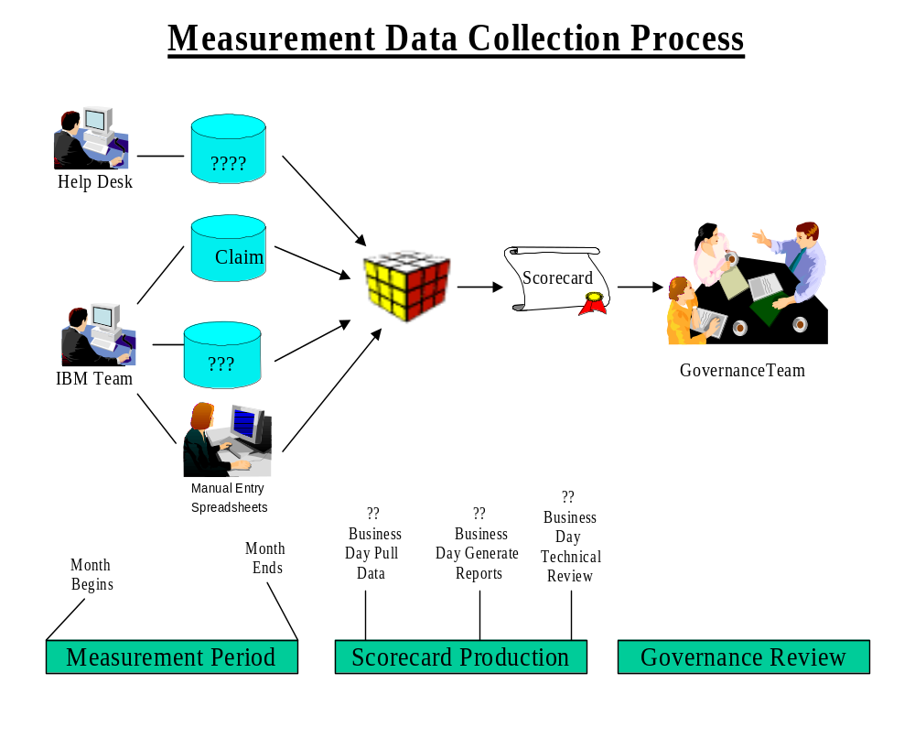

Audit Considerations
Although the IBM business office may not currently provide data to a customer, the data integrity of the Measurements Reported should be such that it could meet the following two audit requirements.

Data Quality Auditing

The customer shall have the right to periodically audit data reported by IBM. These audits may include function points, time, cost and quality data.

Claim Data Verification

Note: We are pulling hours etc for all employees both regular and contract.

