Functional Areas Description

Author: IBM
Owner: IBM

Document History
Document Location
This is a snapshot of an on-line document. Paper copies are valid only on the day they are printed. Refer to the author if you are in any doubt about the currency of this document.
The source of the document will be found in /tmp/lo/0000.doc
Revision History
Date of this revision: 10-14-2008 | Date of next revision (date)

Revision Number | Revision Date | Summary of Changes | Changes marked
3.2 | 10-14-08 | Template extracted out from WPD (Arun Thakore). Updated functional areas description table (Sella Ganapathy). | (N)
3.1 | August 2007 | Updated to capture business entities for functional areas (Shuvanker Ghosh, Tina Abdollah)
2.1 | June 2005 | Version number synchronized with TP
0.4 | May 2005 | Revised after additional feedback
0.3 | April 2005 | Revised after review call
0.2 | Mar 2005 | Revised sections 1-3 (David Janson, Ganesan Lakshminarayanan)
0.1 | Feb 2005 | Initial version for SOMA 2, reformatted to standard WPD template structure (Krishnan Ramachandran)
Approvals
This document requires following approvals. Signed approval forms are filed in the Quality section of the PCB.
Name | Title
(name) | (title)
Distribution
This document has been distributed to
Name | Title
(name) | (title)
Contents
1. Introduction 4
1.1 Identification 4
2. Functional Areas Description 5
2.1 Decomposing domains into functional areas 5
2.2 Functional Area Interactions and Dependencies 7
2.3 Mapping Functional Areas to Subsystem 7

Introduction

Please note that:
- Text in the “Editor’s comments” style (such as this) provides guidance to the editor, in conjunction with the corresponding work product description, and should be removed from the published version of the document.
- The “Reader’s comments” style (in purple) provides guidance for the (client) reader and should be modified as appropriate by the editor to reflect any customization of the template.
- The “Normal” style (in black) should be used by the editor when adding the text describing the (sub)system appropriate for this work product.
When using this template, refer to the Unified Method Framework work product description “Functional Areas Description”.
The Functional Areas work product captures the results of functional area analysis carried out during domain decomposition. It documents a high level description of business domains and the functional areas that the domains are composed of. This work product also identifies (but does not describe in detail) candidate subsystems that can be used to provide IT services supporting the functional areas. This work product therefore provides a description of the business function viewpoint and creates the linkage or traceability to an IT function viewpoint.
Any Business is composed of Domains, a logical grouping of business capabilities (functionalities) that provide related business functions and require similar skills and expertise. To explain the concept of Domain, consider the following simplified example:
• What the Business is selling? → Products Domain
• To whom the Business is selling and how to improve it? → Customer Relationship Management and Marketing Domain
• When and how to sell? → Sales Management Domain
• How to Manage the Business? → Business Administration Domain
Domains can be broken down (decomposed) into “Functional Areas”. Functional areas provide a set of cohesive business functions for the domain and one or more business entities participate during each business function. For example, a functional area in the “Products” Domain could be “Product Development”, whose main function is to develop and enhance the products..

Identification
This document describes the Functional Areas for .
Via the IBM menu, Edit the Document Information, enter the name of the (sub)system being described into the field “Text 2”, and press the “Update” button.

Functional Areas Description
A Functional Areas work product instance describes the overall set of in-scope business domains and identifies the functional areas of each domain that are of going to be the focus of analysis for this work product instance. There are three aspects to document:
- the decomposition of domains into functional areas, and the identification and description of functions associated with a functional area
- description of functional area interactions and dependencies
- the identification of candidate subsystems proposed to realize functions for each functional area
This chapter describes the Functional Areas for the.

Decomposing domains into functional areas
The decomposition of domains into functional areas can be visually represented using a domain decomposition diagram as shown in Figure 1. Domains, functional areas and functions associated with each functional area can be described using the Functional Areas template (Figure 2).

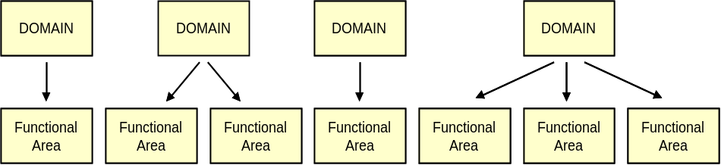
Figure 1: Domain Decomposition Diagram
Complete a Functional Areas template (Figure 2) for all domains that fall within the scope of analysis. Within each domain, identify the functional areas, functions, and business entity that are relevant to the solution area.

Functional Areas Description
Domain | Functional Area | Functions | Business Entities | Description
Figure 2: Functional Areas Description template
Domain: The business domain for which the functional areas are being identified
Functional Area: The parts of the business within a business domain that is capable of operating independently.
Function: The business functions provided by a functional area
Business Entities: The business entities that are owned and managed by the function areas.
Description: A short summary description of the domain, functional area, function, or business entity. Also in the description for business entity include the high level data elements.

Functional Area Interactions and Dependencies
This section describes interactions among the functional areas that have been identified for each in scope business domain.
Interactions can be described in one of several ways, depending on the tools being used. The preferred approach is to use a UML sequence diagram to show how functional areas interact in distinctive scenarios.

Mapping Functional Areas to Subsystem
The mapping of functional areas to subsystems is one of the key bridging points between business and IT views of a solution. Aligning the functional responsibilities of business functional areas and IT subsystems achieves consistency in how functions are defined and used by the business and structured and automated by IT. Typically one functional area maps to one subsystem. This association results in assignment of functional responsibilities to subsystems.
The association of functional areas to subsystems can be captured using the template shown in Figure 3.

Functional Area to Subsystem Cross Reference
Functional Area | Subsystem | Subsystem characteristics
Domain: <domain name>
<functional area name> | <subsystem name>
<functional area name> | <subsystem name>
Domain: <domain name>
<functional area name> | <subsystem name>

Functional Area: name of a functional area that has been documented as being in-scope for the current analysis work (i.e. has been documented in the Functional Areas template).
Subsystem: name of the candidate subsystem that will be responsible for automating functions associated with the functional area. Subsystems will be further analyzed during Subsystem Analysis.
Subsystem characteristics: additional characteristics that establish the scope of responsibility for the subsystem, or are important to note as input to other analysis or modeling tasks. For example, list the subset functions that are expected to be automated and policy/rule related issues that need to be further analyzed during subsystem analysis, or the name(s) of existing systems currently supporting the functional area that need to be analyzed during existing asset analysis.

