
IBM Global Services
Infrastructure Product Selection
Technique Paper (TP)
© Copyright International Business Machines Corporation 1997, 2000
All Rights Reserved
Version 1.3 October 2000
Introduction
This technique is used during the elaboration of an Operational Model from a specification level to the level of physical products. Its focus is on selecting, configuring and validating physical products, which together satisfy the specified requirements. Products are selected for software components executing on nodes, for connections, and for nodes. The technique is applicable to all systems, and seeks to reduce risk and cost by producing a physical Operational Model that is reviewable, auditable and consistent with other models.
This technique takes the specification-level Operational Model and transforms it in several ways:
- Where possible, it selects the various hardware and software products that will be deployed in order to deliver the requirements specified.
- (Otherwise, it creates detailed development specifications for those elements of the Operational model that will require coding or, in the case of hardware, development).
- It describes the configuration of these products, such that they can be seen to deliver the functional and non-functional requirements.
- It describes how this detailed configuration must be managed to support the business application.
As the Operational Model evolves throughout a project, it is common for different parts of it to be at different levels abstraction (and detail), and the technique should be applied flexibly to reflect this (e.g., product selection for one component may precede specification of another).
The terms ‘component’ and ‘deployment unit’ are used relatively interchangeably here, as a deployment unit is merely a convenient collection of components.
Steps

Identify Selection Criteria

Define Selection Process and Roles
A significant part of this technique is the selection of IT products which will be procured, configured, installed and operated to deliver the design requirements posed in the specification-level Operational Model. It is crucial to establish from the outset what the selection criteria are, and the role you and IBM will play in their definition and fulfillment. Are you there just to guide the process, or are you expected or allowed to evaluate components?
In order to ease the presentation of this technique, what follows is written as if you were directly involved in the process. If you are merely advising, you will have to alter the way you read this accordingly.
The evaluation method may include the following steps:
- Review all the givens, policies, vendor preferences and/or rules for qualification.
- Draw up an evaluation criteria list. This list will clearly be based upon mostly what your design demands. The criteria will contain functional and vendor evaluation issues. The functional items may be broken into mandatory (e.g., essential and policy), desirable and other features. The vendor items will contain topics such as support, local presence, financial strength, etc.
- Define a scoring method (exclusions, weights).
- Define a candidate list. You will want to use vendors’ services to a maximum advantage. You may want to request product presentations and visitable references.
- Define how you will conduct reference site visits (e.g., questions to ask).
- Agree on a need for prototype.
- Establish checkpoints, if you have parallel teams dealing with different sets of components. The checkpoints should include compatibility walkthroughs.
- Perform the final evaluation and selection.
Beware of procurement rules, as the evaluation will lead to directed procurement. This is especially true for government clients. It is usually helpful to create an evaluation audit trail even if there is only a single candidate.

Sources and Mechanisms for Selection Criteria
You should use as many sources and perspectives are relevant to the design situation. Some criteria will be generally applicable to the whole solution, such as:
- Select products that integrate with other chosen products
- Achieve the minimum number of vendors
- Exploit existing, installed products (even if they are not mandated)
- Select suppliers with good geographic coverage
- Select suppliers with good technical support & reputation
- Products that are proven
- Additional and future product capabilities
Some criteria will be related to the “non functional characteristics” of the product - particularly if they can deliver more than the minimum requirements:
- Availability and/or Performance
- Security and/or Manageability
- Time-scales for Development and/or Implementation
- Testing and/or Training
- Skills and/or Costs
- Risk
And, of course, you need to review specific criteria that explicitly apply to this situation:
- Givens and other constraints
- Support the prioritized list of functional and non-functional requirements
- Minimize issues and limit assumptions
You will probably be able to identify a long list of such criteria - so it is likely to be helpful to sort this list into some kind of order - maybe limit your selection rationale to the top four or so criteria.

Using the Specified Node Box Diagram
This technique is greatly helped by the use of the specified node box diagram. Thanks to the “ground rules” (presented in the Overview above), you should, in general, be able to follow this technique “node by node,” (or, to put it another way, “box diagram by box diagram) since:
- “One specified node normally maps onto 1 (or more) physical nodes
So you should be able to redraw each of the box diagrams, this time assuming they represent a physical node, and populate the various areas of the diagram with hardware and software products (or parts of products) in place of the “specified requirements.” Keep in mind, however, that it is quite likely (and may even be one of your selection criteria!) that a product can satisfy more than one specified requirement - which may mean the “compartmentalization” of the box diagram may break down. It may help to think of products that achieve this as serving multiple roles.

Selecting Products “Early On”
It is likely that you will use this technique several times during the development of the Operational Model. Early on in the development process, you may wish to only select some key technologies, (for example - those needed to develop code and which may have “run time” components) while keeping your options open for a later date when the requirements are more fully understood (for example choosing the hardware platforms). If this is the case, it is worth considering the following suggestions.
- Products which usually need to be selected early:
- Application Development Environments (particularly if they have “Runtime” environments)
- Middleware
- Object Brokers and Messaging Products
- Transaction Managers
- Systems Management Tools
- Those which influence “Release 1,” but are not needed until R2 or R3:
- RS/6000 SP2s scale for R2, even if PS/2s are best for small scale R1
- Those for which it may be best not to choose yet:
- Hardware Platforms and Operating Systems
- Database Products
- Communications Products
There are no hard-and-fast rules, but you may be well advised to choose standards rather than products where you can and, in general, be less prepared to select technologies towards the “bottom of the box diagram.”
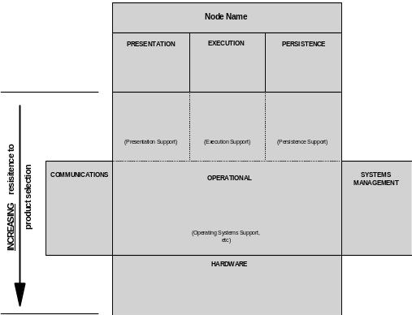
Figure 1: Increasing resistance to product selection
If you are using this technique during an early stage of the design process, it is quite likely you will want to combine this approach with that of the next section.

Products or Standards
During this technique, usually during an early iteration of the design as part of a cyclical development process), you may find it impossible, or you may decide it is desirable, not to choose a specific product. You may, however, be able to:
- Select a standard. For example, you may decide to select “UNIX” as the operating system (rather than some brand of UNIX); or you may decide to select “CORBA” (rather than “DCOM”) as the basis for the Object Request Broker.
- Select a physical “style.” For example, you may decide to implement a collection of specified nodes as a “departmental server,” without deciding - yet - whether this should be an RS/6000, AS/400 or NT PC.
If you are using this technique during an early stage of the design process, it is quite likely you will want to combine this approach with that of the previous section.

Select Products for Components on Nodes
General Guidance
This step is cyclic, selecting specified node by specified node, according to a recommended flow of substeps. Think of the Operational Model as a jigsaw. For each of the components in each of the specified nodes, identify the steps in the figure.
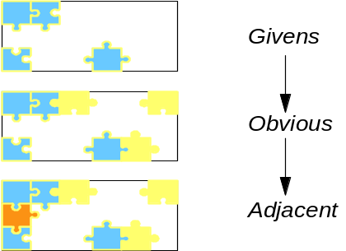
Figure 2: Filling in the Jigsaw
Whether you go through this series of sub-steps “node by node”; “class of deployment unit by class of deployment unit “; or even “ deployment unit by deployment unit “ will depend very much on the circumstances of the project - and on the stage of development of the operational model.
- If you are in the early stages of the design, then you may find it best to look across all the components.
- If you are in the later stages of the design (and therefore may already have a number of products selected), it may be easier to take a more focused approach, selecting products for deployment units node by node.
As you go through this step, it is helpful to assume that a specified node can be mapped directly one for one onto a physical node. For the time being, as you select products, you are advised to show them on box diagrams, which represent the various “perfect” physical nodes.

Identify Components from “Givens List”
Quickly identify all the components and connections that are givens (many are usually known very early from the requirements work products). On the specified node box diagram, write in the product names, and indicate which components they cover.
Remember that a product might satisfy the needs of several components on a specified node’s box diagram - for example, an operating system such as AIX or Windows/NT might satisfy the functional requirements of a node’s GUI component and data access component, as well as its base operating system component.
Identify and resolve any clashes between specified requirements for components, and the capabilities of ‘given’ components.

Identify Components from “Obvious list”
Determine what other components have obvious choices. You and your team has been working on this design for a long time now, and the team will gradually have come to an understanding of the suitable choices for many of the components, even though they are not givens. Do not try to make a rigorous scan of the marketplace for all possible candidates for these obvious ones. You would almost certainly end up wasting a lot of time and money. You may already have been told that your client has a preferred supplier. On the specified node box diagram write down the product names and indicate which components they cover.
As before, a single product may provide functionality for several components.

Identify Products for “Adjacent” and “Other” Components
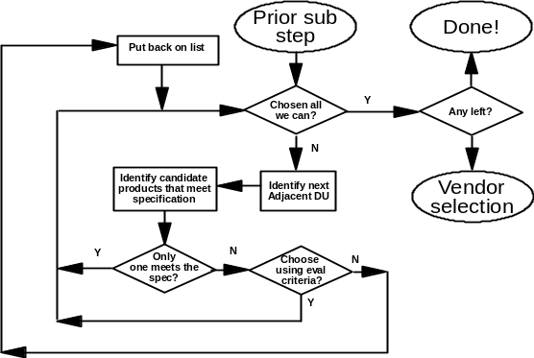
Figure 3: Flowchart for “Adjacent & Other” components
Decide which is the next component for your product selection debate. Continuing the jigsaw analogy, look as the selections you have already made, and try to decide the pieces that fit alongside those ones. You might also want to start a decision chain by beginning with the component or connection closest to the end-user interface.
As well as the required specifications presented for the components in the Operational Model, remember to use the selection criteria (maybe as a prioritized list) to help you.
First, try to gain agreement on a product selection through matching it to the functional specifications. Remember that you actually have more than just the functional specifications, you have also the added knowledge of technical requirements or limitations that are imposed by the adjacent components (whether or not these have already had products selected for them).
Do you, or the team, have a strong preference for one product, but need to document a solid reason for selecting it? Are there multiple choices, and the team has differing opinions about which is the correct product, and needs a set of rules to guide the decision process? Or is there no obvious product? There may still be other criteria you can apply:
- Choose from a single or small number of vendors
- Be consistent with the installed hardware and software
- Choose strategic rather than niche components
- Choose standard, not special or custom-built components
- Choose simple rather than complex components
- Choose less expensive rather than more expensive components
- If there is a choice, go for the component with any valuable extra function
- Choose a component that can be programmed and managed

“Make, Rather Than Buy,” or “Invitation to Tender”
You will probably have three types of list at this stage:
- The first list is set of identified products that you have chosen, or are givens. Further work may be needed on some of the definitions before complete configurations can be documented. Ensure that any extra work is not forgotten.
- The second list may be a set of components that have more than one product identified (options) and you need to set the work in place to make any decisions so that the progress of the system development is not inhibited by the lack of a firm product definition.
- The third list may be a set of components that do not have any product matches. In this case you need to understand how you will resolve the lack of product match. Options you have include:
- Build your own product (hardware or software)
- Issue a tender to suppliers to build one for you
- Significantly modify an existing product
Some of the activities involved in the above can be done in parallel. Some may not finish for many months and you should identify and critical dependencies within the overall project.
You may need to make an early decision on whether you need to prototype, model, or benchmark since specific configurations may need this type of activity.

Select Products - Physical Connections
The specification-level Operational Model provides a specification for communications requirements, taking into account the most appropriate way of routing the various component interactions across the geography of the solution. It identifies the overall “shape and style” of the communications network, e.g., whether it was to be “hub-and-spoke” or “peer-to-peer.” In doing so, it identifies the necessary communications specified nodes and (inter-node) connection segments.
Now you must work out how these requirements will be realized across physical networks—physical connections—whether these be:
- LANs, MANs, or WANs
- Comms software on “standard” physical nodes, or specialized hardware such as routers and MUXes
- Value Added Networks or the clients own networks.

Identify Connection Strategy - LAN
Within each location, look at the required connection segments and identify the appropriate network strategy, for example:
- Single or multiple domain LAN
- Backbone plus departmental LANs, or linked LANs
- Routing and Naming strategies
How you decide to structure the Location’s LAN will depend on many factors, many of which are non-functional, such as:
- Are there heavily utilized nodes, traffic to which may compromise other inter-node communications?
- Do some communications require high levels of physical security?

Identify Connection Strategy - WAN
Between locations, which require communications, look at the required connection segments and identify the appropriate network strategy, for example:
- Point-to-point or multi-point
- Intermittent/temporary or permanent connections
- Routing and Naming strategies
How you decide to structure Inter-location WANs will depend on many factors, many of which are non-functional, such as:
- Are there heavily utilized links, traffic to which may compromise other inter-node communications?
- Do some communications require high levels of physical security?

Identify Connection Technologies
This sub-step needs to consider the physical network at many levels. You will already have selected some of the products that will satisfy the needs of the communications components - for example you could have already opted for MQ Series for your messaging component. But there are still many decisions:
- Selection of the underlying protocol stack: TCP/IP or SNA
- Selection of the underlying Comms protocols: Ethernet or Token Ring
- Selection of the underpinning hardware: 10BaseT or Fiber Optic

Rationalize Communications
In the preceding activities you may not only have changed the number of nodes but also their location as well as their technology base. All the above changes will most likely change the capacity, the topology and potentially the nature of the required physical connections (e.g., you may have identified the need for a new transport protocol). Now review the connections for all the changed nodes and document the necessary adjustments.
- Can lightly used links be replaced by routing traffic via another node? Check the impact of this on the processor load, utilization of adapters, etc.
- Can common protocols be used between components at the same nodes or locations to allow logical sharing of links (for example, all TCP/IP replacing a mixture of TCP/IP and SDLC, or wrapping all TCP/IP in SDLC frames)?
- Can physical links be shared by using multiplexers?
- Can the different types of traffic, such as file transfer and transaction processing, safely share the link?
- What software is needed to manage different types and priorities of traffic?
Identify any connection incompatibilities:
- Different protocols supported:
- Communication protocols
- Content architectures
- Data stream contents for printers and screens
- Required SNA LU types not supported.
- Physical transmission media.
- Cable ducts only large enough for twisted pair, etc.
- Keyboard mappings.
- “But everyone knows that PF12 is ALT + ESC + PF2. It is obvious.”
- “You do not really need to use PA2, do you?”
- Identify methods of overcoming them:
- Add bridges, routers, and/or gateways (protocol converters) in the networks or at nodes.
- Change one or more of the components that have to be linked.
Caution: Pay particular attention to the connections needed for System Management and operation when the system contains nodes with different types of hardware and software.

Outsourced Networks
Consider whether it would be advantageous to outsource the provision of the networking requirements - particularly WANs. Issues to keep in mind include:
- Pros: (so long as appropriate service level agreements can be identified)
- Systems management of the network is now “out of scope”
- Growth and capacity management may be more easily accommodated
- Cons:
- Loss of control over changing requirements
- Loss of control
- Difficulties in setting service level agreements.

Rationalize the Design

Consistency Check
Check that your selection of components is consistent END-TO-END. This sub-step allows you to check that the selected products provide the right functions across the entire design - within specified nodes and across the network.
As you walkthrough the major business processes (batch and online) check that the business processes interact properly with the system componentry and that system componentry interact properly between them. (For example, you might check that the office application uses a IBM LAN Server requester that in turn communicates correctly with LAN Server File server.)
You will do this sub-step thoroughly in Step 5, so for the time being, take a fairly high level approach, looking for obvious out-of-line situations.

Review Locations which are not Economic
Given the product family selected for the nodes in various locations (such as small offices or locations with no existing IT or system management skills), determine whether:
- The smallest locations will ever have the manpower and skills to run the hardware and software that has been selected for them?
- Are there very few small locations so their relative cost is unimportant?
- Can the smallest locations be combined with others to make larger, more economic units?
If you rationalize the design to remove these concerns, have you defined new types of nodes or locations? If you have, then the changes must be checked against the earlier Operational Models, and the appropriate activities repeated for the affected nodes.

Merging, Splitting and Multiple Nodes
At the moment, the design is composed of specified nodes populated with products, together with a moderately detailed definition of the network technologies that are to support the connection segments.
In designing for performance and capacity, security, availability and systems management, you will consider these “collections of products,” together with the required operational characteristics, and you must decide whether a single physical node is capable or justifiable to deliver these requirements.
- Merging involves the combination of the workloads of two or more specified nodes onto a single physical node.
- Splitting involves the division of workload of a specified node onto two or more physical nodes, where the nodes are not doing the same thing. In this case, you may be particularly advised to return to the specification-level Operational Model, and revise it’s design, so that the shape and style of the operational model can still be seen.
- Multiples involves the division of workload of a specified node onto two or more physical nodes, where the nodes are doing the same thing, although there may be additional nodes required for specialized services such as transaction direction, or data management.
In transforming specified nodes to physical nodes, use the following guidelines:
- Components should not require refinement or change. During the transformation the components, initially “in” specified nodes, may be relocated into physical nodes. However, it is unlikely they will be refined or changed.
- Specified Nodes may map 1:1 onto Physical Nodes, when technology can be identified which supports the identified service level characteristics and other non-functional requirements for the specified node.
For example, a “user workstation” specified node can be realized by a physical node made up of an IBM ThinkPad Model 765D, with 64Mb Memory, 3GB disk, (and other hardware) running Windows98 (and other software).
Specified Nodes may map n: 1 onto Physical Nodes, when technology can be identified which can support, within the constraints of networking, location, and the like, the identified SLCs and other non-functional requirements of several specified nodes. This has the benefit of simplifying system management.
For example, a “store network services” specified node, plus a “store application services” specified node can be realized on a single physical node made up of an RS/6000 Model XYZ (plus other hardware), running AIX Vx.y (plus other software)
- Specified Nodes can only map 1:n onto Physical Nodes under certain conditions:
- When several physical nodes are used to carry out the role of a specified node, as a “single-image cluster,” which (as a black box) delivers as a whole all the requirements of the original specified node.
For example, a “store services” specified node, with very high availability requirements, may need to be mapped onto two (or more) physical nodes, each of which is an RS/6000 controlled by some form of “failover software” (such as HACMP/6000). Or, a “central services” specified node, with very high performance needs, may be mapped onto three physical nodes - a load balancing node, plus two back-end processing nodes.
- Specified Nodes cannot map 1:n onto Physical Nodes if this would require a re-placement of components across “ externalized” connections, which may have complex consequences on the design.
For example, a “user workstation” specified node, which was responsible for the execution and storage of application function and data, would not, normally, be mapped into a “terminal” physical node plus a “server” RS/6000. The consequences of such a design change should be considered at the SOM level, not when developing the POM.
Also, although a more qualitative judgement, it is reasonable to imagine that the physical Operational Model might be considered to be a “Response” to an Invitation to Tender (ITT), a key part of which is an unambiguous (but product-neutral) specification-level Operational Model.
Examples of these different specified to physical transformations are provided at the end of this technique.
If you divide the workload of a specified node because of control, availability or security, the reason for splitting the workload will have decided which parts must be separated from one another. If you have to divide a node because of capacity, you are free to make any split. In this case, the criteria for how you divide the workload will be cost, performance and data integrity.

Review and Detail the Design

Review Changes and Tradeoffs
You have now developed a physical Operational Model, driven by the need to deliver the requirements presented in the specification-level Operational Model. You may have made design changes during this technique, which may clash with earlier design decisions. Look for these, such as:
- In order to improve availability, you may have mapped two specified nodes onto two physical nodes, with “mutual standby.” Have you assessed the impact of both workloads on one physical node in the event of failure?
- You may have taken some security decisions, such as solving an encryption problem in software rather than specialized hardware. Have you reconsidered the performance implications?
- Perhaps you have chosen to adopt a particular approach to performance (e.g., load management between two physical nodes), which makes it difficult to achieve your availability targets.
No system will exhibit the required availability unless its management system enforces the correct disciplines. You should check that the management system is in place to control the system so that:
- Changes are done in an orderly fashion and within the designed maintenance constraints.
- The system will operate and react to component failures in such a way that their impact is limited. This will almost certainly mean that there will have to be a significant degree of operational automation.
- There are sufficient monitoring and reporting tools and activities in place so that the availability characteristics of the system and its components can be understood.

Transaction Walkthrough
Perform a walkthrough of the key transaction flows.
Analyze each transaction, from start to finish, following the data flows through each physical node and connection. At each stage, try to visualize what would happen if there were a failure of some part of the system:
- Will the failure be detected by another component?
- How will the end user be notified of the failure?
- How will the transactions and their data be recovered?
- How much work will the system be able to perform while the component is down?
- Who will be responsible for repair of the component?
- Who will be responsible for restarting the component?
- Are there any System Management issues that have been raised? Do you need to specify any special System Management work items?

Response and Turnaround Estimates
Using the loadings from the previous steps, estimate response times of transactions and turnaround times through all their components. Check that these times are within the criteria for an acceptable system. Identify any components that are critically close to acceptable limits.

Produce Configurations
Make use of available configuration and modeling tools from product manufacturers and general industry tools. The output should enable you later to produce an accurate cost of the entire system, and, if necessary, enable someone to order the products.

Examples of Infrastructure Product Selection

Example 1
This example is based on the same “retail store system” scenario as is developed in the Specifying System Topology technique paper. As such, it is a somewhat stylized example, and the specified nodes are not drawn using the correct notation.
In particular, the example does not portray the complexity usually seen in designs that require this technique. Several idealized assumptions have been made:
- All distributed locations are the same
- The communications mechanisms within locations are oversimplified - there is still a need to design the LAN topology.
- The communications mechanisms between locations are the same - there is still a need to design the WAN topology
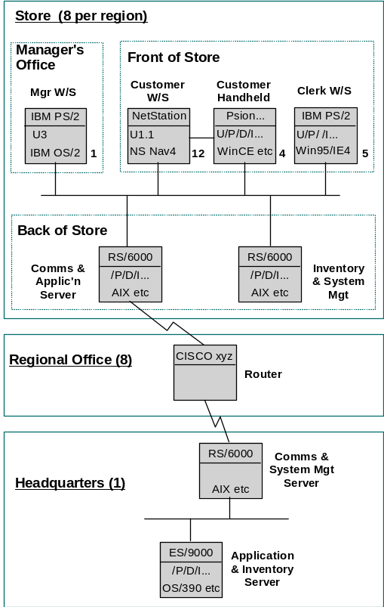
Figure 4: An Example physical Operational Model, showing products
This example shows:
- The four sets of “end user” specified nodes have mapped one-for-one onto four sets of physical nodes.
- The various “back of store” specified nodes have been combined onto two RS/6000s per store; one dedicated to the general requirements of the application, including communications; and the other specialized to support the Inventory system, as well as being responsible for the system management activities in the branch.
- The regional communications specified node has mapped onto a physical node that is a specialized (hardware) communications routing device.
- The HQ specified nodes have been mapped onto an RS/6000 for inventory and systems management (and therefore inter-working with the equivalent RS/6000s in each of the stores), and an ES/9000 enterprise server (interworking with the application-oriented store-based RS/6000s).

Example 2
This example illustrates several of the transformations discussed in the steps above, based on a different scenario.
Note that it is a somewhat stylized example. There is no reference to the numbers of physical nodes, the anticipated characteristics of the nodes and connections have not been highlighted in any way, and no systems management componentry has been identified.
In particular, the example:
- Does not portray the complexity usually seen in designs which require this technique
- Does not name products for the nodes - rather, it presents them as a “style” of physical operational model
Several simplifying assumptions have been made:
- All distributed locations are the same
- All communications mechanisms between locations are the same.
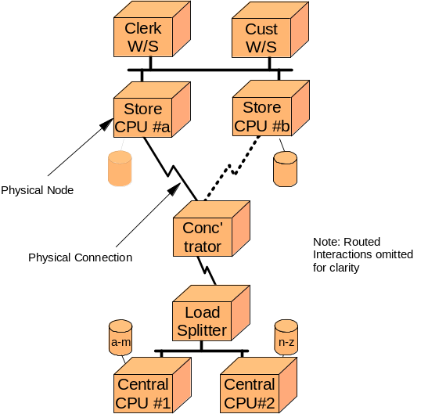
Figure 5: An example physical Operational Model, showing “style of products”
This example shows:
- The end user specified nodes have mapped directly onto physical nodes
- The back of store specified nodes have been transformed into two physical nodes such that, in normal conditions:
- Physical node #a supports the needs of specified nodes “communications” and “store services”
- Physical node #b supports the needs of specified node “Customer services”
- In the event of a node failure, either is able to support the needs of all three “back office” specified nodes. This design is therefore able to provide heightened levels of availability, although, when operating in fallback mode, performance is likely to be compromised to some degree.
- The high performance requirements of the “central services” specified node has been met through the use of a three physical node complex, were a transaction director front ends two processing physical nodes, with transaction routing based on the required data record.
- No detailed thinking has yet been put into the communications network design

Example 3. Good and Bad Transformations
Given a specification-level Operational Model which looked like this:
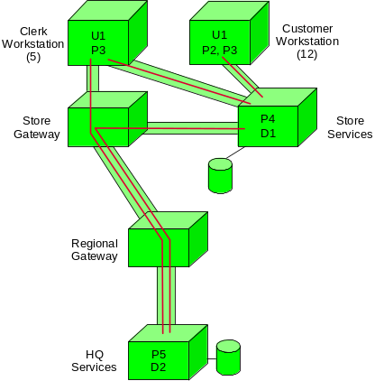
Figure 6: A Specified Operational Model
Then the following physical Operational Model contains some transformations, which are acceptable, and some, which it is recommended you, avoid.
Note the use of several notational standards on this figure:
- “(b)” to represent a backup facility
- Dotted physical connections to represent intermittent links
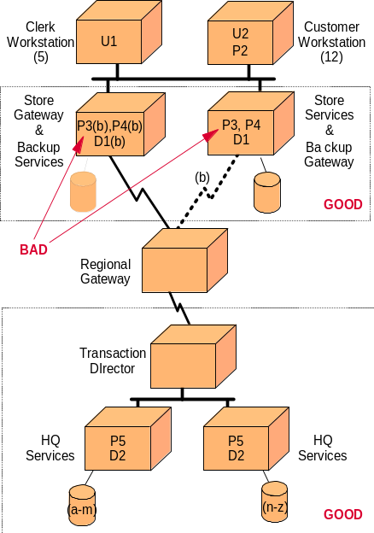
Figure 7: A physical Operational Model
Good Transformations:
- The 1 to 1 mapping of the Workstation specified nodes into physical nodes
- The combination (n to 1) of the Store Gateway and Store Services specified nodes into a single physical node
- The replication (1 to n) of the combined Store Gateway/Services physical node, in order to achieve the required levels of availability. In the event of one replica failing, the other will take on the combined load.
- The division (1 to n) of the HQ Services specified node, into three physical nodes, a Transaction Director plus two HQ services physical nodes.
Note that, in this design, these three nodes are separate CPUs. In an alternative design, they may be three separate images on a single physical computer that supports logical partitioning. Also, as drawn they would suggest distinct computers, although it may be appropriate to implement them as three nodes in a multi-node computer.
Bad Transformation:
- The movement of execution deployment unit P3 from the workstation nodes onto the Store services node.
- This changes the underlying Operational Model, which should be modified to reflect this change. Such changes have a significant impact on the non-functional characteristics of the nodes - particularly the service level characteristics - possibly requiring a recomputation of, for example, performance requirements.
- In this case, the performance requirement of the Store Services specified node was driven by P4 and D1. The “equivalent” physical node is required to support a different load - P3, P4 and D1.
Cross Reference to ISD
- 1.1 Define selection process and roles Major enhancement to WSDDM/ISD C02
- 1.2 Sources and mechanisms for Selection Criteria Not in WSDDM/ISD
- 1.3 Using the Specified Node Box Diagram Generally based on WSDDM/ISD C05
- 1.4 Selecting Products “early on” NOT in WSDDM/ISD
- 1.5 Products or Standards? NOT in WSDDM/ISD
- 2.1 General Guidance Generalization, based on C06 to C13
- 2.2 Identify Components from “Givens List” Enhanced from WSDDM/ISD C06
- 2.3 Identify Components from “Obvious list” Enhanced from WSDDM/ISD C07
- 2.4 Identify Products for “adjacent” and “other” Components Edited from WSDDM/ISD C08 through C13
- 2.5 “Make, rather than buy,” or “Invitation to Tender”? Based on WSDDM/ISD D03
- 3. Select products - Physical Connections A major extension to WSDDM/ISD C33
- 3.1 Identify connection strategy - LAN Not in WSDDM/ISD
- 3.2 Identify connection strategy - WAN Not in WSDDM/ISD
- 3.3 Identify connection technologies Not in WSDDM/ISD
- 3.4 Rationalize Communications Based on WSDDM/ISD C33
- 3.5 Outsourced networks? NOT in WSDDM/ISD
- 4.1 Consistency Check Based on WSDDM/ISD C14
- 4.2 Review locations which are not economic Based on WSDDM/ISD C22
- 4.3 Merging, Splitting and Multiple Nodes? NOT explicitly in WSDDM/ISD
- 5.1 Review changes and tradeoffs Based on WSDDM/ISD F55
- 5.2 Transaction walkthrough Based on WSDDM/ISD D05
- 5.3 Response and turnaround estimates Based on WSDDM/ISD D06
- Produce configurations Based on WSDDM/ISD D04
Revision History
Version 1.3 October 2000 – Removed confidentiality markings from header.
Version 1.2 September 1999 – Applied new template and style, spelling and grammar review.
Version 1.1 February 1999 – A standard format template was applied.
Version 1.0 September 1998 – Base version.

