
IBM Global Services
Creating Architecture Work Products
Technique Paper (TP)
© Copyright International Business Machines Corporation 1998, 2003
All Rights Reserved
Version 4.1.1 March 2003
- Introduction
The purpose of this technique paper is to illustrate how the main work products (WPs) related to application development in the Architecture Domain evolve and relate to one another on real projects.
The following diagram, showing the main dependencies between the work products of the architecture domain, will serve as the background to our discussions.
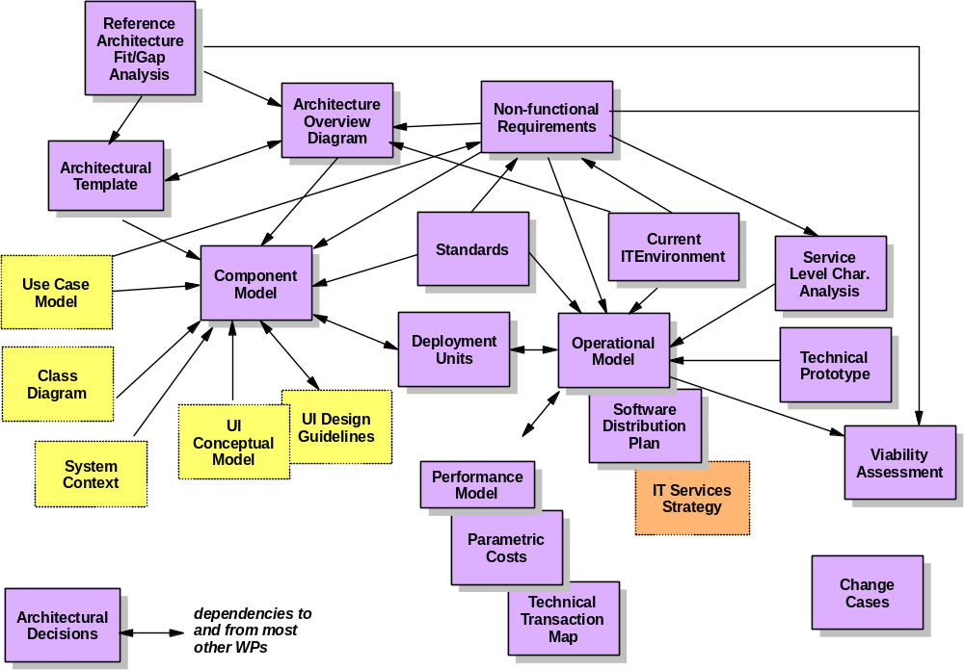
Figure 1: Architecture work product dependency diagram
Work product dependency diagrams show
- the work products influencing one another
- the ‘finished last’ relationship between these work products, the arrow pointing in the direction of the "finished last" WP, e.g. the Operational Model WP can influence the Non-Functional Requirements WP, but must be finished after the NFR.
However these diagrams do not show
- in what sequence the WPs are actually created
- how different work products based on the same work product description relate to one another (e.g. different architecture overview diagrams can be built to cater for different audiences)
- when different versions of these WPs are created
- to what extent the WPs are actually ‘completed’ within a particular phase
In order to give more insight in how these WPs are actually created, we will discuss a number of contexts in which architecture WP development processes can take place. Each of these examples has been structured as follows:
- A description of the main features of the context
- A step by step description of when and on what basis the various (versions of) work products are created
All the examples imply some (relatively minor) tailoring of the standard set of phases, activities and tasks. This technique paper does not discuss the specific tailoring, nor the detailed circumstances that motivated it.
Throughout the technique paper, a specific notation has been used for the diagrams:
- rounded rectangles refer to a WP, i.e. an instance of a work product description, and explicit version information has been added, where appropriate.
- Arrows between work products indicate an input/output relationship between two work products, the arrow pointing in the direction of the output.
- dotted arrows link together versions of the same work product.
Given the specific objective of this technique paper of only illustrating the relationships between the main architecture related work products and also in order to simplify the overall description, the creation and use of other required work products has been ignored. However, their creation and use could be critical to the success of the project. It should be emphasized that conscious decisions need to be taken about which work products should be included or excluded during the Method Adoption Workshop and this technique paper should not be used as guidance in taking those decisions.
- Examples
Example 1: Development of a new IT System
The IT System was developed in the following context:
- The system to be developed addressed new business processes which did not rely on any legacy applications
- The system was to be implemented using new infrastructure
- Overall, this was a medium sized project
- The operational and component models were developed by different sub-teams
The following information was available from the Request for Proposal (RFP):
- A high level description of the business processes to be supported
- A set of non functional requirements tied to these business processes
Two architecture sub-teams were set up, one focusing on the functional aspects of the architecture of the IT system, the other one on the operational aspects.
Step 1: Requirements Gathering and Analysis
During the initial stages of the engagement, the two teams worked together to gather information about the customer’s current IT environment.
During a joint workshop, and working with client personnel, both teams captured the overall shape of the intended solution in an architecture overview diagram, which became the backdrop for the independent work undertaken by these two teams. The two teams also worked together, using the information provided in the RFP to build the following WP’s:
- The System Context Diagram WP focusing on the relationships between the new system and the external actors (both ‘human’ and ‘system’ actors)
- The list of major categories of use cases with associated non-functional requirements (Use Case Model WP)
- The Non-Functional Requirements WP
Step 2: Initial Architecture Modelling
The two teams then worked separately:
- Using the “Component Modeling” technique paper, the functional sub-team identified the initial set of (coarse grained) components each assuming the responsibility for a number of closely related business processes (i.e., on the basis of business process clustering). The specification of these components was further developed based on the information gained from building component interaction diagrams for each of the architecturally significant use cases. Also, a number of technical components were identified and documented via a component relationship diagram.
Besides this 1st version of the specified component model, a number of physical components could be immediately inferred from the Current IT Environment WP and the customer’s constraints. This initial set of physical components was also documented in the Component Model WP via a physical component model.
- In parallel, and using the OM development technique papers, the operational sub-team gathered preliminary information concerning locations and user groups and used this to structure the conceptual operational model, documented in the 1st version of the Operational Model WP.
Step 3: Synchronisation and further Development
On the basis of the 1st version of the component model, both teams jointly created the application level deployment units and fully documented these in terms of the applicable NFR’s.
The teams then again worked separately:
- The operational sub-team further developed the 1st version of the conceptual operational model, showing how the various types of deployment units were to be deployed across the node relationship diagram in order to meet the solution’s NFRs. These NFRs were further analyzed in order to support the development of the operational model resulting in the Service Level Characteristics Analysis WP. During the same effort, initial versions were also created of the specified and physical operational model (SOM and POM).
- Based on the decisions taken for the POM, the functional team were able to identify an additional number of physical components, together with the implementation approach to be followed for the application and technical components. This allowed them to update the physical component model and define the way in which the previously specified components would be implemented via a number of physical components.
Step 4: First Checkpoint
Before delivering an integrated set of WP’s, the sub-teams verified that
- all specified application level components had been placed via deployment units onto the conceptual operational model and all specified components (application and technical) appeared on the specified operational model
- all physical components had been placed via deployment units onto the POM
- all decisions had been taken about the technology and/or products on which the implementation of the specified components would be based, and properly documented.
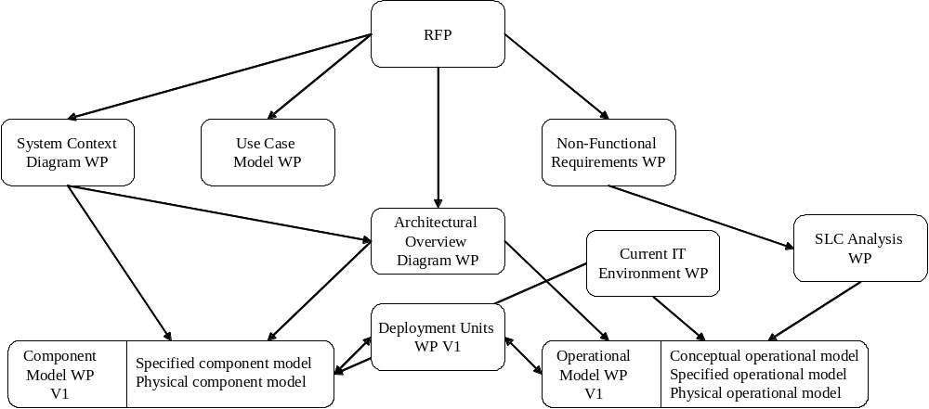
The first major checkpoint consisted of the 1st version of the architecture model related work products (i.e., 1st versions of the Component Model WP, Deployment Units WP and Operational Model WP). The work products created during this first phase are shown on the following figure:

Figure 2: Work products created during 1st phase
Step 5a: Initial Code Development
At this point, a number of development teams were set up. The component model was used as the basis for allocating work and each team was assigned one or more components that they would take through the release cycle.
Step 5b: Architecture Development & Prototyping
Concurrently with the effort in the development teams, the following activities were taking place in the two architecture sub-teams:
- The operational sub team again used the OM development techniques to elaborate the operational model WP so that it could support all configuration and deployment related activities within the scope of the 1st release. In particular, this focused on Systems Management requirements (such as data and code distribution) at the SOM level; and the mechanisms to be adopted in order to achieve the required levels of performance and availability (an “unsized” POM)
- A technical prototype was constructed based on the selected products (physical components) to analyze the particularly challenging throughput requirements (resulting in a Technical Prototype WP and the beginnings of a “sized” POM).
- On the basis of the analysis effort of the development teams, the functional architecture sub-team defined an architectural template, which allowed the easy integration of the application and technical components. This architectural template influenced some of the component interfaces.
- As a result of the feedback from the development teams, from the use of the architectural template and the introduction of additional technical components, the functional architecture sub-team produced an updated and expanded version of the Component Model WP. The new component model was used to refine the deployment units and revise the placement decisions where necessary.
Step 6: Second Checkpoint
At this second major checkpoint, a new version of all architecture model related WP’s were created and published to the development teams. The work products produced in the first two phases are summarized in the following figure:
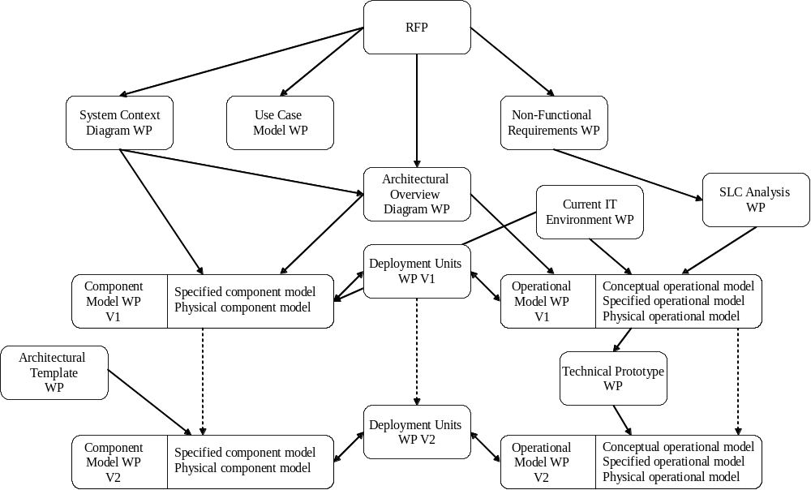
Figure 3: Work products created during the first 2 phases
Step 7: Architecture Refinement
From this point on, all major architecture decisions having been taken, any refinements or additional requirements discovered by the development teams, were fed back into the relevant WP’s. New versions were produced of these work products for each release cycle.
The different versions of and the input/output relationships between the work products used throughout the example are represented in the following figure:
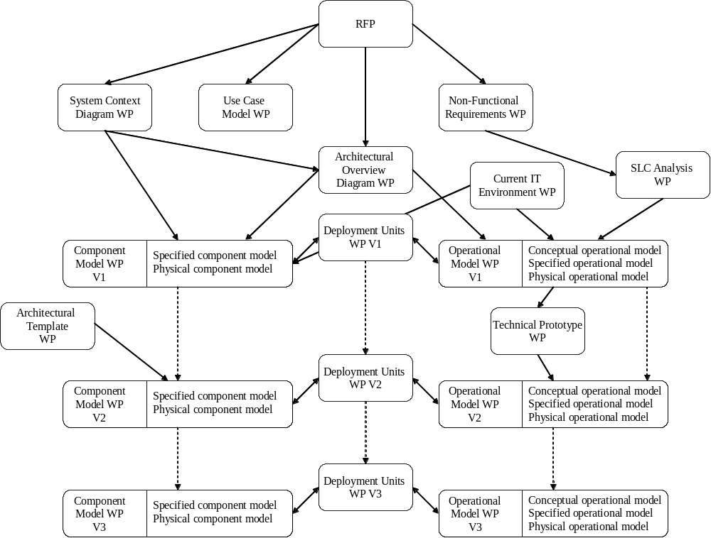
Figure 4: Created WP’s for the development of a new IT System
Example 2: Development of a New Application in an Existing IT Environment
The new application was developed in the following context:
- The application was to be implemented on an existing IT infrastructure (in terms of server and client hardware, networking, products and technology choices).
- The application covered a complex and wide business area
- The functionality to be delivered by the application was well-known
- Overall it was a large development project (consisting of about a dozen development teams, over a 9 month period)
Because of the complexity of the application and the straightforwardness of the IT environment, the architecture team decided to drive the delivery of the system via a number of releases, reflecting the staged delivery of the component model.
Step 1: Requirements Analysis and Release Planning
At the beginning of the project, the scope of every release cycle was defined in terms of the business functionality to be delivered. Business Analysts gathered the requirements targeted at specific release cycles by means of use cases.
In parallel, the architecture team documented the existing IT infrastructure in a Current IT Environment WP and collected the non-functional requirements in the Non-Functional Requirements WP.
Step 2: Initial Architecture Modeling
Given the size and complexity of the application development project, an initial solution based on very coarse grained components was documented in the Component Model WP. These components were identified on the basis of the major categories of use cases. The component interaction diagrams were constructed for a number of key business scenarios so as to verify that complete coverage (albeit at a high level) was achieved over the intended scope.
Development teams were then assigned one or more of these coarse grained components. The teams took these through analysis/design/implementation activities during each of the release cycles, each time taking the additional requirements on board targeted for the specific release cycle.
Based on the initial Component Model, the Current IT Environment and the Non-Functional Requirements WP’s, the application deployment units were derived and used to create the conceptual operational model, whose structure was directly based on the underlying physical OM (since the new system would rely on the existing hardware, network, products and technology). The specified operational model was also created, to permit an initial verification of the existing IT infrastructure’s ability to deliver the NFR’s of the new system, specifically the throughput, response times and availability related requirements.
The following work products were created during this phase:
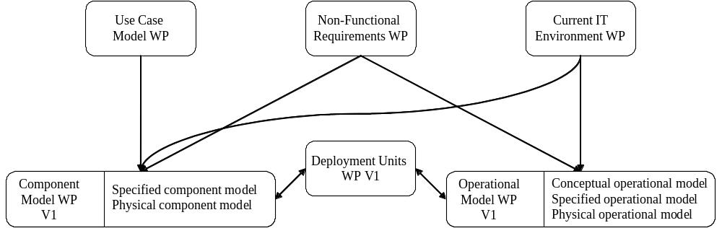
Figure 5: Work products created during the 1st phase
Step 3a: Initial Code Development
The first release cycle of the development groups was started based mainly on the first version of the component model, which was used as the basis for the allocation of work.
Step 3b: Architecture Development and Prototyping
Concurrently, the architecture team evaluated alternate strategies for achieving the required throughput given the existing technical components.
The architecture team was also able to use the code developed by the development groups in a technical prototype, in order to establish a better understanding of the application’s resource requirements on the existing IT infrastructure (the results of this activity were recorded in a Technical Prototype WP). A viability assessment was used to maintain the follow-up of the performance issue and to keep it visible at the project level.
Architecture work products produced by the project up to this point are represented in the following figure:
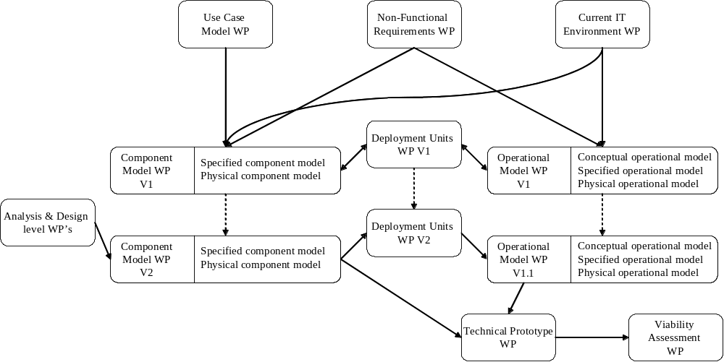
Figure 6: Work products created until this phase
Step 4: Architecture Refinement
Subsequently, each release cycle generated feedback on the component specifications recorded in the Component Model WP both in terms of the refinement of existing interfaces and the identification of new interfaces and components. The newly identified or re-factored application level components were used to update the deployment units which in turn were incorporated into the operational model. The updated operational model allowed us to refine the performance related metrics, which in turn allowed the viability assessment to become more accurate.
In order to emphasize the fact that the operational model was only refined on the basis of the refinements made to the component model (i.e. the operational model was effectively ‘complete’ after v1), the version numbering has been changed in the diagram.
The time and input/output relationships between the work products used throughout the example are shown in the following figure:

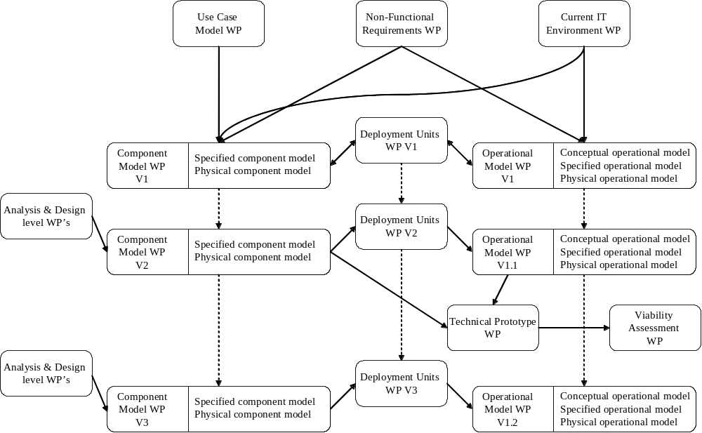
Figure 7: Created WP’s for the development of a new application
Example 3: Straightforward Application in a Complex IT Environment
The development context was the following:
- The application itself was very straightforward
- The proposed system would make its functionality available across two different delivery channels (the internet and a call center), involving the implementation of new IT infrastructure
Because of the complexity of the IT environment and the straightforwardness of the application itself, the architecture team decided to drive the delivery of the system via a number of releases, reflecting the staged delivery of the operational model:
- The 1st release, and therefore 1st version of the operational model, would mainly focus on defining the overall operational model (by building a COM, SOM and POM), including an outline of the specifications and key products/technology selection for each of the delivery channels.
- Version 2 would address the first delivery channel in detail
- Version 3 would address the second delivery channel in detail
Step 1: Requirements Analysis and Release Planning
The architects decided to resynchronize the work products created by the architecture and application development teams each time a new version of the operational model was delivered. Version 1 and 2 of the operational model were to be produced in quick succession, given that the initial technological choices made for the first delivery channel needed confirmation as they profoundly influenced the detailed design effort of the application development team.
For the first phase, the application development team was set up and tasked with gathering the requirements (in a Use Case Model WP) and to continue immediately with the analysis.
Step 2: Initial Architecture Modeling
Based on the results of the analysis activity, the architects defined the specified component model.
Concurrently, the architecture team documented the existing IT environment and drew up the architecture overview diagram that outlined the approximate shape of the solution. Subsequently, the team defined the first version of the operational model, focusing on the specified and physical level for the overall solution and outlines of the specification and physical operational models for each of the two delivery channels. This work took into account both the architecture overview diagram, the non-functional requirements and the component model (via the definition of deployment units).
Due to differing NFR’s and the requirements for distribution imposed upon the application, a number of deployment units were split. This in turn caused an update to the component model both to reflect the consequences of the distribution on the components and to incorporate additionally identified technical components.
The architecture team then immediately proceeded with the second version of the operational model in order to confirm the chosen products and technology. The consequences of the adopted solution in the operational model were fed back into the component model work product via an update of the physical component model.
The work products created in this phase are shown in the following figure:

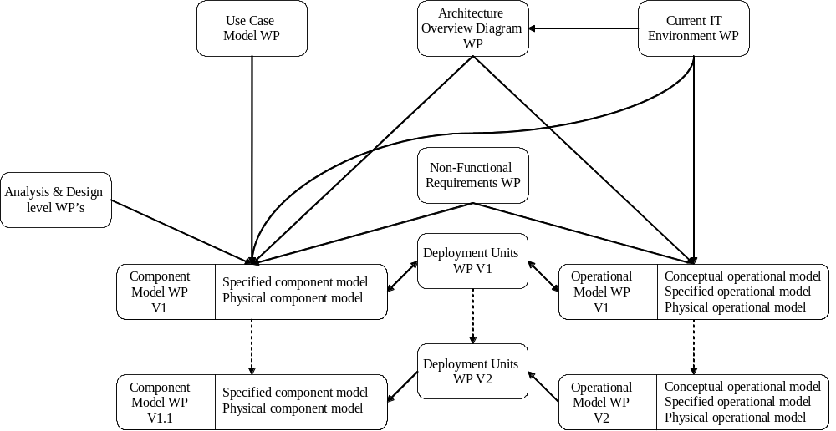
Figure 8: Work products created during the 1st phase
In order to emphasize the fact that the component model was essentially completed after v1, and was only updated to take into account the specificities of the delivery channels in terms of additionally required technical and physical components, the version numbering scheme of the component model has been changed.
Step 3a: Initial Code Development
The application development team continued with the detailed design and implementation,
Step 3b: Architecture Development and Prototyping
Meanwhile, the architecture team drew up the 3rd version of the operational model, this time addressing the 2nd delivery channel. The decisions taken as a result from this exercise, resulted in an update both to the defined deployment units and to the component model itself. Also, some additional physical components were identified as a consequence of the technological choices made for the second delivery channel.
The time and input/output relationships between the work products identified throughout this example are shown in the following figure:
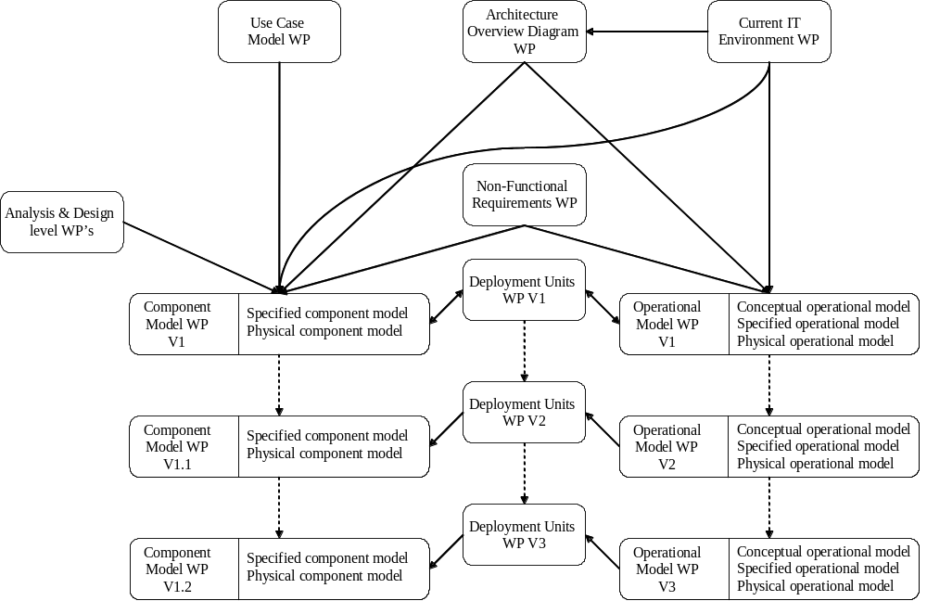
Figure 9: Created WP’s for a straightforward application in a complex IT environment
Comparing the Examples
Although the documents created during each of these three example projects were based on roughly the same set of work product descriptions, and the development processes are broadly speaking very similar, there are nevertheless a number of important differences that are the result of the different contexts within which these projects took place.
- The relative complexity of the functional and operational aspects varies over the three examples. In the 1st example the two aspects are roughly equal in terms of complexity, while in the second one the functional aspect is harder and in the last the operational model is more complex.
In all cases the component and operational models are resynchronized from time to time, particularly at critical checkpoints. The actual staging of the work performed for each of the two aspects of architecture is affected by their relative complexity. Oversimplifying somewhat, the more complex side tends to dominate the definition of what should be achieved by each resynchronization checkpoint.
- The second example project consists of a very large custom development effort. Because of its size, an early version of the component model was built before much detailed analysis was done. The analysis was carried out within the context of the large grained components identified previously. In other smaller projects the full analysis of the entire problem scope can drive the initial choice of components.
- The third example project involved significant effort in defining the operational aspects of the architecture, which required a double pass through the operational model before any code development could begin.
- The context within which each project started differed. Less was known at the start of the first example project about the required functionality than at the start of the others. This also affected the detail of the early work.
- Revision History
Revision Number | Revision Date | Summary of Changes | Changes Marked?
4.1.1 | March 2003 | Updated in line with the updates to the Component and Operational Work Product Descriptions.
1.3 | October 2000 | Removed confidentiality markings from header.
1.2 | September 1999 | Applied new template and style, spelling and grammar review.
1.1 | February 1999 | A standard format template was applied.
1.0 | September 1998 | Base version.

