

IBM Global Services

e-business Infrastructure Assessment – Leading Practices Example

Technique Paper (TP)

© Copyright International Business Machines Corporation 2001
Version 1.0 November 2001
Description
This document is an appendix to the “Assessing e-business Infrastructure against Leading Practices” technique paper. It contains an example of output resulting from an assessment against the e-business infrastructure design leading practices.
Tier 1 e-business Infrastructure Design Guiding Principles

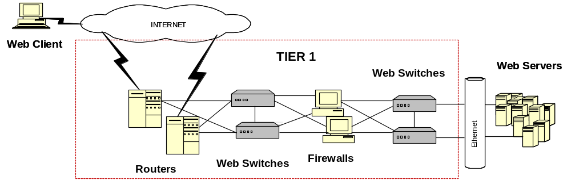

Best Practices e-business Infrastructure Guiding Principles
- Components are configured for hot fail-over
- ISP Connections, routers and firewalls are redundant
- Additional routers and firewalls can be added to scale capacity
- Routers can be upgraded to support additional processing

Best of Breed  Design Points | Business Benefits | Client | Impact
All components are redundant | Ensures there are no single points of failure that would impact site availability | - Switches are redundant  - Routers and load balancers are redundant | - Topology does meet best of breed design points  - Redundancy implemented for deployed components
Components are throttled at 60% capacity | Ensures that all components can handle momentary spikes in volume with out failure | - All components in this tier are well below 60% capacity | - Meets e-business best practices design points
Tier receives, manages and allocates IP traffic to the infrastructure | Ensures optimal distribution of IP traffic to e-business components | - Client effectively uses load balancers to distribute IP traffic across web servers  - Bandwidth is not segmented because ISP pipes are shared with other campus traffic from Trumbull site | - IP traffic is effectively distributed to web servers  - IP traffic is not dedicated to e-business applications  - May degrade performance and impact service
Tier facilitates Global Load Balancing | Provides additional capacity  Eliminates single point of failure | - Client has no Geographic load balancing capabilities at this time | - Excessive usage of the site can overrun capacity and bring the site down
The enterprise network is connected to the Internet is through redundant Internet Service Providers (ISPs) | The enterprise has multiple points of contact to the internet and increased availability for it’s customers  The outage of a single ISP will not impact availability and service | - Client has multiple ISP’s in place | - Meets e-business best practices design points
Physical network connections to TELCO exchanges enter at different points in the facility | Provides redundant physical connections to the internet increasing the resiliency of the communications infrastructure | - Client has multiple physical connections to TELCO exchanges | - Meets e-business best practices design points
Internet Bandwidth connections should be at least two DS-1 circuits (equiv to 1.5 megabits x 2) for heavily trafficked sites  Major web hosting companies with heavily trafficked facilities should utilize at least 2 DS-3 circuits | Provides high quality response time for users by ensuring that performance is not degraded by overloaded bandwidth connections | - Client has the equivalent of one DS-3 spread over multiple circuits | - Meets e-business best practices design points
Internet Bandwidth is dedicated and not intermixed with other types of enterprise data/voice traffic | Ensures that the web environment is not affected by other company network traffic problems or outages | - Client’s internet bandwidth is shared with Data Center and Campus internet traffic | - Web environment may be impacted by network traffic problems or outages
IP addressing should be consistent with uniform IP and netmask ranges throughout and segmentation of IP addresses and netmasks into logical units | Makes troubleshooting easier and allows the site to be more easily replicated or moved | - IP Addressing is morass of different IP ranges that include illegal addressing and different classes | - Creates management inefficiency  - Increased the complexity of troubleshooting  - Inhibits the scalability of the site
LAN in web environment is at least 100 mbs Ethernet | Provides quicker response time resulting in a better overall experience for customer which increases chances of repeat business | - LAN is a 100 mbs Ethernet | - Meets e-business best practices design points
Network is below 60% utilization | Ensures there is sufficient capacity to handle spikes | - Network is below 60% utilization | - Meets e-business best practices design points
Routers should be redundant | Eliminates a single point of failure | - Practiced today with multiple ISP connections supported | - Meets e-business best practices design points
Routers should be connected to the Internet from at least two separate ISPs | If one router goes out connectivity to Internet will not be effected | - Routers are connected to at least two separate ISP’s | - Meets e-business best practices design points
Horizontal Scalability | Site is able to handle increased traffic by adding new routers into service | - Practiced today. Two routers are in place facing the Internet. | - Meets e-business best practices design points
Vertical Scalability | Ability to handle increased volumes by upgrading equipment | - The 7206 routers have very limited upgrade capabilities | - 7206’s do not scale vertically
Routers should limit inbound TCP/IP traffic to only services needed (HTTP, FTP, SSL) | Limiting the services available on the routers reduces the threat of potential security exposure and unwanted access points on the network | - Client limits inbound traffic to selective services on routers | - Meets e-business best practices design points
- Firewalls secure the site and filter IP traffic through easily | - The security design and micro code of the firewall are specialized to it’s security/filtering tasks, allowing it to more efficiently secure and buffer the site from unwanted access  - Security is flexible, detailed and modular without increasing administrative and network overhead | - Client has no firewalls  - Client uses Routers with Access Control Lists (ACLs) are used to control access to web site | - Cannot easily manage service restriction for the web site  - Cannot specify alerts for access failures, authorization failures, etc.  - Intrusion detection is incorporated into the router  - Routers do not have user based or application based security  - Routers cannot filter email messages based on destination, source, address or file size
- Firewalls are remotely and centrally managed using GUI or menu driven configuration | - Security policies are easily configurable  - Remote management minimizes administration efforts and lowers cost | - Client has no firewalls  - Client manages access with ACL  - Routers with ACL’s are used to control access to the web site but cannot provide the broad range of function and manageability of firewalls | - Router performance will degrade under heavy volume  - ACL management requires increased maintenance and highly trained technicians to manage and update configurations  - Support costs are increased  - Outage durations are prolonged
- Horizontal Scalability | - Site is able to handle increased traffic by easily adding additional firewalls to the infrastructure | - No firewalls are used  - Routers have horizontal scalability | - Increased cost of operation  - Firewalls are much less expensive than a router to buy and perform their tasks more efficiently and securely
- Vertical Scalability | - Not usually used as it is easier to add another firewall | - 7206 routers have very limited vertical scalability | - There is no effective way to vertically scale their solution
- Network address translation (NAT) that provides both Network address translation (NAT) that provides both | - Allows flexibility in design by allowing the site addressing to be more available to the entity  - Isolates the web environment from any IP address changes and also hides the structure of the web site from the outside | - Cisco Local Directors perform NAT | - This is acceptable in Client's configuration
- Implement Web Switch to balance web traffic in the infrastructure | - Web Switch can support both load balancing and typical switch functions (eg. VLANS)  - Web Switches are optimized to perform these tasks more efficiently than separate components | - Client has implemented a local director to handle the load balancing and an Ethernet switch to handle the switching functions | - The Local Director and Ethernet switch lack the full function of a web switch, (e.g, no URL load balancing, SSL persistence, no firewall load balancing, and no cookie caching)  - Load balancing and switching are not performed as efficiently as possible
- Redundant web switch implementation with active fail over | - Improves the resiliency of the infrastructure by assuring that web switches do not cause outages | - Local Directors and Ethernet switches are redundant and support active fail-over | - Redundancy criteria met
- An initial tier of web switches should be implemented to balance the load to the firewalls | - Web switches will balance the incoming traffic across the firewalls and optimize the throughput for incoming requests and increase reliability | - There is no load balancing in front of Client’s current filtering/security devices, (routers with ACL) | - Efficiency is diminished because the IP traffic can overrun the filtering device handling it
- A second tier of web switches behind the firewall serve to balance the web traffic load to web servers | - Web switches provide resiliency to the network and optimize the distribution of incoming web traffic across web server resources  - Ensures that SSL connections go back to the same Web server when user access the web site during the same session by tagging the SSL identification to a specific web server | - Client load balances web traffic to the web/application servers using the Local Director  - Local Director has the capability to maintain persistence of SSL connections | - Meets load balancing criteria
- Web switches should load balance Universal Resource Locator (URL’s) to a group of web servers | - Improves operational efficiency by directing user requests at a lower , more efficient level (link level) , conserving server resources | - Client’s Local Director does not have this capability | - User request handling is not optimized  - Application traffic is not able to be directed to specific, dedicated servers (i.e. Members Only service)
- Vertical Scalability | - Ability to add additional processing capacity to the web switch to handle increased volumes | - Switches are currently Cisco 2900 series switches and are not capable of supporting 1 GB traffic  - Local Director | - As bandwidth is upgraded new switches will have to be purchased
- Horizontal Scalability | - Ability to bring additional resources into service to support increasing volumes | - Additional switches can be added into the network easily | - Meets e-business best practices design points

Tier 2 e-business Infrastructure Design Leading Practices

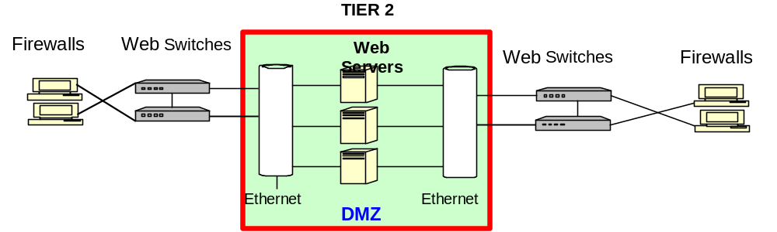
Best Practices e-business Infrastructure Guiding Principles
- Web servers, e-mail servers are placed in a de-militarized zone to filter harmful traffic
- Components are configured for hot fail-over
- Routers and firewalls are redundant
- Additional routers and firewalls can be added to scale capacity
- Routers can be upgraded to support additional topologies

Best of Breed Design Points | Business Benefits | Client | Impact
- Utilize inexpensive machines to deploy web servers | - Balances the investment to the simple level of functionality provided by this tier  - A simplified web server configuration provides the necessary level of function, lower investment and management costs  - Servers are designed to be more expendable, because of their exposure to security attacks  - Lower investment required to develop backup servers that can be easily built and held off-line for horizontal scalability  - Expensive, large, heavy duty servers | - Expensive, large, heavy duty servers | - Larger servers are more costly and more difficult to obtain and replace prolonging upgrades  - Higher value assets exposed to the Internet and unnecessary risks  - Replacement and upgrade is more complex
- Content is common to all servers in this tier | - A common configuration across all web servers, simplifies scalability and systems management because all Internet access devices are the same | - Client is synchronizing the data between web servers through the use of Site Server utilities | - Meets best practices design points for e-business infrastructure  - Systems management is more difficult for Client, because the application business logic is also contained within the web servers  - Updates to the application and the web servers can now affect each other, impacting server availability  - Servers must be maintained through formal change management
- Web servers pass a web request to the application tier to trigger business logic application activity and hand-off the user to an application server | - This technique allows the web servers to handle and screen incoming requests exclusively, optimizing their performance and security effectiveness for these tasks. Application intensive functions are then directed to specialized business logic servers | - Clients applications are consolidated onto the NT Servers in the ASP implementation | - Application servers are placed at the front end and are less secure  - Consolidation of the web server and the application onto a single box limits scalability and can degrade performance
- Content stored at this tier is static and fed from a higher tier | - Increases the efficiency of the web servers | - Static content is stored at Client’s web/application servers | - Meets best practices design points for e-business infrastructure
- User sessions are established and managed by web servers | - Reduces the number of update requests sent to other infrastructure tiers, reducing network and system usage and increasing performance | - Client’s session management is established at the web/application server, but is managed from a database on Canon, which is in a deeper infrastructure tier | - Multi-tier communication places a large computational load on the infrastructure and increases network latency  - The frequency of user requests is increased to Canon, degrading performance and adding unnecessary transactions to the customer experience
- In high traffic environments, LDAP directories are usually installed on separate servers to facilitate and manage user registration and access | - LDAP directory server is a specialized machine that is more easily maintained and optimizes the performance of the tier | - Client’s implementation of access control is on the Web/Application Servers, but is sufficient to meet site volumes | - Meets best practices design points for e-business infrastructure
- In a high volume, highly secure environment, SSL outboard processors may be implemented on the web server or other internet facing components | - Hardware cryptography components can perform SSL functions much faster than software based encoding, thereby increasing performance | - Client’s implementation of SSL is software based, but is sufficient to meet site volumes | - Meets best practices design points for e-business infrastructure
- Application and database functions are not deployed in this tier | - The web server workload is segmented to achieve optimum performance  - Security risks are minimized by eliminating database id’s, user specific information and payment data and placing it in a more secure tier  - Specialized machines allow for faster scaling of the infrastructure | - Client has consolidated application function onto the web servers | - This limits infrastructure scalability  - The web servers reliability will affect and impact application availability  - User, payment and database information are now less secure  - Web server management is more complex
- The tier acts as a demilitarized zone screening and sanitizing potentially harmful data or user traffic with dual firewalls, security and user access criteria | - Harmful data is filtered out  - Multiple tiers of security must be breached in order to access Client’s business and customer data  - Security is managed more efficiently by specialized machines, so performance is increased | - Security between tiers is managed on the routers by using ACL’s  - Intrusion detection is not performed  - Client effectively only has one layer of security | - Clients routers filter some internet traffic  - The routers provide some level of access security  - Router assumes a multi-functional role, degrading performance as ACL pages grow  - Access list can be multiple pages long (30+), delaying packets and consuming router resources  - ACL errors may impact availability  - Systems management is more complex  - Client is unable to detect active hacking efforts
- User access is controlled by the web servers | - Manages access to the application and database servers, providing increased security to the infrastructure | - Web servers establish and manage user access | - Aligns with best practice e-business infrastructure design points
- Web server vertical scalability | - Vertical scalability is the capability to upgrade the processors CPU, Memory or disk capabilities, by either adding resources or upgrading to faster system | - Client’s Web Application Servers are robust enough to provide sufficient vertical scalability options | - Meets best practices design points for e-business infrastructure  - Web servers must now be scaled more frequently and to more robust machines because of application updates  - Server updates are high impact changes and must be maintained through formal change management
- Web server horizontal scalability | - Horizontal scalability is the capability to add additional processing units to the infrastructure, by placing more systems into production  - Simplified web server configurations on low-end machines, allows for additional web servers to be dynamically added to the infrastructure at minimum cost  - Infrastructure capabilities can be expanded to handle greater volumes of requests and increase fault tolerance | - Client’s Web/ Application Servers can be horizontally scaled within the infrastructure.  - Horizontal scaling is likely to be delayed by the cost of the assets and their complex configuration | - Meets best practices design points for e-business infrastructure  - The investment required to upgrade one of Client’s web/application servers requires closer business analysis therefore prolonging implementation of Clients’ current web server configuration  - The application content on the web server would have to be tested and managed as a formal change, prolonging implementation
- Cache user access information in web server memory | - Static information on the servers can be cached to increase performance and avoid database calls that would degrade performance | - Currently Practiced | - Meets best practices design points for e-business infrastructure
- Establish email on a separate server | - Proper implementation of email can significantly increase server security and performance.  - Separate e-mail servers can more efficiently process electronic mail and scrub and verify prior to transmission over the internal network | - Client has implemented the email systems on a separate e-mail server, but only for incoming e-mail.  - Outgoing e-mail is transmitted through the web servers | - Partially meets best practice implementation of e-mail design.
- E-mail should not be sent from web server | - Allowing programs to make systems execs is a security risk. Hackers look for CGI’s that implement system execs | - Outgoing e-mail is transmitted through the web servers | - Implementing e-mail from the web servers places an additional burden on the web servers  - Web server can be exposed to additional risks through electronic mail handling
- Web switches are positioned between web servers and Tier 3 | - Web switches are positioned between the web servers and Tier 3 application servers  - Web switches balance traffic from web servers across a pool of available application servers optimizing performance of app servers and ensuring available resources to users | - Client has no web switches implemented for this purpose today | - Application servers must deal with unfiltered web traffic impacting performance and overloading the application logic with unnecessary requests  - Distribution of user traffic is based on the availability of web server resources and not application server availability  - Client’s infrastructure is not optimized for providing maximum efficiency and availability for user requests
- Firewalls are positioned between web servers and Tier 3 | - Firewalls are positioned between the web servers and Tier 3 application servers  - Implementing Firewalls in the second tier of the infrastructure provides an additional layer of security between the apps servers and the database servers and the internet  - In the event of a security attack, this additional layer of firewall protection can allow the business more time to resist a security, hacker or packet attack and develop procedures to close off the security breach | - Routers and ACL’s are used to block traffic between the web environment and the back-end | - While managing security on the router may be effective, it can also be cumbersome to manage. Also, if the ACL on the router is large, it can reduce the performance of the router  - Routers do not provide comprehensive security protection afforded by firewall systems (e.g. alerts, packet size monitoring, intrusion detection)  - Firewalls can provide this comprehensive protection more efficiently than routers

Tier 3 e-business Infrastructure Design Leading Practices

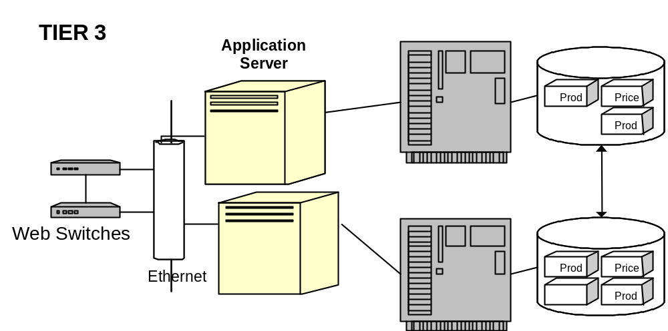
Best Practices e-business Infrastructure Guiding Principles
- Staging environment is created for application and database servers
- Transaction servers interface with Enterprise ERP systems
- Components are configured for hot fail-over and are redundant
- Routers and firewalls are redundant

Best of Breed  Design Points | Business Benefits | Client | Impact
- Database and Application Servers should be large systems capable of handling processing intensive and I/O intensive operations | - The Application and Database servers will perform all the real e-business application work.  - The configuration of these systems should match their anticipated workload and generally the largest servers are dedicated to theses tasks, creating an efficient processing environment | - Client’s application and database systems are large systems | - Client meets design points for a best practices system
- Application Servers and Database servers should be implemented on separate machines | - Application logic is processing intensive. Database operations are I/O intensive and drive different resources on the system.  - Implementing them on separate servers allows the servers to be optimized the specific tasks of application or database operations and improves the efficiency of the infrastructure.  - Deploying these servers as separate components also increases the flexibility of the infrastructure configuration and its scalability. It also increases the resiliency of the network by allowing for multiple fail-over nodes | - Client has placed the application and database servers onto separate processing platforms.  - However, the application logic is intertwined with web server operations, impacting its efficiency and scaling flexibility.  - The database operations are split across multiple databases, creating | - Consolidation of application and web servers onto a single platform inhibits scaling and performance  - Supporting multiple databases on a single system (Canon) undercuts the processing benefit of placing the database on a larger server.  - The database servers are not distributed, so Canon becomes a bottleneck in the system configuration
- All e-business application and database operations that support the completion of an e-business customer transaction are performed in this Tier | - Co-locating the database and the application servers in this enhances business and database logic interaction, by eliminating the constraints of routers, security filtering or additional access devices. It optimizes the efficiency of the interaction between the application servers and the database servers  - Linkage to other systems outside the tier should be avoided. It is inefficient and increases the dependency of e-business application and database components on other systems. This creates the potential for outages or constraints in these linkages that can slow application response or create an outage | - Customer transactions are not completed in this tier and require across tiers and into legacy systems in order to service customers.  - Client’s application servers are consolidated with the web servers in the second tier, so application requests must pass through a router to access database servers  - The application must make calls to the GPS system for application and database operations in order to complete transactions for the Company Z application  - Company X application has implemented GPS databases on Canon server and can complete customer transactions independent of the GPS VMS system | - The additional layers between the application servers and the database systems, (routers and Gallery) diminishes performance efficiency by increasing processing overhead and response times for each operation between application logic and databases servers  - Performance and efficiency of the design are undercut for Company Z by the application and database calls it must make to the GPS system on VMS (Tier 4). These efficiencies have become apparent in the number of outages and processing slow-downs that the GPS legacy link has been implicated in
- Application and Database servers are insulated from web servers and mainframe systems by additional layers of firewalls | - Firewalls between the application/ database servers inhibit intrusion from web server layer and the risk of unwanted access  - Legacy systems generally handle more secure transactions and contain confidential data that the e-business application layer will not. Therefore, a best practices solution will insulate the Tier 3 e-business components from the legacy environment with a firewall system | - Routers with ACL pages are utilized to filter access to the third tier and the VMS systems | - ACL of routers may not inhibit unwanted access or malicious tampering with VMS system  - Routers are not optimized for performing security functions and cannot provide the full range of security functions that are incorporated into firewalls (e.g. Intrusion detection, Packet size restriction, alerts)
- Large specialized systems dedicated to processing business logic | - Intensive business logic processing requires larger scale systems for processing, so dedicate systems to application logic enhances performance  - Specialized systems can be more easily scaled within the infrastructure within the infrastructure | - Application servers are combined with the web server | - Server performance is shared with web server systems and not optimized for application servers.  - User requests are allocated by web server availability and are not distributed based on application processor availability
- Specialized application servers dedicated to special user communities (Extranets) | - The members of Extranet communities are usually known, allowing for their members to be directed towards systems dedicated to servicing the Extranet.  - Distributing Extranet communities to specialized processors allows performance and capacity to be more predictable and provides assured levels of service, performance and availability to these communities | - Client currently identifies and routes AOL traffic to dedicated servers to improve performance  - No special handling is done for Extranet community members | - Client meets best practices design points for e-business systems, but…  - An opportunity is missed to provide a guaranteed level of performance to Company Z members
- Avoid sharing e-business logic processing across multiple platforms, especially interaction with older applications that  - support other business applications  - are batch processing oriented  - are not real-time oriented  - have capacity constraints  - or contain confidential data | - Splitting E-business logic processing between multiple application platforms can prolong completion of a transaction and delay user response.  - Placing all e-business logic at the application server allows user to complete a transaction at a single resource and improves performance and the timeliness of transactions for consumers  - It is easier to scale a single point of presence for e-business logic than attempting to scale multiple application e-business application modules distributed across multiple processing platforms | - Company Z application logic is split across the Company Z NT servers and the VMS GPS system. A transaction processing must occur on both systems to complete the processing of a customer request  - Company X migrated application function of the GPS system | - Company X meets the design points for best practices e-business applications  - Company Z transaction completion will be prolonged because of interaction between multiple processing platforms  - Company Z availability is directly dependent on the GPS system and exposed to the inherent weaknesses, bottlenecks or outage prone aspects of its design  - Transaction requests to the GPS systems are bottlenecked and have caused outages and delays in Company Z transaction processing
- Vertical Scalability | - Application servers should allow for additional CPU, Disk or memory capacity to be added dynamically | - NT Servers have capability to have additional resources | - For Company X, Client meets best practices design points for e-business systems  - Scaling Company Z processing logic will require analysis and balanced scaling of the NT Server, VMS and network, Gallery and router component. This complicates scaling and will prolong rapid improvements to availability
- Horizontal scalability | - Scaling of the infrastructure is enhanced by specialized machines with segmented function, allowing additional application servers to be brought into service as needed to increase availability and performance of the solution | - For Company X, NT servers can be horizontally upgraded.  - For Company Z application is also linked to the VMS system, which must be scaled in a corresponding manner to accommodate the additional capacity added to the Company Z NT application servers  - Client has consolidated the web server functionality onto the application server functionality, creating a more complex system to horizontally upgrade | - For Company X, Client meets best practices design points for e-business systems  - Scaling Company Z processing logic will require analysis and balanced scaling of the NT Server, VMS and network, Gallery and router component. This complicates scaling and will prolong rapid improvements to availability  - Scalability complexity is increased by the consolidation of the web severs and the application servers  - Application upgrades now impact Web Server performance and availability
- Database systems are segmented onto separate platforms from the other e-business functions | - Database operations are processing and I/O intensive, due to the high system requirements of relational databases.  - Dedicating a separate server to database functions optimizes their performance and availability. It simplifies scalability | - Application and database function has been segregated | - Meets e-business best practices design points
- Database Servers are located on high performance systems | - Providing database systems with sufficient capacity will optimize other aspects of the e-business solution | - Client has deployed a SUN 6500 processor to server as the database platform | - Meets e-business best practices design points
- Distribute Database functions across multiple servers | - Distributing databases across multiple servers increases their resiliency and their resource availability for application servers  - Placing the database servers in the same functional tier as application increases efficiency of transaction processing  - The infrastructure flexibility is increased and with it the ease of scaling for performance | - The majority of databases are consolidated onto the Canon platform  - Order information is contained on magnum server  - Additional GPS data must be retrieved from VMS systems for Company Z.  - Company X’s database has been relocated on canon  - Wojo implementation was expected to provide additional capacity to the system | - Canon is a single point of failure  - Magnum is also a single point of failure  - Databases are located across multiple systems, not distributed (i.e. all databases on single platforms) making scaling more complex  - Wojo implementation plan will address redundancy, but not scalability or continuous availability  - Application changes will be required to support distributed data functionality  - Multiple locations of databases undermines scalability of database server, making it more complex
- Utilize system caching to aggregate commonly accessed data for applications or static content | - Caching is the ability to store most commonly accessed information and data so that it can be accessed and used by multiple users in a rapid and timely manner | - Cache is utilized by Gallery to handle database requests | - Client meets best practices design points for e-business systems
- Batch requests between application servers and database servers | - Minimize interaction between application and database server with fewer calls | - Company Z and Company X designs request resources as needed and perform little to no batching of queries or resources requests | - Frequency of requests utilizes excessive infrastructure resource
- Implement distributed database servers that support sets of application servers | - Brings the data into closer proximity to the application servers using it.  - Allows data to be more readily available to the application servers, distributing the processing workload and improving performance.  - Increases the resiliency of the system | - One primary database server, Canon, services application servers at Client.  - Canon manages the majority of the databases and receives the majority of the application calls, because its Gallery application routes these calls to the appropriate databases on Canon or distributed systems  - Gallery has the capability to manage distributed databases and could perform this function for Gallery and new Wojo server. However, Company Z and Company X application changes would be required to implement this design | - Gallery is a single point of failure that can and has impacted availability  - Database drivers within Gallery are shared among databases, creating single points of failure within Gallery that can impact Gallery  - Data bases are not distributed in close proximity to the application servers, impacting performance  - Multiple databases must be called to service an application, increasing latency, wasting resources  - Wojo server implementation will only increase the redundancy of the applications, when it could scale the performance as well
- Database servers utilize caching and request batching techniques improve performance | - Caching stores often requested data in memory allowing database servers to respond to data requests more efficiently. This improves processing performance  - Batching requests consolidates the number of calls to the database, conserving system resources and optimizing performance. This prevents bottlenecks from occurring at key resource points (database, network) and improves availability | - Client has implemented some caching at Gallery and some of the databases on Canon that support | - Client’s overall performance could be improved with a more effective use of caching and relocations of some data resources to the front-end on cache servers. Hitlist and Cust databases are examples of resources that could be relocated
- Horizontal Scalability | - The ability to add additional database servers to the network dynamically as demand grows. This ensures the scaling of the databases servers on the network to meet growing availability requirements | - Client does not have horizontal scaling capability today for the database servers. The number of databases requiring support and application considerations inhibits horizontal scaling  - Gallery has the ability to distribute data requests over multiple servers. However, other application changes are required to fully implement a distributed database schema that can be easily horizontally scaled | - The database design is not as resilient as it should be in a best of practices environment  - Availability is negatively impacted, because Client cannot add database capacity or have extra capacity available to the application servers during peak periods  - Company Z’s linkage to the GPS/VMS system also complicates its scaling. As capacity is added at database servers, corresponding capacity must be added to GPS/VMS systems and networks to ensure balanced processing
- Vertical Scalability | - The ability to add additional resources to database servers dynamically to improve their processing capabilities | - Client has the capability to upgrade the memory, processors and the data storage for the Sun 6500 | - 6500 hardware meets with e-business best practices design criteria  - The scaling of Company Z is complicated by its linkage to the GPS/VMS system. As capacity is added at database servers, corresponding capacity must be added to GPS/VMS systems and networks to ensure balanced processing
- Perform specific, performance intensive tasks for e-business application | - Specialized transaction servers can off-load tasks requiring high-performance processing from the e-business application servers. This increases the performance of the application servers and optimizes the performance of the overall networks  - However, this should be a specific focused application task that requires a specialized high-performance environment for processing. If the function can be performed on the application server with no impact to performance, then a distribution of the application logic can degrade performance | - Company Z shares its transaction processing with the VMS/GPS system. Application calls to this system are integral to the completion of Company Z transactions  - However, the application function on the GPS/VMS system is not a specialized task that should require a special function. In other implementations, the GPS/VMS systems functions have been distributed to e-business servers (Company X, e-tailer solutions)  - Company X does not distribute its application function to other servers | - Company Z’s call to the GPS/VMS system add an unnecessary application call to transaction processing  - During high volumes, this dependency becomes a bottleneck, impacting the performance and availability of the Company Z application
- Optimized for high performance and real-time response or designed to provide post-transaction support | - If the high-performance transaction server must be completed in real-time (i.e. integral to the completion of transaction)  - Otherwise the transaction should be positioned to accept completed transactions and prepare them for insertion into the Enterprise fulfillment system. Utilizing the transaction server in this way off-loads the impact of closing out orders and negotiations with the Enterprise systems to another server, thereby improving performance to e-business servers directly serving customers | - The VMS/GPS system is not optimized to perform high volumes of Company Z transactions in real-time  - Nor has it been designed to accept the transactions in a post-transaction processing mode. Each transaction must call the GPS/VMS system to perform shopping for customers  - Company X does not distribute its application function to other servers | - During high volumes, this dependency becomes a bottleneck, impacting the performance and availability of the Company Z application
- Horizontally Scalable | - The ability to add additional transaction servers to the network dynamically as demand grows. This ensures the scaling of the transaction servers on the network to meet growing availability requirements | - Adding capacity to the GPS/VMS system would require adding an additional VMS system to the cluster  - This is a costly decision requiring business analysis to make and requires some care in its implementation  - Company X does not distribute its application function to other servers | - Scaling the GPS/VMS application horizontally cannot be done easily or without careful analysis. This prolongs upgrading capacity to resolve availability issues  - Nor will scaling address inherent application connection limitations, which must be redesigned to effectively overcome their design constraints
- Vertically Scalable | - The ability to add additional resources to transaction servers dynamically to improving their processing capabilities | - Additional capacity can be added into the VMS system to improve processing capacity. However, these changes would require careful coordination and control as they impact a core-processing system  - Company X does not distribute its application function to other servers | - Adding additional capacity to the GPS/VMS system cannot be done easily or without careful analysis. This prolongs upgrading capacity to resolve availability issues  - Nor will scaling address inherent application connection limitations, which must be redesigned to overcome their design constraints
- Firewalls are positioned between e-business systems and Enterprise system platforms in Tier 4 | - Firewalls prevent traffic from going past the web server farm | - Routers and ACL’s are used to block traffic between the web environment and the back-end. Since there is only one server in the middle tier, the Gallery server, load balancing cannot occur and the application server is the same as the other | - While managing security on the router may be effective, it can also be cumbersome to manage. Also, if the ACL on the router is large, it can reduce the performance of the router  - Routers do not provide comprehensive security protection afforded by firewall systems (e.g. alerts, packet size monitoring, intrusion detection)

Tier 4 e-business Infrastructure Design Leading Practices

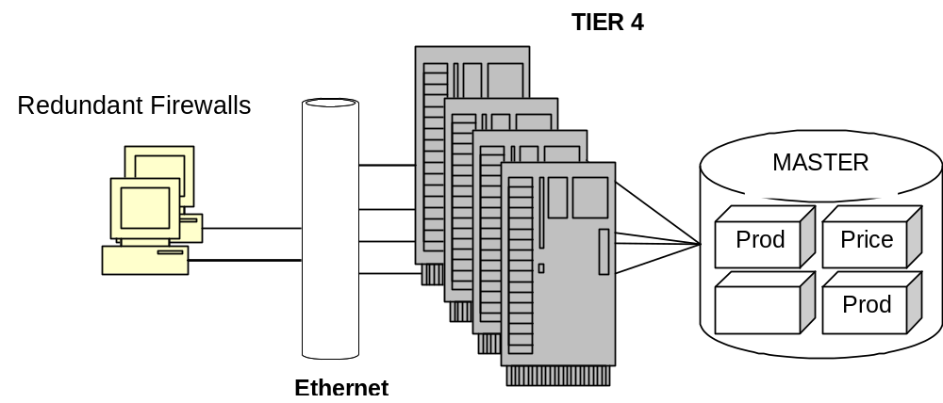
Best Practices e-business Infrastructure Guiding Principles
- Tier 4 should not be integral to the completion of e-business transactions
- All resources in Tier 4 critical to e-business transactions should be migrated to e-business applications servers or transaction servers for high performance
- All data essential for e-business transactions should be pushed forward onto distributed database servers that can directly service e-business application servers

Best of Breed  Design Points | Business Benefits | Client | Impact
- Migrate all application and database logic onto e-business servers | - Allows e-business systems to operate in a self-sufficient manner and complete customer transactions without invoking application or data logic on Enterprise systems this reduces processing overhead, increases performance and availability  - Scaling is simplified because Enterprise systems processing capacity is not central | - Company X’s function has migration to Canon and other database servers  - Company Z must still make application and database calls to GPS system to complete processing | - Company X meets e-business best practices design points  - Company Z’s performance and availability are impacted by its dependency on GPS systems located on VMS  - Scaling Company Z is more complex because the impact of additional capacity on GPS/VMS must be assessed and addressed
- E-business systems should be designed to front-end Enterprise systems and comprise customer  - Transactions without dependency on enterprise systems | - This loosely coupled approach allows e-business systems to optimize their performance without the need to redesign the legacy environment | - Company X has implemented this design principles  - Company Z is dependent upon application logic in VMS system to complete transactions (credit cards) | - Company X meets e-business best practices design criteria  - Company Z’s dependency on enterprise systems diminishes performance and inhibits scalability
- All enterprise system database should be distributed onto database servers supporting e-business application severs | - This allows critical data to be distributed in close proximity to e-business application servers improving performance and availability | - Company X has implemented this design principle  - Company Z has not distributed all data towards application servers | - Company X meets e-business best practices design criteria  - Company Z’s dependency on enterprise system’s diminishes performance and inhibits scalability
- Perform fulfillment and settlement functions | - Fulfillment, settlement and other “back-end” functions are not integral to e-business processing.  - Allowing enterprise systems to perform them optimizes e-business processing and scalability | - Company X has this design point, allowing fulfillment, settlement and credit processing to be implemented by VMS enterprise systems  - Company Z also allows fulfillment to be performed offline by VMS enterprise systems. However, transaction processing and credit card processing are performed in conjunction with e-business processing | - Company X meets e-business best practices design point  - Company Z’s performance availability and scalability are negatively impacted

Revision History
Revision Number | Revision Date | Summary of Changes | Changes Marked?
1.0 | 12 Nov 2001 | Initial Version

