

IBM Global Services

Application Data Design - Developing Data Models

Technique Paper (TP)

© Copyright International Business Machines Corporation 2001, 2004

All Rights Reserved
Version 4.1.1, March 2004
- Description
The purpose of this paper is to present fundamental concepts to structured data design for use as part of an application development effort. The topics discussed in this paper are done from a broad perspective and hold for most business applications.
Topics related to specialized data design considerations such as dimensional data design techniques needed in many data warehouse projects are not covered in this paper. Nor are Enterprise Models (EMs) covered in this paper. Enterprise-wide modeling is a vehicle by which strategic planning for an enterprise can be accomplished. An EM’s purpose and intent are much more germane to aligning processes, information, and technology with the overall business directions of an enterprise rather than supporting a specific set of business processes associated with a given application. An enterprise model can serve as a high-level overlay to which the models discussed in this paper can be mapped, but is not mandatory in being able to create them.
While this paper may present data design principles primarily from the context of developing a new, from-scratch application, elements of the discussion equally apply to other types of projects in which data design efforts may be a part. Examples of other projects in which these concepts may apply include but are not limited to data conversion/migration projects and application enhancements/modifications. The extent to which they apply to any given project will vary per each project’s scope definition and the degree to which data is relevant to the activities to be accomplished within that scope.
All the topics covered in this paper have strong affinity to development efforts where process and data design are not encapsulated and treated as strongly bound aspects of an application. This separation of process and data design is a core tenet of data design methodologies where they each are operationally viewed as separate but codependent disciplines. It is based on the viewpoint that, in relative comparison to one another, data – if properly designed – is less sensitive to change than processes over time. If the data design is too strongly aligned structurally to the processes it supports, it then too has the same relative degree of vulnerability as the process regarding change. Such was the case with the designs created prior to the emergence of data design methodologies. Consequently, one of the main objectives of data design is to ultimately support applications with data structures that not only support the application’s processes at its inception but continue to do so with nominal impact from changes time will bring,
This viewpoint at first glance may seem at odds with object-oriented (OO) development principles. However, OO modelers may benefit from this paper as many core data design concepts transcend physical implementation concerns and have comparable representation in OO class diagrams. In fact, in some OO development projects the OO class diagram serves as a starting point for data designs ultimately targeting non-OO databases. However, any commonality between OO design and data design concepts is tangential and is not a focus of discussion in this paper.
This paper’s topics are listed here and are presented in the following order
- Data Design Overview – Describes the overall purpose and broad understanding of data design.
- Data Models – Introduces the types of data models developed and their relationship to one another.
- Entity Relationship Model (ERM): The Foundation Data Model – Discusses the most fundamental building blocks comprising a data model and the notations used in data models to convey information about the data it depicts.
- From Entity Relationship Model (ERM) to Conceptual Data Model (CDM) – Presents the analysis applied to resolve many-to-many relationships in an ERM to progress data design to a CDM.
- From Conceptual Data Model (CDM) to Logical Data Model (LDM) – Discusses the analysis applied via normalization rules to a CDM to progress data design to a LDM completing Logical Data Design.
- From Logical Data Model (LDM) to Physical Data Model (PDM) – Generically overviews items pertaining to the transformation from logical to physical data design.
- Standard Entities – These are conceptual entities that appear across many industries and can be used to frame the discussion of data for a specific application.
- The Cross Industry Data Model – These are structured, logical depictions of data using the data design concepts and standard entities discussed in this paper.
- Data Design Development Summarization
- Data Design Overview
Data design is an integral part of the application development process. It is an uncommon application that does not have data as a key element in its ability to deliver business function.
The approach by which data design is achieved is through the use of models. Data models pictorially show the data components comprising and supporting a given application and its processes along with the key interactions/interdependencies that exist between those data components. Since modeling is at the core of data design, data modeling has become the generic name used to reference data design activities.
It is important to stress that while data may be at the core of data design activities, achieving good data design requires strong and on-going teaming with application process/logic designers throughout the development cycle. Data design and application process/logic design are intrinsically and unalterably dependent on one another and affect one another. Additionally, both parties – data designers and application process/logic designers – must engage the application’s business users throughout the development cycle to assure, validate, and verify that they jointly deliver end products supporting the business.
While the intent of data design is to ultimately manifest a data model in the form of physical data constructs occupying disk space in the form of a database or sets of data files, considerations as to the target physical implementation are not factored into data models until late-phase design activities. This is important to keep in mind as it means the principles presented apply generically to the design of data regardless of how it ultimately is physically implemented. Independence from physical implementation considerations in early-phase data models enables them to be flexible yet stable in support of business processes and open to any target form of physical data store – flat files, hierarchical databases, relational databases, networked databases, etc.
Throughout the development cycle, data models serve as key communication vehicles between and across both business and technical users
- In understanding the business nuances of data,
- To verify the comprehensiveness and completeness of the data defined to support an application,
- As one of the fundamental tools by which knowledge and insight to an application’s processes and underpinnings can be gained.
- Data Models
As with application logic design, data design evolves over the course of an application’s development cycle. This inherently means data models are not static. The information they convey and the depth of that information progresses from a high-level to a deep understanding of the application’s data. This represents the progression of a data model in the development cycle and is illustrated in the following diagram.
Figure 1 – The Progression of a Data Model Development
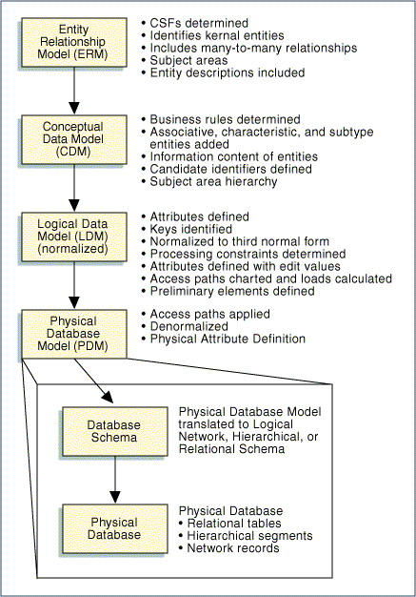
This paper primarily addresses logical data design which is the accumulation of ERM, CDM, and LDM activities. Physical modeling tends to be both product and release specific and is thus addressed at a more generic level.
As Figure 1Error: Reference source not found above shows, the models developed in data design build on one another. In fact, the progression of a data model through the development cycle represents the different transformation states a data design undergoes. This is important to remember. Each progression step represents an increased level and depth of understanding of an application’s data and the means by which it will be used. The data model-type names used to reference these progression steps have a specific connotation as to the degree of understanding attained in the data design versus being totally unique and separate data models onto themselves. With most data modeling tools, one data model exists and these model-types – these transformation states or close approximations to the type of information conveyed in these models – correspond to logical views/overlays over the facts and details contained in the data model.
What this diagram also conveys is that good data design does not stem solely from a business or solely from a technical understanding of data but from both. One can not, for example, develop a physical data model without having applied the analytical processes represented in the prior data model progressions.
The Purpose for the Types of Data Models Produced
- Entity Relationship Model (ERM); presents a high-level view of the significant information of interest to the business and establishes the foundation from which data design will progress in the development cycle.
- Conceptual Data Model (CDM): depicts a high level statement of the main entities needed to support an application, along with known (but not necessarily complete) listings of the attributes associated with the entities in the data design.
- Logical Data Model (LDM): is an implementation-independent normalized data model and generally represents the final deliverable in the logical data design efforts of a project. Completion of the logical data model also includes the completion of data dictionary information – whether represented as part of the data model itself or in other metadata-type repositories.
- Physical Data Model (PDM): The LDM is used as input to create an implementation-oriented model specific to the target database environment (relational, hierarchical or network). The LDM is converted to a model containing records and navigation links based upon the selected database management system (DBMS) and per performance requirements. Definitions of DBMS parameters and actual DBMS schema, including data definition language code, for direct physical implementation are produced as the final activity of physical data design.
Data Modeling Languages
Many data modeling languages exist and all are not universally supported by the various software modeling tools available in the marketplace. No convergence of these languages has occurred to define a governing set of concepts (e.g., a standard of language element concepts) to which data modeling languages must adhere. Nor is there hard-set standard terminology for data modeling concepts, though most of the core concepts do have universally accepted names.
Consequently, some of the topics discussed in this paper can be known or referred to via terms/names other than those used in this paper. Accordingly, it also means all concepts discussed in this paper are not explicitly expressed as language elements in all data modeling languages. Likewise, when explicitly expressed in a language, the syntax and semantics (graphical notations/symbols) used to present them vary from having elements of commonality to being quite distinct.
While such is the state of data modeling terminology and the languages supporting it, the concepts discussed in this paper universally apply to data design whether explicitly or implicitly supported by the language being used in the software tool to graphically depict the data model.
The concepts presented in this paper are primarily illustrated using Information Engineering (IE) data modeling notations. Some examples illustrate concepts using other language conventions, particularly when IE does not offer an explicit, distinct language element for the concept. Most of these are based on notations defined for CASE Data Interchange Format (CDIF).
Data Design Development
Data design is accomplished using a combination of top-down and bottom-up data analysis. As with top-down application design, top-down development of data models progresses from a high-level of abstraction to a lower-level of detail through each phase of the development cycle Its basis of understanding starts from a business perspective and increasingly adds details toward a technical implementation perspective. Bottom-up data analysis is needed when the basis of understanding stems from existing data constructs in the form of inputs, outputs, processing documents and/or pre-existing data designs and implementations. It starts from a detailed level of understanding and extrapolates toward an abstract, business level of understanding data. The degree to which either approach is used will vary per given application development effort based upon the knowledge and materials from which the data required by an application is derived and identified.
Whether top-down or bottom-up, like application design data design has concepts and techniques akin to functional decomposition in developing data models. Resolution of many-to-many relationships and normalization are among the key techniques in developing data design and are discussed later in this document.
Frequently, data design as associated with an application development effort is planned as simply logical data design and physical data design. Respectively, the development of a Logical Data Model (LDM) and the development of a Physical Data Model (PDM) have become strongly aligned with each of these data design levels such that little distinction is made between the level and the model.
Logical data design generally represents the culmination of progressing a data model from its ERM, to its CDM, and to its LDM. It does not mean, per se, that an ERM and CDM are not developed. It is important to remember that the scope and depth of data design developed – and accordingly, the type(s) of data models created - is governed by the project’s scope.
In many cases, the information conveyed in the ERM, CDM, and LDM stems from information that, while aligned as part of one of the models, is intrinsically and naturally understood or viewed as a whole or as strongly related to one another by its users. Therefore, the information conveyed in these models tends to be disclosed or discovered simultaneously rather than via the delineation by which it is presented in the models. Consequently, information gathering for these models is often planned as being performed with some level of parallelism and as activities under the over-arching activity of logical data design.
- First the ERM is developed and serves to
- Establish a framework for subsequent detailed data analysis
- Provide a context for process analysis
- Confirm the overall scope of a project
- The ERM is expanded creating the CDM. This is generally done from a top-down point of view, adding more detail, such as:
- Associative entities
- Characteristic entities
- Supertype/subtype entities
- Existence dependencies
This work is closely integrated with process definition in a system development project.
- Bottom-up (canonical synthesis) techniques can be applied to the CDM to fully normalize its entities and to ultimately create the LDM.
The intent is to develop an initial logical depiction of an application’s data in the CDM using the top-down analysis of the business and then confirm and validate the model using the bottom-up assignment of data.
Though this progression is diagrammatically shown and discussed as a cascading serious of steps, the delineation between these steps is not that clear-cut. In reality, the different portrayals of the data design as depicted in these models will expand, contract, and interplay with one another as a deeper understanding of the data is gained throughout development.
Application Component Naming and Numbering
Good naming standards and adherence to them is extremely important in achieving definition and control of the information resources of a business. Unfortunately, many existing systems do not exhibit consistent naming across their many components. It should be possible to tell what an application component is, and be possible to distinguish it unambiguously from other application components purely via its name.
The naming and numbering standards and conventions adopted by an organization for its applications and systems to identify items such as data names, program names, and files are influenced by a number of factors, including the following:
- Existing installation standards
- Operating system requirements
- The use of a design and development tools
- Development languages used
- Package software standards
As a general rule, a balance needs to be reached between developing a structure that is
- Meaningful
- Imposes some controls on the user
- Readily understandable
- Still flexible enough to be expanded to accommodate new requirements as these are defined
It is also important to be as consistent as possible. This process should greatly assist future application component maintenance if the standards make it easier to understand the system.
Naming conventions may be dictated by specific design and development tools used on a project per their functionality and features.
If no naming and numbering standards or guidelines exist, they should be established for the project.
- Entity Relationship Model (ERM): The Foundation Data Model
The objectives of this section are to describe basic data modeling concepts as represented in Entity Relationship Models. These models are also referred to as Entity Relationship Diagrams (ERDs) and the terms are used interchangeably.
The Building Blocks of Data Models
There are three fundamental data model building blocks used to depict data design -
- Entities
- Attributes
- Relationships
These are the names generally used to refer to the items and notions depicted in data models. They particularly apply to models for which no physical implementation considerations have been factored. As such considerations are applied to the design toward defining its physical implementation, the nomenclature used to refer to these building blocks alters toward names aligned with the physical data constructs to which they are targeted. For example, an entity may be referred to in such models as a table, a file, or any other equivalent construct; an attribute as a field, data element, column, or similar such concept; a relationship as a referential integrity rule.
This shift in nomenclature is offered here for analogy purposes in understanding these data model notions. Using these terms before reaching this detailed, technical implementation level of data design is incorrect as the composition of entities, attributes, and relationships depicted in earlier models do not each directly correlate to physical data constructs. This is attributable to the abstract view of data early-phase data models represent.
Entities
Entities are identified via top-down and bottom-up data analysis. They represent something – a person, place, item, event, etc. - of significant interest to the business or organization requiring identification via name or description. They can be conceptual or physical; digitized or not digitized; tangible or intangible; or associated with automatic or manual processes.
Entities are given noun names and usually represent static objects rather than dynamic processes or activities. These should be singular nouns chosen to describe the basic business notion. Examples of entity names include: EMPLOYEE, SHIPMENT, RESERVATION, INVOICE, PART, and CUSTOMER. Modifiers may be used to further classify or clarify the business notion an entity represents. Examples include: PURCHASE ORDER, SHOP ORDER, HOTEL RESERVATION, UNION EMPLOYEE, and AIR SHIPMENT.
Top-down analysis begins with business knowledge usually obtained through process definition or business rule development. Development of business rules involves the following:
- Acquisition of rule information from interviews, JAD sessions, and business documents
- Analysis of information forming concise business rules
- Validation of the rules with the source of the rule and other effected functional area representatives
Business rules are then translated into data model constructs. Entities are identified from nouns in the rule sentence structure.
When identifying entities using top-down analysis, care should be taken to address only objects that clearly meet the definition of an entity. Things such as listings, computer reports, paper forms, or other output-related objects are usually not entities (e.g., a schedule may be identified as an entity when in fact it is a listing containing attributes from a number of entities such as flights, work orders, or tasks, each of which has schedule dates as attributes). Therefore, in these types of cases, SCHEDULE is not an entity.
In bottom-up analysis, individual data (identified from existing documentation of reports, screens/windows, databases, etc) are aggregated into groups and organized to form entities based on common characteristics and usage. The results are then refined using a set of rules known as normalization. Normalization is discussed in another section of this paper.
Using IE notations, an entity is depicted as a rectangular box having the entity’s name placed immediately over the box as is shown in the following figure.
Figure 2 – A Data Model Entity
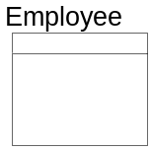
Before continuing the discussion it is important to introduce the notions of type and occurrence as relates to objects depicted in a data model.
Type refers to the classification of data - independent of value.
Occurrence refers to a specific value of a classification of data. The term instance is sometimes used instead of occurrence, and to aid in understanding this notion, from a physical implementation perspective, correlates to the notion of a record in a file or a row in a table.
For example, PURCHASE ORDER is an entity type of data classification, while "purchase order number 15327" is a specific occurrence of PURCHASE ORDER.
Generally, items depicted in data models refer to classifications of data (e.g., types) not their specific values (e.g., occurrences).
Figure 3 – Data Model Notions of Type and Occurrence
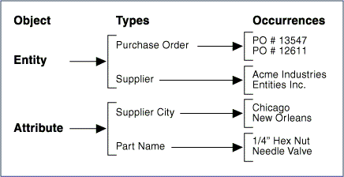
The number of occurrences an entity may have should be estimated and may also be shown on the data model, as well as entered into the data dictionary. This information is useful later in the design process for estimating the size of the database. Specifically how this information is captured and depicted in a data model varies across the data modeling tools available in the marketplace.
An entity ID number is required in some automated data dictionaries so that the name of the entity can be modified without affecting other connections between that entity and other dictionary objects (e.g., attributes and relationships). This number can be used to show ownership of the entity by particular projects or corporate data administration (e.g., entity IDs beginning with 5XXX might belong to a particular project).
Figure 4 – Sample Depiction of an Entity with Occurrence and Identification Numbers
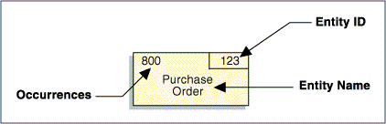
Entities must have definitions and these should be retained in the data dictionary. Their definitions should be as precise as possible and include information regarding different classifications of the entity (e.g., different types of customer orders). Where possible, the entity should be described on its own and not in terms of relationships with other entities. Characteristics that make an entity distinct from other entities should be described, as well as, the criteria for identifying the entity. How and when the entity is created should also be described.
Clear entity definitions can often be difficult to achieve. However, these are very important to the success of the data design. It is not unusual for definitions to be continuously modified as the data design evolves from ERM to CDM and LDM.
When producing a data model for multiple business processes, an individual should be designated are the controller of the definitions for the entities. Typically, this person is the Data Administrator (DA) for the organization. Repository-based tools designed for multi-user access can often assist the DA in maintaining the integrity of the data model.
Types of Entities
There are two classifications of entities:
- Kernel or Independent: An entity representing a business object that stands alone and is not dependent on any other entity. CUSTOMER, SUPPLIER, and PART are typical examples of this type of entity.
- Dependent: An entity that depends on the existence of one or more other entities for its identification. These entities are further classified as
- Associative: An entity that represents the multiple association or intersection between two or more other entities. PART-SUPPLIER, representing the association between a PART and a SUPPLIER, is a typical associative entity.
- Characteristic: An entity that describes some characteristic of a kernel entity. A purchase order line item is a typical characteristic entity.
Kernel entities should be identified when the ERM is developed. Associative and characteristic entities are generally depicted and identified as part of progressing the ERM to its CDM. They are each further discussed as part of CDM development in the next section of this paper.
Attributes
Each entity in a data model will eventually contain attributes. An attribute represents a single unit of data describing the entity (e.g., the attributes of EMPLOYEE would include NAME, ADDRESS, BIRTH DATE, and JOB TITLE). The attributes defined for an entity and the details provided for them evolve as the data model progresses through the development cycle.
Following IE notations, attributes are listed in the bottom portion of the rectangular box depicting an entity as is shown in the following figure.
Figure 5 – Attributes Specified in a Data Model
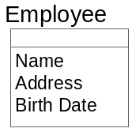
As the primary intent of an ERM is to establish scope and the framework for the development effort, its focus is entity identification and definition. Attributes provided in the ERM for entities tend to be those of most interest to the business. They consequently are initial, but incomplete, attributes listings. Fuller attribute lists will be associated with the entities as a greater depth of the business and the application processes along with the data needed to support them is gained throughout development.
Attribute Naming Guidance
An attribute name should
- Be logical; it should describe what the element is rather than how or when it is used.
- Not include physical mechanics such as file codes or storage IDs.
- Always be singular.
- Be composed of the following:
- A noun word describing the category (e.g., ID, NUMBER, NAME, DATE, TIME, CODE, DESCRIPTION, AMOUNT).
- A key descriptor word. This noun word serves as a modifier to the category word and is similar or the same as entity noun names (e.g., PURCHASE ORDER, INVOICE, PART, SUPPLIER, EMPLOYEE, ACCOUNT, WORK ORDER, and RESERVATION).
- Modifier words as necessary, to fully qualify the attribute (e.g., START, END, MONTHLY, YEAR-TO-DATE, MINIMUM, and MAXIMUM). It is important that these modifiers are used consistently.
Keys
Initially, no significance is placed on the attributes listed for an entity. As the model progresses from an abstract to a more detailed representation of the data design, it becomes important to designate the attribute(s) that uniquely distinguish one occurrence of an entity from another. Such distinction may be via one, or a concatenation of many, attributes. It is also possible that multiple means exist by which occurrences of an entity may be distinguished from one another.
An attribute or concatenation of attributes that can provide the ability to distinguish entity occurrences are generically referred to as Keys. A key defined via the concatenation of multiple attributes is called a Composite Key.
The different keys available to distinguish occurrences for an entity are called Candidate Keys.
Primary Keys
The candidate key by which an occurrence for an entity will be identified is called the entity’s Primary Key. Each entity ultimately must have a primary key to uniquely identify an occurrence of the entity.
Sometimes more than one possible primary key exists among the candidate keys. Each possible primary key must be evaluated to determine which should be the actual primary key (e.g., VENDOR NUMBER and VENDOR NAME might both suffice as a primary key to the vendor entity). To select the best primary key, the following questions should be considered:
- Do all candidate keys uniquely identify the entity?
- Is it possible that different entities are being considered?
- Which of the candidate keys is the most stable and will maintain its uniqueness in the future?
NAME is rarely used as a primary key as it likely will not provide uniqueness across the possible values it represents. Even where such values are found to be unique, it is rare such uniqueness can be maintained over time without the data design impinging on the values used. That would represent poor data design.
Sometimes composite keys can become overly long in length or in the number of attributes comprising them posing complexities in data access.
Where uniqueness is not strongly inherent in the attributes the business has selected as a key or where its composition poses access complication, an attribute solely defined for the purpose of assuring uniqueness or to reduce access complication is created. Such a key is called a Surrogate Key. Examples of such surrogate keys include EMPLOYEE NUMBER for EMPLOYEE and ORDER ID for PURCHASE ORDER.
A surrogate key may be designated as the primary key for an entity. This does not countermand the role the attributes comprising the “natural” primary key play in enforcing occurrence uniqueness for an entity. In many cases, the users perform their processes using the “natural” key and its corresponding surrogate key is generated and only known “behind the scenes”. Consequently, it is important to understand the correlation between a surrogate key and its underlying “natural” key as they each relate to supporting the rules governing data for the application’s business functions and processes.
Following IE data modeling notation, an attribute or concatenation of attributes comprising an entity’s primary key are segregated from the other attributes describing an entity and listed in the top box the entity.
Figure 6 – Sample Specification of an Entity’s Primary Key
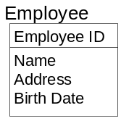
Foreign Keys
Data comprising the primary key of one entity can exist as attribute(s) in another entity whether as part of that other entity’s primary key or not. Such data is referred to as being a Foreign Key in an entity. An entity may contain multiple foreign keys. If the foreign key is part of a concatenated primary key, it is called a primary foreign key.
Using IE diagramming syntax, foreign keys are designated via a “(FKn)” notation following each attribute comprising the foreign key. The “n” in (“FKn)” represents a number distinguishing one foreign key from another – the first foreign key being “(FK1)”, the next “FK2)”, etc.
Figure 7 – Sample Specification of a Foreign Key in an Entity
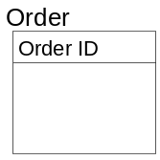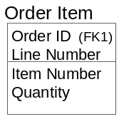
Entities having foreign keys generally have a data dependency on the entity from which the data represented by the foreign key is a primary key. Such entities are referred to as dependent entities. These dependencies tend to be intrinsically hierarchical in nature. The entity for which the data is a primary key is referred to as the parent entity and the entity for which the data is a foreign key is referred to as the child entity. The association between two such entities is hence referred to as a parent-child relationship. The business rules governing how these entities interact per their data dependencies are encompassed in the concept of Referential Integrity.
Relationships
A relationship is a two-way connection between two entities expressing a link between them that is of importance to the business. Typically, relationships can be described in terms of verbs. Since entities are nouns, a short sentence can be constructed using one entity noun as the subject and the other as the object with the verb in the middle (e.g., a PURCHASE ORDER is placed with a SUPPLIER. PURCHASE ORDER and SUPPLIER are the entities and "placed with" is the relationship).
In an IE-based data model a relationship is depicted as a solid line connecting two entities with symbols/notations at either end conveying information about the relationship from each entity’s perspective. The types of information conveyed on relationship lines include Cardinality and Optionality.
Cardinality
The cardinality marking on a relationship identifies whether one or many occurrences of an entity may exist for each occurrence of the related entity. Following IE notations, a "crow's foot" at one end of a relationship means that many occurrences of that entity can relate to a single occurrence of the entity at the other end of the relationship. A straight line at the one end of a relationship means that a maximum of one entity occurrence may exist for a single occurrence of the related entity. This means that a relationship may be one of three types and depicted in a data models as follows:
- One-to-one
- One-to-many
- Many-to-many
One-to-one relationships are relatively uncommon. An example of this type would be that a DRIVER holds a DRIVER'S LICENSE.
The most common type of relationship is one-to-many (e.g., PURCHASE ORDERs are placed with a SUPPLIER). In the context of one-to-many relationships, the terms parent and child are often used to refer to the entities at the one-end and many-end of the relationship, respectively.
Many-to-many relationships often appear to be relatively common in the early stages of data modeling. However, they will be transformed into two or more one-to-many relationships as the data model is refined via normalization. Many-to-many relationships are sometimes referred to as complex relationships. An example of this type of relationship exists between PART and SUPPLIER: a PART can have many SUPPLIERs and a SUPPLIER can supply many PARTs.
The notion of cardinality is also found in the Unified Modeling Language (UML) used in OO development. This notion is called multiplicity in UML and refers to the range of values that an attribute can assume.
Optionality
Optionality identifies whether a relationship must exist (mandatory) or may exist (optional) at the instance when an occurrence of an entity is created. For example, if a PURCHASE ORDER must relate to a SUPPLIER when it is created, then the relationship is mandatory and is marked with a bar. If a PURCHASE ORDER can be created without referencing a SUPPLIER, the relationship is optional and is marked with an O.
The optionality symbol is placed at the end of the relationship opposite from the entity being created. Two separate optionality symbols are required - one at each end of the relationship line so that optionality is explained for both members of the relationship.
The specification of both cardinality and optionality for relationships in a data model are dictated by the business rules governing the data being modeled.
The following table summarizes the IE-based notations used to represent the relationships that appear in data models.
Figure 8 – Relationship Notations and Their Interpretations

Notation | RELATIONSHIP interpretation (From Left to Right)
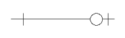 | Represents a “one to zero-or-one (minimum of zero and a maximum of one)” relationship between two entities
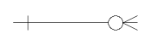 | Represents a “one to zero-or-many (minimum of zero and a maximum of many)” relationship between two entities
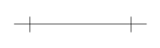 | Represents a “one to one (minimum of one and a maximum of one)” relationship between two entities
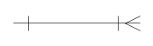 | Represents a “one to one-or-many (minimum of one and a maximum of many)” relationship between two entities

The following figure shows a sample relationship as would be depicted in an IE-based data model highlighting the cardinality and optionality specified at either end of the relationship.
Figure 9 – Sample Relationship as Depicted in Data Models
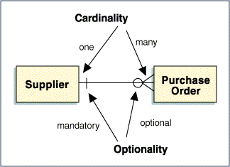
The “Substance” of Relationships
As has been stated, relationships show the connections between entities – data connections. As this implies, the “substance” of a relationship is bound by data that exists in common between the entities forming the relationship. Consequently, data dependency between entities is the basis from which relationships are identified and defined.
Following good data modeling practices, this would imply having attribute names in common between entities in a relationship. However, as this may not always hold true, it is best to understand the concept from the perspective of the data an attribute represents rather than merely from its name. For example, SOCIAL SECURITY NUMBER and TAX IDENTIFICATION NUMBER both represent the same data for an individual – their social security number – though TAX IDENTIFICATION NUMBER has a broader context as it, unlike SOCIAL SECURITY NUMBER, applies to more than just individuals. Consequently, entities containing one of these attribute names could have data connections to an entity containing the other attribute name.
This can also occur when a business notion is known by different names across the enterprise, each name stemming from the understanding and perspective each group has concerning that data. Unlike SOCIAL SECURITY NUMBER and TAX IDENTIFICATION NUMBER, such attribute names represent the identical scope and range of data. They are synonyms for the business notion. An example of such attributes would be FAMILY NAME, LAST NAME and SIR NAME. Synonyms for an attribute should be noted in the data dictionary.
A relationship minimally has as the basis of its data connection the primary key of one of the entities in the relationship. This is important to keep in mind when determining if a relationship exists or not between entities.
A Non-Identifying Relationship is one in which the primary key of one entity is a foreign key in another entity and does not contribute to the composition of the other entity’s primary key.
An Identifying Relationship is one in which the primary key of one entity is a foreign key in another and does contribute to the composition of the other entity’s primary key.
Identifying relationships most commonly appear between parent-child entities.
Relationship Labels
Sometimes it is not clear what the role of the relationship is and it is worthwhile to place a text label on the relationship line to clarify its meaning within the model (e.g., a relationship between EMPLOYEE and CAR could mean many things: employee drives car, employee insures car, or employee rents car). Usually, only one of these will be correct for this business instance.
The standard convention for interpreting relationship labels is to read the label from left-to-right or top-down. If the label is intended to be read right-to-left or bottom-up, then it should be placed in parentheses as a means to highlight it should be read as such. Some data modeling tools require a relationship to be labeled in both directions while others do not provide for labeling of relationships. Consequently, the ability to label relationships, the robustness of such capabilities, and the rules governing the entries made regarding relationship labeling are governed by the data modeling tool used.
Figure 10 – Labeling Relationships
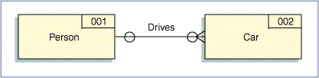
Degree
The degree of a relationship is the number of entity occurrences related to a single entity at the other end of the relationship. As this number usually varies, the minimum, maximum, and modal average is captured (e.g., if suppliers are sometimes inactive, the minimum is zero; if the most frequently used supplier has no more than 50 purchase orders active at any one time, the maximum is 50; if most suppliers have 10 purchase orders active at a given time, the modal average of the relationship is 10).
The ability to specify degree for a relationship as part of a data model is dictated by the data modeling language(s) supported by the modeling tool used. It is valuable information regarding a relationship and should be captured, even if not explicitly shown in the data model. Ideally, it should be among the properties captured about a relationship in a data dictionary.
Figure 11 – Specifying the Degree of a Relationship
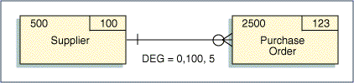
Note: The maximum is a typical maximum, not an absolute maximum.
Recursive (Multiple) Relationships
On occasions, two entities may have more than one relationship with each other. This occurs when the primary key of one entity is represented in another entity via multiple sets of attributes – each attribute set being a foreign key. Such relationships are referred to as recursive relationships.
For example, in a foreign exchange system, the entity CURRENCY has two relationships with EXCHANGE RATE - once as the base currency and once as the risk currency. In the exchange rate from Australian dollars (AUD) to US dollars (USD), AUD is the risk currency and USD is the base currency. EXCHANGE RATE would contain the attributes RISK CURRENCY ID, BASE CURRENCY ID, and RATE OF EXCHANGE.
Figure 12 – Sample of a Recursive Relationships
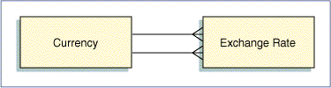
Self-Recursive Relationships
An entity may have a relationship to itself. These are called self-recursive relationships. For example, EMPLOYEE supervises EMPLOYEE is a one-to-many hierarchical relationship between EMPLOYEE and EMPLOYEE. PART contains PART is an example of a many-to-many recursive relationship which will be resolved into two one-to-many bill-of-materials relationships, described later in this document. These relationships are treated with the same rules as those between two different entities.
Typically, self-recursive relationships represent hierarchies, such as an organization chart within a company. As this generally is the case, both ends of the relationship will have optional existence conditions. That’s because there will always be an occurrence representing the top of the hierarchy without a parent and an occurrences at the bottom of the hierarchy with no children. For example, in the EMPLOYEE supervises EMPLOYEE situation, there is always one EMPLOYEE who is at the top and does not have a supervisor. Likewise, there are EMPLOYEEs at the bottom who do not supervise anyone.
Figure 13 – Examples of Self-Recursive Relationships
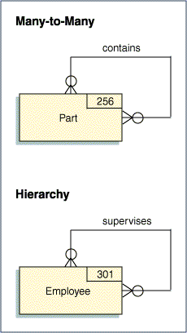
Connection Traps
It is often possible to show relationships in more than one way. As a result, unnecessary relationships may be present in a data model. Consequently, a model should be examined for redundant relationships and, if found, they should be removed.
A triangular relationship between three entities should always be questioned. One of the three relationships is usually redundant. For example, a DIVISION has many DEPARTMENTs; a DEPARTMENT has many EMPLOYEEs. This implies that a DIVISION has many EMPLOYEEs. Explicit depiction of this relationship conveys no additional or unknown information about the interaction between DIVISION and EMPLOYEE that is not understood in the context of DIVISION to DEPARTMENT and DEPARTMENT to EMPLOYEE. Such a relationship, therefore, is redundant.
Sometimes the relationships that are shown are not optimal and it is possible to create "connection traps" as shown in the diagram below.
In a fan trap, the relationships are not optimal because a grandparent-parent-child is shown as grandparent- parent and grandparent-child. This fails to show the parent-child relationship.
In a chasm trap, the relationships are not optimal because a grandparent-parent-child relationship is shown as parent-child and grandparent-child. This fails to show the grandparent-parent relationship.
Figure 14 – Examples of Connection Traps and Resolution
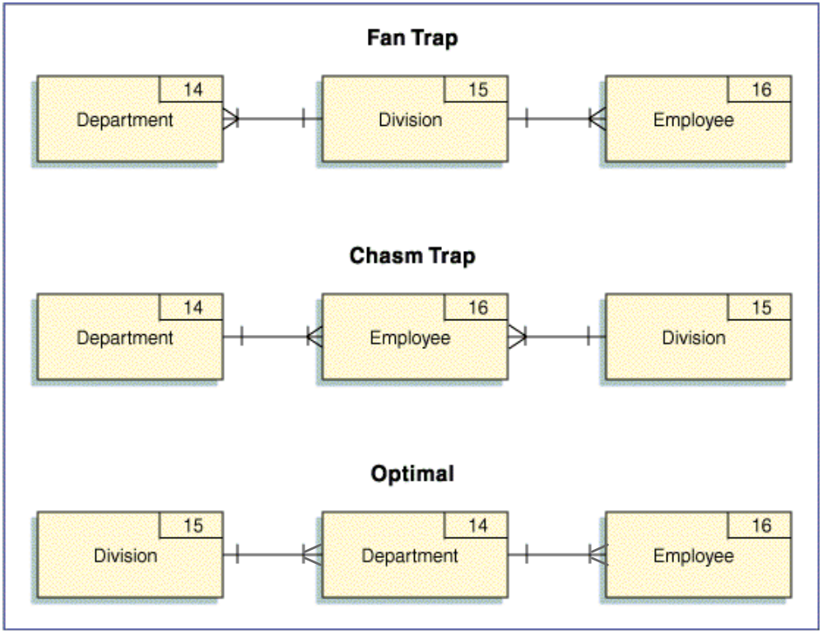
Subject Areas
A subject area is a natural subdivision of a data model centered on a major resource or activity of the enterprise. It consists of a highly cohesive grouping of entities and their relationships used by common business activities.
Subject area modeling is a means for providing high-level views of a data model by suppressing its lower level detail thus enabling a decomposition mechanism for data models as can be done in process analysis. The concept is used as a means of organizing and partitioning the contents of data models into superset aggregates. Subject area boundaries are derived by understanding what data is valuable to a business and how it is used, so that logical groupings of data entities can be identified. As this aligns data with its business context, such diagramming of data is also sometimes referred to as a Data Context Model.
The effect of adding subject areas to a data model is that a hierarchy is established for the data contained in the model. Some of the advantages of creating a subject area hierarchy are as follows:
- It makes the data model easier to understand by allowing the reviewer to focus on specific sections of the data model, without being overwhelmed by the total diagram.
- If the rules of parallel decomposition have been followed, the subject area hierarchy on the data model should map to the process model hierarchy represented by functional decomposition of the application. Since both models should have initially been developed independently, the two hierarchies can be used to cross-validate each other.
- It provides a mechanism to allow the application developer to consider the implications of system "builds". Since the subject areas are derived from an understanding of the business, any decisions to implement an application in a phased implementation approach (i.e., decisions that are based on a desire to implement one functional area of the business first) can be validated against the data model by reviewing the subject area containing all of the data entities needed to support the area of the business under consideration.
Identifying Subject Areas
Subject areas can be defined early in the application development cycle since each kernel entity is potentially a subject area. While subject area boundaries can begin as part of ERM development, it is more fully formed as part of developing the Conceptual Data Model.
In the figure below, a section of a data model is shown that contains three levels of a subject area hierarchy. The top level service area – Service Delivery in the sample diagram - contains all data entities in the subject area (in this case, all the entities shown in the sample diagram) and represents (for illustrative purposes) all of the data required to support this major business activity.
Figure 15 – Sample Subject Area Hierarchy
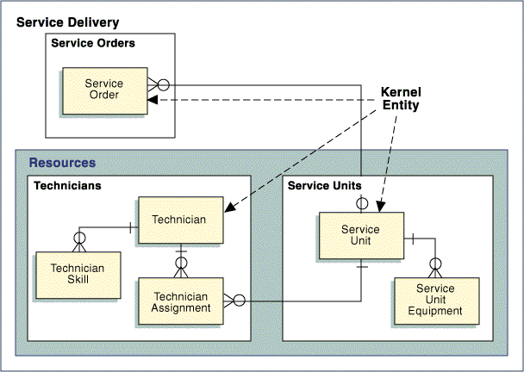
Within this subject area are two lower level subject areas - Service Orders and Resources. The Resources subject area being further decomposed into two lowest level subject areas relating to Technicians and Service Units. At each of the lowest level subject areas (Service Orders, Service Units, and Technicians), the focal point is a single kernel entity plus any related associative or characteristic entities contained within the subject area boundary.
The name of the lowest level subject area should be the plural name of the kernel entity (e.g., in the diagram provided, the subject area focused on the kernel entity TECHNICIAN is named TECHNICIANS). The counterpart to this subject area on a process model would potentially be a part of the business based around maintaining technicians.
Subject Areas and Prototyping
Using subject area hierarchies provide a valuable starting point for developing a superstructure for a prototype menu hierarchy. Each of the levels of the hierarchy can be considered as a level in a window hierarchy that needs to be traversed to get to the object of interest (i.e., the kernel entity). At that point, the business events related to the kernel entity form the actions to be performed against the entity.
- From Entity Relationship Model to Conceptual Data Model
The Conceptual Data Model (CDM) is a refinement of the Entity Relationship Model (ERM). The ERM depicts the kernel entities identified for the application and the key relationships between them. At the completion of the ERM, many-to-many relationships exist in the data model. These must be resolved to one-to-many relationships. That is the primary intent of the activities involved in creating a CDM.
The transformation of many-to-many relationships involves the introduction of “intermediary” entities to obtain one-to-many relationships. These are categorized as Associative Entities and Characteristic Entities.
Hierarchical data that is inherent to organizational charts, Bill of Materials, and the like can be among the more challenging type of data to model. This section will also discuss how associative entities, generalization hierarchies, and recursive relationships can be used to provide durable, yet flexible, models for this type of data.
Associative Entities
An associative entity is the association or intersection of two or more entities. This new entity has attributes of its own and is a legitimate business concept and should be named using a noun representative that concept. If a single noun name is difficult to determine, then the name is built from the names of the entities being associated.
For example, a many-to-many relationship between PART and SUPPLIER may be modeled with a new entity in the middle – PART SUPPLIER. This associative entity represents a specific PART from a specific SUPPLIER. It has two one-to-many relationships back to each of the original entities - PART and SUPPLIER - and has attributes such as cost, lead time, and quantity on order.
An associative entity can be thought of as a matrix between occurrences of the entities that originally had the many-to-many relationship. Using this analogy, the maximum number of occurrences an associative entity can have is the Cartesian Product of the occurrences each entity in the many-to-many relationship from which the associative entity was “derived”. For example, if 100 PARTs are possible and 200 SUPPLIERs are possible, the maximum number of PART.SUPPLIERs is 100 x 200 or 20,000 occurrences.
Figure 16 – Sample of Resolving Many-to-Many Relationship via an Associative Entity
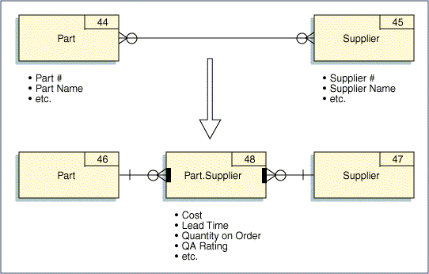
It is possible for an associative entity to be an association of more than two entities. For example, a WINE VINTAGE can be shown to be an association among WINE TYPE, VINEYARD, and YEAR. Thus, it is actually a three-way association.
Figure 17 – Example of a Three-way Association of Entities
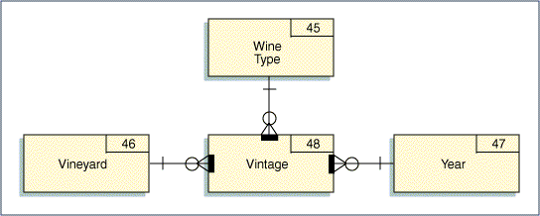
Primary Key Rules for Associative Entities
An associative entity’s primary key should be comprised of the concatenation of the primary keys for each entity involved in the association (i.e., the participating entities). For example, the primary key of PART SUPPLIER is PART NUMBER plus SUPPLIER NUMBER. These are primary foreign keys.
If the primary key of an associative entity is not the concatenation of the participating entity's keys, an evaluation should be completed to determine whether the association is defined correctly.
Associative Entities and Existence Dependency
An occurrence of an associative entity cannot exist unless there first exists occurrences of the participating entities. For example, a specific PART SUPPLIER cannot exist unless the specific PART and the specific SUPPLIER exist first. Furthermore, deletion of a PART requires deletion of all PART SUPPLIERs involving that particular PART. Therefore, it can be said that PART SUPPLIER is existence-dependent on its participating entities. Associative entities are always existence dependent on their participating entities.
The following diagram is provided here as a sample of how existence dependency may be depicted in a data model. In this diagram the associative entity’s existence dependencies are shown as bold marks inside the associative entity – one for each relationship back to each of its participating entities.
Figure 18 – Example of Explicit Depiction of Existence Dependency in a Data Model
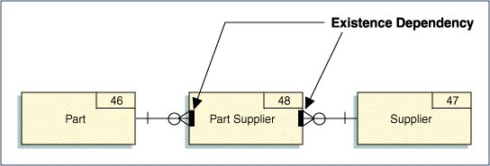
An existence dependency is different from a mandatory relationship because a mandatory relationship can be disconnected from one entity occurrence and connected to another occurrence (e.g., an EMPLOYEE related to a WORK CENTRE can be disconnected from one WORK CENTRE and connected to another). With existence dependency, relationships can not be sustained between the associative entity and its participating entities in this manner because the associative entity’s occurrence can not be re-connected to another occurrence in the participating entity.
Obviously, an occurrence of PART SUPPLIER can not exist without first having its corresponding value for its foreign keys from each of its participating entities – PART and SUPPLIER. However, the relationship between an occurrence in PART SUPPLIER is strongly connected to each of its parent entity’s occurrence – and specifically to those occurrences. The associative entity occurrence can not be connected to any other occurrence in the participating entities. For example, a PART.SUPPLIER occurrence involving, say, PART number 123 cannot be connected to any other PART occurrence – only to PART number 123.
Existence dependency is inherently part of the relationships between an associative entity and the participating entities forming the association. Consequently, many data modeling notations do not provide a means to explicitly indicate existence dependency between such entities. This also means such explicit depiction of existence dependency is not widely available across the data modeling tools in the marketplace.
Where existence dependency can be depicted in a data model, it clearly identifies the relationships and entities participating and defining the association. The ability to call-out this relationship property can be particularly valuable if the associative entity has relationships that are not involved in the association.
Characteristic Entities
A characteristic entity helps describe (i.e., is characteristic of) a kernel entity in some way. A characteristic entity exists with a kernel entity in a parent-child relationship. The kernel entity is the parent and the characteristic entity is the child. Usually, characteristic entities have a one-to-many relationship with the parent entity (i.e., one parent has many characteristic children). However, it is possible for a one-to-one relationship to exist.
Characteristic entity names should be nouns and they often include their parent names as a modifier. Examples of characteristic entities are PURCHASE ORDER LINE ITEM, DOCUMENT REVISION, and EMPLOYEE VACATION PROFILE.
Figure 19 – Example of Characteristic Entities Depiction in a Data Model
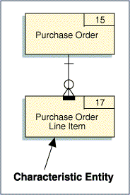
Primary Key Rules for Characteristic Entities
Usually, the primary key of a characteristic entity inherits the primary key of the parent entity but also includes some other attribute to make the key unique. For example, PURCHASE ORDER LINE ITEM typically has the key PURCHASE ORDER NUMBER plus LINE ITEM NUMBER. Likewise, DOCUMENT REVISION has the key DOCUMENT ID plus REVISION NUMBER.
If the key of the characteristic entity does not include the parent entity's key as a primary foreign key, an evaluation should be completed to determine whether the characteristic has been properly defined.
Characteristic Entities and Existence Dependency
A characteristic entity is, by definition, existence-dependent on the parent entity (.i.e., an occurrence of a characteristic entity cannot exist unless the parent entity occurrence exists first). Likewise, if a parent entity occurrence is deleted, all the related characteristic entity occurrences are also deleted.
An example of explicitly denoting existence dependency between the parent-child entities is shown above in Figure 19 via the bold bar in the characteristic entity, PURCHASE ORDER LINE ITEM.
Generalization-Specialization: Supertype-Subtype Characteristic Entities
In most cases, describing a business notion as an entity is driven by the attributes that collectively characterize that business notion - an employee can be characterized (e.g., described) by an employee number, a name, a job title, a skill set, etc. Generalization-Specialization is a technique by which entities are characterized via both their similarities and their differences and is represented in data models via supertype-subtype entities.
Though generalization and specialization result in the same graphical depiction of data in a data model, as their names imply, they do so from opposite perspectives. However, the distinction as to which led to further abstract understanding of the data can often not be purely delineated as it tends to be a combination of both.
Generalization establishes supertype-subtype entities through the identification of common business notions or attributes across a set of entities. The supertype is formed to represent the commonality across a set of entities and its subtypes to represent their distinctions. Discovery is driven from bottom-up, conical data analysis. It enables further abstraction in how data is represented across in the data model.
For example, consider an electric utility data model that has entities for construction work done on POLEs and in TRENCHes. The entities POLE and TRENCH could be made subtypes of a newly created supertype entity WORK LOCATION.
Specialization establishes supertype-subtype entities by breaking an entity down into logical subtypes. Discovery of such entities is via successive top-down, specialized decomposition of an entity.
An airline may offer both domestic and international flights. Each is similar in that they both generically are AIRLINE FLIGHTs, so a common set of attributes exists for each. Yet, a set of attributes distinct to each also exists. AIRLINE FLIGHT is the supertype entity and DOMESTIC FLIGHT and INTERNATIONAL FLIGHT are its subtype entities. Furthermore, there are a common set of attributes to describe a DOMESTIC FLIGHT and a distinct set unique to each PASSENGER FLIGHT and CARGO FLIGHT. DOMESTIC FLIGHT, therefore, though a subtype entity to AIRLINE FLIGHT can, in turn, be a supertype entity. In this case, PASSENGER FLIGHT and CARGO FLIGHT are its subtype entities.
As this shows, subtypes may themselves be further classified into subtypes, thus becoming a supertype forming what are called generalization-specialization hierarchies or simply generalization hierarchies since a greater level of data abstraction is achieved regardless of which analysis is applied. No matter how the hierarchy was identified, once defined, traversal down the hierarchy represents increasing degrees of specialization and traversal up the hierarchy represents increasing degrees of generalization.
There is no limit to the number of levels a generalization hierarchy can have nor to the number of subtypes a supertype may have. The following diagram illustrates a generalization hierarchy for the airline examples discussed above.
Figure 20 – Sample of a Generalization Hierarchy
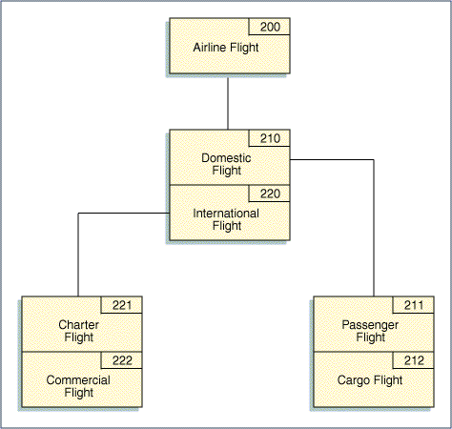
Generalization and specialization improves the overall stability and flexibility of a data model. They minimize the impact of change by reducing the overall number of entities and relationships in a data model. By so doing, change is contained to the entities and/or relationships having significance to the change.
Supertype-Subtype Constraints
Subtypes may be mutually exclusive or inclusive.
In the airline flight example illustrated and discussed above, CHARTER FLIGHT and COMMERCIAL FLIGHT are mutually exclusive subtypes of INTERNATIONAL FLIGHT. This means a flight can be one or the other but not both. Such subtypes are also referred to as disjointed subtypes and the hierarchy they form as a disjointed hierarchy.
Contrast this to a say a supertype entity that represents a PERSON having subtypes that represent the different types of roles a PERSON may have. In this case, it is possible that a PERSON can function in more than one role – the role subtype entities are mutually inclusive. For example, in a movie production, an individual - an occurrence of PERSON - may have the roles of DIRECTOR, of PRODUCER, of ACTOR, as well as other roles. In this case, a PERSON can be any number of the subtypes – one, some, or all. Such subtypes are also referred to as overlapping subtypes and the hierarchy they form as overlapping hierarchies.
In some cases, it is required that an occurrence of a supertype entity must be a member of at least one of its subtype entities. In other cases, it may exist onto itself without being a member of any of its subtypes. These are referred to as total completion and partial completeness, respectively. Generalization tends to be total completion since the supertype entity was derived from its subtype entities.
Subtype Entity Properties
In a supertype-subtype structure, a subtype entity automatically inherits all the attributes of the more generalized supertype (i.e., the dependent entity <subtype> inherits all characteristics of the entity on which it is dependent <supertype>). Each subtype entity may have individual characteristics and these are not shared with the other subtype entities comprising a characterizing supertype-subtype set. It is not possible for a supertype to inherit characteristics from a subtype. Each subtype has attributes of its own that are different from the other subtypes, but all subtypes share the common attributes of the supertype.
These same rules apply to relationships. The subtypes inherit all relationships of its supertype.
ust as a subtype can have attributes distinct onto itself from both its supertype and sibling subtypes, it can also have distinct relationships to other entities that its supertype and sibling subtypes do not have.
When documenting subtype hierarchies, a subtype entity should be treated as any other entity and receive a name, definition, ID, etc. Since, by definition, the supertype's attributes are inherited by the subtype, it is not necessary to duplicate the supertype's attributes for as being part of each subtype. Only the unique attributes each subtype has need to be identified.
Subtype Discriminator Attribute (Supertype Class Code)
Often an attribute is created as part of the supertype entity for the purpose of linking one of its occurrences to its correspondent subtype occurrence. Such an attribute is generally referred to as the subtype discriminator or as the supertype class code. Typically, such an attribute is short in length, usually 1 to 3 characters and might require a separate edit and description/reference/look-up table in the database in its support. .Such attributes are important factors taken into consideration on how a given generalized hierarchy will ultimately be physically implemented.
Figure 21 – Example of a Subtype Discriminator
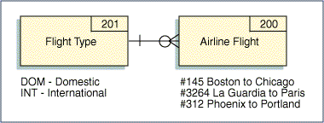
Orthogonality: Parallel Subtypes for a Supertype
A supertype entity can have multiple subtype sets. These multiple subtype sets are said to be orthogonal (or parallel) and enable specializing a supertype entity in multiple ways. For example, expanding on the movie production example cited earlier in this section of the document, beyond a PERSON having a role in the production company as a DIRECTOR, a PRODUCER, an ACTOR, etc., a PERSON may be an employee of the movie production company or could be an external RESOURCE. There is no limitation as to the number of subtype sets an entity may have.
Figure 22 – Example of a Supertype Having Multiple Subtypes
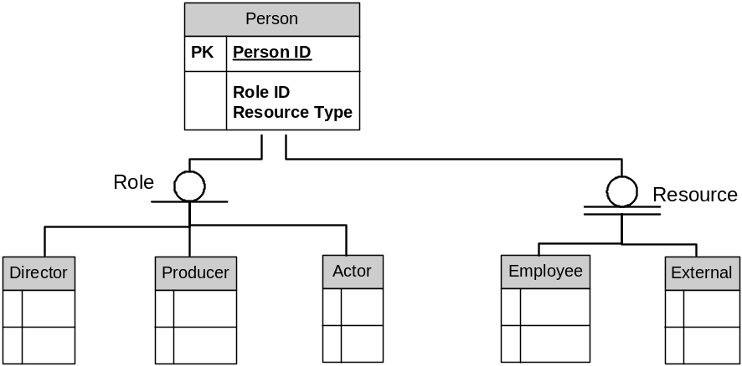
In the example illustrated in the above figure, the Role subtype is partially complete meaning a PERSON occurrence can exist without having a Role subtype occurrence. The Resource subtype is totally complete meaning a PERSON occurrence must be an occurrence of one of the Resource subtypes. Note how this is distinguished in the software product’s graphical syntax as a single line under the subtype category for partial completeness; as a double line for total completeness.
The graphical depiction is based upon Integrated Definition for Data Modeling (IDEF1X) syntax which extends IE to include explicit syntax for supertype-subtypes. The software modeling tool used to draw this diagram had explicit syntax to indicate subtype completeness but did not have explicit syntax for subtype exclusivity.
For reference, languages that also use this type of graphic symbol for supertype-subtypes and do include explicit syntax for subtype exclusivity often use the convention of an open circle, as is shown in the above diagram, to convey the subtypes are mutually inclusive (overlapping subtypes) and a closed circle (a solid black circle) to convey they are mutually exclusive (disjoint subtypes). In our example, this can not be determined from the diagram. Here, it is likely that the Role subtypes are mutually inclusive as a PERSON occurrence – that is, an individual – could fulfill multiple roles and that the Resource subtypes are mutually exclusive since an individual could be an EMPLOYEE or an EXTERNAL Resource but not both.
When to Consider Generalization-Specialization
- A large number of entities seem to cover the same or nearly the same abstract business notion.
- The attributes and/or relationships of different occurrences of an entity are substantially different.
- Different processes apply to specific classes of the entity.
- The business meaning is substantially enhanced by showing subtypes.
- Several entities on the model have similar relationships and/or attributes.
- The model exhibits a relatively high degree of sensitivity to change and greater abstraction may offer greater stability and flexibility to the model reducing that vulnerability.
Generalization-specialization can be overdone creating needless detail in a data model thus obscuring the important business notions. Therefore, it should be applied rationally.
Model Syntax for Supertype-Supertype Entities
The graphical means by which supertype-subtype entities are depicted are among the most varied of the concepts discussed in this paper.
Figure 20 shown previously in this section, illustrates one of these graphical depictions. All the subtype entities for a supertype entity are contiguously abutted to one another in a vertical column. A line is drawn having no markings at either end between a supertype entity and the top entity in the column of grouped subtype entities. This line is referred to as a subtype connection. The syntax shown in the diagram does not explicitly connote completeness (total or partial) via markings on the subtype connection line requiring such information to be retained via descriptive mechanisms or notation in the data model, a data dictionary, etc.
In this syntax and many others, a subtype connection is not a relationship. A relationship connects entities representing discrete notions. Subtype connections link entities representing common notions.
Traversal down the hierarchy tends to be interpreted as “a supertype is a subtype”, as in a PERSON is a DIRECTOR, an ARLINE FLIGHT is a DOMESTIC FLIGHT. Often “is a” is concatenated and written as “isa”. For this reason, generalization hierarchies are also sometimes called "is a" or definition hierarchies.
The following table shows how a supertype-subtype connection would be interpreted for each combination of subtype constraints. The extent to which these can be explicitly indicated on subtype connections varies across the data modeling languages available, so too their correspondent graphical depiction. A fairly common graphical portrayal of generalization hierarchies is a tree-like structure with specialized markings at each tree-branch-fan point explicitly connoting the subtype constraints that apply to that level in the tree structure.
Figure 23 – Interpretation of Subtype Connections AcrossSubtype Constraint Combinations
Subtype Constraint |  | Interpretation  “An occurrence of the supertype…”
Exclusivity | Completeness | Interpretation  “An occurrence of the supertype…”
Mutually Exclusive | Total | Must be an occurrence of one and only one of its subtypes
Mutually Exclusive | Partial | May be an occurrence of one and only one of its subtypes
Mutually Inclusive | Total | Must be an occurrence of one, some or all of its subtypes
Mutually Inclusive | Partial | May be an occurrence of zero, some, or all of its subtypes

If explicit syntax for generalization hierarchies is not in the data model language, the concept can be graphically shown using relationships as is shown in the following diagram. However, note how there is no quick means by which to recognize a generalization hierarchy, the members of its tree, and the subtype constraints governing each level in the tree in this syntax. Much valuable understanding of the data is lost without having an explicit means by which to connote generalization hierarchies in a data modeling syntax.
Figure 24 – Sample Depiction of a Generalization Hierarchy Using IE Notation
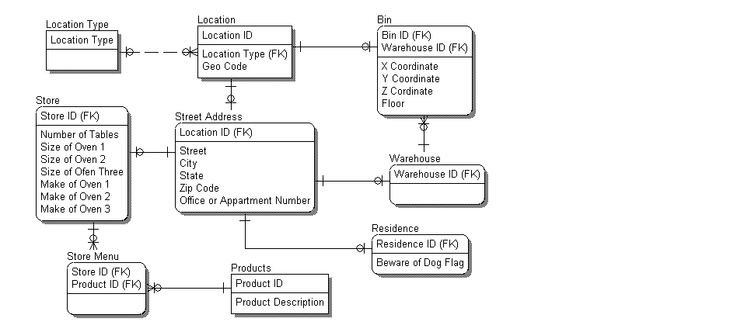
Unlike subtype connections, relationships require identification of primary keys for each participating entity. So an entity that is a subtype has the same primary key as its supertype entity. Note that the supertype entity must have a non-key attribute serving as the subtype discriminator across the sibling subtype entities.
Figure 24 above shows the business notion of location in a generalization hierarchy. The Location entity is an independent entity and, in this example, will be the supertype entity. Geo Code is common to all Location occurrences and is thus defined as an attribute of Location. By virtue of being members of a generalized hierarchy, all subtypes of Location implicitly inherit Geo Code. Consequently, Geo Code is not defined in any subtypes of Location. The non-key attribute, Location Type, is used to distinguish between the Street Address and Bin subtype entities and serves as this generalization hierarchy level’s subtype discriminator. Both Street Address and Bin entities have Location ID as their primary key by virtue of being a child entity in a parent-child relationship – Location as their supertype being their parent. The Bin ID attribute in Bin is a synonym of Location Id as they both represent the same business notion. Each also has a set of attributes distinct onto themselves. When portrayed as relationships, supertype-subtypes are always one-to-(zero or one) relationships as the supertype is mandatory and the subtype is optional. Street Address has subtypes: Residence, Warehouse and Store. Note that these are also modeled as one-to-(zero or one) relationships since a street address can be a either a residence or a store or a warehouse.
Modeling Hierarchical Data
The following figure shows three ways by which organizational hierarchies can be modeled.
Figure 25 – Three Depictions of a Pizza Chain’s Organizational Hierarchy
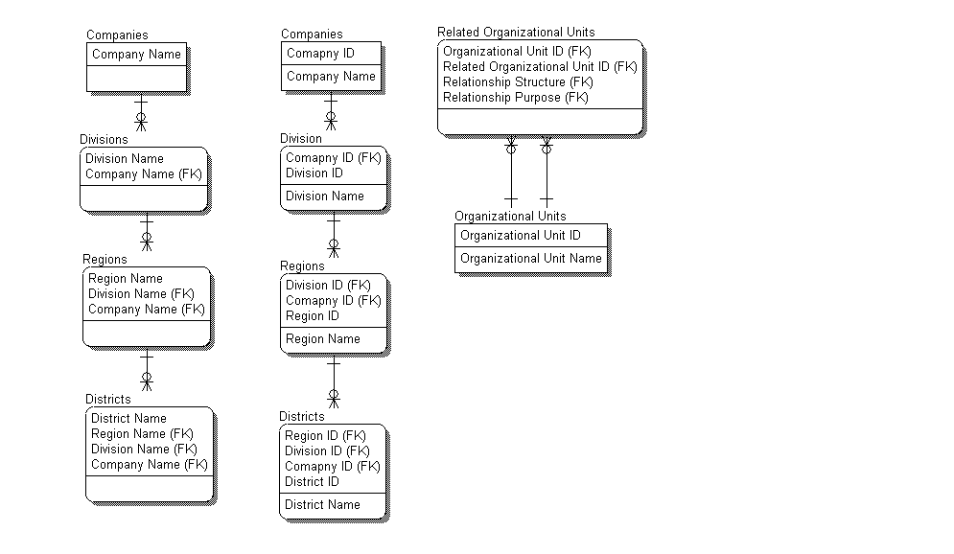
The left-most model in Figure 25 shows a fairly common approach used to model organizational hierarchies where each type of organizational unit is explicitly named and inherits part of its primary key from its parent. There are several advantages in this model of the organization. One advantage is that it is very explicit. There can be no confusion to a user of the data model regarding levels in the hierarchy. Another advantage is that while it is not shown here, it can easily accommodate different types of information at different levels in the hierarchy.
The disadvantage is that the structure is inherently inflexible. One problem is that the primary keys are organizational units’ names. Because organizational names frequently change, they are inherently unstable as a primary key. The embedding of the hierarchy in each unit’s primary key causes a second problem. As the layers of the organization expand or contract, the primary key of each unit may have to change. For example if regions were eliminated and districts reported directly to divisions, the primary key of each district would change.
Some of this inflexibility is addressed by the second model shown in the center of Figure 25 and is a variant of the first making the primary key for each entity a surrogate key. With a surrogate key the name can change without affecting the primary key of the entity. However the problem of changing hierarchies remains.
The right-most model shown in Figure 25 represents the organizational hierarchy using an associative entity, Related Organizational Units, and a recursive relationship between it and its participating entity, Organizational Units. The Organizational Unit ID is a surrogate key that must be unique across the organization. Occurrences of Organizational Units are associated with one another through the associative entity via the two relationships Organizational Units has with Related Organizational Units - one representing the occurrence for an organizational unit and the other an occurrence representing an organizational unit to which the former is related.
But which organizational unit is the parent and which is the child in the organizational hierarchy? One approach is to apply role names to make the relationship explicit. Another approach is to include the notion of Relationship Structure in the primary key. Relationship structure describes the nature of the relationship and the values typically used to specify this are discussed in the following table.
Figure 26 – Specifying the Nature of a Recursive Relationship in an Associative Entity

Relationship Structure Value | Explanation
Part of | A Region is part of a Division. This supports a composition hierarchy. Another hierarchy of this type is the Related Products entity in Figure 27. A pizza is a product that has a bill of materials. A pepperoni pizza is made up of crust, cheese and pepperoni, each in different quantities depending on the size of the pizza. Composition hierarchies are further covered later in this section.
Type of | A pizza is a type of a product. A foccacia pizza is a type of pizza. A pan pizza is another very different type of pizza. A florentine foccacia pizza and a “meat lovers” foccacia are types of foccacia pizza. Using a recursive relationship in this way is a means by which a greater level of abstraction can be used to represent this data via a generalized hierarchy as has been discussed earlier in this section.
Related to | Two things are related, but not as a “part of” or a “type of”. The Stores Division may get pepperoni from both the Manufacturing Division and from outside vendors. In Figure 28, the Stores and Manufacturing Divisions are Related Organizational Units. This leads to the notion of Relationship Purpose.

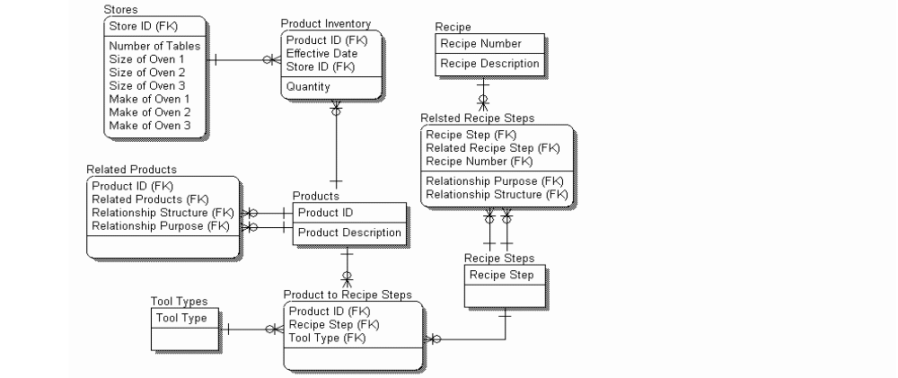
Figure 27 – Modeling a Composition Hierarchy via an Associative Entity & Recursive Relationships
Figure 28 – Using Relationship Structure and Relationship Purpose in Data Models
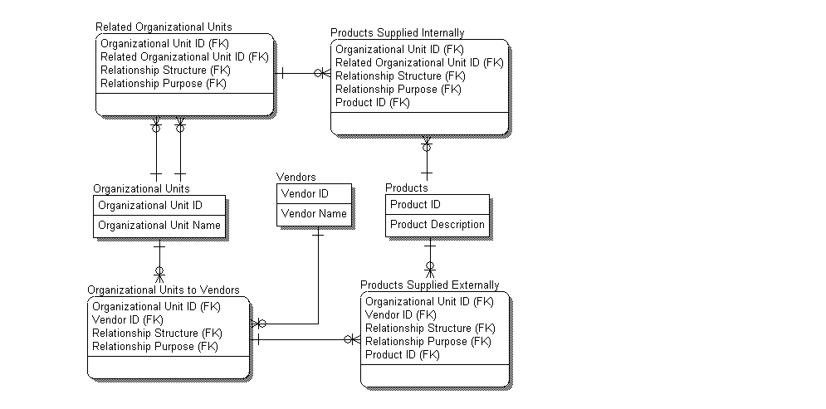
Relationship Purpose is the reason for the relationship. In Figure 28, the purpose of the relationship is customer-vendor. The products associated with this relationship are in the Products Supplied Internally. The Stores Division also acquires products from outside vendors. These are in the Products Supplied Externally. If the organization has no other relationship with vendors than purchasing products, the relationship structure and purpose may be implied and left out of the model. However, if the organization has other relationships, such as a joint venture in a new product line, the relationship structure and purpose are necessary.
Another example is an employee who can be structurally “related to” a store in the role of store manager. He or she can also be part of a reporting hierarchy to a district manager where the role is “reports to”. He or she can also be a “related to” an inter-store team to improve store processes where his or her role is team member. The same district manager could also be related to the team as a team member. In fact the roles on the team could be reversed. The structure supports both. This allows multiple relationships that are structurally the same but which have different purposes.
Sometimes two entities can be related more than once for the same purpose. The Meat Plant has recipes for the many types of sausage used by the stores. A recipe consists of a set sequence of recipe steps. A pair of recipe steps may be adjacent to each other in many recipes where the before and after steps are different for each recipe. The Recipe Number connects the sequence of recipe steps. In fact the same sequence of steps can be in many different recipes because sausage formulations can vary based on regional preferences.
A general term for this a relationship chain. In a relationship chain, a relationship identifier must be part of the primary key. In our example, the recipe number is the relationship identifier. This allows the recursive structures to be rolled up along multiple axes. Since the relationship identifier guarantees uniqueness, the Relationship Structure and Relationship Purpose need not be part of the primary key.
Composition Hierarchies – Bill-of-Materials Type Structures
Composition hierarchies usually manifest themselves in ERMs as self-recursive relationships. Since Bill of Materials-type data is the most frequently type of composition hierarchies encountered, these hierarchies are often referred to as the bill-of-materials structure.
Improper modeling of composition hierarchies will result in overly complex physical implementations of the data that severely constrains the application. To illustrate this point, consider the example of a company involved in assembling and selling engines and spare parts. The company produces a number of different products each of which is composed of many components. At first sight it may appear that there are two entities, PRODUCT and COMPONENT, related by a one-to-many relationship. However, it will soon become clear that this is incorrect for two principal reasons:
- A particular component may be used in many different PRODUCTS (e.g., the same carburetor may be used in more than one engine model).
- A component, such as a piston assembly or a carburetor, is itself composed of subcomponents and these may in turn be assembled from components.
Figure 29 – Example of a Bill-of-Materials Structure
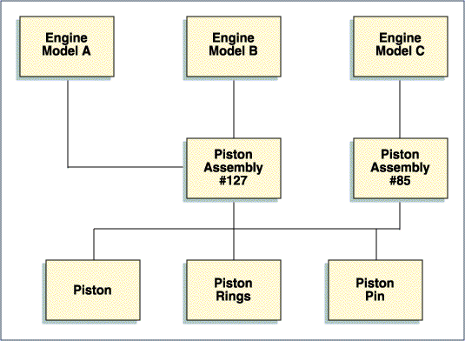
These problems can be overcome by recognizing that there is only a single entity, that will be called PART, and that any PART can be made up of other PARTs and be a component of other PARTs.
In this structure, there is a many-to-many relationship for PART with itself since a PART may contain many other PARTs to form an assembly and a particular PART may be contained within many other PART assemblies.
As with other many-to-many relationships, an associative entity should be introduced resolving this many-to-many relationship to two one-to-many relationships to the PART entity. This associative entity represents the concept of a PART contained within another PART and has attributes, such as QUANTITY, SCRAP FACTOR, LEAD TIME OFFSET, or ASSEMBLY DEPARTMENT.
QUANTITY represents how many of one PART are assembled into another PART (e.g., how many carburetors in a particular engine assembly). This construct is required whenever a many-to-many relationship exists for a single entity. These situations may not necessarily be related to manufacturing parts (e.g., the same constructs would be required for business organizations that have agreements with one another, or geographic routes that contain smaller geographic routes).
Model Syntax for Composition Hierarchies
Being hierarchical data, composition hierarchies are modeled as depicted in the figure below - two entities having recursive one-to-many relationships. Each relationship is identified with an existence dependency mark, meaning that the associative identity PART CONFIGURATION cannot exist unless each of the related PARTs first exist.
The primary key of the associative entity PART CONFIGURATION is the concatenation of PART NUMBER plus PART NUMBER. The assignment of values to these attributes is important since one represents the containing PART while the other represents the contained PART.
Figure 30 – Illustration of a Composition Hierarchy
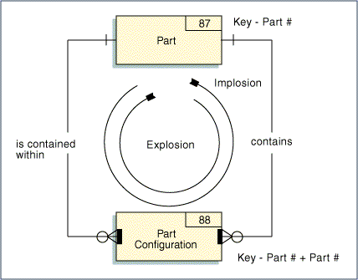
Traversing Composition Hierarchies: Implosion and Explosion
A unique feature of the composition hierarchies modeled in this fashion is the recursive manner in which it can be navigated in both up and down its tree. For example, a user or applications program might start at the part CARBURETOR and query to obtain all of the ENGINEs in which the CARBURETOR is used. Then, an ENGINE might be queried further to determine which CARs it is used in. This upward traversal of a composition hierarchy is called an implosion.
A downward traversal is called an explosion. For example, a query might start again at the CARBURETOR and request all subassemblies contained within the CARBURETOR. Then, another query might request all PARTs contained within one or all CARBURETOR subassemblies. An explosion can be repeated until the lowest level PARTs are reached. Likewise, an implosion can be repeated until the top level ultimate end products are reached.
It is possible with some data manipulation languages, including some SQL extensions, to complete an entire traversal of a composition hierarchy tree in a single SQL statement.
A particular PART can be used at many different points in the structure (e.g., bolts are used in carburetors and in engines). For this reason, a level code is sometimes stored in the PART CONFIGURATION entity to indicate the depth of the association levels.
Figure 31 – Explosion and Implosion
Explosion and Implosion
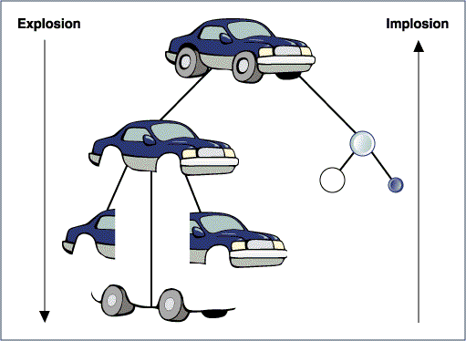
- From Conceptual Data Model to Logical Data Model
The Logical Data Model (LDM) represents the completion of logical data design. Its purpose is to
- Fully capture all the properties pertaining to the items comprising a data design and its model so that the model fully identifies entities, relationships, and attributes for each entity to support the application’s processes.
- Normalize the data contained in a model toward achieving a stable yet extensible data design shaped from the business understanding gained during logical data design.
Design Completeness
Entity Life Histories
Entity Life Histories (ELH) are a simplified form of State Transition Models (STMs) that focus specifically on state changes to data entities. They are used to validate the completeness of the data model (and by reference, the completeness of the process models).
Process Definition addresses the time sensitive nature of business events. The ELH equivalently does so from a data perspective. These are done in parallel with one another as both perspectives are needed in decomposing an application into its respective elements and components.
ELHs are developed as a way to confirm that all data attributes related to different states of an entity have been captured. However, for an entity to change status it has to be acted on by an elementary process. Therefore, the technique - although primarily aimed at validating data - can also be used to confirm the completeness of the process models.
New elementary processes or changes to existing elementary processes identified through the use of an ELH need to be mapped back to the application’s Process Definition.
The following subsections further present ELH techniques:
- Intent of Entity Life Histories
- Basic Concepts and Components
- Constructing Entity Life Histories
- Summary Guidelines and Tips for Entity Life Histories
Intent of Entity Life Histories
ELHs create a graphic representation of the changing state of selected entities of the Conceptual Data Model (CDM) and represent a time-sequenced view of the processes that affect the entity.
The example shown below describes a business view of processing and data, but reflects the time or control aspects applied within the business process. It states that there is a necessary sequence of processing.
Figure 32 – Example ELH for a Loan Account Entity
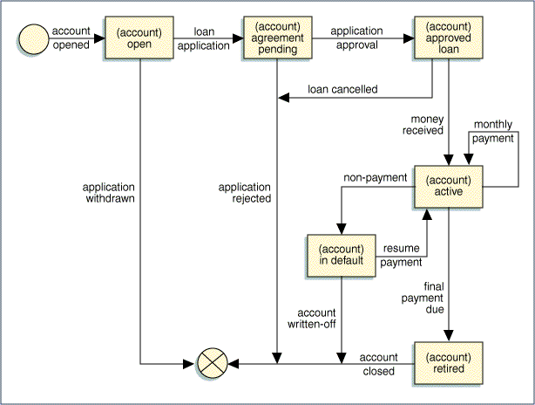
Note: Account retired is a state the entity is placed in, when the final payment is due.
ELHs offer a way to check the statement of requirements, and then lead into design. Some of the problems that may be identified could include:
- Overlooked processes
- Additional current system (automated or manual) problems
- New requirements
- Missing data entities
- Missing attributes for identified entities
- Problems with processing the system as defined
- Missing error identification and exception handling procedures
Problems that represent errors and redundancies should be corrected within the analysis and definition documents and verified with users and management. Some omissions, particularly new requirements, may represent a change of scope and should be handled as an issue requiring resolution and should be resolved following the issue resolution process and procedures established by the project.
Basic Concepts and Components of ELHs
An entity in an ELH can be changed by an event to be in a specific state.
State: The state of an entity occurrence represents the information at rest or the status of an entity occurrence after an event.
Events: In this context, an event is a defined stimuli that triggers system processing thus updating an entity (or entities). An event may be an externally generated action in the "real world" or an action that occurs due to the passage of time. An entity can be acted upon by three types of events:
- Birth Event: A process that results in the change of state that initially creates an entity occurrence.
- Life Event: A process that results in a change of state for an entity occurrence.
- Death Event: A process that results in the change of state that finally deletes an entity occurrence. This may be a logical or physical deletion as dictated by business rules.
Figure 33 – ELH Notation
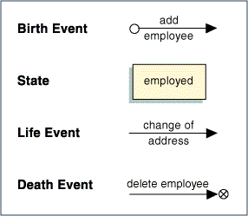
- Constructs: The constructs used in ELHs are the same as those of structured design and structured programming:
- Sequence: Used when an event leads from one state directly to another state.
- Selection: Used when a single event can result in two possible states.
- Iteration: Used when an event results in a changed value without a change of state.
Figure 34 – ELH Constructs
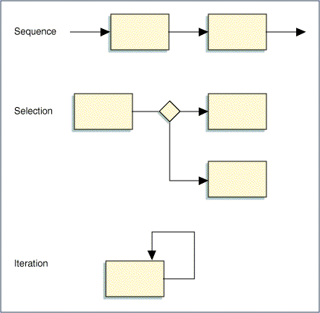
Constructing Entity Life Histories
The construction of an ELH diagram involves:
- Identifying the business events for which the business has planned a response.
- Defining the data entities affected by each in-scope business event.
- Mapping the sequence of business events to the life cycle of each entity (represented by the entity's possible states over time).
- Reviewing the life history to identity errors and exceptions that the system must handle.
Events can be identified by referring to the application’s Process Definition(s).
The way in which an entity is varied by an event is referred to as an effect. There are several types of effects. An effect can cause an occurrence of an entity to be:
- Created
- Updated (i.e., the attribute values are updated)
- Deleted (logically or physically)
- Paired, or associated, with another entity occurrence in a relationship
- Disassociated from another entity occurrence to which it is associated
- Paired with a different occurrence of an entity that the occurrence to which it is currently associated (i.e., the relationship is transferred from one occurrence to another)
ELHs are not created for all entities of the system. They are done only for the driving entities, that is, entities that have a multi-state life. These are entities whose nature change over time in a specific unalterable sequence. They are typically the entities that are affected by transactional business processes.
A driving entity then is affected by events which change the state of that entity. These changes are diagrammed using the notations and constructs of ELH modeling.
Summary Guidelines and Tips for Entity Life Histories
- ELHs are developed to assist in checking the quality and completeness of the process and data analysis and definition tasks. They supplement the static view of data offering an understanding of data behavior from a dynamic, time-dependent perspective.
- The benefits gained in using ELHs to verify the completeness of a data design is dictated by the presence of event and/or time driven processes that act upon the data. If such processes are not part of the application or are nominal as regards the degree and extent of states the data may undergo, ELHs will offer few or no additions to the overall data design.
- Depending on the nature and complexity of an application and the scope of the project, ELHs can be used as project checkpoint activities to aid in maintaining synchronization between process and data designs at strategic milestones in the overall project’s efforts. For large projects, it is likely ELHs would be used in conjunction with State Transition Diagrams/Models (STMs) for such checkpoints.
- ELHs assist in verifying the quality and completeness of design analysis deliverables by relating the processes and data over time.
- For some projects (e.g., real-time or object-oriented system development projects), STMs may play a major role in the requirements development process and are integral to the proper design of an application toward its target implementation processes and data definitions.
- Sometimes an initial list of events may be developed by examining the entity relationships in a data model and identifying the events that create, modify, or delete the relationship instances. These events (and their responses) can then be recorded in the process model.
- The ELH analysis is only completed for the driving entities of the CDM. The driving entities are those that may assume multiple states (e.g., an EMPLOYEE may be a 'new hire', a 'regular employee', 'on leave' or 'terminated'). While in these various states, there are specific elementary processes that can affect the entity and others that are inappropriate. The attribute values for the entity will be altered in each different state.
- ELHs can uncover attributes intrinsic to controlling and/or managing the state of data in support of multi-step processes, cross-process dependencies, etc. versus those rendered from business context.
In some project environments, STMs may provide a useful communication vehicle between the project analysts and the users in understanding the requirements of an application system (e.g., the users may be more familiar with and feel more comfortable talking about the dynamic behavior of the system). STMs may be employed as an information gathering tool to develop both the process and the data models.
Attribute Groups
An attribute group is a set of closely related attributes that have meaning when used together. An ADDRESS is a group which may consist of CITY, STREET, STATE, ZIP, and COUNTRY. An attribute may belong to more than one group and it is possible for a group to have other groups within it.
Attribute groups should be documented in the data dictionary.
Attribute Properties
All attributes must be clearly defined in the data dictionary and represented in the data design when the LDM is produced.
Atomic units of data - independent of any assignment or use within an entity or record - may be identified as a result of process and business rule analysis. This data should be defined as attributes in the data dictionary and ultimately assigned to entities. The following metadata (data about data) should be documented for each attribute at the completion of the LDM:
- Attribute ID: a unique dictionary identifier for the attribute if required by the data dictionary system being used. This identifier allows changing the name without disturbing relationships and assignments to other dictionary objects.
- Descriptive name: a meaningful name describing the attribute
- Functional data type: the data type of the attribute independent of physical representation (i.e., character, integer, decimal, date). This is also referred to as the attribute’s domain
- Size: the length of the attribute
- Precision: the attribute scale or number of places to the right of the decimal point
- Synonyms: alternate names for the attribute
- Use: a description of the purpose of the attribute
- Custodian: the person responsible for defining and controlling the definition
- Textual definition: a logical description of what the attribute represents
The following are guidelines for preparing textual definitions for attributes:
- The name should not be used in the definition.
- The definition should describe what the attribute is in terms of its logical characteristics rather than what it does or how it exists from a physical standpoint.
- Definitions for attributes that are codes with a small domain of values (i.e., less than 15) can include all or at least some of the values and their descriptors (e.g., the codes CAN, APP, HLD with their respective descriptors CANCELLED, APPROVED, ON-HOLD should be included in the definition).
Decomposition of Composite Attributes
In a LDM all attributes should represent discrete, atomic, indivisible data elements. Some attributes identified in the CDM may actually represent an attribute group rather than a discrete, atomic data element. If such attributes exist, they should be decomposed so that each elemental part is itself an attribute and the original attribute defined as an attribute group.
For example, Size of Oven, Make of Oven and Location of Oven are not atomic attributes. They each represent multiple pieces of information. Size of Oven is composed of height, depth, width and temperature variance (i.e. the degrees that an individual oven tends to run hotter of cooler above standard cooking temperature). Make of Oven is composed of vendor name and model number. Location of Oven is composed of Floor, X Coordinate and Y Coordinate.
In some cases, an attribute may represent what the business construes or has come to construe as a discrete business notion that in reality is an attribute group. This generally occurs with encoded data – a business notion having a name onto itself, commonly known in the business by that name, yet, in reality is comprised of other elemental data. For example, rather than being an arbitrary number, a Claim Number for an automobile insurance company may be comprised of the claimant’s policy number, accident incident year, followed by a sequence number,
Resolution of Multi-Valued Attributes
In a LDM, all attributes should have single, unambiguous meaning. Some attributes may have values that convey multiple rather than a single business notion. For example, the attribute named Employment Status has not only status but also employment status reason. Value “R” means “No longer an active employee per employment retiring”. Value “A” means “Active employee”. Value “T” means “No longer an employee per employee resignation”. Value “F” means “No longer an employee per company initiated employment termination”. Two distinct attributes should exist – one for Employment Status, the other for Employment Status Reason.
Derived (Computed) Data
Derived data is computed from other data. It may be stored in a database or calculated when a procedure or report is produced. Important derived data should be documented in the data dictionary and treated as any other attribute with appropriate definitions and metadata. Derived data should include in its dictionary definition the derivation formula in terms of the other attributes comprising the formula.
It is important to differentiate a derived attribute definition from its derivation (i.e., what the element is versus where it comes from). For example, the ECONOMIC ORDER QUANTITY is the economically optimal amount of a particular item that should be ordered, considering purchase cost, storage cost, demand, and other factors. Often, the mistake is made of storing the formula as the definition, without explanation. The formula is the derivation, not the definition.
Derived data is never assigned as an attribute of an entity in logical modeling. If the derivation is required due to some physical constraint, it will be assigned during physical modeling. Storing derived data limits the flexibility of the system but is sometimes necessary to enhance performance.
Normalization
Where data analysis techniques previously discussed in this paper broadly focused on the items comprising a data model – identification of entities and the interactions between them, normalization’s focus is narrow as it is applied individually to each entity in the model.
Data normalization is a technique for decomposing data per prescribed dependency rules between an entity’s primary key and its attributes resulting in stable data constructs in the data design. Its principles have mathematical set theory underpinnings and deal with optimizing data constructs for effective update operations (insertion, deletion, modification) against the data they represent. It emerged as a data design method with the advent of relational databases. While its origins may be tightly linked with relational databases, its principles are not bound to them and have equal applicability to other types of databases.
Normalization of data should eliminate redundancies and ensure that data inconsistencies can not arise from application processes. A normalized data model has the advantage of showing the inherent relationships among the data based on the business rules of the enterprise. As applications are implemented, the physical design of the database will often vary from this model for performance reasons. However, without the logical model as a starting point, the physical database designer can make false assumptions about the data that can lead to inflexible application designs.
Normalization views an entity as a set (as in a mathematical set) of data represented in tabular form. An entity occurrence is a tuple in that mathematical set comprised of the values it has for the attributes defined for the entity - a tuple being discrete pieces of information jointly considered as a single unit such as an occurrence of an entity would naturally be perceived. Occurrences are viewed as rows, so it then follows that the values for each attribute in each occurrence of an entity are viewed as the columns in the tabular representation of this mathematical set.
Theoretically, normalization proceeds from an unnormalized set of data (an entity) to increasingly normalized sets of that data (entities) via successive decomposition of that data. Each successive step further restricts the relations between an entity’s primary key and its attributes strengthening the entity’s structural design and removing its vulnerability to application update (insertion, deletion, modification) anomalies.
The intent of normalization is to have data in the model in normal form (NF) – normal form being defined as having satisfied data normalization rules. Data not in normal form is in unnormal form – 0NF or UNF for shortened reference.
There are five normalization rules and they have a prescribed sequence in which they should be applied to each entity – from least to most restrictive. Each rule is individually referred to per the sequence in which it is applied – first normal form, second normal form, etc. The shortened reference used for each being, respectively, 1NF, 2NF, 3NF, etc. They are all applied to an entity - data found to satisfy a less restrictive rule does not infer it also satisfies more restrictive rules.
The degree of normalization a given entity may have is defined by the highest NF its data satisfies – an entity in 2NF has data satisfying both 1NF and 2NF rules. The degree of normalization a given data model may have is defined by the lowest NF achieved by all its entities – a data model in 3NF has entities that all have data in 3NF but may also satisfy higher NFs. Most data design strives to achieve 3NF because the subsequent, higher levels of NF rarely offer any additional change to the design as the dependencies they uncover are not commonly encountered and 3NF has proven to generally offer the best performance for physical implementation.
Data design driven by bottom-up data analysis would, by nature, need to repetitively apply normalization as a means to rationalize the data into well-defined data design structures. Data design driven from top-down data analysis has less need to apply normalization repetitively as rationalization of data is a natural consequence of starting from a high-level understanding of the data. In this case, assuring the entities in a model adhere to third normal form typically results in a fine-tuning of the data assigned to the entities. In contrast, bottom-up data analysis uses normalization as a means to discover entities and the attributes that should be assigned to them. Optimal data design is achieved with a balance of both top-down and bottom-up data analysis. Some data modeling software tools provide utility programs and/or product aids to assist in the normalization process.
Often times a modeler will arrive at the correct normalization intuitively without going through each of the NFs in a rigorous, step-wise fashion. From this perspective, normalization can be viewed as a series of questions that the modeler can use to check his or her intuition.
Unnormalized Data - 0NF
Unnormalized data is characterized by groups of data elements that are repeated for each occurrence of other data elements. Unnormalized data is difficult to portray as a table or flat file because, while many groups of data are repeated, each column and row intersection does not necessarily contain a value.
The following diagram shows three entities with their assigned attributes. The notation for attributes is as follows:
- The entity name is followed by the attribute names in parentheses.
- The primary keys of the entity are underlined.
- Any attributes that repeat within the entity are placed in square brackets.
Figure 35 – Example of 0NF
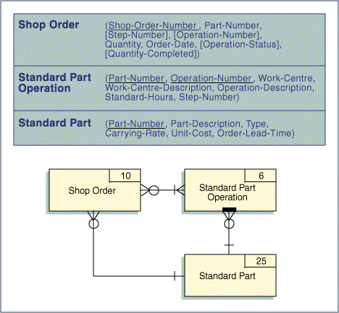
First Normal Form - 1NF
An entity is considered to be 1NF when it has no repeating groups of attributes within it. If an entity has repeating groups of attributes, these must be removed into separate entities to place them into 1NF.
In the 0NF example, the entity SHOP ORDER has a repeating group of attributes consisting of STEP-NUMBER, OPERATION-NUMBER, OPERATION-STATUS, and QUANTITY-COMPLETE. These attributes are removed to create a new entity SHOP ORDER OPERATION. This new entity is an associative entity and carries with it the primary keys of SHOP ORDER and STANDARD PART OPERATION (SHOP-ORDER-NUMBER and STEP-NUMBER).
Figure 36 – Example of 1NF
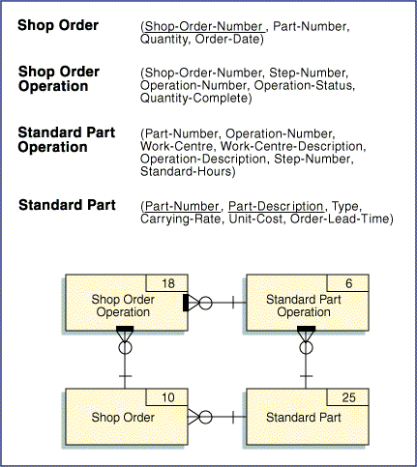
Functional Dependency – 2NF
An attribute is functionally dependent on another if it can be determined from the attribute (i.e., the first attribute is a determinant or key for the second attribute). For example, a person's name can be determined from a social security number. It can be said that NAME is functionally dependent on SOCIAL SECURITY NUMBER.
To check for second normal form, the identifier for each attribute within the group must be determined. Attributes that are dependent on only part of the key of an entity are considered partially dependent on the key (note that when an entity has a single data element key there can be no partial dependency). These partially dependent attributes must be separated into a new group or table to achieve second normal form.
A group of attributes is in 2NF when it is in 1NF and all partial dependencies have been removed (i.e., an entity is in 2NF when each attribute is dependent on the whole primary key).
In the 1NF example, the entity STANDARD PART OPERATION has several attributes that are partially dependent on the primary key. WORK-CENTRE, WORK-CENTRE-DESCRIPTION, and OPERATION-DESCRIPTION are dependent on OPERATION-NUMBER alone. These attributes are separated out into a new entity, STANDARD OPERATION.
Figure 37 – Example of 2NF
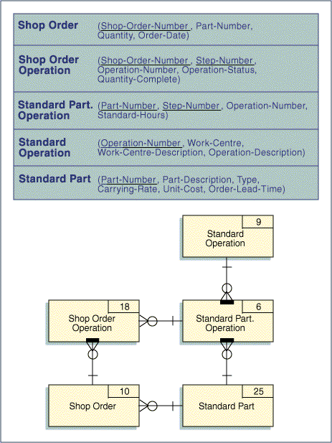
Transitive Dependency – 3NF
It is possible for an attribute to be dependent on not only the primary key of the record but also on another attribute. This situation is called transitive dependency. This condition creates redundancies in a database that can be avoided by placing the data into third normal form.
If an attribute is transitively dependent, it must be removed into a separate entity. An entity is in third normal form if it is in second normal form and each attribute is non-transitively dependent on the primary key, that is, each attribute is dependent on the whole primary key and nothing but the whole primary key.
In the example, the entity STANDARD OPERATION has WORK-CENTRE-DESCRIPTION transitively dependent on WORK-CENTRE. This attribute is removed and added to a new entity, WORK CENTRE.
Figure 38 – Example of 3NF
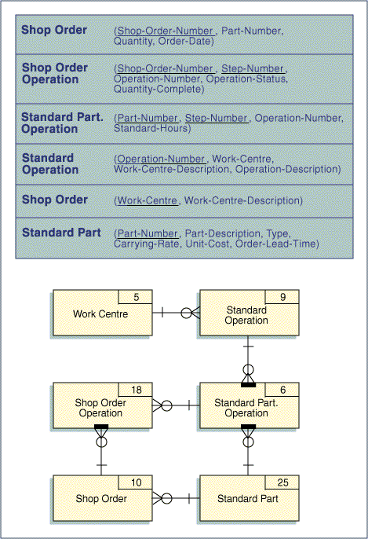
Normalizing Entities – 1NF to 5NF
The following is a brief procedure for checking the normal form for the entities in a data model:
- Does any entity contain repeating groups? If so, remove them to another entity. The primary key of the new entity will be the primary key of the original entity and the primary key of the repeating group. The original entity will have a one-to-many relationship to the new entity. When an all attributes are at an atomic level and all repeating groups are removed, the entity is 1NF.
- Does any entity contain attributes that are only partially dependent on the entity’s primary key? If so, remove these attributes to an entity where they are fully dependent on the entity’s primary key. Create a foreign key reference from the first entity to the second entity. When all partial key dependencies have been removed an entity is 2NF.
- Does any entity contain attributes that are dependent on other attributes in the entity other than that entity’s primary key? These are referred to as transitive dependencies. If so, move these attributes to a new entity. There will be a foreign key reference from the original entity to the primary key of the new entity. When all the values of an entity’s non-key attributes are determined by the primary key and only by the primary key, the entity is 3NF,
And so to have touched upon all normal forms, a brief example of 4NF and 5NF are given here.
Note: 4NF and 5NF only apply to associative entities that relate three or more other entities.
- In an associative entity that relates three or more entities (a.k.a. a multi-valued dependency) are there any two components of the primary key that can vary without reference to the third component of the primary key? If so, the three part associative entity should be split into separate associative entities. When a three-part associative entity is split into two two-part associative entities it is known as fourth normal form (4NF).
Because a pizza restaurant has an extensive menu, including many local cuisines depending on the locale, an employee can be trained in multiple cooking skills based on the type of food product. In the following figure, Employees Skills and Product shows which employees have the skills to prepare each product. But what about a new product that has a skill but for which no employees have been trained? To accommodate this situation, the three-way association was split into two two-way associative entities, Employee Skills and Product Skills.
Figure 39 – Example of 4NF
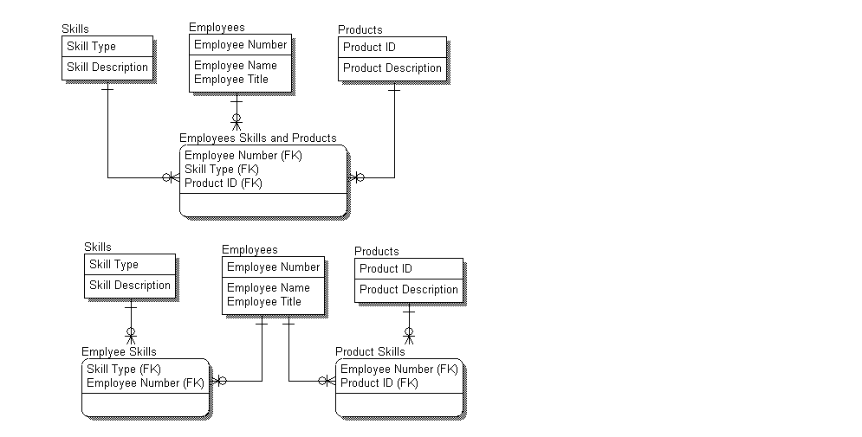
- If a three-way associative entity is decomposed into two two-way associative entities, will a join of the two-way entities result in any rows not found in the original three way entity? If so, the three-way entity should not be decomposed. This is the reverse of the fourth normal form and is known as fifth normal form (5NF).
Because of regional variations in taste, the same product can be made using more than one recipe. For each city in which stores are located, a store has its own set of product / recipes variations.
The first set of entities in the following figure shows a three-way association of Products, Recipes and Store Cities. A sample set of values for this table is shown in Table 1. The second set of table shows three two-way associations: Products to Recipes; Recipes to Store Cities and Products to Store Cities. Sample sets of values for each of these is shown in Table 2, 3 and 4, respectively.
When the three two-way tables are joined the result is a join projection. This is done in two steps. First, Products to Recipes and Recipes to Store Cities are joined on Recipe. This intermediate result set is the first three columns shown in Table 5. Then Recipes to Store Cities and Products to Store Cities are joined to the intermediate result set using Product and Store City. The rows resulting from this join projection are indicated with a “Y” in the fourth column. The fifth column indicates the row number in the original three-way associative table illustrated in Table 1. Notice, the row in the join projection for “Marinara Sauce / Sweet / Houston” is not present in the Products to Recipes to Store Cities three-way associative entity. Therefore, the original three-way association is not decomposable into three two-way associations.
Figure 40 – Example of 5NF
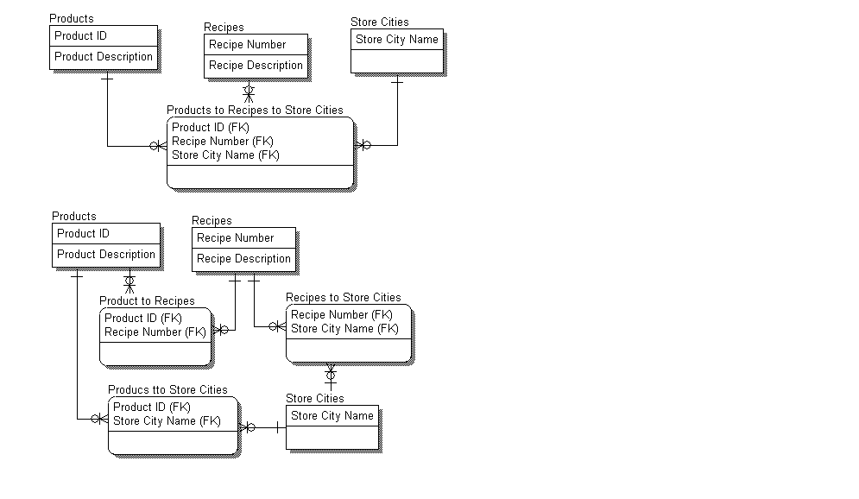
Table 1 – Products to Recipes to Store Cities - A Three-Way Associative Entity
Product | Recipe | Store City
Meat Sauce | Spicy | Waco
Meat Sauce | Sweet | Houston
Marinara Sauce | Spicy | Houston
Meat Sauce | Spicy | Houston
Marinara Sauce | Sweet | Dallas
Table 2 - Products to Recipes
Product | Recipe
Meat Sauce | Spicy
Meat Sauce | Sweet
Marinara Sauce | Spicy
Marinara Sauce | Sweet
Table 3 – Recipes to Store Cities
Recipe | Store City
Spicy | Waco
Sweet | Houston
Spicy | Houston
Sweet | Dallas
Table 4 - Products to Store Cities
Product | Store City
Meat Sauce | Waco
Meat Sauce | Houston
Marinara Sauce | Houston
Marinara Sauce | Dallas
Table 5 – Join of Products to Recipes and Recipes to Store Cities on Recipe
Product | Recipe | Store City | Join Projection | Original Row Number in the 3-Way Associative Table (Table 1)
Meat Sauce | Spicy | Waco | Y | 1
Meat Sauce | Spicy | Houston | Y | 4
Meat Sauce | Sweet | Houston | Y | 2
Meat Sauce | Sweet | Dallas
Marinara Sauce | Spicy | Waco
Marinara Sauce | Spicy | Houston | Y | 3
Marinara Sauce | Sweet | Houston | Y
Marinara Sauce | Sweet | Dallas | Y | 5

Creating Entities and Relationships via Normalization
The process of normalization creates new entities and relationships. Each new entity created should have a relationship with the entity from which it was separated. A one-to-many relationship exists between the old entity and the new entity.
Note: Entities split out via normalization often have primary keys that are subsets of one another. In this case, the “many” (in IE syntax, the “crow's foot”) of a relationship always belongs at the entity that includes the other entity's primary key as a foreign key.
Deletion Constraints
Deletion constraints are very important at the logical and physical design levels, particularly with relational database implementations. To properly provide for these constraints in later modeling phases, they should be defined on the LDM.
A deletion constraint controls what happens to related entities when an entity is deleted. These constraints are applied to ensure referential integrity in the database. For example, when a PURCHASE ORDER is deleted, all the PURCHASE ORDER LINE ITEMs should also automatically be deleted, or a SUPPLIER should be allowed to be deleted only if there are no related PURCHASE ORDERs referencing that SUPPLIER. The following three possibilities of deletion constraints exist:
- Cascade deletion constraint: forces the automatic deletion of related entities’ occurrences when the parent entity occurrence is deleted. If the primary key of the parent entity occurrence is changed, it should automatically change in each child occurrence.
- Restrict deletion constraint: disallows the deletion of an entity occurrence if there are any related entities’ occurrences still existing. Related entities’ occurrences must be deleted first.
- Nullify deletion constraint: requires references to the deleted entity occurrence to be marked null automatically.
If the modeling syntax has explicit syntax to convey deletion constraint for relationships, each relationship should be marked accordingly. All deletion constraints should be noted in the data dictionary when the LDM is produced.
Figure 41 – Example of Deletion Constraints
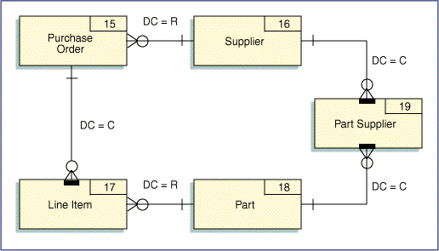
Ideally these deletion constraints should be controlled by the database rather than the application programs. The trend in relational DBMS products is to move these integrity features into the DBMS software. This provides for consistent integrity that can be enforced across all applications. Where referential integrity is not enforced by the DBMS software, it must be explicitly programmed in the application code.
Associative Entities and Deletion Constraints
Associative entities always have relationships with at least two participating entities. Typically, these relationships are marked with cascade deletion constraints. The only other possibility is a restricted delete. A nullify delete is not applicable and would be a violation of the primary key rules (no portion of a primary key can be null).
Characteristic Entities and Deletion Constraints
Characteristic entities always have a relationship with a parent entity. Typically the relationship is marked with cascade deletion constraints. The only other possibility is a restricted delete. A nullify delete is not applicable and would be a violation of the primary key rules (no portion of a primary key can be null).
- From Logical Data Model to Physical Data Model
At this point, the LDM is complete. The data has been normalized and new definitions included in the data dictionary. The next step begins the creation of the Physical Database Model (PDM). The schema Data Definition Language (DDL) for the target database represents the PDM for the data’s application.
Because the target implementation data stores have a significant bearing on physical data design, this section only overviews key, high-level aspects of physical data design. Most examples or analogies will be to relational databases over other physical implementation data stores as they currently dominant the types of databases being used by applications today. Most often the references will be to DB2.
LDM to PDM in Modeling Tools
Many modeling tools will offer some degree of automation in transforming LDM components to PDM components. As the LDM is input to such a process, models having such capabilities will require PDM type information be specified in the LDM in order to produce the PDM. Because of this, some modifications to the LDM for PDM purposes may be done in the LDM versus in the PDM itself. It can be beneficial to understand this function for the modeling tool being used on a project as it can greatly aid in creating the PDM.
Typical information specified in the LDM for PDM generation purposes includes, but is not limited to,
- Logical name to physical name mappings of model components
- Logical domain to physical data type and length for attributes
- Value defaulting rules – nullable; not nullable with default value or without default value
- Valid attribute values for implementation as constraints
- Referential integrity rules for primary–foreign key pairs
- Specification of primary and secondary indices via primary key and alternate keys in the LDM
Factors Influencing Physical Data Design
Progression from logical design to physical design involves making adjustments to the model to account for various implementation considerations such as those provided in the following list. This is not an exhaustive list, but imparts the character of the factors weighed in performing physical design.
- Target implementation restrictions. This generally concerns model component names but can also be related to physical parameters related to data volumes for large data bases.
- Access optimization. This generally entails understanding the performance behaviors likely to be exhibited in the target implementation environment (DBMS) by the application’s processes per their execution demands and commitments against items such as
- Granularity of the design
- Projected volume of data the processes will access per execution
- Volume of data projected to reside in the tables being accessed from onset, average, and growth perspectives
- Modes in which the data is accessed (select/read, insert, update, delete). What they are and which dominate for what data
- Nature by which the data is accessed (random or sequential). What the mix may be and which dominates for what data
- Execution environment in which the process will run (online or batch). Again, the mix across the application’s processes and which prevails for what data
- Number of concurrent processes vying for the same data and the access mode(s) <read/select, insert, update, delete) each would be imposing on that data (concurrency, partitioning, locking)
- Access paths (predicates, sorts) used to access data as well as the prevailing order by which processes operate against the data (indices – primary and secondary; sequence specification for index attribute(s) <ascending, descending>)
- Placement of data on storage devices as relates to process access patterns
- Nature by which data tends to be inserted and deleted in the tables (random or contiguously)
- Nature by which data tends to be deleted
- Demand frequency for the same data across processes (buffering/caching)
- Attributes
- Placement within an occurrence of an entity (frequently accessed attributes at beginning of occurrence; attributes frequently accessed together contiguous to one another, variable length attributes at end of occurrence, etc.)
- Values (use numeric data types for numeric data as character data)
- Physical storage requirements.
- What allocation values to use (primary space, secondary space)
- How much space to allow for random inserts (freespace, freepage)
- Type of storage to which tables should be allocated
- Placement and distribution of data on storage devices to minimize access contention between a table’s data and its indices
- .Buffering/Caching values
- Access “standardization” (views)”
- Values for attributes.
- Physical data typing (packed decimal <decimal> vs zoned decimal <character> vs binary halfword vs binary fullword; fixed length or varying length, etc.)
- Default values
- Nullable or not nullable
- Valid values (constraints)
- Access security and the granularity by which it must be applied (access privileges, views)
- Audit Requirements (new entities, triggers, DBNS audit capabilities/features)
Typical Implementation Targets for LDM Components
The following table highlights the typical means by which LDM components are mapped to PDM components. It predominantly references DB2 terms to convey the type of PDM component. If another DBMS is the target implementation, there could be differences in how the LDM components map to specific types of PDM components.

LDM | PDM | Comments
Data Model | Potentially a Database | For some models, the whole model represents a single database. Where Subject Areas constitute a database, the model as a whole remains a purely logical view of the data
Subject Area | Potentially a Database | For large models, each Subject Area may represent a database. Where the whole model represents a single database, Subject Areas remain a purely logical view of the data. Depending on naming conventions, the Subject Area may be used as a qualifier on tablespace, table, and index names.
Entity | Tablespace | Overwhelming, a tablespace contains only 1 table, though it is possible for more than 1 table to reside in a tablespace.
Entity | Table | Generally a 1-to-1 mapping of an entity to a table. See entry for Supertype-subtype as they need to consider multiple entities in deciding their physical design.
Supertype-Subtypes | “Typing” via a Single Table | Table represents the superset of all attributes for the supertype and all its subtypes. “Consolidation” to physically implement as one table very likely where few distinct attributes exist across the subtypes.
Supertype-Subtypes | “Typing” via Separate Tables | A table for each subtype is created containing the attributes for the specific subtype and its supertype. This is likely when the subtypes each have a fair number of distinct attributes warranting discrete tables for each.
Attribute | Column | A one-to-one mapping of an attribute in an entity to a column of the entity’s target table.
Primary Key | Clustering / Partitioning Index | Clustering Index is DB2’s term for the index that defines the actual physical order by which data will be sequenced on disk space. It is also called the partitioning index as value ranges for primary key attribute(s) will define each partition of the table.
Candidate Keys | Alternate / Secondary / Non-Partitioning Indices | Candidate Keys represent potential alternate / secondary indices. As such indices are not used to partition tables; they are also called non-partitioning indices (npi).
Foreign Key | Alternate / Secondary / Non-Partitioning Indices  Referential Integrity | As foreign keys represent an interaction point with another entity, these are high-consideration candidates for alternate / secondary indices. If the DBMS is to enforce integrity between the related entities, referential integrity rules will be defined for the primary key as relates to management of this foreign key.
Relationships  Deletion Constraints | Referential Integrity

Implementation Data Names
The intent of logical design being to predominantly convey data from its business context over its technical context, the names used to identify each were specified in that context and unrestricted in length. These names may need to be shortened per the restrictions posed by the target implementation environment. Consequently, implementation names for such items will need to be created. Sometimes different implementation names are required for different implementation environments (e.g., COBOL, SQL).
Implementation Data Naming Guidance
Implementation data names should
- Follow standard name format/structure formats. If these do not exist, they should be created as part of the overall set of standards/conventions set by a project.
- Be shortened using standard established acronyms, abbreviations and mnemonics.
- Maintain a logical context identifying what it is not how or when it is used.
- Not include any physical mechanics such as file codes or storage IDs.
- Composed of the following:
- A noun word code (abbreviation) for the category word in the long name. Category codes might include ID (for identifier), NUM (for number), NAM (for name), DAT (for date), TIM (for time), and COD (for code).
- Modifier codes as necessary, to fully qualify the element (e.g., STRT (for start), END, MON (for monthly), YTD (for year-to-date), MIN, MAX). It is important that these modifiers are used consistently.
- In some cases, a descriptor code or prefix/suffix is used to tie the element to a specific entity (e.g., FLIGHTNUM contains the descriptor FLIGHT). Generally, these qualifiers are used when the element is a primary key of an entity and often appears in a database in other tables or records as a foreign key, where the entity context is not known. If the data element is not a primary key, descriptors are not generally needed since the entity context is provided by the table or record name.
Entities
The following lists the common kind of physical information added to the data model and/or data dictionary during physical design for entities. It is representative of this information and is not exhaustive.
- Physical type: the actual physical representation of the entity (e.g., the type of data store such as a the type of DB2 table).
- Implementation or short name: the physical name used when the entity is implemented as a table.
- Physical specifications of the target table’s primary and secondary indices (e.g., the columns comprising the indices and the sequencing order <ascending, descending> for each in each).
- Referential Integrity rules for primary-secondary key pairs.
- External name(s) by which the table is known by its users.
- Tablespace and database to which the table will be assigned.
- Storage considerations (Bufferpool assignment; primary and secondary space allocations; storage group specification; etc.).
- Security requirements: access permissions and restrictions.
- Management requirements (Recovery requirements; Data purge requirements; Data archival requirements, etc.).
Attributes
The following lists the common kind of physical information added to the data model and/or data dictionary during physical design for attributes. It is representative of this information and is not exhaustive.
- Physical data type and length: the actual physical representation of the element (e.g., float, integer, date)
- Implementation or short name: the physical name used when the element is implemented as a field within a record or a column within a table
- Validation rules: allowable range of values and other constraints
- External name(s) by which the attribute is known by its users (e.g., print and display names: default names displayed on screens/windows and reports, if applicable)
- Picture clauses: input mask showing the format of the element, such as "$9,999.99" or "dd-mm-yy"
- Default value: default value of the element in the database, if any
- Security requirements: access permissions and restrictions (e.g., employee salaries are modifiable only by the personnel manager)
Segregation of Entity Data
Horizontal Segregation of Entity Data
In some instances, entity data may be segregated to isolate data per geographic usage, event-driven, time-driven or other similar such delineation, that is strongly held by the data’s business context, its user communities, and/or the application’s processes. It may also be done in support of multi-time zoned/international processing having strong geographic isolation of data. And it may be done for performance as a means to reduce the overall amount of data any given process would access to only that germane to its use as well as enable isolation to computer/server, system processor, and/or operational environments/regions on a given machine. It additionally aids performance in that it distributes access management across a broader set of physical files hence reducing contention that could arise if residing all in one physical file.
With this type of data segregation, all the tables are identical in definition. They only vary in name (usually, but the degree of isolation will dictate this) and the data content they each have. This represents a horizontal segregation of an entity’s data.
In some cases this segregation of data can be more “logical” in nature. In DB2, some of the isolation mechanisms can be achieved using partitioned tables. Each partition is a separate physical data set, but all these data sets (partitions) “belong” to one table. Partitions, therefore offer some measure of data segregation without wholly creating separate physical tables.
Segregation per horizontal divisions of an entity is a common approach to addressing many security and performance concerns associated with entity data and its access. It is a commonly used approach used in both initial and ongoing PDM efforts.
Vertical Segregation
There are cases where a given table has many columns and some columns are frequently accessed and others are not. Or the nature of access for a set of attributes poses potential contention in accessing rows of a table with other processes. For example, a process has a few set of attributes that it may frequently need to update, while the majority of processes read other attributes in the table. When the process updating data in the table executes it may cause other read processes to wait for locks to be released before they can access data on that same row.
For these types of and similar scenarios, it may be better to split the table into separate tables to reduce the size of a table (in the first condition cited) or to reduce contention (in the second condition cited) toward improving performance. Each table would have the same primary key, but distinct columns. In the first condition cited, one table would contain the frequently accessed data, the other the infrequently accessed data. In the second condition cited, one table would contain the columns commonly read by most processes, the other would have the columns the other process(s) update. This type of segregation of entity data vertically divides the entity data into separate physical tables.
As a cautionary note, vertical segregation should be applied only when needs truly dictate the potential performance gains it can offer because it introduces tables that have the same primary key thus increasing referential integrity concerns across the segregated tables as well as to each of these to the tables having that primary key as a foreign key. This approach is not one generally applied to a PDM until actual execution performance issues arise and rarely is applied with initial rollout of a PDM.
Denormalization
Denormalization reverse normalization. It steps an entity down in normal form.
The higher degree of normalization a model has, the more discrete entities it contains. Too much discreteness can negatively impact performance. This applies to entities that are frequently accessed together for which normalization has actually complicated access over simplifying it. To jointly use the data either a process must use a join (SQL operation) or use nested-loop logic to obtain data from such highly related table in order to have the data it needs.
Depending on the frequency by which such data is accessed, the volume of data accessed per each I/O operation, the number of unique attributes each table represents, and the nature by which the data is used and needed by an application, it may be better to represent such data in a single table to improve performance.
Denormalization is a commonly used method by which performance concerns are addressed in physical data design. Striking a balance between normalization and denormalization is among the challenges of data design. A swing too much in one direction and the design can have less flexibility and stability. A swing too much in the other direction and access performance may be poor or worse. Understanding the target DBMS’ access optimization techniques and the experience that comes with time in doing data design – along with good intuition, generally enable the delivery of good data design.
Entity Coordinates Map
In cases where a data model becomes large or where the ability to navigate and locate information in the data model is limited in the modeling tool, it can be difficult to find specific entities or check for duplications. It is suggested to create an entity coordinates map. This is a "road map" to the entities in the data model. A grid is drawn over the model and the coordinates for each entity are listed on an alphabetic entity list. This "road map" index is an easy find mechanism for any location on the model. Creating such a list is best done once the design has stabilized as the location of entities on the model can change when modifications are made to it. Better modeling tools may offer assistance in managing this change via model repositories that enable version and release controls of data models in the same fashion as software configuration tools.
Figure 42 – Sample Entity Coordinates Map
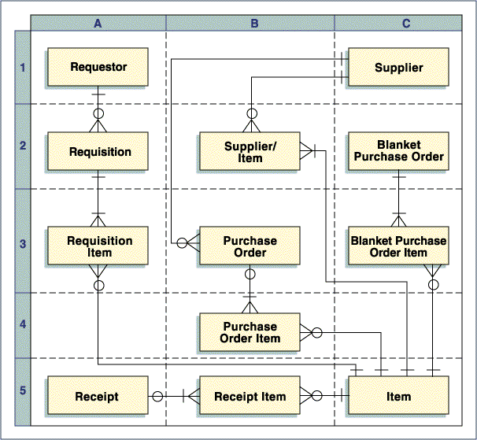

- Standard Entities
Purpose of Standard Entities
The purpose of a standard set of entities is to provide the practitioner with a framework for understanding the data of any enterprise, regardless of industry. The idea is to start at the highest possible level of abstraction but not so high that the entities used are meaningless. The Standard Entities discussed in this section were the basis for the top-down development of the cross industry data model discussed in the next section of this paper. Using standard entities and common data structures as provided in the cross industry data model allows the modeling of any business in a coherent fashion. To the extent a model is used for object development, the standard entities become the base classes in a class hierarchy.
In addition, this section provides a description of all of the common types of entities of interest to most enterprises. Many ER models limit themselves to major subjects. Since the goal is to provide a basis for doing top-down data modeling, it is necessary to include all categories for all types of data. While there may be some overlap based on these definitions, these three categories are, for the most part, distinct, intuitive and all-inclusive.
Standard Entity Descriptions
For the purposes of this document, entities have been classified into three categories.
- Subjects - Subjects are the sources and objects of actions. They are usually nouns (i.e. persons, places, things, etc). They also provide the context or frame of reference in which actions occur.
- Activities - Events are actions or prescriptions for action. They act on and in the context of the subjects.
- Hybrids - The first three entities each embody a single concept. They are the starting points for modeling tables. They are the highest meaningful level of abstraction and are therefore at the top each generalization-specialization hierarchy.
Subjects
Parties
These can include any person or entity with which the enterprise has dealings. These can also include any person or entity about which the enterprise wants to keep information. Parties include customers, vendors, competitors, shareholders, government agencies and employees. This allows an entity to have multiple roles. For example, a chemical company can both buy and sell the same chemical from a competitor depending upon market conditions.
A party can also be an organizational unit such as a department or division. The Party-to-Party Relationship table is used to define multiple hierarchies within a company. Through that same table, an employee can be defined to belong to multiple organizational hierarchies. This same type of structure can be used to associate individuals to a household.
Resources
Resources are components, services and products that are bought, sold or used by the enterprise as part of a value adding business operation. A resource is not necessarily a physical material. It can be a service. Note that a service is a distinct entity from the service provider. The former is a resource; the latter is a party (i.e. vendor). A resource can also be data sold as a product. One example of this is stories by individual authors that are stored in electronic form and that packaged into various anthologies by a publishing house prior to printing. Another example is stock quotes. Resources also include indirect materials (e.g. lubricating oil for machinery) since ultimately the reason the enterprise buys indirect materials is to produce products.
In a bank, the collateral for a loan would fall in this category. A bank provides financing to one of its customers to purchase something from a third party. The loan itself is an agreement between the bank and its customer. The resource that secures the loan is the loan’s collateral. Another bank example is the securities that are bought and sold for a trust customer. Securities to a trader are like raw materials to a manufacturer. They are the things that the trader operates on as part of a normal business process.
Documents and reports are another type of resource. Documents include image data maintained by the enterprise of paper forms submitted, engineering drawings, etc. Reports are structured data that pertain to internally and externally generated documents. Examples are invoices, external financial reports and budgets. These are generally created by the enterprise in the course of doing business or are received from an outside source as of a point in time and not changed thereafter. For example an invoice may have subsequent adjustment transactions but the invoice itself is not changed.
Locations
Locations are the physical places that are associated with parties, resources, etc. One example of a location of a customer is a postal address. Another example is a location code within a plant. A third example is a geo-code.
Agreements
Agreements are the basis for interactions between parties. Agreements may be but do not have to be contracts. Agreements include product pricing and delivery contracts and as such are the basis for verifying the validity of sales and delivery orders. In addition to an agreement with a specific party, an agreement may be with the public at large as in the case of a retail-pricing schedule. Agreements can have a hierarchical relationship to one another. For example, a pricing agreement with a dealer can be overridden by a special deal with a company officer. In this case the agreement between one set of parties the company and the dealer is overridden by another agreement between the company officer and the company regarding his or her authority to offer special deals.
Accounts
Accounts define the structure of the financial records of the enterprise. Account is used in two ways. The first are monetary accounts. These are cash on hand or amounts owed to or owed by the enterprise. Examples are accounts receivable and accounts payable in all enterprises. In a bank these would include demand deposit accounts, loan accounts, and securities trading accounts. The second are non-monetary accounts. These refer to the financial representation of business events, assets or liabilities that are not specifically related to amounts owed. Examples of these are revenue, cost of sales, inventory and fixed asset valuations and non-financial claims. Note that the financial reports of the enterprise include both kinds of accounts.
In a bank a loan agreement is the basis for disbursing a loan into a deposit account. This is a monetary account that reflects the bank’s liability to the customer. A loan account is also a monetary account that reflects the amount of the loan owed to the bank. The collateral is a resource that secures payment of the loan. In the event of a loan default where collateral is repossessed, the estimated value of the collateral will be recorded in a non-monetary, asset account. Any difference between the financial value of the collateral and the balance due on the loan is recorded in a non-monetary gain and loss account. When the collateral is sold, the amount due on the sale is recorded in a monetary asset account (i.e. accounts receivable).
Activities
Orders
Orders are instructions to perform an activity. Orders are often be made in the context of an agreement that provides the basis for an interaction between two parties. For example a sales order is priced using the terms and conditions of a pricing agreement. Orders can also include material movement orders such as picking orders, shipping orders, and receiving orders and production process orders. These types of orders may not require an agreement since they do not involve interactions between parties. Orders also include financial processing orders such as payment orders. Orders can be related to other orders. For example, a sales order can give rise to many shipping orders.
In a bank a loan approval is an example of an order since the approval is the basis for disbursing the loan. The order, that is, the approval is made in the context of the loan agreement.
Events
Events are anything that the business wishes to track. Events can be actual or planned. There are many types of events. The following are examples of types of events:
Interactions
Interactions are activities that involve two or more parties. They can be at whatever level makes sense for the business. For example, a trial could be an interaction. So could each session of the trial where the trial as a whole is a set of related interactions. For an insurance company the former may be the right level. For a law firm the latter is appropriate.
In a medical setting a doctor-patient encounter is a type of interaction. At each interaction diagnoses are made (i.e. Judgments), treatments prescribed and rendered (i.e. Procedures).
An interaction may or may not be related to an agreement. For example, a trial is related to a law in a criminal case or to a contract in a civil case. A customer service inquiry, however, may not be. These can include inquires to vendors or by customers. They can also include the logging of complaints and follow-up conversations by CSR’s.
Causals
Causals are things that the business wants to track for correlation purposes. These include business events (e.g. interest rates or stock prices), political events (e.g. passage of new legislation) or natural events (e.g. a hurricane or an earthquake). These are used to in data analysis to correlate the data or to explain anomalies.
Resource Movements
These are the records of resource movements or other activities. They can be, but are not necessarily, in response to an order. For example a shipment may be created in response to a shipping order. However, a customer return is not.
In a bank this would include the shipment of a physical security certificate to settle a trade or for a capital change. The movement of the resource from one location to another is independent of its financial impact.
Judgments
These are conclusions that are rendered by a party. In a medical setting these are diagnoses. In a government setting these could be court or administrative rulings.
Chains of Events
A chain of events is a set of events that are related in such a way that the whole is a separate entity from the sum of the parts. Many activities of the enterprise are event chains.
Procedures
Procedures relate the events associated with performing a business operation. These can be either business or financial events. A procedure consists of events, their sequence and conditions for performing them. A procedure can reference resources that are the inputs to and the outputs of the events.
Procedures can be:
- Prescriptive - describing what should be done, or
- Planned - describing what is intended to be done, or
- Actual - describing what has been done
In a medical setting, a protocol is a prescriptive procedure. It describes a standard course of treatment based on a given diagnosis. A treatment plan describes what is planned for a specific patient. The treatments performed are actual procedures.
In a manufacturing setting these include the actions associated with transforming resources. In this sense there are resource movements into an assembly and resource movements out of the assembly. A production process could be an assembly with each work step as a sub-assembly. Since an assembly focuses on transforming resources they can include plant maintenance and repairs and repairs made to satisfy warranty claims.
Cases
Cases are broader than procedures. Cases relate parties, interactions, procedures, rules, agreements, judgments, etc. As such a case cannot be prescriptive since the parties and events in a case cannot be known in advance. An example of a case is course of medical treatment involving interactions between parties (doctors and patients), procedures (courses of treatment prescribed and given) and judgments (diagnoses), funds movements (payments), etc.
Campaigns
A campaign is a series of related promotion events.
Trip Schedules
Each event in the schedule has one location. A take-off has a location. A landing has a location. All of these scheduled events taken as a whole comprise a schedule.
Accounting Events
An account balance is changed via an account entry. An account entry is triggered by an event. These may be part of the normal operation of the business as in the case of billing. Or, they may also have a strictly financial impact as in the case of depreciation.
Billing
These refer to the creation of a payable or a receivable through an invoice that was received from a vendor or sent to a customer.
Funds Movements
One type of funds movement is a payment. Payments can be either outgoing or incoming. An outgoing payment will generally be related to some form of authorization. This is often an invoice but not necessarily. For example, a payment could arise from a refund to a customer due to a customer return or from an invoice overpayment. It could also arise from a claim.
In a bank this would include deposits to or withdrawals from an account. In commercial lending the loan is an agreement. The collateral is a resource that is related to but not part of the loan. After all, the loan may go into default and the bank will have to repossess and track the collateral. The instruction by the loan officer to disperse the loan is an order. The actual crediting of the customer’s account is a funds movement.
Account Adjustments
These are financial transactions that are created to correct an error. For an account that involves actual amounts owed, they may, but do not necessarily, result in a transfer of funds. For example an overcharge on an invoice could result in either paying a refund or entering a credit against the next invoice. For this reason account adjustments for these types of accounts are a separate category and cannot be combined with funds movements. An example of an Account Adjustment that does not involve amounts owed is a write down of an inventory balance.
Account Calculations
These are transactions that result from calculations and therefore alter the account balance. For accounts that involve actual amounts owed, examples are interest or fee calculations that change an account balance. For accounts that do not involve actual amounts owed, examples are depreciation and amortization calculations.
Claims
These are claims both by and against the enterprise. A claim can be either financial or non-financial in nature. The difference between a financial claim and accounts receivable/payable are that the former involve actions by a third party whereas the latter involve payment for specific resources sold or purchased. Examples of financial claims in manufacturing are warranty claims and promotional claims. Examples of financial claims in financial services are interest claims arising from incorrect securities or funds deliveries, incorrect dividend or interest payments due a trade near an ex date and missed capital changes. An example of a non-financial claim is a judgment for specific performance.
Even though claims will generally have a dollar amount associated with them, they are classified as non-financial events because they do not in and of themselves affect an account.
Hybrid Entities
Hybrid entities embody multiple concepts. For example an Order embodies the concept of an instruction (e.g. a sales order). A Resource is the things that are used in the basic operation of the business to add value (e.g. raw materials and products). A Funds Movement represents a payment from one party to another. These are all basic entities. A Retail Sale embodies all three of these at the same time. Rather than fracture a single business transaction across three basic entities, it makes more sense to use a hybrid entity. As such the following two are examples and are not an exhaustive list.
Retail Sales
A retail sale is a hybrid because it uses aspects of three basic events: Orders, Resource Movements and Funds Movements. An Order embodies the concept of an instruction (e.g. a sales order). A Resource is the things that are used in the basic operation of the business to add value (e.g. raw materials and products). A Funds Movement represents a payment from one party to another. These are all basic entities. A Retail Sale embodies all three of these at the same time.
Bank Checks
A bank check is a hybrid entity because uses aspects of three different concepts: a Payment Order, a Financial Resource, and a Document. The check is an order by the maker of the check to pay the bank’s customer and to collect from the maker of the check. The processing of the check has a financial impact on the two parties’ accounts. As a physical document it is part of the bank’s check clearing process.
What differentiates a bank from a manufacturer is that the latter has orders that result in a product that has value that is separate from the order. In fact, if a manufacturer could dispense with the orders and still produce the correct amount of product it would do so since from the customer’s point of a view a production order is a non-value added activity. In a bank it is exactly the opposite. Processing the order for the customer is the value added activity.
- The Cross Industry Data Model
Overview
The cross industry data model is divided into eight topic areas that are based on the Standard Entities described in the previous section of this paper. The idea in forming this data model was to focus each topic area on a central concept. To remove the cluttered feeling often associated with data models, each topic area includes only those tables that are essential to understanding its central concept. The topic areas selected are:
- Dates and Time
- Parties, Locations and Resources
- Agreements
- Orders
- Events
- Accounting
- Claims
- Shipping and Billing
Topic Area Descriptions
Dates and Time
- Dates and Time were not discussed in the Standard Entities section. This is because time is a factor in modeling all entities. Also, it is at the data model level versus the Standard Entities level that the discussion of time becomes more interesting and not just philosophical.
- The key to the Date table is a surrogate key, Date ID, not the actual calendar date. The attributes of the Date table contain information about the date such as Month, Day, Year, Day of the week, etc.
- A single date may be a special date, such as a holiday, for many different reasons. These reasons are described in the temporal purpose.
- A single date may be the starting date and / or the ending date for many different time periods.
Time is modeled in a similar fashion as dates. There is a surrogate key, Time ID, with information about the point in time, points in time that have special meaning, and time periods.
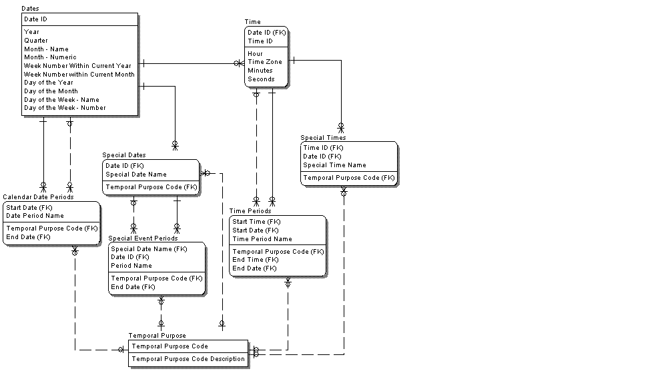
Parties, Locations and Resources
- The entities, Parties, Locations and Resources are independent entities. In the data model, they have essentially the same definitions as discussed the Standard Entity section of this paper. In addition, they can represent various levels of abstraction. For example, a Party ID may be represent a class of parties (e.g. individuals versus organizations) or a specific party (e.g. the IBM Corporation).
- Parties, locations and resources may be involved in various types of recursive relationships.
Related Parties
This table is used to store information about actual relationships between parties. These relationships are either defined explicitly or can be derived from other data (e.g. agreements, transactions, etc.) and stored here.
An example of an explicitly defined relationship is the organizational hierarchy for a company's sales organization. Because the table is recursive and there are no fixed relationships, it can handle any organizational structure that the company desires. The table can then be used to relate outside parties, such as, dealers and vendors to the internal sales organization.
An example of a derived relationship is the company's "top customers". These are derived through various criteria such as sales volume and on time collected receivables. These could be derived every time the information is needed. However it may make sense to derive the relationship at certain intervals and to store it in this table for performance. For example, evaluation of customers may be done monthly to identify the top 10% and stored in this table and used for special deals or for other reports.
Related Resources
A resource can be related to another resource in a bill of materials. This would include both mandatory and optional hierarchies of configurations. A resource could also be serialized components that are part of serialized resource. These are "as built" versus "allowable" configurations. A sub-assembly is a serialized resource that is composed of other serialized resources. The Resource ID denotes the subassembly. The components that make it up are the Related Resource ID's. The Connection ID allows for multiple resource hierarchies to exist.
Related Locations
This table describes relationships between physical locations. There are two types of related locations: a route and a hierarchy. A route is one location followed by another. A hierarchy is locations within locations. The same pair of locations can be part both many routes and many hierarchies. In other words, the Location ID identifies a specific point. The Connection ID connects a set of locations. Even a bi-directional chain is not sufficient. The current location, previous and next location role by themselves are not sufficient to identify a chain of locations. Two separate routes (or hierarchies) could have the same three locations (current, previous and next) in common at one point only to diverge into different sets of points previously or later.
While a route can have only one previous location, a hierarchy can have many child locations. For example, a warehouse contains many bin locations. Both, however, can only have one parent or next location.
- A Resource ID can also refer to either a serialized or a non-serialized resource. A serialized resource is specifically identified. For example, a specific engine with a serial number. Because a serial number can change over the life of a serialized resource, the serial number is not the primary key. Rather it is an attribute of the Serial Number History.
- Because a Resource ID is assigned to a type of resource at the lowest level (e.g. SKU) and to a specific serialized resource, the connection of a specific resource to the type of resource it represents is through the Related Resources table. For example the ABC-L25 Gas 6 cylinder engine is a specific production option. It is assigned a Resource ID. A specific engine, XYZ-12-7675 is also assigned a Resource ID. In the Related Resources table there will be a row where the serialized engine is the Resource ID, the production option is the Related Resource ID and the Connection Structure indicates that the engine is an “instance of” the production option.
- The physical identity of a non-serialized resource requires a location, a point in time and a quantity. This is in the Non Serialized Resources to Location entity.
- Each Party can have its own part numbers for the same resource. The Part Number History permits this and allows these party-specific numbers to change over time.
The resource ownership tables allow the ownership of a resource to be shared among multiple parties. Although not included in the model, a possible extension would be to incorporate a relationship to an agreement that specifies the ownership percentages.
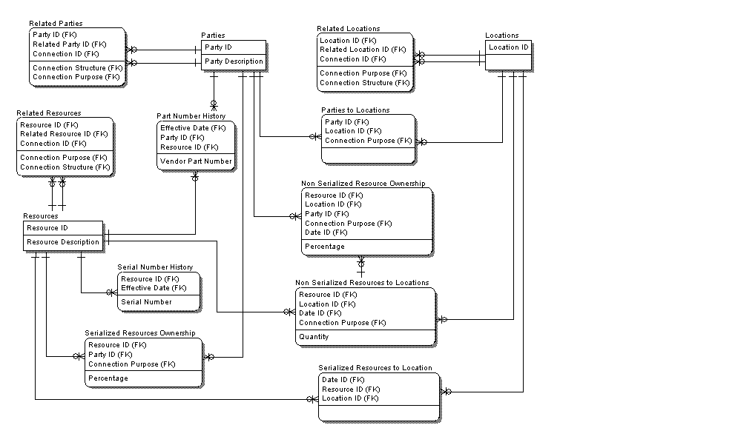
Agreements
- An agreement is the basis for the relationships between parties. The Agreement is an independent entity with a surrogate key, Agreement ID. Parties to Agreements is an association between Parties and Agreements. This structure accommodates both bilateral and multilateral agreements. The Connection Purpose describes the reason the party is related to the agreement, not the business purpose of the agreement. If it is possible for a party to have multiple roles with regard to an agreement then the Connection Purpose should be part of the key. An example is where a party is both the maker and the trustee of a trust.
- An agreement can be related to another agreement. These are Related Agreements. The Connection ID as part of the key allows an agreements to be linked in various ways. For example, one connection relates agreements that are amendments to an original agreement. Another connection represents contingent agreements that take effect only if certain conditions are met.
A specification is a section or a clause of an agreement. An agreement can have many specifications and the same specification can be in many agreements. A specification can cover a wide variety of topics. These are modeled as one-to-one optional relationships. The cross industry model shows a handful of the many possibilities. Related Specifications deal with a situation where a clause in one agreement specifically refers to a clause in another agreement.
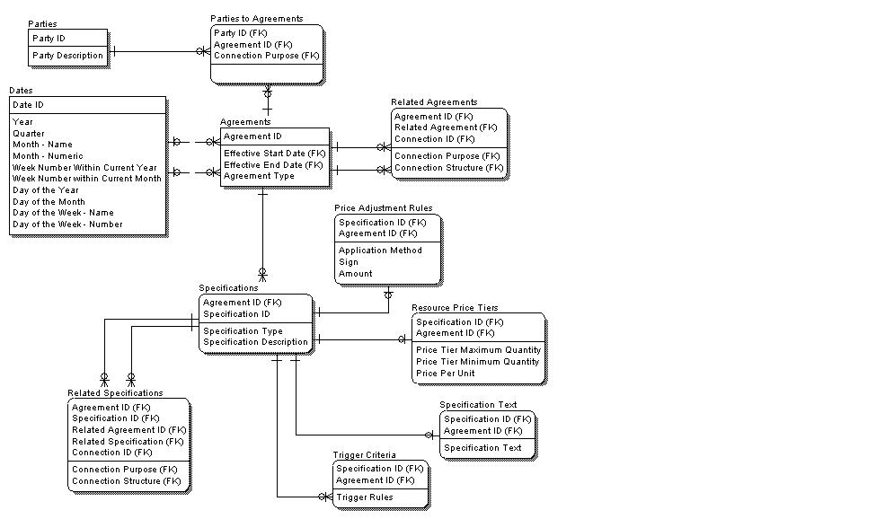
Orders
- An order is an instruction, not the actual event itself. It can be an order to buy or sell materials, to produce materials, to deliver or receive materials, etc. The order has a date when it is issued and a date when it is supposed to take effect.
- Many parties can participate in an order. The parties to a brokered securities trade include the buyer, the seller and the broker. The connection purpose describes the relationship of each of the parties to the order.
- Parties are related to the order as a whole. However, an order may relate to many materials. The Resource ID of each of these and the number of units of each is in the Order Line Items. This price is not, however, because of the potential complexity in calculating a price.
- An agreement is the basis for the order. A sales contract is the basis for a sales order. Some terms and conditions relate to the order as a whole. These are in Order Header to Agreements. Other agreements relate to the pricing of specific items on the order. These are in order detail to agreements. Multiple agreements can enter into pricing a single line item. The contribution of each of these to the calculation is in Order Line Item Pricing by Agreement. The sum of each of these is in the Order Line Item Pricing Summary. The total price of the order may not be the sum of the line items due to discounts that apply to the sum of the line item amounts. As with the line items, several agreements may impact the calculation of the header level price adjustment. The result of each of these to the total is reflected in the Order Header Pricing Adjustments by Agreement. The Order Pricing Summary is a recap of detail and header level pricing. While these are derivable, they are shown in the model to illustrate the concept of how these different calculation drivers may interact.
- Orders may be related to other orders. These are in Related Order Details. An example of this is multiple delivery orders and / or back orders for a single line item on a sales order. Another example is the substitution of one order for another.
An order is an instruction for an event to occur. Orders to Events relates these. A single production order can give rise to many production events, both planned and actual. An event need not be the result an order. For example, a causal event such as a flood is not the result of an order. The causal event may however be related to the many delivery orders that were affected. However, if an event is the result of an order it is usually related to a single order. For example, when multiple sales orders are consolidated into a single shipment, it is the consolidated shipping order that triggers the shipping event, not the multiple sales orders.
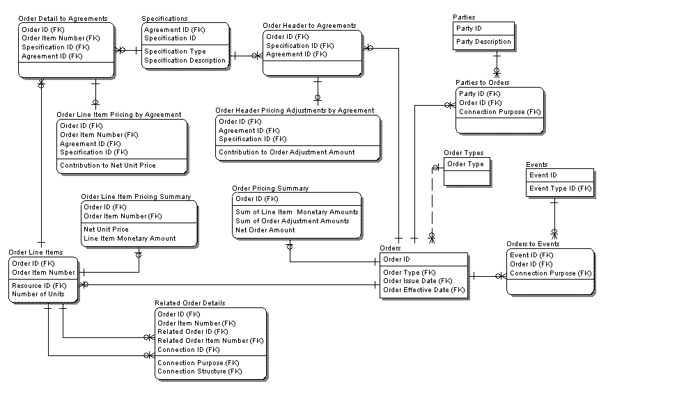
Events
- An agreement can be related to an event without reference to an order. An example is a trial. The statutes that are the subject of the trial events are a form of agreement.
- A resource can be related to an event both with and without reference to a location. For example, at the early stages of production planning, a planned production event can reference the resources that will be needed without specifying the plant where the production will occur. At later stages the planned and actual production events will reference resources at specific plant or warehouse locations. Another example is allowable operations. Certain labor operations can only use specific parts. Likewise, certain operations can only be performed at specific locations. In some cases, it is a specific combination of all three. The structure that will be used depends on the business rules.
- Events can be related to events in various ways. One is the chain of events discussed under Standard Entities. Another example is causal events that are correlated to business events.
An event may or may not have a financial impact. For example in brokerage, a retail trade is initiated by an order from a customer. The broker may need more than one trade execution fill the order. In the case of a “fill or kill” order, each of these has a status of completed but pending. Only when the entire order is filled can the status of each trade event be changed to “fully executed”. Otherwise, the status of each pending trade will be changed to “cancelled”. The changes in status of each event are tracked in the Event Status History. An accounting entry to a customer’s will be generated when the status of each of the trades is “fully executed”. Each event is separately related to its accounting entries since the each trade to fill the order could have been executed at a different price. Likewise, multiple accounting entries can be generated out of a single trade execution to account for the trade itself, fees, etc.
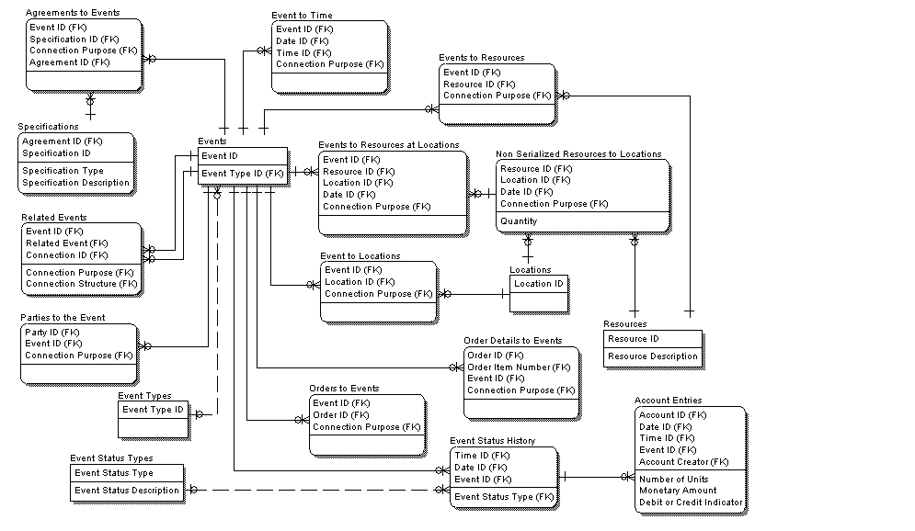
Accounting
- An account is created by an agreement. This could be a deposit agreement at a bank or an accounting policy that creates a general ledger chart of accounts.
- An account always has an Account Creator. Since accounts represent financial ownership, they cannot exist without reference to some Party. A general ledger pertains to a specific organizational entity. An account may be related to many parties. A bank account may be a joint account with multiple parties as signatories. On the bank’s books, the bank is the Account Creator on the customer’s account. The signatories on the account are maintained in the Parties to Accounts. On the customer’s books, a different general ledger account number may be used to represent the cash in the bank account. The Related Accounts table shows the relationship of the two accounts.
- It would be possible to infer the relationship of the parties to the account through the Parties to the Agreement and its Connection Purpose. It is shown explicitly in the model to illustrate the concept.
- As discussed above, resources are related to accounts through events’ statuses. Thus the relationship of resources to accounts can be derived through events. As with the relationship of Parties to Accounts, the association of Resources to Accounts is shown to illustrate the tight conceptual connection between the two. An account is the financial representation of an asset. An asset may also be collateral for an account. These are common real world situations that are shown in the data design whether or not they are physically implemented as modeled.
Related Accounts can be used to represent an account hierarchy. Because the Connection ID is part of the key, an account can participate in multiple hierarchies. For example, a company may have one hierarchy for legal reporting, one for line of business reporting etc.
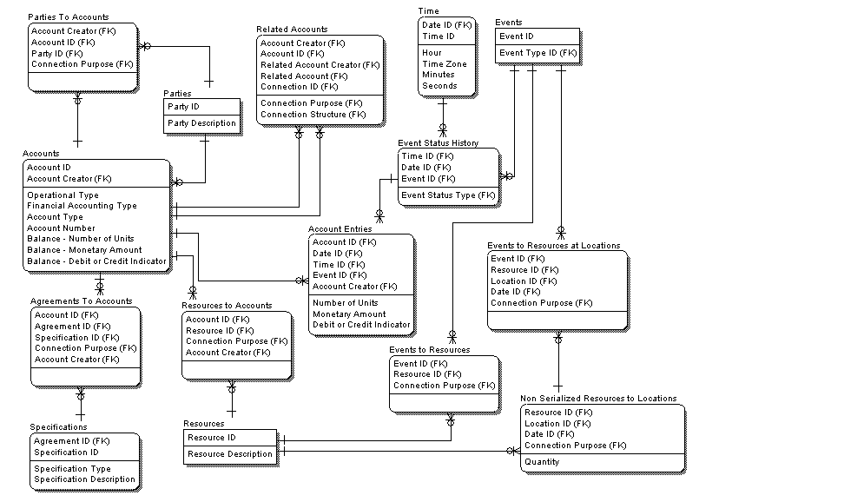
Claims
- Events are related to claims in many ways. An event, such as, an accident may lead to a claim. The assertion of a claim is a type of event. The interactions of the parties in settling the claim are also events. There may also be many parties to the claim: the person causing the accident, the accident victim, the insurance carrier, the lawyers, etc. Resources may also be related to the claim in various ways. There are resources sought by the claimant to settle the claim. There are resources actually given up to settle the claim. When a claim involves different resources from or to the various parties a three way relationship of Resources to Parties to Claims may be necessary.
- An agreement need not be present for the assertion of a claim. Settling a claim, however, will involve one or more agreements. A claim may be related to an insurance policy, a court settlement or a contract. An example of the latter is a disputes property line where the contract to sell the disputed property settles the claim. In the case of an insurance policy, the Agreements to Resource shows the resources covered by the policy. Agreements to Resources claimed matches the coverage with the claim.
A claim settlement event results in an accounting entry.
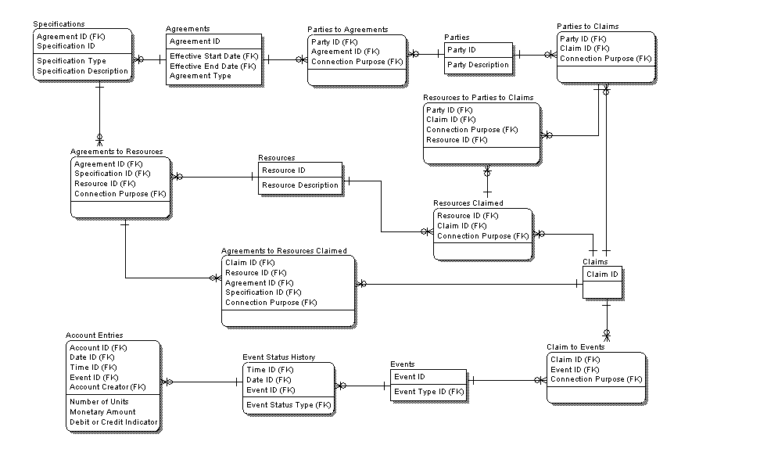
Shipping and Billing
- This topic area applies the techniques described above to a specific problem area, shipping and billing to fulfill sales orders.
- Orders can be sales orders, assembly orders, shipping orders, etc. The Related Orders contains the chain of orders from sales to shipping. The Connection ID is the link back to the original sales order. The events that occur based on these orders have that same Connection ID. Events can spawn other events in the chain.
- Events include both planned and actual events. Planned Resource Movements show the location from which shipment will take place. A Connection ID associated the two locations would designate a specific route. A Planned Carrier designates the common carrier that will make the shipment. An Actual Resource Movement contains the actual facts of the movement. Planned and actual resource movement events are connected through the Related Events.
- The shipping event triggers an invoicing event. The invoice reflects the amounts in the Order Line Item Pricing Summary and the Order Pricing Summary. This is redundant but is necessary since the invoice is a document, either paper or electronic, that will be sent to the customer. This, however, may just be a starting point for calculating the invoice amount. The invoice may be subject to separate agreements and / or specifications that deal with discounts based on timing of payments, etc. The results of these calculations are the Invoice Adjustment Amounts. These are applied to the Net Order Amount to get the Net Invoice Amount in the Invoice.
While not shown here the invoice event is related to an Account Entry to book the receivable. The receipt of a payment is an event also that is related to an Account Entry to reduce the amount of the receivable.
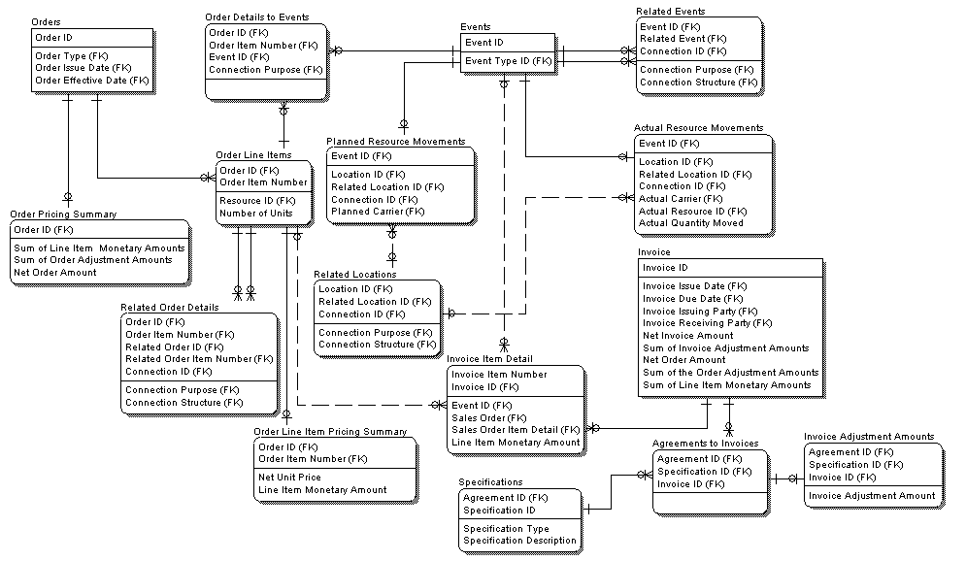
- Data Design Development Summarization
Step 1: ERM - Identify the data requirements to support each business operation or to answer each business question that is in the scope of the application.
Use cases should drive information requirements that in turn drive the attributes that are included in the logical data model. Allowing use cases to drive this keeps the model focused on the application’s requirements.

Step 2: CDM - Determine the lowest possible level of granularity associated with the data required.
For example, if a business question that asks for product category, the lowest level is the entire merchandise hierarchy down to the SKU. This is important to ensure that the data model will not be built at too high a level of aggregation based on initial requirements. For example, the original business question may ask for sales by product category and customer type and division. If the data model is built at this level, it will be impossible to support later requirements to drill down to the customer level or product level.
- Determine the lowest level of granularity in the current operational systems. Obviously, the best way to do this is to work with users and developers who are familiar with these systems. If there is any uncertainty, review the screen input that the business users expect to drive the reporting to determine the level of detail captured. It is important to go beyond the screen layouts to determine if the users are using the system in unintended ways. Is a screen field labeled “Customer Type” being used to hold an interest rate? Is a split shipment of the same order line item copied to a second line item?
- Review these aberrations with the business users. The goal is to develop a common understanding of any business nuances that are reflected in the data. They may know of other nuances that were missed. Doing this will make data model more accurate. This is also a necessary step in developing the application design.
- Identify with the business users the requirements for drill down and drill across based on what has benn learned about the lowest layers of granularity.
Step 3: LDM - Create the fully normalized data model by customizing the tables in the Cross Industry Data Model or other off the shelf model whenever possible.
- Data modeling is an art. The products of that art are not ends unto themselves. They are a link between gaining an understanding of the business requirements and developing and implementing a system. The approach discussed here uses an IBM asset, The Cross-Industry Data Mode,l as a starting point. The goal is that when engaged on a project for a new client or in an unfamiliar industry, one does not have to “start from scratch with a blank white board”. Rather, standard models can be used to quickly arrive at a close approximation of the final model. The discussion, then, focuses on how the client is different from our “straw model”. It also helps the data modeler at the conceptual level to understand some of the potential issues.
While the Cross-Industry Data Model is a logical model, it tends to reflect details that would concern an application developer. The important thing to remember is that this is intended to be a starting point for creative thinking, not a cookie cutter answer to all modeling problems.
- Map the existing operational data to the cross industry data model. If possible, create new tables as subtypes of standard tables. In doing this, remember that the cross industry model is a starting point for the modeler. Because the cross industry model relies heavily on recursive relationships, it can sometimes be too abstract for a business user. When this is the case, create separate tables. For example in an HMO, plans, members and providers are all parties. This may be too abstract for the business user. If so, create separate tables for each. Eliminate data elements and tables that obviously do not apply.
- Add additional data elements to reflect the specifics of the business. One common problem is that the actual business data will often have many names for a single business concept. The challenge is to filter out and document these aliases/synonyms. The opposite is also true. Often times there are overloaded terms where the meaning will vary depending on the context. In this case, separate attributes must be created for each concept and assigned to the appropriate entity in the model.
- Document the calculations for any derived fields in the legacy systems. Verify that they match the definitions used to answer the business questions in business discovery.
- Document the domain values and data types for the relevant data elements in any legacy systems that are being replaced and / or operational systems that will feed a data warehouse. This will help in the understanding of the data and may be necessary for a conversion. In a data warehouse, it is especially important that this be done in conjunction with the requirements gathering process. Otherwise, the requirements and the data model to support the requirements may be inconsistent with the operational data that will feed the warehouse.
- Conform the terminology in the standard entity and cross industry model to what is familiar to the business users. There is nothing to be gained by engaging in a terminology debate with the customer.
For example, the standard model is based on manufacturing and uses the term orders to denote sales to customers. Structurally, an Order in manufacturing has a lot in common with a POS transaction in a retail setting. This makes orders a good starting point for modeling for POS transactions. This does not mean that a data modeler should try to convince a grocer to refer to “register sales” as orders.
Another example is in airline operations. The modeling of production processes in manufacturing has much in common with flight operations. This makes the former a good starting point for the data modeler in understanding the latter. However, it does not mean that the modeler should try to change the terminology of the business user to a more generic term.
Users tend to think their business is unique. Even if from a data perspective dissimilar businesses have much in common, there is usually no point in trying to convince a business user that this is the case. They want to be convinced that you understand their business. Examples from other businesses will often times only convince them that the modeler doesn’t really understand the user’s business. At the point where a user begins to really understand data modeling as an art, a conversation about similarities between industries can be useful. However, doing this prematurely will tend to contribute more to confusion than insight.
Step 4: Review, analyze and document findings
Regardless of the tool used to develop the logical data model, it is important that the conventions used in the model are well defined. The following are the conventions used in the Cross Industry Data Model. The important thing is that the conventions are well documented.
- Specify entity definitions and attribute definitions in the data modeling tool whenever possible. This is especially important when the name doesn’t make the definition self-evident.
- Supply domains of values for “type” entities. For example, if there is an entity, Customer Types, specify the valid values as part of the definition.
- Provide standards for names. Entity names and attribute names should be singular. Surrogate keys are suffixed with ID.
- If a logical data model will be used to generate a physical data model, there may be restrictions on the length of the column names. This means that complete logical names may be truncated in the process of generating the physical model. To plan for this, use a standard set of abbreviations in the logical model. If abbreviations are used, use them consistently throughout the model. For example: Security_Master is less than the 18 characters allowed for a DB2 column name; Security_Price_Interval is more than 18. Both should be abbreviated as: Sec_Mast and Sec_Pric_Int.
- A subtype entity must have a discriminator in the super-type. It is represented in the model by a one-to-one optional relationship using IE syntax.
- Resolve all many-to-many relationships into associative entities. An Associative Entity may be named in one of two ways. If the relationship is general in nature, a common naming convention is “nnnnn To xxxxx”. This is an association between two entities that can occur for more than one reason. In this situation, the nature of the relationship should be part of the key. This is the relationship role. An example is Related Parties. Two parties can have both a vendor relationship and a customer relationship. In order to manage the customer relationship, it may be essential to consider the vendor relationship as well since it can be a form of leverage.
- Model relationships that can be open-ended as recursive. If the relationship is recursive in nature, it is named “Related nnnnn”. Examples are Related Parties and Related Agreements.
- Divide the main data model into subject areas that reflect clusters of related tables (e.g. Orders, Events, etc.) or connections between those clusters (e.g. Shipping and Billing). Preferably these can be printed to no less than 60% reduction on 81/2” X 11” paper. This makes it easier to explain and review the model since the focus is reduced to a specific topic and printing is more practical.
- Derived attributes may be included in the data model to illustrate concepts to the application developers. The definition of a derived attribute should include the derivation rules. The decision whether to store a derived attribute or to derive it at execution time is made during physical design.
Step 5: PDM – Weigh physical implementation factors and process access considerations against the logical data design.
The design to this point is implementation-independent. In order to create the target data stores such that they not only serve the business but do so as optimally as can be delivered in the context of those data stores, the design must now have elements of physical-dependence interjected. Much of this is identified from analysis and understanding of the application’s processes regarding the types of accesses they perform; the environments in which they execute; the degree of randomness or serialization by which they process data; data access contention that may arise from concurrent running processes; access security to protect the data and also to prevent disclosure of sensitive data to only those users/processes requiring such data; and other such items. Additionally, logical component names generally must be “mapped” to their correspondent physical names which usually are shorter in length due to the name-length restrictions of the target DBMS. At the completion of this exercise, the model is the basis from which the target DBMS schema/Data Definition Language (DDL) is created. Revision History

Revision Number | Revision Date | Summary of Changes
4.1.1 | March 2004 | Incorporate Ascendant Methodology Data Modeling Reference material; Broaden context and elaboration of data modeling and data design
1.1 | November 2001 | Applied new template and style, spelling and grammar check
1.0 | May 2001 | First Draft

Within this document, the term application is used in its most abstract sense to mean any set of processes delivering business function or in support of business functions.
Throughout this document the term “component” is used in its broadest meaning and does not have any specific connotation as may be attributed to the term as used in object oriented development.
Data dictionary here is used in a broad connotation. It also refers to metadata repositories of which data dictionaries may be a part. In some cases the data modeling tool provides and serves as the data dictionary or repository of information about data.
With the emergence of businesses viewing data as a corporate asset, data ownership and related responsibilities are becoming more formalized via Data Governance organizational structures. Under such programs, the role described here for a DA is generally fulfilled via Data Stewards.
The diagram in Figure 10 shows another convention by which entities can be depicted. The numeric number shown in the upper right corner of the entity is an entity identification number. It serves as a unique identifier for the entity as an object in a data dictionary. This is not as prevalently used a notation as that used from IE- based or derived languages.
The numeric number provided in the left-most corner of each entity in this diagram represents the maximum number of occurrences the entity is estimated to have. This is also valuable information that should be captured for use in subsequent design and implementation activities.
It is not common, but in some cases resolution will introduce one-to-one relationships.
Explicit demarcation of existence dependence is not provided in all data modeling languages/notations and would only be available in data modeling tools supporting it,
Explicit demarcation of existence dependence as shown in this diagram within the Purchase Order Line Item entity is not provided in all data modeling languages/notations and would only be available in data modeling tools supporting it,
The concept of Supertype-Subtype Entities is not part of all data modeling languages/notations and the ability to explicitly depict this concept graphically in a data model, consequently, depends upon the data modeling language(s) supported within the modeling tool used.

