

IBM Global Services

Business Justification

Technique Paper (TP)

© Copyright International Business Machines Corporation 1999, 2001
All Rights Reserved
Version 2.0 September 2001
- Cost Benefit Analysis
As part of an assessment or redesign engagement the client will frequently require a quantified analysis of the potential benefits of the proposed solution as part of the final report to enable them to make an informed business decision. This type of cost benefit analysis is focused on;
- The identification and quantification of all the benefits and cost related to the proposed solution alternatives
- Careful consideration of the benefits and costs by means of an economically oriented criteria or model
It is important that the client assign a knowledgeable individual the responsibility to work with the consultant team to develop the benefit estimates and to quantify them in a manner that is consistent with the client’s standards and disciplines.
The benefits of the proposed technology enabled solution will typically fall into six major categories.
- cost avoidance
- cost reduction
- revenue improvement
- performance improvement
- product quality improvement
- improved customer satisfaction
Costs can be categorized as development costs, implementation costs, and operating costs. Typical development and implementation costs include;
- hardware
- software
- services
- documentation
- training
- supplies
Typical operating costs include;
- new employee salaries
- replacement equipment
- maintenance
- supplies
- Context of Use
The techniques covered in this paper provide direction for structuring data gathering and analysis of solution benefits and costs. This paper supports the development of the following work products;
- Preliminary Cost/Benefit Analysis
- Recommendations and Preliminary Business Case
- Solution Recommendation and Business Case
- Scope of Organizational Redesign
- Cost Benefit Analysis Stages
Cost benefit analysis can be broken into five stages;
- Develop cost benefit hypothesis and data matrix
- Gather solution benefit information
- Gather solution cost information
- Select and develop decision model to be used
- Review and gain client buy in
3.1 Stage one: Develop cost benefit hypothesis and data matrix
To identify the critical information necessary to develop an effective cost benefit analysis it is important to develop a set issues/hypos and questions based upon client goals, objectives and strategic issues. Much of the information necessary for answering the questions identified in this process may have already been obtained through initial interview process and the redesign workshop. An additional set of interviews may be necessary to fill the identified information gaps. Below are a sample of issue areas and hypotheses that could be investigated;
Customer service.
Hypotheses
- The Client can place a specific financial value on customer service levels.
- An increase in customer service can be specified in financial terms.
- The technology-enabled system will improve the Client's ability to serve their customers.
New and expanded business opportunities.
Hypotheses
- Applied technology will allow existing employees to handle increased business volume.
- Improved processes will allow existing employees to handle new business opportunities.
Competitive position.
Hypotheses
- Competitors are using technology for efficiency and cost control.
- Improving efficiencies will enable the Client to more effectively compete in market place.
- The client can place a specific financial value on competitive advantage.
- The technology-enabled system will provide the Client with a strategic weapon.
Resource utilization
Hypotheses
- A new process will let current employees handle a greater range of tasks, making better use of skilled resource.
- A technology-enabled process will let less skilled people deal with greater complexity.
- A new process will require less nonproductive resource (management and supervisory personnel)
Worker productivity
Hypotheses
- With the new process, individual task times will be reduced.
- With the new process, more work can be done with the same people.
- With the new process, the work can be done more accurately in the same time.
Job enhancement
Hypotheses
- Job enrichment has a direct correlation to employee productivity.
- The costs associated with employee turnover can be avoided by improving a process and enhancing a system.
Management control
Hypotheses
- Improved control over the flow of work will increase the output of the Business Area.
- Improved scheduling of work will increase individual productivity.
- Increased output and individual productivity can be translated into specific financial gains, e.g.
- The production of additional revenue
- The reduction of specific costs
Access to information
Hypotheses
- More timely access information will decrease customer callbacks and improve customer satisfaction
- The technology-enabled process will improve access to information and increase employee productivity.
Current hardware
Hypotheses
- Additional processors will be required
- Additions to existing processors will be required
- New workstations will be required
- New hardware unique to work flow management technology will be required.
New software systems
Hypotheses
- New system software will be required
- Existing system software will need to be upgraded
- New application software will be installed
Special skills
Hypotheses
- The client may want to employ outside skills to do:
- Site preparation
- Hardware installation
- Software installation
- Application tailoring or customization
- Project management
- Training
Outside services
Hypotheses
- The Client requires an outside systems integrator.
- The Client prefers to contract for required implementation skills rather than build in-house skills.
- The Client requires additional resources for this project
3.2 Stage two: Gather solution benefit information
The benefits of the proposed solution are driven by the process improvements created by the To-Be process redesign work. To quantify these benefits, costs should be identified at the activity level for both the existing and proposed process. This exercise will provide the necessary building blocks for pinpointing cost savings and avoidance. The most common benefit area to investigate is the time currently spent in the performance of an activity and the savings potentially obtained through the improved efficiency or elimination of the activity. Beyond timesavings and employee costs, other benefit areas to be investigated are;
- management supervision
- education and training
- sales and marketing
- rework
- quality control
- general administration
- information systems
- facilities
In addition, strategic benefits such as improved customer service or expand market presence should be included in benefit analysis. Figures 1 and 2 are sample worksheets to provide a structure for collecting client provided information on potential improvements that may result from the redesigned process.
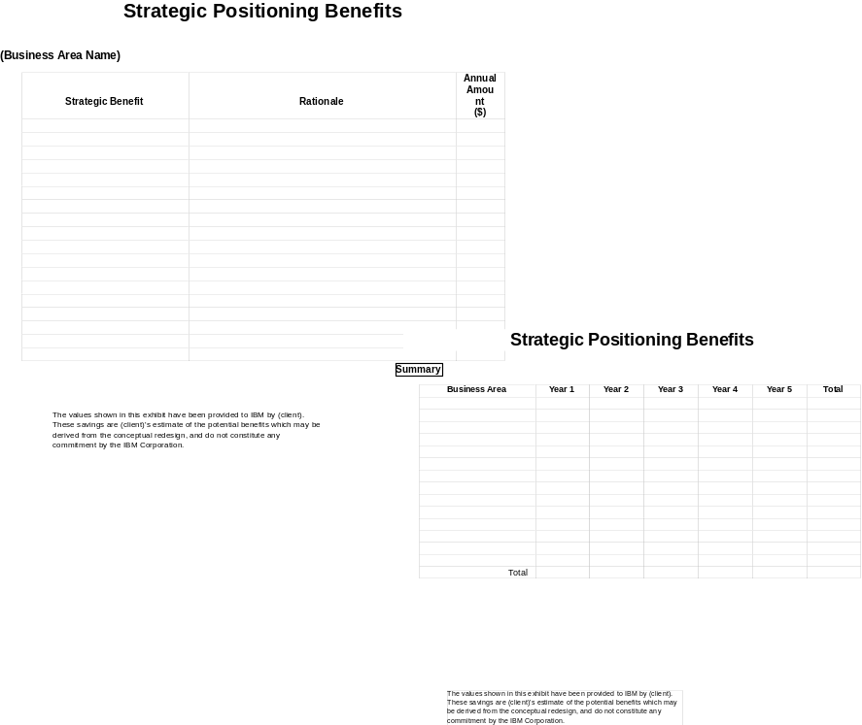
Figure 1
Steps
3.2.1 Identify specific benefit area to examine
- Review client issues and goals.
- Review the interview summaries and the notes taken in the Design Workshop.
- Study the As-Is process and compare it to the redesigned (technology enabled) process.
- Determine the where benefits are most likely to occur
- Identify preliminary cost associated with key activities in both As-Is and To-Be process.
- Select the Clients from whom you can get benefits information.
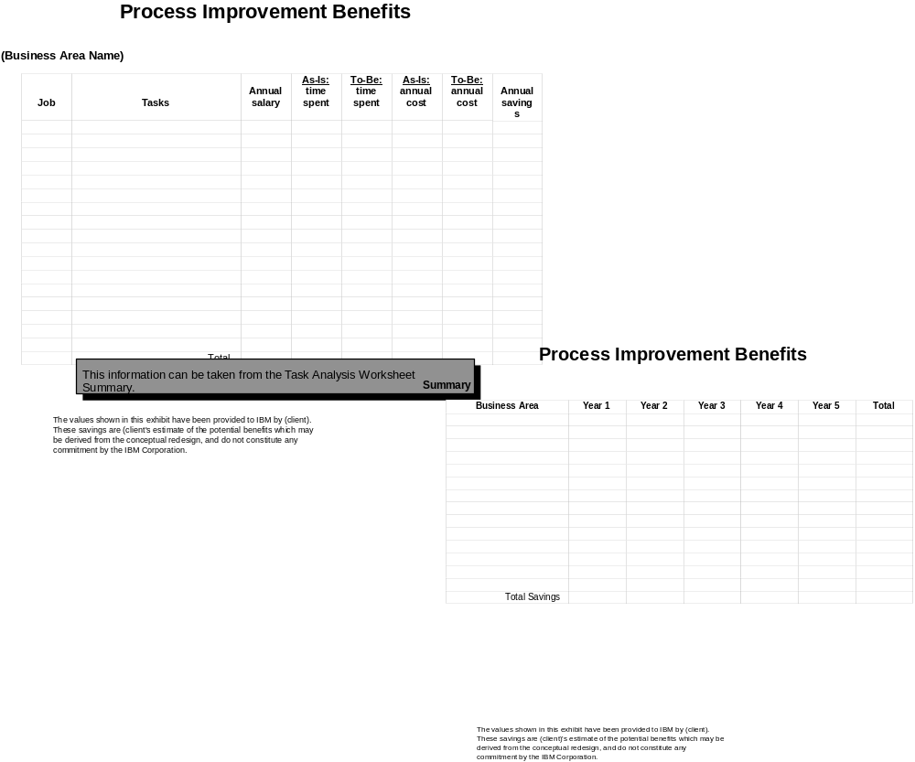
Figure 2
3.2.2 Establish a Client "benefits team"
- Request that the Executive Sponsor names a "value assessment" coordinator to be responsible for the collection and verification of benefits data.
- Working with the "value assessment" coordinator, determine hypothesis to be investigated, develop questions and identify the sources of benefits data.
3.2.3 Prepare benefits worksheets
- Customize the benefits worksheets for this Client, deleting irrelevant items and adding others as needed.
- Make paper copies the customized Benefits Worksheets for all individuals who will be asked to provide input.

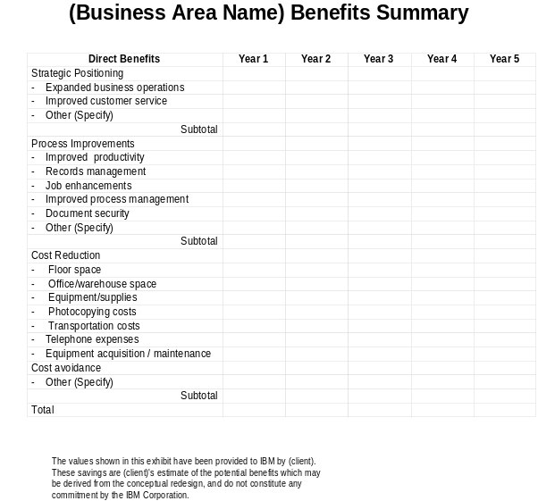
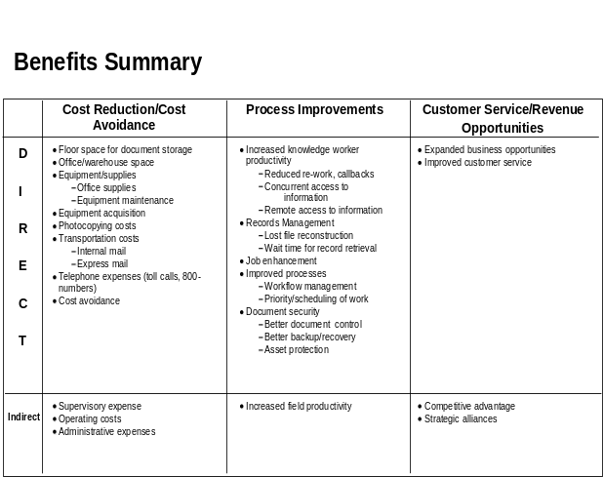
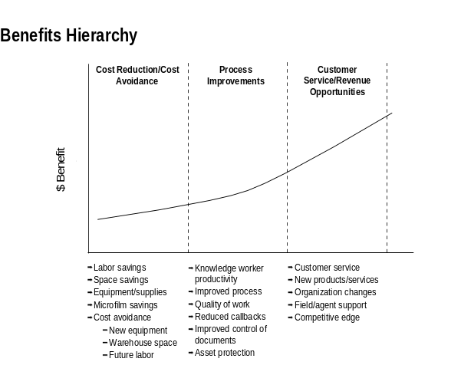
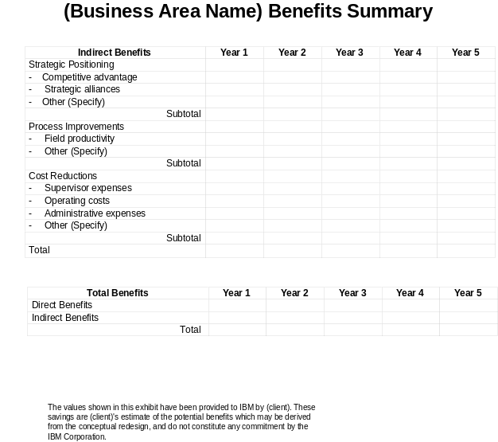

Figure 3
3.2.4 Interview executives for strategic benefits
- Working with the "value assessment" coordinator, schedule meetings with the individuals identified.
- Begin meetings with questions developed with client “value assessment” coordinator.
- Working jointly with individual executives or managers, complete the customized benefits worksheets.
3.2.5 Interview Business Area managers for process improvement and cost reduction benefits
- Working with the "value assessment: coordinator, schedule meetings with the individuals identified.
- Review the worksheet with the manager, and offer to sit with them as they fill it out.
- Get the worksheet completed in their handwriting, if possible.
3.2.6 Compile the information gathered from the benefits interviews.
- Document your assumptions
- Consolidate the data in the benefits worksheets filled out by the various Client managers.
- Complete the Benefits Summary (figure 3), summarizing:
- Strategic benefits - customer service and increased revenue
- Process benefits - improved operational efficiency
- Cost Reduction benefits - cost displacement and avoidance
3.2.7 Review the Benefits Summary with the Client
- Prepare a presentable version of the assumptions using the Benefits Assumptions list (figure 4).
- Prepare a report-ready copy of the Benefits Summary (figure 3) using the handwritten information on the Benefits Worksheets.
- Review the Benefits Summary with the "value assessment" coordinator to ensure that it represents the information that the Client provided, and correct the information as required.
- 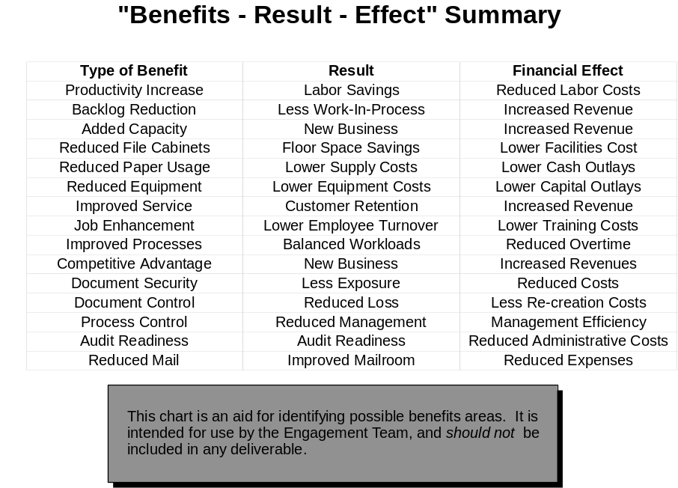Review the Benefits Summary with the Executive Sponsor, and inform them that this is what you intend in the final report.
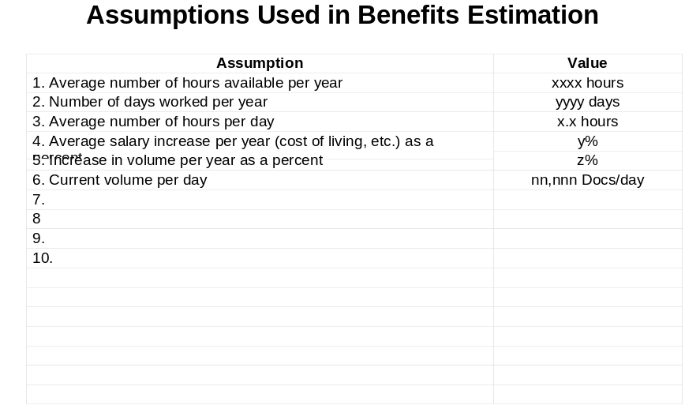
Figure 4
3.3 Stage three: Gather solution cost information
Steps
3.3.1 Size the hardware and software components of the solution
- Review the redesigned process and the system concept, including:
- PLOVC and JLOVC charts for the technology enabled process
- Activity descriptions
- System concept diagram
- Requirements worksheets
- Confirm with the Executive Sponsor the vendor alternatives for solution.
- Select the vendor's system that will be used as the basis for the cost. Document the reason for selecting this system.
- Estimate the size of the system needed to meet the requirements
- Define the number of users who will be serviced.
- Develop a high-level component list that will be used for project evaluation purposes. This should be at the "box" level, not at the feature level.
- Obtain pricing information from either vendor marketing representatives or published information.
- Establish a cost for the components needed (figure 6)
3.3.2 Size the consulting and services effort.
- Review the system concept
- Identify the sources of services (i.e. different vendors).
- Review any appropriate platform implementation guides, as applicable.
- Review recent proposals recommending implementations of this platform type.
- Review recent implementation project completion reports.
- Identify potential work products to be produced on next phases.
- Estimate the implementation tasks for the appropriate platform.
- Complete the Consulting /Services Costs worksheet (in figure 5).
- Quality assures the services requirement.
- Develop an estimate of all consulting and services required.

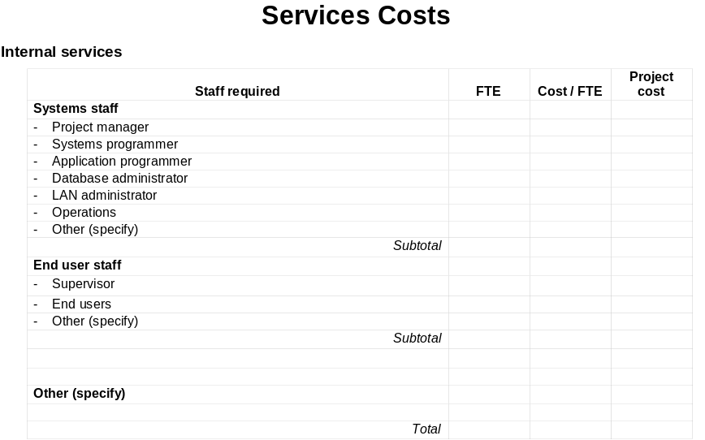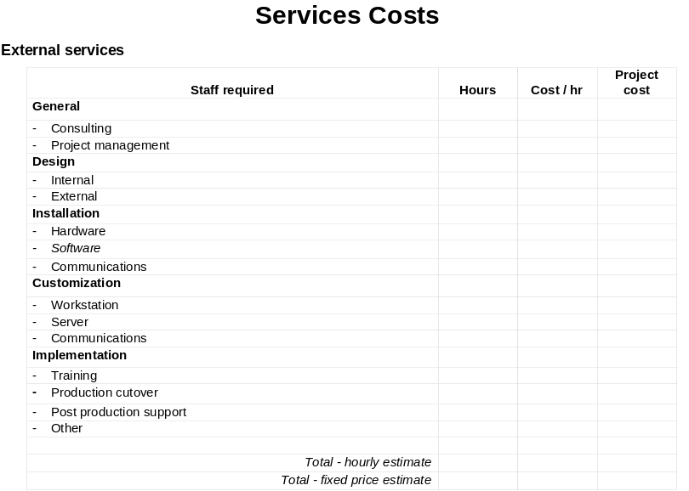
Figure 5
3.3.3 Estimate the Client's tasks and responsibilities
- Review Client skills (and their availability) with I/S executive.
- Determine the Client's interest/need in doing any of the implementation activities in-house, e.g.:
- Software installation
- Functional tests (planning and execution)
- Customization
- User department training
- Estimate the client's effort and summarize on the Internal Services Costs worksheet (in figure 5).
4. Develop a cost estimate range for both direct and indirect costs.
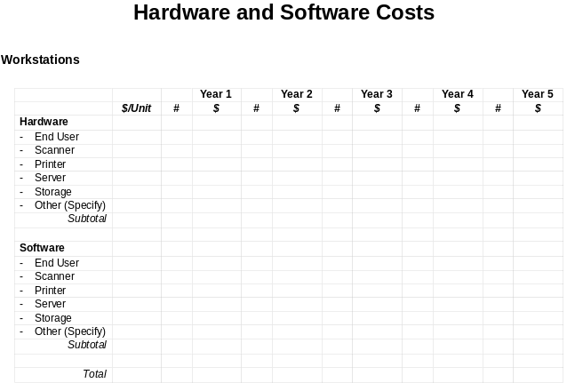
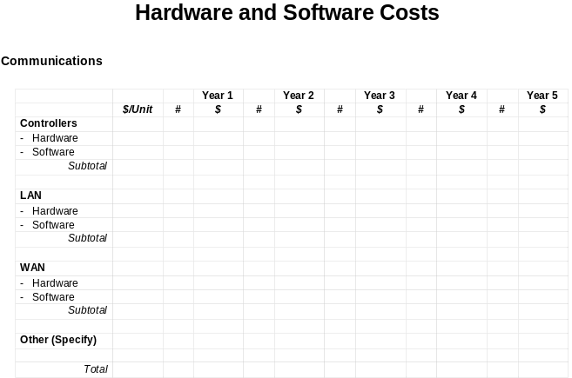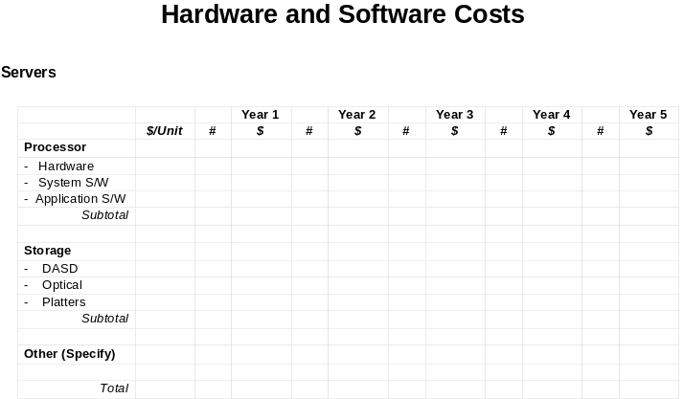
Figure 6
3.4 Stage four: Select and develop decision model to be used
Once you have identified all the quantified all the benefits and identified all of the cost of implementing the proposed solution a decision model must be selected for evaluating its economic feasibility for the client. It is important that you work with the client’s financial organization in the selection of the model to be used to ensure consistency with the standards they use for evaluating financial investments. Some typical models used by clients are;
- Break-even Analysis - Cumulative benefits are compared with cumulative fixed and variable costs to determine the point in time when the solution alternatives reach zero net benefits, i.e. break even. The solution with the shortest payback period is the best financial candidate for selection.
- Net Present Value Model - Cumulative benefits and costs are discounted by compound interest (discount) formulas that reflect the time value of money to obtain their attributed values at he present time (i.e., the time of the decision). The present value of all costs is then deducted from the present value of all benefits to obtain net present value. The solution alternative with best net present value would be the best candidate for selection.
- Internal Rate of Return - Cumulative benefits and costs are discounted by compound interest (discount) formulas, as in the case of the net present model. However, the internal rate of return process has the purpose of determining the internal rate of return (the interest rate that causes the net present value to be zero). The solution alternative with the highest internal rate of return is the best candidate for selection assuming the internal rate of return exceeds the cost of capital internal rate.
Client agrees upon should be captured in an electronic spreadsheet such as 123 or Excel. This will facilitate the modeling of multiple alternatives and cases by easily varying key factors. In addition, given all potential models and benefit are estimates it maybe advisable to select a conservative factor for estimates such as taking credit for only 65% of estimated benefits. This approach will serve to enhance the credibility of proposed solution.
3.5 Stage five: Review and gain client buy in
The details of the model and its results should be reviewed with client financial representatives to gain understanding and buy in on assumptions and approach. The final report should extract conclusions from this analysis worded as a dramatic call to action for the client.
- Examples
Figure 7 is an example of a spread sheet model which was developed to quantify cost saving for a redesigned call center. The financial model translates benefits into seconds saved on calls which is then converted into full time equivalents. The model supported the goal of the client to expand market without growing call center.


Figure 7
- Revision History
Revision Number | Revision Date | Summary of Changes | Changes Marked?
1.0 | 1999 | Base version
2.0 | September 2001 | Applied new template and style, spelling and grammar check.

