

IBM Global Services

Composing an Enterprise Application Integration Conceptual Architecture

Technique Paper (TP)

© Copyright International Business Machines Corporation 2001, 2002
All Rights Reserved
Version 1.0 July 2002

Synopsis
This technique provides an approach to the creation of a Conceptual level System Component Model specific to Enterprise Application Integration (EAI). As a byproduct, EAI specific Architectural Decisions, and an EAI specific Architecture Overview Diagram will also be generated.

Contents
1 Introduction 5
Unique Aspects of EAI Architecture 5
Document Structure 7
2 Overview 8
3 Make Initial Architectural Decisions 9
4 Assign EAI Services 11
Basic Services 11
Connection Service 12
Format & Transform Service 13
Monitoring, Analysis, & Feedback Service 14
Process Management Service 15
Queuing Service 15
Routing Service 16
Specialized Services 16
Application Adapter Management Service 17
Batch Control Services 18
Trading Partner Agreement Management Service 18
XML Handling Service 19
Horizontal Services 19
5 Partition the EAI Subsystem 21
EAI Subsystems 21
Drivers for Subsystem Partitioning 21
Subsystem Overlap 21
Partitioning Example 22
6 Identify EAI Categories 24
Connectors and Adapters 24
Execution Notes 24
Message Queuing 24
Execution Notes 24
Gateways 24
Execution Notes 25
ETT Technology 25
Execution Notes 25
RPC Technology 26
Execution Notes 26
Integration Brokers 26
Execution Notes 26
Process Managers 27
Execution Notes 27
Platforms – TP Monitors 27
Execution Notes 29
Platforms - Application Servers/ORB’s 29
Execution Notes 30
Integration Frameworks 30
7 Apply Architectural Patterns 32
Architectural Decisions 32
A2A Data-oriented pattern: Basic queuing interaction 32
A2A Data-oriented pattern: Basic brokered interaction 33
A2A Data-oriented pattern: Data Warehouse/ODS interaction 33
A2A Process-intensive pattern 34
B2B Data-oriented pattern: Basic brokered interaction 34
B2B Process-intensive pattern 35
8 Confirm Architectural Decisions 36
Utilization of the EAI Infrastructure 36
EAI Functionality within Business Applications 36
End Point Insulation 37
Example 37
Build vs. Buy 37
Customization of Vendor EAI Components 39
Process-intensive versus Data-oriented Situations 39
Example 40
Transactional Interactions 41
Example 42
Failure and Exception Handling 43
Event-triggered versus Batch Interaction Styles 44
Communication Type 46
Object or Component Platform Standards 47
Routing 49
Data Transformation 50
Message-oriented vs. Remote Procedure Call/Object-oriented 51
Business Object Documents 52
Adapter Functionality 54
Application Access 55
B2B Interaction 56
Security 57
Audit Capabilities 59
System Management and Monitoring 60
Administration 61
Repositories 62
Recovery 62
Planning and Tools/Environment 63
General EAI Model (Centralized vs. End Point Services) 64
Architectural Layers and Modules 64
Functionality/Performance Trade-offs 65
9 EAI Architecture Decisions Example Work Product 67
EAI Service Centralization 67
Adapter Functionality 68
Application Access 69
10 EAI Architecture Overview Diagram Example Work Product 70
11 EAI Component Model Example Work Product 71
Appendix A: Architectural Decisions Background Information 72
Utilization of the EAI Infrastructure 72
EAI Functionality within Business Applications 72
Business Application Insulation 72
Build vs. Buy 73
Customization of Vendor EAI Components 73
Process-intensive versus Data-oriented Situations 73
Transactional Interactions 74
Failure and Exception Handling 75
Event-triggered versus Batch Interaction Styles 76
Communication Type 76
Object or Component Platform Standards 77
Routing 78
Data Transformation 78
Message-oriented vs. Remote Procedure Call/Object-oriented 79
Business Object Documents 79
Adapter Functionality 82
Application Access 82
B2B Interaction 83
Security 86
Audit Capabilities 88
System Management and Monitoring 89
Administration 89
Repositories 89
Recovery 90
Planning and Tools/Environment 90
General EAI Model (Centralized vs. End Point Services) 90
Architectural Layers and Modules 92
Functionality/Performance Trade-offs 92
Appendix B: EAI Example Problem Background 93
Engagement Background 93
Daukas & Lee Background 93
Strategic Initiatives 93
Current IT Environment 93
Planned IT Initiatives 95
EAI Problem Domain 95
Actors 97
Use Cases 99
Partner Information Synchronization Use Cases 100
Available to Promise Use Case 103
Available to Promise Process Flow 105
12 Revision History 107

- Introduction
This technique provides an approach to the creation of a Conceptual level System Component Model specific to Enterprise Application Integration (EAI). As a byproduct, EAI specific Architectural Decisions, and an EAI specific Architecture Overview Diagram will also be generated.
Note: EAI Attributes Blueprint is a requirements deliverable for EAI engagements.
Unique Aspects of EAI Architecture
EAI subsystems do not provide core business functions, but rather enable the interaction between core business applications, components, business partner systems, and other business unit systems to provide one or more integrated business systems. Accordingly, EAI architectures are focused specifically on the details of interactions between these end points.
An EAI architecture defines a framework to:
- Facilitate Interaction between End Points - The most common goal of EAI is to enable interaction between heterogeneous applications.
- Enable Distributed Operation of Business Components - The architecture should allow for business components to be distributed throughout the network, as needed. This can be useful for both situations with heterogeneous components, and components that natively work well together (a federated set).
- Insulate End Points - Ideally, end points should not require knowledge of consumers, messages/business objects, or how a request is satisfied. Since many business applications were designed in isolation from a wider business system context, they fit the criteria very well. A well designed EAI subsystem allows presentation of business functionality as anonymous services, where the location and provider of the service does not need to be known by the requester of the service.
- Provide an Infrastructure that is Extensible and Scalable - The EAI architecture should be flexible enough to support ready addition of new end points, as well as expandable to accommodate increases in business workload.
- Enable the Reuse of End Points - Ideally, each application and end point service should have a single interface point, or at least a limited number of interface points, for all interactions. As new interactions are added, they should use the established interface point; thereby promoting re-use, synergy, and a simplified design.
- Facilitate the exploitation of existing Infrastructure Services - The EAI architecture should formulate common EAI internal access to infrastructure services to facilitate meeting security, directory, application management, etc.; requirements imposed by the business system.
- Meet Administration and Maintenance Requirements - Except for aspects selected to be otherwise, the EAI architecture should define the foundation for creating a central administration facility.
- Enable a Phased Approach to Implementation - The EAI architecture should facilitate development of short-term solution increments that lay the groundwork for implementation of the complete architecture.
In almost every case, an EAI subsystem will be implemented using packaged integration applications. As a result, product selection plays a central role in the specification of an EAI architecture. This paper focuses on the preparation of the conceptual EAI Component Model to facilitate that selection. Figure 1 below depicts the placement of this technique within the scope of total system development, and with respect to the related EAI techniques.
Note that prior to initiating product selection the component model will need to be elaborated to a specification level. Both product selection and component model specification are well documented already in the Method, and those techniques are not replicated here. The only EAI unique aspect to specification of the component model is the use of the EAI Attributes Blueprint as the consolidated source of parameters for the model.
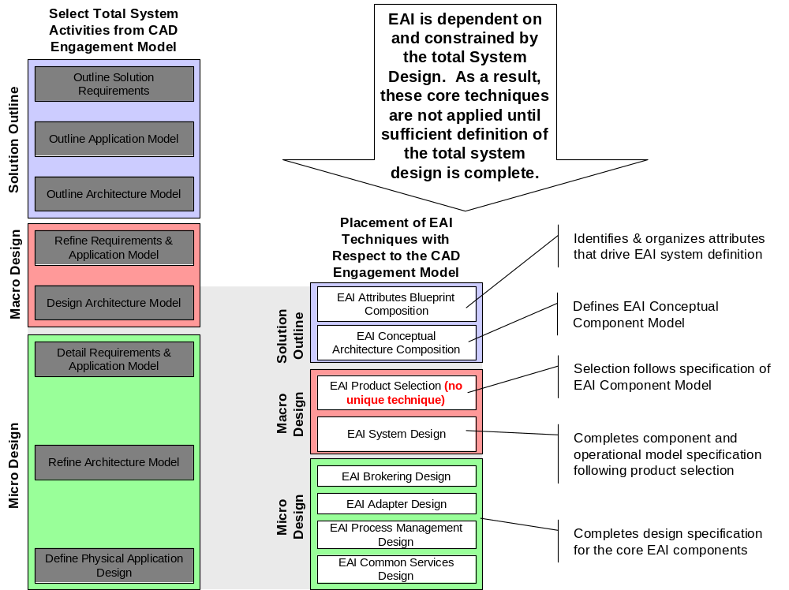
Figure 1 - EAI Conceptual Architecture Composition is one of 7 EAI Specific Techniques. The EAI Conceptual Architecture is expressed through a number of work products. These are tabulated below. With the exception of those indicated, composition of an EAI architecture is dictated by the existing techniques for these work products.
Table 1 - Conceptual Architecture Work Products
Work Products Involved In Conceptual Architecture | Work Products focus of this technique
ARC 100 Architectural Decisions | X
ARC 101 Architecture Overview Diagram | X
ARC 118 Change Cases
ARC 108 Component Model | X
ARC 102 Reference Architecture Fit Gap Analysis
APP 011 System Context
ARC 107 Architectural Template
ARC 301 Current IT Environment
ARC 111 Deployment Units
ARC 119 Nonfunctional Requirements
ARC 310 Standards
ARC 117 Viability Assessment
APP 303 Detailed Gap Analysis
ORG 006 Future Organization Design

Document Structure
This remainder of this paper is divided into a brief overview of the approach, followed by a detailed walkthrough of each step, illuminated by examples drawn from the fictitious Daukas & Lee Company. This is followed by reference material to support the architecture decisions made and refined at each step. The paper closes with examples of the EAI conceptual component model, EAI architectural decisions, and EAI architecture overview diagram. Appendices are included for key decision background information.
This technique assumes that the reader has a good understanding of EAI technology, and of IBM Global Services Method Work Product Descriptions. Readers who are new to the composition of component models for EAI should read this document in its entirety. Subsequently, the technique may be used as a reference for architecture development and decision-making.
This is a large document. To make the most effective use of it the reader should choose those sections that are most applicable to the current engagement or educational need. When navigating to a specific document topic, it is suggested that the reader select the View – Document Map feature in Microsoft Word, to speed up navigation.
- Overview
EAI conceptual component model composition is achieved in five basic steps, as depicted in Figure 2. These steps are:
- Make initial EAI architectural decisions
- Identify required EAI services
- Partition the EIA subsystem into smaller subsystems, where required
- Identify EAI technology categories present, to align components with available product configurations
- Apply integration architectural patterns to coalesce and confirm the required components.
Throughout these steps, architectural decisions are being made and confirmed.

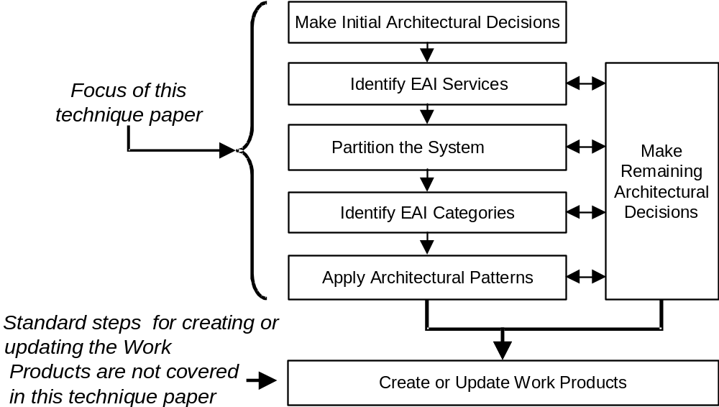
Figure 2 - EAI Conceptual Architecture Composition Steps
- Make Initial Architectural Decisions
Table 2 indicates the set of EAI Architectural Decisions that should be made up front for architecture composition. These decisions will ultimately be documented in the Architectural Decisions work product.
To form these initial decisions, perform a systematic inspection of the attributes for each EAI facilitated interaction tabulated in the EAI Attributes Blueprint. If additional information is needed to make the decision, consult the client’s architects and solution experts. It is best if the client’s appointed integration architect is directly involved throughout this process. When that is not possible, review the recommended initial decisions with the client for approval.
The execution notes for framing and making these decisions are contained in Section 8 “Confirm Architectural Decisions.” Table 2 contains links to these execution notes, as well as background information, for each decision to be considered.
Table 2 - Initial EAI Architectural Decisions to Make
Architectural Decision Topics That Apply | Link to Execution Notes | Link to Background Info
Utilization of the EAI Infrastructure |  | Utilization of the EAI Infrastructure
EAI Functionality within Business Applications | EAI Functionality within Business Applications | EAI Functionality within Business Applications
Business Application Insulation | End Point Insulation | Business Application Insulation
Build vs. Buy | Build vs. Buy | Build vs. Buy
Process-intensive versus Data-oriented Situations | Process-intensive versus Data-oriented Situations | Process-intensive versus Data-oriented Situations
Transactional Interactions | Transactional Interactions | Transactional Interactions
Failure and Exception Handling | Failure and Exception Handling | Failure and Exception Handling
Event-triggered versus Batch Interaction Styles | Event-triggered versus Batch Interaction Styles | Event-triggered versus Batch Interaction Styles
Communication Type | Communication Type | Communication Type
Object or Component Platform Standards | Object or Component Platform Standards | Object or Component Platform Standards
Routing | Routing | Routing
Data Transformation | Data Transformation | Data Transformation
Message-oriented vs. Remote Procedure Call/Object-oriented | Message-oriented vs. Remote Procedure Call/Object-oriented | Message-oriented vs. Remote Procedure Call/Object-oriented
Business Object Documents |  | Business Object Documents
Adapter Functionality | Adapter Functionality | Adapter Functionality
Application Access | Application Access | Application Access
B2B Interaction | B2B Interaction | B2B Interaction
Security |  | Security
Audit Capabilities | Audit Capabilities | Audit Capabilities
System Management and Monitoring | System Management and Monitoring | System Management and Monitoring
Administration | Administration | Administration
Repositories | Repositories | Repositories
Recovery | Recovery | Recovery
Planning and Tools/Environment | Planning and Tools/Environment | Planning and Tools/Environment
General EAI Model (Centralized vs. End Point Services) | General EAI Model (Centralized vs. End Point Services) | General EAI Model (Centralized vs. End Point Services)
Functionality/Performance Trade-offs | Functionality/Performance Trade-offs | Functionality/Performance Trade-offs
- Assign EAI Services
Review the EAI Attributes Blueprint, and identify the EAI Services that apply to this solution. EAI Services are not products. They are the essential integration functionality required in our business systems. EAI Services are built into EAI products in a variety of combinations, and, unless products have already been selected, nothing should be assumed about how EAI Services will be rendered by any particular EAI product.
The following sections focus on the definitions, drivers and considerations for the EAI Services that are to be considered for inclusion in the EAI subsystem. Use them as guides in examining the Blueprint to determine the need for each service within the system of focus.
Basic Services
Table 3 provides definition of the basic services that comprise and EAI subsystem.
Table 3 - EAI Basic Service Definitions
Basic EAI Services: core services that are present most often in EAI subsystems.
Connection Service | Interacts directly with end points to:  - Move data in and out  - Sense when an event happens in the end point  - Invoke programs or call specific end point processes  - Move data between end points by making the appropriate network calls to send and receive data over the network transport.
Format & Transform Service | Enables end points to understand information passed between one another:  - Formatting changes the position of data elements  - Transformation changes the representation of the data attributes or values  - Cross-reference databases are sometimes accessed to lookup synonymous content, or to add data (data enrichment)
Monitoring, Analysis, and Feedback Service | Enables:  - Collection of data about the EAI subsystem’s handling of process interactions  - Analysis of that data to enable decisions  - Use of feedback mechanisms to influence the EAI subsystem, based upon those decisions  Enhances the operation of other EAI services
Process Management Service | Controls multi-interaction processes, where information flows between end points in a dynamic pattern. Examples include:  - Short-lived, highly transactional (ACID) processes: binding multiple interactions so that they execute as an atomic unit (all or nothing)  - Complex, long-lived workflows, with loose consistency requirements (not ACID)  Usually employed in conjunction with routing services
Queuing Service | Stores data from a sending end point, and delivers it when the receiving end point(s) is ready to receive it.  - Essence of asynchronous interaction  - May include special functionality to guarantee one-time delivery
Routing Service | Utilizes rules/logic to determine which end points are to receive the information from the sending end point. Routing rules can be:  - Topic-based (pub/sub)  - Content-based  - Both

Table 4 below identifies the Blueprint attributes that drive the need for, and characterize the richness of functionality required in these basic services.
Table 4 – Basic EAI Services and their Associated Blueprint Attributes
 | EAI Service | Blueprint Attributes Driving the Service Need
Basic EAI Services | Connection | End Point Adaptation (Access Path)
Basic EAI Services | Format & Transform | End Point Adaptation (Parsing & Assembly, Transformation)
Basic EAI Services | Monitoring, Analysis, & Feedback | Interaction Path & System Characteristics (Reference Requirements (Application Workflow), System Requirements), Infrastructure Adaptation
Basic EAI Services | Process Management | Reference Workflow (Application Workflow), Interaction Path, End Point Adaptation (Access Path)
Basic EAI Services | Queuing | End Point Adaptation (Access Path)
Basic EAI Services | Routing | Interaction Path, Interaction Arc

Connection Service
Identify each point in the EAI subsystem where there is a need for Connection Service, and for each Connection Service, decide which type of application access will be used.
The application being accessed may offer API-based access, and this is the preferred access type.
If different interactions require different functional routines from an end point, and those different functional routines are not possible with the same type of access (e.g. its API supports an RFC for Function A, but not for Function B), then multiple types of access may be needed at that end point.
Where API access is not viable, user interface emulation is the next best option. When user interface emulation is also not practical, then direct database access may be the only option. Direct database access is risky, and should only be used in a read-only mode, unless no other options are possible. Direct database access presents the risk of disturbing the integrity of the database, and also presents the risk of selecting the wrong data (e.g. SAP™ (**) has dozens of dates associated with orders in its database, and it is difficult to know which is the right one for a particular need).
Review and verify, or change, the following decisions for every connection.
Architectural Decision Topic That Applies | Link to Execution Notes | Link to Background Info
EAI functionality within Business Applications used for the connection. | EAI Functionality within Business Applications | EAI Functionality within Business Applications
Transactional interactions exploited by the connection. | Transactional Interactions | Transactional Interactions
Failure and exception handling for the connection. | Failure and Exception Handling | Failure and Exception Handling
Communication type exploited by the connection. | Communication Type | Communication Type
Object or component platform standards used, or violated by the connection. | Object or Component Platform Standards | Object or Component Platform Standards
Message-oriented vs. remote procedure call/object-oriented approach taken by the connection. | Message-oriented vs. Remote Procedure Call/Object-oriented | Message-oriented vs. Remote Procedure Call/Object-oriented
Adapter functionality required to support the connection. | Adapter Functionality | Adapter Functionality
Application access method exploited by the connection. | Application Access | Application Access
Functional partitioning to support the connection. | Functionality/Performance Trade-offs | Functionality/Performance Trade-offs

Format & Transform Service
Examine the adaptation attributes of the Blueprint to determine the need for Format & Transform services. Most interactions between heterogeneous applications will require this service to some extent.
Understand the depth of transformation required for each interaction. Formatting does not change content, and is significantly easier than reorganization or enrichment, which may significantly alter content. Needs for cross-reference queries are particularly important, due to their performance impacts.
Even when initial architectural decisions provide enough guidance, it is still necessary to determine if the transformation is better located in an adapter or in a central component.
Determine the type of Business Object Documents (Blueprint exchanged entity, and end point rendered entities) that are involved with each interaction and end point, and understand whether a canonical form is to be utilized.
Review and verify, or change, the following decisions for every interaction requiring transformation.
Architectural Decision Topics That Apply | Link to Execution Notes | Link to Background Info
EAI functionality within business applications that format & transform will exploit. | EAI Functionality within Business Applications | EAI Functionality within Business Applications
Use of canonical forms to provide business application insulation. | End Point Insulation | Business Application Insulation
Failure and exception handling for the transformation. | Failure and Exception Handling | Failure and Exception Handling
Object or component platform standards followed or violated by this transformation. | Object or Component Platform Standards | Object or Component Platform Standards
Data transformation performed. | Data Transformation | Data Transformation
Business object documents utilized. |  | Business Object Documents
Adapter functionality used for transformation. | Adapter Functionality | Adapter Functionality
Functional partitioning to support transformation. | Functionality/Performance Trade-offs | Functionality/Performance Trade-offs

Monitoring, Analysis, & Feedback Service
If the EAI subsystem is not to be operationally effective, some form of Monitoring, Analysis, & Feedback Service will be required. Inclusion of this service will require additional outputs to be generated during interaction arc handling, to enable monitoring. In addition, the service will generate events that must be intercepted and responded to via automation or manual intervention. The greater the analytic capability of the service employed, the less manual interpretation will be required to respond to the monitored business integration operations.
Determine the specific capabilities required of this service based upon the application workflow and sub-tier interaction element availability attributes captured in the Blueprint.
Review and verify, or change, the following decisions for every interaction that will be monitored.
Architectural Decision Topics That Apply | Link to Execution Notes | Link to Background Info
Business application functionality for interface monitoring. | EAI Functionality within Business Applications | EAI Functionality within Business Applications
Sophistication of process management required to achieve the automated response to events generated by this service. | Process-intensive versus Data-oriented Situations | Process-intensive versus Data-oriented Situations
Incorporation of this services into the failure and exception handling scheme. | Failure and Exception Handling | Failure and Exception Handling
Object or component platform standards followed or violated by this service. | Object or Component Platform Standards | Object or Component Platform Standards
Monitoring capability incorporated into adapters. | Adapter Functionality | Adapter Functionality
Functional partitioning to support interaction monitoring. | Functionality/Performance Trade-offs | Functionality/Performance Trade-offs

Process Management Service
Determine the needs for Process Management Service to implement each application workflow and sub-tier interaction. It is important to identify if an interaction is involved in a Process-intensive situation, or if it is in a Data-oriented situation. Strongly transactional situations, and interactions that need multi-phase commits (especially if distributed) argue for generalized process management, in particular when transaction compensating techniques are required.
Determine where there is workflow involving human decision steps within these interactions.
Review and verify, or change, the following decisions for every interaction with respect to process management.
Architectural Decision Topics That Apply | Link to Execution Notes | Link to Background Info
Use of process management functionality within business applications. | EAI Functionality within Business Applications | EAI Functionality within Business Applications
Use of process management to achieve end point insulation (business service rendering). | End Point Insulation | Business Application Insulation
Process-intensive versus data-oriented implementations. | Process-intensive versus Data-oriented Situations | Process-intensive versus Data-oriented Situations
Exploitation of available transactional facilities. | Transactional Interactions | Transactional Interactions
Failure and exception handling for the process management service. | Failure and Exception Handling | Failure and Exception Handling
Use of event-triggered versus batch Interaction styles. | Event-triggered versus Batch Interaction Styles | Event-triggered versus Batch Interaction Styles
Object or component platform standards followed or violated by this service. | Object or Component Platform Standards | Object or Component Platform Standards
Impact of process state information on Business Object Documents. |  | Business Object Documents
Process management functionality within adapters. | Adapter Functionality | Adapter Functionality
Functional partitioning to support interaction process management. | Functionality/Performance Trade-offs | Functionality/Performance Trade-offs

Queuing Service
For every interaction, determine if there is a need for Queuing Services. Most frequently, Queuing Services are located just between the adapter and the rest of the middleware.
Determine the relative priority of queued interactions, and which interactions will depend upon queuing to achieve one-time delivery characteristics.
Review and verify, or change, the following decisions for every interaction with respect to exploitation of queuing.
Architectural Decision Topics That Apply | Link to Execution Notes | Link to Background Info
Use of business application functionality supporting scheduled, and one-time delivery characteristics. | EAI Functionality within Business Applications | EAI Functionality within Business Applications
Use of queuing to achieve end point mutual availability matching. | End Point Insulation | Business Application Insulation
Use of queuing to achieve only once delivery of exchanged entities. | Transactional Interactions | Transactional Interactions
Failure and exception handling for the queuing service. | Failure and Exception Handling | Failure and Exception Handling
Use of event-triggered versus batch Interaction styles. | Event-triggered versus Batch Interaction Styles | Event-triggered versus Batch Interaction Styles
Object or component platform standards followed or violated by this service. | Object or Component Platform Standards | Object or Component Platform Standards
Queuing functionality within adapters. | Adapter Functionality | Adapter Functionality
Functional partitioning to support interaction queuing. | Functionality/Performance Trade-offs | Functionality/Performance Trade-offs

Routing Service
Determine the need for Routing Services for each interaction arc in the Blueprint. When a number of interaction arcs share a common exchanged entity and source node, pub/sub-based services become a more likely implementation choice.
Determine the complexity of the routing decision rules required. In addition, determine whether reference to a common directory service will be necessary.
Review and verify, or change, the following decisions for every interaction with respect to routing.
Architectural Decision Topics That Apply | Link to Execution Notes | Link to Background Info
Use of routing functionality within end points. | EAI Functionality within Business Applications | EAI Functionality within Business Applications
Use of routing to provide source end point - destination end point isolation. | End Point Insulation | Business Application Insulation
Use of available transaction services with routing service. | Transactional Interactions | Transactional Interactions
Failure and exception handling for the routing service. | Failure and Exception Handling | Failure and Exception Handling
Object or component platform standards followed or violated by this service. | Object or Component Platform Standards | Object or Component Platform Standards
Routing characteristics required for this interaction. | Routing | Routing
Routing functionality within adapters. | Adapter Functionality | Adapter Functionality
Functional partitioning to support interaction routing. | Functionality/Performance Trade-offs | Functionality/Performance Trade-offs
Specialized Services
Table 5 defines specialized services that are often provided in EAI subsystems but are not as universally required as the basic services defined above.
Table 5 - Specialized EAI Service Definitions
Specialized EAI Services: additional services that are sometimes employed in EAI subsystems.
Application Adapter Management Service | Defines adapter process, data, and transport method. Facilitates centralized adapter specification creation and specification execution.
Batch Control Services | Manages scheduled interactions.
Trading Partner Agreement Management Service | Defines TPA process, data, and transport method. Facilitates TPA creation, TPA review and agreement, and TPA execution.
XML Handling Service | Includes:  - Predefined message super-structure  - Defining mechanism for sub-structure  - Facilities for transferring sub-structure definition

Table 6 identifies the Blueprint attributes that drive the need for, and characterize the richness of functionality required in these services.
Table 6 - Specialized EAI Services and their Associated Blueprint Attributes
Specialized EAI Services | Application Adapter Management | End Point Adaptation (Availability Matching, Intrinsic Availability)
Specialized EAI Services | Batch Control | End Point Adaptation
Specialized EAI Services | Trading Partner Agreement Management | End Point Adaptation
Specialized EAI Services | XML Handling | End Point Adaptation (Parsing & Assembly, Transformation)

Application Adapter Management Service
Determine if the system requires centralized adapter management. This may be either directly expressed as a requirement by the client, or derived from stringent requirements for system adaptability and availability.
Review and verify, or change, the following decisions for every interaction with respect to adapter management.
Architectural Decision Topics That Apply | Link to Execution Notes | Link to Background Info
Use of existing end point functionality for adapter management. | EAI Functionality within Business Applications | EAI Functionality within Business Applications
Use of process management to facilitate centralized adapter management. | Process-intensive versus Data-oriented Situations | Process-intensive versus Data-oriented Situations
Failure and exception handling for adapter management. | Failure and Exception Handling | Failure and Exception Handling
Object or component platform standards followed or violated by this service. | Object or Component Platform Standards | Object or Component Platform Standards
Management functionality within adapters. | Adapter Functionality | Adapter Functionality
Functional partitioning to support adapter management. | Functionality/Performance Trade-offs | Functionality/Performance Trade-offs

Batch Control Services
Determine which interaction arcs require batch control. Record the batch characteristics.
Review and verify, or change, the following decisions for every interaction with respect to batch control management.
Architectural Decision Topics That Apply | Link to Execution Notes | Link to Background Info
Use of batch control facilities within end points. | EAI Functionality within Business Applications | EAI Functionality within Business Applications
Use of process management facilities to implement batch management. | Process-intensive versus Data-oriented Situations | Process-intensive versus Data-oriented Situations
Failure and exception handling for batch management. | Failure and Exception Handling | Failure and Exception Handling
Use of event-triggered versus batch interaction styles. | Event-triggered versus Batch Interaction Styles | Event-triggered versus Batch Interaction Styles
Object or component platform standards followed or violated by this service. | Object or Component Platform Standards | Object or Component Platform Standards
Batch management functionality within adapters. | Adapter Functionality | Adapter Functionality
Functional partitioning to support batch management. | Functionality/Performance Trade-offs | Functionality/Performance Trade-offs

Trading Partner Agreement Management Service
TPA Management Services can vary in complexity from relatively simple functionality to complex process management. In addition, they can extend from execution time frame forward into management of the TPA making process.
Determine the scope and capabilities of the TPA management service required to cover the external end points in the solution.
Review and verify, or change, the following decisions for every interaction with respect to TPA management.
Architectural Decision Topics That Apply | Link to Execution Notes | Link to Background Info
Need for complex process management to implement the TPA. | Process-intensive versus Data-oriented Situations | Process-intensive versus Data-oriented Situations
Failure and exception handling for TPA management. | Failure and Exception Handling | Failure and Exception Handling
Use of event-triggered versus batch interaction styles in TPA execution. | Event-triggered versus Batch Interaction Styles | Event-triggered versus Batch Interaction Styles
Object or component platform standards followed or violated by this service. | Object or Component Platform Standards | Object or Component Platform Standards
Impact of TPA implementation on Business Object Documents. |  | Business Object Documents
TPA management functionality within adapters. | Adapter Functionality | Adapter Functionality
Use of TPA management in B2B interactions. | B2B Interaction | B2B Interaction
Functional partitioning to support TPA management. | Functionality/Performance Trade-offs | Functionality/Performance Trade-offs

XML Handling Service
Determine where XML will be exploited in the system, and whether DTD’s will be used in the implementation. Determine what industry or client standards will be followed.
Review and verify, or change, the following decisions for every interaction with respect to XML handling.
Architectural Decision Topics That Apply | Link to Execution Notes | Link to Background Info
Use of XML handling functionality within end points. | EAI Functionality within Business Applications | EAI Functionality within Business Applications
Failure and exception handling for XML facilities. | Failure and Exception Handling | Failure and Exception Handling
Object or component platform standards followed or violated by this service. | Object or Component Platform Standards | Object or Component Platform Standards
Impact of XML on Business Object Documents. |  | Business Object Documents
XML handling functionality within adapters. | Adapter Functionality | Adapter Functionality
Functional partitioning to support XML handling. | Functionality/Performance Trade-offs | Functionality/Performance Trade-offs

Horizontal Services
Table 7 defines horizontal services that are applied across the EAI subsystem, enabling the other basic and specialized services.
Table 7 - Horizontal EAI Service Definitions
Horizontal EAI Services: broad-scoped services that complement and support the other EAI Services.
Application Management Service | Enables centralized management of key EAI components
Directory Service | Enables end points to obtain the physical location of information, end points and components. Also includes name services
Metadata Repository Service | Stores metadata, making it easy to find, understand, and access enterprise data.
Policy Management Service | Stores and administers policy models. Provides for policy-based profile access
Security Service | Controls authentication, authorization, data integrity and privacy protection, and other security aspects.

Table 8 identifies the Blueprint attributes that drive the need for, and characterize the richness of functionality required in these services.
Table 8 - Horizontal EAI Services and their Associated Blueprint Attributes
Horizontal Services | Application Management | Reference Workflow (Availability), Infrastructure Adaptation
Horizontal Services | Directory | Infrastructure Adaptation
Horizontal Services | Metadata Repository | Infrastructure Adaptation
Horizontal Services | Policy Management | Infrastructure Adaptation
Horizontal Services | Security | Infrastructure Adaptation

Determine which of these service instances will be utilized by the EAI subsystem, and to what extent they will be used. For example, will the client’s desktop directory and security be used by the EAI subsystem? If so, for what sub-domain will be applied?
Similarly, is there an existing policy management facility or metadata repository that the EAI subsystem is expected to leverage? If so, what capabilities will be leveraged, and for what portion of the EAI subsystem will they be applied, both functionally and physically?
- Partition the EAI Subsystem
EAI Subsystems
While it is always advantageous to contain overall system complexity, it may be necessary in larger EAI subsystems to require multiple EAI approaches. Under such conditions, it is useful to define additional EAI sub-tier subsystems to provide the specific focus necessary for each approach. Applying separate focus to each can facilitate a more and cost effective solution to the overall client problem.
A common example of the case for multiple EAI subsystems, is the front office integration between desktop systems that facilitates ongoing document based collaboration between work teams, juxtaposed with the integration of line of business applications required to take and fulfill end consumer product orders. The integration characteristics of these two ongoing business processes differ widely. The two subsystems can, of course, interact with each other.
Once EAI Services have been selected, examine the system for stereotypical clusters of EAI Services. These clusters form the nuclei of separate EAI subsystems.
The Daukas & Lee example below depicts the capture of prospective EAI Subsystem characteristics in a table, and by tracing lines on an architecture overview diagram to assist in making the subsystem partitioning decisions. This partitioning will be performed before a rich Component Model is available, but the Architectural Overview Diagram, when updated with EAI Services, can be used for tracing out the subsystems.
Drivers for Subsystem Partitioning
There are no hard and fast rules for proper subsystem partitioning. Subsystems are an indication of differences in requirements and facilities for different EAI interactions.
- Process-intensive situations can drive the need for a different subsystem.
- Transactional, distributed multi-phase commit, and workflow situations may also drive separation.
- Pub/sub situations may be an indication of interactions that need less reliable delivery, and these types of interactions may be separated from those that need more reliable delivery.
- Some interactions may need rich Business Object Document structures, and this may drive separation from areas in the EAI subsystem that require less structured interactions.
- Object-oriented areas may also drive separation versus message-oriented areas.
- It is common to partition B2B systems into public process subsystems and private process subsystems, where the public processes are those exposed to other enterprises, and private processes are those that are not. EDI and other standards for B2B interaction should be considered in a similar way to Business Object Documents. For B2B systems that have scope across multiple enterprises, there may be EAI subsystems that are entirely within other enterprises. Trading partner agreement handling and security concerns may also drive creation of unique subsystems.
- It is not uncommon for subsystem partitioning to follow departmental boundaries, but care should be taken to not design department “silos”, that will create issues in cross-department interaction.
- Other middleware services, such as security systems and system management software, may drive the formation of EAI Subsystems that are focused on servicing the needs of the other middleware.
- Data warehouse and Operational Data Store (ODS) situations may also require specialized aggregation or summarization techniques, as is performed by the ETT (also known as ETL) category of products. This is true in the Daukas & Lee example below.
Subsystem Overlap
As evidenced by the Daukas & Lee example below, an EAI subsystem may fully contain another EAI subsystem. This can be a very effective strategy to apply when the characteristics of the contained subsystem are aligned with pre-selected products that will be a part of the solution. With the exception of complete containment, EAI subsystems should not be allowed to overlap. Such partial overlap inhibits effective system specification, product selection and implementation.
Partitioning Example
The Daukas & Lee Company has a number of subsystems defined for their EAI subsystem:
- Subsystem A – a B2B integration broker, to handle direct interaction with partners
- Subsystem B - a general asynchronous message-oriented EAI hub
- Subsystem C - a subsystem with synchronous interaction to facilitate synchronizing partner master file information. In this subsystem, the queues are set up as a synchronous relay for transferred data.
- Subsystem D – an ODS/Data Warehouse subsystem, which needs batch ETT capabilities. The ODS receives near-real-time inputs of operational data from the general hub subsystem.

Subsystem | End Points | Model | End Point EAI Services | Central EAI Services
A | - VPN Server | Hub | - Thin adapters, object-oriented | - Format & Transform  - Routing (B2B)
B | - Web App Server  - Order Entry  - CRM  - ERP  - Production  - ODS | Hub | - Thin adapters, with some XML conversion | - Queuing  - Format & Transform  - Routing – content-based  - Process Management
C | - Order Entry  - CRM  - ERP | Hub | - Thin adapters, with some XML conversion, to facilitate synchronous interaction | - Process Management
D | - ODS  - Data Mart | Hub | - Thin adapters, SQL oriented | - Batch Scheduling  - Format & Transform  - Queuing

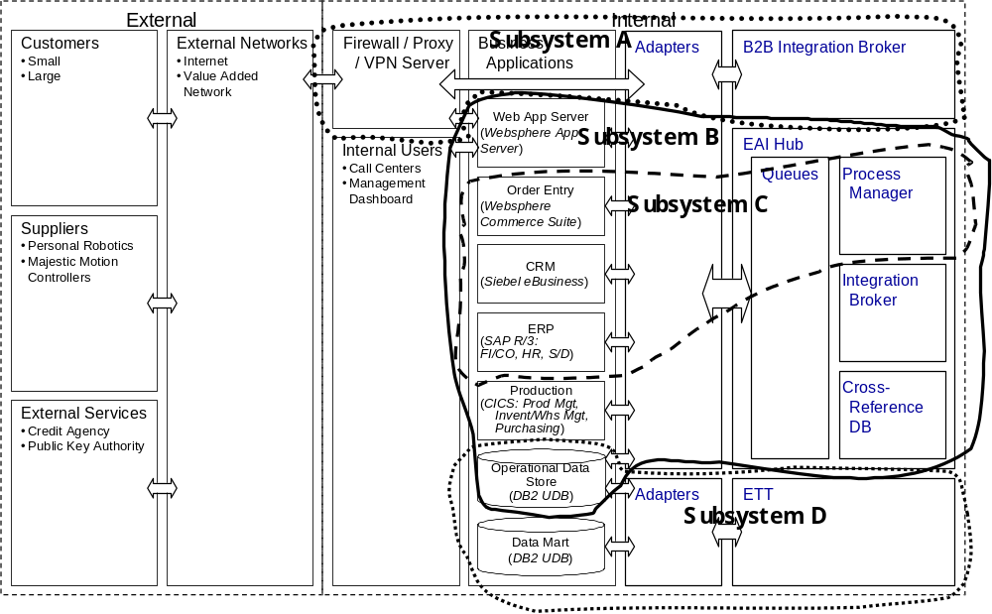
- Identify EAI Categories
The identification of EAI Categories narrows the focus for the product selection process to come, by aligning the system’s required functionality with common groups of EAI products.
The EAI subsystem information should help to identify EAI Categories. This is not to say that each subsystem will need a different EAI Category, or that there is only one EAI Category associated with each subsystem.
This selection of EAI Categories is best done without specific vendor products in mind, or there is a risk that the solution will be unnecessarily limited to one vendor’s approach. When finished with this categorization, the existing service view of each EAI subsystem should have an overlapping product category view.
Identifying EAI Categories is a judgment process, because, even with the best information, the proper choices are often not clear. The most common EAI Categories are described in the following.
Connectors and Adapters
As the name implies, Connectors provide Connection services, and usually create a simple linkage to the middleware. Adapters are super-functional connectors that include other services such as Format & Transform, Queuing, Routing, Process Management, etc.
Execution Notes
It is generally safe to assume that every application linked together by the solution will need either a Connector or an Adapter. The difficulty is in deciding which EAI services to have at the end point, and which to position more centrally.
Examine the end points included in each subsystem, and the associated service partitioning decisions made with respect to them. Use this to guide the choice of connectors versus adapters for the subsystem.
Message Queuing
The Message Queuing category handles the storage and subsequent delivery of data to a target application, and provides Queuing services.
Execution Notes
Factors that make this category a candidate:
- Message-oriented
- Asynchronous and Non-Available communication
Examine the interaction arcs allocated to each subsystem for the presence of a queuing service. In addition, examine the delay / response time constraints on the arcs, and the availability adaptation requirements for each end point of the arcs. When moderate response times / delay times are present (order of a second or longer) and / or the need for availability adaptation it present, asynchronous messaging is a good choice. Otherwise, a synchronous queuing product implementation can be considered.
Gateways
The Gateway category provides translation between two or more protocols, which means that it provides Format & Transform services. This category focuses on specialized translation, usually between two protocols. Some examples are:
- Database Gateways
- MOM Gateways (e.g. MQSeries®-to-MSMQ)
- Other (e.g. COM™-to-CICS®, CORBA®-to-CICS, COM™-to-CORBA)
Execution Notes
Factors that make this category a candidate:
- Interactions that must cross multiple protocols.
Examine the subsystems for the presence of standard protocol transformation services. One specific popular space for gateway application is in the B2B arena, where transformation between internal and external transport and syntactic representation protocols are very common. Another common application to consider is between EAI subsystems that are based upon different implementation technologies. This later situation can occur when a previous integration scheme is being maintained, but not extended in the business system.
ETT Technology
The Extract-Transform-Transport category (also known as Extract-Transform-Load, or ETL) is data management middleware that helps programs read from and/or write to remote databases or file systems. This category usually includes: Queuing, Format & Transform, Batch Management, and sometimes Routing services. Products in this category are usually batch-oriented (vs. real-time).
In broad terms, ETT applications extract data from a source database, transform the data into a format suitable for a target database, and then load the data into the target database. Traditionally, businesses have relied on ETT routines to transfer data from old applications to new ones, or to move operational data into business intelligence systems, such as data warehouses and data marts. Due to the explosive growth of the Internet, however, ETT processes are now commonly used to support Web applications as 'well. For example, a manufacturer might use ETT routines to load a Web-based order-status system with production data from an internal legacy application.
ETT products have become common components for e-commerce initiatives, including business-to-business and business-to-consumer applications.
This category provides flexible functionality with which to extract data from databases. Leading ETL products include pre-built extraction routines designed for popular ERP (enterprise resource planning) applications.
Once extraction routines have collected the data, transformation routines prepare the data for its new home. ETT Transformation techniques may include: aggregation, value translation, calculated field derivation, and data cleansing.
After data has been transformed for the target database, load procedures are used to write the information to the new database. Propagation can occur as periodic replenishment, such as daily, weekly, or monthly. Sometimes known as snapshot propagation, this approach captures the state of operational systems at a specific moment.
If users require more current information, there may be an option for continuous propagation, where data is load data into the target database on a near-real time basis.
Data transport/loading can be accomplish in two methods:
- Push replication, where the source application "pushes" transformed data to the target application
- Pull replication, where the target application ''pulls" data as it's needed, such as when an end-user runs a query
Execution Notes
Factors that make this category a candidate:
- Database extracting or loading, especially data warehouse or data marts
- Batch feeds
- Special transformation needed for large batch data sets.
Examine the subsystems for the tell tale presence of large and complex data set transformation service associated with bulk load or relatively lethargic delay time constraints. In such situations, ETT/ETL products provide a very good fit. When transformation requirements are less complex and / or delay time constraints are tighter, a different product implementation, based upon asynchronous messaging or synchronous connection is more appropriate.
RPC Technology
The RPC category refers to middleware that facilitates interaction between applications by calling pre-programmed procedures within those applications. This synchronous technique usually relies on standards, like that set forth by Distributed Computing Environment (DCE). Often this category is the means by which a TP Monitor environment is able to control distributed applications.
The RPC category can contain a variety of EAI services, including Format & Transform, Routing, and Process Management.
Execution Notes
Factors that make this category a candidate:
- Distributed environment that needs strongly synchronous interaction
- Not object-oriented or message-oriented
- TP Monitor controlling the process
- Applications are continuously available.
Examine the subsystem constrains for the presence of existing RPC based technologies that are to be leveraged in the solution. A client that has made the significant investment in these technologies will in most cases have the appropriate organic expertise to successfully leverage them as a part of an integrated business system. When this situation exists, in particular when it includes a transaction management environment, it can provide the basis for very high-integrated system performance in terms of both capacity and response time.
The primary caution to exercise is with respect to the limits geographic scalability achievable with synchronous based technologies.
Integration Brokers
This category facilitates interactions between applications, with an emphasis on routing services. Integration brokers commonly include other EAI services, especially Queuing, and Format & Transform services. It is becoming more common to find XML Handling in Integration Brokers as well.
The Integration Broker category includes a variety of products that all do similar things, including message brokers, integration engines and hubs, Interface engines, EDI servers, XML servers/gateways.
Execution Notes
Factors that make this category a candidate:
- Mostly message-oriented
- Data-oriented interactions, and not Process-oriented
- Need for Routing services.
Integration Brokers do not track previously successful exchanges, and do not provide automated means to change applications back to a start state or do other compensating interactions. This category should not be relied on to support a Process-intensive situation.
Examine the subsystem service allocations for the core integration broker services of routing, transformation and queuing. In many cases, a broker will be a good fit for the integration system (hence their current popularity). A broker of some description is very likely present in the external facing B2B EAI subsystems.
Integration Brokers fall short when complex process management is required, or when high volume traditional transaction processing is a large part of the subsystems responsibilities.
Process Managers
Process Managers direct complex processes that involve sequences of many individual interactions. This category focuses on providing Process Management services, but may also include Queuing, Format & Transform, Routing, and Monitoring, Analysis, & Feedback services.
Process Managers differ from TP Monitor or object-oriented process management devices, because Process Managers are generally (but not exclusively) oriented at asynchronous techniques, and can handle long-running and nested transactions. They monitor the state of messages/objects, and can manage compensating transactions. These products can often handle both application-oriented, and people-oriented processes.
This category includes workflow systems/servers/brokers, Business ware, enterprise work management systems, and business process automation managers.
Process Managers add a process-aware layer on top of the integration activities that provides better visibility and management of business processes. This increases integration reliability, and is also an aid in auditing the system to make sure that the business processes are being accurately carried out.
Process Managers enable the reuse of process, offering time-to-market benefits. To the extent that multiple business scenarios share common tasks or sub-workflows, the cloning of process for reuse can accelerate conversion to new business processes. For example, a B2C process for credit verification and approval might be cloned, and applied to additional sites.
Execution Notes
Factors that make this category a candidate:
- Process-oriented interactions, and need for Process Management services
- Little need for strongly ACID transactional integrity
- Complex or long-lived processes
- People-oriented workflow.
Process managers can usually make routing decisions, but while they often could do the job of Integration Brokers or message brokers, they generally do not make simple routing decisions as quickly/efficiently. Those interactions that are not process-intensive, unless their performance requirements are rather modest, are usually better handled by Integration Brokers.
Examine the subsystem for the presence of complex process management services with moderate response time and data volume handling characteristics. In addition, look for the presence of human workflow in the subsystem responsibilities.
Platforms – TP Monitors
TP Monitors are a platform that can facilitate both business application functionality, and EAI functionality. Business applications can be created, and run on this type of platform. EAI functionality can also be created and run on this type of platform (e.g. transformation functionality can be created). Additionally, TP Monitors have a rich set of “built-in” services; both related to EAI, and for general application development and operation.
When it comes to support for many clients and strong processing demands, nothing beats a good TP monitor. TP monitors can also use priority scheduling to prioritize messages and support server threads, thus saving on the overhead of heavyweight processes. Also, special load balancing mechanisms make sure that no one process takes on an excessive load, meaning that load increases do not have to effect response time.
TP Monitors are optimized for short-running ACID transactions. They can use rollback techniques to recover from problems that may occur while processing a transaction and bring the system back to the state it was prior to invoking the transaction.
TP monitors are extremely flexible, with capabilities to:
- Offer connectivity to a variety of different database systems simultaneously.
- Provide two-phase commit protocol, to guarantee the completeness of database transactions across multiple databases.
- Process user requests using lightweight operating system threads, rather than full processes. This allows TP monitors to exploit today’s SMP systems
- Maintain a persistent pool of database connections and share them across users
- Keep shared database connections open over long periods, dramatically reducing the amount of connection traffic
- Load balance, by measuring the usage of shared resources and directing requests to the least-used servers. Monitors can also detect and act on situations where a server or other resource has failed and needs to be restarted. This is a significant advantage over the Process Manager category.
- Manage requests asynchronously, distributing multiple requests over separate database connections to the same server (known as pipeline parallelism)
- Distribute requests over multiple database servers. This technique is known as fan-out parallelism.
- Communicate peer-to-peer with other transaction processing monitors to coordinate the operation of partitioned and distributed applications
Once based solely on procedural techniques, the leading TP monitors have moved to also embrace technologies for the Internet and the World Wide Web, including Java programming and ActiveX software component technology.
For EAI work, TP Monitors are focused on Process Management services, but may also have capabilities in Routing and Queuing. TP Monitors are primarily oriented at synchronous communication, although they can control asynchronous activity. TP Monitors normally use RPC techniques to control applications not running outside of the platform. For distributed transactions, there are “transaction RPC” techniques available.
The negatives to TP Monitors are:
- They are very challenging to install and configure
- Their messaging support is not as robust as MOM products
- They are not a distributed-object model (does not provide all the advantages of distributed object computing), and are more of a proprietary solution suited to static environments
- Java support is relatively unsophisticated, offering compatibility with only Java clients
- They are expensive
A hybrid of a TP Monitor is the Object Transaction Monitor (OTM), which handles transaction management with objects (basically a TP Monitor mated with an ORB). The drawbacks to this approach are:
- Hybrid solution that is usually not as full-featured
- Transaction services are generally not completely integrated with the ORB
- Commonly use proprietary calls, versus industry-standard IIOP, to interact with the TP Monitor
- A static model that cannot take advantage of dynamic discovery of the transaction service, which means the transaction service must reside on every node that supports transactions
- Difficult to install and configure
- Unsophisticated Java support (only supports Java clients)
- New technology with limited industry adoption and experience
Execution Notes
Factors that make this category a candidate:
- Process-oriented situation
- Need for strongly ACID transactional integrity
- Synchronous environment
- Not strongly object-oriented
- Need for load-balancing
- Skilled programmers
- OTM’s may be a good option for environments that must maintain transactional interactions involving both legacy mainframe applications and distributed object-oriented applications.
Examine the subsystem constrains for the presence of existing TP Monitor or OTM technologies that are to be leveraged in the solution. A client that has made the significant investment in these technologies will in most cases have the appropriate organic expertise to successfully leverage them as a part of an integrated business system. When this situation exists, it can provide the basis for very high-integrated system performance in terms of both capacity and response time.
The primary technical caution to exercise is with respect to the limited geographic scalability achievable with synchronous based technologies such as OTMs and TP Monitors.
Platforms - Application Servers/ORB’s
Application Servers represent the convergence of multiple technologies, including object and component models, distributed application processing, and object transaction monitors. They also provide low-level native services required for both objects and components, including security, naming and directory services, persistence, threading, and EAI services. Usually, the native EAI services include Process Management and Routing. Sometimes XML Handling, Queuing, and other services may be included.
Application Servers are like TP Monitors in that they both have native services, and serve as an environment to create and run applications. While TP monitors are effective tools for large-scale Online Transaction Processing (OLTP), they generally don’t have facilities for:
- Locating and instantiating objects (name services)
- Caching objects and controlling object lifetimes.
Application Servers, on the other hand are optimized for broad object re-use. Application Servers are object-oriented, and best suited for synchronous communication (although asynchronous techniques can be accommodated).
Some of the most important features of an Application Server are:
- They facilitate application partitioning. Developing efficient multi-tiered applications involves partitioning, which is the division of labor between the client and one or more specialized servers. Application servers facilitate partitioning by allowing the components of the application to be moved to the architectural level and physical platform where they can work most efficiently. In theory, this can optimize a network’s processing power and reduce network traffic. In practice, partitioning often introduces architectural issues and high complexity.
- They enable superior scalability by enabling database management (caching, connection pooling), the activation of multiple copies of the application server, fail-over capacity, and load balancing.
- They have the ability to maintain open databases (connection pooling), store data subsets (data caching), and provide logic to access the appropriate data are application server characteristics.
- They provide native services, such as transactional process management. Some Application Servers offer full-blown, built-in transaction processors. Some have been enabled to work with traditional TP Monitors to facilitate transactional control.
- They can play a major role in security by managing user authorization against standard directories (LDAP and X.509, for example). They can also provide encryption and work with the host platform to manage application security at several levels.
Most application servers provide their own development environments for building client-side GUIs as well as business logic. Nearly all servers support Java EJBs, and a number of these also offer CORBA and/or Microsoft compatibility.
To control distributed interactions, Application Servers generally rely on CORBA Object Request Brokers (ORB’s), or Java Remote Method Invocation (RMI). Like other types of brokers, ORB’s provide services for routing messages and requests between objects. ORB’s let objects make and receive requests and responses over a TCP/IP network regardless of location or programming language. They also provide basic messaging, communication, directory, security, and location transparency; and insulate applications from hardware, networking, and system software details. Despite over a decade of improvements, however, ORB’s remain difficult to implement and require highly skilled programmers.
Execution Notes
Factors that make this category a candidate:
- Preference for object orientation
- Strong application development orientation
- Mostly synchronous interaction.
Examine the subsystem constrains for the presence of existing Application Server technologies that are to be leveraged in the solution, or a client expressed preference for an application server based approach. A client that has made, or is about to make, the significant investment in these technologies, will in most cases have or train the appropriate organic expertise to successfully leverage them as a part of an integrated business system. When this situation exists, it can provide the basis for very high-integrated system performance in terms of both capacity and response time.
The primary technical caution to exercise is with respect to the limited geographic scalability achievable with synchronous based technologies.
Integration Frameworks
Frameworks bundle many different object and message-oriented services, including platform technology and other EAI categories, in an attempt to provide a complete solution for any requirement in creating and integrating distributed applications.
Products in this category usually include most, or all, of the EAI services, and often also include other middleware, like security and directory services.
Frameworks also offer complete environments for building, integrating, and managing sophisticated business applications.
Frameworks are usually collections of products from many IT categories, and are designed for broad use across a diverse enterprise, or multiple enterprises. They attempt to add value through integrated run-time and build-time capabilities. Some may even offer pre-configured templates for specific business activities.
Framework products, however, usually fall short of enabling common and consistent build-time tools, and are at the high end of complexity and expense.
Execution Notes
Frameworks are usually considered for enterprises that:
- Do not have an existing infrastructure that they would like to preserve
- Have a strong desire for quick move to a very rich infrastructure that will include:
- Sophisticated object-oriented application development capabilities
- The full spectrum of EAI functionality
- Other middleware facilities, like security and directory services
- Can devote many skilled resources
- Have a large budget
Because of their scope, complexity, and expense; frameworks are a challenge to justify for most enterprises. There are not many framework products on the market (Websphere Business Integrator, and Sun’s Forte, may be the only two).
Examine the complexity of the total EAI subsystem under consideration, as well as the client’s appetite for the dedicated training and support required for an Integration Framework based approach. When the system service requirements align well with the full capability of an integration framework, it may be a viable approach. If a large portion of the framework will not be leveraged, then it should be rejected in lieu of technologies that better target the service needs of the system.

- Apply Architectural Patterns
With EAI Categories established, standard architectural patterns can be referenced to select a Category-level Component Model for each EAI subsystem. Patterns need to be tailored to the specific business applications, categories, and services in the solution.
The output of this activity will be documented as an ARC 108 Component Model. For larger complex solutions, it may be best to present the component model in the hierarchy of System – Subsystem – Component Model.
The Component Model Work Product Description is a valuable resource for identification of commonly needed components for the model. Consult this document as a reference during development of the component model.
In the traditional construction of a component model, each component must be able to be traced to an application that requires its support. EAI subsystems create “distributed applications” by linking many separate applications, making it a challenge to trace an EAI component back to a specific application. EAI components must, therefore, be traceable to specific integration interaction and adaptation attributers that are captured in the EAI Attributes Blueprint.
The reference patterns for category-level component models are listed below:
- Application to Application (A2A) Data-oriented patterns
- Basic queuing interaction
- Basic brokered interaction
- Data Warehouse/ODS interaction
- A2A Process-intensive pattern
- B2B Data-oriented pattern: Basic brokered interaction
- B2B Process-intensive pattern
These patterns are reviewed in the following sub-sections.
Architectural Decisions
A number of architectural decisions will influence, and will be influenced by, the application of these patterns. Review and finalize the following decisions.
Architectural Decision Topics That Apply | Link to Execution Notes | Link to Background Info
Utilization of the EAI Infrastructure |  | Utilization of the EAI Infrastructure
Customization of Vendor EAI Components | Customization of Vendor EAI Components | Customization of Vendor EAI Components
Definition of Architectural Layers and Modules | Architectural Layers and Modules | Architectural Layers and Modules

A2A Data-oriented pattern: Basic queuing interaction
This pattern shows three applications linked together in point-to-point fashion, with fat adapters that facilitate Format & Transform services, and queues that provide Queuing services for asynchronous/non-available interaction. Queuing services may also be included in adapters, which would obviate the need for separate queue components. If only synchronously/available communications are necessary, then the queue components may not be needed.
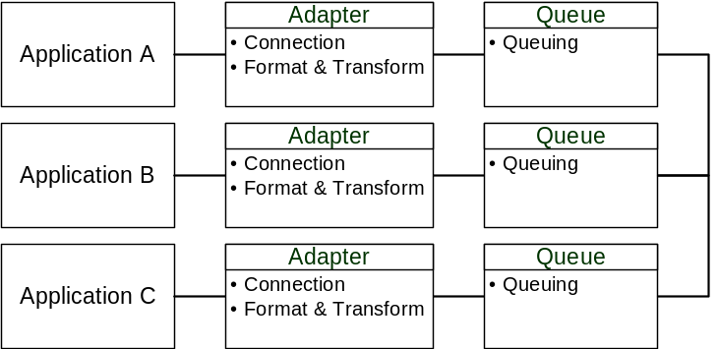
Figure 3 - A2A Data Oriented Queuing Interaction
A2A Data-oriented pattern: Basic brokered interaction
This pattern shows three applications connecting, via thin adapters, to a Queuing Layer that provides Queuing services. An Integration Broker provides Format & Transform, and Routing services, and together with the Queuing Layer, constitutes a hub configuration.
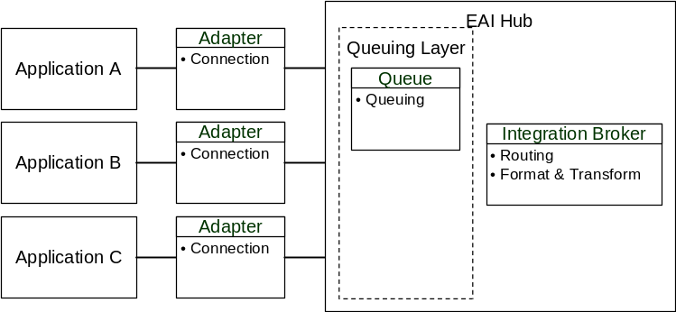
Figure 4 - A2A Data Oriented Brokered Interaction
The diagram shows the Queuing Layer and Integration Broker resource as separate components, but this is simply for better visualization of the EAI resources. The EAI products to be selected may eventually combine these resources into fewer components.
A2A Data-oriented pattern: Data Warehouse/ODS interaction
This pattern illustrates two architectural subsystems, a basic brokering subsystem (as shown in the previous pattern), and an Extract-Transform-Transport (ETT) subsystem involving Operational Data Store (ODS) and Data Mart applications.
A typical Operational Data Store serves two purposes. One is to serve as a collection point, and reporting source, for frequent updates of operational data. In this pattern, this data is fed to, and pulled from, the ODS via an Integration Broker hub.
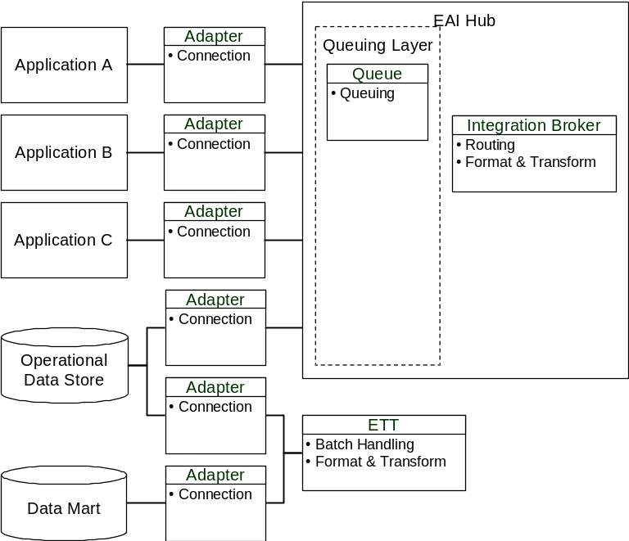
Figure 5 - A2A Data Oriented Data Warehouse/ODS Interaction
The second purpose for the ODS is to provide large batch loads for a data warehouse, or, as in this example, a Data Mart. This is shown facilitated by an ETT resource, which incorporates Batch handling and Format & Transform services.
There are two different adapters used to facilitate the involvement of the ODS in the two different architectural subsystems.
A2A Process-intensive pattern
This pattern shows a basic Integration Broker hub, augmented with Process Management services.
As with any of these patterns, many of the EAI resources shown as separate components, may eventually be embodied in EAI products that are fewer components.
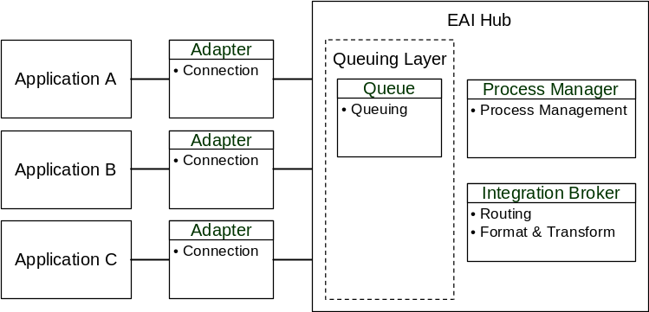
Figure 6 - A2A Process Intensive Interaction
B2B Data-oriented pattern: Basic brokered interaction
This pattern depicts an architectural configuration for EDI interaction with customers and/or suppliers. Usually, there is a server that handles secure communications with a trusted Value Added Network (VAN), and an adapter connects the VAN as a node on an Integration Broker hub.
This configuration has the hub handling both internal and external interactions. In some solutions, the B2B related components may be better positioned outside of the hub. For an example of this configuration, see the Daukas & Lee subsystem for B2B.
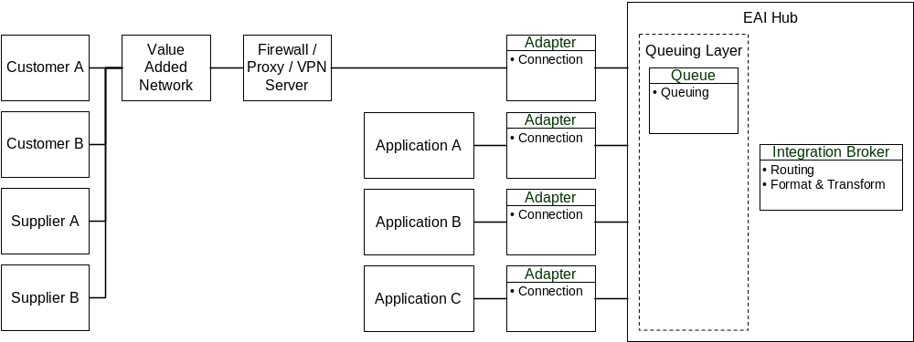
Figure 7 - B2B Data Oriented Basic Brokered Interaction
B2B Process-intensive pattern
This pattern shows a both a VAN and a web/app server connected as nodes to an Integration hub that is augmented by Process Management services, and a Cross-Reference Database resource.
This configuration has the hub handling both internal and external interactions. In some solutions, the B2B related components may be better positioned outside of the hub. For an example of this configuration, see the Daukas & Lee subsystem for B2B.
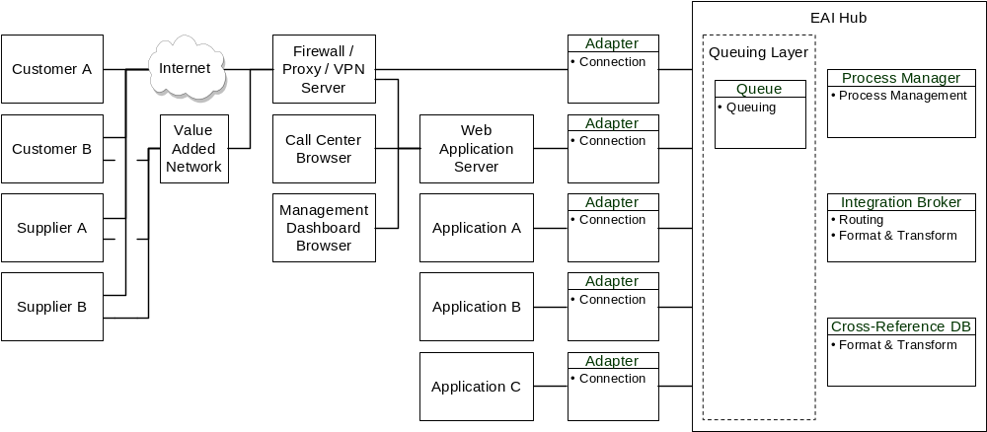
Figure 8 - B2B Process Intensive Interaction
- Confirm Architectural Decisions
Perform a final review of the architectural decisions made in the previous steps in conjunction with the EAI Attributes Blueprint and finalize them to reflect the compromises that have been made to compose the EAI subsystem.
Utilization of the EAI Infrastructure
Determine what organizational areas, core applications and business process interactions will use the EAI infrastructure.
Key Underlying Questions | Execution Notes
What organizational areas, applications, and/or interactions are expected to use the EAI subsystem, and in what time frame? | It is important to delineate which organizational areas, applications, and/or interactions should be expected to use the EAI subsystem. This allows the primary customer to better orchestrate the ongoing communications within the client’s (and business partner’s) stakeholders, and to sell and extend the use of the EAI subsystem. In addition, it identifies the initial priority and implementation ordering of business initiatives that will take advantage of the EAI subsystem. This priority and ordering forms the basis for defining an Implementation Strategy for the EAI subsystem.
What areas are not expected to exploit the EAI subsystem?

EAI Functionality within Business Applications
Determine what EAI functionality is available within the existing business applications, and to what extent these functions will be leveraged in realizing the EAI subsystem.
Key Underlying Questions | Execution Notes
What EAI functionality is located within business applications? | In general, business applications should not be relied on for EAI functionality, as they are usually not optimized for use across an enterprise. A primary goal of the EAI subsystem should be to relieve business applications of EAI tasks. Also, there is should be a general objective, to minimize the number of different EAI components involved. The more EAI functionality is leveraged from business applications, the more risk there is to the overall efficiency in maintaining, manipulating, and updating the EAI infrastructure.
What EAI functionality located within business applications, should be leveraged, and in what ways? | Some business applications may offer existing functionality that can save considerable time if used for interactions within an application complex. Common examples are SAP’s ALE subsystem and i2’s EAI module. It would be too much work to configure an external broker to interact directly with the separate modules in these packages. In these cases, it is better to utilize the package’s internal EAI facility as an adapter to that broader application. These EAI modules should not be used for generalized EAI duty. Occasionally, there is need for a simple point-to-point interface that is already configured for interaction, and is unlikely to change over time. In that case, the larger application suite is treated as an end point, similar in most respects to the treatment given a custom application execution environment such as CICS, or the WebSphere® Application Server family.
What EAI functionality, in which business applications, has been of interest with the client? | Many clients will have built experience with EAI services that are part of business applications, and may have extended those services for inter-application duty. The client’s comfort with the current approach can make it difficult to convince the client of its shortcomings.

End Point Insulation
Determine how well insulated the end points are to be from knowledge of the facilities and internal structures of other end points.
Key Underlying Questions | Execution Notes
What levels of understanding of other applications should be built into business applications? | Insulating applications, with respect to physical location, allows for more flexibility in reconfiguring the environment to address performance needs (e.g. moving SAP from a Sun machine to an IBM machine).  Insulating with respect to logic and data aspects serves to ease the transition of replacing applications. It also allows business processes to be controlled and configured outside of the producer application, without requiring changes.
How difficult will it be to insulate each business application? | In general, application insulation should be maximized, but there may be reason for varying from the general rule. Achieving insulation may present the need for cross-reference or directory services techniques, may require more intelligent and complex EAI components, and may require participation across the enterprise to gain the potential benefits. In such situations, the benefits to be gained must be balanced against the effort required on a case-by-case basis.

Example
Ideally, the EAI subsystem should achieve strong application insulation. As indicated in Appendix B: EAI Example Problem Background Daukas & Lee Company intends to replace many of their existing legacy systems with packaged systems. This will create significant volatility in the systems over the next 5-7 years. By insulating individual application business systems components from one another as a part of the EAI subsystem implementation, the complexity and volatility of that integration problem will be localized, increasing reliability. Insulating the applications will also facilitate easier upgrades as packages change from release to release.
Build vs. Buy
Determine what EAI components should be candidates for product implementation, and which must be custom created. In addition, determine which existing client EAI assets will be carried forward into the EAI subsystem.
Key Underlying Questions | Execution Notes
What priority should be placed on Building versus Buying EAI components? | It is generally less efficient and slower for a customer to build significant EAI functionality from scratch, when it can be found in major EAI products, because:  - EAI products have become very sophisticated  - A large number of EAI vendors are present to create competitive pricing  - High rates of change and improvement in EAI make it more expensive to upgrade homegrown EAI applications, versus having a vendor do it.  This means that it is almost always preferable to buy the vast majority of an EAI subsystem’s functionality.
What existing EAI functionality is useful, and where is there a need for new EAI components to be purchased? | One of the benefits of EAI is to enable customers to avoid buying expensive business functionality, and instead, interconnect the existing business components that can offer strategic value. Yet, at the same time, it is not always the right approach to purchase new EAI components. Where there exists valuable EAI technology in the company, that technology should be examined for fit with the requirements of he new solution, and if it is a good fit, then reuse of those EAI components may be a good idea. More often than not, however, there are significant EAI components to purchase. It should be remembered that EAI functionality is more of a generic IT service than those found in business applications, and it is generally more efficient to buy fill gaps in generic services, where there are good packaged products available.
What is the client’s capability and motivation to build EAI functionality? | The customers that will want to build much of their EAI functionality will generally have very strong software development environments, and strong motivations to stay tightly focused on object, or well defined structured programming techniques. These customers may have most of their business applications incorporated in framework products (e.g. Sun’s Forte), which may have a number of native EAI services and capabilities. Vendor EAI components will probably just be needed to connect non-framework applications to the framework. The use of the custom EAI work should be detailed in the architectural decisions.
What are the client’s abilities and limitations with respect to custom coding related to the EAI subsystem? | With the complexity of business situations and requirements, it is important to create architectural decision with the understanding, that vendor products often do not meet all functionality requirements. For most large projects, it is likely that some functions will require custom coding to be realized. Normally, this custom work falls in the area of adapter or transformation functionality, as there are a wide variety of potential requirements in these areas. Usually, the custom work in a project is the most onerous, so it is important to define related architectural directives carefully.
How do the client’s “Build vs. Buy” preferences influence the approach to the solution? | Generally, EAI subsystems for a “Buy” solution will have more individual components, and are more likely than “build” solutions to include message-oriented/asynchronous approaches. “Build” solutions tend to be more focused on application servers, TP Monitors, or frameworks, and will tend to use approaches that are more object-oriented/synchronous.

Customization of Vendor EAI Components
Determine how much customization of vendor components will be allowed within the EAI subsystem.
Key Underlying Questions | Execution Notes
What programming capabilities does the customer have? | Companies with strong programming resources may be more tolerant of customization, and may prefer solutions that are programming-oriented. Organizations with fewer programming resources may decide to minimize customization, which also may drive a preference for more configuration-oriented EAI products.
What types of EAI products are preferred? | EAI products range from those that are strongly configuration-oriented, to those that merely provide specially structured programming environments (requiring healthy programming expertise). An organization’s level of comfort with customization will often depend on the amount and skill levels of their programming staff.
What limits should there be for customizing vendor EAI products? | As with any purchased application, in general, customization (beyond the configuration range) of EAI components should be minimized. The more customization that is performed on an EAI component, the more difficult it will be to upgrade and maintain that component.

Process-intensive versus Data-oriented Situations
Determine which interactions are data oriented versus process intensive, and what existing transaction capabilities will be applied to meeting those needs in the EAI subsystem.
Key Underlying Questions | Execution Notes
Which automated interactions are inherently Process-intensive, and for what reasons? | Process-intensive situations are sometimes difficult to see until the business processes are thoroughly modeled. Because of the impact on other decisions, it is important for the EAI architect to form an early understanding of the client’s process requirements, to discover Process-intensive situations as early as is possible.
Are there a number of process-intensive situations, such that the choice of EAI model is influenced? | Process-intensive situations usually require special EAI techniques and process management services, designed specifically to orchestrate complex processes, monitor state, and perform automated rollback or compensation. Process management implies a source of centralized control, and the more that there are Process-intensive requirements, the more there is justification for a centralized EAI model.
What processes should be designed as Data-oriented, and which should be designed as Process-intensive? | Normally, optimal process designs should be specified first, and then EAI techniques should be chosen to execute those process models. It may be, however, that the same basic process can be modeled to be either Data-oriented (e.g. no parallel process, and manual compensation), or Process-intensive (e.g. parallel process and/or automation of complex compensation). Although Process-intensive designs may yield better process performance, it also usually requires more expensive EAI techniques. It is important to understand if the solution might be designed both ways, and it is sometimes necessary to weigh the performance and cost implications of both.
What are the drivers to choosing, or not choosing, Process-intensive designs? | Besides the engagement budget, there may be other drivers (e.g. available skills) that may limit the solution to Data-oriented techniques. When this is the case, process designs must be created (or redesigned) to fit that decision.
Where are needs for rollback or compensation? | It is important to model automated compensation processes, just as would be done for any other automated processes.
Which compensation processes are to automated, and which of these are Process-intensive? | Where compensation can be accomplished as a Data-oriented routine, automation of that process is a strong idea, because it is not difficult. Because automated compensation is often the only cause of a Process-intensive situation, in an effort to maintain a Data-oriented scenario, it is common to relegate compensation processes to human operators. This is only practical where the expected peak amount and timing of unsuccessful steps can be handled effectively by humans, within service level requirements (also see the Failure and Exception Handling subject area).
What are the implications on adapters? | Automated compensation can drive adapter requirements, as sometimes compensation routines may need to have different data elements collected than were available in the main process.
Which interactions have steps that involve decisions with people? | Any time there is significant reliance on decision points in the process, which human-generated, as in people-oriented workflow, the situation is almost always Process-intensive.

Example
The Available-To-Promise (ATP) scenario for the Daukas & Lee Company, described in Appendix B: EAI Example Problem Background, is an example of a Process-intensive interaction. In this situation, customer demand has exceeded current planned inventory for the requested delivery time frame.
The ATP process must accomplish several sub-processes:
- Inventory Check sub-process
- Inventory Check (First Part) sub-process
- Search planned finished product inventory at Daukas & Lee
- If the Daukas & Lee planned inventory is short, generate a revised demand
- Production Schedule Check sub-process
- Verify that production scheduling can support the revised demand, and generate revised production plan to achieve it
- Parts Availability Check sub-process
- Search parts inventory at Daukas & Lee for the revised parts inventories
- If the Daukas & Lee planned inventory is short, generate a revised supply plan
- Request the parts from suppliers
- ATP Validation sub process
- Use the suppliers’ ATP responses to select the best supply and production plans, and to validate their feasibility
- ATP Commit sub process
- Commit the demand, production and supply plans, and the revised orders to suppliers.
If inventory, production, and parts supply are appropriate for the order, then verify that the order can be accommodated. As soon as any of the sub-processes results in failure, or the inability to meet the needs of the order request, then the entire ATP process should be halted, and the customer notified.
The possibility of executing these individual sub-processes in parallel, as well as the complexity of recovering the process from an in-process failure make this a process intensive situation.
Transactional Interactions
Determine what business transaction characteristics are required of the EAI subsystem, and what facilities should be used to meet them.
Key Underling Questions | Execution Notes
What are the areas with transactional and non-transactional interactions? | Transactional integrity can be selectively applied to parts of an overall process to reduce potential points of risk (e.g. using transactional guarantees of message delivery from a queue to another component).  Even scenarios with a single database resource may present a distributed transactional situation, if distributed applications participate in any part of the transaction.  If this transaction process is not tightly managed, such that the entire set of interactions either all succeed, or all fail properly, inconsistencies may be generated within the database.
What EAI Services are implied by the solution’s transactional interactions? | Transactional interactions can drive EAI architectural aspects in certain directions. Whenever a transaction uses more than one data source, process management services are needed to coordinate the interaction across those data sources. Large-scale ACID two-phase commit situations usually involve business applications that have special API’s with native functionality defined by specific transactional standards (e.g. XA standards), and sophisticated process managers (e.g. TP Monitors). On a small scale, process management services may be included in components, and only applicable to very specific transactional interactions (e.g. guaranteed queue-to-queue delivery).
What are the basic approaches that are preferred and discouraged for transactional interactions? | Requirements for strict ACID transactions across distributed applications often dictate synchronous communication, with native transactional capabilities in every participating application.
What role will adapters play? | Where native transactional capabilities (XA compliant API’s) do not exist in the application, adapters may be designed to simulate native two-phase commit functionality. For example:  - When it receives a transaction-initiating request, an adapter collects a before-image of the database  - When it receives a commit request, the adapter performs the necessary cleanup  - When it receives a rollback request, the adapter returns the database to the before-image  Using adapters to simulate native two-phase commit behavior may not meet ACID requirements, however, if the adapters cannot lock the application’s database for the duration of the transaction. Also, the effects of adapter failure must be examined to see if it might cause loss of control of the application during the transaction.
How should compensation and rollback be applied? | A compensating transaction differs from a two-phase commit rollback. A rollback is part of the original transaction, whereas a compensating transaction is a separate transaction. In some situations, it may not be practical to lock records, or to wait for all participating resources to fully commit. In these cases, even though it is not ACID, compensation may be a viable solution. If:  - Requirements are flexible with regards to ACID standards  - There is low risk in varying from ACID standards  For extra transactional integrity, it might be decided that the compensating transaction should also be conducted with a multi-phase commit process.

Example
Daukas & Lee have a situation where customer master records must be updated across multiple application databases: Siebel, Websphere Commerce Suite, and SAP’s S/D module. First, it was decided that the option of consolidating all records into one database (persistent or cache) was highly impractical. In addition, an out of synchronization state with respect to partner information is not a significant impact to business operations. Several other approaches could be considered:
Approach 1: ACID Transactional Synchronization
To guarantee data consistency across all of the applications, there must be no change to any of the customer master files, in any of the databases during the update process. To achieve this would require locking all of the databases for the duration of all of the updates. However, making the databases unavailable (which may make an entire application unavailable) for this duration can have a large impact on system performance. Also, as there are very large differences in the structure and access techniques between the different applications. As a result, it is not practical to apply more intensive ACID transactional techniques.
Approach 2: Tight Synchronization with Automated Compensation
This approach attempts to:
- Collect an image of each database’s before-update condition
- Initiate the update in each database
- Collect an image of each database’s after-update condition
In this case, if any of the updates are unsuccessful, a compensating transaction can be issued to:
- Check that each database matches the after-update image, verifying that no changes were made since the update
- Initiate a reversal of the original update in each database
- Check that the database matches the before-update image, verifying that the reversal was successful
Given that there is no locking of the databases, and that each application will update at a different rate, this approach may still in short term data inconsistency, and it introduces the additional performance cost of data set copying in the critical update path.
Approach 3: Loose Synchronization with Primary/Secondary Databases, and Automatic / Manual Compensation
This approach updates a primary database, and when that has succeeded, attempts to update the other secondary databases. If a secondary databases fails to update, a retry is attempted. If this also fails, an operator is notified to complete the synchronization.
The Selected Approach
The decision between the three approaches weighs the importance of a number of objectives:
- Consistency
- Performance
- Objectives to minimize customization to applications (e.g. modifying to enable low-level locking, to minimize performance impact)
- Degree of difficulty in creating the interaction
In financial institutions with high volumes of updates, even very brief periods of minor inconsistencies may be intolerable. In these types of institutions, there is probably the need to use the first approach, and applications may need to be modified to lock only selected database areas.
The second approach might be considered if tight synchronization was very important, but locking databases were not practical. This approach is challenging to program, and may be slow in operation.
The third approach is suited where high-performance, and the ease of construction, are the main priorities.
Daukas & Lee are in a manufacturing situation, where volumes of updates to this referential information are low. The manual effort to compensate the data for an unsuccessful update is not onerous. Further, Daukas & Lee have decided that it is acceptable to halt related processing for the affected partner for the short period required to correct the reference information.
Failure and Exception Handling
Determine what failure and exceptions must be handled, and what approach will be taken to handle them.
Key Underlying Questions | Execution Notes
What types of failure and exceptions can be expected, and what general types of handling are preferred? | The initial EAI architectural decisions should designate preferred Failure and Exception handling techniques. Various levels of sophistication are available, and it must be determined which level of sophistication is appropriate for different interaction situations. The two general types are:  - Automated handling  - Human handling
What types of automated failures and exception handling techniques are to be used? | Automated handling of exceptions within process interactions can either be tightly controlled (transactional) or loosely controlled (e.g. compensation). These techniques are discussed in other sections. Automated handling of failures usually requires specialized software or hardware (e.g. application management software).  Another technique for managing exceptions is to have the system report situations that are likely to cause issues. An example is when a notice that queues are filling up is issued in an asynchronous messaging system.
What types of human-based failures and exception handling techniques are to be used? | Human handling requires that the operator obtain information about the situation. This can happen in two ways:  - The system makes an entry to a log, and the operator checks the log periodically  - The system notifies the operator directly, perhaps by email  The operator handles the issue from the point of notification.
Where human-based techniques are an option, what are the risks, and how can the risks be mitigated? | It can be risky to rely on operators for failure and exception handling, especially in situations with high volumes of interactions. To determine this risk, estimate the peak potential for load on the operators for various types of failure and exception situations.  Relying on the operator to check a log is the least effective method. It is far better to push the notification to the operator. If email notification is not trustworthy, it may be worthwhile to plan for a custom notification program.
What are the priorities for the different failure and exception situations? | Assign priorities to different types of failures or exceptions (e.g. issues related certain key customers or types of transactions). This may define filtering information to assist in automatically evaluating failure and exception notifications, and deciding where they should be sent (e.g. to a priority email if high priority, or to a log if low priority).

Event-triggered versus Batch Interaction Styles
Determine where batching is required in the EAI subsystem to support the business processes, and what mechanisms should be used to provide this facility.
Key Underlying Questions | Execution Notes
Where are batch interactions preferred or considered acceptable? | In many cases, an event-triggered environment, where more interactions are happening in near-real time, will help a company overcome the key issues related to information latency, end-to-end turnaround times, etc.
What applications or situations are impractical to convert to near real time? | Generally, the conversion to event-triggered interaction involves tradeoffs across four factors, listed below with defining questions:  Response time  - How rapidly must changes in one application be available to other applications?  - How closely must the applications work together?  Quantity of data  - How much data is being synchronized?  Accessibility  - How accessible is each application?  Cost  - Does the benefit justify the cost?  Some applications may take a lot of work to ready for event-triggered processes. There may be parts of the enterprise that will not, provide enough benefit from converting to event-triggered processing to justify the cost.  Conversion to event-triggered operation can be very challenging in environments that are strongly batch-oriented. One of the biggest problems is that there may be many sub-processes that must be run much more frequently in order to maintain constant synchronicity across interacting applications. Sometimes these sub-processes are not readily visible in early explorations, and help from application experts is essential. The effort to accomplish these changes should be weighed against the benefits of having a system that reflects current changes in a business situation.
What situations are not good candidates for conversion to event-triggered techniques? | Some types of business activities are not good candidates for conversion to event-triggered techniques:  - Data warehouses, data marts, Executive Information System (EIS) databases, Decision Support System (DSS) databases, etc.  - These are usually not good candidates for event-triggered interactions, as they usually work best with snapshots, summaries, or aggregation of a lot of data at certain points in time. These applications are better-suited for Extract-Transform-Transport (ETT, aka ETL) EAI techniques, which are designed to handle batch needs.  - Systems that focus on providing complex consolidated statements, such as systems to issue consolidated customer payment statements  - Compiling statements that involve complex multi-system interactions and data computations, may not be able to produce results in a reasonable time.
What situations are good candidates for conversion to event-triggered techniques? | In other types of business activities, obtaining the most current data is essential, and these are better candidates for conversion to event-triggered techniques:  - Operational Data Store (ODS) databases, and databases feeding dashboards that monitor operational activity  - Systems for planning and control of operations (manufacturing, distribution, etc.)  - Call center systems, and systems supporting customer contact

Communication Type
Determine what communications mechanism to apply to each interaction arc.
Key Underlying Questions | Execution Notes
What situations are better suited for unavailable, non-conversational, and non-synchronous communications? | In general, business systems with complex processes across distributed components will perform better, and be more flexible to scale or manipulate, if configured for non-available, non-conversational, and asynchronous communications.
What situations are better suited for available, conversational, and synchronous communications? | Always available, conversational, and synchronous may be required for processes with all of the following:  - The process involves only a small number of applications  - Every application in the process is likely be highly available up to the peak load expected, which means that other processes won’t be interfering, and processing within the applications will complete quickly and predictably  - The entire process must perform at extremely high rates of speed
What techniques are preferred for the various non-available situations? | Not always-available scenarios, that require assurances of delivery, may need specific techniques (e.g. queuing). When absolute assurance of delivery is not required, a pub/sub mechanism may apply.
For not always-available situations with high rates of data flow, will downstream applications be able to handle the flow? | Not always-available communications with high-flow requirements, and that require assured delivery, can be difficult to control. When using this style of communication, evaluations may be warranted to make sure that downstream applications can draw down queues at (at least) the rate that upstream applications are loading the queues, or else queues may fill up.
Where are there ACID requirements that will require specific types of communications? | Available communications may be important for situations requiring strong ACID transactional integrity, or very tight data synchronicity.
When should conversational communications mechanisms be used? | Conversational communication is difficult to conduct unless the applications involved are built for it, but it also may be the easiest technique where the capabilities exist (e.g. legacy mainframe environments). Distributed CICS situations may lend themselves to Conversational communications. Non-Conversational communications are prevalent for RPC or ORB-based interaction.
When should asynchronous communication mechanisms be used? | Asynchronous interactions can reduce operational dependencies and cost, by optimizing availability requirements for specific systems. Asynchronous communication can support the use of replicated instances of an application. Long-lived transactions are usually best served with asynchronous techniques.
When should synchronous communication mechanisms be used? | Synchronous communication may more easily accomplish certain types of interactions, such as those requiring two-phase commitments. Synchronous routines can also be simpler and easier to program than asynchronous approaches. This type is usually required to support object-oriented or RPC interactions.  Synchronous communication, however, can be extremely taxing on distributed system performance. Aside from the performance problems associated with blocking applications during communications, there are often other issues such as demands on processing resources, and the number of exchanges required across the network.  Synchronous techniques are typically used to execute interactions with many, very basic steps. For example, a typical RPC call can require 24 distinct steps in completing a request, as well as several calls across the network. It's not a good idea to make RPC calls across slower networks, such as the Internet.  RPC’s also demand a lot from processors, often requiring 10,000 to 15,000 instructions to process a remote request (several hundred times the cost of a local procedure, or simple function call). Additionally, synchronous environments like DCE, while very reliable, tend to involve many services in the middleware, with performance impacts from extra steps involved with naming services, security services, etc. Most object-oriented techniques are simply other layers on top of basic RPC techniques, making those techniques challenging to scale.
When is dynamic invocation applicable? | Dynamic invocation is useful where application objects may be reused broadly across a large distributed enterprise. This flexibility, however, comes with performance impacts.
What communication type should predominate? | EAI subsystems will often have the need for multiple communication types. Care must given define points at which different types of communications intersect. Usually, an EAI component is required at these points of intersection, to perform a gateway or hand-off function.

Object or Component Platform Standards
Determine what object or component platforms are to be used in the EAI subsystem.
Key Underlying Questions | Execution Notes
When should object technologies be utilized? | The primary limitation of these distributed object technologies is that they do not operate well together, which presses enterprises to select only one. A significant problem is the incompatibility between COM™- and CORBA-based systems. Components or applications developed using one model will not automatically communicate with objects or software created with the other. There are a few products that provide such interoperability, (e.g. Visual Edge's ObjectBridge, Iona's ORBIX/Web, and Inprise's Delphi IDE and VisiBroker ORB), but these are relatively expensive and difficult to use. As techniques involving XML and SOAP become more sophisticated, it should become easier to implement inter-object communication. For the near future, it is wise to minimize the number of different object approaches used.
When should Java and EJB component approaches be employed? | Java offers a significant advantage in that the same version of an application can run with relatively few changes on any platform with a compatible Java Virtual Machine (JVM). Claims that applications do not need any changes when porting are not really true. On the other hand, porting Java applications requires much less work than porting those written in platform-specific languages like C++.  Java is also an Excel™lent application integration choice, and is a good choice for integrating information from heterogeneous and legacy platforms. Almost all application servers, integration brokers, transaction monitors, XML servers, B2B/enterprise application integration products, and data translation engines support Java. Many products using XML for integration support Java for building application logic, and Sun offers a variety of technologies for integrating XML and Java.  Customers can protect their existing IT investment because existing enterprise information resources, such as relational databases, transaction monitors, and custom line of business applications; can be accessed by wrapping them in EJB components, eliminating the need to replace applications or rewrite major pieces of code.  The sophisticated EJB approach is, however, very difficult to implement and optimize. If a company does not have an extremely strong commitment to it, and abundant talented resources specific to it, an EJB approach may not be the best choice on which to base a complex EAI subsystem. It may be preferable to use a combination of packaged EAI products, and regular Java to fill just minor gaps in functionality.
When should CORBA infrastructure be utilized? | CORBA does offer good support across multiple platforms and languages, and is suitable for hosting enterprise-scale distributed information systems. CORBA is not easy to implement across many applications that are not object-oriented, however. CORBA-based ORBs also have a few problems. Performance can sometimes be an issue, and ORBs sold by different vendors do not necessarily work together. Also, ORBs lack the tool support they need to become easy.
When should Windows based component technologies be employed? | For organizations whose mission-critical applications run primarily on Windows, or who have a large number of legacy Windows applications, Microsoft’s approaches may be a good choice. However, unlike Java, which was designed for heterogeneous distributed applications, COM™ is relatively unfriendly to non-Windows platforms. It is not certain whether .NET will support heterogeneous platforms.  Although COM™ provides many of the same services as CORBA, Java RMI, and EJB, it is actually a component rather than an object distribution technology. Because COM™ does not support inheritance, developers cannot modify existing COM™ components to create new components, and must build new components from scratch.

Routing
Determine what types of routing are preferred for different aspects of the EAI subsystem.
Key Underlying Questions | Execution Notes
When should content-based routing techniques be used? | Content-based techniques may be the only way to accomplish complex conditional routing routines. Although Content-based routing is very flexible, it can be significantly slower than Topic-based techniques. Also, developing and maintaining Content-based rules for many interactions can be a large amount of work.
When should topic based routing techniques be used? | Topic-based routing requires the maintenance of subscription information and registration information, but this is generally a relatively simple effort, versus requirements for Content-based rules. Topic-based routing is more appropriate where many applications will need the same message, and where there is not the need for complex rule evaluation (e.g. frequent stock market updates to thousands of users).  Topic-based techniques generally group into two types:  - Serial Delivery: Messages are sent to subscribers one after another  - Multi-cast Delivery: Messages are sent to subscribers simultaneously  Serial delivery is slower than Multi-cast, and performance usually declines with more subscribers.  Multi-cast techniques have more challenge in achieving assured delivery, as they typically rely on network multi-cast mechanisms. Multi-cast reliability is usually accomplished by periodic checks of what each application adapter has received, and higher reliability can be achieved with more frequent or thorough checking. However, the more checking that happens, the more burden there is on performances and bandwidth. Multi-cast solutions, with lists containing very large numbers of subscribers, can also be a burden on network bandwidth. Multi-cast solutions may require sophisticated network router capabilities.
Data Transformation
Determine what types of formatting and transformation are needed for different aspects of the EAI subsystem.
Key Underlying Questions | Execution Notes
What formatting should be performed centrally versus in the adapters? | Consideration should be given to which format and transformation work should be in the adapter, and which should be more centrally accessible. Generally, where fatter adapters are acceptable, adapter format and transform work should focus on those types that are more quickly processed, and are not likely to change frequently. More sophisticated adapter transformation may be warranted, if the performance requirements are simply too much for a centralized resource.  Generally, centralized format and transform services are more flexible, more reusable, easier to configure, and easier to maintain; than adapter-based format and transform services. However, centralized transformation components often contribute the largest impact on performance of any component in an EAI subsystem. As adapters can be faster, for situations with strong performance requirements, it may be important to strategically divide format and transform services between adapters and the hub.  The choice of formatting and transformation service placement also hinges on the richness of the security context model that must be provided. Internal integration for a single enterprise can in many cases be carried out in an open, single-context security model. Under such conditions the choice of formatting or transformation service placement maybe irrelevant.  When a business system shares information amongst several organizations, or performs automated processing on behalf of multiple organizations, a single-context security model is unacceptable. In that case, a centralized format and transform service must be completely security context aware, and behave effectively as an integral component of every trust relationship established between each organization. Such an arrangement requires intimate knowledge of the security context associated with every element of every transformed and re-formatted entity. Otherwise, these services provide a significant fissure in the solution wide trust relationships.  By contrast, formatting and transformation services held within the implementation of an adapter, can bind to, and operate within, the same security context as the application (or business partner system) itself. This contains the exposure and makes implementation of the formatting and transform services significantly simpler.
What transformation requirements drive performance considerations? | Some types of transformation work are particularly taxing on performance. This is especially true with transformation routines that must query a cross-reference database. To achieve fast performance, it is important to sparingly use cross-reference transformation, and to configure cross-reference repositories for maximum performance (e.g. perhaps it is better to use a spreadsheet instead of a relational database).  XML parsing, and evaluation against DTD’s, are types of format and transform work, and are done by special devices. These activities also can have a significant impact on process performance.  The data transformation approaches taken will vary dramatically based on requirements.  Extract-Transform-Transport (ETT, and also known as ETL), includes format and transform services, and includes transformation across large batches of data, as well as individual messages.  Data cleansing is an extreme form of format and transform service, which focuses on aligning or correcting large volumes of data, usually in very long-running complex routines. Data cleansing is often included in ETT products, but is primarily intended for the aligning of entire sets of data across databases, rather than for enabling EAI interactions. Sometimes it is difficult to draw clear distinctions between data cleansing and EAI formatting and transformation, as data cleansing may also include functionality to:  - Replace missing data values  - Correct field values to match field definitions  - Remove unwanted duplicates  - Establish storage and data presentation standards  - Standardize abbreviations  - Remove unwanted or unnecessary characters and data types  - Check the consistency of data across files  - Test data integrity rules

Message-oriented vs. Remote Procedure Call/Object-oriented
Determine what areas of the solution will be best suited for message-oriented interaction, and which are best suited for object/RPC techniques.
Key Underlying Questions | Execution Notes
When is message oriented technology indicated? | In a widely distributed organization, a message-based strategy improves reliability and flexibility. Messaging allows for location, DBMS, and data structure transparency. Messaging technology is complex to implement, but using messaging technology is relatively easy.  Using synchronous techniques may not fit with event-driven applications. Programs may not be able to wait for other programs to complete their work before proceeding. This is where message-based techniques have the advantage. Message-based techniques also have more flexibility, in that they are able to fluctuate from industry standards.
When is RPC technology indicated? | While RPCs are slow, their blocking nature provides the best data integrity control. For instance, when using an asynchronous layer to access data, it is difficult to assure that the update will occur in a timely manner. An update to a customer database could sit in a queue for a long time waiting for the database to free up, and there is a risk that, while it waits, a data entry clerk may create a sales transaction using the older data. With RPCs, updates are always applied in the correct order. If data integrity is more important than performance, RPCs may be best.

Business Object Documents

Key Underlying Questions | Execution Notes
What types of business objects are needed in different in different parts of the solution? | Business object document standards vary significantly across industries, and often there are more than one standard to consider. The choice of standards may influence the style of interaction, as some standards may not support sophisticated process automation. Also, the choice of EAI vendor may be influenced, as some vendors offer pre-configurations specific to certain types of business objects.
What standards may be best to adopt? | EDI is still a mainstay for B2B duty, and many companies will not feel a need to change from it, especially if it is working well, and in a situation that is unlikely to change much. The predominant EDI standards (ANSI X.12 and EDIFACT), however, only support a limited set of automated electronic operations, such as order processing, drop shipment, and payment. Also, these standards are fairly inflexible and not particularly extensible, making it difficult to add new transactions, or modify existing transactions. It is common that existing EDI transactions do not supply as much information as a company would like.  One of the biggest problems with EDI is that there is a learning curve of trial and error before new business partners correctly execute the standard. The use of self-defining structures can help business partners “on-ramp” more quickly.  Self-defining business objects make also make integration simpler by reducing custom transformation mapping requirements. There are issues associated, however. For instance, the size of a self-defining object is much larger than pre-defined objects with the same data. Self-defining structures still require parsing, syntax/structure checking, and may require matching to metadata definitions (e.g. DTD’s), which can amount to performance implications. Self-defining business objects still require transformation at the data element level, and may require that more transformation be included in adapters.  It is sometimes claimed that converting EDI to XML-based EDI will help a company expand automated interaction with smaller business partners. This assumption should be investigated, because it may be that, even though their smaller partners can more efficiently receive the message, these smaller companies may not be able to automate the processing and response that should follow. If not, the benefit to the sender may amount to being able to send an XML message instead of a fax.  XML’s ability to be readily decomposed and understood is one of its largest benefits. It is also a risk factor, in that if intercepted by unauthorized people, it is easy to understand and store in a database.  Self-defining structures are more useful with large numbers of participating components, which have significant differences in the way they exchange data (as is typical in B2B). In less dynamic situations, with fewer applications, and more predictable data, as may be the case with many internal EAI subsystems, there may not be enough advantage to justify the effort and potential performance hit from using self-defining structures.
Where might canonical forms be useful? | Canonical business objects are most useful when a large number of potential transformations are required in the solution. There should also be large overlaps in the data elements required by many of the applications, to realize the benefits of synergy. With canonical forms, there is an extra transformation routine added, and this will definitely impact performance. Canonical structures are therefore less appropriate for situations with very demanding throughput requirements. Canonical forms are very useful within environments that must change components frequently, as with companies which often buy new applications, or buy other companies with their applications.

Adapter Functionality
Determine how much functionality should be incorporated within each adapter.
Key Underlying Questions | Execution Notes
What preferences does the enterprise have for adapter “fatness” or “thinness”? | In general, the fatter the adapters become, the more challenging it becomes to develop and maintain its decentralized functionality. Thin adapters are easier to develop and support, but they also place more of the burden of interaction functionality on other parts of the EAI infrastructure. This trade-off is similar to that between using thin clients or fat clients, in client/server applications. In a fat-client client/server application, multiple interactions with the application's database generate heavy network traffic, making this approach less scalable. The same heavy network usage occurs with a thin-adapter architecture, where the hub must manage heavy interaction through the "spokes" of the architecture, to the adapters.  Adapter development is typically the most challenging type of EAI work. It can take many weeks to develop a complex adapter. With both fat and thin adapters, state management and exception handling can be written in any programming language. EAI vendors provide tools to reduce the need for manually coding these processes, but these tools are available differently for different types of adapters:  - With a thin adapter configuration, state management and exception handling may have the support of graphical process design tools, as part of a central process management engine. These tools may allow the developer to define complex rules in a "flow charting" environment.  - With fat adapter configurations, adapter vendors have tools for defining processing logic, built into their development kits (e.g. ADKs, SDKs, etc.). Some of these tools are quite elaborate, with GUI or wizard-based interfaces that allow the developer to specify API calls without writing a lot of code.
What amounts and types of EAI Services are preferred for adapters? | Any applications that are involved with strongly ACID interactions must have transactional integrity throughout its design, and existing adapters may need to be re-built to accommodate these types of needs.  It is often useful to require adapters or wrappers, which handle multiple types of methods or procedures, to be defined with separate classes for each method or procedure, so that future enhancements can affect less than the entire adapter or wrapper. It can also be valuable to specify that adapters be constructed as much as possible from a set of common patterns to make it easier to change adapters.  Guidelines may be defined to designate the types of EAI Services that are allowed within adapters. Connection (including API handling) and rudimentary transformation services are common. The level of transformation sophistication can vary greatly, however, and other capabilities, such as queuing and routing, are candidates for incorporation into adapters. Explicit limits on the types of adapter functions can save inefficiencies in adapter development, and better leverage the overall system’s resources.  New information technology concepts can drive the need for fatter adapters, such as the emerging concept of Web Services, where adapters must provide the necessary component view of an application’s business functions (sometimes known as “wrapping”).  Many sophisticated adapters can be purchased from EAI product vendors. These adapters may incorporate many different EAI services. Vendor adapter products can be useful, even if they fall outside of the company’s overall adapter functionality guidelines. Many ERP packages have vendor adapters that can greatly reduce adapter work. Vendor adapter products can be expensive, however, and the cost should be weighed against the benefits. Some applications are particularly difficult to access, and would require a large effort in custom adapter creation. The more difficult it is to create an adapter, the more it becomes a candidate for a vendor product, regardless of the guidelines.  It can be useful to indicate in guidelines, what adapter functionality is to run on the same physical machine as the application, and which should run on different machines.  In situations where departments, divisions, or subgroups must have strong ownership/control of certain EAI functionality (perhaps for security reasons), it may be more convenient to position that functionality in the group’s end point adapter. This is a decentralized strategy, which diminishes the benefits of enterprise reuse, so there should be other benefits identified to justify this approach.

Application Access
Determine what style of access is preferred or discouraged for different types of business applications.
Key Underlying Questions | Execution Notes
When should API access be used? | In general, if the solution is largely object-oriented, the preferred access technique will be object-oriented. If the solution is largely message-oriented, then the preferred access technique will message-oriented or function call-oriented.  When an API is available, it is the preferred method for gaining access to an application.
When is user emulation appropriate? | For applications that do not lend themselves to API access, the next best recommendation is user emulation. It is much less risky than direct database updates. The use of user emulation techniques is often awkward and always less elegant, yet it is often the most-effective method for non-invasive interaction with an application that does not offer an API. Performance requirements may dictate whether to use this technique (also known sometimes as screen scraping). Sometimes a user emulation adapter must traverse multiple application screens to collect the required data, which may take too long on slower applications.
When should direct database access be used? | When neither API nor user interface emulation is practical, direct database access must be used to access the end point.

B2B Interaction
Determine what styles of interaction are preferred with different B2B relationships.
Key Underlying Questions | Execution Notes
When is browser-based interaction with HTML message passing applicable? | Using a browser does not offer automation benefits, but will enable smaller partners to participate.
When are proprietary communication, requiring the same EAI product at both ends, and passing of proprietary data forms applicable? | Requiring that the same EAI product exist at both ends is difficult to implement, especially across many independent business partners.
What standards based messaging are applicable? | The XML-based standards for B2B vary dramatically. Some standards only provide part of an entire solution, while others offer a complete set of interaction specifications. A few of the industry-specific standards, like Rosettanet, are very complete, and provide significant acceleration in establishing sophisticated B2B interactions.
How should B2B processes be managed? | The invocation of application components across organizational boundaries must be carefully controlled and monitored, because of the difficulties in achieving correct execution of complex interactions. In automated B2B, trust is a major concern. During runtime, explicit checks are necessary to ensure that business partners are not violating any policy constraints (e.g. the cancellation of a reservation must be within the allowable time window).  Because the entire chain of functions that fulfill the transactions can be very long-running, and are difficult to tightly control, it is not practical to expect many B2B transactions to be ACID. Normally, it is useful to divide processes into “private” processes, for interactions that are within the full control of an enterprise, and those that are “public” processes, for interactions that are between partners.
Should automated TPA management be considered? | Automated TPA management is particularly challenging. When a business externalizes automated functions to make them available to business partners, several new issues must be addressed which were less important, or had simple solutions, within a single enterprise. If the function becomes accessible via a public network:  - How will it be reached?  - Who will be allowed to use it?  - How will these users identify themselves?  - What do both parties, in the resulting long- running conversation, commit to in terms of behavior, responsiveness, and recovery from error situations?  Not many B2B EAI products offer enhanced TPA management capabilities, and those that do are not necessarily easy to implement. At the time of this writing, TPA management is probably not standardized or easy enough to automate, to make automated TPA’s widely applicable. This is one of the reasons that eMarketplaces have had difficulty, as each trading partner must be manually “on-ramped”.

Security
Determine what security characteristics are required and how will they be provided.
Key Underlying Questions | Execution Notes
What authentication and authorization facilities are required? | Deciding how strong is strong enough is a business decision and involves balancing the cost of security against the value of the resources being protected.  Most business applications will have individual facilities for sign-on by users. In EAI subsystems, where applications that were designed to operate independently, are re-configured for automated interaction, the control and maintenance of separate and different sign-on requirements can become difficult.  For business processes requiring complex multi-component interaction, it is impractical to require users to sign-on separately to all the different business applications that are involved. It is common for the EAI infrastructure to be relied on to access the back end systems on the user’s behalf, after an initial single sign-on.  In some situations, a sophisticated single sign-on service may be implemented, and the EAI subsystem may leverage it.  Public Key Infrastructure (PKI) techniques are a more sophisticated means for facilitating authentication in e-business interactions.
What confidentiality facilities are required? | Since integration typically involves communication over a network, there may be needs to support encryption of that information to insure privacy. Cryptography may be required to protect sensitive information (such as personal financial data, health, legal, or trading data), whenever that information is transported, backed-up or stored.  If the business applications that store sensitive information are sufficiently protected by access control mechanisms (physical and logical), then sensitive information may only need the added protection of cryptography when it was removed from the trusted applications. A network encryption service may be an option, to avoid making applications crypto-aware. Cryptography adds size to business object documents, and extra processing in interactions, which can impact solution performance.
What data integrity facilities are required? | Where the integrity of interactions is critical, special provisions may be required to enable the detection of unplanned alterations to business object documents. Special components can be bought to do hash checking on critical files, and should be considered in the design of the subsystem. Some of these checking resources are not real-time, and some may tax system performance.
What non-repudiation facilities are required? | Basic non-repudiation measures may simply involve maintaining a log of transactions and system/application/data actions, to capture information such as userID, timestamp, function being processed, action, etc. Usually these types of logs need to be retained for the amount of time required by business rules and regulatory restrictions. As a central resource, the EAI infrastructure may be in the best position to feed these logs.  External service providers may require the system to support more sophisticated non-repudiation techniques. More sophisticated non-repudiation can be supported with PKI techniques.  Corporations must be capable of recovering data encrypted with lost keys. For this and other reasons, enterprises need to keep a backup copy of the user’s private key, a need that runs headlong into the conflicting requirement for non-repudiation. Because of the tension between recovery and non-repudiation requirements, enterprises will often require users to have at least two key pairs: one for digital signature and another for data encryption. In more complex situations, users may have different keys for different applications, based on different levels of trust and authority.
What isolation facilities are required? | Industry best practices usually encourage the use of security layers, so intruders must face a succession of obstacles. A simple example of the concept of layered security is a typical E-Commerce DMZ, which may have a separate intrusion detection layer, and external firewall layer. The EAI subsystem should be developed with consideration for any layering strategies that apply to the overall organization’s architecture.  It is also important to clarify which are the trusted and less trusted internal domains, and how less trusted domains should be isolated from the trusted domains. Domains containing sensitive corporate information should be isolated from all inbound traffic initiated from other domains.  An XML container can serve as a “Trojan horse” for penetrating firewalls with potentially dangerous payloads, and policies and controls should be decided as to how to properly facilitate the crossing of domains.
What other security facilities are required? | Where fraudulent activities can be anticipated, it may be important for the EAI subsystem to enable processes that can flag transactions as potentially fraudulent. Sophisticated process monitoring may require the addition of custom components and interactions.

Audit Capabilities
Determine what auditing capabilities will be utilized in the EAI subsystem.
Key Underlying Questions | Execution Notes
What auditing capabilities are required, and how will they be implemented? | Some companies may wish to leverage an EAI infrastructure to capture large amounts of audit information related to transactions or interactions. The capture of audit information can have an impact on performance and the positioning of resources, in that additional transformation, routing, or adapter work may be required.  The review and management of audit log information can be a complex, manpower intensive process. Modern tools exist that allow for automation of this process. These tools shorten the time spent locating potential problems and reduce the manpower overhead in monitoring and managing the system. The EAI subsystem should be designed to support these tools.  Rather than create separate auditing capabilities, distributed across the system, it may be more efficient to architect a centralized audit collection and storage system.  Some aspects of audits may only be collected within different business applications. Depending on the need for fast and easy audits, it may be a good idea for the EAI infrastructure to pull this distributed information from the business applications, and consolidate it in a central log/repository.  As the accuracy of audit information may be critical for certain industries or transactions, the process of updating audit logs may have ACID transactional requirements.

System Management and Monitoring
Determine what systems monitoring and management facilities will be provided in the EAI subsystem.
Key Underlying Questions | Execution Notes
What types of system monitoring and management are appropriate and practical for each part of the solution? | EAI subsystems are often enterprise-scale mission-critical infrastructures, and may require robust monitoring and management facilities. In order to facilitate the ongoing care and maintenance of an integration solution, capabilities may be needed to allow IT staff to proactively monitor the health of the system, and detect problems.
What functionality and information needs, related to system management, are to be accommodated by the EAI infrastructure? | Different aspects of the solution may have different system management and monitoring needs. System monitoring and management requirements should be carefully considered for all aspects of the system. To achieve required system management capability, the EAI subsystem may need to be designed to help monitor:  - The availability status of any given resource connected to the integration service  - The relative load being experienced  - If practical and important, the types of activity being experienced  Generating causal information can be difficult, but EAI infrastructures, and some EAI products, can provide a base from which to build system management based on causal information. A causal-oriented business management concept that has risen in popularity recently is the “Management Dashboard”. Similar to their equivalent in an automobile, dashboards provide users with a variety of indicators, which are fed with near-real time data from the system.  It is often important to have ability to monitor any resource in the integration service from a single application, and any location (including remotely). Some EAI vendors include monitoring functionality in their applications, and these may be viable to leverage.  It may be important to create automated responses in the EAI subsystem, to react to alerts generated from monitoring. It is rare, however, for EAI vendors to provide a rich system management solution, and few even provide a limited solution that runs out of the box.  In general, for sophisticated needs, it is best to base sophisticated system management on products specially designed for this. To collaborate with these products, it may be important for adapters, queuing devices, and transformation engines to provide specific functionality and information. Vendors (like NasTel, NetIQ, and Computer Associates) build on standards like SNMP and XML, to make it easier to provide the necessary data.

Administration
Determine what administrative facilities will be included in the EAI subsystem.
Key Underlying Questions | Execution Notes
What administration issues are important? | Clients may have a strong interest in simplifying administration, and this may drive how EAI subsystem is designed. The integration infrastructure must support the efforts of technical staff to configure and administer the system to meet the changing needs of the business processes.
How much and what kind of automation will be applied to offset the administration load? | As some administration activities can be manual procedure intensive, and sometimes EAI subsystem can improve administrative routine. For example, by enabling a single sign-on solution, an EAI subsystem might result in significant administrative cost savings and minimize mistakes.

Repositories
Determine what repositories are necessary to the EAI subsystem.
Key Underlying Questions | Execution Notes
What repositories are important to the integrated business system? | Directory services are often important support for EAI subsystems. Sometimes, an EAI subsystem can be the driving force for a company to refine an enterprise directory strategy. The directory information may be a central source of information for routing services in the infrastructure.  Metadata repositories may offer important information to support transformation, but it is unusual to find an EAI subsystem designed with automatic links to this type of repository.  Cross-reference databases are commonly needed by EAI subsystems for automated transformation support.  As repository access can take time, their involvement can significantly impact EAI subsystem performance. Sometimes streamline tabular files or spreadsheets are used, instead of relational databases. Also, caching techniques are sometimes used, instead of direct directory access, or other disk-based methods.  To be effective, a repository is usually logically unified. Repositories, however, may not need to be physically monolithic. A repository implementation can range from a single database to many widely distributed databases of different types. Development of EAI subsystem requires an understanding of the logical and physical structure of related repositories.

Recovery
Determine what recovery facilities will be provided by the EAI subsystem.
Key Underlying Questions | Execution Notes
What are the client’s recovery needs? | The techniques for recovery will depend somewhat on the service level requirements for different portions of the system, and the tolerance for data corruption. Also it is important to understand the value of, and risk to, data used by each component in the system.  In less critical situations, it may be adequate to perform a simple restart, or execute some very simple procedure. However, tight service level requirements, together with very strong data integrity requirements, can place large demands on an EAI subsystem. More demanding situations will require more comprehensive tracking/identification, and more automated routines to restore the system.
What level of automation will be included? | Automated recovery requirements can have a strong influence on the EAI subsystem, as it may be necessary to run several complex business transactions through the various end points to achieve a valid recovered state. Also, any in-flight business transactions between end points may need to be properly accounted for, and closed out.  The more distributed components that are included the EAI subsystem, the more that recovery of any type becomes difficult. The EAI subsystem should be designed with consideration for:  - Valid target states for each business process in the business system  - End point states that support each business process valid target state  - Orders of recovery for the end points associated with each business process, to bring it to the valid target state  - Compensating routines or transactions, or rollbacks that are available and necessary  - Custom recovery techniques are needed  - Manual procedures that will be needed  Recovery must be considered both, for portions of the system, and for the entire system (e.g. in the case of a disaster). The approaches for these two situations may be somewhat different.  Identifying the activities that were involved, and how the interaction was affected, can drive a requirement for sophisticated tracking of all steps in an interaction. This may be a good impetus for employing a process management component, instead of relying on more lightly tracked data-oriented techniques.

Planning and Tools/Environment
Determine what tooling considerations impact the EAI subsystem.
Key Underlying Questions | Execution Notes
What architectural aspects may be influenced by tool perceptions? | A number of tools may impact certain architectural decisions.  Process management tools can greatly simplify the effort required to model process, and configure process management engines. Sometimes decisions related to Process-intensive and Data-oriented approaches will be influenced by the perceived difficulty of working with process management.  In the same way, the decision between centralizing or decentralizing EAI services may be influenced by the perceptions about tools being able to provide easy and secure centralized management.

General EAI Model (Centralized vs. End Point Services)
Determine whether a centralized or endpoint focused model will be applied to the EAI subsystem.
Key Underlying Questions | Execution Notes
What EAI Model will be the dominant configuration for the solution or enterprise?  What other EAI Models will be preferred for specific areas? | It is important to determine the division of EAI functionality between the end points (usually in adapters), and a central position (in a hub). The drivers for this decision include:  - Needs for short response time or delay, and / or high capacity  - Forcing all interactions through a central hub introduces more potential points of interruption in message flow.  - Tolerance for single points of failure  - An ordinary hub configuration can present more risk from a single point of failure. Most vendor hub products have fail over protection schemes to offset this, but this isn’t always automatic and dynamic.  - Requirements for ease in designing, managing, and recovering complex and/or long-running processes  - Sophisticated process management usually involves a hub-based model, because it requires a source of central control.  - Requirements for the convenience of centralized rules and facilities  - Centralized models generally have the advantage of centralized rules and facilities for the EAI subsystem. This is not to say that end point systems can not employ centralized rules, but as the number of connections increases, end point models become less flexible and harder to manage over time.  Most often, one model will be dominant in the overall EAI infrastructure, but other models can be added to meet specific requirements in certain areas of the enterprise.

Architectural Layers and Modules
Determine what aspects of the system should be implemented as layers or modules.
Key Underlying Questions | Execution Notes
What aspects of the system should be implemented as layers or modules? | Layers should be defined as a focus on a single EAI service. Sometimes certain EAI components in a layer will have already been selected for the solution, and it is known that a few of these components will be used significantly differently than the rest (e.g. a few of many queues are also performing pub/sub functions). In this case, it is probably better to separate those few from the layer, perhaps into their own layer.  Modules may take the form of a configuration specific to the business needs that are addressed. In a company that owns a number of similar organizations, there may be some slice of business functionality that can be designed as a module, which would look the same when used in all the organizations. An example of this could be seen with a company that owns several telecom organizations, which all need Business Support Systems (BSS) for billing and order handling, and Operational Support Systems (OSS) for setup and connection of services for customers. In this example, it might be that the OSS portion is too different across each organization to allow for a modular approach to be adopted. But it may be that the BSS side can become a modular design, which includes a collection of specific business apps linked with specific EAI capabilities. Such BSS module might become the standard that is used across all organizations.

Functionality/Performance Trade-offs
Determine the functionality versus performance trade-offs for the EAI subsystem.
Key Underlying Questions | Execution Notes
What functionality/performance trade-offs are necessary, and for what areas or systems? | Different interactions, and/or different areas of the organization, may have different functionality/ performance needs. A couple of common examples are:  - Operations applications that need small operations messages to be sent quickly and frequently  - Front office applications that need large management information messages to be sent infrequently  Some EAI services are more likely to introduce performance impacts. XML handling, cross-reference queries, and other transformation services can have a particularly large impact on flow rates. Queuing with strong persistence can be of impact. Complex routing decisions can have a noticeable impact.  Certain EAI techniques can present performance challenges. Synchronous communications across many distributed applications can be a challenge. RPC techniques, including object-oriented techniques can present a performance challenge. Multi-phase commit protocols, and other transactional exchange techniques can slow performance.  Vendor approaches can present performance issues as well. For example, some vendors who offer a collection of separate specialized components, may result in many queues, or points of persistence, along an interaction path.  It is important to distinguish between the overall performance of the solution, from the performance of just the EAI aspects. Normally, a process will involve interactions between a number of business applications, and will incur processing time within each application. Performance should be measured across an entire cycle of a business activity, rather than for each interaction separately. Business applications account for a large percent of the impact on solution performance.

- EAI Architecture Decisions Example Work Product
The following sections provide excerpts of the architecture decisions for Daukas & Lee.
EAI Service Centralization
Subject Area / Topic / AD ID:
- General EAI Model / Degree of EAI Services Centralization / AD 001
Issue or Problem
- Need guidelines as to where EAI services should reside: predominantly in a central hub, or at the end points
Motivation
- This decision is essential for attaining the objectives for the EAI infrastructure
Alternatives
- Generally, EAI services are concentrated at the end points (in adapters) or in a central hub
- Can have dual locations, with many EAI services at both the end point and hub, but this is more complex
- Another consideration is whether to have a single hub, or a multi-hub configuration, but this is more complex
Assumptions
- There is a strong interest in achieving ease and flexibility in designing, managing, and recovering complex and/or long-running processes, and in maintaining high levels of convenience in managing rules and facilities
- While wary of single points of failure, the company can tolerate the minor incidents of downtime typical for this industry, with reasonable back-up and recovery procedures
- There is no requirement for extraordinary throughput rates and response times that might be challenging for a highly centralized configuration
Decision
- The configuration which best meets requirements is a basic hub configuration, with most EAI Services located in a centralized location
Justification
- This configuration will provide the desired ease and flexibility with business processes, and then convenience desired for managing the rules and general system
Implications
- Limits the degree to which EAI services should be built into adapters
- Increases the reliance on centralized services for EAI functionality
- Constrains integration product and technique selection
Derived requirements
- Products and techniques for integration should conform to a hub-based orientation

Adapter Functionality
Subject Area / Topic / AD ID:
- Adapter Functionality / EAI Services to be in Adapters / AD 002
Issue or Problem
- Need guidelines as to the amount and type of EAI services to be in end point adapters
Motivation
- There is a risk that adapters will be built inefficiently, and the efficacy of the EAI subsystem will be reduced
Alternatives
- Adapters can be fatter (containing more services) or thinner (containing fewer services)
- The types of EAI services can be constrained
Assumptions
- The basic model for the EAI infrastructure is a hub configuration
- There is an interest in establishing a canonical form in the middleware
- The company would like to fully leverage the benefits of its centralized EAI resources
- The company is small, and less able to support decentralized services
Decision
- Adapters should be kept very thin
- Adapters should only contain connection and limited transformation services
- Transformation functionality should be incorporated only where it entails simple programming, will be durable, and will save significant effort in the overall transformation of the information being exchanged
- Applications that require large adapter development efforts may be considered for vendor adapters
Justification
- This guideline will help to ensure that adapter work is as efficient as possible, that central EAI resources are fully leveraged, and the overall system operates effectively
Implications
- Limits the degree to which EAI services should be built into adapters
- Increases the reliance on centralized services for EAI functionality
- Constrains integration product and technique selection
Derived requirements
- Products and techniques for integration should conform to a thin adapter approach

Application Access
Subject Area / Topic / AD ID:
- Application Access / Style of Access by Adapter / AD 003
Issue or Problem
- Need guidelines as to the style of application access utilized by end point adapters
Motivation
- Access style can impact system efficacy, and security
Alternatives
- There are five basic styles: API-oriented (RPC, object, and message), database-oriented, and User Interface-oriented
Assumptions
- There is a priority on protecting database information, security, and application availability
Decision
- API-oriented message styles are preferred
- RPC or object techniques can be used, but without blocking, and only if response times are adequate
- For applications for which API access is not practical, then read-only database access is preferred
- For all other applications, User Interface approaches are preferred
- Access techniques that write directly to databases are to be avoided
- Access techniques must conform to security/authorization requirements for each application to be accessed
Justification
- This guideline will help to improve application availability, response times, and security
Implications
- Constrains integration product and style selection
Derived requirements
- Products and techniques for integration should conform to these access guidelines

- EAI Architecture Overview Diagram Example Work Product
The EAI focused architecture overview diagram for Daukas & Lee depicts the partitioning of B2B interaction functionality from internal integration functionality, and a similar partitioning of operational data store / data mart integration functionality.

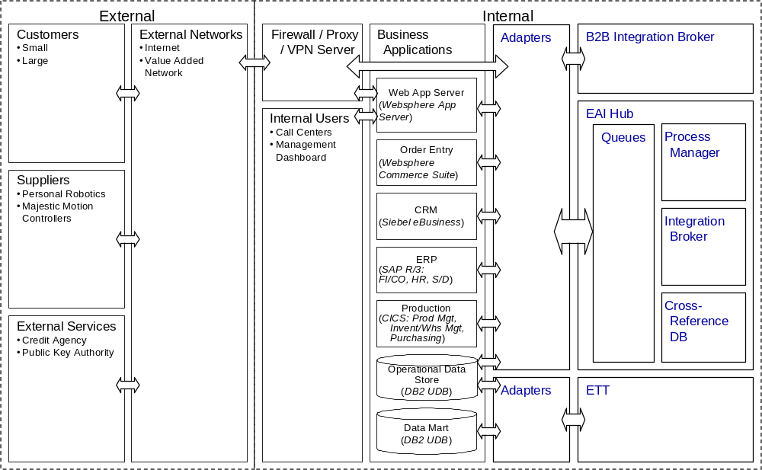
Figure 9 - ARC 101 Architecture Overview Diagram – EAI Conceptual

.

- EAI Component Model Example Work Product
To support Daukas & Lee’s integration needs, a logical EAI broker based system will be introduced, with most of the functionality executed and administered via the hub. This model provides a good match for their limited integration support team resources. The concentration will minimize the complexity and maintenance associated with individual application adapters.
A separate, dedicated logical broker will be used to manage the B2B interactions with their suppliers. Similarly, separate ETT technologies will be applied to their operational data store / data mart integration requirement.
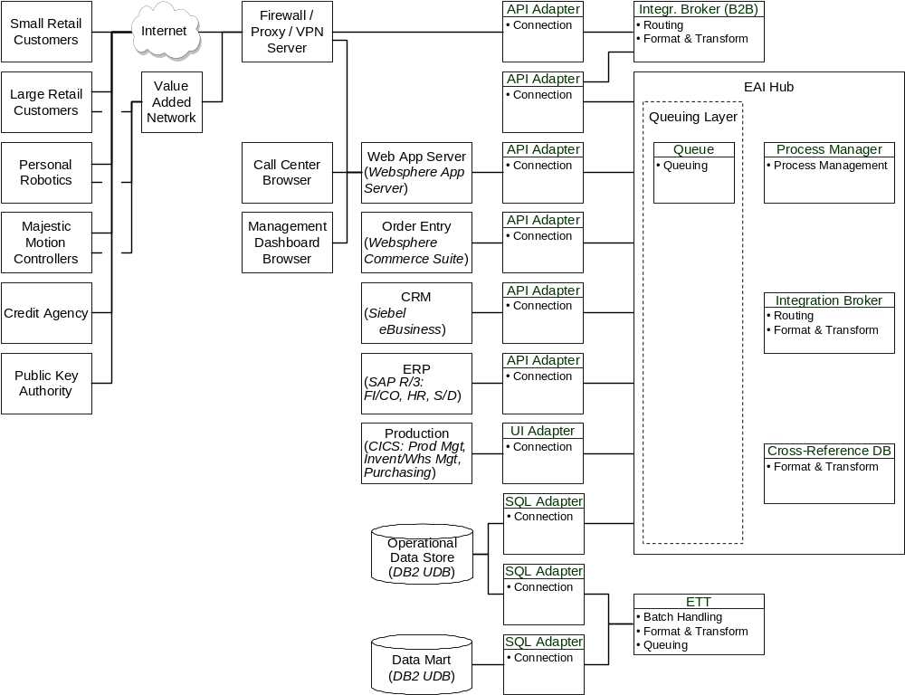
Figure 10 - ARC 108 Component Model Diagram – EAI Category-level
Note: The complete component work product also contains the component descriptions, interaction diagrams, and descriptions. These are excluded from the technique for brevity.

Appendix A: Architectural Decisions Background Information
Utilization of the EAI Infrastructure
In a large enterprise, there are usually many different departments or groups, with different ideas about how to facilitate interaction across their business applications. EAI subsystems often have a broad scope, with the potential to benefit multiple departments and groups, and in these cases, the total benefit to the enterprise depends on incorporation of the solution by all of these different factions.
There is a great risk that the solution will not be incorporated or perpetuated, if the different groups do not clearly understand the expectations related to their utilization of the EAI subsystem. The Architecture Decisions document can be an important instrument for clarifying these expectations.
EAI Functionality within Business Applications
As the need for inter-connectivity has become recognized as a critical enabler for business applications, it has become common to find EAI functionality living within the domain of business applications. There are four ways in which this usually is found:
- Vendor-provided business applications with EAI modules
- Vendor-provided business applications with internal “workflow” functionality
- Custom business application, with custom EAI services added
- Applications built on platforms that have native EAI services
Packaged applications, and especially those in the ERP, CRM, and SCM areas, will often have a module dedicated to EAI functionality. It is even common for these vendors to use the letters “EAI” in the name of the module, so they are not hard to find in a list of their modules. Often these EAI modules also serve intra-application needs, as these packaged applications are usually many separate modules that need to interact. Some of these EAI modules can be fairly sophisticated, to the point of resembling a decent message broker. Normally, these modules are optimized to focus on the message types, and interaction types that serve the needs of the package, and are not created with the richness found in products provided by EAI vendors.
Packaged business applications will also often offer “workflow” functionality. This functionality is almost always intended to create a series of steps for the user, with each step being one of its internal business functions. Vendors almost never claim that this workflow is generally applicable, as if it were sophisticated EAI workflow.
Custom applications that have accompanying custom EAI services usually do not try to do more than what is usually found in a fat adapter: format and transform services, with perhaps rudimentary queuing, and routing services. Normally, these services target interaction with a specific few of the customer’s other applications, and the intention was not to design something that could scale for enterprise-wide use. There are a few ambitious IT shops that have built from scratch a sophisticated broker device, and sometimes this is a standard that a customer will want to maintain in their collection of EAI components.
Applications built on application server and TP Monitor platforms can utilize native EAI services that are built into these platforms. TP Monitors are proven performers in process management for transactional interactions across applications built onto their platform. It takes considerable effort to extend TP Monitors for new use in controlling distributed interactions, but where there is a need for tight transactional control, this may be the best solution. The EAI aspects native in application servers are usually object broker and/or process/workflow services. This native functionality is optimized for use by components riding on the platform, and are usually are not intended by the vendors to be extendable for enterprise-wide service.
Business Application Insulation
Application insulation (sometimes called location independence) strives to limit the degree of knowledge one business application has of another, and specific goals and approaches related to this are important to capture. Application can be divided into two major categories:
- Physical Aspects: The degree to which one application knows the physical details of where another application resides.
- Logic and Data Aspects: The extent to which one application knows of another’s internal logic, data schemas, or other capabilities/needs. (E.g. whether or not SAP is to have direct knowledge of how another application produces new sales orders)
Build vs. Buy
Customers will often have general preferences as to how much EAI functionality should be built in-house, and how much should be bought from vendors. Very few customers will want to build all of their EAI functionality, so the common situations are:
- Buy all of the solution
- Build some significant part of the solution
Most large EAI project will require some custom work, be it for minor things like transformation objects or cross-reference databases, or major aspects like custom fat adapters.
Customers who want to build big parts of their solutions usually believe they can get:
- Faster or cheaper implementation
- Synergy with other in-house IT construction
- Special functionality
- Political benefits (e.g. it is a way to use underutilized programmers)
Customization of Vendor EAI Components
Even after the best efforts in selecting vendor EAI components, it is still common to be left with some important requirements unsatisfied, within the range of configuration offered. This situation often results in a need to custom build the functionality, and a decision arises as to whether to do this custom programming in the domain of, or outside the domain of the EAI components.
Process-intensive versus Data-oriented Situations
EAI subsystems usually involve automating some portion of a business process. A process is a progression of multiple interaction steps that, together, represent a single unit of work. If any step in the process is unsuccessful, then the entire process is unsuccessful. A single interaction is not a process. A collection of interactions that has no required sequence or progression, and no requirement to be successful as a group, is not a process.
EAI subsystems can be categorized into two types, Process-intensive and Data-oriented. Data-oriented situations include non-process interactions, and situations with less challenging process automation requirements. Process-intensive situations are more challenging, with process automation involving one of the following:
- Parallel paths in the process model (independent and potentially simultaneous steps), where different outcomes in one of these paths can call for a difference in future processes for another path
- Steps that can not be expected to complete with a predictable and relatively short duration
Data-oriented process automation only requires EAI services that are aware of the current and next steps in the process, while Process-intensive process automation requires process management services that are aware of multiple steps in the process.
Parallel Process Paths
Process performance can often be significantly improved through the use of parallel processing, where all, or some, of the steps are executed in parallel. This situation can be managed in Data-oriented fashion, as long as the combined outcome of different steps on parallel paths is not a determining factor in how to proceed.
For example, a simple process may involve three parallel paths, each with several steps to collect stock data from three different information sources, as part of an update frequently provided to a web site, and where occasional brief inaccuracies are tolerable. If the requirements for this process are such that the overall process is the same, regardless of how the different process paths complete, then this situation is only Data-oriented.
A Process-intensive situation can be seen in a process with three parallel flows, to check/reserve inventories across three different suppliers, and then to confirm or cancel all or part of the order, depending on the results of the supplier interactions. In this case, the different combination of outcomes from the efforts at each supplier may dictate different processes to follow, to automatically confirm or cancel all or part of the total order.
The appearance of parallel paths on a process model does not necessarily indicate a Process-intensive situation. It is only situations where more than one path can be active at the same time that can lead to a Process-intensive scenario (must also potentially different future processes too). A process model can show parallel paths, but may allow only one path to be active at a time. This is where a decision point is reached, and an only one path can proceed. These situations are not inherently Process-intensive.
Rollbacks and Compensation
Rollbacks and compensation are specific types of routines that can be spawned by a decision in a process to clean up, reverse, or correct effects from the process. Rollbacks are usually associated with tightly controlled transactional situations, and refer to the routine of returning databases to an exact previous condition. Compensation is where functions are initiated to change an affected application to an acceptable condition, rather than to an exact previous condition.
Compensation routines can themselves be sophisticated processes, and can be more complex than the main process that spawned it. For example, in the case where a compensation is needed to reverse an order entry, the compensation routine may need to first recognize whether or not the order has been fully processed, and initiate a “return” function if it has, or a “cancel order” function if it has not.
As processes, compensation situations can be Data-oriented or Process-intensive, according to the criteria above. Sometimes a main process that would otherwise be Data-oriented, is caused to be Process-intensive by the compensation process it contains. Complexity in compensation processes can also be caused by requirements for different data elements than were used in the main process. Further complication may be caused by requirements to have an automated compensation routine for an unsuccessful automated compensation process.
Steps with Unpredictable or Long Duration
Some interactions can take an unpredictable and/or extraordinary length of time to complete. (E.g. a step involving a human response). This can require sophisticated process management services, and is considered to be Process-intensive. This situation is most common in document management processes, and people-oriented workflow.
Transactional Interactions
Transactional interactions are interactions that require high levels of control. The degree to which an interaction is Transactional is not defined by the content of the information exchanged (e.g. involving funds). It is a reference to the integrity of the exchange procedure, as described in the ACID properties:
- Atomic: Atomicity implies that the transaction makes either all, or none of the changes that it attempts. In other words, database record or other changes will not have any impact to any part of the system until the transaction is committed. If any part of the transaction fails, or if cancellation is ordered before completion, the entire transaction is cancelled via a process to return all affected records to their original condition.
- Consistent: Consistency says that the transaction’s activities, taken as a group, do not violate any of the integrity constraints associated with the state. This requires the transaction to be a correct program.
- Isolated: Isolation is the notion that, even though multiple transactions may execute concurrently, each transaction executes independently from the others
- Durable: Durability implies that, once a transaction completes successfully (commits), it will survive failures.
Highly ACID transactional situations may require the use of record-locking, rollbacks, once-only delivery guarantees, before- and after-images of databases, and multi-phase interaction protocols. A common technique is to lock the affected database rows in such a way as to prevent other users from modifying or reading the rows until a transaction is committed. Another technique is to keep a copy of the original condition of affected rows, until the transaction is committed. While the transaction is in execution, other transactions requesting to read rows that have been changed can be redirected to read the original row copy, and are prevented from actions that would try to change that copy.
Multi-phase protocols define an interaction process by which to assure transactional integrity in an exchange. An example is the commonly used “two phase commit” protocol, which has a voting phase, where all participants prepare to commit, followed by a commit phase, in which all the participants commit.
Where transactional integrity requirements span more than two applications, each interaction and all interactions must meet the desired level of transactional integrity. Orchestrating multi-phase transaction protocols across distributed applications can be very challenging. A classic distributed multi-phase commit situation works as follows:
- The process manager directs the request for an update to the participating applications
- Each of the participating applications lock their databases, retain before-images of their databases, perform the update, report the success to the process manager, and wait for a response
- If all participating applications report successful updates, the process manager issues to all the participating applications an approval to commit
- The participating applications commit the update, and report their success to the process manager
- If one of the participating applications cannot perform the update, the process manager instructs the other applications to rollback their updates
- The participating applications use the before-image to return the database to its original condition, and report their success to the process manager
Transactional integrity can be a consideration in either Data-oriented or Process-oriented situations. Highly ACID situations distributed process situations tend to be tightly coupled, and use rollback routines. Less transactional multi-step situations may be facilitated with loosely coupled techniques, and may use compensation routines. The looser the coupling between applications in a distributed process, the more challenging it is to ensure transactional integrity.
Failure and Exception Handling
Exceptions happen when interactions are unsuccessful for reasons related to the normal decisions made in the process. Exception handling is the means by which Exceptions are detected, reported, and managed. An example of an Exception in an interaction is where a new product is created in one application, and that application attempts an interaction that includes data related to the new product with another application. If the other application has not also been updated with the new product information, then it may reject the interaction, which would mean the interaction generated an Exception.
Failures happen when interactions are unsuccessful for reasons related to the mechanics of the integration system itself. Failure handling is the means by which Failures are detected, reported, and managed. Examples of Failures include:
- Software errors in the code of the integration system
- Hardware outages (network and computers)
- Inability to properly perform data transformations
Event-triggered versus Batch Interaction Styles
Batch processing is the periodic transfer of data on a scheduled or manually initiated basis. Event-triggered interaction is initiated by specific business events. Event-triggered interaction has become more important as enterprises need to complete business processes more quickly.
Communication Type
The following are the dimensions of communication types that shape the interaction between separate applications.
Available vs. Non-Available
In Available communication a remote application component needs to be available for communication to take place. For example, for a client module to execute an RPC, an SQL stored procedure, an object request, the server module providing the service must be available.
In Non-Available communication, a remote application component need not be available for communication to take place. This type of communication can be done with more and less assurance of delivery. If more assurance of delivery is required, often this type of communication involves other services with which to stage the request while waiting for the (e.g. a queue or persistent channel).
Conversational vs. Non-Conversational
In Conversational communications, a connection between requester and providers must be established for communication to take place: typically a handle, session, or conversation identifier is established that ties the calling instance to the provider instance. Once this identifier is created, the two applications can carry out a conversation that may consist of one or more request/reply interactions; data may be transferred, and state may be shared between calling and providing applications. Typically, the connection will persist until one of the applications (usually the one that established the connection) explicitly closes it down. Accordingly, this type of communication is also termed Persistent. This type of communication is sometimes termed State Aware because it is conducive to sharing state. Conversational communications are almost always synchronous.
In Non-Conversational communication, a connection between the calling and called applications does not exist. Typically, there is no session or conversation identifier that needs to be established to enable communication. Usually, based on the request identifier, the infrastructure handles the marshaling of arguments and transportation of the request. This type of communication is also said to be Stateless. It has sometimes been termed Connectionless Request/Reply or CLRR.
Synchronous vs. Asynchronous
In Synchronous communication, after it makes a request, the calling application is blocked until it receives the reply from the recipient application.
In Asynchronous communication, the calling application can carry out other work after the request is sent. Asynchronous communication is different from Non-Available in that, the caller is not blocked, but the recipient application must be available for the request to take place. Asynchronous behavior is often achieved via a polling mechanism at the requesting application.
Static Invocation vs. Dynamic Invocation
For object-oriented interaction, communications related to invocation can be of two different types. In Static invocation, the specification of the interface must be known at development time. In Dynamic invocation, the exact specification of the called interface is discovered at runtime, built up by the calling program.
Object or Component Platform Standards
The customer may be predisposed to build IT solutions according to object or component platforms of choice. The more dominant choices are listed below:
CORBA
The Object Management Group's CORBA defines a model for creating objects and a brokering technology that manages communication between these objects. The model, called the Object Management Architecture, describes the objects themselves as well as how objects send messages to one another. CORBA also describes the messaging technology, called the object request broker (ORB), and associated services needed to implement a distributed object system. CORBA’s current version provides full integration with the Internet, and has support for legacy platforms, and includes a language- and platform-independent component model, object persistence, integration, and guaranteed quality of service. To support language independence, CORBA applications are coded in Interface Definition Language (IDL). This language is syntactically similar to C++, but contains no semantics: operations specified in IDL are operation interfaces, not operation implementations.
Java, Remote Method Invocation (RMI), and Enterprise Java Beans (EJB)
Sun's Java is a set of three compatible platforms. Java 2 Standard Edition (J2SE), formerly known as the Java Development Kit, is the foundational language, component development, and coding tool set. J2EE is a set of technologies and components for enterprise and Internet development that supplement J2SE. Java 2 Micro Edition (J2ME) is for creating software for embedded, mobile, consumer, and other small devices. Because of Java's portability and ease of use, major vendors like IBM, Sun, and Oracle™ are using J2SE and J2EE for deploying mission-critical business services and applications on distributed systems. Other vendors and companies have followed suit, and Java has become a significant, if not the preeminent, server-side platform. Java offers distributed object facilities, in the form of remote method invocation (RMI) middleware, and the JavaBean and EJB component models. RMI and JavaBeans exist in both J2SE and J2EE, while EJB is part of J2EE:
- Java RMI is the communication protocol that allows Java objects to communicate, using normal method calls, even if they are running in separate machines. RMI enables the passing of both data and code between a server (the machine where the objects normally run) and a client (which requests the objects). This allows different instances of a particular object to run on both client and server machines. RMI provides extra security to help insure downloaded code safety.
- While JavaBeans is a graphical component model concept, Enterprise JavaBeans (EJBs) is a somewhat less graphical approach intended to package distributed middleware services. The EJB model encapsulates business logic on the server side, and consists of two primary entities:
- The Java objects or components themselves, linked together as a "bean;"
- The container, which mediates between the bean and its environment. The container provides communication between the environment and the bean; manages the bean components; and provides key services such as concurrency, persistence, security, and multithreading support. Developers can assemble EJBs into applications, or wrap legacy non-Java code as an EJB for integration into Java applications.
Although the EJB and CORBA specifications describe independent technologies, EJB implementations currently utilize some aspects of CORBA technology. One example is RMI/IIOP. RMI specifies syntax and semantics for remote methods, but does not specify what transport protocol should be used to provide network connectivity. The CORBA Internet Inter-ORB Protocol (IIOP) basically defines a way to transmit CORBA messages over TCP/IP. EJB implementations can be developed to exchange RMI data in the form of IIOP messages.
COM™, DCOM™, DNA™, and NET ™
Whereas Java's architecture is restricted to a single language but operates on many platforms, Microsoft's architecture applies to multiple programming languages on a single platform: Windows. Like CORBA, COM is a language-independent, binary standard that allows applications to communicate with each other via interfaces. These interfaces are actually contracts between software components that promise the delivery of certain specified functions. The components themselves are units of software that deliver specific services to the rest of the system. COM is based on an object broker, but unlike other brokering models such as CORBA or Java, the underlying broker is built into the Windows operating system. As a result, Microsoft's development platform has been restricted to Intel machines running Windows operating systems. COM also was restricted to applications running on a single computer. Distributed COM, known as DCOM, was introduced as part of Windows NT 4.0. As such, it adds services that allow COM components and applications to inter-operate across networks.
COM™+ was introduced as a significant upgrade to the original COM (and patched-together DCOM) component model, and was intended to compete with CORBA and Java. COM+ amalgamates transaction processing from Microsoft Transaction Services and Transaction Internet Protocol environments with a distributed component model. The new model features automatic load balancing, in-memory (cached) database services, object pooling, central administration, and queued components (which replace remote procedure calls). It also includes a publish-and-subscribe event service like Java and CORBA. The COM+ framework is built specifically for, and most of its functionality is now available within, the Windows 2000 family running on Intel.
Windows DNA™ is Microsoft's term for its three-tier architecture based on COM+ and MTS™. It includes client technologies like ASPs, server technologies like COM+, and the SQL Server back-end database. Microsoft's currently available development products are based on Windows DNA. DNA uses a tightly coupled messaging architecture, which means that a message's recipient and the sender must both be running DNA-compliant applications. DNA 2000 is intended to replace Windows DNA. The main difference is that DNA 2000 uses a loosely coupled messaging architecture based on BizTalk's™ XML and SOAP. DNA is still on the drawing board, but it has apparently been superseded by the .NET architecture. DNA 2000's fate is uncertain.
.NET appears to be an entirely new architecture that completely replaces the COMs and the DNAs. It will not, however, upgrade existing technologies. .NET replaces the COM runtime with a common-language runtime (CLR) that is supposed to support and integrate components developed in any compliant language. The CLR works much like CORBA and uses an intermediate language (IL) compiler, similar to CORBA IDL, which translates between the different languages by compiling them in IL. Developers will use a Microsoft JIT or native IL compiler to compile the IL code into Windows-specific machine code. .NET supports a loosely-coupled architecture for distributed applications, and remote access based on BizTalk XML and SOAP technologies. A new language, Web Services Description Language (WSDL), will be used to create remote XML-based interfaces for .NET components transported via SOAP.
Routing
Routing is the use rules or lists to determine the destination for transported data, insulating source applications from the chore of maintaining this information. Routing is different from process management, in that the focus of a routing service is on the next destination for a single interaction, rather than on managing a series of interactions as an entire unit of work. Routing services categorize into two basic types:
- Content-based: The routing services determines the destination based on an evaluation of the information in transportation
- Topic-based (commonly known as pub/sub): The routing is based on input provided (lists), or is inferred by the source of the information
Some EAI products are able to combine both of these types of routing techniques.
Data Transformation
Different applications, both in house and purchased, often have different views and definitions for similar concepts. For example, a sales support system and an ERP system may have different ideas about what an order entails. These differences can range from simple data type inconsistencies to larger structural and conceptual changes. Format and transformation services provide a mechanism to bridge this gap.
In general, formatting is the manipulation of the condition or position of the data content, while transformation refers to manipulations of the content itself. Formatting and transformation is needed to enable:
- Combining messages
- Changing data types: adding, deleting, rearranging, splitting, or concatenating fields
- Parsing and selecting sub-strings; and interpreting tagged data structures (e.g. XML)
- Padding or truncating data fields
- Cleaning fields, and executing unlimited string and numerical manipulations
- Defining external table lookups
- Manipulating different types of data structures and language arrays
- Employing math functions, logarithmic functions, and date/time functions
- Searching and replacing
- Manipulating bits/bytes
- Utilizing conditionals
- Leveraging metadata repositories
Formatting and transformation services may be located in a central position, at the end points, or both.
Message-oriented vs. Remote Procedure Call/Object-oriented
Object-oriented and RPC techniques use information containers structured according to very specific industry standards. Defined in those standards are specific treatments for portions of the container related to method invocation and data payload, as well as other parameters or code. Object-oriented techniques conduct method invocation in essentially the same manner as RPC techniques. RPC and Object-oriented approaches also tend to be synchronous.
Messages can also be used to integrate systems. A message may contain both data, and other information related to process or the event. Message-based integration allows applications to be loosely coupled and insulated from each other. Message containers may or may not conform to industry standards. Message-oriented techniques tend to be asynchronous.
Business Object Documents
Application integration of any kind involves the passing of data sets between applications. These data sets have characteristics along two basic dimensions:
- The content: the data elements within the container that are intended for transfer
- The container: the virtual envelope that contains the content (not to be confused with “containers” used with JavaBeans)
Transferring data between applications for business use is not practical without some type of container. Containers provide things like headers, delimiters, sequential arrangements, etc.; as a means for applications to understand things about the content. This is why data sets are often referred to as Business Objects or Business Object Documents (BOD’s): not because they meet the formal definition of objects, but because the container “packaging” resembles similar constructs in object-oriented application development.
Containers provide understanding about content in two ways:
- Data elements specific to the container (e.g. source, destination, size, security info, etc.)
- Structure: meaning that can be derived from the container’s configuration or design
Container data element and structural configurations must be somewhat predictable and decipherable to be useful, and specifications are either:
- Pre-defined by:
- The enterprise (proprietary)
- Software vendors (e.g. SAP IDoc’s)
- Industry standards (e.g. EDI)
- Self-defining (e.g. XML)
Pre-defined static business object structures have been the focus until recently. The more that these pre-defined structures can be standardized, the easier it is to broaden integration. Electronic Data Interchange (EDI) is probably the best recognized of this type of standard, as it has been the traditional mainstay for e-commerce among the Fortune 2000. EDI cost structure, however, has prevented widespread adoption among small- to medium-scale enterprises. According to CommerceNet, only an estimated 125,000 organizations worldwide use EDI, and less than 2 percent of businesses in the United States have implemented EDI systems. EDI services are delivered over expensive value-added networks (VANs), and the installation costs, maintenance, and transaction fees impose a substantial barrier to entry for smaller organizations. Although one company may have full support for EDI, it is rare that all its partners also support EDI. For many enterprises, a large part of supply-chain management still depends on telephone, fax, e-mail, and the human factor.
In an effort to increase application interoperability, without incurring the need for more rules and performance-limiting transformation routines, many companies are beginning to consider more self-defining business objects documents. Structures based on the Extensible Markup Language (XML) standard are the most common choice for self-defining containers.
With XML, and with similar markup languages like SGML and HTML, the information pieces in a document are marked with beginning and ending tags. These markings identify the pieces according to the creator’s intentions (within the frame of the language). To define what is the meaning of the tags used in a document, these languages use the document type definition (DTD) description. Document creators can select or create a DTD they want to use to specify the meaning of tags. The DTD defines all elements used in a set of documents, and it also specifies the relation of these tags to each other in a tree format. Each element has an element type name (tag name) and a set of attributes. Each attribute consists of a name and a value.
As a source format for content, XML allows:
- The abstract description of documents using metadata.
- Enhanced search and filtering capabilities using metadata information.
- Automatic document validation.
- Managing smaller, reusable fragments of documents.
- Multiple presentation formats for different delivery types, like Web, paper or CD-ROM.
As a document exchange format, XML helps in:
- Flexible interchange of documents and metadata between applications
- Standardized interchange to support wide range of applications
- Integration of data from other sources, for example from databases
- Transferring complex, application-specific data in business-to-customer applications
As a document delivery technology, XML has these advantages:
- It integrates to client application without need for manual editing or presentation transformation.
- It allows rich presentation formats that can be individually tailored to customer’s needs.
- Using XML, data can be processed at the client side controlled by the customer for maximum flexibility.
XML’s flexibility has enabled many different efforts to create standards XML-based business objects, yielding a wide variety of options. Most of the basic EDI data sets have been translated into XML-based versions, an the bulk of the adoption of XML-based business objects so far seems to be with companies that are attempting to broaden their EDI activity to smaller firms.
There are horizontal and vertical XML specifications. Horizontal specifications are not tied to a single application field, they contain information about several fields, for example measurements, date and time, country codes, basic business forms, descriptions of businesses and individuals. Vertical specifications describe a specific application area like electronic payment, mathematics or chemistry.
Many XML standard forms have been created, for different industries and purposes, including:
- ebXML - e-business XML Initiative
- FpML - Financial Products Markup Language
- IFX - Interactive Financial Exchange - Banking
- SVG - Scalable Vector Graphics
- RosettaNet - IT Supply Chain
- XMI - XML Metadata Interchange
- OTA - Open Travel Alliance
- HL7 - Health Level Seven
- OTP - Open Trading Protocol
- WML - Wireless Markup Language
- XML/EDI - Electronic Data Interchange
- XHTML - XML HTML
Many XML-based business object documents have also been created to enable B2B interaction beyond the scope of EDI. These standards have begun to include different data content, which includes process-enabling data elements to facilitate more sophisticated process automation. SOAP is a good example of this, as it contains the data elements that allow one application to invoke a remote procedure call (RPC) in remote application, using an XML message and the Internet. SOAP attempts to address the growing need for business partners to exchange structured data over the Web independently of each other's underlying application platform. It is designed to let organizations publish data and process instructions over the Web as easily as they can publish HTML pages. As such, it can connect to and trigger operation within many different types of components and environments. Many standards employ the same basic approach as SOAP, including Rosettanet, ebXML, etc.
To integrate large numbers of different applications requires a lot of transformation effort. Even with a central hub to facilitate fewer physical integration points, the logical situation still requires a unique transformation for each combination of applications that interact. With dozens of highly interactive applications, this can lead to many hundreds of different transformation maps. In much the same way that a central physical hub can reduce the number of physical interfaces, adoption of an intermediate “generic” business object document can simplify the number of transformations. The concept is that, if a group of applications need to share the same types of data, they need only to be mapped once, to a generic business object, which is sometimes called a canonical business object. The exchanges from each application would have two transformations, once to the canonical form from the sending application, and again from the canonical form to the receiving application.
Adapter Functionality
As seen in the different EAI models, adapters may contain many different types of EAI Services. An adapter can be either “fat” or “thin”, depending on the amount of functionality it contains. Fat adapters contain relatively more EAI functionality than thin adapters. There are several functions that an adapter must address. Once the application that is tended by the adapter has created an event, the adapter must:
- Recognize that the event has taken place, and
- Interact with the application to pull together the information that other programs will need (e.g., the new employee's name, mail stop and telephone number).
It's easier for the adapter to recognize an event if the application it is monitoring automatically emits an alert when critical events occur. Applications do not often do this, so adapters may employ non-invasive, or minimally invasive techniques to enable them to recognize events. An example of a non-invasive technique is a program that scans a transaction log, looking for entries that indicate when new employees have been added. A minimally invasive technique may be to place a trigger on the database table for employees. Whenever a record is added to that database, the trigger would send a message to the adapter program.
Once the adapter has recognized that the event occurred, it must collect all the relevant information about that event. Adapters may have to make multiple calls to an API to collect this data, which can involve significant programming logic. For example, an adapter may have to make three calls to the API to gather an employee's name, address and phone number. In this case, code is required to store the name after the first call, and both the name and the address after the second call. Code is also needed to support exception handling, in case the process fails before all the required data can be collected. Further code would be required if the adapter must also perform transformation or routing routines.
Fat adapters and thin adapters can use two different approaches to provide the state management and exception handling logic that manages the multiple calls an adapter might have to make to an application.
- Fat adapters, generally contain the code to handle calls to an application.
- Thin adapters, however, may only recognize events, and interact with the application's API; leaving state management and exception handling logic to be handled by the other parts of the EAI subsystem (I.E. the hub).
Application Access
Adapters and connectors can facilitate access to business applications in five basic ways:
- API – Message-oriented
- Message or document-focused interfaces in which one imports/exports messages to/from the target system
- Examples: SAP's IDOC/ALE, PeopleSoft's MessageAgent
- API – Function Call-oriented
  - Exposed function calls with specific input and output formats, generally provided as linkable libraries or remote calls
  - Examples: SAP's RFC's, JD Edwards OneWorld API
- API – Object-oriented
- Interfaces corresponding to modern object/component models
- Examples: the OAG's CORBA, Microsoft's DCOM™, Sun's JavaBeans
- User interface emulation
- Interfacing with an application by appearing to be a user (connects via the application’s communications interface)
- Examples: IBM's CICS EPI, Mitem
- Direct database access
- Application-independent data manipulation languages by which one can communicate directly with an application's database or other central data store
- Examples: SQL
B2B Interaction
B2B applications focus on using the Internet and/or extranet to improve business-to-business partnerships and transform inter-organizational relationships. B2B trade is generally conducted:
- Between a company and its supply chain
- Between a company and its customers
- Between buyers and sellers with the help of a third-party intermediary (eMarketPlace)
In the future, B2B technology is predicted to enable pools of independent specialized service providers, to be automatically organized in reaction to customer requests, creating “virtual enterprises” that efficiently deliver products or services
B2B environments need dynamic and flexible integration techniques, that address issues related to privacy, autonomy, heterogeneity in software and platforms, and manage complex interactions.
In its long history, EDI has greatly contributed to automating business-to-business transactions. However, EDI’s high cost and inflexibility have been barriers to adoption for all but the largest enterprises. EDI’s simplistic nature does not address all the aspects needed for sophisticated cross-company automation.
With the unpredictability and heterogeneity possible in B2B environments, it has been difficult to form standards that will facilitate B2B. XML has become the de facto standard in terms of data object structure, and is now being leveraged heavily in initiatives attempting to create the remaining standards that are necessary.
One area that needs standardization is the means by which companies establish and maintain an agreement to work together. These agreements are commonly called Trading Partner Agreements (TPAs). Most efforts attempting to standardize B2B techniques, employ a special data object to define TPA information. TPA objects commonly help to generate understanding, and create commitments, by exchanging information related to:
- TPA name, starting and possibly ending dates for the agreement, and other global parameters
- Roles and identification aspects
- Communication and security
- Actions or process
- Sequencing rules
- Cancellation rules
- Error handling rules
- Service levels
- Anything else that is important
TPA’s offer a common language for existing or potential trading partners to specify how they will interact. B2B standards also define the mechanisms for making the TPA legally binding (e.g. via digital signatures), and the process for solidifying the agreement.
Many different approaches have been initiated to help create more sophisticated B2B interaction, including:
- Electronic Business XML (ebXML)
- Commerce XML (cXML)
- eCo Specification
- BizTalk™
- RosettaNet
- XML/EDI
- Trading Partner Agreement Markup Language (tpaML)
In parallel with the general B2B Framework initiatives, there have been efforts to develop “vertical” market vocabularies, specific to industry sectors or cross-industry segments (see www.xml.org/xmlorg_registry/index.shtml).
The goal is to be able to generate TPA commitments in as automated a fashion as is possible. This will speed up the conversion of terms and conditions into operating instructions for each company’s internal automated processes, and achieve quick fulfillment of customer orders.
The purpose of the electronic TPA is to express the IT terms and conditions to which the parties to the TPA must agree in a form in which configuration information and the interaction rules which must be executable can be automatically generated from the TPA in each party’s system.
The TPA describes how to engage generalized business services from trading partners, without defining the specific sub-functions that are initiated to provide those services. Normally, a TPA represents a single long-term running conversation, which is a set of related interactions, dispersed in time, comprising a single unit of business (UOB). A UOB is performed under the TPA by instantiating the TPA as a long-running conversation.
eMarketPlaces
The traditional B2B model, centered around the buyer-seller transaction paradigm, has limitations in terms of scalability, and economies of scale. EMarketPlaces, or online trading communities, have evolved to assist multiple buyers and suppliers in the exchange of information and transactions.
Through the eMarketPlace hubs buyers and sellers can trade electronically with established partners and at the same time get access to a new markets and new parts of the supply chain. eMarketPlaces can be public, where all members participate in an open, interactive buying and selling community, or private, which are invitation-only communities whose members participate in special pricing arrangements and/or product and service offerings.
The role of the intermediary involve the areas of communication, commerce, and content, including:
- Bringing together buyers and sellers within a common eMarketPlace
- Providing methods for transactions to take place, for example through an auction and standard contracts in order for them to be cleared.
- Characterizing buyers and sellers. For the former they provide assurance that sellers have suitable goods, by tracking levels of service quality. For sellers they provide assurance that the buyers are capable of making payments
- Aggregating third party content
- Creating original content through aggregating trading data and user data
- Providing value-added services such as insurance, logistics and financing through partnerships with third parties
- Communicating through offering e-mail, alarms and alerts and personalization of advertising and content
- Supporting buyers and sellers in accessing the eMarketPlace
B2B online intermediaries make use of a number of business models to enable trade among parties to the eMarketPlace. eMarketPlaces are usually Internet based hubs, that focus on specific industry verticals or specific industry processes, and use various models for interaction, including:
Directories
- Buyers and sellers promote themselves, exposing the list of services and the types of contracts that they accept.
- Business transactions can take place between buyer and seller pairs independently from the intermediary.
Auctions
- Match buyers and sellers and prices to levels of supply and demand
- Typically delivered as:
- Bulletin boards (sellers post offers and buyers bid on these offers the bidding period is not defined: offers and bid are valid until are removed from the bulletin board and bidders are not aware of other people’s bids),
- Reverse auctions (traditional auction mechanism in which buyers post requests to purchase in a structured format, and sellers to bid for supply of the goods or services)
- Regular auctions (traditional auction mechanism in which sellers post an offer and buyers to bid on this).
Exchanges
- Both buyers and sellers make bids and offers for some underlying commodity
- Different from auction because offers can be made at any time and are often withdrawn or revised.
Aggregation
- Intermediaries play an active role by aggregating requests coming from the various parties.
- In selling aggregation intermediaries aggregate, standardize and index suppliers catalogues or content and make these available in a centralized location to buyers.
- In buying aggregation, buyers requests for quotes (RFQs) are aggregated and linked into a pool of suppliers who can make bids.
- In content aggregation, online intermediary publishers aggregate and filter third party content and combine this with proprietary content to attract communities of industry professionals.
Added Value Services
- Intermediaries play an active role in the business process transaction, providing value added services that complement or complete the business transactions between parties
Security
An EAI subsystem must be designed as compliant with, and in support of, all of the security needs of a company’s security strategies. The common categories for security considerations are shown below:
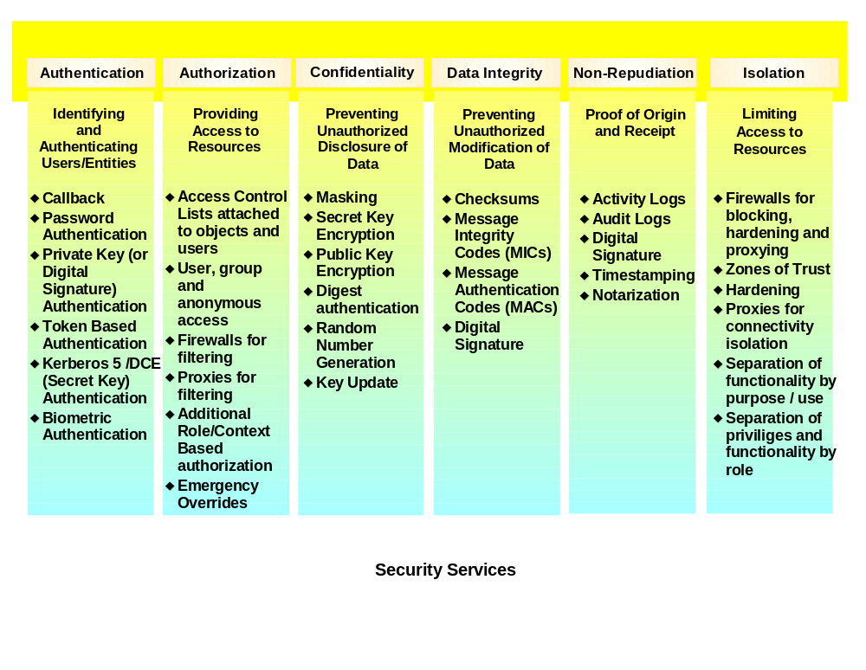
Authentication
Authentication is the process of proving your identity, i.e. who are you. Most authentication routines are focus on userID/password controls.
Other, more sophisticated techniques include the use of keys or tokens. Public Key Infrastructure (PKI) is a collection of technologies, services, institutions, policies and laws that facilitate electronic commerce. PKI can be described as a “pervasive security infrastructure whose services are implemented and delivered using public/private key concepts and techniques”.
A general-purpose PKI consists of PKI-enabled applications, X.509 digital certificates, Certificate Authorities (CAs), a publicly accessible directory service, trust list relation-ships between CAs, and the policies that govern the operation and use of the PKI. In combination, these PKI components present the opportunity both for higher degrees of trust and for some significant management issues, both legal and technical.
When considering these components, it’s important to distinguish between encryption keys and the certificates that vouch for a given public key’s validity. In public key security systems, each user has both a public and a private key. Because each user’s public key is “public,” users can validate the integrity of information and authenticate each other in a fully distributed environment without the key management problems associated with secret key systems. For example, people can encrypt information they want to send to a given user with his or her public key, knowing that only the intended user can decrypt it with his or her private key. The inverse is also true. Users can decrypt data sent to them by another user only by using the sending user’s public key.
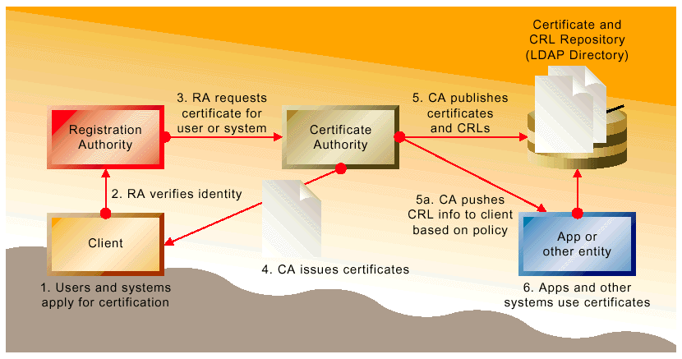
The challenge with PKI is in ensuring that a given public key indeed belongs to the person to whom it appears to belong. That’s where the certificate comes in. It binds the identity of a person or other entity to the public key, ensuring users that the key does indeed belong to a given user, server, or other entity. A trusted third party, the certification authority, certifies the public key as belonging to a specific person. If you trust the certificate authority, then you can rest assured that the key is valid.
When a Certification Authority issues a certificate, then, it’s making a statement to the relying party. It’s saying that a particular public key is indeed bound to a specific entity (the subscriber, or certificate subject). The degree to which the relying party trusts the binding a certificate embodies depends on the degree to which the relying party trusts the CA that issued it. Relying parties can use several factors to determine such degrees of trust.
Bilateral cross-certification is more typical of an enterprise PKI. In a bilateral cross-certification operation, CAs cross-certify each other by certifying each other’s public keys, creating a “cross-certificate.” Bilateral cross-certification eliminates the overhead of a hierarchy, allowing organizations to establish trust, when no suitable third party is available to facilitate the formation of the relationship. It also matches the way in which many companies do business: one-on-one, with trusted partners. Business partners, for example, may choose to cross-certify each other to ease communication between company employees.
Authorization
Authorization takes the authenticated identity and answers the question “are you permitted to perform the action you are requesting on the resource you are seeking to act upon?” This is perhaps the cornerstone of any security architecture since most security goals are directed toward protecting against unauthorized access and usage of some resource. With the growth of electronic commerce, authorization has recently garnered a lot of press, and vendor interest (i.e. products). Authorization has acquired a more general name of Privilege Management Infrastructure (PMI) to reflect the fact it has outgrown its roots in simple access control lists (ACLs).
Confidentiality
Confidentiality is the process of protecting data from unauthorized viewing. Encryption and decryption are typically used to accomplish this service. Two related terms are:
- Symmetric key means two parties share the same secret (key), examples are 1) logging into RACF® where both you and the RACF system know your password and 2) DES encryption where both ends of a secure communications channel know the password used to encrypt the data flowing on wire. The two primary disadvantages of this approach are 1) lack of scalability and 2) distribution of the secret to both parties. The primary advantage is high performance.
- Asymmetric key means two parties do not share the same secret. The primary example is X.509 certificates used with a PKI. Each party generates a mathematically related pair of keys, the private and public key. The private key never leaves the party’s possession. The public key is placed in an easily accessible location, such as an LDAP directory. A party encrypts with their private key, the receiver decrypts with the sending party’s public key. Because of the mathematical relationship between the two keys, only a party’s public key can decrypt data encrypted with the corresponding private key (and visa versa). Advantages are no key distribution issue (assuming a central directory accessible by all parties) and good scalability. A disadvantage is poor performance during encryption/decryption.
Often symmetric and asymmetric key technology is used in tandem, with the bulk of the encryption work being done by high performance symmetric key algorithms (in hardware or software). Only the initial sharing of the symmetric key is done using asymmetric key encryption (obviously to maintain confidentiality of the shared symmetric key).
Data Integrity
Data Integrity is the process of protecting data from unauthorized modification. This is traditionally done with checksums or hashes (sometimes extended to digital signatures).
Non-Repudiation
Non-repudiation is the state where one cannot deny initiating an action, such as submitting a bid for services in response to a Request for Proposal (RFP) or initiating a purchase. Another way to describe this service is “preventing false denial”. This is a critical requirement (and therefore required service) on the Internet where physical presence and/or written signatures are not possible.
Isolation
Isolation is the notion of limiting access to a collection of resources that share a common set of security requirements. Zones of trust are a mapping of this idea into reality, for instance partitioning your environment into zones: Internet, DMZ and intranet -- and protecting each zone with a common set of security mechanisms.
Audit Capabilities
Auditing, as its name implies, involves the ability to examine historical data about activity within the system. This includes specialized data capture, storage, and access; for specific types of activities and information. Auditing may answer the basic questions of how a company’s information is created and manipulated, including:
- Who performed an operation to create, update, or delete information?
- When was the operation performed?
- What information was affected by the operation?
- How was the operation performed (via what application)?
- Were all interested parties properly informed of the operation?
Audit capabilities may also serve the processes involved with security, system management, application recovery, or compensation processes for failures and exceptions. Auditing capability usually relies on log files that are fed with certain data, at specific points in time or place in a process.
System Management and Monitoring
System management and monitoring capabilities let operators (or devices) know if aspects of the system are up, if they are down, and if they are functioning properly. Other system management services may involve reaching into all integration tiers to provide services like exception-based alerts, system testing, and automated performance tuning. Systems management services provide the core functionality that supports end-to-end management across networks, systems, middleware and applications.
System management, as it is discussed here, can involve two general types of information:
- Status information, which focuses on the status, or change of status, for parts of the system at points in time; with the comparison to, important limits (e.g., a queue depth has become hit a critically high level). This is usually a lower-level technical perspective.
- Causal information, which focuses on understanding why situations are happening (e.g. most of the messages that have flowed to a queue are of a certain type). This is a higher-level process perspective than with Status-oriented techniques.
Notification can be reactive, requiring resources to initiate a review of the situation; or proactive, where notification is more directly and immediately delivered.
The resources that are notified may be human or software, and responses may be manual or automated.
Administration
Administration services provide assistance with the following:
- Location/relocation of resources – the ability to easily address changes in hardware application locations
- Load Balancing – the ability to easily modify the path information travels in order to respond to changes in information volumes, hardware availability, and network routing structures
- Producer/Consumer relationships – the ability to understand and configure the information produced by a given application, and to understand and configure which application(s) need to consume the information
- Shared services – administration of shared services such as data transformation and security
A large portion of the administration load for the integrated business system can be for maintaining authorization currency on the applications that underpin the solution.
Repositories
Repositories are software mechanisms that provide centralized information to assist with the management of components, application services, business logic, and data. Repositories may contain critical information, or metadata, about components and component interfaces, about specific systems, about object designs (such as UML diagrams), about database definitions, and about aspects or relationships between data.
Directory services repositories supply information on the location, capabilities, and various attributes of resources and users, across the system. This may include security information related to authentication and authorization (e.g. userid/password pairs and certificate verification). LDAP is a common standard for directory services.
Metadata repositories contain data that helps to define other data, and are generally used to help label and catalog data. Metadata helps in organizing, locating and understanding data, making the data management process more efficient and effective.
Cross-reference databases are useful to help reconcile differences in the way the same data is captured between different applications. For example, a cross-reference resource could be queried when attempting an interaction between three applications, in order to identify a customer that is stored in three different ways:
ID# First Name Last Name
App A: LED1473 Robert Plant
App B: 4522ZEP Bob Plant
App C: 992513 -- --
Other repositories may be useful for capturing business rules, functional logic, and EAI configuration parameters.
Recovery
Recovery focuses on the impacts from significant unexpected malfunctions of the system, with the objective of restoring the business system to the most current valid state possible. This involves the means to:
- Identify those activities that were not complete properly
- Execute specific routines to return the components, processes, and data to an acceptable condition
- Illuminate the different impacts to expect from the malfunction
Recovery can be very manual, or aided by automated techniques.
Planning and Tools/Environment
EAI work can be accelerated and enhanced with the use of certain planning, modeling, or project management methods and tools.
General EAI Model (Centralized vs. End Point Services)
There are four basic models for centralizing/distributing EAI functionality. The End Point Model and the Hub Model are the most common forms; and there are two hybrids, Network and Multi-hub models:
End Point Model
- The End Point Model places most/all of the EAI functionality in the adapters or other EAI components dedicated to the end point. This is not simply a scenario where a large amount of programming is at the end point (fat adapters), but where the end points contain EAI Services, logic, or rules for interaction with other specific applications. This model offers interaction speed advantages, and reduced risk in terms of single point of failure. End Point Models usually present more difficulty in designing, managing, and recovering complex long-running processes.
Hub Model
- The Hub Model places most/all of the functionality in a central hub. This offers advantages from simplicity and centralized access to business rules. Hubs face risks from a single point of failure, and may present load-related performance constraints.
Network Model
- Network Models position services both centrally, and at the end points. Typically, network models have generalized support functionality positioned centrally, which supports independently operating “agents” that are spawned as needed at the end points. Network Models can add interaction speed and decrease the risk of a single point of failure. This model can add some difficulty in designing, managing, and recovering complex long-running processes.
Multi-hub Model
- Multi-hub Models create redundancy in a hub configuration. This is not simply multiplying instances of a single hub product, but an integrated collection with sophisticated overall management. This model reduces the risks of a single point of failure associated with hubs. Usually, this approach entails some compromise in simplicity.
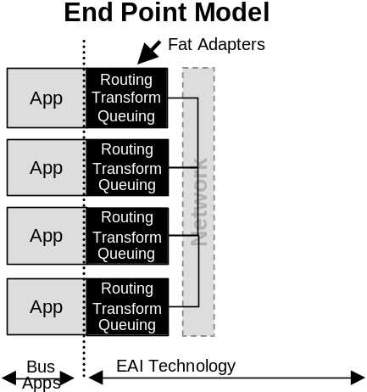
The different models are depicted in the diagrams below:
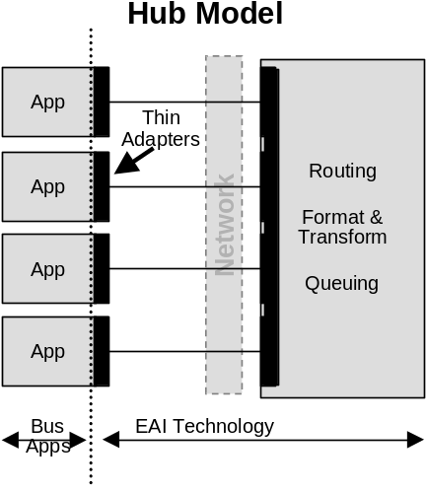

Figure 4 – Comparison of EAI Models (adapter domain shown in black)
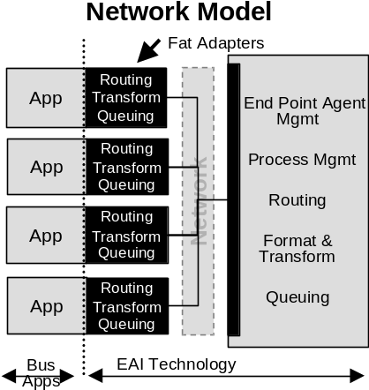
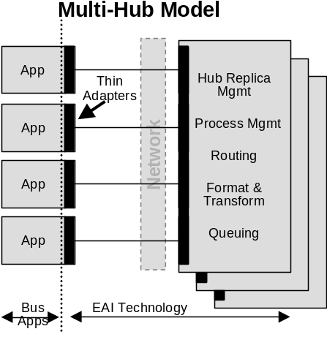

Figure 4 – Comparison of EAI Models (continued)
These models are logical constructs, rather than literal physical configurations. For example, an end point model may have adapters that run on separate physical machines from the applications they service.
In general a “bus” is not a useful concept in defining overall EAI models. Qualities that define a bus have to do with the providing of generic services to all applications, and not with where those services are located. Because of this, a bus and hub are not mutually exclusive concepts, as a bus can be configured in a Hub Model, as long as the services in the hub are sufficiently generic in their treatment of connected applications.
Also, the notion of a bus is difficult to associate with EAI services. A pure bus provides generic services, to the extent that there is no application-specific functionality. In a pure bus, all applications would receive all information objects, without having gone through any treatment specific to any one application. The closest situation to an “EAI bus” would be an End point Model with no application-specific EAI services in the adapters. This would mean that the applications would all have to send and receive information objects that needed no transformation, routing, etc.; and that all distributed information objects are sent to all applications, without no priority or sequence. This situation would only exist if the applications natively knew everything about how to interact with each other, and most of the relevant services are in the network. There would be little need for an EAI subsystem.
It is common to find references to certain layers within an overall EAI subsystem as bus configurations (e.g. queuing or pub/sub layers), but the services in these layers are usually not as generic as would qualify the layer to be a bus. For example, for a pub/sub layer to be a bus, it would need to broadcast all information objects generically to all applications. This can be made to happen, but does not indicate a need for pub/sub services, which are intended for non-generic distributions, targeting specific subscriber lists. Also, with larger information objects and many application objects, such a broadcast technique would also have the potential to cause severe bandwidth issues. Generalized broadcasts are closer to a network transport function; however, even network technology typically restricts broadcast techniques, in favor of select multi-cast techniques with more targeted routings. Similarly, queuing layers are often less than bus-like, with targeted delivery priorities or other application-specific logic.
Architectural Layers and Modules
EAI subsystems are often implemented with certain services or components diagramed as grouped layers or modules. This can yield a number of advantages. Layers usually indicate a certain type of EAI service, where as modules are more likely to be a collection of services that together, serve a special function.
Defining the architecture with these constructs helps to communicate key functional aspects, and may define domains for specialized work focus. Sometimes modules indicate a specific configuration that can be copied and “plugged” into other parts of the architecture or enterprise.
Functionality/Performance Trade-offs
Intuitively, the more processing performed by the EAI subsystem, the greater the challenge will be in achieving faster rates through the infrastructure. The richness of functionality must, therefore, be balanced with needs for interaction performance.

Appendix B: EAI Example Problem Background
This appendix provides an overview of an example EAI problem at the fictitious Daukas & Lee Company. In particular, it focuses on the integration of their core business applications, and their two primary suppliers to automate two key processes.
- Partner Information Synchronization
- Available to Promise.
Engagement Background
Daukas & Lee Background
Daukas & Lee assembles and markets a product called the Modem Masseuse, sold through major retail outlets around the world. The Modem Masseuse is a handheld robotic massage machine that responds to movement instructions received over a modem from a special web site, called MassageBroker.com.
Features user buttons to provide instant feedback to the site about the users:
- Likes and dislikes
- Body area being massaged
- Also features special tactile sensors that provide the web site with feedback about contact pressure, the direction of movement, etc.
The MassageBroker.com web site dispatches digital instructions to the device to:
- Invoke a variety of massage techniques, each with different therapeutic advantages
- Evaluates feedback, and provides movement patterns that maximize "like" feedback from the user
- Employ special pattern recognition processes to learn the preferences of the user, and become more proficient with each massage session
The company has created the modem-based massage category, and there are currently no direct competitors.
Since its introduction last year, a major infomercial campaign has driven rapid sales growth. This growth has exceeded their plans, and the company has had to scramble to build an infrastructure in support. Their current IT infrastructure is probably not sufficient to meet their near-term requirements. The company would now like help from IBM in devising and implementing a new solution.
Even though Daukas & Lee have their product hardware well-protected (patents), the company believes that its huge success will stimulate at least one of its potential competitors to come up with their own hardware soon, and attempt a quick and forceful entry.
Strategic Initiatives
Daukas & Lee has established a number of strategic objectives and imperatives that will influence the direction of an EAI subsystem:
- Sustain high growth
- Build strong customer satisfaction
- Provide special attention to key customers
- Create strong alignment with strategic suppliers.
Current IT Environment
Daukas & Lee's systems are a combination of proprietary components, and an ERP package. The proprietary applications were purchased from another manufacturing company that previously employed the CIO. These include applications for:
- Order Collection (Call Center Clients)
- Order Processing
- Production Management
- Inventory/Warehouse Management
- Distribution
- Purchasing.
The Inventory/Warehouse Management and Distribution applications have not functioned up to expectations, and the company has initiatives to replace this functionality. The Production Management application is thought of as a best-of-breed in this area of functionality, and felt by the company to be a valuable asset to maintain.
Daukas & Lee currently allow their key suppliers, Majestic Motion and Personal Robotics, some visibility into their supply planning by providing dedicated USERIDs for each on the existing CICS based Purchasing application.
The company also has a version of SAP's R/3 system, including:
- The FI/CO module that provides:
- Financial Management: General Ledger, Accounts Payable, Special Ledger, Legal Consolidation
- Cost Accounting: Overhead Cost Management, Product Cost Planning, Profitability Analysis
- Enterprise Controlling: Executive Information System, Profit Center Accounting
- The HR module, which provides general human resources support.
Daukas & Lee’s current IT environment is depicted in Figure 11.

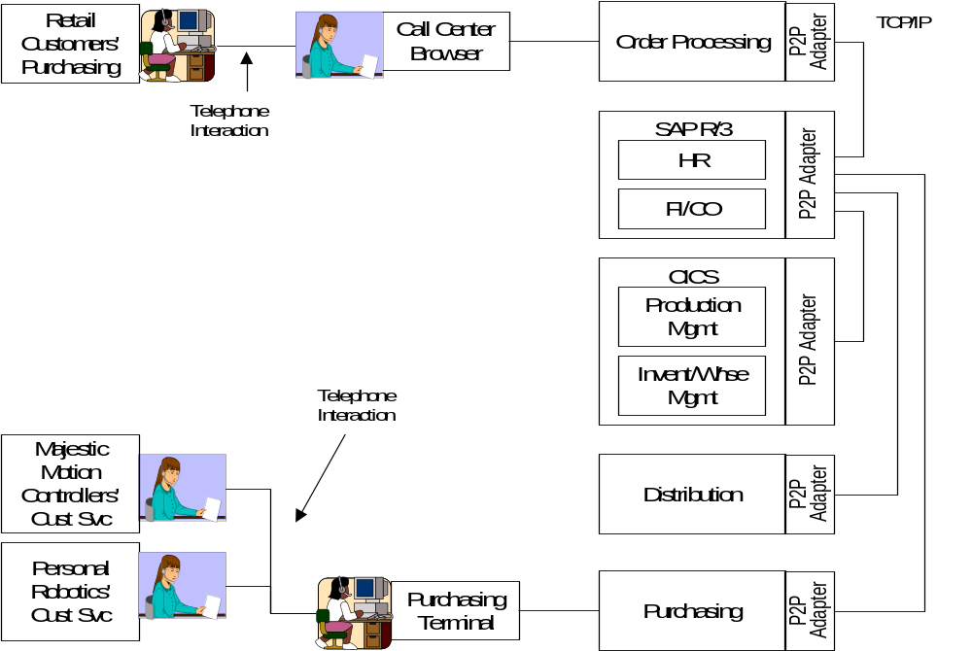
Figure 11 - Current Daukas & Lee IT Architecture Overview Diagram
From an integration perspective, most of the automated data exchange within Daukas & Lee is related to updating their SAP FI/CO module to facilitate financial tracking, and most of the interaction is done with batch processing techniques. Aside from SAP, the company's business applications were not designed to share information easily, and do not have sophisticated API's. The company connects its applications with proprietary point-to-point adapters, mostly written with C++.
Planned IT Initiatives
Daukas & Lee plan to add the following core business applications as a part of achieving their strategic goals:
- SAP's SD module - Sales and Distribution Module which provides functions for Sales Order Processing (Inquiries, Quotations, Orders), Contract and Scheduling Agreements, Pricing, Credit Checking, Rental Processing, Cross Company Processing, Delivery Processing, Billing Processing, Rebate Processing, Returns Processing, Sales Information System, EDI Messages.
- This application is to replace the current Order Processing application
- Siebel - Call center order entry, Customer Information
- This application is to replace the current Order Entry application used by the call center.
- Web Order Entry – A direct, self service, product order application based upon IBM’s Websphere Commerce.
- Operational Data Store and Data Mart
- The company is evaluating the incorporation of a data warehouse, as a way to better equip the management team with key operational and EIS information.
EAI Problem Domain
The problem focuses on providing a tightly integrated enterprise for Duakas & Lee, enabling business processes that operate across their key business applications, and reach to their supplier’s IT systems. Figure 12 depicts a future architecture overview diagram for Daukas & Lee.
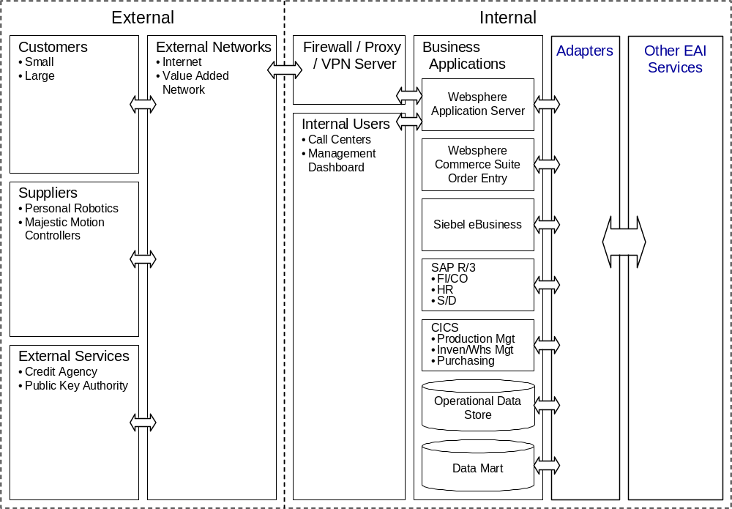
Figure 12 - Daukas & Lee Future Architecture Overview Diagram
There is a specific early focus on synchronization of partner (customers and suppliers) information across the company’s business channels, as well as automation of key parts of their supply chain.
As indicated previously, Daukas & Lee are introducing the SAP Sales and Distribution Module, Siebel, and a Web Order Entry application based upon IBM Websphere Commerce as a part of this update program. These three applications need to maintain a common view of the attributes of Daukas & Lee’s customers and suppliers. Due to the on-line nature of call center and web order entry processing, this synchronization must be held to response times of a few seconds. The business solution design team has chosen to utilize Siebel as the reference master for this “Partner Information.” The coordinated introduction of these three application functions has allowed the design team to use a common logical representation of this information object in all three applications. Each application maintains a slightly different internal representation of the information, necessitating format modifications to support information exchange. The existing, screen driven CICS based Purchasing application was considered as a potential participant in this synchronization, but the team elected to have the SAP Sales & Distribution function feed the necessary information to Purchasing as a part of ATP processing instead.
The second key initiative of this update program is the automation of their supply chain. Daukas & Lee have negotiated with their two suppliers to cross supply one another’s subassemblies based upon their committed capacity and demand in the marketplace. As a part of this relationship, the suppliers have agreed to automate their interaction with Daukas & Lee using a common plan entity (object) for exchange of planning and purchase information. In the new system, SAP Sale & Distribution (SAP S&D) will forecast product demand based upon marketing plans, sales history and current order volumes. As orders are processed, the forecast demand is checked against positioned inventories by Inventory / Warehouse management. As long as in-plan inventory levels cover the forecast demand, no action is taken.
When a net demand is present, exceeding a planning threshold, SAP S&D generates a net demand plan. This net demand is compared with available capacity by Production Management, and a production plan is generated to meet it, with parts supply assumptions. This is used by Inventory / Warehouse Management to generate a Supply Plan. The Supply Plan is in turn decomposed into Requests for Quote (RFQ) by Purchasing, and individual RFQs are sent to each supplier.
Previously, supplier sales personnel could examine the RFQ and respond on-line using dedicated Purchasing USERIDs that allowed the Purchasing application to control what information each supplier could see. In the future system, this interaction is to be carried out system to system between Purchasing and supplier IT systems.
Responses from each supplier are received by Purchasing, and valid purchase options are selected. These are reviewed within the scope of the Supply Plan by Inventory / Warehouse Management, and valid supply options are selected. These are similarly weighed within the Production Plan, and a production option is selected. This drives a sequence of selections through the supply plan and purchasing, resulting in a reservation being made with the suppliers. Subsequently, when this committed ATP is reviewed through SAP S&D, the production and supply plans will be committed, and a firm Purchase Order issued to the suppliers.
Actors
The preceding narrative has introduced the key actors for these processes from an EAI perspective. Several of the business applications are interactive in nature and require user participation to perform their business functions. This is particularly true in the case of the ATP process. Such user interaction is assumed but not detailed, as it lies outside of the scope of EAI. The actors of specific concern to the EAI subsystem in these business processes are:
- Web Order Entry (Websphere Commerce)
- Customer Relationship Management (Siebel)
- SAP (S&D)
- Inventory / Warehouse Management (Custom CICS)
- Purchasing (Custom CICS)
- Personal Robotics Systems
- Majestic Motion Systems.
These actors are detailed in the following tables.
Table 9 - Web Order Entry
Actor Name | Web Order Entry
Brief Description | This is the originating application for Partner Information updates entered on–line by customers and suppliers.
Status | Primary Actor
Relationships
Inheritance | Subclass | N/A
Inheritance | Superclass | N/A
Associations to Use Cases |  | Partner Information Synchronization

Table 10 - Customer Relationship Management
Actor Name | Customer Relationship Management
Brief Description | This is the master information source for Partner Information. It is the originating application for Partner Information updates entered by Customer Service Representatives.
Status | Primary Actor
Relationships
Inheritance | Subclass | N/A
Inheritance | Superclass | N/A
Associations to Use Cases |  | Partner Information Synchronization

Table 11 - SAP Sales & Distribution
Actor Name | SAP Sales & Distribution
Brief Description | This is the originating application for generation of the demand plan that initiates the ATP process with Daukas & Lee’s suppliers.
Status | Primary Actor
Relationships
Inheritance | Subclass | N/A
Inheritance | Superclass | N/A
Associations to Use Cases |  | Partner Information Synchronization, ATP

Table 12 - Inventory / Warehouse Management
Actor Name | Inventory / Warehouse Management
Brief Description | This application manages the finished goods and parts supply inventories, and is responsible for generating a supply plan to meet the needs of a specified production plan.
Status | Secondary
Relationships
Inheritance | Subclass | N/A
Inheritance | Superclass | N/A
Associations to Use Cases |  | Partner Information Synchronization, ATP

Table 13 - Purchasing
Actor Name | Purchasing
Brief Description | This application is responsible for composing RFQ’s, reservation requests and POs to meet a specified supply plan.
Status | Secondary
Relationships
Inheritance | Subclass | N/A
Inheritance | Superclass | N/A
Associations to Use Cases |  | Partner Information Synchronization, ATP

Table 14 - Personal Robotics Systems
Actor Name | Personal Robotics Systems
Brief Description | Personal Robotics is one of two suppliers that provide the two subassemblies that comprise the hardware of Daukas and Lee’s product. Their systems provide automated update of their own Partner Information. In addition, their systems provide an automated response to Daukas & Lee’s RFQ’s, part reservations and Pos.
Status | Primary Actor
Relationships
Inheritance | Subclass | N/A
Inheritance | Superclass | N/A
Associations to Use Cases |  | Partner Information Synchronization, ATP

Table 15 – Majestic Motion Systems
Actor Name | Majestic Motion Systems
Brief Description | Majestic Motion is one of two suppliers that provide the two subassemblies that comprise the hardware of Daukas and Lee’s product. Their systems provide automated update of their own Partner Information. In addition, their systems provide an automated response to Daukas & Lee’s RFQ’s, part reservations and Pos.
Status | Secondary
Relationships
Inheritance | Subclass | N/A
Inheritance | Superclass | N/A
Associations to Use Cases |  | Partner Information Synchronization, ATP

Use Cases
The following provides Use Case descriptions for each of the two key Daukas & Lee business Processes:
- Partner Information Synchronization
- ATP.
The complete relationship of these Use Cases and the actors previously defined are given in Figure 13.
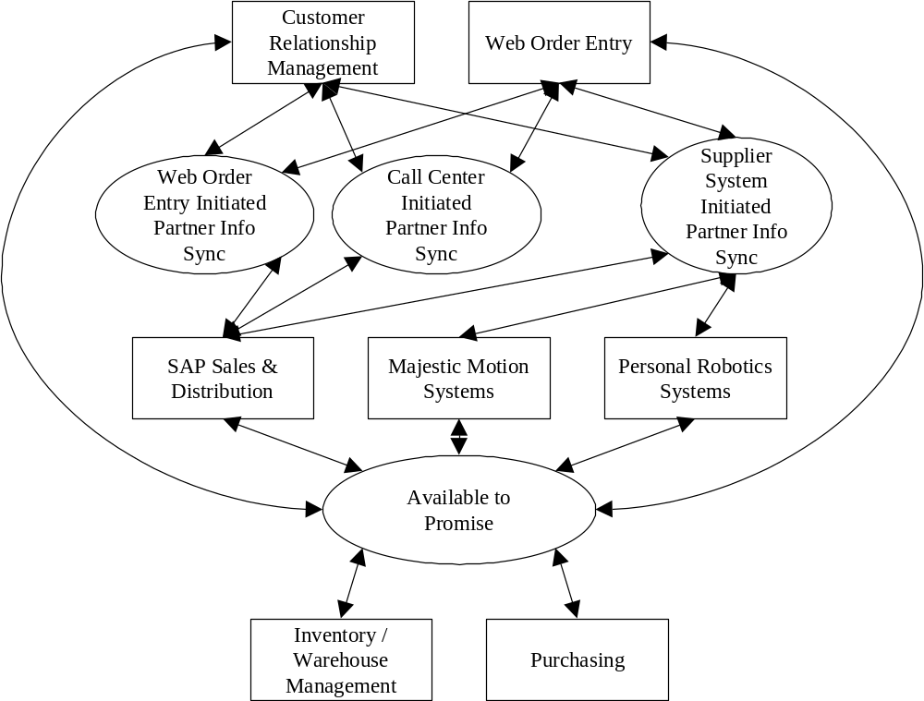
Figure 13 – Daukas & Lee Use Cases and Participating Actors.

Partner Information Synchronization Use Cases
These Use Cases capture the business function interaction for the synchronization of Partner information.
Table 16 – Supplier System Initiated Partner Information Synchronization Use Case
Use Case # | 1 | Supplier System Initiated Partner Information Synchronization Use Case
Subject Area |  | Daukas & Lee Company Partner Information Synchronization
Business Event |  | Triggered by the receipt of a partner information change by the Daukas & Lee CRM application.
Actor(s) |  | The initiating actor is one of the supplier systems.
Use Case Overview |  | An update to Partner Information for a supplier is received by the CRM application. Based on that receipt, the CRM application, the Web Order Entry Application, and the Sales & Distribution application will update their records in accordance with the update request.
Preconditions |  | The three Daukas & Lee applications are assumed to be available, and their internal Partner Information records are assumed to be in synchronization.
Termination Outcome |  |  | Conditions Affecting Termination Outcome
All 3 Daukas & Lee applications are updated and an acknowledgement is sent to the originating supplier system.. |  |  | All 3 Daukas & Lee applications have succeeded in their internal updates. No updates have been lost in communication.
The CRM application fails to update its internal records, and no update request is sent to the other applications. The originating supplier system is informed of the failure. |  |  | Communications error between the supplier system and the CRM application. CRM application internal exception during update.
Use Case Description |  | An update to Partner Information for a supplier is received by the CRM application. Based on that receipt, the CRM application will update its records and send an equivalent update to the Web Order Entry Application and the Sales & Distribution application. These applications update their own internal records and send an acknowledgement to CRM. Upon receipt, the CRM application sends an acknowledgement of update to the originating supplier systems.
Use Case Associations |  | Web Order Entry Initiated Partner Information Synchronization Use Case, Call Center Initiated Partner Information Synchronization Use Case
Traceability To |  | N/A
Inputs Summary |  | Partner Information update request.
Output Summary |  | Advisement of update success or failure.
Usability Index |  | N/A
Use Case Notes |  | This is one of 3 possible update paths.

Table 17 - Web Order Entry Initiated Partner Information Synchronization Use Case
Use Case # | 2 | Web Order Entry Initiated Partner Information Synchronization Use Case
Subject Area |  | Daukas & Lee Company Partner Information Synchronization
Business Event |  | Triggered by the receipt of a partner information change by the Daukas & Lee CRM application.
Actor(s) |  | The initiating actor is the Web Order Entry application.
Use Case Overview |  | An update to Partner Information for a supplier or customer is received by the CRM application. Based on that receipt, the CRM application, the Web Order Entry Application, and the Sales & Distribution application will update their records in accordance with the update request.
Preconditions |  | The three Daukas & Lee applications are assumed to be available, and their internal Partner Information records are assumed to be in synchronization.
Termination Outcome |  |  | Conditions Affecting Termination Outcome
All 3 Daukas & Lee applications are updated and an acknowledgement is sent to the Web Order Entry application. |  |  | All 3 Daukas & Lee applications have succeeded in their internal updates. No updates have been lost in communication.
The CRM application fails to update its internal records, and no update request is sent to the other applications. The originating Web Order Application is informed of the failure. |  |  | Communications error between the Web Order Entry application and the CRM application. CRM application internal exception during update.
Use Case Description |  | An update to Partner Information for a supplier or customer is received by the CRM application from the Web Order Entry application. Based on that receipt, the CRM application will update its records and send an equivalent update to the Web Order Entry Application and the Sales & Distribution application. These applications update their own internal records and send an acknowledgement to CRM. Upon receipt, the CRM application sends an acknowledgement of update to the originating Web Order Entry Application.
Use Case Associations |  | Supplier System Initiated Partner Information Synchronization Use Case, Call Center Initiated Partner Information Synchronization Use Case
Traceability To |  | N/A
Inputs Summary |  | Partner Information update request.
Output Summary |  | Advisement of update success or failure.
Usability Index |  | N/A
Use Case Notes |  | This is one of 3 possible update paths.

Table 18 - Call Center Initiated Partner Information Synchronization Use Case
Use Case # | 3 | Call Center Initiated Partner Information Synchronization Use Case
Subject Area |  | Daukas & Lee Company Partner Information Synchronization
Business Event |  | Triggered by the entry of a partner information change into the Daukas & Lee CRM application.
Actor(s) |  | The initiating actor is the CRM application.
Use Case Overview |  | An update to Partner Information for a supplier or customer is received by the CRM application. Based on that receipt, the CRM application, the Web Order Entry Application, and the Sales & Distribution application will update their records in accordance with the update request.
Preconditions |  | The three Daukas & Lee applications are assumed to be available, and their internal Partner Information records are assumed to be in synchronization.
Termination Outcome |  |  | Conditions Affecting Termination Outcome
All 3 Daukas & Lee applications are updated and an acknowledgement is reflected in the CRM application. |  |  | All 3 Daukas & Lee applications have succeeded in their internal updates. No updates have been lost in communication.
The CRM application fails to update its internal records, and no update request is sent to the other applications. The CRM application reflects this failure. |  |  | CRM application internal exception during update.
Use Case Description |  | An update to Partner Information for a supplier or customer is entered into the CRM application.. Based on that receipt, the CRM application will update its records and send an equivalent update to the Web Order Entry Application and the Sales & Distribution application. These applications update their own internal records and send an acknowledgement to CRM. Upon receipt, the CRM application reflects an acknowledgement of update.
Use Case Associations |  | Supplier System Initiated Partner Information Synchronization Use Case, Web Order Entry Initiated Partner Information Synchronization Use Case
Traceability To |  | N/A
Inputs Summary |  | Partner Information update request.
Output Summary |  | Advisement of update success or failure.
Usability Index |  | N/A
Use Case Notes |  | This is one of 3 possible update paths.

Available to Promise Use Case
These following Use Case captures the business function interaction for Available to Promise of Daukas & Lee product to meet forecast demand.
Table 19 - Available to Promise Use Case
Use Case # | 4 | Available to Promise
Subject Area |  | Daukas & Lee Fulfillment
Business Event |  | Triggered by realization of an the unplanned demand reflected in the Sales & Distribution order processing functionality, and validated against the current product inventories reflected in the Inventory / Warehouse Management application.
Actor(s) |  | The initiating actor is one of Web Order Entry, Siebel or SAP S&D, depending upon which order event has caused the planned demand threshold to be exceeded (above or below target).
Use Case Overview |  | Product orders received by the Sales & Distribution application indicate that the planned demand profile will be exceeded. Demand, Production and Supply plans are formulated in response to this change, and suppliers are queried for updates to their parts supply commitments to meet them. When an acceptable combination of supplier responses is received and processed by Daukas & Lee fulfillment applications, the plan updates are committed, and the updated demand plan is made operational.
Preconditions |  | A valid set of demand, production and supply plans are in place to drive current fulfillment operations.
Termination Outcome |  |  | Conditions Affecting Termination Outcome
Supplier commitments are obtained, and valid updated supply, production and demand plans are in place to drive continued fulfillment. |  |  | All applications are available within the cycle time frame to perform their focused processing. A combination of supplier parts supply is available to support the demand plan.
An updated demand plan cannot be met. |  |  | A combination of supplier parts supplies cannot be found to meet a supply plan and production plan that support the demand plan.
Use Case Description |  | Product orders received by the Sales & Distribution application indicate that the planned demand profile will be exceeded, when compared with the available inventories in the Inventory / Warehouse Management application. As a result, Sales & Distribution generates a net unfulfilled Demand Plan. The Demand Plan is used by Production Management as the basis for an updated Production Plan to meet the demand. Similarly, Inventory / Warehouse Management provides an updated Supply Plan based on the Production Plan that is used by Purchasing to formulate Requests for Quote, parts reservations, and Purchase Orders for the Suppliers. As the supplier responses to RFQ’s are processed, their impact is evaluated on the plan hierarchy. When an acceptable combination of supplier responses is received and processed, parts reservations and subsequently Purchase Orders are exchanged with the suppliers, the plans are committed, and the demand plan is made operational..
Use Case Associations |  | N/A
Traceability To |  | N/A
Inputs Summary |  | Customer orders and existing demand plan.
Output Summary |  | Updated plans and supplier contracts (P.O.s).
Usability Index |  | N/A
Use Case Notes |  | N/A

Available to Promise Process Flow
The following figure depicts the Daukas & Lee ATP process for committing to an updated product demand.
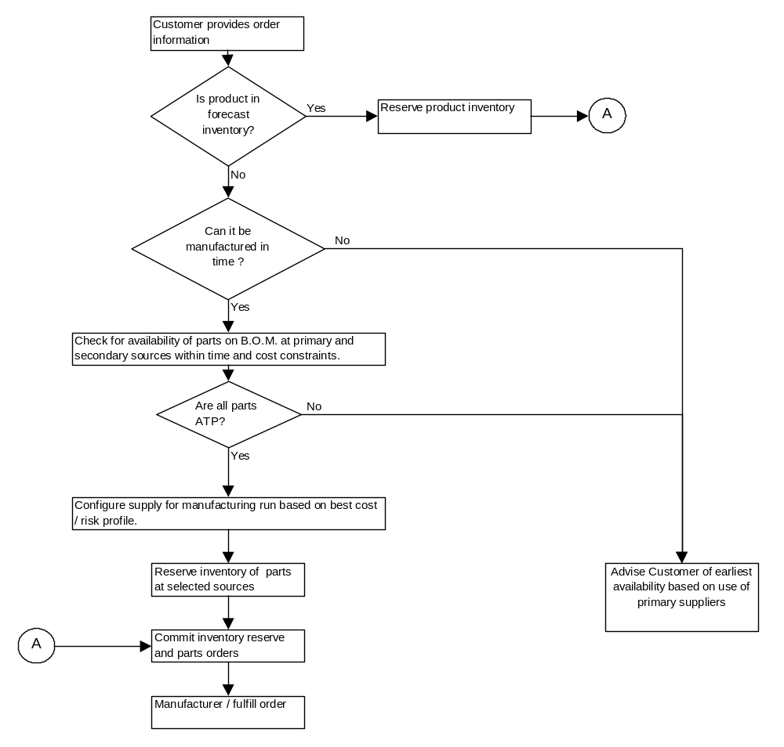
Figure 14 - Daukas & Lee ATP Process
- Revision History
Revision Number | Revision Date | Summary of Changes | Changes Marked?
0.9 | 11/8/2001 | Release for GCD QA
1.0 | July 2002 | QA Approved

The following companies and products are referenced in this document.
Microsoft, Windows, Windows NT, and the Windows logo are trademarks of Microsoft Corporation in the United States, other countries, or both.
Windows DNA, SQLServer, Excel, .NET, COM, DCOM, COM+, MTS and BizTalk are trademarks of Microsoft Corporation in the United States, other countries, or both.
Java and all Java-based trademarks are trademarks of Sun Microsystems, Inc. in the United States, other countries, or both.
SecureWay PKI is a trademark of INTERNATIONAL BUSINESS MACHINES CORPORATION CORPORATION NEW YORK Old Orchard Road Armonk, NEW YORK 10504
OMG (Object Management Group) and CORBA (actually a standard, not a product) are trademarks of OBJECT MANAGEMENT GROUP, INC. NON-PROFIT CORPORATION DELAWARE 492 Old Connecticut Path Framingham MASSACHUSETTS 01701
Oneworld is a trademark of J.D. EDWARDS WORLD SOURCE COMPANY CORPORATION COLORADO ONE TECHNOLOGY WAY Denver COLORADO 80237
Holosofx BPM Workbench is a trademark of Holosofx, Inc. CORPORATION MASSACHUSETTS 100 N. Sepulveda Blvd., Suite 603 El Segundo CALIFORNIA 90245
ORBIX/Web is a trademark of Iona Technologies Ltd. CORPORATION IRELAND O'Reilly Institute, Innovation Centre Trinity College Dublin 2 IRELAND
ObjectBridge (corporate name is now Actional) is a trademark of Visual Edge Software Corp. CORPORATION DELAWARE 19925 Stevens Creek Blvd. Cupertino CALIFORNIA 95014
Visibroker (Inprise is now part of Borland) is a trademark of Visigenic Software, Inc. CORPORATION DELAWARE 951 Mariner's Island Blvd., Suite 120 San Mateo CALIFORNIA 94404
IBM is a trademark of International Business Machines Corporations in the United States, other countries, or both.
Microsoft is a trademark of Microsoft Corporation in the United States, other countries, or both.
Peoplesoft is a trademark of PeopleSoft, Inc. CORPORATION DELAWARE 4305 Hacienda Drive Pleasanton CALIFORNIA 94588
i2 is a trademark of ) i2 Technologies, Inc. CORPORATION DELAWARE 11701 Luna Road Dallas TEXAS 75234
Siebel is a trademark of Siebel Systems, Inc. CORPORATION DELAWARE 2207 Bridgepointe Parkway San Mateo CALIFORNIA 94404
NasTel is a trademark of Nautronix Ltd CORPORATION AUSTRALIA 108 Marine Terrace Fremantle, WA 6160 AUSTRALIA
NetIQ is a trademark of NetIQ Corporation CORPORATION DELAWARE 5410 Betsy Ross Drive Santa Clara CALIFORNIA 95054
Computer Associates is a trademark of Computer Associates Think, Inc. CORPORATION DELAWARE One Computer Associates Plaza Islandia NEW YORK 11749
WebMethods is a trademark of WEBMETHODS, INC. CORPORATION DELAWARE 3975 University Drive, Suite 360 Fairfax VIRGINIA 22030
MVS, RACF, CICS, 3270, MQSeries, MGIntegrator and Websphere are all registered trademarks of International Business Machines Corporation in the United States, other countries, or both.

Delphi is a trademark of INPRISE CORPORATION CORPORATION DELAWARE 100 ENTERPRISE WAY SCOTTS VALLEY CALIFORNIA 95066

**Other company, product and service names may be trademarks or service marks of others.
Oracle
SAP

