
FF ``````

IBM Global Services

Defining Enterprise Application Integration Requirements

Technique Paper (TP)

© Copyright International Business Machines Corporation 2001, 2002
All Rights Reserved
Version 1.0 July 2002

Synopsis
This technique provides an approach to building an Enterprise Application Integration (EAI) Attributes Blueprint. The Blueprint is a structure for the consolidation of EAI requirements as described within this technique paper. The EAI Attributes Blueprint organizes key attributes that an EAI subsystem must meet to support a customer’s defined business system(s). It provides a consistent base of information from which an EAI subsystem can be defined and implemented.
In this context, a defined business system means that the requirements, scope and functional characteristics of the customer’s overall business system(s) have been detailed. In other words, a business architecture, defined in accordance with the Business Architecture Definition Standard is in place for the solution. In addition, a solution architecture has been defined in accordance with the Architecture Description Standard, elaborated at a specification level with respect to business functionality.
The information organized by the Blueprint also exists (or will exist during the system life cycle) in standard Method work products. The Blueprint provides an integration based lens for system architects and designers to view this information. This makes the integration team more effective in gathering these specific system characteristics, and developing integration solutions for distributed business systems.

Technique Contents
1 Introduction 3
Business and System Design Recursion 3
Definitions 5
Baseline Management 8
Relationship between the Blueprint and Method Work Products 8
Required Participant Roles 8
Example EAI Problem 9
Document Structure 9
Context 9
2 Overview 10
3 Preparation 11
Identify the scope of the EAI subsystem 12
Plan the Approach and Prepare the Team 12
Extend Solution Application Flows to Include Administration 12
4 Establish Constraining Baselines 14
Identify End Points and Infrastructure Services 14
Establish Interaction Paths & System Characteristics 15
Identify Interaction Paths 18
Create Recovery Interaction Paths 20
Identify and Characterize Interaction ARCs 20
Characterize End Points 22
Characterize Infrastructure Services 23
5 Perform Gap Analysis to Establish End Point Adaptation Attributes 25
Perfrom Gap Analysis for Each Intercepting Arc 25
Determine the End Point Adaptation Aggregate Attributes 26
6 Perform Gap Analysis to Establish Infrastructure Adaptation Attributes 28
Determine Common Access Method 28
Determine Common Signature 28
Determine Availability Characteristics 28
Determine Delay Characteristics 28
Determine Aggregate Volume 28
Blueprint Element Populated 29
Appendix A: EAI Attributes Blueprint Meta-Model Details 30
Appendix B: Simple Baseline Management Process 39
Appendix C: EAI Example Problem Background 40
Engagement Background 40
EAI Problem Domain 42
Actors 44
Use Cases 47
Available to Promise Process Flow 53
Appendix D: Example EAI Attributes Blueprint 55
7 Revision History 56
- Introduction
This technique provides an approach to building an EAI Attributes Blueprint. The EAI Attributes Blueprint organizes key attributes that an EAI subsystem must meet to support a customer’s defined business system(s). It contains information that is the result of integration requirements analysis, as well as the basis information for that analysis.
In the ideal situation, this technique is applied after a solution architecture team has established the client’s business and solution architectures, to the extent that they have selected the business applications and specified the custom business components that will implement the individual business functions. In addition, the solution integrated business processes are assumed to be detailed and expressed across this set of applications and components. Its placement with respect to Custom Application Development engagement model for the business system is illustrated in Figure 1.
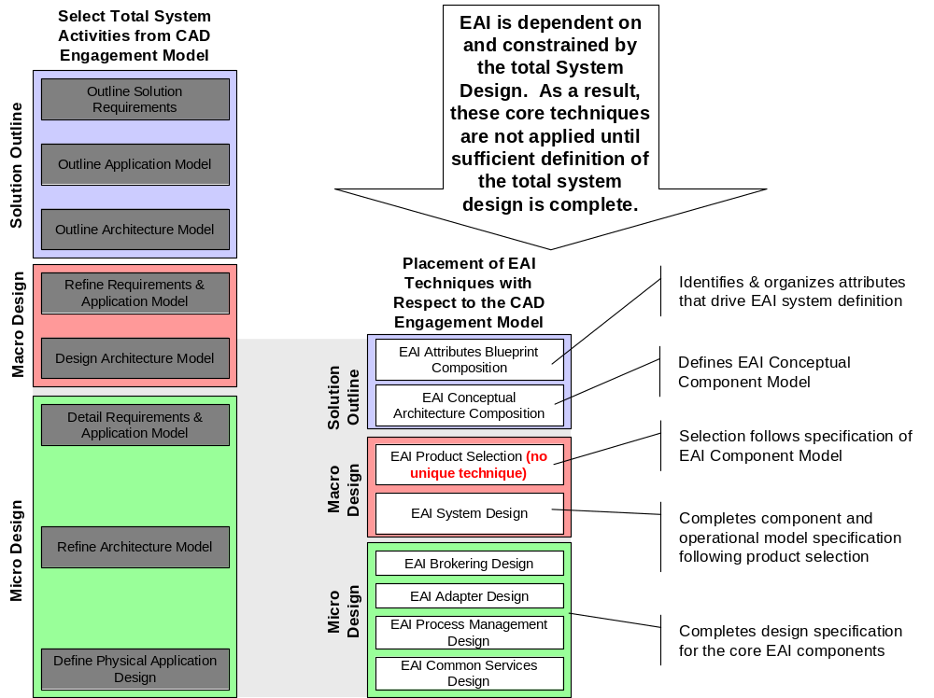
Figure 1 - Attributes Blueprint Composition is one of 7 Core EAI Techniques
Once assembled, the Blueprint can be used directly by the integration team to formulate the EAI architecture and to generate the product configurations, product extensions and custom component designs necessary to implement the EAI subsystem.
Business and System Design Recursion
An unforeseen impact of including an EAI subsystem as a part an integrated system design may be the discovery of new opportunities to improve business process efficiency and reach by integrating, or extending access to previously isolated business process automation and information. An example is the integration of e-Commerce applications to existing corporate fulfillment applications. In many cases, the implementing organizations do not fully appreciate the impact of introducing an entirely new Internet channel to their customers, resulting in fragmentation of customer information amongst the applications that handle each channel. The integration of this customer information is another possible application for EAI subsystem capabilities, and / or an opportunity to introduce a Customer Relationship Management (CRM) application.
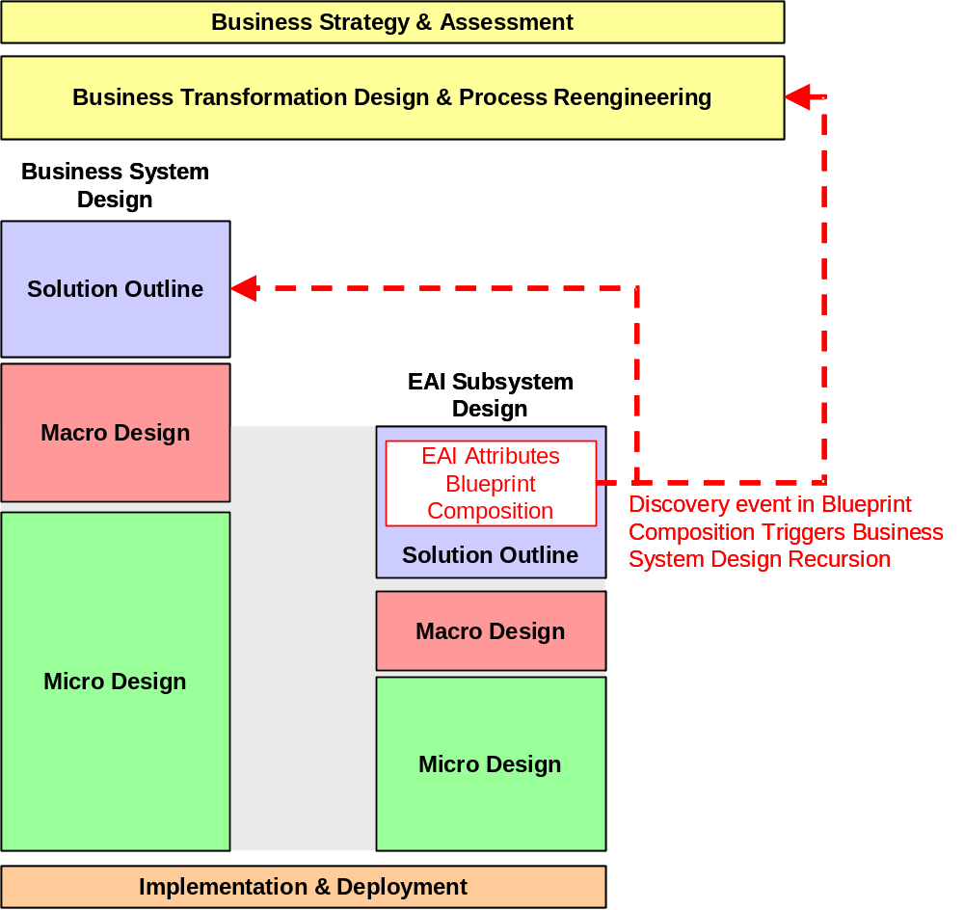
A recursion must be introduced into the business and / or system design process to accommodate this discovery, if it is not postponed past system increment implementation. The discovery of such business process and information artifacts is most likely during composition of the EAI Attributes Blueprint. In Figure 2 below the feedback necessary to support this design recursion is depicted on the EAI design flow diagram from Figure 1 above.
Figure 2 – Business System Design Recursion Induced by EAI Subsystem Design
While Blueprint composition represents the most likely source of such discoveries, it can also be the result of application of sophisticated solution templates during to the business problem. Such templates often contain business process realizations that exceed the immediate needs of the business problem as initially defined, and can lead to the same reconsideration of process design scope and approach as introduced by the discovery of process fragmentation during Blueprint composition.
Definitions
An EAI subsystem is responsible for providing the necessary integration conduits, including proper business semantics, and business process linkage, to enable the assembly of a defined business system, composed of:
- Application packages
- Legacy custom applications
- Application components
- Existing client infrastructure services
- External business partner systems
- Externalized business unit systems of the same enterprise.
We refer to these as End Points. The client’s business model determines whether another business unit is treated as a single end point, or its individual applications are exposed. These should already be reflected in the solution functional architecture.
End points provide the core business functionality for the business system. The integrated business processes that execute across these end points are detailed in Application Workflows, produced by the solution architecture team. A single application workflow covers the life cycle of a business process, and may transition the solution through several business states. The supply chain management Available to Promise (ATP) process is an example of such.
Typically, an ATP process is implemented across several end points involving multiple business partner systems. The process contains a number of stable business states, each of which is defined by a specifying the state of each end point involved in the process. An example is when a manufacturer’s demand forecasting application is operating within the existing demand plan, the production management application is executing within its existing production plan, and suppliers’ systems are executing parts supply against their existing supply plans for the manufacturer. The generation of a proposed new demand plan by the forecasting application initiates a complex exchange of information between these end points, represented by the application workflow, that eventually results in the update of all of the plans, and the operation of each end point against the updated plan set. Between these two business states can be a number of long lived, stable, interim business states where the plans are not yet “synchronized.” These stable business states, like the application workflows that implement them, are defined by the solution architecture team.
To effectively represent the inter-end point process management, and capture business recovery needs, we introduce the concept of an Interaction Path. An Interaction Path is a proper subset of a defined application workflow that causes the transition of the integrated business system from one stable business state to another.
EAI subsystems are constructed in a constrained environment in which many of the architectural decisions for the total business system have already been made. The system must comply with existing standards, application selections and defined application workflows. To effectively construct the system in this environment, it is essential that the myriad characteristics of:
- Included applications
- Solution business process and information models
- Participating business partners or independent business units
- Existing infrastructure services
Be documented and maintained so that the evolving system architecture and design will comply with them. We refer to these characteristics as EAI Attributes.
EAI attributes fall into the two general classes; Interaction Paths and System Characteristics, and Adaptation. The Adaptation class can be further sub-classed into End Point Adaptation and Infrastructure Adaptation. This classification scheme is illustrated in Figure 3.
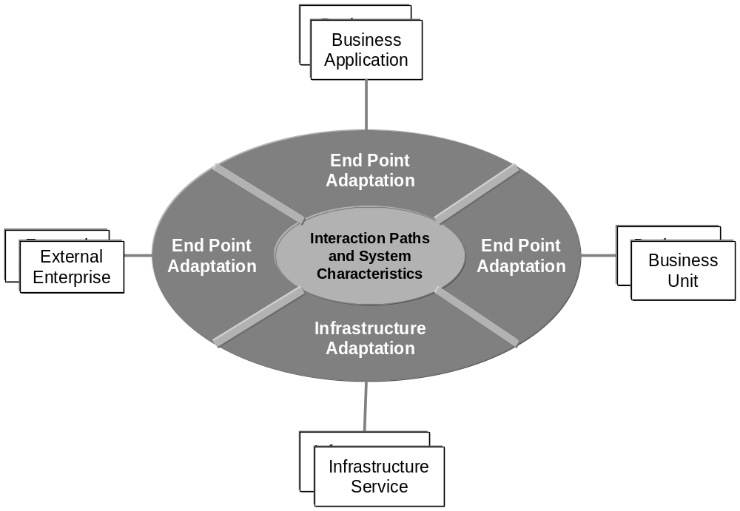
Figure 3 - EAI Attribute Classification
Interaction Path and System Characteristics attributes address the closure of business transactions between end points, to meet the pre-defined processes in the solution business architecture. This class:
- Includes reliability, availability, performance and capacity attributes of the interaction path
- Includes standard content and representation of solution business entities
- Excludes the End Point Adaptation attributes defined below.
End Point Adaptation attributes address the access of end points to interaction paths, and the conversion of end point specific entity forms to business system business entities. Within this context, conversion includes:
- Content assembly
- Content rendering
- Security context conversion
- End point availability matching
- End point performance matching
- End point capacity matching.
In addition, adaptation includes attributes that address the APIs, data structures and other mechanisms available to connect to and access the information owned by the end points. We term these the Access Paths for an end point.
Infrastructure Adaptation attributes address the services that must be leveraged from the client’s existing infrastructure, and the constraints imposed on the EAI subsystem by it. These services typically include Security, Directory and Systems Management frameworks. The associated attributes include technology and other IT Standards, as well as access path attributes for accessing and leveraging the existing IT services.
Note that all three attribute classes; Interaction Path and System Characteristics, End Point Adaptation and Infrastructure Adaptation, contain functional and non-functional attributes.
This technique allows us to capture and organize these classed attributes for a client into an EAI Attributes Blueprint.
The Blueprint Meta-model and the individual attribute definitions for the elements of the Blueprint are provided in Appendix A: EAI Attributes Blueprint Meta-Model Details. A mapping of these EAI subsystem attribute elements to the EAI Services they influence is provided below in Table 1.
Table 1 - Recognized EAI Services and the Attributes that Influence Them
 | EAI Service | Characteristics Driven By
Basic EAI Services | Connection | End Point Adaptation (Access Path)
Basic EAI Services | Format & Transform | End Point Adaptation (Parsing & Assembly, Transformation)
Basic EAI Services | Monitoring, Analysis, & Feedback | Interaction Path & System Characteristics (Reference Requirements (Application Workflow), System Requirements), Infrastructure Adaptation
Basic EAI Services | Process Management | Reference Workflow (Application Workflow), Interaction Path, End Point Adaptation (Access Path)
Basic EAI Services | Queuing | End Point Adaptation (Access Path)
Basic EAI Services | Routing | Interaction Path, Interaction Arc
Specialized EAI Services | Application Adapter Management | End Point Adaptation (Availability Matching, Intrinsic Availability)
Specialized EAI Services | Batch Control | End Point Adaptation
Specialized EAI Services | Trading Partner Agreement Management | End Point Adaptation
Specialized EAI Services | XML Handling | End Point Adaptation (Parsing & Assembly, Transformation)
Horizontal Services | Application Management | Reference Workflow (Availability), Infrastructure Adaptation
Horizontal Services | Directory | Infrastructure Adaptation
Horizontal Services | Metadata Repository | Infrastructure Adaptation
Horizontal Services | Policy Management | Infrastructure Adaptation
Horizontal Services | Security | Infrastructure Adaptation
Baseline Management
It is important to establish an EAI subsystem baseline and manage it throughout the life cycle of the system. Since the EAI subsystem can provide a general integration facility for the enterprise, it is not uncommon for changes to occur to the scope of the integrated business system(s) that directly impacts the attributes of the EAI subsystem. If we do our job well as architects, the core EAI services implemented will be largely unaffected by most changes, but there will very likely be functional configuration changes, and possibly geographic scaling implications to account for. This baseline management should begin with the Blueprint for the EAI subsystem. A simple process for performing baseline management is provided in Appendix B: Simple Baseline Management Process.
Relationship between the Blueprint and Method Work Products
Much of what the Blueprint organizes is information that is or will be housed in a number of Method work products, describing the business system and the EAI subsystem. The purpose for the Blueprint is to focus this information to identify the build to attributes of the EAI subsystem, so that the implementation team may effectively architect, select, assemble, and where necessary construct the components that will implement the system.
Since this duplication of information exists, there is an inherent issue of information baseline maintenance that must be managed. Updates to associated Method work products must be reflected in the Blueprint, and similarly, changes made to the Blueprint must be reflected in the appropriate work product. This synchronization can be made less onerous in some cases by treating the implementation of the Blueprint as an index to the work product information. If such an approach is taken, it must be balanced against the effectiveness of presenting the focused views of the Blueprint to drive system definition and implementation.
Required Participant Roles
All 3 classes of EAI attributes will be found to a greater or lesser extent in every integrated business system. Successful application of this technique requires a multi-disciplinary team. Technique execution should be lead by a single EAI core team, but each class of attributes require a slightly different mix of skills for optimum application:
- Interaction path and system characteristic attributes required roles
- EAI Architect
- Solution Architect
- Process & Data Modelling expertise as required (drawn from client and/or industry consulting team)
- End point adaptation attributes required roles
- EAI Architect
- End Point Architect (either an application architect or a Trading Partner Agreement cognizant architect for the partner(s) enterprise(s) or other business unit
- Infrastructure adaptation team roles required
- EAI Architect
- Client Infrastructure Architect(s) (there may be multiple, different client IT infrastructures in scope).
With the Blueprint established, the following baseline management roles come into play:
- EAI Architect
- Solution Architect
- Project Manager
- Client Project Manager
- Technical Experts.
Example EAI Problem
To illustrate the application of this technique, we include several examples from the fictitious Daukas & Lee Company, a medium sized assembler and retailer of Internet integrated consumer products. The engagement background is included in Appendix C: EAI Example Problem Background. In addition, a partially populated Blueprint for the example is attached as an Excel™ Workbook at Appendix D: Example EAI Attributes Blueprint.
Document Structure
The remainder of this document contains a brief overview of the technique, followed by a detailed walkthrough, exploiting the Daukas & Lee Company example problem. Given the variety of personnel involved in Blueprint composition, it is important that each participant be familiar with the portions of the technique applicable to their role. The following guidelines apply for who should read this technique:
- EAI Practitioners should read the technique in its entirety
- Interaction path and system characteristic team members should read the introduction, overview, and section 4 Establish Constraining Baselines.
- End point adaptation requirements team members should read the introduction, overview, and section 5 Perform Gap Analysis to Establish End Point Adaptation Attributes.
- Infrastructure adaptation requirements team members should read the introduction, overview, and section 6 Perform Gap Analysis to Establish Infrastructure Adaptation Attributes.
- Requirements Management team members should read the introduction and overview sections.
Context
This technique applies to all EAI subsystem application contexts, whether confined within a client enterprise, or extended to include business partner enterprises. In addition, it applies whether the ultimate integration required is data oriented in nature or includes complex process management logic.
- Overview
The Blueprint is constructed by establishing the EAI constraining baselines
- Interaction path and system characteristics
- End point characteristics
- Customer infrastructure characteristics
and performing a gap analysis between these baselines to identify the EAI subsystem attributes.
It is important to establish the interaction path and system characteristics baseline first, because this provides guidance in defining the scope of characteristics required in the other two baselines. In addition, it instills a vision of the overall system intent on the EAI team members. With that baseline established, the other two baselines may be worked in parallel by separate teams. Similarly, the gap analysis between the baselines may be worked in parallel.
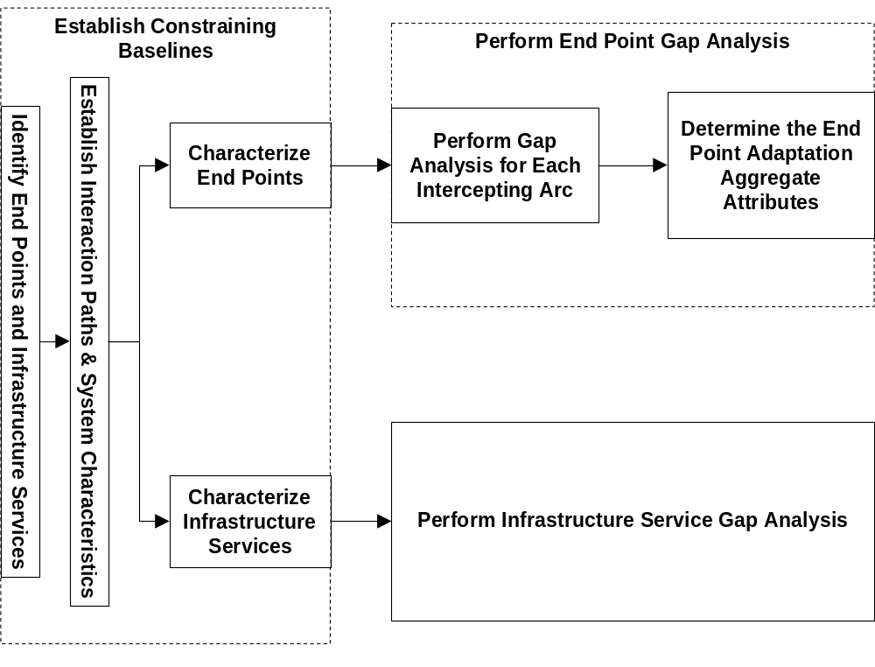 Figure 4 - Blueprint Construction Order of Analysis
- Preparation
The work products in Table 2 (or their equivalents) should be available to the Blueprint construction team prior to beginning. There are two groups of input work products represented in the table. The first group is outputs of business system design activities, and addresses the scope of the entire integrated business system. These contain the modifier “Business System” in their name. The second group is outputs of individual application (or other end point such as a business partner’s systems), or infrastructure service design and implementation. These define the constraints that the EAI subsystem must work within, and carry the modifier “Application X” in their name.
Table 2 - Input Work Products from Solution Architecture
Method Work Product | Work Product Name | Description | Elaboration Point | Information Required in Blueprint
APP 011 | System Context - Business System | Business System Context | Concept | Identification of End Points
ARC 101 | Architecture Overview Diagram – Business System | Architecture Overview Diagram | Concept | Characteristics of End Points
APP 130 | Use Case Model – Business System | Depiction of business system states. | Specification | Solution State Definitions
APP 130 | Use Case Model – Application X | Access methods of end point | Specification | Characteristics of End Points
ARC 119 | Non-Functional Requirements – Business System | Non-Functional Requirements for total business system | Specification | Inter-End Point Non-functional Requirements, Standards
ARC 108 | Component Model – Application X | Functional characteristics of end point | Specification | End Point Characteristics
APP 108 | Interaction Diagrams – Business System | Interaction Diagrams (At application / component level) | Specification | Application Workflows
APP 110 | Logical Data Model – Business System | Logical Data Model (At element content (attribute) description level) | Specification | Entities exchanged between end points
APP 110 | Logical Data Model – Application X | Logical Data Model (At element content (attribute) description level) | Specification | Entities rendered within End Points
ARC 319 | Performance Model – Business System | Solution Performance & Capacity Model | Specification | Solution performance and capacity specifications
ARC 400 | Solution Recovery Strategy | Application Recovery Strategy | Concept | Solution recovery states and end point recovery order.
Identify the scope of the EAI subsystem
Using the business system context diagram and solution architecture, determine whether a single EAI subsystem context or a collection of subsystems applies to the problem.
Single System Context | Applies when the enclosed scope is controlled by a single organization.
Multiple System Contexts | Apply when multiple business partners or units are present in the solution, and when the solution context extends into these organizations. In that case, each partner or unit represents a focal point for one EAI subsystem, as well as an end point for one or more other EAI subsystems.
Each unique EAI subsystem context defined identifies an EAI subsystem, or subsystem. An EAI Attributes Blueprint must be composed for each context.
Example
The Daukas & Lee Company future system architecture overview depicted in Figure 22, and the associated background information indicate that none of the customer or supplier system internal structures are included within the scope of the required solution. As a result, a single EAI subsystem context is adequate.
Plan the Approach and Prepare the Team
Based on the availability of client information and personnel, decide the subsystem analysis order if more than one EAI subsystem is present. Similarly, decide the order of baseline establishment for each subsystem.
Assure that the team members are briefed on the project, and this specific effort. Also assure that the team have read this technique, and understand their roles within the effort.
Extend Solution Application Flows to Include Administration
Review application flows and identify additional application flows necessary to cover distributed administration tasks. Determine with the client whether automation of such capabilities is required in the solution. The typical administration flows cover “User” administration Create, Read, Update, Delete (C.R.U.D.) tasks across the solution.
For those distributed administration tasks that will be automated, detail the administrative application flows. Identify the remaining tasks as procedural requirements. Take advantage of any existing EAI administrative pattern flows, either from the client’s existing systems, or from Intellectual Capital, and modify them as necessary to fit the specific situation.
Once the flows are established, identify and detail the administrative entities that must be exchanged to support them. This may require updates to the established solution logical data model.
Be aware that even though this automation is an integral part of the solution architecture, its definition is not commonly completed prior to involving EAI expertise in the solution team.
Example
The Daukas & Lee Company’s integrated solution incorporates only a few business applications. In addition, the only access for external entities to these systems is limited to their key suppliers, and the Purchasing and Siebel™ applications. As a result, the business process administrative load is minimal and does not justify the additional integration complexity that automation would introduce. As a result, the company has elected to meet these requirements with manual procedures.
- Establish Constraining Baselines
Identify End Points and Infrastructure Services
For each defined EAI context, identified above, define the EAI subsystem/subsystem specific context diagram.
- Identify the end points that define context boundaries. These end points can be applications, other enterprises, or other business units. End points lie outside of this specific EAI subsystem context, and are not a part of the EAI subsystem.
- Identify the customer infrastructure services that define context boundaries. These typically include directory, security, and systems management. In addition, they can include such services as meta-data repositories in sophisticated client implementations. It is important to include all implementations of a service type that exist in the business system (e.g. both LDAP and Active Directory implementations if present). These services also lie outside of the EAI subsystem context.
Record the end points and infrastructure service instances in the Blueprint.
Blueprint Element Populated
- End Point
- Infrastructure Service
Other Outputs
- APP 011 System Context – EAI

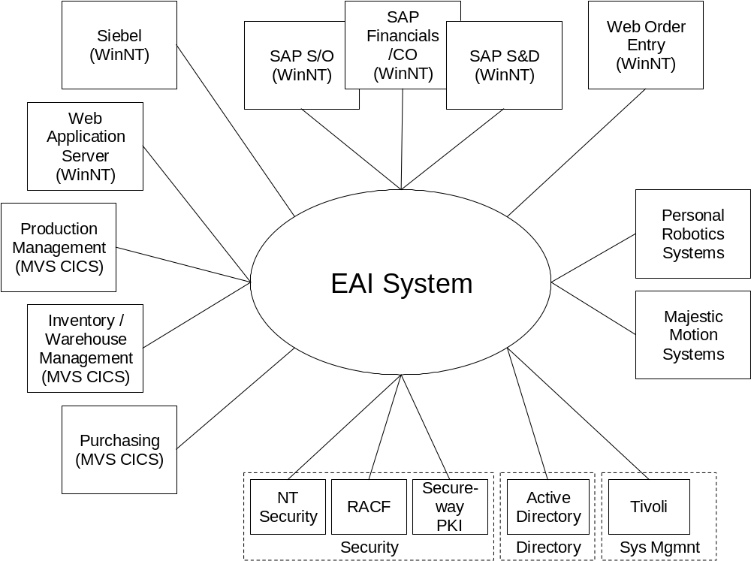
Figure 5 - Daukas & Lee EAI Context Diagram
Example
Daukas & Lee’s end points include their two key supplier’s systems, Personal Robotics and Majestic Motion, as well as their existing and new business applications. Their infrastructure services are confined to standard Windows NT™ services, MVS services, Tivoli systems management and Secureway PKI™ services. The EAI context diagram for Daukas & Lee is depicted in Figure 5, above.
Establish Interaction Paths & System Characteristics
Identify and Detail the Application Workflows within the Context of the EAI subsystem
Review the application workflows and record the following characteristics for each workflow extending between the identified end points for the EAI subsystem.
- Availability: What is the availability requirement for this workflow. This may need to be allocated from the non-functional requirements and business processes if not already assigned by the solution architecture team.
- Volume: The traffic volume characteristics, including peak timeframes for the workflow may need to be allocated from the business process and general non-functional requirements for the solution.
- Response Time / Allowable Delay: These may need to be allocated from the response or total delay characteristics of the total business process flow.
Blueprint Element Populated
- Reference Workflow
Example
Daukas & Lee are integrating two key business processes across their applications in the early implementation of their business systems, Partner Information Synchronization and Available to Promise. These are depicted in the example Blueprint excerpt of Figure 6 below.
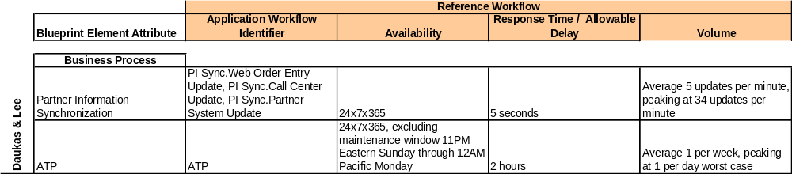
Figure 6 - Daukas & Lee Key Application Workflows
Identify and Detail the Entities Exchanged through the EAI subsystem
Examine the application flows for the solution in conjunction with the logical data model, and catalog the business entities that are exchanged between end points. For each entity, extract from logical data model the following characteristics of the exchanged entity:
- Structure: This is the logical structure of the entity information (ERD, class diagram, XML based representations), which can range from a simple list of attributes to complex hierarchical or network structure.
- Security Class: Can be a member of a simple or complex taxonomy, driven by the business problem. Should be recorded in the business architecture – logical data model. This may or may not have been completed by the solution architecture team, or may have been treated only at the application function & information level. Where necessary, the application flows can be “executed” to identify the correct assignment of the exchanged entities within the security model.
- Representation: This may or may not be defined within the solution architecture. If not, it will be a design decision for the EAI and Solution architects to resolve during EAI architecture composition. Examples include EDI, other fixed formats, and XML dialects.
- Attribute definition and range for each attribute contained in the exchanged entity
Blueprint Element Populated
- Exchanged Entities
- Entity
- Entity Attributes
Example
The Daukas & Lee design team has taken the approach of using a common exchanged entity to support the Partner Information Synchronization process. Similarly, they have devised a common plan entity that is exchanged throughout the Available to Promise (ATP) process. The structures for these entities are depicted in the Blueprint excerpt of Figure 7 and Figure 8. The detailed attributes can be reviewed in the example Blueprint attached in Appendix D: Example EAI Attributes Blueprint.
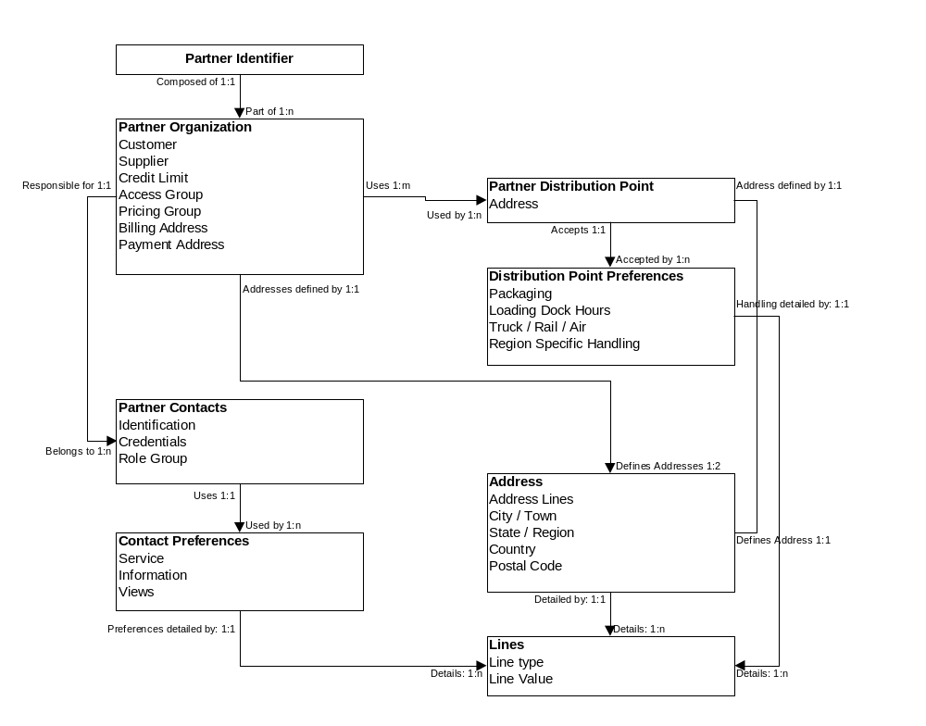
Figure 7 - Partner Synchronization Exchanged Entity

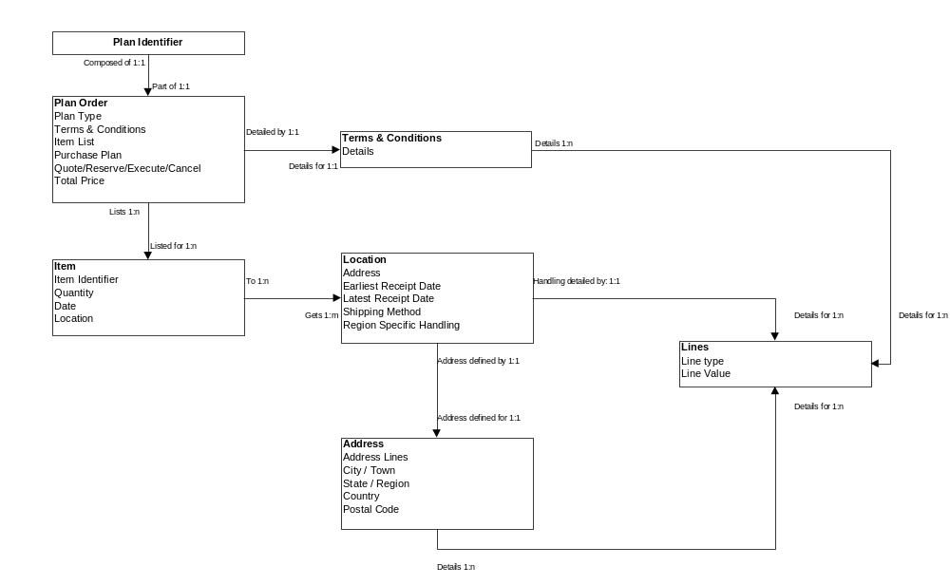
Figure 8 - ATP Plan Exchanged Entity
Identify Interaction Paths
Analyze each application workflow and identify the interaction paths that compose the flow. Recall that an interaction path is the smallest application workflow subset containing 2 or more end points that advances the business process represented from one durable business state to another. It may or may not represent an ACID transaction in the technical sense.
Keep in mind the basic principle that the EAI subsystem may not create or consume a business entity. That remains the preview of end points. If such unresolved functionality is discovered during the analysis, work with the solution architecture team to resolve its location within an end point. This commonly occurs when the solution architects elect to use business process workflow technology outside of the selected applications and components to manage the business process. Under such conditions, the technology may be leveraged to perform EAI process management, as well as to perform business process logic. During this analysis phase, such a component should be represented as an end point, and the business process management performed by it should be encapsulated by the end point and removed from the application workflow.
Record the recoverability characteristics for each identified interaction path, i.e.; indicate whether the interaction path must be reversible. A path is recovered when the originating solution business state for the path is restored. This may involve traditional transactional undo activity, as well as compensating operations.
Blueprint Element Populated
- Interaction Path
Example
A portion of the Daukas & Lee Partner Information Synchronization (PI Sync) process is depicted graphically in the interaction diagram of Figure 9. The Interaction path characteristics for the Partner Information Synchronization and ATP processes are depicted in the Blueprint excerpt of Figure 10.
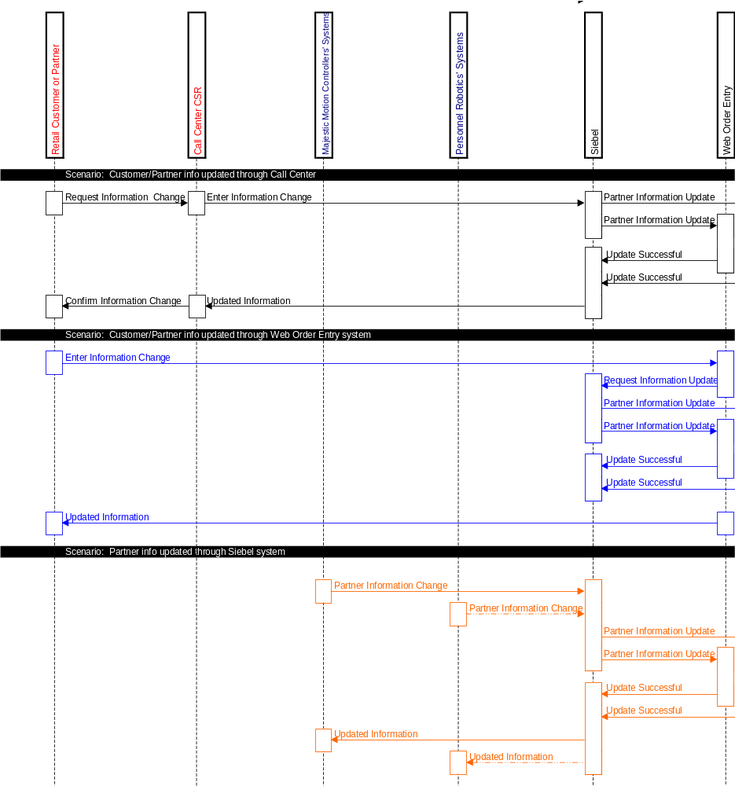
Figure 9 - Partner Information Synchronization Interaction Diagram
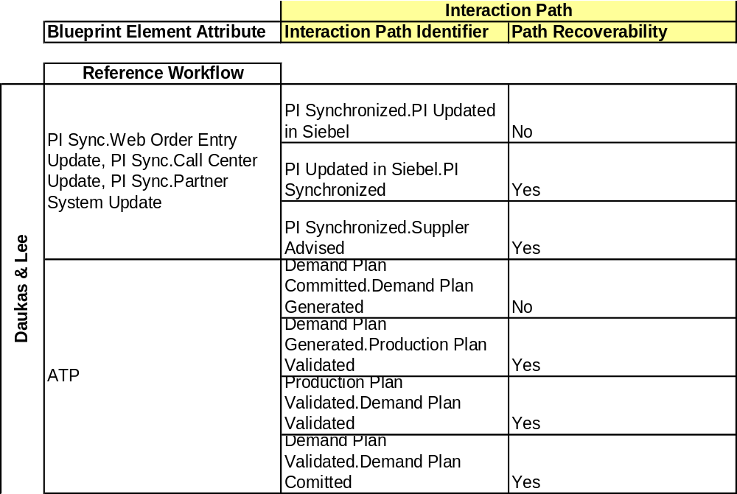
Figure 10 - Daukas & Lee Interaction Paths
In the Daukas & Lee Blueprint the EAI team have chosen naming conventions that differentiate the application workflows by process and initiating business event (when required). They have elected to identify the interaction paths by noting the initial and end business state for each path.
Create Recovery Interaction Paths
Every interaction path identified is classified as recoverable, or non-recoverable. When a path is recoverable, the EAI subsystem has the responsibility for performing the recovery. For every recoverable interaction path, define the interaction path that will perform the recovery. This will require direct collaboration with the solution architect or solution architecture team. It may also require the involvement of end point architects / experts, since the recovery of the involved endpoints is, of course, end point specific.
A recovery interaction path is always non-recoverable.
Blueprint Element Populated
- Interaction Path
Identify and Characterize Interaction ARCs
Review each interaction path and identify the interaction arcs that compose the path. Recall that an interaction arc consists of a single interaction path segment between any two end points. For each interaction arc identified, allocate availability, performance and volume requirements to the interaction arc to meet the overarching characteristic of the parent application workflow. Our convention is that the interaction arc allocation of these attributes includes the allocation for end point adaptation at each end of the arc. This is consistent with the viewpoint that an application workflow contains the allocations of the applications as well as the integration between them in its overall non-functional characteristics. This allocation model as applied to processing delay is depicted in
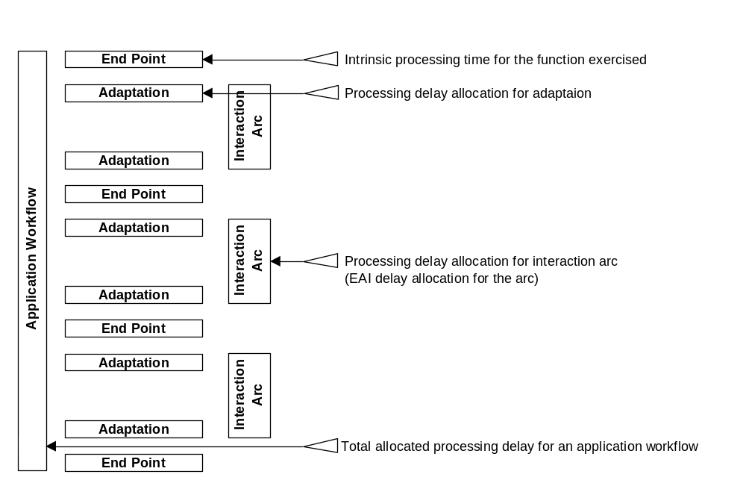
Figure 11 - Allocation of Delay to Interaction Arcs
When the allocation is complete, record the following Blueprint attributes for each arc:
- Initiating end point
- Partner end point
- Arc availability
- Arc response time / allowable delay
- Volume characteristics for the arc.
Blueprint Element Populated
- Interaction Arc
Example
A sample of the interaction arc characteristics for Daukas & Lee are tabulated in the Blueprint excerpt of Figure 12. A more complete and readable version is attached in Appendix D: Example EAI Attributes Blueprint.
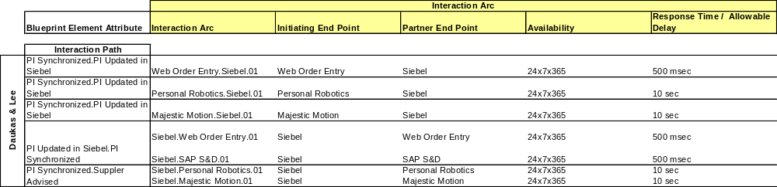
Figure 12 - Partial Characteristics Tabulation for Daukas & Lee
Characterize End Points
For each identified end point, characterize the access methods available and the associated rendered entities that these methods expose. This information is usually available from a variety of sources, dependent on end point type.
- Packaged applications manuals and as used configuration specifications. Similar documentation and operational history for legacy custom applications.
- Business Partner systems are available either in the existing / proposed trading partner agreements or the logical data model, or business information model. Similar documentation will establish the characteristics of a business unit’s systems.
For each access method, record the following:
- Signature: May be in the form of an API, data table structures and standard DB access, gateway or network access calls
- Availability: Availability of the end point accounts for maintenance windows on the end point and intervening network
- Intrinsic Response Time / Processing Delay: Includes intervening network characteristics where these are not within the bounds of the EAI subsystem. An example is the network connection between a client server application, when the EAI subsystem is accessing the application via client calls.
- Volume: Limitations on volume handling, including peak effects from other using organizations.
For each rendered entity, record the following:
- Structure: This is the logical structure of the entity information (ERD, class diagram, XML based representations), which can range from a simple list of attributes to complex hierarchical or network structure.
- Security Class: Can be a member of a simple or complex taxonomy, driven by the end point. Many applications have simple 2 to 3 tier access class hierarchies. Business partner and business unit taxonomies should be reflected within the trading partner agreement (existing or proposed) or its equivalent.
- Representation: Should be specified in the support documentation for applications, and in the trading partner agreements or their equivalents for business partners and other business units.
- Attribute definition and range for each attribute contained in the each rendered entity
Blueprint Element Populated
- End Point Access Method
- End Point Rendered Entity
- Entity
- Entity Attributes
Example
The end point access method characteristics for Daukas & Lee are tabulated in the Blueprint excerpt of Figure 13.
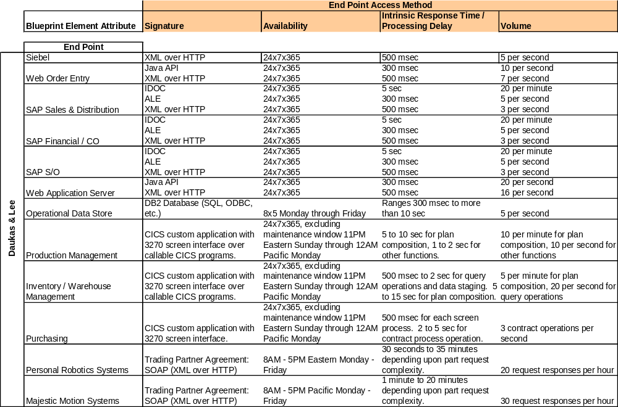
Figure 13 - Daukas & Lee End Point Access Methods
Characterize Infrastructure Services
For each identified infrastructure service, characterize the access methods available. This information is usually available from a variety of sources, dependent on the implementation of the service. These include:
- Packaged application based services manuals and as used configuration specifications
- Similar documentation and operational history for custom built services.
For each access method, record the following:
- Signature: May be in the form of an API, data table structures and standard DB access, gateway or network access calls
- Availability: Availability of the service accounts for maintenance windows on service and intervening network
- Intrinsic Response Time / Processing Delay: Includes intervening network characteristics where these are not within the bounds of the EAI subsystem.
- Volume: Limitations on volume handling.
Blueprint Element Populated
- Service Access Method
Example
The service access method characteristics for Daukas & Lee are tabulated in the Blueprint excerpt of Figure 14.
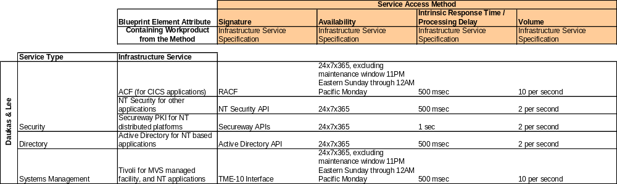
Figure 14 - Daukas & Lee Service Access Methods
- Perform Gap Analysis to Establish End Point Adaptation Attributes
Perform Gap Analysis for Each Intercepting Arc
Perform a gap analysis between each intercepting interaction arc and the associated end points’ characteristics to determine each of the following end point adaptation attributes.
Determine Parsing and Assembly
Compare the intercepting arc’s conveyed entities with the rendered entities available from the end point, and map the content between the two forms. Be mindful of the embedded functionality that the business system expects this end point to execute in initiating or terminating this arc. Review the solution Application Function Model and the Component Model as necessary to attain the necessary focus.
Using this information determine the parsing or assembly steps necessary to extract or construct one the conveyed (exchanged) form from the rendered form. This is not intended to be a detailed procedural view, but rather the specification for the map.
Determine Transformation
Compare the intercepting arc’s conveyed entity’s form to the “assembled content” from the end point and record the specification for the content transformation necessary to map between the two forms. This is again defined at a specification level, and is often best conveyed in a from/to comparative manner.
Determine Access Path
Using the map required to parse or assemble the content for the entities of the intercepting arc, determine the set of end point access methods necessary to create or consume the entity content received or delivered by the arc. This is to be at a specification level and not design or code. An example of this would be to specify IDOC exchange as opposed to an ALE call to access a SAP™ function.
Determine Security Class Matching
Compare the security class of the exchanged entities conveyed by the interaction arc with the security classes available at the end point and assign an appropriate end point class to the access path for each exchanged entity.
A common example of this is the case where an existing application has an administrator security class as well as a general user security class. When the intercepting interaction arc is a part of regular business operations for the application, such as creating an order in an order entry application, the general user class should be used. When the arc is a part of an administrative process, such as adding a new “user,” the administrative class should be used.
Determine Availability Matching
Compare the availability required for the interaction arc with the availability of the set of access mechanisms defined for the path. Make note of any situations where the availability of the arc is higher that that of the access path. These occur most often when the end point is subject to maintenance windows. If this cannot be corrected in some way by the EAI subsystem, the arc’s availability attributes will not be met.
Determine Response Time / Delay Matching
Compare the response time required or delay allowed for the interaction arc with the intrinsic response or delay time for the associated access path. The later can be loosely estimated from the characteristic delays of the end point access methods utilized by the path. Allocate a delay time to the path. Remember that this allocation and the allocation for the access path at the other end of the interaction arc must fit within the total allocated delay for the arc. The remaining arc allocation must account for network processing delays between the access paths that terminate the arc.
Blueprint Element Populated
- Access Path Adaptation
Example
Daukas & Lee Company need to exchange planning information with their key suppliers as a part of automating their ATP process. The primary exchanges take place between the supplier’s systems and the CICS 3270 screen interface based Purchasing application. A sample of some of the access path adaptation attributes for a few of the pertinent interaction arcs for Daukas & Lee are tabulated in the Blueprint excerpt of Figure 15. A more complete and readable version is attached in Appendix D: Example EAI Attributes Blueprint.
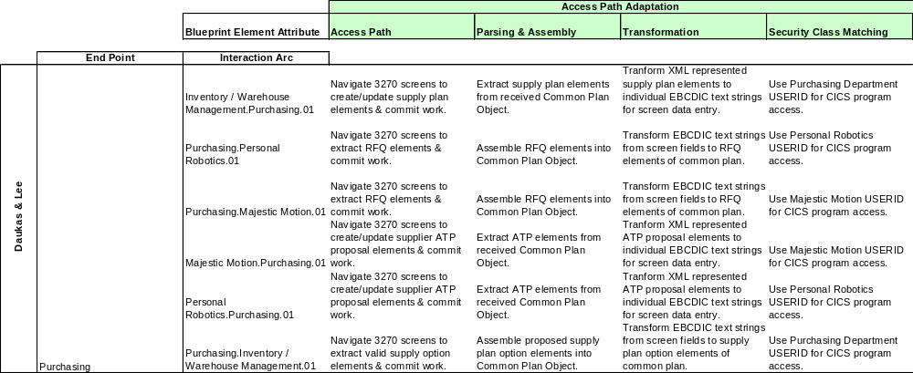
Figure 15 – Daukas & Lee Access Path Adaptation Attributes
Determine the End Point Adaptation Aggregate Attributes
For each end point, formulate an aggregate adaptation attribute view for the end point, including the following.
Determine Intrinsic Availability
Review the availability requirements for the set of access paths exercised by all intersecting interaction arcs for the end point and allocate an intrinsic availability characteristic that will meet the needs of the entire collection.
Determine Intrinsic Allowable Delay
Review the response time / allowable delay for the set of access paths exercised by all intersecting interaction arcs for the end point and allocate an intrinsic allowable delay characteristic that will meet the needs of the entire collection.
Determine Aggregate Volume
Analyze the overlapping availability and associated volumetric characteristics for all of the interaction arcs intercepting the end point and allocate an aggregate volume characteristic that will meet the needs of the collection in operation. This will often be less than the simple sum of the volumetric characteristics for each arc, due to the variance in availability for each arc.
Blueprint Element Populated
- End Point Adaptation
Example
An excerpt of the Daukas & Lee Attributes Blueprint depicting the aggregate end point adaptation attributes is provided in Figure 16. Note that this example accounts for only the ATP and Partner Synchronization processes. In a fully developed Blueprint for the solution, these attributes would need to be adjusted to account for the other business processes executed through each end point.
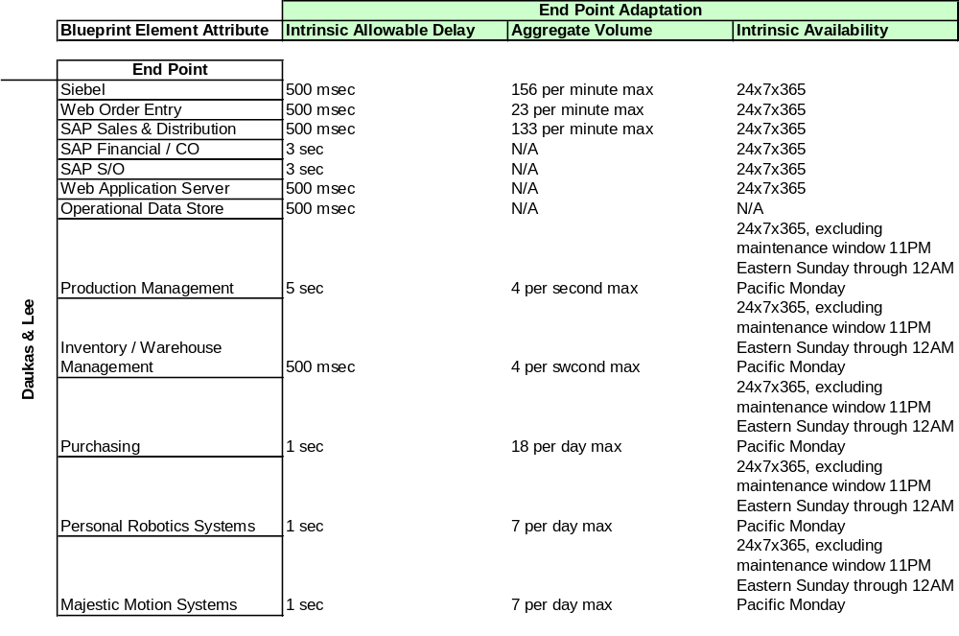
Figure 16 - Daukas & Lee End Point Adaptation Attributes
- Perform Gap Analysis to Establish Infrastructure Adaptation Attributes
Perform a gap analysis between the individual infrastructure service instances’ characteristics to provide a common view of the aggregated service for the EAI subsystem components, for each of the following attributes.
Determine Common Access Method
Review the infrastructure service access methods for each type of service, and select one or specify a single access method for the infrastructure service type. In most cases, one of the access methods should be selected, either one that is an accepted industry standard, or the most prevalent across the solution scope. In rare cases, it may be necessary to compose a common access method that is not one already in use within the client infrastructure. This is most often true in multi-enterprise solutions, where the client does not control standard setting.
Determine Common Signature
Either adopt the signature of the selected service access method for each type of service, or specify a single signature to accompany the specified access method. As with the access method, in rare cases, it may be necessary to compose a common signature that varies from the selected access method signature. This most often occurs when the selected service is not functionally rich enough by itself to support the EAI subsystem.
There are also cases where a common service is either unnecessary, or necessary for only a part of the EAI subsystem. This is most often true when multiple infrastructures are present within the client enterprise, or in multi-enterprise solutions.
Determine Availability Characteristics
Estimate the intrinsic common service availability necessary to support the availability of the EAI subsystem as indicated from the aggregate availability of the set of application workflows for the solution. Compare the availability of the service instances with the intrinsic common service availability of the System and identify any gaps in service instance availability that must be addressed.
Determine Delay Characteristics
Estimate the intrinsic common service delay acceptable to support the EAI subsystem as modeled from the allowable delay for each application workflow for the solution. Remember that each interaction arc has an allocated delay. These service access delays are incorporated in the remaining allocation, after end point adaptation delays are removed from each arc.
Compare the acceptable service delay with the delay of the service instances and identify any gaps in service instance delay that must be addressed. In general, the number of accesses for each service type range from one per workflow, to one per interaction arc. Usually, systems management access will be the most frequent, with both directory and security services tending toward the least frequent.
Determine Aggregate Volume
Estimate the service request volume necessary to support the availability of the EAI subsystem as modeled from the aggregate volume of the set of application workflows for the solution. Such a model must account for the number of infrastructure service calls the EAI subsystem will need to make to support the application flows.
In general, the number of accesses for each service type range from one per workflow, to one per interaction arc. Usually, systems management access will be the most frequent, with both directory and security services tending toward the least frequent.
Blueprint Element Populated
- Infrastructure Adaptation
Example
An excerpt of the Daukas & Lee Attributes Blueprint depicting a subset of the infrastructure adaptation attributes is provided in Figure 17. Note that this example accounts for only the ATP and Partner Synchronization processes. In a fully developed Blueprint for the solution, these attributes would need to be adjusted to account for the other business processes executed through each end point. A more complete and readable version is attached in Appendix D: Example EAI Attributes Blueprint.
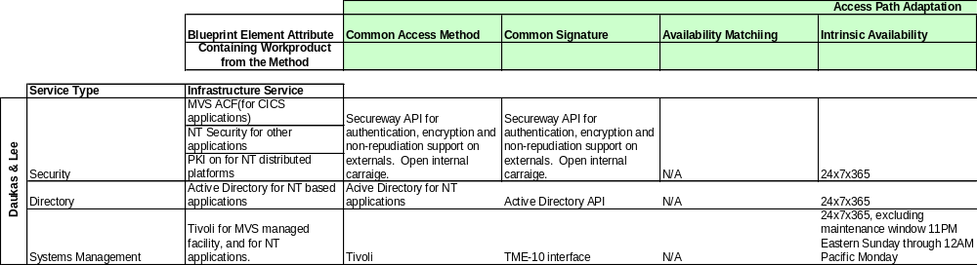
Figure 17 - Daukas & Lee Infrastructure Adaptation Attributes

Appendix A: EAI Attributes Blueprint Meta-Model Details
This technique allows us to capture and organize classed integration attributes for a client into an EAI Attributes Blueprint. Figure 18 and Figure 19 depict the meta-model for an EAI Attributes Blueprint.
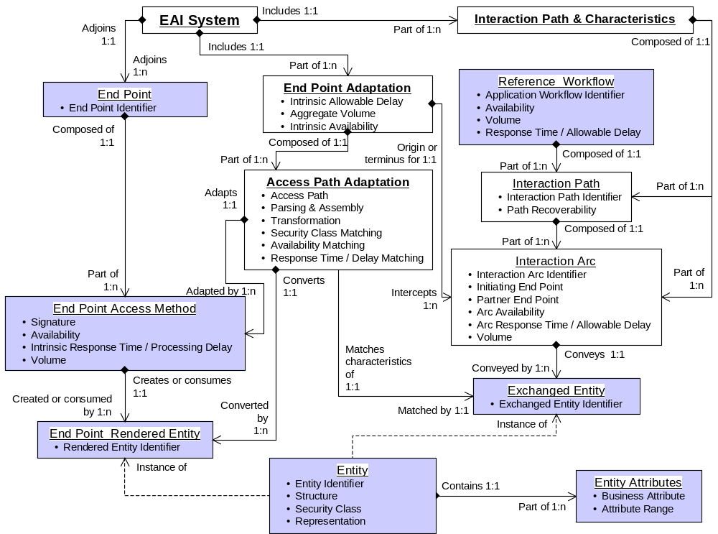
Figure 18 - EAI Attributes Blueprint Meta-model (Part 1 of 2)

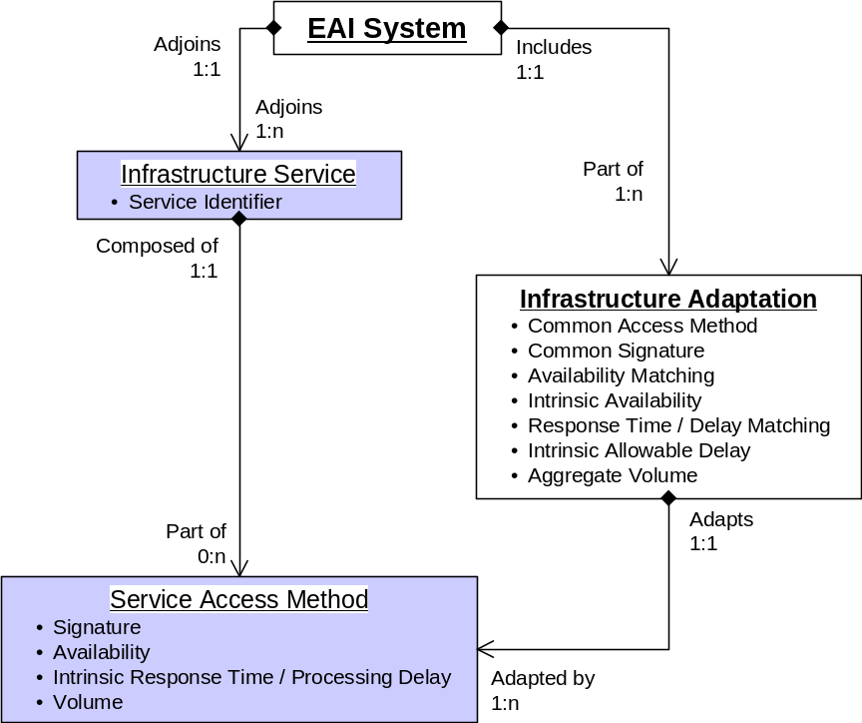
Figure 19 - EAI Attributes Blueprint Meta-model (Part 2 of 2)
The following tables, Table 3 through Table 16, detail the attributes for each element of the EAI Attributes Blueprint Meta-model.
Table 3 - Refernece Workflow Element
Element Attribute | Containing Work Product from the Method | Comments
Application Workflow Identifier | APP 108 Interaction Diagrams | These should have already been defined by the solution architecture team, but in most cases will not include multi-end point administration and support workflow. The EAI team must detail these latter.
Availability | ARC 119 Nonfunctional Requirements | Required intrinsic availability of the application workflow.
Response Time / Allowable Delay | ARC 119 Nonfunctional Requirements | Total maximum response time or allowable delay for the execution of the defined application workflow.
Volume | ARC 119 Nonfunctional Requirements | Volumetric requirements for the application workflow: mean, peak, and peak period.

Table 4 - Interaction Path Element
Element Attribute | Containing Work Product from the Method | Comments
Interaction Path Identifier | APP 108 Interaction Diagrams | Each interaction path represents a process flow that transitions the business system from one durable business state to another. This does not necessarily imply the ability to recover or reverse the transition. The application workflow is an ordered assembly of these paths. These paths define the EAI subsystem process management characteristics.
Path Recoverability | N/A | Defines whether the business system must be recoverable to the initiation point of a specific interaction path.

Table 5 - Interaction Arc Element
Element Attribute | Containing Work Product from the Method | Comments
Interaction Arc | APP 108 Interaction Diagrams | Each interaction arc represents a single segment of an interaction path, extended between two end points. The interaction path is an ordered assembly of these arcs.
Initiating End Point | APP 108 Interaction Diagrams | Each interaction arc has a single initiating end point.
Partner End Point | APP 108 Interaction Diagrams | Each interaction arc has a single partner end point.
Availability | ARC 119 Nonfunctional Requirements | Required intrinsic availability of each interaction arc.
Response Time / Allowable Delay | ARC 119 Nonfunctional Requirements | Total maximum response time or allowable delay for the execution of the defined interaction arc.
Volume | ARC 119 Nonfunctional Requirements | Volumetric requirements for the interaction arc: mean, peak, and peak period.

Table 6 - Exchanged Entities Element
Element Attribute | Containing Work Product from the Method | Comments
Exchanged Entity Identifier | APP 110 Logical Data Model | The solution architecture data team should have already defined these.

Table 7 – Entity Element
Element Attribute | Containing Work Product from the Method | Comments
Entity Identifier | APP 110 Logical Data Model | Design details are not included here. This is a specification of structure and content.
Structure | APP 110 Logical Data Model | Can be a simple list of attributes, or a complex hierarchical or networked structure.
Security Class | APP 110 Logical Data Model, and Security Model | Each entity must be mapped to a specific class in the security taxonomy. Two entities with identical structure, but different security classifications, must be represented as unique entities.
Representation | APP 110 Logical Data Model | Representation required for the entity.

Table 8 - Entity Attribute Element
Element Attribute | Containing Work Product from the Method | Comments
Business Attribute | APP 110 Logical Data Model | What business term is represented by the attribute?
Attribute Range | APP 110 Logical Data Model | Valid range of values the attribute can take

Table 9 - End Point Element
Element Attribute | Containing Work Product from the Method | Comments
End Point Identifier | APP 011 System Context | May be an application, another enterprise, or another business unit, depending upon client preference and business strategy.

Table 10 - End Point Access Method Element
Element Attribute | Containing Work Product from the Method | Comments
Signature | ARC 108 Component Model | May be one or more of: API, User Interface, Direct Data Access. Note that this is true for enterprises and business units as well as applications, because ultimately a gateway or network access mechanism will be employed to effect the technical layer integration.
Availability | ARC 119 Nonfunctional Requirements | May include standard maintenance windows, or event driven administration that limits availability. It is also possible for it to vary by Access Method.
Intrinsic Response Time / Processing Delay | ARC 119 Nonfunctional Requirements | Different access methods for an end point often exhibit different response times or processing delays.
Volume | ARC 119 Nonfunctional Requirements | Different access methods for an end point often exhibit different volume handling characteristics.

Table 11 - Rendered Entity Element
Element Attribute | Containing Work Product from the Method | Comments
Rendered Entity Identifier | APP 110 Logical Data Model | The rendered entity can take on a number of forms including: COBOL copybooks, Java or CORBA objects, database structures, EDI, XML dialects, etc.

Table 12 - End Point Adaptation Element
Element Attribute | Containing Work Product from the Method | Comments
Intrinsic Availability | ARC 119 Nonfunctional Requirements | Required intrinsic availability for the adaptation.
Intrinsic Allowable Delay | ARC 119 Nonfunctional Requirements | Total maximum response time or allowable delay budget for the adaptation.
Aggregate Volume | ARC 119 Nonfunctional Requirements | Volumetric requirements for the adaptation: mean, peak, and peak period.

Table 13 – Access Path Adaptation Element
Element Attribute | Containing Work Product from the Method | Comments
Access Path | ARC 108 Component Model | May include multiple instances of the Access Method types to affect a specific interaction arc.
Parsing & Assembly | APP 130 Use Case Model | Includes any parsing and / or assembly of entities to map between the content of an Interaction Arc's Exchanged Entities and the content of the end point's Rendered Entities.
Transformation | APP 110 Logical Data Model | Addresses transformation of parsed entity content to map between the Interaction Arc's Exchanged Entities and the end point's Rendered Entities. Can include format change and symbolic mapping, as well as information reordering.
Security Class Matching | APP 110 Logical Data Model, and Security Model | The security class assumed for an entity exchanged with an end point must be matched to a class with corresponding characteristics that exist in the end point's implementation.
Availability Matching | ARC 119 Nonfunctional Requirements | Identifies those situations for which the availability characteristics for the end point are lower than the requirements for an interaction arc.
Response Time / Delay Matching | ARC 119 Nonfunctional Requirements | Identifies those situations for which the response time / delay characteristics for the end point are longer than the requirements for an interaction arc.

Table 14 - Infrastructure Service Element
Element Attribute | Containing Work Product from the Method | Comments
Service Identifier | APP 011 System Context | May be a service application, manual procedure or both.

Table 15 - Service Access Method Element
Element Attribute | Containing Work Product from the Method | Comments
Signature | ARC 108 Component Model | May be one or more of: API, User Interface, Direct Data Access. Note that this is true for enterprises and business units as well as applications, because ultimately a gateway or network access mechanism will be employed to effect the technical layer integration.
Availability | ARC 119 Nonfunctional Requirements | May include standard maintenance windows, or event driven administration that limits availability. It is also possible for it to vary by Access Method.
Intrinsic Response Time / Processing Delay | ARC 119 Nonfunctional Requirements | May vary by Access Method
Volume | ARC 119 Nonfunctional Requirements | May vary by Access Method

Table 16 - Infrastructure Adaptation Element
Element Attribute | Containing Work Product from the Method | Comments
Common Access Method | ARC 108 Component Model | May include multiple instances of the Access Method types to affect a specific interaction arc.
Common Signature | ARC 108 Component Model | Defines the requirements for a common content exchange for EAI leveraged infrastructure services.
Availability Matching | ARC 119 Nonfunctional Requirements | Identifies those situations for which the availability characteristics for the service are lower than the required intrinsic availability of the included application workflows.
Intrinsic Availability | ARC 119 Nonfunctional Requirements | Required intrinsic availability for the adaptation.
Response Time / Delay Matching | ARC 119 Nonfunctional Requirements | Identifies those situations for which the response time / delay characteristics for the service are inconsistent with the total maximum response time or allowable delay for the execution of the included application workflow.
Intrinsic Allowable Delay | ARC 119 Nonfunctional Requirements | Total maximum response time or allowable delay budget for the adaptation.
Aggregate Volume | ARC 119 Nonfunctional Requirements | Volumetric requirements for the adaptation: mean, peak, and peak period.

Appendix B: Simple Baseline Management Process
The change management process illustrated in Figure 20 provides a mechanism that can be applied as often as necessary to assess and address changes to the baseline. It has been used effectively in the delivery of complex IT based systems.
In addition to the technical artifacts indicated in the flow, the management mechanism can be applied to other system aspects such as the method specialization and Engagement Template applied to the project, the project organization, etc. It could conceivably be included as the common control mechanism for all system and project baselines.
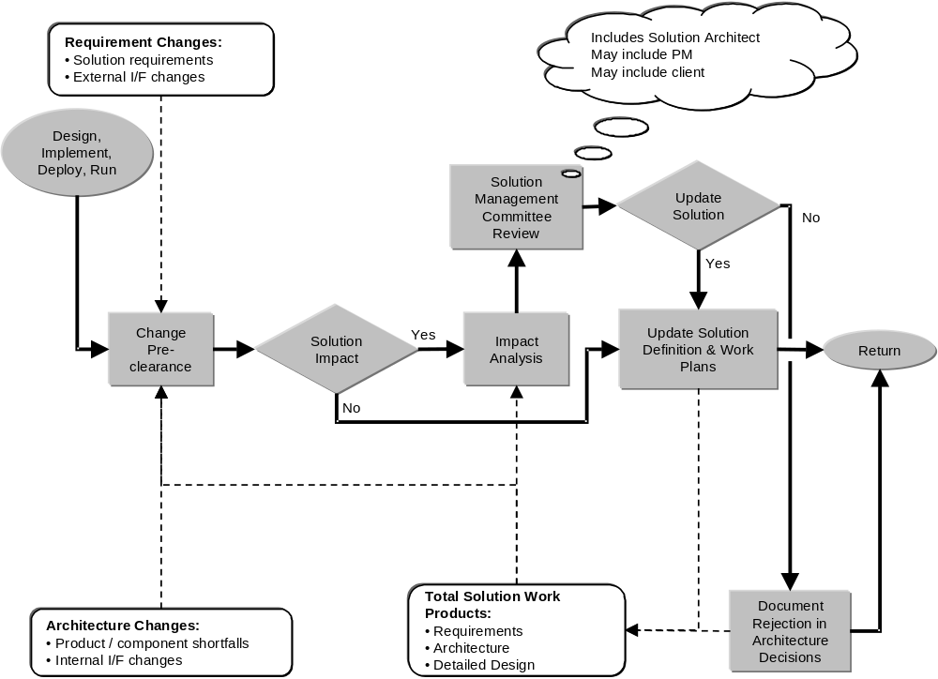
Figure 20 - Baseline Management Process

Appendix C: EAI Example Problem Background
This appendix provides an overview of an example EAI problem at the fictitious Daukas & Lee Company. In particular, it focuses on the integration of their core business applications, and their two primary suppliers to automate two key processes.
- Partner Information Synchronization
- Available to Promise.
Engagement Background
Daukas & Lee Background
Daukas & Lee assembles and markets a product called the Modem Masseuse, sold through major retail outlets around the world. The Modem Masseuse is a handheld robotic massage machine that responds to movement instructions received over a modem from a special web site, called MassageBroker.com.
Features user buttons to provide instant feedback to the site about the users:
- Likes and dislikes
- Body area being massaged
- Also features special tactile sensors that provide the web site with feedback about contact pressure, the direction of movement, etc.
The MassageBroker.com web site dispatches digital instructions to the device to:
- Invoke a variety of massage techniques, each with different therapeutic advantages
- Evaluates feedback, and provides movement patterns that maximize "like" feedback from the user
- Employ special pattern recognition processes to learn the preferences of the user, and become more proficient with each massage session
The company has created the modem-based massage category, and there are currently no direct competitors.
Since its introduction last year, a major infomercial campaign has driven rapid sales growth. This growth has exceeded their plans, and the company has had to scramble to build an infrastructure in support. Their current IT infrastructure is probably not sufficient to meet their near-term requirements. The company would now like help from IBM in devising and implementing a new solution.
Even though Daukas & Lee have their product hardware well protected (patents), the company believes that its huge success will stimulate at least one of its potential competitors to come up with their own hardware soon, and attempt a quick and forceful entry.
Strategic Initiatives
Daukas & Lee has established a number of strategic objectives and imperatives that will influence the direction of an EAI subsystem:
- Sustain high growth
- Build strong customer satisfaction
- Provide special attention to key customers
- Create strong alignment with strategic suppliers.
Current IT Environment
Daukas & Lee's systems are a combination of proprietary components, and an ERP package. The proprietary applications were purchased from another manufacturing company that previously employed the CIO. These include applications for:
- Order Collection (Call Center Clients)
- Order Processing
- Production Management
- Inventory/Warehouse Management
- Distribution
- Purchasing.
The Inventory/Warehouse Management and Distribution applications have not functioned up to expectations, and the company has initiatives to replace this functionality. The Production Management application is thought of as a best-of-breed in this area of functionality, and felt by the company to be a valuable asset to maintain.
Daukas & Lee currently allow their key suppliers, Majestic Motion and Personal Robotics, some visibility into their supply planning by providing dedicated USERIDs for each on the existing CICS based Purchasing application.
The company also has a version of SAP's R/3 system, including:
- The FI/CO module that provides:
- Financial Management: General Ledger, Accounts Payable, Special Ledger, Legal Consolidation
- Cost Accounting: Overhead Cost Management, Product Cost Planning, Profitability Analysis
- Enterprise Controlling: Executive Information System, Profit Center Accounting
- The HR module, which provides general human resources support.
Daukas & Lee’s current IT environment is depicted in Figure 21.

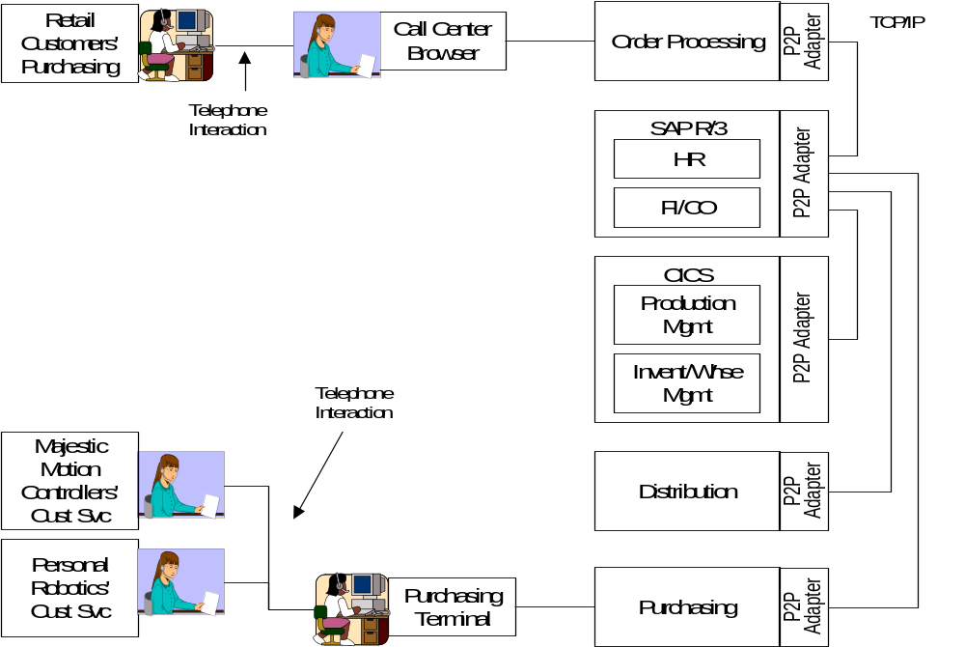
Figure 21 - Current Daukas & Lee IT Architecture Overview Diagram
From an integration perspective, most of the automated data exchange within Daukas & Lee is related to updating their SAP FI/CO module to facilitate financial tracking, and most of the interaction is done with batch processing techniques. Aside from SAP, the company's business applications were not designed to share information easily, and do not have sophisticated API's. The company connects its applications with proprietary point-to-point adapters, mostly written with C++.
Planned IT Initiatives
Daukas & Lee plan to add the following core business applications as a part of achieving their strategic goals:
- SAP's SD module - Sales and Distribution Module which provides functions for Sales Order Processing (Inquiries, Quotations, Orders), Contract and Scheduling Agreements, Pricing, Credit Checking, Rental Processing, Cross Company Processing, Delivery Processing, Billing Processing, Rebate Processing, Returns Processing, Sales Information System, EDI Messages.
- This application is to replace the current Order Processing application
- Siebel - Call center order entry, Customer Information
- This application is to replace the current Order Entry application used by the call center.
- Web Order Entry – A direct, self service, product order application based upon IBM’s Websphere Commerce.
- Operational Data Store and Data Mart
- The company is evaluating the incorporation of a data warehouse, as a way to better equip the management team with key operational and EIS information.
EAI Problem Domain
The problem focuses on providing a tightly integrated enterprise for Duakas & Lee, enabling business processes that operate across their key business applications, and reach to their supplier’s IT systems. Figure 22 depicts a future architecture overview diagram for Daukas & Lee.
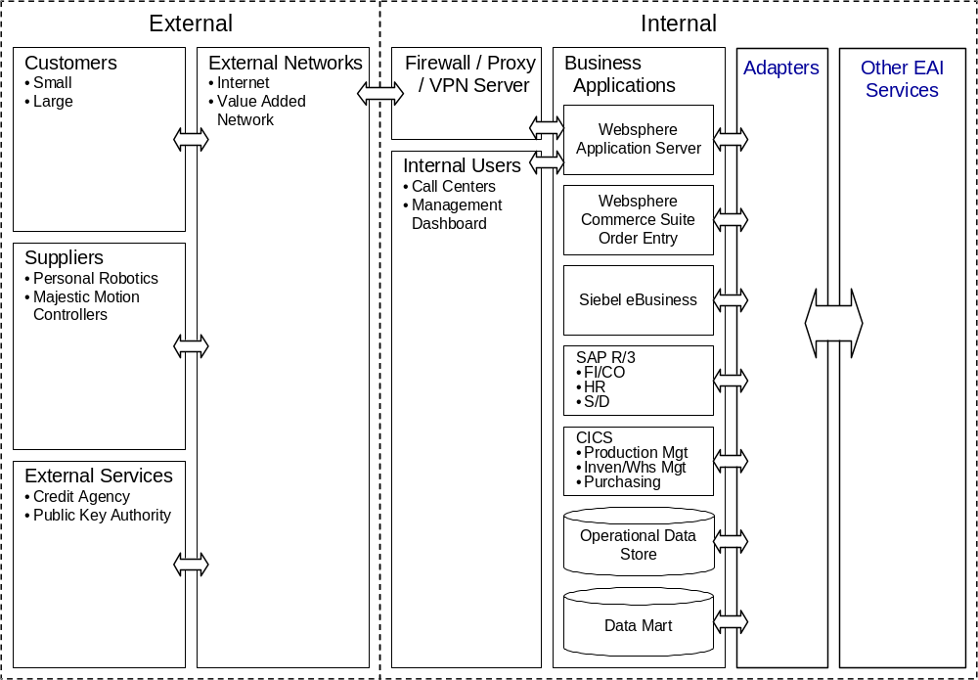
Figure 22 - Daukas & Lee Future Architecture Overview Diagram
There is a specific early focus on synchronization of partner (customers and suppliers) information across the company’s business channels, as well as automation of key parts of their supply chain.
As indicated previously, Daukas & Lee are introducing the SAP Sales and Distribution Module, Siebel, and a Web Order Entry application based upon IBM Websphere Commerce as a part of this update program. These three applications need to maintain a common view of the attributes of Daukas & Lee’s customers and suppliers. Due to the on-line nature of call center and web order entry processing, this synchronization must be held to response times of a few seconds. The business solution design team has chosen to utilize Siebel as the reference master for this “Partner Information.” The coordinated introduction of these three application functions has allowed the design team to use a common logical representation of this information object in all three applications. Each application maintains a slightly different internal representation of the information, necessitating format modifications to support information exchange. The existing, screen driven CICS based Purchasing application was considered as a potential participant in this synchronization, but the team elected to have the SAP Sales & Distribution function feed the necessary information to Purchasing as a part of ATP processing instead.
The second key initiative of this update program is the automation of their supply chain. Daukas & Lee have negotiated with their two suppliers to cross supply one another’s subassemblies based upon their committed capacity and demand in the marketplace. As a part of this relationship, the suppliers have agreed to automate their interaction with Daukas & Lee using a common plan entity (object) for exchange of planning and purchase information. In the new system, SAP Sale & Distribution (SAP S&D) will forecast product demand based upon marketing plans, sales history and current order volumes. As orders are processed, the forecast demand is checked against positioned inventories by Inventory / Warehouse management. As long as in-plan inventory levels cover the forecast demand, no action is taken.
When a net demand is present, exceeding a planning threshold, SAP S&D generates a net demand plan. This net demand is compared with available capacity by Production Management, and a production plan is generated to meet it, with parts supply assumptions. This is used by Inventory / Warehouse Management to generate a Supply Plan. The Supply Plan is in turn decomposed into Requests for Quote (RFQ) by Purchasing, and individual RFQs are sent to each supplier.
Previously, supplier sales personnel could examine the RFQ and respond on-line using dedicated Purchasing USERIDs that allowed the Purchasing application to control what information each supplier could see. In the future system, this interaction is to be carried out system to system between Purchasing and supplier IT systems.
Responses from each supplier are received by Purchasing, and valid purchase options are selected. These are reviewed within the scope of the Supply Plan by Inventory / Warehouse Management, and valid supply options are selected. These are similarly weighed within the Production Plan, and a production option is selected. This drives a sequence of selections through the supply plan and purchasing, resulting in a reservation being made with the suppliers. Subsequently, when this committed ATP is reviewed through SAP S&D, the production and supply plans will be committed, and a firm Purchase Order issued to the suppliers.
Actors
The preceding narrative has introduced the key actors for these processes from an EAI perspective. Several of the business applications are interactive in nature and require user participation to perform their business functions. This is particularly true in the case of the ATP process. Such user interaction is assumed but not detailed, as it lies outside of the scope of EAI. The actors of specific concern to the EAI subsystem in these business processes are:
- Web Order Entry (Websphere® Commerce)
- Customer Relationship Management (Siebel)
- SAP (S&D)
- Inventory / Warehouse Management (Custom CICS)
- Purchasing (Custom CICS)
- Personal Robotics Systems
- Majestic Motion Systems.
These actors are detailed in the following tables.
Table 17 - Web Order Entry
Actor Name |  | Web Order Entry
Brief Description |  | This is the originating application for Partner Information updates entered on–line by customers and suppliers.
Status |  | Primary Actor
Relationships
Inheritance | Subclass |  | N/A
Inheritance | Superclass |  | N/A
Associations to Use Cases |  |  | Partner Information Synchronization

Table 18 - Customer Relationship Management
Actor Name |  | Customer Relationship Management
Brief Description |  | This is the master information source for Partner Information. It is the originating application for Partner Information updates entered by Customer Service Representatives.
Status |  | Primary Actor
Relationships
Inheritance | Subclass |  | N/A
Inheritance | Superclass |  | N/A
Associations to Use Cases |  |  | Partner Information Synchronization

Table 19 - SAP Sales & Distribution
Actor Name | SAP Sales & Distribution
Brief Description | This is the originating application for generation of the demand plan that initiates the ATP process with Daukas & Lee’s suppliers.
Status | Primary Actor
Relationships
Inheritance | Subclass | N/A
Inheritance | Superclass | N/A
Associations to Use Cases |  | Partner Information Synchronization, ATP

Table 20 - Inventory / Warehouse Management
Actor Name | Inventory / Warehouse Management
Brief Description | This application manages the finished goods and parts supply inventories, and is responsible for generating a supply plan to meet the needs of a specified production plan.
Status | Secondary
Relationships
Inheritance | Subclass | N/A
Inheritance | Superclass | N/A
Associations to Use Cases |  | Partner Information Synchronization, ATP

Table 21 - Purchasing
Actor Name | Purchasing
Brief Description | This application is responsible for composing RFQ’s, reservation requests and POs to meet a specified supply plan.
Status | Secondary
Relationships
Inheritance | Subclass | N/A
Inheritance | Superclass | N/A
Associations to Use Cases |  | Partner Information Synchronization, ATP

Table 22 - Personal Robotics Systems
Actor Name |  | Personal Robotics Systems
Brief Description |  | Personal Robotics is one of two suppliers that provide the two subassemblies that comprise the hardware of Daukas and Lee’s product. Their systems provide automated update of their own Partner Information. In addition, their systems provide an automated response to Daukas & Lee’s RFQ’s, part reservations and Pos.
Status |  | Primary Actor
Relationships
Inheritance | Subclass |  | N/A
Inheritance | Superclass |  | N/A
Associations to Use Cases |  |  | Partner Information Synchronization, ATP

Table 23 – Majestic Motion Systems
Actor Name | Majestic Motion Systems
Brief Description | Majestic Motion is one of two suppliers that provide the two subassemblies that comprise the hardware of Daukas and Lee’s product. Their systems provide automated update of their own Partner Information. In addition, their systems provide an automated response to Daukas & Lee’s RFQ’s, part reservations and Pos.
Status | Secondary
Relationships
Inheritance | Subclass | N/A
Inheritance | Superclass | N/A
Associations to Use Cases |  | Partner Information Synchronization, ATP

Use Cases
The following provides Use Case descriptions for each of the two key Daukas & Lee business Processes:
- Partner Information Synchronization
- ATP.
The complete relationship of these Use Cases and the actors previously defined are given in Figure 23.
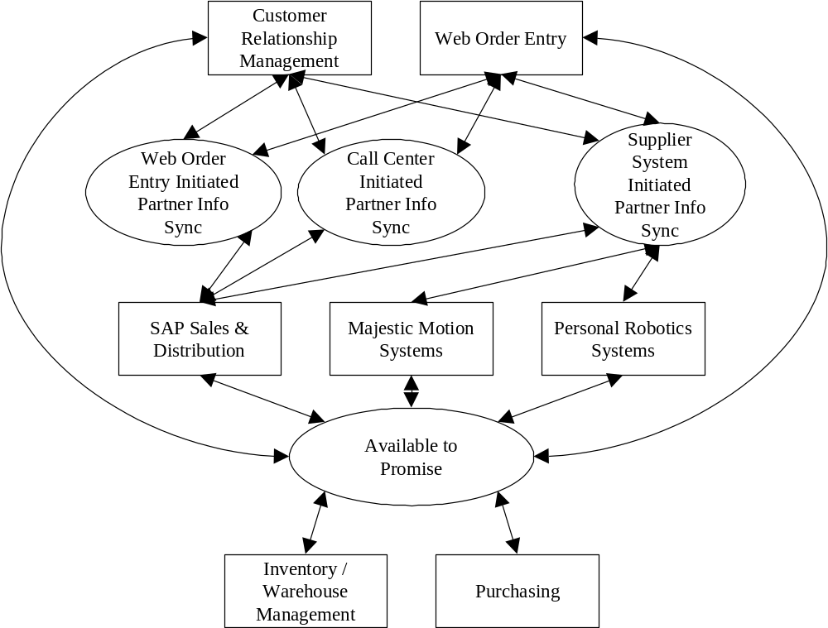
Figure 23 – Daukas & Lee Use Cases and Participating Actors.

Partner Information Synchronization Use Cases
These Use Cases capture the business function interaction for the synchronization of Partner information.
Table 24 – Supplier System Initiated Partner Information Synchronization Use Case
Use Case # | 1 | Supplier System Initiated Partner Information Synchronization Use Case
Subject Area |  | Daukas & Lee Company Partner Information Synchronization
Business Event |  | Triggered by the receipt of a partner information change by the Daukas & Lee CRM application.
Actor(s) |  | The initiating actor is one of the supplier systems.
Use Case Overview |  | An update to Partner Information for a supplier is received by the CRM application. Based on that receipt, the CRM application, the Web Order Entry Application, and the Sales & Distribution application will update their records in accordance with the update request.
Preconditions |  | The three Daukas & Lee applications are assumed to be available, and their internal Partner Information records are assumed to be in synchronization.
Termination Outcome |  |  | Conditions Affecting Termination Outcome
All 3 Daukas & Lee applications are updated and an acknowledgement is sent to the originating supplier system. |  |  | All 3 Daukas & Lee applications have succeeded in their internal updates. No updates have been lost in communication.
The CRM application fails to update its internal records, and no update request is sent to the other applications. The originating supplier system is informed of the failure. |  |  | Communications error between the supplier system and the CRM application. CRM application internal exception during update.
Use Case Description |  | An update to Partner Information for a supplier is received by the CRM application. Based on that receipt, the CRM application will update its records and send an equivalent update to the Web Order Entry Application and the Sales & Distribution application. These applications update their own internal records and send an acknowledgement to CRM. Upon receipt, the CRM application sends an acknowledgement of update to the originating supplier systems.
Use Case Associations |  | Web Order Entry Initiated Partner Information Synchronization Use Case, Call Center Initiated Partner Information Synchronization Use Case
Traceability To |  | N/A
Inputs Summary |  | Partner Information update request.
Output Summary |  | Advisement of update success or failure.
Usability Index |  | N/A
Use Case Notes |  | This is one of 3 possible update paths.

Table 25 - Web Order Entry Initiated Partner Information Synchronization Use Case
Use Case # | 2 | Web Order Entry Initiated Partner Information Synchronization Use Case
Subject Area |  | Daukas & Lee Company Partner Information Synchronization
Business Event |  | Triggered by the receipt of a partner information change by the Daukas & Lee CRM application.
Actor(s) |  | The initiating actor is the Web Order Entry application.
Use Case Overview |  | An update to Partner Information for a supplier or customer is received by the CRM application. Based on that receipt, the CRM application, the Web Order Entry Application, and the Sales & Distribution application will update their records in accordance with the update request.
Preconditions |  | The three Daukas & Lee applications are assumed to be available, and their internal Partner Information records are assumed to be in synchronization.
Termination Outcome |  |  | Conditions Affecting Termination Outcome
All 3 Daukas & Lee applications are updated and an acknowledgement is sent to the Web Order Entry application. |  |  | All 3 Daukas & Lee applications have succeeded in their internal updates. No updates have been lost in communication.
The CRM application fails to update its internal records, and no update request is sent to the other applications. The originating Web Order Application is informed of the failure. |  |  | Communications error between the Web Order Entry application and the CRM application. CRM application internal exception during update.
Use Case Description |  | An update to Partner Information for a supplier or customer is received by the CRM application from the Web Order Entry application. Based on that receipt, the CRM application will update its records and send an equivalent update to the Web Order Entry Application and the Sales & Distribution application. These applications update their own internal records and send an acknowledgement to CRM. Upon receipt, the CRM application sends an acknowledgement of update to the originating Web Order Entry Application.
Use Case Associations |  | Supplier System Initiated Partner Information Synchronization Use Case, Call Center Initiated Partner Information Synchronization Use Case
Traceability To |  | N/A
Inputs Summary |  | Partner Information update request.
Output Summary |  | Advisement of update success or failure.
Usability Index |  | N/A
Use Case Notes |  | This is one of 3 possible update paths.

Table 26 - Call Center Initiated Partner Information Synchronization Use Case
Use Case # | 3 | Call Center Initiated Partner Information Synchronization Use Case
Subject Area |  | Daukas & Lee Company Partner Information Synchronization
Business Event |  | Triggered by the entry of a partner information change into the Daukas & Lee CRM application.
Actor(s) |  | The initiating actor is the CRM application.
Use Case Overview |  | An update to Partner Information for a supplier or customer is received by the CRM application. Based on that receipt, the CRM application, the Web Order Entry Application, and the Sales & Distribution application will update their records in accordance with the update request.
Preconditions |  | The three Daukas & Lee applications are assumed to be available, and their internal Partner Information records are assumed to be in synchronization.
Termination Outcome |  |  | Conditions Affecting Termination Outcome
All 3 Daukas & Lee applications are updated and an acknowledgement is reflected in the CRM application. |  |  | All 3 Daukas & Lee applications have succeeded in their internal updates. No updates have been lost in communication.
The CRM application fails to update its internal records, and no update request is sent to the other applications. The CRM application reflects this failure. |  |  | CRM application internal exception during update.
Use Case Description |  | An update to Partner Information for a supplier or customer is entered into the CRM application. Based on that receipt, the CRM application will update its records and send an equivalent update to the Web Order Entry Application and the Sales & Distribution application. These applications update their own internal records and send an acknowledgement to CRM. Upon receipt, the CRM application reflects an acknowledgement of update.
Use Case Associations |  | Supplier System Initiated Partner Information Synchronization Use Case, Web Order Entry Initiated Partner Information Synchronization Use Case
Traceability To |  | N/A
Inputs Summary |  | Partner Information update request.
Output Summary |  | Advisement of update success or failure.
Usability Index |  | N/A
Use Case Notes |  | This is one of 3 possible update paths.

Available to Promise Use Case
These following Use Case captures the business function interaction for Available to Promise of Daukas & Lee product to meet forecast demand.
Table 27 - Available to Promise Use Case
Use Case # | 4 | Available to Promise
Subject Area |  | Daukas & Lee Fulfillment
Business Event |  | Triggered by realization of an the unplanned demand reflected in the Sales & Distribution order processing functionality, and validated against the current product inventories reflected in the Inventory / Warehouse Management application.
Actor(s) |  | The initiating actor is one of Web Order Entry, Siebel or SAP S&D, depending upon which order event has caused the planned demand threshold to be exceeded (above or below target).
Use Case Overview |  | Product orders received by the Sales & Distribution application indicate that the planned demand profile will be exceeded. Demand, Production and Supply plans are formulated in response to this change, and suppliers are queried for updates to their parts supply commitments to meet them. When an acceptable combination of supplier responses is received and processed by Daukas & Lee fulfillment applications, the plan updates are committed, and the updated demand plan is made operational.
Preconditions |  | A valid set of demand, production and supply plans are in place to drive current fulfillment operations.
Termination Outcome |  |  | Conditions Affecting Termination Outcome
Supplier commitments are obtained, and valid updated supply, production and demand plans are in place to drive continued fulfillment. |  |  | All applications are available within the cycle time frame to perform their focused processing. A combination of supplier parts supply is available to support the demand plan.
An updated demand plan cannot be met. |  |  | A combination of supplier parts supplies cannot be found to meet a supply plan and production plan that support the demand plan.
Use Case Description |  | Product orders received by the Sales & Distribution application indicate that the planned demand profile will be exceeded, when compared with the available inventories in the Inventory / Warehouse Management application. As a result, Sales & Distribution generates a net unfulfilled Demand Plan. The Demand Plan is used by Production Management as the basis for an updated Production Plan to meet the demand. Similarly, Inventory / Warehouse Management provides an updated Supply Plan based on the Production Plan that is used by Purchasing to formulate Requests for Quote, parts reservations, and Purchase Orders for the Suppliers. As the supplier responses to RFQ’s are processed, their impact is evaluated on the plan hierarchy. When an acceptable combination of supplier responses is received and processed, parts reservations and subsequently Purchase Orders are exchanged with the suppliers, the plans are committed, and the demand plan is made operational.
Use Case Associations |  | N/A
Traceability To |  | N/A
Inputs Summary |  | Customer orders and existing demand plan.
Output Summary |  | Updated plans and supplier contracts (P.O.s).
Usability Index |  | N/A
Use Case Notes |  | N/A

Available to Promise Process Flow
The following figure depicts the Daukas & Lee ATP process for committing to an updated product demand.
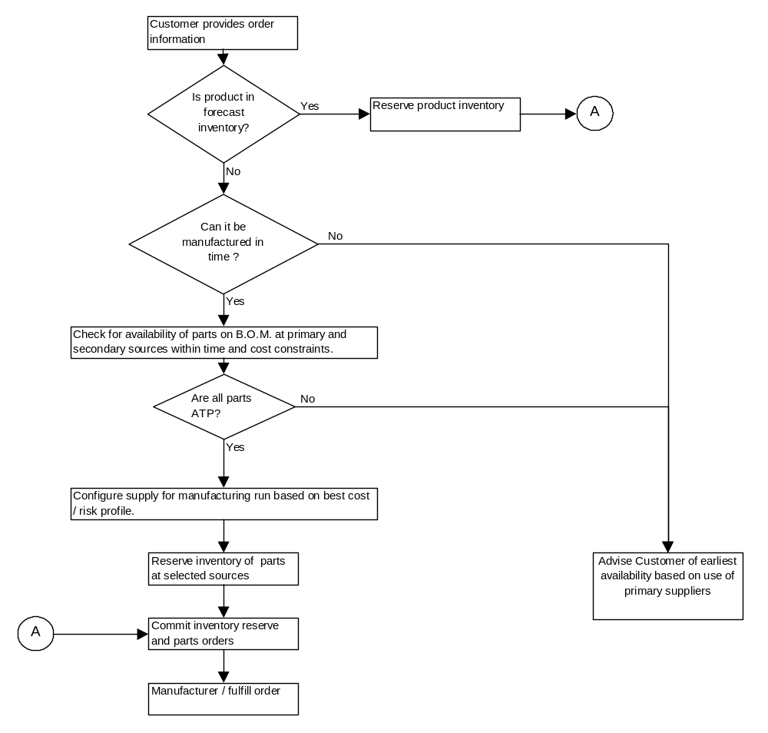
Figure 24 - Daukas & Lee ATP Process

Appendix D: Example EAI Attributes Blueprint
The attached Excel Workbook is a partially populated example of an EAI Blueprint for the Daukas & Lee example engagement. Please find this attachment stored externally in the Method Catalog entry for this Technique Paper. The file name of this attachment is “EAI_Attributes_Blueprint_for_Daukas&Lee.xls”.
- Revision History
Revision Number | Revision Date | Summary of Changes | Changes Marked?
1.0 | July 2002 | QA Approved
0.9 | 11/08/2001 | Release for GCD QA

The following non-IBM companies and products are referenced in this document:

Windows NT, Windows and Excel are trademarks of Microsoft Corporation in the United States, other countries, or both.

SecureWay PKI is a trademark of INTERNATIONAL BUSINESS MACHINES CORPORATION CORPORATION NEW YORK Old Orchard Road Armonk, NEW YORK 10504

IBM is a trademark of International Business Machines Corporations in the United States, other countries, or both.

Siebel is a trademark of Siebel Systems, Inc. CORPORATION DELAWARE 2207 Bridgepointe Parkway San Mateo CALIFORNIA 94404

Other company, product and service names may be trademarks or service marks of others.

