

IBM Global Services

DesignFlow Analysis Diagram Guide – Using Visio or WBI Modeler

Technique Paper (TP)

© Copyright International Business Machines Corporation 2004

All Rights Reserved
Version 4.1.1, May 2004
- Description
This paper describes the technique for creating DesignFlow analysis diagrams. These diagrams provide a graphical depiction of complex processes. As such, DesignFlow analysis diagrams are at the heart of process definition, redesign, and implementation engagements. These diagrams are time, role and process synchronization-based schematics of the entire process. They are generally, drawn using the VISIO or the Websphere Business Integration (WBI) Workbench modeling application called WBI Modeler.
The purpose of the diagram is to represent a business process with its activities organized within the roles that perform them and assembled in time sequence showing synchronization and process decisions.
The DesignFlow Analysis Diagram, is easily understood, and becomes a key communication device that focuses subsequent design discussions among process experts, end users and implementers. This capability is especially important for discussions that must focus on one activity at a time without losing information about their position within the process and their relationships to other activities.
This technique paper is divided into the following sections:
- What is a DesignFlow Diagram?
- Process Design and Analysis
- DesignFlow Constructs
- Additional Constructs
- Sample DesignFlow Process
- Context
The DesignFlow methodology packages operational process redesign work products into the following four deliverable volumes:
- Volume 1: As-Is Process Definition
- Volume 2: Redesign Requirements
- Volume 3: To-Be Process Definition
- Detail Design
Consultants may use the standard DesignFlow volume templates or customize them to meet client-specific needs. This technique provides guidance on how to create or refine the DesignFlow Analysis Diagrams for Volume 1 and/or 3. These volumes represent the Process Definition Work Product (BUS 309), but may also include parts of other work products.
See the “TP DesignFlow Volume Framework” technique paper and the appropriate work product description for recommended sections, notation, sample templates and other considerations.
- Steps

What is a DesignFlow™ Analysis Diagram?
As business processes become more and more complex, efficiently planning and managing all the involved activities and resources become more challenging. In order to achieve the required efficiency, it is necessary to systematically study and categorize the various elements or constructs that form the flow of work in business processes. DesignFlow™ provides the methodology and tools to capture this knowledge and design or transform an operational process.
This technique paper discusses the creation of a DesignFlow™ Analysis Diagram, which requires many design decisions based on good judgment resulting from experience.
As good judgment is critical for good results, the actual implementation of the DesignFlow™ team should be led by an experienced process designer.
A DesignFlow™ Analysis Diagram has more detail than a normal business process model, and includes key information not generally considered a part of business processes, such as:
- The concept of a role or skill set
- Individual activities
- A time line perspective -- activity sequencing, dependencies and synchronization over time
- Recognizes process instances, and all logic paths
- Knowledge-based decisions
- Applications used
- Control and measurement points
- Rework and restart definition
A DesignFlow™ Analysis Diagram is a detailed description of an operational process.
- It can be implemented by workflow manager software
- It can be executed by individuals who work in the process

Goal of a DesignFlow™ Analysis Diagram
The overall goal of a DesignFlow™ Analysis Diagram is to define it correctly from the user’s point of view. It is designed so that:
- The right skill,
- Is guided step by step through the appropriate decisions and actions,
- At the right time,
- So the operational process executes smoothly and efficiently
The above goals may appear easy to achieve. In fact, businesses are littered with process modeling projects that cannot be implemented.
A good DesignFlow™ Analysis Diagram is a communication tool that allows a business to:
- Deal with complexity
- Define their processes fully
- Plan and manage all their activities and resources
- Prevent problems
- Reuse tested parts of processes
- Change with the times
- Capture metrics

Overview of the DesignFlow™ Analysis Diagram
A flow diagram (as in the example shown below) has roles, activities, and actions that affect the flow (path) of work. The diagram must have all the paths including decisions, synchronizations, and dependencies like reject loops.
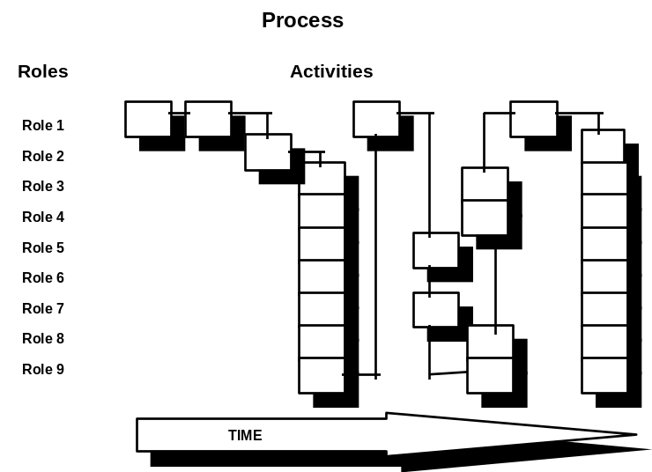

DesignFlow™ Paradigm

- Time: Always moves from left to right.
- Roles: A set of skills that perform activities or tasks, independent of the organizational structure in the company. One person might perform one or more roles, or a role might be an organizational unit. Examples of roles are:
- Designer
- Supplier
- Team Leader
- Waiter
- Monitor

- Activities: Work done by a specific role at a specific time in the process, such as:
- Making decisions (in response to guidance prompts).
- Analyze results
- Attend a meeting
- Writing a report
Activities could be composed of one or more “events” such as:
- Invoking an application program(s),
- Accessing data and/or database(s),
- Manual activities (make notes on paper, telephone, etc.),
Note: Events that go on within an activity are described on associated Activity Data Sheets, not on the flow diagram.

- Sequencing and Synchronization. Activities are sequenced and synchronized by their placement on the flow diagram and by the flow lines that connect them. In a flow diagram:
- Activities occurring at different times will be in different columns,
- Concurrent activities will appear in the same column,
- Activities could be waiting for other activities to start,
- An activity could start but may need to wait for other activities to be completed before it, is completed,
- Decision boxes may reject, revert, or change the process flow to different roles.
- Instances: An Instance is one occurrence of the process. Some processes have points where more instances are created. This is noted in the diagram.

Process Design and Analysis
Process definition is a collaborative activity between the design team and the user team.
The design team builds, tests, and documents the Analysis Diagram. It generates the flow diagram and registers the programs and the data structures that it requires. This team requires business analysis and system analysis skills and must ultimately understand the staff concerns of the process they are modeling. It would include programmers that either develop new applications or modify existing ones to be integrated to support the process.
The user team would include process administrators that start, interrupt and resume the process, and change work assignment, people who work in the process and system administration.

Before Starting to Model
Before beginning the modeling process, the design team needs to:
- Gather existing process descriptions.
- This may be in policy and procedures manuals, or in flowcharts (wall charts, overhead transparencies, etc.)
- Most of the process description is probably not written down (or may be incomplete and out of date). It is critical to get the right people who understand the process in the user team.
- People who work in the process (the users).
- People who know the process end to end (anyone who has been working on re-engineering this process).
- People who will implement the process (from the Information Systems organization).
- Make sure all the organizations associated with the process are involved in modeling it.
- Make sure the best people are on the user team. They are the busiest people and businesses would reluctantly spare them.
- Prepare for an intensive DesignFlow™ session.

Initial Questions
Start the modeling session by asking the design team to:
- List all the "roles" involved in the process. This may be done through brainstorming.
- What starts the process, and how it is started?
Substantial discussion is expected for the first activity as the teams warm up to the constructs.
For the initial activity, the following questions should be answered:
- What decisions or choices are made at the start?
- Who makes them?
- What completes the activity?
- Does anything in this activity cause a reset or repeat loop in the process?
Note that the granularity (size/bounds) of an activity is very flexible and that each activity can have sub-activities called "events."

Subsequent Questions
For each subsequent activity in the process, the following needs to be known:
- What activity is done next?
- Who does it?
- Is this done at the same time as any other activity?
- What decisions or choices are made at this point?
- What data is needed?
- Where is the data stored?
- What application programs or tools are used?
- What is done manually (on paper, telephone, or sneaker-net)? Should any of this be automated?
- What are the results of these decisions/choices?
- What guidance (prompts) are needed to guide the user to perform this activity?
- What completes this activity?
- Do any events in this activity or the completion of the activity signal another role/activity to begin?
- What are the conditions of resets or loops?
Modeling each activity is an iterative process. In the end it should benefit the user and be perceived as value-add and not as "just more work."

Hints and Tips
- Select appropriate roles. Often roles can be identified in a number of different ways. Pick one that is natural to the user team.
- Select the right activities. Activities can also be identified in different ways. Again pick one that is natural to the user team. All activities should be in the form of “verb-noun”.
- Do not violate the left-to-right timeline of the flow diagram (except for redos/rejects).
- Identify activities and decision points that happen simultaneously (concurrently).
- In the flow diagram, only show what affects the flow of work (not the events inside the activities).
- In the Activity Data Sheets, describe what goes on inside the activity and identify points where applications, tools, and databases are used. Also describe guidance prompts for the user.
- Model real user processes. Some process methodologies try to model the ideal. To add real value, an Analysis Diagram must capture the real processes so it can be used it to run the business.
- Think of the diagram as an assistant for each role, guiding the user through the process.
- Involve all the people on the team.
- When done well, the modeling not only captures the process, but also finds ways to streamline and improve it. For example, can what is done manually today be done electronically in the workflow (scratch sheets vs. electronic notepads)?
- Look for ways to eliminate activities, or to make them concurrent, to improve cycle time.

Pitfalls to Avoid
Not getting the best people to participate in the user team. People who are respected by their peers and know the real process must participate in the process modeling.
Focusing on technology concerns instead of the user view. The model will only work in the business environment if the user view takes priority over any technology concerns.
Settling for the status quo. Process modeling will naturally uncover areas that are inefficient. Those areas should be improved.
People tend to over design. Keep the design as simple as it can be.
Be careful in leading the group in to your own conclusions. Allow enough discussion to get to the real process.

DesignFlow™ Constructs

The different types of DesignFlow™ Constructs are described in this section in alphabetical order, with examples of each, for both the VISIO and the WebSphere Business Integration (WBI) Workbench modeling applications.

ACTIVITY (Task in WBI)

Visio WBI

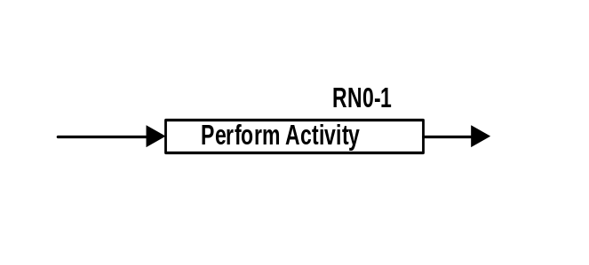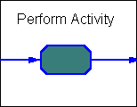

Description
- An activity is a piece of work done by a specific role at a specific time in the process. Activities can have several different sub-activities called "events,” such as:
- Make decisions (in response to guidance prompts)
- Review data
- Attend a meeting
- Selecting an analysis method
Events that occur within an activity are described in the associated narrative description in the Volume 1.

There is no fixed size to an activity. It may have one event, or it might have many events. The size of a specific activity is a design decision.

Location
- Activity constructs are placed horizontally in time order next to the associated role.
- Activities that are in the same vertical column are performed at the same time (concurrently).

Notes
- Each activity should be identified with a unique ID. By convention, the ID includes the first letter or two of the role name, and then a sequential number. It is recommended to increment these numbers by 10, so that intermediate activities can be added in later revisions. For example, the second activity for the Host role would be H-20.
- The template will drop in a label “RN0-0”, which should be changed to the Role Name and Activity Number.
- The activity description should be in the form of verb-noun , e.g., "Review Draft” -- not ‘draft is reviewed” and not just “draft”
- All input paths enter an activity from the left and exit to the right. There are no top or bottom connections on the activity box.

Related Constructs
- Role
- Autoperform
- Interactive Activity

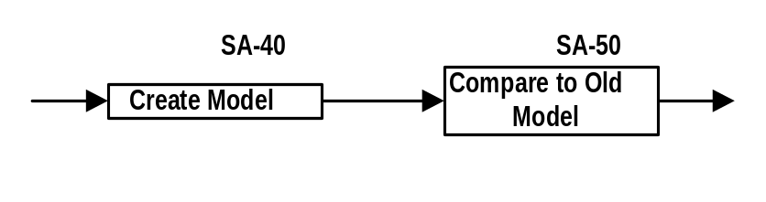Examples

This is a simple example of two activities of the “System Analyst” role.

For WBI Modeler:
- The WBI refers to Activities as Tasks.
- Activity numbers will be specified in the “Abbreviation” field on the “General” Tab of the Task.
- The “notes” tab of the task uses the “Process Participant Narrative” to output the task description in the Volume 1 or 3. The input and output conditions will output to the Activity Detail Matrix in the Volume 1 or 3. The “System…” will output to the Detail Design Document. Volumes are generated through the “Reports->Documentation Reports->All” commands.
Example:

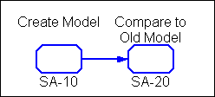

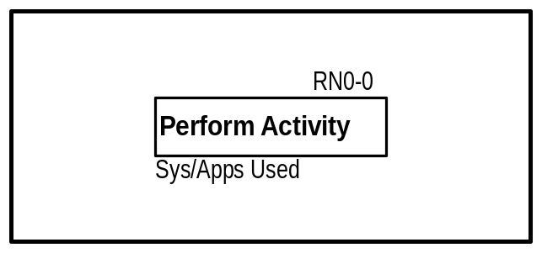ACTIVITY – INTERACTIVE ACTIVITY
Visio WBI

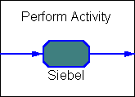

The Interactive Activity is similar to an Activity construct but emphasizes a system or application that is required to perform this activity. This construct is used in situations where it is critical to denote systems or applications on the diagram.

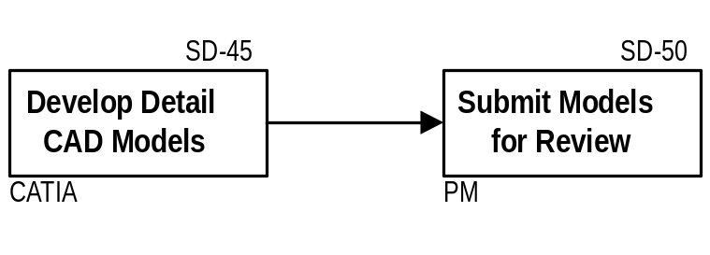Examples:

Notes:
This construct always resides on a human role.
The application used is found on the “General” tab of the WBI Task. If more than one application is used to perform the activity, it can be specified on the “Resources” tab. The applications must be defined in the respository.

WBI Example:

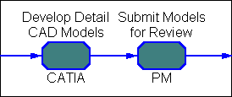

AUTOPERFORM

Visio | WBI modeler
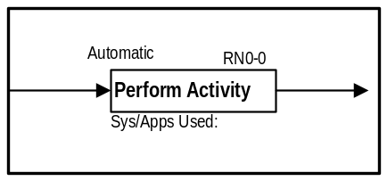 | 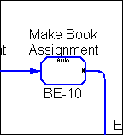

Description
The Autoperform construct designates an activity that is automatically performed. This can be a software program that gets launched, or a script that is run if a condition is met. An Autoperform Construct is designated by the label “Automatic” directly above the activity. If there are a series of activities involved, they should be bounded by n activity group or placed on a system role line.

Notes
- In cases where the Autoperform is executed on a series of activities, these activities should be bounded by a box and the “Automatic” text should appear in the upper left corner.
- The Autoperform activity resides on a human role line and is equivalent to activities placed on a System role line if it is known or pertinent at the time

Related Constructs
- Activity
- Flow Lines
- Text

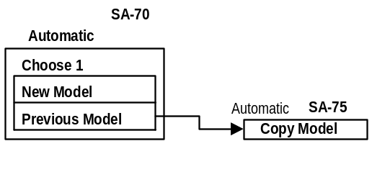Example

In this example, the choice between using a new model or previous model is selected automatically based on predetermined values. If the “Previous Model” option is selected, a script automatically copies the data to the user’s work area.

WBI Modeler
- The “Auto” designation on the task is done by checking the “Auto” Box on the “Automation” Tab of the task.

CONTROL POINT

Visio WBI Modeler
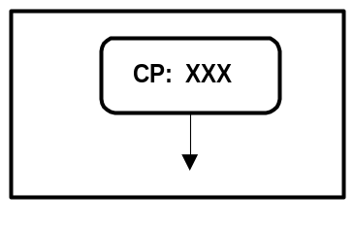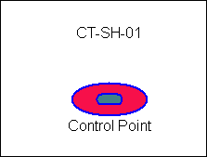

Description

A location in an application, system or business process where an action (control) must be taken to ensure data integrity, effectiveness and efficiency of operations, reliability of financial reporting or compliance with applicable laws and regulations. It may apply where opportunity for an error or undesired activity can enter or occur in the application, system or process.

Notes
- The text within the construct always begins with “CP:” and is followed by one or more Control Point identification codes. If there are multiple identification codes, they are separated by commas, and documented in the Volume 1 or Volume 3.

Related Constructs
- Flow Lines
- Activity

Example:
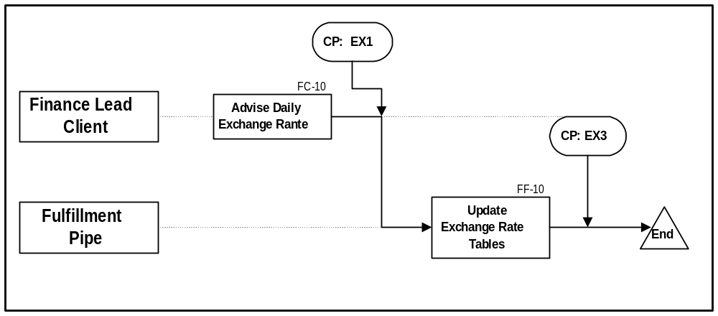

Control Point:
EX1 Daily Exchange Rate Update: - 2% Difference Report - performed by ESAP
EX2 Daily/Monthly Exchange Rate Update: Batch Control Process before billing run; Error log message/verification

In the above example, a control is used to verify system integrity e.g. if I ship a file to another system I check control logs to verify it was received, that is a control point. If I allow the operator to change the price, a control point is the print a report with who changed the price, by how much, on what order. Here is a file with a few real examples. The first diagram exchange rate update, there is a control point to print a report with any exchange rate that varies by 2%.

Measurement Point:

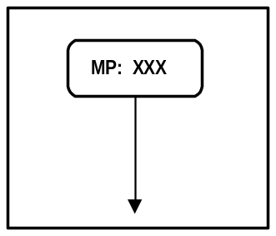

By editing the Control Point Construct text, a Measurement Point can also be defined as a point in the process where a critical measurement must be taken.

WBI Modeler
1. The Control Point will be modeled as an external process with an external entity of “Control Point”. The external process name will match the control point number. The note field of the external process will contain the URL associated with the Control Point document.

DATA STATE CHANGE (WBI Modeler – See “Phi”)
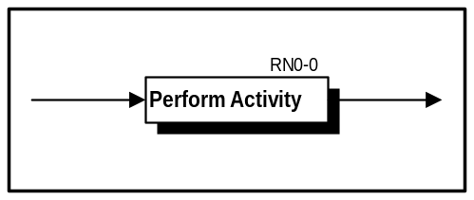

Description
A shadowed box is used to designate a change in status of data, such as release levels

This construct might be used for indicating data state changes in a Product Data Management (PDM) system, because many other processes are keyed off the data state changes in the PDM.

Notes
- Many PDM installations will have documents in different states of release, such as “Create”, “In-Work”, “Review”, and “Release”.
- A shadow is created through the “Format – Shadow” icons.

Example

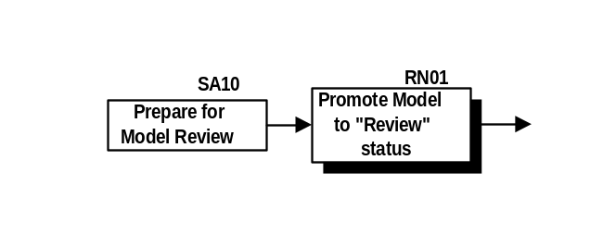

In this example, an analysis model is promoted from its release status of “In-Work” to “Review”.

WBI Modeler
A data state change will be modeled through ”Phi” states in the WBI Modeler. Please refer to the “Phi” section of this document.

DECISION -- CHOICE BOX

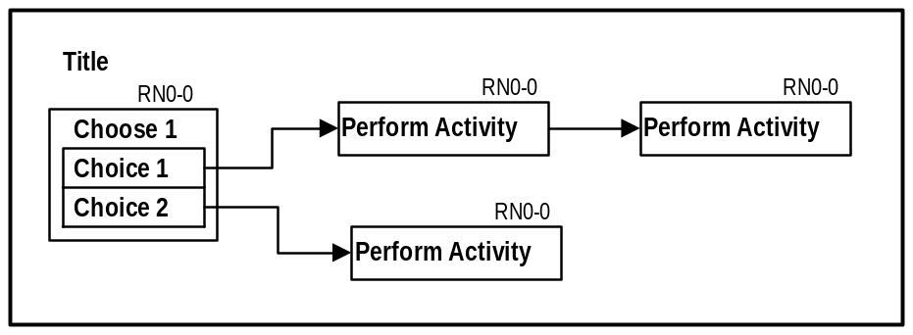

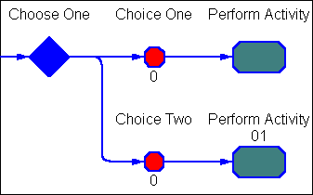

Choice Box
The choice box can be a simple branch in the process (Choose 1), or may represent a point in the process where several branches may occur (Choose N, where N is greater than 1).

Related Constructs
- Activity
- Multi-Thread
- Decision (2 way branch)
- Flow line

Notes
- When “n” of “Choose n” is greater than 1:
- Flow lines connect to a “thread” of activities aligned with that Choice
- Subactivities within the thread may be performed by other roles (but this is rare)
- You can use “Choose n” where n is a variable number only if n will be defined prior to getting to this Choice Box (in other words, you must be able to enumerate the selections once you get to the choice box).

WBI Modeler
- The WBI modeler also has a simple or a complex choice. For a simple binary choice, see “Decision Diamond” in this document.
- Both types of choices are modeled with a Choice Diamond.
- A complex choice allow for more than one choice option in the branch (e.g., 1 of 3); or for multiple choices to be selected (e.g., 2 of 4 or 4 of 4).
- For the Multiple choice, a “Phi” must connect each thread of the choice to the decision diamond.

Examples:
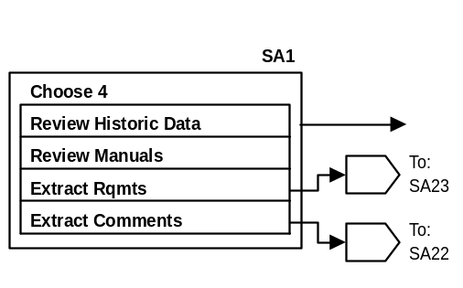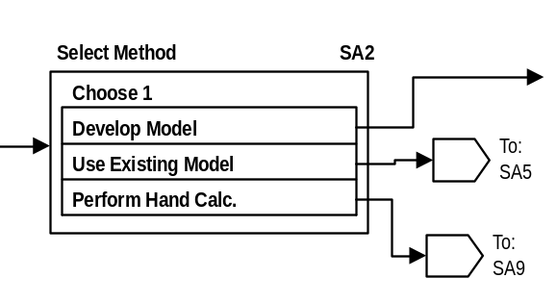The following are two examples of Choice Boxes:

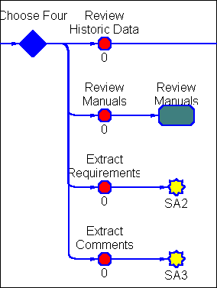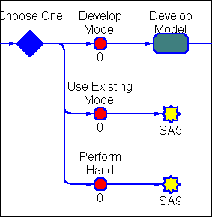

The Choice Box for Activity SA1 requires all four options to be performed before completing the activity. The second Choice Box example shows a situation where only one option is chosen, and the flow continues from there.
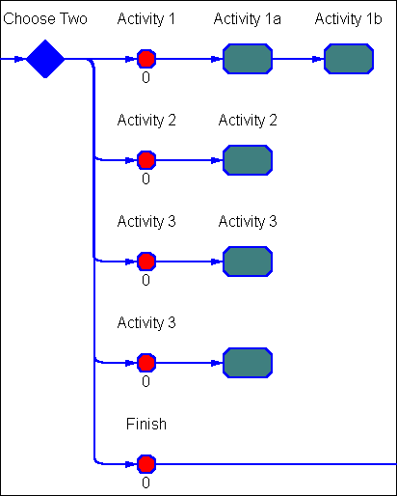
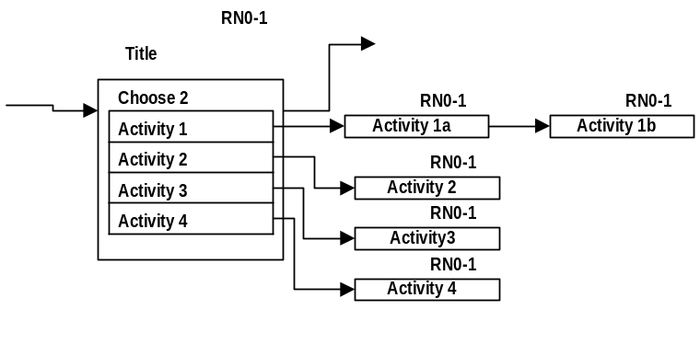

In the choice box above, any 2 of the 4 activities can be selected (in any order), then control returns to the outflow line on the outer part of the Choice Box.

Example of a complex choice to model web menu:
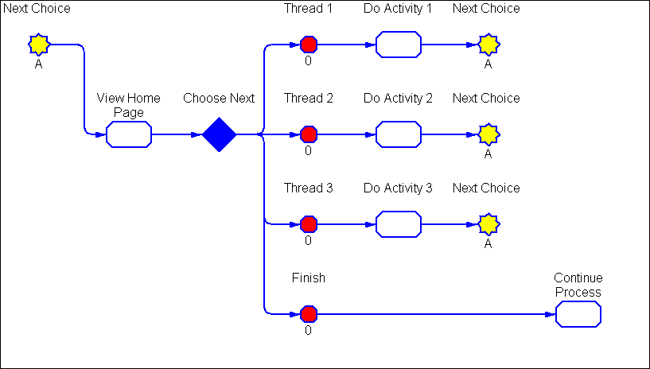

DECISION – MULTI-THREAD
A Multithread denotes a point in the process where several “threads” of activities may occur simultaneously. It is similar to a Choice Box, but more than one thread of activities may be performed at any given time. You will use a Multi-thread when you cannot model the process sequentially.

This Multi-Thread activity is complete when either:
- All activities in the box are complete
- The user selects Finish, even if some of the activities are incomplete

In all cases, the flow continues from the FINISH thread when the Multi-thread is complete.

Related Constructs
- Activity
- Choice Box
- Flow line

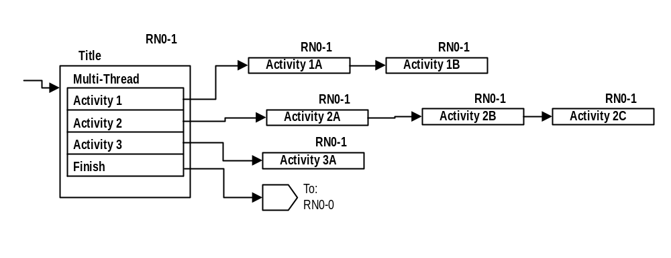The following is an example of a Multi-Thread Box:

Each option of this multi-thread consists of multiple activities. Any of Activity threads 1-3 can be done in any order, and furthermore, the subactivities can be suspended to return to the Multithread box to work on another thread. When threads are completed, the flow returns to the multi-thread control continues from Finish.

To be more specific, you could do the activities in the preceding example in any of the following orders:
- 1A, 1B, 2A 2B, 2C, 3
- 2A, 2B, 3, 2C, 1A, 1B
- 3, 1A, 2A, 1B, 2B, 2C
- etc.

WBI Modeler
- The Multithread Box construct is not supported in WBI
- The behavior of activities may be represented in several ways in WBI. The simplest form would be as follows: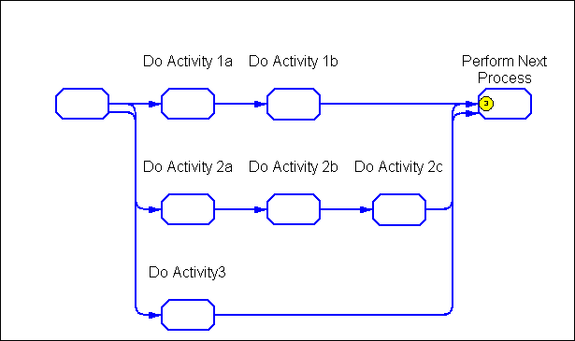
- More sophisticated behavior can be modeled with the use of choice logic and is dependent on the level of detail required.

DECISION BRANCH (2 WAY)

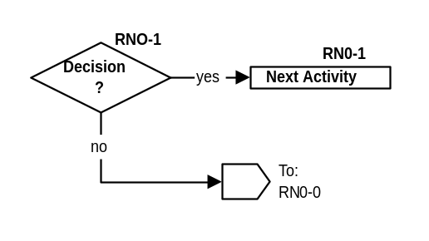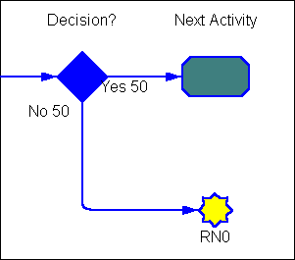

Description
Decision constructs are used to indicate different process paths for a role, depending on the result of an either/or (2-way) decision.

Notes
- The “Choice Box” construct preferred over this “diamond” construct, unless it is clearly a Yes/No decision. The reason for the preference is that 2-way branches tend to grow into multi-way branches as you further validate a process.
- Decision constructs are used only when the path of the process is changed.
- These are not the decisions that occur within an activity.
- YES is always a forward (horizontal) path.

Related Constructs
- Choice box
- Activity
- Flow line

Examples
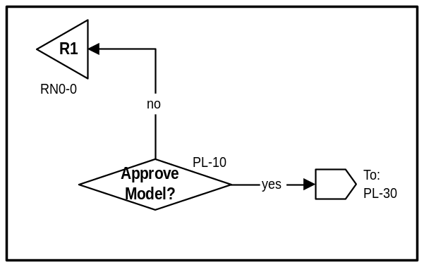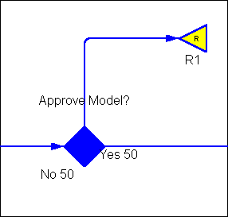

END ROLE

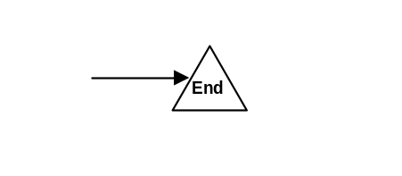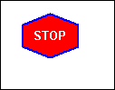

Description
The end role construct marks the end of a role.

Location
The end role construct is placed after the last activity of a role. This construct is often not used unless the role ends before the end of the diagram.

Notes
This “end role” construct is generally assumed, unless a role unexpectedly ends well before the end of the page.

Related Constructs
- Role
- Activity

Example
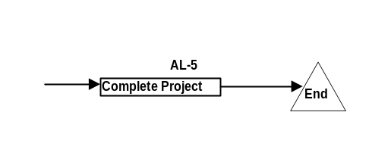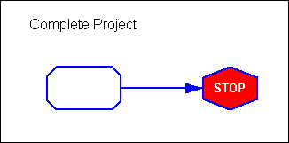

EVENT TIMER (WBI Modeler – see “Phi)

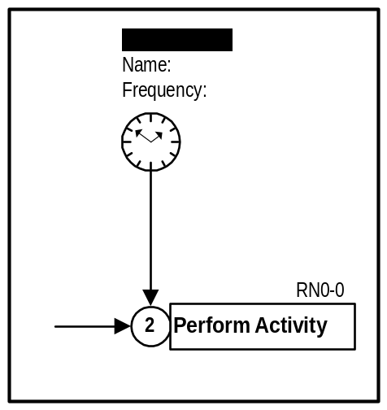Description
The Event Timer is used to synchronize time-related events such as batch processes or significant milestone events.

Notes
- The text fields under the title can be customized to the type of event described. If it is a batch process, the frequency may be daily at midnight.

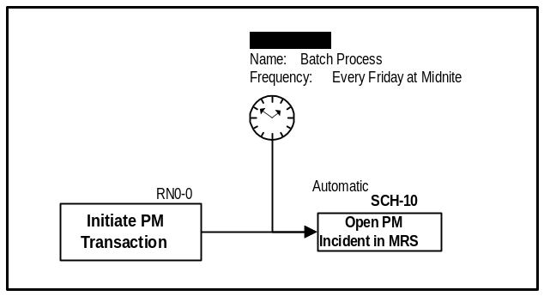Related Constructs
- Activity
- Flow Lines
- Wait

Example
In this example, a “PM Incident” is automatically opened either when a manual transaction is initiated, or every Friday at midnight.

WBI Modeler
The event timer will be represented as a “Phi” in the WBI modeler. Please refer to the section of “Phi” in this document.

EXTERNAL PROCESS
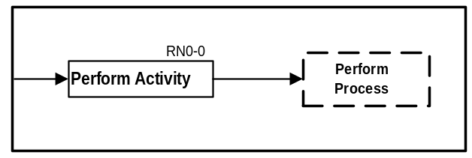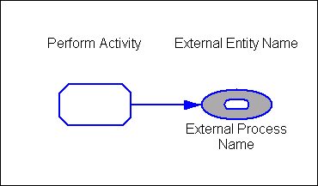

Description
The External Process construct is used to denote work that continues in another process and is not documented in this diagram.

Notes
- The external process name should be entered in the box.
- This construct is used when work is continued and the entire external process is then performed.

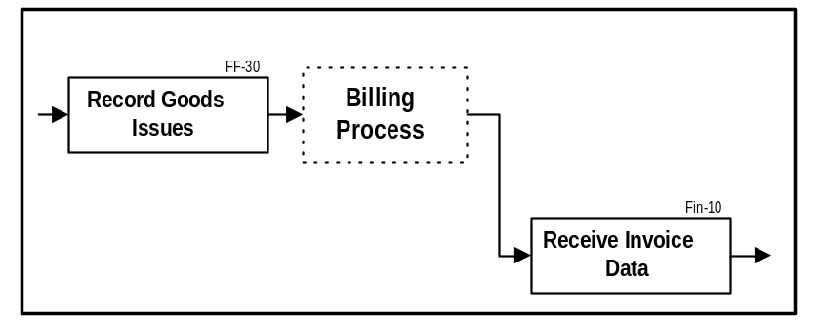Related Constructs
- Activity
- Flow Lines

Example

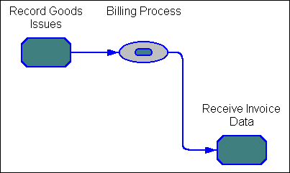

WBI Modeler
1. The external process is also denotes that information for that process is not contained in the .org file of the active process.

FLOW LINES

Visio WBI Modeler

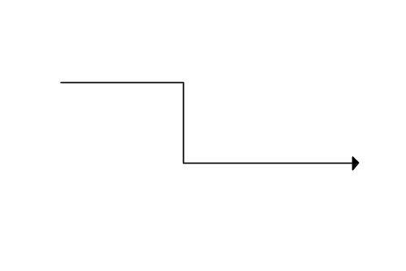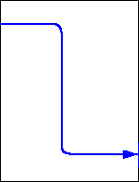

Description
A flow line shows how work in a process “instance” flows from one activity to the next.

Notes
- In a DesignFlow Analysis Diagram, it is not data that is flowing. Rather, it is work (or a signal to do work).
For example, the assumption is not that a document or folder flows from role to role. Instead, a signal flows, which might indicate to look in a database, find and open a folder, or use data that is already at hand.
- Work always flows from left to right. The only exception is a redo/reject loop.
- When multiple flow lines from the left condense in to one flow line to the right, only one of the signals is needed to start the next activity, unless a “Wait” construct appears.
- When a single flow line from the left branches to multiple flow lines to the right of the connect, it is assumed that the flow follows all paths.

Related Constructs
- Activity
- Connector
- Multi-Tree Connect

MULTI-INSTANCE ACTIVITY GROUP (Instance)
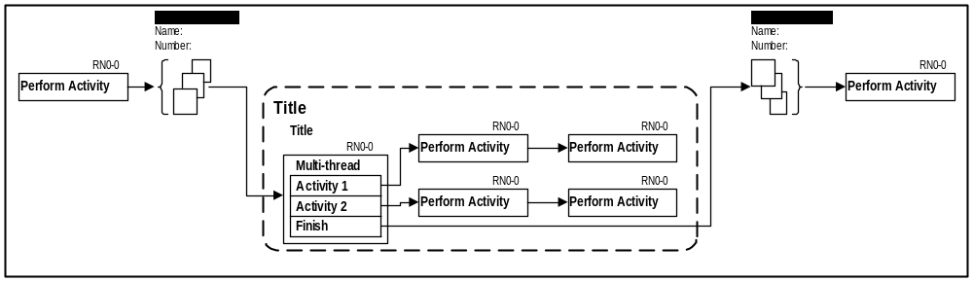

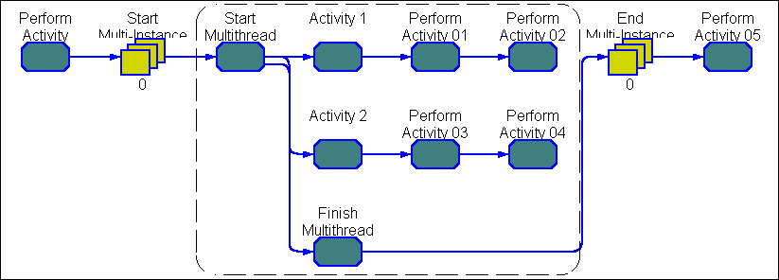

Description
In some processes, a set of activities may be performed multiple times concurrently at a point in the process execution. Each set is an “instance”

An example of where instantiation is important would be in a process to develop a document when the document will be translated into different languages. The specific languages for translation are selected during the process execution, so you cannot tell ahead of time how many “instances of language” translations you will need.

The Multi-Instance Activity Group is surrounded by a dashed line font and labeled accordingly.

It is important to represent where an activity creates multiple copies or “instances” of an Activity Group and the basis for how many instances of work are created. It is also important to represent where the process waits to synchronize while the many instances complete (usually on different schedules.) They may involve the same roles as this process, or involve a subset or different roles.

Notes
- Multiple instances of a group of activities occur simultaneously,
- Instances are generated dynamically: the number of instances cannot be determined ahead of time

Related Constructs
- Activity
- Flow Lines

WBI Modeler

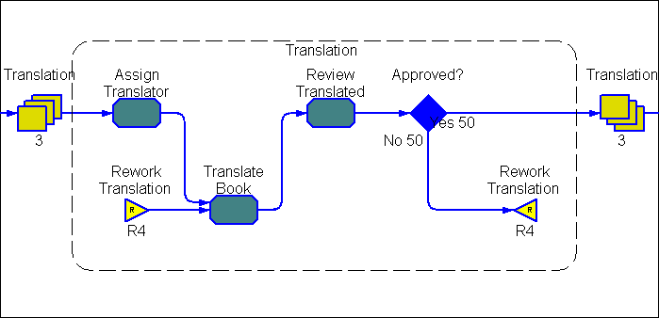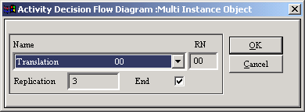
The start of a MultiInstance will prompt for a Multi Instance Name
By Checking the “End” field, a pulldown arrow will appear in the Name Field to select the Multi Instance

MULTI-TREE CONNECT (N/A for WBI Modeler)

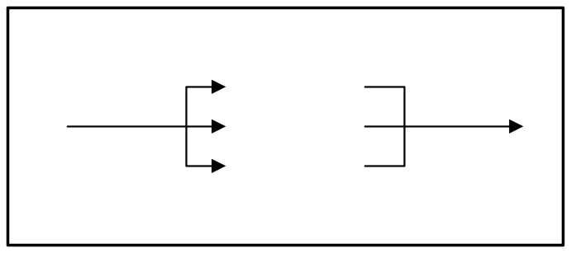Description
A multi-tree connect is used when there is a branch in the process signaling more than one follow-on activity, or where many activities return to one activity.

Notes
- The default construct has three branches, with up to seven additional branches built in. To add a branch, hold the left mouse button over the green box located midway along the left horizontal line. Move the cursor to the right and place at the desired end location. Let go of the mouse.
- This feature can also be accomplished by manually entering connect lines.

Related Constructs
- Activity
- Flow Lines

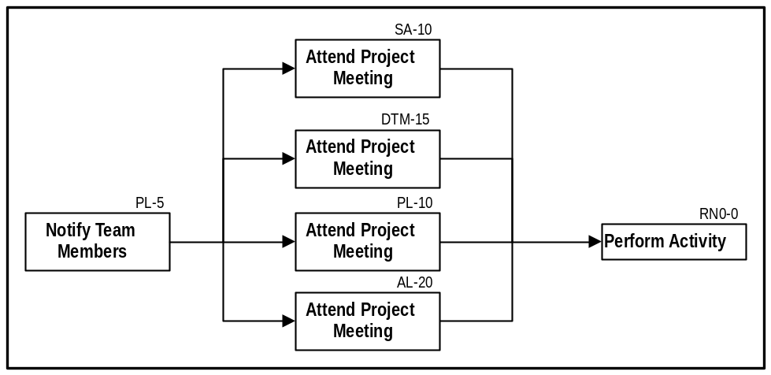Example
In the above example, the first activity is described by PL-5, where the Project Leader notifies team members of a meeting. The second activity in time is the meeting, which is attended by the Project Leader, the Design Team Member, Activity Leader, and the Stress Analyst.

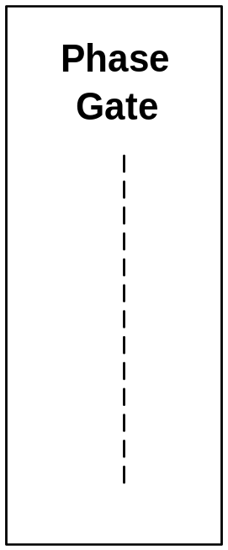PHASE / GATE DELIMITER (N/A for WBI Modeler)

Description
Most end to end processes consist of phases and/or gates. The separation of these phases is represented by the Phase/Gate delimiter.

Notes

Related Constructs
- Activity
- Flow Lines

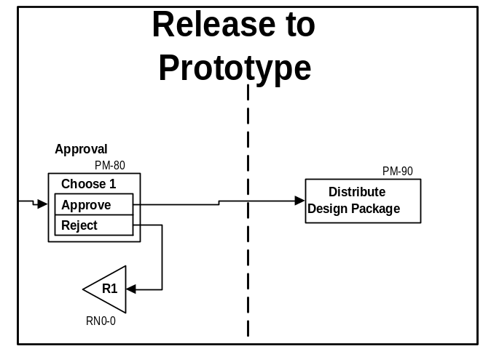Example

PHI (WBI Modeler ONLY)
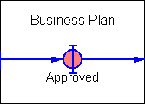

Description
Phis define the inputs and outputs of tasks and are important for capturing the business information objects (ex. orders, reports, bills of materials) and triggers (ex. notifications, emails, approvals) and their flow through the process. Phis are also used to designate a change in status of data, such as release levels. This construct might be used for indicating data state changes in a Product Data Management (PDM) system, because many other processes are keyed off the data state changes in the PDM.
Phi Types are used to group Phis into classifications based on common characteristics (ex. Phone Call, Display, Order) and are defined in the repository.
Phi Categories are used to specify the medium of the Phi (ex. Electronic Document, Paper Document, Other).
Phi States are used to represent a Phi’s life cycle through a process (ex. Pending, Approved, Not Approved, Complete).
It is not necessary to specify a Phi between every pair of tasks, but they should be used in all of the following situations:
When the performance of a task significantly transforms the Phi’s state
At the beginning and end of each sub-process
At handoffs between roles
Where additional input comes from other entities or processes

Notes
- Many PDM installations will have documents in different states of release, such as “Create”, “In-Work”, “Review”, and “Release”.
- Phis correspond to Living Architecture / EDM information flows
- Because of their large number, standard Phi names are not included in template.org
- Phis should have ‘noun’ names.
- Do not include Phi state or category as part of the Phi name. Use the State and Category fields to capture this information.
- To create a Phi, click on the Phi button on the tool bar and then click on the chart to place the Phi symbol in the desired location. To create a new Phi icon, click on “Phi Types” -> “Bitmap” -> “Add”, and select the BPM subdirectory “icons” . Select and icon from list list and it will enter it on y our bitmap library. From there, it can be applied to the Phi type.
- Enter minimally the Phi Name, Type, Category, and State in the appropriate fields.

Related Constructs
- Even Timer
- Data Handoff
- Data State Change
- External Entities
- External Processes
- Sub-processes

Example

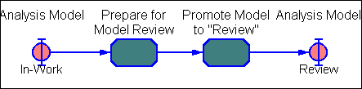

In this example, an analysis model is promoted from its release status of “In-Work” to “Review”.

RESTART / REWORK

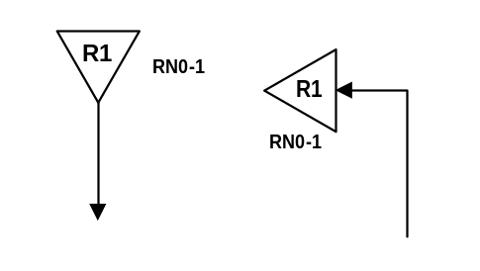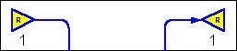

Description
The rework symbol designates a return to a specific point in the Analysis Diagram. There are two components: The rework symbol points to the left, indicating the origin of the rework effort (usually some sort of rejection). The restart symbol points down, indicating where the work is to continue. A restart/rework construct can also perform designated functions when the process is restarted. Examples of this may be to reset the environment of a role at the Restart instant in time, or to set certain flags or environment variables when the Restart occurs.

Notes
- The number inside the triangle designates a specific rework instance.
- Each restart/rework pair should have a unique rework number.

Related Constructs
- Activity
- Flow Lines
- 2-Way Decision
- Choice Box
- Multi-Thread

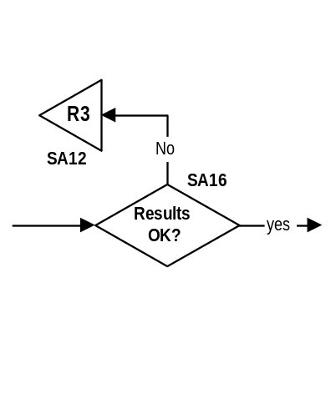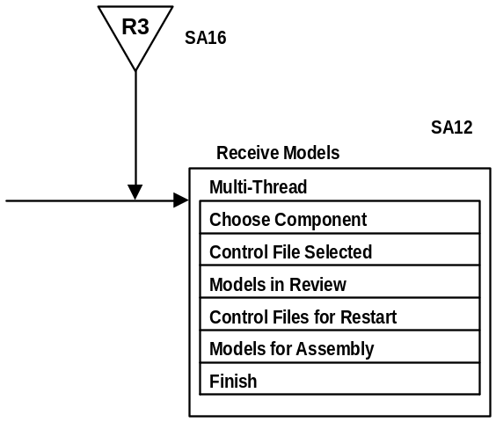Example

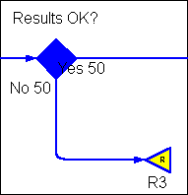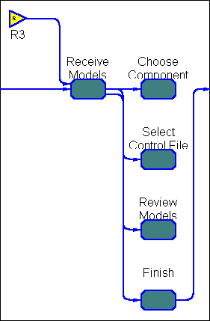
REDO GRAPHIC
In this example, a “No” response to “Result OK?” takes the workflow back to the return construct, “R3”.

In a complex process, where multiple reverts point to the same restart location, you must create unique restart/rework designations to clarify different conditions. In the example below, reverts to activity SD1-2 occur multiple times in the process. We see two of these occurrences, labeled R1 and R2.

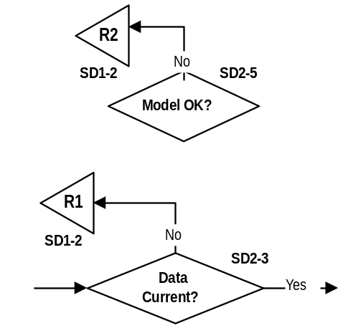
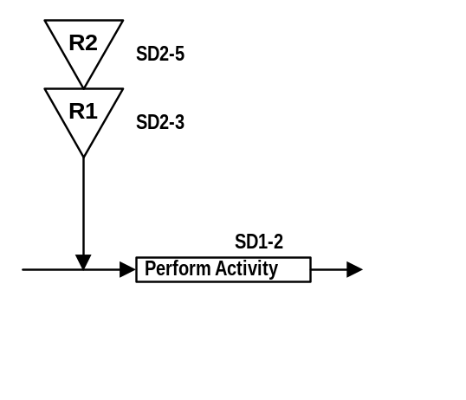

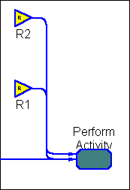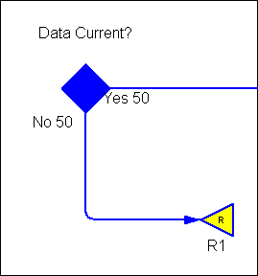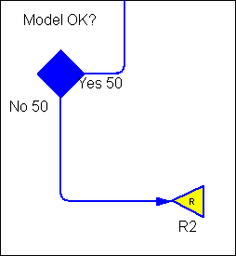

WBI Modeler

The Rework and restart symbols are created in BPM Workbench by use of the “Go To” object, and clicking the “Rework” field. 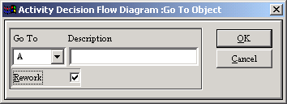

ROLE

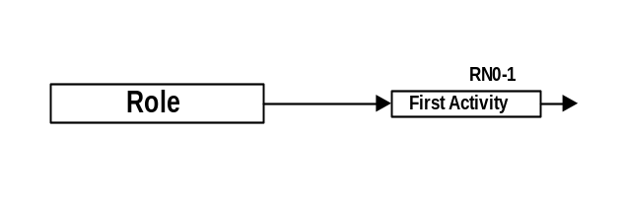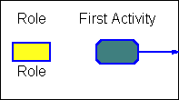

Description
A role indicates an individual who performs activities or tasks, independent of the organizational structure of the business process. One person might perform one or more roles, or one role might be filled by several different individuals.
Examples of roles:
- Designer
- Supplier
- Manager
- Team Leader
Roles are intended to be individuals, not departments or organizations. Keep in mind that the responsible role is the person who is accountable for this result, not someone who may have been delegated this responsibility. Roles can also be used for monitoring events. In that case the role is not necessarily a skill set. All the roles in a process need to be included in the flow diagram.

Location
Roles are listed vertically along the left-hand side of the diagram. Activities for each role are aligned horizontally beside the role (in “swim lanes”).

Notes
- Role names are entered by double clicking the text box. The name will also appear in gray on the role line across the width of the page.
- To make the names on the role line different than the name in the box (if you want an abbreviated name across the page and the full name in the box at left), double-click the text box and enter the abbreviated name. The abbreviated name now appears in the box and across the page. Single click on the text box and hit F2 (text mode). Edit the text in the box to the full name.

Related Constructs
- Activity
- End Role

Example

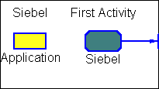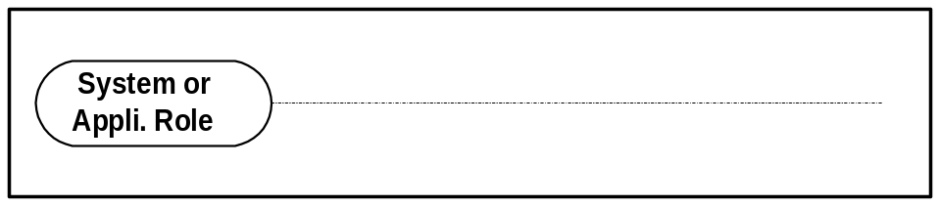

When many automated activities are being performed by a system or application, and it is important to distinguish these from activities done by individuals (as in a technology view required for the Detail Design), a role can denote a system or application. In these cases, the role construct is modified to have rounded corners, and the role should be placed at the bottom of the diagram when possible.

WBI Modeler
1. The application role is entered as a role type of “Application”.

SIGNAL BREAK / LINK
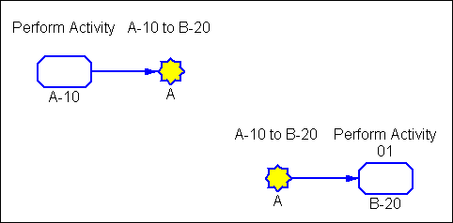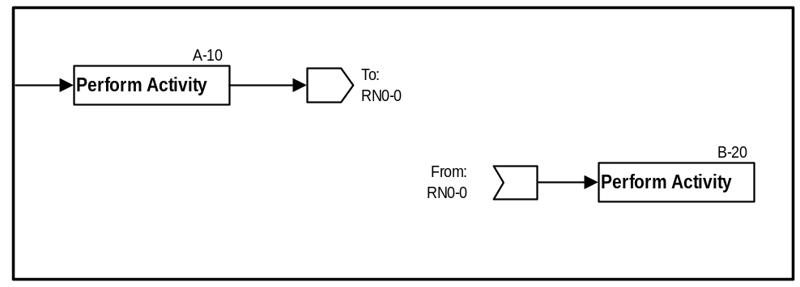

Description
Signals are used for linking one spot to another, without drawing the full connecting line. This can occur on the same page or on different pages.

The signal break/link is useful because long flow lines are difficult to see and understand.

Notes
- The connecting activity number should be entered in the text field provided.
- If two activities connect to the same third activity, the activity numbers may be listed as in the example below

Related Constructs
- Flow line
- Activity

Example
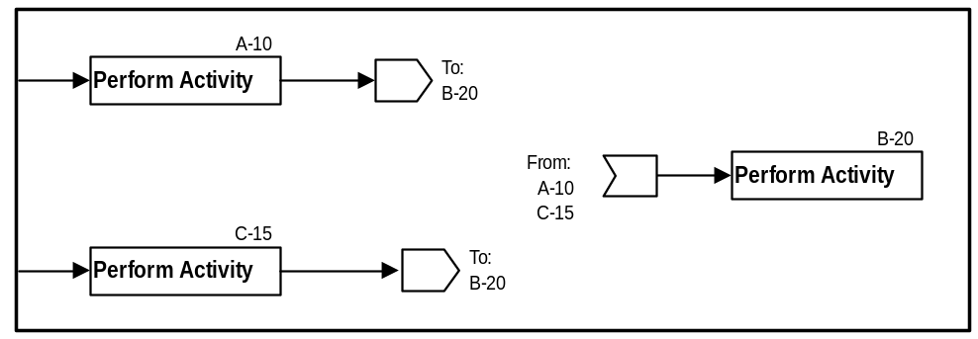

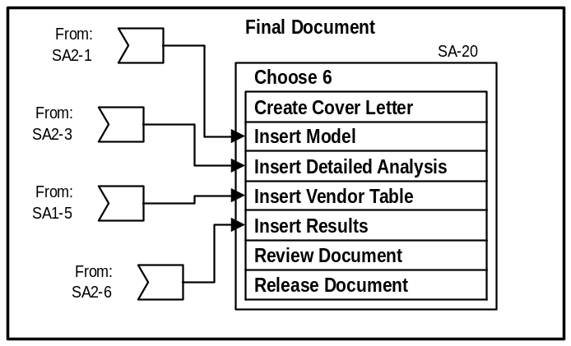

The activity to create a document has input from various places in the process. This example shows how the signal construct is used to eliminate confusing flow lines.
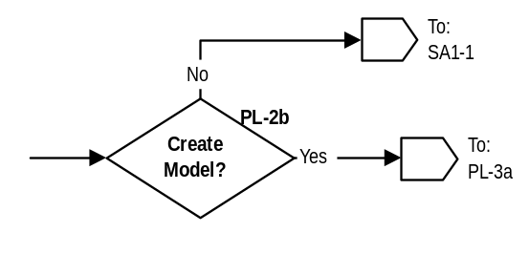
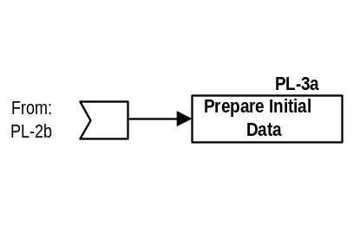

This example shows the “yes” decision to “Create Model” continues later in the flow.

WAIT

There are two wait constructs:
- Wait-to-Begin
- Wait-to-Complete.

Wait-to-Begin

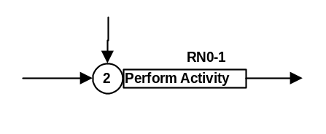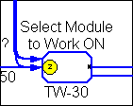

Description
The Wait-to-Begin construct is used to show that a role is waiting for signals along more than one flow line before it can begin. The wait is released when all of the specified flow lines enter the activity construct.

Notes
- A primary input of 1 is the default condition, and would not generate a wait symbol.
- The wait condition can be attached to other constructs such as “Choice boxes” and “Multithread boxes.” It is not limited to activity constructs.

Examples
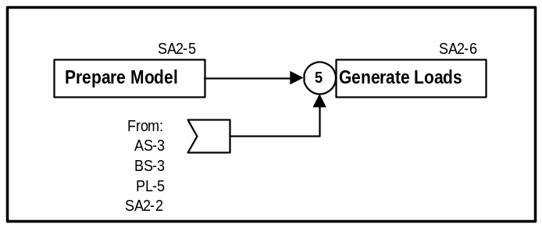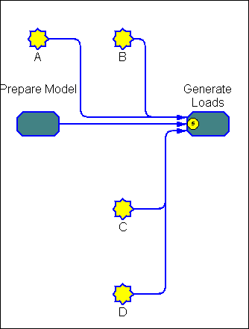

In the above example, all five input flow lines are required before activity “SA2-6” can begin:
- SA2-5
- AS-3
- BS-3
- PL-5
- SA2-2

Note: If the wait construct indicated “3” instead of “5” in this example, only three of the input flow lines would be needed to start the activity. The details about “which 3, and under what conditions” would be described in Volume 1.

Wait-to-Complete

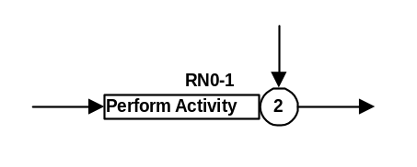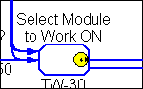

Description
The Wait-to-Complete construct is used to show that an activity may begin but must wait for other activities to complete before it completes. The wait is released when the specified number of flow lines enter the wait construct.

The number indicates the number of roles that are being waited on, including the activity itself.

Notes
1. The activity itself counts as 1 condition, so if 2 flow lines enter the activity, the wait-to-complete condition would be 3.

Related Constructs
- Activity
- Flow line

Example
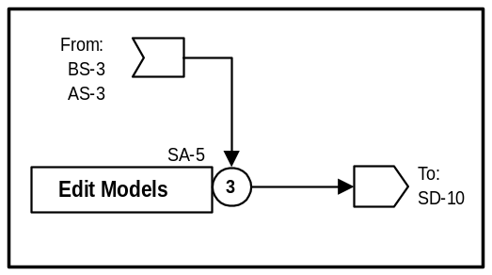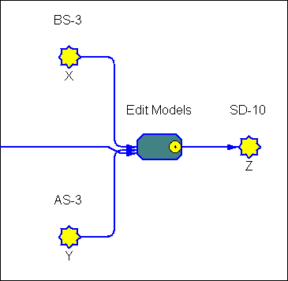
In this example, two activities in addition to SA5 itself are required in order for activity “SA5” to complete:
- BS-3
- AS-3

WBI Modeler

The wait condition is entered on the “details” tab of the task, in the fields “primary inputs” and “secondary inputs” for the Wait to Start and Wait to Complete.

Additional Constructs

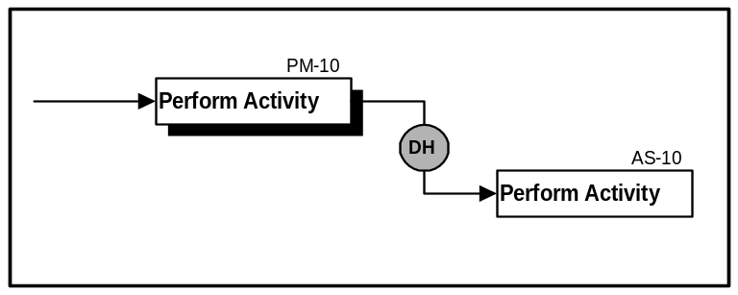DATA HANDOFF (WBI Modeler – see “Phi” section)

Description
The Data Handoff construct should be used in cases where it is critical to explicitly show data passed between roles on the analysis diagram, usually at a higher level or composite view of the process. Use care in applying this symbol to show only selected data objects. The DesignFlow™ Analysis Diagram shows activity precedence, not data flow. This data handoff instance would be documented as “PM-10 to AS-10”. Validation scenarios can expose whether the receiving role expected the same information that the sending role created.

Notes
- The example below shows a simple data handoff, but data descriptions can become very detailed, depicting data type, attributes, etc. Tables are typically constructed in the Volume 3 and/or Detail Design.

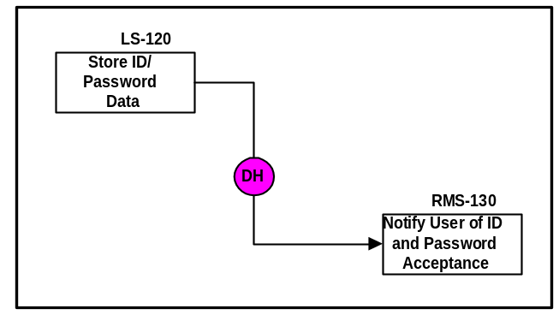Example

Activity Group | From Activity | To Activity | Application  System
Create & Maintain User Identification | LS_120 Store ID and Password | RMS_130 Notify User of ID and Password acceptance | MPP: MarketPlace Profile & LDAP Server

POINT OF INTEGRATION
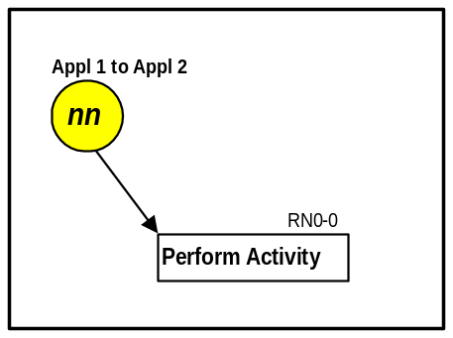

Description
A Point of Integration (POI) designated a specific point in the process where integration between two applications are required. This construct is normally used to clarify requirements in the Volume 3 Detail Design.

Notes
- The number in the circle represents a unique application pair and would be used everywhere in the process that these two applications require integration.
- Text above the circle should denote the applications involved.

Related Constructs
- Activity
- Flow Lines

Example
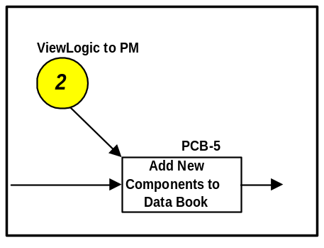

Sample Analysis Diagram

Technical Document Development Process

This process is for developing the technical documentation (also called a "book") for industrial “self-propelled mechanical products” manufactured by a Fortune 500 company.
Each “self-propelled mechanical product” is accompanied by a large collection of technical documentation (printed books, CD ROMs) that tells the new owner about the product: how to operate, how to service, parts lists, etc.
Each technical document is made up of a series of “book modules”, each roughly a page long, which cover a specific topic.
The process includes these roles:
- Assignment Editor
- Book Editor
- Technical Writer
- Graphics Artist
- Translation Coordinator
- Translator
The “Assignment Editor” (AE) assigns the writing of a new document to the “Book Editor” (BE). The AE also sets the due date for the book. At any time, the AE can check on the status of the development of all books in the system.
The “Book Editor” assigns book modules (usually about 1-page long) to several different “Technical Writers” (TW), who accept or reject the work from the BE. Thus one instance of work at the book level spawns several instances of work at the book module level.
The TW then proceeds to research the book module and then write the text and graphics through a variety on-line tools. If graphics art or photos are needed, the TW may choose to do simple graphics himself/herself, or may choose to send more complex graphics to the graphics artists (GA), along with a due date for completion. There can be one or more graphics per module, thus one instance of work at the module level can spawn several instances of work at the graphics level.
The “Graphics Artist” (GA) accepts work from the TW, and when its completed, sends it back to the TW.
When the TW has completed the book module, he/she checks it through some on-line tools, then sends it to the BE who originally assigned it. The BE then checks the module for human readability, page layout, adherence to company standards, etc. If the book module is OK, the editor stores it in a database for later assembly into a book. If there are simple problems with the book module, the BE will fix the text or graphics. If there are large problems, the editor will send the module back to the TW for major rework.
If the BE OKs the book module, it is simultaneously sent to the “Translation Coordinator” who coordinates the text translation into French, German, Spanish, etc. on a per book basis. One book may be translated into many languages, thus one instance of work at the “book-in-English” level spawns several instances of work at the “translated book” level; and each translated book is made up of many modules.. The TC sends each module to a Translator (T) who translates the module and sends it to the TC for acceptance or rejection.
When all the due date for the book is reached, the BE assembles them into a book.
When the due date for the translated modules is reached, the TC assembles them into a book.
- Tools
This Technique Paper supports both Microsoft Visio 2000 and above as well as WBI Modeler tools to create process models called DesignFlow Analysis Diagrams.

- Revision History

Revision Number | Revision Date | Summary of Changes
4.1.1 | May 2004 | Baseline version. Reformatted into Technique Paper.
1.0 | 04/01/03 | Added reference to WBI Modeler
Draft | 12/11/00 | Added IGS Method technique paper introduction and context sections to AnalysisDiagramHandbook.pdf

