

IBM Global Services

Designing Applications for Performance

Technique Paper (TP)

© Copyright International Business Machines Corporation 2000, 2001
All Rights Reserved
Version 1.1 July 2001
Table of Contents
1 Introduction 1
1.1 Scope 1
1.2 Audience 2
1.3 Document Structure 2
2 Context within Global Services Method 3
2.1 Overview & Context 3
2.2 Work Products Influenced By This Technique 4
2.3 Related Technique Papers 4
2.4 Timing and Phases 5
2.4.1 Performance Design Work Guidance - Work Breakdown Structure 5
2.4.2 General Activities 8
2.5 Participants: Teaming in the Performance Engineering Process 8
3 Determining the Application Performance Requirements 9
3.1 Recap: Business Requirements 9
3.2 Recap: Business Volumetrics 9
3.2.1 ‘Peak’ vs. ‘Average’ Requirements 10
3.2.2 Period of Specification, and Time Criticality 10
3.3 Setting Application Budgets & Targets 10
3.3.1 Determining Application Focus Areas 11
3.3.2 Types of Performance Budgets and Targets 11
3.3.3 Prerequisites for Application Budget Setting 11
3.3.4 Setting Response Time Budgets 12
3.3.5 Setting Throughput Targets 13
3.3.6 Setting Resource Usage Budgets 14
3.3.7 Setting External Call Profiles 14
3.3.8 Setting Concurrency/Load Targets 14
3.3.9 Setting Custom Budgets 15
3.4 Other Considerations 15
3.4.1 Owner of Budgets 15
3.4.2 Budget assessment 15
3.4.3 Assumptions and Exception Conditions 15
3.4.4 Testing Linkage 16
3.4.5 Relationship to Performance Model 16
3.4.6 Operational Processes 16
3.4.7 Beware of Setting False Expectations 16
4 Performance Guidelines for Solution Classes 17
4.1 Business Architecture Domain 18
4.1.1 Computationally Intensive 18
4.1.2 Traditional Transactional 19
4.1.3 Data Intensive 19
4.1.4 Internet 20
4.1.5 Pervasive/Wireless 21
4.2 Application Architecture Domain 22
4.2.1 Style of Application - Online Application Architecture 22
4.2.2 Style of Application - Batch Application Architecture 29
4.2.3 Style of Programming 33
4.2.4 Style of Messaging 35
4.2.5 Other Application Considerations 36
4.3 Technical Architecture Domain 37
4.3.1 Topological and Geographic Considerations 37
4.3.2 Platform definitions 40
4.3.3 Network connections and protocols 40
4.3.4 Placement of software components 40
4.4 Data Architecture Domain 41
4.4.1 Considerations due to Data Placement 41
4.4.2 Considerations due to Style of Data 42
5 Generic Techniques for Performance and Scalability 42
5.1 Optimising Path Length/Unit Cost 43
5.2 Parallelizing 44
5.3 Contention Avoidance 46
5.4 Overhead Reduction 48
5.5 Pacing, Throttling and Restrictions 50
5.6 Data/Component Management 51
6 Afterward 55
7 Revision History 56
Appendix A: Definitions 56
Appendix B: References 57
Solution specific references 57
Product and Technology specific references 57
Appendix C: Further Work Products Influenced By This Technique 58

- Introduction
This paper is intended to provide guidance and techniques for designing applications to meet performance objectives. Before we go any further let’s stop and think what we mean by performance objectives - they can be expressed in the following ways:
- Responsiveness - a measure of how quickly the system responds to an end user request
- Throughput - a measure of how many requests of the same type the system can process in a given unit of time.
- Scalability - the ability of the system to be scaled cost-effectively to handle greater (or occasionally lesser) volume and deliver greater throughput whilst still meeting an acceptable level of response.
Performance objectives come under the category of "non-functional requirements" and are easy to neglect during the design phase of applications. It is often mistakenly thought that application performance problems can be fixed by "tuning" exercises towards the end of the build and test cycle, however this is a risky approach which often leads to serious problems during the later phases of projects. Typical tuning efforts may be expected to improve performance by anywhere between 10% and 100% but rarely much more than that. Experience shows that when performance objectives are not considered during the early phases of a development project, it can often turn out that the design contains fundamental constraints which mean the performance and scalability objectives - which may be contractually binding - are unachievable. If this is discovered late in the project lifecycle, the design may need to be changed at the last minute, perhaps fundamentally, with damaging consequences for the development and testing already performed.
Designing for performance and scalability is a discipline, which requires an understanding of the ways in which applications can be performance-limited, and the ways in which these limitations can be overcome. This skill must be combined with a thorough consideration of the hardware and software infrastructure on which the application will be running; only from this basis can the best decisions be made during application design.
This paper aims to provide a grounding in the techniques required to design applications with performance in mind from the outset. Its benefit is to reduce the risk of designing applications, which cannot meet their performance requirements.
1.1 Scope
The technique paper offers generic guidance that is intended to apply to the most common classes of application development projects. It is most relevant to projects where the bespoke development of an application is a major or critical part of an overall solution, and correspondingly less relevant when the solution is based mainly upon pre-existing packages. The guidance herein should be broadly applicable to all types of application development methods, languages, technologies and environments, as the challenges of performance design and the range of potential solutions are essentially common, regardless of development and deployment methods. By the same token, the paper is relevant for any size of application development effort, from one-man teams to large distributed development organizations.
1.2 Audience
This paper is aimed principally at Application Architects and Designers who are setting out to design an application or subsystem of an application to meet a set of performance objectives. It may also be relevant to Application Developers working on specific parts of applications where performance has been identified as a particular issue.
Project Managers managing the development of an application will benefit from an understanding of the issues involved in designing for performance. Whilst specialist Performance Architects are expected to be very familiar with most of the information on this paper, this technique paper will prove useful for non-specialist IT Architects supporting application development groups where performance is of concern.
1.3 Document Structure
The remainder of this document contains the following sections:
- Context within Global Services Method describes the outline of where this technique fits in the overall performance engineering process of an IBM Global Services Method based project, including the specific work products influenced by the technique.
- Determining the Application Performance Requirements covers the approaches that can be taken to setting performance requirements and budgets for applications and their components.
- Performance Guidelines for Solution Classes provides guidance for a number of typical architectural, solution and application styles which are frequently encountered.
- Generic Techniques for Performance & Scalability presents the generic techniques within the performance engineer’s ‘kitbag’, including examples of problems that are encountered and can be addressed with those techniques.
- Appendices include text that is referred to in the main body; definitions of common performance related terms, and a list of references.

- Context within Global Services Method
This section positions the subject matter of this Technique Paper within the broader context of the Global Service Method.
2.1 Overview & Context
As mentioned in the Introduction, the advice and guidance contained within this IBM Global Services Method Technique Paper has been kept as generic as possible. There are other places where detailed performance guidance for specific solutions and technologies can be found. This information hierarchy is indicated schematically in Figure 1 below.
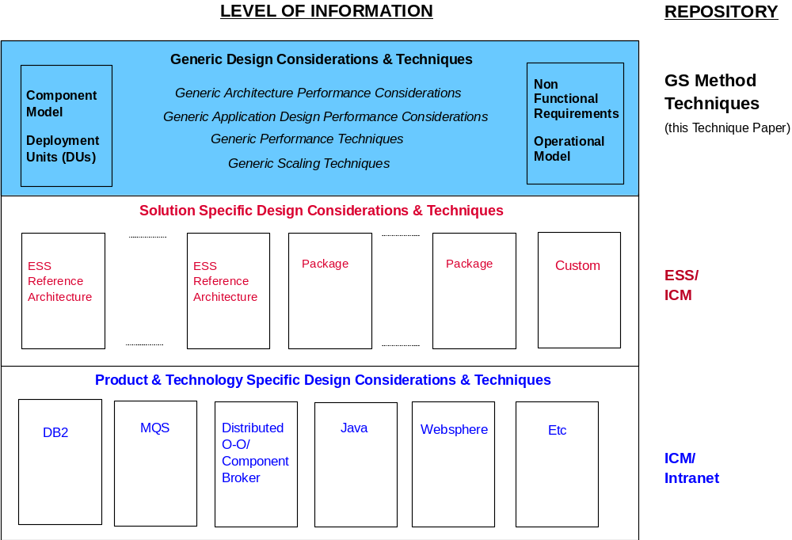
Figure 1: Level of Subject Matter within the Scope of this Technique Paper
The information presented here is not restricted to specific solution types, nor is it restricted to particular products or technologies. This decision was taken both to protect the currency of the information contained within this Technique Paper, but also to maximize the applicability of the information to a broad range of Component Models and Operational Models.
For information and specific design guidance targeted at the lower levels within the figure see the individual references given in Appendix B.
2.2 Work Products Influenced By This Technique
Given the scope of the performance and scalability themes, a large number of Work Products are influenced by the Designing Applications for Performance Technique.
Figure 2 below shows the Work Products within Release 3 of the Global Services Method that are most significantly influenced by this Technique (for the purpose of clarity some Work Products and their associated links have been omitted from this Work Product Dependency Diagram - further work products influenced by this Technique are shown in Appendix C.).
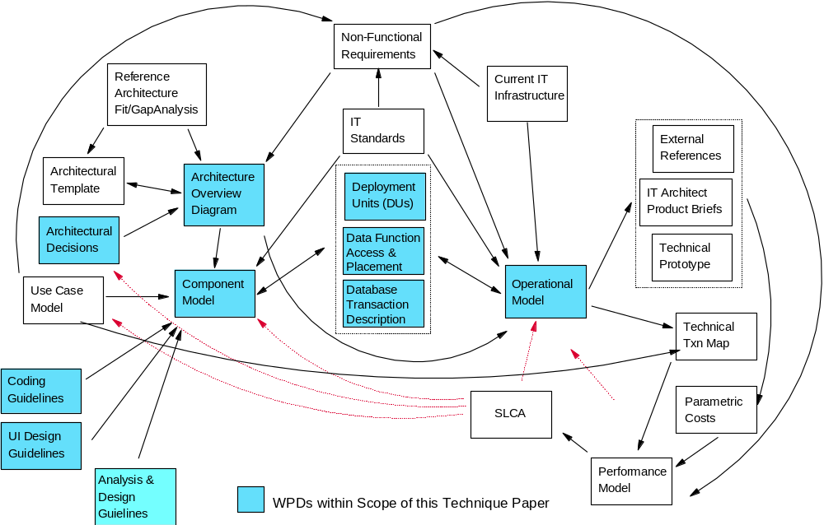
Figure 2: Influenced Work Products (major WPs linked to creation of the Operational & Component Models)
The type and number of influenced work products requires some explanation. Performance engineering has sometimes historically been treated as a responsibility that lies entirely within the development of the operational design aspects of the IT solution (as captured within the Operational Model work product) - also known as "infrastructure design". In this approach, the principal design challenge from a performance perspective is specifying hardware and networks of sufficient capacity. This is still an important aspect of overall design for performance, however it is well covered elsewhere in the Global Services Method.
The focus of this technique is therefore on those application aspects of the solution that can have an effect on the performance of the business system. This has a clear impact on not only the Operational Model, but also on the Component Model, as shown in Figure 2.
2.3 Related Technique Papers
A number of existing Technique Papers within the IBM Global Services Method already provide Performance Engineering related guidance to the Project:
- Performance Estimation & Modeling Technique Paper - which provides techniques for estimating the performance and scalability characteristics of one or more components within the operational model of a business system, for which performance is deemed a significant project risk.
- Designing for Performance & Capacity - which provides a technique for ensuring the Operational Model is designed and sized to satisfy the performance and capacity requirements of a business system. It does not address the functional design aspects of the business system as reflected in the Component Model, and is anyway intended to apply only to systems where performance is not deemed a significant risk.
- Non-Functional Requirements Technique Paper - which provides a technique for gathering the non-functional requirements for a business system.
- Defining Conceptual Systems Architecture - which provides a technique for establishing the Operational Model's basic shape and style (the conceptual view of the Operational Model)
- Defining Architectural Specification - which provides a technique for developing the technical requirements necessary to deliver the solution (the specified view of the Operational Model)
- Infrastructure Product Selection - which provides a technique for identifying and configuring the technologies necessary to deliver the technical requirements (the physical view of the Operational Model)
As discussed, the majority of these techniques focus on the operational aspects of the business system. However, it is important the information within the Designing Applications for Performance Technique is read in conjunction with these other Techniques.
2.4 Timing and Phases
The level of detail of performance design, which can be executed at a particular moment during a project, depends on the phase of design work which is being undertaken, and on the level of information which is currently available.
This section gives high-level guidance on the approach to designing for performance in terms of the Phases, Activities and Tasks which form the lifecycle of a typical IBM Global Service Method project. The three most relevant phases for performance design within the method are Solution Outline, Macro Design and Micro Design. The table below selects a subset of Activities and Tasks from those phases in which performance design work is particularly required. There are of course many other activities and tasks which involve the wider performance engineering process (e.g. those pertaining to performance modeling, SLC analysis, testing plans, capacity sizing and so on); the ones identified here are those for which this technique paper provides some input.
2.4.1 Performance Design Work Guidance - Work Breakdown Structure
PHASE  | Activity  | | Task  | | | | Performance design work required
SOLUTION OUTLINE | In this phase:  Requirements assessment  Early technology research  High-level design for performance  High-level budget setting  First-cut performance estimation  Use guidance on style of solution
Outline Solution Requirements | Identify any impossible or very challenging performance requirements  Identify any unclear or ambiguous performance and volume requirements - raise issues if so
Outline Architecture Model | Early decisions about application and system structure made w.r.t. performance
Develop Architecture Overview | Assess ability of outline architecture to satisfy performance requirements
Identify Stereotypical Interactions | Include high-level response time budgets for layers of the system  Identify where architectural pattern may cause performance problems  Estimate ability of fundamental interactions to meet performance requirements
Develop High Level Component Model | Map service level/performance requirements to high-level component performance requirements  Create high-level throughput and response time targets for identified subsystems and components  Use solution class guidelines and reference architecture guidelines
Develop High Level Operational Model | Set resource usage targets for identified components  Use solution class guidelines and reference architecture guidelines  Research contribution to performance of known technology components (e.g. parametric costs)  Refine high-level performance budgets
Review Capabilities of Operational Model | Assess likely performance of system (SLC analysis/performance model)  Refine design to address performance risks
MACRO DESIGN | In this phase:  Requirements refinement  Technology research  Design for performance  Performance budget refinement and detailing  Accurate performance estimations  Take in guidance on style of solution  Design in performance and scalability techniques
Refine Requirements and Application Model | Refine performance requirements and budgets for system components and interfaces  Reconsider clarity and feasibility of requirements
Design User Interfaces
Establish User Interface Design Guidelines | Use application requirements to set guidelines and targets with respect to the user interface
Design Architecture Model | Consider the performance targets and budgets set for subsystems and components throughout the architecture  Design to meet the performance requirements
Develop Component Model | Refine performance targets and budgets for identified components  Use solution class guidelines, reference architecture guidelines and performance techniques to assist with design of components and their interfaces
Develop Operational Model | Use solution class guidelines and reference architecture guidelines  Where necessary, obtain detailed performance data about technology components (e.g. parametric costs)  Use performance requirements and budgets to assist with technology evaluation and selection
Refine Component & Operational Models using SLC Analysis | Where SLC analysis shows performance or scalability are at risk, select from design options or redesign, employing guidance and techniques
Update Operational/Component Models | Incorporate performance-related design decisions
MICRO DESIGN | In this phase:  Requirements and performance budgets refined and completed  Continued design for performance  Design to meet performance budgets  Employ low-level performance and scalability techniques  Influence database design  Set guidelines for implementation  The Micro Design phase mainly refines the work performed in the Macro Design phase for a specific release or implementation.
Detail Requirements and Application Model | Finalize performance requirements  Finalize usability requirements  Ensure initial database schema considers performance targets
Refine Architecture Model | Finalize performance targets and budgets for identified components  Finalize design for performance  Use performance techniques to assist with design of low-level components and their interfaces  Use performance requirements and budgets to assist with technology evaluation and selection  Where SLC analysis shows performance or scalability are at risk, select from design options or redesign, employing guidance and techniques
Detail User Interfaces | Finalize user interface design guidelines
Define Physical Application Model | Set performance-related design guidelines  Ensure number and costs of object interactions are within performance budgets  Refine database schema to support identified high-volume or high-performance transactions
Plan Development | Set performance-related coding guidelines to ensure best practice is adopted
2.4.2 General Activities
There are also general activities, spanning the project lifecycle, which are vital to successful design of an application, and in which those concerned with designing for performance will have to play a part. These include:
- Documenting and Managing Assumptions: Within the overall performance engineering and management processes of a project, it will undoubtedly be necessary to make assumptions about key data items, or about functional areas which are not yet thoroughly understood. The process of considering the application design for performance is likely to lead to new assumptions that need adding to the complete list. Once an assumption has been made, it needs managing - including tasks such as getting it accepted and agreed (say by business management) then getting it reviewed and revised as the project progresses.
- Managing sign-off of documentation: This especially applies to Business Volumetrics and Performance requirements, and is discussed further in the Non Functional Requirements Technique Paper. It is vital that the business accepts responsibility for the requirements and data as the basis for design. This acceptance should normally be shown by getting formal sign-off for the set of business volumetrics and workload scenarios.
- Change Control: For many projects, the duration of the project is such that it will be necessary to manage changes to requirements, and to business and technical data. All non-trivial changes should be impact assessed from a performance perspective.
2.5 Participants: Teaming in the Performance Engineering Process
Performance engineering and management of the total system across the project may be the responsibility of a dedicated Performance Architect/Engineer, however they will rely on the support of a virtual team, which is typically distributed about the project organization. One of the key relationships is between the Performance/Infrastructure Architect(s) and the Application Architect(s), and their respective teams. This is for several reasons:
- The Performance Architect relies on the Application Architect and developers for design information about how the application works or is going to work - without this the Performance Model Work Product cannot sensibly be completed.
- The Application Architects can expect the Performance Architect to assist with providing key technical data and understanding which facilitates application design decisions, and to generally contribute to application design decisions where performance is of concern.
- The outputs from early performance modeling and estimation may show that particular application design options are not viable, or that some are preferable to others.
- Assumptions, volumes, technical data, technical understanding, etc. must be shared so that decisions can be made in light of all the facts.
- As highlighted above, changes that affect the design in any way must be managed correctly across the project and this will need input from all sides.
There is usually a portion of the testing organization in a project, which is responsible for testing the performance of the system at various stages. The Performance Architect should set out the overall performance testing strategy during test planning. As and when application performance problems are discovered by testers, a constructive dialogue is necessary between testers and the application development team. If the problems discovered are serious, the dialogue may involve both the Application Architect and the Performance Architect to work out how the problem can be best overcome.
[Note: As job titles vary considerably between organizations and projects, the correct person for the roles discussed above may have a different job title to the role name. Also note that logical roles are being discussed above, and that these may or may not be represented by full-time individuals depending on the size of the project. ]
- Determining the Application Performance Requirements
This section describes techniques for translating high-level performance requirements into application-specific performance requirements, which can be used as design targets.
3.1 Recap: Business Requirements
The IBM Global Services Method Non-Functional Requirements Work Product Description documents the ways in which performance requirements are typically specified by customers and written into contracts.
The following table repeats for convenience some of the types of performance requirements which form part of the overall non-functional requirements for a system, and which are often agreed as part of the contract between the vendor and the customer.
Contractual Performance Requirement Type | Example(s)
Response Time Targets | For 95% of occurrences, provide response to an on-line query within 2 seconds  No navigation step within the browser should take more than 5 seconds  Complete a particular Business Unit of Work within 20 seconds.
Batch Elapsed Time targets | Settle all transactions on the queue within 5 minutes
Throughput Targets | Process no less than 10 orders per second
Deadline Targets | Complete all billing operations by 6:00am CET
User Community Targets | Support at least 100 concurrently logged on users
Acceptable Perception Performance Targets | Provide responses within a reasonable period of time from the user's perspective
Resource Usage Targets | Use no more/less than 70% of available capacity
All requirements should make sense in themselves and require no further explanation. They should also be unambiguous, i.e. it is clear precisely what measurement can be taken to prove whether the requirement has been met or not. If it is felt performance requirements for the application are in some way vague or incomplete on the project, this should be raised as a high priority issue.
3.2 Recap: Business Volumetrics
The next table gives examples of the types of business volumetrics that should accompany performance requirements and which may also be contained with the contract between the vendor and the customer.
Volumetric Type | Example(s)
Workload within fixed period | 90,000 messages per day
Concurrent users | 2000 active concurrent users
Number of entities within the system | 120 members configured in global data  6000 part structures in the database
Feature uptake | 35% of members will expect notifications of type X
Peak time stipulation | 25% of all inputs during the peak hour
An important principle is that for each performance requirement, there should be sufficient matching volumetric information; without this, it can be impossible to assess whether the performance requirement can be met, to have confidence in the application design, or to size the hardware on which the system will run. If it is felt volumetric information is missing, this should be raised as a high priority issue.
Business Volumetric information is often presented for a number of predicted future business workload scenarios. These scenarios may be related to a specific time following the supposed live date of the project, or may be related to different workload scenarios dependent on the success of the business. Increasing volume targets over time, or through a progression of business scenarios, constitute the Scalability Requirements of the system. Customers will typically want performance not to degrade over time despite the increase on load on the system.
The Use Case Model and Change Case work products provide a source of information on the supported use cases and workload scenarios, the former for an identification of today’s workload scenarios and the latter for an understanding of the workload scenarios that will appear in the future.
3.2.1 ‘Peak’ vs. ‘Average’ Requirements
Performance volumes may be specified for peak workload scenarios (i.e. specifying the highest load the system is expected to perform under) or for average scenarios. Care must be taken to understand what is being specified, and to design the system accordingly.
If a system is designed explicitly only to cope with average volumes, during periods of higher than average loads there is likely to be significant performance degradation or instability. It is usually better to design for the expected peak volume. If, however, the peak is specified at an unrealistically high level it may turn out that the cost of the solution increases significantly and that in practice, there is an unwarranted amount of unused resource on the deployed hardware. Expected values for peak-to-average ratios are often known for certain types of systems (e.g. between 2-to-1 and 4-to-1 for Internet sites) and should be sought during the requirements phase.
3.2.2 Period of Specification, and Time Criticality
The time period associated with a volume specification is important. Often the available figures will only allow average daily or hourly volumes to be easily calculated - more effort then needs to be put in to calculate a sensible peak rate of work. The finer the granularity of time used in a volume specification, the closer it becomes to specifying the real peak that should be sized for. For most applications it should be sufficient to understand how many things need to be processed in a peak hour or peak minute, but this depends on what the impact of not being able to handle peak loads is. For online applications serving a large number of users, it may be acceptable for the system to not keep up with infrequent transitory peaks, so long as it can catch up quickly. However, for time critical systems, where data must always be completely up to date, the challenge is greater, and the peak second may have to be considered.
3.3 Setting Application Budgets & Targets
The types of requirements and business volumetrics outlined above are often put in terms specific to the business concerned. They typically pertain to users, transactions, business processes, services and operations. These high level requirements do not always directly illuminate the performance challenge for each area of the application (although some may be easily interpreted), so it is usually beneficial to map those high level requirements down to lower level requirements which can be more readily understood by developers and measured by testers. These low-level requirements can be expressed as performance budgets; as with financial budgets, performance budgets define limits or constraints within which you must manage your affairs - in this case the construction of an application. The idea is that the application functions are then designed specifically to come within the budgets which are set for them; and that once set, these targets will be tracked against throughout the project lifecycle. If budgets are set well and then achieved, when all the different components of the application are brought together, the total system is much more likely to meet its overall performance objectives.
3.3.1 Determining Application Focus Areas
Note that not all components of an application will require budgets setting for them - the key or performance critical areas of the application should receive most attention, especially considering that the performance resource on any project will be finite. On very large systems, for example, it may only be feasible to manage budgets related to a small percentage of all transaction types. Determining focus areas is not necessarily an easy task, however the following considerations may assist in this area:
- Portions of the application, which will be processing the greatest rates of work (e.g. during the peak hour), or the largest quantities of data are clearly candidates for budget setting.
- Looking at the original performance requirements, which appear to be the most challenging, or the most stringent? Answering this question may help identify the application components to focus on.
- Early estimation and performance modeling work may have identified the performance-critical components of the system.
- Parts of the system which are particularly novel, or use new or previously untested technology, are also good candidates for budget setting and tracking.
3.3.2 Types of Performance Budgets and Targets
The next table lists common types of lower level targets and budgets that can be set for application components (subsystems, objects and/or processes depending on the application development style).
Low Level Target Type | Example(s)
Response Time Budgets | Process a single request through all steps within 500ms  Execute back-end transaction type A within 1 second
Process Throughput Targets | Input Validation Server must process 10 inputs per second
Resource Usage Budgets | Notification Server must use no more than 15ms per notification  Process X must use no more than 20MB of memory
External Call / Request Profiles | Perform no more than 3 INSERT/UPDATE operations in the database per request  Send no more than 100Kb of data per second
Concurrency/Load Targets | Handle up to 100 concurrent requests
Ideally, each major functional component within the system should have a combination of targets, specifying for example the throughput to be achieved and acceptable response times, together with resource or external call limits.
3.3.3 Prerequisites for Application Budget Setting
Setting performance budgets for application parts is non-trivial and is only possible when some information about the construction of the system is available. The following work products should be available before this work is initially considered in the Solution Outline phase:
- Non-Functional Requirements
- Architecture Overview Diagram
- Architecture Template
- Conceptual Operational Model
- Outline Component Model
As the project progresses from Solution Outline phase to Macro and Micro Designs phases, further work products may be created which allow revised and more specific budgets to be set:
- Detailed Component Model
- Specified Operational Model
- Parametric Costs
- Performance Model
- Technical Transaction Map
- Service-level Characteristics Assessment
3.3.4 Setting Response Time Budgets
In online systems, end-users perceive application response times from observing the outermost layer of the system only. The total time to respond to user requests is however usually made up of a number of individual elapsed time contributions from different components in the system. User requests typically cause a chain of events and interactions, which involve several serially-executed processing steps. Response time budgets set targets for response time from each of the individual contributions to the total response time from each of the processing steps. Typically each of these budgets should correspond to a major layer of the system, for example:
- the time spent at the client end-user device
- the time spent in the presentation layer
- the time spent in the functional layer
- the time spent executing a back-end transaction.
- the time spent transferring data over a network
The budgets for individual processing steps should be set to as to sum in the worst case to the required end-to-end response times, as seen from the end-user’s perspective. (This is a conservative starting point that can be revised if, for example, the worst case is a very rare event.) The proportion of the overall response time to initially allocate to each step should be made pragmatically and based on previous experience of the typical times spent performing comparable tasks - some early research may be required here. It will be unrealistic to assume that the total response time can be divided equally across each processing step. If after initial analysis, the total expected response time is greater than the requirement then a problem may already have been uncovered.
Response time budgets can be revised as the project progresses and more is learned about each layer of the system; reallocation of time between layers can be performed, or budgets can be tightened or loosened where it is appropriate to do so. As the system is specified in greater levels of detail, it may be desirable to break response time budgets down further to cover more detailed levels of transaction flows.
As an example, Figure 3 below shows a picture of high-level response time budgets for an online application. Budgets (not intended to be accurate) at each layer of the system are given for three different types of system interaction (Complex Transaction, Simple Transaction, Content Only).
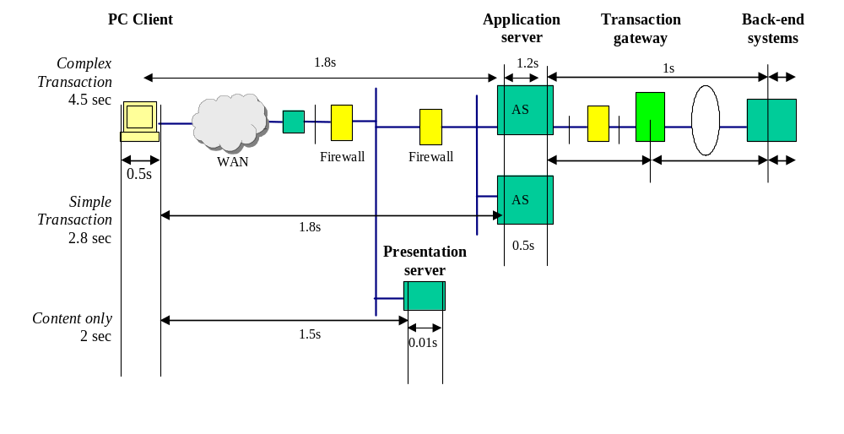
Figure 3: Example of response time budgets for a multi-tier online system
3.3.5 Setting Throughput Targets
Throughput considers a different aspect of system performance. As well as contributing acceptably to response times, components of the system need to be able to support the rate of processing required of them - if not, queuing will occur and performance targets could be missed. When queues form in a system for any significant length of time, there are the following adverse performance effects:
- additional elapsed time is incurred for all queued transactions; the time between arrival and being processed can grow to be very large
- the system may fall behind and fail to process batches of work before set deadlines
- memory and/or temporary disk storage is required for the queue; depending on the size of the queue elements, this could be significant
- additional time is lost managing the queues
Ideally, a system should be designed so as to avoid significant queuing by aiming to keep up with peak rates of work. Interaction diagrams and technical transaction maps should be the principle means by which the throughputs required in each component are driven out. There will be a relationship between the business volumetrics and the implied technical transaction volumetrics through the various components. The throughput targets for components are the rates of work, which are required during the peak time of processing.
Components may process different types of transactions, in which case their throughput may need to be specified in terms of a mix of those transaction types. Most attention should of course be focused on the transaction profile of the peak hour, and within that on the most common transaction types.

3.3.6 Setting Resource Usage Budgets
Resource usage budgets specify how much of the processing capacity of a particular hardware element application functions are allowed to consume per invocation. Frequently encountered examples include cpu processing time, message size or transmission time, and memory requirement.
Resource usage targets should be set to ensure that all the application functions running on each node in the system can be accommodated within the capacity of the installed or planned hardware configuration. Initially, the setting of resource budgets can be done in relative terms, assigning more weight to functions, which are assessed to be more heavyweight, and then converted to more absolute targets when the hardware platform is understood in more detail. Resource usage targets may be affected by many infrastructural considerations; e.g. the consideration of failover scenarios which cause previously separated processes to co-exist on the same hardware.
Resource usage and other budgets may be strongly interdependent. E.g. a completely cpu-bound serial process set with a resource usage budget of 100ms per request can clearly support a maximum of only 10 requests per second in throughput terms. The relationship is not as clear for processes that access other processes and use asynchronous calls.
Note that targets might be specified as aggregates for a whole subsystem of the application - e.g. "Processes A, B, C and D must use no more than 50% of the cpu capacity of node 5 at peak times".
3.3.7 Setting External Call Profiles
When a component uses the services of common products or infrastructure services, there may be a need to specify some constraints on the profile of calls made to those services. This may be because the service(s) in question themselves have limitations on the rate of work they can perform and need to be protected from overloading. Furthermore, there is a resource cost associated with such services, which needs to be assessed alongside the application’s resource costs. An example is a shared database server that has to serve several connected applications at the same time with good performance. If one of the applications is designed so as to require a very high rate of work from the database server, the performance of the service offered to the other applications will degrade.
Shared services for which usage profiles might need to be set include:
- persistency (database) services
- messaging services
- transactional services
- packaged application services
- operating system services, e.g. inter-process communications
In each case, the usage profile can be specified in terms of the number of invocations of the service’s functions and the size of data being transferred as a result of the call. For common infrastructure services such as these, there is often good performance data available to indicate the highest rate of work that is achievable, and what the implied resource usage is. External call profiles should be set so that the total rate of work required from the infrastructure services at peak times can be accommodated.
3.3.8 Setting Concurrency/Load Targets
A figure often quoted or used to assess the loading on the system is ‘number of concurrent users’. Although this in itself cannot tell us much about the performance being experienced, it is a useful indicator of activity levels in the system. Active sessions managed for users or for other purposes require resources - including memory, handles, and other logical resources - for the duration of the session. Infrastructural services often contain limits that pertain to concurrency, for example, the number of open connections, and they may become overloaded if the number of concurrent sessions is too high.
Systems should be designed to cope with the expected number of concurrent sessions at the peak time, keeping in mind any inbuilt limits of infrastructure or external services. The application itself also needs to cope gracefully with concurrent loadings, and not become inefficient as numbers grow. Higher concurrency levels can show up points of serialization for shared resources within the system that can degrade performance at high loads and prevent scaling.
Concurrency targets need to be set based upon the available volumetrics and analysis of the likely concurrent loadings.
3.3.9 Setting Custom Budgets
The above classes of budgets should not be taken as the only sort that can be specified. Other characteristics of applications may be important to manage for performance purposes and during the budget-setting process consideration should be given to what kinds of budgets will be most effective. A modern example for web-based applications is a budget for the number and/or size of graphics that are allowed on each page. For this type of application in particular it is vital to consider the balance of content versus performance.
3.4 Other Considerations
3.4.1 Owner of Budgets
If these targets are not being provided by the Performance Architect(s) or other staff on the project, it may be the responsibility of the application designers to derive the targets for the applications. Alternatively, the architecture team might set high level budgets, whereas detailed budgets might be managed by the application development organization. End-to-end performance targets typically remain with the Performance Architect, however.
Regardless of who provides the budgets, it is essential that the application development organization have a sense of responsibility for meeting them.
3.4.2 Budget assessment
A certain amount of common sense needs to be applied to application budget setting. It is necessary to keep on asking the question: are the requirements being set sensible and achievable? Referring to known figures, benchmarks, and technical data for similar systems can be a way of verifying the validity of budgets as targets for parts of the application. If budgets that are set for good reasons appear unachievable, it may be that a potential performance problem has already been identified in which case an issue needs to be raised. If budgets appear challenging, this may suggest that early prototyping, benchmarking or modeling is required for the component in question.
It is also valid to add, expand, refine or remove performance targets as time goes along as more is understood about the system, or the volumetric information changes during the lifetime of the project.
3.4.3 Assumptions and Exception Conditions
You should clearly state all assumptions regarding the documented performance targets. For example, the response time targets may assume a specified minimum workstation specification or a minimum network bandwidth and/or network latency, etc. This latter example is particularly pertinent if a 3rd party supplier is providing the network. All such assumptions should be clearly stated alongside the requirements themselves.
Similarly, be sure to specifiy any exception conditions that may apply to these targets. There may be times when a reduced response time is noted, for example, during weekends when the workload prioritization is shifted from online to batch in many cases. Similarly, any geographic exceptions should be noted. For example, within IBM, US based users will typically experience better dial in and LAN based access than similar users in parts of Asia Pacific. Response time targets should be set accordingly.
3.4.4 Testing Linkage
The setting of performance budgets and targets for the application should be strongly linked to testing plans across the project. If testing plans include measurements for budgets that have been set, the performance of the application can be tracked and verified throughout the project. The contribution of different testing phases is ideally as follows:
- Unit and functional tests should be designed to measure unit operation budgets set for individual components, for early indications of slow performing areas. (Be aware that it may often not be possible to make such measurements of application budgets on the target hardware, and those therefore appropriate compensations will have to be made when considering the results.)
- System tests validate performance for application subsystems, including resource usage and throughput
- Integration and acceptance tests check response time budgets, throughput under load, and high levels of concurrent loading
The means by which those measurements are taken and the approach for comparing the measured data with the various budgets must be clearly agreed by all parties.
A well-designed testing plan is the essential partner of the performance budgeting and tracking process.
3.4.5 Relationship to Performance Model
If the project is developing performance models to predict the performance of the system before it is built and in future workload scenarios, there is a two-way linkage between performance budget setting and performance modeling:
- Budgets set for the application can be fed into the performance models as parameters for key operations being modeled
- The performance model can be used to assess the effect of different values for the budgets and therefore help refine budgets to more accurate or realistic targets.
As the project progresses, the performance modeling and application budget setting need to be kept in line and tracked against measurements obtained from testing activities.
3.4.6 Operational Processes
It is also important to consider the response time and throughput requirements of the operational workload. For example, system backups, data replication, system recovery following failure, etc.
With the move towards globalization and 24 x 7, the requirement to complete these operational processes in the shortest time possible is becoming more business critical.
3.4.7 Beware of Setting False Expectations
In many situations an early prototype is built to demonstrate some functional or UI aspect of the application. In some cases this prototype may be no more than a storyboard presentation.
In all such cases it is important to set the performance expectations of the users accordingly. The level of performance they see within the prototype may not reflect that delivered by the live system.
- Performance Guidelines for Solution Classes
This section provides guidance on the performance challenges, issues and techniques associated with a variety of common solution classes. The performance characteristics of an IT solution can be thought about from a number of different perspectives - dimensions, or domains - that contribute to the definition and behavior of that solution:
- The Business Architecture domain (as documented primarily within the Process Definition and Use Case Model Work Products) - which defines the business problem being addressed by the solution, along with the fundamental characteristics of the workload associated with that business solution
- The corresponding Application Architecture domain (as documented primarily within the Architecture Overview and Component Model Work Products) - which defines the style of application being created to solve the business problem
- The corresponding Technical Architecture domain (as documented primaily within the various elaborations of the Operational Model and Network Design Work Products) - which defines the technical infrastructure onto which the application and its supporting data is deployed.
- And finally, the corresponding Data Architecture domain (as documented primaily within the Data Stores, Logical Data Model, and Physical Database Design Work Products) - which defines the format of data required to support the application, and the means of storage of that data
Dependencies exist between each of these domains as represented schematically in the figure below.
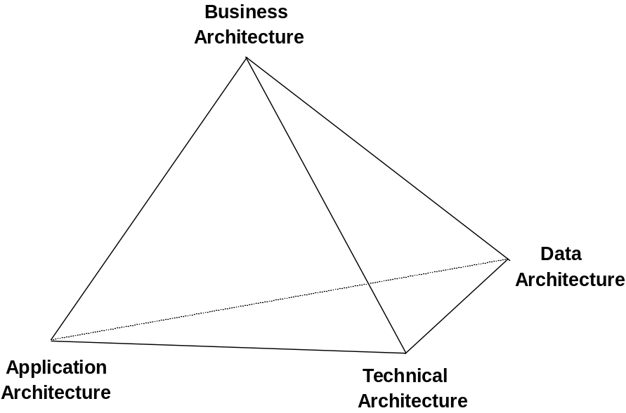
Figure 4 - Solution Domains
It is useful to discuss the performance aspects of systems from each of these four perspectives in turn, as the application of performance design principles to each domain can require some specialist knowledge or domain specific experience. However, only by understanding the performance characteristics of the solution domains in concert can we hope to understand the characteristics of the solution as a whole.
This chapter provides a taxonomy of solution classes from the perspective of each of these solution domains, and presents guidance concerning the performance challenges in the identified categories. Where relevant, there are references to specific performance design techniques, which are catalogued, in the next chapter. The reader should match the characteristics of their system against the categories identified for each domain and aggregate the information for a fuller picture of the likely performance characteristics, challenges and relevant techniques for the system they are designing.
4.1 Business Architecture Domain
This section discusses performance challenges that are driven by:
- business requirements (e.g. the fundamental business service being provided, the way the users will interact with the individual business systems required to deliver that service, etc)
- workload characteristics (e.g. the projected workload volumes, the nature of that workload i.e. ‘front office’ or ‘back office’, etc)
- user communities and volumes (e.g. the number and demographics of the users of the individual business systems, etc)
The performance characteristics of the Business Architecture domain are primarily governed by the style of workload the individual business systems are being asked to support. The most common styles of workload seen in IT systems can be split into five broad categories:
- Computationally Intensive
- Traditional Transactional
- Data Intensive
- Internet
- Pervasive
Each workload category has distinctive performance characteristics. A complete service as provided by the business will typically contain business systems/applications that map to more than one of these workload categories. For example, an Internet banking service will relate to both the Internet and data and/or computationally intensive categories. The initial challenge is understanding the different categories of workload that exist within a given business service.
4.1.1 Computationally Intensive
This category of workload is particularly related to applications within the Engineering & Scientific industry (e.g. Geological Surveys, Stress and Fatigue Analysis within Engineering Design, etc), and the aviation and military arenas (e.g. missile control systems, air traffic control) although it is also encountered as a subclass within more commercially oriented applications (e.g. insurance/actuaries, finance/share & economic forecasting, search engines, etc). Its characteristics include:
- traditionally cpu bound application components
- often a characteristic of batch applications (see the Application Architecture Dimension for more information)
- often relatively small numbers of complex or very complex requests which are usually processed in one location
- time to retrieve and store data from permanent store can be significant
- overheads (e.g. context switching, connection setups, etc.) associated with processing are not usually significant
Specific examples of functionality that can give rise to this category of workload are:
- Repeat scientific formulae calculation
- Scheduling
- Searches through very large or complex data structures
Most Relevant Performance Techniques and Practices
- Fast processors and specialised hardware - e.g. for reducing the cost of frequently performed computations
- Optimising path length - e.g. improving the efficiency of code in order to be able to process more operations in a unit time (this should involve a combination of code profiling and then optimisation, i.e. finding out which instructions, often inner loops, are most frequently executed and optimising or re-coding them first.)
- Parallel processing techniques - e.g. expoiting multiprocessor hardware and clusters to spread the computational task over many processors
- Pipelining - i.e. creating separate logical stages of processing which can be processed in parallel.
- Coding in a more efficient language - e.g. hand coding in C rather than relying on 4GL generated code (see Application Architecture Domain)
4.1.2 Traditional Transactional
This category of workload is typical of most traditional commercial IT systems, including transactional banking systems such as those supporting branches or cashpoint networks, call centers, and many other types of query-response systems supporting large user communities or online processing of messages from other systems. Traditional transactional systems are also often the ‘back-end’ of an Internet system. This workload is characterized by:
- a large number of mainly simple requests, but often with a mixture of different transaction types of varying complexity
- requests processed across a geographically dispersed infrastructure (with the time implications that can arise in such cases)
- complexity arises from managing the currency and integrity of requests
Most Relevant Performance Techniques and Practices
- Overhead Reduction - e.g. to reduce the volumes of expensive interactions (e.g. connection setups) between components in the end-to-end system
- Workload Segmentation - e.g. to separate the 'informational' requests from 'update' transactions
- Parallel Processing Techniques - e.g. to expoit multiprocessor hardware and clusters in spreading the computational task over many processors
- Caching - e.g. to reduce uneccesary communications when accessing data
- Pacing, Throttling & Restrictions - e.g. to restrict the number of logged on users during periods of peak activity
- There is significant discussion of transactional systems in the context of online systems in the Application Architecture domain below.
4.1.3 Data Intensive
This category of workload is typical of Decision Support Systems, Data Warehouse Systems, and many traditional batch applications. Many of these systems involve some form of data pre-processing, e.g. Data Warehousing system may involve pre-loading data into OLAP structure, extracting and aggregating data from operational system. This workload is typically characterized by:
- small or middling numbers of complex queries with potentially significant response times
- very large volumes of data (and hence storage requirement)
- small user community (‘power users’)
Relevant performance techniques and practices for improving the performance of this type of system are:
- Caching - as very large volumes of data are being accessed, avoiding the cost of many physical I/Os is important (also see 4. below)
- Workload Segmentation - e.g. splitting of databases into different parts
- Specialised Hardware - e.g. specialised servers to support data warehouse processing, caching adapters, etc.
- I/O Avoidance Techniques - e.g. exploitation of operating system memory constructs (e.g. dataspaces), or techniques such as application pipelining (e.g. batch pipes), to avoid physical I/O to disk
- Efficient I/O Subsystems - e.g. data cache, high channel bandwidth, high specification adapters Internet and Web-based
- Pacing, Throttling & Restrictions - e.g. to provide a ‘governor’ facility for restricting the execution of unecessarily complex and hence resource consuming queries, or to provide a throttling mechanism for limiting the number of parallel batch executions.
4.1.4 Internet
This category of workload is defined as any system based around Internet technologies, involving TCP/IP, browsers, HTTP, HTML, applets, web servers, application servers, etc. and delivered either over the Internet World-Wide Web itself or over a company's Intranet or Extranet. These types of systems are found not just in 'dot.com' startup businesses, but also in many businesses in traditional industries. The characteristics of this style of workload are:
- potentially very large user community which is very widely distributed
- the speed of network connections through which users access the system can vary significantly
- the user interface (potentially including much graphical content) is effectively being transmitted across the network in HTML pages
- large numbers of relatively simple requests (often termed "hits"), some of which however might cause complex transactions to be executed
- a mixture of transactional and informational user requests
- application processing can be split between client and servers using downloadable "applets"
- more often, however, the majority of application processing, including both presentation and business logic, is run on the server side
- the availability of applications over public network requires security features to be employed (e.g. encryption sessions) which have performance impacts
Additional aspects of web solutions that cause further performance challenges are:
- If the content of the site is not entirely static then content must be dynamically generated from some data source, which implies online data retrieval, conversion and formatting.
- Integration with one or more backend transactional systems is often required in order to retrieve data with which to populate dynamic content - this aspect introduces the characteristics of traditional transaction systems.
- Sophisticated sites are designed to provide some level of customization or personalization, which tailors content to end users based on their identity and history. This entails extra processing and potentially extra database work. It also potentially reduces the opportunity for data caching.
- Web applications are often built using sophisticated, object-oriented programming models and/or interpretive programming and scripting languages, both of which can lead to significantly increased processing requirements per transaction in comparison with simpler programming models (see Application Architecture Domain).
One of the major challenges from a performance and scalability perspective is that growth of the user base is often unpredictable, and has the potential to become extremely large indeed. This potential for rapid, large growth in the workload in Internet systems over time means that web applications must be designed particularly with scalability in mind.
Most Relevant Performance Techniques and Practices
This class of solution can overlap significantly with many of the other classes of solution identified, so many techniques are likely to be relevant. The major ones are:
- Caching - often employed at several layers, including in the end user's browser
- Overhead Reduction - e.g. reducing the volumes of expensive interactions (e.g. connection setups) between components in the end-to-end system
- Parallelisation - e.g. scalability is achieved through multi-processor hardware and replicated machines. Further more, end-user performance can be enhanced by simultaneously fetching multiple items on a page.
- Workload Segmentation - e.g. separation of 'informational' requests from 'transactional' requests
- Load Balancing - e.g. requests from many different users are spread as evenly as possible over a large number of servers
- Pacing, Throttling & Restrictions - e.g. to deny access to, or deactivate, resource hungry functions beyond specific system utilisation thresholds.
- Specialised Hardware - e.g. specialised adapters to assist with cryptographic operations.
4.1.5 Pervasive/Wireless
This category of workload is emerging from a subset of those businesses involved in Internet-based systems. In this class of system, the client is typically a small portable device with a limited graphical interface. Examples of such devices are WAP-enabled mobile phones or personal digital assistants (PDAs).
In this type of system all application processing takes place on the server-side and the formatting of output is geared specifically towards the particular device through which the service is being accessed. Due to the wide variety of end-user devices, presentation logic and content are frequently held separately, and combined when requested through a separate transcoding step. This processing can adversely affect the throughput and response time of pervasive systems unless particular care is taken over design of the transcoding component. This technology is also being taken up for ‘traditional’ browser systems where content customization is required.
The overall characteristics of this style of workload are very similar to those of an Internet solution, however because of the reduced user interface, response time will tend to be dominated by server-side processing time and network transfer time (whilst the volume of data sent across the network is reduced compared with the internet case, the latency of that network connection is now significantly slower).
Most Relevant Performance Techniques and Practices
- Caching - often employed at several layers
- Overhead Reduction - e.g. reducing the volumes of expensive interactions (e.g. connection setups) between components in the end-to-end system is critical
- Parallelisation - e.g. scalability is achieved through multi-processor hardware and replicated machines. Further more, end-user performance can be enhanced by simultaneously fetching multiple items on a page.
- Load Balancing - e.g. requests from many different users are spread as evenly as possible over a large number of servers
- Pacing, Throttling & Restrictions - e.g. to deny access to, or deactivate, resource hungry functions beyond specific system utilisation thresholds.
- Application Optimisation - writing the application specifically for the device, and not ‘clipping’ or ‘transcoding’ a larger page designed for a normal browser.
4.2 Application Architecture Domain
This section focuses on the Application Architecture domain and presents performance issues which are connected with the following areas:
- the Style of Application on which the business system is based
- the Style of Programming against which the application is developed
- the Style of Messaging used to communicate between the application components
- the User Interface design
- a variety of other application domain characteristics
4.2.1 Style of Application - Online Application Architecture
An 'application style' in this paper is defined as the essential structure and deployment model for the application. This section deals with ‘online’ systems, which are those that are principally designed to support communities of interactive users, or rapid processing of new requests or inputs from other traffic sources. In online systems application components essentially provide presentational, business application, and data management functions. In the IT industry, it has become common to characterize online systems based on how their functionality is distributed in layers, including:
- Presentation Logic - concerned with the end-user interface and its appearance
- Business Logic - the code which provides the actual business function, for example "Pay=Salary-Tax"
- Data Access Logic - the function which interprets data requests from the business logic and returns or stores data elements, while providing all the integrity and other requirements of data management.
There are five basic ways in which these three functional components can be structured and logically distributed within an online system, as illustrated in the following diagram. In each distribution of function, the boxes containing "P", "B" and "D" represent the Presentation Logic, Business Logic and Data Access Logic respectively. The horizontal lines represent the point at which the functionality is split and distributed. The function above the split is implemented on the client, the function below the split is implemented on the server (or more correctly logical server, since in practice that server functionality could be further split and distributed between a number of physical server nodes, e.g. distinct Application Server and Database Server nodes - see the Technical Architecture Domain). Understanding this distribution for a specific project is vital in assessing the performance of the system.
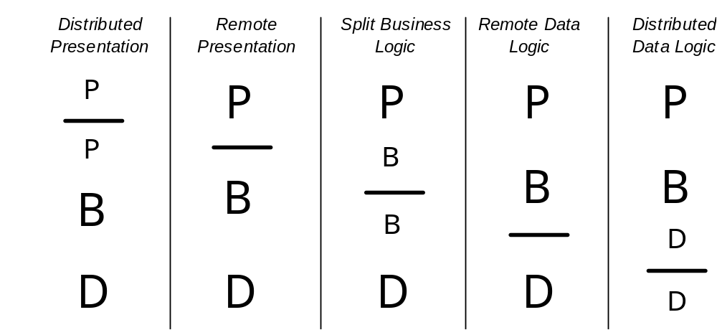

Notes on variations of the above patterns:
- Real applications can often contain more than one major split - for example a client-server system could have distributed presentation and remote data logic. If this is the case, then it should be treated as a combination of the appropriate styles.
- These simple models provide a framework for analysing any application system - regardless of technology. It is the responsibility of the performance architect on a specific project to investigate and understand technology-specific detail. Other topics in this unit will give a start point for technology such as web-based systems.
- In real systems, different distributions may be in use at the same time for different business functions.
- There are two simpler patterns at the extremities of the above model which are not shown on the diagram: Terminal Application, and Standalone Application. Terminal Applications are described below. A standalone application is an application with no connection to other systems at all - all logic and data is located with the end user on a workstation.
Within the IT industry a number of common online application styles are frequently encountered. These vary in age and are often associated with major changes in the predominant architecture style. The table below shows the typical relationship of the above distribution models to the most commonly encountered application style terms (and to the other domains of this chapter).
Distribution Style | Also known as | Typical overlaps with Business & Technical Domain
Terminal Application | “Dumb terminal”, “Green-screen” | Centralized system  Transactional
Distributed Presentation | Client-server - thin client | Centralized or Distributed system  Transactional, Internet or Pervasive
Remote Presentation
Split business logic | Client-server - thick client | Transactional (or applet-based Internet)
Remote data logic |  | Distributed system
Distributed data logic | Client server - distributed data
Standalone Application | - | Specialist application
In the following pages we identify the key performance characteristics of each of these distribution styles.
4.2.1.1 Terminal Applications
Many applications serving dispersed user communities have historically been delivered using relatively simple (“dumb” or “green screen”) terminal equipment which possesses little or no local processing capability other than displaying text-based screens, and supporting user input via keyboard. These are close to the Distributed Presentation model (see below), but where the local client presentation logic is simply the ability to display a screen sent from the host and send back filled-in screens.
In this model, all application logic - presentational, business, and data access - is executed on the host (serving) computer. This implies from a Technical Architecture perspective that the system is ‘centralized’ (the reader is referred to this later section). Performance issues and challenges are in fact the same in principle as more modern centralized applications, although historically terminal-based applications were delivered over significantly slower networks, executed on significantly less powerful computers and had less sophisticated user interfaces.
4.2.1.2 Client/Server Application Architecture
These styles of solutions are generally defined by a significant distribution of application function across the tiers of the system, with generally a significant amount of presentation and business function placed on the user’s workstation.
The performance issues and recommendations depend on the client server model adopted for the solution in question. In the Distributed Presentation case, where presentation logic components interact remotely, special care must be taken of the human factors of the responsiveness of the combination of the server and network to what users may perceive as ‘simple’ requests (such as pressing a function key). As all types of function reside at the server-side in this model, the performance of the server is likely to become the major challenge as volumes increase.
In the Remote Presentation case there are a set of potential problems concerned with the design of the end-user interfaces, for example:
- If the user needs to be presented with large lists (or other data sets) on a particular screen, window or panel, is the entire list to be transmitted to the client in its entirety every time the screen is displayed? This can significantly impact the response time to draw the screen because of both the message lengths over the network and the time required to format and present the list. The volume of data to be returned to the client application can often be underestimated and can vary significantly even for one type of transaction (e.g. retrieving information about all the accounts a customer has).
- Alternatively, the application could be designed so those list items are only transmitted as a user scrolls through them. However, this may cause expectation problems with an unexpected delay in response to apparently simple requests. As a compromise it may be better to transmit more than a single ‘scroll unit’ in response to the initial request. A configurable ‘transmit window size’ could be established to control the amount of data returned to the client. The client would post a subsequent retrieve request to download the next ‘transmit window’ once that initial window had been exhausted.
- From a performance point of view, frequently accessed large data sets could be held locally or cached on the client. However, this then raises the design question of how these locally held lists are to be distributed and maintained.
- Special care will still need to be taken with the human expectations of response compared with whether the system can respond with local processing or will require remote access to the server.
For the Split business logic case, there is more flexibility available in the development of the client application and hence a number of extra performance complexities and techniques:
- The break-up of business logic between client and server is critical. The business logic should be decomposed so as to minimize the number and size of client - server interactions. The most frequently used business logic components may often be best placed on the client unless they require services or data contained at the server. Another consideration during this decomposition is the ability to replicate the resultant server logic across multiple server nodes (i.e. horizontally scalable). If the split can be done in such a way as to achieve this, the inherent scalability of the system can be increased significantly.
- The perception of long initial response times may be reduced by displaying some data very quickly whilst retrieving the remainder of the information later - either as required or, if the middleware will allow it, asynchronously while the user reviews the early data. Of course, this can increase message traffic and server processing, and there may be some requirements on the infrastructure to support this.
- If the client communicates with multiple servers, the interaction design is complicated further. An example of multiple co-ordinated server access is travel agency booking, where the customer wishes to book an entire package involving hotels, cars, insurance, etc. Upon booking, all elements need to be committed (or all backed out). This can be the cause of a large amount of processing and network traffic over a relatively short elapsed time. If each confirmation is synchronous there can be a significant delay.
In the Remote data logic case the client application contains all of the presentation and business logic. The processing time on the workstation will usually be a very significant factor in determining the end to end response time and care will need to be given to the workstation specification. The number of data transmissions and transmission data lengths can also have a significant effect perceived response times. Furthermore, depending on the application usage and the database query design, the data access complexity resulting from a single client request can add substantially to the service time and hence response times.
In the Distributed data logic case there are a number of additional considerations:
- The distribution of data access function is often controlled by the database manager and may not be externally defined.
- Data retrieval strategies may be the responsibility of the data management software and may not be controllable.
- Potentially, a single database request can cause data access to multiple distributed databases. Furthermore, depending very much on the database management system, joins of multiple tables may involve multiple distributed databases. In the worst case, the client may act as the point of joining - in which case, both large numbers of rows may need to be transmitted, and significant client logic will be necessary.
- Determining in advance how the data will be retrieved can be more difficult and have greater impact when distributed than the equivalent retrieves all on the same node.
- New releases of the data management software may adopt different (and not necessarily better) retrieval strategies - a major change control problem
Essentially, this is a complex environment with many of the factors affecting performance outside the control of the application architect. It needs to be approached with considerable care and as a high-risk environment.
Most Relevant Performance Techniques and Practices
Because of the range of solutions that can be classified as “client-server”, most performance design techniques are relevant in some way. The following table summarizes the basic characteristics of the 7 application models:
Distribution Style | Performance Challenges | Most relevant techniques | Most suited to/for
Terminal Application | Response time for screen steps  Host system performance | Vertical scalability (contention avoidance) | Distributed user communities  Simple user interfaces  Low-cost solutions  Low-bandwidth networks  Restricted space solutions
Distributed Presentation | Presentation logic interactions  Host system/server performance | Interaction design  Vertical scalability (contention avoidance) | Distributed user communities  Simple user interfaces  Low-cost solutions  Limited data access
Remote Presentation | Management of data sets required for user interfaces  Rendering performance | Communications overhead reduction  Caching  Horizontal Scalability (parallelizing)  Vertical Scalability (contention avoidance, optimizing path length) | Infrequent business logic invocation  Simple workstations
Split business logic | Business logic decomposition  Accessing multiple servers | Communications overhead reduction  Affinity based placement  Asynchronous calls  Horizontal Scalability (paralleling)  Vertical Scalability (contention avoidance, optimizing path length) | Frequent business logic invocation  Collaborative applications
Remote data logic | Data retrieval and storage  Workstation performance | Communications overhead reduction  Caching  Vertical Scalability (contention avoidance, optimizing path length) | Frequent business logic invocation  Infrequent data access  Infrequently changing data
Distributed data logic | Data retrieval and storage  Workstation performance | Communications overhead reduction  Vertical Scalability (contention avoidance, optimizing path length) | Frequent business logic invocation  Frequent data access  Distributed data systems
Standalone Application | Workstation performance  Local data management | Path-length reduction, Vertical Scalability (optimizing path length) | Specialist applications  No distributed/shared data
4.2.1.3 Internet, E-business and Web-based Applications
The move to the delivery of applications using Web-based technology has presented renewed, but not necessarily different, performance design challenges. One of the most noticeable differences between this and the traditional client-server application paradigm lies in the formatting and presentation of user interfaces. In one sense, user interfaces in Internet solutions are more ‘sophisticated’ due to the typical mix of text, graphics, and in some cases multimedia elements in a web page, however they tend to be delivered via common or standard technologies such at HTML which in fact constrain the user interface model from some perspectives. From the end user’s perspective, response time is all about the time it takes to assemble and format successive pages for display. The data required to populate parts of those web pages can involve retrievals from many target systems.
Leaving aside the increased complexity introduced by the number of components and interactions, a web transaction's activity still decomposes into a number of client-server transactions (with processor and I/O response times) exchanging data across network connections. Web applications often combine characteristics of the following classes of online solution: Distributed Presentation, Remote Presentation, Split Business Logic and to a lesser extent Remote Data Logic. [Note that a basic web-browser is simply an application which implements presentation logic in the form of HTML page rendering.] As such, performance challenges and guidance are largely similar to those outlined above, however there are a number of particular aspects and focus areas which are worth highlighting at this stage which can have an overriding influence on system performance.
The Client Workstation
The time spent processing on the client in a Web-based application can be almost negligible or it can be many seconds. Particularly heavy processing is incurred by:
- Rendering images and complex graphics within a Web page
- Starting components which playback multimedia elements
- Starting and executing any locally downloaded components
The two basic extremes for delivery of a web-application are:
- Pure HTML, where presentation is decided entirely on the server and sent to the client.
- Applet-based, where standards-based application components are downloaded and executed locally on the client workstation. It may contain some or all of the presentational, business and data access logic as with a traditional client-server application. (The platform-independent Java progamming language was designed for this model.)
In between these extremes are various sleights for increasing the sophistication of client-side processing without downloading whole applications, including embedded scripts and browser plug-ins. The simpler the client stays in terms of function, the more the system tends to the Distributed Presentation model, and the more server-side processing is implied.
Solving workstation performance problems after implementation can be very expensive (by upgrading many machines) or impossible (for workstations belonging to the public, or if no available machine is powerful enough). It is therefore essential that the performance issues are addressed at application design time and that early testing is performed on a workstation configuration likely to be encountered in production.
Network characteristics
Because of the geographic distribution of connected clients, the potentially large number of routes and steps that web-based application traffic can take, and the cost of high-speed connections, it is difficult to be sure about both available throughput and likely latency of interactions. Significant numbers of users may still connect at the speeds permitted by analogue modems (e.g. 56 Kbps nominal, slower in practice), or slow private network links (e.g. 64 Kbps), which can imply significant number of seconds spent transmitting to and from the browser. Prudent application design is again required to achieve acceptable response times.
Generally bandwidth in Internet backbone networks is not an issue for individual messages although it can be significant for large file transfers. There may be periods in the day when due to peaks of public usage of the Internet, there is a shortage of capacity effecting some parts of the network (e.g. local Internet service providers) causing increased response times.
The Server-side Web Application
Typically, for an Internet application with users connected on slow lines, the server application itself will not be the largest contributor to overall response times. In high-speed network (e.g. Intranet) environments however this situation is reversed. With potentially many complex interactions between components required to build one page, the performance of critical transactions should be estimated carefully taking all these interactions into account.
The most important consideration is to ensure that none of the components become over-utilized causing excessive queuing and response delays - this is a question of avoiding excessive contention for shared components. The technique of setting and then tracking component targets and budgets is key to ensuring that all server-side application components are up to the job.
Systems Management
Given the often unpredictable load characteristics of the Web, application design for web-based system is not just a question of initial design but of supporting performance management activities in the live system. Early warning is required of impending overloading of components, so that problems can be forestalled. Whilst statistics available from web servers, application servers and other common products in the application infrastructure are often sufficient, consideration should be given to whether any monitoring/performance management features should be built into the application code itself.
Presentation and Interface Design
Because perceived end user response times are so critical to application acceptance, and presentation in web-based applications can have such a significant effect on overall performance, the presentation design should, among many other recommendations:
- Aim to limit the number of page items to reasonable limits since each requires a separate interaction with the server.
- Control the excessive ambitions of the Graphic Designers and programmers and only use complex graphics and multimedia elements where they are appropriate and effective
- Ensure that important elements of the page appear early, even if the complete page takes much longer
- If the page is likely to be used by many users only for navigation to other pages, display the navigation controls as early as possible so that the user can move on rapidly without having to wait for the entire page to render
Legacy / Back-end integration
As with any multi-tier system attention needs to be paid to each layer of the system, and the interactions between those layers (the client, the network, the servers, etc.). Many web-based applications are sophisticated front-ends to, or integrators of, existing or older applications within the customer’s enterprise - so called ‘legacy’ applications.
As a result, an apparently simple transaction may turn out to involve a very complex series of flows involving multiple systems in multiple locations - it is very important to understand the detailed flows which are required before making any commitments to the user.
There are a large number of potential technologies and infrastructures involved in back-end integration that will not be discussed here (e.g. MQSeries, CICS, etc). References to sources of information relating to some of those technologies are given in Appendix B.
General
There are a few macro level guidelines for designing for performance that apply to all components of an end to end web-based solution. You should keep these in mind as you work on the architecture, design, development and deployment of your system.
- Understand the potential growth requirements for the application and plan for that growth. One element of such planning can be to avoid proprietary technologies and interfaces which are tied to a specific platform and which may provide only limited scalability. If platform independence is acheived the application could if required be moved to a different platform affording greater scalability. Proprietary implementations may in the first instance perform better than open standards-based systems, therefore a plan for future growth requires a good understanding of the longer term performance and scalability needs versues any short-term performance advantages of the proprietary technology.
- Because of the high requirement for data and content transfer (including all the elements which constitute the user interfaces), a particularly important and prevalent technique for web-based applications is caching.
There are other specific performance guidelines, hints, tips and other helpful information presented in some of the reference documents listed in Appendix B.
4.2.2 Style of Application - Batch Application Architecture
Batch applications generally have no “users”, and no interactive response time requirements. Instead, batch applications are required to process large amounts of data and run in limited windows of time. The challenge with this style of application typically lies in the sequencing of processing, and the complexity of the interface between the application and data components.
A key design requirement is normally to maximize the throughput achievable through the batch application. This will generally involve architecting the application such that the workload can be segmented and processed via a number of parallel streams.
With batch processing there is no waiting for terminal activity, so performance is not measured by an actual response time. The critical metric is throughput, or the number of batch transactions which can be processed per second, which depends on the time taken to process an individual transaction (a batch 'response time') combined with the number of such transactions that can be processed in parallel. Most batch programs individually use relatively little processor resource and are mainly limited by waiting for I/O. The objective of batch design and tuning should be to keep the processor as busy as possible and minimize the time spent waiting for I/O. This can be achieved through two main approaches:
- running many batch programs in parallel, so that I/O is overlapped with processing of other programs
- minimising both the number of I/Os required to process a transaction and the I/O service times
4.2.2.1 Running parallel batch programs
Running parallel batch programs can be achieved in two ways:
- By running different programs from the batch schedule at the same time. In a typical schedule many programs can often be run in parallel, constrained only by dependencies in the schedule and the need to avoid the overload of some server resource, such as memory. In batch systems, the sequence of running is usually controlled by a batch scheduler (such a Maestro for Unix or OPC for OS/390) which maintains dependencies and controls parallelism. However to provide the maximum scheduling flexibility and thus increase throughput, the number of dependencies should be kept to the minimum demanded by real business constraints. Too often developers will enforce scheduling constraints either for technical reasons or because they are not sure if they are required or not.
- By running multiple copies of the same program in parallel (multi-streaming):
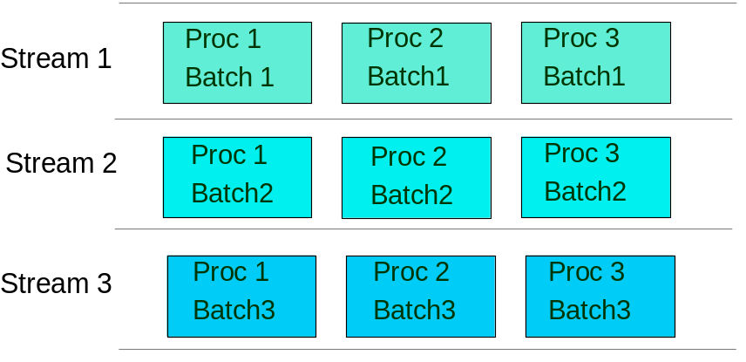In this example there are 3 streams each of which processes 1/3 of the input. With a reasonably well balanced workload the run time of each stream will be roughly 1/3 the time taken to process all the data in a single stream. To make this technique effective it must be possible to separate the input into 3 roughly equal parts either physically or by key ranges. Ideally the database should be partitioned so that each stream only accesses one partition and the streams do not interfere (the number of streams should be a multiple or fraction of the number of partitions) but significant total run time reductions can be achieved even without partitioning.
Also, the stream schedules should be as independent as possible, although there will probably be points where they must synchronize (e.g. before creating a merged, sorted output file). An operational advantage of streaming is that most of the batch can complete even if one stream fails completely.
One performance risk with parallel running which must be considered is that interference (contention) can occur between programs either by:
- creating excessive I/O to one device (and therefore queueing); a well-designed physical data layout will minimise this
- database locking (generating non-I/O waits) which can be minimised by the use of short Commit intervals (the number of transactions processed before updates are Committed to the database) and page-level or row-level locking
4.2.2.2 Minimizing total I/O times
There are many techniques for minimizing total I/O times.
Application and database design
- Choosing the appropriate data access logic to minimise the number of database accesses
- Implementation of appropriate indexes, which may be different from those required for on-line processing
- Controlled de-normalisation of the database to ensure that, for example, important selection criteria are held at the entity level (e.g. account balance held in the account record, not derived from all the transaction records)
- Effective physical data placement on disk, spreading active data across the multiple access paths, to minimise queueing delays
To achieve the best application design, it is essential for a Performance Architect to be involved early in the process where changes can easily be made. It can be difficult or time consuming to make a major change to the application or database design if a performance problem is recognized in late testing or production.
Data in Memory (DIM) techniques
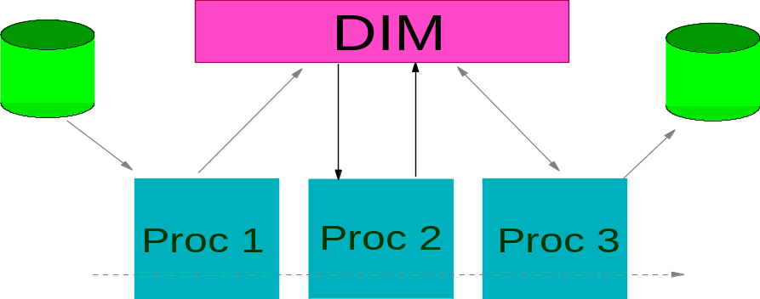
It is a truism that the fastest I/O is 'no I/O', so one objective is to read and write data from and to memory wherever possible, only using external media where necessary. This is essentially a form of caching.

This shows a suite of processes where the initial input comes from disk to Process 1, the final output goes to disk from Process 3 but all the intermediate data storage and retrieval is from/to memory at processor speed. Different facilities for data-in-memory are provided by different platforms and products; for example OS/390 has in-memory DataSpaces and HiperSpaces, DB2 has in-memory databases, and very large database buffer pools have a similar effect.
4.2.2.3 Batch Pipes
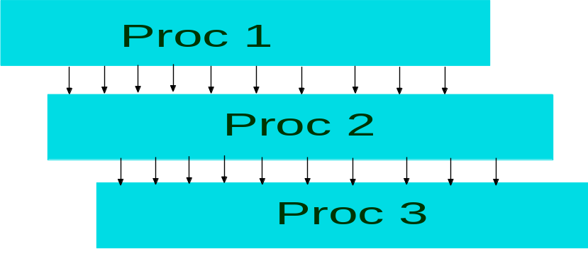
Pipes are a specialized implementation of data-in-memory where one process writes an output record into a 'pipe' (which is an in-memory queue) and a second dependent process reads from the pipe, waiting if necessary for a record to become available.
The Process 1 is not delayed while writing to the pipe and the Process 2 can handle the individual transaction as soon as Process 1 has finished with it and it appears in the pipe. Batch Pipes have two benefits:
- Much physical I/O is eliminated, reducing waiting time
- Process 2 can start shortly after Process 1, rather than having to wait until it has finished
However, careful consideration must be give to database Commit processing to ensure that data is not sent down the pipe while the originating transaction can still be backed out.
Pipe technology is implemented on many platforms, including OS/390. In addition, with OS/390, the HiperBatch facility operates in a very similar way.
Another flavor of data-in-memory has been used for many years in Sort processing. Sort is still a very common requirement in batch processing, re-ordering a transaction file to enable the most efficient processing against the database by making it sequential for the current process. Simple sorting looks like:
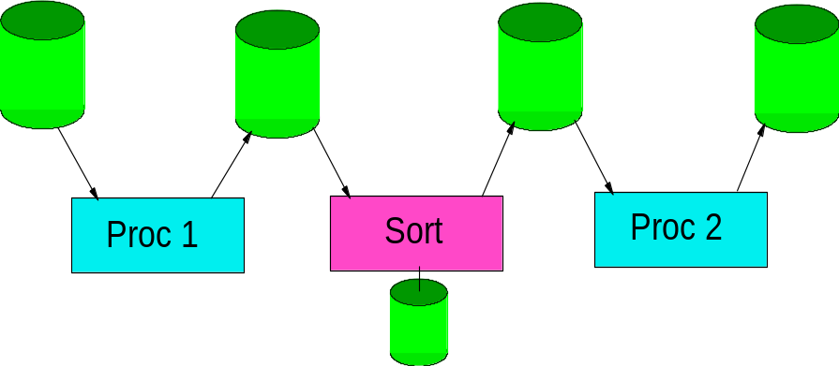
With input and output files from Processes 1 & 2 and the Sort, and disk-based Sort workfiles. This incurs significant physical I/O and, although Sorts have been developed to employ very sophisticated I/O handling, performance is still inhibited.
Greatly improved processing can be achieved by using the following techniques:
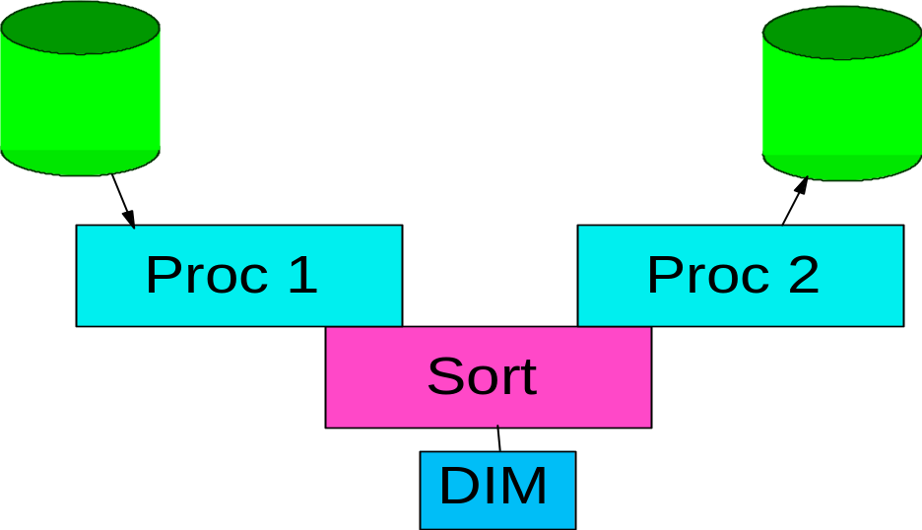
Where Processes 1 & 2 are written as exits to the Sort. In this mode Process 1 passes its output record directly into Sort and Process 2 accepts its input directly from Sort. The amount of physical I/O is much reduced and there is processing overlap between Sort and the Processes. Performance can be further improved by using data-in-memory for the Sort Workfiles.
4.2.2.4 Batch with On-line
The demands of the on-line system sometimes squeeze the batch window to an extent where the question 'Can the Batch run alongside the On-line Day?' needs to be asked. This is especially relevant with Internet systems that often demand 24-hour service from the on-line system.
Batch can be a very heavy user of system resources, which could have a severe impact on on-line processing performance. This can be alleviated to some extent by reducing the number of batch streams contending with the on-line workload for system resource. The effect can also be reduced by running the batch at a lower execution priority than the on-line, but this is more effective on some platforms than others and with client-server batch it may not be possible for the database manager to distinguish between on-line and batch data requests.
Batch programs tend to process many transactions before committing database updates (sometimes leaving it until the end of the program). This could cause severe locking problem with on-line transactions, so the Commit interval must be reduced to ensure that a lock is not held for more than a few seconds. Increasing the Commit frequency will reduce the individual program performance to some extent, so a balance must be struck.
Major problems with a batch run (such as processing a payment file twice) have often been overcome by restoring the database to the status at start-of-batch. If the batch is running alongside the on-line this is not possible without asking all the on-line users (including the Internet customers) to re-enter all their data which is not really practicable. Even backing out a single batch job is not possible because of the reduced Commit interval. In these circumstances a database Commit must be viewed as permanent. If a problem is found later, then a process must be run to undo the updates cleanly. This may require developing 'antiprograms', which undo batch updates, during the development process or in an emergency.
A useful model for batch processing is to identify the part of the batch schedule which must run during the batch window (for performance or application reasons) and the parts which must complete that night (e.g. the bills must be produced). This is known as the 'Core Batch' which could be comprised of both ‘functional’ batch (e.g. bill run) and ‘operational’ batch (e.g. database re-organization) processes. There are usually then
- preparatory processes which run before the Core and could be run alongside the evening on-line system when the load may be low (such as payment receipt processing)
- processes which run after the Core which could either be abandoned or postponed if there is a risk of batch overrun, or run alongside the start of the of the next on-line day (such as reports).
This approach requires application and business knowledge, but can significantly reduce the pressure on the Batch Window.
In summary the requirement to run batch alongside the on-line system is becoming essential for more and more systems. It is possible, but raises new design and performance challenges that must be addressed at the design stage.
4.2.2.5 Specific Techniques
Relevant performance techniques to improve the performance of batch systems are:
- Optimising Pathlength - to reduce the cost of individual steps in the batch processing
- Parallelising - specifically running applications simultaneously, segmentation and multi-streaming, and pipelining
- Pacing, Throttling and Restrictions - controlling the rate of work of some elements in order to provide the best overall balance and throughput
- Data/Component Management - specifically to minimise the impact of I/Os on the batch processing

4.2.3 Style of Programming
The style of programming selected can have a significant impact on the performance of the resulting application. This section looks at some of the more common programming style and programming model issues.
4.2.3.1 Code Generation Vs Hand Crafted
Care needs to be taken when dealing with code generators, e.g. those often associated with fourth generation languages (‘4GLs’). This category includes the many ‘visual’ programming tools and development environments that are much in use for thick-client applications. Their strengths are that they can speed up the code development process considerably, by enabling the code to be generated from a series of high level menus, forms and other visual constructs. The downside of this increased speed of development is that the code produced is often less than optimal. In practice there can easily be an order of magnitude difference in the performance of code produced by generators as opposed to that produced manually by competent developers.
A further risk of code generators is the inclusion of a fixed model of application component decomposition and interaction. As was discussed extensively above for client-server systems, inter-component interaction design is critical. The less control the application developer has over such aspects of design, the greater the risk of inadequate performance as fewer performance design techniques can be employed.
In those situations where 4GLs are used and where performance is a significant project risk it is recommended that prototyping is used to validate the performance characteristics of the generated code. Early experience gained in this way can also be used to identify development best practice and those cases where manual coding is required. In many cases it is good practice to code by hand the most frequently executed, or most complex, program modules. In this way the performance of the overall system may be improved dramatically by focussing the more scarce and highly skilled programming resource on the key elements of the application. The benefit of faster development using the more automated tools can still be realized for the less performance significant processes. In many projects, that will apply to roughly 80% of the overall code base.
Any rigidities or limitations in the data or component interactions introduced by the choice of development tool should be understood early in the development process so that they can be worked around as necessary.
4.2.3.2 Object-Oriented Vs Procedural
One of the difficulties seen with early object-oriented (O-O) code implementations was the significant overhead cost associated with inter-object communication. Highly structured code involving large numbers of relatively ‘small’ objects was obviously more prone to this. The problem was particularly acute in environments where the cost of linkage was relatively high (although significant improvements have subsequently been made in this area). Applications based on large object populations are also inherently more difficult to test and maintain. The run time data is dispersed across those objects and the complexity of the resulting object class diagram can require testing down to the individual object level.
Another potential problem area for performance is the cost of creating and deleting objects. This is significant, especially when garbage collection is used in the language itself. The developer must think of the life of each object when designing the application. Repeated creation and deletion of the same object should be avoided.
Of course, procedural based developments bring their own set of challenges. As well as the obvious need to design efficient and well-structured application code, areas such as data access and data locking need careful attention. In many cases it is common practice to separate the data access logic from the core application logic and establish a separate data access team to ensure the data is accessed in a consistent manner.
All these points considered, there is an obvious trade-off between the size of the individual code modules within the application (reflecting the level of ‘normalization’ built into the application), and the efficiency of resulting application execution. It is likely that O-O technology will continue to pay a performance penalty for the foreseeable future compared with efficient procedural based developments. The upside of well designed O-O based applications are improved manageability and testability, along with the potential for wider re-use. However, if ‘state of the art’ performance is the driving requirement, then procedural based development is and will remain the development paradigm of choice.
4.2.3.3 Compiled Vs Interpretive
This is an old issue with a recent re-emergence in the case of web applications developed in the platform-independent Java programming language. (It should be noted that Java is inherently also an O-O language and lends itself well to an O-O style of program development - see the previous subsection).
One of the inherent advantages of interpreted applications is their potential for portability from one platform or operating environment to another. The consequence of this portability is an impact on the throughput due to the necessity to interpret the code as the application is running. The concept of ‘just-in-time’ (JIT) compilation was introduced to address this problem, such that the code is compiled, and hence optimized for the specific operating environment, just prior to program execution. The advantage is that the code is no longer run interpretively, with a significant execution speed up, however the compilation time is inline with program execution (at least the first time the code is run within that session - this is less of an impact if the same code is executed multiple times within the scope of a single session).
Recent advances in JIT compilers have resulted in the efficiency of the JITed code being comparable with that of native compiled code. Significant JVM enhancements have also been made which have significantly improved Java performance from that seen in the early days, such that under specific conditions and with highly skilled developers it is possible to construct Java programs exhibiting performance close to native Fortran or C code when processing computationally intensive workloads.
However in most situations, when attempting to build high performance applications, use of the Java language still poses challenges that must be tackled at the design and development stages. The references section of this document contains pointers to information sources discussing these performance challenges and associated good practice for Java based developments in some detail (in particular “Designing e-business Solutions for Performance”).
In Internet and Wireless style developments where flexibility in the type of client platform executing the application logic is a key requirement, then interpretive program development and execution using Java is the obvious choice. However, in more traditional Client/Server and Batch style developments where program execution speed and throughput are key requirements and the execution platform is stable and well understood, then compiled program development is likely to be required.
4.2.4 Style of Messaging
The style of messaging selected can have a significant impact on the performance of the resulting application. Here we look at some of the more common messaging styles. For each we discuss any specific performance considerations that apply (specific techniques for improving messaging performance are given in the Techniques Section of this document, in particular see Pacing, Throttling and Restrictions).
4.2.4.1 Synchronous Vs Asynchronous
Traditionally application components would communicate via synchronous calls, the sending process waiting until a response was sent by, and received from, the receiving process before program execution could continue. During that wait period the sending process would often remain ‘despatched’ on some less sophisticated server systems, with the result that other work running on the same system would queue behind that process. The net result was an impact on overall throughput in multi-tasking workload environments.
In distributed computing, the sending and receiving components are typically located on different physical nodes, those nodes often separated by relatively slow WAN links. The obvious consequence is a lengthening in the duration of a synchronous program call, and associated reduction in application throughput.
The opportunity for asynchronous application communication has become more straightforward through use of modern messaging and middleware services. If done successfully, the resultant throughput can be increased significantly as calling processes can continue with other work whilst earlier requests are being handled elsewhere. The challenge is often more acute within a 4GL development environment. In such cases the middleware components and/or the nature of the client - server interaction is often mandated. Asynchronous program execution can then only be achieved through custom development. In those cases the key design challenges involve the mechanism for handling the interrupts/ notifications between client and server components and the recovery from client or server failure during asynchronous process execution.
There are still situations where synchronous messaging is essential, in particular in real time systems such as can be found in the defense industry. In those cases it is important to design the individual calls to be as efficient as possible. This involves minimizing the number of individual calls between sender and receiver, and also minimizing the latency of the communication link.
4.2.4.2 Persistence Vs Non-persistence
Regardless of whether synchronous or asynchronous messaging styles are being used, the individual messages can be processed persistently or non-persistently (i.e. transiently). In the former case a record is written synchronously to a log file for each message exchanged. The basic trade-off between persistent and non-persistent messaging is one of recoverability versus performance. Persistent messaging requires additional processing to write out records to a log file on disk. The impact can be a significant increase in the elapsed time for the request.
Such recoverability is essential for update transactions, particularly for financial transactions that could involve the exchange of large amounts of money. However, for read only transactions, which constitute the bulk of transactions in many systems, such logging overheads are not required and can place a significant additional load on the system. It is therefore important to make judicious use of persistent messaging services. As a general rule a persistent messaging workload tends to be I/O bound whilst a non-persistent messaging workload tends to be CPU bound.
4.2.5 Other Application Considerations
A number of additional application characteristics are important when considering performance.
4.2.5.1 Stateful Vs Stateless
For applications comprised of simple ‘units of work’ it is likely that individual user interactions, and their corresponding transactions, are independent of each other (i.e. Stateless). Contrast this with the case of applications comprised of more complex units of work. In such cases the unit of work will typically span multiple user interactions. This introduces a dependency between those interactions and their corresponding transactions. In this case it is likely that context data will need to be shared between different transactions within the scope of that unit of work (i.e. Stateful). This has implications for the way those individual transactions can be scheduled in a workload sharing environment. The state data needs to be preserved between interactions such that it can be readily accessed.
Options include holding the state data in a persistent back-end data store, holding it in the middle tier (along with a mechanism for accessing the data between nodes within that tier), or passing the state data along with the interaction requests themselves. The references section of this document contains pointers to information sources discussing the relative merits of each approach (in particular “Designing e-business Solutions for Performance”).
4.2.5.2 Secure Vs Open
There are several aspects to system security, each of which have potential performance impacts which must be considered. Firstly there is authentication. This is the activity of confirming that individual users are authenticated before accessing protected systems. Secondly there is access control, or authorization checking. This is the activity of confirming that individual logged on users are authorized to access a given application and perform the action they are requesting from within the application. Thirdly, there is data confidentiality and integrity in the form of data encryption and data signing. The former involves protecting the data exchanged between client and middle tier, and/or database server from unauthorized viewing. The latter involves guaranteeing the source and integrity of the data received by the server.
The references section of this document contains pointers to information sources discussing the performance implications of each of these aspects (in particular “Designing e-business Solutions for Performance”).
4.3 Technical Architecture Domain
In the technical architecture domain, we are interested in the aspects of the system infrastructure (documented in the Operational Model work product) which have a direct bearing on application performance and therefore application design. The most relevant aspects of the infrastructure include:
- Topology
- Geographic distribution
- Platform definitions
- Network connections and protocols
- Placement of software components
Often, there will be infrastructural givens for a particular system from the outset, e.g. platform types, available network or user locations which have to be taken into account. This section gives guidance on understanding the influences that technical architecture features can have on the application design from a performance perspective. Of course, application design and infrastructure design share a two-way dependency, and the joint and consistent design of the application and infrastructure is in fact one of major challenges facing projects of any size.
4.3.1 Topological and Geographic Considerations
Topology means the layout or structure of the system from a physical perspective, showing how nodes in the system are physically inter-related. One major aspect of topology is how many layers there are to the system. Often the physical layers match the logical tiers that the application is to be divided up into. For example, a client / application server / database server tiering might be physically implemented as three separate physical layers containing the client application, application server and database servers respectively. Consequently, there is a strong relationship between this section and previous sections on distributed application architectures.
4.3.1.1 Centralized Systems
A centralized system can be defined as a system where all processing is done in one physical location or tier, and generally run on a single computer. Users accessing a centralized system do so typically via simple terminals or text-mode only interfaces; no business processing occurs at other tiers of the system. Application functions, although still potentially varied, are co-located in one place in this type of system. Performance principles for this kind of system are:
- Prioritize most common requests: the application should be designed to return responses to common user requests within acceptable time frames.
- Because of the collocation of function on one or a small number of systems, the application should be designed to be vertically scalable, i.e. it should be possible to increase throughput by adding more or faster hardware (memory, processors, disks etc.) to the computer. This implies the exploitation of hardware multiprocessing by the use of multiple schedulable entities at the operating system level (e.g. threads).
- Understand the peak processing times for the system and consider what functions will be running together during these times - a ‘24-hour’ picture of activity is highly useful here covering both batch and online activities. Understand the dependencies that exist between those functions/ processes, along with the existence of any serialization points that would inhibit their parallel execution.
- Performance design effort should be put into optimizing use of the operating system and hardware features on the centralized platform. Key areas to consider include memory management, interprocess communication and I/O work.
- There may be requirements for connections to other external systems - i.e. located elsewhere - to or from which data may need to be transferred in batches at specific times or at regular intervals, or via a transactional interface. Thought needs to be put into the design of such interactions so that they will be able to perform adequately, taking into account the performance characteristics of the connection to the remote system. Inbound or outbound staging may be considered, for example.
4.3.1.2 Multi-node, Clustered or Peer Systems
An alternative single-tier physical architecture is that involving groups, clusters or “farms” of computers operating together to support an application within one physical domain. Usually such groups or clusters are connected by a high-speed local network or switch which allows very low-latency and high-bandwidth inter-node communications. In such systems, processing is distributed amongst the computers in the cluster. Key performance considerations are centered around parallelism and component placement, and include:
- How is application function spread across the available nodes? The aim is to achieve an even loading across the available servers. If it is possible to distribute the same application functions to each node in the cluster (i.e. a peer system), then even balancing is more easily achieved.
- Workload balancing is often achieved by other nodes within the system which perform a dedicated workload balancing role using hardware and software features to route traffic as equitably as possible across the available servers.
- In these scenarios, horizontal scalability is a key characteristic. This means that the application should be design so that the throughput of the system can be increased linearly (or near linearly) by adding more nodes to the cluster - this means eliminating potential bottlenecks such as single-threaded services, points of serialization and contention for data. Vertical scalability is still of concern so that individual node throughputs can be increased as well.
- Despite the availability of a high-speed network, an aim should be to keep the number of cross-node interactions to a minimum in order to increase throughput and enhance future scalability.
4.3.1.3 Distributed, Multi-Tier and Client-Server System
The definition of these different types of systems overlaps significantly so they will be considered together. The key characteristics of such systems are that application processing (i.e. functional components) is geographically distributed in the different layers of the system. In what have been commonly termed ‘client-server’ systems, ‘client’ applications (collocated with users) perform local processing but also directly access services located remotely on shared ‘server’computers; these are also termed “2-tier” systems.
Distributed systems in general can contain an arbitrary number of tiers to the system, with application function and/or data placed across the layers. Performance considerations for multi-tier systems are numerous as individual user requests can lead to a complex set of interactions between components and tiers. Total response time from the user’s perspective is made up of many different elements:
- network transfer times
- server processing times (possibly at more than one tier)
- back-end transaction times
- client-side processing and rendering time
- any time spent queuing for services or resources
Key performance guidelines for these types of solutions are mainly to do with reduction of communications overhead and data and component design and placement:
- The design of interactions between distributed components is particularly critical for multi-tier solutions. In general, the number of interactions required to service user transactions should be kept to a minimum. A common technique for reducing interactions is to cache commonly accessed code and data.
- In the design of interactions, the size of data in messages being communicated (requests, responses, notifications, content pages etc.) should be kept to a minimum to avoid significant network delays and reduce the bandwidth requirement. This includes the message header itself. Only required data items should be sent with transactional requests for example.
- The nature of the networks between tiers of the system will be a principal constraint for the application design. Some application models may not be viable over low-bandwidth or high-latency networks. In many distributed systems, including Internet and pervasive systems, there may be a range of connection speeds connecting users to the system, which need to be taken into account.
- The considerations for single-tier systems (as above) should be applied to each individual layer of the system in order to support the required volumes and scalability targets. Application server tiers - e.g. those directly serving user requests - are generally more open to horizontal scaling, whilst database and backend transaction tiers are most commonly limited to vertical scalability (that is without significantly increased application and database complexity).
- Distributed solutions often require thorough security architecture. The overheads of the security solution (encryption, decryption, authentication, etc.) need to be factored into the overall design for performance.
4.3.1.4 Other topological considerations
Many business-critical solutions have a requirement for a disaster recovery site where operations can be resumed in the case of a disaster at the primary site. In such solutions, data is usually replicated to the backup site, either asynchronously or in real time. Depending on the separation of the two sites and the replication technology chosen, there can be substantial performance overheads when writing data to disk which need to be taken into account during application design.
4.3.2 Platform definitions
The choice of platforms on which the various parts of the application will run - which may be a given for a particular system - can constrain the development of the application in the following ways:
- application development environment and tools
- programming languages and models
- persistency and other middleware services
- graphical user interfaces
- multiprocessing / multithreading
- parallelization options
The constraints on the application due to platform choice have a knock-on effect on native application performance, and available performance and scalability options. Such implications should be assessed as soon as platform choices are known.
4.3.3 Network connections and protocols
It has already been noted that the type of network connecting nodes in the system will have a significant effect on the performance design challenge for the application. In distributed systems, it is likely that at least one Wide Area Network (WAN) will be employed to connect end-users to server systems. The performance characteristics of WANs and WAN connections can vary quite significantly depending on whether they are public or private, and on the investment made in them. The key performance characteristics of a network connection are:
- latency - the basic time required to make one point-to-point transfer of a small message across the network
- bandwidth - the “speed” of the line, defining the maximum achievable data rate through a particular connection (assuming negligible latency)
- committed information rate (CIR) - the constant end-to-end throughput which the network provider commits to supporting for a particular virtual network connection
Local area network (LAN) performance can be described in similar ways, but generally have much higher throughput and a more predictable quality of service. Typically, LANs are owned by the business (or service provider) which runs and manages the system. LANs can generally be driven to 60-70% of their maximum throughput without significant increases in elapsed times.
The other aspect of network connectivity to consider is protocol availability. Different protocols offer different overheads, messages sizes constraints and qualities of service and therefore can have a significant effect on response time and throughput for given loads.
During the design of component interactions, assessments need to be made of the likely required response times and throughput across network connections, and then assessed in terms of feasibility and cost-effectiveness. If the network requirements are beyond current technology or too costly, alternative application designs must be considered.
4.3.4 Placement of software components
As has already been discussed, in distributed or multi-tier systems the placement of data and software components is an important decision which takes into account many other factors, including the above infrastructure factors. Some basic principles and techniques for data and component placement are:
- Affinity-based placement 1: Estimate what components will interact the most frequently and place these together in the infrastructure where possible. This is to minimize the volume of time-consuming remote interactions over networks.
- Affinity-based placement 2: Locate data sources in a place where they can be quickly accessed by the components which most frequently read or write from them
- Caching: Where data cannot be physically co-located with components that need it, aim to cache data as much as possible, especially data which is read-only, not regularly updated or does not need to be completely up to date.
4.4 Data Architecture Domain
The performance characteristics of the Data Architecture domain are primarily governed by the placement and style of data the application is supporting.
4.4.1 Considerations due to Data Placement
The most typical data placement options can be categorized under the following broad headings.
4.4.1.1 Centralized Data Store
A centralized system can be defined as a system where all processing is done in one physical location or tier, and generally run on a single computer. This usually implies that the system’s data is held centrally as well.
Data is likely to be resident in a single, local database management system. How is data shared amongst different parts of the application? Data locking may be required for concurrent access to the database and the performance impacts of this must be considered.
4.4.1.2 Multi-node, Clustered or Peer Systems
An alternative single tier physical architecture is that involving groups or clusters of computers operating together to support an application within one physical domain. In such systems data may be shared amongst the computers in the cluster.
In this scenario, shared data may need to be accessed from multiple nodes. In this case the database server can be located on a dedicated server or a parallel database product will be in use. Locking may be an issue.
4.4.1.3 Distributed Data Stores
Distributed systems in general can contain an arbitrary number of tiers to the system, with application data placed across the layers. Performance considerations for multi-tier systems are numerous as individual user requests can lead to a complex set of interactions between components and tiers.
When considering distributed data stores, significant thought needs to be given both to the complexity of implementation and to the performance of data replication between distributed data stores (whether the design is master/replica, or peer databases). Such data replication activity can have a significant impact on network bandwidth utilization. As such the required replication frequency should be carefully considered. The performance benefits of distributed data should be assessed versus the simplicity of centralized data management.
4.4.2 Considerations due to Style of Data
The style of data, or rather the format of the data as it is accessed by the application and/or stored on disk, can have a significant impact on the performance characteristics of the solution as a whole. The considerations and relative merits associated with some of the more common data formats are discussed below.
4.4.2.1 RDBMS Vs File
Typically this is a question that arises when designing batch applications, where the options are either to hold the application data in flat file format, or in one or more database tables. One of the key considerations when attempting to answer this question is the required recoverability of the batch application in the event of failure.
When designing a long running batch process it is good practice to introduce checkpoints at specified intervals, such that in the event of failure, the batch application does not need to be restarted from the beginning. Managing this recoverability is a complex design challenge. If the decision is made to hold the data in file format, whilst the speed of access to that data is potentially increased, the capability to manage that application recovery lies with the application itself. The advantage of holding the data in a database table is that the RDBMS itself will provide logging and recovery services to assist in this task.
Another consideration that has more relevance to decision support systems is the questions of BLOB storage. Binary Large Objects, or BLOBs, are used to store data objects that typically vary in size from a few Kbytes to many Mbytes and beyond. Examples are Project Documents, Spreadsheets, and Project Plans.
Efficiencies can be realized by holding BLOB data external to the database itself. Instead, the database will hold pointers to the location of the individual BLOB within the file system. Access to that BLOB will be through a thin layer of application logic that requests the pointer from the database and then uses that pointer to retrieve the data from the file system. In this way unauthorized access to the BLOB data is prevented, and its integrity is guaranteed.
4.4.2.2 OLAP Vs RDBMS (e.g. Cube - ref Data Warehouse)
The question here arises when designing complex decision support systems around some form of central data warehouse. The application can either access the data directly from database tables, or from an abstracted multi-dimensional data structure that in some cases can provide a more effective cut through that data.
The trade-off is the time to load the data into the data structure, compared with the potential improvement in access time to run the subsequent queries. A number of configurations are possible:
- The abstracted data is held in an array structure along with the source data
- The abstracted data is held in an array structure, although the source data is still held in relational table format
- Both the abstracted data (this time in the form of database views), and the source data are held in relational table format.
The references section of this document contains pointers to information sources discussing the relative merits of each approach.
- Generic Techniques for Performance and Scalability
The above sections focused on:
- establishing the performance requirements for an application and gaining an insight into what areas of the application have challenging targets to meet
- understanding the typical characteristics of various solutions classes, especially useful when first considering the design of the system
This section focuses on techniques that can be used in design to help meet the application performance challenges. It is a survey of generic techniques that are applicable at various levels of abstraction, from high-level component models to individual program modules, and as such they should be considered at each major stage of the system design lifecycle. Consideration of these techniques can help to define the overall structure and style of the application as well as providing specific solutions for performance critical areas. These techniques also constitute a checklist of options for redesigning existing applications to make them go faster. The techniques fall under the following six categories:
- Optimizing Path Length/Unit Cost
- Parallelizing
- Contention Avoidance
- Overhead Reduction
- Pacing, Throttling and Restrictions
- Data/Component Management
5.1 Optimising Path Length/Unit Cost
Description of category
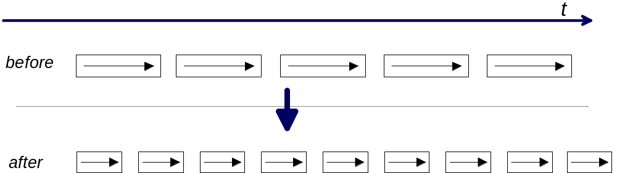
Applications tend to perform the same operation on each transaction or units of data flowing through the system. Unit costs are the typical or average costs associated with the execution of frequently used functions. Because they are executed frequently, it is important to keep these cost to a minimum otherwise they will prove to be a bottleneck. The maximum allowable cost for a single-threaded function that must be performed n times a second is clearly (1/n). In the following diagrams, an arrow inside a box represents a single unit of work being performed.

Examples of potential problem
- A developer does not understand the context of his code in terms of its performance requirements and writes a routine to search a list using a linear scan. He does not realise that his routine will be called every millisecond, and that the list contains thousands of entries.
- It turns out that for most of the orders made at an online shopping web site, the invoice address and shipping address are identical. However the application logic is not aware of this special (but common) case and always stores the two addresses seperately. This wastes disk space on the database server and causes unncessary cpu usage at many stages of processing.
Specific Technique
Technique | Description/Example(s) | Comments/Applicability
Employ efficient algorithm | Perform a tree search instead of a serial search | Efficient algorithms are usually more effort to code
Employ specialized hardware for expensive operations | Add-on card to perform encryption/decryption | Should be considered if software optimization would be time consuming or extremely difficult. Some options may permit many data items to be operated on simultaneously.
Minimize size or number of objects being operated upon | Include only necessary fields in a structure or string  Retrieve only necessary data from a database  Avoid whitespace in data objects | Operating on smaller data objects usually reduces costs
SQL Optimization and Indexing | Select a clustering index to avoid use of expensive sorts.  Add an index to avoid resource consuming tablespace scans. | Tools such as dB Explain should be used to assess the efficiency of the most complex and/or most frequently executed SQL statements. The tools attempt to offer alternative statements in those cases when the assessed complexity is high.
Scalability comments
Reduced path lengths can significantly contribute to increased throughput, but have a limited effect on ultimate scalability. Once a unit operation has been fully optimized, it constitutes a throughput bottleneck in that it allows a maximum rate of operations to be performed. If the cost is related to cpu processing time, future scalability of the function will be related to the increases in speed of available hardware. Scaling a system by increasing the speed of the hardware is known as vertical scaling.
5.2 Parallelizing
Description of category
When a single active entity in the system is not capable of achieving the necessary throughput, and it cannot be significantly speeded up, to increase overall throughput extra active entities must be deployed which can process work in parallel with the first. Parallelizing at the application layer usually requires a degree of inherent parallelism in the underlying hardware, e.g. multiple processors or several active disks.
Parellelization is a major performance and scalability technique that can be seen in many different forms and many different levels of computer systems.
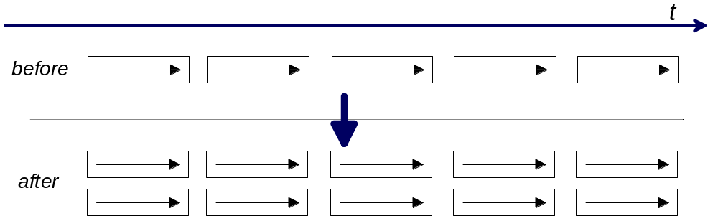
Example of potential problems
- Several processors are not being utilised on a node, however a throughput limit has been reached because the busy part of the application is single-threaded and only one cpu can be used - a classic bottleneck.
- A single database is being used to manage all database work inside the system. The rate of INSERTs and UPDATEs is so high that the database manager cannot keep up, and the application starts to slow down.
- A GUI locks the user out when it is fetching a result set from a server. It could have been coded to allow the user to start another query before the first had finished.
- A web site needs to interface with an unresponsive legacy system. One of its web pages features a high graphic content and a table with cells populated by the legacy system, but the table is the last item on the page to be requested by browsers. When viewing the page the request to the backend system does not execute in parallel with the graphics download, giving a poor response time.
Specific Techniques
Technique | Description and Example(s) | Comments/Applicability
Multiprocessing | Divide the processing amongst several processes which can execute on the available processors of the host computer | Multiprocessing improves performance if having one process only would be a bottleneck. This might be because the function in question must perform time consuming synchronous calls, or because there is spare cpu capacity in the system. Obviously most effective on SMP hardware. There can be overheads associated with sharing data between running processes.
Multithreading | Divide the work within a process amongst a number of threads | This has similar advantages to multiprocessing, and can be more 'lightweight'. Threads in a process can share data more easily than multiple processes. Explicit multithreading by the programmer requires a certain degree of skill however. Effective on SMP hardware (provided the threads can be individually scheduled).
Pipelining (inter-process) | Create a dedicated process (or thread) for each stage in a sequence of activities | Applicable when the stages in processing a transaction can be readily broken down into stages of largely equal cost
Asynchronous calls (intra-process pipelining) | Use asynchronous external calls for time consuming operations | Within a process, asynchronous calls free the process to work on the next incoming item (or next phase in processing) whilst waiting for a response from an external agent. This technique is also useful in end-user interfaces to allow users to continue with other work whilst waiting for an operation to complete.  Choosing the right order of events can be important - in general the slowest in a sequence of asynchronous calls should be initiated first.
Workload segmentation / multi-streaming | Process customers A-D, E-H, ... as independent groups in parallel | Applicable when the data sets can be operated upon independently (i.e. not units of work across data sets). Commonly used in batch processing.
Load balancing | Split incoming requests equally across a number of equivalent servers | This technique is only applicable once base parallelization has been achieved. Requires replication of components serving requests (e.g. hardware and/or software). Dispatching front-end is required and can become the bottleneck. Suits workloads where transaction are independent of one another, and there is little contention for shared resources.
Scalability guidance
Parallelization is one of the most commonly used scalability approaches, and gives theoretically limitless scaling of performance. However, in real systems, there are always diminishing returns for continuing to add more active processing entities:
- in symmetric multiprocessing computers, beyond a certain number of processors contention for memory bandwidth becomes the constraining factor
- multi-process or multi-threaded applications often are limited in performance by contention for shared data
- workloads can be split across many physical nodes in a system until the point where the cost of dispatching and managing those nodes becomes the bottleneck, or until access for any shared resources (e.g. single database) limits further scalability
Scaling a system by adding more of the same type of active processing entities is known as horizontal scaling.
Most of the limitations of parallelization are related to contention for shared resources. The next section looks at techniques for minimizing such contention.
5.3 Contention Avoidance
Description of category
Multiple active entities in a system that are working in parallel often have to access the same resources in the system. In order to maintain integrity and/or consistency, it is usually necessary to serialize access to shared resources in some way, especially when the contents of the shared resources can be updated by sharers. Delays are incurred when processes in the system wish to access shared resources that are currently in use by others. This applies to both physical resources, such as disks, and logical resources such as rows of data in a database table.
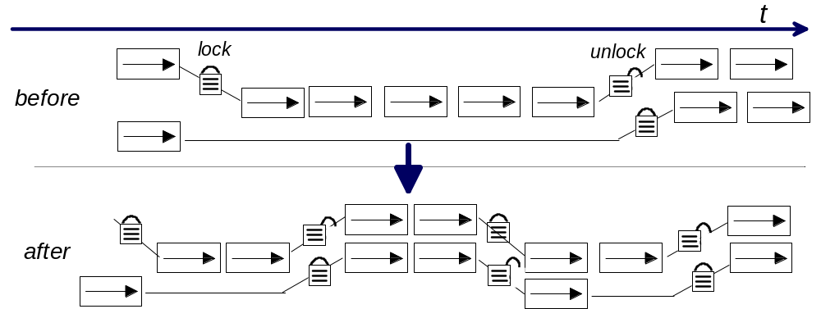
Examples of potential problems
- Two processes read and update rows in the same table in a database. Each time they perform an update they lock the whole table, thereby preventing the other process from proceeding in parallel. Throughput is limited.
- A web site for online shopping becomes very popular because it allows users to check an item is in stock before reserving it, thereby guaranteeing a quick delivery. There are many concurrent users of the web site so access to the stock database is serialised to prevent two users reserving the last item of stock. But, as the webserver is scaled to cope with the increasing demand, access to the stock database becomes a fundamental bottleneck in the system.
Specific Techniques
Technique | Description/Example(s) | Comments/Applicability
Lock granularity reduction | Lock individual table records rather than the whole table | Applicable when benefit of the potential reduction in time spent waiting for access shared data outweighs the overhead in lock management.
Lock time reduction | Net payments against a payment account first, then transfer to the shared main account. | Processing against non-shared data and then transferring results to the shared data can reduce the time for which locks are held. The benefit of this should be offset against the cost associated with staging and transferring.
Speculative Execution | Assume that the account will not be overdrawn after the transaction is processed. If it does becomes overdrawn back out the transaction. | Even though one calculation may depend on another it may be possible to proceed with second calculation in parallel by making an assumption about the first. However, if this assumption turns out to be false the results of the second calculation must be discarded and any effects backed out, which can waste system resources.  Most applicable when there is a cheap-to-calculate heuristic for the required assumptions, which is often correct.
Scalability guidance
Contention between resources may be unavoidable and the ultimate bottleneck in the system. Removing or reducing the effects of contention can lead to significant improvements in the scalability of the system. Often this will be achieved through hardware configuration as well as application design.
5.4 Overhead Reduction
Description of category
All interactions between entities in the system or external to the system incur overheads that must be understood when designing the application. There is a typically a minimum fixed resource cost or time associated with any operation involving interaction with other running processes or pieces of hardware, such as:
- connection setup and closure costs
- inter-process communications
- network transfer time
- low level device costs
- time to encrypt/decrypt
The magnitude of such overheads can mean severe throughput limitations unless measures are taken to reduce their impact.
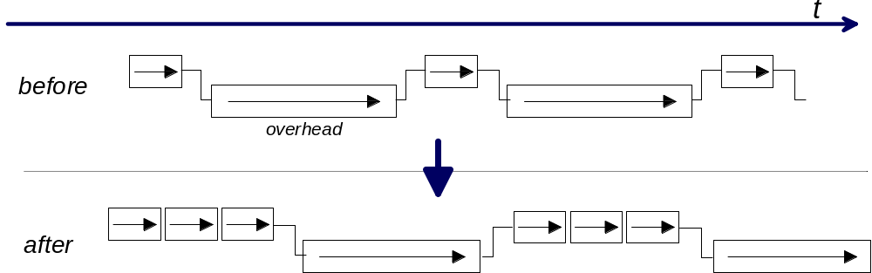
Examples of potential problems
- In a high throughput system, data items must be made persistent before they can be moved to the next stage of processing. Data items are stored individually and in turn, but writing to disk incurs significant elapsed time and throughput is very low.
- An application needs to send a high rate of messages over a secure wide-area network, but with each message it sends there is an expensive encryption operation and a lengthy round-trip time on the network; the application cannot keep up.
- An Internet shopping applet interacts several times with its server for each individual action the user takes. The high network latency between the applet and the web server is incurred many times and potential customers are likely to give up waiting.
Specific Techniques
Technique | Description and Example(s) | Comments/Applicability
Batching | Perform multiple logical storage operations before physically storing (e.g. many INSERTS before a COMMIT in a relational database) | Batching is most effective when the target throughput rate cannot be met by processing items one by one due to the latency of a necessary operation (e.g. log to disk). If the elapsed time of the operation does not increase significantly with the number of items (or size of data) being operated upon (as is usually the case with I/Os and network sends), then much greater throughput can be achieved by creating batches of items.
 | Send multiple items of data in one message when communicating | Requires the overhead of sending to not grow significantly with the size of message. A configurable maximum message size is often useful.
 | Timer-controlled batching: a process only performs an interaction with another entity after a fixed time (the ‘bulking period’) | All messages in the bulking period are queued together. Can lead to unpredictable batch sizes e.g. if incoming rates are variable, but can be used in conjunction with the above technique for maximum control.
Compression | Reduce size of data before sending over network | Requires spare cpu capacity. If good compression is achieved, there may be significant benefits, especially with slow networks.
Connection persistency | A process needs to communicate to another processes frequently. Instead of connecting for each conversation, it maintains an open connection for ongoing use. | Connections sometimes have static overheads (e.g. memory) which must be considered.
Connection pooling | A multithreaded service needs to be able to have multiple parallel requests outstanding with another service. Connections required for the requests and responses are managed in a pool and allocated to threads as they are needed. | There are often limitations in legacy systems with respect to numbers of connections and/or outstanding messages.
Scalability guidance
Often the mode of interaction with another entity is via a fixed API in which case it might not always be possible to exploit the above techniques (e.g. it may not be possible to send bulks of messages).
Parameterization of any batch or bulk sizes, or any bulking periods, is highly desirable to that they can be altered as meet the system’s changing requirements over time.
5.5 Pacing, Throttling and Restrictions
Description of category
In some scenarios, the workload generated by one part of the system, or coming in from an external source, is greater than other parts of the system can handle. The technique of pacing, or throttling, reduces the rate of generation of new work to a manageable size, allowing the whole system to keep up with the prevailing rate of work.
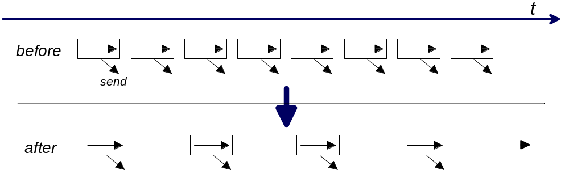
Examples of potential problems
- A financial batch process works extremely fast, but the rate of messages it generates cannot be handled by the layer of the system that must notify external parties. Very large queues may form leading to the over-allocation of memory and inefficient processing. Other service levels may be endangered.
- A batch suite must run within a particular window, but if all the jobs were released in parallel at the same time, there were be insufficient real memory to accommodate all the processing, and paging would ensue leading to very poor throughput.
- An intenet site offers many functions, but also has to cope with very unpredictable workloads. If all the users try to use particular functions (e.g. video), the site will be overloaded.
Specific Techniques
Technique | Description and Example(s) | Comments/Applicability
Inter-operation delay control | Process A can generate 200 messages/s, but only needs to generate 40 messages/s to meet its performance targets. Employ an appropriate sleep delay between messages to throttle its output. | This technique may not be appropriate if the source of work cannot be slowed for technical reasons, or because there are performance requirements associated with the source server.
Operations per unit time | A large user community spread across a number of branches can submit queries to a centralized system. If a predefined threshold is exceeded in a minute at a branch, further requests are refused. | This throttling could prevent the central system from becoming overloaded.  This is only permissible if the potential for query refusal/delay is acceptable to end-users.
Intermediate staging | An intermediate process or queue is used to collect messages generated very quickly, and to forward them on to the next part of the system at a manageable rate. | There may be a requirement for temporary storage areas with this technique.
Message aggregation | Messages arrive from an external source at a very high rate but usually contain similar data. The data contained is averaged or aggregated across many messages before being sent further into the system. | This only applies if there is not a requirement to further process each individual arriving message.
Restricted scheduling | A large number of jobs must be completed in a particular window, but are released for processing in a staged manner for optimal use of resources. | It may be difficult to construct the best schedule to meet a particular set of requirements. Knowledge of each job’s resource requirements may be necessary.
Logon limit | A count of logged on users is kept within the application. Once a pre-configured limit is met, further user logons are rejected.
Function offlining | The application is designed to assess the current loading. Past pre-configured thresholds, access to resource hungry functions is denied or the functions are deactivated. | This is only acceptable for non-critical functions.
Scalability guidance
This type of technique can be useful as systems are scaled up to higher volumes or to cope with larger volumes of users. If pacing and throttling mechanisms are made parameter driven (but not exposed to users) ongoing decisions can be made post-deployment as to what rates of work various parts of the system can be exposed to.
5.6 Data/Component Management
Description of category
Most applications involve significant data access and component interaction. Fundamental application design decisions must be made as to how data and components will be placed and managed. The optimal placement of data and functional component of the application is not always obvious at the outset, as it will depend on exactly how the components will interact (frequency, size of communications) and the speed of the connections between them.
There can be significant overlap between techniques in this section and the sections on parallelism and overhead reduction.
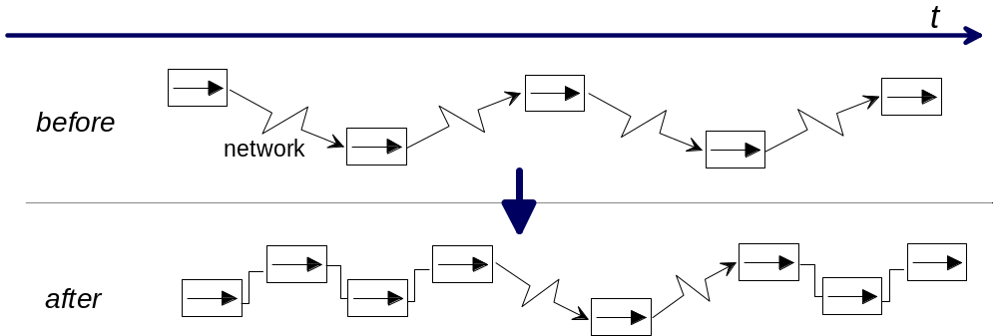
Examples of potential problems
- A business-object component communicates with a data component which is remotely placed. It turns out that this interaction is used very frequently in the normal usage scenario and that this interaction causes a bottleneck.
- A share dealing site provides a facility to display a real-time graph of a share’s value. Rather than using a client applet to render the graph, the graph is rendered at the server and repeatedly sent over the internet to the client. The high level of internet traffic becomes a bottleneck.
Specific Techniques
Technique | Description/Example(s) | Comments/Applicability
Caching  (read-only) | A series of in-memory caches are used to hold live data sent to members of a global financial system; the data comes from a central system and is sent to a ‘gateway’ at the member. Queries are satisfied from the local caches rather than requiring remote interaction with the central system. | If data, or other required objects, are needed to be accessed frequently, the time to access can be greatly reduced by fetching from a local copy. There is an overhead of maintaining synchronization with the master data set; if updates to the data are frequent, the benefits can be outweighed.  Some caches work on a pull mechanism - once data in the cache has reached a certain age it is discarded and the master copy refetched. (It may be worth comparing to the master first to see if it is out of date e.g. using a timestamp or version number)  Other caches work on a push mechanism - the master server informs the caches when data has changed. The choice of mechanism is often determined by such factors as life expectancy of the data, the cost of transferring data, and the likelihood and impact of using stale data.
 | Application components for an Internet application are remotely downloaded when needed, however, recently executed application components are stored locally and reused when the user accesses the same functions.
Replicated Data  (read-write) | A GroupWare application allows users to work with local replicas of databases. Edits to the databases are performed locally and uploaded in the background improving user response times. | If a data store is costly to access, performing work on a local or nearby copy can greatly improve performance.  If the data store is large and/or frequently updated, maintaining the local copy can be expensive. Consideration must be given to the likelihood and impact of different copies of the data containing conflicting updates. A push or pull mechanism can be used to keep copies synchronized.  Fully automatic distributed data solutions with replicated data stores are notoriously difficult to implement.
Data in Memory | In a batch billing process account and usage/costing information is loaded into a virtual memory construct at the start of the bill run process. The subsequent bill run programs then access that data from memory rather than physical disk. As a consequence the elapsed time for the bill run process is reduced significantly due to the resultant I/O avoidance. | Using this technique the performance of batch applications can be improved dramatically (see Section 4.2.2.2 and Section 4.2.2.3). This technique is particularly relevant on the mainframe platform where most of the large scale batch applications still run today. To aid recoverability in the event of failure the in-memory data should be synchronized to disk at various points within a long running batch process.
 | A simple batch improvement technique is the ‘single file pass with many calls’ technique. A very large master file can be processed once with a table driven facility coordinating the execution of programs as each record within the file is read. As a result we can avoid having to pass the same file multiple times for each program.
 | Web based applications use state management techniques such as cookies and session objects to hold session related data in application server or client memory, thus avoiding potential back-end database access and consequent physical I/Os. | Issues such as session persistence need to be considered (refer to the paper ‘Designing e-business Solutions for Performance’ referenced within Appendix B for a full description of these issues).
Partitioned Data | In a retail banking solution account data is held physically at the branch where the account is registered. As most data accesses for an account originate from the branch where the account is registered, the WAN delays associated with accessing remote data are often avoided.  (A further example can be found under 'Partitioning' in the Parallelization section). | Performance can be improved by partitioning a large data store into several smaller data stores and then employing parallelizing techniques or placing the smaller data stores in more appropriate locations. This technique is most applicable when there is a partitioning of the data such that the partitioning appropriately splits the workload, any units of work spanning multiple partitions do not generate too much contention for shared data, and there is a low overhead required to decide against which partition(s) a piece of work should be dispatched.
Affinity based placement | The logic for validating a form on a web page is executed on the client. If the form is invalid there is no need to interact with the server, improving the response time. | If there is a high degree of interaction between functional components and data, performance can be improved by placing them close together, so that expensive remote interactions become local. When moving an object or data store however, the interactions with some objects may become more remote. The ideal location may not be able to house the object or data store because it does not have sufficient physical resource, or it may be unsuitable because it is beyond a systems management or security boundary
 | An online shopping solution uses a compact disc (or other local file) at the client side to store a list of the shop’s goods with pictures. It would not have been possible to use pictures and browsing would have been much slower were all the data at the web server.
 | A web page on a share-trading site includes a graph of a share’s value over time. By rendering the graph with a Java applet on the client instead of at the web server, the amount of data sent over the Internet is reduced. The user can also zoom in on the graph without requesting further data from the server. | Frequency of use of service can affect the decision as to whether a downloaded applet is worthwhile or not.
Content or data preprocessing | A system serving very large numbers of user maps dynamic data into static formats on a regular basis. Users access the static data, which can be easily cached for improved performance. | This technique works whenever access is principally read-only, and when data provision does not necessarily need to be completely up to date.
Scalability guidance
Correct design of the interaction of components and data is critical to the scalability of systems. Extensive use of caching in applications significantly decreases response time and increases maximum throughput of the total system. Central systems can be protected from increasing numbers of users, and correct placement of functional components can mean processing is performed in a scalable, distributed fashion.
- Afterward
It must be borne in mind that every system will have a performance limit, no matter what techniques are employed. Even the simplest operation in the system has an associated latency, and this implies a maximum rate of processing. Even when a system is scalable by parallelism, there are still inevitably points of serialization or contention at the hardware or software level, which will ultimately limit performance.
The key to designing applications for performance is to ensure that the system in question is going to have sufficient ability to perform and scale for all the envisaged (and/or contracted) scenarios in which it will operate. Employing the above techniques requires effort and there is a balance to be struck between designing the most efficient application and keeping development time under control. The judgement as to the amount of effort that needs to be made will vary from situation to situation. Having said that, experience has shown that there is often more effort made in the long term because insufficient thought was given to performance design in the early phases of system development.
It should also be born in mind that the quality and style of coding application logic (and the constraints of the particular programming model) could have a significant effect on system performance. It is not within the scope of the paper to give guidance on how to design and write efficient programs at the low-level, however as developers are ultimately at the sharp-end of the process, it is worth listing the ways in which they can be assisted in their task:
- Developers should be made aware of any performance targets that might exist in their areas of responsibility (such as budgets for particular unit operations) so they are able to put effort into optimizing the parts of the application that matter the most.
- Ensure that the developers producing the system understand how much they can influence the performance of the system by simple mistakes, or conversely by good practice.
- Ensure the right kind of architecture-level work-products (including programming guidelines etc.) are made available to them as early as possible.
- Ensure they receive suitable education on how to code and integrate components with performance in mind.
- Utilize design and code walkthroughs to cover performance issues as well as functional ones.
- Revision History
Revision Number | Revision Date | Summary of Changes | Changes Marked?
1.0 |  | AM Jowett, C J Spencer, L Momtahan
1.1 | July 2001 | Updated template and style, spelling and grammar review.
Appendix A: Definitions
This section contains simple definitions of many frequently used performance related terms.
Throughput | The rate at which a system, subsystem or process can complete work
Response time | The time between the sending of a request and the receipt of the response for that request
Elapsed time | The total time between any two events, or the total time for a particular operation to complete
Scalability | The degree to which a system can be cost-effectively expanded to perform acceptably as the volumes and rates of work in the system increase over time
Vertical scalability | The ability of a system to be scaled by the upgrading the specification of the existing hardware components
Horizontal scalability | The ability of a system to be scaled by adding further hardware nodes to the system alongside the existing ones
Contention | Any situation where multiple entities compete for the same resource
Latency | An inherent, usually constant, delay which is incurred for a particular type of operation
Process | A running operating system entity which performs work within an application
Thread | The lowest schedulable entity within the operating system; a Process can consist of 1 or more threads (in this latter case, it is known as a multithreaded process)
I/O | An input/output operation, usually to a disk or other storage medium
Cpu | Central Processing Unit - often called the Processor - the central execution unit of the computer. Cpu time means time spent processing on a cpu.
Bandwidth | A measurement of expected data throughput over a particular electronic link (usually a network connection), often expressed in bits per second (or multiples thereof)
Synchronous | A call or operation in which the entity initiating the operation must wait for the answer before performing any other work
Asynchronous | A call or operation in which the entity initiating the operation does not have to wait for the answer before performing any other work
SMP | Symmetric Multiprocessor - a computer with multiple, equivalent processors, capable of performing more than one computational task at the same time
Bottleneck | The point within a system at which performance is constrained in some way. Bottlenecks by definition are surrounded by components, which have the potential to perform faster, but cannot because the bottleneck is preventing them being fully utilized.
OLAP | Short for Online Analytical Processing, a classification of system typically involving the analysis of large quantities data via complex database queries
Batch system | A system which runs jobs in batches in an automated fashion, e.g. at certain times
Appendix B: References
Solution specific references
ICM ESS Knowledge Network (ICM Asset Web)
Patterns for eBusiness (http://www.ibm.com/software/developer/web/patterns/index.html.)
Product and Technology specific references
Note to reviewers: A performance information portal is in the process of being established. Once in place a reference to it will be included here.
Websphere Performance Information (http://water.raleigh.ibm.com)
- Many Red Books and White Papers
- Websphere V3 Performance Tuning Guide (SG-5657-00)
- Patterns for e-business: User to Business Patterns for Topology 1 and 2 using Websphere Advanced Edition (SG24-5864-00)
HVWS Papers (http://w3.cupertino.ibm.com/Highvolwebsite/hvwshome.html)
- Designing e-business Solutions for Performance
- Web Site Personalisation
- Designing Pages for Performance
- Techniques for Scaling e-business Solutions
- Page Detailer User's Guide
HyPerformix Home Page (http://www.hyperformix.com) - contains links to specific Web Design guidance for performance.
PIG Team Room (c_dir\csiperfo.nsf on server D06DBL08/06/A/IBM) - contains many technique specific references.
Appendix C: Further Work Products Influenced By This Technique
The diagrams below detail Global Services Method Work Products that are related to this technique paper other than the major ones detailed in the chapter “Global Service Method Context and Overview”:
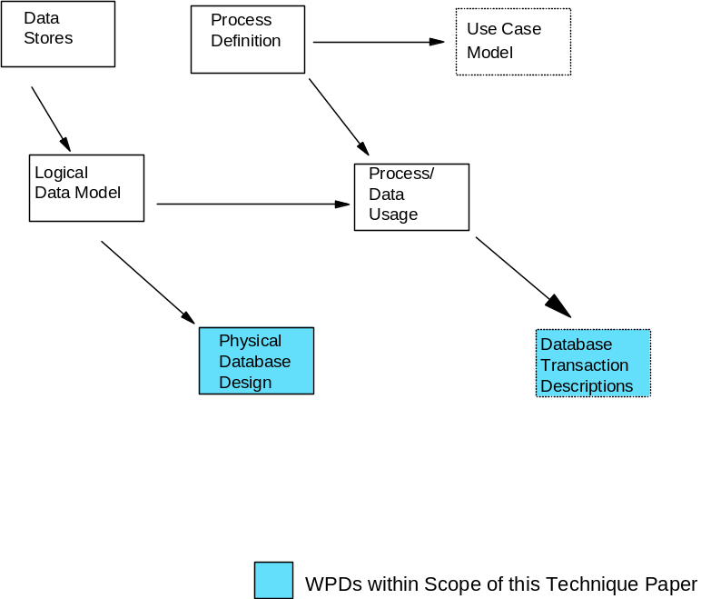
Figure 5: Influenced Work Products linked to creation of the Database Design
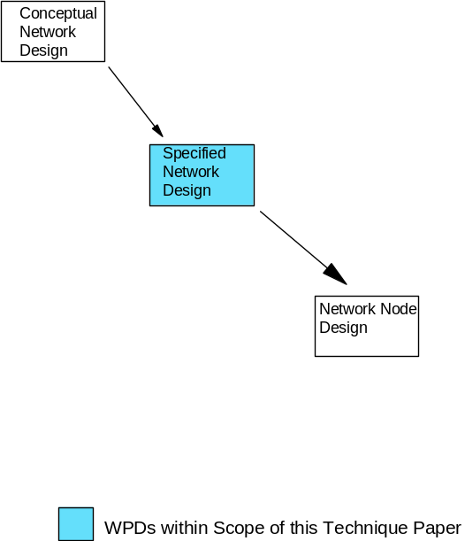
Figure 6: Influenced Work Products linked to creation of the Network Design

Whilst the information is presented within the context of the IBM Global Services Method, its basic content is equally applicable to any style of system design engagement.
These phases are found with the following engagement families within the IBM Global Services Method: Custom Application Development, e-business (Custom), Business Intelligence. This technique paper is also applicable to other engagement families/ models where application design and development forms an important element of the solution; though phases and activities may be differently named in other models, the basic elements of performance work are similar.
Throughout the document, there is no assumption as to whether the application is being designed using an object-oriented development method, a classic procedural method or any other type of development method. Performance targets should be set at a level of granularity, which is appropriate to the design method, in question.
The mapping of the application components onto the physical nodes within the operational model, as embodied within the Data Function Access & Placement Work Product - see also the Technical Architecture Domain.
Reference the Gartner Model for Client Server computing.
Designing and sizing the Operational Model is the subject of other techniques and work products within the IBM Global Services Method.
Traditional Ethernet LANs saturate at around 40% utilization due to network collisions, however switched Ethernet LANs can now operate at much higher utilization’s.

