

IBM Global Services
Developing Architecture Overview Diagrams with RSA

Technique Paper (TP) – Tool Mentor
© Copyright International Business Machines Corporation 2006

All Rights Reserved
Version 4.1.1, February 2006
- Brief Description
This paper provides techniques that use Rational Software Architect (RSA) to develop an Architecture Overview Diagram (AOD). These techniques may also be applied to Rational Software Modeler (RSM) to develop the same work product. This paper only focuses on the tooling to develop the work product, not the work product itself.
AODs depict the governing ideas and candidate building blocks of an information technology system or enterprise architecture. They provide an overview of the main conceptual elements and their relationships.
See GS Method work product ARC 101 for a complete description of the Architectural Overview Diagram.
- Usage Context
Use the Rational Software Architect (RSA) techniques to model an overview of the main conceptual elements in an architecture.
Do not use these techniques without prior training (Refer to sections 4 and 5).
- Content
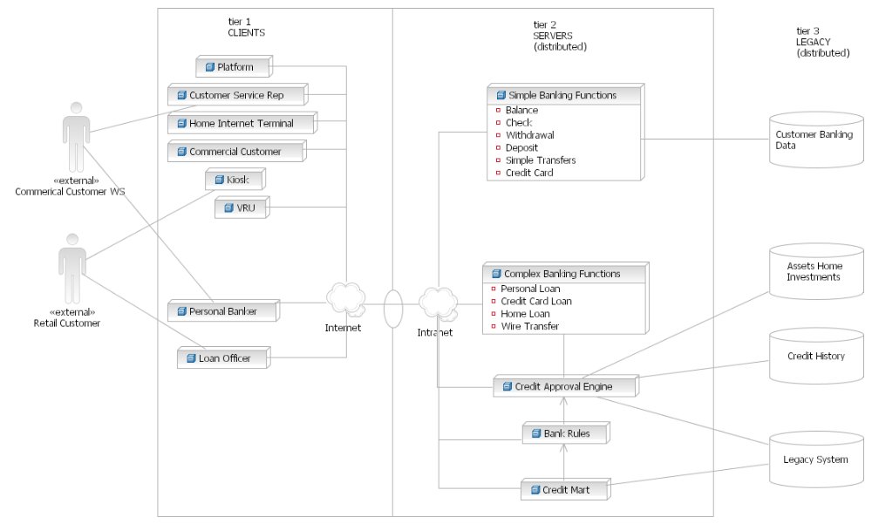
Figure 3.0.1
OVERVIEW
Use the UML 2 Deployment Diagram to model an AOD in RSA/RSM. Select actors (possibly available from a use case model) to represent external systems or people. Add Deployment Diagram nodes to represent clients and servers. Represent data stores by using UML 2 Deployment Diagram nodes or cylinders.
PROCEDURE
First create a package and diagram. Then, add the actors, nodes, and data stores in any order, prior to adding associations.
  - Add Architecture Overview Package
- Click the right mouse button on the Design Contracts package in the Model Explorer.
- Select Add UML>Package from the context menu.
- Provide an appropriate name for the new package (e.g., “Architecture Overview”).
- Delete the Main diagram (created as the default for this package).
  - Add Deployment Diagram
- Click the right mouse button on the new package.
- Select Add Diagram>Deployment Diagram from the context menu.
- Provide an appropriate name for the diagram (e.g., “Architecture Overview”).
- Designate this diagram as the default for the package
  - Click the right mouse button on the diagram.
  - Select Make Default Diagram from the context menu.
  - Add Actors
UML uses actors to represent external entities (e.g., people or systems) that interface with the target system. An image of a human figure represents actors in UML. Create associations to show the relationship between an actor and another UML element (e.g., deployment nodes or use cases).
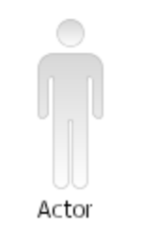
A consulting or analysis team using RSA or RSM may have the actors needed for an AOD. If so, drag the UML actor icon from the Model Explorer onto the deployment diagram.
To create new actors, use the drawing palette’s Use Case Diagram drawer (see figure 3.3.1). To create an actor in a different package than the diagram, click the right mouse button on the desired package (in the Model Explorer) and select Add UML>Actor from the context menu.
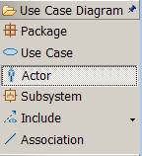
figure 3.3.1
  - Add Nodes
    - Add Nodes to Diagram
There are four ways to add nodes to a deployment diagram.
Option 1: Click the right mouse button on the drawing surface, and select Add UML>Node from the context menu.
Option 2: Hold the cursor motionless over the drawing surface to get a menu. Then, use the first tool on the left side of the action bar (menu) to add a new node.
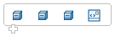
figure 3.4.1.1
Option 3: Use the drawing palette’s Deployment Diagram drawer to add nodes to a diagram. Click on Node in the Deployment Diagram drawer, then click on the drawing surface of the diagram.
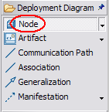
figure 3.4.1.2
RSA draws a new node on the diagram. It names the node “NodeX” where X is an integer. Rename the node by typing over NodeX with the desired name.
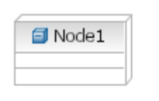
Option 4: Drag an existing node from the Model Explorer onto the deployment diagram. In this case, the node will already have a name. It may also have functions and attributes.
    - Add Functions to Nodes
After adding a node, add functions as attributes. See figure 3.4.2.1 to see a node with functions depicted as attributes.
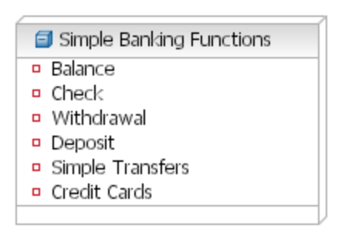
figure 3.4.2.1
Option 1: Hold the cursor motionless over the node to get an action bar. Use the first tool on the left to add a new attribute. (See figure 3.4.2.2)

figure 3.4.2.2
Option 2: Click the right mouse button on the node. Select Add UML>Attribute from the context menu.
Option 3: Add the attributes from the Attributes tab of the Properties view:
- Select the node.
- Click the Attributes tab of the Properties view.
- Push the Insert New Property button on the right. See figure 3.4.2.3.
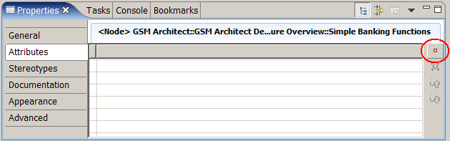
figure 3.4.2.3
  - Add Data Nodes
Add data nodes in the data tier of the diagram (See section 3.7 for tier separations.).
Option: Add the keyword “data” by selecting the node. Enter “data” in the Keyword field of Stereotype tab in the Properties view. See figures 3.5.1 and 3.5.2.
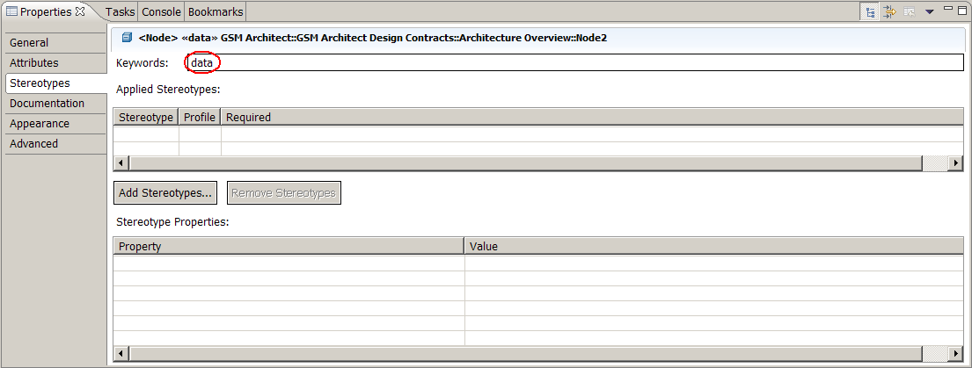
figure 3.5.1

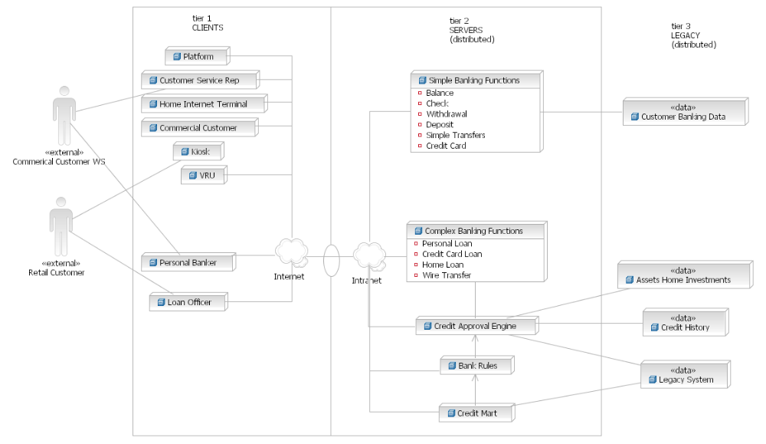
figure 3.5.2
To make the diagram resemble the example in GS Methods (see figure 3.0.1), do the following steps:
- Use a cylinder from the Geometric Shapes drawer (see figure 3.5.3), instead of a data node.
- Change the line color to match the other nodes.
- Change the fill color to match the background.
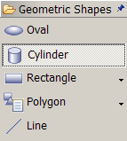
figure 3.5.3

  - Add Associations
There are two ways to add associations between nodes.
Option 1:
- Hold the cursor motionless over a node.
- Arrows will pop up adjacent to the node (figure 3.6.1).
- Drag an arrow to the desired node.
- Release the mouse button.
- From the resulting menu, select Create New Communication Path.
figure 3.6.1
Option 2:
- Select a communication path (figure 3.6.2) from the Deployment Diagram drawer.
- Draw the association between two nodes by clicking one node. Move the cursor to the next node, while holding down the mouse button.
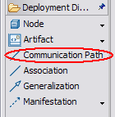
figure 3.6.2
By default, the new association will show roles and multiplicity. Hide these elements by clicking the right mouse button on the association to see the context menu. Select Filters->Hide Connector Labels from the context menu.
To associate nodes with a cloud that represents an intranet or internet, follow these steps:
- Hold the cursor motionless over the drawing surface.
- Select the second choice (figure 3.6.4 Add new Stereotyped Node) from the action bar.
- Select “Create New <<cloud>> node” from the resulting menu.
- RSA will draw cloud node named “NodeX” (where X is an integer).
- Give the new node an appropriate name (e.g., “intranet” or “internet”).
- Hide the compartments by clicking the right mouse button on the cloud and select:
  - Filters->Show/Hide Compartment->Deploy Compartment
  - Filters->Show/Hide Compartment->Attribute Compartment.
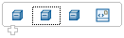
figure 3.6.3
Figure 3.6.4 shows the node before and after renaming and filtering compartments.
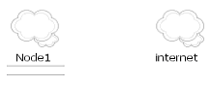
figure 3.6.4
To draw associations between two non-deployment node elements (i.e., actors and cylinders), use Line from the drawing palette’s Geometric Shapes drawer (figure 3.6.5).
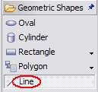
figure 3.6.5
  - Add Tier or Location Separations
To separate tiers or locations, use the Rectangle from the drawing palette’s Geometric Shapes drawer.
- Click on the rectangle in the palette’s Geometric Shapes drawer (figure 3.7.1).
- Click on the drawing surface.
- While holding the mouse key down, drag the shape from one corner of the rectangle to the opposite corner.
- Resize the rectangle - select the rectangle, and drag the handles that appear as small black dots along the edges and corners of the rectangle (figure 3.7.2).

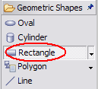
figure 3.7.1

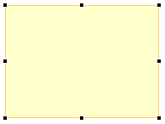
figure 3.7.2

After adjusting the shape and size, send the rectangle to the background so that all actors, nodes, cylinders, text, and associations become visible. To send the rectangle to the back, click the right on the rectangle, and select Format>Order>Send to Back from the context menu.
Alternative: Change the fill color of the rectangle to the same color as the background - select the rectangle, and use the Appearance tab of the Properties window (figure 3.7.3).
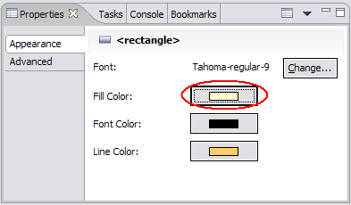
figure 3.7.3
To show access between two rectangles, use an Oval from the Geometric Shapes drawer.
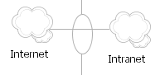
figure 3.7.4

Key Considerations
This document assumes an introductory level of expertise with Rational Software Architect (RSA). The reader must be able to use the Modeling perspective, drawing palette, Properties view, and Model Explorer. Before using RSA, the reader should take the first RSA e-Learning course DEV343: Essentials of IBM Rational Software Architect: Getting Started.

- References
Global Campus e-Learning - Take e-Learning@IBM courses on IBM Global Campus for FREE!
http://w3.ibm.com/education/lang_en_US/catalog/index.jsp
Essentials of RSA – Free for IBM personnel through Global Campus e-Learning
http://www-128.ibm.com/developerworks/rational/training/catalog.html#8
IBM Global Services Method
http://w3.ibm.com/services/assets_innovation/gcd/methods/index.html
UML 2.0
http://www.uml.org/

- Revision History

Revision Number | Revision Date | Summary of Changes | Authors
4.1.1 | February 2006 | Base Version | Richard V Hom  richhom@us.ibm.com

