

IBM Global Services

Developing Guiding Principles for a Network Design

Technique Paper (TP)

© Copyright International Business Machines Corporation 2003
All Rights Reserved
Version 1.0 March 2003
- Description
This technique paper discusses how to develop guiding principles for a network conceptual design. Development of network guiding principles, while being specific to networking, uses the same underlying techniques for developing all guiding principles.
Guiding principles define the general underlying rules which an organization will use to plan and deploy network resources and assets across an enterprise, e.g., “Networks will be designed to be capable of rapid expansion in line with planned and unpredicted business growth.” Principles are also developed to help explain why certain products, standards, techniques or methodologies are preferred. “The XYZ Corporate Network will be designed using standards based components to support network management, change and maintainability.”
Network guiding principles must reflect business goals and strategy. The diagram below illustrates the relationship of guiding principles to business drivers, strategy and network strategy.
Example:
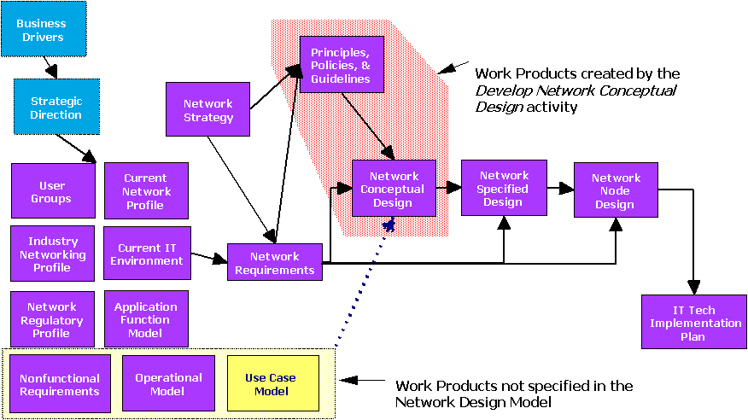

Each principle must be aligned with at least one key client requirement or business driver. Establishing guiding principles is critical to the future effectiveness of the network as well as a driver for the amount of flexibility and adaptability built into that network.
Each principle should include motivation and implication statements:
- The motivation statements highlight the value to the business of implementing the principle and a basis for justifying all related activities, for example, the implementation of an enterprise network architecture or the implementation of a network security framework
- The implication statements provide an outline of what has to change, key tasks, resources and potential costs to the business of implementing the principle. They also provide valuable inputs to future transition initiatives and planning activities
See the technique paper, “Principles Definition” for additional general guidance on developing principles, motivations and implications.
Networking guiding principles are used to capture the fundamental, underlying truths about how the organization will plan and deploy networks. These principles are used in a number of ways:
- As a foundation for a network architecture and an effective framework within which the business can start to make conscious decisions about the business and how it uses and implements networks
- As a guide to establishing relevant evaluation criteria and, thus, exerting a strong influence on the selection of suppliers, business partners, components, products or product architectures
- As drivers for defining the functional requirements of an enterprise wide network architecture
- As an input to assessing both the existing networking environment systems, organization, management practices and the future environment, e.g., a strategic project portfolio, for compliance with the future desired state. These assessments can provide valuable insights into the transition activities needed to implement the principles, in support of the business goals and priorities
- As the starting point for justifying proposed decisions and related activities
- As the starting point for planning for the tasks, resources and potential costs to the business of designing and implementing a network based on the principles
Guidelines are used to make general statements of direction to describe a desired future state, which is not necessarily mandated. Guideline statements are similar in content to principle statements but without the associated motivation and benefit statements.
Guidelines are used in situations where mandated principles would not be acceptable.
Without agreed principles and the level of consensus which defining them brings to an organization, there will be no firm basis for moving forward. The absence of clearly defined principles indicates a lack of management support for the directions that they embody, making conscious, informed decision-making difficult.
There is no excuse for not having a defined set of network guiding principles (or if required by circumstance – guidelines) as a major deliverable component in any network strategy or architecture project. If the client already has a set of principles, guidelines or other policies, which seem reasonable, these should be reviewed for completeness. The project team may be able to add further value by assisting with the definition of associated motivation and implication statements. To be effective, all principles and guidelines should be defined and agreed by both senior business and IT executives.
Once they have been agreed and published, principles provide a framework which can be used to explain and justify why certain business and IT decisions are being made or need to be made.
- Context
Guiding Principles for networking are developed and documented in the strategy phase or in the solution outline phase of network engagement. The documented principles are key input to developing Level 0 and Level 1 conceptual designs. Developing Level 0 and Level 1 conceptual designs is addressed in a separate technique paper “Creating a Network Conceptual Design.”
This technique paper is associated with the Principles, Policies and Guidelines work product description (ARC 309). Also, this paper can be used in conjunction with a related technique paper, “Principles Definition,” which focuses more broadly on IT principles and includes a principles repository and sample documentation.
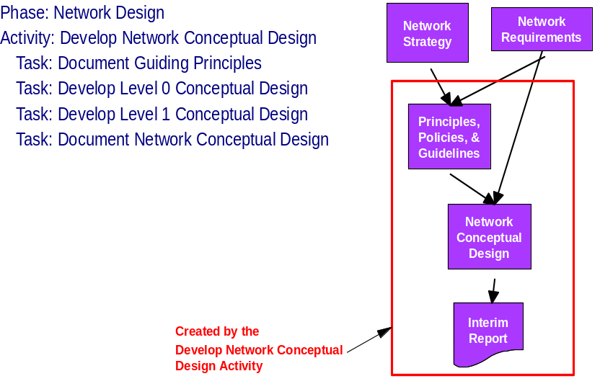
Key business drivers and business requirements are used as input to build the design principles. The resulting guiding principle statements set the stage for developing the design. They state the high-level business needs the network design must satisfy in a clear and unambiguous way. They profile users, sites, applications and security requirements.
Guiding principles are normally developed at the beginning of a project. If the network architect or consultant joins a project in progress that has not defined guiding principles, performing this exercise can, if necessary, clarify the mission and get the project back on track.
- Steps
Initial input to the guiding principles is gathered through interviews or workshops with business stakeholders such as the CIO, CFO and other key management staff. As a result of these activities, issues and concerns are collected. These can be analyzed to create strawman principles. The strawman principles form a foundation for a guiding principles workshop.
A workshop is the preferred method for refining principles and obtaining consensus:
- Immediate buy-in for the principles
- Ability to easily review and change the principles during the workshop
- Ability to focus on changes to the principles vs. defending where the principles came from
- Visibility for the network strategy and/or design team to decision makers
- Process closure
Typical workshop length is two to eight hours. A four-hour workshop divided by one break is the most common length. Activities are divided into three steps:
- Preparing for the guiding principles workshop
- Conducting the workshop
- Validating the principles.
Preparing for the guiding principles workshop
Often the preparation for the workshop takes significantly more time and effort than running the workshop. It is important to determine the function and needs the network will meet and then to develop the strawman guiding principles and the associated rationale and implications around those functions and needs.
Preparing strawman principles
- Determine the documentation guidelines based on the relationship developed during creation of the statement of work and other prior knowledge of the client or industry. You can use samples from previous projects or mock-ups as starting points for the discussion.
- Conduct executive interviews and review documentation to understand the current environment, future directions and management’s concerns. Individual concerns are recorded on cards categorized by area of concern or issue. The cards or entries serve as an audit trail to link concerns and goals to strawman principles.
- Sort entries or cards from interviews and document reviews into affinity or related groups for the first pass at strawman principles. Issues entries become motivations or implications.
- Have your sponsor and other executive stakeholders review the strawman principles and obtain their suggestions/feedback for modification and clarification.
- Develop a strawman set of principles with motivations and implications. The strawman set of principles is used to guide the discussion during the workshop. You will want to select principles that are pertinent to the client situation. Principles for the workshop are a work in progress rather than a directive to the client.
- When the principles are finalized, six to ten principles are adequate to strongly indicate network philosophy and to guide design development. More than twelve are too many for a single group.
By analyzing data gathered earlier in the project, groups of affinities should become visible and requirements for certain types of principles can be identified. Many of these will distill into similar statements. That is a good thing that should be tracked and preserved as background information that was used to form strawman principles. Also, this data should be used to refine the strawman principles and to add strength to motivation and implication statements.
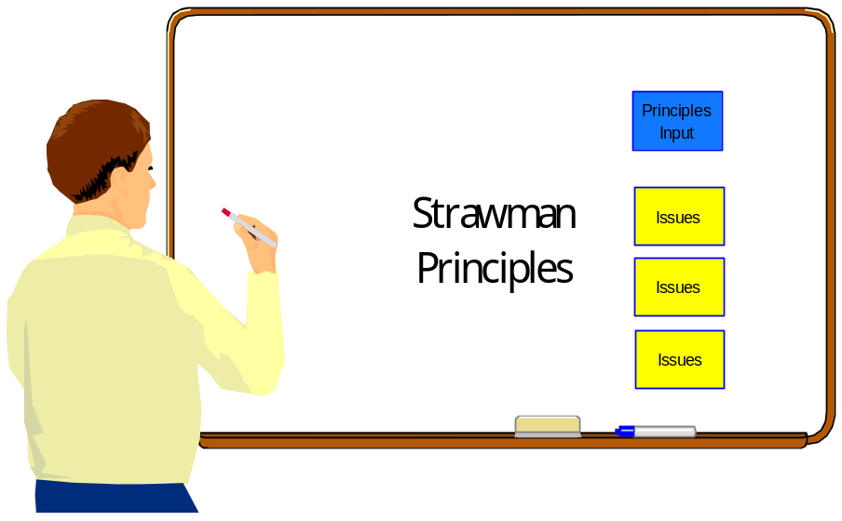
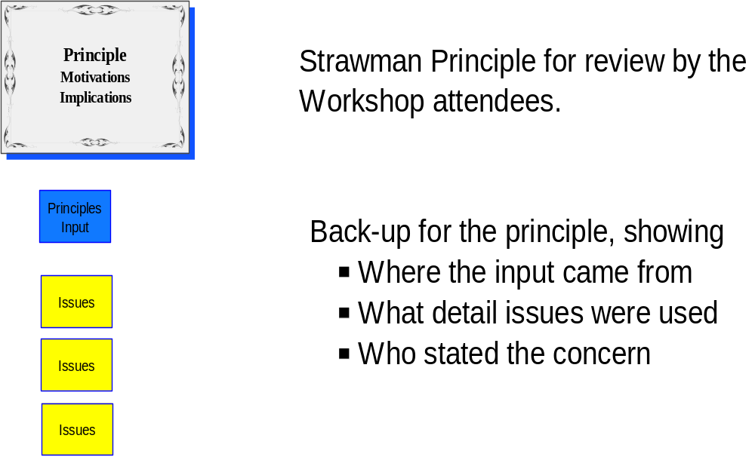

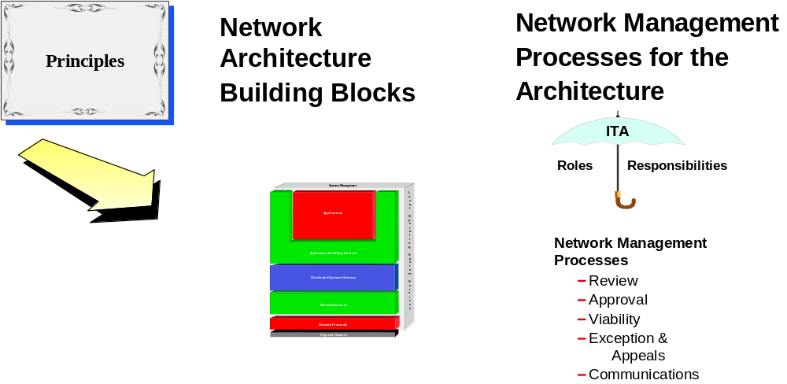
- Principles are refined during the workshop and used to develop network architecture building blocks and management processes

Network design principles must be at a consistent level. They must provide guidance without dictating how things must be done when designing the network. They must be generated with motivation and implication statements. A good principle:
- Is clearly worded statement about a fundamental belief about the enterprise in one or two sentences, three if you must
- Recommends an action against which some arguments could be made
- Is relevant to the technical architecture of the enterprise but without technical jargon
- Is stated in a clear manner as to be meaningful to both business and technical leadership
- Applies throughout the client’s business
- Is high level enough to be durable rather than dependent on technology
- Meets business objectives instead of other alternatives that were considered
- Has impacts that need to be documented
- It must make a difference to the business
- Examples of good principle statements (Each principle should include motivations and implications. Please refer to the examples section for completed principles):
- The preferred approach to fulfilling business requirements is to reuse existing, purchase new or build customized solution components
- The preferred approach to fulfilling business requirements is to purchase new solution components, reuse existing or build custom solution components
- The preferred approach to fulfilling business requirements is to build custom components, reuse existing or purchase new solution components
- All network components must support selected standard management protocols
- All network components to be selected will clearly be best of breed.
- All network components and processes must conform to XYZ Corporate Enterprise Network Architecture
- Standard network interfaces and protocols will be defined, maintained and used
- Open system standards will be used for communication both within the enterprise and with suppliers and clients.
- There will be a single logical, production network that provides access to all authorized services
- The network should facilitate authorized connectivity to external organizations
- Network event monitoring will be managed from a single corporate NOC
- Network event monitoring NOCs are based on time of day
- The network design is a living document the should be reviewed periodically and modified as needed to accommodate changes in business and technology
A poor principle:
- Makes a statement that no one would dispute
- Is a general or financial or business statement
- Is too specific (narrow) and may be at a standards election level or may be not endure
- Is included because “I say so”.
- Examples of poor principles:
- All applications should be designed to be easy to use
- Computing costs need to be reduced
- All servers will use a specific technology to achieve high performance (EISA bus)
- Dial access will be provided by a certain type of fax modems (speed or technology restricted)
- Only Ethernet LANs will be implemented
Each principle statement must be associated with motivations and implications.
Motivations are sentences that explain why the principle is important. This forms the business case. Motivations must be directly related to and support the principle. Motivations are the benefits statement for the investment, the why of it. If there is no benefit, then why do it?
Implications may include the
time, resources and money required to do what you have decided to implement the principles. Implications may also be what must change to implement the principle and may be the foundation of a project list and set of initiatives.
See the technique paper, “Principles Definition” for additional general guidance on developing principles, motivations and implications
- Have more strawman principles than you think you are going to use. It is a good idea to have some principles that are mutually exclusive and perhaps even controversial. That will stimulate and guide the discussion in the workshop and help develop meaningful guidelines for the network conceptual design. The most important point is to select principles that reflect all applicable areas so they are discussed and the resulting design supports business goals. Note: If you choose to include principles which are solely to create a conversation, be sure to stress that point when you introduce the strawman principles in the workshop. Otherwise, some people in the group will undoubtedly feel you are not in touch with their needs!
- Start to link principles to business goals before the workshop. This helps to ensure the full set of strawman principles support all key business goals. If there are some obvious gaps, you can develop some additional strawman principles or include discussion in the workshop on how to fill the gaps.
- Techniques for defining business linkages are discussed in the section on conducting the workshop.
- Determine the workshop participants. The participants should be decision makers in the organization who have a stake in the successful design and implementation of the network. It is preferred that all of the participants in the workshop have the authority to make decisions for their organizations or be a key influencer to an essential decision maker. If potential participants are not at the right level in the organization to make decisions, work with the right management level before scheduling the workshop to obtain participants who can make decisions during the workshop.
- The number of participants often influences the usefulness of the products developed during the workshop. More than sixteen people are difficult to lead to resolution. Ten or fewer are ideal for developing consensus and clear principles.
- Work with your executive sponsor to develop a letter to send to the workshop participants describing why the workshop is important, when it is scheduled, what is expected of the participants and what the outcome will be.
- Distribute an overview of the workshop and information that the participants can quickly read ahead of time so a level of expectation is set. . For example:
Overview for workshop participants
Please review the attached document and come to the Principles Workshop scheduled for Thursday 5th March, 8.30 AM –1:30 PM, with your thoughts and ideas on potential themes for principles. During the workshop, we will use the samples in the document sent to you to take a first pass at developing some key high-level principles. The document provides an overview of principles for network architecture (the good and the bad) and samples for you to consider. These are by no means complete but are presented as a ‘strawman’ set to initiate your thoughts.
Activities and tasks
- Review and preparatory reading for workshop
- Initial workshop - to define and agree on a draft set of guiding principles
- Draft set of principles sent out to Executive Management Board or Team for review
- Executive Board workshop - draft principles revised and agreed
- Architecture team workshop - discuss Executive Board draft principles and finalize
- Finalized principles sent to all representative areas of the business and IS/IT for review and comments
Preparing the workshop structure and logistics
Think about how you want to refine the principles and what you and your co-facilitator are comfortable doing. If you think you need to use an approach that you have never done before, talk to other architects, consultants or principals who have done some of these workshops and find out what worked for them.
One basic approach is to present the strawman principles to the group whole and discuss them. This can be accomplished with a white board, easel, paper and a scribe. The scribe becomes very important because there is little to no written output from the client workshop participants.
Another approach, if the workshop is taking place in two sessions, is to divide the group into smaller groups (in even numbers if possible and no more than 4) to each work on 1-3 principles and revise them during a specified period of time, such at 10 or 15 minutes per principle. Have more than one group work on each principle and do include principles that are mutually exclusive. Have the participants write the revisions on 5 x 7 Post-It lined paper of different colors. (If you use heavier board paper, you can use spray fixative (the temporary kind!). The 3M brand sticks better than competitive products, which makes a difference if you are conducting your workshop over multiple days. However, be aware that spray fixative is very strong smelling. In many cases, Post-It type lined paper is preferred.)
When the workshop is conducted, it must be structured logistically. Work with your client contact to select a location that will allow the participants to pay maximum attention to the task at hand. This frequently is away from the client location. Make sure the facility is comfortable and the participants have what they need to achieve targeted results. This includes such things as accessible creature comforts and appropriate food and beverages. It also may include separate breakout areas for workgroups.
Consider the way the room is arranged. Perhaps a facility can be found where the furniture breaks up into groupings and then may be put in a classroom style for presentations and discussions of work. White boards are not ideal for many workshop activities. A record of what was written is very important, so make sure to have a good supply of the materials the architect or consultant has decided to use for development activities.
If the workshop will include voting, have different color sticky dots. If the workshop is going to include small groups developing principles about different aspects of network design, management or functionality, have a supply of large lined post-it 5 x 7 paper to put on the walls. Have an easel and paper for a parking lot to list important topics that arise during the workshop but are not principles. Have a supply of felt tip markers that are made to write on paper and not go through and stain the walls. It is better to have a few extra colors of supplies ready for contingencies.
Conducting the workshop
At least 2 practitioners (and a scribe if possible) are needed to facilitate the workshop. In a workshop setting there can be many people talking and offering important ideas at the same time. More IBM participants increase the likely hood of capturing all ideas and having a successful workshop. The scribe or another workshop position that is not the lead facilitator is an excellent way for a new practitioner or one inexperienced at conducting workshops to observe how one might be conducted.
Define IBM workshop roles before the workshop begins. Understand your audience because each attendee is a stakeholder and has authority to make decisions for his or her area.
Before the workshop begins
Before the client arrives at the workshop:
- Get all of the material ready to use and sorted
- Post or write out any essential notices
- Distribute materials to the workshop areas
- If you are using an overhead projector or projector system, make sure it works
At the start of the workshop
At the beginning of the workshop it is essential to:
- Greet your client and thank them for coming
Announce the housekeeping items and provide a copy of them to the participants or post them or both
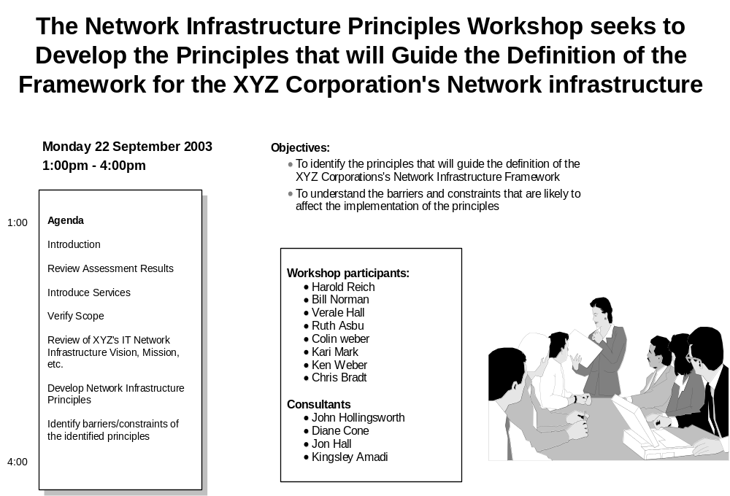
- Briefly describe the purpose of the workshop as agreed to with the client
- Introduce the workshop team and define their roles
- Have the participants introduce themselves
- Describe how the workshop is going to be conducted (have an agenda)
- Distribute any additional workshop materials
Refining the guiding principles
Use the techniques and materials that you prepared to refine the strawman principles. See the section on preparing for the guiding principles workshop for more details.
Defining the business linkages
After refining the principles, use a matrix or other documentation technique to link each principle to the strategic directions, business drivers and/or distinctive requirements or capabilities that it supports. Many network principles will support multiple business drivers and each business driver will usually be supported by more than one principle. Developing this matrix is a good check to ensure that each principle is truly founded in a strategic network direction required by the business and that the full set of principles supports all key business drivers. The linkage from principles to business drivers is often fairly direct.
Another useful technique is to analyze all business requirements, network requirements and principles in a three-column table with the first column being the business requirements, the second column being the network requirements and the third column being the principle. Then, each business requirement is linked to each network requirement and each technical requirement is linked to a principle. When this is done, any 'orphans' are very clearly identified and can be addressed.
This diagram shows the relationships.
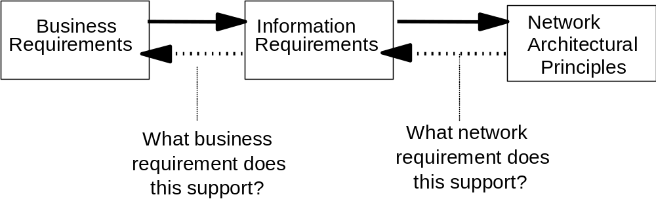
Validating the principles
After the workshop, the principles should be distributed to a wide circle for additional review. Once key stakeholders have provided input, the network principles should be refined, as appropriate.
While the validation process must be tailored to individual client needs, it usually involves getting concurrence from all workshop participants, presenting the principles to executives, approval by the executives and publishing the principals for the whole organization. A mechanism for updating the newly defined principles should be devised as part of the overall engagement effort.
See the technique paper, “Principles Definition” for additional guidance on refining and consolidating principles and reviewing these principles with stakeholders, sponsors and senior executives.
- Tools
N/A
- Examples
Motivation and Implication Examples
These examples of principles with associated motivations and implications were developed for a company that researched, extracted, abstracted and sold industry specific information. They have been generalized. When creating principles, be more specific so that the principles accurately reflect your client’s business.
- The network must enable and support the business goals of the client by providing efficient, timely access for information services
- Motivation
- Client provides and uses information to maintain competitive advantage
- Efficient and effective information delivery is key to achieving and maintaining market place leadership position
- Implication
- Investments in network infrastructure must align with business goals and plans
- The network must be optimized to provide the most efficient (cost and performance) and effective (technologies utilized) service
- The network must be available to enable the delivery of services the customer requires
- The network must be sufficiently scalable to meet network performance and availability requirements for 2-3 years
- In order to maintain currency with business goals and directions, the nework architecture and design components must be reviewed periodically and incorporated into the IT planning process
- Motivation
- Ensure the network architecture and design continue to meet and support client business requirements
- Ensure the network architecture and design continue to be efficient and effective
- Implication
- Incorporate the review of the network architecture and design into the business and IT planning processes
- Confirm relevance of the network architecture during periods of significant business or technology change
- There will be a single logical, production network that provides reliable access to all authorized services and it will provide efficiencies in management and cost, while enabling more consistent service delivery
- Motivation
- Gain efficiencies in network design and management of the infrastructure
- Simplify access for internal and external customers
- Provide consistent global network services and common network inforastructure
- Implication
- Document and enforce a global network architecture and design
- Consolidate network infrastructure to one to two vendors and technologies
- Reduce the number of external access means to pervasive media and technologies
- Converge to common designs and technologies across the enterprise
- Converge network protocols to a single standard protocol (TCP/IP) within the client network infrastructure
- The client collect, distills and distributes information, therefore, the network must facilitate communications to external organizations, customers and partners
- Motivation
- The client collects information from external organizations to build its information product database for resale
- The client distributes products and services (information) to external organizations
- Implication
- Provide a secure communication facility between client and selected external organizations using pervasive, efficient and effective media
- The network design and operations must enable the protection of the enterprise assets and facilitate compliance with local, regional, country and international laws
- Motivation
- Enterprise assets (information) are the purpose of the existance of the client and its means for earning revenue and profit
- The client must closely protect the integrity and availability of its assets
- The client must maintain compliance with the various laws regarding privacy and access to information assets
- Implication
- Develop and enforce a security plan to include security strategy, processes and procedures
- Provide a secure and auditable network infrastructure as a component of an over-all security plan
- Align security plan and policies with enterprise security policies
- All network components and processes must conform to the nework architecture to ensure aligments with business requirements
- Motivation
- Global network architecture enables the alignment of the business requirements and network service delivery throughout the enterprise
- Common vendors and technologies provide cost control opportunities in procurement, management, maintenance and staff skill
- A documented and adhered to process increases efficiency and effectiveness of networking services
- Implication
- Document, implement and enforce a global network architecture and design
- Consolidate vendors and technologies and refocus resources accordingly
- Document and enforce systems managemetn processes to increase organizational effectiveness and exploit available tools and automation
- All network comonents must support selected standard management protocols to provide effective systems management and service delivery
- Motivation
- Efficient systems and network management require automation
- Effective automation across varying technologies and vendors require adherence to industry standard management protocols
- Implication
- Select and implement components based on the client’s standard network management protocol
- Implement network automation tools to support systems and network management processes
- A single group must control and have responsibility for the entire global network, in order to synchronize global activities and to meet business goals
- Motivation
- Coordinate architecture and design decisions within the enterprise to allign with business goals and strategies
- Assure network security is uniformly adhered to throughout the enterprise
- Implication
- Direct all budget and procurement activities through one coordinating group to assure adherence to network architecture, designand standards
- Empower and hold accountable a single group for network security
Additional examples of network oriented principles are posted in the Networking & Connectivity knowledge network database on IBM’s ICM AssetWeb system.
The technique paper, “Principles Definition” includes a principles repository covering networking and other IT infrastructure elements. The paper also includes a sample presentation covering principles basics an example of mapping principles to business goals.
Some of the documents in the Networking & Connectivity knowledge network database also have presentation pages for preparing participants and to review at the start of the workshop.
- Revision History
Revision Number | Revision Date | Summary of Changes | Changes Marked?
1.0 | March 2003 | Baseline version.

