

IBM Global Services

Developing a Communications Plan

Technique Paper (TP)

© Copyright International Business Machines Corporation 1998, 2003
All Rights Reserved
Version 4.1.1 April 2003
- Introduction
This is an age of unprecedented challenge for most companies. In response to these challenges, most companies are undertaking a variety of improvement projects. The Controller’s Division is frequently involved in these projects, and often takes the lead with system implementations and other changes that impact both its own Division and other organizations within the company.
Most companies have experienced the disappointment of a failed project. Although there are many reasons for project failures, one common risk is inadequate communications. Although project managers agree that effective communications are necessary, communication efforts often fail to achieve targeted results for a variety of reasons. For example, many communication efforts lack consistent focus and adequate attention, particularly when the project gets into later stages and other priorities seem to be more pressing. Also, the communications may fail to address the need for multiple communication media and message repetition. Most people are surprised to find out that it may take nine or more separate communications of a single message to ensure that the target audience has received the message. In addition, many of today’s projects impact groups of people who are geographically dispersed. This raises the challenge of being effective with communications, especially when the project crosses national boundaries.
The people who need to do their work differently as a consequence of the project need to prepare for the changes the project will entail. Project communications are one important ingredient to this preparation. Also, if the communications are done in an effective manner, other benefits will be achieved:
- Sponsorship for the project can be clearly demonstrated through careful consideration of the proper people to deliver key communications
- Reasons for the project and expected benefits can be communicated, which can be important factors in building adequate motivation toward the project
- The project vision can be repeated with increasing levels of detail so that it becomes well understood and actionable
- Speculation and gossip may be reduced when people are confident that the formal communications will be complete and timely
Also, since many companies have not communicated effectively on previous projects, an effective communication campaign on a new project may signal a positive change to the people within the organization. This change may help to overcome organizational inertia caused by previous implementation problems.
Project communications need careful planning, development and delivery to be an effective response to the organizational need for awareness, understanding, and preparation for action. This chapter describes a framework that companies can use to develop an effective communication program for implementation projects.
- Communication Program Overview
Effective communications are built upon a solid foundation that will provide consistency throughout the project. They are also tailored to the communication requirements, which differ depending on the phase of the project. Finally, effective communications are planned and managed in the same manner as other elements of the project. To achieve these objectives, the components of a complete Communication Program are:
- Communication Strategy. The Communication Strategy defines the overall approach to the Communication Program in terms of lasting principles and approaches to be used throughout the Program. It is likely that few, if any, changes to the Communication Strategy will be needed throughout the performance of the Program.
- Communication Campaign Definition. The Communication Campaign Definition clarifies the different phases of communications to be rolled out during the Communication Program. Some of the key components of the Communication Campaign Definition are definition of the objectives for each campaign, identification of the information requirements for each audience, and development of the key messages to be delivered in the campaigns. This document is relatively stable throughout the Communication Program, but is subject to clarification and other modifications throughout the performance of the Program, particularly for later campaigns.
- Communication Plan. The Communication Plan is the document that defines the workplan and other details for accomplishing the identified communications. This document is subject to modifications for additional detail and changes that are necessary to achieve the campaign objectives throughout the Program and ensure that the communications are well coordinated with other aspects of the project.
The detail and examples contained in this chapter represent the degree of specificity and effort appropriate to a relatively significant project. Although, there may be instances when more communication effort would be required than is shown here, it is more likely that some of the components may be scaled back and still meet the project’s communication requirements.
- Communication Strategy
The purpose of a Communication Strategy is to define the overall approach that will be used in conducting the communications activities for a particular project. The Communication Strategy is prepared as the first stage in the communication process because it is used to guide development of the Communication Campaign Definition and the Communication Plan. It contains a definition of communication principles, audiences, campaigns, and media. If carefully prepared, these elements should remain relatively stable during the communication process.
A Communication Strategy contains:
- Communication Principles. The Communication Principles are a series of decisions used to guide the development and delivery of the communication activities.
- Audience Definition. The Audience Definition identifies the groups of people who will need various types of information during the Communication Program.
- Communication Roadmap. The Communication Roadmap is a definition of the campaigns to be employed and their timing during the Communication Program.
- Communication Media Definition. Communication Media Definition is an identification of the communication mechanisms to be used during the Communication Program and the campaign(s) most appropriate for each mechanism.
Communication Principles
Communication Principles are a means to ensure consistency and effectiveness in the communication process. A complete communication process can be lengthy and may involve the efforts of several people. Communication Principles can provide the direction needed to effectively manage communications under these circumstances.
Example Communication Principles
- Communication delivery will be done by the most credible source(s) for that particular message. This will require the involvement of executives and other members of the management team.
- When executives or members of the management team are needed for specific communication activities, they will receive at least two weeks notice and will be supported by the prepared materials and briefings necessary for a successful communication delivery.
- To ensure managers at all levels feel that they are well informed about the project and ready to answer employee questions, communications to managers will precede communications to the people who work for them.
- Each campaign will be based upon specific objectives. At the end of each campaign, these objectives will be evaluated. If the objectives have not been adequately achieved, appropriate follow-up measures will be taken. This follow-up may involve additional communications to be added to the next campaign or a delay in the next campaign to allow for additional communications to achieve the unmet objectives.
- Each campaign will focus on delivering a relatively small number of key messages multiple times through multiple communication media. The specific number and type of communications will be mapped to the audience, in consideration of the importance of the message, the size of the audience, and the difficulty of ensuring that the audience has been reached. The Communication Program will focus on delivering critical messages up to nine times to large groups of affected people. No message will be delivered to any audience less than three times.
- The campaign messages will be written to honestly portray important information, even if it will be viewed negatively. Also, when the message is particularly important or complex, multiple types of wording will be used to indicate what will and what will not happen to enhance the effectiveness of the message delivery.
- As the communication plan progresses, more “personal” types of communication media will be used (e.g., staff meetings and one-on-one communications rather than memos and voicemail messages).
Audience Definition
It is apparent that different groups of people need different types of information for a particular project. During the development of a Communication Strategy, it is important to identify all of the groups of people that will need communications over the life of the Communication Program. This information can then be used to develop the audience requirements for individual campaigns. In developing the list of appropriate audiences, several considerations are valuable:
- Identify groups of people that have similar information requirements and consider whether they can be combined into one audience. Segmenting the audiences into too many groups can complicate the communication process with relatively little enhanced value.
- Recognize that the audience groupings are likely to change between campaigns due to changing needs for information. An opportune time to evaluate this type of change is when considering the campaign objectives and the best ways to achieve these objectives.
Remember to consider audiences that are external to the organization that need information about the project. These groups can include suppliers, customers, unions, governmental organizations, and the like.
Example Audience Definition

Groups Directly Impacted | Groups Indirectly Impacted | Groups Needing Information Only
Finance and Accounting | Manufacturing | Corporate Communications
Information Services | Human Resources | Customers
Sales and Marketing | Legal | Suppliers
Field Service | Corporate Strategy | Engineering
 | Union
Communication Roadmap
The Communication Roadmap defines the specific campaigns to be conducted during the Communication Program and the relative timing of each of these campaigns. This Roadmap provides a degree of clarity necessary for beginning the Communication Campaign Definition.
One particularly effective way to develop and deploy communications is to map the Communication Campaigns to the stages in which commitment toward the project will be developed. One model of the stages of commitment is shown below. This model shows the progressive nature of the commitment process. When viewed from this perspective, it is easier to target the communication process toward the needs of the audiences during that particular stage of the project.
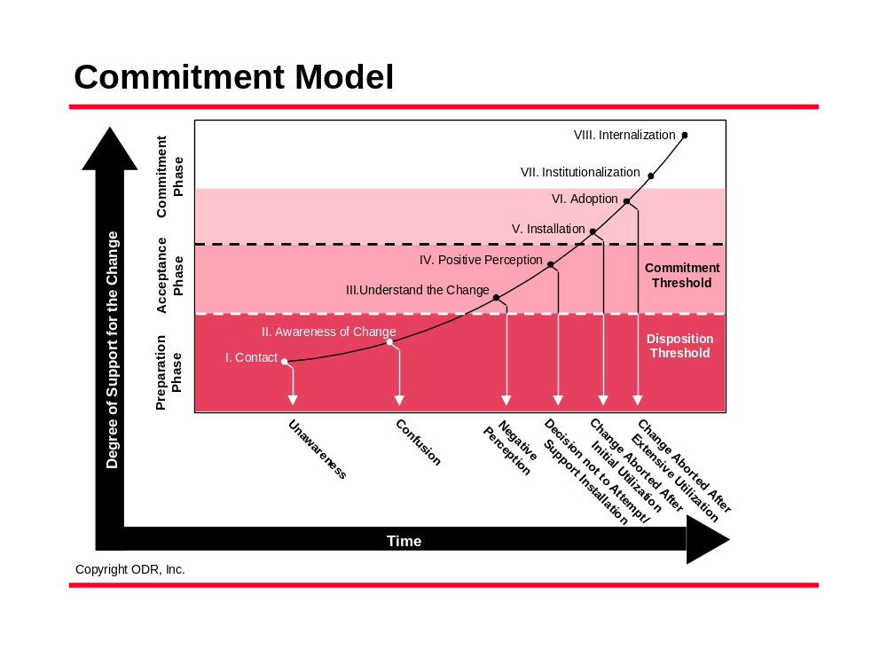
There are other advantages from using this model. First, using this Commitment Model will make it easier to identify the most appropriate communication media for a particular stage in a project. It is common for certain types of communications to be overused due to the ease of development and/or deployment. For example, it is common for “non-personal” types of communication (e.g., memos, voicemail, and newsletters) to be used when more “personal” types of communication (e.g., one-on-one conversations and staff meetings) would be more appropriate for achieving the specific objectives for that communication. Also, using this Commitment Model may make it easier to explain the goals of the Communication Program. This can be valuable when seeking buy-in from the people who need to deliver more “personal” types of communications, such as executives and other high level managers.
Example Communication Roadmap
Campaign | Dates
Awareness and Understanding | 7/1/99 - 10/15/99
Understanding and Positive Perceptions | 10/16/99 - 4/31/00
Installation (“Go Live” date is 10/15/00) | 5/1/00 - 12/31/00
Follow-Up | 1/1/01 - 3/31/01
Communication Media Definition
As with consideration of audiences, a definition of the types of communication media to be used is important during development of the Communication Strategy. An effective Communication Program will use a variety of “personal” and “non-personal” communications, as appropriate to each campaign and its specific objectives.
The first step in the media definition process is to identify and evaluate the communication media available at the company. Then the specific types of communication media to be used may be targeted. As the Communication Program progresses, this information may be modified to reflect findings from actual experiences with the media.
Example Communication Media Definition
Communication Media | Awareness and Understanding Campaign | Understanding and Positive Perceptions Campaign | Installation Campaign | Follow-Up Campaign
E-Mail
Voicemail
Newsletter
Memo/Letter
Presentations and staff meetings
“Ask Your Question” voicemail box
Management scripts
Intranet
One-on-one conversations
“Day in the Life” video
Education and training sessions
Mentoring and coaching
Performance expectation setting
Performance reviews
Rewards and recognition
The Communication Media Definition is an opportune time to consider communication media that are new for the organization. Posters/banners, fortune cookies, project “open houses”, pocket information cards, “our future looks bright” sunglasses, “quiz your manager about the project” games, and other non-traditional mechanisms may be valuable for gaining attention to the communication messages.
- Communication Campaign Definition
The purpose of the Communication Campaign Definition is to provide methods, processes and tools for further development of the planned communications. It builds on the contents of the Communication Strategy and serves as a bridge to the Communication Plan.
A Communication Campaign Definition guides the development of a set of messages designed to help the specified audiences move through one or more of the stages of commitment as identified in the Communication Strategy. For example, the campaigns chosen for a particular project may be:
- Awareness and understanding campaign
- Understanding and positive perceptions campaign
- Installation campaign
- Follow-Up campaign
A Communication Campaign Definition contains:
- Campaign Objectives. The Campaign Objectives guide development of the communication campaigns and establish criteria for measuring the success of each campaign.
- Audience Requirements. The Audience Requirements identify the communication topics applicable to each group identified in the Communication Strategy. Also, by identifying common requirements, it may be possible to consolidate identified groups into a smaller number of audiences for the purpose of minimizing the complexity of the communication campaign.
- Message Definition. Message Definition specifies the key messages or primary category of messages to be delivered for each of the campaigns. Also, the Message Definition details the audiences that will receive the message, and the communication media, frequency, and timing for that message. Typically the Message Definition is subject to the most revision and clarification as the Communication Program progresses.
Communication Objectives
Communication Objectives specify the overall goals of each communication campaign. At the end of each campaign, these objectives will be used to determine if the Campaign has been successful. If the Objectives have not been achieved, a plan to remedy this issue can then be implemented early enough to ensure that the next campaign builds upon a firm foundation. Two likely remedies for missed objectives are:
- To include additional communications in the following Campaign, or
- To delay the following campaign while the missed objectives are addressed.
Example Communication Objectives
The following twelve objectives are examples for four Communication Campaigns:
Campaign: Awareness and Understanding
- 100% of directly impacted personnel will be aware of the ABC project.
- The majority of directors and managers will be able to explain the ABC project and its objectives in their own words.
- 100% of executives and directors of indirectly impacted organizations will be aware of the ABC project.
Campaign: Understanding and Positive Perceptions
- The majority (over 60%) of the directly impacted personnel will be able to explain the ABC project and its four objectives.
- The majority of executives and directors will view the project as necessary to the long-term competitive positioning of the organization.
- 45% of impacted personnel will have voluntarily participated in at least one Brown Bag Lunch presentation about the ABC project by March 31, 2000.
Campaign: Installation
- 100% of directly impacted personnel know the required training schedule applicable to their position.
- 80% of all inbound communications are answered within 2 business hours.
- 100% of impacted personnel know that a Help Line exists.
Campaign: Follow-Up
- The majority of directly impacted personnel can describe at least one benefit or success story associated with the ABC project.
- 100% of directly impacted managers are aware that a performance appraisal guideline document is available for their use in setting next year’s employee performance goals.
- 100% of all inbound communications are answered (or acknowledged, if the answer must be researched extensively) within 2 business hours.
- 100% of directly impacted managers are aware of the additional training possibilities for new employees or people who need to learn additional system functionality.
Audience Requirements
The Audience Requirements portion of the Communications Campaign is a means to specifically consider the needs of each audience grouping. Notice that the definition of audiences and Audience Requirements are specific to a particular campaign. The Audience Requirements are helpful in:
- Consolidating groups of people into a single audience to simplify the communication process
- Ensuring that the messages for that Campaign will be adequate to achieve the communication requirements for all audiences
- Identifying common communication requirements that may be appropriate for mass communication media, such as newsletters and memos.
In identifying audiences, the following characteristics apply:
- Members of an audience need the same kinds of information
- Members of an audience may be impacted in a similar way during that particular stage of the project
- Members of an audience may have similar responsibilities towards the project at that particular stage
To help correlate the message to each audience, the following Example Audience Requirements chart provides general and specific information needs for some sample audience definitions.
Example Audience Requirements
Campaign: Awareness and Understanding
Audience | General Information Requirements | Specific Information Requirements
Executives | - Overview of project  - Project goals and timing | - Interrelationship and/or impact on other corporate initiatives and financial position  - Project priority  - Project leadership and staffing  - Project status and issue discussion
Directors  (for directly impacted areas) | - Overview of project  - Project goals and timing | - Their personal and departmental responsibilities  - Impacts on their department and timing  - Impacts on their personnel and timing  - Who to contact for answers
Managers and Supervisors  (for directly impacted departments) | - Overview of project  - Project goals and timing | - Their personal and departmental responsibilities  - Impacts on their position and timing  - Impacts on their department and timing  - Impacts on their personnel and timing  - Who to contact for answers
Employees  (for directly impacted departments) | - Overview of project  - Project goals and timing | - Impacts to their position and timing  - Who to contact for answers
Union for Employees  (for directly impacted departments) | - Overview of project  - Project goals and timing | - Positions to be impacted  - Impacts on the positions and timing  - Ways they will be informed and involved
Directors and Managers  (for indirectly impacted areas) | - Overview of project  - Project goals and timing
Customers | - Overview of project  - Project goals and timing

Message Definition
Each Campaign will focus on delivering a relatively small number of key messages. Different messages will be applicable to different audiences at separate times on the basis of their information requirements. Also, the messages will naturally lend themselves best to certain types of communication media. For this reason, it is important to specifically consider the messages for each Campaign along with the applicable audiences, media, frequency, and timing. One way to perform this definition is shown below.
Example Message Definition
Note that the following messages are worded in complete sentences. In the development of the actual messages, concise wording is appropriate as long as the essential points are conveyed to the people who must prepare the messages.
Campaign: Awareness and Understanding
- XYZ Corp. is implementing a new system for customer service within the 123 division. The name of this project is CSI – Customer Service Integration. The goals of this project are to enhance customer satisfaction and to reduce transaction costs through a “one call does it all” strategy. The project timeline is from 7/99 through 12/00, when the package will be fully implemented and all impacted personnel will have fulfilled applicable training.
- Although productivity enhancements are expected, this project will not result in lay-offs.
- To accomplish the CSI project objectives, corporate funding priorities for some projects will be revised. Also, headcount reallocations will be necessary. Details about the headcount reallocations will be announced when the process changes are identified.

1. Implementing a new system for customer service within 123 division. Project name is CSI. The goals are to enhance customer satisfaction and reduce transaction costs. Project timeline is from 7/99 through 12/00.
Executives | 7/99
Directors (impacted) | 7/99-8/99
Managers and supervisors (impacted) | 8/99-9/99
Employees (impacted) | 8/99-9/99
Union (impacted) | 8/99-9/99
Directors and managers (non-impacted) | 8/99-10/99
Customers | 10/00-12/00
Media: Memo, E-Mail (2), Voicemail (2), Newsletter (2), Intranet, Staff meetings, Management scripts, Customer letter
2. No lay-offs will result from the CSI project.
Executives | 7/99
Directors (impacted) | 7/99-9/99
Managers and supervisors (impacted) | 7/99-9/99
Employees (impacted) | 8/99-11/99
Union (impacted) | 8/99-11/99
Directors and managers (non-impacted) | 10/99-11/99
Media: Memo, E-Mail (2), Voicemail(2), Newsletter (2), Intranet, Staff meetings, Management scripts

3. Funding priorities and headcount allocations will change. Details about headcount reallocations will be announced when the process changes are identified.
Executives | 7/99-8/99
Directors (impacted) | 7/99-9/99
Media: Memo, E-Mail, Staff meetings
- Communication Plan
The Communication Plan is the document used to direct the actual preparation and delivery of communication materials. It defines the specific communications to be prepared and delivered, the timing for each communication, and the budget for the overall Communication Program and/or Campaign.
There are three elements in the Communication Plan:
- Communication Delivery Planner
- Workplan
- Budget
- Communication Delivery Planner. The Communication Delivery Planner builds upon the detail developed in the Message Definition. For each campaign, the Communication Delivery Planner identifies the communication media, timing, applicable messages for that media, and audiences to be targeted. This information will be used predominantly by the person who prepares the communication materials.
- Workplan. The Workplan will be used to schedule the production and delivery of communications. The Workplan is a gantt chart for the overall Communication Program. It contains the following information:
- Detailed communication activities for the current communication campaign
- Summary information for later communication campaigns
- Preparation and delivery responsibilities
- Completion dates
- Timeline showing elapsed time
- Budget. The Budget is used to determine the total cost of developing and delivering all the communications specified in the Communication Plan. The Budget should meet the content and format specified by the organization. It may reflect only incremental or cash expenses (such as video production costs) or it may also include costs for resource time and the like.
Communication Delivery Planner
The Communication Delivery Planner is a means to consolidate messages by media, which is needed to facilitate effective preparation of the messages identified in the Message Definition. The Communication Delivery Planner also allows for a review of the key message delivery to ensure that the targeted number of repetitions is accomplished. Note that although there may be media delivering the same messages multiple times, these are not meant to be mere duplication of the same materials. Instead, each iteration of the same media needs to include additional information relevant to the key message(s) and valuable to meeting the campaign objectives.
Example Communication Delivery Planner
Campaign: Awareness and Understanding

Media | Timing | Messages | Audiences
Memo to executives and directors | 7/99 | #1, #2, #3 | Executives and directors (impacted)
Memo to all employees | 7/99 | #1, #2 | All audiences except customers
E-mail (2) | 7/99. 9/99 | #1, #2 | All audiences except customers
Voicemail (2) | 7/99, 9/99 | #1, #2 | All audiences except customers
Newsletter (2) | 7/99,  9/99 | #1, #2 | All audiences except customers
Intranet | 7/99 | #1, #2 | All audiences except customers
Management scripts | 8/99 | #1, #2 | Directors (impacted and non-impacted), managers and supervisors
Staff meeting - executives | 8/99 | #1, #2, #3 | Executives
Staff meeting - directors | 8/99 | #1, #2, #3 | Directors (impacted and non-impacted)
Staff meetings - managers and supervisors | 8/99 | #1, #2 | Managers and supervisors (impacted)
Staff meetings - employees | 8/99 | #1, #2 | Employees (impacted)
Workplan
The Workplan is the document that contains the activities, responsibilities, and timing of the overall Communication Program. It enables the communication effort to be integrated into the overall project management approach. In evaluating the success of specific campaigns, the Workplan and Communication Objectives are key inputs.
The Workplan is a meaningful way to portray the communication effort to others and ensure that the flow of the Communication Program is consistent with the timing and sequencing of the project it supports. Also, it is a means of identifying the required communication resources and the support that will be needed from others during the communication process. Finally, the Workplan is an important input to the Budget development.
The Workplan may be created using a spreadsheet or project planning software to enable revisions as the Communication Program progresses.
Example Workplan
Budget
The final piece of the Communication Plan is a Budget for the Communication Program. The Budget should follow the typical format and content requirements specified by the organization.
When developing the Budget, the following costs may be applicable:
- Material costs, such as paper, video tapes, etc.
- Printing charges for newsletters, posters, etc.
- Programming costs for placing communications on the intranet or other electronic media
- Video production, duplication and distribution charges
- Postage
- Costs associated with any rewards or special recognition procedures
- Costs for personnel time for preparation and/or delivery of communications
Fees for external resources involved in preparation and/or delivery of communications
- Conclusion
Today’s business environment is one where organizations are implementing a variety of projects. One of the key preparation activities for the people who will be impacted by a project is ensuring they have the necessary awareness, understanding, and preparation for action. An effective Communication Program is a primary means for meeting these requirements.
An effective project Communication Program will be guided by a carefully prepared Communication Strategy, deployed through Communication Campaigns with specific objectives, and managed through a Communication Plan that specifies responsibilities, timing, and budget information. A Communication Program that contains these elements is an effective way of addressing a key project risk factor. No matter the project size or scope, this focus on communications will enhance project success.
- References
“Building Commitment to Organizational Change,” ODR Inc., 1991
- Revision History
Revision Number | Revision Date | Summary of Changes | Changes Marked?
4.1.1 | April 2003 | Applied new template and style, spelling and grammar.
1.0 | 1998 | Baseline version

