

IBM Global Services

Enterprise Architecture Assessment Process

Technique Paper (TP)

© Copyright International Business Machines Corporation 2003, 2004
All Rights Reserved
Version 4.1.1, January 2004
- Description
This technique paper describes some practical guidance regarding the steps to take to assess Enterprise Architecture (EA). It describes the content of the "Two-week EA Assessment."
2 Contexts of Use
The following sections describe the contexts in which you can use this technique.
As information technology continues to advance, businesses are increasingly implementing more complex enterprise (computer) architectures. For example, in today’s market, an automobile manufacturer will typically implement computer infrastructure to accommodate dealers, customers as well as the underlying manufacturing operation. In many of these cases, the enterprise architecture will change/grow with time to accommodate changes in the business. Unfortunately, as such changes occur, it is often difficult to determine whether the overall enterprise architecture has remained optimal for the business. For example, resources added to improve one aspect of the business might actually have an adverse effect on existing resources that are designed to aid another aspect of the business. Moreover, such changes could expose unforeseen risks within the enterprise architecture.
To this extent, it would be beneficial for an enterprise architecture to periodically undergo an assessment to determine if any changes are needed. Heretofore, attempts have been made to provide techniques for assessing an enterprise architecture. No such attempt, however, provides the extent of assessment that is currently needed. Specifically, the previous assessment techniques focus on the technical aspects of the enterprise architecture. For example, the previous techniques will examine issues such as storage space, computing bandwidth, etc. without considering the underlying business environment in which the enterprise architecture is implemented. Further, no existing technique considers the risks currently being experienced within the enterprise architecture in making the assessment. Knowing the underlying business environment and the current risks can not only impact the determination of whether the enterprise architecture is fully optimized, but also whether certain changes are necessary. Still yet, no existing technique assesses an enterprise architecture by comparing its operational performance to best practice data. That is, no existing technique considers how other similar enterprise architectures perform in assessing an enterprise architecture.
In view of the foregoing, there exists a need for a method for assessing an enterprise architecture. Specifically, a need exists whereby an enterprise architecture is assessed on the technical business environment in which it is implemented as well as the integration challenges of applications therein. A further need exists for the assessment of the enterprise architecture to be based on best practice data for other similar enterprise architectures. Still yet, a need exists for architectural alternatives to be recommended based on the assessment and any risks identified within the architecture.
- Steps
  - Data Collection
As indicated above, to fully assess enterprise architecture, certain pieces of data should be provided. Such data includes responses to questions, integration information, and risks within enterprise architecture. As will be further described below, this data is generally provided by customer’s information technology (IT) staff /owners of enterprise architecture. To this extent, this data can be determined by the customer’s IT staff responsible for the enterprise architecture in collaboration with one or more assessors who are responsible for administering the assessment process. For example, to obtain responses, the customer’s IT staff of enterprise architecture would first be provided with a questionnaire that includes questions designed to determine the business and IT needs that currently face enterprise architecture . The customer’s IT staff and the assessors can prepare the responses jointly. Similarly, integration information and risks can be determined pursuant to workshops, meetings and the like between the customer’s IT staff and the assessors.
3.1.1 Responses to Questionnaire
The general purpose of the questionnaire is to determine the business and information technology based needs that currently face enterprise architecture. As such, several types of questions can be posed. For example, the questions can pertain to:
(1) The business context/environment in which the enterprise architecture is implemented. Typical questions to determine this could include “What business processes, business functions (components), information, roles and locations must be addressed?”
What are the business and IT goals for the enterprise architecture?” and “What are the key users, entities and systems interacting with enterprise architecture?”
(2) The system context of enterprise architecture. Typical questions to determine this could include “What are the different types of client devices accessing the system?” and “What users/systems/entities are interacting with enterprise architecture via which channels/devices?”
(3) IT environment, process and procedures of enterprise architecture. Typical questions to determine this could include “What are the key IT roles and responsibilities?” and “How is the IT group organized?”
(4) General architecture of enterprise architecture. Typical questions to determine this could include “Have the roles of business architect, application architect and technical architect been identified and assigned to individuals with sufficient experience?” and “Have the business architecture, application architecture and technical architecture been created?”
(5) User experience for those using enterprise architecture. Typical questions to determine this could include “what are the primary user groups?” and “What are the primary user types?”
(6) Information architecture of enterprise architecture. Typical questions to determine this could include “What information needs to be made available, to whom, and how?” And “What are the language requirements for business content?”
(7) Application architecture of enterprise architecture. Typical questions to determine this could include “How do applications support the required functionality?”
“What are the primary applications within enterprise architecture?” and “What are the interactions among applications, users and external entities?”
(8) Content management of enterprise architecture. Typical questions to determine this could include “What types of content, how is it maintained, published, and distributed?” Will the content for the web pages be stored in multiple places?” and “Will the content of the web pages be managed?”
(9) Data and integration architecture of enterprise architecture. Typical questions to determine this could include “What is the enterprise data architecture – “What are the data elements, where stored, and how are they accessed?” and “What is the current logical design of the databases?”
(10) Operational Architecture of enterprise architecture. Typical questions to determine this could include “What infrastructure do we need to provide the required Service levels?” “What are the main components of the IT environment?” and “What environments are supported for different phases?”
(11) Security architecture of enterprise architecture. Typical questions to determine this could include “What are the security and privacy requirements for the infrastructure and applications?” “What are the authentication/identification requirements for the various business processes?” and “Have the access requirements for the various data elements been identified?”
(12) Systems management of enterprise architecture. Typical questions to determine this could include “Is there an ongoing performance planning process?” and “Is there an ongoing capacity planning process?”
(13) Functional and volumetric information of enterprise architecture. Typical questions to determine this could include “Does a baseline of business volumetric information captured exist?” and “What are the current and future arrival rate of the various business sessions?”
(14) Testing of enterprise architecture. Typical questions to determine this could include “Who will perform the testing?” and “What tools will they use?”
(15) Hosting of enterprise architecture. Typical questions to determine this could include “Who is the provider?” and “Who owns the equipment?”
The questionnaire could also request information per application or system within enterprise architecture. For example, the customer’s IT staff could be requested to identify the access channels per user type, the total number of users, etc. In any event, it should be understood that the questions cited above are not intended as an exhaustive list of questions. Rather, they are cited herein only to illustrate the possible types of questions that can be posed. A more complete listing of illustrative questions is referenced in section 7, which is attached hereto and is herein incorporated by reference.
3.2 Integration information
In addition to responses, to properly assess enterprise architecture, information pertaining to the integration challenges among major applications (e.g., customer systems, marketing systems, commerce applications, etc.) of enterprise architecture should also be provided. This “integration information” could be determined by referencing Patterns for ebusiness (please see section 5) pursuant to workshops, meetings and the like between the customer’s IT staff of enterprise architecture and the assessors. Once it is determined, it will be used to derive final architecture alternatives similar to responses to questionnaire.
3.3 Risks within the Enterprise Architecture
The final piece of data that is collected is the risks within enterprise architecture. This information can not only be used to determine whether the current resources (hardware, software and or personnel) are adequately addressing those risks, but also whether the current resources are unnecessarily exposing enterprise architecture to risk. The risks can also be used to recommend architectural alternatives for enterprise architecture. Similar to integration information, risks can be determined based on workshops, meetings and the like between the customer’s IT staff of enterprise architecture and assessors. Once the risks are identified, they can be populated into a viability assessment.
3.4 Assessment of Enterprise Architecture
In a typical assessment, responses to questionnaire, integration information and risks will be aggregated into some form of useable data such as a set of scores. This can be accomplished in any number of ways. For example, you could assign scores or points based on certain responses or integration challenges. This could lead to a composite score that represents the operational performance of enterprise architecture. It should be appreciated, however, that any methodology for determining the performance of enterprise architecture based on responses to questionnaire and integration information could be implemented.
Once the operational performance is determined, those results should be compared with the best practice data corresponding to operational performances of similar enterprise architectures. Specifically, the best practice data can be determined based on previous enterprise architectures that are similar to enterprise architectures and were determined to have optimal or ideal performance. In identifying similar enterprise architectures, any type of standard can be applied. For example, a similar enterprise architecture could be one that is implemented in a similar business environment and/or has similar resources as enterprise architecture. In any event, the best practice data of similar enterprise architectures can be used to rate the operational performance of enterprise architecture.
Based on the comparison, one can generate an assessment of enterprise architecture. Assessment will also attempt to identify the resources within enterprise architecture that are responsible for any sub-optimal performance. Moreover, assessment will also recommend architectural alternatives for enterprise architecture to improve the operational performance. Such alternatives could include changes/alterations to hardware, software and/or personnel/individuals within enterprise architecture. Final report will include the details of the assessment process as well as any recommended architectural alternatives.
- Tools
Following files/documents will be used:
Business & IT Architecture Questionnaire
IBM patterns for ebusiness
Viability Assessment Technique Paper
- Patterns for e-business

Patterns for e-business overview
Introduction
The idea of patterns is not new; they have been used extensively in the fields of design and architecture for centuries. The compelling case for patterns arises from the simple but significant fact that in many, if not most cases, it is simply too expensive, too time consuming and too risky to recreate all features of a system from the ground up. “Green field” exercises in designing business systems are becoming far less common, as experienced architects and designers come to recognize an ever-increasing number of recurring scenarios at all levels of detail in the business, organizational, and technical domains. Mining of previously implemented solutions takes precedence over invention, allowing invention to be reserved for special areas of a solution that can clearly benefit from unique treatment.
Patterns are, by their nature, generalized solutions, allowing reuse to be applied more broadly than would be the case with a specific design or implementation. This does not reduce the inherent worth of specific designs or component implementations. Instead, it points out that generalized patterns offer a significant opportunity to reuse proven solutions on the broadest possible scale. As more and more patterns-based solutions are implemented, the common framework provided by patterns increases the likelihood of finding reusable designs and implementations.
When to Apply Patterns in EA Assessment
While a very strong case can be made for patterns, patterns do not qualify as a “silver bullet,” with magical qualities guaranteeing success. Simply applying patterns does not assure success, since careless use of a pattern can lead to negative results. Effective use of patterns requires deciding which pattern applies at a particular time, and making sure that people making pattern selection decisions have the background needed to make a good selection.
The IBM Patterns for e-business provide a set of patterns starting at the business level, enabling use of the patterns at the earliest stages of planning, and assuring traceability of resulting solution is to business requirements. Patterns for e-business will be used during the EA assessment and are aimed at common integration information based on e-business scenarios and present a complete picture of the enterprise solution(s) from Business patterns down to Application and Runtime patterns.
- Sample assessment report
This section contains a summarized version of a report produced in conjunction with this assessment effort
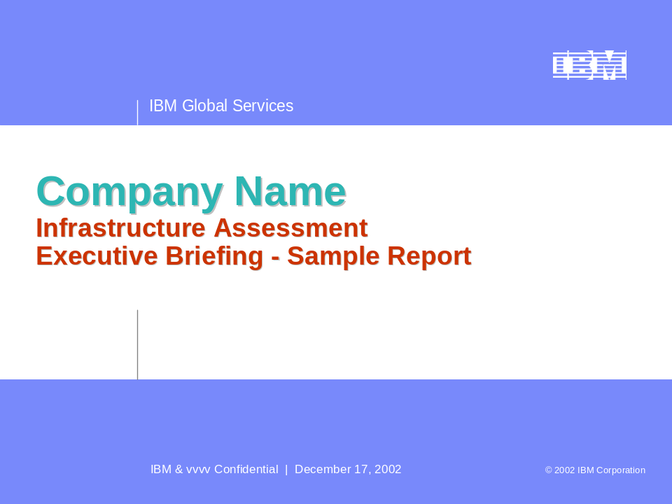

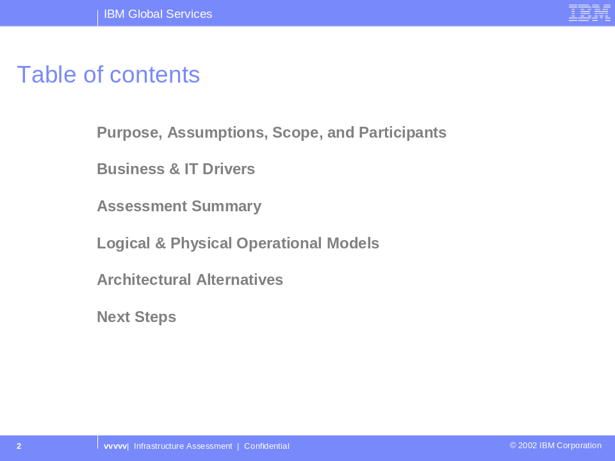
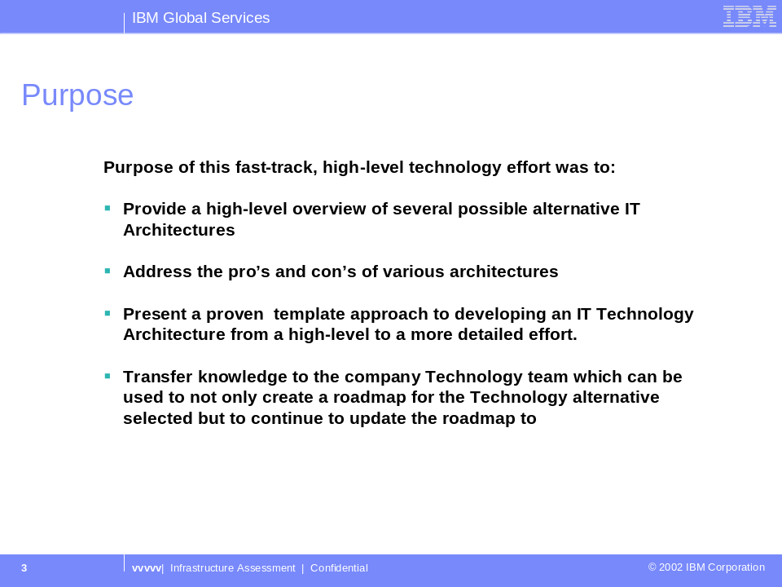
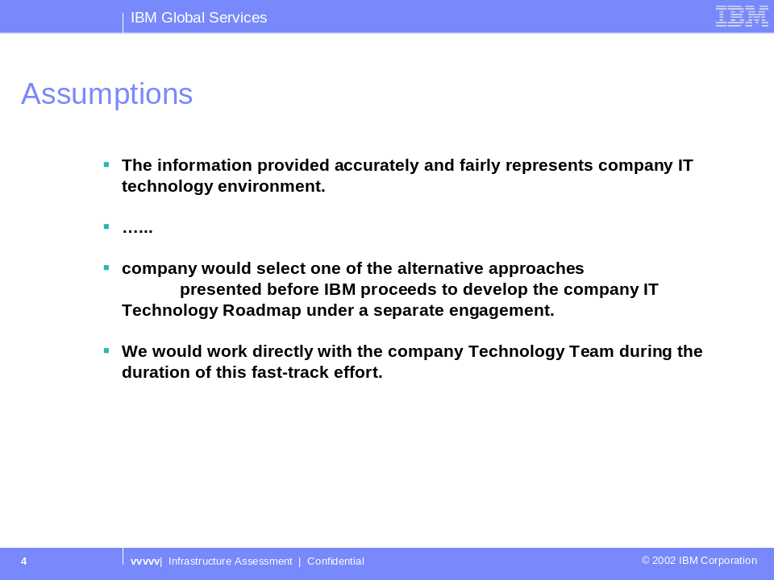
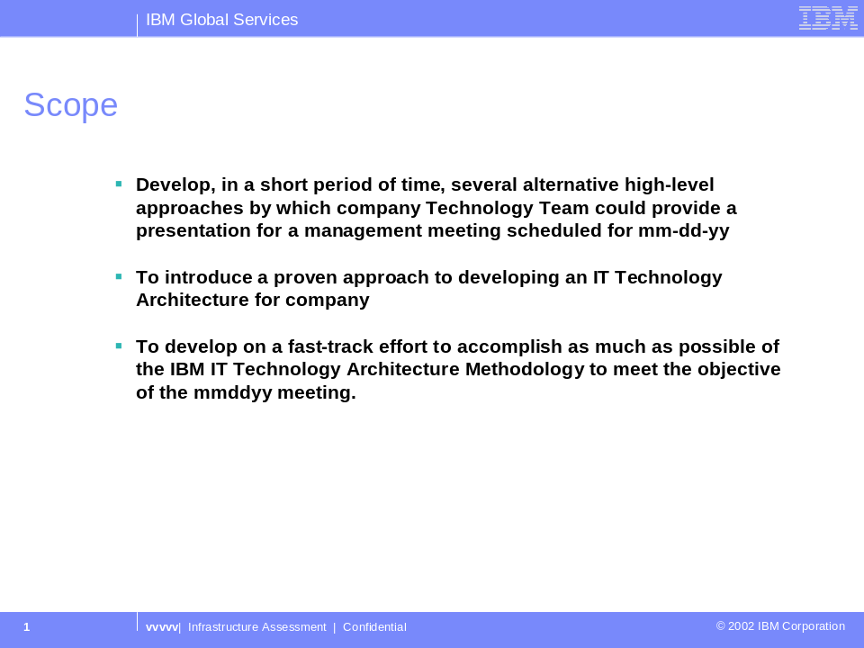
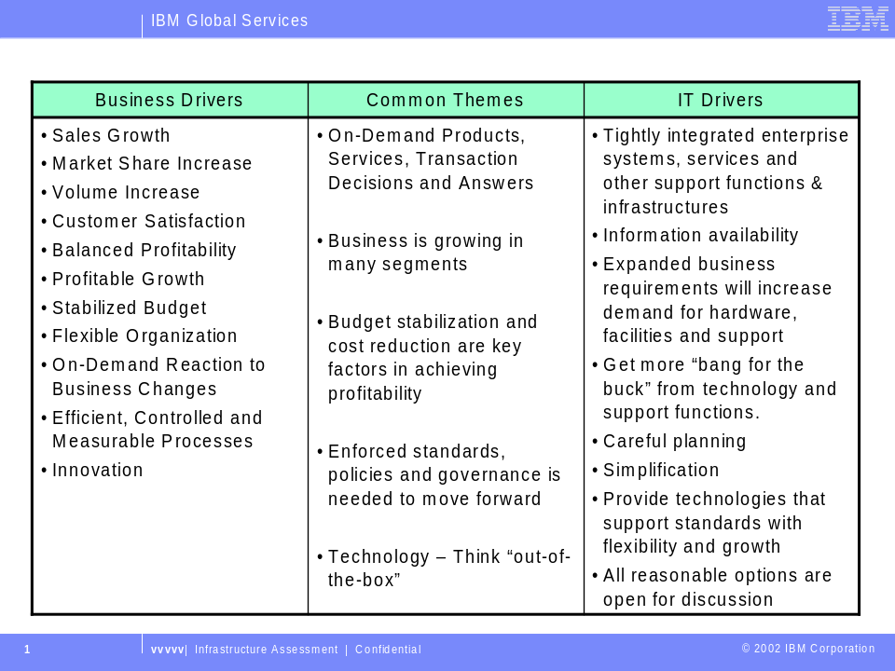
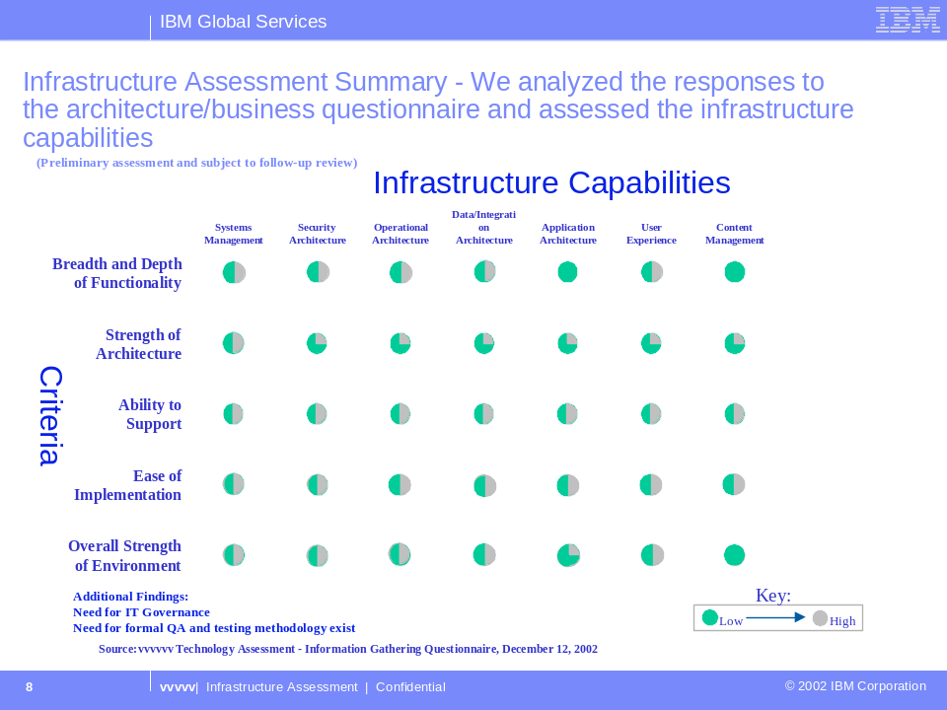

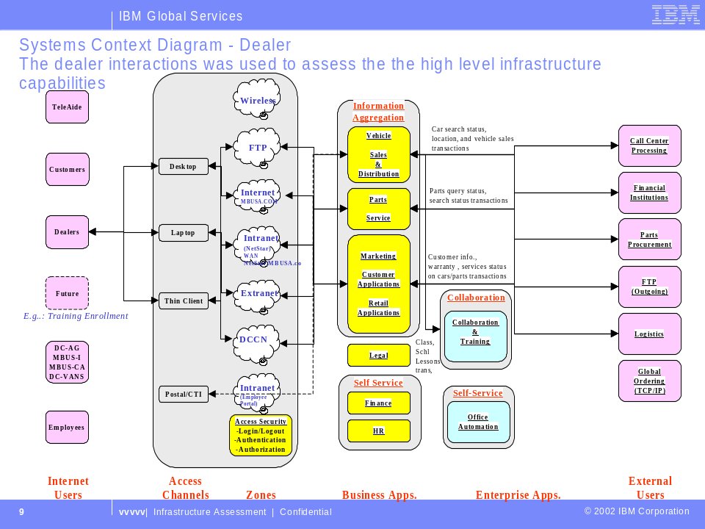

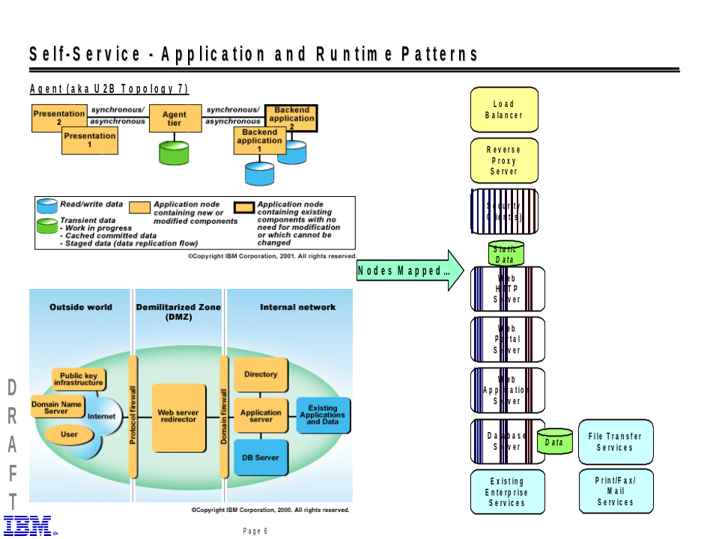
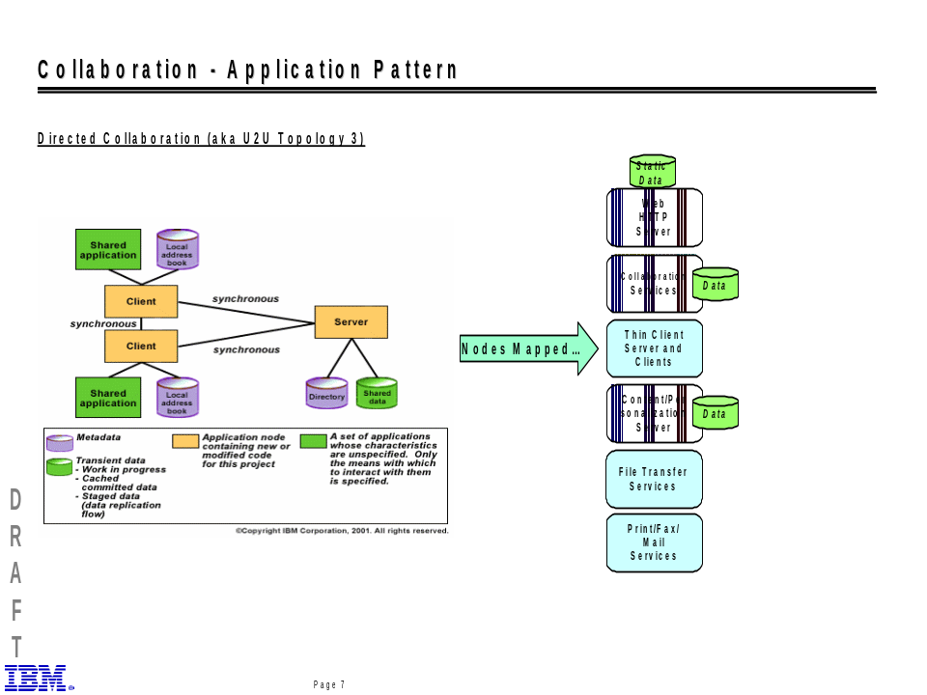
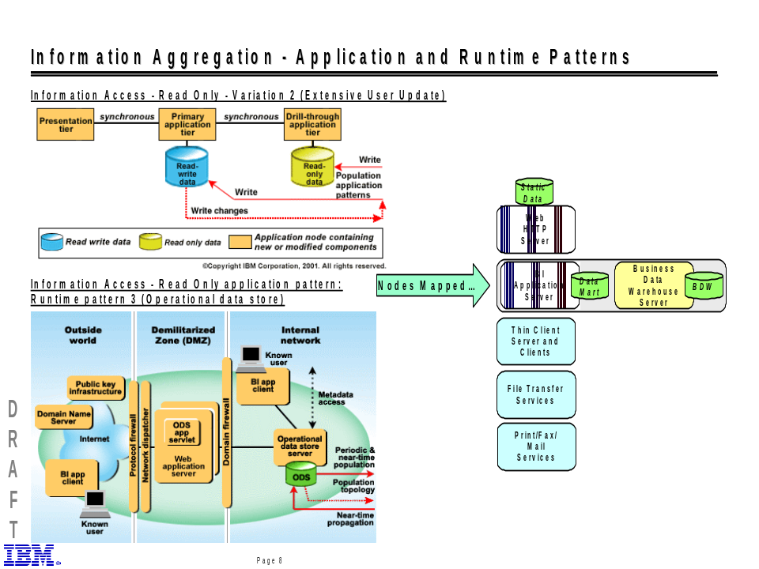
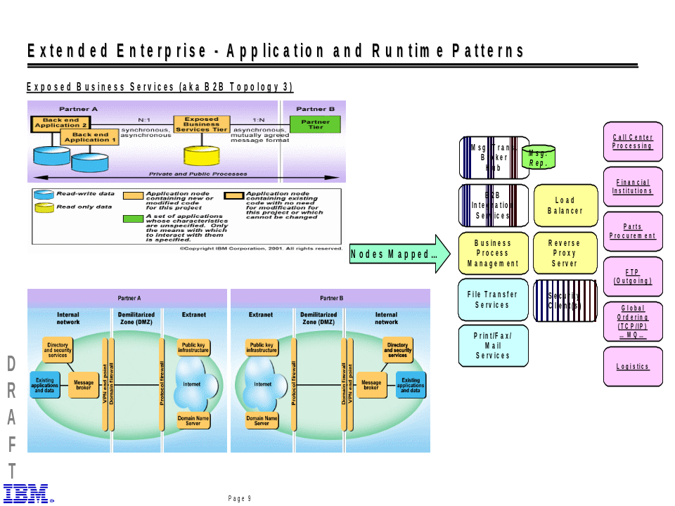
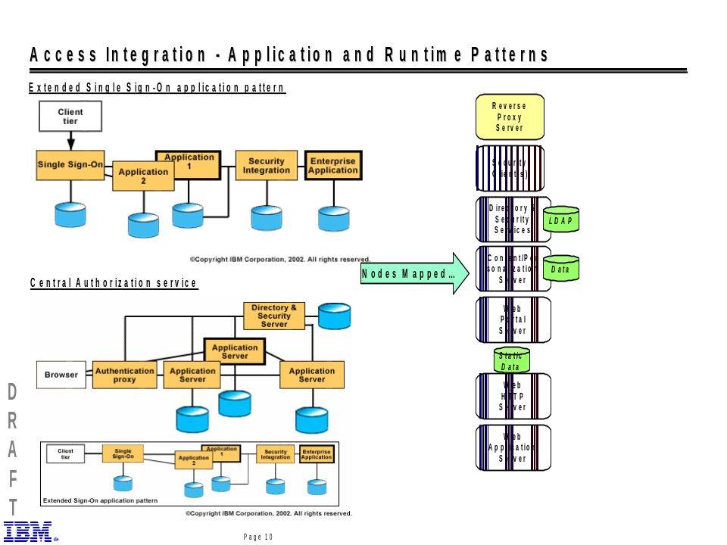
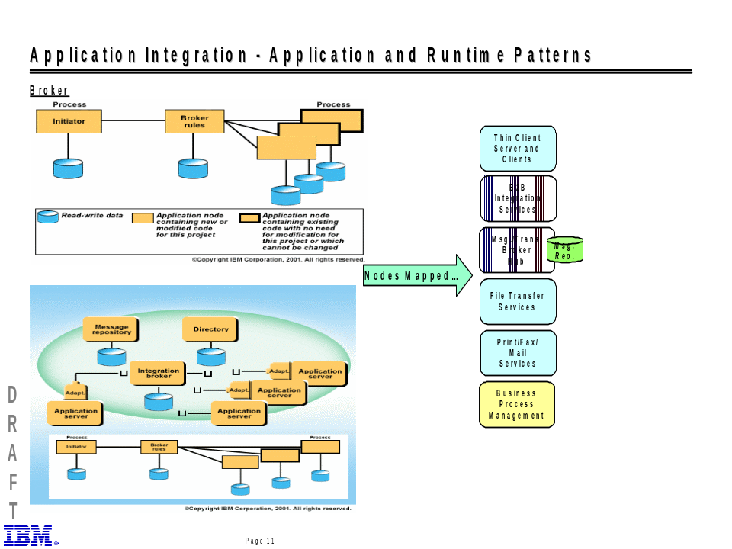

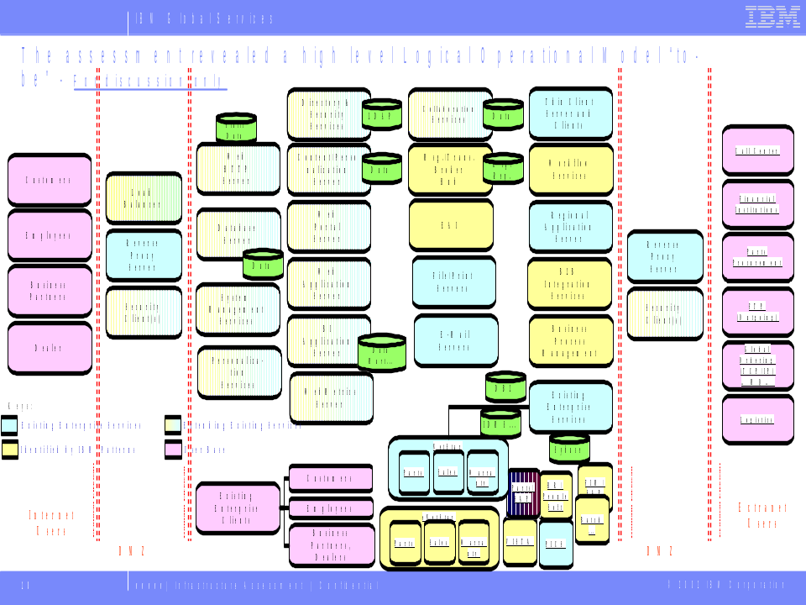

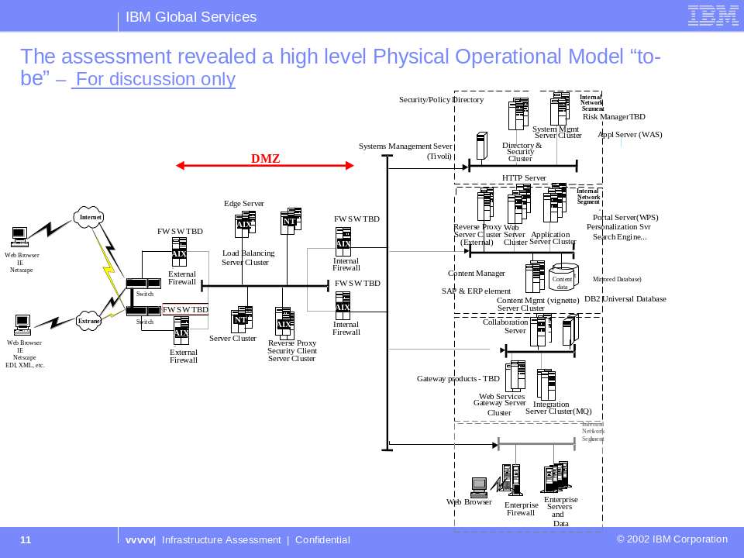
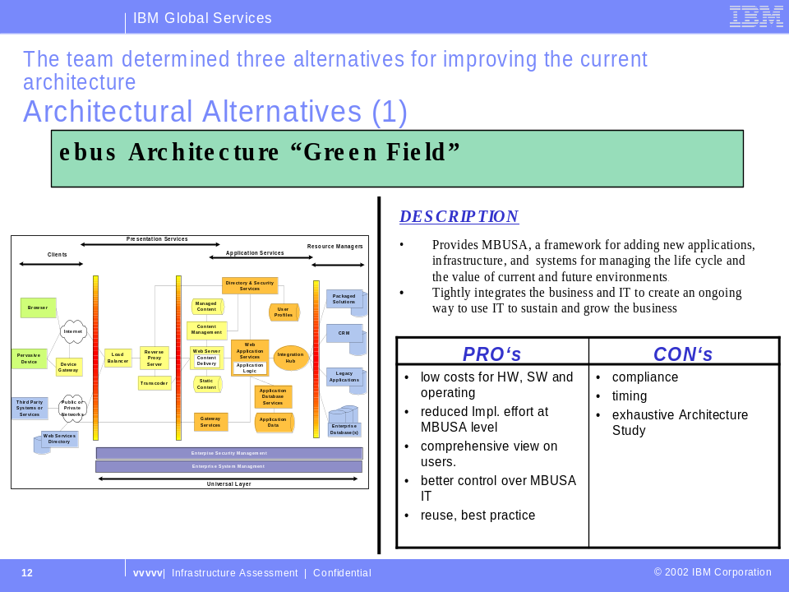
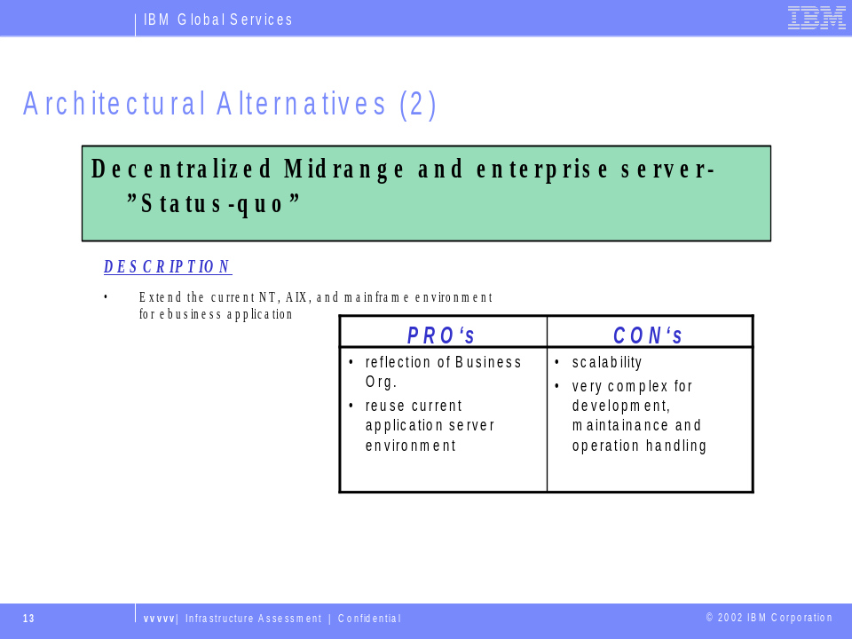
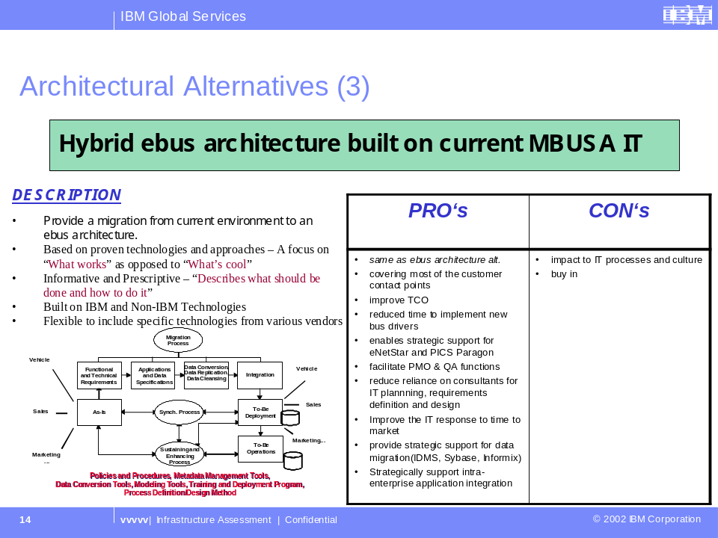
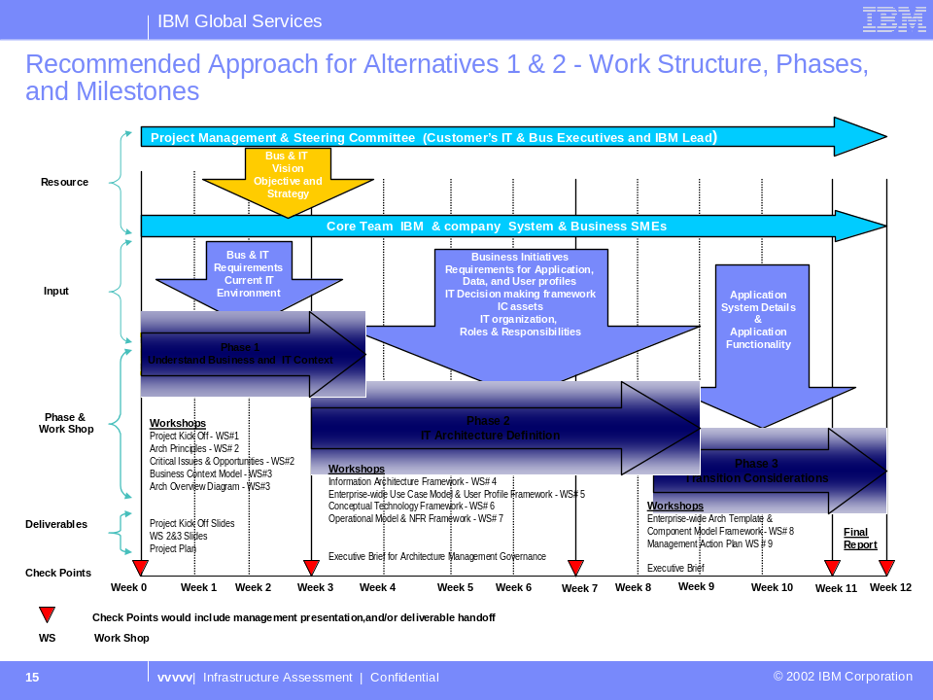
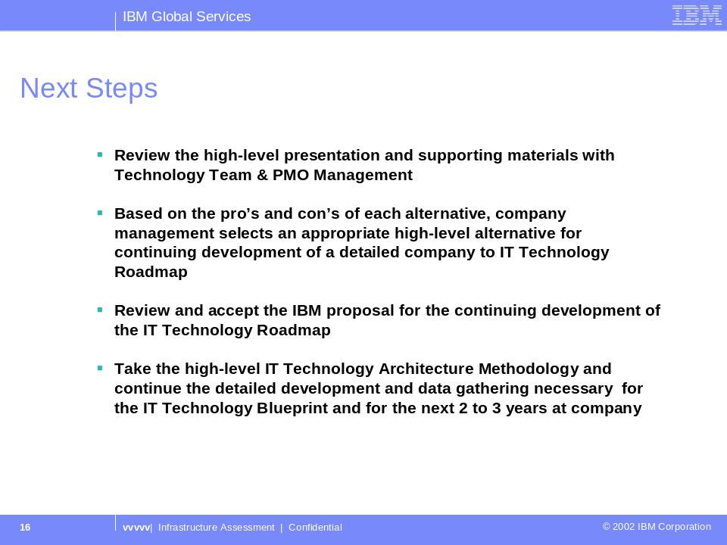
- Questionnaire
Please reference the Business & IT Architecture Questionnaire document

- Revision History
Revision Number | Revision Date | Summary of Changes
4.1.1 | January 2004 | Baseline version
1.1 | 12/15/03 | Updated content
1.0 | 5/20/03 | Updated style.

