

IBM Global Services

High Level Implementation Strategy

Technique Paper (TP)

© Copyright International Business Machines Corporation 2001
All Rights Reserved
Version 1.0 September, 2001
- Description
The High-Level Implementation Strategy defines the initial strategic plan for the development, implementation, and rollout of the client’s technical solution. It provides an initial approach and plan in the implementation of the identified software and technical solution components. It provides key information to the implementation team and the client in planning the implementation of the selected solution as well as facilitates the transition to the implementation project team.
It supports the implementation team’s effort in the development of detailed implementation work plans and the engagement implementation Statement of Work by providing the following key information:
- Project Goals
- Project Scope
- High Level Implementation Approach
- Implementation Planning Assumptions
- High Level Timelines and Milestones
- Project Risks
- Organizational Impacts
- Other Planning Considerations
In the development of the High Level Implementation Strategy, the following information is compiled, assessed, and evaluated in the production of the work product:
- Preliminary software solution gaps and customization requirements
- Application and component groupings for release planning
- Initial integration and interface points between the software solution and the existing client application portfolio
- Potential organizational changes requirements that may require procedural changes
- Potential role resources for the implementation team
- Database components requiring data conversion
- Technical Infrastructure gaps and requirements

- Context
In a Packaged Solution Integration engagement, the High-Level Implementation Strategy is used as a communication vehicle between the selection and integration teams to facilitate a smooth transition from the selection activities to the implementation of the software solution. It provides the bridge for the integration team to quickly gain the necessary details for an expedient project start-up and detail planning of the software implementation.
The High Level Implementation Strategy work product:
- Supports the development of an implementation work plan
- Establishes the implementation scope, approach, and planning assumptions
- Defines an initial implementation release strategy.
- Identifies key target dates and a high level timeline.
- Defines the preliminary project team organization structure, roles and responsibilities.
- Identifies the next steps for the project.

Related Work-Products
Work-products that are helpful in the development of the High-Level Implementation Strategy include:
- APP 011 System Context
- ARC 113 Operational Model
- ARC 301 Current IT Environment
- BUS 080 High Level Gap Analysis
- BUS 082 Business Case
- ORG 002 Future Organization Scope and Requirements

- Steps
The steps to develop a High-Level Implementation Strategy vary from project to project and are influenced by the size, complexity, and scope of the intended solution, and client’s business and technical environment. Under most conditions, the following steps are typical of any effort to develop a high-level implementation strategy. Variations to these steps are usually in the level of detail, breadth of the analysis, or effort expended to complete the step.
The following outline, defines the typical steps and activities that are performed to produce a High-Level Implementation Strategy. These steps are listed in the general order that they are performed but many of them should be executed concurrently to expedite the development of this work product. Evaluate these steps to the specific project requirements and constraints to determine the appropriate execution path.
Steps in developing a High-Level Implementation Strategy:
- Confirm project objectives and business areas within scope of the implementation effort
- Upon completion of the package assess phase activities, commitment from the client should be secured on the finalist vendor software solutions and other technical components. This will allow the team to stay focused on the software solution identified and the business areas that they support.
- In those situations where the client wants a better understanding of the business ramifications and implementation costs associated to competing vendor solutions before committing to one, multiple implementation strategies can be developed for each solution option to facilitate the client’s final decision. In this situation, planning assumptions should be well document on this approach.
- Revalidate the scope of the process areas and extended functions for implementation. During the package assess phase, a “process view” of the solution requirements is defined to identify the best-fit cross-functional solution(s) for the client’s target end-state process design. Some process areas are included in scope for the solution selection activity to evaluate the cross-process ties and the integration of the underlying application components. Once the software solutions are evaluated, and process areas prioritized the scope of the implementation effort may change. It is therefore best to confirm the scope of the software components and business processes to be implemented with the client.
- Identify the enabling technologies for the supporting processes. To facilitate a good understanding of the process and solution component scope, associate the process to the application modules/functions or technology. This can be captured using a simple table or for more complex projects that include many process areas or software components; a process/application matrix can be used to show this association.
The following example shows the association of the vendor’s application functionality to the client’s process areas:
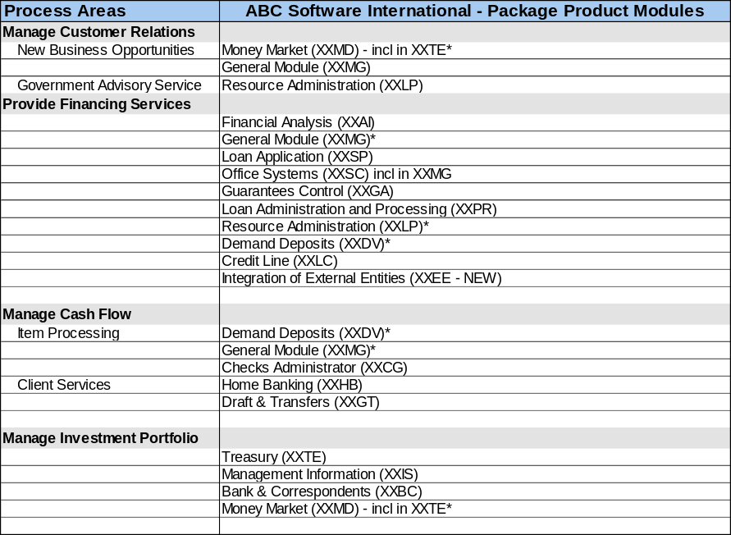
- Document any implementation planning assumptions
As the implementation strategy is defined, issues or constraints will be identified on the analysis of the software solutions, enabling technologies, client’s business and technical environment, roles/resources, etc. that will require some assumption to move forward in the definition of the implementation strategy. These assumptions should be captured in a common list for inclusion in the final implementation strategy presentation or document.
The following is a list of commonly identified planning assumptions established during the definition of an implementation strategy:
- The selected package will support the business functions of the systems to be replaced and allow for the desired systems to be integrated.
- A key goal is to utilize the functionality of the selected package wherever possible to fully reap the benefits of an integrated solution.
- A “Big Bang” approach is not feasible for ABC Company.
- XYZ Company wants to do a rapid implementation approach with implementation cycles of not more than 6 months.
- Applications will be developed based on desired standards wherever possible to allow for a rollout strategy and re-use of functionality rather than a re-design for every region.
- Bolt on solutions will be standardized throughout the regions as long as local requirements do not force different solutions (i.e. tax packages)
- The IT infrastructure does not require radical changes to support the selected package

- Establish the high level decision criteria to define the order and release strategy of the software solution
This step looks to establish the criteria used in defining the release strategy of the software solution and rollout to the organizational units.
The decision criteria are established through a short workshop with representation from both the client’s business and technical groups. An evaluation of the organizational impacts, technical environment, and business processes provides the foundation for the discussion to establish the criteria for the release strategy. During the workshop, priorities must also be established for the process areas to define the order of the module implementation.
The following is a sample list of decision criteria for a release strategy:
- Focused on functionality that is core to the business
- Organized the Divisions and Territories into “phases” that were large in scale, but still manageable
- Minimized complexity, maximized benefits and addressed divisional receptivity
- Best practices and built-in processes will drive our design
- Include a complex division and an international territory in the initial roll-out
- Minimized the interface and conversion effort and maximized their re-use in later phases

- Establish an implementation approach
Determining the appropriate implementation approach for the client requires an assessment of the client’s situation and needs. Typically the client requests some type of cost benefit or ROI (Return on Investment) analysis as part of any significant implementation that requires a substantial investment. This analysis ties heavily to this step since the implementation approach can have a significant impact to the benefit timeline and total cost of the implementation. There are two main implementation approaches that can be taken on any given project:
- Phased or Staged Implementation
- “Big Bang” or Single Phase Implementation
Each approach has its own inherent advantages and disadvantages. For the purposes of this technique paper a brief and general view of each approach is provided below:
- The “phased” approach is seen as less risky, more costly, longer implementation cycle, but achieves incremental bursts of business benefits over the implementation window. Each phase or implementation “release” impacts a subset of the organization and therefore requires a small focused team to be involved and committed to the implementation effort.
- The “big bang” approach is usually more risky, and generally less costly since the entire solution is implemented in a single release. It requires more commitment from the entire organization and provides for the potential of achieving the business benefits across many of the functional areas of the organization at once. The disruption to the organization is greater and more intense since it may affect all areas of the business. There are less throwaway interfaces and conversion efforts which keeps the total costs down compared to the phase approach. This approach is viewed as higher risk due to the longer cycle time before any business benefits are achieved while the costs of the implementation effort are incurred at upfront.
Some factors to consider when establishing the implementation approach:
- Evaluating the ROI to the implementation approach can provide some justification to the approach selected. The benefits and risks associated to each approach needs to be evaluated to the client specific situation.
- Analysis of the software solution to the client technical environment must also be weighed into the equation. The architecture of the vendor’s solution may set constraints on how the solution must be implemented.
- Review of the organizational impacts and issues must be performed to determine the most feasible and best course of action. For example, the big bang approach may not be feasible to smaller organization that already run a lean staffing model. If the full commitment to the project is required then there may not be anyone available to run the current operations of the business during the implementation effort.
- The cost of too many throwaway interfaces and conversion efforts may outweigh the risks and the benefits of a phased in approach. Maybe few yet larger releases provide an acceptable balance to the implementation approach.
Once the implementation approach is established, the assumptions, assessment, and analysis that was performed to reach consensus should be document in the High Level Implementation Strategy and communicated back to the client.

- Define manageable application component release groups
Establishing releases of the application functionality provides a manageable approach to reduce the impacts to the client’s organization and mitigate implementation risks. This is an essential step for a phased approach.
The following provides some guidelines to the establishment of the release groups:
- Identify the application dependencies. Review the following work products. These work products can provide valuable insight into the application landscape and inter dependencies that exist between them:
  - APP 011 System Context
Provides a representation of the client’s application landscape and identifies the interfaces between the system and external entities. Usually shown as a diagram, this representation defines the system and identifies the information and control flows that cross the system boundary. The System Context highlights several important characteristics of the system: users, external systems, batch inputs and outputs, and external devices.
  - ARC 113 Operational Model
Provides a representation of the client’s computer systems network, their associated peripherals and the systems software, middleware, and application software that they run.
  - ARC 301 Current IT Environment
Provides an inventory of the client's installed applications, data, computing and network infrastructure and the current status of all the non-technical, management aspects of the overall client IT environment
- Review any additional models or work products developed that describe the client's current application and technical environments. This includes any application context diagrams or application area maps that the client may have documented on their current systems.
- Discuss the software component architecture with the vendor to determine any implementation dependencies that exists within the software product boundaries. Typically this information is predefined by the vendor and is readily available upon request.
- Evaluate any organizational constraints on the business and technical resources that support the current application portfolio and future software solution. This may set constraints on the application grouped in a release.
- Assess the technical infrastructure impacts that support the application and future software solution. For example, a replacement strategy might require that all UNIX based application be replace first since the maintenance agreement on the UNIX hardware is expiring with no plans for renewal. Therefore all application on this platform must be address first. This becomes a priority in the establishment of the applications in the release groups.
- Assess the impact and replacement strategy on the client’s current application portfolio. Identify the integration requirements and their application dependencies for each application. Evaluate the impact of proposed release groups to identify interfaces issues and conversion efforts. Depending on the number and complexity of applications within the client environment, developing a matrix to map the client’s current applications to a release may be needed to support the analysis. An example is provided below:
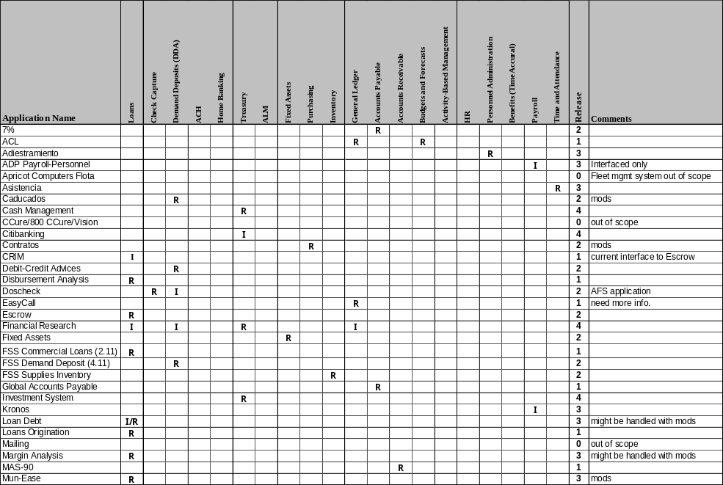
Once the applications are mapped to a release, the table can be sorted by release to provide a release view of the applications. The matrix below provides insight to the application replacement approach and integration effort required for each release:
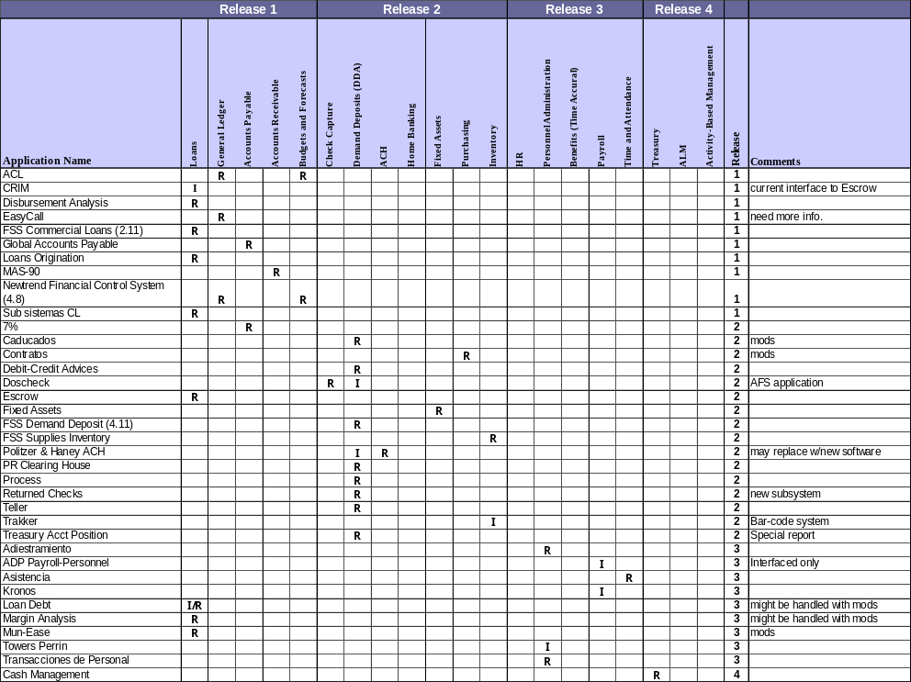
- Finalize the logical application groups. Since many factors and dependencies can exist between the current applications and the new software solution, this activity tends to require a “trial and error” approach. Definition of the application groups varies by project so use the best judgment to reduce the development of costly “disposable” interfaces.
An example application release groups:
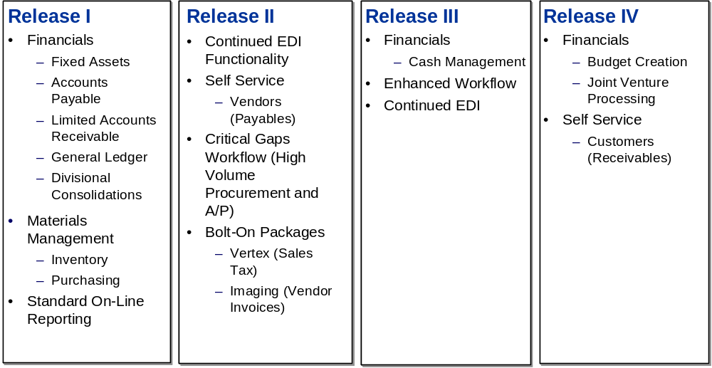

- Define a structured implementation approach for the final solution
This step looks to communicate to the client the need for a structured approach for a successful, manageable implementation of the solution. It is not intended to be the work effort for the development of a detailed work plan for implementation but instead provide the client with an overview of the key phases and activities to be performed during the implementation effort. This helps set the client’s expectations and commitment levels for the project.
The following are some general steps to be followed when defining the high-level implementation approach:
- Define an outline of the key phases and activities that should be followed for the implementation of the solution.
- When appropriate, use the IBM Global Services Method Engagement Support Environment (ESE) Tool in an informal method adoption workshop to define a preliminary engagement model for the effort. The ESE tool can provide a comprehensive approach to identify the key work products, activities, and deliverables for the project. It is not important to complete the project engagement model at this time. The focus here should be only in defining an initial guide to the implementation activities. Do not expend too much effort for this step.
- Document the key phases and work activities in an outline format for the implementation strategy presentation.

- Establish high level timeline and milestones
The high level timeline and milestones schedule provides an initial estimate and timing of the entire implementation effort. It is best notated in a project scheduling tool to graphically depict (e.g. Gantt chart) the release schedule to the key activities. The high level timeline is also a useful tool to define the high-level budget and planning cost of the implementation effort.
The following provides some guidelines in establishing a high level timeline:
- Determine the implementation phases, major activities, milestones and release dates. This can be captured in a worksheet or project management tool.
- Establish the role types and assign them to the major activities.
- Working with the package vendor, determine an initial estimate of the implementation of the base solution by application module or component. Establish a worksheet to record the level of effort by application module and release.
- Review the results from the high level gap analysis (see work product: BUS 080 High Level Gap Analysis) with the product vendor and implementation team. Assess the gaps that require application enhancements or extension beyond the core functionality. Determine a high level estimate of effort to complete the modifications for those process gaps in scope. Notate this as a separate estimate in the level of effort worksheet.
- Establish a high level estimate for each release by phase using the time estimates for each application module captured in the preceding steps.
- Create a high-level release timeline to depict the timing of the implementation of the applications with an estimated level of effort. Notate any key milestones.
An example high-level timeline (Gantt chart view):
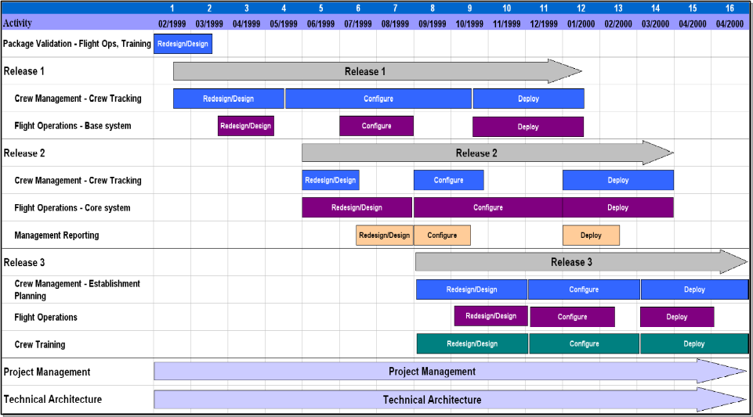
- Capture identified project risks associated with the implementation strategy
As the implementation strategy is defined, project risks are identified during the analysis of the software solutions, client’s business and technical environment, roles/resources, etc. These risks should be captured in a common list for inclusion in the final implementation strategy presentation or document.
The following is a sample of identified project risks:
- Managing the transition to new processes and systems to match gains offered by software and establishing new policies and procedures
- Adoption of common processes and common chart of accounts
- Number of legacy systems that will remain, and significant # of interfaces
- High profile initial rollout
- Timing, coordination, legacy systems that will remain and temporary interfaces due to implementation strategy
- Sustaining commitment throughout the client organization
- Securing and retaining dedicated full-time client resources for the project and providing appropriate back-fills for business continuity

- Identify the roles and skill sets needed to manage and implement the solution
This step provides a preliminary view of the roles and skill sets needed on the implementation team. It is presented in the High Level Implementation Strategy in connection with the high-level implementation timeline to communicate the resource needs and commitment levels from the client for specific skill sets on the implementation project. It provides an initial view of the staffing mix and schedule for the resources. This information provides useful insight to the development of the detail work plan and statement of work development.
The standard project management practices in defining a resources plan are not the focus of this technique paper. Use the appropriate project management toolset to define a preliminary resource plan that supports the high-level implementation timeline defined in the prior step.
Summarize the resource role requirements by release in a format that best communicates the resource types and demands to support the High Level Implementation Strategy.
The following is a sample of a Resource Role by Release matrix:
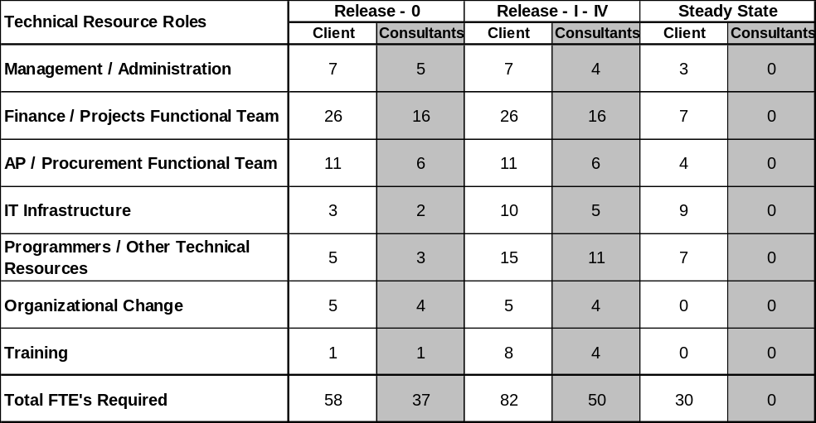

- Document any other key considerations that may affect the overall project.
Summarize and document any specific issues, findings, or considerations related to the client environment, resources, experience with the vendor or package, etc. that can impact the implementation of the solution. Include any points of observations that would be helpful to the implementation team.

The following is a sample list of key considerations:
- The process areas that were not included in scope for the selection project must be addressed during implementation to provide an integrated solution
- Establish an enterprise-wide engagement business architect to manage and address cross business area implementation and integration issues.
- Develop an integrated program master plan to manage all implementation initiatives and their dependencies.
- Define the technical infrastructure and application architecture holistically to include all areas of the organization.
- Identify schedule impacts due to client resources being over-extended and develop the appropriate contingency plan.
- Establish communication campaign
- Establish employee retention program

- Outline the next steps for the project
Finally, document the next steps or activities that should be performed in preparation for implementation of the software solution. Note any activities or “to do’s” for the client as an interim This helps keep the momentum of the project moving while decisions are finalized and the appropriate.
- Complete contract negotiations with the package vendors
- Perform IT Infrastructure planning to identify detail hardware and network requirements
- Perform database, hardware and implementation agreement negotiations
- Manage the logistics and prepare the facilities for the next phase
- Develop the detail plan and secure the appropriately skilled resources for the next phase
- Define the roles and responsibilities and involvement on the project for the vendor and system integrators
- Tools
- IBM Global Services Method Engagement Support Environment (ESE) Tool

- Examples
See individual steps in Section 3 for examples.

- Revision History
Revision Number | Revision Date | Summary of Changes | Changes Marked?
1.0 | September 2001 | Created the Base Version

