

IBM Global Services

Issue Analyzer Tool Guide

Technique Paper (TP)

© Copyright International Business Machines Corporation 1999, 2001
All Rights Reserved
Version 1.2 September 2001
Preface
This document is designed to enable consultants to install and use the SCI Competency Issue Analyzer Tool for the management of issues, hypotheses, questions, datamatrix, interview guides and responses in support of the Issue-Based Consulting process. The specific work products which this tool can apply to are:
- Critical Issues/Entry Points
- Non-Functional Requirements
- Usability Requirements
- As-Is Process Definition and Assessment
- Business Scenarios
- Customer View and Requirements
- Preliminary Cost Benefit Analysis
- Process Selection
- Target Future Business Capability
- Solution Recommendation and Business Case
- To Be Process Design
- IT Readiness Assessment and Issues
- As Is Organization Assessment
- As Is organizational Description
- Capability Assessment
- IT Organization Skills Gap Analysis
- To Be Organizational Design
Table of Contents

1 Overview 2
2 Installation 3
2.1 Prerequisites: 3
2.2 Setup 3
3 Issue Analyzer Tool Description 4
3.1 Work Flow Master 5
3.2 Work Flow Engagement 5
3.3 Interview Guide 5
3.4 Response Guide 5
3.5 Miscellaneous Information 5
4 Creating Engagement Issues/Hypos/Questions database. 6
5 Selecting Engagement Issues/Hypos/Questions 10
6 Creating Interview Guides 11
7 Capturing and Analyzing Responses 13
8 Engagement Team Tool Usage Considerations 13
8.1 Distributing Questions, Interview Guides, Responses 14
8.2 Consolidating Questions, Interview Guides, Responses 14
9 Advanced File Maintenance 14
9.1 Unique Database Saving and Naming 15
9.2 Unique Exporting 15
10 Appendices 15
10.1 Field Descriptions 15
10.2 Syntax Rules 16
10.3 Control Button Functions 16
10.4 Tab Descriptions 17

1 Overview
The Issue Analyzer (IA) tool for the Solution Consulting and Integration competency segment is designed to assist consultants performing SCI assessments and redesign engagements. The Issue Analyzer contains documented assessment issue areas, hypothesis and questions for the initial SCI assessment areas which include:
- Customer Service
- Sales Force Transformation
- Digital Library
- Document Management
- Image/Workgroup
This tool is a pre loaded Lotus Approach database which enables the consultant to select from a master set of issues/hypos/questions to produce tailored interview guides and capture the responses on a database for analysis. Consequently, the consultant does not have to “reinvent the wheel” when selecting questions for interviews. Once records are selected from the “Master” the Consultant may create his own unique client specific issues/hypos/questions. The Master and client specific questions are combined into a work file that supports the engagement. Questions may be specified for the position or job title of the people who are being interviewed. The same question may be asked to several individuals. An Interview Guide is then created for the type of interview desired after the selection of questions. The Interview Guide can be printed for manual capture of responses to be entered later into the Issue Analyzer tool. (the responses may also be entered directly into the Issue Analyzer. Once the responses are entered, a gap analysis can be performed through the selection of specific groups or areas, such as job title, position, department etc, The results may be archived to maintain “standards” questions and responses for a particular industry or type of company. Consequently, it is hoped that the common database of questions and answers will grow.
The hypotheses in the tool have been positively worded and are based upon an ideal conclusion that is defined in IBM Global Service’s consulting standards. The benefit of positive hypotheses is that in the absence of information we can define what the ideal should be and develop questions to test its presence. This approach enables us to identify gaps between ‘as is’ and an ideal model.
If used properly this tool has proven to be a significant productivity enhancement for consultants. We caution you that, although the information is pre loaded into the tool and represents many of the typical issues/hypos/questions you may encounter on an engagement, every client is somewhat unique. Therefore every engagement should have additional data points tailored to the client. For further information regarding issue-based consulting process please see SCI technique paper on this topic.
- Installation
2.1 Prerequisites:
- Windows 95 or later
- Lotus Approach
- 2 MB disk space
2.2 Setup
The Issue analyzer tool is a self-extracting “zipped” file called WFMISSUC.zip or WFMISSUD.zip depending upon what destination drive is used (WFMISSUC.zip for drive C and WFMISSUD.zip for drive D). To setup the tool on your system you should follow the procedure outlined below:
- Via Program Manager for Windows click on Main icon. When window opens up click on File Manager.
- On File Manager window click on drive ‘C’ or ‘D’ and click on ‘c:\’ or ‘d:\’ respectively.
- Click on ‘File’ on menu bar and then ‘Create Directory’ in drop down menu.
- Create Directory window will then open and you MUST enter ‘WFMIA’ ONLY as directory name click on ‘OK’
- Your new directory ‘WFMIA’ will appear as an additional folder under ‘c:\’ or ‘d:\’ alphabetic sequence.
- Switch to Lotus Notes and detach WFMISSUC.zip, for ‘C’ drive or WFMISSUD.zip for ‘D’ drive file into new folder.
- Switch back to File Manager and click on new directory.
- When directory opens up click on WFMISSUC.zip or WFMISSUD.zip file.
- When unzip function is complete click on ‘wfmaster.apr’ to start tool
- The following files should be in your new directory:
- wfmaster.apr,adx,dbf,dbt - Pre loaded SCI issues/hypos/questions master database
- wfwork.apr,adx,dbf,dbt - Tailored Engagement database
- iguide.apr,adx,dbf,dbt - Interview guide database
- iresp.apr,adx,dbf,dbt - Interview response database
- issuecrm.adx,dbf,dbt - Detailed issue definition database
- blankcrm.adx,dbf,dbt - work database
- crmhold.adx,dbf,dbt - work database
- holdcrm.adx,dbf,dbt - work database
- newstuff.adx,dbf,dbt - work database
- help.adx,dbf,dbt - Online help database
- Issue Analyzer Tool Description
The Issue Analyzer tool is composed of 4 Lotus approach databases which work together to provide a data framework for the engagement and to capture responses for analysis. They are the WorkFlow Master , WorkFlow Engagement , Interview Guide and Interview Response databases. The step of the Issue Analyzer tool is briefly described below and is followed by a more detailed explanation.
Step 1 - The WorkFlow Master database is used for selection of archived issues/hypos/questions from previous engagements.
Step 2 - The tool automatically moves to the WorkFlow Engagement database that allows the consultant to add new issues/hypos/questions that are customer specific.
Step 3 - The tool automatically goes to the Interview Guide database that produces the individual interview guides.
Step 4 - The tool gathers responses in the Interview Response database.
3.1 Work Flow Master
The WorkFlow Master database contains the pre-loaded issues/hypothesis/questions . The information in this database should be selected for use in individual engagements as appropriate. To ensure the integrity of the tool the information in this file should not be modified.
Before selecting the questions to use in the engagement the consultant may wish to print all the pertinent records on the WorkFlow Master for review. Fields (categories) or individual records can be selected to print. After reviewing the printed list of records, questions from the master database can be selected for use in the engagement. These questions are exported to the engagement database. The procedures to print, select and export this information are described in the ‘Creating Engagement Issues/Hypos/Questions database’ section of chapter 4.
3.2 Work Flow Engagement
The WorkFlow Engagement database contains the issue/hypo/questions records that were selected from the WorkFlow Master database for use in the engagement. This database is the working copy of the engagement data framework of issues/hypos/questions. Any additional questions to be included in the data framework for the engagement should be added to this database. The ‘Adding Questions “ section of the ‘Creating Engagement Issues/Hypos/Questions database’ in chapter IV contains the procedure for adding elements.
Once the complete working data framework for the engagement has been completed, the consultant can select those questions he/she wishes to be included in the interview guides for a particular person, group or position title. The questions that are selected for the guide will be exported to the Interview Guide database. The WorkFlow Engagement database may be renamed to identify the file as being unique for this engagement. The procedures for selecting , exporting and printing interview guides is described in the ‘Creating Interview Guides’ section of chapter V.
3.3 Interview Guide
The Interview Guide database contains the customized interview questions for the engagement. Individual guides can be created by selecting those questions to be asked of an individual or group. Once selected these questions can be printed in a customized interview guide. The procedures for creating and printing interview guides are contained in the ‘Creating Interview Guides’ section of chapter 7.
3.4 Response Guide
Once the interview guide has been completed the response can be entered into the interview database and exported into the Interview Response database. Updates to responses can be entered directly into the Interview Response database. The procedures for entering and exporting responses are contained in ‘Capturing and Analyzing Responses’ section of chapter 8.
3.5 Miscellaneous Information
Database Handling
The tool is set up with predefined versions of these databases that will automatically be opened when files are exported using ‘Export’ button under the ‘File Maint’ tab to the next logical file in hierarchy. These files can be uniquely name for the current engagement (e.g. if the tool is used in multiple engagements) the procedures used to accomplish this are contained in the ‘Advanced File Maintenance’ section of chapter 9.
Note: Once any of the databases have been populated with data an individual can go directly to that database by opening the “.APR’ file extension for that file. The library of “.APR’ extensions will appear when you select file open from Approach menu bar and click on the ‘WFMIA’ directory.
Help Support
Each database in tool contains a ‘Help Index’ tab. This tab enables you to view the contents of this guide while working in tool if you need assistance.
Multiple Consultant Usage
The procedures for using the tool when multiple consultants are doing interviews is contained in ‘Engagement team Tool Usage Considerations’ section of chapter 10.
- Creating Engagement Issues/Hypos/Questions database.
The database that contains the base set of issues/hypos/questions for SCI is the WFMASTER. Approach sets up 4 files for each database with different suffixes *.apr, *.adx, *.dbf and *.dbt. The most important of these files is *.apr which enables a person to view the database. The first step should be to print out all the data points for the areas which associated with the engagement. This allows the individual to familiarize themselves with the contents of existing questions. The procedure to print the questions is explained below.
Print Master Questions
- Click on icon for Lotus Approach.
- Click on ‘OK’ for ‘Opening existing file’ or click on open file icon.
- On ‘Open’ file window click on directory you created which contains Issue analyzer tool.
- Click on the ‘wfmaster.apr’ file.
- Click on the “Form 1” tab at the top of the record (it is the default tab and consequently the program should automatically open to this point) This is the “Master Records Display” screen. See figure 1.
- Refer to appendix A. for field definitions.
- When you have become familiar with fields click on ‘PRT Setup’ tab.
- Click on ‘Sort/Select’ button and the “Record Find” screen will appear. See figure 2.
Notice that the “Master Records Display” screen and the “Records Find” screen are very similar. The “Master Records Display” screen contains individual data records and allows you to take action on those records. The “Records Find” screen is blank and allows field or general categories to be selected for use in the engagement.

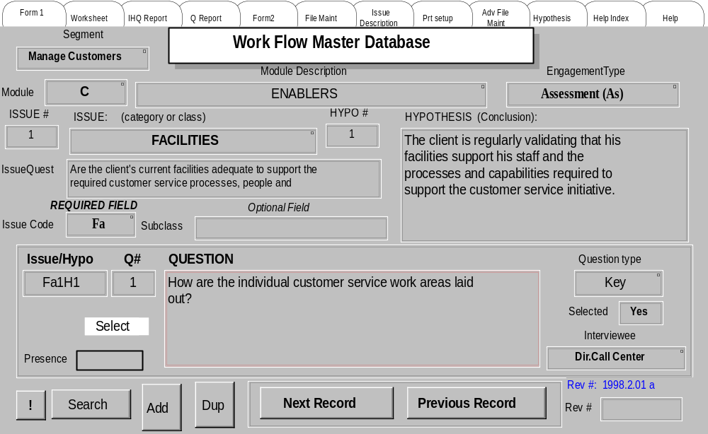
Figure 1
Diagram of “Master Records Display” screen.

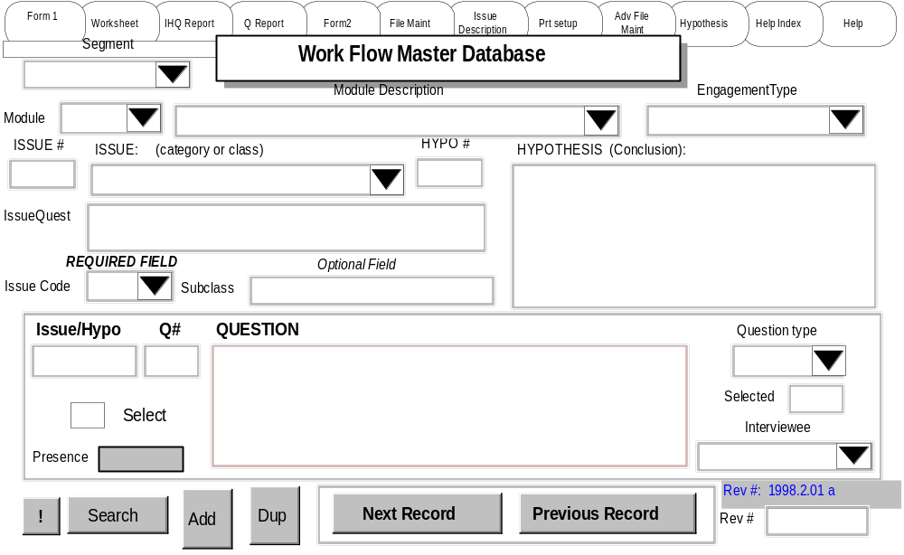
Figure 2
Diagram of the” Record Find” screen
(NOTE: the “Records Find” screen uses the same color background as the “Master Records Display” screen)
- To select a set of records to print click on arrow in ‘Methodology (Module Description Type)’ type field. A drop down list will appear which allows you to click the segment you wish to print. A segment is associated with a SCI phase (i.e. Manage markets, manage sales, manage customers, etc.).
- If you wish to print more than one segment click on the ‘Find More’ command and make another selection. The “Find More” command can be found on the command line at the top of the page when the Issue Analyzer is in the “Records Find “ screen See figure 3.

File Edit View Create Browse Window Help

Find

Fine More

Figure 3
How to locate the “Fine More” Key
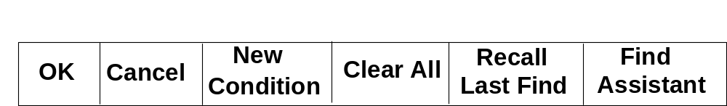Click ‘OK’ when you have completed making selections. The “OK” button is part of a row of buttons located at the top of the record while in the “Find Record” screen. See figure 4.

Figure 4
Row of buttons across the top of the form.
Next the ‘Sort’ window will open.
- To set up sorting argument click on fields you wish to sort on from major to minor sorting sequence clicking on the ‘Add’ button after each selection. When you have completed this process click on ‘OK’ on the sort screen. You may bypass the sort criteria by clicking on the “OK” button before choosing the sort parameters.
- You will return to ‘PRT Setup’ tab where you can select either to print issues/hypos and questions, ’PRT IHQ’ button, or print questions only, ’PRT Q’ button. Please be sure you have performed the ‘Print Setup’ option within ‘File’ menu before clicking on either print button.
The requested report should appear on your printer shortly. An example of the report format is shown in Figure 5.

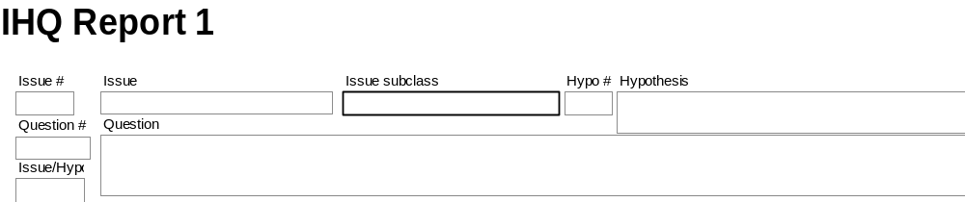Figure 5
Issues/Hypos/Questions Report format.
- Selecting Engagement Issues/Hypos/Questions
Once you have reviewed and decided which records are appropriate for your engagement follow the steps outlined below to create your engagement issue analyzer database;
- While still in the ‘WFMASTER.APR’ file click on ‘File Maint’ tab.
- Click on ‘Reset Select’ button to reset database to all records status.
- To select those items you wish to include on your engagement database do one of the following…
Select Individual Questions
Click on ‘Form 1’ tab. Click on ‘Select’ box (see figure 6 for location of Select box) for those fields you wish to include in your engagement database. After you have selected all the desired questions click on ‘File Maint’ tab and then click on ‘Export’ button. Go to step 4.
-or-
Select All Questions Associated with a Desired Area/Group
If you wish to include ALL the questions for a given area/group click on ‘File Maint’ tab and then click on ‘Export’ button. Go to step 4.
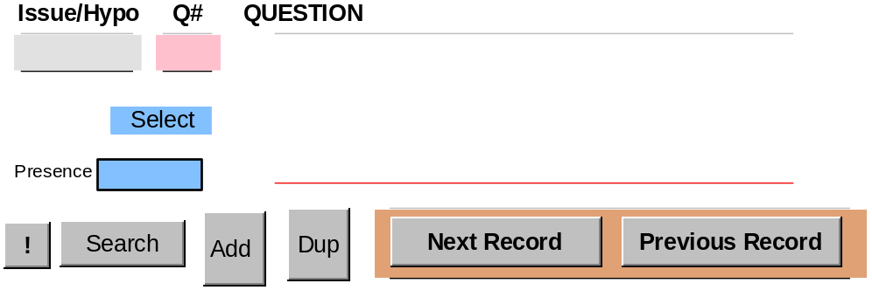
Figure 6
Location of the “Select”, “Add” and “Duplicate” keys.

- The “Records Find” screen from the WorkFlow Master Database will appear.
- If you individually selected the questions click on the ‘Select’ box and click on ‘OK’. See figure 6.
- If you wish to include all records for a given field click on the arrow of the appropriate field and make your selection. See figure 2. Click on ‘OK’.
- The WorkFlow Engagement database view will appear (WFWORK.APR). The name appears on the top of the record under the tabs.
- Click on the ‘File Maint’ tab.
- If you wish to delete old records in file that may have been left from a previous engagement click on the ‘Del File’ button.
- If you wish to include records you selected from ‘WFMASTER.APR’ file click on the ‘Import’ button. The selected records are moved from the WFMASTER.APR file and stored in the WorkFlow Engagement database (“WFWORK.APR”).
You have now populated your engagement data points from master file!!
Adding Questions
To add additional records to your engagement database follow the steps outlined below;
- While in WorkFlow Engagement Database (“WFWORK.APR”) click on ‘Form 1’ tab. This displays the “Records Find” screen.
- If you wish to add completely new issues/hypos/questions click on ‘Add’ button on bottom/left side of the form (see figure 6) and enter information according to the syntax rules in appendix B. Press enter to accept the new record.
If you wish to add an additional hypo or question based on an existing issue, select the record that your modification is based upon via the master record display screen and click on the ‘Dup’ button on the bottom of the form (see figure 6). Update the appropriate fields following syntax rules in appendix B. Press the enter key to accept the new record.
- Creating Interview Guides
To create interview guides tailored to your engagement follow the steps outlined below;
- While in the WorkFlow Engagement Database (“WFWORK.APR”) click on the ‘PRT Setup’ tab.
- Click on the ‘Sort’ button and the ‘Sort’ window will appear.
- To set up sorting argument click on fields you wish to sort on from major to minor sorting sequence clicking on the ‘Add’ button after each selection. When you have completed this process click on the ‘OK’ button. If you do not want to sort then press the “OK” without assigning a sort sequence.
- You will return to the ‘PRT Setup’ tab where you can click on ‘PRT Rep1’ button to print out issues/hypos/questions. Please be sure to have performed ‘Print Setup’ option within ‘File’ menu before trying to print report. Review this report for the questions you wish to include in your interview guide.
- The ‘Form 1’ tab/window automatically displays..
- Click on the ‘Select’ box (located in the lower left portion of the “Find Record” Screen, Look at Figure 6) and select the ‘Interview Type’ for those fields you wish included in this interview guide. The “Interview Type” window is located on the bottom of the “Records Find” screen.
NOTE: To quickly locate questions you wish to select click on ‘Search’ button and enter ‘Issue/Hypo’ key from ‘Report 1’ for data element to be selected and click on ‘OK’.
- After you have selected all the questions for the interview guide click on the ‘File Maint’ tab.
- Click on the ‘Export’ button to export questions that will used in the Interview Guide. The “Export” button transfers to the Engagement database’s “Records Find” screen. Press “Enter” to transfer to the interview guide database (“IGUIDE.APR”).
- You will be automatically switched to interview guide database’s “Master Records Display” screen.
- Click on the ‘File Maint’ tab.
- Click on the ‘Del File’ button if you wish to delete the existing file from previous engagement.
- Click on ‘Import’ button to add questions you just selected from engagement database.
- To print out interview guide click on ‘PRT Setup’ tab.
- Click on ‘Sort/Select’ button and record find screen will appear.
- To select a set of records to print click on arrow in ‘Interview Type’ field. A drop down list will appear and you should click on the interview guide type you wish to print.
- If you wish to print more than one guide click on ‘Find More’ and make another selection.
- Click ‘OK’ when you have completed making selections.
- Next the ‘Sort’ window will open.
- To set up sorting argument click on fields you wish to sort on from major to minor sorting sequence clicking on ‘Add’ after each selection. When you have completed this process click on ‘OK’
- You will return to ‘PRT Setup’ tab where you can select either to print interview guide, ’PRT Guide’ button, or print questions only, ’PRT Questions’ button. Please be sure to have performed ‘Print Setup’ option within ‘File’ menu before clicking on either print button.
- The requested report should appear on your printer shortly.
NOTE: The interview guide database (IGUIDE.APR) will contain multiple interview guide types which should map to the people within your clients organization that you have to gather data. Therefore it is important that you consistently indicate interview type before exporting questions from engagement.
- Capturing and Analyzing Responses
Once you completed an interview you can enter the responses on the database by following the steps outlined below;
- Open ‘IGUIDE.APR’ file and click on “Form 1” tab.
- Click on “Search” button and record find screen will appear.
- Click on “Interview Type” and select desired interview type to update from drop down list.
- Click on “OK” (if selected interview guide has old response data click on ‘File Maint’ tab and click on ‘Clear Response’ button. Return to blank interview guide by clicking on ‘Form 1’ tab).
- Update the selected interview guide with response data.
- When the response update is completed click on ‘File Maint’ tab.
- Click on the “Export” button.
- The “Find Record” screen will appear. Click on ‘Interview Type’ and select the completed interview type you want to export to response database.
- Interview response database (IRESP.APR) will open automatically.
- Click on ‘File Maint’ tab.
- Click on ‘Del File’ to delete old data from previous engagement. If you wish to retain information from previous engagement before deleting click on ‘File’ menu bar and click on ‘Save as’ menu option. Type in new file name and save database.
- Click on ‘Import’ button to add updated interview guide to database.
- To print out response reports click on ‘PRT Setup’ tab.
- Click on ‘Sort/Select’ button and record find screen will appear.
- Enter find information for records you wish to print and click on ‘OK’.
- ‘Sort’ screen will appear.
- To set up sorting argument click on fields you wish to sort on from major to minor sorting sequence clicking on ‘Add’ after each selection. When you have completed this process click on ‘OK’
- You will return to ‘PRT Setup’ tab where you can select to print either responses and questions with the’PRT Responses’ button, or issues/hypos/questions with the ’PRT Summary’ button. Please be sure to have performed ‘Print Setup’ option within ‘File’ menu before clicking on either print button.
The requested report should appear on your printer shortly.
- Engagement Team Tool Usage Considerations
Typically the Issue analyzer tool will need to be used by multiple consultants on the same engagement . To effectively use this tool in this environment you will need to distribute and consolidate databases. The steps outlined below will enable you to do this.
8.1 Distributing Questions, Interview Guides, Responses
- While in either the engagement database (WFWORK.APR), interview guide database (IGUIDE.APR) or the response database (IRESP.APR) click on the ‘Adv File Maint’ tab.
- Click on the ‘Export Diskette’ button and put blank diskette in drive.
- The record find screen will appear.
- Enter the appropriate information for the records you want to select for distribution and click on ‘OK’
- Next the ‘Export Data’ screen will appear.
- Enter the file name you wish the selected records you are exporting should have such as your initials/date/client acronym.
- Select drive ‘A’ as destination.
- Select all the ‘Database Fields’ in same sequence for export and click on ‘Add’ to include in ‘Fields to Export’ list.
- Click on ‘OK’
- your database export should now be on your diskette.
8.2 Consolidating Questions, Interview Guides, Responses
- While in either the engagement database (WFWORK.APR), interview guide database (IGUIDE.APR) or the response database (IRESP.APR) click on the ‘Adv File Maint’ tab.
- Click on ‘Import Diskette’ button and put source diskette in drive.
- Next the ‘Import Data’ screen will appear.
- Select drive ‘A’ as source.(or hard drive where import file is saved)
- Click on file name you wish to import.
- Click on ‘OK’
- ‘Import Setup’ screen should appear.
- If all fields from imported file line up with fields on target database click on ‘OK' .(If fields do not line up contact source of information to ensure it was exported properly)
- The additional information should now be consolidated in your database.
- Advanced File Maintenance
In addition to the exporting and importing of diskette databases described in ‘Engagement Team Tool Usage Considerations’ .you may wish to uniquely save and name the databases produced by the tool for your engagement. To do this follow the steps outlined below;
9.1 Unique Database Saving and Naming
- For either the Work Flow Engagement, Interview Guide or Interview Response database after the selected data points have been Imported, click on ‘Adv File Maint’ tab.
- Click on the ‘Save As’ button and the file save window will open.
- In file save window enter the name you wish to call the database and be sure ‘Exact copy’ is selected. You will need to use the same name for both “.APR’ and “.DBF .file extensions.
- After you name each file extension click on ‘OK’.
9.2 Unique Exporting
- To export data to a uniquely named you must click on ‘Adv File Maint’ tab.
- Click on ‘Export Special’ and open file window will appear.
- Select file name you wish datapoints to be exported to and click on ‘OK’.
- When selected file view appears click on ‘File Maint’ tab.
- Click on ‘Import’ button and datapoints will be added to database.
Note: Once any of the databases have been populated with data you can go directly to that database by opening the “.APR’ file extension for that file. The library of “.APR’ extensions will appear when you select file open from Approach menu bar and click on the ‘WFMIA’ directory.
- Appendices
- Field Descriptions
- Syntax Rules
- Control Button Functions
- Tab Descriptions
10.1 Field Descriptions
Name | Type | Size | Description
Methodology (Module Type) | text/list | 18 | segment name
Module | text/list | 4 | segment or major issue group of segment id
Module Description | text/list | 44 | segment or major issue group of segment title
Engagement Type | text/list | 32 | engagement description
ISSUE # | numeric | 2 | major issue area # in segment or issue group
ISSUE | text/list | 32 | major issue area category
HYPO # | numeric | 2 | hypothesis number for major issue area
HYPOTHESIS | memo | var. | hypothesis description
Issue Quest | memo | var. | major issue area question
Issue Code | text/list | 4 | major issue area code
Issue Subclass | text | 44 | optional issue sub-classification
Issue/Hypo | calc | var. | concatenated key from issue code/issue#/hypo#
Question (Q#) | numeric | 3 | key or check question # for hypothesis
Question | memo | var. | key or check question description
Question type | text/list | 10 | key or check question indicator
Select | check box | n/a | check box for record selection
Selected | text | 10 | record selection indicator field
Soft Key | text | 16 | optional sub classification of data element
Interview type | text/list | 22 | interview guide classification
Response type | text/list | 22 | response classification
Interviewee | text | 22 | name of interviewee
Interviewer | text | 22 | name of interviewer
Bldg/Code | text | 10 | optional field for location or interview method
Presence | text | 16 | qualitative measure of performance
ISSUEDEF FILE
Issue code | text | 4 | see Issue code above
Issue name | text | 32 | see ISSUE above
Issue Description | memo | var. | detail description of major issue area
10.2 Syntax Rules
When adding new or modified questions to the Issue Analyzer database please follow the follow syntax rules outlined below;
- Whereever possible please use predefined lists for fields which have drop down lists. If this is not possible these fields will allow you to enter data in them.
- All major issue areas must be named and defined within one of the seven methodology segments.
- All major issue areas must have a primary issue question.
- All hypotheses must be associated with major issue area and be positively worded.
- All questions must be associated with hypothesis.
- The numbering of new issues, hypothesis or questions should start at 50.
10.3 Control Button Functions

Name | Location | Function
Add | ‘Form 1’ | Add new record
Del | ‘Form 1’ | Delete current record
Dup | ‘Form 1’ | Duplicate current record
Next Record | ‘Form 1’ | Go to next record
Previous Record | ‘Form 1’ | Go to previous record
Search | ‘Form 1’ | Find record
1st | ‘Form 1’ | Go to first record
! | ‘Form 1’ | Reset to find all records
Clear Response | ‘File Maint’tab | Clear all response information from interview guide
Del File | ‘File Maint’tab | Delete entire file
Export | ‘File Maint’tab | Export found set
Import | ‘File Maint’tab | Import found set
PRT **** | ‘PRT Setup’tab | Print indicated report
Reset All | ‘File Maint’tab | Reset to all record status
Reset Select | ‘File Maint’tab | reset selected records
Sort | ‘PRT Setup’tab | Sort selected found set
Sort/Select | ‘PRT Setup’tab | Select found set and sort
Export Diskette | ‘Adv File Maint’ tab | Export data points to diskette
Import Diskette | ‘Adv File Maint’ tab | Import datapoints from diskette
Save As | ‘Adv File Maint’tab | Save database with unique name
Export Special | ‘Adv File Maint’tab | Export selected questions to uniquely named file

10.4 Tab Descriptions
- Adv File Maint - used to import, export or save databases.
- Datamatrix - matrix that relates issue/hypos to be tested against interview type.
- Engagement Information - tags each element in engagement work file with specific engagement information i.e. client, engagement mgr, contract number.
- Form1 - base record display and entry form.
- Form2 - alternate record display and entry form.
- Help - displays help information selected from ‘Help Index’
- Help Index - table of contents and access for on line help.
- Hypothesis - displays individual hypothesis
- IHQ Report - report that lists selected issue, hypothesis, and questions
- Issue Description - displays issue descriptions for selected records.
- Prt Setup - sorts/selects records for printing of indicated reports
- Q Report (Questions) - report which lists questions for selected records
- Response - report which lists responses for selected records
- Response Summary - displays individual issue, hypos, questions and responses for selected records
- Worksheet 1 - displays information for selected records in spreadsheet format.
- Revision History
Revision Number | Revision Date | Summary of Changes | Changes Marked?
1.2 | September 2001 | Updated style.
1.1 | October 2000 | Applied new template, spelling and grammar.
1.0 | May 1999 | Base version.

