

IBM Global Services

Aligning Application Models for SOA Success

Technique Paper (TP)

© Copyright International Business Machines Corporation 2006
All Rights Reserved
Version 1.0 April 2006
- Purpose
A large portion of solutions are an amalgam of multiple Independent Software Vendor (ISV) and custom applications. A business object such as customer, product, account has distinct and disparate representations in each of these applications. ISV applications tend to be "coarse grained" each needing proprietary implementation of these objects to function. The appeal of Service Oriented Architectures (SOA) is the provision of common services across (significant parts of) the organisation. Implicit in the service definitions is a homogenous set of business objects. How can an SOA solution be realised if compatibility between disparate object representations in underlying applications is not examined and addressed?
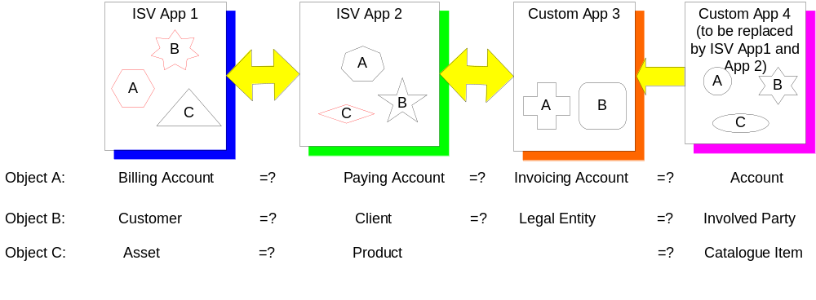
Figure 1 Multiple Object Representations
Figure 1 Multiple Object Representations shows an example of a solution comprising two ISV applications (App 1 and App 2) and a custom application (App 3); the two ISV applications are replacing a single existing custom legacy application (App 4) and data from this application will be migrated to both ISV App 1 and ISV App 2. Each application has its own representation of an account and a customer; Apps 1, 2 and 4 also have a product; however, each application’s implementation is different as denoted by the different shapes in the diagram. The question is: are the concepts sufficiently the same to allow the applications to present a common set of business objects to service clients?

This paper describes a technique that assesses the degree of alignment between application models participating in a solution and recommends the changes required to bring applications into alignment. Alignment is an analysis activity. It compares an object in one model with a ‘similar’ object in another model One model is always chosen as the “base” against which all other models are aligned. An application model is the set of objects in an application. Objects have both data and behaviour.

Any project which integrates several ISV applications should use this technique to verify that one ISV application’s underlying object model will work with another application.

Employing this technique provides:
- A mapping between application models
- Early insight into the hidden cost of service realisation and integration
- Lead time to lobby ISVs to change their product
- Lead time for business to change their processes and products
- A framework for integration issue resolution in micro design
- Decisions about which application should master an object
.
- Description
The Problem
Each ISV and custom application has its own:
- object semantics, model, lifecycle
- specificity in a domain – some packages are generic across telecom, finance, utilities while other packages are highly specific to one domain
- performance constraints
- product roadmap (the priorities and initiatives set by IS Vendors to develop features of their product)
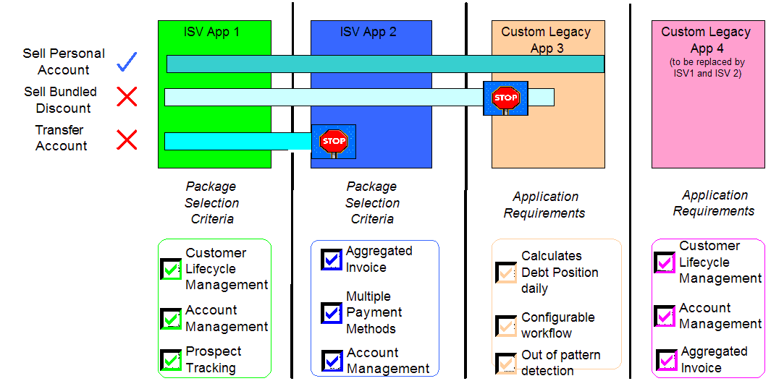
Figure 2 End to End Business Capability
While an individual ISV application may mostly satisfy a client’s package selection criteria, collectively the set of applications may not be capable of implementing a set of services end to end. For example in Figure 2 End to End Business Capability”, the alignment activity analyses the three business processes “Sell Personal Account”, “Sell Bundled Discount” and “Transfer Account“. These telecommunications processes require the participation of multiple applications namely: Customer Care (ISV App 1), Billing (ISV App 2), and Credit Monitoring (Legacy App 3). For “Sell Personal Account” there is no problem because each application has the objects and operations on the objects to support the business service. “Sell Bundled Discount” entails a sophisticated product bundle capability; the new ISV Applications 1 and 2 supports this capability but the custom built credit monitoring system cannot. For “Transfer Account” (from one account holder to another) the Customer Care application (ISV App1) supports it but the more domain specific billing application (ISV App 2) cannot support this operation in the same way as the Customer Care system.
The outcome of the alignment activity is that the client cannot achieve the anticipated benefits of the solution without incurring additional expense to change the set of applications comprising the solution.
Why Is Object Transformation Necessary?
The primary reason for object transformation is the coarse granularity of some ISV applications. ISV Applications are often “coarse grained” with a broad set of domain objects. For example, in “Figure 3 Object Synchronisation Across Multiple Applications Account”, “Sold Product” and “Sold Service” are represented in three applications, two of which are ISV apps. An account along with its number, address and associated sold products is required by both the customer care and billing system. When an object is managed by more than one application it needs to be synchronised between applications because each application may need the object to operate; for example, a customer care system needs accounts owned by a customer to manage the customer relationship and a billing system needs an account to rate and bill charges incurred by the customer.
Architectural decisions define which application “masters” the object, that is, has responsibility for its integrity and for ensuring (via integration technologies) that it is kept synchronised with other applications which require it.
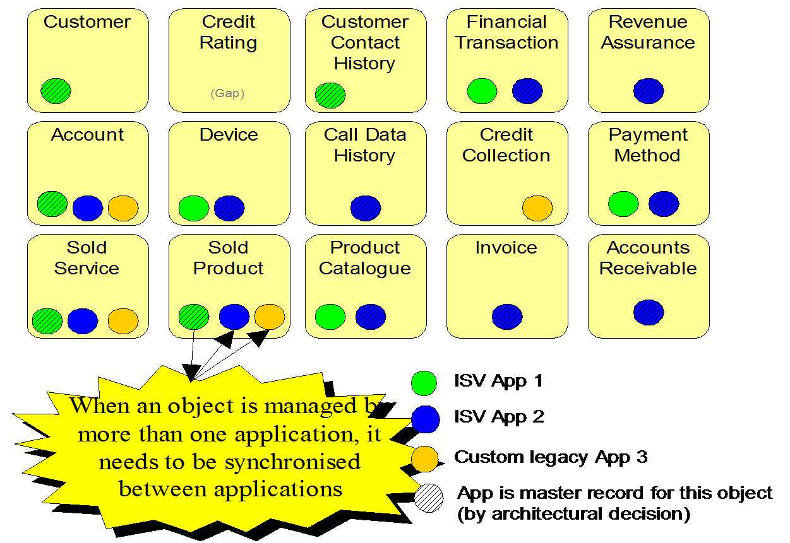
Figure 3 Object Synchronisation Across Multiple Applications
With the growing tendency of clients to purchase ISV applications (buy rather than build) and to choose to purchase from a variety of vendors, the problem of inconsistent models becomes more prevalent. Although the technology and infrastructure to do transformation has evolved, the capability for each application to represent an object at the same level of sophistication may be prohibitively expensive to achieve the required business benefits.
In some cases enterprise application integration (EAI) adaptors may come ready built to transform objects from one ISV application to another. It is often the case that such adaptation does not exist, or lack the required maturity level, or do not exist using open standards. Transformation is further complicated as it can be realised by variety of mechanisms not just EAI:
- Point to point interfaces (FTP, RPC),
- Extract Transform Load
- Direct database extract

- Inputs and Outputs

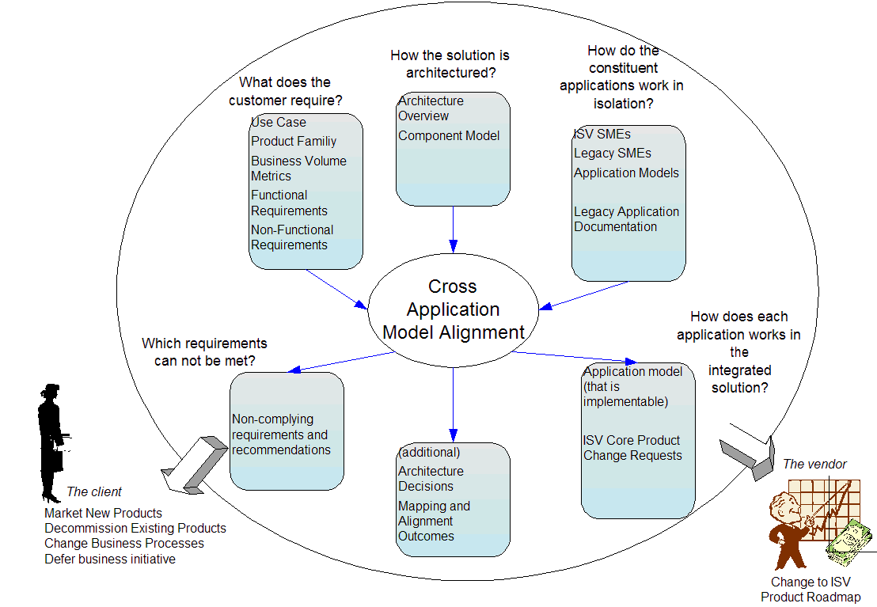
Figure 4 Inputs and Outputs

Inputs
Input | Description and How it is Used
Use Cases (WP) | List of the use case and high level description for each use case – business events that initiate system interactions which involve one or more applications that need to be aligned. Do not need to be detailed.
Product Family | List of major product groups (things sold to customer) the business supports and a statement of their capabilities and features – sufficient to be able to assess if the applications can support their features.
Business Volume Metrics | Order of magnitude volumes of key domain objects and the ratio of their relationships e.g. number of customers and customer to account ratio
Functional Requirements (WP) | A list of functional capabilities in scope
Non-Functional Requirements (WP) | Key response times, key batch window,
Architecture Overview (WP) | Depiction of major functional components, their interface with key actors and with each other.
Component Model (WP) | Allocation of ownership of major objects (which component masters an object) to components and their interdependence. The application implementing the component (name of ISV or existing legacy, to be technology that is planned to implement the component)
Application Models | Logical data models of each ISV and Legacy System application (if available)
Legacy Application documentation | List of APIs and a short description of the major objects that are updated.

Skills
Skill | Description
ISV SMEs | Technical architects/specialists knowledgeable in the functional and non-functional capabilities, constraints, future product plan of an ISV.
Legacy SMEs | Technical architects/specialists knowledgeable in the functional and non-functional capabilities and constraints of each legacy SME.
Architect | Familiar with customer requirements and the solution architecture. Leads the alignment activity and makes recommendations.

Outputs
Output | Description and How it is Used
Architecture Decisions WP (updated) | Update to architectural decisions especially if constraints identified in the alignment activity require a decision to be made on best solution moving forward or another application should master an object
Application Model (updated) | Logical model of each application based on the aligned model. This becomes a starting point for micro design. It should be signed off by ISV vendors to state that this will work and is in line with future direction of product.
Mapping and Alignment Outcome | Mapping of each application against base model – which acts as a starting point for micro design detailed mapping for both development and data migration from systems to be decommissioned.
Non-compliance Items | List of requirements against which cannot be met and options/recommendation to business on what can be done.

Selection of the Base Model
A model must be chosen as the base against which other models are aligned. The base model is the most complete model of the customer’s requirements in scope. Candidates for the base model are:
- a domain specific language (DSL) or industry model such as IBM’s Insurance Application Architecture (IAA), or IBM’s Information Framework (IFW)
- a custom developed based on an analyst’s understanding of the requirements
- an existing application that is the most complete requirement

- Approach
Step 1 Initial Mapping:
The approach commences with an alignment based on data entities. This is achieved by forming a candidate mapping between entities in the base model and each participating application.
Step 2 Verify Candidate Mapping in Use Cases:
The candidate mapping is then verified by walking through each high level use case (or business scenario if use cases are not yet available) and confirming that the candidate mapping holds true as the sequence of interactions are played out and an entity is transformed from one application to another.
Step 3 Verify Application Models Against Other Functional and Non Functional Requirements:
Once stabilised, the individual application models are assessed against the remaining functional requirements and non-functional requirements.
Figure 5 Alignment Approach provides an example of applying these steps in an example solution. (More detailed steps and a more detailed example follow later in this paper). The diagram shows objects within each application model: for App 1 the objects are x, y, z; for App 2 the objects are p, q, r and so on. Implicit in the diagram is a base model with objects A, B and C.
- Step 1 shows an initial mapping between equivalent objects in the base model and each application model; this is denoted by labeling the objects within each application model with the base model object name to which it is aligned (for example, base model object A is equivalent to object x in App 1 and object p in App 2). The large horizontal arrows emphasize the alignment.
- Step 2 is depicted as a sequence interaction diagrams (where each object is represented on a vertical line) and operations on the object are invoked as the end-to-end use case is exercised.
- Step 3 shows three changes to application object models after considering Step 2 and additional requirements: in App 1 subclasses of x have been removed because other applications do not support them; in App 2 the parent-child relationship around object q has been removed because it is not supported by the other applications and in App 3 and additional object u is required to fill a gap in functionality provided by the other applications.
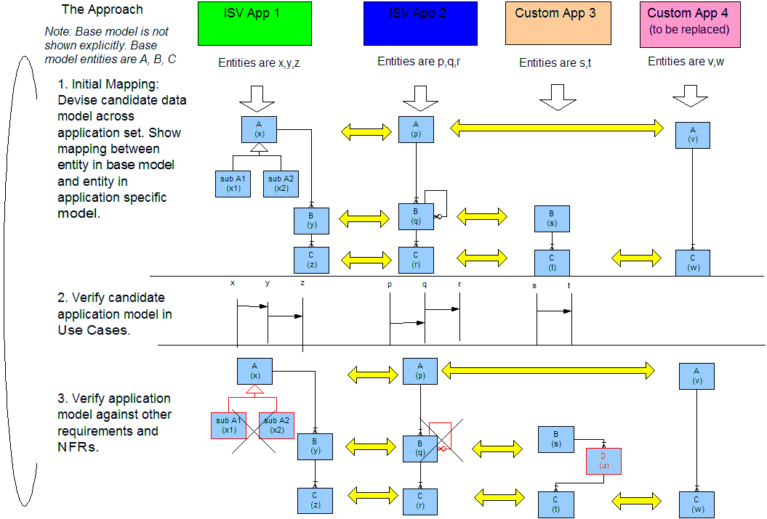
Figure 5 Alignment Approach

Step 1 Initial Mapping
Divide large models into application subject areas such as “customer management”, “new business” or “generate invoice” for ease of managing the order in which mapping is examined. (Note that subject areas play no part other than helping to organize the alignment task). For each application model form a candidate mapping against the base model one data entity at a time.
For each data entity in the base model, identify the candidate entity in the application model by considering the following questions:
- is there an object in the application model semantically equivalent to an object in the base model?
- are there constraints under which the two objects are equivalent e.g. only when the object is of a certain subclass or only when the object is in a specific state?
- do the key relationships in one model have the same meaning and cardinality as the object’s relationships in the base model?
- are the object’s lifecycle changes in the application model triggered by the same business events as the object in the base model?
- is the full set of lifecycle states in the base model supported in the application model?
The candidate mapping and the outcome of the alignment are recorded. A suggested approach is to use an entity relationship (E-R) diagram initially on a whiteboard to align entities. Initial mapping should be high level only – just noting but not analyzing areas of potential complexity. Once agreed at a high level, the E-R diagram should be drawn in a tool (Visio is adequate if more sophisticated tools are not available). The second pass through should go into more detail understanding entity properties and relationships and record how they differ from the base model. This level of detail and alignment should be recorded in a table with a structure shown in Figure 6 Step 1 Mapping and Alignment Outcome.
 | Base |  |  | App A |  |  | App B |  | Alignment Outcome
Entity | Description | Relationships | Entity | Description - Variation From Base | Relationships - Variation From Base | Entity | Description - Variation From Base | Relationships - Variation From Base
Figure 6 Step 1 Mapping and Alignment Outcome

Step 2 Verify Candidate Mapping in Use Cases
Upon completion of the Step 1 Initial Mapping, walk through each use case and specify the interactions in terms of the operations on individual application entities. The aim of this step is to understand what is happening inside an individual applicationfor that part of the end to end use case.
Consider the following questions:
- does the application support this type of operation on this entity i.e. is there an exposed published API by the ISV or existing legacy system to support this operation?
- what are the pre-conditions for this operation in this application and will they always be true at the point of invoking this operation?
- does the application support this type of operation on this entity for all major variations (subclasses of the entity)?
- does the operation in this application have any side-effects that result in mandatory creation of other entities or trigger follow on activities such as batch processes, workflow that requires human intervention that is unexpected or undesirable (e.g. first account always needs a customer, package creates a dummy customer if one does not exist)?
- does this application operation assume a key identifier will be passed to it and will that key identifier be passed to it by the prior application?
- does the operation work with temporal consideration e.g. will it support backdated or future dated transaction?
- if the operation undertakes a significant change of state does it keep a date sequenced history of the state change?
The analysis relies on system documentation – inventories of APIs with short descriptions and the knowledge of the application SME. As the analysis proceeds it may be necessary to apply constraints to the individual application models or record assumptions about how the application model will be configured.
A suggested approach is to record the list of use case names based on the input Use Case work-product in a spreadsheet. Next, prioritorise the list to consider core functionality (e.g. add a customer, add an account) and then variations (sell a complex product, transfer a connection). It may be necessary to draw interaction diagrams on a whiteboard to discuss areas of complexity or incompatibility. The results should be recorded in a table structure as shown in Figure 7 Step 2 Mapping and Alignment Outcome.
Base |  | App A |  | App B |  | Alignment Outcome
Use Case | Description | Use Case | Description – Variation from Base | Use Case | Description – Variation from Base
Figure 7 Step 2 Mapping and Alignment Outcome

Step 3 Verify Application Models Against Other Functional and Non Functional Requirements
The purpose of this step is to verify the Application Model against other requirements (after having already verified the Application Model with the main transactional behaviour in Step 2). The result may be an entry in a table structure as shown in Figure 8 Step 3 Mapping and Alignment Outcome or an update to tables in previous steps.
. Other requirements include:
- support for saleable item features – i.e. the product catalogue or inventory. An approach to this is to divide the catalogue into families of products with like features and assess the representation of the products in each participating application. For example, can the application support the bundling of products into a package, discounting of fees, free offers, loyalty points ?
- support for auditing and logging – if a transaction transcends several applications is it possible to associate an audit entry in one application with an audit entry in another ?
- support for user identity – how will the userid in one system be mapped to userid in another system or is there a system user identity function which can be used?
- performance – using business metrics, estimate the number of instances of each major entity including the extreme cases and ask each application SME to identify any potential performance problems with these metrics against the aligned model. Consider the unit of work for each major operation will an application model batch processes for example, to operate on one data entity does one application need to build large in-memory data structures while another application does not need to ?
- assess each application model against ISV vendor product roadmap to determine if it can take advantage of features the vendor plans to enhance in future releases or precludes opportunities for the customer in future releases.

Base |  |  | App A | App B | Alignment Outcome
Topic | Requirement | Variation From Base |  | Variation From Base
Figure 8 Step 3 Mapping and Alignment Outcome

Define Alignment Outcomes
If a misalignment between the base and application model is realized in the above steps then decide how the misalignment will be addressed. Consider:
- additional customization or configuration to an ISV application model
- a customized component (either as a separate application or as a supplement to an existing application) should be constructed to fill a gap
- if the base model requirement can be simplified or removed
- if the base model requirement can be met by a manual solution
- if the side-effects in an ISV application model can be prevented by configuration
- features/functionality of an ISV application should not be used (this is recorded as an architectural decision)
- features/functionality of an ISV application will be used up to a limit (this is also recorded as an architectural decision) (for example, a limit of 100 accounts per customer will be built into the system)
- if the side-effects in an ISV application are allowed to occur but additional housekeeping jobs must be created to remove their effect (for example, removal of additional database rows created)
- changing previous decisions about which application should master an object – perhaps splitting the system of record of an object between super and subclasses of the object
Non Compliant items are recorded as an output for follow-up action with:
- vendor to advise if a patch can be provided and the timeline/cost; also the impact of the decisions to exclude ISV application functionality on the product roadmap and on performance
- customer to determine the criticality of the requirement and if a manual workaround for the problem is acceptable to the business; the output may be a list of non-compliance items
- project management to determine impacts on cost and timeframes
- Sequence of Model Alignment
This section outlines the recommended order in which applications should be aligned. The rationale is to align applications in order of business criticality and order of longest lead time to fix if they do not easily align. Figure 9 Transformations in Typical Architecture provides an example of primary and secondary applications which play a role in the sequence of model alignment.
Align Models For Primary Applications
- Select the set of primary applications – typically these are core ISV applications in which reside key business entities (customer, account, product) and which may require common entities to be synchronised. Typically, primary applications are customer management, billing, account processing.
- Proceed through steps 1-3 above
Align Primary Applications with Applications to be Decommissioned
If the scope of the project includes data migration from an existing legacy system, then the next set of applications to be aligned are the source systems for data migration
- Identify the legacy source applications
- For each legacy source application, proceed through step 1 above. (Note, the assumption here is that the data and not the functionality is migrated from systems to be decommission. If there is a requirement to ensure that all existing functionality is available in the new solution then Step 2 is also advisable).
- In step 3 above, focus on the verification of mapping of major products and services families from source to target
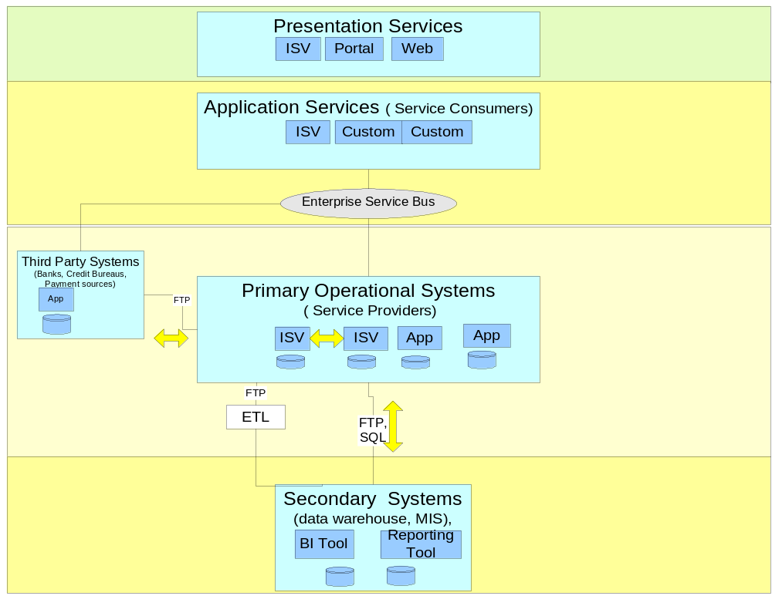

Figure 9 Transformations in Typical Architecture
Align Models With Secondary Applications
- Select the set of secondary application– typically existing legacy systems that are dependent on core systems for input or provide input to core systems e.g. data warehouse, reporting, general ledger, credit monitoring, payment mediation applications
- For each legacy source application, proceed through step 1 above
- Where relevant, proceed through step 2 – though for most secondary applications it is unlikely that this step will be extensive or necessary
- In step 3 above, focus on the verification of mapping of major products and services families from source to target
- Tools
If sophisticated tools (such as those from Rational) are not available, use standard office and graphic tools such as: MS Word, Excel and a diagramming tool such as Visio.
- Validation and Verification
The alignment and the outcome should be validated by inspection with
- ISV Application vendor technical specialists (subject matter experts) for correctness of mapping to individual ISV applications
- ISV Application commercial management for compatibility with service level agreements and product road-maps
- solution architects during walkthroughs that exercise critical components for major business scenarios or high level use cases
- the customer’s enterprise application architects for impact on all the customer’s applications
- the project team architects for impact of constraints imposed by the alignment outcomes
- the customer’s business analysts for completeness and correctness of base model
- the customer’s project management – for agreement to remove requirements

- Examples

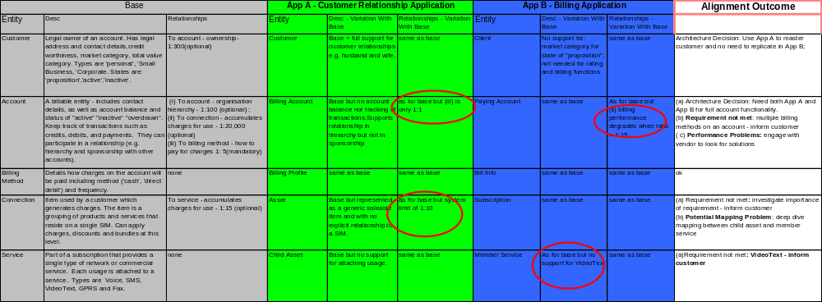
Figure 10 Example of Entity Alignment (Step 1 and Step 3 Non-Functional)

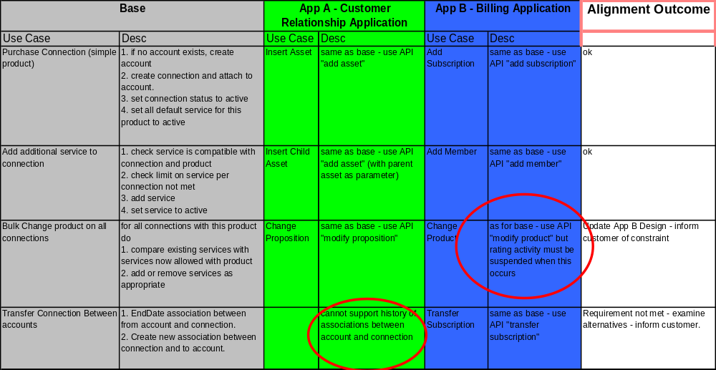

Figure 11 Example of Use Case Alignment – (Step 2)

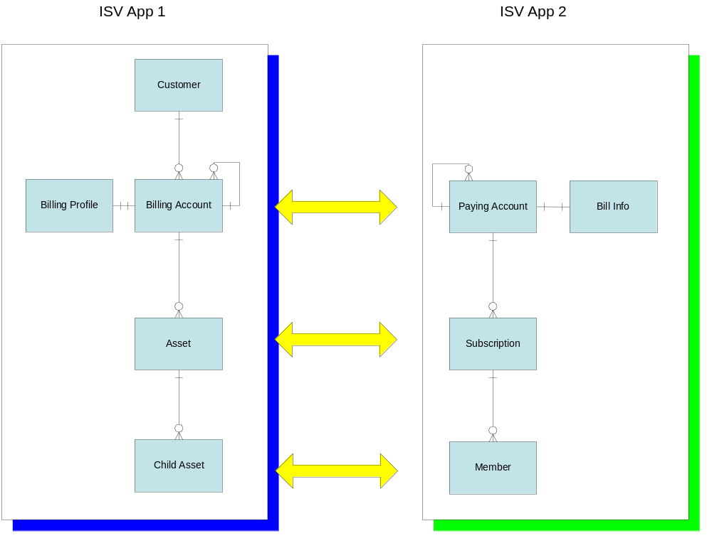
Figure 12 Application Model after Alignment Outcome

Non-Compliance Item | Recommendation
only one billing method per account can be supported (requirement is multiple) | Cost to change is prohibitive so remove requirement.
can only support up to 10 types of services per SIM (requirement was 15) | Cost to change is prohibitive so relax requirement.
cannot support VideoText service (requirement was to support this) | Issue formal request to vendor to enhance product in next release; meantime build temporary custom solution to handle this service.
rating activity must be suspended when there is a bulk change across the customer base from one product to another | Change business processes to modify products at period of low rating
Billing performance degradation expected when more than 15 connections per account | Engage vendor to improve performance
Figure 13 Non-Compliance Items and Recommendations
- Advice and Guidance
- There is a risk that this technique can lead to “analysis paralysis”; the key to success is applying judgment to decide if a misalignment is likely to incur major cost or have a major impact on the business
- Business sponsors need to accept that for solutions using a package enabled approach not all business requirements may be achievable without major ISV product upgrades; the technical leader must be in a position to work with the customer to get agreement on the criticality of a requirement if it is difficult to support – “a nice to have” versus ‘ business critical” versus “provides competitive advantage”
- When misalignment between applications is identified, often there is no simple answer; a set of predefined architectural principles should be in place against which solution alternatives are evaluated; for example, in a package enabled core system replacement an architectural principle might be that “no change to core package object definitions are permitted” thereby enabling ISV product upgrades
- Availability of ISV SME with deep knowledge of their product’s functionality (worth getting best resources available for this exercise from the vendor) to reduce time spent searching copious documentation or suffering from differences between implementation reality and product documentation
- When misalignment is identified there can be conflict between application teams about who should pay to fix it etc; a “neutral” technical leader with facilitation skills is required to ensure that the best technical options are tabled; discussions who pays for changes that results in aligned models should be handled outside this exercise
- During the course of such analysis the need for a cross-reference database/referential party database (which could be fulfilled by a product such as WebSphere Customer Centre) could be identified and thus impact the proposed solution architecture, cost and schedule

- References
None
- Estimating Considerations
Activity | Recommended Metric/Duration
Acquiring a Base Model  If a common base model needs to be custom developed then timebox and encourage containment to top 15-20 entities. Document in UML class diagrams with descriptions, key identifiers, state transitions.  If using a standard industry model, select areas within scope.  Include an educational session to ensure that all participants in further activities in this technique are well grounded in the base model. | Time boxed to 5 days
Primary Application – Step 1 Initial Mapping  Recommend each application SME participate or review mapping to promote a common understanding across the project | 2 days per primary application
Primary Application – Step 2 Verify With Use Case | 1 day per use case per primary application
Primary Application – Step 3 Verify With Product Catalogue | 0.5 days per product grouping per primary application
Primary Application – Step 3 Verify Against Other Functional and Non-Functional Requirements | 1 day per primary application
Data Migration Source Application – Step 1 Initial Mapping | 3 days per data migration source
Secondary Application – Step 1 Initial Mapping | 3 days per large application (e.g. data warehouse) and 0.5 days for other applications
Secondary Application – Step 2 Verify With Use Cases | 0.5 days per application
Primary Application – Step 3 Verify Against Other Functional and Non-Functional Requirements | 3 days per large application (e.g. data warehouse) and 0.5 days for other applications
Final Report and Recommendations | 5 days

- Revision History
Revision Number | Revision Date | Summary of Changes | Changes Marked?
1.0 draft | April 2006 | Base Version | No

