
IBM Global Services
Package/Process Alignment
Technique Paper
© Copyright International Business Machines Corporation 2001
All Rights Reserved
Version 1.0 September 2001

Description
Package/Process Alignment provides a technique for effective validation and implementation of package or asset based solutions. This technique improves and accelerates engagements focused on redesigning or improving processes with the use of packages or assets and industry expertise to develop solutions for a specific business process group. Package/Process Alignment employs small cross-functional teams to redesign and integrate business processes, application components, and organizational requirements, using package software as a base.

Context
The Package/Process Alignment technique uses a lab or prototyping environment to validate and leverage a package solution to meet the business needs of a customer. This effort combines the talents of industry and functional experts in an environment and approach promoting experimentation, testing, and delivery of solutions, using the package as the starting point and guide. By using a prototyping environment, it provides:
- Facilities for designing and enabling new business processes in an iterative manner
- A means to enable business users and technical support staff to reach decisions quickly through effective goal-setting, team dynamics, and shortened communication paths
- An environment where new ways of doing business can be tested and validated
- A realistic demonstration facility

Contexts of Use
This technique can be used when an organization:
- Is planning to use a package to supply virtually the entire system solution for a business area
- Has selected a fully functioning application package, rather than a package that requires the selection of hundreds of parameters to work, or a package that supplies only a small part of the solution, or a package that is just a development shell or tool
- Requires order-of-magnitude improvements in quality, cycle time, or cost measures
- Needs to define organizations, roles, business processes, and systems for a new enterprise or strategic initiative
- Recognizes the importance of cross-functional teams for quickly producing consensus on new solutions
- Believes in an iterative approach to identify and refine ideas
Labs in general require a significant commitment from all participants. The project must have commitment to the effort in order to achieve success with this technique, otherwise the consulting team may produce an end result not accepted by the client.
In addition, you should only use this technique when the client requires a package or set of packages that addresses the bulk of the business needs and has a team that is fully committed and mobilized for major change. Do not use this technique if any of the following conditions exist:
- The package(s) does not deliver most of the business solution.
- Appropriate product knowledge is not available for the effort
- You do not have strong support and sponsorship from business function managers.
- The client is not prepared to accept the risks of decreasing the time between the initiation of the project and the implementation of a solution

This technique of package and process alignment can be executed in several types of labs to:
- Help select or validate a proposed packaged application
- Highlight gaps in a selected package and assist in risk mitigation before purchase of a package
- Prototype the business design in the application

Steps

Conduct Package/Process Alignment Proof of Concept (POC) Lab
The Package/Process Alignment Proof of Concept Lab is used to prove that the package will adequately support the business process performance goals.
This lab may be used during package selection to match major business processes to the package processes available to enable them. The lab uses prototyping supported by the package to illustrate key parts of the new business system in action. At the end of the lab, the selection team is ready to decide whether to use this package to support the business solution.
The purpose of this lab is to test the key new processes and the application software while determining the impact of the critical business process changes on the business area and identifying major issues to be addressed next.
This effort is used to
- Confirm the business process design concepts
- Provide proof before final purchase that the package supports the leverage points adequately
- Create the environment to design and test a preliminary business process prototype based upon best practices, redesigned business processes, and the package.
- Demonstrate the feasibility of the new business processes using the package in the target technical environment.
- Confirm the Case for Investment by observing the desired results
- Confirm package selection by providing a better understanding of the capabilities and limits of the base software.
- Accept or reject the package as the solution to the business problem.
- Provide the team with time to develop a working relationship with the vendor before the contract is finalized.
- Identify and reduce risks.
- Prepare for implementation by providing both the team and the vendor with better information for estimating and planning the development effort.
- Identify small projects to provide early successes.
- Provide the team with information that may be useful in contract negotiations.
- Establish the proper team environment, tools, and procedures.
- Test the new processes and the application software as an integrated whole
- Ensure the package operates in the target technical environment
- Begin determining the impact of the business process changes on the business area
- Identify major issues
- Prepare for implementation
This lab uses small cross-functional teams to iterate through the design, to valuate, and refine redesigned business processes, technical infrastructure components, and organizational requirements. This lab uses the package software as the foundation.

Confirm Approach
Determine whether or not this lab is appropriate and what kind of participation is required from selection team members and the vendor. This will be based on the level of apparent fit of the package, level of risk involved and the degree of product knowledge within the consulting team. It also will be appropriate when the project team has decided to use an iterative prototyping approach to package implementation.
Once the team has determined that it is appropriate to conduct this lab, confirm the objectives and scope of the Proof of Concept Lab.
Define the Proof of Concept Lab’s objectives and scope clearly so that senior management and lab participants can distinguish what to accomplish from what to defer until the package configuration and custom development efforts.

Establish Lab Environment
Prepare to use the actual package software, not demonstration software, running in the target technical environment. Arrange all activities and details so that the Proof of Concept Lab process runs efficiently and effectively.

Train Lab Participants
Develop training, and train the participants to be as effective as possible during the Proof of Concept Lab sessions. This includes training about the lab process, roles and responsibilities, expectations, and training in the application software. Limit the application software training when conducting a Proof of Concept Lab. Adjust the application training to reflect how much exposure the lab participants have had to the package. Conduct additional application software training as the team moves to implementation. The training should provide a basic knowledge of the package functionality and allow the team to develop customer scenarios to be tested in the lab.

Develop Customer Scenarios and Scripts
Use customer scenarios to drive the Proof of Concept Lab sessions. The team has most likely developed demonstration scripts during the selection activities. These can leveraged and adjusted to reflect the desired workflow and customer business operations desired. These scenarios will have more detail and information as well as follow a script sequence or flow to test the business design.
Develop only enough new scenarios and scripts to fit the time allotted for conducting the Proof of Concept Lab sessions. Prioritize script development to focus on leverage points, greatest risk areas, significant issues, and areas of major business change. Cover the most critical requirements. Avoid developing scripts for scenarios that require extensive modification. These should be addressed during the implementation. Use the Proof of Concept Lab to check out key ideas about changes in policies, organization, and culture.

Conduct Proof of Concept Lab
Develop a schedule of lab sessions. The Lab should execute each script case with the package, document results and compare to those results to those expected. This lab should help identify and allow discussion of the impacts of key new business processes and software on jobs, skills, organization, and culture. In addition, lab results will help document major gaps in the application and begin planning for required configuration or development.
Anticipate having to adjust the schedule as you conduct the lab sessions. To complete the lab on time, defer the less important script cases until later.
This lab will also highlight any technical issues that should be addressed during implementation.

Determine Impacts to Project Plan
Use the results of the Proof of Concept Lab to determine impacts on the project plan and implementation strategy. . Refined business processes, application software components, and organizational requirements can impact the existing implementation plan. Work with the vendor to determine any planning dimensions the software’s structure imposes.

Document Findings
Summarize the lab findings. Include recommendations about each business process and work flow. Send planning information and quick hits to the appropriate individuals. Document issue resolutions. Complete the documentation while the ideas are still fresh in the lab participants’ minds.
Create or update the business process work products reflecting changes to the process definition and requirements based on the findings.

Conduct Package/Process Alignment Conference Room Pilot (CRP)
The Conference Room Pilot is used to experiment with and redesign business processes during the design phase of the implementation. The lab uses prototyping, with the package as the foundation, to illustrate the new business system in action.
The purpose of this lab is to design the future-state business processes to a level of detail that comprehensively defines what is required of the system. This lab provides a forum to think through the business design, a means to identify issues, assumptions, and integration points.

Identify Participants
Identify the participants for this lab. Include business representatives of each stakeholder target area, members of the selection team, and the client project manager. The business representatives should include as many participants as possible from the process work sessions done to define the high level processes. Confirm the participant list with the project sponsor.

Confirm Participation
The participants’ manager(s) will be the initial point of contact. He or she is best able to evaluate and confirm the participants’ availability and notify them. Direct follow-up contact by the client project manager and written confirmation of such things as dates and relocation is essential.

Set Up Facilities and Equipment
Review the targeted development environment. Locate a room that will accommodate the number of lab participants and all the associated lab equipment and supplies. Provide the client project manager with the list of what you need. Assess the capabilities of the targeted application development language, process/diagramming/simulation tools, or cooperative processing tool for creating prototypes with limited and changing database definition. Install and test all hardware, software, and network components prior to starting the lab.

Gather Lab Reference Material
Assemble all background information, work products from earlier phases of the project such as the process identification, process definition, business events, customer scenarios, demonstration scripts, etc. as well as any other related information that will help the lab participants’ understanding or facilitate their decision-making. Include copies of the methodology and training materials for quick reference, if needed.

Produce Kick-Off Documentation
To prepare a kick-off document, perform the following:
- Document the scope of this lab in clear, concise terms. Also document the scope of any related labs.
- If the lab participants did not contribute earlier in the project, review the project background and purpose and the current work products. Prepare a summary package containing key documents.
- Create a schedule identifying three iterations of lab activities.

Plan Lab Activities
- Perform the following for each week for the duration of the lab according to the project plan:
- Create an initial agenda for the week, and designate a team member to have lead responsibility for each agenda item. Plan for some feedback and a wrap-up period at the end of each day to assist in team building, quality assessment, and burnout prevention.
- Identify any extra lab activities or expertise needed during the week. These may include performing integration tests, conducting special sessions with industry experts, or bringing additional functional subject-matter experts into the lab for a short period.
- Maintain the agenda by crossing off completed items and reprioritizing items as necessary.

Conduct Kickoff
Conduct a lab kickoff to build effective team dynamics, set objectives, and completion criteria. Lab team members need to willingly commit to this process. Each person must understand the lab approach, work environment, and personal commitment required before taking the assignment. Lab team members should not fear reprisal if they choose to decline the challenge. We recommend presenting an option to decline at the end of this workshop.

Create or Refine Lab Prototype
This is the critical point in the lab, focused on furthering the redesign of business systems. Do not spend too much time developing application prototypes. Build enough of an application flow to allow the business simulation to occur smoothly, but do not try to code a fully functional application. Perform the following:
- Decompose the business processes to an activity level
- Challenge old rules, cultural restrictions, and unwritten assumptions that impede progress toward meeting the business process performance measures.
- Brainstorm new business process flows. This can be done by modeling or by using customer scenarios to simulate the business process.
- Identify impacts and requirements to the organization and technology.
Perform or consider the following:
- Discuss the required organizational change as it affects culture, work group structures, roles, competencies, and management styles. Summarize the organization’s current capacity for change and the major inhibitors to achieving the required future state.
- Identify any location or facilities changes that must occur to enable the new business process.
- Document data requirements for each process within the flow.
- Build new application menu structures and screen flows.
- Assess the capability of different technologies to enable the business processes.

Simulate Results
Try out the new business processes, organizational elements, and enabling systems in a life-like environment by running through the processes. Perform the following:
- Develop initial user acceptance test scripts reflecting the future.
- Simulate new business process flows by role-playing or by tracing data transformation or work products through the flow. Follow the test scripts as closely as possible.
- Perform a simulation that integrates the results of this lab with the results of other labs by bringing multiple labs together and role-playing at the release level.
- Capture performance information, such as timing, exception conditions, and recommended changes to any model view.

Evaluate Simulation Performance
Determine the suitability of the current prototype version for achieving the lab objectives based on design quality, achievement of goals outlined, level of fit and integration, quality and effectiveness.

Update Models
Given the dynamic nature of the lab environment, it is often a challenge to collect, record, and distribute changes in associated work products to coordinate the various teams in the lab. Maintain a current record of the work products by:
- Identifying work product changes during the creation, refinement, or evaluation of the prototype
- Locating the current version of each work product
- Making corrections and changes as required
- Resubmitting the work products to the repository manager.

Close Lab
When the lab exit criteria have been met, perform the following:
- Summarize accomplishments
- Document key lessons learned
- Document achievement or deviation from lab objectives
- Review the issue log to ensure all issues are captured
- Document detailed gaps and mitigation options
- Assemble prototypes, testing materials, and any other relevant work products for subsequent use.

OTHER Considerations:
Formally present the lab results to project management, the process owners and the steering committee in order to gain sign of the detailed process design. The business must agree that the information is correctly documented and that the business requirements are met.
The official sign off for the detailed design should be obtained in writing and stored in the Project Control Book.
To get the job done quickly, you must be prepared to give up the old ways of doing things when those ways are no longer effective. The following suggestions can improve productivity:
- The process can be sped up by abandoning some traditional ideas of activity sequence. For example, it is possible to save time by starting to customize the package before prototyping begins. However, since later changes may require rework of some components, introducing concurrence may achieve speed at the expense of total development cost.
- During prototyping, it is important to keep up the momentum and forward progress of the prototyping effort and to minimize the impact of armor plating, performance engineering, retrofitting for reuse, and concurrent application testing.
- Package modifications can generate ongoing costs that are not always immediately obvious. Once you have selected the package that best supports business performance goals, modify only the parts that do not support these goals. Use other parts of the package as they are, modifying manual processes where necessary to use the package efficiently. Above all, do not modify the package only to make it fit existing procedures in non-critical areas. Keep the organization focused on reaching the vision and business performance goals as quickly as possible.
- If team members are not empowered to make most decisions that come up during this effort, they will spend too much time trying to influence decision makers and not enough time moving forward with the project. Select team members empowered to make most decisions about business process changes, software products, and the overall process. Involve people outside the team only in the most important and final decisions, such as final budget or contract approval.
- Different situations require different approaches. In one case, limited function prototyping will not be feasible; in another, concurrent application testing will not work. The work plan should be tailored to the realities of the situation and should not force a radical approach in situations where only a conservative approach will be accepted.

Who Should Participate?
Labs used during package-based development include the same participants as labs used with other process enablement approaches.
Labs used during package-based development include a new participant, the vendor, when appropriate. To work successfully in a lab environment, the vendor must be willing to work as a partner. The vendor must be aware of the level of partnering expected. The vendor may resist the lab approach at first because the lab relationship is closer, more interactive, and less governed by a contract than the relationships to which the vendor is accustomed.

Participants’ Roles and Responsibilities
Participants in labs used during package-based development have the same roles and responsibilities as participants in labs used with other process enablement approaches. The roles of leader, performer, application consultant, subject matter expert, content expert, coach, and core architect are all relevant here. The role of the application consultant is expanded during Package/Process Alignment to include recording in detail all package configuration requirements and requests for new or modified code.
As a participant in these labs, the vendor may assume various roles, including subject matter expert, content expert, and core architect. The vendor does not usually take the lead in these roles but does provide expert information about the package, best practices in the industry, and how other companies have successfully applied the package to similar business situations.

Tools
There are several types of support tools that help during the use of this technique, as detailed from Burton’s Business Process Management:

Tools | Characteristics
Drawing/Flowcharting | - Simple graphics tools that connect named shapes with other shapes.  - They do not manage concepts, meaning or context in an active repository.  - Poor choice for large or complex interrelated models in which changes often have to be made  - Good for presentations, not for knowledge management  - Easy to learn  - Inexpensive
Process Modeling and Analysis | - More sophisticated tools that manage information and graphics and keep both in sync with one another  - Based on knowledge repository or database  - Usually process oriented with few links to other types of asset knowledge  - Allows graphical entry and display of results  - Can be standalone or multi-user with check-in/check-out capability  - Captures process knowledge, including process metrics, according to a predefined standard format or strict methodology  - Generates reports  - Has some version control and audit trail  - Some provide dynamic links with spreadsheets and other tools  - Good for projects, but not as good for architecture and not very suitable for program management
Object-oriented Modeling | - Models knowledge according to meta-models of your business concepts and how they relate to one another  - Models interactions among different types of concepts, such as processes, technologies, and organization  - Flexible and easy to change concept definitions and instances  - Provides full integrity through conformance to built-in, defined rules  - Model composed of business object related to other business objects, according to defined connection types; the connectors have a specific meaning that can be queried  - Allows many different views of the same information  - Any change in an object is updated everywhere that the object is used – on all diagrams, reports, and in the knowledge base  - The approach of choice for architecture and program management, where changes and impacts are significant and must be managed  - Might provide or have links to OO technology development, including C++ and Java environments
Simulation/Animation | - Models business performance variables based on extensions to the process or object models defined earlier in this table  - Works form the assumption of variation and randomness according to statistical patterns of events and resource efficiency  - Captures different scenarios of the process according to a set of chosen model parameters (usually time, cost, resources, and events)  - Animation graphically shows the paths being executed across the graphical process model  - Produces statistics of performance over a sample period of time, based on assumed constraints on the variables. Tallies up an overall report for the tested timeframe  - Allows the running of the process to examine outcomes under different “what-if” situations  - Good for experimenting, especially with different resource allocation alternatives  - Only as good as the statistical assumptions applied to information  - Deals well with only a restricted number of variables  - Overkill for many process types but useful for those with large volume of transactions and many operational resources

Here is the latest list of tools currently being used within IBM:

Vendor | Product | URL
IDS Sheer | ARIS | http://www.ids-scheer.com/
SES Holdings | BOMA | http://www.sesh.com/
SAP | Business Engineer | http://www.sap.com/products/index.htm
Hewitt Assoc. | Client/Server Atlas
Sterling Software | Cool:Biz | http://www.sterling.com/products/cool.html
Sterling Software | Cool:Gen | http://www.sterling.com/products/cool.html
CaseWise Inc. | Corporate Modeler | http://www.casewise.com/casewise/casewise.htm
Cimax Int'l | Decomp | http://www.cimax.com/
Virtual Integration Tech. | Design Manager | http://www.vit.com/frames/products.htm
Baan | Dynamic Enterprise Modeling
PTECH | Framework | http://www.ptechinc.com/products.htm
Platinum | BPWin | http://www.platinum.com/products/appdev/emrc/buspmod.htm
NCR | Metis | http://www3.ncr.com/service/wsitveap.htm
Livemodel Intellicorp | Modelworks | http://www.intellicorp.com/livemodel.html
 |  | http://www.intellicorp.com/businessvisualizer.htm
Silverrun | Relational Data Modeler | http://www.silverrun.com/product/rdm/erdm.html
Viasoft | Rochade | http://www.viasoft.com/sltns/index.htm
Rational | Rose | http://www.rational.com/
Framework Software | Structure | http://www.frameworksoft.com/
Popkin | System Architect | http://www.popkin.com/prods/product.htm
Visio | Visio Professional | http://www.visio.com/
 | Visio Enterprise | http://www.visio.com/products/enterprise/

Examples
Application Functionality Overview

Define Journal Books
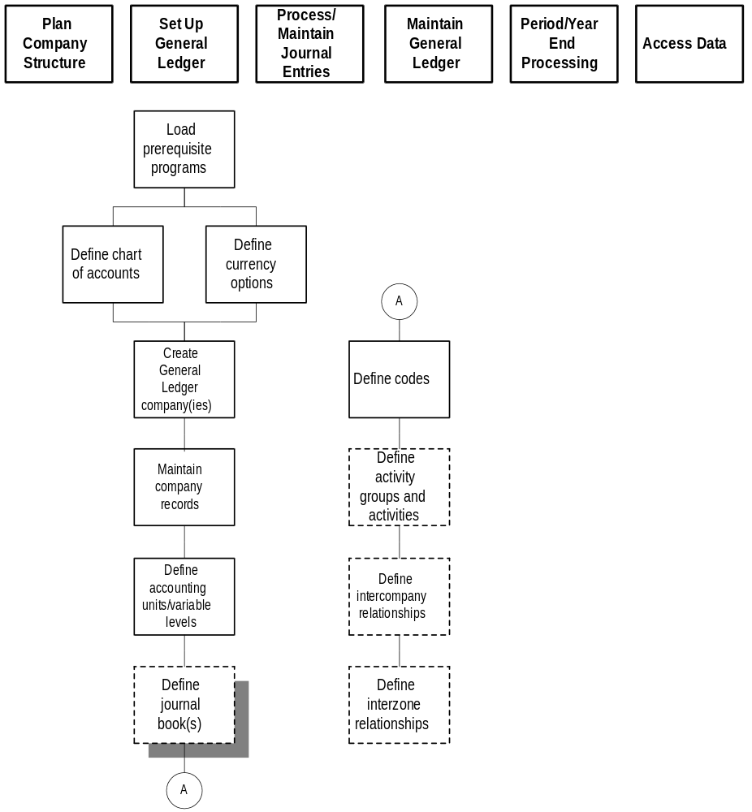
Defining journal books is the fourth procedure that is completed before defining a General Ledger company. In this optional procedure, you define journal books that can be associated to transactions. If you decide to use journal books for a company, you must do this before you define the General Ledger company because the information you define here will be used in company setup.

Journal books enable you to group Lawson General Ledger transactions. You can restrict journal books by specific system codes, operators, accounts, and accounting unit lists.

Journal books are associated to a company. After journal books are defined, they are applied to all journal entries.

Business Scenario
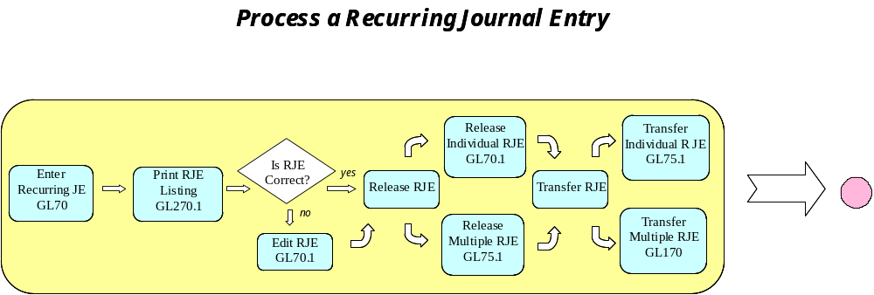

Business Script

Script ID Number: | GL04 | Functional Area: | GL
Script Name: |  | Create a Reversing JE
Prepared By: |  | Date Prepared:
Tested By: |  | Date Tested:

Description/Purpose of Test:
Create a Reversing Journal Entry.

Test Steps:
- Go to GL40.1 Journal Entry.
- Click on New JE Button to go to GL40.2 Define Journal.
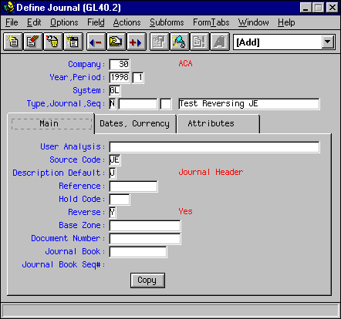
- Enter JE header information, including “Y” in the Reverse field. A reversing transaction will be created for the next period upon the close of the current period.
- Click on the Dates tab to enter Posting Date and Transaction Date.
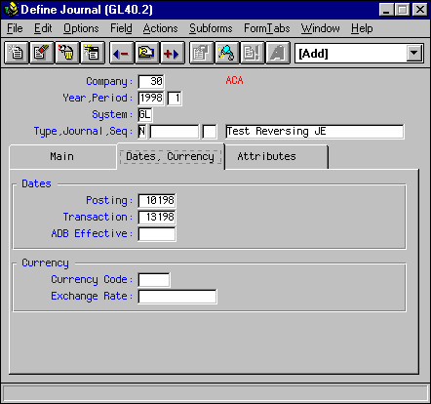
- Click Add to add the Journal Entry Header and return to GL40.1 Journal Entry.
- Enter Journal Entry distribution detail.
- Click Add to complete the Journal Entry creation.

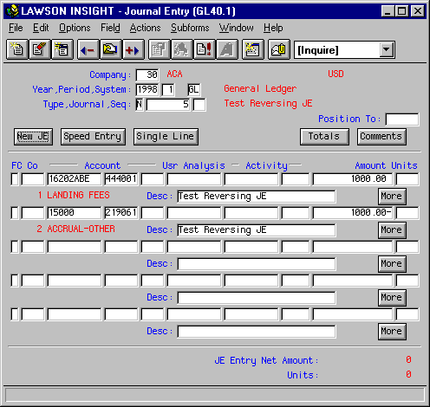

References
.
Periodical | Month | Year | Reprint # | Author | Title
Harvard Business Review | Sept/Oct | 1996 | 96505 | Majchrzak & Wang | Breaking the Functional Mind-Set in Process Organizations: If they want employees to take collective responsibility for customers, managers must do more than reorganize.
Harvard Business Review | July/Aug | 1998 | 98401 | Davenport | Putting the Enterprise into the Enterprise System: If you’re not careful, the dream of information integration can turn into a nightmare.
Harvard Business Review |  |  | 64112 |  | Strategies for Effective Interviewing
CIO | 9/1 | 2000 |  |  | ERP, One Letter at a Time: Transforming your enterprise and supply chain? Better get the business case down, goal markers set up and everyone on board to make it happen.
RESEARCH REPORT – Benchmarking Partners (for Deloitte & Touche)  (www.cio.com/forums/erp/articles_content.html) |  | 1998 |  |  | Ten Go Live Surprises: The bad things that happen when ERP goes live
Sams Publishing (www.samspublishing.com) | May | 2001 |  | Burlton | Business Process Management: Profiting form Process

6 Revision History
Version 1.0 September 2001. – Base version.

