

IBM Global Services

Pipeline Management Practices

Technique Paper (TP)

© Copyright International Business Machines Corporation 2001, 2002
All Rights Reserved
Version 2.0 May 2002
- Description
Preface
Pipeline Management is a key process in the Business Technology Management (BTM) Framework. The BTM Framework outlines a holistic approach for managing IT investments that provides for the continuous identification, selection, control, lifecycle management, and evaluation of IT investments. The framework describes how the portfolio of IT investments is planned, developed, and evolved in a continuous end-to-end closed loop.
Key Elements of the BTM Framework
The BTM Framework is made operational through four key components:
- The Processes component – three integrated processes that help ensure consistent, high quality results
- The Management Structure component - the organizational structure for making decisions and getting work done
- Tools/Enablers component - that enable or automate process execution, decision making and reporting of results
- Measurements component - assessments of the effectiveness of BTM in supporting business goals
BTM Processes
This component is comprised of three critical processes: Business Strategy & Plans, Portfolio Management, and Pipeline Management. For more information on the Business Strategy & Plans process, the reader is referred to the Business Strategy method. The Portfolio Management and Pipeline Management processes describe the activities for managing the IT portfolio in order to minimize risks and maximize returns. Portfolio management is the process that decides the set of investments, strategic and operational, based on the organization’s strategic intent and priorities. Pipeline management is the process that develops and operates the IT products/services that comprise the IT portfolio.
A key differentiator of the BTM Framework from other investment management models is the integration of portfolio decisions and pipeline decisions. Pipeline decisions, via the Decision Checkpoints (DCPs), are made on individual project investments in real time as the project moves through the pipeline. Portfolio decisions are made periodically in calendar time, perhaps semiannually or quarterly, but on all project investments together. However, simply being “in the portfolio” does not guarantee funding or “Go” decisions. Each project still must pass through each DCP.
BTM Management Structure
This component is the cornerstone of the entire framework. The BTM management structure is built around cross-functional teams for both investment decision-making and project execution. This tiered management structure provides the ability to make real-time decisions involving trade-offs between various functional areas and stakeholders. The first tier is the Investment Review Board (IRB) role that sets the business strategic direction and priorities. The second tier is comprised of the Integrated Portfolio Management Teams (IPMTs) that are chartered by the IRB. The IPMT selects and manages the investment portfolio and project execution for their defined service/market segment. The third tier is the Project Development Teams (PDTs) who are commissioned by an IPMT. This is the cross-functional team that performs the development activities.
BTM Tools/Enablers
To facilitate the execution of the BTM processes, a number of techniques and tools can be utilized. Two of the most common are:
- Portfolio Analysis (refer to Portfolio Analysis TP for additional detail)
- Project Management (refer to WWPMM for additional detail)
BTM Measurements
BTM measurements are both quantitative and qualitative to motivate continuous improvement of BTM practices.
The overall BTM Framework, highlighting relationships amongst its components, is depicted in Figure 1. This technique paper focuses on the Pipeline Management process.
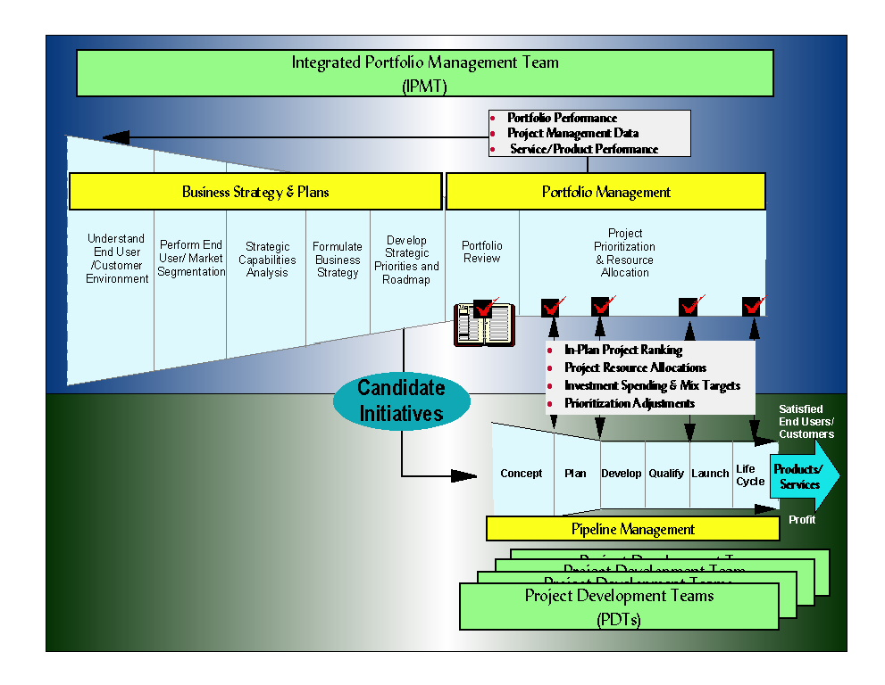
Figure 1 BTM Framework
Introduction
This technique paper describes best practices for the effective organization and management of IT products / services development projects. The development pipeline, or simply pipeline, is a graphical representation of an organization’s development process. As illustrated in Figure 2, a converging pipeline is used to depict the progression of a development project from concept to reality. A variety of IT product offering and IT services ideas (new as well as enhancements to existing IT products / services) enter the pipeline for investigation, but only the most promising become fully funded development projects. Pipeline management practices define the way the organization identifies, selects, reviews, and converges on the content of a development project as it moves through the pipeline.
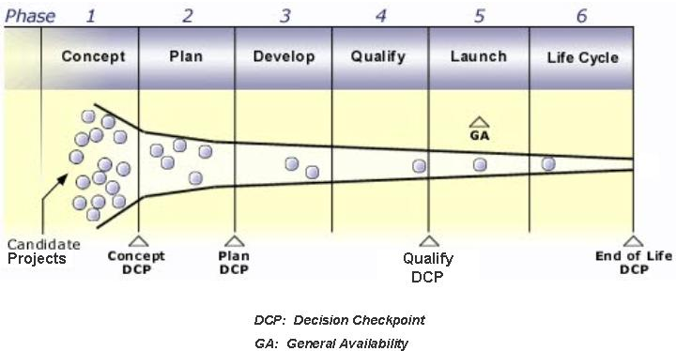
Figure 2: Development Pipeline
The cornerstone of pipeline management is a two-tiered, team-based management structure involving the active participation of all relevant functions. The first tier comprises the Integrated Portfolio Management Team (IPMT). The IPMT is an executive cross-functional management group responsible for business strategy and investments. Executing Portfolio Management (see Portfolio Management Practices technique paper), the IPMT prioritizes and selects opportunities and determines candidate projects. The cross-functionality ensures consideration of the full business value proposition from the chartering of the project through the end of life of all products/services s.
The IPMT "commissions" a similarly cross-functional Project Development Team (PDT) to perform the six phases of the pipeline management process illustrated in Figure 2. PDT members anticipate potential project or resource problems and enlist the support of the IPMT as needed. The IPMT ensures sufficient provisioning of the PDT — with resources, skills, and dollars — throughout the development cycle.
The IPMT validates the business value proposition for all functions, at checkpoints at the end of the Concept, Plan, Qualify phases and transitioning on to the Lifecycle (End of Life). The Plan checkpoint includes a signed contract between the PDT and IPMT.
In some cases, a Life Cycle Management Team (LMT) is commissioned to manage products/services from post-general availability through end of life. Additionally, depending on the size of the organization, there may be an Investment Review Board (IRB) that will oversee a portfolio of IPMTs.
Clearly effective Portfolio Management is necessary to drive effective Pipeline Management. Effective portfolio management identifies and selects of the “right” portfolio of investments, and translates those investments into candidate projects for the pipeline. The pipeline is structured into six phases and four decisions checkpoints (DCP), as depicted in Figure 3. Candidate projects entering the pipeline are managed using staged investment practices, i.e. resource (funding and people) allocation is tied to successful DCP exit review.
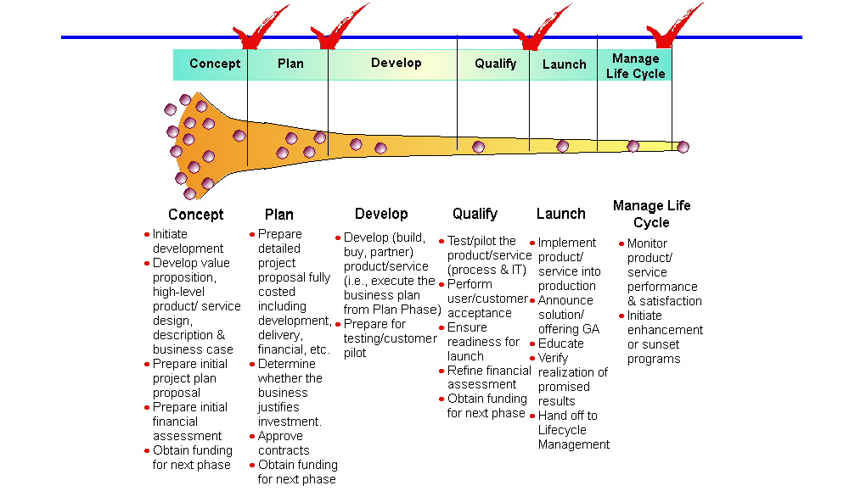
Figure 3: Pipeline Phases
Concept Phase is focused on assessing viability, strategic value, potential return on investment, and risks for a new, or an enhancement to, product/service before committing significant funds and resources.
Plan Phase defines the project, develops a formal product/service proposal and detailed project, and formally establishes agreement on project, schedule, and financials through a contract between management and the project team.
Develop Phase develops and verifies the completed product/service against defined specifications.
Qualify Phase conducts final testing and production/deployment qualification of the product/service, and decides to proceed to announce and general availability (GA).
Launch Phase ramps up to full-volume production/deployment and initiates maintenance support.
Life Cycle Phase is focusing on managing support of production/deployment, marketing, sales, and customer/end user support through end of life. This phase also manages the withdrawal of the product/service and the systematic end of production/delivery and support.
Key activities and deliverables through the phases are guided by a set of structured Decision Checkpoints (DCPs). Specific exit criteria must be met at each DCP.
The pipeline management practices described in this technique paper are based on IBM’s world-class Integrated Product Development (IPD) model and IBM’s BT/CIO Business Transformation Management Structure (BTMS). IPD practices are reviewed, externally benchmarked, and revised regularly to reflect changing conditions, with input from professional societies, academics, and consultants. For more information on IPD and BTMS, see [http://w3-1.ibm.com/transform/ipd/ and http://w3-1.ibm.com/transform/btms/roadmap/, respectively]. The major benefits of effective pipeline management practices are:
- A world-class set of principles and practices
- Common & consistent terminology
- Efficient, timely decision making
- Significant reduction in time and resources for development
- Improved responsiveness and timeliness of products/services
- Improved quality of products/services
- Increased focus on the end user /customer
- Overall improvement in financial results
This technique paper describes the phase objectives, major steps, and key disciplines used in each phase and the templates and decision checklists for the DCPs. Consultants can use this technique as a best-of-breed development framework for assessing clients’ development and investment management practices.
- Context
Pipeline Management Practices describe a world-class development framework of key activities, critical behaviors and disciplines, and templates and checklists. Consultants can use this framework in both an assessment and a process design/redesign context. The framework can be applied to clients who build and deploy IT solutions, e.g. a typical in-house IT organization) and with clients who build and offer IT products and services internally and/or externally. Each of these perspectives uses different terminology to describe similar constructs. For example, an in-house IT organizations usually refers to end users and business units while externally-focused IT service providers refer to customers and markets; in-house IT refer to IT solutions while who externally-focused providers refer to products or; in-house refers to solution deployment while externally-focused refers to product distribution. To acknowledge both of these perspectives, common terminology from each perspective is documented in this technique paper using the following format: <in-house terminology>/<externally-focused terminology>.
Typical client issues that this pipeline management framework addresses:
- Development expense high relative to products/services deployed/delivered (produced)
- Development expenses unknown, particularly by IT product/service
- Projects cancelled or otherwise “tabled” late in the development cycle
- Slow “time-to-market”
- Missed project deadlines; slipping schedules
- Project often over budget
- High number of helpdesk support calls after product/service deployment/launch
- Over-committed development personnel
- Project “metamorphosis” – often as a result of project teams receiving conflicting direction and priorities from management teams
- Major surprises in user/customer acceptance testing
- Large number “field engineering” changes after product/service deployment/launch
In an assessment context, the consultant uses the pipeline management practices as the “standard” against which the client’s development management process and practices are compared. In a design/redesign context, the pipeline management practices form a “straw man” development management framework that can then be tailored to the client.
- Steps
Pipeline Phases and the Tiered Management Structure
Pipeline management employs six phases and four decision checkpoints to manage the development pipeline to ensure the availability of resources when needed. Driven by a new product/service (or enhancement) decision from Portfolio Management (see Portfolio Management Practices technique paper), pipeline management begins with the Concept and Plan phases to decide on investment and plan the project, continues with the Develop, Qualify, and Launch phases to develop and deliver the product/service to the end users/customers, and ends with the Life Cycle phase to manage support over the life of the product/service and its ultimate withdrawal.
Pipeline management phases are executed by a tiered, team-based management structure. The Investment Review Board (IRB) role, if it exists, otherwise this role is performed by the IPMT, sets the business strategic direction and vision for the organization. The board is a cross-functional team comprised of senior executives responsible for the functional areas. The team defines end user/customer segments and facilitates the strategic architecture, standards compliance, and other corporate initiatives. It establishes corporate investment decision criteria, organization targets, and cross-organization optimization of resources in line with its strategy and investment decisions. The Board sets goals for IPMTs, measures progress, and resolves any cross-organization issues in line with strategy decisions.
The Integrated Portfolio Management Team (IPMT) is responsible for making ongoing business investment decisions in selected end user/customer segments based on growth, profitability, resource availability, and risk. The IPMT commissions the formation of Project Development Teams (PDTs). It carries out the approvals and high-level decision-making activities in the pipeline management phases. The IPMT is responsible for timely issue resolution within the teams, with business management and critical cross-organization projects. In addition, they motivate and manage performance and behavior of the PDTs and appropriately reward PDTs for successful performance.
All pipeline projects are executed by one or more PDTs. The PDT is a technical and business team commissioned by a sponsoring IPMT to execute the development cycle for a new product/service. The IPMT ensures that the PDT is sufficiently provisioned with resources, skills, and funding on an ongoing basis throughout the development cycle. The PDT executes against a contract with the IPMT and manages the project schedule, scope, risk, and issues to achieve successful development. PDT’s have end-to-end product/service responsibility and provide guidance, coordination, and direction to any dependent component PDTs.
Phase 1. Concept Phase
The objective of the Concept Phase is to qualify the business need, formulate a proposed product/service, confirm the feasibility of developing the proposed product/service, and define recommendations based upon facts that the sponsoring IPMT can use to make a "go/no go" decision. This phase allows for early recommendation of a potential product/service before committing funds and resources on a plan for development. The PDT determines the product’s/services’ feasibility, viability, strategic value, and potential return on investment.
When a new idea or enhancement is proposed, the PDT analyzes the opportunity, business value, competitive position, potential approaches, risks, cost, quality, schedule estimates, and financial implications. It also gathers end user acceptance/customer buying criteria and requirements. The PDT analysis positions the potential product/service in the overall IT portfolio. The Concept phase concludes with a Concept DCP and an IPMT decision based on the PDT recommendation.
Major Activities
- Receive a request for a new product/service or enhancement (from Portfolio Management process)
- Form a Project Development Team (PDT) — and create a work plan to draft a proposal
- Develop an initial product/service proposal and plan — validate the opportunity and product/service feasibility, and create the preliminary development plan, project schedule, and resource requirements
- Perform concept decision checkpoint directives — prepare the initial product/service proposal and Concept DCP presentation, provide the recommendation, and communicate the decision to all affected stakeholders
Phase Deliverables
- The Initial Product/service Proposal is a business plan (typically under 15 pages) that validates the opportunity, provides a definition of the product/service, shows how it can be deployed/offered to end users/customers on a timely basis, explains how it meets the business goals, and provides a recommendation about moving to the Plan phase.
- Initial contract (optional)
- Concept DCP recommendation
Concept DCP Checklist Questions/Considerations
Does the proposal have enough business potential relative to other projects to be viable as a project?:
- What are the end user/customer segment requirements that this project would satisfy?
- Are the end user/customer segment requirements significant enough to proceed with this project?
- How will the project deliver sufficient value to the targeted end users/customers?
- How does this project map to our business vision, mission, goals and corporate strategy?
- What analysis for build vs. buy was conducted?
- Are there other vendors/subcontractors involved?
- Does the project appropriately leverage intellectual capital and assets?
- Are all members of PDT with necessary skills identified and available?
- Are there other projects that address these end user/customer segments and how does this project relate to them?
- Do the assumptions (financial, technical, market, schedule, risks) appear reasonable?
- How have these assumptions been validated with the end users/customers?
- What is the payback period?
What are the risks and their impact associated with the project and what are the corrective actions to minimize risk?
- Would any existing projects be sunset when this project is completed?
- Is the scope and general function of the product/service sufficiently clear to begin the plan phase and to warrant funding for the plan phase?
- Does the Initial Project Proposal include a preliminary schedule and target date for the Plan phase?
- Has there been an Architecture Board Review conducted on this project? If so, what were the results?
End of Life Questions to be included in Concept DCP
- What is the life expectancy of the application being developed?
- What current applications are impacted by this new application?
- Are the current applications able to be sunset by this new application or do they need additional investment to extend their life?
Phase Ends With Concept DCP
At the Concept DCP, the PDT makes the recommendation, and the IPMT makes the decision:
- Go (proceed) — The IPMT approves the Concept DCP exit, and the PDT leader moves the product/service to the Plan phase and updates the pipeline management information repository/ database
- No Go (cancel) — The PDT leader notifies the performing functions, indicating the expense through IPMT cancellation plus the remaining funds. This note stops all spending on the project.
- Redirect — The IPMT gives instructions for next steps (such as change in requirements, funding, schedule, and so on).
Phase 2. Plan Phase
The objective of Plan Phase is to develop a Final Project Plan (FPP) for IPMT assessment and commitment. The development of the product/service concept into a formal definition with product/service objectives highlights this phase.
The Plan phase develops a detailed plan for the work to be done from development through the announcement and availability of the product/service. Included in the plan are a project schedule, expenses (resource and capital), and a financial business case.
The product/service and plan definition include elements for all major cross-functional areas (development, production/operations, fulfillment, marketing and sales support, services delivery, end user/customer service and support, and finance / pricing). This is an agreement between the PDT and IPMT that specifically outlines and commits the project’s schedule and financial scenario. The contract is “signed” by both the PDT and IPMT and can only be changed at a subsequent DCP meeting.
Major Activities
- Augment the PDT for plan development — receive the inputs, identify skills, add members, and create a work plan.
- Develop the final product/service proposal and plan — quantify the opportunity, define the product/service, and develop the final business and project plan
- Perform the plan decision checkpoint directives — final product/service proposal, Plan DCP presentation, and the contract; provide the recommendation; and communicate the decision to all affected stakeholders.
Phase Deliverables
The Plan phase ends with these typical deliverables:
- Final product/service proposal — a business plan with the necessary information (25-35 pages) to bridge from any assumptions from the concept to a fact-based plan. It quantifies the opportunity, defines the product/service, documents the project plan, completes the business plan, and prepares a recommendation for progressing to the Develop phase.
- Approved contract — an agreement, included as part of the final product/service proposal, between the IPMT, PDT and optionally the LMT (if there is a standing LMT for this product/service area). The contract covers the scope and metrics of the product/service over its life.
- Plan DCP recommendation
Plan DCP Checklist Questions and Considerations
Does the proposed project support business objectives in a timely manner?
- Has the scope of the project changed based on end user/customer requirements?
- Do commitments satisfy specific worldwide geography requirements?
- How does this project optimize the return on our business plan commitments? Describe how the design supports achievement of benefits noted in the business plan?
- Does this proposal continue to make business sense and fits within the overall strategy?
- Have the geographies identified any deployment/delivery issues and have these been resolved?
- Is the design stable and achievable?
- Has the buy vs. build decision been reviewed by Architecture?
- What vendors are being utilized for this project, if any?
- How were usability requirements validated?
- To what extent has the design been validated with users outside the project team?
- Are the required resources identified for the remainder of the project?
- Does the project development team (PDT) include all appropriate business, functional and technical areas?
- Is the Project Plan feasible and is the Qualify DCP date attainable?
- Are end user/customer service & support plans in place?
- Have all project dependencies been identified?
- How do the identified dependencies affect scope and time/resources?
- Has there been an Architecture Board Review conducted on this project? If so, what were the results?
- Is there a quality plan?
- Has a communication and education plan been completed?
- Describe the process and team used to develop the test plans.
- What is the backup and recover plan for the testing phase?
What degree of user resource is expected for testing? Has this support been formally agreed upon and arranged for?
- How is the budget (plan and actuals) being tracked for the project?
- How is project success determined/measured?
- Have all requests for IPMT action been clearly defined and assigned to the appropriate IPMT or PDT member for resolution?
Phase Ends with the Plan DCP
At the Plan DCP, the PDT makes the recommendation, and the IPMT makes the decision:
- Go (proceed) — The IPMT approves the Plan DCP exit and deliverables, and the PDT leader moves the product/service to the Develop phase and updates the pipeline information repository/ database. The IPMT, PDT, and optionally the LMT sign the contract with committed dates, development expense, marketing expense, volumes, charge back/revenue, cost recoveries/profit, and other appropriate business objectives
- No Go (canceled) — The PDT leader notifies the performing functions of the expense through cancellation plus the remaining funds. This note stops all spending on the project.
- Redirect — The IPMT gives instructions for next steps (such as change in requirements, funding, schedule, and so on) with firm, agreed dates for follow-up. The PDT leader communicates the next steps to the affected parties.
Phase 3. Develop Phase
The objective of the Develop Phase is to develop and verify the product/service to defined specifications. The phase includes all aspects of the solution design, integration and verification, development process design and implementation, end user/customer service and support structure definition, architecture, performance, and risk assessments. This phase has no formal decision checkpoint, but rather a PDTL led exit review to ensure readiness to proceed.
The Develop phase creates the product/service and verifies it against defined specifications. When the plan and contract have been approved, the PDT begins to develop all aspects of the product/service. All PDT members begin to execute their plans in support of the total product/service. This includes design, verification, and early prototyping of the product/service components, as well as the design and verification of supporting processes, such as production/operations, fulfillment, marketing, and end user/customer service.
The Develop phase concludes with the integration of the components and the successful testing of the product/service against the functional specifications and description.
Major Activities
- Augment the PDT for execution — acquire skills required to implement the plan, and track the milestones
- Design the product/service — all aspects of the product/service, test plans, and support
- Perform design verification — against the objectives and specifications of the product/service
- Create the product/service — create and review all deliverables and obtain end user/customer feedback on early work or prototypes
- Integrate the product/service — assemble the components for testing
- Verify the product/service — verification testing, validation of the product/service and its documentation, and risk assessment
- Perform the formal release to production/operations and fulfillment — to support deployment/delivery
Phase Deliverables
Depending on the nature of the product/service, the work of the Develop phase results in the following typical deliverables:
- Functional specifications or an equivalent
- Test specifications, standards, cases, and/or tools
- Design verification results and verification test results
- Early builds or prototypes
- Final supplier selection
- Revalidation of end user/customer requirements
- Initial sales kit, practitioner’s guide, and education
- End user/customer support plan and documentation
Phase Ends with the Formal Release
The PDT determines when the product/service is ready to enter the Qualify phase. For hardware offerings this means release to production and fulfillment, but for software and services offerings, it means that design verification is complete. The product/service enters the Qualify phase, and the PDT reviews the product/service metrics to date against the contract.
Develop Phase Exit Checklist Questions and Considerations
The PDTL is responsible for conducting the develop phase exit review to ensure readiness for Qualify.
What risks still exist and what are the contingency plans?
- What has changed from the Plan phase?
- What is the status of the Risk Assessment?
- What are the risks to users/customers if the project is delayed or does not meet their expectations/ requirements?
- What financial exposures exist for the project?
- What are the key areas of expense that are above or behind the plan?
- Are vendors/subcontractors delivering accurately according to the agreed upon output?
- What contingencies are in place to cover vendor/subcontractor delays, errors or cost overruns?
- What are the critical success factors for the Develop Phase?
- How have the end user/customer requirements been met in the Develop Phase?
- Describe how standards were enforced and consistency applied in the Develop process.
Phase 4. Qualify Phase
The purpose of the Qualify Phase is to perform final testing and certify product/service availability/launch readiness.
The Qualify phase provides final qualification testing and certification of the product/service, ensures readiness of the supporting production/operations, end user deployment/customer fulfillment, marketing, and end user/customer support processes, and determines whether or not to proceed to announce and make the product/service generally available (GA). End user/customer pilots and/or beta testing may be performed during this phase.
The qualification required depends on the nature of the product/service. Production readiness for both hardware and software takes place after the Qualify DCP exit. For hardware offerings, qualification may involve successful internal testing and release to production and fulfillment, stress testing, conformance to standards, final assessment against requirements or objectives, and/or agency certifications if needed. For software offerings, qualification may include system testing, early piloting/shipping to certain end users/customers, build and integration, and quality certification. For services offerings, qualification may require successful end-to-end testing (from request/order through receipt of charge back recovery/payment).
Major Activities
- Test the final product/service and process design — verification of product/service and performance, deployment/manufacturing process, request/order process, configurator, and formal release of software
- Ensure conformance to standards and specifications — hardware and software compliance testing, services validation, intellectual property assessment, and export classification
- Ensure the specific product/service meets current end user/customer requirements — feedback from early programs
- Ensure marketing and sales support readiness — marketing and sales support, services status, and Release for Deployment/Announcement (RFA)
- Ensure end user/customer service and support readiness — documentation, training, and support centers
- Develop Availability assessment — validation of product/service positioning, financial assessment, and risk mitigation
- Perform the Availability Decision Checkpoint directives — prepare the recommendation to proceed to deployment/announcement
Phase Deliverables
Depending on the nature of the product/service, the work of the Qualify phase results in the following typical deliverables:
- Production builds and test results
- Final marketing and sales support plan (including RFA and announcement plan)
- Final production/operations plan
- Final end user deployment/customer fulfillment plan
- Final product/operations environmental profile and delivery/manufacturing process environmental impact assessment
- Final Declaration of Conformity
- Final services delivery plan
- Final end user/customer service and support plan
- Final end user/services practitioner’s guide and sales kit
- Qualify DCP assessment
Qualify DCP Checklist Questions and Considerations
Is the project ready for deployment?
- Does the project continue to make business sense?
- What controls were in place to ensure tests were executed completely and consistently?
- Has the stability of the design been validated?
- Are there any areas that have not been tested and why?
- How are the sponsors showing continued, visible commitment?
- Have the objectives, changes and plans been communicated to all stakeholders and constituencies (Internal, external, touch points, customers, entire organization)?
- Are there any outstanding risks and have any new risk factors come to light since the planning phase (Timing, Personnel changes, marketplace changes, stress level of project team)? How are these being handled?
- Have all the necessary resources for roll out/launch been made available?
- What specific decision or action do you need from the IPMT to help you to enter the Launch phase?
End of Life Questions to be included in Qualify DCP
- Is it still appropriate to sunset the currently identified applications?
- Are there changes to the timing?
- Has the funding for sun setting the applications been approved?
Phase Ends with the Qualify DCP
At the Qualify DCP, the PDT leader certifies the quality of the product/service and that the provisions of the contract are and will continue to be met (based on input from all performing functions certifying that all tasks are on schedule to meet the committed date, including communication/marketing preparation for deployment/launch).
The PDT makes the recommendation, and the IPMT makes the decision:
- Go (proceed to Announcement) — The IPMT approves the Qualify DCP assessment and recommendations to proceed to deployment/announcement. The PDT leader moves the product/service to the Launch phase, updates the pipeline information repository/database, and reviews the product/service metrics against the contract.
- No-Go (canceled) —The PDT leader notifies the performing functions of the expense through cancellation plus the remaining funds. This note stops all spending on the project.
- Redirect — The IPMT gives instructions for next steps with firm, agreed dates for follow-up. The PDT leader communicates the next steps to the affected parties.
Phase 5. Launch (Deploy) Phase
The purpose of the Launch (Deploy) Phase is to roll out and deliver the product/service to end users/customers.
The Launch phase initiates the activities required to successfully announce and deploy/deliver a new product/service to intended end users/customers, and to ensure that all internal and external systems and support organizations are ready to perform their responsibilities.
After the decision to proceed to Announce and General Availability of the product/service, the Project Development Team (PDT) ensures that the balance of the project plan is performed, including enacting the deployment plan/”routes to market” plan (RTM), ramping up to volume production, loading the fulfillment process, ramping up for education, and the transition from development to product/service maintenance and support. This phase contains the marketing launch of the product/service (announcement and initial sales and end user/customer support).
Major Activities
- Initiate full volume production or engagements — continue project execution and tracking, start operational support structure for production, and begin shipping to distribution centers (for product offerings)
- Execute the deployment plan/load the distribution channels — initiate deployment/RTM plan, end user/customer fulfillment, and other downstream support; begin deploying/shipping the product/service; and monitor supplier performance (as appropriate)
- Execute the transition plan — begin marketing and sales support and execute transition plan from development to delivery of the product/service
- Initiate operational support structure — initiate the support structures for marketing, sales, technical support, and channels, and begin end user/customer service and support
- Announce product/service and General Availability (GA) — confirm charge back/pricing, announce product/service, and begin full-scale operational support
Phase Deliverables
Depending on the nature of the product/service, the work of the Launch phase results in the following typical deliverables:
- Final Release for Announcement (RFA)
- Marketing and announcement materials
- Product/service deployment/delivery to distribution and fulfillment channels
- Initiation of operational support
- Project experiences and product/service business results
Phase Exit Review Questions and Considerations
Is the product/service ready to roll out?
- Has education and training been conducted for all end user/support groups?
- How will problems be handled in each of the geographies?
- Has a measurement system to monitor results been established?
- Is there an updated plan for Life Cycle Management?
Phase Ends with Announcement and GA
The PDT executes the final release for announcement when the product/service is ready. The PDT leader moves the product/service to the Life Cycle phase and reviews project metrics to date against the contract.
Phase 6. Life Cycle Phase
If there is a Life Cycle Management Team (LMT), the Product Development Team (PDT) hands over the product/service to the LMT after GA. During the Life Cycle phase, the PDT or LMT manages the support of production/operations, marketing and user request/sales support, and end user/customer service and support through the end of life of the product/service. The PDT or LMT monitors performance in each area and responds appropriately. Interim decision checkpoints may be scheduled, depending on circumstances. This phase lasts until the PDT or LMT and the IPMT agree that the product/service is at the end of life.
At the end of life, the PDT or LMT oversees the systematic withdrawal of the product/service. It manages the end of production/operations, end of marketing and user request/sales support, and end of end user/customer service and support. Formal notification of the end of life is provided through the Release for Announcement (RFA) process. For hardware, this phase also includes responsibility for the orderly transfer of unique service parts and customer service and support to the appropriate organization, if needed.
These events may occur concurrently, separately, in different sequences, or more than once for a given product/service and its elements, depending on the business plan, performance, market environment, and end user/customer acceptance.
Major Activities
The first activity manages the product/service until end of life; the second determines whether the product/service should be withdrawn in preparation for the End of Life DCP; the remaining activities manage the systematic withdrawal of the product/service.
- Manage the operational performance of the product/service — manage production/operations, marketing and user request/sales, and end user/customer service and support, assess end user/customer satisfaction, and keep the product/service on track to meet its objectives
- Perform the end of life assessment — for end of production/operations, end of marketing and user request/sales, and end of end user/customer service and support for the product/service
- Perform the end of life decision checkpoint directives — for end of production/operations, end of marketing and user request/sales, and end of end user/customer service and support for the product/service
- Perform transfers to service — for hardware, transfer unique service parts and actual customer service and support to other support organizations
- Perform the product/service end of life — for end of production/operations, end of marketing and user request/sales, and end of end user/customer service and support for the product/service
- Close out the product/service — update and close the product/service pipeline information repository/database, review product/service metrics against the contract, and review the process and business lessons learned
Phase Deliverables
Depending on the nature of the product/service, the work of the Life Cycle phase results in the following typical deliverables.
- Product/service operational performance assessments (for production/operations, marketing and user request/sales, and end user/customer service and support)
- Product/service End of Life DCP assessments (for production/operations, marketing and user request/sales, and end user/customer service and support)
- Transfer of responsibility for service and support (for hardware), including service parts and customer service and support
- End of life documentation, including internal notification of end of production/operations, marketing and user/request/sales support withdrawal RFA, and end user/customer service and support withdrawal RFA
- Project experiences and measures of customer satisfaction
- Product/service business results
Phase Ends with Withdrawal of the Product/service
At the End of Life DCP, the PDT (or LMT) assesses the product/service performance and planned end of life dates for the end of production/operations, the end of marketing and user request/sales support, and the end of end user/customer service and support. For each area, the PDT makes the recommendation whether to proceed with the planned end of life dates, or to change them, and the IPMT makes the decision:
- Proceed with planned end of life —The PDT leader continues to manage the plan for end of production/operations, the end of marketing and user request/sales support, and the end of end user/customer service and support:
- For end of production/operations, the PDT leader manages all related activities, transfers service parts responsibilities as appropriate, and notifies all affected stakeholders.
- For end of marketing and user request/sales support, the PDT leader manages all related activities including the creation of a marketing and user request/sales support withdrawal RFA, and notifies all affected stakeholders.
- For end of end user/customer service and support, the PDT leader manages all related activities, including the creation of a end user/customer service withdrawal RFA, transfers remaining service and support responsibilities as appropriate, and notifies all affected stakeholders.
- Change the end of life dates — The PDT leader revises the end of life plans, and continues as above, using the new plan dates.
- Close out the project — The PDT leader closes out all project support applications, databases, and infrastructure support.
- Tools
Tiered Management structure – Roles & Responsibilities
- Attachment: IPMT IPD Orientation and KO.ppt – client example
- Revision History
Revision Number | Revision Date | Summary of Changes | Changes Marked?
2.0 | May 2002 | Applied new template and style, spelling and grammar.
1.0 | September 2001 | Base version.

