

IBM Global Services

Solution Definition

Technique Paper (TP)

© Copyright International Business Machines Corporation, 2026
All Rights Reserved
Version 2.0 November 2026
Introduction
The objective of this technique paper is to define an approach that is designed to quickly gain a shared understanding of business issues, requirements and appropriate technical approach. It has been used very successfully on Entergy, Deere Horicon, and United eCMS Consulting projects. Examples of filled-in workshop reports for these projects (following the prescribed agenda) are also on the eCMS ROCK Documentum Docbase.
This technique is powerful because it:
- Forces a solid understanding of business issues as the basis for requirements.
- Gets users and management excited while keeping them focused on the most important benefits and functions.
- Facilitates the client making their own tradeoffs between functionality and cost/schedule constraints.
- Puts everyone in the same room (users, managers, IT people) to gain a shared understanding of the issues, tradeoffs and agreed-upon approaches.
- Provides an excellent reference point for weeding out critical requirements from nice-to-have requirements, and for continually keeping the right focus during design and implementation.
- Contains all the high points of the SIMethod Solution Outline phase, and thus provides a good context for finishing off requirements / solution definition in an optimum manner.
- Takes almost no time, and is therefore very attractive to clients.
- Very quickly yields a sense of progress and comfort level with IBM.
This approach is recommended as a way:
- To understand the client's requirements well enough to provide a business justification and initial approach, without requiring the client to immediately commit to a full phase 0 effort (note that a full phase 0 should follow, however, if the business case is made)
- To kick off a full phase 0 effort, establishing a shared context for further interviews and planning sessions.
Guidelines
When performing a scope workshop with a client, keep the following in mind:
- It is important to have all the right people in the room at the same time. This includes business executives, IT personnel, and users.
- Keep the meeting moving to keep on track, yet allow enough discussion on each topic.
- Use the Business Objectives to help keep requirements discussions on track. It is easy to spend a lot of time discussing requirements that are not key to meeting the business objectives.
Template Agenda
The following is a sample agenda to follow when performing a scope workshop with a customer.
IBM EDMS&S High-Level Solution Definition
Agenda for Joint Planning Session
Define Business Framework (Day 1 Morning, 1-2 hours)
- Business Area Mission and Key Measures of Performance (describe briefly)
- Business Objectives / Drivers for Document Management (list 3-5)
- Current Barriers to Meeting Those Objectives (list 3-5)
- Desired Approach and Anticipated Benefits (review briefly)
- How Success Will be Measured (describe briefly)
- Key Business Constraints – including timing and budget (list 3-5)
- Key Technical Constraints – including platforms and infrastructure (list 3-5)
Describe Current System (Day 1 Morning/Afternoon, 2-3 hours)
- High-level Information Flow - Contributors / Coordinators / Consumers (draw simple diagram)
- Profile of Key Users - Contributors / Coordinators / Consumers (describe briefly)
- High-level System Context (draw diagram showing all key interfaces with other systems / processes)
- High-level Process / Workflow (draw diagram showing key users and processes)
- Major Document Types (list 3-5) Formats / Sizes / Volumes / Change Cycles / Interrelationships
- Location and Format of Repositories / Data (describe briefly)
- Technical Infrastructure - Hardware / Software / Networking (draw simple diagram)
- User Interface Approach (describe briefly)
- Control and Security Measures Currently Employed (describe briefly)
- Known Problems and Issues With Current System (list 5-10)
Define High-level Requirements - Overall (Day 1 Afternoon, 1-2 hours)
- Desired High-level Information Flow - Contributors / Coordinators / Consumers (diagram changes)
- Desired High-level System Context / Interfaces (diagram changes from current system)
- Desired High-level Process / Workflow (diagram changes from current system)
- Required Major Document Types and Characteristics (describe changes from current system)
Define High-Level Requirements - Specific (Day 1 Afternoon, 1-2 hours)
- Key Features / Functions (list 10-20), covering:
- Document Management
- Workflow
- Information Delivery / Publishing / Web / Intranet
- Authoring / Editing
- Search and Retrieval
- Linking and Reuse
- Reporting, Audit Trail, and Archiving
- Interfaces to Other Systems
- Key Regulatory Requirements (list 3-5)
- Key Security Issues (list 1-2)
- Key User Interface / Usability Issues (list 1-2)
- Key Data Validation Issues (list 1-2)
- Key Data Conversion Issues (list 1-2)
- Key Performance Issues (list 1-2)
IBM EDMS&S High-Level Solution Definition
Agenda for Joint Planning Session (continued)
Review/Refine High-Level Requirements (Day 2 Morning, 1-2 hours)
- As Above
Model High-Level Solution (Day 2 Morning/Afternoon, 4-5 hours)
- Overall Technical Approach (describe briefly)
- Preliminary List of Off-the-Shelf Products (list all known products required)
- Preliminary High-level Architecture
- Physical Architecture (draw diagram showing hardware, networks, user groups and repositories across all physical locations, and indicating which software products reside on each hardware component)
- Logical Architecture (draw diagram showing how software products are interconnected and where interfaces to other systems will occur, also indicating which user groups interact with each software component).
- Probable Areas of Customization (list all key areas with indication of approximate scope)
- User Interfaces
- Data Validation
- Common Services / Functions Underlying User Interfaces
- Workflows
- Queries and Reports
- Batch Publishing / Composition Processes
- Authoring Environments
- Archiving Functions
- Interfaces to Other Systems
Report Template
The following is a template for the final report that is a result of performing the scope workshop.

Systems Integration/Application Development Method

Enterprise Document Management System

Meeting Results

Prepared for

Meeting Date:
The information in this document shall not be disclosed outside the and shall not be duplicated, used or disclosed in whole or in part for any purpose other than to support IBM's Enterprise Document Management consulting engagement with .

Prepared By:

Connie Consultant
Enterprise Document Management Solutions & Services
IBM Global Services
5600 N. 63rd St.
Boulder, CO 80314

Revision: 1.0
Last Revised: Mmm. dd, yyyy
File name: 0000.doc

 | Global Services  eCMS

1 Introduction
1.1 Participants
2 Business Framework
2.1 Business Area Mission and Key Measures of Performance
2.1.1 Mission
2.1.2 Measurement
2.2 Business Objectives / Drivers for Document Management
2.3 Current Barriers to Meeting Those Objectives
2.4 Desired Approach and Anticipated Benefits
2.5 How Success Will be Measured
2.6 Key Business Constraints (including timing and budget
2.7 Key Technical Constraints (including platforms and infrastructure)
3 Current System
3.1 High-level Information Flow - Contributors / Coordinators / Consumers
3.2 Profile of Key Users - Contributors / Coordinators / Consumers
3.2.1 Group name (Number and comment)
3.3 High-level System Context (key interfaces with other systems / processes)
3.4 High-level Process / Workflow
3.5 Major Document Types with Sizes / Formats / Volumes / Change Cycles / Interrelationships
3.6 Location and Format of Repositories / Data
3.7 Control and Security Measures Currently Employed
4 High-level Requirements
4.1 Desired High-level Information Flow - Contributors / Coordinators / Consumers
4.2 Desired High-level System Context / Interfaces
4.3 Desired High-level Process / Workflow
4.4 Key Features / Functions
4.5 Key Regulatory Requirements
4.6 Key Security Issues
4.7 Key Data Validation Issues
4.8 Key Data Conversion Issues
4.9 Key Performance Issues
5 Solution Implications
5.1 Overall Approach / Architectural Implications
5.2 Implications for Off-the-Shelf Products and Potential Customization Requirements

- Introduction
- Participants
The following staff participated in this session:
Name | Organization | Role
 | IBM Global Services | Facilitator
 | IBM Global Services | Facilitator

- Business Framework
- Business Area Mission and Key Measures of Performance
- Mission
List in bullet-like form
- Measurement
List in bullet-like form
- Business Objectives / Drivers for Document Management

- Current Barriers to Meeting Those Objectives
List in bullet-like form
- Desired Approach and Anticipated Benefits
List in bullet-like form

How Success will be Measured
List in bullet-like form
- Key Business Constraints (including timing and budget)
List in bullet-like form
- Key Technical Constraints (including platforms and infrastructure)
List in bullet-like form
- Current System
- 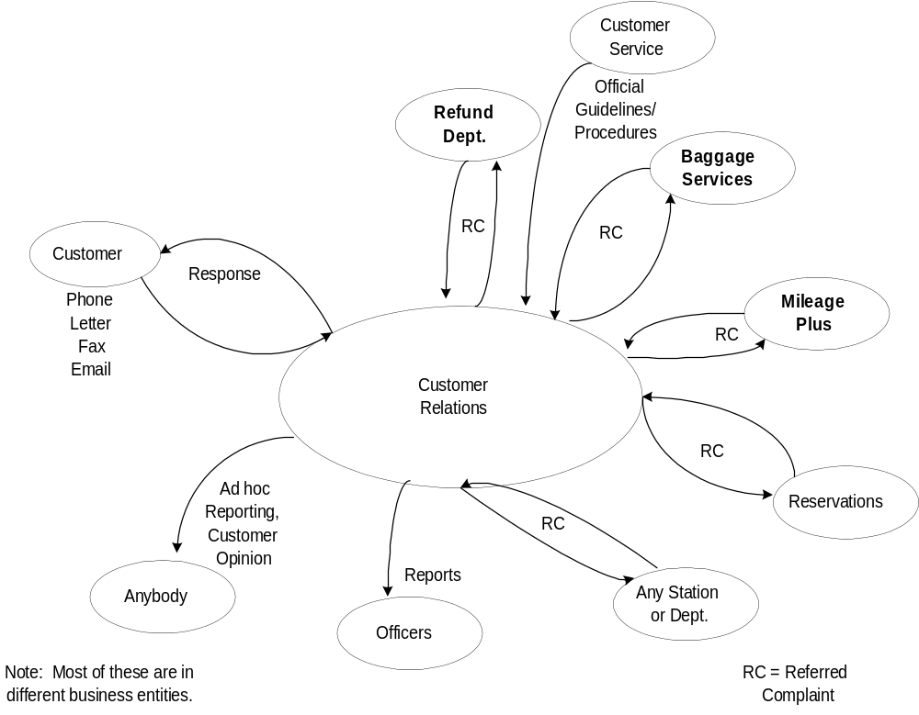High-level Information Flow - Contributors / Coordinators /Consumers

- Profile of Key Users - Contributors / Coordinators / Consumers
Group | Role
Managers | Coordinator

- Group name (Number and comment)
Additional details
- High-level System Context (key interfaces with other systems / processes)
List in bullet-like form
- 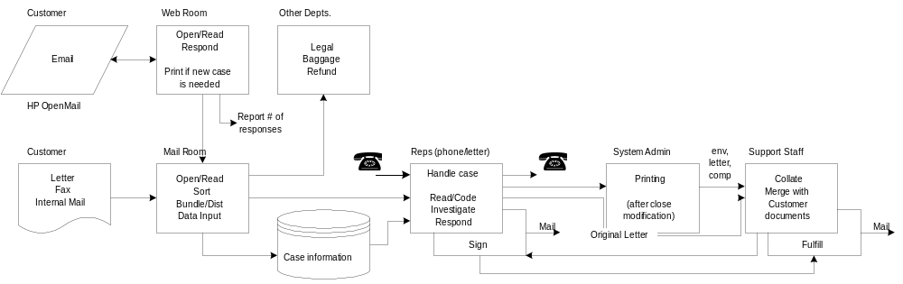High-level Process / Workflow
Put Visio drawing here
- Major Document Types with Sizes / Formats / Volumes / Change Cycles / Interrelationships
Summary table
Document Name | Type / Format | Process | Tasks Supported | Qty./ peroid | #  Page
- Additional context/details in bullet form
- Location and Format of Repositories / Data
List in bullet-like form
- Control and Security Measures Currently Employed
List in bullet-like form
- High-level Requirements

Desired High-level Information Flow - Contributors / Coordinators / Consumers
List in bullet-like form
- Desired High-level System Context / Interfaces
Insert context diagram here
- Desired High-level Process / Workflow
List in bullet-like form
- Key Features / Functions
List in bullet-like form

Key Regulatory Requirements
List in bullet-like form
- Key Security Issues
List in bullet-like form
- Key Data Validation Issues
List in bullet-like form
- Key Data Conversion Issues
List in bullet-like form

Key Performance Issues
List in bullet-like form
- Solution Implications
- Overall Approach / Architectural Implications
- Implications for Off-the-Shelf Products and Potential Customization Requirements

