

IBM Global Services

Using Logical LOVEM Charts

Technique Paper (TP)

© Copyright International Business Machines Corporation 1999, 2000
All Rights Reserved
Version 1.1 October, 2000

Preface
The LOVEM process mapping technique can be used to create the following work products:
- Process Selection
- As-Is Process Definition
- Future Process Design Points
- To-Be Process Model
- To-Be Organization Model
- To-Be Process Design
- Future System Attributes
- To-Be Organization Design
Table of Contents
1 Description 1
2 Purpose 3
3 Benefits 3
4 Visibility Chart 4
5 Complementary LOVEM Modeling Techniques 8
6 When to use LOVEM 9
7 Benefits when Using LOVEM 10
8 The Logical Line of Visibility Chart (LLOVC) – Introduction 12
9 Major Uses of the LLOVC 12
10 Structure and Main Components of the LLOVC 13
The Bands of the LLOVC Template 13
LLOVC Symbols 14
Symbols on the LLOVC Template 14
11 What to Do and What to Avoid 15
12 Creating an As Is LLOVC 16
Creating a To Be LLOVC 17
How to Read LLOVCs 18
Things all LOVCs Share 18
Reading the LLOVC 18
Things to Look for in LLOVCs 20
Example of an LLOVC 20
13 General Hints and Tips 22
Hints and Tips for the LLOVC 22
14 Symbols for Logical Modeling Techniques 23
15 Symbols Summary Matrix 32
16 Revision History 39

- Description
Today's business environment demands improved service and quality. Business managers and professionals continually assess how they deal with their customers, and question how they can improve such relationships. At the same time, businesses need a way to help document, evaluate, and often change business processes to meet the demands of customers for quality and service. Equally important, and requiring continuous focus, is employee moral and internal efficiency.
While Computer Aided Software Engineering (CASE) tools and methodologies are available for systems design, they are predominantly designed for Information Systems (IS) professionals who need tools and techniques to consistently develop data and process models used in application development. These models and techniques represent a more abstract view of a business and are not easily understood or used by business professionals and managers.
This document provides you with a methodology, which is especially suitable for business process re-engineering (BPR) and business process management (BPM). LOVEM is a people-oriented methodology and is supported by a number of modeling tools (VISIO, ProModeler, etc.). LOVEM uses an integrated set of graphics to document, evaluate, and redesign the business process flows. The family of line of visibility charts (LOVCs) is at the core of LOVEM. An LOVC highlights every time an organization, department, or individual has contact with its customer. LOVCs help you to:
- Identify the service encounters with your customers or clients
- Understand how your customers and clients see your company's or department's processes
- Focus on the redesign of those areas in need of:
- Improvement in customer service
- Improvement in employee morale
- Cycle time reduction
- Better use of resources
- Cost reduction
What is LOVEM?
LOVEM is a business process engineering or re-engineering methodology designed for business and systems professionals. The focus of LOVEM is the service encounters with your customers and clients. This results from the emphasis on customer satisfaction, market-driven quality, internal service levels, and total quality management. Another major focus area is its emphasis on interfaces, such as internal and external hand-offs and dependencies, and interfaces to systems and automation. The objectives of LOVEM are:
- To delight customers by designing quality service encounters
- To improve employee morale by focusing on individual jobs and their interfaces to other internal or external organizations and systems
- To focus on cost reduction by optimizing process path or work flow steps
- To gain competitive advantage by extending the value chain of your business to your customers and suppliers.
This is accomplished by analyzing the business processes with questions, such as:
- What needs to be done and why?
- Who is involved?
- How does work get done?
- How long does it take?
- How much does it cost?
- What are the roles and responsibilities of everybody involved?
- What are the internal service level targets?
- What are the key indicators?
- What is the maturity level of the process?
LOVEM is based on the concept of process path management. It uses a pictorial language to demonstrate the processes of an enterprise. Symbols represent logical and physical process and data components. Their arrangement represents the sequence and order of a process path or workflow. In this way, each service encounter, process or data component, problem, or opportunity can be examined in the appropriate context of a process path or workflow, and the maturity level for the overall process or process path can be established. LOVEM is like a set of maps of your business with guidelines to help you create and read them. LOVEM shows all the elements of your business in relationship to one another -- similar to maps showing the relationship between cities and countries.
LOVEM is built on the realization that business and systems professionals are jointly responsible for process design and management. Business process design and ongoing business process management, according to services marketing principles, must be shared between business and systems professionals. LOVEM offers a common specification language that lets business and systems professionals document, analyze, evaluate, rate, and manage business processes and systems functions. In addition, employees and management within your business, as well as your relationship with customers, vendors, and suppliers can benefit from this common specification language.
LOVEM is a methodology for rapid implementation of workflow solutions.
- Purpose
LOVEM has numerous applications for BPM and BPR. It assists in highlighting areas of opportunity or concern. By using LOVEM, you can:
- Improve your relationship with your customers, vendors, and suppliers, because you can design optimum service encounters, superior service delivery, and reduced cycle time. You can also extend the value chain of your business to your customers and suppliers by integrating some of your processes with theirs.
- Assess the impact of internal changes on your customer. For example, how organizational, systems, procedural, or policy changes are likely to affect the customer.
- Define key indicators and critical success factors (CSFs) for your processes and establish a maturity rating (MR).
- Measure the performance of your processes.
- Radically re-engineer your business to achieve competitive advantage.
- Incrementally improve your processes.
- Facilitate major business restructuring and establish clear departmental responsibilities.
- Identify opportunities for enabling technologies or business strategies.
- Build employee-oriented blueprints for individual jobs, which can lead to improved employee morale and job satisfaction. This provides the basis for empowerment.
Note: LOVEM is unique in its focus on job design and redesign. It allows you to integrate individual jobs within the overall process path design and establish service level contracts.
- Create customer-oriented and employee-focused systems requirements.
- Benefits
What Business Can Benefit from LOVEM?
Any business that is concerned with customer satisfaction, employee morale, vendor and supplier relations, cycle time, defect elimination, expense control, productivity, process management, and clearly defined manual-to-automation boundaries.
Examples of types of businesses that can benefit from using LOVEM include:
- Order-fulfillment businesses that go through the sell, order, supply, distribute, settle, support cycle, such as:
- Retail
- Wholesale
- Mail order
- Product development businesses that go through the requirements, design, build, test, deliver, support cycle, such as:
- Software development
- Manufacturing
- Visibility Chart
What is Line of Visibility Chart?
A line of visibility chart (LOVC) is a pictorial representation of the business processes and the data that flows between them. Just like a geographical map shows cities and provinces and their relationships, an LOVC shows the business processes and their relationships. You derive an LOVC from your analysis and design of the sequential and parallel business processes.
Often, the act of creating an LOVC is called blueprinting or modeling, because you are creating a blueprint or model of your business processes. Blueprinting lets you graphically depict a company's process design, whereas modeling is part of the design process. Through modeling, you create several alternatives during the design process before committing to a final blueprint.
You can identify the following on an LOVC:
- Those aspects of your business that directly affect your customers or clients. These are the service encounters with your customers or clients; they are shown at the line of visibility (LOV).
- The roles, departments, and jobs that make up your business
- The processes and activities that your business performs and the necessary data, information, and material flows
- The internal and external interfaces and hand-offs that create dependencies for your business
- The systems and other automation that your business depends upon
- The opportunities, problems, and measurements of your business
- Employee skills, education, and training requirements
- Possible solutions that often become obvious through the process of creating the LOVCs, such as opportunities for productivity improvement with enabling technologies.
Figure 1 on page 11 shows a generic LOVC. In this example, a customer establishes a relationship by making contact with the first business area, department, or job. The first business area must seek support from the second business area, which in turn seeks support from the fourth business area. The fourth business area completes the relationship with the customer. The line between the internal business areas and the customer is the line of visibility (LOV). Any interaction between the customer and your business takes place at the LOV and is called a service encounter.
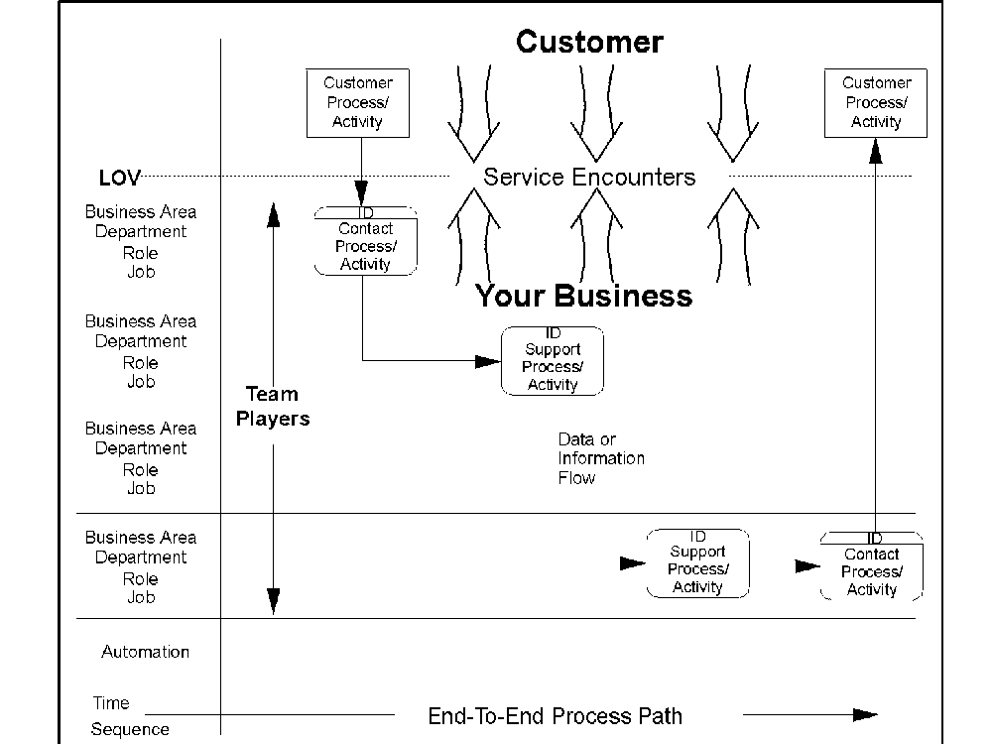

Figure 1. Generic LOVC
The Family of Line of Visibility Charts
The family of LOVCs is an integrated set of graphical representations of the business processes from the customer's point of view. LOVCs show the relationship between an organization and its customers for any given business unit, or line of business (LOB), or any job. The key features are:
- Service encounters that occur at the LOV
- Internal and external interfaces, hand-offs, dependencies, and organizational considerations
- Processes, activities, and procedures that the business performs, with special emphasis on those that deal directly with the customer
- Major data entities and data, information, and material flows
- Upstream and downstream data dependencies, especially for those contact processes that deal directly with the customer
- Manual-to-automation interfaces. These are especially important, because in most modern businesses the majority of processes are performed by systems.
- Process cycle time and critical measurement points (CMPs) to provide benchmarks and comparisons to best-of-breed competitors
- Other business control parameters that the business deals with, such as process path costing, skills requirements, and problem or opportunity areas.
The family of LOVCs consists of the following types of charts:
- Architecture LOVC (ALOVC)
- Logical LOVC (LLOVC)
- Physical LOVC (PLOVC)
- Job LOVC (JLOVC).
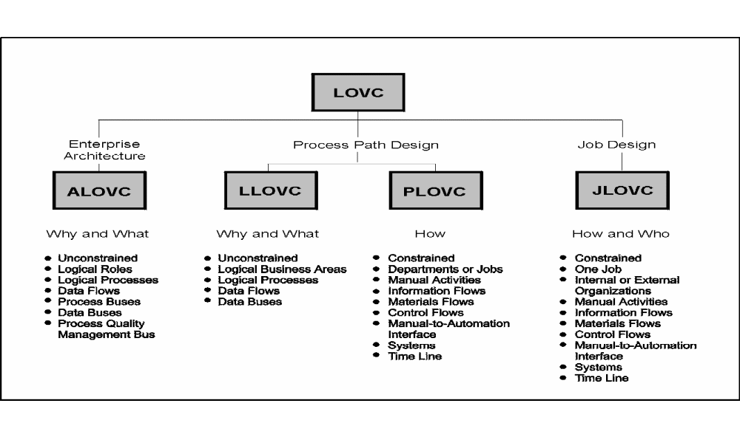
Figure 2 shows the characteristics that define each type
Figure 2. Characteristics of the LOVCs
You can create and use any or all of these charts to represent process paths or jobs for an enterprise or a LOB.
When you create LOVCs, you use a predefined set of symbols and techniques that help business professionals create consistent charts that are easy to understand by people not involved in the process. Figure 7on page 53 shows the various LOVC symbols and the particular LOVC to which the symbol belongs.
The following describes the four types of LOVCs.
- Architecture LOVC (ALOVC)
The ALOVC has a predefined structure. It focuses on:
- The main customer processes
- The main enterprise processes and key data components
- Critical measurement points and critical success factors.
You create a high-level ALOVC before you begin to divide your enterprise into its business units or LOBs. The ALOVC is logical and unconstrained, and it shows the sequential nature of enterprise processes. It also addresses the first touch, only touch characteristics needed by today's businesses in order to be competitive.
- Logical LOVC (LLOVC)
The LLOVC is the starting point for documenting or creating the design of individual lines of business. At this stage, you assess your business at a high level -- first, as it is today, then as it could or should be in the future. Often, these charts are referred to as the As Is blueprints, or To Be models or blueprints. When working with an LLOVC, you concentrate on "what" your business does. You do not include any physical constraints, such as systems, geographic locations, or organizational units; you rather identify the logical business areas and processes as they currently exist or as you would like them to exist. This results in a stable model or blueprint of your business.
When creating an LLOVC, you focus on the following:
- Your customers
- Service encounters with your customers
- Interactions between logical business areas
- What your business does
- Maturity levels of your processes or process paths.
- Physical LOVC (PLOVC)
A PLOVC deals with the constraints of your business processes. You now ask the following questions:
- Who performs a process?
- How is a process performed?
- Where is a process performed?
- When does a process take place?
- How much does it cost to perform a process?
- How long does it take?
- Where do the hand-offs occur?
- What systems or tools are used?
- What is the maturity level of the process?
On a PLOVC you identify the manual activities and their interfaces to customers, internal or external organizations, and systems. With a PLOVC you can create As Is blueprints and To Be models or blueprints of a process path.
- Job LOVC (JLOVC)
The JLOVC focuses on the people who perform the tasks within the business. A JLOVC shows the activities and tasks of a job and their relationships with customers, other jobs, internal or external organizations, and systems. With the JLOVC you can create As Is blueprints and To Be models or blueprints of the jobs. This lowest level of the LOVCs is the most important, because it is from the JLOVC blueprints that you implement your new business process design. Using your JLOVC, you can:
- Implement new procedures
- Improve existing procedures
- Define skills requirements
- Aggregate skills into new job descriptions
- Define systems requirements
- Define tool requirements
- Provide education for improving efficiency
- Consider all aspects of jobs that affect customer service and internal efficiency and effectiveness
- Define the maturity level of individual jobs.
Line of Visibility Charts Summarized
At the heart of LOVEM are the four types of LOVCs: the Architecture, Logical, Physical, and Job LOVCs. Using these four types of LOVCs, you can create graphical representations of different views of the business processes from the customer's viewpoint.
The four types of LOVCs can be thought of as a common specification language between business and systems professionals, as well as, between management and employees. They are also means to educate employees, or to discuss process issues with vendors or suppliers.
The underlying formalism is rich in business symbols and icons. This makes the LOVCs very suitable for developing process path models or blueprints, as well as, job models or blueprints. Blueprints can be used for day-to-day decision-making, process maturity rating, incremental process improvement, and for re-engineering projects. Key business parameters, such as cycle time, problem or opportunity areas, critical measurement points, critical success factors, costs, and skills can also be expressed by LOVCs.
While the ALOVC and LLOVC show the logical, or unconstrained, service encounters, processes, and data requirements, the PLOVC and JLOVC provide you with a graphical representation of the physical, or constrained, service encounters, activities, information flows, internal and external dependencies, and interfaces to systems.
- Complementary LOVEM Modeling Techniques
In addition to the family of LOVCs, LOVEM includes the following complementary modeling techniques:
- Data Flow Diagram (DFD)
- Information Flow Diagram (IFD)
- Hierarchical Structure Diagram (HSD)
- Logical Transformation List (LTL)
- Navigation Chart (NAVC).
The DFD allows you to systematically decompose logical processes into sub processes for any logical model, such as the ALOVC and the LLOVC.

The IFD is very similar to the DFD, but it is used at the physical level. If you are working with any of the physical models, such as the PLOVC, the JLOVC, or the LTL, you can use the IFD to decompose activities or systems functions into lower-level components.
The HSD can be used in LOVEM for multiple purposes, including:
- To decompose logical processes into sub processes
- To decompose activities and systems functions into lower-level components
- To build a tree structure of LOVEM charts that were created as part of a project, a business unit, or an enterprise
- To create organization charts.
The LTL is used to graphically show the transformation of a logical process into physical implementation scenarios.
The NAVC shows the sequencing and branching of process path components, such as activities, sub paths, and jobs.
- When to use LOVEM
All businesses, as well as educational institutions and government agencies have opportunities to study, analyze, rate, refine, or significantly re-engineer processes. In any of these situations, you can benefit from LOVEM, because it uses a consistent, common specification language that helps you to document and study your business processes.
You can use LOVEM for the following major applications:
- To create a blueprint of your current business to support your efforts to:
- Define your business at the enterprise, line of business, business area, department, and job levels for the following applications:
- Business process management (BPM)
- Business process re-engineering BPR)
- Incremental process improvements
- Process and system education
- Communication between related organizations.
- Focus on service encounters to improve customer satisfaction
- Identify process problems, such as bottlenecks and excessive cycle time
- Identify opportunities for enabling technologies, such as image, work flow management, EDI, call center, and Internet
- Set key indicators, such as errors, cycle time, costs, and customer satisfaction
- Rate the maturity of your processes
- Refine and improve your processes
- Understand and improve cycle time and costs
- Plan the required skills for a given job
- Identify and eliminate critical workload problems
- Implement ISO 9000 conformance and auditability
- Educate new employees (this is especially useful in areas of high staff turnover)
- Identify and resolve negative results at critical measurement points on your process path
- Focus on process quality.
- To support your re-engineering effort if you want to make quantum leap improvements to your organization and processes. LOVEM can help you to:
- Understand your service encounters with customers
- Understand your current business, organization, and processes
- Model various "what if" scenarios on how your business could or should perform
- Create a blueprint of your re-engineered business, its processes, works flows, and jobs
- Create a migration plan and business case to move from your current (As Is) to your future (To Be) environment
- Provide job level details to help understand systems, skills, tools, training, and education requirements.
- To design work flow solutions to ensure that:
- People and automation are working together effectively and efficiently
- The right work gets to the right person at the right time
- The correct data and information get to the right person at the right time
- Processes are measurable.
- To design solutions for enabling technologies, such as image, work flow, document and folder management, as well as, call flow management.
- To use the LOVEM blueprints as a common specification language to:
- Communicate between functions and departments
- Educate executives, managers, or people in new jobs about their customers, processes, external and internal interfaces, and critical measurement points
- Communicate with your customers, suppliers, and other external parties.
LOVEM is most effective when used as a part of an overall plan for BPM, BPR, or business transformation (BT). It complements other BPM, BPR, and BT analysis and design approaches and methods.
- Benefits when Using LOVEM
The following section provides a summary of the benefits of LOVEM:
LOVEM
- Is easy to use, because it:
- Uses a graphical language that business and systems professionals and management can understand
- Can be used independently of tools
- Is highly flexible.
- Allows you to visualize internal and external hand-offs, interfaces, and dependencies and shows the interfaces between manual activities and systems.
- Can lead to higher process quality by graphically showing:
- Problems, pitfalls, and bottlenecks
- Process and cycle times
- Opportunities
- Can lead to improved customer satisfaction by focusing on customer service encounters.
- Can lead to improved employee morale by:
- Visually defining accountability and ownership
- Identifying the required skills, education, and training to perform a job
- Can help to lower operating costs and increase revenue through process re-engineering and incremental improvements.
- Helps you to graphically establish critical milestones and measurement points for your process path.
- Can lead to job-oriented and integrated systems and data by defining IT requirements at the job level.
Success Factors
Factors leading to the successful application of LOVEM include:
- LOVEM has to be applied consistently across an enterprise, a line of business, or a major re-engineering project.
Summary
LOVEM is a concise set of business process management and business process re-engineering techniques that you can apply in a wide range of situations -- from business process blueprinting for day-to-day operational management to radical BPR.
The focus is the service encounters with your customers and clients for designing customer and client satisfaction into the processes. It also has many other important focus areas, such as employee morale, cost and cycle time reduction, productivity, internal efficiency, and process quality.
By using LOVEM, you can identify:
- Service encounters
- Opportunities
- Problem areas
- Solutions
By evaluating, analyzing, and rating the processes or activities involved in a process path or work flow from a customer's and employee's point of view, you can quickly identify problems and opportunities; this often leads to solutions. For example, you may discover that you are going through several steps when there is no proven value to either the customer or your business. Once you have identified these unnecessary steps, you can eliminate them.
The results of your process analysis and design with LOVEM can lead to the application of effective enabling technologies, such as:
- Electronic image processing
- Work flow management
- Document and folder management
- Call center management.
- The Logical Line of Visibility Chart (LLOVC) – Introduction
The LLOVC shows the why and what of a process path, but not how it is done or who does it. The LLOVC shows all the important aspects of a process path for one LOB. Because an LLOVC blueprint is logical and unconstrained, it gives you a stable view of a process path.
The LLOVC is like a map of a continent, showing the boundaries, capitals, rivers, and mountains of countries. These usually remain stable for years.
The LLOVC is:
- The graphical representation of the essential customer and internal processes and the essential data flows, arranged in sequence
- A way to help develop models and blueprints of a process path for one LOB at various levels of detail
- A mapping of the most important service encounters for planning and delivery of market-driven quality
- A means to establish a high-level process maturity rating for your As Is, and a target maturity level for your To Be, process path
- A mapping of process quality and business control parameters for process quality planning
- A mapping of the latest customer research results for customer satisfaction.
The design point for this view of the business is the service encounters for one LOB.
- Major Uses of the LLOVC
While the ALOVC shows the enterprise process path with its high-level characteristics and provides a framework for downstream process re-engineering or engineering, the LLOVC has several different uses and purposes. It can be used as:
- The next step in the top-down design project
At this stage, you translate the ALOVC into one or several process path models.
- A starting point for engineering a new LOB or for re-engineering an existing LOB
- A blueprint for making high-level business decisions, such as:
- How should your new organization look?
- What organization units do you want to out source?
- What processes do you want to operate manually and what processes do you want to automate?
- What are the essential data requirements?
- What processes can be executed by the customer?
- What is the cycle time requirement for this process path?
- What are the current and the target process maturity levels?
- What are the critical measurement points for this process path?
- What areas are most in need of re-engineering?

- Structure and Main Components of the LLOVC
Unlike the ALOVC with its predefined template, the LLOVC is more freeform. You still use a template with a band for the customer processes above the LOV, but for the internal processes you can have as many bands and as much detail as you need. You can also show one or more optional data buses at the bottom of the chart if you want to draw attention to one or more logical grouping of data, such as customer data. You can also have an optional time line at the bottom of the chart if you want to show the overall cycle time for this process path. Figure 3 shows an LLOVC template
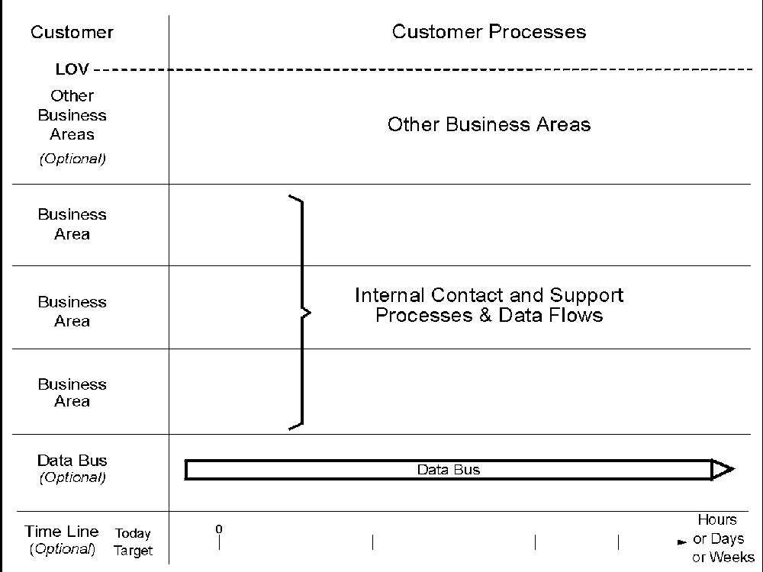
Figure 3. LLOVC Template
The Bands of the LLOVC Template
Following is a description of the bands of the LLOVC template:
- Customer Band - The customer band shows the major customer processes.
- Line of Visibility - The LOV is the interface line between customer processes and internal processes. It reflects:
- Service encounters
- What the customer sees
- Moments of truth
- The company's image.
Note: The service encounters occur at the LOV.
- Other Business Area Band - This band is optional and can be placed right below the LOV. If used, it contains symbols for business areas that are either internal or external to this LOB, but which are not shown as separate business area bands.
- Business Area Bands - There are several bands, which represent logical business areas of an enterprise, such as Sell, Order, Supply, Distribute, and Settle. Other terms that describe business areas can be Marketing, Administration, Supply Management, and Accounts Receivable. These bands contain internal logical processes and data flows.
Between two business area bands, there are lines, which represent internal interfaces. They can be thought of as internal LOVs, representing:
- What the other business area sees
- Internal moments of truth
- Where hand-offs take place
- Where dependencies are shown.
- Data Buses (Optional) - A data bus is a high-level dynamic data store that can link the process model or blueprint to a separate data architecture.
For most businesses, data is a very important asset. You must understand and manage it at the enterprise, the LOB, as well as at any level of design and implementation. Examples for optional data buses include:
- Customer data
- Product data
- Order data.
LLOVC Symbols
“LOVEM Symbols Summary Matrix” document shows the symbols that can be used on an LLOVC. For a detailed description of each symbol, refer to chapter on ”Symbols for Logical Modeling Techniques” on page 14.
Symbols on the LLOVC Template
Figure 4 shows how the symbols are placed on the LLOVC template. The customer processes interface with internal contact processes, and internal processes interface with each other, with customer processes, or with other business areas. The figure shows an optional data bus at the bottom of the chart.

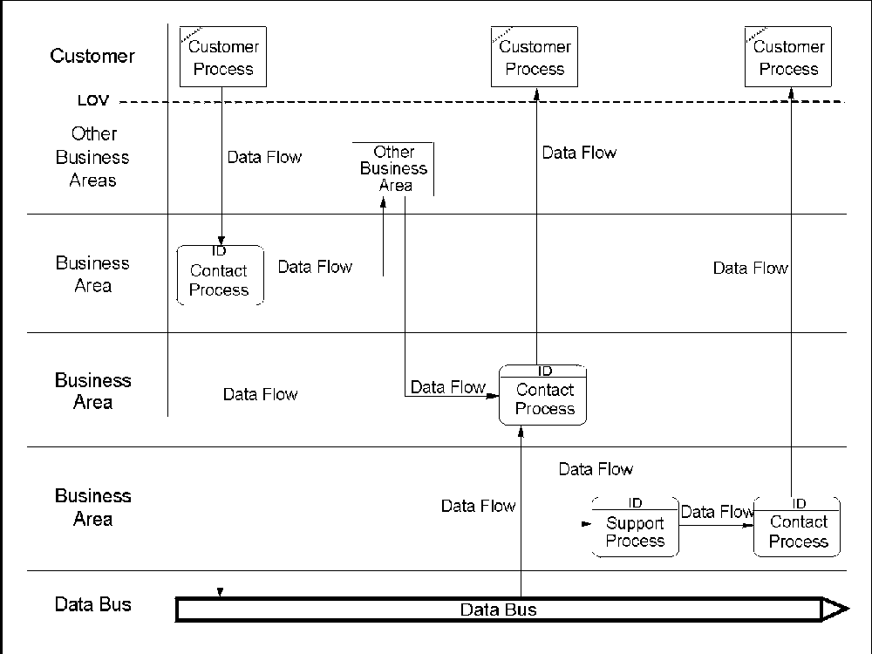
- What to Do and What to Avoid
The following lists some general guidelines to consider when creating an LLOVC:
- Keep the LLOVC logical and simple.
- Keep it at the process path level or sub path level for one LOB.
- Use logical and stable names for business areas, processes, and data flows.
Note: These are not physical names that you will find in your business, such as department, document, or systems names.
- Do not put more than one process into a process box.
- Use common and well-defined terms and definitions.
- Use a different LLOVC for each LOB.
- Use different LLOVCs for different sub paths for the same LOB, if necessary.
- Each component on the diagram must have an associated description for future reference.
- Differentiate data flows; do not show branching and keep them one-directional.
- Make sure data flows originate from, or terminate at, internal process processes.
- Make sure each process generates at least one output and has at least one input.
- The output of a process can only be produced based to the input; avoid spontaneous creation.
- Make sure a process receives only the input necessary to produce the output; avoid redundant input.
- Creating an As Is LLOVC
The As Is LLOVC shows your business processes at their current unconstrained level. This section explains the procedure for building an As Is LLOVC. Before you can build your LLOVC, you must collect information about the logical aspects of your business.
Collecting Information about your Logical Process Path
Use the following set of questions to collect information for creating your As Is LLOVC. The questions help you to determine the most important aspects of your LOB. You can supplement them with questions unique to your environment.
- What is the scope of your project?
- What business are you in?
List all key products and services.
- Who are your customers or clients?
- What are your customers' or clients' expectations?
Support this with customer research information.
- What are the competing best-of-breed factors?
How does your company compare?
- What are the key business rules, goals, policies, and strategies that should be expressed by the resulting process path design?
- What is the level of maturity for your LOB or for individual processes?
- What are the major service encounters with your customers, and what are their logical owners within the organization?
For example, a service encounter might be "ordering" and the logical owner could be "marketing"; another service encounter might be "inquiries about delivery schedule", and the logical owner could be the "order" business area.
Note: The number of different logical owners determines the number of bands on the chart.
What are the customer processes and internal processes involved in each service encounter?
- What are the necessary support processes, processes that are not part of a service encounter?
- What are the required input data flows and the expected output data flows for each process?
- What are the process quality and business control parameters, such as CMPs, CSFs, and goals?
Building an As Is LLOVC
Once you have identified the required components, you can build your LLOVC as follows:
- Draw a template with as many bands as there are logical owners and label them with the names of the logical owners. You can also use a blank LLOVC template (see Figure 3 on page 23).
Note: If you have identified many logical owners, group them together or add an "other business area" band below the LOV for business areas that you don't want to show as separate bands to have a template with a maximum of six bands. A chart with up to six bands is still readable and fits on a single page.
- Place a symbol for each component on the LLOVC template in the sequence as they occur in a relationship with a customer.
You usually start with a customer process requesting information. You can also start with an internal service encounter process offering information, such as in marketing.
- Connect processes with data flows.
- Add the process quality and business control parameter to the chart, such as AIRs, CSFs, CMPs, OAs, and PAs.
- If you want to highlight some key data requirements for the entire process path, for example, customer data, you can add an optional data bus to the bottom of the chart. Connect the data bus to processes through data flows.
- If required, you can also add an optional time line to the bottom of the chart.
- Label each component on the chart to make the chart more self-sufficient and add a detailed description for each component.
Creating a To Be LLOVC
When you have mapped your current business processes in your As Is LLOVC, you can start to create your To Be LLOVC. Using the As Is LLOVC as your base, you can use the following questions to validate your To Be LLOVC:
- Do you have all the service encounters that you need? Do you have too many?
- What is the optimal number of logical business areas? These will eventually be translated into physical organization units.
- Do you have all internal support processes that you need? Do you have too many?
- Do you have all the data flows that you need? Do you have too many?
- Can the sequence and flow be rearranged for better customer service?
- Did you account for all business rules, goals, policies, and directions?
- Did you address the best-of-breed factors?
- What is the expected process maturity level for your LOB?
- What process quality and business control parameters do you want to apply and at what points in the process path?
- What are the guiding principles on which the new process path design is to be based?
- Is the current systems architecture still valid or does it need revising?
- Do you need to re-engineer certain aspects of your LOB? What can you afford to re-engineer at a detailed level?
You can also use other analysis questions to fit your circumstances.
Note: Because the LLOVC is at the logical level, it is a relatively stable representation of your business. Therefore, the To Be LLOVC will be very similar, if not identical, to your As Is LLOVC.
How to Read LLOVCs
This chapter discusses how to read LOVCs to get as much information from them as possible. It is meant for individuals who have no need to know how to create LOVCs, but who have to work with LOVCs, or who want to understand LOVCs.
Things all LOVCs Share
LOVCs are drawn on predefined templates. Each type of LOVC has its own template, which is designed to graphically enhance the focus of the LOVC. Common to all LOVCs is the line of visibility (LOV). The LOV is the heart of each LOVC; it focuses on the service encounters with your customers.
Reading the LLOVC
An LLOVC is a logical view of one LOB. It shows the ‘what’, not the ‘how’ or ‘who’, of a process path. Figure 5 on Page 33 shows an example of an LLOVC.
An LLOVC shows the processes and data flows that make up the LOB and the interactions between customers and your business; customer processes are shown above the LOV. It can also include one or more dynamic data stores at the bottom of the chart. These represent important types of data that are used by the LOB; for example, customer or product data.
An LLOVC has a set of bands that represent logical business areas that make up the process path, such as marketing, order, and supply. There can also be one optional "other business areas" band, which is used to show business areas that are either not part of this LOB or that belong to the LOB but are not shown on the LLOVC as separate bands.
The boxes in the bands represent logical processes that are performed by the business areas. The arrows on the LLOVC represent data flows.
For a complete list of LLOVC symbols, refer to ”LOVEM Symbols Summary Matrix” document.
Figure 5 shows an example of an LLOVC for the mortgages LOB of a banking institution.

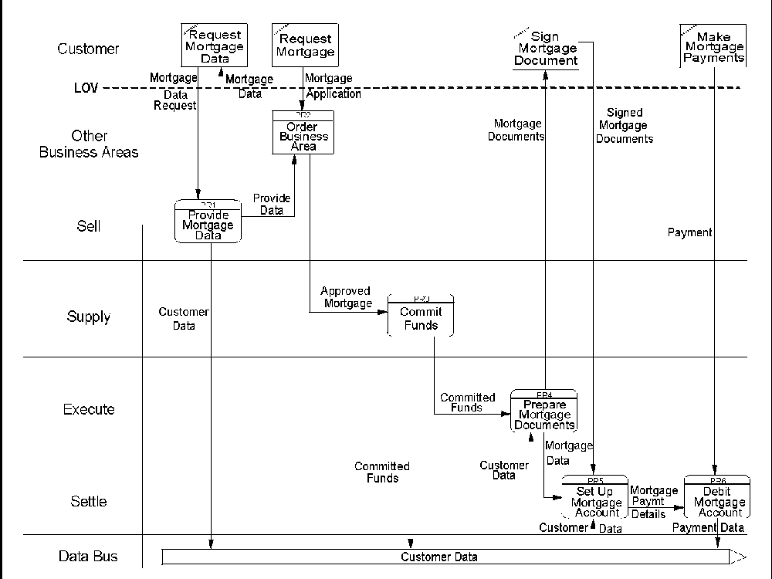
Figure 5. Example of an LLOVC
Read an LLOVC as a sequence of processes, usually initiated by a customer process. A process receives input data and produces output data. Throughout the process path, there are interactions with the customer: the service encounters.
Read the LLOVC from left to right. Look for interactions in which the customer initiates a service encounter; typically a request for data or a product. These interactions are represented by data flows that cross the LOV from a customer process to an internal process.
Data flows are labeled with the type of data they represent. Data flows can represent:
- Updates to, or retrievals from, the data bus
- Data passed to or from customer processes
- Input to or output from internal.
In Figure 5 on Page 33, there are two interactions initiated by the customer:
- Request Mortgage Data
- Request Mortgage.
The customer request for mortgage data is directed toward the Sell business area, which provides the requested data, updates the Customer Data bus, and forwards customer data to the Order business area.
The customer request for a mortgage is directed toward the Order business area, which verifies the mortgage application and updates the Customer Date bus; it then approves the application and sends the approved mortgage data to Supply.
The Supply business area commits the funds and sends committed mortgage data to Execute, which forwards the committed mortgage data to Settle and sends the mortgage documents to the customer. The customer signs the mortgage documents and returns them to Settle, which sets up the mortgage account and debits the account, whenever the customer makes regular mortgage payments.
Things to Look for in LLOVCs
Look for:
- The optimum number of service encounters
- Opportunities for automation, such as EDI, enterprise databases, enterprise systems, network computing, and work flow management systems
- Commonalties for organizational design
- CMPs, CSFs, MRs, PAs, or other process quality and business control parameters
- Opportunities for giving customers access to company data or letting the customer perform customer processes
- Potential for implementing the same policies, business rules, directions, service encounters across all LOBs
- Opportunities for merging or separating LOBs.
The logical views as expressed by the ALOVC and LLOVC can provide directions for the physical design of the new process path and jobs.
Example of an LLOVC
The example in Figure 6 illustrates an LLOVC of the mortgage process path of a banking institution.

Figure 6. Example of an LLOVC for the Mortgages Process Path of a Banking Institution
In the example in Figure 6, the customer processes are shown in the customer band above the LOV; they are:
- Request mortgage data
- Request mortgage
- Sign mortgage document
- Make mortgage payments.
Below the LOV Below the LOV are five bands representing the five major business areas that are involved in the process path; they are:
- Sell
- Order
- Supply
- Execute
- Settle
The ‘order’ business area is shown as an ’other business area’ symbol in the band ‘other business areas’.
The business area bands contain the most important processes that the business areas are responsible for. For example, the ‘sell’ business area is responsible for providing mortgage data, and the ‘execute’ business area is responsible for preparing mortgage documents.
The processes are connected through data flows. For example, the ‘order’ business area receives mortgage application data from the customer, and the ‘settle’ business area receives payment data from the customer and mortgage payment details from the internal process ‘set up mortgage account’ before it can debit the mortgage account.
At the bottom of the chart is a data bus that captures customer data. It is updated by the ‘provide mortgage data’, the ‘commit fund’, and the ‘debit mortgage account’ processes. The processes ‘prepare mortgage documents’ and ‘set up mortgage account’ receive customer data from this bus.
Success Factor
If you integrate and synchronize the logical design for one LOB with the overall enterprise architecture, you have a much better chance for a successful implementation of the re-engineered process path.
Summary
The LLOVC is an important part of LOVEM because it has many different applications for business process engineering and re-engineering.
The most important features of the LLOVC are:
- Focus on service encounters with customers
- Internal interfaces and dependencies
- Process sequence and flow
- Data flow and databases
- Process quality and business control parameters
The LLOVC provides a stable framework for the physical design of the new internal organization, processes and systems.
- General Hints and Tips
The following hints and tips apply to all LOVEM graphics:
- Use common and well-defined terms and definitions.
- Put only one process or activity in each process or activity box.
- Describe each component on the chart.
Hints and Tips for the LLOVC
Follow these hints and tips when creating or updating an LLOVC:
- Keep the LLOVC logical and simple.
- Keep it at the process path, or sub path, level.
- Use logical and stable names for business areas, processes, and data flows.
- Use different LLOVCs for each LOB.
- Use different LLOVCs for different sub paths for the same LOB, if necessary.
- Sequentially connect all processes on the path to show continuity.
- You can achieve this connection through customer processes, data buses, and other business areas.
- For decomposition of logical processes, use the DFD or HSD.
- For logical-to-physical transformation, use the LTL and NAVC.
- Symbols for Logical Modeling Techniques
This section describes the purpose and use of the symbols that can be used with the LLOVC, PLOVC, JLOVC and NAVC. To determine what symbols can be used with which modeling technique, refer to ”LOVEM Symbols Summary Matrix” document.
Activity
- Represents a manual action performed by a specific person at a specific time and place using input to produce output
- Can interface with:
- Other activities or tasks
- Customer activities
- Internal or external organizations
- Systems
- Has at least one input and one output
- Connects to other model components through information, material, or control flows.
AIR (Assumption or Issue or Recommendation)
- Represents any assumptions, issues, or recommendations
- Can be associated with activities or information flows
Note: It is suggested to put a brief notation about the nature of the AIR on the chart.
Airplane
- Represents a means for transporting material
- Can be associated with material flows
And
- Denotes that two or more information, material, and control flows have to happen
- Is placed between two flows
- 'And' is the default
Boat
- Represents a means for transporting material
- Can be associated with material flows

CMP (Critical Measurement Point)
- Identifies points on the process path where critical measurements are or should be taken.
Example: Cycle time or service quality measurements.
- Can be expressed in any unit of measure, such as time, quantity, or error rate
- Can be associated with activities.
Note: It is suggested to put a brief notation about the nature of a CMP on the chart.
Computer Data Store
- Represents computer files or media containing information
Example: An online database, batch file, computer tape, PC diskette.
- Connects to other model components through information flows.
Control Flow
- Represents a control flow
A control flow shows the passing of control from one activity to another or from an activity to a system.
- Connects activities and systems
CSF (Critical Success Factor)
- Denotes any factor that is critical for achieving the business goals and objectives
- Can be associated with activities, information flows, and systems
Note: It is suggested to put a brief notation about the nature of the CSF on the chart.
Customer Activity
- Represent an activity performed by a customer, such as:
- Apply for mortgage
- Receive invoice
- Is the source or destination of information or material flows
- Is placed in the customer band
- Connects to other model components through information and material flows
Diskette
- Represents an information medium
- Is associated with information flows
Document
- Represents a hard copy document, such as an order form, an invoice, or a report
- Can be associated with folders and information flows
Document Storage
- Represents a physical data storage where hard copy documents are stored
- Can be connected to other model components through information flows.
EDI (Electronic Data Interchange)
- Represents a means of transmitting information
- Can be associated with information flows.
Electronic Document
- Represents an electronic document, such as an electronic image of an order form, an invoice, or a report
- Can be associated with electronic folders and information flows.
Electronic Folder
- Represents an electronic folder for storing electronic images of paper documents
- Can be associated with electronic documents and information flows.
EXIT
- Points to other external architectures, models, or blueprints, which are not part of this project
- Can be connected to other model components through information flows
- Can also be stand-alone
EXITC
- Represents an exit condition on a NAVC
- Receives input triggers from preceding model components through control flows
Fax
- Represents a means of transmitting information
- Can be associated with information flows
Folder
- Represents a folder for storing hard copy documents
- Can be associated with documents and information flows
Forklift Truck
- Represents a means for transporting material
- Can be associated with material flows and activities
G (Goal)
- Denotes a business goal
- Can be associated with activities, information flows, and systems
Note: It is suggested to put a brief notation about the nature of the GSP on the chart.
Go-to Connector
- Denotes that the flow of sequence continues on a subsequent page
- Need a source and target go-to connector with the name of the target and source activity, respectively
- Connects with other components through information, material, or control flows
Happy Customer
- Represents satisfied customers
- Can be associated with customer activities and internal activities.
HSD
- Denotes that an HSD exists with the given name
- Can be connected to other model components through information, material, or control flows, if it represents an activity
- Can also be associated with activities, systems, and system functions
IFD
- Denotes that an IFD exists with the given name
- Can be connected to other model components through information, material, or control flows, if it represents an activity
- Can also be associated with activities.
Information Flow
- Represents a flow of information between model components, such as:
- A request for information
- An order from a customer
- An invoice to a customer.
- Can have a visual representation of the flow medium, such as a telephone, a fax machine, or a document
- An information flow can be described by a set of representative attributes
- Connects other model components
Internal or External Organization
- Represents any internal department or job, or an external company or government agency, such as a bank, a supplier, or a government agency, but not a customer
- Connects to other model components through information, material, or control flows
IOR (Inclusive Or)
- Represents an inclusive 'or' condition
- Is placed between two information, material, or control flows
- Denotes that one or the other or both flows can happen.
Example: A customer can place an order by phone or mail or both.
JLOVC
- Denotes that a JLOVC exists with the given name
- Can be connected to other model components through information, material, or control flows, if it represents an activity
- Can also be associated with activities.
LAN
- Represents a local area network (LAN)
- Can span multiple departments or jobs
- Can be associated with activities and information flows.
Note: It is suggested to put a brief notation about the nature of the LAN on the chart.
Location
- Represents the location where a process is performed
- The physical location of an organization unit, such as a department or a job
- Can be associated with activities.
Note: It is suggested to put a brief notation about the location on the chart.
Loop Connector
- Represents the starting point of a loop.
The loop connector carries the name of the activity where the loop starts. If the flow goes to the loop connector, it returns to the activity with the name of the loop connector. There are two sets of exit criteria for a loop:
- One set contains the criteria for exiting the loop through the normal flow when the exit criteria are met.
- The other set contains the criteria for how often the flow can go through the loop before exiting it if the first criteria are not met. This set also has to describe where the flow continues in case of an abnormal termination.
The exit criteria for loops should be described in the description field for the loop connectors.
- Connects to other model components through information, material, or control flows
Magnetic Tape
- Represents an electronic data storage medium
- Can be associated with systems, system functions, computer data stores, and information flows
Note: It is suggested to put a brief notation about the nature of the magnetic tape on the chart.
Mail
- Represents a means of sending information or material
- Can be associated with information or material flows
Note: It is suggested to put a brief notation about the nature of the object being mailed on the chart.
Material Flow
- Represents the flow of material, such as:
- Computers
- Car
- Computer parts
- Can have a visual representation of the means of transportation associated with it, such as a truck, a boat, or a plane
- Connects other model components
MR (Maturity Rating)
- Denotes the level of maturity of a process or process path
- Can be associated with activities
Note: It is suggested to put a brief notation about the maturity rating on the chart.
NAVC
- Denotes that a NAVC exists with the given name
- Can be connected to other model components through control flows
OA (Opportunity Area)
- An area on process path or job, where major breakthroughs can be achieved, such as new technologies, personnel strategies, revolutionary means of transportation, distribution, or material handling
- Can be associated with activities
Note: It is suggested to put a brief notation about the nature of the OA on the chart.
Office System
- Represents the use of an internal office system, usually for communicating within a department or between departments
- Can be associated with information flows
Note: It is suggested to put a brief notation about the use of the office system on the chart.
Online Link
- Represents the use of an electronic link for communicating with external organizations, such as customers, vendors, suppliers, or government agencies
- Can be associated with information flows
Note: It is suggested to put a brief notation about the use of the online link on the chart.
Other (Other Graphic)
- Denotes that there exists another type of graphic, not defined in LOVEM, with the given name
- Can be connected to other model components through information, material, and control flows, if it represents an activity, system, or system function
- Can also be associated with activities, systems, and system functions.
P (Policy)
- Denotes a business policy
- Can be associated with activities, information flows, and systems.
Note: It is suggested to put a brief notation about the nature of the P on the chart.
PA (Problem Area)
- Any area on the process path that prevents you from achieving goals such as target cycle time, productivity goals, or planned operating cost.
Example: Bottlenecks, cost overruns, lack of, or too much, automation, cycle time problems.
- Can be associated with activities and information or material flows.
Note: It is suggested to put a brief notation about the nature of the PA on the chart.
Percentage of Time Spent
- On a PLOVC, it represents the percentage of time spent for one activity, sub path, or job as compared with the overall process path
- On a JLOVC, it represents the percentage of time spent for one activity or sub job, as compared with the overall job
- Put the number that represents today's time above the symbol on the chart and the target time below it
- Can be associated with activity, PLOVC, and JLOVC symbols.
Person
- Denotes that a service encounter or any other interface is carried out by a person
- Can be associated with information or material flows.
Note: It is suggested to put a brief notation about the nature of the interface on the chart.
PLOVC
- Denotes that a PLOVC exists with the given name
- Can be connected to other model components through information, material, or control flows, if it represents an activity
- Can also be associated with activities
Printer
- Represents the printing of documents
- The location of the printer symbol on the PLOVC or JLOVC indicates where the documents are printed
- Can be associated with information flows and activities.
Note: It is suggested to put a brief notation about the nature of the printer or print jobs on the chart.
Report Layout
- Denotes that a report layout exists
- Can be associated with systems or system functions.
S (Strategy)
- Denotes a business strategy
- Can be associated with activities, information flows, and systems.
Note: It is suggested to put a brief notation about the nature of the S on the chart.
Screen Layout
- Denotes that a screen layout exists
- Can be associated with systems or system functions.
Shredder
- Represents a facility to destroy hard copy documents
- Can be associated with activities, information flows, and documents.
Note: It is suggested to put a brief notation about the nature of the shredding operation on the chart.
Skill
- Denotes the skills required to perform the activities of a job
Example:
- Communications skills and telephone etiquette for a job that deals with customers over the telephone
- Marketing skills
- Order entry systems skills.
- Can be associated with activities, systems, information and material flows, and JLOVC symbols.
Note: It is suggested to put a brief notation about the nature of the skill on the chart.
STARTC
- Represents a start condition on a NAVC
- Sends triggers to downstream model components through control flows.
System
- Represents a data processing system, such as:
- An order entry system
- An invoicing system.
- If the system symbol is placed on the manual-to-automation interface line, it represents an online system
- If the system symbol in the automation band is below the manual-to-automation interface line, it represents a batch system
- Connects to other model components through information flows.
System Function
- Represents an automated activity or procedure performed by a system
- On a PLOVC or a JLOVC, it is placed in the automation band below the manual-to-automation interface line
- Can indicate a systems requirement or an existing system function
- Connects to other model components through information flows
- Can also be associated with systems.
Task
- Represents the lowest level activity or smallest unit of work
- Connects to other model components through information, material, or control flows.
Telephone
- Represents a means of transmitting information
- Can be associated with information flows.
Truck
- Represents a means for transporting material
- Can be associated with material flows.
Unhappy Customer
- Represents dissatisfied customers
- Can be associated with customer and internal activities.
XOR (Exclusive Or)
- Represents an exclusive 'or' condition
- Is placed between two information, material, or control flows
- Denotes that only one or the other of the flows can happen
- Can also be used as a decision symbol.
If used as a decision symbol, put a notation about the decision conditions on the chart and describe them in the description field of the source or target activity.
Example: A mortgage application can be accepted or rejected. The following conditions can happen:
- Condition: mortgage application is accepted
Information flow: acceptance notice
- Condition: mortgage application is rejected
Information flow: rejection notice

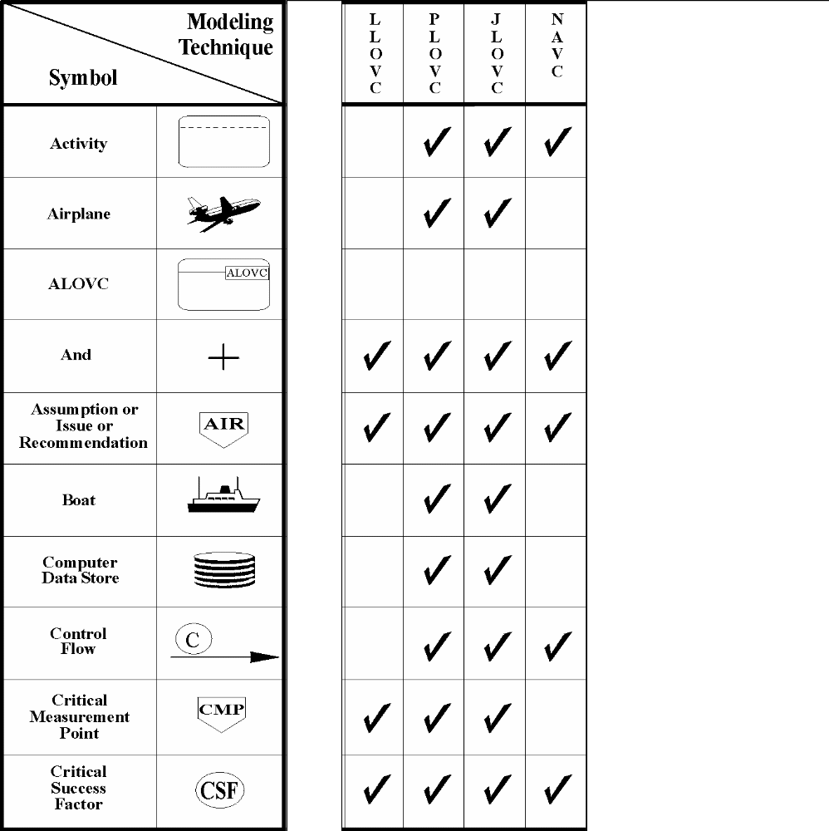
- Symbols Summary Matrix

Figure 7(Part 1 of 8). LOVEM Symbols Summary Matrix
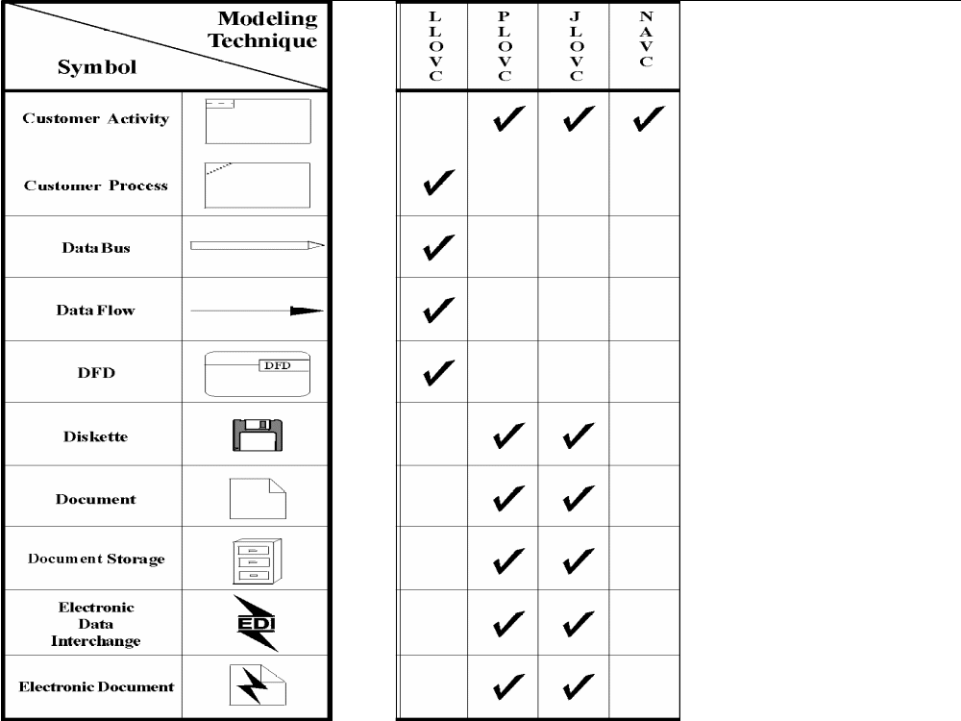

Figure 7 (Part 2 of 8). LOVEM Symbols Summary Matrix

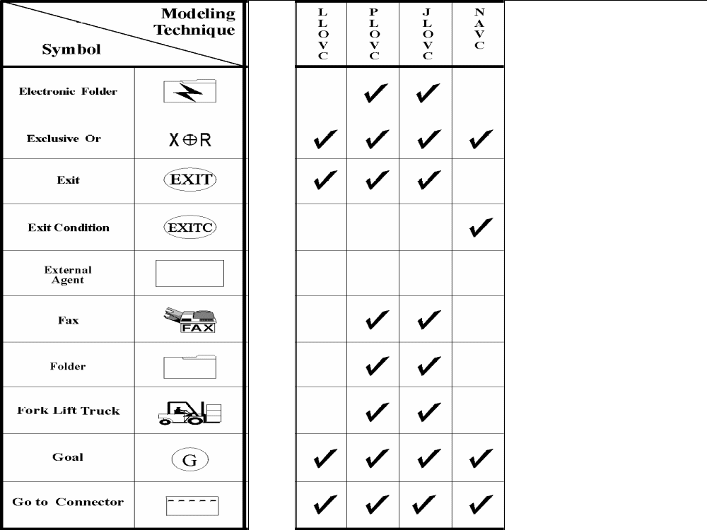
Figure 7 (Part 3 of 8). LOVEM Symbols Summary Matrix

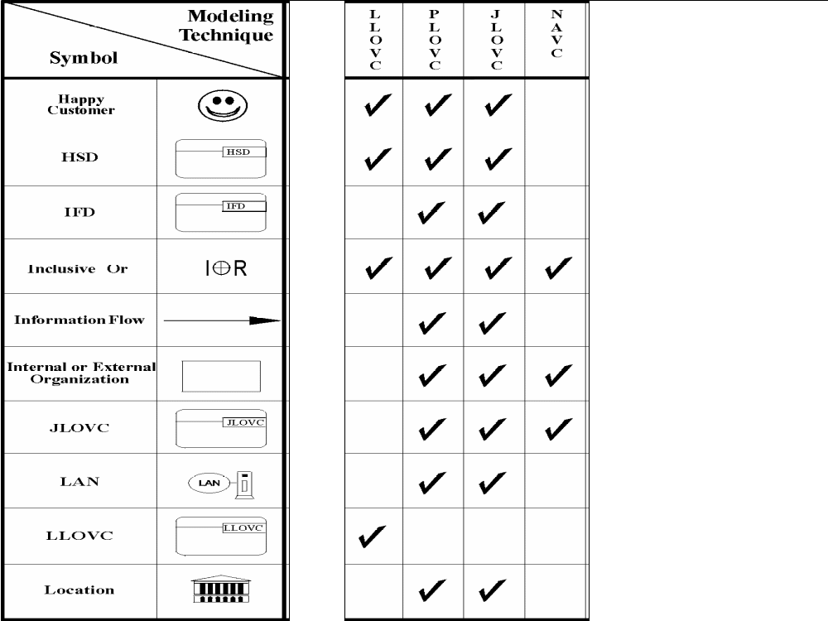
Figure 7 (Part 4 of 8). LOVEM Symbols Summary Matrix
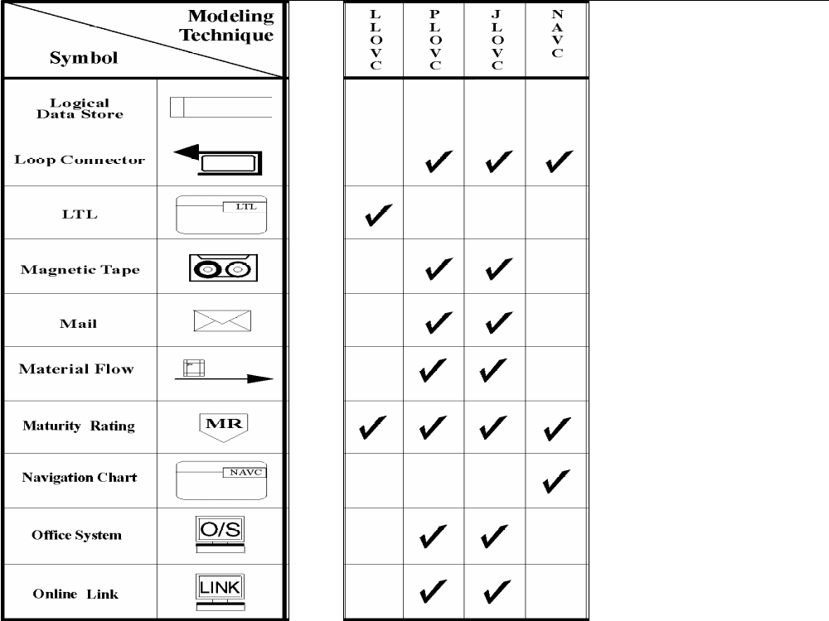
Figure 7 (Part 5 of 8). LOVEM Symbols Summary Matrix
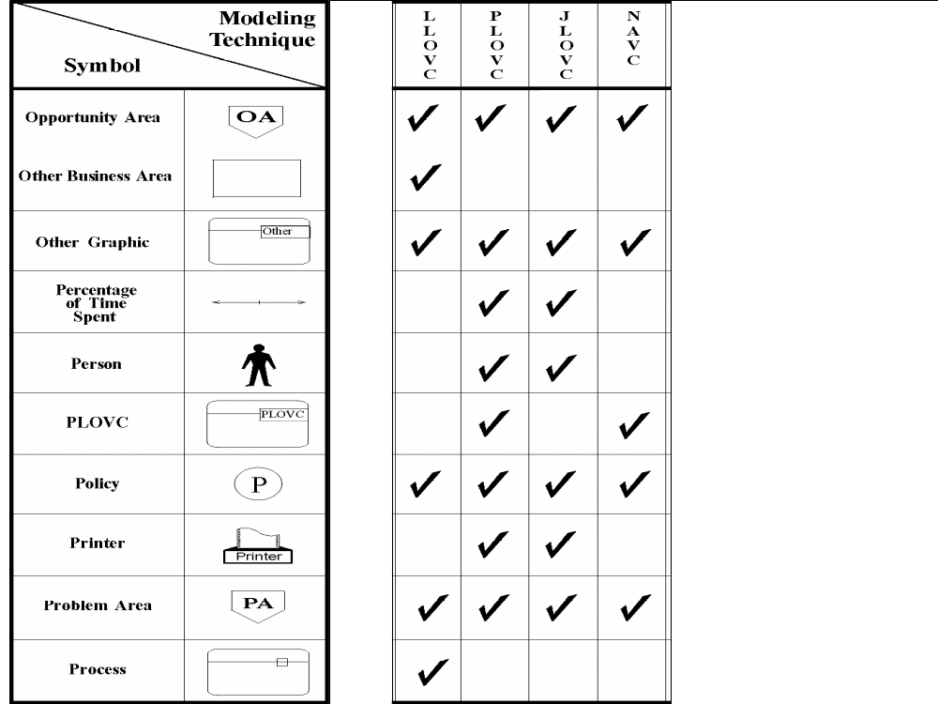
Figure 7 (Part 6 of 8). LOVEM Symbols Summary Matrix

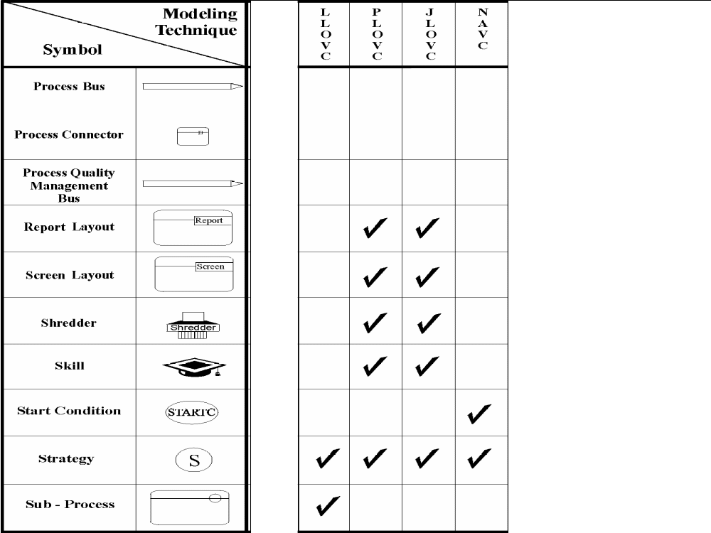
Figure 7 (Part 7 of 8). LOVEM Symbols Summary Matrix

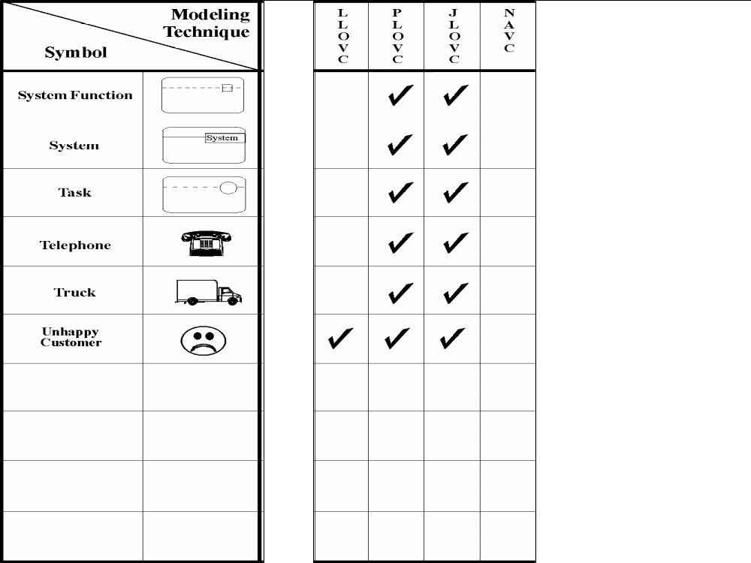
Figure 7 (Part 8 of 8). LOVEM Symbols Summary Matrix
- Revision History
Revision Number | Revision Date | Summary of Changes | Changes Marked?
1.1 | October 2000 | Applied new template and style, spelling and grammar review.
1.0 | May 1999 | Base Version. Mark Eaton - converted from earlier WordPro documents.

