

IBM Global Services

Vendor Analysis

Technique Paper (TP)

© Copyright International Business Machines Corporation 2001
All Rights Reserved
Version 1.0, October 2001
1 Description
The purpose of the Vendor Analysis is to provide the information necessary to develop a Decision Model based on high level target business capabilities or requirements, determine measurements for these target capabilities and a Capabilities Model based on vendor intellectual capital. The objective, based on a comparison of these high level criteria and associated measurements and capabilities is to create a short or “interim list of vendors for final Vendor Evaluation.
The Vendor Analysis technique paper is the summarization of information from the RFI and/or research. This is used to assist the project team in evaluating a “long list” of potential vendors in order to identify an “interim list” of vendors that best meets the needs of the client.
This also provides a document that can be used in a structured presentation to the client executives to lead them through the selection process of a list of interim vendors. The document may also serve as a reference guide for the client to justify to their organization, which vendors will be part of the detailed selection.
The Vendor Analysis captures valuable information provided from vendors’ based on the High Level Business processes and requirements to be supported by the package and the generic requirements for the application and vendor, and the technical requirements for the software package.
This includes a review of strategic business processes, requirements and an evaluation of existing or newly developed Vendor Intellectual Capital. This can include a Request for information (RFI) or a Request for Solution (RFS) in order to evaluate each vendor's ability to satisfy the initial future capabilities and attributes identified by the client as well as a software providers current and future viability to the client.
The may include development of a:
- Request for Information,
- Decision Model
- Request for Proposal or Request for Solution,
- IT Platform RFI/RFP,
- Vendor Response Summary
as appropriate.
Without a Vendor Analysis there is no clear quantifiable link between the Business Strategy and the Software Solution. This creates a risk to the project by introducing uncertainty as to the basis for the Vendor Selection and to a subsequent implementation by not effectively assessing Vendor capability and may ultimately impact any decision to proceed.
It is also not efficient to evaluate all possible software solutions supporting all business processes within the scope of an engagement. The Vendor analysis allows the client to limit the vendor evaluation to the best alternatives that will provide the business capabilities necessary to support their needs.
This approach affords maximum focus to those possible solutions that are the most likely alternatives for the enterprise solution.
An experienced consultant can develop a vendor analysis process from existing work products without following this technique. Also if the scope of the business processes is sufficiently specific as to limit the possible alternatives to less than five a Vendor Analysis process may not be required.
2 Context
The purpose of this technique is to provide a document that can be used to provide continuity between the business strategy and requirements and the software evaluation in order to arrive at a software solution.
This may include but not be limited to:
- The Vendor Analysis is based on the functionality required by the client in its software solution. The Decision Model is generated from the results of the business process definition and processes for the software being evaluated. It documents metrics based on defined business process and high-level requirements for each selected software vendor alternative in order to evaluate vendor information
- A Request for Information, which gathers detailed information about package vendor software products and services that may suit the client's software needs.
- A Pre-Qualification Analysis that details the RFI findings and can be used to limit the “qualified vendors” based on their ability to satisfy the initial To Be capabilities and attributes identified by the client. The Pre-Qualification Analysis assists in creation of a Vendor “interim list”.
- A Request for Solution or Proposal which is a formal procurement document that solicits responses from package vendors to detail their software solution. It presents a clear understanding of the client's software selection goals and objectives to the vendors and solicits the vendors to provide their software’s solution to address those business needs.
- An evaluation of the potential impact upon the IT Platform by the software packages being considered in order to support the business strategy, goals and objectives. It identifies the high-level infrastructure environment necessary to support the strategy, processes as well as the technical capability of each possible software solution. This may be a formal part of the initial RFS/RFP process, a secondary request or developed based on existing intellectual capital.
- A summarized analysis of the package vendor's responses to the RFI, RFS or RFP. It reports the detailed and summary view of the vendor’s software compared to the functional requirements of the client by process and business areas. It also presents the Vendor Short List.

3 Steps
The Vendor Analysis technique provides a summary view of information necessary to develop and evaluate the “long list” of vendors for comparison and elimination of vendors. It captures data on the overall stability of the vendors and their products as well as their industry focus. This technique overviews the vendors’ technology, functionality and provides general information about the vendors for review by the team in order to identify a vendor “short list.”
The format of this technique can vary tremendously. The content emphasized for a client presentation is recommended as a subset of the analysis material to present. The consultant should add any research information that is unique to the client, industry, or solution that would differentiate one solution vendor from another. The important outcome, however reached, is to gain the client’s agreement that the vendors on the shortlist are the correct vendors to invite in for Evaluation.
These work products are normally developed in a series of spreadsheets and word processing documents, but may be created in a database or in word processing tables.
The Vendor Analysis content should consist of the following work sheets or pages:
- Title Page
- Client Strategy
- Client Decision Model
- Vendor Long List
- RFI Response Summary
- General Information - This section captures company profile information such as name, locations, number of employees, contact data, web sites, etc.
- Stability/Focus - This section details company history information such as number of years in business, number of installations, industry focus and client base. It may also be used to capture financial performance and risk assessment information.
- Technology Overview - This section details the general technology base of the product such as operating system, database(s), hardware requirements, etc. It also looks at type of technology and interface provided by the vendor (i.e., Client/Server, GUI, etc.)
- Functionality Overview -This section outlines the functional capabilities of the software being offered by the vendor against the functional criteria identified by the client.
- Vendor Elimination – Interim List
- This section details the elimination of vendors from consideration, listing the reason for elimination.
- Vendor Interim List
- This section identifies the resulting “interim list” of vendors that will be considered going forward in the engagement.
- RFS/RFP Response Summary
- General Information - This section captures company profile information such as name, locations, number of employees, contact data, web sites, etc.
- IT Platform Analysis - This section details the general technology base of the product such as operating system, database(s), hardware requirements, etc. It also looks at type of technology and interface provided by the vendor (i.e., Client/Server, GUI, etc.)
- Functional Requirement Matrix Response - This section outlines the functional capabilities of the software being offered by the vendor against the functional criteria identified by the client.
- Technical Requirement Matrix Response - This section outlines the technical capabilities of the capabilities of the software being offered by the vendor against the technical environment required by the client.
- Vendor Elimination – Short List
- This section details the elimination of vendors from consideration, listing the reason for elimination.
- Short List
- This section identifies the resulting “short list” of vendors that will be considered going forward in the engagement.
After the analysis is complete, the information should be displayed in a presentation for the client. The main advantage of the work product is to take the client through the process of the interim list selection; therefore, the presentation format seems to be the preferred approach to creating this interactive discussion session.
The main sections of the presentation portion of the work product include:
- Cover Sheet
- Table of Contents
- Overview of Process and Sources
- Screening Criteria appropriate for the client environment
- Initial Long List of possible solution providers
- Vendor Analysis Process
- Elimination Criteria and Justification
- Recommended Short List of Vendors
- Next Steps
Define Package Evaluation Criteria
The purpose of this task is to capture client requirements for software selection and to evaluate the initial capability of a vendor's software solution to the business needs of the client. The completed matrix is used to identify initial functional “gaps” or special software enhancements needed to enable each vendor's software to fulfill the client's desired system capabilities and evaluate their relative impact.
This initial matrix is called a Decision Model. The Decision Model is an analytical hierarchy of the criteria used in evaluating the alternative solutions to the client business requirements. It provides a single set of selection criteria for components, packages and suppliers to provide the functions and capabilities required by the client. It is essential that each criterion be carefully selected and defined so that no room for ambiguity is left when performing the actual evaluation and selection
The purpose of the Decision Model is to define and document the decision and measurement criteria used in evaluating alternative solutions to the client defined business requirements. The Decision Model provides a structure for summarizing the opinions and interpretations of the selection team, and represents the complex decision process in a simplified model. It is important to create this scoring type model early in the process so that interpretation of the vendor response results is consistent and objective.
The Decision Model can be developed using a variety of techniques ranging from text to graphical notations. The hierarchical decomposition of the decision model can be documented using MS Word, MS Excel, VISIO, or PowerPoint.
The choice of tool and technique used in documenting the decision model will depend greatly on the complexity of the model and the level of detail at which the client chooses to evaluate the alternative solutions.
Very complex decision models, and those defined with the intent to evaluate alternative solutions at the lowest process level, should use a graphical organization chart format to describe the evaluation criteria, weighting, and hierarchical relationships among the business processes. For less complex decision models, or when decision criteria are defined at a summary level (i.e., business area), documenting the decision model as text using MS Word may be more appropriate.
The development of the Decision Model is the responsibility of the client core selection team with guidance from the IBM consultant. It is very important that the final set of decision criteria represents a consensus among the core selection team members.
The development of this work product is usually performed in a “workshop” setting. All members of the core selection team should be present or at least represented to achieve consensus of the final decision model. The IBM consultant should facilitate this working session and perform the following steps:
- Define the major categories for solution evaluation. These will typically represent the different areas of concern (i.e., business area, functional areas).
- Define the minor categories for each major category as appropriate. This may include key process areas, key functional components, or other areas that the client feels is an essential differentiate in evaluating the alternatives. Define sub-categories as appropriate depending on the level of complexity of the client process requirements (but only if it aids in the analysis of the results from the solution evaluation process).
- Assign a weight value to each major category relative to the other major categories. One example would be to start with 100 total points, and allocate them to each category until the "correct" balance is achieved. The "correct" balance attempts to represent the importance of having, and the risk of not having, a strong fit to the client preferences and requirements in a category.
- Allocate a weight value down through the hierarchy to the lowest level of detail.
In doing this, attempt to match business benefits to the detail levels to guide the allocations.
It may be helpful to produce a scoring guideline to improve the objectivity of the weighting of each category. Use the guides to provide a "minimum/maximum" advice to the decision team.

Develop RFI
The Request for Information (RFI) is a tool for gathering detailed information about a vendor's products and services. This work product is a brief, expedient document designed to focus on vendor products that may suit the client’s software needs. Some RFIs are distributed and responded to via electronic mail due to the necessity of a quick response. This work product is generally produced when the software being considered is of a greater level of complexity (such as an application software suite, an operating system or platform, or a sophisticated software tool).
The Request for Information is an informal work product that seeks to gather qualitative and quantitative information to assess the vendor’s offerings for potential “fit” with the client’s business requirements. It offers a less rigorous means of gathering information on vendor products and services to identify vendors to respond to the Request for Proposal (RFP) or Request for Solution (RFS) and present their products in a scripted functional demonstration.
The RFI is usually a word document that typically includes the following sections:
- Title Page: A title page for the RFI should be created to display the client name, logo and project name as well as the date of release to the vendors.
- Table of Contents: A table of contents should be developed to assist ease of use for the vendor.
- Project Background: The project background provides an overview of the client’s business focus and the business areas within scope of the software selection. It usually provides a brief overview of the selection project and other initiative that affect the selection.
- Procedures and Rules: A brief description outline of the selection process, its timeline and major milestones are provided. The response format is informal and allows the vendor to respond quickly with their product and service information. A request for specific information should be prepared to best evaluate the vendor offerings.
- Response Content: This section outlines what information is desired from the vendor. It should emphasize that the RFI seeks information on the vendor’s product, its functionality and technical details rather than marketing related materials. It is often necessary to require electronic responses due to time constraints.
- Key Contacts: This section should identify the key contacts for the vendor. It should provide names, addresses, and phone and fax numbers as well as e-mail addresses. The key contacts section indicates who will administer the RFI, answer vendor questions and establishes a clear communication vehicle for the vendor.
- Background: This section should supply any background information that will assist the vendor in responding to the RFI. This may include:
- Known Constraints (usually technical)
- Business Volumes or Metrics
- Business Process Descriptions
Pre-qualification Vendor Analysis
The Pre-Qualification Vendor Analysis work product is the summarization of information from the RFI and/or research. This work product is used to assist the project team in evaluating a “long list” of potential vendors in order to identify an “interim list” of vendors that best meets the needs of the client.
The Pre-Qualification Vendor Analysis work product captures valuable information provided from the vendors’ Request for Information (RFI) responses. This information helps the team evaluate each vendor's viability as a software provider to the client. This work product captures the following information about the vendors, where available:
- General
- Company Profile
- Contact Information
- Stability and Focus
- Duration in Business
- Installation Base
- Financial Status
- Industry Experience
- Technology Overview
- Functional Capabilities (high level)
The Pre-Qualification Vendor Analysis work product details the team’s findings and justifies elimination of vendors to the client, thus gaining “buy in” from the client. This is developed by the IBM Selection Team members upon receipt of the vendor responses to the Request for Information. The team the prepares the analysis according to the following steps:
- Collect the vendor responses to the RFI.
- Clarify responses, if needed, and validate information from the vendor where appropriate.
- Research any missing information from the vendor.
- Populate the template and adjust to meet the specific needs of the client.
- Evaluate information with the work product to determine elimination of vendors based on client criteria, document reasons for elimination.
The IBM team will use the vendor information to analyze each potential vendor’s ability to satisfy the initial future capabilities and attributes identified by the client. The Pre-Qualification Vendor Analysis work product assists in completing this task in order to eliminate vendors to reach an “interim list” of vendors.
Develop RFS/RFP
The Request for Proposal (RFP) is a formal procurement document that solicits responses from vendors to detail their software solution. It presents a clear understanding of the client’s software selection goals and objectives to the vendors and solicits the vendors to provide their software’s solution to address those business needs. It focuses on the client’s major business processes, business performance goals and the essential system requirements associated to the client’s desired business processes for the future.
Some clients may choose to use a more informal procurement document, the Request for Solution (RFS) instead of the RFP. The client’s procurement organization and guidelines will make this choice. The RFS also presents a clear understanding of the client’s software selection goals and objectives to the vendors and solicits the vendors to provide their software’s solution to address those business needs.
The purpose of the Request for Proposal is to gather enough detailed information about the vendors in order to compare vendor solutions in detail. It solicits vendors, identified through the vendor analysis task, to assist the client in reaching a viable solution to their future business needs. Unlike the RFS, it includes more specific requirement and environment formats and often includes legal terms and conditions the vendors must accept before they go forward in the selection process.
Normally, this document is used in conjunction with the Requirements Matrix to evaluate each vendor’s functional “fit” to the client’s needs, but some engagements may require that the requirements be embedded in the RFP document.
The Request for Proposal (or Request for Solution) provides an overview of the client’s business objectives, company background, the project scope, its desired future business processes, and a brief overview of the current technical environment.
The RFP (or RFS) is usually a word processing document that typically includes the following sections:
- Title Page
A title page for the RFP should be created to display the client name, logo and project name as well as the date of release to the vendors.
- Table of Contents
A table of contents should be developed to assist ease of use for the vendor.
- Procedures and Rules
A brief description of the RFP, its purpose and the selection process should be included. This section should outline the RFP schedule, how to respond to the RFP and who should be contacted. In addition, a standard statement of confidentiality appears in this section for the vendor to sign upon their response.
- Legal Terms and Conditions (normally not required for the RFS)
A detailed overview of the terms and conditions required to participate in this software selection bid process. It includes:
- Contract type
- Rules for modification
- Terms
- Settlement of disputes
- Confidentiality
- Termination criteria
- Penalty and Bonus clauses
- Payment Schedule
- Background
The background section should detail the client, their current environment; any key issues or problems as well as their future business strategy.
- Vendor Questionnaire
The vendor questionnaire section should consist of specific questions addressing the vendor’s company background and financial performance, their warranty policies, a technology overview as well as soliciting references for the reference check task.
The IBM Selection team develops the Request for Proposal. The IBM Selection Team members use information gathered on the client, include appropriate best practices and complete the RFP for delivery to the vendors.
Prepare the Request for Proposal according to the following steps. These steps will be the same for a Request for Solution, exceptions are noted.
- Utilize the various models and work product components produced during the pre-selection phases to identify the business areas to be evaluated in the RFP as well as specific problems or issues the client is seeking to eradicate with the software solution.
- Develop the purpose description for the RFP, which will establish to the vendors the desired result of the software selection. Emphasize the focus of the software selection in the purpose to ensure a clear understanding of the client’s goals.
- Determine the schedule for the selection process to highlight key dates to the vendor.
- Establish the response content and format desired from the vendors.
- Identify the key points of contact for the vendor with regards to the RFP.

Develop IT Platform RFI & RFP
The IT Team’s goal is to develop the criteria required to understand, define and evaluate the potential impact upon the IT Infrastructure by the software packages being considered in order to support the business strategy, goals and objectives. In order to dos this the client may submit an RFI to specific information on vendor products and services in support of a subsequent RFS/RFP document

Sections included in this process are:

- Assessment of Current IT Infrastructure, Standards & Applications
- IT Requirements Workshop Results
- Preliminary IT Requirements Matrix
- IT Infrastructure RFI/RFP

Initially the team will request information in order to evaluate the software "To Be" client/server infrastructure requirements, the current "As Is” infrastructure and methods for leveraging the existing IT infrastructure. The team will also begin to define the client/server workload, the technical architecture and design (Servers, Network) and the required skills, staffing and training necessary to complete the implementation. The objective is to define the future technology configuration and estimate incremental infrastructure utilization.
During this process the team utilize metrics based on defined business strategy and process for each selected software vendor alternative as documented during the initial vendor evaluation.
This will provide the basis for the high level evaluation of:
Business Volume & Service Level Requirements
- Business Volume & Transaction estimates based on a questionnaire/interview of the client IT Staff
- Assumptions for Development/Test/ Production Availability and Response Time
“To-Be” Technical Infrastructure
- Infrastructure Requirements - End User throughput requirements
- Capacity Requirements and Database, Application, and Support Servers
The potential architecture for each software alternative will be based on a high level view of the hardware impact of software on IT infrastructure and an estimate of budget costs to develop and configure the solution. This may include multiple detailed server configurations and costs for each software product based the architecture environment and the number of active users.
During this process the team will identify the operational and organizational environment necessary to support the strategy and process for each selected software vendor alternative. This will include high level estimations of:
Required Operational Processes
- Identification of required processes for the prospective vendors
- Requirements to Enhance Processes
IT Staffing Requirements
- Identify required IT Team Skills
- FTE Requirements
Additional Process level criteria that may be taken into account include:
- Backup/Recovery methodology for software across the necessary platforms is critical for system availability.
- Change Management must be a comprehensive process for software related changes.
- Batch Scheduling must be a formal process for the software environment to meet the functional requirements.
- File Transfer (interfaces) should use standardized enterprise-wide tools and procedures to facilitate requirements for interfaces and data conversion.
- Output Management requires processes to be developed which can be used with existing applications and which are complementary to software.
- Security requires access to be restricted to authorized users in order to maintain the integrity of the software system.
- Service levels are the driving forces behind all processes. Service levels need to be quantified, documented, measured, and managed with the end users.
- System Management requires an enterprise-wide and topology independent process to support the enterprise-wide applications.

Summarize Vendor Response
The Vendor Response Results and Shortlist work product summarizes the analysis of the vendor's responses to the Request for Information (RFI), findings of the Pre-Qualification Analysis as well as responses to the Request for Proposal (RFP) or Request for Solution (RFS). It details the scored results of the vendor responses to the Requirements Matrix using the Decision Model. In addition, it outlines the initial "pros and cons" of each vendor solution, initial cost information, elimination criteria of the shortlist evaluation, and concludes with the vendor shortlist identified for the software demonstrations.
The Vendor Response Results and Shortlist work product is the summarization of the completed Requirements Matrix using the Decision Model designed with the client. The results are used to assess the initial functional “fit” of a vendor’s software solution to the business needs of the client.
This work product also summarizes the justification of moving from the list of vendors on the interim list to deciding which vendors are to be brought in for vendor demonstrations. The presentation document’s purpose is to walk the client through the following processes that were used to reach the shortlist of vendors.
- Details the summary results of the RFI/RFP results
- Shows the analysis performed on the interim vendors
- Justifies the elimination of vendors that should not be pursued
- Defines the shortlist of vendors that should be scheduled for demonstrations
In addition, the work product is the document where the preliminary cost models for the vendors that will be demonstrating are presented. The document will also serve as a reference guide for the client to justify, to their organization, which vendors will be part of the detailed demonstration selection process.
The Vendor Response Results and Shortlist provides a summary view of each vendor’s ability to meet the functional, general, and technical requirements desired by the client in their software solution. It begins with the completed Requirements Matrix with additional spreadsheets. The additional spreadsheets detail the decision model and summary results of the vendor responses.
Vendors respond by populating the Requirements Matrix using a scoring model to indicate their ability to satisfy the functional, technical, and general requirements with the current release of their software. A comments section is included to describe anticipated enhancements (& release dates), customizations, etc.
Vendors score their software using the following model:
- 2 - Now Standard: Supported in Current Version
- 1 - Planned as Standard: Definitely Supported in Next Release
- 0 - Not Supported or Planned: Requires Custom Modifications
Vendors are able to provide additional detail to each requirement to clarify their response using the "Comments" column within each worksheet.
The Vendor Response Summary should consist of the following:
- Title Page
- Completed Requirements Matrix -The Requirements Matrix Excel Workbook should be completed in its entirety.
- Decision Model Worksheet - An Excel spreadsheet should be created to reflect the scoring decision model created with the client.
- Summary Results Worksheet - An Excel spreadsheet should be created to reflect the vendor scores by each component of the Requirements. It should follow the scoring method determined in the decision model. As part of the results summary, it is suggested that a percentage performance is reflected by each business area or evaluation component.

Other points to consider:
The following are general points to keep in mind when developing this approach:
- The decision or scoring model determined to assess the vendor scores should emphasize the key business areas and process existing in or desired for the client environment. It should match the level of depth determined in the business process definition task and subsequent meetings with client management.
- The evaluation criteria for reaching an “interim list” of vendors should be clearly defined and agreed upon by the client.
- The allocation of weights and priorities can be a very emotionally charged process. Assess the situation on your project, be prepared to deal with and resolve conflicts that arise during the working session, and strive to achieve consensus among the core team members. It is important to devise a decision model where all members’ views can be represented
- The RFP should ask the vendor to use a creative approach and the strengths of their product to offer progressive solutions to the client’s business needs. It should include as much base information as possible to help clarify what the client is looking to facilitate with the software solution.
- Again, the format of this work product can vary tremendously. Attention should be paid to maintaining continuity between the business Strategy, Business Requirements and the Decision Model Criteria. It should be clear to the client that the approach addressees their unique business and industry needs and that the solution is based on those objectives.
- Each of deliverable documents submitted for client evaluation review and ranking need to be supported by the client's project sponsor and project team. These include the Client Strategic Objectives, Decision Model, Vendor Long List, Vendor Interim List and Vendor Short List. Each is a checkpoint that should receive group agreement if not sign-off by presentation to a project steering committee or approval committee.

4 Tools
See steps.

5 Examples

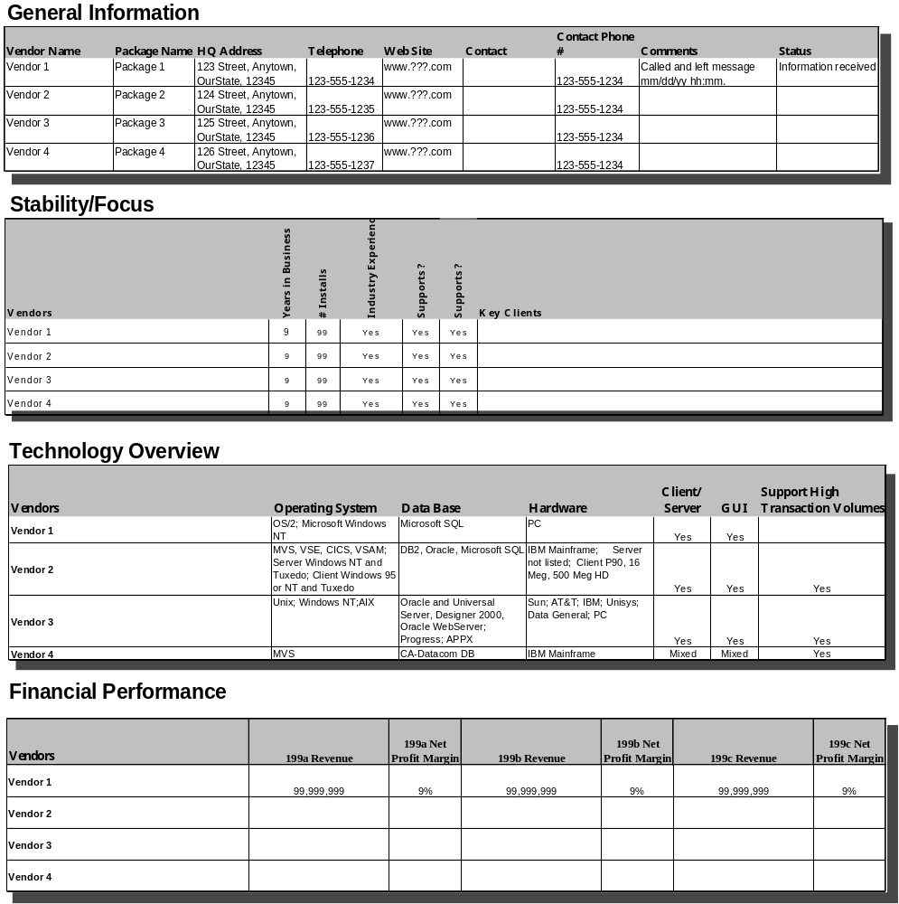

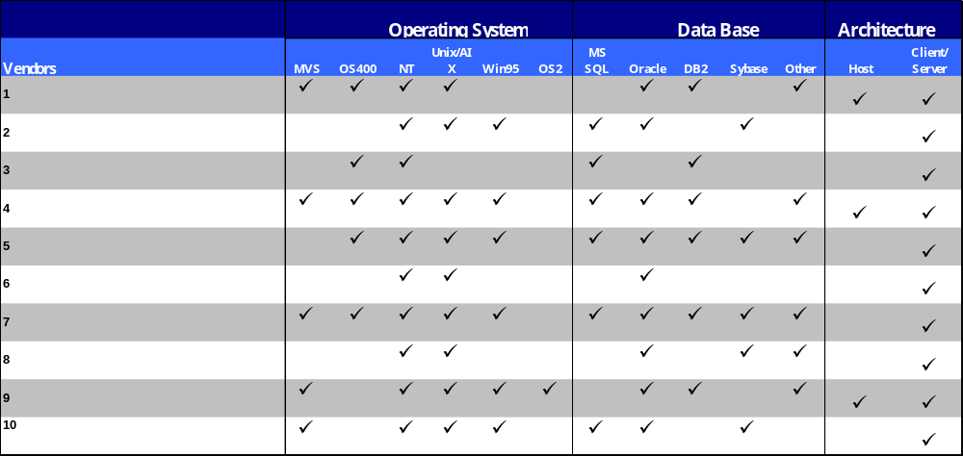Technical Review of Vendor Packages

Vendor Disqualification
Vendor #1 | Not an Integrated Enterprise Solution, Niche Player in Enterprise Applications
Vendor #2 | Unstable Implementations due to Architecture Upgrades
Vendor #3 | Niche Player in Enterprise Applications
Vendor #4 | Focused on Manufacturing Industry, Weak Enterprise Applications for Non-Manufacturing Clients
Vendor #5 | Closed Architecture
Vendor #6 | No Inventory Control or Warehousing

References
Research of vendor sites such as Gartner, AMR, Dun and Bradstreet, vendor product overviews, industry periodicals and IBM intellectual capital are used to assess the vendors.

6 Revision History

Date of this release: | Date of next revision:

Revision Number | Revision Date | Summary of Changes | Changes Marked?
1.0 | October 2001

