

IBM Global Services

Balanced Scorecard

Technique Paper (TP)

© Copyright International Business Machines Corporation 2001, 2002
Version 2.0 May 2002
- Description
The Balanced Scorecard is one way to establish the ongoing measurement of success of an enterprise or a line of business within an enterprise.
1.1 Definition of Balanced Scorecard
The "balanced scorecard" is a management system designed to project the energies, abilities, and specific knowledge held by people throughout the organization in support of achieving long-term strategic goals. It supplements classical measurement methods like ROI that only focus on financial results, by integrating financial and non-financial perspectives into performance management. The balanced scorecard helps the client to get a balanced view of his enterprise, and to subsequently make balanced investment decisions.
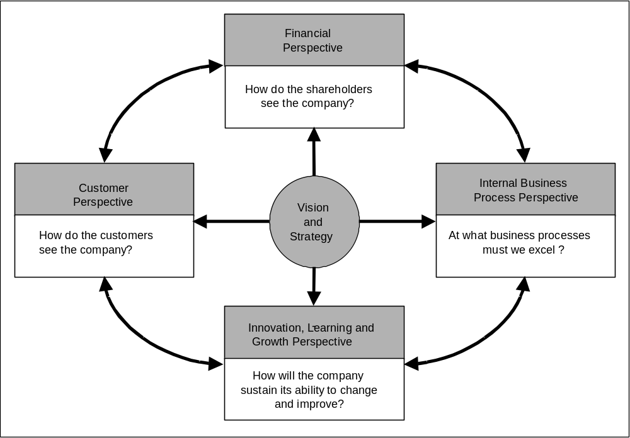
The classic balanced scorecard from Kaplan/Norton – published 1992 at Harvard Business School – is a tool to steer the value of a company. It does not look solely at the business with a financial perspective, as is the traditional way to measure a company. In addition, it presents three more perspectives: a customer perspective scoring the business from a customer view; an internal perspective, measuring the efficiency of the internal processes; and an innovation, learning & growth perspective valuing the companies ability to adapt to the future.
The balanced scorecard acts as a link from the strategic intent of a client to the operational measurements of performance. Every client is unique; as such the scorecard framework is developed / adapted for each individual client;
- Perspectives vary (‘arms’ of the scorecard) in terms of number and content. The top-level content of these ‘arms’ is made up of objectives / goals that fit in with the overall mission and vision for the organization. The ‘balance’ of the scorecard is achieved by attributing a weighting or percentage to each objective, so that when all objectives are totaled they yield 100% coverage, thereby achieving a relative focus for each objective within the scorecard.
- Underpinning these objectives within each arm are critical success factors, (CSF’s), that outline what critical things need to be done in order to achieve the objectives / goals. Operational measurements are then derived for each objective and set of underpinning CSF’s; such measurements are often referred to as key performance indicators (KPI’s). Each client is unique having a different set of objectives, CSF’s and KPI’s, often with different perspectives or arms, sometimes more or less than four, as dictated by the original scorecard design.
- Having determined what measurements are to be used, we need to apply these in order to drive strategic fulfillment and improvement. Fulfillment criteria and / or orders of magnitude of improvement need to be attributed to each measure over a specified time period. This ‘initial’ desired achievement is most appropriately defined by ‘baselining’. That is to say assessing the current position in order to define a realistic future position.
- A scorecard can be used at the functional as well as enterprise level. Here the overall objectives of the enterprise are taken into account and a ‘supporting’ scorecard is developed that helps enable achievement of overall corporate objectives. This situation is often true when we consider the IT function or a line of business, for instance, provided there is a corporate scorecard in existence. Even if this is not the case, overall objectives are required to appropriately develop such a functional scorecard. Scorecards can even be derived at the unit or group level within a function using the same ‘pyramid’ style ‘drill down’ of objectives, only this time the starting point would be those derived at a functional level.
To get maximum value from the use of a balanced scorecard, baselining should be done – either periodically or as an on-going situation – with processes and tools in place to guarantee on-going performance measurement. As well as using the framework for on-going strategic alignment and performance measurement it can also be used to support ‘one off’ investment decisions.
1.2 The Benefits of using a Balanced Scorecard
There are three major benefits to using a balanced scorecard as the primary performance measurement system:
- Link from Strategic Goals to Operational Measurement.
The benefit that a balanced scorecard brings is the ability to measure the company’s performance with the strategic aims using a balanced view. The balanced scorecard helps a client to derive actual measures from strategic directions, incorporating critical success factors, in essence giving the client a structured framework to work with.
Further it can be used for communication throughout an organization and to drive targets, yielding a common ‘frame of reference’ and focus throughout the enterprise with measures of success achievable at all levels. This is achieved by breaking down global corporate objectives / goals defined in the top-level scorecard to balanced scorecards within lines of business, with subsequent decomposition to a departmental level and even the possibility of decomposing measurable targets to the individual (as described in the previous section).
- Balanced Performance Measurement System
Other than traditional methods the balanced scorecard focuses not only on financial aspects such as ROI (Return on Investment), or on operational efficiency like process quality, but also combines these measures with a balanced set of perspectives. Focusing only on financial measures may lead a client to under-invest; organizations do not often include long term or non-financial impacting aspects of performance into ROI calculations. On the other hand, focusing on internal efficiency only may lead to overspending (getting an efficiency or process quality level that is beyond requirements) or spending in the wrong places (by not taking changing customer wants & needs into account).
Using a balanced scorecard gives a view of all relevant performance factors for a business and considers them and their interactions in parallel. This helps to make more appropriate and ‘balanced’ investment decisions. Weighting the different objectives / goals additionally helps to give further ‘balance’ and focus on critical success factors underpinning these performance objectives.
- Graphical Planning and Controlling System
Implementation of an on-going performance measurement process allows measurement of actual strategic success against set targets. If these targets are not met, visibility will be given not only to deltas in the financial perspective (e.g. ROI too low), but also the reasons for these gaps (e.g. not meeting quality targets defined in the other perspectives). Such information can drive appropriate refocusing and adjustment to rectify the situation, which can then feed down into directions for the operational side of the business to deliver on such adjustments. By adding dependency trees between the different perspectives and factors this information can be even more easily derived. In essence the strategy becomes operationalised itself, not simply a paper document that gathers dust on some shelf somewhere in the enterprise.
1.3 Structure of a Balanced Scorecard
As already mentioned, the classical BS (Balanced Scorecard) includes traditional financial objectives from the enterprise mission and vision and also more detailed strategic direction, developed as a result of external strategic analysis and internal environmental indicators. Goals / targets and measurements are derived from these elements. But this financial aspect is only one of the four arms of the scorecard that are also considered within the same context:
- The financial perspective,
- The customer perspective,
- The internal business process perspective and
- The innovation, learning and growth perspective.
The mapping of strategic measurements within the four perspectives of the BS illustrates the overall value chain:
- The innovation, learning and growth perspective focuses on employees and therefore on a significant input.
- The internal business process perspective concentrates on the transformation process.
- The customer perspective quantifies the output of the production function.
- The financial perspective describes the measure of the important outcome.
These measures can be identified as either “leading” or “lagging” indicators:
- Leading indicators are the forward looking measures, those factors which determine future success (e.g. number of employee suggestions or percentage of staff receiving customer training)
- Lagging indicators are the “rear view”, those results which tell us where we have been (e.g. Net operating profit or customer satisfaction)
Financial Perspective should answer the question: “How do our shareholders see us?” In essence this considers how economically a company has performed in terms of cost efficiency and profitability. This gives one dimension to the success of an organization’s strategy and its realization. However, underpinning this financial ‘outcome’ is the focus placed on all other perspectives of the BS: every customer perspective related KPI and those KPI’s attached to internal business process and innovation, learning and growth perspectives are a significant part of a cause and effect relationship with the financial perspective, in essence contributing to the long-term improvement of the financial position of the company.
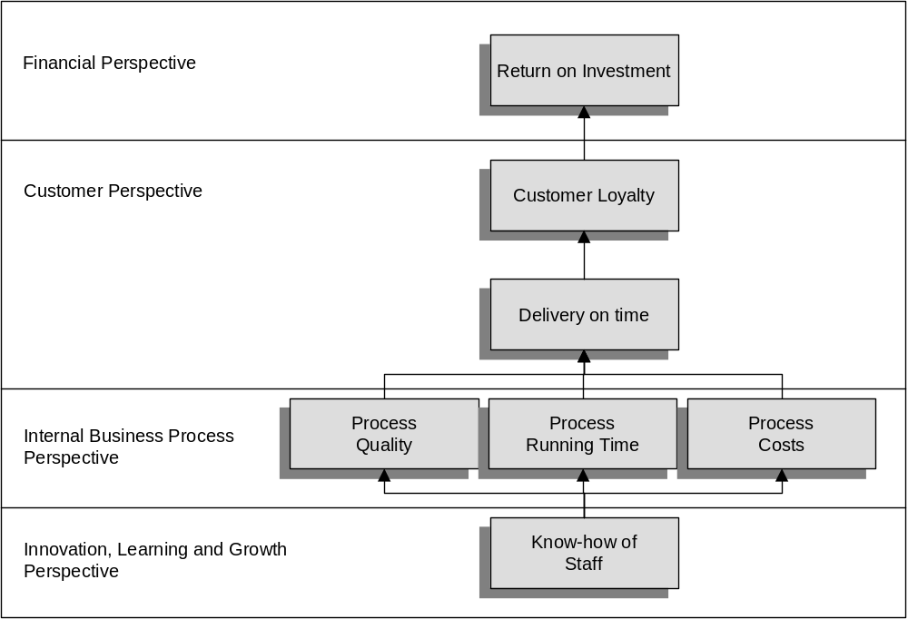
Figure: Cause and Effect Relation of the BSC
For example the Financial Perspective should give an answer on what financial targets the company wants to achieve with this investment. It therefore describes the costs and the financial returns of such an investment. The costs can be divided into:
- Initial / capital costs, i.e. costs that arise from the development of an e-Business-Application: personnel costs, investment in hardware and software, licenses and infrastructure etc.)
- Ongoing / periodic costs (communication costs, support of the website etc.).
The determination of actual investment return is not as simple. Associated cost savings and the acceleration of internal processes are pretty difficult to quantify. As a rule of thumb the following areas of potential investment returns can be identified:
- Cost savings due to efficiency increases
- Increased revenue as a consequence of new channel and market development.
Customer Perspective should answer the question: “How do our customers see us?” It describes both the position of the company within a market (for example, market share) and, at a more granular level, customer satisfaction and loyalty towards the company and its products and services. It is necessary to define customer and market segments in which the company wants to be successful. Furthermore, the demands of the customer regarding time, quality, price, product and service have to be defined. Example KPIs for the customer perspective are:
- Market share,
- Customer loyalty,
- Acquisition of new customers,
- Customer satisfaction and
- Customer profitability.
These are the lagging indicators. Additionally, the leading indicators have to be defined. The company has to provide these leading indicators to reach a high level of customer satisfaction, loyalty, profitability and a high market share. Example leading indicators are:
- Product and service attributes,
- Customer relations,
- Promotion, image and reputation.
Internal Business Process Perspective should answer the question: “How can we satisfy our shareholders and customers and at what business processes must we excel?” This perspective describes how internal processes have to be changed to reach the targets of the financial and customer perspective. The company should present a complete value chain of all internal processes. Innovation processes, operating processes and customer service processes are the critical core processes.
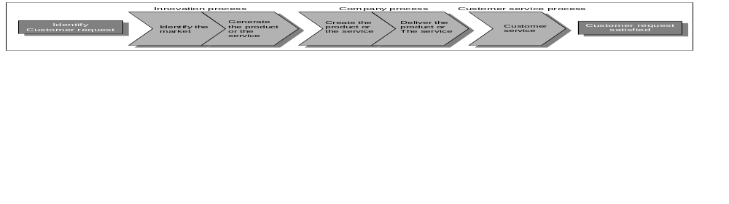
Figure: Value chain of the internal processes
Innovation, Learning and Growth Perspective should answer the question: “How will we sustain our ability to change and improve?” It creates the framework for the necessary strategic infrastructure to reach the targets of the financial, customer and internal business process perspective. Employees, knowledge (intellectual capital), innovations, technology and information are the significant factors to create the ability to adapt to the future. Three categories that apply to this perspective are:
- Employee potential,
- Potential of information systems,
- Motivation, empowerment and targets.
The classical BS can be extended to incorporate further perspectives, so that a holistic view of all stakeholders of the company is considered.
1.4 Types of balanced Scorecard
1.4.1 The e-Business Scorecard
The classical four perspectives of BS are not always sufficient for all companies. Depending on the business strategy and the conditions of the industry sector, additional perspectives should be added. This can be demonstrated by looking at the scorecard of an e-business. The following Views are important additions to the traditional view:
- Supplier relationship,
- Competitive position and
- Environmental framework
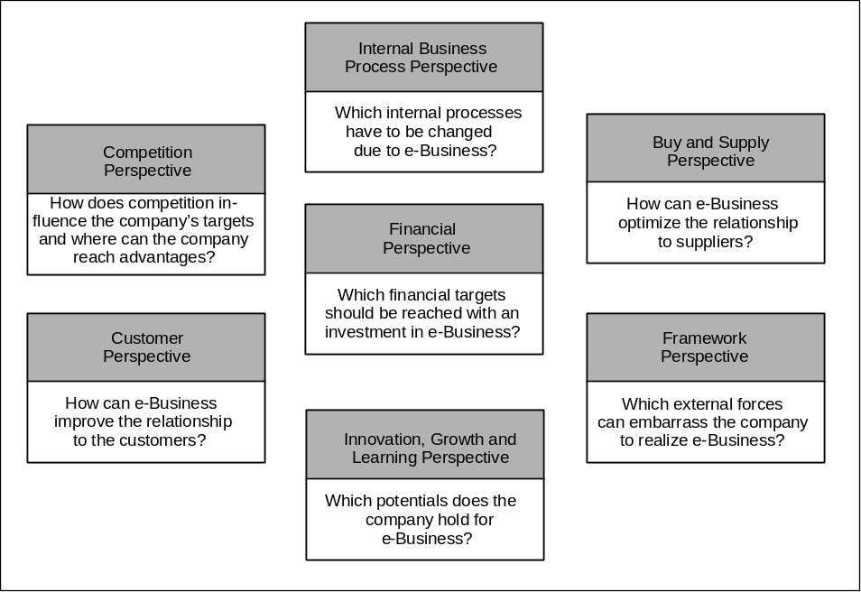
Figure: The e-Business Scorecard
Buy & Supply Perspective should answer the question: “How can e-Business improve the relationship with suppliers?” An investment in e-Business often impacts boundaries beyond the internal organization; as such key suppliers have to be involved in the redesign of the value chain. This will ensure that the overall ‘partnership’ can obtain cost scale economies in procurement and channel efficiencies throughout the supply chain. Examples of this are that effective Supply Chain Management (SCM) makes the purchase order process transparent so that the supplier can deliver in a just-in-time fashion and therefore high storage costs for the manufacturer can be avoided. The supplier benefits from the SCM by also avoiding stock related costs and completing transactions faster. It is therefore possible to create a “Win-Win-Relationship” between supplier and manufacturer.
Competition Perspective should answer the question: “How does competition influence the company’s targets and where can the company reach advantages?” The Internet determines an intensification of competition because a total transparency of the market is achievable. It is important for the company to know which competitive advantages it can reach. This can only be understood by having a very good understanding of competitor positioning in the Internet marketplace, which includes factors such as brand image, target customer segments etc.
- Competitive advantages: to reach an advantage, offerings need to map directly to the wants, needs and priorities of the customer. Price-performance ratio is very important.
- Competitors: permanent monitoring of the Internet is necessary to recognize changes and new competitors, both to react quickly and to maintain or increase market share.
- Image and reputation: to attain a strong image, it is essential to establish a brand that is positively and significantly recognized by the target market segment. Considerations here are Internet advertising, classical advertising, search engine registration, appropriate and fast choice of domain name.
Environmental Framework Perspective should answer the question: “How are we doing/what do we need to be doing to cater for external influences which can negatively impact the enterprises ability to effectively realize e-Business?” The company has to consider several technical, social, economic, environmental, political and legal restrictions that may determine viability of an e-business development and subsequent launch. Laws applicable to ‘bricks and mortar’ business are only partially applicable to e-Business. The reason is often an inability to apply and enforce due to the large scope and global character of the Internet (e.g. frontiers don’t figure, real persons are not present at business transactions). For some e-business potentials, technology may be too immature for viability, as with bricks and mortar conditions such as physical infrastructure and availability of skills may also apply.
1.5 IT-Scorecard
Another important example for an adapted Balanced Scorecard is an IT-Scorecard.
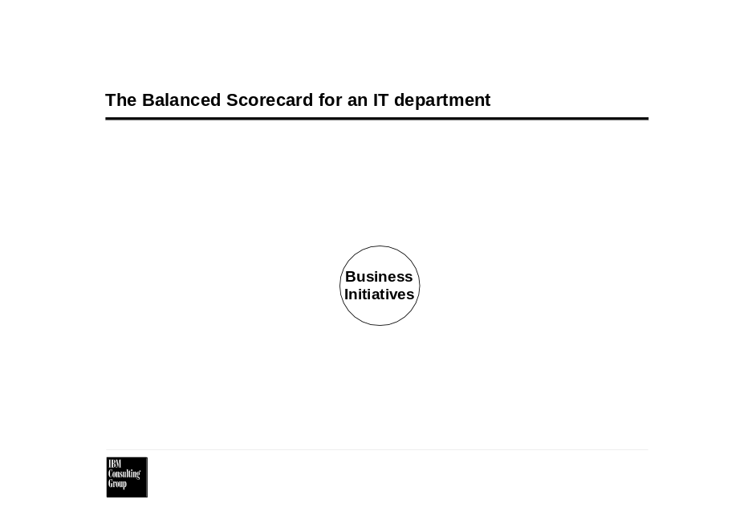
As can be seen, in this example the innovation perspective has not been changed, the internal perspective has been divided into performance and capability, the customer perspective has been shrunken to customer satisfaction, and the financial perspective only focuses on cost. This is a typical example for a balanced-scorecard at the supporting functional level such as IT, simply focusing on contribution that the function fulfills in supporting the overall business. The value of the IT-Department is measured within the perspectives of Cost, Capabilities and Customer Satisfaction. These perspectives should be related to the business goals and capabilities. Innovation and Performance are internal IT perspectives, focused on measuring efficiency and future readiness. Weighting perspectives and KPIs often leads to a heavy focus on IT cost reduction (perhaps unbalancing the scorecard). This kind of scorecard is typical for a company seeing IT as a utility not as a business enabler (The e-business scorecard is an example where an enterprise views IT as an enabler).
1.6 Additional Information
The balanced scorecard was developed by Kaplan/Norton at Harvard Business School, additional can therefore be obtained from the Harvard Business School web site www.hbsp.harvard.edu. Many other consulting companies also offer Balanced Scorecard services. For information relating to Balanced Scorecard events, competitors, … the Balanced Scorecard site www.balanced-scorecard.com, is a useful source of information, this site is also run by Harvard Business School.
- Context
The balanced scorecard is primarily used where a client requires an ongoing planning and performance measurement system. The BS will provide a holistic, balanced view across the clients business. Typical questions clients may ask that could indicate a balanced scorecard approach would be appropriate are (be aware these questions vary also by the hierarchical level of your sponsor):
- How can I break down my strategic goals (monetary and non-monetary) into measurable operational targets?
Using the balanced scorecard allows strategy, objectives and critical success factors to be broken down into measurable units called KPI, enabling the implementation of a performance measurement system.
- How can I measure the performance of my business?
Implementing a process based performance management system based on a balanced scorecard yields a holistic view of business performance, ensuring that critical KPIs are both identified and focused on, linking strategic intent with actual performance.
- What is the value of the IT function (or any other business function) / a specific e-business initiative to the business?
Breaking down a business-wide balanced scorecard to functional and subsequently to a group level ensures that all groups are focused on the overall enterprise targets. As such function and group performance can be both aligned and measured against the business targets, ensuring that function / group value contribution can be continually assessed.
- How is my financial performance linked with my operational performance?
Using a dependency tree that links different perspectives and KPIs shows how operational performance is related to financial performance, but also how performance in other perspectives influences financial performance and what kind interdependencies exist between different KPI’s.
- What are the targets for IT (or any other function / group), or individuals within a department?
Breaking down enterprise level scorecards and deriving an IT scorecard enables aligned objectives and underpinning KPI setting from the enterprise BS. The granularity can be such that individual targets could be derived from a departmental level scorecard.
- Having a set of options, which investment shall I take?
This is not a question that is generally resolved by applying the balanced scorecard, but measuring an investment and its performance against the KPIs of a scorecard will help to determine whether an investment is in line with the business objectives. This illustrates that for large and complex projects a balanced scorecard approach may be appropriate and can also be applied.
Highlighted below are a set of related techniques and methods that can be applied within similar contexts. These should be viewed as supplementary and additional aids and not as replacements:
- Strategy Development and associated tools and techniques
If a client requires operational measures, but does not have a strategy, the starting point will be strategy derivation. This incorporates a multiplicity of techniques such as value chain analysis, Porter’s five forces analysis etc, which are beyond the scope of this paper.
- Business Case
Justification of investments often requires development of a business case. If the performance framework already exists this may not be necessary or at a minimum provides valuable feeds into a business case. However if a BS or other performance framework does not exist then a business case needs to be developed.
- EVA (Economic Value Add) and related DCF (discounted cash flow) Analysis
EVA is a number and very basic description that illustrates the profit that it is possible to generate with specific business directions, investments are taken into account using DCF techniques for calculation purposes. Shareholder value can be related to EVA numbers; as such EVA can provide a powerful output, perhaps a “key” KPI within the financial perspective. If a customer is only interested in the financial performance of the organization then DCF techniques and EVA may provide a significant part of a planning and performance measurement system.
- ABC (Activity Based Costing)
ABC is a method used to analyze internal efficiency. By relating costs to individual activities performed in an organization, it is possible to build up a framework relating cost to activities, processes, services and products. ABC is a strong tool aimed at efficiency and productivity improvements. In the balanced scorecard environment this can be used as a performance measurement tool for the internal perspective. It can also link this perspective with the financial perspective. If a customer’s focus is only on efficiency ABC may be the starting point for a planning and performance measurement system.
- Steps
A balanced scorecard project has two major parts:
- Design of the Balanced Scorecard
- Implementation of the Performance Measurement Process
Marketing & Project Initialization
During marketing you have to qualify whether this client is ready for a balanced scorecard project. If you have a very hands-on client, focusing on “practical approaches”, it will be very hard to sell the benefits of a balanced scorecard. A client wanting to follow a strategic approach may well be interested in a balanced scorecard approach. The sponsor needs to be the CEO, LOB or departmental head depending upon the level at which the scorecard is to be developed and the fit with their respective responsibilities.
Proposal creation requires definition of a scope of work. As mentioned above a balanced scorecard project has two main parts, defining the scorecard and implementing the performance measurement process. These phases should be sold as different engagements, as it is much more easy to estimate the cost for implementing the performance measurement process after you have the scorecard design (including the requirements for the data gathering and reporting tools), in addition the former requires knowledge of the customer’s current performance measurement process and tools. Developing a performance measurement process first is likely to lead to a scorecard design being required and hence re-work and excessive data gathering.
In the scorecard design phase the effort is dependent on:
- Current level of strategy definition and detail
- Current level of critical success factors definition and detail
- Level of detail required in scorecard design
- Depth required in scorecard design (i.e. only functional or enterprise with functional and unit decompositions)
In the project initialization phase you have to staff the IBM and the client team.
Client Team:
- Sponsor: Executive, head of the unit for which the scorecard is being developed
- Project Manager: Manager, who has direct access to the Sponsor
- In Workshops: Board of managers reporting to the Sponsor or at sponsor peer level, to discuss KPIs
- Controller and / or Business Analyst, providing required data
Above all the success of the Balanced Scorecard will be dependent on the communication of its existence, its purpose, its impact and the results to the organization as a whole.
Performance Management Process Owner:
It is absolutely critical that the sponsor is both committed and proactive to and within the project respectively.
- If the sponsor is not the head of the unit for which the scorecard is being developed a BS project would be at high risk of failure as the decision maker and major issue resolver is not present.
- If the project manager has no direct access to the sponsor, there is a disconnect in direction, decision-making and commitment. Continual communication is required with the sponsor throughout the project.
The IBM team should combine several skills:
- A management Consultant (Executive or Senior) as lead consultant with expertise and experience in balanced scorecard development and implementation; this individual is also the lead communication channel with the sponsor
- An Industry or IT Process Consultant, who understands the industry’s or IT’s value chain
- A Data Analyst, leading linkage of strategy to KPIs
- A Process and Tool Consultant, identifying data sources and defining requirements on process- and tools
- An Organizational Change Consultant (Senior), to identify and mitigate organizational change management impacts and determine organizational requirements required for successful scorecard implementation
Please note, the above should not be read to indicate 5 personnel, employed full time on a project. This is not the case; different skills are required at different times as the project proceeds, and individuals can be found who exhibit several of these skills.
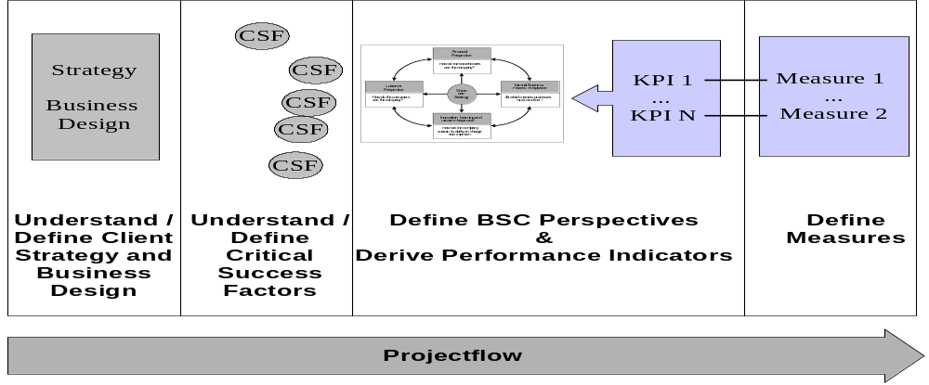
  - Design of the Balanced Scorecard

3.1.1 Understand / Define Client Strategy and Business Design:
The starting point of a balanced scorecard development is the client strategy and client business design. The client strategy provides:
- The strategic aims (including timeframes)
- The aimed position of a client in a value net
- Target customers and customer segmentation
- Key competitors and their position
- Critical influencing environmental factors
- Planned initiatives and business cases
The business design yields further information on
- The initiatives started to accomplish these aims,
- The customers of your client,
- How value is achieved along the value chain
If the data exists then there is an excellent starting point for your scorecard development. Many objectives, CSF’s and KPIs for the scorecard can be derived directly from such information. Most customers however will not have all the required information, as such a strategy and business model development engagement may be required as a pre-cursor. Generally the information required at this level can be found from documentation or perhaps more informally via executive interviews and workshops. It is critical to continually ensure that the sponsor’s requirements are fully understood and addressed as the project progresses.
If most of the information is available then it is feasible to proceed with the engagement as planned, deriving the missing information and KPI’s in client workshops and interviews using the balanced scorecard framework. On the other hand if much of this information is missing the engagement scope and direction needs to change as discussed above. In such situations the balanced scorecard framework can be used as an enabler to derive a client strategy. Bare in mind the majority of clients have a strategy; this can be explicitly stated or simply defined as tacit knowledge within the heads of executives. Where strategy has to be created from tacit knowledge there is a considerable additional workload consideration for an engagement.
Again, as stated above, if little or no required input information is available, this may ring alarm bells as to the ‘readiness’ of a client and organizational culture for a balanced scorecard …Also as stated above the lack of input information may also provide an opportunity to change the project scope and direction to a strategic / business model design project, helping the client to define a business or IT strategy and underpinning business model. These kinds of projects are pre-cursors to a balanced scorecard project, but have the same sponsor.
3.2 Understand / Define Critical Success Factors
The Critical Success Factors (CSFs) are derived from strategic objectives. They mark milestones on the way to realization of a strategy and business design. A CSF is a statement defining a state, such as “It is critical to become known as the technical leader”. These kinds of statements are easily transformed into a set of KPIs, by identifying supporting key performance indicators / measurements. Critical success factors normally reside in the same documents as strategy and business design. It is critical to discuss and determine your understanding of the CSFs with the client.
If the CSFs are missing they can be derived from the client strategy and business design using the balanced scorecard framework. CSF workshops and client interviews can be an approach in development but is not the only approach if CSF’s are missing. CSF’s can be derived implicitly as KPIs are developed. Sorting CSFs in-line with derived BS perspectives may allow objective gaps to be identified or changes in objective focus to be determined. In essence a top-down or partial bottom up approach can be taken.
3.2.1 Define Scorecard perspective and derive Performance Indicators
Understanding client Business / IT Strategy, Business Design and CSFs allows the initial definition of key performance indicators for the scorecard. Generally this is achieved via a workshop. It is extremely important to have an industry or IT process consultant integrated within this phase of the work as appropriate.
To prepare for the workshop, the core project team has to define the perspectives and a set of performance indicators for the different perspectives of the scorecard. These can then act as a ‘straw man’ set for the workshop. It is best to use this straw man if the client has difficulty in conceiving their own ideas otherwise the straw man suggestions tend to be accepted without much thought and commitment. The original scorecard could be used as a straw man, although perspectives could be added or changed depending upon the client and the situation. Examples are the e-business scorecard or the IT scorecard, described in chapter one. Another example that may have very different perspectives could be a scorecard for a non-profit organization.
The industry / IT process consultant can help to identify performance and value indicators along the value chain of the company or the IT function as appropriate. A set of up to 50 Performance Indicators could be initially derived. A dependency diagram illustrating KPI relationships should also be derived in preparation for the workshop discussion.
3.2.2 Define Measures
The future performance process owner of the client has to be integrated into the project team during this phase.
The data model requires definition here along with specific measures belonging to each KPI. Data sources and current values need to be identified with the client contact. It is important to have a client team member whom is familiar with today’s performance measurement process and tools; this facilitates data source identification. It is unlikely that all required data is contained in the clients systems, especially data associated with the non-financial perspectives. Some KPIs may already exist in reports, for other KPIs the measurement method has to be defined at this point. This step includes creating an initial data model and the information flow model from the raw input data to high-level aggregated KPIs.
Client financial controllers tend to be key contact personnel in identification of data sources related to the financial perspective. They also will be the most aware of existing data marts (e.g. MIS, Internal Charge back etc). The best source for efficiency measurements within client organizations are operational management and internal consulting, operational research or quality group where they exist. Customer related data might be gathered already within marketing; call centers and other direct customer contact functions. It is important to understand the organization and current projects via client contacts to identify further points of information. E.g. relevant procurement information may reside in a procurement department and / or within a supply chain project.
If it is not easy to obtain a required measure, the scorecard may require adjustment. This is a cost vs. benefit decision and must be agreed with the sponsor. The preferred way is to exchange a measure with a similar one, if this is not possible, to exchange the KPI by a similar one. Always have in mind how to implement this measure efficiently, as it will be part of an on going, repeated (e.g. on monthly base, or at least quarterly) process. It might be necessary to drop a KPI completely, if there is no efficient way to get the related number/s.
The next step is to discuss the agenda of the workshop with the sponsor and client project manager. During this meeting it would be appropriate to run through the identified performance indicators and their linkage to the strategy. If gaps, focus discrepancies or inconsistencies have been identified at this stage then they should be discussed during this pre-workshop meeting.
In the workshop ‘straw man’ perspectives, KPI’s and strategy linkage will be discussed, amended and prioritized. CFSs may well be derived during this workshop or again a pre-determined set presented for discussion. The result of the workshop should be a signed off set of 30 KPIs (Maximum) for the BS. In the workshop clarification should be obtained as to the client representative/s responsible to further KPI detail, baselining, measures and measurement method.
Always have in mind: Creating a balanced scorecard is an iterative approach. Don’t try to define “the final scorecard” in this workshop. Always have the 80:20 rule of thumb in mind.
It is important that there is an appropriate balance between Leading and Lagging indicators, for example if all the KPIs are lagging then there is no real forward looking perspective, results may show that the client is doing well today but not taking steps to cater for tomorrow.
The measures need clear definition, including:
- Name
- Description
- Formula
- Frequency
- Owner
3.2.3 Scorecard Baseline (Prototype)
Having created a first scorecard template and defined the measurement methods, the next step is to fill it with real performance numbers. Taking the data you can fill the scorecard for the first time. In reality part of this will be done in parallel with the define measure step for numbers with easy access, e.g. those that do not require a new measurement method.
The information about data sources, responsibilities, identified during the baseline of the scorecard should be gathered in a rough process model for performance measurement. This rough process can be used as a prototype for the performance measurement process.
The completed scorecard and engagement experiences to date should be discussed in a workshop. In preparation for this workshop, the sponsor should be shown the results, in order to identify critical points prior to the workshop (e.g. poor performance indicators, surprising results etc). Buy-in is critical here for any required pre-workshop refinements.
If necessary, have face-to-face meetings with client executives who could be embarrassed by the results of the baseline. It is critical to be able to illustrate the transparent way of how the numbers have been gathered.
The workshop has two main topics:
- The Baselined Balance Scorecard
- The Performance Management Prototype
Discussing the baselined balanced scorecard will determine how well the company or function currently performs and the validity of results (Sensitivity is required when considering personnel whose units do not currently perform well). The knowledge of an industry or IT process consultant will be required to interpret the results. In this workshop you have to show the value that can be obtained from a regularly updated scorecard.
All questions related to the data validity should be discussed in the second part of the workshop with respect to the performance management prototype. Since this discussion will focus on validity, be prepared to show the data gathering activities, and pro-actively discuss weak points in the prototype approach (showing resolutions for a more matured system) or required adjustments in the scorecard. The other important topic will be, whether the pain of running the prototype processes is too much for the organization. These discussions will hopefully end in an initiative for a new performance measurement process and tool.
If employees’ performance data is captured in the system you may have to inform/integrate workers councils / unions, depending on local country laws and unionization power.
3.3 Implementation of the Performance Management Process
The following steps outline the Performance Management process, the key message here is that this process must result in the collected results being interpreted and subsequent management actions taken.
3.3.1 Project initialization
As mentioned above this phase is normally sold as a separate project. There are two ways to scope this project:
The Balanced Scorecard Design phase should yield a strong enough knowledge (a high level design) of the current performance management process status. This enables a reasonable estimate of the effort needed to implement new performance measurement tools and process. If this is not possible then the Performance Management Process may need to be defined from scratch as a separate engagement.
For the implementation phase, the team will need to be enhanced by personnel with a strong technical background in the following areas:
- Architect
- Data Designer
- Data Base / Data Mart specialist
- Programmer as required…
To design and implement interfaces or enhancements to existing systems it is vital for the project to have skilled integration personnel working with client system specialists. Planning this phase of the engagement has to take the availability of these specialists into account. If there is insufficient client IT support; the project is at a high-risk of failure.
Be aware that building a new complex Performance Management Tool is an application development project. Detailed description of IBM application development approaches exist in the Global Services Method e.g. CAD engagement model. The following description is only meant to be a rough guide through such an engagement. It is not a replacement for an application development model and structured AD techniques and tools.
3.3.2 Define Performance Management Process
The prototype design is used as a starting point for a detailed design in this phase.
The data model and information flow model will require refinement and greater granularity. This task will define which information is needed to fuel a certain KPI and how this data flows through the company.
An important task is to identify the data sources; that provides required information. Within this new data sources may need to be designed, additional manually feeds may be required and need to be considered in this design.
At this stage it is also important to develop a change management strategy in order to obtain employee buy-in. Involvement of key employee’s within the design process helps to enable this process.
Another task is to refine the Performance Management Process. Activities required to feed data, gather data, aggregate data and interpret data need to be defined at a low level. Gathering and aggregation should in the main be automated; as such the focus should be on data feeding (and its control), and on implementing a process to interpret the BS. Roles and responsibilities should be attached to activities. The process design should document which activities are performed manually and which by tools. The future overall process owner should be involved in the process design. You can find additional information on process modeling in appropriate process related ICM databases.
Having completed the data model, the information flow and the process model, a desired state is determined. As such a gap analysis needs to be performed, incorporating development of a list of requirements for tools, process and organization. These requirements then need to be compared with the as-is state, deriving the gaps.
If employees’ performance data is captured in the system you may have to inform/integrate the workers council / unions, depending on local country laws and unionization power.
3.3.3 Implement Tools & Process
The gap analysis, together with data model, information flow and process design are input for the tool / data mart selection. A build/buy decision follows on from this. For companies having a performance management system already in place, you may have to consider whether this tool can be improved to fit the requirements.
Building of tool / data mart requires the use of application development tools and techniques, another option is to purchase a package and make necessary amendments, this whole area is however beyond the scope of this paper. Some key considerations however are:
- Strong buy-in and acceptance of the BS, enabled by joint user GUI definition and ergonomic design (for the feeder and for the reader).
- Much of the work to be done often involves integrating existing data points. Do not underestimate the planning and time required for interface design and testing.
- The BS logic and representation is not complex. This part can be easily implemented (adapting an existing or bought tool or building one)
- Unit tests can be easily completed; the integration test phase tends to be the complex focus area.
To get the Performance Management Process running, process needs to be implemented as well as tools. Client personnel need to be assigned to roles, involved in the development and educated. The latter tends to be a costly oversight in such projects. When designing and implementing process bear in mind that tool and process development should be done in parallel, since tools automate and can therefore dictate process development direction, further the BS needs to be integrated into the overall management process.
3.3.4 Validate Performance Management Process
The validation of the process normally takes place by launching a pilot. This pilot should show the full functionality of the BS, involving only a part of the organization. The pilot will show the validity of the design (especially the data design) and the integration.
3.3.5 Deploy Performance Management Process
After a successful pilot phase full roll out is progressed. A roll out strategy and plan is required with strong project management, defined milestones (e.g. who, when, what). Part of the roll out is to inform and educate employees and to educate the management on:
- What is BS?
- Why is BS being implemented?
- What information do we get from the BS?
- What do I have to do in the Performance Management Process (Role & Activities)?
- What is the Performance Management Process (e.g. Process Description)
Process quality measurements and tools need to be in place and the process owner has to feel comfortable with the process.
Operational guidelines need to be developed and agreed upon by IT, prior to handing it over to production, which is the last step of the project.
- Tools
There are many commercial BS tools available. A high level aggregated view can be easily implemented using spreadsheets. Additional information on tools is available on www.balanced-scorecard.com
- Examples
- Balanced Scorecard Strategy Map Example
- Revision History
Revision Number | Revision Date | Summary of Changes | Changes Marked?
2.0 | May 2002 | Applied new template and style, spelling and grammar.
1.0 | July 2001 | Base Version

These are often know as “imperatives”, in the context of Balanced Scorecard we use either of these terms to produce the same result

