

IBM Global Services

Defect Management

Technique Paper (TP)

© Copyright International Business Machines Corporation 2000, 2006
All Rights Reserved
Version 5.2, June 2006
- Description
This paper describes the process and techniques for managing defects. The purpose of defect management is to:
- Effectively manage the tracking and resolution of defects found during the project lifecycle; and to
- Capture the information needed in order to perform root cause analysis, or for ODC (see Defect Categorization under Advice and Guidance Section) and analysis.
The successful identification and resolution of defects found during testing to agreed predetermined targets is a key enabler to efficient progress through each phase of the project. A well-managed defect management process which is an integral part of the project activities is essential to accomplish this. This process involves compiling information on defects found throughout the project, including static testing, test management, dynamic testing, and infrastructure or system operation, and analyzing that information so that trends and significant events or problems with the overall systems development process are recognized and resolved timeously and cost-effectively.
- Scope
The scope of this document focuses on defect management for both static and dynamic testing.
- Defects
A defect is identified when there is a variance in the test results from the expected test results that were predefined for a particular test cycle. It is important to differentiate between:
- a defect that is found during a correct test process (e.g. bug in program)
- a defect found because the test process itself is faulty (e.g. flow of test script is wrong)
- a defect that is introduced during the test process (e.g. by entering faulty input)
- a defect that is introduced by the fix of an existing defect.
All of these defects and any others should be logged, but the cause/type should be established as the action to resolve the defect could differ in each case.
Examples of defects are:
- Bug in the code
- Incorrectly stated requirement
- Overlooked requirement
- Incorrect function
- Well-implemented function that is not wanted
- Performance problem.
Once a defect has been identified, it passes through various stages in its lifecycle. All defects will pass through some of these stages, and other defects will pass through only a subset. Some projects may require stages be added to the defect lifecycle between the “raised” and “closed” stages to achieve satisfactory resolution.

# | Stage | Description
 | Raised | The defect has been identified as a defect and logged.
 | Assigned | The defect has been assigned for analysis.
 | Analyzed and Estimated | The defect has been analyzed for cause, action recommended and the effort to resolve it estimated
 | Recommended Action Approved | The recommended action has been reviewed and approved
 | Fixed or Resolved | Action to resolve defect has been taken
 | Ready for Re-test | The defect has been resolved (and/or installed/migrated) and may be re-tested.
7. | Signed Off | The defect has been resolved according to the recommendation, and retested successfully
8. | Closed | The defect has been closed either because it has been resolved or because it is now withdrawn from the work plan, and information about this defect and resolution have been completed in the defect tracking tool or other mechanism.
All defects detected during each phase of a project either through static or dynamic testing will be recorded, logged, and have cause attributed. These measurable defects will then be used to determine the quality level achievements of prior testing activities and to assist in determining defect forecasts for the remaining phases. The defect logging process and subsequent reports will provide key management information during the project, and also enable the prioritization of defect resolution. In addition, the historical information collected will aid in defect rate forecasts for future releases and projects.
Defects identified may result in one of the following:
- No action
- A change to project documents such as design documents, use cases, or test plans
- A procedural or program fix
- Test environment changes
- A change that is outside the scope of the project.
Following is an overview of the Defect Management Process, which may be customized for a particular organization as required, e.g. to integrate seamlessly with other enterprise processes, to take advantage of defect tracking tool capabilities, or to satisfy audit or metrics requirements.

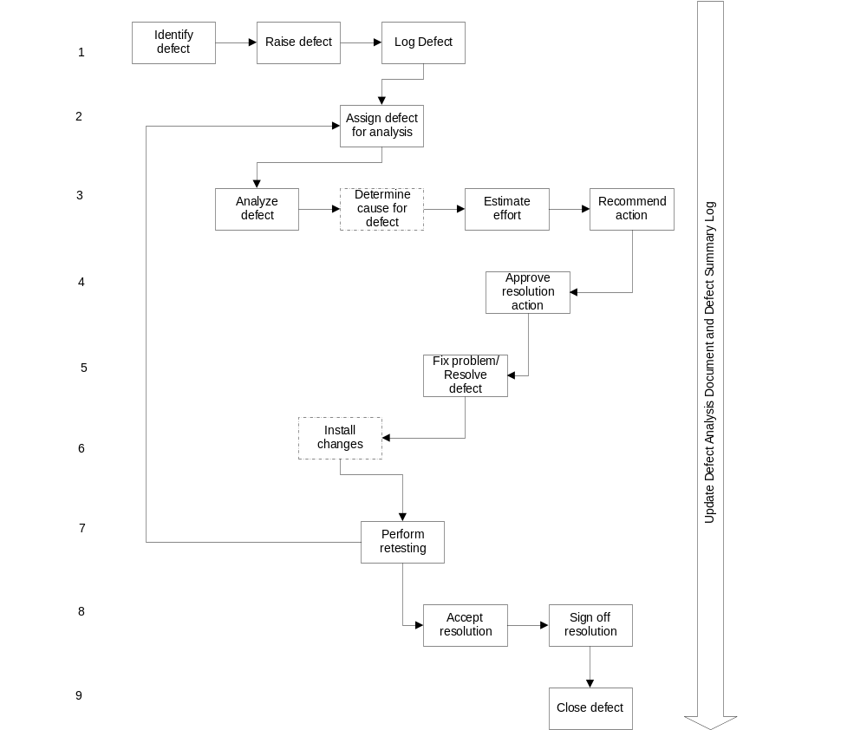

- Steps
Defect Tracking
The steps followed to perform defect management are described in this section:
- Identify, raise and log the defect.
- Assign the defect for analysis and update the Defect Summary Log with the defect status.
- Analyze the defect, recommend action to resolve it and estimate the effort for the resolution, or recommend its withdrawal.
- Review and approve the recommendation and estimate or withdrawal, and update the defect status (and alternative recommendation if selected)
- Fix the defect and update the defect status and information on all changed components
- Install or migrate the resolution for the defect to enable re-testing
- Perform retesting until the fix successfully passes the success criteria by looping back to the analysis step, update the Defect Log with the status
- Accept and sign off the defect resolution
- Close the defect in the Defect Summary Log, update the defect status and signoff information.
Roles Involved
The following test team members are usually involved steps 1, 2, 3, 5 and 7 at a minimum:
- Business Test Specialist
- Developer
- Technical Test Specialist
The following roles may be involved in steps 4 and 6, particularly in large and/or high-risk projects:
- Test Manager
- Project Architect or Lead Developer
- Project Manager
- Business User
Refer to the Test Method for the detailed descriptions of the roles.
- Identify, Raise and Log the Defect
Purpose
The first task in defect management is to identify the defects (through static or dynamic testing), and document and track the defects in order to aid their resolution, optimize defect uncovering and removal within the project, and allow assessment of the progress of the project.
Description
Once a defect has been uncovered, a brief initial assessment should allow basic identification of its nature. If the defect has not already been identified, capture its details on the Defect Analysis Document together with a summary of the defect in the Defect Summary Log. This log will allow the defect to be tracked, and therefore ensure that it is resolved as efficiently as possible. The Defect Analysis Documents together with the Defect Summary Log will act as a source and repository for the defect information, aiding the capture and dissemination of data about them.
Inputs
- Defect found
Outputs
- Raised defect
Steps
- To raise a defect, a new entry must be made in the Defect Summary Log. Exact details of this process will differ according to the testing tool being used. Much of the process is generic, and the details of the information to be recorded are valid for any defect. Also, the following detailed information must be supplied on the Defect Analysis Document or entered into the appropriate defect tracking tool:
- Defect Number – Unique number set manually, or by the testing tool
- Date Raised – Date defect raised
- Raiser's Component - Test or operation which uncovered the defect
- Impacted Components - All areas affected by the defect.
- Severity Level - As allocated by the user, on a scale of descending severity from 1 to 4.
- Priority Level - As allocated by the user, on a scale of descending priority from A to D.
- Brief Description – A short description (1-2 sentences) summarizing the defect.
- Complete Description – A detailed description (paragraph) describing the defect and how to re-create it.
- Supporting Documents – References and/or attachments to assist with problem identification and resolution (e.g. test scripts, pre and post data compares, report printouts, screen prints etc.).
- Causal Reference - Underlying problem that caused the defect as chosen from the list of Closing Codes (to simplify statistical analysis).
- Status - Initially set to Raised.
- Audit Log - Containing details of the raiser and the raising date of the defect.
- Answer/Fix Required by Date - May be assigned manually or calculated from the severity and priority ratings.
- It is the responsibility of the defect raiser to communicate sufficient analytical information to the appropriate resolution teams to aid the efficient resolution of the recorded defect. The Test Manager should define a policy for addressing defects that are not reproducible.
- The team responsible for the testing activity in which the defect was identified ensures that a reference to the defect is entered on the respective test control document (e.g. test script) when the defect is raised. If any other test control documents are affected by the same defect, these records are also updated with the unique Defect Number of the defect.
- When a defect is identified, check against the Defect Summary Log to determine whether any existing defect encompasses some or all of the new defect's symptoms. If a relationship is discovered, the old defect is updated to reflect the new occurrence and any other additional information.
- Assign the Defect for Analysis
Purpose
The purpose of this step is to assign responsibility for the defect and start action towards its resolution.
Description
The name of the person responsible for executing the next step is identified along with an expected completion date for the step. This provides a definite contact for status and reduces confusion in tracking progress. This assignment and update may be repeated at each step, as the defect flows through the process.
Inputs
- Raised defect
Outputs
- Assigned defect
- Updated Defect Summary Log and Defect Analysis Document
Steps
- Assign the defect to the appropriate development and/or delivery team and individual for further investigation. The raiser may do this when the defect is first uncovered, if the appropriate individual is known at that time and the raiser has that authority.
- Add the following information to the existing defect records:
- Assigned To - name and contact information of the assigned investigator.
- Date Assigned
- Estimated Completion Date
- Status set to Assigned.
- Defects encountered during the testing lifecycle will typically fall into the following categories:
Business or Technical Functional Errors, e.g.
- Programming Error: the code does not match the detailed design
- Design Error: the design does not meet the functional requirements.
- The requirements are incorrect and/or some are missing
- Documentation errors.
Testing Process Errors, e.g.
- Test Execution Errors: the test executor did not follow the script to the letter
- Test Data Error: the original data created to test the condition did not meet the specification of the test data model for the condition
- Script Error: the instructions or responses stated in the script were incorrect
- Configuration Error: the environment was incorrectly configured

- Analyze the Defect, Estimate Effort and Recommend Action for Defect Resolution
Purpose
The purpose of this step is to confirm the cause of the defect, and the effort and actions required to resolve it.
Description
The defect is diagnosed as a true defect (i.e. one not caused by errors or omissions in the test process). This is confirmed in this step by in-depth investigation. Any potential associated defects are identified and reviewed to confirm the scope of the item.
The fix required to resolve the defect is designed and the time required to execute the repair is estimated.
On the other hand, if information suggests that the defect should not be addressed, the recommendation to withdraw it from the management process would be made. Withdrawal may be recommended at any time during or after this step.
Inputs
- Assigned defect
Outputs
- Recommended actions
- Estimated effort, skills and resources required
- Updated Defect Summary Log and Defect Analysis Document
Steps
- Confirm the diagnosis of the defect to ensure it was not caused by testing errors and omissions.
- Perform further analysis of the defect, and collect data about the problem to determine:
- Whether it is in fact a procedural and/or program fault, or
- A change that is outside the scope of the project, or
- Requires no further action
- Look for evidence that the defect impacts other areas of the organization, project or code.
- Optionally, perform root cause analysis if project schedule allows to identify any potential impacts of this defect on other areas and to raise additional defects if required.
- Depending on the outcome of the defect analysis, the following action may be recommended:
Business or Technical Functional Errors:
Defects or variances that are the result of conflicts between the requirements, specification and / or design and its actual execution are investigated to determine whether they are true defects or a miscommunication of expectations. The former are referred to the defect management process and rated for severity and priority for fixing as assigned by the master test plan and the defect management team. The latter are referred to the change management process to prioritize the revision of requirements, specification, design and construction of each item. (These items will eventually re-enter the testing process as defined by the management of the change request.)
Testing Process Errors:
Defects or variances that are the result of testing process errors usually require the process to be remedied and the test to be repeated. These errors should also be reviewed to ensure that they have not impacted previous test results. Confirm that the test execution process followed, and test environment components and configuration meet the test design and specification. If not, document discrepancies and request action to correct. Check for impact of failure on other tests, and take appropriate action – re-test, revise test execution plan and / or test design and specification, double-check execution, etc.
- Design a fix that will accommodate all areas impacted.
- Estimate the effort, skills and resources required to build, test and implement the repair.
- Document the recommended actions and estimates in the Defect Analysis Report. At this point the following information should be entered in the defect records:
- Status Code set to Analyzed and Estimated
- Fix Description
- Assignee.
- Approve Recommended Defect Resolution Action and Estimate
Purpose
The purpose of this step is to approve the resolution action to resolve the defect and assign it.
Description
This activity confirms that the effort to fix the defect falls within the scope of the project, and meets the return on investment (ROI) requirements of quality management. It provides an opportunity to revisit risk assessment and ensure that the appropriate resources are being applied to address the defect. The approved resolution plan should be assigned for execution.
This step may not always be carried out on all projects or for all defects. It depends on the guidelines established in the Defect Management Plan and thresholds for review based on risk, resource level required, etc.
Inputs
- Recommended defect resolution action and estimate
Outputs
- Approved recommendation
- Updated Defect Summary Log and Defect Analysis Document
Steps
- Review the recommendations, Defect Analysis Document and project risk guidelines.
- Determine whether or not the recommended fix fits the ROI for the organization and project.
- If not, return for further analysis or submit the defect for withdrawal with stakeholder agreement.
- If yes, add the approval to the Defect Summary Log.
- Schedule and assign the fix. At this point the following information should be entered in the defect records:
- Closing Code
- Approval Description
- Schedule
- Assignee
- Estimated Fix Completion Date
- Status Code set to Recommended Action Approved
Related Templates and Examples
- Fix the Problem/Resolve Defect
Purpose
The purpose of this step is to carry out the necessary action to resolve the defects, in order of severity and priority.
Description
Perform the necessary fixes, ensuring that defects with a high severity and/or priority are dealt with first. The defects with a severity code of 1 or 2 and a priority code of A or B are seen as Halts Progress and Critical Defects, and as a general rule must be corrected and re-tested prior to the conclusion of the current testing phase and before live implementation.
Inputs
- Categorized defect
- Type of fix required
Outputs
- Fix or correction for defect
- Updated Defect Summary Log and Defect Analysis Document
Steps
- Once Defects have been categorized, they should be resolved in order of importance, based on their allocated severity and priority classifications, and in all cases within the turnaround times specified for the project.
- On completion of the fix, the defect should be progressed to status: Fixed or Resolved. At this point the following information should be added to the defect records:
- Closing Code - if not already entered.
- Complete Answer Description - for the defect.
- Actual Effort - spent in resolving the defect.
Roles Involved
The following test team members are involved in fixing the defect:
- Developer (primary)
- Technical Test Specialist
Related Templates and Examples
- Migrate Changes for Re-Test
Purpose
To migrate the fixed defect back to the right environment or organization for re-test. This may require an install of code if it was a defect in an executable development component.
Description
Conduct regular meetings to review the status of all defects and fixes, and to determine a schedule for the migration of fixes. If it is a defect found during static testing, the amended component is handed over for re-test without an install. Correct version management is extremely critical at this stage.
Inputs
- Categorized defect
- Fix ready for installation
Outputs
- Fix installed
- Ready for re-test
- Updated Defect Summary Log and Defect Analysis Document
Steps
- Review the completed fixes for all defects.
- Decide on a date and time for the fixes to be migrated from development to the relevant testing environment. Plan the details of this migration, communicate to all interested parties, and obtain approval where necessary.
- Update the defect records with information about fixes and migration, and update the status of the defect to: Ready for Re-test.
- Re-assign the query back to the test area (i.e. defect raiser/test specialist) for performance of re-test.
Roles Involved
The following test team members are involved in installing the changes:
- Business Test Specialist
- Developer
- Technical Test Specialist
- Test Manager
- Perform Re-testing
Purpose
The purpose of this step is to determine whether the completed resolution for a defect has been successful in fixing the problem and has not introduced others.

Description
- Once defects have been fixed they are re-tested. Dynamic re-testing will usually involve re-executing not only the failed test(s), but a regression set of tests which will ensure that new errors have not been introduced with the fix. If the fix has worked, the condition can be checked off as being successfully tested. Static testing will involve an impact analysis of components associated with the changed component to ensure consistency and integrity.
Inputs
- Defect and fix in status: Ready for Re-test.
Outputs
- Defect recommended for Signed-Off, or
- Defect Assigned (defect management lifecycle restarted)
- Updated Defect Summary Log and Defect Analysis Document
Steps
- Select those test cases and scripts which either uncovered the defect, and which deal with areas impacted by the defect and/or the fix. Execute these cases and scripts to ensure that the fix has resolved the defect, and has not caused any new problems in related areas. Confirm that the expected result follows requirements and design specification.
- If the fix passes all tests successfully, recommend sign-off of the defect record, and update all test assets to reflect the resolution. The information which must be added to the defect records is:
Actual Retest Effort - actual effort spent on fix and retest.
- If retesting shows that the fix has not resolved the defect, the defect record remains Open, and must be recycled to be re-assigned - status: Assigned. This process must continue until all defects are at status: Closed (signed off or withdrawn).
- Accept and Sign-Off Resolution
Purpose
The purpose of this step is to accept the resolution for the defect and to sign off this resolution as satisfactory.
Description
The recommendation for sign-off is reviewed and accepted (or rejected in which case the defect returns to the defect assigned step in the process). Acceptance depends on meeting the success criteria with due diligence in ensuring that new defects have not been introduced and that the expected test results have been achieved. Rejection can mean these conditions have not been met.
There may also be reasons for withdrawal at this point because although acceptance criteria have not been met, further investment is not deemed appropriate. (This will require buy-in from stakeholders, either through pre-set criteria or through review and consensus on project risk tolerance levels).
Inputs
- Defect recommended for Sign-Off
Outputs
- Repair Acceptance
- Defect Sign- off
- Updated Defect Summary Log and Defect Analysis Document
Steps
- Review the recommendations, resolution and defect history
- Accept resolution for defect
- Sign-off defect:
- Sign- off
Roles Involved
The following test team members are involved in signing off the defect:
Business Test Specialist
Technical Test Specialist
Test Manager
- Close Defect
Purpose
The purpose of this step is to ensure the documentation of the completed resolution for a defect is complete, that impacted test assets have been updated and to assign the appropriate closing code.
Description
The defect history documentation is reviewed for completeness. Defects often have impacts beyond the immediate repair, and any other test assets affected and requiring updates should be checked to see that the changes have been incorporated correctly. The closing code appropriate to the source of the defect is chosen to simplify statistical analysis.
Inputs
- Accepted and signed-off defect
Outputs
- Completed defect history
- Updated impacted test assets
- Updated Defect Summary Log and Defect Analysis Document
Steps
- Review defect history documentation for completeness
- Review impacted test assets for appropriate updates
- Select appropriate closing code The information which must be added to the defect record is:
- Closing Code
- Status is Closed.

- Tools
Defect tracking can be done automatically through the aid of defect tracking test tools. There are many considerations in selecting an appropriate defect-tracking tool.
For example, is the tool capable of:
- Logging and tracking defects found during each project phase?
- Allowing multiple users to use it?
- Recording the ultimate resolution, including which modules were fixed?
- Reporting defects by severity level?
- Providing tailorable workflow capability to manage the defect tracking and resolution process?
- Reporting defects by status?
- Identifying and linking the person responsible for providing a fix?
- Linking a defect to the test run and test case that found it?
- Performing trend analysis?
- Performing keyword searches?
- Performing sorting functions based on user specifications?
- Providing E-mail notification when new defects are logged or fixed and ready for retest?
- Reporting defects remotely?
- Performing Internet/Intranet-based defect reporting and tracking?
- Providing general features such as:
- Ease of use, user friendly?
- Stability of tool?
- Providing general security requirements such as:
- Defining user level access?
- Defining group level access?
- Being able to control user access for defect tracking?
- Advice and Guidance
Root Cause Analysis or ODC Analysis
After defect management is performed and the test results and defects are properly reported (see Test Results, Test Reports Work Products, and Test Management Technique Paper), root cause analysis and/or ODC analysis should be conducted on all defects detected.
Purpose
This activity analyzes the root causes of defects identified during testing, and instigates and tracks action plans to prevent re-occurrences of the same defect or defect pattern.

Description
Root cause analysis activities should be performed to discover defect trends and to produce recommendations for development and testing process improvements. It is not enough to fix errors or defects detected during testing.
This "closed loop" process is implemented to ensure that errors or defects detected during testing are not only recorded and fixed, but that the root causes of the defects are identified, and process improvements are put in place to reduce the chances of similar types of errors recurring. Root cause analysis may also be used to perform preventive or perfective of the application.
Steps (refer to Root Cause Analysis Technique Paper for further information):
- Review the root cause analysis criteria.
- Schedule root cause analysis.
- Conduct root cause analysis:
- Review any existing quality standards and benchmarks.
- Perform various statistical analyses of performance against these standards.
- Review defect analysis records and build profiles of common factors.
- Use the results of these analyses to identify problem and opportunity areas, such as: skills, process gaps and redundancies, new technologies or business function, poor hand-offs between test levels or business/development/testing/operations.
- Determine the earliest point where the defects could have been detected.
- Make recommendations for change.
- Examine defect rates by test procedure. Select those with rates higher than production
- Update procedures
- Update lists of commonly occurring defects (observations).
- Review and accept corrective action.
- Implement corrective action.
- Track and report status.
Roles
The following test team members are typically involved in root cause analysis:
- Business Test Specialist
- Developer
- Technical Test Specialist
- Test Manager
- Project Manager
ROI
Effective defect management allows the project team to balance the risk posed by a defect against the effort required to fix and manage it and to recommend an optimum course of action, appropriate in cost vs. benefit. This can only be effective where there is good dialogue and strong confidence and trust among the stakeholders: viz. business, development and testing. This confidence is established prior to the initiation of testing and preferably before the project start, particularly through organization wide quality, risk and testing programs that set the stage with standards and guidelines for various types of projects. These help facilitate the conversations around risk acceptance and prioritization, which should be supported by excellent test and defect management processes.
Regular Defect Review Meetings
In order to ensure that adequate resources are scheduled to resolve defects according to priority, it is beneficial to have regular defect review meetings daily or weekly. At this meeting, development management, test management, and business and technical test specialists would:
- review all new defects, and assign them or reclassify them as issues, enhancements, etc
- review all closed defects and their resolutions
- discuss how defects should be batched or prioritized; and
- review the metrics such as number of open/fixed/closed defects, and trends in debug/fix time and project impact.

Any critical impact on project deadlines or budget, other inter/dependent projects and high risk items are escalated to the appropriate stakeholders such as the project sponsor for resolution.
Defect Categorization
Detailed information on how to classify defects (for process improvements and root cause analysis) using a standardized, rigidly-defined categorization technique, may be found at IBM’s websites http://wwwidd.raleigh.ibm.com/swtest/swtest.nsf/index.html and http://www.research.ibm.com/softeng/ODC/ODC.HTM. At present the examples on these pages are geared towards the development of systems software, but the analogy can be adopted for application development. The IBM Testing Competency is currently investigating the inclusion of this technique into the IBM Global Services Method – Testing Subdomain.
- References
For further details on test execution, test results, or test reporting and test management, see the following test work products/technique papers available in the IBM Global Services Method:
- Test Execution
- Test Results
- Test Reports
- Test Management Procedures
- Defect Analysis Document
- Revision History
Revision Number | Revision Date | Summary of Changes | Changes Marked?
Version 5.2 | June 2006 | Removed incorrect references (also note that version numbering is off and this document is still part of release 4 at this time)
Version 5.1 | November 2000 | Applied new template and style, grammar and spell check.
Version 5.0 | November 2000 | Updated to reflect MFT review recommendations.
Version 4.0 | November 2000 | Updated to reflect local and SME recommendations.
Version 1.1 | October 2000 | Updated to reflect TFEM initiatives.
Version 1.0 | August 1999 | Base version.

