
IBM Global Services
Defining Architecture Specification
Technique Paper (TP)
© Copyright International Business Machines Corporation 1997, 2000
All Rights Reserved
Version 1.3, October 2000
Introduction
This technique is used during the elaboration of an Operational Model from a conceptual level to the specification of nodes, connections and components. A fully specified Operational Model is sometimes referred to as an Architecture Specification.
A specification-level Operational Model is at an appropriate level of abstraction and detail to be used as a key part of an Invitation to Tender (ITT), where there is a need to maximize the opportunity for a wide range of vendors to present their best solution, without changing the overall structure of the design. Alternatively, the project team can subsequently develop the Operational Model to a physical level, by selecting software and technology products, which satisfy the specifications.
This technique takes a conceptual-level Operational Model and transforms it in several ways:
- It identifies the underlying technical requirements necessary to deliver the required business function where and when it is needed, with the appropriate service level characteristics and within the necessary constraints.
- A subset of constraints have already been accommodated, specifically the limitations imposed on the design due to the non-functional capabilities of the solution’s network infrastructure. This has already largely determined the shape and style of the solution, in terms of the application’s data and function placement across the geography of the client.
- It converts the vaguely defined conceptual nodes (which simply represent some form of approximate co-location of application-oriented deployment units) into fully specified, potentially independently deployable computer systems and other IT hardware, referred to as specified nodes. Specified nodes are described in terms of technical requirements, not technical products which meet these requirements
- It converts the “point-to-point” connections (which represent the required component interactions) into fully specified inter-node connections (referred to as connection segments since an interaction may need to be supported by several “linked” connections). Connection segments are described in terms of technical requirements, not technical products that meet these requirements.
- It refines the system management requirements, described in general terms at the conceptual level, into full specifications.
During the transformation the deployment units and components may be relocated and/or redefined according to the design choices made.
This technique is used in parallel with specific techniques to design for availability, security, performance and capacity, and system management.
As the Operational Model evolves throughout a project, it is common for different parts of it to be at different levels abstraction (and detail), and the technique should be applied flexibly to reflect this.
As a ‘deployment unit’ is merely a convenient collection of components, the technique often refers to placing components rather than deployment units. Where it is important to distinguish between placing the data aspect, execution aspect, installation aspect, the term deployment unit is used.
Steps

Identify Appropriate Specified Nodes
General Guidance
During steps 1 - 3, you will identify how the conceptual nodes of your Operational Model could be realized, but without considering how to deliver the various service level characteristics (step 4).
In this first step, create specified nodes as empty containers, which will, in the next step, have the various application components placed in them. So do not worry too much about getting this first attempt at the specification-level Operational Model right. All we are doing is “getting started.”
As you do this step, bear in mind that you are looking to define specified nodes which can be defined as collections of components which, when taken together, are required to present a “single systems image” to the rest of the solution. With this in mind:
- Sometimes, a conceptual node will map directly onto a specified node, one-for-one.
- Sometimes, a conceptual node will be split into multiple specified nodes, with the original set of components divided across the specified nodes
- Sometimes, a specified node will end up containing components, which were originally in several different conceptual nodes.
For each of these candidate specified nodes, think about their basic nature (end user support, processing, data support, high availability, secure, high performance, combinations of these, etc.), based on the service level characteristics you identified for the conceptual nodes on which they are based. For the moment, however, consider these things qualitatively - we will work out later whatever supporting infrastructure is needed to deliver these qualities. For the time being (in fact, in the next step), we will use these required qualities to guide the placement of the various application components.
The degree of transformation from the conceptual to the specification-level Operational Model may also depend on the circumstances of the engagement, for example:
- If you are dealing with a technological environment with which you (or the client) are unfamiliar, you may over-emphasize the distinctions between nodes and develop a rather “fine grained” Operational Model.
- If the “answer is obvious” for some aspect of the IT system, do not bother taking a fine-grained approach to the constituent parts, when a holistic specification is clear.
As you identify these candidate-specified nodes, prepare an appropriate set of empty specified node box diagrams (see Operational Model work product description). You will populate these with components, as you proceed through the later steps of this technique.

System Management
For the moment, do not worry too much about the connections and most of the other underlying requirements that you identified for the conceptual nodes in the IOM - these are dealt with later. The exception to this is system management.
You previously identified, for each of the “ordinary” conceptual nodes, a high level specification of their system management requirements, plus a single system management conceptual node which acted as a place holder for the various system management disciplines the IT system needs to support.
The system management requirements of the ordinary conceptual nodes will be mapped into the specification-level Operational Model in much the same way as their other requirements. The system management node, however, is handled differently.
You need to identify the required system management specified nodes as distinct nodes: nodes that have the same basic nature as the “ordinary” nodes, although they are responsible for system management processes and data, rather than application components. These system management specified nodes will be the “system management command and control centers,” which manage and react to system management activity on the other nodes.
Typically, in a distributed environment, a hierarchical structure is often adopted, with distributed system management managers, and some form of centralized “manager of managers.” This is illustrated in the third example below.

Users and External Interfaces
One key distinction between conceptual and specified nodes, which you must accommodate now, is related to “numbers of nodes” and “numbers of users.” At the conceptual level:
- The number of each conceptual node per location is 1 - by definition
- The number of end users or external systems per node per location, for those nodes that had such users or external systems was 1 to n.
For these “end user” conceptual nodes, you must now begin to decide how the numbers of users are going to be supported, such that the design shows “one user per specified node.” In other words, the number of specified nodes per location is NOT necessarily one for those nodes, which are supporting end users. This is illustrated in the first two examples below.
Example 1: Partial Operational Model - “lightweight” end user specified nodes
In order to illustrate the activity of mapping user nodes from the conceptual to the specified level, it has been helpful to show the placement of application components. This activity does not actually take place until step 2.
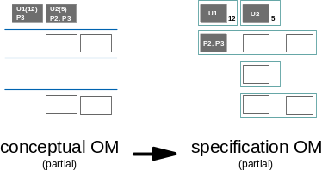
Figure 1: Transforming conceptual to specified nodes (Lightweight user specified nodes)
Example 2: Partial Operational Model - “heavyweight” end user specified nodes
As above, in order to illustrate the activity of mapping user nodes from the conceptual to the specified level, it has been helpful to show the placement of application components. This activity does not actually take place until step 2.
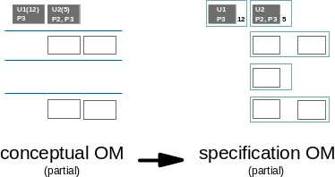
Figure 2: Transforming conceptual to specified nodes (Heavyweight user specified nodes)

Example 3: Full specification-level Operational Model
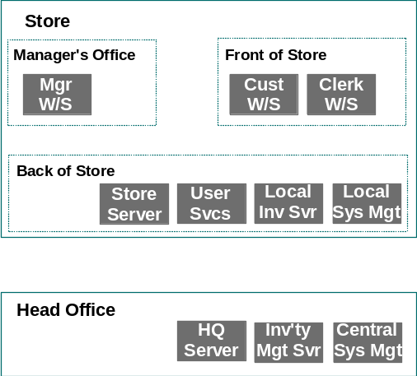
Figure 3: Candidate Specified Nodes
This example is based on the same scenario as the example in the Defining Conceptual System Topology technique, and shows:
- Locations (and sub-locations) instead of layers
- The end user conceptual nodes have been transformed into workstation specified nodes, with the possible provision of “end user services” on a separate specified node.
- The various “services” conceptual nodes have all been left “as is,” but have been renamed “servers,” to reinforce their more technologically bounded nature.
- The system management conceptual node has been realized as a store based system management specified node, plus a centralized “manager of managers” system management specified node.

Refine and Replace the Application Components
General Guidance
Place the various components on the candidate specified nodes, paying particular attention to the nodes’ basic “qualities.” (The components were previously laid out over the conceptual Operational Model.) While you are doing this, consider whether any deployment units need:
- Further Splitting and/or recombining? Is it unclear whether a deployment unit should be replaced in specified node A or B? If components were grouped differently into deployment units, or if the component model was revised (e.g., by splitting a component) would placement be easier?
- Further Replication or duplication? In some circumstances would a deployment unit, originally placed on conceptual node X, now be best placed on specified node A, while in others it would be best on node B? If so, then place it in both specified nodes, noting the conditions when it would be used on each.
This theme of “alternative placement” is relates to achievement of the system’s service level characteristics, particularly when dealing with “degraded mode” options, and is considered in more detail in designing for availability.
Usually, the best approach is to consider the application deployment units in the following order:
- Presentation
- Data
- Execution
- Installation
(The category “installation” was not considered at the conceptual level. We are now going to decide where the application components should be stored as well as where they execute.)
The following sections adopt this sequence. However, there will be circumstances where you feel it easier to (re)place execution before data.
As you go through the sub-steps, change the candidate-specified nodes as required.

(Re)Placement of Presentation Components
These should be relatively straightforward to place, since they are directly related to “end user” specified nodes. Think about the presentational requirements at a deeper level, probably because since the Operational Model was built, there has been some additional design work or prototyping on the various end user interfaces.
In particular, understand the need for:
- Output (Screens)
- The sophistication of the users
- Monochrome or color
- Windowing, Menus or icons
- Interface Standards
- local installation standards
- GUI, Drag and Drop
- National Language Support
- Input (Keyboards etc.)
- Mice, tablets, etc.
- Stylus
- Keypads, other specialized layouts
- National Language Support
- Printers and Scanners:
- Speed
- Paper sizes
- National Language Support
- Specialized industry devices (for example, robots, ATMs)
Do you now have the need for two (or more) user/system interfaces, where on the conceptual Operational Model you could identify only one? If so, then transform the conceptual node into two (or more) specified nodes, each of which represents the different interface.
The manner in which these presentational needs will be delivered is considered in step 4. Document what is needed rather than how it might be done.
Example

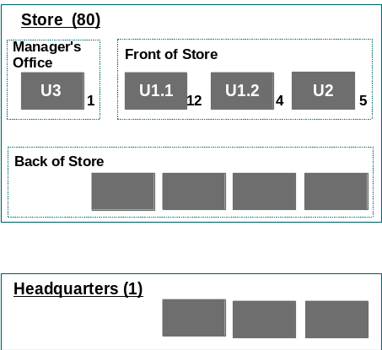
Figure 4: Placed Presentation components
This example (based on one in the Defining Conceptual System Topology technique) shows:
- The Customer interface (previously U1) has now been resolved into two distinct aspects:
- An interface (U1.1) which will be static in the store, of which the original number (12) is required
- An interface (U1.2) which will enable the customers to wander at will around the store, doing many (but not all) of the functions they could do via U1.1 - of which only 4 are required per store.
- It has been possible to map U1 and U3 directly onto the equivalent specified nodes from their original conceptual nodes.
- In particular, review the system’s capabilities and special requirements related to printing:
- Ensure that the specifications include allowance for printing data. Since those are not directly linked to the data deployment units you will consider later, there is a risk they may be overlooked.
- Similarly ensure that the special device needs are represented by any necessary specified node(s).
- Consider any special considerations for mobile users who want to print.

(Re)Placement of Data Deployment Units
Taking each conceptual node in turn, rethink the placement of its data deployment units onto the specified nodes.
- Are the required characteristics of the deployment unit still uniform, or could you reconsider the deployment unit’s set of components, in order to simplify the IT system’s deployment - even if such finer grained definition makes the Operational Model appear more complex?
- Can you still see how to deliver the required characteristics with the replication/copy management/segmentation strategy you adopted in the conceptual operational model? Do you need more or less sophistication?
- Is there any opportunity to combine data deployment units? (Although this might make for a simpler diagram and description, it is sometimes NOT a good idea to combine deployment units in spite of this opportunity. It is easier to recognize subtle differences between units than it is to spot subtle differences within a deployment unit.)
Refer to the Deployment Unit work product, since the design will be driven by:
- The need for some data deployment units to be placed in obvious or given locations
- The scope of the data deployment units
- The deployment units’ characteristics (size, volatility, etc.).
Example
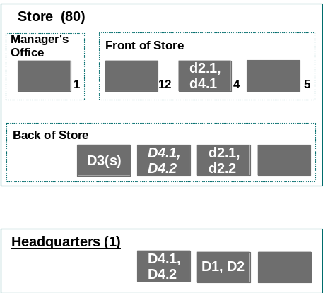
Figure 5: Placed data deployment units
This example (based on one in the Defining Conceptual System Topology technique) shows:
- Because of the mobile nature of one of the customer interfaces, it is probable that there will need to be some local data but not all of the appropriate units:
- Deployment unit d2 has been refined into two parts - d2.1 and d2.2, with only that part necessary for the customer’s mobile activities on the workstation
- D4 has been refined into two parts, with only that part necessary for the customer’s mobile activities on the workstation - d4.1.
- The Inventory data (D1 and D2) have been directly placed on the equivalent specified nodes as has the centralized data D4 and the segmented store based data D3(s).
- The temporary (but master) data previously located on the clerk conceptual node D4, now D4.1 and D4.2, has been placed on the (new) User Services specified node, since the relatively high level of availability and integrity required may be easiest to achieve in a “back office” environment

(Re)Placement of Execution Deployment Units
Taking each conceptual node in turn, rethink the placement of its execution deployment units onto the more physically structured specified nodes.
- Are the required characteristics of the deployment unit still uniform, or could you reconsider the deployment unit’s set of components, in order to simplify the IT system’s deployment - even if such finer grained definition makes the Operational Model appear more complex?
- Can you still see how to deliver the required characteristics with the replication/duplication strategy you adopted in the conceptual Operational Model? Do you need more or less sophistication?
- Is there any opportunity to combine execution components? (Although this might make for a simpler diagram and description, it is sometimes not a good idea to combine deployment units in spite of this opportunity. It is easier to recognize subtle differences between units than it is to spot subtle differences within a deployment unit.)
When (re)placing execution components in an object-oriented environment, remember that:
- The attributes of components (which are represented by data deployment units) can only be “accessed” by the methods of the same components (as represented by execution deployment units)
- Interactions between components are supported by connections between execution deployment units.
Thus, as the third sub-step (following the placement of presentation and data), placing execution components must find the best compromise between where the users are; the placement of the business information they need access to; and the need to support interactions with components represented by other execution deployment units:
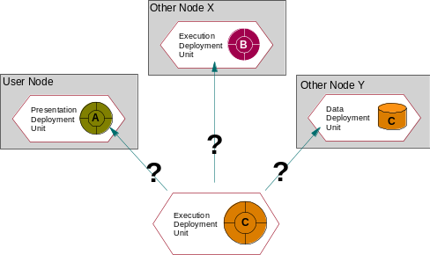
Figure 6: Where to place execution components
For example, determine where should the execution of component C be placed.
- Co-locating execution and data is clearly the “default” option, thereby retaining the holistic nature of the objects, which underlie the deployment units. So, in many circumstances, this will probably be the easiest and apparently safest choice.
- On the figure, the execution deployment unit associated with component C would be placed on Node Y.
- If the business function demands highly interactive processing with only occasional light access to data then it may be appropriate to put the execution nearest to the end user even if the data has been located elsewhere (perhaps for scope reasons).
- On the figure, the execution of component C would be placed on the User Node.
- Under some circumstances, it may be wise to redesign the underlying component model so that parts of the original component are in separate nodes, in which case they would be in separate components (components cannot span nodes). For example, those parts of a component which handle display and dialogue management might be at a specified node associated with the user, while file access and data handling might be at another specified node.
- On the figure, component C would require redesign, with part ending up on the user node, and part on Node Y.
You will already have thought through the implications of these alternatives at a conceptual level. Ask, “Are the decisions you made still valid now that you have more precisely defined the nature of the nodes involved?”
These placement decisions should also be reconsidered as you now think about the nature of the linkages between data and execution components, and between execution components, as is discussed in the next sub-step.
Example
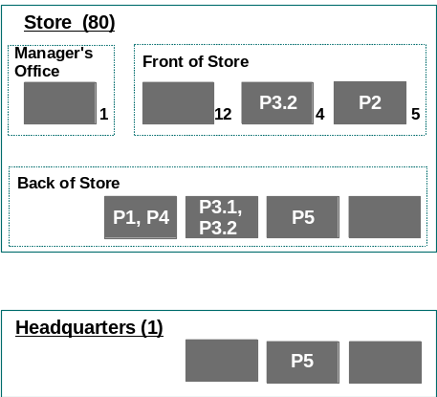
Figure 7: Placed Execution components
This example (based on one in the Defining Conceptual System Topology technique) shows:
- Because of the mobile nature of one of the customer interfaces, it is probable that there will need to be some local processing - but not all of the appropriate components:
- Deployment unit P3 has been refined into two parts - P3.1 and P3.2, with only that part necessary for the customer’s mobile activities on the workstation
- P1, P2, P4 and P5 have been directly placed on the equivalent specified nodes.
- The processing directly associated with the customer’s “fixed” workstation (and also some of the clerk’s role) P3.1 and P3.2 has been placed on the (new) User Services specified node, since this is probably going to provide the simplest approach to system management (although, because all users are now dependent on the one specified node, it requires a higher level of availability).

The Nature of the Linkage Between Data and Application Execution
Much of the decision process involved in the execution placement exercise revolves around the nature of the linkages between execution deployment units and data, and between different execution components. These linkages are, in general, controlled by the capabilities of the underlying technical components that are needed to support them. In order to understand the choices you have, consider the following example.
Example: Centrally located data - where to place execution
In this case, we have (maybe for reasons of scope) decided to hold the attributes of a component centrally, on a “HQ” specified node - represented by data deployment unit D3. We also have distributed users, who need access to this data (through their appropriate presentation component, U1), via the execution component P3.
How can we link these? Of the many options, consider these two:
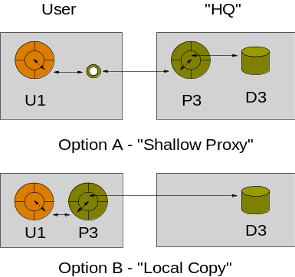
Figure 8: Execution component placement Options
- In the first option, P3 is co-located with D3 on the User specified node, and a “shallow proxy” technical component, on the User specified node, acts as a broker between the components U1 and P3.
- This is a fairly normal arrangement, using CORBA or DCOM object brokers.
- In the second option, P3 is co-located with U1, and some form of middleware is used to fetch the necessary attributes of the required components from D3 “into” P3.
- This is also a fairly normal arrangement, although at the time of writing it usually relies on bespoke (project developed) middleware code.
Which of these two options is best? It depends on the operational service level characteristics you are required to support:
Option 1 (shallow proxy):
- Strengths:
- Response times between U1-P3 interactions should be fairly consistent
- Weaknesses:
- As the requirements placed on the shallow proxy middleware grows, so system management may become more complex
- Response times may be long, particularly if interactions between U1 and P3 need to traverse WAN type networks.
Option 2 (local copy)
- Strengths:
- Following the initial fetch of attributes, response times may be quick.
- Weaknesses:
- “Roll your own” middleware code may require significant code management.
- Initial response time, while fetching attributes, may be long, particularly over WAN type networks.

Installation Deployment Units
As part of the Operational Model’s detailed specification of requirements, you must also now decide where the “binaries” of the various application components are going to be stored - represented by the fourth type of application deployment unit - the installation deployment unit.
For example, if you have decided to execute a component on a User’s specified node (i.e., you have placed the execution deployment unit on that node), do you also want the component’s binaries to be stored there as well?
In so far as this is an “Object Oriented” environment, probably the default answer is “yes - co-locate the installation and execution components” (just as is the default case for data and execution). This is not, however, always the best - or available - option.
Example
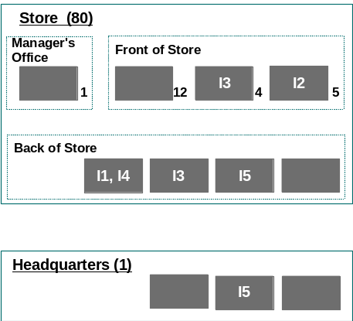
Figure 9: Placed Installation deployment units
This example (based on the example in Figure 7) shows:
- All installation components are “co-located” with their equivalent execution components
- That the installation deployment unit (I3) is also placed on the mobile user workstation specified node, in order to support the execution of P3.1 - but that the “executable” is the same as that on the User Services specified node. This is perfectly valid, and simply indicates that not all of the interfaces of the components associated with I3 will be exercised (only those associated with P3.1).

The Nature of the Linkage Between Execution and Installation Application Components
Much of the decision process involved in the installation deployment unit placement exercise revolves around the nature of the linkages between execution and installation components. These linkages are, in general, controlled by the capabilities of the underlying technical components that are needed to support them.
Consider the following example (which is a continuation of the one presented in the equivalent execution sub-step).
Example
In this case, we have (maybe for reasons of scope) decided to hold the attributes of a component (#3) centrally, on a “HQ” specified node - represented by a data D3. We also have distributed users, who need access to this data (through their appropriate presentation U1), via the execution of component P3, which has (for reasons of performance), been located on the User Node.
Where should we store the binaries of component #3 (I3)? Of the many options, consider these two:
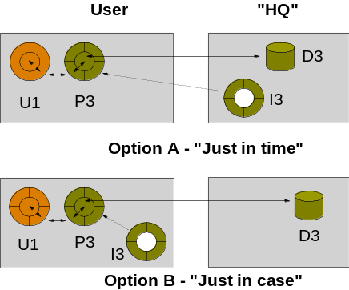
Figure 10: Installation deployment unit placement options
- In the first option, all long term storage aspects of the component #3 are held on the “HQ node,” and only when required (“just in time”) is the binary of component #3 (stored as deployment unit I3) moved down to the end user node for execution (as P3).
- This arrangement is implemented by JAVA.
- In the second option, the binaries of component #3 are stored on the end user node (represented by deployment unit I3), so that as and when required (or “just in case”) it is available for execution (as P3).
- This is a fairly normal arrangement, as for Smalltalk, C++ etc.
Which of these two options is best? It depends on the operational service level characteristics you are required to support:
Option 1 (“just in time”)
- Strengths:
- Reduced system management challenges of distributed code.
- Weaknesses:
- Initial Response times may be long, since “I3” will probably be quite large, and particularly if the network between nodes is of the WAN type.
Option 2 (“just in case”)
- Strengths:
- Response times should be greatly reduced (so long as the size of the binary is significantly larger than the size of the required attributes)
- Weaknesses:
- System management may be more complex, since there is more distributed code to manage.

Develop Connections and Identify Communications Specified Nodes
Transforming the abstract “point to point” connections on a conceptual Operational Model into the detailed physical networks that appear on a physical Operational Model is best accomplished through a staged technique, in much the same way as for nodes.
General Guidance
Experience has shown that a workable/affordable network solution can be designed by first deciding, in the specified Operational Model, how the required component interactions should be routed between the various specified nodes. This technique involves the identification of:
- Routed interactions
- Communications specified nodes
- Connection segments
Throughout this step remember that you are working out what communications needs you will have in order to support the distributed deployment units you have now placed. As always, you may find that this activity causes you to go back and change some of your placement decisions, and may even cause you to change the set of specified nodes.
Document the requirements for connections. As you follow the next few sub-steps, make sure you consider:
- Have the physical connections that will support the required connection segments been specified (are they “givens”)
- Processor channel
- Teleprocessing links
- Switched or leased facilities
- Packet switched facilities
- Bandwidth management
- LANs
- Shared message queue.
- Docking facilities for mobile users
- Connection segments that may be impacted by distances
- Time zones with possible impact on service hours and time windows for maintenance
- International boundaries with requirements to meet particular common carrier regulations or standards
- Excessive costs to provide required bandwidth
What connection segments will need extra analysis for:
- Function, for example protocol conversion
- Security
- Availability
- Response time and throughput?
- National Language Support

Identify Key Point-to-Point Connections
Given the placement decisions you have now made, it is usually a good idea to review the required point-to-point interactions this placement implies. It is these point-to-point interactions that will drive your design decisions, leading to a specification of the required “routed interactions” and the associated connection segments.
As with all aspects of this technique, bear in mind the givens and other constraints you are operating under. Do not, for example, spend time on interactions for which the connection segments over which they will be supported are obvious or given.
Example
This is based on the examples of step 2.
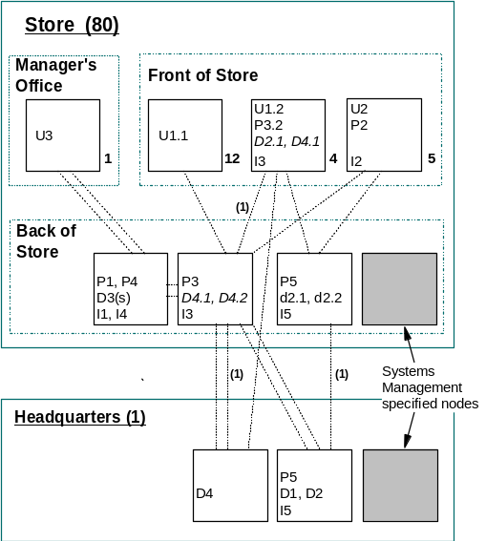
Figure 11: Point-to-Point connections between specified nodes
This example shows
- Some of the key component interactions (“execution to execution” and “presentation to execution”).
- Some of the linkages required between the execution of components and the permanent storage of their attributes (“execution” to “data”).
- Some of the key interactions necessary to maintain the attributes of application components in sync or otherwise up to date (“data to data”), identified by the label (1).

Identify Candidate Communications Nodes
Sub steps 3.3 to 3.6 refer to a rather iterative and interrelated set of activities, to be performed in parallel.
The point-to-point interactions you have identified on the Operational Model may be best supported if they are “routed” via intermediate specified nodes that are expressly required to handle network traffic, communications nodes. This will be particularly pertinent whenever you identify a requirement for inter-location communications.
From the overall shape of the interactions, identify any candidate communications nodes.
Example
This is based on the example in the previous sub-step.
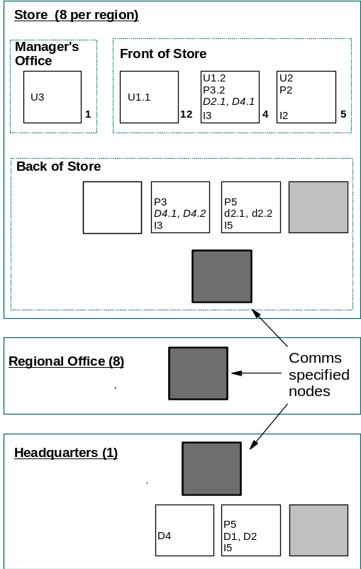
Figure 12: Candidate “Communications” nodes
This example shows only one of many options, many of which would probably need to be explored before the best could be identified. In particular, it reflects a somewhat “normalized” network, where all stores are broadly the same, within a consistent store-region-HQ structure.

Establish Required Routed Interactions
The various communications specified nodes should now be exploited to allow interactions to be routed from “used by” to “used” components.
- Using these communications specified nodes, establish the required routed interactions.
- Remember to think about all the different interactions identified for the application components, whether they be:
- Presentation to Execution
- Execution to Execution
- Execution to Data
- Execution to Installation.
Example
This is based on the example in the previous sub-step.
Only those interactions that require routing through communications specified nodes are shown. All other interactions, identified in the earlier sub-step are still required, but not illustrated.
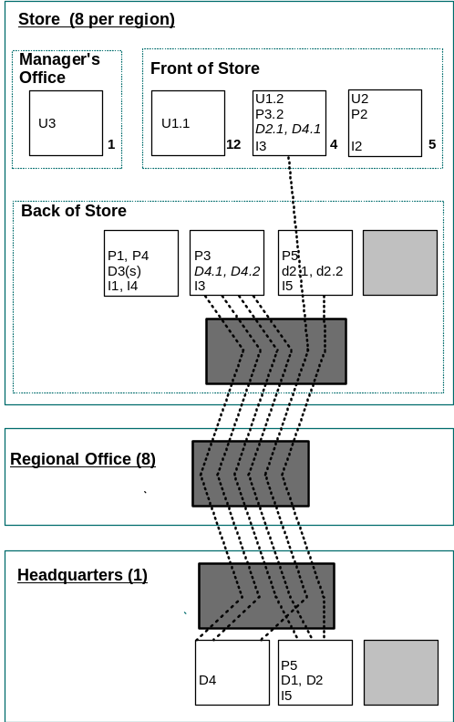
Figure 13: (Selected) routed interactions
This figure only shows how those interactions, which are “inter-location” will be routed from store, via regional office, to HQ.

Identify Required Connection Segments
With the interactions “routed” between the various nodes, you can now look to understand the requirements for the individual connections between nodes:
- Identify the various connection segments that these routed interactions may imply
- Determine any tentative opportunities for consolidation of these routed interactions, connection segment by connection segment, whether these be related to, for example:
- Performance improvement: Is there an opportunity to use compression or multiplexing mechanisms?
- Availability improvement: Is there an opportunity to use “store and forward” or alternate routings?
Is it reasonable to expect all the routed interactions that flow between two specified nodes to be supported over one connection segment? Remember that these segments - just as for specified nodes - are described in terms of requirements. So:
- DO identify two or more connection segments between two nodes if the nature of the supported routed interactions vary widely, such as
- “real time, sub-second transit, small messages during the on-line day
- “batch,” throughput sensitive, files during an overnight window
- DO NOT identify two or more connection segments between two nodes if the nature of the supported routed interactions is “high availability.” If two are needed to deliver this SLC, then this will be established in the physical Operational Model.
Example 1: Connection segments
This is based on the example in the previous sub-step.

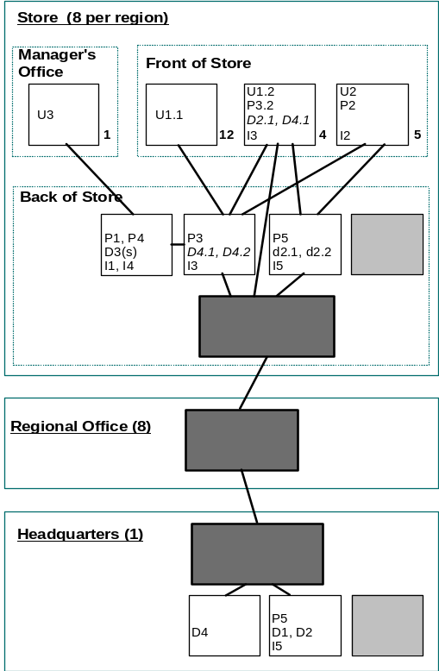
Figure 14: Connection segments
Example 2: Connection segments and routed interactions
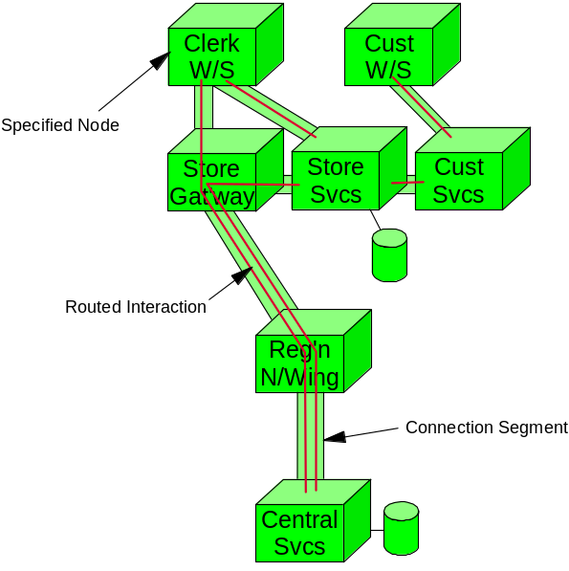
Figure 15: A specification-level Operational Model diagram showing routed interactions and connection segments
This example shows:
- Several communications specified nodes.
- How the various routed connections are supported over connection segments.
- A visual clue to the need for application data on some specified nodes (the disk symbol).
Note that it is somewhat stylized. There is no reference to the numbers of specified nodes (per location or layer); the anticipated characteristics have not been highlighted in any way; but the specified nodes are drawn using the correct notation.

Describe Requirements for Connection Segments
Describe the characteristics of the connection segments. These will, in many respects, reflect the same set of topics as you considered for the conceptual nodes, and which still apply to the various specified nodes. Document these requirements, in the Operational Model connection segment matrix, with (as necessary) supporting detailed text.

Identify Required Technical Components
General Guidance
This step is intended to help you transform some of the “non functional characteristics “ you have been determining for the specified nodes and connection segments into technical statements of requirement. These "non-functionals” cover:
- The required/compromised Service Level Characteristics.
- The requirements you have established to ensure the solution can be managed.
During the development of the physical Operational Model, you will convert these technical specifications into products and/or detailed design specifications.

The Specified Node Box Diagram
The complex nature of the many technical components you may need to consider can be more easily understood if you classify and document them according to the Specified Node box diagram.
This is not the only possible specified node box diagram. You or your client may prefer to use an alternative one. However, it will probably have many similarities, and so this model will be helpful as it guides you through the following steps.
Although the sub steps described below consider the different sorts of technical component as independent things, this may not be the case in practice - the boundaries between the boxes on the diagram below are purposefully drawn dotted, since there will be occasions when you identify a component which does not fit comfortably in one category.
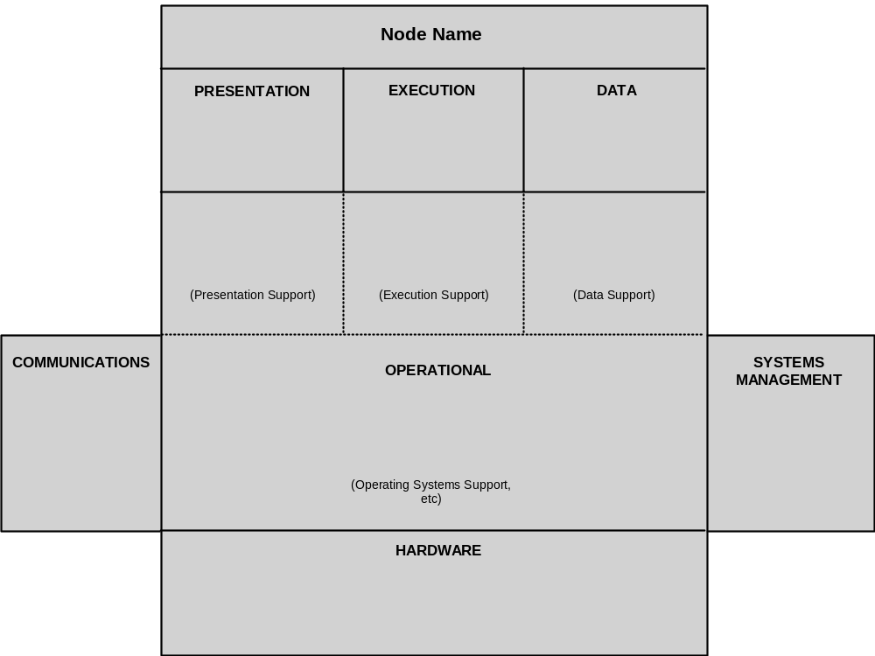
Figure 16: Specified Node box diagram.
The layout of this diagram is intended to provide visual clues as to the relationships between the various types of deployment unit, which are placed on the specified node:
Application components:
Most of these may already have been considered in the conceptual level of the Operational Model.
- Presentation is that set of components (usually represented as a Presentation deployment unit) that defines how data is accepted from and displayed to the end-users) or external systems), as required by the business function. This aids the isolation of the business function from the physical characteristics of the input/output components.
- Execution is that set of operations that actually execute the business processes for which the system is designed, represented by execution deployment units.
- Data is the data deployment units that hold attribute data of component instances which is to be stored on this specified node.
- Installation is the installation deployment units that represent the storage of the binaries of those components, which are to be installed on this specified node.
Operational components:
These are components that are responsible for ensuring the application components deliver many of the required service level characteristics, such as integrity, security, and availability:
- Operational (Presentation) support is that set of functions that deal with the physical interface with the user (or other external system), handling input and output of information to and from these end-users. As such, they are directly related to the application’s presentation components.
- Operational (Execution) support is that set of functions that controls the flow of system and business tasks. As such, they are directly related to the application’s execution components.
- Operational (Data) Support is that set of functions that controls and accesses the physical data elements of the system. These are usually organized in a database. As such, they are directly related to the application’s data and installation components.
- Operational (Operating Systems etc.) is the basic services that run the hardware environment and the set of program services.
Support components:
These are the components that provide the underpinning environment for the specified node:
- Hardware is the base hardware of any specified node, including all elements such as those in the following list. Note that a specified node is not only a computer. Terminals, LAN attached printers, mainframes, routers are all possible specified nodes, for which this list would be distinctly different.
- CPU, memory, disks
- Adapters and cards
- Screens, keyboards, other input/output devices
- Printers, scanners
- System management is that set of functions that manage and control irregular events, or other “non-application” events, whether they be continuous (such as performance monitoring) or intermittent (such as software upgrades).
- Communications are the logical means by which specified nodes are joined (the hardware elements of this being accommodated in the “hardware” area of the diagram). This includes any middleware to bridge between any of the presentation, execution and persistence functions across nodes, for example; Distributed Management, Queuing system, and asynchronous event handler.

Presentation Support
Define the presentation support functions that are needed on those specified nodes that host presentation components. In this context, “presentation support” refers to those technical functions that you can foresee will be needed to support the user (or external systems) interface.
Keep in mind that these functions are required to support “presentation components,” which represent those components in the application that are particularly responsible for system input/output. Therefore, you will need to work closely with the developers of these components in order to understand the presentation function requirements
For example, will the presentation components need:
- Help facilities
- Dialogue Managers
- Simple Input validation and verification
It is probable that you will find it difficult, particularly if you are using this technique early on in the design process, to distinguish between “presentation” and “presentation support.” Probably one of the key distinguishing features is that “presentation components are application specific, whereas things which support are application neutral.
For example:
- A system help facility is usually (part of) a “presentation support” component, whereas the sets of words presented on the help screens are part of a presentation component (they maybe held in the form of message catalogues).
- A generalized mechanism to compare input with a defined set of options may be part of a “presentation support” component, whereas the set of options used in the comparison are part of a presentation component.

Execution Support
Determine how the execution components will be executed, routed and managed within the specified node. For example, is there a need for:
- Transaction Manager required
- Process/Workflow Manager required
- Distributed Time function
- National Language Support
Remember that some of your technical components may have to operate in a distributed manner because the business logic that they are supporting is itself distributed, e.g., a transaction manager needs to be distributed.

Data Support
As you consider these functions, keep in mind the advantages to be gained if you can coordinate the requirements with those for “installation support.”
Determine how requests from the execution components will interface with persistence components, and how those might flow within the system. Be particularly careful to understand how you will meet the SLC requirements, when these two aspects of the underlying components are on different specified nodes.
A key test of the homogeneity of a specified node is that a single “set” of persistence support components can support all the persistence components it contains.
For each specified node summarize:
- The file and DB organizations (Relational, Object)
- Controls over sharing
- Integrity and recovery, both in the DB and the transaction manager if these are separate
- Logical unit of work (LUW) scope of recovery
- Two-phase commit support - synchronization, recovery
- Journaling, logging
- The needs for archiving, security copying, storage management
- The special needs of mobile users who may want to dock periodically to upload and download data
- National Language support requirements
Determine the functions that are required to support backout of changes. Must these functions exist in multiple specified nodes or locations. That is, is the application process to be recovered a distributed application process, involving multiple components and/or execution components.

Installation Support
As you consider these functions, bear in mind the advantages to be gained if you can co-ordinate the requirements with those for “installation support.”
The storage requirements for application “executables” has, traditionally, been comparatively straightforward, with the use of standard operating system file storage mechanisms or other appropriate techniques, such as distributed file systems. With the advent of object oriented databases, you may now need to consider a more complex (or more restricted) situation. For example, you may need to identify:
- The mechanisms required in order to manage and distribute objects to their storage locations around the operational model.
- How they going to be made available at the location where they are going to be run.

Operating Systems
Determine what is needed to control and manage the workload. Perform the following steps:
- First identify what needs to be controlled.
- Characterize each specified node with respect to processing workload or data storage capacity.
- For each node, refine the checklist of processing and data storage requirements by adding scheduling and capacity characteristics.
- Do not forget to include notes about the workload of other business processes if the particular node is to be shared with some other application in the same environment.
Consider the following issues:
- How many different parts of the workload will need to be managed separately, with different priorities, etc.?
- Is the workload always the same or do different time periods need to be managed differently?
- How many dispatchable units of work need to be supported concurrently, (for example, tasks, threads, or processes)?
- Do different parts of the workload have to interact? Synchronously or asynchronously? Do not forget batch processing.
- What function will be needed to provide the necessary control?
- What workload balancing will be needed?
- How will the system be able to recognize the different types of work?
- What sorts of mechanism will be needed to control execution:
- CPU dispatchers
- Storage allocation
- Storage contents
- I/O
- Communications
- Timers?
- What is required to schedule transactions and/or batch jobs?
- What interface points are required for applications, and what standards need to be supported by the interfaces?
- What deadlock detection is required for distributed processes or data?
- If statistics or error logs are to be time stamped, what mechanisms are required to provide timing consistency between locations or specified nodes? (If multiple time zones, what timing convention will be used?)
- What process state and data status needs to be synchronized between different specified nodes? What control functions need to be provided to support this?
- How does a node know when a partner-specified node (application session or server function) is terminated or the session broken?

Communications Support
You now need to create more detail round the high-level “routed interactions” and the supporting connection segments between the specified nodes. You will need to consider:
- Based on these functions define the characteristics of the logical connections:
- Synchronous or non-synchronous
- Connection profiles (mainframe interactive, client-server, peer distributed, hierarchical distributed, internet) and the communications protocols required to support them:
- LU type for SNA
- TCP/IP
- HTML etc
- Programming Interface styles
- Remote procedure call
- CPI-C
- Message Queuing
- Object messaging
- Transfer units (character, record, stream):
- Files
- Messages that form transactions
- Image blocks
- Voice
- Required transit times
- Time Windows
- National Language Support message and field translation
Unless the system connections are very simple, you may want to review your conclusions or concerns with a communications specialist.

Validate the Design
General Guidance
This step endeavors to cover a number of related issues:
- Analysis and Review the overall design of the Operational Model as you have it thus far
- Validate the overall structure of the design
These sub steps are intended to help you create a specification-level Operational Model that is much more in keeping with the actual organizational and geographic structure of the client. Maybe, up to this point, the design has been somewhat stylized, with all “peer locations” considered to be the same, or maybe categorized in some general way (small, medium, large?) Now is the time to consider the detailed nuances and differences across the whole model.

Analyze the Effects of Placements
Analyze the effects of the placement of deployment units on the candidate collection of specified nodes and connection segments.
Check that the placement of execution and storage is viable. Pay particular attention to how the data is to be kept current. Consider in detail:
- Must changes be synchronized across multiple specified nodes?
- Is the performance of the data access acceptable?
- Will the data be partitioned or will copies be used?
- What, where and when will be the source(s) of updates to the data?
- How will the data be updated - partial or total refresh?
- How quickly must changes be reflected?
- Within seconds
- Within minutes
- Nightly
- Weekly
- What is the impact of an update being delayed?
- What load will this place on the system - processing, communication?
- What effect on access control, audit and potential for denial of service?
Do you fully understand all the implications of the placement of the data? If they are unacceptable, the data cannot be placed in this location. If, in answering questions such as these, you change the placement of the data, check the pattern of access again.

Characteristics of Specified Nodes
As you have been placing the various components, the characteristics they require are “inherited” by the nodes on which they are placed. Now is the time to summarize the characteristics of these specified nodes. For example:
- Execution:
- Applications
- Volumes
- Response requirements
- Availability requirements
- Types of processing - batch, transaction, message-based, etc.
- Persistence:
- Volumes
- Types of data access
- Data integrity and recovery
- Security.
Flag special requirements such as numeric intensive computing, or the requirement for a specified node not to be capable of storing data because of security.
Check that you have included System Management and development processes and data.
In the conceptual Operational Model, you may have documented this type of information (in summary form) on the conceptual node box diagram and (in detail) in associated free form text. For specified nodes, which are much more precise in nature, a more formal documentation technique may be appropriate, such as those below.
Example 1: Execution Characteristics specified node “User Services”
Component | Type | Priority | From | To | Avail-‘ity | Max outg | Rsp time | Units | Avg Vols | Peak Vols | Peak Hour
Browse | On- line | 1 | 0800 | 1800 | 99.5 | 5 min | <1s | txns/ hr | 6 | 9 | 17:00
Order | On- line | 1 | 0800 | 1800 | 99.5 | 5 min | <5s | txns/ hr | 4 | 6 | 17:00
Register |  | 2 | 0800 | 1800 | 99 | 10 min | <5s | txns/ hr | 1 | 1.5 | 17:00

Example 2: Data Characteristics, specified node “Store Server”
Data | Data Type | Size | Security
Catalogue Item (Image) | Image (“blob”?) | 10,000 @ 150Kb | Read only
Catalogue Item (Text) | Text (relational?) | 20,000 @ 1Kb (two languages) | Read only
Example 3: Data Access Characteristics, specified node “Store Server”
Data DU | Usage type | Access hours (from) | Access hours (to) | Access rate (avg.) | Availability
Catalogue (all components) | Blob enabled DB | 08:00 | 18:00 | 200 per min | 99.5
Customer | Relational DB? | 08:00 | 18:00 | 60 per min | 99.5

Validate the Design (Walkthrough)
Walkthroughs are an excellent mechanism for understanding what is required of the Operational Model, and to verify that the model is capable of supporting the business requirements. Now may be a good time to conduct a more formal review of the design using such a mechanism.
Walk through all major processes (batch and online), if necessary with the application architect and systems management expert. Make sure you cover all major business processes, applications, operation and system management, particularly where more than one specified node is involved. Make sure you consider:
- Normal operation
- Error conditions and their recovery
Be careful to choose only the major processes. If you go into too much detail in the processes, this activity could be very large. Make sure you understand exactly:
- What processing is performed on each specified node
- Where the information being accessed is held and how it is accessed
- What communication takes place between specified nodes
- The form of that communication, for example, functional profile (mainframe interactive, client-server, hierarchical or peer distributed, or extra-enterprise) and protocols, if known
- Who defines the unit of recovery, that is, the work backed out after a failure
- Where logging takes place
- Who manages the recovery.
If you have a large number of specified nodes and business processes, this activity will probably be too time-consuming to perform for each one. Build a walkthrough list of processes (transactions) you will use in this walkthrough.
- Group similar processes, and choose one per group to represent that group.
- If you cannot choose a representative process, create a hypothetical process, which tests all the necessary business functions and specified nodes used by that group.
- Ensure that after walking through all the processes on your list, you have touched every node and every important deployment unit in each node in the system.
- If you find that you have not considered one particular specified node, then add to your walkthrough list another process, which does touch that node.
- Ensure that your walkthrough list will test all major recovery functions.
- Ensure that your walkthrough list includes the most heavily used business processes.
Diagramming these walkthroughs on the specified nodes and connection segments in a meaningful way will help you with the activity. One way may be to start with a blank system picture and represent each major process by shading the nodes that are involved in the particular transaction. It is also helpful to use diagrams such as those presented in “Example 2: Connection segments and routed interactions.”
You can break down individual flows further, using an object interaction diagram.
From these message flows a picture can be built up of the processing to be performed at each specified node and the traffic that will flow over each connection segment. One approach is to consolidate this information using simple worksheets. These can then be used to identify the level of function needed at each node and in each link, their requirements for availability, etc.
If the design has many specified nodes the information should be held online in standard formats so it can be sorted by service, node type, availability requirement within node, etc. If the nodes have many different requirements for the amount of data they must store or the amount of processing they must perform, the data should be held on a spreadsheet. The spreadsheet may take a little more effort to set up but it can save a large amount of time later in the design process.
You should also thoroughly check that your online processes do not have to be stopped or acquiesced because a batch process has to be run against an important DB, file or library. It is quite common for batch processes to require a stable view of data or for DB managers to require that batch does not run with online workloads.
Even if you are allowed a small batch window (for example each week) when batch might be run there is always the possibility that the batch processes might overrun and thus prevent the online work from restarting.
In particular, understand the consequences of failure, and play “what if” games at each node, such as:
- What if a connection segment is down?
- What if a specified node is down?
- What if the data is corrupt?
- What if the management of a specified node is not working?
- What if a specified node fails whilst a transaction is executing in it? How will the transaction be rescued?
- What if a connection segment goes down while a transaction between two interacting components is in progress?
- Does any end user(s) need to be informed if a specified node is (or goes) down?
- Who else needs to be informed if a specified node has failed?
Ensure that all major transaction and failure scenarios are investigated and that any out-of-line scenarios are documented and resolved.

Rationalize the Design
General Guidance
This step examines the design to see whether it will be able to be operated by the staff who will be available or whether it is unnecessarily expensive. If necessary the design is changed to address these problems.
If the client has architects responsible for concerns such as data architecture or networking, it is wise to work with them during the following sub-steps to ensure that decisions made for this design do not have a negative impact on other existing or planned systems.

Classify Specified Nodes by Size
You may have a specified node that has been derived from a conceptual node, but you can now see that there are actually two or more variations of this node. The variations may be determined by the size of the expected workload, for example:
- You have 3 classes of branches within the business:
- Large branches
- Medium branches
- Small branches
- You can therefore have 3 classes of nodes within the infrastructure:
- Large branch server node
- Medium branch server node
- Small branch server node
Thus the one conceptual node has been split into 3 types of specified node.

Identify Locations which are not Economic
There are locations where the costs of the new IT system are too high to be justified by the volume of work. This might be because all (or all but the largest) locations of a given type (for example, sales offices) are too small to justify their own equipment. In these cases, if the necessary execution components and/or data are moved to other locations (with the presentation components either remaining or being changed), the Operational Model will need to be changed because the nodes will be doing different work.
Other examples of non-viable location types are:
- Locations with very few staff may never be able to develop and keep the level of skill needed to run anything more complex than stand-alone workstations.
- Very high communications costs also can make a location uneconomic. In this case consider whether more function and processing power can be placed at the location to reduce the amount of communication.
As well as “location types,” you should also consider individual locations (particularly those that are near the extremes of the type.
The decision that a location (or location type) is not economic will be based on level of utilization and impact on total system costs - absolute or as a proportion. Also, keep in mind that it may actually be less costly to use a single design for a location type (irrespective of, for example, size) even if some of the equipment is under used, than it may be to use different designs for locations of different sizes. For example, system management of a system involving different designs for stores type A, B and C may be greater than if there were only one type.

Transfer Components
Decide which locations you will use to support users in locations that will no longer have their own IT capability. This could be accomplished by merging the same type of locations (for example, two branches), or by combining different types of location (for example, a branch and a regional office).
- Check that this really is an improvement. Will the changes cause a large increase in communications costs or unacceptable response times? If this is not an improvement try to identify another type of location for the placement of execution components and data.
- Is there a need to change the presentation components in some way (for example, if there was a significant reliance on execution components to support input/out data verification)?
- Update the connection statistics (flow volume, etc.) if they have changed.
- Check that you have not created a new implementation of your system models that will require some new functions, especially middleware. If you have, revisit the appropriate activities.

Check the Effect on the Conceptual Operational Model
If components have been moved from their original specified nodes, check that these changes have not altered (or have already been accommodated on) the conceptual Operational Model.
In particular look to see if you have changed the shape and style of the system. For example:
- From Distributed to Centralized
- From ‘Open’ to proprietary at certain critical interfaces and the architecture is not valid anymore.
You may choose to document certain parts of the system in much more detail than others. For example you may have designed a LAN Client/Server part of the system that is new and needs special attention and considerable new functional elements, whereas another part of the system is Host based, has been running for years and requires little change.

Review the Design
Review the design and revise it as necessary to satisfy availability, security, performance and system management requirements (guidance for each of these areas is contained in separate technique papers).
You may make design changes during any of these topics, which may clash with earlier design decisions. Look for these. In particular look out for clashes of requirement, such as:
- In order to improve availability, you may have increased the numbers of specified nodes, but forgotten to update the numbers and recalculate the performance characteristics.
- You may have taken some security decisions, such as adding encryption, which were not considered in the performance section.
- Perhaps you have chosen to adopt a particular approach to security, which makes it difficult to achieve your availability targets.
No system will exhibit the required service level characteristics unless its management system enforces the correct disciplines. You should check that the management system is in place to control the system so that:
- Changes are done in an orderly fashion and within the designed maintenance constraints.
- The system will operate and react to component failures in such a way that their impact is limited. This will almost certainly mean that there will have to be a significant degree of operational automation.
There are sufficient monitoring and reporting tools and activities in place so that the availability characteristics of the system and its components can be understood.
Cross Reference to ISD
- 1. Identify appropriate specified nodes Major enhancement to WSDDM/ISD Question F04 - maybe even a replacement?
- 2.2 (re)Placement of presentation components based on WSDDM/ISD F05 and F19
- 2.3 (re)Placement of data deployment units NOT based on WSDDM/ISD F06.
- 2.4 (re)Placement of execution deployment units NOT based on WSDDM/ISD F07.
- 3. Develop connections and identify communications specified nodes NOT based on WSDDM/ISD F08
- 3.1 General Guidance Based on WSDDM/ISD F57
- 3.2 Identify key point-to-point connections NOT in WSDDM/ISD
- 3.3 Identify candidate communications nodes NOT based on WSDDM/ISD
- 3.4 Establish required routed interactions NOT based on WSDDM/ISD
- 3.5 Identify required connection segments NOT based on WSDDM/ISD
- 3.6 Describe requirements for connection segments. NOT based on WSDDM/ISD
- 4.2 The Specified Node box diagram Based on WSDDM/ISD F03.
- 4.3 Presentation Support NOT based on WSDDM/ISD F05
- 4.4 Execution Support Based on WSDDM/ISD F06
- 4.5 Data Support Partly Based on WSDDM/ISD F07
- 4.6 Installation Support NOT based on WSDDM/ISD
- 4.7 Operating Systems etc. Based on WSDDM/ISD F09
- 4.8 Communications Support Based on WSDDM/ISD F08
- 4.9 System management NOT based on WSDDM/ISD
- 4.10 Hardware NOT based on WSDDM/ISD
- 5.2 Analyze the effects of placements Based on WSDDM/ISD F10
- 5.3 Characteristics of specified nodes Based on WSDDM/ISD F11
- 5.4 Validate the Design (Walkthrough) Based on WSDDM/ISD F12 and F49CA
- 6.1 General Guidance Based on WSDDM/ISD F13
- 6.2 Classify specified nodes by size Based on WSDDM/ISD F14
- 6.3 Identify locations that are not economic Based on WSDDM/ISD F15 and F16
- 6.4 Transfer components Based on WSDDM/ISD F17
- 6.5 Check the effect on the conceptual Operational Model. Based on WSDDM/ISD F18
- 7 Review the design Based on WSDDM/ISD F55
Revision History
Version 1.3, October 2000 – Removed confidentiality markings from header
Version 1.2, September 1999 – Applied to template, spelling and grammar review.
Version 1.1, February 1999 – A standard format template was applied.
Version 1.0, September 1998 – Base version.

Under certain circumstances, these separate specified nodes may recombine into one physical node - for example if there is a need for magnetic stripe and keyboard data entry, this may be delivered via a single physical workstation with a card reader.
At the time of writing, an example, which places the installation and execution components separately, is JAVA, over the Internet - JAVA applets are downloaded from the web server to web client "just in time" for execution.
You must, however, be confident that these givens are capable of supporting the required traffic - which is addressed in the later "SLC refinement" steps.
Bear in mind that the application-oriented components also have some responsibility to deliver SLCs - such as being coded bug-free (availability) and efficiently (performance)

