
IBM Global Services
Defining Candidate Application Deployment Units
Technique Paper (TP)
© Copyright International Business Machines Corporation 1998, 2003
All Rights Reserved
Version 4.1.1 March 2003
- Introduction
The objective of this technique is to assist in the preliminary definition of a set of application oriented specified Deployment Units (DUs).
It combines information from, among others, the Non-Functional Requirements and Component Model work products, documenting the candidate DUs in a DU WP in preparation for their placement across the Conceptual Level of the Operational Model (COM) in the OM WP. As such, it can be seen to have a close link with the COM’s development technique “Defining Conceptual Architecture”.
In so doing, it focuses on:
- Defining each application DU – representing the execution, data and presentation aspects of the components in the solution’s Component Model,
- Describing the Non-functional characteristics of each DU,
- Identifying the relationships between the DUs.
Other technically related DUs are considered later in the design process, since at the conceptual level, the Operational Model does not consider technical components, or the actual hardware and software products, which will be used to realize the design.
As the definition of the solution’s application level Deployment Units evolves throughout a project, it is common for different DUs to be at different levels of accuracy, precision and detail, and the technique should be applied flexibly to reflect this.
Note that the example presented in this technique paper is rather simplified from those found in actual engagements (please refer to the more complete examples available in the Deployment Units WPD). Also note that the naming convention used in this example is based on that defined in the Operational Model Notation Technique Paper.
It also takes a “solution requirements” driven (not technology) perspective – although at all times it is important to remember these specified DUs will need to be implemented in code or via a package (customised or not!). Therefore experience and planning ahead is required – for example, it is probably necessary at the very beginning to assess the likely difficult areas and the extent of uncertainty and thinking about this system, as well as have in mind the key technologies or products in which the solution will be implemented.
- Examples
1 Identify Candidate Deployment Units
Since DUs represent the various aspects of the components involved in the application level component model, it is natural to start by a direct examination of the CM. Therefore, make a first assessment of the need (or otherwise) for Presentation, Execution and Data DUs for each component.
During this step it may be helpful to focus on the CM’s relationship diagram, since this provides the most direct link to the placement activities on the OM relationship diagram. Also, consider the following when assessing the need for each type of DU:
- Presentation DUs (PDUs): Each component that is responsible for supporting the link to each user or external IT system will have one or more presentation aspects and therefore require one or more PDUs.
While identifying these PDUs, it may also be helpful to refer to the System Context Diagram, which defines the systems relationship with all users and external IT Systems.
- Execution DUs (EDUs): In a conventional IT system, all application level components will have an execution aspect, and therefore will require an EDU. However, it may be that you can immediately (and implicitly) identify different characteristics for some parts of a component’s execution – in which case it may be appropriate to define several EDUs for this aspect of that component.
- Data DUs (DDUs): Many (although often not all) components have responsibility for business oriented data. Each of these will be represented by at least one DDU. However, as with a component’s EDU, it is possible that you can immediately identify different characteristics for some parts of a component’s data – in which case it may be appropriate to define several DDUs for this aspect of that component.
As you are working through this step, think about whether you want to identify names for the DUs – or whether you simply want to identify their existence. Although names are important, it may be best to wait until a little later in the technique, when more is known about the DUs, before naming them in a way that reflects their purpose.
One convenient way of documenting the results of this step may be via a matrix, relating the list of application components to the DU types, for example:
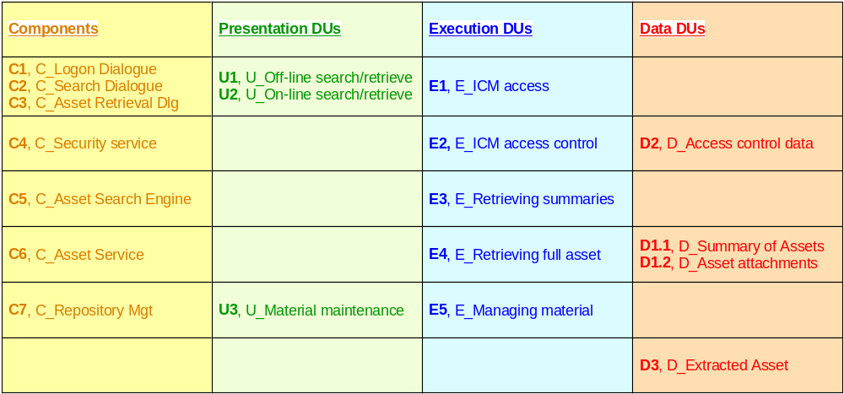
Example Component-DU matrix
It must be born in mind, however, that there may be circumstances in which the component/DU mapping cannot be represented in a simple matrix such as this, particularly when there is significant component grouping, and the component-DU mapping must therefore be documented DU type by DU type.
2 Identify DU Characteristics
Using information documented in the Non-functional Requirements work product, determine the key non-functional characteristics for the candidate deployment units. In particular, it is almost always vital to explicitly identify each DU’s service level characteristics (SLCs). The detail behind each of these SLCs will depend on the type of DU being described but, in general, it is helpful to document:
- “Numbers”. How big, how often, or how fast?
- Volatility. How often does the DU or one of its attributes change?
- Security. What levels of access control does the DU require?
- Availability. How available does the DU need to be – both in terms of scheduled availability and unscheduled unavailability? And in the event of a problem, what levels of degraded service will be acceptable for the DU?
The detail behind each of these categories depends on the type of DU in question. So, for each type of DU in turn, establish the NFRs for each DU defined in step 1. As you work, be particularly aware of the potential for:
- The separation or splitting of a component’s aspect into two or more parts. For example:
- It may be that the same component will be responsible for more than one system’s interface, such as a system that needs to provide the same services to the same user, but via a hand held terminal as well as a workstation. In this case, it may be helpful to separate these two sets of system’s interface (presentation related) NFRs into separate PDUs.
- It may be that some functions available from a component are resource intensive, while others generate a lighter load. In this case, it may be helpful to separate these two parts into separate EDUs.
- It may be that some parts of a component’s data aspect are very large, but quite stable, while other parts are very volatile, but small. In this case, it may be helpful to separate these two parts into separate DDUs
- The aggregation or grouping of one aspect for two or more components, if it is clear at this point that this aspect can always be treated as one thing operationally. Each aspect is aggregated independently, so that, for example:
- If the system interface presented to a user or external system by a number of components is subject to the same NFR's then this aspect of the involved components can be grouped into one PDU.
- The execution of a component may be grouped into an EDU with a different set of components to that with which its DDU is aggregated.
- The large, stable parts of a component’s data aspect are grouped into a DDU with similar data aspects of other components, while its small, volatile data parts are handled in a separate DDU.
In all cases, it may be that you don’t yet have quantitative information, and you may therefore be making qualitative judgments or assumptions. As the project proceeds, so the metrics on the associated components should become more firmly established and you can therefore document quantitative information for each DU.
Presentation Deployment Units
Presentation DUs represent the non-functional requirements of the interactions between the external interface (as used by users or other external IT systems) and the application component.
Remember these NFRs are associated with the PDU, not the device supporting the PDU. It is likely that a device will need to support multiple PDUs, in which case its presentational requirements will be determined by the entirety of those of the supported PDUs.
It can sometimes be difficult to establish that the target system actually has an interface with an external system, when it appears at first glance to be with a real person. The key is to understand the system boundary, from both an application and infrastructure perspective. For example, consider a “home shopping” system, which must provide:
- An on-line service to private customers. At first glance, you may feel the PDU represents the interface with the private customer him or herself.
Actually, the system boundary will probably be where the HTML/HTTP messages leave/enter the Internet from the target system and, therefore, this requires a PDU to an external system.
- An “off-line” service to corporate customers, who interact directly with a locally running “home-shopping” application provided by the retailer.
In this case, the PDU represents the interface between the user and the component(s) running on the corporate customer’s PC – i.e. an interface to a real user, but only at the application level.
- A “call centre” based service, in which Call Centre Representatives (CSRs) interact with the home shopping application on their workstation, while dealing with customers on the telephone.
In this case, the PDU represents the NFRs of the interface between the CSR and the component(s) running on their workstation – i.e. an interface to a real user, but at both the application and systems software / hardware levels.
Human Users
For human users, these non-functional requirements will probably include:
- The geographic location of the user interface, plus the number of users per location, plus how many locations there are (i.e. how many instances of this PDU will the system have to support?)
- The required scheduled availability, and permitted levels of unscheduled outages (for the interface as a whole)
- The levels of access control (authentication) required
- The level of IT skill the user has, as well as the level required by the new system
- The availability (or otherwise) of systems management expertise locally available (either in the user or available to the user)
- Whether the user uses the system from a fixed location from a specific device, or whether they are mobile (either using a specific or any device of the same type)
- The nature and “form factor” of the device needed by the user – for example, is it is PC or PC-like interface, a PDA, Hand held Terminal (HHT), phone, or a specialized device such as a till.
And don’t forget that a printer or other “output only” device such as a display screen is also an external interface used by human users!
- The need for any “specialized” input/output mechanisms, such as authentication devices, audio/visual outputs, or bulk printing.
External Systems
For external IT Systems, these requirements will probably include.
- The geographic location of the external IT system, plus the number of systems per location, plus how many locations there are (i.e. how many instances of this PDU will the system have to support?)
In some cases, such as with the internet, it may not be possible to determine the number of external IT systems (browsers etc.) accessing the target system. In these cases, it is therefore necessary to understand the overall nature and number of transactions that the system is receiving, split as necessary across the disparate internet access points provided to the target system.
- The required scheduled availability, and permitted levels of unscheduled outages for the interface
- The levels of access control (authentication) required, and the need (or otherwise) for encryption of information exchanged across the interface.
- The volumes and frequency of data transfer between the external and target systems during the scheduled periods of availability
- Identification of the methods, processes, or protocols that will be used to exchange information – and whether these exist in the current environment
In most cases, it is appropriate to document the presentation DU characteristics in a table, such as the one below. However, as necessary, it would also be advisable to supplement the table with textural descriptions:
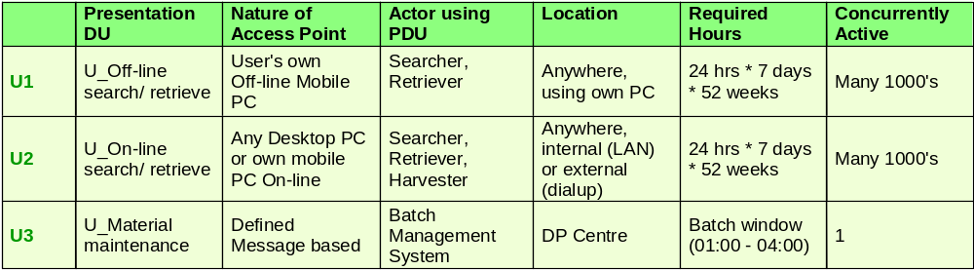
Example Presentation DU Characteristics Table
Data Deployment Units
The major NFRs to be determined for the data DUs are closely linked to the standard collection of Service Level Characteristics.
Volumes. How much data is there likely to be associated with the component(s)? If there is a “substantial” amount, then it may be difficult to distribute it - particularly if it is also volatile or in need of being up-to-date
Volatility. How frequently do the data’s attributes change (across the full set of instances, or “per instance”)? If it is “a lot” then this will influence the placement of the data deployment unit differently than if it is “largely static or read only”.
Security. Does the data need to be protected from unauthorised access? This may be via “line of business” processing, or directly through the interface of the (to be) selected storage manager.
In addition to security there is the separate issue of privacy. This generally relates to the location and manner of the data’s storage. For example, some countries have introduced a Data Protection Act, which requires private data to be held in the same country as the person to whom the data applies.
Availability. How available does the data need to be - and to whom? Does it need to have the same levels of availability to all users, and at all times of the day?
Data availability relates to scheduled availability and unscheduled outages. In the event of an outage (scheduled or unscheduled) what levels of data availability (and its other SLCs) must be provided?
Data currency. How old can the data be which is being used in the various business processes? For example, in one situation, reading last night’s data or data from a few seconds ago may be equally satisfactory. In other situations, such as a “guaranteed” electronic fund transfer application, the transaction absolutely must be based on the data from the most recent transaction that affected that record.
This data currency characteristic will help the designer in at least two ways:
- He/she will understand when they do or don’t have the flexibility to choose whether to make the updates immediately or queue them for update a few seconds, minutes, or hours later. This also becomes very important for recovery planning.
- He/she will know what frequency of refresh will be acceptable for distributed data that is required in the solution, in order to overcome constraints (such as an unreliable network)
Operational Sequencing. This refers to cases where making changes to a data record has a strict dependency on the outcome of a prior update. For example:
- Processing of an electronic fund transfer transaction MUST be based on the account balances resulting from the most recent transaction which affected those accounts. (If this were not done, the system risks accepting/rejecting a very large, guaranteed, funds transfer based on an invalid check for “sufficient funds”.)
- In a case where two systems are trying to maintain synchronized data (for example, for backup or workload balancing purposes), updates to database records must be made in the same sequence on the two systems. If this were not done, the content of the two databases might not be identical.
In most cases, it is appropriate to document the data DU characteristics in a table, such as the one below. However, as necessary, it would also be advisable to supplement the table with textural descriptions:
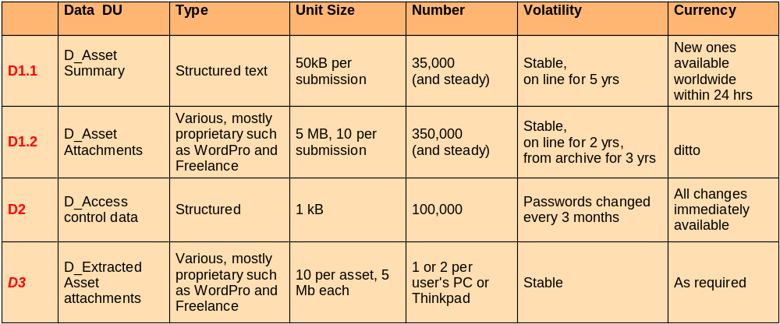
Example Data DU Characteristics Table
Execution Deployment Units
The major NFRs to be determined for the execution DUs are closely linked to the standard collection of Service Level Characteristics. For example, for each EDU:
Volumes. How many transactions per second must the system support, and with what response times? Or is throughput more important than response time?
Volatility. Are the functions (or other non-functional characteristics) of the EDU dependant on some external factor (such as time of day, or an unexpected event)? Often, this volatility can be described in terms of peak and average loads, with a common approach being to design for some pre-determined peak.
Security. What levels of authorisation are required for access to this execution DU?.
Availability. How available does the function need to be - and to whom? Does it need to have the same levels of availability to all users, and at all times of the day?
Function availability relates to scheduled availability and unscheduled outages. In the event of an outage (scheduled or unscheduled) what levels of functional availability (and its other SLCs) must be provided? Is it acceptable for the function to be unavailable during these outages, or is some form of degraded function required?
In most cases, it is appropriate to document the execution DU characteristics in a table, such as the one below. However, as necessary, it would also be advisable to supplement the table with textural descriptions:
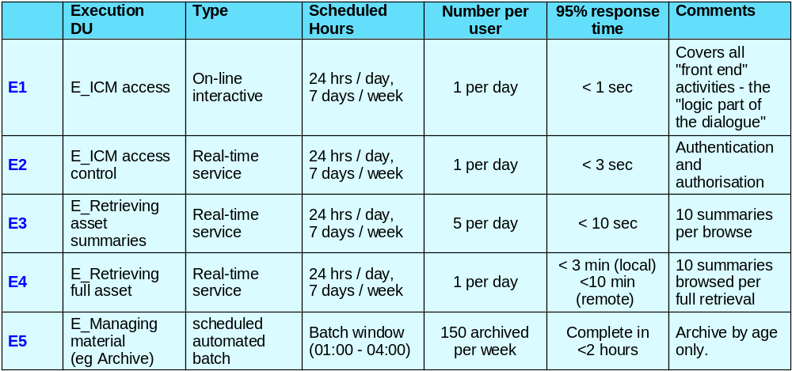
Example Execution DU Characteristics Table
3 Analyze Deployment Unit Relationships
The relationships between the Deployment Units identified and described in step 2 is largely dependent on the corresponding relationships between the components in the application’s component model. However, the separation into the three different aspects (Presentation, Execution, Data) means that there are additional relationships between DU types.
There are four key DU oriented relationships to be understood in order to successfully deploy the DUs on the Operational Model:
- Presentation to Data deployment units
- Presentation to Execution deployment units
- Execution to Data deployment units
- Execution to Execution deployment units (‘uses/used by’)
It is normal to document these relationships via DU – DU matrices, since matrices permit the documentation of relationship’s characteristics in the intersecting cells.
As an understanding of these relationships is gained, remember that revisions may be induced in the candidate deployment units.
Initially, you may decide to document the relationships between DUs as a simple “Yes/No”. However the NFRs of the relationship will be important, particularly the Service Level Characteristics of:
- Performance.
- Availability.
- Security.
These NFRs will be cascaded onto the characteristics of the nodes and connections in the Operational Model.
Presentation to Data DU matrix
This information is of particular value in defining the SCOPE of data DUs across the IT system, which aids in the Data DU placement on the Operational Model, as described in the “Defining Conceptual Systems Architecture” technique.
Note that these PDU –DDU relationships do not represent “interactions” between the PDU and DDUs – these must be always be achieved by component executions as represented by EDUs. However, the scope and other NFR data captured in this matrix provide a very useful insight into the requirements of the solution.
Identify the presentation DUs that are linked in some way to each data deployment unit. For example:
- The D_Customer DDU is used by order clerks and accounts receivable clerks via the U_Clerk PDU
- The D_Document DDU is used by the U_Secretary PDU
- The D_Program DDU is used by the U_Programmer PDU
- The D_Performance DDU is used by the U_Systems Monitoring PDU (a system interface)
Many clients have a hierarchical business organization. Thus, at this point you may find useful to identify and document the lowest organizational level which contains all the user groups who use a particular data deployment unit. Similarly, you may want to document whether a user group from a single or multiple locations uses this data DU.
During this analysis you may discover that the characteristics of a DU-DU relationship are not clear. In these cases it probably means the deployment units you had formed earlier were not quite right. Alter them in order to provide an unambiguous result in the matrix’s cells.
For example, the PDU – DDU matrix associated with the DUs defined in step 2 is presented below:
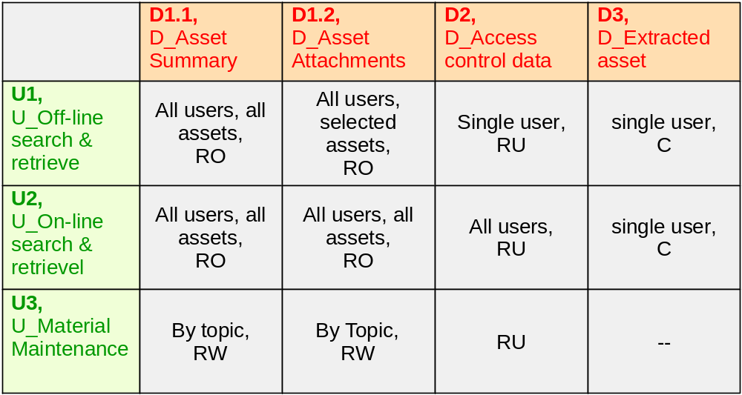
Example PDU – DDU Characteristics Matrix
This matrix relates the components’ presentation DUs (rows) with their data DUs (columns). Note that in this example, only a very minimal amount of information on the relationship is documented.
Presentation to Execution DU matrix
Create a matrix which relates the interfaces used by the end users (ie presentation DUs) to the tasks they perform (as represented by the candidate execution DUs).
Note that often many execution DUs do not provide direct support to a user, and therefore not a PDU. However, it is quite possible (although not shown in the example here) for two or more EDUs to share a common PDU, as well as one EDU to require two or more PDUs (as with E1 in the example)
During this analysis you may discover that the characteristics of a DU-DU relationship are not clear. In these cases it probably means the deployment units you had formed earlier were not quite right. Alter them in order to provide an unambiguous result in the matrix’s cells.
For example, the PDU – EDU matrix associated with the DUs defined in step 2 is presented below:
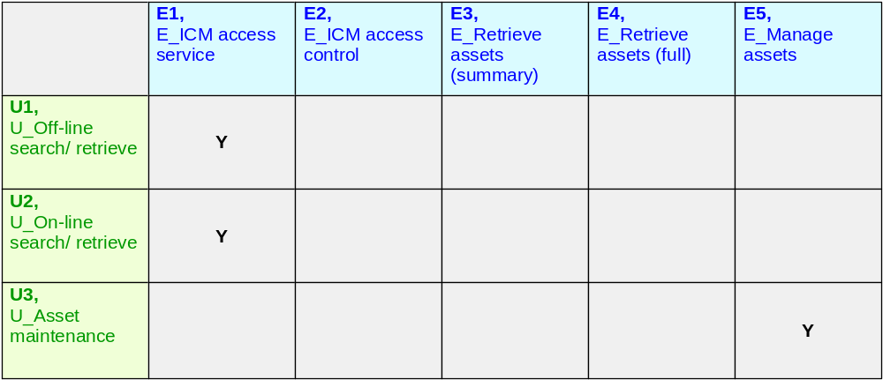
Example PDU – EDU Characteristics Matrix
This matrix relates the components’ presentation DUs (rows) with their execution DUs (columns). Note that in this example, only a very minimal amount of information on the relationship is documented.
Execution to Execution (“uses/used by”) and Execution to Data DU matrices
Both of these DU relationships (EDU-EDU and EDU-DDU) needs to be understood before any viable placement decisions can be taken in the development of the Operational Model.
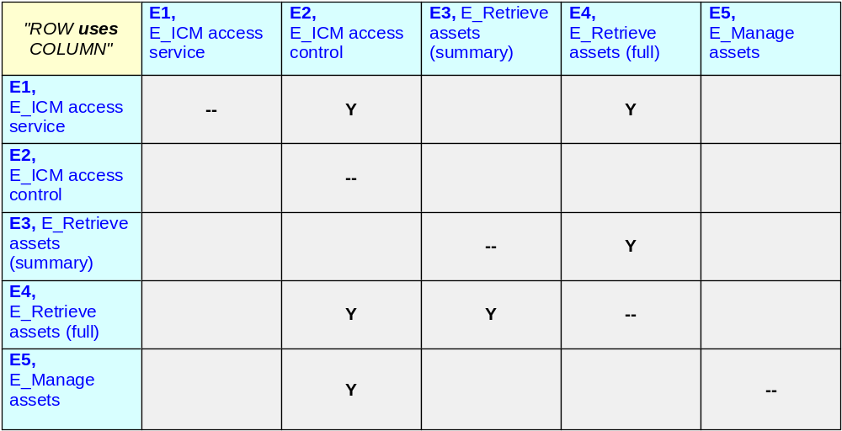
Example EDU – EDU Characteristics Matrix
Note that in this example, only a very minimal amount of information on the relationship is documented.
Note that the diagonal on this matrix is empty. Given the current level of elaboration (i.e. ahead of any OM development activities) this is valid. However, as placement decisions are taken it will be perfectly possible for instances of the same EDU to interact (for example if the same EDU is placed in multiple branch offices, and there is a requirement for peer-to-peer interactions).
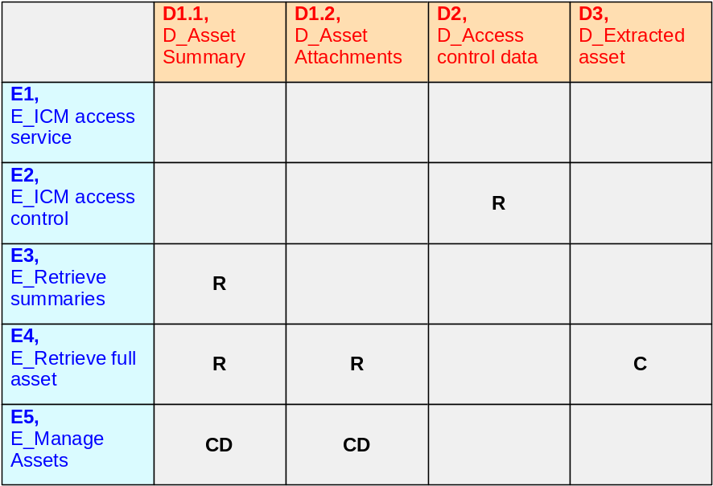
This matrix relates the components’ execution DUs (rows) with their data DUs (columns). Note that in this example, only a very minimal amount of information on the relationship (the “CRUD” relationship) is documented.
Note that, although one specific component (i.e. EDU) controls the access to one or more sets of data (as represented by one or more DDUs, this matrix can indicate a relationship with an EDU that does not own the DDU. As with the PDU-DDU matrix, this should not therefore be taken to imply any direct interactions between the DUs – rather a specification of requirement for access, which may (or may not) be restricted to the owning EDU.
4 Review the Candidate DUs and Their Relationships
Now that you have established a first pass at the candidate deployment units and their relationships, stand back and review the information and how you have structured it. Remember:
- Always seek a level of granularity compatible with the needs of the Operational Model’s development. You can always refine the DUs (finer or coarser grained) as the development proceeds:
- Avoid splitting if an appropriate refinement of NFRs can be negociated. Just because part of a DU is small and stable doe not automatically mean it must be separated from the remaining “volatile” data.
- Avoid grouping together different sets of requirements at a high level if it creates a “fuzzy” set of non-functional requirements for the DU.
- The objective is to ensure deployment units are sufficiently granular to identify the key potential infrastructure differentiation - yet are not too granular to create unnecessary work
- Is the overall feel of the DUs right?
- If a relationship is not clear - then the deployment units are probably wrong.
- If everything is related to everything - then the deployment units are probably wrong
- Deployment units in one project are not necessarily the same in another
- Apply your own experience, judgment and common-sense
- Ensure close co-ordination between the IT Architects responsible for the “components”, “deployment units” and “nodes”, to ensure all needs are accomplished
5 Identify “Hot-spot” DUs and inter-DU relationships
By now, you will probably have a very large amount of non-functional requirements information associated with the solution’s DUs. Moreover, it is probably going to be very difficult or very expensive – or both - to deliver on all of these. For example, some performance requirements may not be compatible with some availability or security needs.
So it is important to identify where the “hot spots” are in the DU tables and matrices. What are the functional and non-functional requirements that the IT system must deliver?
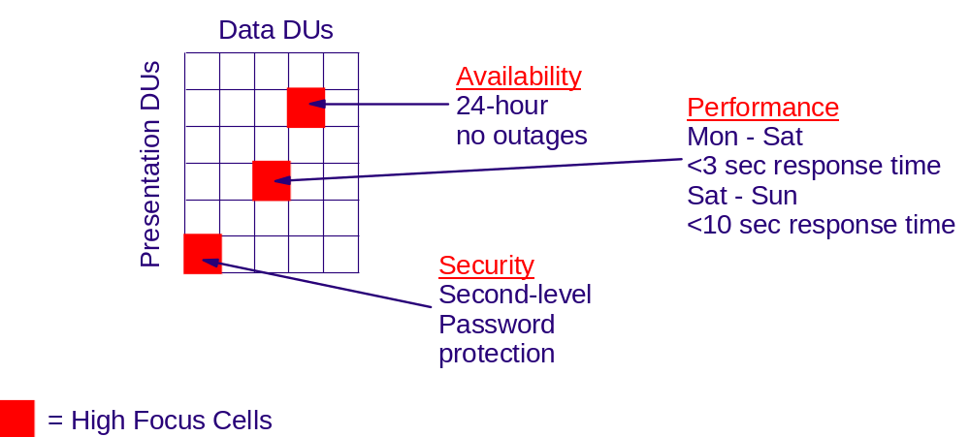
Figure 6: “Hot spots” in a DU-DU characteristics matrix
As well as identifying these hot spots, it is probably a good idea to rank the requirements defined in the DU tables and matrices. You may consider a sequential ranking (in which you identify the top requirements in some order), or you might adopt a MoSCoW scheme: “Must”, “Should”, “Could” and Would”
6 Next steps
This technique has provided a basic approach to the identification and description of the specified DUs associated with the application’s specified components.
This information is a key input into the development of the Operational Model – but the DU work product will not yet be finished. As the OM evolves, it is likely that the DU work product
- Will elaborate, as the specification of the application oriented DUs is improved
- Will expand, as the solution’s technical DUs are specified
- Will include physical aspects of the DUs, as technology and products are selected, code is developed, or packages are customized.
- Revision History
Revision Number | Revision Date | Summary of Changes | Changes Marked?
4.1.1 | March 2003 | Base version.

The forth type of DU – representing the component’s installation aspect, is not introduced into the Operational Model until the Specification Level, when decisions are taken on where the implemented component’s executables will be located.
This notion of splitting does NOT immediately imply a re-factoring of the component. It may be appropriate to leave the component unchanged, since it is possible to ensure the service it is called upon to deliver in each location will be different.
Clearly, in the finished IT system, many of these NFRs will be supported by technical components and hardware – but for the moment we are working at the at the specified level and restricting ourselves to application level functionality, and establishing the requirements the technical components and hardware will have to deliver
also known as a Cash Register or Point of Sale device.
Note that response times are generally “end to end”, measured at the system boundary. Therefore, establishing the required response times for an EDU requires an understanding of how it fits into the overall end to end process. In the Operational Model, walkthrough diagrams can be used to assist in this.

