
IBM Global Services
Defining Conceptual System Architecture
Technique Paper (TP)
© Copyright International Business Machines Corporation 1998, 2000
All Rights Reserved
Version 1.3 October 2000
Introduction
The objective of this technique is to define a conceptual System Architecture, which consists of an Operational Model at a conceptual level.
The technique takes a (preliminary) set of application deployment units, and describes how these should be placed across the geographic organization of the client.
In so doing, it accommodates a particular subset of constraints, which the Operational Model will have to overcome:
- It accommodates the geographic dispersion of the users and external interfaces the solution is required to support.
- It accommodates any needs for multiple delivery devices per user and/or shared delivery devices amongst users.
- It overcomes any service level limitations that there may be in the underlying networking infrastructure - whether this is pre-existing or to be newly deployed.
- It overcomes any remote access restrictions associated with the need for the IT system to use existing IT databases, and takes account of other givens and constraints which will influence the placement of the application components across the geography of the client.
All other constraints are considered later in the design process. At the conceptual level, the Operational Model does not consider technical components, or the actual hardware and software products, which will be used to realize the design.
As the Operational Model evolves throughout a project, it is common for different parts of it to be at different levels abstraction (and detail), and the technique should be applied flexibly to reflect this.
As a ‘deployment unit’ is merely a convenient collection of components, the technique sometimes refers to placing components rather than deployment units.
Steps

Identify the Layers and Locations of the System
Layers and locations start to outline and segment the solution across the geography of the organizations the system will cover.
In order to perform this activity you must have information on the business organization, geographic organization, particularly regarding the user and external system interfaces the system is required to support. It is specifically important to identify the need for multiple groups of users at a given layer or location; and the need for specific users to have multiple interfaces.
Note that the layering we are developing here is a physical layering - where might we want to put things. The other “organizational layerings” are more abstract. If, however, there are significant differences in these views of layers, ask why, and consider if this is likely to cause problems later.
As well as identifying those locations where users, existing components or legacy feeder systems are (or are mandated to be) placed, it is important to identify and name the layers and locations where components could be placed. It may be that, later in the design, some places may not be required to support the IT system, but equally, it is possible you will not yet have identified all the places where components will be required.
- Use geography to identify the potential physical layers
- Consider personal desktop environments as a separate layer
- Distinguish different types of “location” at the same layer as necessary
- Alternative (or additional) layering strategies may be appropriate (e.g., organizational)
- It is a good idea to layer the system quickly - it can be changed later if necessary.
The shape and style of the system may now start to be seen for the first time. This layering or tiering is intended to be a quick start towards the next step of defining a system structure based on conceptual nodes. Do not waste time trying to form layers if they are not obvious at this stage. With this layering we are trying to understand any obvious physical geographical/physical or hierarchical relationships, rather than identifying any IT relationships (such as Client/Server).
Example 1: Simple (using “layers”)
If the system is to support:
- Store users, using delivery technologies (as yet unspecified type, but with a known user population of 17 per store)
- Working in a single “store”, (of which there are 8 per regional Office)
- Supported out of a Regional Offices, (of which there are 10)
- Which may be linked into a single national headquarters.
This might be drawn out like this:
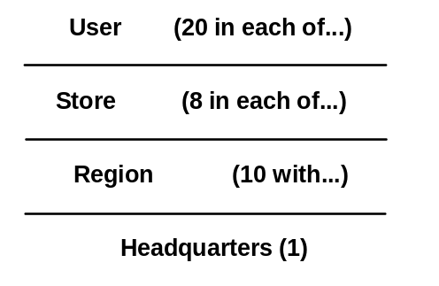
Figure 1. Initial Identification of Layers
In this case, the layering is strictly hierarchical, and the notion of “layers” is a good one.
Also, there has been no need to consider distinctly different types of store (we do not have different stock ranges), numbers of stores per region (they are not disproportionately distributed) and users (customers and clerks).
In practice, some layers may have two or more distinct locations.

Identify Candidate Conceptual Nodes
Given that one of the key objectives of a conceptual-level Operational Model is to identify the “shape and style” of the solution, from the perspective of the application components, it is generally helpful to be able to draw the network diagram on a single page so:
- The maximum number of conceptual nodes is 20
- The level of conceptual node definition is driven by the breadth and complexity of the design.
Start each conceptual node as an empty logical container where you may decide to place data and/or processing later on in the design process – it is a “logical” construct, and does not yet have any technical explanations as too how it may be realized.
What constitutes a “conceptual node” is widely dependent on the circumstances of the design, but there are some general guidelines:
- There should be a conceptual node for User and external system interface (remember - some users may need more than one interface, and different users may share common interface devices). For the moment, do not worry too much about numbers of users - this is accommodated in the step “Place presentation deployment units on conceptual nodes.”
- Create other conceptual nodes wherever you think there may be different functionality/placement across the layers and locations.
- Do not be afraid of creating multiple conceptual nodes at each identified layer or location, if there are to be widely differing service level characteristics at that layer/location, for example if some parts of the solution must be highly available, while others can tolerate more conventional service hours.
- Be sensitive to names you attach to conceptual nodes, especially if “technology independence” is critical, which leaves your options more open, e.g., “Customer” or “Customer Workstation.”
Note the following:
- Conceptual nodes do not usually represent a hardware device or system unit; only when it is clear from some given or constraint.
- Conceptual nodes do not reflect specific named products, except when required as a “Givens.”
- Some conceptual nodes will naturally fit at one location type. For example, user access requirements at a branch office or automated devices (such as ATMs) at bank branches.
- Some conceptual nodes may span several locations (for example a system management conceptual node - see next step).
- A LAN, or WAN (for example a traditional SNA network) is not a conceptual node. They are concerned with connectivity. The network may be required to contain some form of functionality, such as:
- Routing functions
- LAN management
- Directory services
- These services may be represented by nodes later in the design process, but not now. We are concerned with the placement of application components.
- Some conceptual nodes will be part of a larger computing facility, for example, a host system that is part of a complex of host systems within a data center.
- Note any National Language Support considerations that may influence your choice of components later. This will be especially necessary for the choice of workstation features.
Do not worry about a lack of completeness of the Operational Model if you are in the early stages of this technique. You may be able to fill in the missing conceptual nodes, eliminate one, or fill in missing details because of later work in the development of the Operational Model, or account for changes later when developing the specification-level Operational Model. Sometimes, you may not have enough information to determine the conceptual nodes in either stage. If so, you will have either to:
- Revisit the requirements and gather extra information, or
- Make assumptions, and remember to document and validate these.
You may have several different Operational Model shapes at this stage. Each may be a valid architecture. Go on with them, eliminating them one by one as they fail to match the criteria that the requirements are setting.
Finally, prepare an appropriate set of empty conceptual node box diagrams (see Operational Model work product description). You will populate these with components, as you proceed through the later steps of this technique.
Example:
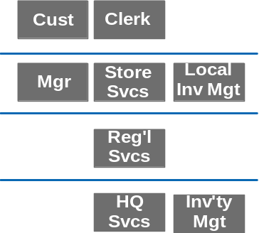
Figure 2: Initial Conceptual Nodes
In this example, (which develops the example in Figure 1):
- Two distinct “User” conceptual nodes have been identified in the “desktop” layer - Customer and Clerk.
- A “user” conceptual node has also been identified in the “store” layer - Manager
- Two “special” conceptual nodes have been identified - associated with the Inventory management aspects of the solution (which might, for example, have significant performance/capacity SLCs) - Local Inventory Management and Inventory Management.
- The purpose of the Regional Services conceptual node has not, as yet, been identified. But it’s a viable location for something.

Identify “Special Purpose” Conceptual Nodes
Conceptual nodes are used for two purposes:
- Those which supported the prime functionality of the solution (as identified in the previous step).
- Those which highlight some other critical success factors for this design, associated with the operational aspects of the solution.
In general, these “special purpose” conceptual nodes are optional, depending on the circumstances of the engagement - their prime purpose is to give critical design issues extra visibility and therefore ensure they receive close attention. Experience has shown, however, that it is vital to always have a Systems Management conceptual node - it is always critical to success.
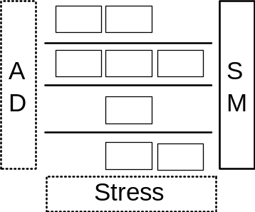
Figure 3: “Special Purpose” Conceptual Nodes
This diagram shows the “functional aspects” of the conceptual Operational Model in the center (the same design as described in previous steps), with various other special purpose conceptual nodes. This representation reflects (for this particular view) the central nature of the “runtime” design. However, the central aspect of the Operational Model depends on the topic under scrutiny - if the Operational Model is concentrating on the project’s Application Development environment, then maybe the diagram would be something like:
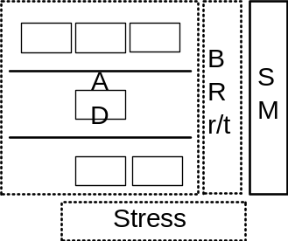
Figure 4: Focusing on the AD environment
Some of the key “special purpose” conceptual nodes are:

Systems Management
There are a number of distinct aspects to Systems Management when developing an Operational Model:
- What software components are necessary to allow the system to be systems managed?
- What are the processes and activities, which must be done, using systems management components, in order to ensure the system operates with the required service level characteristics?
It is vitally important to get both of these correct if the IT System is to operate successfully. This technique paper, however, is predominantly concerned with the first. Other techniques, associated with other work products, will enable you to design and implement the processes, which exploit this software componentry.
- This technique helps you identify the necessary system management “dials and levers.”
- Other techniques are concerned with “reading the dials and pulling the levers.”
There is a further distinction necessary when considering systems management componentry:
- Software that “commands and controls” the various parts of the system.
- Software that enables the various parts of the system to be controlled.
However, for the time being, we are only concerned with the systems management requirements, from an overall system perspective, rather than how system management will be enabled. Thus, the systems management conceptual node is usually drawn as an system-wide node as in figure 3. Therefore, at this time, use this conceptual node to document those aspects of systems management that emerge as being critical to the success of the design.
Use the system management conceptual node to identify the high-level management disciplines that will be required to manage or operate this system, as you go through the next steps. For example, if in step 5 you identify the need for distributed data, then record the need to manage this distribution against the systems management conceptual node. We call these the Major Disciplines. If you need more granularity you might refer to a list of detailed processes - as would be necessary to distinguish the different challenges faced by distributing copy data, compared to distributed, segmented, prime data.
As well as identifying the major disciplines (and perhaps some of the detailed processes) of the systems management conceptual node, you should suggest other characteristics such as:
- Manual or automatic process.
- Location that the process resides, for example:
- At a local server
- At a centralized computing center
- At an outsourced Help Desk.

Recovery/Restart
In a “High” or “Continuous Availability” solution, specific approaches will have to be designed to execute recovery and restart on failure.
At this point this should be a single, system-wide conceptual node (just like the system management conceptual node). You should note information that is relevant at this point for the Recovery/Restart conceptual node, such as the functions listed below:
- Logical DB recovery
- Hot standby “shadow”
- Queuing system (store and forward function)
- Alternative logging/audit journals
- Monitoring/detection facilities
- Automated operations focal point
- Recovery of cryptography keys
The Recovery/Restart conceptual node may be absorbed at later stages of design into other conceptual nodes but at this point it will represent the need for significant design effort.
If you can see distinct “shape and style” relationships at this stage remember that you may have to take several views of restart/recovery:
- Restarting/recovering an individual client
- Restarting/recovering all the clients on a given server
- Restarting/recovering the server
- Restarting/recovering a whole client/server ‘system’.
You will probably not be able to see how to do any or even all of these at this stage but you should note your requirements as part of the Restart/Recovery conceptual node.
Also, after completing the availability analysis, you may want to assign specific Recovery/Restart conceptual nodes to a number of your original (business) conceptual nodes.

Disaster Recovery
If disaster recovery capability is required as part of this system, then create a Disaster Recovery conceptual node to facilitate designing this disaster recovery capability.
The reason for suggesting a Disaster Recovery conceptual node separate from the previously-created Recovery/Restart conceptual node is that both the criteria (recovery time, data currency, etc.) and the implementation mechanisms are likely to be different for rarely-occurring “disaster” situations (which require remote site recovery) than they are for local recovery from more “normal” failure conditions.
The Disaster Recovery conceptual node may be absorbed at later stages of design into other conceptual nodes but at this point it will represent the need for significant design effort.
Take care that you understand the Disaster Recovery options, which may be advisable for any perceived architectural style you may implement. For instance a Server may have to have much more tight Disaster/Recovery criteria than any individual Client does.

Application Development
If the application development and testing is going to be new for the client, either in function or in scale, consider adding a conceptual node to cover this. This conceptual node will need certain service hours, will need to offer certain functions (software development and test facilities, library management functions) and may need to be designed as much as the business system conceptual nodes.

Stress/Regression Testing
This conceptual node may be used for stress testing, or regression testing, or both. The main purpose of stress testing is to validate there are no performance or capacity problems. Regression testing is used to verify that a modified application or system continues to respond to a predefined set of inputs in the desired manner, after the coding or system changes.
Not knowing the shape of the system, you cannot yet fill in this conceptual node. But it is an important placeholder, to:
- Specify, during the specification of the Operational Model, part of the system to be subjected to stress testing and its exit criteria.
- Define, in the physical Operational Model, the extra hardware and software necessary to support stress testing.

Place Presentation Deployment Units
Identify the presentation deployment units required on each conceptual node. Remember to ensure that all forms of “users” are accommodated:
- Human Users
- Other Computer Systems (whether “clients” of “servers” to this system)
- “Automated Users” (e.g., Batch; time or event triggered)
As well as “who,” we need to understand “how many” - the numbers of (each of these sorts of) users per location. Because we are not yet designing the Operational Model in detail, this should be recorded as “numbers of users per conceptual node,” not “numbers of conceptual nodes.” This allows greater design flexibility when transforming the conceptual nodes into specified nodes. See the example below.
As well as the “conventional” computer terminal/workstation interfaces needed by users, remember to place the presentation components related to printing, (where will print out be made; at the user’s workstation or on a departmental or centralized print service?).
In general you can think of types of printing data deployment units that are subject to placement include:
- Print data source
- Fonts
- Electronic forms
- Spool data
You will find that the flexibility of placement is much more restrained by the potential technology choice than is the case for some of the other application components.
The printing execution components (such as the print spooler) will tightly follow the above list. Remember you must include the results of your placement decisions into the description of the inter-conceptual node connections (Step 7). You will need to describe whether these connections are to support character data or AFP streams, etc.
For all aspects of presentation deployment units, record the service level characteristics implied by each deployment unit on the node in which it has been placed - using the conceptual node box diagram to give you an overall view of requirements.
Example
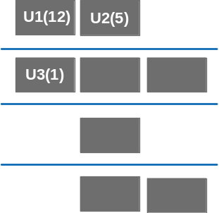
Figure 5: Placed presentation deployment units
In this example:
- The Presentation deployment units for the three users of the system have been “placed” in the appropriate conceptual nodes -12 Customer interfaces per location (represented by “U1(12)”), 5 Clerk interfaces per location (“U2(5)”) and one Manager (“U3(1)”).
- There are no external systems for this design, and no “automated users” (batch or otherwise).

Place Data Deployment Units
Experience has shown that to place the data deployment units (where data is going to be stored) before working out where execution will take place (binaries loaded into memory and run) is usually the most effective approach.
General Guidance
The next few steps - up to Step 8 - will have significant impact on application development, system performance and/or cost, and system management. Thus you should be sure to work with application design, communications, and operations experts during these steps
In a larger enterprise, the client application design, data administration, and operations staff should participate in the placement decisions. For a smaller enterprise without specialized staff, you may need to work with other experts, ensuring that you validate your conclusions with whoever will be responsible for the application and systems administration.
This step may be very easy, or in complex distributed systems, very difficult. In the latter case, you will probably not be able to complete it on your first iteration through this stage, and will probably have to refine it during the creation of the specification-level Operational Model. For the moment, you are trying to work at a high level and with obvious givens and data scope. You are about to make high-level suggestions about the allocation of data deployment units to individual conceptual nodes.
You may also find that copies of the primary instance of a data deployment unit will be required. (Note, that the primary instance is also referred to in the industry as master data, data-of-record or reference copy.)
In this technique, we distinguish between operational and information copies. An operational copy has many of the same characteristics as the prime instance; it may be updateable and requires exacting levels of synchronization.
An information copy (also known as business copy or MIS copy) could well be at a lower (and arbitrary) level of currency, can be refreshed from the prime instance on request and its updates will not be reflected in the prime instance.
In practice, when you are adding to an existing IT structure many of the data deployment units will already have been positioned, or the requirements will have dictated where they should go. When they have not been positioned already, it may often be obvious where you should place them.
Try to determine at which level the “control” of this new system resides. The “control” may not coincide with the placement of the data deployment units. However, it frequently may impact and even overrule the placement suggested by technical considerations. The placement decisions driven by “control” may reflect:
- Corporate Policy on decentralization
- Leadership of IT organization or lack of it
- IT track record of delivering new applications, etc.
- Security policy
Awareness of location of control may also help to define the need for additional IT management facilities, (for example remote auditing, accounting, etc.).
Pay attention to both the inter- and intra- conceptual node relationships. Take care to understand the real function of, for example, a data server.
For all aspects of data deployment units, record the service level characteristics implied by each deployment unit on the node in which it has been placed - using the conceptual node box diagram to give you an overall view of requirements.
As you place the data deployment units do bear in mind that, in order to accomplish the operational requirements (whether these are SLCs or the adherence to some constraint or given), this will probably cause you to change the deployment units and, in some circumstances, cause the underlying component model to also change. Make sure these changes are recorded in the appropriate work products.
As well as these “conventional” data deployment units, remember to place the data deployment units related to printing. In general you can think of types of printing data that are subject to placement will include:
- Print data source
- Fonts
- Electronic forms
- Spool data
You will find that the flexibility of placement is much more restrained by the potential technology choice than is the case for some of the other application data deployment units.
As you proceed though the following sub steps, bear in mind the notation you will use to portray the different perspectives on “data deployment units” as they are laid out across the conceptual nodes - for example:
- Use upper case to represent master data deployment units, e.g., D1
- Use lower case to represent copies, e.g., d1
- Use italics for temporary data (which, is none the less, master) e.g., D1
- Use (s) to signify segmented deployment units, e.g., D1(s) or d1(s)
Example
Note that this is a stylized example, only those conceptual nodes, which have data deployment units, have been annotated.
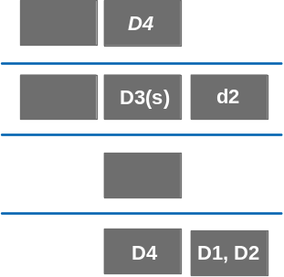
Figure 6: Placement of data deployment units
In this example:
- There are three data deployment units that have been centrally placed, since their scope covers all branches (D1, D2 and D4).
- Two of these (D1 and D2) have a particularly significant availability requirement, and are therefore located in the “high availability” node.
- Although one data deployment unit (D3) has an organization-wide scope, it as been segmented and placed in the branch (annotation = D3(s)).
- For a brief period, one data deployment unit is held locally to the clerk, although only for a small number of instances of the deployment unit (D4). Note that this is not segmentation; it may be a new customer registering, who has been unable to complete the registration in one visit to the branch.
- In order to achieve the required levels of availability, with an unreliable network, one data deployment unit (d2) is held (read only) on the branch inventory conceptual node. This is maintained on a 24-hour basis.
Note that some of the factors surrounding these data deployment units are not captured on the diagram. This information would be recorded in the freeform text, which accompanies the diagram.

Perform a High Level Walkthrough
In order to make some of the placement decisions, you need to have a high-level understanding of the way the deployment units interact. For example, if one needs to interact with another once per month, in a batch mode, it probably is not necessary to place them close together. But if one makes several accesses per minute to another, exchanging large amounts of data each time, you probably want to place them close together, or design in business copies. The following activities will prompt you to consider each of these points. You will expand the detail in developing the specification-level Operational Model; so do not get trapped in detail.
If you cannot select individual relationships, then choose or agree one or more generic or abstract ones. Those selected should perform meaningful and representative functions, such that eventually you consider all the important interactions.

Place the Given and Obvious Data Deployment Units
Place as much data as possible based on the givens and imperatives of the requirements.
- Put data and processing where the requirements specifically say they should be placed because of a given such as:
- the use of an application package
- the data already exists today and is already placed.
- See if there are any special requirements that mean that data must be placed in one particular location. Examples are:
- very high physical security
- exceptionally large amounts of data that cannot reasonably be split or partitioned
- batch processing
- contingency.

Scope of Data Deployment Units
Identify how the usage of the data deployment units maps into the organization and the geography of the user community. Use this information to define the scope of the data deployment units. The term scope is used to identify the range or area of effectiveness or use of the deployment unit. Specifically, scope is used to identify the lowest position within the conceptual node structure at which a single copy of the data deployment unit (whether this later turns out to be a file, table, database, and etc.) can be placed and yet be accessible to all its users.
For example:
- A branch’s customer files, if used only by personnel within the branch, would have the scope of that branch.
- Corporate data, which might be accessed by anyone in any position within the organization, will have corporate scope, even though, in an extreme example, two people in different parts of the organization might only use it.
Scope is just a useful way of summarizing what you have discovered about which user groups in which locations access which data groups. When assessing scope:
- Take into account the fact that data deployment units may be used by other application systems than the one you are designing.
- Remember, that the users accessing the deployment unit may be spread geographically, thus the conceptual node layer or location corresponding to the organization may not represent the correct scope.
- Focus on the users which access the prime instance of the data deployment unit.
- Consider the fact, that the scope of the information in the deployment unit may change with time. An example is the data created and processed at department level, but qualified “history” data after a certain state or date. The history part of the data may have a corporate scope, and could be a selected portion of the original data or an information copy.

Characteristics of the Data Deployment Units
Ensure the characteristics of the data deployment units are documented:
- Size
- Type of organization
- Approximate reference rates
- Any special management characteristics: security, availability, etc.
- Any data deployment unit that is a single point of failure in the flow of a critical transaction
- In a “Continuous Availability” design, deployment unit currency may be very critical to the system design. If the application must work with current data you will have to take extra care in specifying how the current data access is required. You will probably have to ensure that multiple copies are kept in absolute synchronization. This is not the time to design the solution, but options that you might choose to bear in mind as you place the data deployment units are:
- duplex (mirrored) storage devices (hardware replication)
- double updating via software facilities (software replication)
- two-phase commit updating across a network or a LAN
- the use of secondary transactions that perform updates to backup storage devices.
- If you can use backups that are not exactly in step with the prime copies then you will have to know how out-of-step you can be (staleness of the backup). This staleness might be expressed in terms of:
- Time
- Number of updates
- Any time so long as the end user is actually informed that the data is X minutes stale so that they can make a decision
- It might even be worth telling the end user that the data is not available in any form rather than just letting the system appear to be “down”. In this way the end user might be able to use alternate means to get access to some data such as:
- The telephone
- Paper backup
- Some other workstation.
The secret is to make the system look available so that some business activity can continue. Remember that you may be able to continue processing even if certain parts of the whole range of the data are not operational. The more that the data can be partitioned and split or spread over multiple storage devices the better the odds are that you can contain problems to a specific piece of data.
Be careful not to accept requirements such as “up-to-the-second accuracy” without questioning them. The cost and complexity of achieving this can be very high, and cause you much work, which may then be wasted if the real requirement is then discovered to be less demanding. Also note whether any of these characteristics obviously exclude certain placement options. For example, a very large file cannot be held on an average user workstation.

Place all other Data Deployment Units
This is a first cut placement for the prime instance of each data deployment unit.
Remember that these are the data deployment units whose position is not given, that is, they are either new or existing movable data deployment units.
- If the scope of shared access is a single user, place that data deployment unit at the user’s conceptual node.
- If the scope of shared access is limited to users in one location, place the data deployment unit on a conceptual node in that location.
- If the scope of shared access spans locations, place the data deployment unit at the conceptual node which provides convenient secure connectivity and the optimum service levels to all the users who require access to that deployment unit:
- In some cases this will be a “corporate server” or “regional server”
- In some cases this will be the location server of the users with the dominant access (this implies access to another location’s server). This is particularly true if you will opt for SEGMENTED primary data deployment unit (see the next sub-step). As an example, a retail stores customer information system may choose to store customer information in the store that the customer visits most often. Thus, in the majority of circumstances the information is available locally, although from time to time access may be required from other stores (for example, if the customer is away on vacation or business).
- After placing the deployment units check that you might now be able to redesignate a conceptual node as a data server rather than just, say, a departmental system.

Segmentation of Data Deployment Units
You may find that, although the scope of some of the data deployment units is (say) corporate, it could naturally be segmented (partitioned) based upon the patterns of lower granularity, e.g., regions or product divisions, etc. Thus the scope of the segment may become regional or departmental.
If this were the case, the deployment unit in question is in multiple parts and cross-segment access, leading to remote deployment unit access, may be required. Examples include: information used by regional government agencies or geographically localized prospect information for insurance agencies.
- Understand that in a segmented data group, each segment of the data is a master copy of that data.
- If you undertook any of the above, you may have to add new data deployment units and also redefine their scope.
- If you decided to segment some of the prime (operational) data deployment units and cross-site access is required, you have to keep in mind the need for updating multiple sites at the same time.
The need for synchronization will impose demanding requirements on the DBMS technology, or transaction management, explored in the specification level of the Operational Model, which may lead to the revision of this choice.

Operational Copies
In defining the scope you may discover that there are dominant users of the prime instance at more than one layer or location. This may indicate the need for operational copies that is an updateable copy with established rules for synchronization with the origin. Note, that an operational copy could also be (might be preferred to be!) read only, still requiring a certain level of currency.
For example, a large database is required at the host for batch processing, whereas a small subset of it is used in a department for a process of long duration (e.g., financial audit, credit check, investigation).
- You must understand that when you have operational copies of a data group, there is only one master copy.
- Similar to the decision on segmentation, examine if there is a need (and the facilities) for updating multiple sites at the same time.
The need for synchronization will impose demanding requirements on the DBMS technology, explored in the specification level of the Operational Model, which may lead to the revision of this choice.
Similarly, the data may be required for decision assist or market analysis. This need may be met with an “information” copy, the currency of which is defined in the deployment unit.

Viable Locations for Data Deployment Unit
Make an initial assessment as to whether the conceptual node into which you have placed data deployment units are a viable option for that placement. Consider:
- Operational (run-time issues)
- Integrity
- Recovery
- Security
- Performance (access rates)
- Capacity
- Level of data management function.
Determine if the conceptual node with this responsibility can be made viable. Define the extra skills and facilities that would be needed. Decide if remote support could be used. Evaluate these considerations, and discuss your thinking with both your data and communications specialists.
This can be a complex study itself if the data in question is used in other applications. Unless you know the scope of all the data in question, both existing and new, to be held at this type of location, do not spend time on this activity without appropriate support from data administrators and consideration for the project schedule.
If the location can be made viable, document how this is to be done. If it cannot be made viable, document the reasons and move the deployment unit to the location nearest to the users where adequate skills and function exist or can be made to exist. Consider providing mobile facilities (less permanent) as an alternative.

Check Availability Needs
Assess the ability of the prime site to meet the user requirements for data availability, and alter the design if necessary.
A high availability target may be difficult to meet in some circumstances, (such as across a WAN connected to a complex multi-application corporate server.) If needed, consider keeping operational copies of some data deployment units on a location server. Assess data distribution and synchronization requirements:
- This solution is particularly attractive for low volume, low volatility, and data deployment units.
- This solution is particularly unattractive for high volume, high volatility, and data deployment units.
Watch out for the need to identify the minimum set of data deployment units necessary to provide data availability for the key location processes when disconnected from the corporate server.

Check Performance Needs
Assess the ability of the prime site to meet the user requirements for response time, and alter the design if necessary.
In some cases the storing of operational copies of some data deployment units on a location server can provide improved response time. Be aware that, in many cases, the resulting design and data management issues (for example synchronization) mean that the performance benefits will only outweigh the costs for ‘read only’ data. A good example would be image data.
In some cases the storing of operational copies of some data deployment units on a location server can provide worse response time. This occurs when many data calls are required to satisfy an interaction, and the response time may be dominated by a processor and I/O service time which is much longer on the location server than the corporate server.

Check Security Needs
Assess the ability of the prime site to meet the user requirements for data security, and alter the design if necessary. Ensure that all aspects of security are considered, including:
- Physical and Logical: - Ensure that the location sufficiently secure and that any technology deployed there can be protected, either in terms of physical theft or direct “sign on.”
- Internal and External: - Ensure that the conceptual node can be sufficiently protected from employees and other authorized users doing things they are not authorized to do; as well as preventing members of the public from gaining unauthorized access.
- Intentional and Accidental: - Ensure that, as well as guarding against systematic attempts to gain access, that there are considerations regarding unforeseen, accidental security exposures.

Cross-check Copies and Segmentation
Earlier you may have decided that the requirements are best met with using operational or information copies. The latter may require consolidation from multiple (segmented) locations. Check that you can visualize how this will be achieved.
You may want to mark down the need for utility processes to support the copies and specify them in Systems Management. Also, mark down the requirement for any inter-conceptual node connections, which would not automatically follow from the requirements.
Some prime data deployment units may need to be copied and consolidated for decision support and planning operations. Check that you can visualize how this will be achieved.

Place Execution Deployment Units
General Guidance
Most of the points in 5.1 apply also to this step.
As you place the execution deployment units do bear in mind that, in order to accomplish the operational requirements (whether these are SLCs or the adherence to some constraint or given), this will probably cause you to change the deployment units and, in some circumstances, cause the underlying component model to also change. Make sure these changes are recorded in the appropriate work products.
As well as the “conventional” execution deployment units, remember to place the execution deployment units related to printing, where will print out be controlled. For example, where will the print spooler run?
As you proceed though the following sub steps, it may help to refer to the following example:
Example
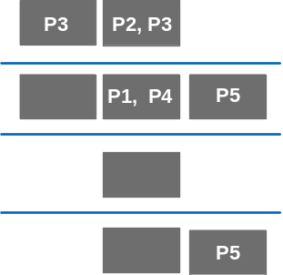
Figure 7: Placement of execution deployment units
In this example:
- Some execution deployment units (P2 and P3) have been placed close to the users, rather than to the other components they interact with.
- P3 appears in two conceptual nodes, since it is used both by customers and clerks.
- P5 represents the execution of the components associated with inventory management. It is placed on both inventory conceptual nodes - one providing access to the read-only copy in the branch, the other providing read-write access the up-to-date master held at headquarters.

Perform a High Level Walkthrough
In order to make some of the placement decisions, you need to have a high-level understanding of the way the deployment units interact. For example, if one needs to interact with another once per month, in a batch mode, it probably is not necessary to place them close together. But if one makes several accesses per minute to another, exchanging large amounts of data each time, you probably want to place them close together, or design in business copies. The following activities will prompt you to consider each of these points. Do this only at a high level. You will expand the detail in the specification level of the Operational Model; do not get trapped in detail.
If you cannot select individual relationships, then choose or agree one or more generic or abstract ones. Those selected should perform meaningful and representative functions, such that eventually you consider all the important interactions.

Place the Execution Deployment Units
These execution deployment units are associated with End Users and External Systems. In an object-oriented environment:
- The attributes of components (which are stored in data deployment units) can only be “accessed” by the methods of the same components (as represented by execution deployment units).
- Interactions between components are supported by connections between Execution deployment units.
As the third step (following the placement of presentation and data deployment units), placing execution deployment units must find the best compromise between where the users are; the placement of the business information they need access to; and the need to support interactions between the components they represent:
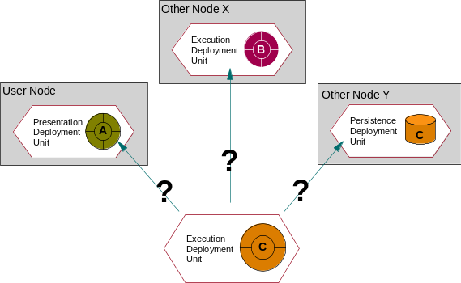
Figure 8: Where to place execution deployment units
Determine where the execution deployment unit associated with component C should be placed:
- Co-locating execution and data is clearly the “default” option, thereby retaining the holistic nature of the objects, which underlie the deployment units. So, in many circumstances, this will probably be the easiest and apparently safest choice
- On the figure, the execution deployment unit associated with component C would be placed on Node Y.
- However, if the business function demands highly interactive processing with only occasional light access to data then it may be appropriate to put the execution deployment unit nearest to the end user even if the data deployment units have been located elsewhere (possibly for scope reasons).
- On the figure, the execution deployment unit associated with component C would be placed on the User Node.
- Under some circumstances, it may be wise to redesign the underlying component model, so that parts of the original component are in separate nodes - in which case they would be in separate components (components cannot span nodes). For example, those parts of a component which handle display and dialogue management might be at a specified node associated with the user, while file access and data handling might at another specified node.
- On the figure, component C would require redesign, with part ending up on the user node, and part on Node Y:
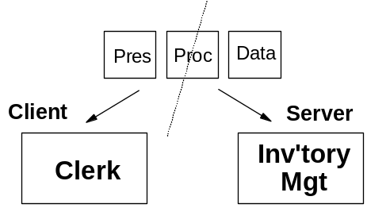
Figure 9: “Splitting” Components
Frequent data access across networks can be very costly and can lead to adverse performance and availability characteristics.
Bear in mind that this activity is only concerned with working out where the object’s binaries will execute - as yet, no decisions have been made about where the binaries will be stored or how the binaries will gain access to the necessary attributes of the components - this comes in the specification-level Operational Model.
Pay particular attention to the execution deployment units associated with copy and segmented data deployment units, since, if you decide to co-locate the execution and data deployment units, execution deployment units will require supporting in all (or some?) of the “containing” conceptual nodes.
Bear in mind that the needs associated with external systems which are “users” of this IT system will be quite different from those associated with systems which are “service providers” to this IT system.

Viable Location for Execution Deployment Units
Check the following:
- Firstly, check whether there is a probability of having enough power and function at the location where the execution deployment unit has been placed. If there is not, can it be moved to another conceptual node, either in the same location or elsewhere?
- Determine if there is an option to leave some of the execution function where it is placed, and move the rest to another location. Maybe part can be “near the user” and the other can be “near the location of data.”
- Note that this “splitting” will impact the formation of the deployment units, and may require changes to the underlying application components.
- Determine if the placement is effective, or if dividing the processing cause too much communication or “management” of communication. If you are not confident about your design, review it with a communications specialist and/or an application specialist. There are few rules that apply to all situations.
- Check whether system management is viable if this is a distributed environment. System management is far more complex in such an environment.

Mass (Batch) Execution Deployment Units
For the moment, we are only concerned with the execution of batch or mass processes, rather than the control mechanisms that cause them to be executed.
Identify and place those execution deployment units, which represent batch (a.k.a., mass) processing. If this is a significant requirement, you may need to specify a dedicated conceptual node for this, because of these unique service characteristics. Batch processes operating over massive amounts of data are frequently confined to “batch windows” (overnight for example), when the constraints of on-line processing (such as the need to maintain data locks) can be alleviated.
The ability to execute the task within these may significantly impact the availability of an online system. Thus, there may be a need for innovative solutions. In particular, if you can interrupt “processing” and “DB update,” this can help to isolate the online processing from data management problems. But it does imply a degree of mass processing later.
Distributing processing and data generates inter-conceptual node ‘batch’ exchanges. In a centralized architecture, these processes would use simple inter-process communication and thus would not generate any network traffic. But in a distributed design, these exchanges are handled by underlying processes, which we will be required to design during the subsequent development of the Operational Model.
The various options for such underlying processes are mainly:
- File transfer
- Distributed print spooling
- Distributed queue management
- Database copy management.
Understand, in principle, how the Operational Model will be able to implement these processes.
In a Continuous Availability (CA) environment, most CA systems are faced with the task of point-in-time processing of all data, or massive inflow of external data (for example batches of checks, tariff updates, etc.). Some of the most intriguing design challenges will be solved while working to maintain CA. Special cases of mass processing are activities serving support, maintenance, creation of contingency copies, etc., all typically requiring access to massive amount of data and processing resources. Since the development of the specification and physical levels of the Operational Model must deal with these issues, it is important to create the focus at this conceptual level.
Technology may solve the problem, but often high-level design or even policy issues are raised and settled now. Examples are:
- Allowance for multiple (including online) processes to access and modify data, usually calling for the use of DBs.
- Creation of archival or spill files (DBs)
- Special data fields oriented toward point-in-time processing

Identify Required Inter-Node Connections
As you identify the inter-conceptual node connections do bear in mind that these connections are associated with inter-component interactions, as described in the Component Model.
Identify the point-to-point connections (associations) between each of the conceptual nodes. At this time, we are only interested in “who needs to communicate with whom,” rather than how this communication may be realized in practice (both in terms of selected technologies and network topologies) - hence the name.
Do not forget any connections that are external to your design (that is, connections to other systems that may or may not be part of the enterprise for which the system is being designed). Note, that during the earlier steps in this technique you may have created the need for connections that could not be readily identified by following the end-user’s activity. For example you may have split a deployment unit or elected to use a (operational) copy. The inter-deployment unit communication, or the synchronization of the copy with the master will call for utility connections. In performing this activity it may be useful to cross check and expand the tables created in the Deployment Unit work product to reflect these various utility connections.
At this time you are only trying to give a Yes/No answer to the question of whether something on a particular conceptual node “uses” something on another, as the system design is currently defined. Note, that a connection of a conceptual node with itself is quite legitimate. Ensure you can distinguish:
- The need for one deployment unit to communicate with another deployment unit on the same conceptual node.
- The need for a deployment unit to communicate with another deployment unit (whether or not this is another instance of the same deployment unit) on the same conceptual node in another location.
The first example may be important later when designing the internal communication for a node; while the second example might be due to the need to support distributed data, or communication among mail servers, etc.
Make sure that you allow for the “uses/used by” nature of these connections. In other words, if you were to represent connections via a matrix, both axes of which listed the involved conceptual nodes, it would probably not be symmetrical about the diagonal - for example:
- If conceptual node A “uses” conceptual node B, there is an entry in the matrix
- If conceptual node B does not “use” conceptual node A, there is no entry in the matrix
Inter-conceptual node connections represent the required inter-component interactions, bearing in mind that aspects of these components are placed (via deployment units) on the Operational Model several times (execution, data, installation). Therefore, as well as drawing the (relatively simple) point-to-point connection diagram, it may be helpful to draw the more complex component interaction diagram.
Example 1: “Point to Point Connections” Matrix
Uses \ used by | Cust’r | Clerk | Man’g’r | Store S’vices | Local Inv. Mgt | Reg’l S’vices | HQ S’vices | Inv. Mgt.
Cust’r | yes (intra) | -- | -- | yes | -- | -- | yes | --
Clerk | -- | yes (intra) | -- | yes | yes | -- | yes | yes
Man’g’r | -- | -- | -- | yes | -- | -- | -- | --
Store S’vices | -- | -- | -- | yes (intra) | -- | -- | yes | --
Local Inv Mgt | -- | -- | -- | -- | yes (intra) | -- | -- | yes
Reg’l S’vices | -- | -- | -- | -- | -- | -- | -- | --
HQ S’vices | -- | -- | -- | -- | -- | -- | -- | --
Inv.  Mgt | -- | -- | -- | -- | -- | -- | -- | yes (intra)
Note: “Intra” indicates that there is connectivity required between deployment units on the same conceptual node. If there had been a need for connectivity between similar nodes in different locations, the annotation would have been “inter.”
This matrix shows:
- A strong “client-server” structure, since there are no “used by” relationships from hub to rim.
- A strong “hub and spoke” structure (rather than a web like structure), since there are no peer-to-peer inter-conceptual node connections (all diagonal cells are “intra” not “inter”).
- That the regional services conceptual node has no application responsibilities
Example 2: Interactions on a on an network diagram (example 1)
It is a development of the earlier example, taking account of the placement of the various deployment units in steps 3 through 6.
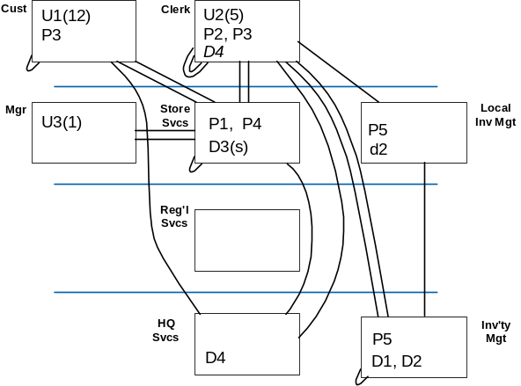
Figure 10: A network diagram, showing component interactions, will all candidate conceptual nodes
This example shows:
- The interactions between components (as placed via deployment units), which are associated with the set of connections in the matrix in the previous example.
- The “layers” still in place.
- That there is nothing placed in (and therefore - at this time - no need for) the Regional Services conceptual node.
Example 3: Interactions on a network diagram (example 2)
This is the same IOM as in the previous example, redrawn:
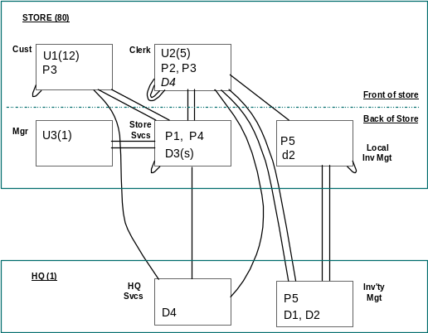
Figure 11: A network diagram illustrating the inter-conceptual node component interactions
This example shows:
- The removal of the unused Regional Services conceptual node.
- The removal of most of the layers, to be replaced by “locations,” with the exception of the “front / back of store” boundary. It is these boundaries that will prove most helpful in the further development of the design.
- The numbers of locations and (for those conceptual nodes with end users) numbers of users per conceptual node per location.
Example 4: Connections on a network diagram
The Operational Model of the previous example has now been simplified to show the connections, which are required in order to support the component interactions. (In this diagram, we have also chosen to omit the “locations” and “numbers” data.)
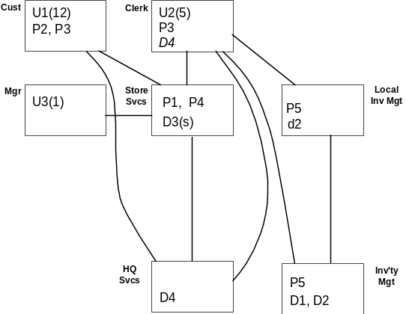
Figure 12: A point-to-point connection diagram, with unused conceptual nodes removed.
Example 5: Interactions on a network diagram (example 3)
This example is similar to the previous few examples.
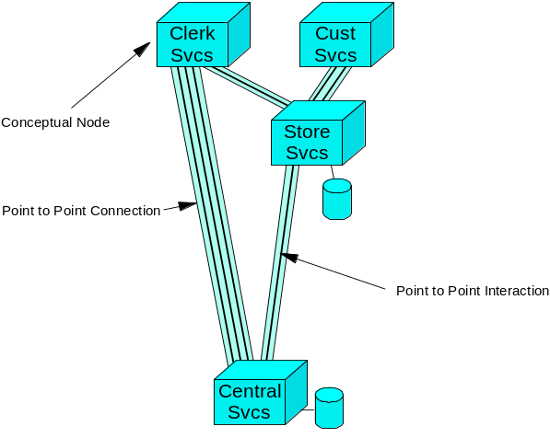
Figure 13: A network diagram showing component interactions
This example shows:
- How the various interactions between components relate to the various connections.
- That there is no need for multiple connection types between any conceptual nodes
- A visual clue to the need for application information on some conceptual nodes (the disk symbol).

Inter-Conceptual Node (Point-to-Point Connection) Requirements
Having identified the required point-to-point connections between conceptual nodes, it is necessary to identify their requirements. Identify these by walking through the major use cases and associated interactions between components (accounting for the distributed nature of their execution and data aspects).
For each connection (remember they are directional), note the type of communications required between the connected conceptual nodes. For example, it may be possible to identify:
- File transfer
- Transactional communications
- A single message, with no response expected
- A message requiring a fast response
- A message expecting a response in due course
- An exchange of several messages between a pair of components (i.e., a conversation)
- Data distribution (such as to maintain copies)
- Software distribution
- Electronic mail
- A mobile user who might require docking facilities to refresh his local data.
- Any National Language considerations (NLS)
It is possible that the characteristics of the component interactions which “make up” a point-to-point connection vary greatly (such as “data distribution”, overnight, where throughput is paramount) and “transactional communications, during the day, where response and integrity are vital). In these cases identify multiple connections between the same two conceptual nodes, each of which will reflect these very different needs.
As well as identifying the type of connection, you need to also understand the service level characteristics that these connections will need to deliver - whether these are in line with the service level requirements (recorded in the Non Functional Requirements work product), or whether they have been compromised or modified in some way (due to the need for balance, or because conflicting needs could not be realized). These SLCs will usually include things like:
- Throughput per unit time (whether this be per second, per hour, or over a 24 hour period) - peak and average
- Latency (maximum time allowed for a message to traverse from one conceptual node to another)
- Availability (including any degraded mode options you may have - in the SOM you may identify a leased line solution, which might use a dial-up line as backup)
- Security
- Transmission error rates
- Class of service requirements (where some messages or transmissions receive a higher priority across the network than others).

Identify Given Interconnection Profiles and Interfaces
Based on the inter-conceptual node connection requirements you have just identified, determine the high-level interconnection profiles. Examples might be:
- Client-Server, which you may already be able to sub-classify as
- Relational Data Server
- Object Server
- File Server
- Communications Server
- Print Server
- Host interactive
- Inter-host networks
- Distributed peer interconnections
- Distributed hierarchical interconnections
Execution - Data deployment unit
If you have execution deployment units requiring access to “remote” data deployment units, identify what is to be transmitted over the interconnections between the involved conceptual nodes. Examples might be:
- Textual attributes
- Image
- Full-motion video
- Voice recordings
Execution - Execution deployment unit
Where there is a need for execution deployment units to interact, you should try to specify the connection profiles in more detail, e.g., make a choice between the various connection models. You should keep in mind the information you have in the “Current IT Infrastructure” work product that may help you decide:
- Conversational (which you might later decide is best implemented using CPI-C, APPC, Named Pipes, Sockets, etc.)
Like a telephone call, the components represented by the deployment units talk to each other synchronously. Each program is very aware that it is communicating with the other. The link must be active, and often the components handle re-synchronization after errors.
- Remote Procedure Call (which you might later decide is best implemented using DCE-RPC, DPL, SPC, ARI, etc.)
One component CALLs a second just like a subroutine. It passes parameters and waits for the second component to RETURN. Usually (but not always) the second component is actually running in a remote system. These components are usually not aware that they are remotely connected. The link must be active but the components often do not handle communications error conditions.
- Messaging and Queuing (which you might later decide is best implemented using MQSeries, etc.)
Messages are passed from one program to a QUEUE. The second program pulls the messages off the QUEUE, handles the processing and may put replies back on another QUEUE for the first program to read. The system handles the passing of the queue elements across communications links. The programs are unaware whether they are communicating remotely. For some types of application logic, the link need not even be up, for the queues can store the information until the link is ready.
Data - Data deployment unit
Where there is, in some manner, distributed data, there will inevitably be a need for some kind of intercommunication for the following reasons:
- In order to keep the various copies of the deployment unit in sync, or up to date
- Because a request to one deployment unit for data cannot be satisfied by that deployment unit, which must then communicate with another deployment unit in order to provide the information (as may be the case in a segmented data design, when the attributes associated with a request for “customer 12345 account details” are not held in the local branch).

Given Connection Technologies
Even though we are usually only interested in “point to point” connections at this stage in the technique, if there are any given or specified high-level interconnect technologies for the interconnections you have just drawn, then make sure they are reflected in the Operational Model.
However, do not replace the point-to-point connections with these more physical connections. The requirements recorded against the point-to-point connections will be used to calculate the required throughput, latency, availability ands other characteristics of the physical networks you design during the development of the specification-level Operational Model, and will therefore verify the suitability or otherwise of these “given” technologies.
Examples might be:
- WAN
- Dial up
- Leased line (point to point)
- Private network
- X.25 Packet-Switched Network
- LAN
- Ethernet
- Fast Ethernet
- Fiber
- ATM
- Channel-to-channel connections.
Make a note if any of these connections span international boundaries. Also, make a note of any connections that:
- Include architectures or technology that is unfamiliar to you or your specialists.
- Connect to types of conceptual nodes that are likely to be unfamiliar to you or your specialists.
It is normally more difficult to deal with these system designs.
At this stage it may not be obvious that the existing technology needs to be upgraded since you may not have enough performance information available. Do not become too performance-oriented at this stage.
A separate network diagram that represents the physical networking topology might help.
Example
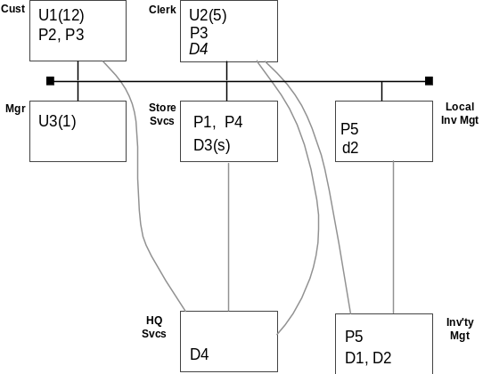
Figure 14. Identification of high-level physical connections between conceptual nodes
This example shows:
- That the communications between the various conceptual nodes in the store will be via an Ethernet LAN, but that the designer is still undecided as to how the inter-location communications will be realized. This aspect will be designed during the development of the SOM.
- Keep in mind that on this sort of diagram, which indicates “pre-selected” connectivity, you may have difficulty in ensuring the abstract nature of conceptual nodes is not lost. On such a diagram, “boxes” look awfully like computers!

High or Continuous Availability Connections
A connection serving a conceptual node with CA requirements may need CA characteristics itself. Certainly, if the intended service requires the conceptual nodes at both ends of the connection simultaneously (that is, within the time scope of the unit of work), then a CA connection is mandatory.
However, if a conceptual node may survive and provide the apparent CA service on its own (for example, using a fall back mechanism of “store and forward” queuing) then a connection with lower availability is acceptable.
At the conceptual level we are not concentrating on IT technology issues. Concentrate instead on the impact that the conceptual node placement has on the serviceability of the connection or the need for alternate connections, etc. (for example the likelihood of providing a CA connection over 5000 miles is low or will be extremely expensive). You might therefore force the two conceptual nodes closer together.

Review the Design

Summarize and Review Deployment Unit Requirements
When you have completed steps 4 through 7, make sure you have summarized the requirements placed on each conceptual node due to the placement of the various deployment units, as well as the requirements placed on the various connections. Do they present a consistent picture? For example, are the availability requirements of a conceptual node consistent with those of its associated connections?
Remember to include all the existing processing and data at those conceptual nodes that are already in existence, as well as those due to the new applications, to build up a complete statement of all the activity at the node.
Determine if the requirements you have for connections can be met by any of the existing network topology that you are required (or hope) to use.
Check that you have documented, for example:
- For Execution deployment units:
- Volumes (txns per second or whatever; whether per node, per location, or per system)
- Response requirements (whether this is for individual txns, or the elapsed time for a business process)
- Availability requirements
- Security (access control) requirements
- Types of processing - batch, transaction, message based, etc.
- For Data deployment units
- Volumes (approximate disk storage requirements - probably not allowing for any database overheads at this stage)
- Volatility (the rate of change) and Currency (how up to date it needs to be)
- Types of data access
- Data integrity and recovery
- Availability
- Security.
Check that you understand all the Client/Server relationships that you may have created. Also check that any that are givens are still true. You will be identifying the system management requirements for the new system later.
Check that you are conforming to any processing and storage placement that is dictated by the use of an application package.
At this point, if you do not have application developers as part of the Operational Model design team, then you should arrange a checkpoint with the application developers to review the placement with them, and the impact on their development activities. In particular, identify any concerns or issues that they may have regarding the skills or amount of development activity they anticipate to support the placement.
In some circumstances, the IT system you are developing will deploy technology that may be used for other purposes (such as departmental servers being used to store personal productivity data). In these cases make sure you document the rules governing how much execution or data resource is available for the users and/or local department to use for local applications, otherwise you may find there is not enough space left when you come to install the production system of this design.

Summarize and Review Conceptual Node and Connection Requirements
As you proceeded through steps 2 to 7, you may have redrawn the conceptual nodes several times because of the decisions that you have made about placement. Check that the outline system still conforms to the mandatory requirements defined in the various input work products, and that it does not violate any of the client’s strategic IT directions.
For example is it required that:
- This is a distributed system and all systems must be centralized (or vice-versa)?
- End users will always have programmable workstations?
- No end user will be allowed to keep local data?
- The design reflects standards for programming and documentation?
- Documented practices for design
- The design conforms to any legal requirements dictated by law such as:
- Hours of work
- Safety
- Levels of accuracy
- The design supports special considerations of mobile users
Revisit the Operational Model and make sure that the various parts of it (deployment units, conceptual nodes and connections) make sense. You may still not be able to see all the elements that you will need, or you may now realize that a particular conceptual node is wrongly specified or positioned. If so, revisit the appropriate earlier step(s).
Ensure that in each conceptual node you can see all the necessary deployment units, in their various guises.
Although this level of detail (“what” not “how,” “application deployment units only”) is appropriate at the conceptual level, do not ignore any more detailed facts or insights you may have about the likely outcome of the specification-level Operational Model.
For example, determine:
- How the presentation deployment units can be supported by some form of presentation management technical component
- How an execution deployment unit might be enhanced by Workflow Management technical component
- How a data deployment unit might be realized via a database manager
Constrain the design choices in the subsequent development of the Operational Model. You may have something on the base hardware, the operating control program, system management and some inter-conceptual node connections.

Sensitivity to Organizational Change
Ensure your architecture remains flexible enough to handle a reasonable amount of organizational change. Check that any user group geographical move will not lead to complex deployment unit relocation from one conceptual node to another. Determine what may happen if a group of users became mobile.
Check that imprecise user profile definition will not impact the workstation profile. For example, it is likely that a user group’s responsibilities might be extended to cover several processes that at present only need a simple ‘dumb screen’ interface. The combined effect of all these at one user workstation might be sufficient to justify a more advanced interface.

Given (or Implied) Architectural Standards
Within each conceptual node and its interconnections identify any specific architectures or standards that are givens or are strongly implied by the known requirements.
For example:
- Open systems with DCE
- Client/Server relationship based upon a specific relational database product
- Internationally agreed industry standard connectivity like a financial transaction credit authorization protocol.
- TCP/IP
- CORBA or DCOM
- Message queuing, based on a specific product.

What is the Shape and Style of the Conceptual Operational Model
Remember there may be several overlapping shapes and styles within a system design. Examples are:
- Host interactive
- Hierarchical
- Peer-to-peer
- Distributed
- Co-operative
- Client/server
- Mobile users
It is important to give some sort of label to the system so that people can speak of the system shape and visualize it. Probably one shape or style will dominate. It may not be possible to see all the shapes and styles at the first pass. They will become more apparent later.
Example
The shape and style of the Operational Model that has been discussed in previous steps is local client-server, with data distribution from a centralized server system.

Check Impact of Design Changes
Review the design and revise it as necessary to satisfy availability, security, performance and system management requirements (guidance for each of these areas is contained in separate technique papers).
You may make design changes during any of these topics, which may clash with earlier design decisions. Look for these:
- Did you alter your data and execution deployment unit placement? If so, is the documentation completely consistent?
- In order to improve availability, you may have changed the conceptual node structure, but forgotten to update the volume information and recalculate the performance characteristics.
- You may have taken some security decisions, such as adding encryption, which were not considered in the performance section.
- Perhaps you have chosen to adopt a particular approach to security which makes it difficult to achieve your availability targets.
- A system is often as dependent on the system management processes of the system as on the business related processes. Therefore check that your system availability is not exposed by part of your system management being less available than the rest.
- Not all of your system management processes will have to be highly available, but some are more likely than others to need careful availability design. These might include:
- Problem detection and correction
- Security, if the security system does not work then the system may not be allowed to work
- Workload scheduling of important tasks.
- Recovery actions.

Conformance to Systems Management Policies
Are you conforming to the system management architecture (if one exists or is implied)? Such policies should have already been documented in the Non-Functional Requirements work product. If one, or more, does exist how applicable is it to the work that is being done? Is it up-to-date?
- What is unusual or challenging about this system management requirement, when compared to the existing skills and experience of the client?
- Size and scale
- New technologies to be managed, for example mobile workstations?
- Very frequent changes?
Cross Reference to ISD
- 1. Identify the layers and locations of the system Enhancement to WSDDM/ISD Question A07.
- 2. Identify candidate Conceptual Nodes Enhanced from but based on class material, plus selected parts from WSDDM/ISD question A09.
- Note that much of this step replaces material from WSDDM/ISD Question A09, which was much more inclined towards a technical (or even technology) perspective, making it difficult to distinguish from the subsequent ISD phase (Infrastructure Specification); and masked the “shape and style” aspects of the step.
- 3. Identify “special purpose” conceptual nodes A combination of enhanced class material, plus parts of WSDDM/ISD questions A09 (Systems Management), A10CA/A11S, A12CA, A13 and A14
- 3.1 Systems Management Not directly addressed in WSDDM/ISD at this point (A09 comes closest).
- Based on WSDDM/ISD A35:
- 3.2 Recovery/Restart WSDDM/ISD A10A
- 3.3 Disaster Recovery WSDDM/ISD A11S and A12CA.
- 3.4 Application Development WSDDM/ISD A13
- 3.5 Stress/Regression Testing WSDDM/ISD A14
- 4. Place presentation deployment units Based in part, on part of WSDDM/ISD A28.
- Based on WSDDM/ISD A37
- Based on WSDDM/ISD A38
- 5.1 General Guidance Based in part on WSDDM/ISD A15
- Based on WSDDM/ISD A37
- 5.2 Perform a high level walkthrough Based on WSDDM/ISD A16
- 5.3 Place the given and obvious data deployment units Based on WSDDM/ISD A17
- 5.4 Scope of data deployment units Based on WSDDM/ISD A18
- 5.5 Characteristics of the data deployment units Based on WSDDM/ISD A19S and A20CA
- 5.6 Place all other data deployment units Based on WSDDM/ISD A21
- 5.7 Segmentation of data deployment units? Based on WSDDM/ISD A22
- 5.8 Operational Copies Based on WSDDM/ISD A23
- 5.9 Viable Locations for data deployment unit? Based on WSDDM/ISD A24
- 5.10 Check Availability Needs Based on WSDDM/ISD A25
- 5.11 Check Performance Needs Based on WSDDM/ISD A26
- 5.12 Check Security Needs Not in WSDDM/ISD
- 5.13 Cross-check “Copies” and “Segmentation” Based on WSDDM/ISD A27
- 6.1 General Guidance Based in part on WSDDM/ISD A15
- Based on WSDDM/ISD A37
- 6.2 Perform a high level walkthrough Based on WSDDM/ISD A16
- 6.3 Place the Execution deployment units Based on WSDDM/ISD A28
- 6.4 Viable location for execution deployment units? Loosely based on WSDDM/ISD A29
- 6.5 Mass (or batch) execution deployment units Based on WSDDM/ISD A30S and A31CA
- 7 Identify required inter-node connections This step is quite a bit different from the equivalent part of WSDDM/ISD
- Loosely based on WSDDM/ISD A39
- 7.1 Inter-Conceptual Node (point-to-point connection) requirements Enhancement of WSDDM/ISD A40
- 7.2 Identify given interconnection profiles and interfaces Based on WSDDM/ISD A41
- 7.3 Given connection technologies Based on WSDDM/ISD A42.
- 7.4 High or Continuous Availability connections? Based on WSDDM/ISD A43CA
- 8.1 Summarize and review Deployment Unit requirements Based on WSDDM/ISD A36
- 8.2 Summarize and review conceptual node and connection requirements Based on WSDDM/ISD A44
- 8.3 Sensitivity to organizational change WSDDM/ISD A45
- 8.4 Given (or implied) architectural standards WSDDM/ISD A46
- 8.5 What is the shape and style of the conceptual Operational Model? WSDDM/ISD A47
- 8.7 Conformance to Systems Management policies Based on WSDDM/ISD A67
Revision History
Version 1.3 October 2000 – Removed confidentiality markings from header.
Version 1.2 September 1999 – Applied to template, spelling, grammar, and style review.
Version 1.1 February 1999 – A standard format template was applied.
Version 1.0 September 1998 – Base version.

Its purpose is to communicate the essence of the proposed design (in terms of its function and placement) to others, including the Sponsor.
"System wide" means those parts of the system for which we can develop and implement systems management componentry. So if, in figure 4, the top layer were (for example) going to be implemented in private homes where we have no control, then the system management conceptual node would have stopped short of that layer.
Most inter-conceptual node connections will be added to the network diagram later in this technique.

