
````

IBM Global Services

Designing Enterprise Application Integration Brokering

Technique Paper (TP)

© Copyright International Business Machines Corporation 2001, 2002
All Rights Reserved
Version 1.0 July 2002
- Introduction
This technique provides an approach to design the brokering capabilities within a defined EAI System. This design, as depicted in Figure 1 below, is performed after the product architecture, and system design for the EAI subsystem is established, meaning:
- Functional partitioning to EAI products and components is complete
- EAI subsystem standards are established, including inter-product / component communications and interfaces to customer infrastructure services
- Allocation of performance, capacity and availability budgets to EAI products and components is complete.
Since the facilities of EAI packaged products vary widely, it is not feasible to completely address product extensions or custom component needs for a particular broker within the scope of a general design technique. As a result, the primary focus for this technique is to establish the specification details for those brokering capabilities common to all implementations:
- Routing of business entities between EAI subsystem end points
- Queuing of business entities between end points
- Transformation of business entities (e.g. business objects, messages)
- Repository considerations
- Tooling considerations for the above capabilities.
Note: EAI Attributes Blueprint is a requirements deliverable for EAI engagements.
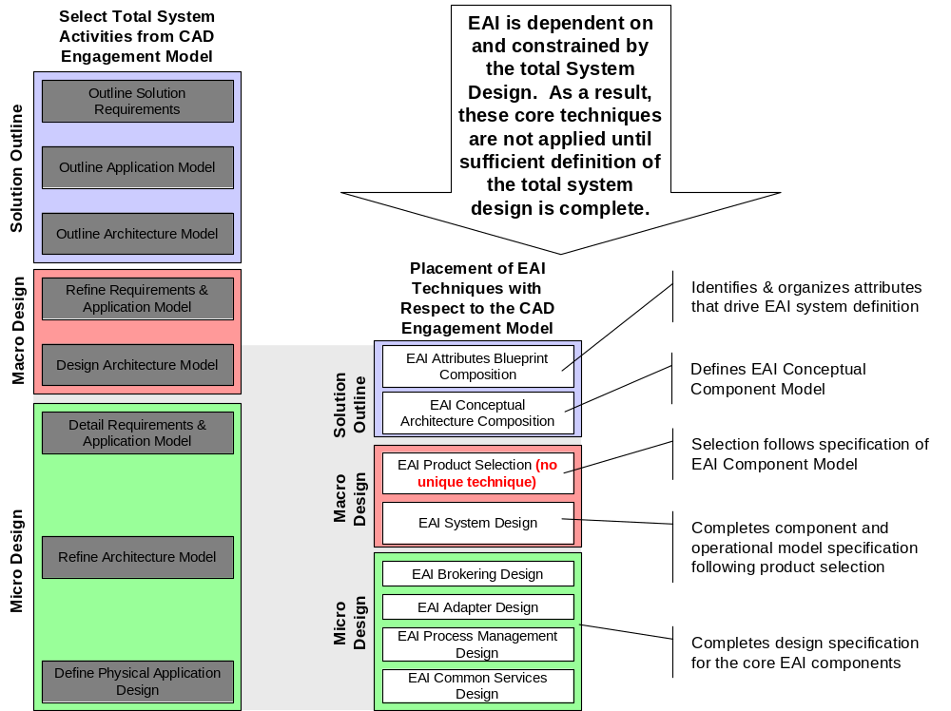
Figure 1 - Brokering Design is one of 7 core techniques specific to EAI
Definitions
An EAI subsystem is responsible for providing the necessary integration conduits, including proper business semantics, and business process linkage, to enable the assembly of a defined business system, composed of any or all of the following end points:
- Application packages
- Legacy custom applications
- Application components
- Existing client infrastructure services
- External business partner systems
- Externalized business unit systems of the same enterprise
It also includes standard content and representation of solution business entities.
At the highest level (prior to package introduction), an EAI subsystem is composed of just a few components:
- Adapters
- Brokers
- Process Management
- Common Services
- Custom Components.
An adapter is custom or packaged code that connects an end point to the EAI subsystem. Some or all of the brokering capabilities (as well as other non-EAI capabilities) may be found in a “fat” adapter, whereas a “thin” adapter merely provides the connectivity desired.
An integration broker is a (usually separate) service that acts as an intermediary between two or more of the above end points. It provides all of the brokering capabilities, as well as possibly providing non-EAI capabilities.
Example EAI Problem
The example problem referenced throughout the rest of this document can be found in Appendix B: Example Problem Background.
Document Structure
The remainder of this document is organized around the core brokering design areas to enable brokering services. Connection is a base facility that applies to all EAI subsystem components, and is normally covered as a part of the EAI System Design. The aspects of XML handling and Trading Partner Agreement handling that apply are covered in section 5 Transformation of this document.
Context
This document applies to all EAI subsystem application contexts, whether confined within a client enterprise, or extended to include business partner enterprises. In addition, it applies whether the ultimate integration required is data oriented in nature or includes business process logic.
- Preparation
Assemble the materials and prepare the team
Plan the approach to the brokering design. Decide the design analysis order if more than one brokering product or component is in use. Similarly, decide the order of design analysis for brokering capabilities within the confines of each adapter. In this case, this design technique is used in combination with the process management design technique and the adapter design technique. Apply the technique for each brokering product or adapter in the EAI subsystem.
Assure that the team members are briefed on the project, and this specific effort. Also assure that the team have read this technique, and understand their roles within the effort.
In the most general case, brokering services can be found in both the brokering components and the adapter components. As a result, both the brokering component architects and designers, as well as the adapter architects and designers should read this technique.
- Routing
Routing focuses on the determination of the next destination in an interaction arc or path. For a complete discussion of routing, see the EAI Conceptual Architecture Technique.
The basic tasks to perform are:
- Analyze the Interaction Arcs for each interaction path defined in the EAI Attributes Blueprint and allocated to the brokering capability in this component. The availability matching and response time attributes may be useful as well
- Determine which routing mechanisms are available. The options generally available are described in Table 1 below, along with advantages and disadvantages to each. Determine which routing mechanism will be applied to complete each desired arc.
Table 1 – Routing Mechanisms
Mechanism | Description | Advantages | Disadvantages
Pre-specified | The originating end point determines the destination end points.  Examples of this are dedicated queues between two end points or using the ReplyToQ field of a MQSeries message to hold the destination queue name. Also, virtually all RPC/OO methods, such as Java RMI or CORBA, use a pre-specified mechanism due to the direct connections used. | Fast, both in terms of execution time and setup time. | Inflexible. Requires software development to change routes.  Change control can be difficult to manage.
Content-based | Exchanged entities on an arc are dynamically parsed to determine the destination end point(s), usually based on routing rules stored in a rules repository.  An example of this is to broker an existing queuing application that cannot be changed. The content can be parsed to determine the message route. | Very flexible | Parsing each entity can be slow.  Requires rules repository.  Content changes may require additional changes in mechanism or rules repository.
Topic-based | Additional keywords or “topics” can be sent with the exchanged entities. This topic determines the destination end point(s), usually based on routing rules stored in a rules repository.  Topic-based can be thought of as a special instance of content-based. The main difference is that the broker/adapter supports this without needing to fully parse the data, or that a field outside of the data is used to hold this information.  Examples of this are queuing messages to MQSI with a MQRFH2 header containing the topic, or using the Corralled field in MQSeries to hold a topic. Note that topic-based can be used without using publish-subscribe. | Very flexible  Generally faster than content-based parsing when supported by broker/adapter | Can be just as slow as content-based when not supported by broker/adapter.  Requires rules repository.
Publish-Subscribe, or Pub-Sub | Usually derived from a topic-based approach, destination end-points subscribe to topics and receive entities as published by source end points.  The main difference between pub-sub and topic-based is that the routing is typically more dynamic in nature. Subscribers can come and go, obtaining data as they need it, rather than having a strict routing scheme.  Examples of this are using MQSI, the MA0C SupportPac, or JMS as the pub-sub broker/server. | Very flexible  Gives delivery control to destination end points; they can subscribe as needed. | Requires a pub-sub broker/server that maintains a dynamic rules repository of subscriptions and published entities and forwards entities appropriately.

Example problem decisions
Here is part of the Reference Workflow section and part of the Interaction Arcs section of the EAI Attributes Blueprint for the Daukas & Lee Company:
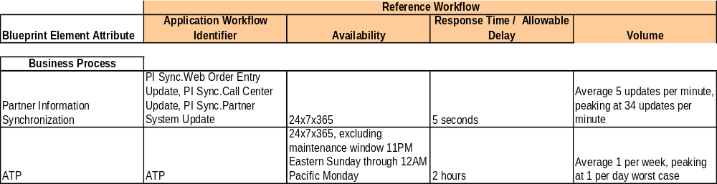Figure 2 – Reference Workflow for Daukas & Lee Company

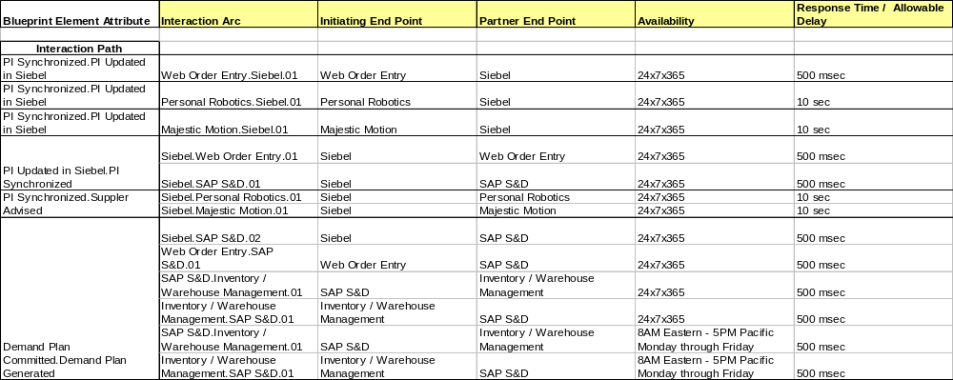Figure 3 – Interaction Arcs for Daukas & Lee Company

For the Daukas & Lee Partner Information Synchronization problem, time is the primary factor affecting the mechanism used (from Figure 2, a 5 second response time). From Figure 3, availability matching is not a problem, since all systems involved are available 24x7x365. Since a fast response time is required, an RPC or OO mechanism will be used over a message-oriented approach. For all of these reasons, a pre-specified routing mechanism will be used. There are only 3 end-points involved so change management can be dealt with appropriately.
For the Daukas & Lee ATP problem, time is not a significant factor; in fact, availability of the Inventory/Warehouse Management system is not 24x7x365 (from Figure 3). This means that a message-oriented solution will be used to cover the availability gap. There are many end-points involved. So, unless some other reason appears, pre-specified should not be used. Either content-based or topic-based would be acceptable. Since this is new development and the adapters allow flexibility in building the message, using a topic-based approach is recommended. Since there are few end points, a full pub-sub model may not be needed. This can be adopted at a future time within the broker system.
- Queuing
Queuing allows for the temporary holding of exchanged entities by the EAI subsystem until appropriate conditions are present for delivery to the target end point. For a complete discussion of queuing, see the EAI Conceptual Architecture Technique.
The basic tasks to perform are:
- Analyze the Interaction Arcs for each interaction path defined in the EAI Attributes Blueprint, and allocated to the brokering capability in this component, including the availability matching and response time attributes.
- Review the availability matching attributes from the Blueprint for each end point access path assigned to this component.
- Determine which queuing mechanisms are available, if any, for each end point access path.
- Determine the appropriate queuing mechanism, if any, for each end point access path. Determine additional attributes, as needed, from Table 2 below.
Table 2 – Queuing Attributes
Attribute | When Needed | Advantages | Disadvantages
Persistence | The interaction arc assumes assured delivery.  The availability matching window can span EAI subsystem shutdown. | Assured delivery is enabled.  Messages are maintained over EAI subsystem outages. | Performance suffers from additional overhead (CPU time, response time and media) needed to make messages persist. The number of systems touching the messages can magnify the effect.
Recoverability | The interaction arc error recovery scheme does not provide for re-queue of entities from originating end point. | Messages can be “replayed” to recover integrity of interaction arc sequence previously applied. | Performance suffers from additional overhead (CPU time, response time and media) needed to make messages recoverable. The number of systems touching the messages can magnify the effect.
Example problem decisions
Refer to Figure 2 and Figure 3 starting on page 6 for the Reference Workflow section and Interaction Arcs section of the EAI Attributes Blueprint for the Daukas & Lee Company.
For the Daukas & Lee Partner Synchronization problem, no queuing will be used. Time is the primary factor affecting the process so an RPC or OO mechanism will be used over a message-oriented approach, again to save time. These mechanisms tend not to support queuing. The volume is appropriate and the systems involved have the same availability (from Figure 2 on page 6 and Figure 3 on page 6), and are located in the same data center. Persistence and recoverability are not factors; if the update fails, it will simply be retried as needed.
For the Daukas & Lee ATP problem, queuing should be used, primarily due to the availability matching differences. Persistence should probably be used, since, for example, the supplier response may return while CICS is not available. Recoverability may not be needed, but this depends on, for example, whether CICS can easily resend the requests, whether the suppliers can resend responses and, if CICS does resend, will the supplier recognize this and handle appropriately? In the absence of such knowledge about the business process as reflected in the applications, the queuing choice is appropriate.
- Transformation
Transformation focuses on the parsing and transformation of one exchanged entity to another over an interaction arc or path. For a complete discussion of transformation, see the EAI Conceptual Architecture Technique.
The basic tasks to perform are:
- Review the parsing and assembly, and transformation attributes from the Blueprint allocated to this component. This may include Trading Partner Agreements detailing exchanged entities.
- Review available transformation templates (rule sets) from ICM and previous engagements for applicability. It may also be useful to determine if additional broker/adapter support is available (e.g. MQSeries Integrator SupportPacs).
- Determine which parsing mechanisms are available for each end point access path. The options generally available are described in Table 3 below, along with advantages and disadvantages to each. Compose parsing rules needed.
- Select the transformation approach to be applied to each exchanged entity, and detail its specification. The options generally available are described in Table 4 below, along with some notes.
- Identify external component call outs such as security services. Specify brokering extensions and custom components required to support each transformation.
Table 3 – Parsing Mechanisms
Mechanism | Description | Advantages | Disadvantages
Self-defining data | The message contains both data and the metadata (e.g. field name, data type, etc) needed to extract the data. The parser must know how to read the metadata.  An example of this is XML. | No previous knowledge of data is needed. | Metadata size is usually quite a bit larger than actual data, so messages tend to be large.  Parsing can be slow, due to additional metadata parsing needed.
Standard predefined forms | The message contains data that has been standardized, usually by an appropriate governing body.  An example of this is EDI, but can also apply to industry standardized XML data. | Little previous knowledge of data format may be needed.  Standards dictate use and contents of fields. | Data may contain many fields that are not needed, but which cannot be removed.
Well-known application package forms | The message contains data that has been standardized by the vendor of a well-known application.  An example of this SAP IDOC. | Little previous knowledge of data format may be needed. | Data may contain many fields that are not needed, but which cannot be removed.  Users of package may dictate specific uses for certain fields
Custom parsing | The message contains data that is in a custom format. | Data can be reduced to fields needed, so parsing can be fast. | Data format must be known to proceed, so preparation may be slow.
Table 4 – Transformation Mechanisms
Mechanism | Examples | Notes
Simple | Character conversions (e.g. ASCII → EBCDIC)  Data type conversions (e.g. ASCII → Binary)  Padding or truncation of data field  Adding, deleting, rearranging, splitting, or concatenating data fields  Basic mathematical computations  One-to-one symbol mapping | Performing many simple transformations can be as costly as some more complex transformations
Moderately complex | External table lookups  Combining messages  Parsing sub-strings of fields  Searching and replacing  One-to-n, n-to-one and n-to-m symbol mappings  Handling data structures and language arrays  Manipulating bits and/or bytes  Using conditional transformation | Can be somewhat computationally expensive, especially in combination.  Look for opportunities to stage the transformation and deliver the most time sensitive entities early in the process.
Very complex | Complex data structures such as hierarchies and network structures  Complex assembly such as table joins and aggregation  Handling of BLOBs, executable objects, and other binaries including encrypted information  Leveraging metadata repositories | Can be computationally expensive. Look for opportunities to parallel process or multithread / multitask the transformation.
Example problem decisions
Here is part of the Exchanged Partner Entity section of the EAI Attributes Blueprint for the Daukas & Lee Company. It describes the entity for the Daukas & Lee Partner Synchronization problem:
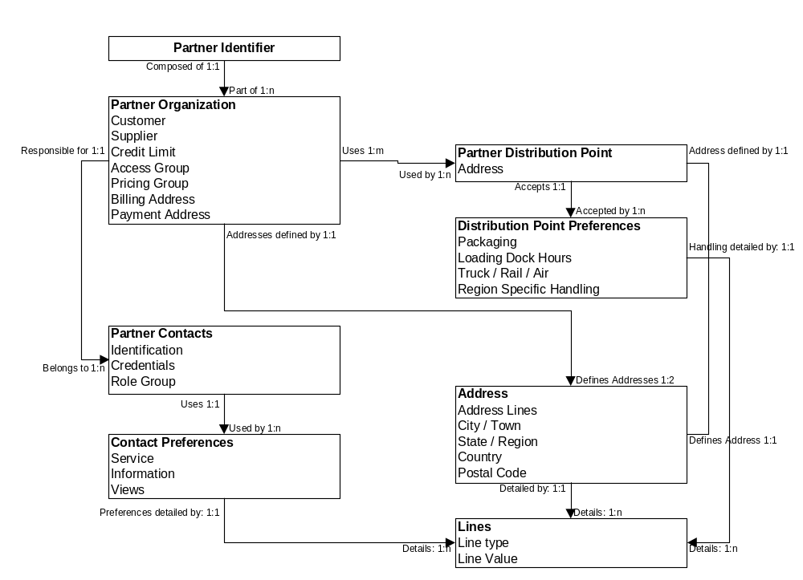Figure 4 – Exchanged Partner Entity for Daukas & Lee Company

Figure 5 – Exchanged Partner Entity for Daukas & Lee Company
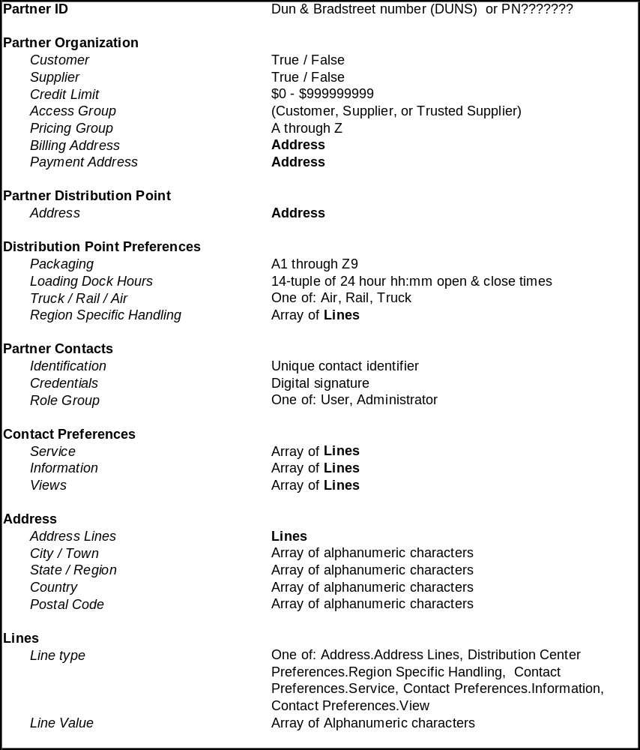
For the Daukas & Lee Partner Synchronization problem, time is the primary factor affecting the transformation. Since Siebel has a well-defined set of XML based messages and is the “master” for this process, all 3 components will send and receive Siebel XML formats. Most transformations needed are simple ones.
For the Daukas & Lee ATP problem, the non-functional requirement of XML can be adhered to. The suppliers must handle their own transformations to/from this standard. CICS is the major component that cannot natively handle XML, but there is an established message format to handle the 3270 interface via MQSeries and the MQ-CICS Bridge. As it happens, most of the transformations needed for CICS are simple ones, from ASCII to EBCDIC, with a few Integer conversions to support the MQCIH header and the 3270 Bridge structures. Figure 6 below shows part of the message needed to get the location information from the CICS Purchasing system.

Figure 6 – 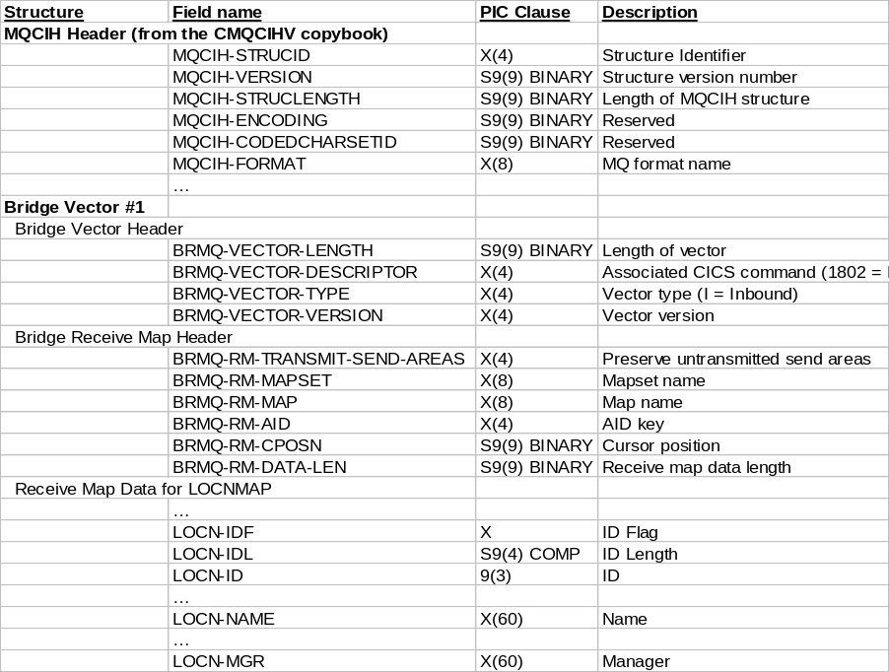Purchasing Location Message for MQ-CICS 3270 Bridge

- Repository Considerations
Routing, queuing and transformation decisions may require the existence of certain repositories, as well as programming and design tools to support the repositories.
The basic tasks to perform for repositories are:
- Determine what repositories are needed. Review the typical repositories listed in Table 5 – EAI Repositories below. Note that you may have more than one instance of each type.
- Determine where each instance of a repository will reside. See Table 6 – Repository locations below for typical locations and advantages and disadvantages for each location.
- Determine what tools are available to accommodate the repository choice(s). This leads into the normal tool selection process, if more than one tool is available for each repository.
Tools supporting the brokering capabilities in adapters, integration brokers, and gateways, and the need for such tools, tend to vary by product implementation.
For brokering tools, consider these items:
- Where possible, it is best to select design tools that support integration with other tools in use within the customer’s environment, or required by the rest of the EAI product suite for the system.
- Since brokering is often present in adapters and gateways as well as integration brokers, it is unusual for one set of tools will cover all of the adapters and broker components in use. It is important for best leverage of design effort to represent the brokering specifications in a run time component independent form as late into the design as possible. This facilitates use of transformation templates at multiple points in the EAI subsystem, and reuse of these templates in other engagements.
Example problem decisions
For the Daukas & Lee Partner Synchronization problem, time is the primary factor. Since the number of components is small, the routing rules, queue names, and transformation rules will be held in a private data store in each component. Therefore, the tools supported by the programming language supported by each adapter will be used. This may mean hard-coding the rules, or storing them in a file on the local file system.
For the Daukas & Lee ATP problem, the routing and transformation will be done by MQSI, so the data store will be DB2. There are no additional tools specifically for MQSI, although there are many DB2 related support tools to choose from.
Table 5 – EAI Repositories
Repository Contents | Description | Example
Routing rules | Used to determine which end point receives the exchanged entity.
Queue names and configurations | Used to resolve queues names and attributes. | Pub-sub repository
Transformation rules | Used to hold parsing and transformation rules. | MQSI Broker Database

Table 6 – Repository locations
Location | Description | Advantages | Disadvantages
Private data store | Component stores data internally  An example is a private file used only by the component, loaded into memory. | Fast | Inflexible. May require changes to adapt to changes in topology.  Data may need to be duplicated across solution compounding change management problems.
General purpose repository | Data is stored in a general purpose data store mechanism.  An example is a relational database (e.g. DB2 or Oracle) or a directory solution (e.g. LDAP or Active Directory). | Flexible | Can be slow.  Security can be an issue.  Replication can be an issue.  Change management can be an issue.
Authority | Data is obtained via a query to a known authority. The method this authority uses to store the data can be either a private data store, or a general purpose repository.  Example are using a SOAP query to a UDDI server (for Web Services), or using a Value Added Network provider who maintains external routes. | Flexible  Especially useful for external entities where end point is not directly controlled. | Can be slow.  Security can be an issue.
- Tooling Considerations
EAI products containing brokering capabilities each tend to have their own unique development environments. As a result, it is important to capture the brokering design specification in a common form prior to ‘hiding’ the information within one of the tool specific environments. To achieve that end, we employ an Input Process Output (IPO) template to capture the specification. The template, and a filled out example for the Daukas & Lee Purchasing application employed in the ATP process are attached as a Microsoft Excel Workbooks in Appendix A: Specification IPO Template.

Appendix A: Specification IPO Template
The Input Processing Output specification template for brokering is attached. Please find this attachment stored externally in the Method Catalog entry for this Technique Paper. The file name of the attachment is “Sample_IPO.xls”.
A completed sample for the Daukas & Lee Purchasing application involved in the ATP process is attached. Please find this attachment stored externally in the Method Catalog entry for this Technique Paper. The file name of the attachment is “Daukas&Lee_ATP_IPO.xls”.

Appendix B: Example Problem Background
This appendix provides an overview of an example EAI problem at the fictitious Daukas & Lee Company. In particular, it focuses on the integration of their core business applications, and their two primary suppliers to automate two key processes.
- Partner Information Synchronization
- Available to Promise.
Engagement Background
Daukas & Lee Background
Daukas & Lee assembles and markets a product called the Modem Masseuse, sold through major retail outlets around the world. The Modem Masseuse is a handheld robotic massage machine that responds to movement instructions received over a modem from a special web site called MassageBroker.com.
Features user buttons to provide instant feedback to the site about the users:
- Likes and dislikes
- Body area being massaged
- Also features special tactile sensors that provide the web site with feedback about contact pressure, the direction of movement, etc.
The MassageBroker.com web site dispatches digital instructions to the device to:
- Invoke a variety of massage techniques, each with different therapeutic advantages
- Evaluates feedback, and provides movement patterns that maximize "like" feedback from the user
- Employ special pattern recognition processes to learn the preferences of the user, and become more proficient with each massage session
The company has created the modem-based massage category, and there are currently no direct competitors.
Since its introduction last year, a major infomercial campaign has driven rapid sales growth. This growth has exceeded their plans, and the company has had to scramble to build an infrastructure in support. Their current IT infrastructure is probably not sufficient to meet their near-term requirements. The company would now like help from IBM in devising and implementing a new solution.
Even though Daukas & Lee have their product hardware well protected (patents), the company believes that its huge success will stimulate at least one of its potential competitors to come up with their own hardware soon, and attempt a quick and forceful entry.
Strategic Initiatives
Daukas & Lee has established a number of strategic objectives and imperatives that will influence the direction of an EAI subsystem:
- Sustain high growth
- Build strong customer satisfaction
- Provide special attention to key customers
- Create strong alignment with strategic suppliers.
Current IT Environment
Daukas & Lee's systems are a combination of proprietary components, and an ERP package. The proprietary applications were purchased from another manufacturing company that previously employed the CIO. These include applications for:
- Order Collection (Call Center Clients)
- Order Processing
- Production Management
- Inventory/Warehouse Management
- Distribution
- Purchasing.
The Inventory/Warehouse Management and Distribution applications have not functioned up to expectations, and the company has initiatives to replace this functionality. The Production Management application is thought of as a best-of-breed in this area of functionality, and felt by the company to be a valuable asset to maintain.
Daukas & Lee currently allow their key suppliers, Majestic Motion and Personal Robotics, some visibility into their supply planning by providing dedicated USERIDs for each on the existing CICS based Purchasing application.
The company also has a version of SAP's R/3 system, including:
- The FI/CO module that provides:
- Financial Management: General Ledger, Accounts Payable, Special Ledger, Legal Consolidation
- Cost Accounting: Overhead Cost Management, Product Cost Planning, Profitability Analysis
- Enterprise Controlling: Executive Information System, Profit Center Accounting
- The HR module, which provides general human resources support.
Daukas & Lee’s current IT environment is depicted in Figure 7.

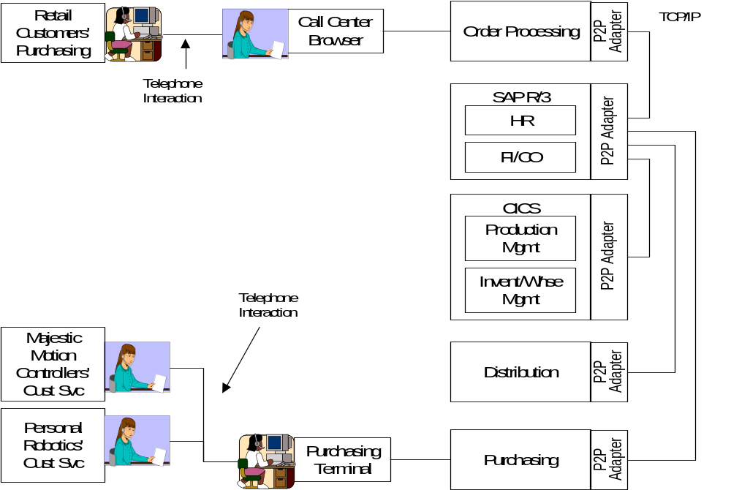
Figure 7 - Current Daukas & Lee IT Architecture Overview Diagram
From an integration perspective, most of the automated data exchange within Daukas & Lee is related to updating their SAP FI/CO module to facilitate financial tracking, and most of the interaction is done with batch processing techniques. Aside from SAP, the company's business applications were not designed to share information easily, and do not have sophisticated API's. The company connects its applications with proprietary point-to-point adapters, mostly written with C++.
Planned IT Initiatives
Daukas & Lee plan to add the following core business applications as a part of achieving their strategic goals:
- SAP's SD module - Sales and Distribution Module which provides functions for Sales Order Processing (Inquiries, Quotations, Orders), Contract and Scheduling Agreements, Pricing, Credit Checking, Rental Processing, Cross Company Processing, Delivery Processing, Billing Processing, Rebate Processing, Returns Processing, Sales Information System, EDI Messages.
- This application is to replace the current Order Processing application
- Siebel - Call center order entry, Customer Information
- This application is to replace the current Order Entry application used by the call center.
- Web Order Entry – A direct, self service, product order application based upon IBM’s Websphere Commerce.
- Operational Data Store and Data Mart
- The company is evaluating the incorporation of a data warehouse, as a way to better equip the management team with key operational and EIS information.
EAI Problem Domain
The problem focuses on providing a tightly integrated enterprise for Duakas & Lee, enabling business processes that operate across their key business applications, and reach to their supplier’s IT systems. Figure 8 depicts a future architecture overview diagram for Daukas & Lee.
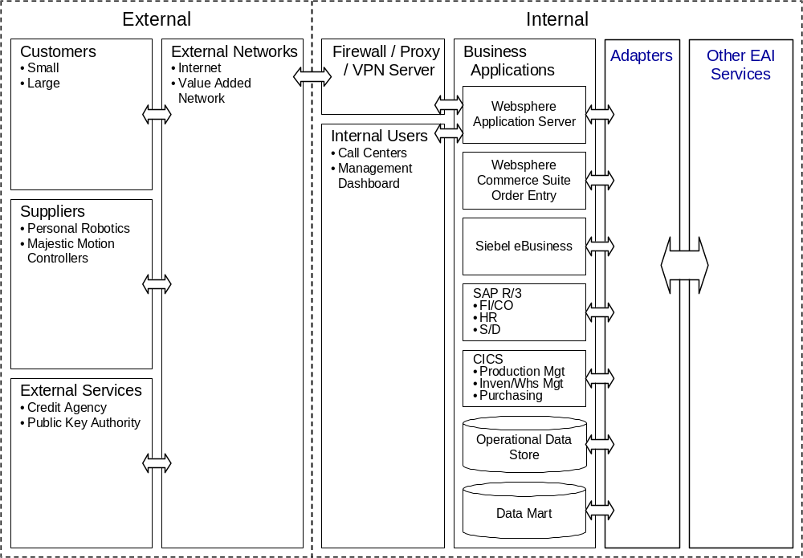
Figure 8 - Daukas & Lee Future Architecture Overview Diagram
There is a specific early focus on synchronization of partner (customers and suppliers) information across the company’s business channels, as well as automation of key parts of their supply chain.
As indicated previously, Daukas & Lee are introducing the SAP Sales and Distribution Module, Siebel, and a Web Order Entry application based upon IBM Websphere Commerce as a part of this update program. These three applications need to maintain a common view of the attributes of Daukas & Lee’s customers and suppliers. Due to the on-line nature of call center and web order entry processing, this synchronization must be held to response times of a few seconds. The business solution design team has chosen to utilize Siebel as the reference master for this “Partner Information.” The coordinated introduction of these three application functions has allowed the design team to use a common logical representation of this information object in all three applications. Each application maintains a slightly different internal representation of the information, necessitating format modifications to support information exchange. The existing, screen driven CICS based Purchasing application was considered as a potential participant in this synchronization, but the team elected to have the SAP Sales & Distribution function feed the necessary information to Purchasing as a part of ATP processing instead.
The second key initiative of this update program is the automation of their supply chain. Daukas & Lee have negotiated with their two suppliers to cross supply one another’s subassemblies based upon their committed capacity and demand in the marketplace. As a part of this relationship, the suppliers have agreed to automate their interaction with Daukas & Lee using a common plan entity (object) for exchange of planning and purchase information. In the new system, SAP Sale & Distribution (SAP S&D) will forecast product demand based upon marketing plans, sales history and current order volumes. As orders are processed, the forecast demand is checked against positioned inventories by Inventory / Warehouse management. As long as in-plan inventory levels cover the forecast demand, no action is taken.
When a net demand is present, exceeding a planning threshold, SAP S&D generates a net demand plan. Production Management compares this net demand with available capacity, and a production plan is generated to meet it, with parts supply assumptions. This is used by Inventory / Warehouse Management to generate a Supply Plan. The Supply Plan is in turn decomposed into Requests for Quote (RFQ) by Purchasing, and individual RFQs are sent to each supplier.
Previously, supplier sales personnel could examine the RFQ and respond on-line using dedicated Purchasing USERIDs that allowed the Purchasing application to control what information each supplier could see. In the future system, this interaction is to be carried out system to system between Purchasing and supplier IT systems.
Responses from each supplier are received by Purchasing, and valid purchase options are selected. These are reviewed within the scope of the Supply Plan by Inventory / Warehouse Management, and valid supply options are selected. These are similarly weighed within the Production Plan, and a production option is selected. This drives a sequence of selections through the supply plan and purchasing, resulting in a reservation being made with the suppliers. Subsequently, when this committed ATP is reviewed through SAP S&D, the production and supply plans will be committed, and a firm Purchase Order issued to the suppliers.
Actors
The preceding narrative has introduced the key actors for these processes from an EAI perspective. Several of the business applications are interactive in nature and require user participation to perform their business functions. This is particularly true in the case of the ATP process. Such user interaction is assumed but not detailed, as it lies outside of the scope of EAI. The actors of specific concern to the EAI subsystem in these business processes are:
- Web Order Entry (Websphere Commerce)
- Customer Relationship Management (Siebel)
- SAP (S&D)
- Inventory / Warehouse Management (Custom CICS)
- Purchasing (Custom CICS)
- Personal Robotics Systems
- Majestic Motion Systems.
These actors are detailed in the following tables.
Table 7 - Web Order Entry
Actor Name | Web Order Entry
Brief Description | This is the originating application for Partner Information updates entered on–line by customers and suppliers.
Status | Primary Actor
Relationships
Inheritance | Subclass | N/A
Inheritance | Superclass | N/A
Associations to Use Cases |  | Partner Information Synchronization

Table 8 - Customer Relationship Management
Actor Name | Customer Relationship Management
Brief Description | This is the master information source for Partner Information. It is the originating application for Partner Information updates entered by Customer Service Representatives.
Status | Primary Actor
Relationships
Inheritance | Subclass | N/A
Inheritance | Superclass | N/A
Associations to Use Cases |  | Partner Information Synchronization

Table 9 - SAP Sales & Distribution
Actor Name | SAP Sales & Distribution
Brief Description | This is the originating application for generation of the demand plan that initiates the ATP process with Daukas & Lee’s suppliers.
Status | Primary Actor
Relationships
Inheritance | Subclass | N/A
Inheritance | Superclass | N/A
Associations to Use Cases |  | Partner Information Synchronization, ATP

Table 10 - Inventory / Warehouse Management
Actor Name | Inventory / Warehouse Management
Brief Description | This application manages the finished goods and parts supply inventories, and is responsible for generating a supply plan to meet the needs of a specified production plan.
Status | Secondary
Relationships
Inheritance | Subclass | N/A
Inheritance | Superclass | N/A
Associations to Use Cases |  | Partner Information Synchronization, ATP

Table 11 - Purchasing
Actor Name | Purchasing
Brief Description | This application is responsible for composing RFQ’s, reservation requests and POs to meet a specified supply plan.
Status | Secondary
Relationships
Inheritance | Subclass | N/A
Inheritance | Superclass | N/A
Associations to Use Cases |  | Partner Information Synchronization, ATP

Table 12 - Personal Robotics Systems
Actor Name | Personal Robotics Systems
Brief Description | Personal Robotics is one of two suppliers that provide the two subassemblies that comprise the hardware of Daukas and Lee’s product. Their systems provide automated update of their own Partner Information. In addition, their systems provide an automated response to Daukas & Lee’s RFQ’s, part reservations and Pos.
Status | Primary Actor
Relationships
Inheritance | Subclass |  | N/A
Inheritance | Superclass |  | N/A
Associations to Use Cases |  | Partner Information Synchronization, ATP

Table 13 – Majestic Motion Systems
Actor Name | Majestic Motion Systems
Brief Description | Majestic Motion is one of two suppliers that provide the two subassemblies that comprise the hardware of Daukas and Lee’s product. Their systems provide automated update of their own Partner Information. In addition, their systems provide an automated response to Daukas & Lee’s RFQ’s, part reservations and Pos.
Status | Secondary
Relationships
Inheritance | Subclass | N/A
Inheritance | Superclass | N/A
Associations to Use Cases |  | Partner Information Synchronization, ATP

Use Cases
The following provides Use Case descriptions for each of the two key Daukas & Lee business Processes:
- Partner Information Synchronization
- ATP.
The complete relationship of these Use Cases and the actors previously defined are given in Figure 9.
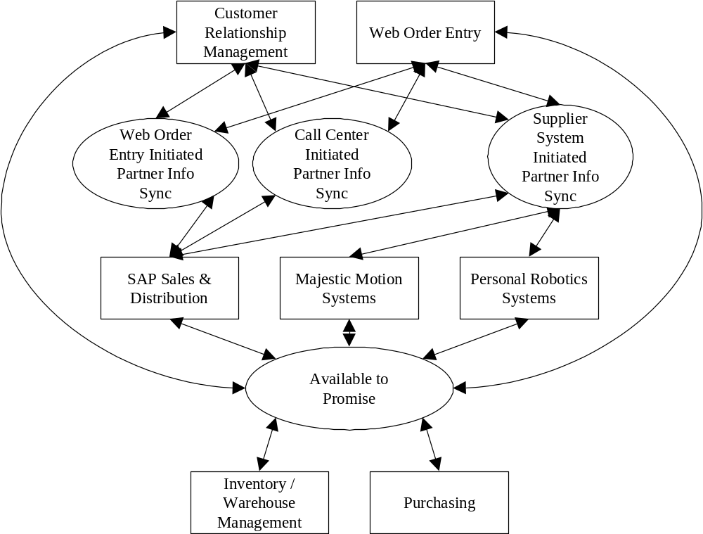
Figure 9 – Daukas & Lee Use Cases and Participating Actors.

Partner Information Synchronization Use Cases
These Use Cases capture the business function interaction for the synchronization of Partner information.
Table 14 – Supplier System Initiated Partner Information Synchronization Use Case
Use Case # | 1 | Supplier System Initiated Partner Information Synchronization Use Case
Subject Area |  | Daukas & Lee Company Partner Information Synchronization
Business Event |  | Triggered by the receipt of a partner information change by the Daukas & Lee CRM application.
Actor(s) |  | The initiating actor is one of the supplier systems.
Use Case Overview |  | An update to Partner Information for a supplier is received by the CRM application. Based on that receipt, the CRM application, the Web Order Entry Application, and the Sales & Distribution application will update their records in accordance with the update request.
Preconditions |  | The three Daukas & Lee applications are assumed to be available, and their internal Partner Information records are assumed to be in synchronization.
Termination Outcome |  |  | Conditions Affecting Termination Outcome
All 3 Daukas & Lee applications are updated and an acknowledgement is sent to the originating supplier system. |  |  | All 3 Daukas & Lee applications have succeeded in their internal updates. No updates have been lost in communication.
The CRM application fails to update its internal records, and no update request is sent to the other applications. The originating supplier system is informed of the failure. |  |  | Communications error between the supplier system and the CRM application. CRM application internal exception during update.
Use Case Description |  | An update to Partner Information for a supplier is received by the CRM application. Based on that receipt, the CRM application will update its records and send an equivalent update to the Web Order Entry Application and the Sales & Distribution application. These applications update their own internal records and send an acknowledgement to CRM. Upon receipt, the CRM application sends an acknowledgement of update to the originating supplier systems.
Use Case Associations |  | Web Order Entry Initiated Partner Information Synchronization Use Case, Call Center Initiated Partner Information Synchronization Use Case
Traceability To |  | N/A
Inputs Summary |  | Partner Information update request.
Output Summary |  | Advisement of update success or failure.
Usability Index |  | N/A
Use Case Notes |  | This is one of 3 possible update paths.

Table 15 - Web Order Entry Initiated Partner Information Synchronization Use Case
Use Case # | 2 | Web Order Entry Initiated Partner Information Synchronization Use Case
Subject Area |  | Daukas & Lee Company Partner Information Synchronization
Business Event |  | Triggered by the receipt of a partner information change by the Daukas & Lee CRM application.
Actor(s) |  | The initiating actor is the Web Order Entry application.
Use Case Overview |  | An update to Partner Information for a supplier or customer is received by the CRM application. Based on that receipt, the CRM application, the Web Order Entry Application, and the Sales & Distribution application will update their records in accordance with the update request.
Preconditions |  | The three Daukas & Lee applications are assumed to be available, and their internal Partner Information records are assumed to be in synchronization.
Termination Outcome |  |  | Conditions Affecting Termination Outcome
All 3 Daukas & Lee applications are updated and an acknowledgement is sent to the Web Order Entry application. |  |  | All 3 Daukas & Lee applications have succeeded in their internal updates. No updates have been lost in communication.
The CRM application fails to update its internal records, and no update request is sent to the other applications. The originating Web Order Application is informed of the failure. |  |  | Communications error between the Web Order Entry application and the CRM application. CRM application internal exception during update.
Use Case Description |  | An update to Partner Information for a supplier or customer is received by the CRM application from the Web Order Entry application. Based on that receipt, the CRM application will update its records and send an equivalent update to the Web Order Entry Application and the Sales & Distribution application. These applications update their own internal records and send an acknowledgement to CRM. Upon receipt, the CRM application sends an acknowledgement of update to the originating Web Order Entry Application.
Use Case Associations |  | Supplier System Initiated Partner Information Synchronization Use Case, Call Center Initiated Partner Information Synchronization Use Case
Traceability To |  | N/A
Inputs Summary |  | Partner Information update request.
Output Summary |  | Advisement of update success or failure.
Usability Index |  | N/A
Use Case Notes |  | This is one of 3 possible update paths.

Table 16 - Call Center Initiated Partner Information Synchronization Use Case
Use Case # | 3 | Call Center Initiated Partner Information Synchronization Use Case
Subject Area |  | Daukas & Lee Company Partner Information Synchronization
Business Event |  | Triggered by the entry of a partner information change into the Daukas & Lee CRM application.
Actor(s) |  | The initiating actor is the CRM application.
Use Case Overview |  | An update to Partner Information for a supplier or customer is received by the CRM application. Based on that receipt, the CRM application, the Web Order Entry Application, and the Sales & Distribution application will update their records in accordance with the update request.
Preconditions |  | The three Daukas & Lee applications are assumed to be available, and their internal Partner Information records are assumed to be in synchronization.
Termination Outcome |  |  | Conditions Affecting Termination Outcome
All 3 Daukas & Lee applications are updated and an acknowledgement is reflected in the CRM application. |  |  | All 3 Daukas & Lee applications have succeeded in their internal updates. No updates have been lost in communication.
The CRM application fails to update its internal records, and no update request is sent to the other applications. The CRM application reflects this failure. |  |  | CRM application internal exception during update.
Use Case Description |  | An update to Partner Information for a supplier or customer is entered into the CRM application. Based on that receipt, the CRM application will update its records and send an equivalent update to the Web Order Entry Application and the Sales & Distribution application. These applications update their own internal records and send an acknowledgement to CRM. Upon receipt, the CRM application reflects an acknowledgement of update.
Use Case Associations |  | Supplier System Initiated Partner Information Synchronization Use Case, Web Order Entry Initiated Partner Information Synchronization Use Case
Traceability To |  | N/A
Inputs Summary |  | Partner Information update request.
Output Summary |  | Advisement of update success or failure.
Usability Index |  | N/A
Use Case Notes |  | This is one of 3 possible update paths.

Available to Promise Use Case
These following Use Case captures the business function interaction for Available to Promise of Daukas & Lee product to meet forecast demand.
Table 17 - Available to Promise Use Case
Use Case # | 4 | Available to Promise
Subject Area |  | Daukas & Lee Fulfillment
Business Event |  | Triggered by realization of an the unplanned demand reflected in the Sales & Distribution order processing functionality, and validated against the current product inventories reflected in the Inventory / Warehouse Management application.
Actor(s) |  | The initiating actor is one of Web Order Entry, Siebel or SAP S&D, depending upon which order event has caused the planned demand threshold to be exceeded (above or below target).
Use Case Overview |  | Product orders received by the Sales & Distribution application indicate that the planned demand profile will be exceeded. Demand, Production and Supply plans are formulated in response to this change, and suppliers are queried for updates to their parts supply commitments to meet them. When an acceptable combination of supplier responses is received and processed by Daukas & Lee fulfillment applications, the plan updates are committed, and the updated demand plan is made operational.
Preconditions |  | A valid set of demand, production and supply plans are in place to drive current fulfillment operations.
Termination Outcome |  |  | Conditions Affecting Termination Outcome
Supplier commitments are obtained, and valid updated supply, production and demand plans are in place to drive continued fulfillment. |  |  | All applications are available within the cycle time frame to perform their focused processing. A combination of supplier parts supply is available to support the demand plan.
An updated demand plan cannot be met. |  |  | A combination of supplier parts supplies cannot be found to meet a supply plan and production plan that support the demand plan.
Use Case Description |  | Product orders received by the Sales & Distribution application indicate that the planned demand profile will be exceeded, when compared with the available inventories in the Inventory / Warehouse Management application. As a result, Sales & Distribution generates a net unfulfilled Demand Plan. The Demand Plan is used by Production Management as the basis for an updated Production Plan to meet the demand. Similarly, Inventory / Warehouse Management provides an updated Supply Plan based on the Production Plan that is used by Purchasing to formulate Requests for Quote, parts reservations, and Purchase Orders for the Suppliers. As the supplier responses to RFQ’s are processed, their impact is evaluated on the plan hierarchy. When an acceptable combination of supplier responses is received and processed, parts reservations and subsequently Purchase Orders are exchanged with the suppliers, the plans are committed, and the demand plan is made operational.
Use Case Associations |  | N/A
Traceability To |  | N/A
Inputs Summary |  | Customer orders and existing demand plan.
Output Summary |  | Updated plans and supplier contracts (P.O.s).
Usability Index |  | N/A
Use Case Notes |  | N/A
Available to Promise Process Flow
The following figure depicts the Daukas & Lee ATP process for committing to an updated product demand.
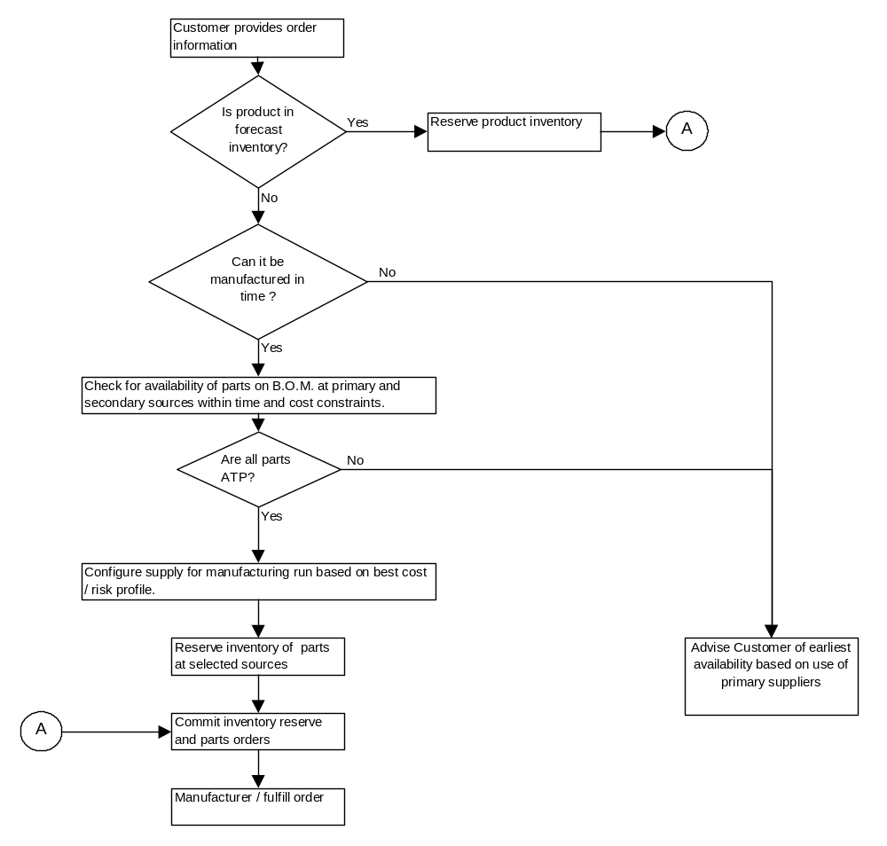
Figure 10 - Daukas & Lee ATP Process
EAI Physical Architecture
For the purpose of understanding EAI detailed design techniques for Brokering, Process Management, Adapter s and Common Services, an EAI Physical Architecture is assumed to have been completed by the EAI architecture and system design team. An overview of this physical architecture is depicted in Figure 11.
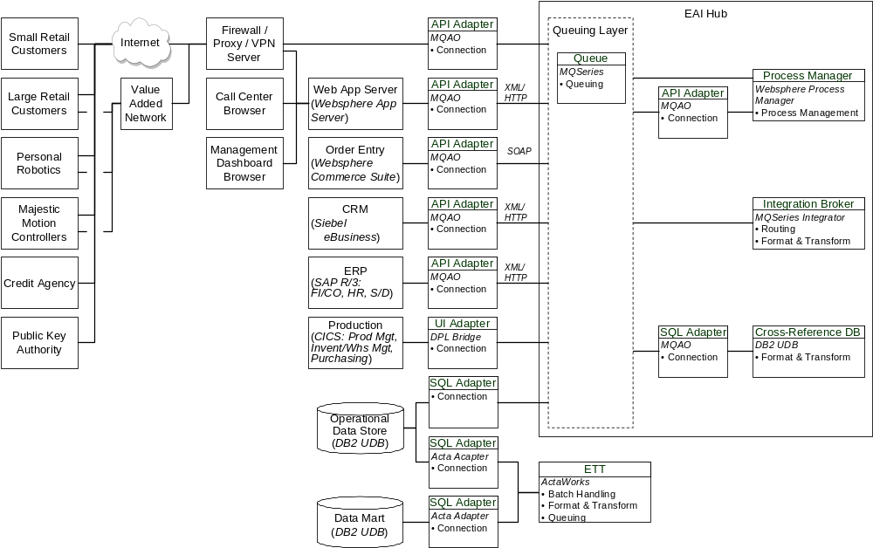
Figure 11 - EAI Physical Architecture Overview Diagram

- Revision History
Revision Number | Revision Date | Summary of Changes | Changes Marked?
0.9 | 11/08/2001 | Release for GCD QA
1.0 | July 2002 | QA Approved

The following companies and products are referenced in this document.
Excel is a trademark of Microsoft Corporation in the United States, other countries, or both.
IBM is a trademark of International Business Machines Corporations in the United States, other countries, or both.
Microsoft is a trademark of Microsoft Corporation in the United States, other countries, or both.
Pleasanton CALIFORNIA 94588
Siebel is a trademark of Siebel Systems, Inc. CORPORATION DELAWARE 2207 Bridgepointe Parkway San Mateo CALIFORNIA 94404
Other company, product and service names may be trademarks or service marks of others.
SAP
Oracle

