

IBM Global Services

Designing for Availability
Technique Paper (TP) – Guideline
© Copyright International Business Machines Corporation 1998, 2005

All Rights Reserved
Version 4.1.2, July 2005
- Brief Description
The purpose of this document is to assist someone who is working on the availability aspects of a solution design at various stages of a delivery engagement as defined in the IBM Global Services Method. It does not replace any of the Work Product themselves, but is specifically aimed to work alongside them and provide guidance and advice on topics outside of the core architectural work products.
The main user of this document is expected to be the IT Architect / Designer of a system who wishes to consider the aspects of the design with regards to availability. However sections of this document will also be of great use to High Availability (HA) specialists such as the Patterns section in Chapter 3.
This document contains a number of chapters and appendices, that each provides a different approach to thinking about high availability solutions, namely:
Chapter 1 – Practice & Process – provides a high level process that enables you to define the scope of the High Availability work.
Chapter 2 – High Availability for On Demand – explains how availability relates to an on demand environment.
Chapter 3 – HA Patterns – provides more detail through a core set of reusable HA patterns across the areas of application, data, network and infrastructure.
Chapter 4 – HA Tools and Techniques – provides descriptions of key tools and techniques that can be used to assist in the capture of HA requirements, and the analysis and design of a system for High Availability.
Chapter 5 – Applying HA Techniques in the IBM Global Services Method – applies the practice, patterns, techniques and tools to the IBM Global Services Method context by aligning to the six key work products for availability: Architectural Decisions, Current IT Environment, Viability Assessment, Operational Model, Non-Functional requirements and Service level agreement characteristics.

Backup material within the appendices cover:
Appendix A – Terms and Definitions – a list of all the terms and their definitions used throughout the documents
Appendix B – Examples – which provides examples of how the tools can and have been used and examples of populated IBM Global Services Method work products with respect to a HA design.
Appendix C – Formulae – includes a selection of key formulae used within HA design that can be used to help predict availability.
- Usage Context
  - How to use this document
This chapter provides three different scenarios for using this document.
    - Scenario 1 Bid Design
When creating a solution in response to a bid request your time is short and you will therefore not have time to perform most of the sections within this document.
Your main focus should be to use chapter 1. This chapter will help you to define the scope of HA required for the project and give you the questions you will need to think about in order to ensure availability is being focused on correctly.
If you have time after this then it is recommended that you use some of the tools in chapter 4 to help capture the key availability requirements. These tools include:
- Planned maintenance table
- Redundancy table at a high level
- Service to component table at a high level
- Operating Phase table
- Use Case Availability Requirements table for critical use cases developed through the bid phase
    - Scenario 2: Solution Design & Delivery
This scenario covers the situation when a solution design is required that may require elements of High Availability.
First read Chapter 1. This will provide you with a set of questions that will allow you to:
- Understand the areas of a solution where High Availability needs to be considered
- Determine a first pass of how much high availability your client is asking for in the solution
- Set the scope of the solution with regards to High Availability
The whole of this document will help you in designing a solution for HA. The basic approach would be:
First proceed to Chapter 5 to use the following sections to help capture the requirement for HA:
- Service Level Agreement Characteristics - To capture the clients expectations of service in a business related manner
- Non-Functional Requirements - To capture the key availability requirements
You should then use the following sections in chapter 5 to help create the design, along with Chapter 2 and 4, as described below:
- Architectural Decisions – to capture the key decisions made for availability
- Operational Model – to help define the infrastructure components required to support the availability of the system
Existing system assessment is often part of a solution design and delivery engagement. If the scope of what is being designed is included in the context of an existing system, then use Scenario 3: Existing System assessment.
Once you have understood this chapter and have started to use it, Chapter 3 Patterns should be skimmed to find specific patterns that can be used to address availability requirements.
Chapter 4 then provides good tools that can be used throughout the project to monitor and assess your design / solution for availability. These tools cannot only help ensure governance of the design, but can also be transitioned into the run environment for assessing impact of change.
    - Scenario 3: Existing System assessment
This scenario focuses on the situation when you are assessing a customer’s current solution for High Availability, with the purpose of suggesting improvements and identifying key risks with regards to HA.
Chapter 1 should be used to help ensure that the assessment is capturing the complete scope of where HA will have an impact on the system. Once this chapter has been used to help provide you with a toolset to understand the scope with regards to availability, issues and questions that should arise can be addressed through more formal approaches.
To start, the following HA Work Products from Chapter 4 should be assessed for use:
- Current IT Environments - To determine the HA capability of the current system
- Service Level Agreement Characteristics - To capture the client’s expectations of service in a business related manner
- Non-Functional Requirements - To capture the key availability requirements
Once you have this material you should be able to present a clear view of what the current system can perform and can then perform a:
- Viability Assessment - to determine the gaps between expectation and what the systems can achieve.
If more detail is then required with specific regards to the impact of certain components failing, then it is suggested that a Failure Mode Effect Criticality Analysis (FMECA) from Chapter 4 is performed.
  - Definitions
What is Availability?
There are many definitions. We will use the following:
The Availability of a system is a measure of its ability to deliver the business function at the desired service characteristics.
Two additional terms that contribute to high availability are:
- Robustness
- Serviceability
Robustness is the ability of the system to be resilient to external effects without damage. This has the effect of broadening the envelope of “stated conditions” under which the system is reliable. Reliability is the probability that an item will perform its intended function for a specified interval under stated conditions. Simply stated, it is how long the system can work. Resilience is the ability of the system to continue to function after it has been damaged, encompassing fault tolerance and redundancy.
Serviceability is the ability to operate and maintain a system without disruption to its end users.
This document will cover these and assumes that all three are part of high availability. High availability must be considered in the widest sense, which is from the infrastructure up to the business that the infrastructure must support.
For a complete listing of all terms and definitions used within the HA space please go to appendix A.
  - Good practice / patterns versus technology
This document approaches High Availability designs from many levels of detail. The following describe the meanings of those levels for the purpose of this document:
- Method: consists of a set of tasks that designated persons should perform in order to complete an engagement. The method is the highest level of approach that should be adopted. An example is the Global Services Method.
- Technique: provides a much more rigorous set of steps that have to be followed in order to help you scope and document a problem. For example FMECA, Reliability Block Diagram (RBD).
- Patterns: define a specific approach to solving a problem. In this document patterns are specific to making applications, data or infrastructure highly available. They are based on proven experience from many prior engagements. An example pattern could be “active / active”
- Practice: is a less specific approach than a pattern to solving a problem but moreover are good ideas that can be followed. For example good practice could be to define “No single point of failure”; however the pattern one could use to achieve this could be “active / active”.
- Tools: support the technique and provide a mechanism of capturing the data for analysis. These range from spreadsheets through to specific products such as Relex (Ref. Appendix D)
- Technology: refers to the actual technology that can be deployed to increase the availability of the solution. Examples of this include products such as HACMP and systems such as Blade Centers.
- Content
1. The Practice of HA Design 8
1.1 Requirements 10
1.1.1 Users and Business Services 10
1.1.2 Costs associated with Service Outage 11
1.2 Solution Design 12
1.2.1 Components and Availability Design 12
1.2.2 Techniques 14
1.2.3 Operations and System Management 15
1.3 Other Factors 17
1.3.1 Testing 17
1.3.2 Disaster Recovery 18
2. High Availability for on demand 21
2.1 Resilience through Recovery computing 21
2.1.1 Maintaining Service (masking the failure) 23
2.1.2 Recoverability 23
3. HA Patterns 25
3.1 Generic patterns 25
3.2 Component Redundancy 25
3.3 Active / Active configuration 26
3.4 Active / Passive 26
3.5 Application Patterns 27
3.5.1 Store and Forward 27
3.5.2 Acknowledgement 28
3.5.3 Sequenced Synchronisation 28
3.5.4 Sequence numbering 30
3.5.5 Functional Isolation 30
3.5.6 Technical Isolation 31
3.5.7 Maintaining State 31
3.5.8 Checkpointing 31
3.5.9 Application Components in Parallel 31
3.6 Infrastructure Patterns 32
3.6.1 Clustering Technologies 32
3.6.2 Virtualization 36
3.6.3 Point-in-time Copy (PIT) 37
3.6.4 Freeze 38
3.6.5 Fuzzy copy 38
3.7 Data Protection Patterns 38
3.7.1 Local patterns 38
3.7.2 Remote patterns 39
3.7.3 Hybrid or combined patterns 42
3.8 Network Patterns 42
3.8.1 Data Centre Point-to-Point connectivity 42
3.8.2 Ring configuration 43
3.8.3 Mesh configuration 44
4. HA Techniques and Tooling 45
4.1 Introduction 45
4.2 Technique 1. Failure Mode and Effect Criticality Analysis 47
4.2.1 Description 47
4.2.2 Approaches 48
4.2.3 Steps 49
4.2.4 Tools 51
4.2.5 FMECA Example 52
4.3 Technique 2. Reliability Block Diagram 54
4.3.1 Description 54
4.3.2 Technique Selection 55
4.3.3 Steps 55
4.3.4 Tools and Further Reading 57
4.3.5 RBD Example 58
4.4 Technique 3. Fault Tree Analysis 60
4.4.1 Description 60
4.4.2 Technique Selection 61
4.4.3 Steps 61
4.4.4 Tools 63
4.4.5 FTA Example 64
4.5 Tools 66
4.5.1 Component Availability Characteristics Table 66
4.5.2 FMECA Core Process Table 66
4.5.3 Component Management Table 67
4.5.4 Planned Maintenance Table 67
4.5.5 Redundancy Table 68
4.5.6 Service to Component Table 68
4.5.7 Operational Phase Table 69
4.5.8 Use Case Availability Requirements Table 69
4.5.9 Viability Assessment Table 69
5. Applying HA techniques in the IBM Global Services Method 71
5.1 Current IT Environment 71
5.1.1 Context 71
5.1.2 Notation 71
5.1.3 Development Approach 71
5.1.4 Advice and Guidance 73
5.2 Architectural Decisions 73
5.2.1 Context 73
5.2.2 Notation 74
5.2.3 Development Approach 75
5.2.4 Advice and Guidance 75
5.3 Operational Model 76
5.3.1 Context 76
5.3.2 Notation 76
5.3.3 Development Approach 76
5.3.4 Advice and Guidance 79
5.4 Service Level Agreement Characteristics 79
5.4.1 Context 79
5.4.2 Notation 79
5.4.3 Development Approach 79
5.4.4 Advice and Guidance 80
5.5 Viability Assessment 80
5.5.1 Context 80
5.5.2 Notation 80
5.5.3 Development Approach 80
5.5.4 Validation and Verification 82
5.5.5 Advice and Guidance 85
5.6 Non-Functional Requirements 87
5.6.1 Context 87
5.6.2 Notation 87
5.6.3 Development Approach 87
5.6.4 Advice and Guidance 89
Availability 104

The Practice of HA Design

Historically, designing for high availability meant focusing on the infrastructure/hardware stack and tracking and reporting its availability.
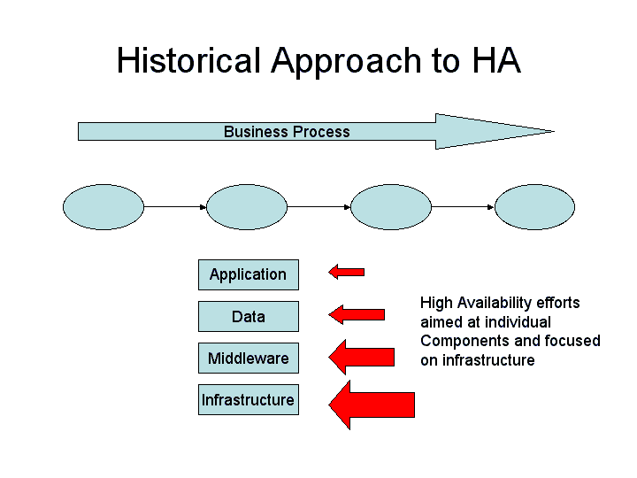
As our customers evolve, the focus of design and service level management are aimed at producing high availability for services from the end user’s perspective. This trend demands that at least equal attention is paid to the applications, data and operational processes. Ultimately focusing on the business function to be delivered.
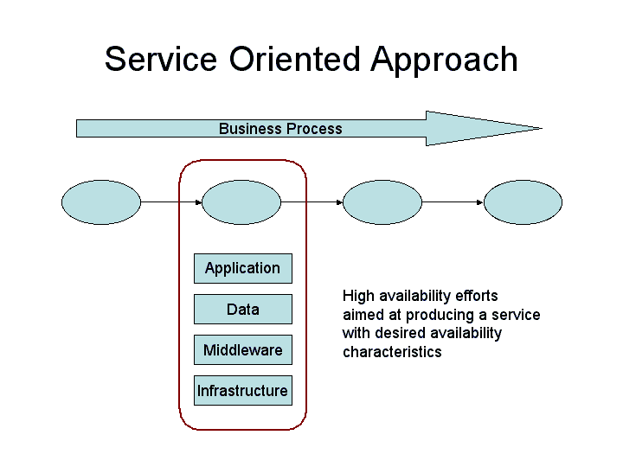
The recent focus of automation, accelerated by the on demand transformation, shifted to end to end business processes, which themselves may be made up of different IT processes and/or services. The genesis and the constituent technologies of these processes vary widely, yet the outcome for the user/business depends on the complete execution of the automated business process. The overall availability of the process will depend on the availability characteristics of multiple applications/services, thus making the task more complex. In addition, on demand will require that business processes change more often than today, while still delivering the required levels of service availability.
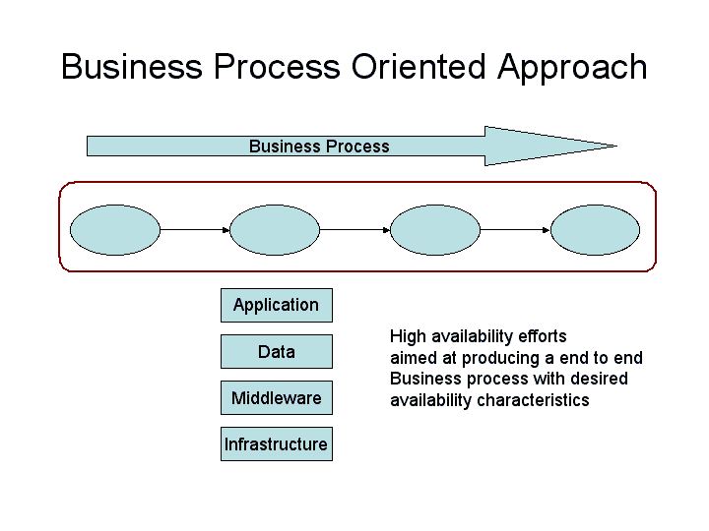
Therefore when designing a High Availability solution the overall business processes that the system will support are the ultimate measure of how the availability will be measured.
The following will take you through a set of steps that will enable you to consider the business problem with respect to availability and allow you determine where High Availability will be required in the solution.

GATHER THE AVAILABILITY REQUIREMENTS:
- Who the users of the system are and what time of day and week they expect the services of the system to be available for their use? Are there any critical times (e.g. month end)? Are there any quiet times (e.g. public holidays?)
- The costs associated with service outages

HIGH AVAILABILITY DESIGN THEN STARTS WITH:
- Determine the components and nodes of the system:

- What Components & Nodes of the system that we should focus upon for the design aspect of availability?
- What are the characteristics are as regards availability for these components and nodes?
- Determine the availability requirement for each component / node, such that the overall solution matches the business objective

- Select and apply the availability techniques.

Use of analysis techniques will help us to:
- understand more completely the failure space for the design,
- establish that a given design will meet the business process availability requirements, and thus,
- increase our ability to meet client availability needs.

We have found the following three main analysis techniques to be of value to IT design from an HA perspective:
- Failure Mode, Effect and Criticality Analysis (FMECA) also known as Component Failure Impact Analysis (CFIA)
- Fault tree analysis (FTA)
- A Reliability Block Diagram (RBD)

- Understand the impact of the solution to operations and systems management

THE OTHER FACTORS THAT WILL VERIFY DESIGN OBJECTIVES HAVE BEEN MET:
- Testing
- Business Continuity (which acts as a driver of requirements that include Operational and Disaster Recovery)

The following describes this approach in more detail, and covers the three areas of availability, where the component design and techniques address the Inherent Availability, the Operations and Systems Management address the Operational Availability and the Testing section addresses the Achieved Availability. Ref. Appendix A for a full description of these categories of availability.

Requirements
This chapter focuses on the requirements of the solution with regards to availability

Users and Business Services
In this section we decide who the users of the system are and when they expect the services of the system to be available for their usage.
Look at the overall design of the system and determine who the main users of the system are and what they expect as regards:
- The hours of each normal day that they expect service to be available
- Special periods of a day when core business services must be available
- Special considerations at weekends, month ends, vacations etc
- If the service fails how quickly the system must be restored and how much data can be lost
- If there are any degraded levels of service that are acceptable

As this shows the temporal aspect of availability is very important, determining the periods when business services MUST run allows you to build a system that can meet those availability requirements. Too often we talk about when the system must run and not the service.
A good way to document the business availability is through the use of a timeline. This can be either a calendar or for real time systems an actual 24 hour clock, where on the timeline, you place the critical business services and the periods where if they fail significant costs will be incurred. This allows you to see the critical periods of the day.
Once you have this information you then need to make a decision with regards to the availability strategy that is adopted for the solution. What you often see is availability requirements expressed as 99.9% 0500 to 2200 for the service. Or, no more than 3 hours downtime per month averaged over 1 year. What these figures do not tell us is whether you should design the system to cope with:
- a few long outages or a larger number say 2 of maximum 2 hours in a given period. This might be acceptable to a service where the end users can do other work but do not want to lose their in flight work too often (they have long units of business work that have infrequent checkpoints)
- or quite a number of short outages say 10 of 3 minutes maximum. This might be acceptable where the end users have no other tasks to do (public Internet systems are often like this) and losing their in flight work is not a big issue (they have short units of business work or the units of work are checkpointed often).
The availability design decisions that you take can be quite different. If 1 above is required then you might design to have good resilience (fault tolerance and redundancy) and average recovery. If number 2 above is the requirement then you might design to have average resilience and fast recovery.
Decide
- Who the main users are and what their Service Requirements are (4.5.7 Operational Phase Table, page 69)
- Once this data has been captured define a timeline that captures the key business processes and the critical periods when they must run
- If you have hundreds of types of users, assess why you have so many and question whether you can handle this number. Try to reduce the number through grouping. This is important as you will need to do a lot of work to handle more than, say, 20 types
- Your design strategy as regards resilience versus recovery to achieve the overall availability

Costs associated with Service Outage
In this section we look at the costs associated with Availability or more often the Lack of Availability. You need to be aware that cost is a big factor in determining how much redundancy and availability management you can design into a system. By understanding the real value of service availability then you can understand the real costs that you as a designer can spend to provide this availability. Or, you can explain why the system is not being designed to meet the desired availability characteristics because of cost constraints. You are often in a trade off situation between cost and extra components to provide increased availability.
Look at each of the services that are provided to the users and assess what costs (financial penalties) might be associated with an outage to that service. You might consider:
- Lost revenue from existing business, especially if the existing business is ‘perishable’ like fresh food, today’s theatre tickets.
- Lost new business. You lose a new customer who might be a significant revenue source in the future.
- Loss of operational productivity through inactivity of staff and possibly any rework that is associated with re-entry of transactions that have been lost. Perhaps there might be a need to pay overtime for catch up.
- Financial penalties for being late, say with a payment or a contracted delivery time.
- Loss of brand image and customer confidence and loyalty. This is not easy to assess but it is worth remembering that normally fewer than 5% of the users of on line buying websites actually transact. The rest are just browsing.
- Some over powering reason why the service must be available ‘at all costs’, like a major sporting event (Super Bowl, Wimbledon, Olympics).

The cost of a service outage may vary with times of day or day of week etc. For instance:
- ATM cash services at 1 PM on a Friday versus 3 AM on a Sunday.
- Internet buying services at 8 PM (synchronized to television advertising) versus 6 AM.
- Just before a major public holiday versus during that public holiday.

Note these factors also determine when you can do maintenance of the system. Carry out simple exercises as to how sensitive each major end user is to system outage. A basic example:
100 telephone order agents will miss 12 business transactions per hour if the system is down. If each transaction is worth 100 dollars of revenue and 10 dollars of profit each hour of downtime is worth 120K dollars of revenue and 12K dollars of profit.
Decide
- Which services incur cost penalties if they are not available and when
- What is the monetary value of any outages?
- Does the design need to be changed to meet the cost implications of service outages or should these cost implications be reviewed and perhaps changed?
Verify these findings with your sponsor to determine if they are correct and to determine any possible changes required.

Solution Design

Components and Availability Design
In this section we decide which Components of the system we are interested in for our Availability Design Work.
Look at the overall design of the system and determine what granularity of components you want to deal with for your availability tasks. The highest level might be:
- Workstation with all of its software
- Server with all of its software
- Server to external storage
- Workstation to Server Connectivity
- External Connectivity. E.g. to an ISP for Internet access

The level of granularity that you choose to look at will determine the amount of time that you spend and the accuracy of your availability tasks. Don’t choose a level that means that you can’t find basic availability data about the component or its connection.
Try to think of the components and connections with which you are going to work as Availability Entities. Invariably each entity can be broken down into many other sub components or entities. As the Availability Designer or Engineer you may not have to explain these entities outside the availability tasks so don’t get too hung up about this.
Remember that every entity in a system can be decomposed into smaller entities. For instance a workstation can be decomposed down into screen, disk, power supply, motherboard, adapters, etc. But it may not be worth going down to that level. A computer centre can be decomposed down into servers, cables, workstations, etc. But you may need to decompose the servers into types and then into what components make up each type like: database server has hardware, operating system, database manager, etc. 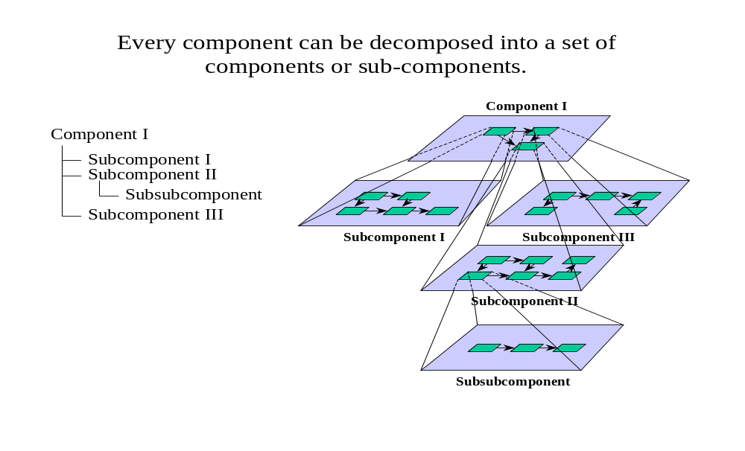
Translated into application component terms the sort of level of design granularity that you might be looking at for this level of availability design could be:
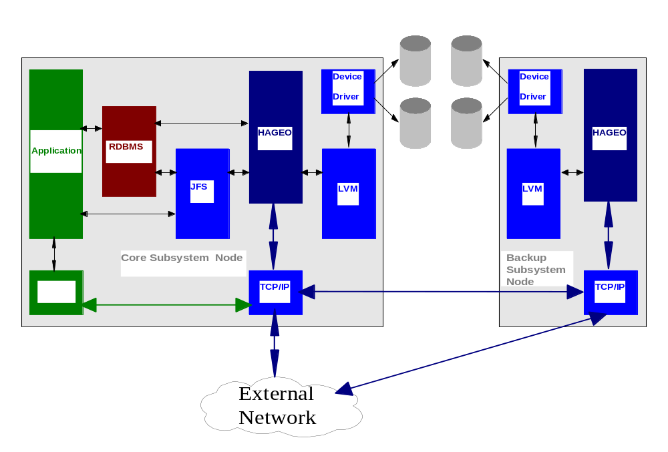

Decide
What are the main components of the system and what are their main availability attributes such as:
- Mean Time Between Failure (MTBF)
- Mean Time to Recover (MTTR), In this context Mean Time to Recover could involve a repair action, a replacement action or a reload action.
Use a spreadsheet to document this information. You can find a simple spreadsheet here as a starting point. Ref. 4.5.1 Component Availability Characteristics Table, page 66

Use a 4.5.6 Service to Component Table, page 68 to determine which of the components are critical to support the business services.
This should be a visual check, but can be used to determine which components require the most availability analysis. Then look for really out of line situations like:
- The mean time to replace, repair, or restart a failed component is 2 hours and the service must not be down for more than 1 hour
- A component fails once per week (mean time to failure) but the service must only fail once per month.

Remember that components in a chain (in series) all fail when one fails and so probably does the service. So you may have to make some quick assessment as to the effects of combinations of components in the chain. Very simply:
- If two components are in a chain and each fails once per year then the chain fails once per 6 months
- Any one component is a Single Point of Failure for the whole chain. One Down All Down.

You might like to produce a redundancy chart to see what redundancy you have for major components. You can use the chart here as an example: 4.5.5 Redundancy Table, page 68.
Determine all of the components in the solution that will be created specifically to provide high availability, for example each application component. Then for each of these components make the following decisions:
- Will these components need to maintain state and be able to recover to a point in time prior to the failure?
- What levels of component recovery are required, i.e. all data that the component creates or just subsets of that data.
- What are the recovery points, e.g. the other components of the solution that the failed component will be able to recover from.
- What special mechanisms will be required in order to control the recovery of the component? (E.g. Synchronized recovery actions)

Techniques
Refer to chapter 4 for more detail on the actual techniques that can be used to refine the component and availability design and refer to chapter 5 for replicable patterns for availability. We have found the following three main analysis techniques to be of value to HA design:
- Failure Mode, Effect and Criticality Analysis (FMECA) is a bottom up procedure to analyze each potential failure mode, to determine its effects on the system, and to classify each potential failure mode according to its severity. The purpose is to provide a safer, more reliable initial design. FMECA also helps to identify and eliminate any single points of failure in the design process.

- Fault tree analysis (FTA) is a deductive, top down method of analyzing the causes of system failure. It involves specifying a top event, such as a system crash, followed by identifying all the possible causes for that top event. The entire system, including human interactions, is analyzed when performing a fault tree analysis. Fault trees provide a convenient symbolic representation of the combination of events or failures resulting in the top-level event.

- A Reliability Block Diagram (RBD) is a tool for analyzing the combinations of complex components and assemblies, often designed with various redundancies in order to improve the overall reliability of the system. The analysis of these types of redundancies and failure rate calculations require the use of sophisticated mathematical algorithms to calculate failure rates, reliability, and availability.

Operations and System Management
In this section we look at the way that the system will operate and be managed. The subjects of system management and service availability are closely coupled. Any design for availability will not be complete without considerations of how the system will be managed to achieve the necessary availability characteristics. We can, for the purposes of our work under the guidance of this document, call this topic Availability Management. Availability Management can include aspects of the following more general System Management disciplines:
- Operations (day to day event handling)
- Monitoring and Reporting
- Nodes
- Networks
- Workload
- Event Correlation
- Incident to Problem Management
- Configuration Management
- Change Management
- Release Management
- Security Management
- Recovery Management
- Technical Support including Help Desk and Desk side / On site support
- Backup and Recovery (local and remote)
- Any special considerations due to third Party support / maintenance / outsourcing

Through 4.5.6 Service to Component Table, page 68 mapping one can determine the impact to the business of a component failure. A sophisticated approach to operations, systems management and operational procedures are created to focus the operational staff on the business impact of the component failure.
Check with the Operations / Delivery function (those who will be responsible for the running of the service) to make sure that they are aware of and are planning for the Recovery aspects of the operational service. When designing for availability we often focus upon the moment of the system failure and preventing failures, but what often eats away at availability is the time to recover from a failure (MTTR).
- Look to see if the current (if any) recovery approaches are adequate
- Look at any related operational Work Products
- Examine current availability achievements and reporting
- For a complex system, consider appointing a Recovery Manager

Look into the maintenance characteristics of the main components. Look at Planned Maintenance when changes are applied during predicted and scheduled times. You may want to look at these based upon categories like:
- Hardware and connections
- Environment – power, cooling etc.
- Microcode
- Control software and middleware
- Application Software
- Data

Record the times for the maintenance schedules and remember that these can affect your service hours. Check that the scheduled maintenance makes sense in terms of concurrency. That is: workstations, servers and network planned maintenance periods overlap and are not at different times. You can find a simple spreadsheet here as a starting point: 4.5.4 Planned Maintenance Table, page 67.
Check that the System Management design activities are aware of planned maintenance. Planned maintenance can be seen as a Change Activity that should make maintenance non disruptive to activity within the scheduled hours as it is, by definition, outside scheduled hours.
Validate that the correct governance is in place to ensure that the support organization is ready to manage failure and changes to the system.
Decide
- What System Management Disciplines are going to be important to achieve the service levels that are required?
- Whether the designers and developers that are producing the System Management Work Product Descriptions will cover these needs. You may need to influence some of them to achieve the availability goals.
- Whether the Change Management processes are adequate for any planned maintenance that the system components will need. If they are not, make sure that the System Management design and Work Products deal with this.
- Whether the Operations / Delivery function has the right focus on recovery to meet the service availability targets that you are designing to.
- Whether the implementation of the design can be managed to the required levels of service. If not, do these levels need to be reviewed or the design changed.
- Whether the operations / service function has the correct staffing to support your recovery design. If not you may need to propose that the staffing or the design is changed.
- Whether the design is good enough to meet the service requirement
- What level of recovery is required, e.g. disaster recovery, database rebuild, etc
- Whether I need to add extra components or change component types
- If there is a need to address the balance of business impact due to lack of availability and the cost of the availability solution.

Other Factors

Testing
This section looks at aspects of Availability that are centered upon the way that the system and its constituent parts are tested. Failure modes need to be added to the test plans to ensure that recovery actions can be performed as designed. Non-trivial high availability systems cannot be fully tested for their availability and reliability characteristics.
You, as the availability designer, are not going to develop the Testing Strategy and Plan but you should influence these.
Ensure that you understand how the availability characteristics of the system will be, or have already been tested and proven. Testing is a process that tends to progress from unit test (test small units of system) and progress into the testing of larger sub assemblies and then into the whole system.
Sometimes it is not possible to test a complete system with a complete end-to-end message flow. Increasingly with e commerce, e-business, e-trade types of system there is often more than one owner of the constituent parts of the total system and it is not possible to test the system in its entirety. It is important that critical interfaces, especially external interfaces, are thoroughly tested.
Assess whether a special testing environment will be needed for Availability Testing. Examples are:
- A special server configuration
- A special data server for data recovery testing
- A special network connection for routing recovery
- A special set of servers for technical support testing of operating systems, databases. Networks and middleware
Remember that Availability and Resilience Testing often involves the ‘destruction’ of a working system (turning off servers, corruption of data etc.) and you cannot assume that you can use the testing environments that are being used for say functional or performance testing.
Operational recovery not only includes the testing to the systems recovering the service but the operational staff ability to follow the procedures to manage the service. Include in the test plan Operational Proving to ensure that procedures for service recovery are tested alongside the recovery of the system.
Consider whether you know, or need to know, the following:
- Who owns the overall testing strategy of the project and whether one already exists or needs to be influenced by you with availability testing considerations?
- Look at any documentation (Work Products) that you can find as regards:
- Testing strategy
- Acceptance strategy
- Operability test plan
- System test plan
- Maintenance Strategy
Decide
- Which Work Products or current practices, as regards testing, you need to influence.
- How many of the nodes and sub systems of nodes do you believe should undergo availability testing that will involve three main activities:
- The failure of a component or group of components
- The recovery of a failed component or group of components.
- If a special Availability Testing Configuration is needed and if you need to design this.
- Can the system, as designed, be tested to provide reasonable confidence (level of risk) that it will work (with respect to availability and service to end users) or does the design need to change to reduce the level of risk that the system may not be manageable?

Disaster Recovery
The goal of any disaster protection planning is to protect the most business critical processes and minimize unplanned downtime. Keep in mind that all planning for any type of a disaster tolerant solution is always subject to balancing the solution versus the downtime versus the cost.
The recovery time of any Disaster Recovery solution is very much dependent on the following:
- Recovery point for the data
- Recovery of the IT infrastructure
- Restoring the operational processes and personnel
- Restoring the business processes

At this level of design for availability it is unlikely that much time will be spent designing for very sophisticated Disaster Recovery. The following provides an overview of the technical aspects one should consider when looking at Disaster Recovery. As well as these technical aspects of disaster recovery, you will also need to take account of many non-technical considerations, such as people, processes and premises. The same techniques below can be used for the non-technical aspects as well as the technical.
Based on the following objectives it becomes relatively simple to decide, as a business, which solution to select according to how much you can afford to spend and the speed at which you need your data recovered. The quicker the recovery the higher the cost:
- Recovery Time Objective (RTO): How long can you afford to be without your services?
- Recovery Point Objective (RPO): When it is recovered, how much data can you afford to lose or recreate?
- Degraded Operations Objective (DOO): What will be the impact on operations with fewer data centers?
- Network Recovery Objective (NRO): How long to recover on switch over of the network?
When all the components that make up a solution are situated in the same computer room the building becomes the single point of failure. While you must, of course, be prepared to react to a disaster, the solution you select may be more of a recovery solution than a continuous availability solution.
A recovery solution must then be defined by making a trade off among implementation costs, maintenance costs and the financial impact of a disaster, resulting from performing a business impact analysis of your business.
Basic considerations that apply include:
- When data is at only one physical site it is vulnerable because that site might be destroyed. In this state the data is unsafe. Should a disaster occur at the site then the data will be lost. It may be possible to reconstruct it from some basic input data but this might take a long time. You cannot expect everyone who drew money from a bank to own up and say: “I withdrew money”, if the withdrawal records are lost.
- When data, or a copy of it, is shipped off site to a secure alternative location either electronically down an external communication channel or physically in a vehicle, the data becomes safe.
- When data is safe it is not necessarily usable. For instance if database manager logs / journals are shipped offsite the data is not useable until the logs / journals are used to update a copy of the database that may have been taken one week before. The data is therefore safe but unapplied.
- When the database is updated the data is safe and applied. When assessing recovery times associated with Disaster Recovery it is necessary to understand how long it takes until data is safe and applied.
- Be aware that the level of Disaster Recovery as regards the safeness and timeliness of data is often not limited by design and technology, but by cost. As a general rule the more cost spent on Disaster Recovery technology and activities (design, development and operations) the better the cover.

You will have to decide what level of recovery you will require, selected from the seven tiers described above. For a given system there may be a mixture of all of these tiers. Also you should determine which type of recovery you are protecting the system from:
- Planned Outage: the solution is required to only facilitate planned outages or data migrations. Unplanned Outage recovery is not necessary.
- Unplanned Outage: the solution is required, at the hardware and data integrity level, to facilitate unplanned outage recovery. It implies that Planned Outage support is also available in this solution. This level of recovery does not perform transaction integrity recovery at the application or database level.
- Transaction Integrity: the solution is required to provide unplanned outage recovery at the application and database transaction integrity level. This level relies upon an underlying assumption that hardware level Planned Outage and Unplanned Outage support is also available.
Decide
- What level of recovery you want (Note: you may change this as you proceed especially with respect to cost).
- What data is critical and needs to be considered for Disaster Recovery
- How often you need to take data off site, and whether it is incremental of full backup
- How copies are made
- How often you need to apply it at a back up site
- How data is shipped to the back up site
- What the recovery times are
- Don’t forget critical data like programs and security data
- Will any critical data ever be lost in the event of a disaster?
- What is deemed acceptable in terms of data loss?
- Whether the running costs involved with Disaster Recovery are acceptable.
- Is the Disaster Recovery design adequate to meet the requirements or does the design or perhaps the requirements need to change.

In a situation where you are using a Primary and Secondary computer centre for DR, to help visualize the states that centers have you can use diagrams like the following. The states are for this level of design:
- Normal (both Primary and Secondary operating – this is the predominant state)
- Loss of Primary (the state that the design has to allow for it could exist for some time)
- Loss of Secondary (should not affect production at primary it could exist for some time it may be that you want the secondary to become the primary and reverse roles)
- Re-integration of failed (this is a transient state) - This final state is extremely important as in practice it the stage that is often overlooked.

Example
In the diagram below, the boxes with ‘xxx’ in them represent the functional component within the technical node that executes the remote site link and transportation of the changes. For example this might be a part of the S/390 Geographically Dispersed parallel Sysplex technology, the AIX HACMP – HAGEO technology, the remote synchronization feature of a relational database manager, or a simple file transfer program.
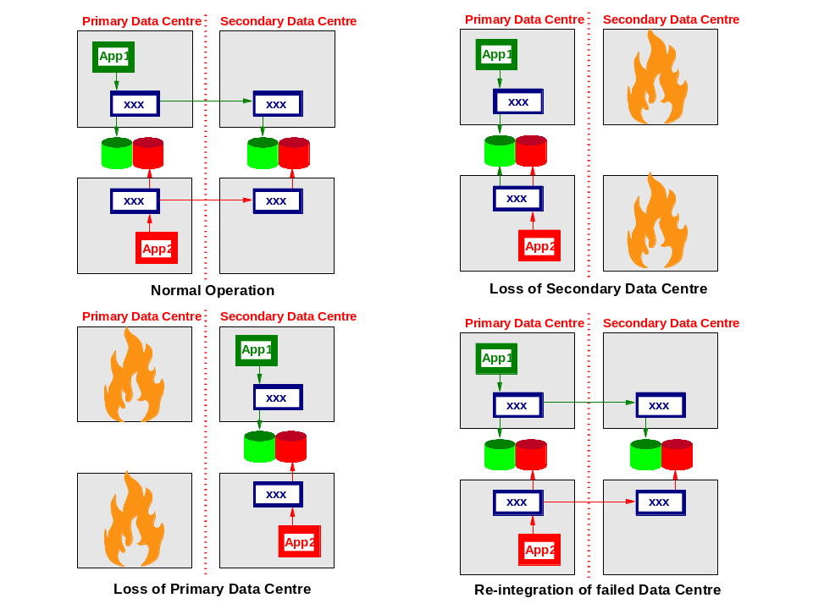

High Availability for on demand
Businesses need to transform themselves to become more responsive, variable, focused and resilient in order to cope with pressures from competition and other factors associated with an increasingly global economy. This implies a transformation to a fully integrated and resilient business across people, processes and information, including suppliers and distributors, customers and employees. Unfortunately, the past 40 years of IT evolution have left most companies with an enterprise computing infrastructure that constrains their abilities to realize the benefits of an on demand business.
Based on the principles of a Service Oriented Architecture (SOA), IBM’s on demand Operating Environment (odOE) seeks to address this challenge. Service Oriented Architectures are typically implemented using Web Services standards. How and where information is published about the service and how other organizations discover services, connect to each other and invoke services with appropriate security, reliability and confidentiality, are all addressed by Web Services standards.
As environments become more integrated and complex, the scope of any one error becomes harder to determine and control. For example, a logic error in an application that causes data inconsistency within a critical database which is the main source of information for a company’s customer facing sales system can be both hard to detect and difficult to contain. The ultimate goal is to preserve the customer facing sales system, but the component parts along the path are all required to be sufficiently resilient.
The objective of the odOE Business Resilience strategy is to ensure that the availability and resilience needs and actions are integrated into the everyday ongoing operations of information technology systems and therefore will lead to predictable, successful outcomes in case of failure or planned outage. The approach is built around the idea of identifying the components that constitute a business function and identifying successive levels of recovery.
The following three steps will help form the foundation to ensure that the IT infrastructure supporting a particular business function is adequately resilient:
- Identify the elements that make up logical business functions and their inter-relationships in order to determine potential impacts of an outage.
- Specify recovery goals at a business function level based on business priorities. The recovery requirements specified for a business function will then translate into the appropriate semantics for the underlying resources.
- Specify, for both planned and unplanned outages, a consistent set of recovery policies and actions at the desired level of granularity.
Over time, the composed nature of recovery segments allows customers to make a natural transition from specification of recovery actions on low level targets to a more business aligned approach of specifying recovery targets for critical functions.

Resilience through Recovery computing
Availability is the ratio of time a functional unit is capable of being used within a given interval to the length of the interval. Key factors in availability are Mean-time-between-failure (MTBF) and Mean-time-to-repair (MTTR). Today most effort is aimed at making software and hardware more reliable, that is, improving the MTBF. In spite of these efforts, latent bugs persist in complex software systems; as complexity increases they multiply further, making it difficult to achieve high availability. Greater focus has to be placed on MTTR (rather than MTTF) to make further dramatic improvements in availability. Recovery oriented computing (ROC) takes the approach that hardware faults, software failures and operator errors are facts to be coped with, not problems to be solved. The four key things that need to be undertaken to reduce restart time (MTTR) are:
- Proactively Monitor. Predict the failure before it happens.
- Reduce the time taken to detect failure. Problem detection today is based upon monitors that are focused on internally generated events and network level polling to identify failure. Monitors need to be able to detect and react to early warning signs of problems, such as storage shortages or network failures. For example, to provide early detection of failures over IP network, the MQ Channel component (z/OS platform) implements the ‘TCP KeepAlive’ function. Not only should this support be on all platforms, but also other products should implement support to detect failures over IP network.
- Reduce restart times. Currently systems are often restarted, as it is not easy to identify and restart individual failing components. This arises because the nature of software failures in production quality software is related to interactions and external events and often there is no other way to work around them but by rebooting. Up to 80% of all software and hardware problems are estimated to be associated with these transient faults.
- Restart automation. Availability can be improved substantially by having system software products capable of restarting in isolation of each other (and not treating transient failures as permanent failures) and by automating restart.
- Recovery time from disk failure. While the frequency of fatal disk I/O errors is continuously diminishing, the time required for forward recovery is still very significant. Experience with some DBMS products, e.g. IMS DEDB (Data Entry Data Base), has shown the value of data mirroring in reducing outage due to disk failures.

In this section we consider how you might influence the design of application components as regards availability. As a general statement application components are provided through two main sources:
- Custom built components that are designed and developed specifically by a development project. You may, under normal circumstances, be able to influence their design and development as regards availability.
- Package supplied components which are designed and mainly developed outside the project and over which you can have only limited influence. But you need to assess the availability design and characteristics of such application components and influence how they are used within the project.
So when developing application components extra criteria and thought processes often need to be taken into account as regards availability. When assessing an application component for availability there are three specific areas that need to be thought about:
- Maintaining Service (Robustness)
- Maintaining Service (Upgrades)
- Recoverability
Then within each of these areas you should always think about both the technical and business considerations. For example using sequence numbers (purely for availability purposes) on messages is a technical consideration, whereas a business consideration could involve designing the system so that some business processes can function even though some other business processes are not available. (E.g. A Money Transfer System will accept payments but will not forward them).
An especially important aspect of application design (if necessary) is in ensuring the application can continue while it is being upgraded from one release to another.
As mentioned previously the amount of time spent in designing the application component for availability will be dependent on the degree of importance of the requirement to ensure that the system is available.

Maintaining Service (masking the failure)
Maintaining service covers the functions given to an application so that it will continue working. The following questions should be thought about when trying to develop an application component that will maintain availability:
- Can / will the application use any of the existing components within the system?
- How do the availability characteristics of these existing components effect the creation of your new component? (E.g. if the existing component is a piece of messaging middleware, does the component have guaranteed message delivery).
- Does this deviate from the availability that you require? (E.g. the project may require that all messages are guaranteed delivered)
- If it does deviate what can you add to the developed application components to ensure the availability requirements?
- Is this existing component being used to increase the application availability? If so what is it that this component provides that the application is missing?
- Should the application be able to maintain state? (E.g. Running / Missing Service)
- Does this application state need to be notified to other components to aid in maintaining service?
- How will this application handle exceptions?
- What are the levels of exceptions that the application will have, e.g. failed, recoverable, info.
- What are the common defined actions the application will perform to report this exception and to continue processing when the exception occurs?
- If a non-recoverable exception, how does the component notify this, what are the steps to get it back to a stable state?
- What can you do to ensure that the exception is not repeated after it has been identified?
- How many times does the application component have to fail and recover before it is stopped? (E.g. One customer record in error may be acceptable but multiples may not be)
- When considering the business processes, how will they be decomposed with respect to availability? (I.e. can these business processes be distributed in such a way that a specific business function can continue to be performed without all other business processes functioning)
- Have you considered using any techniques to ensure that the application component does not fail when the components connected to it fail?
- Is it possible to create the application so that it can be duplicated, so that if the primary application fails a backup application can takeover?
- Have you considered using techniques or package components to monitor the errors collated by the application such that predictive analysis can be performed?
- Can you trace the progress of the business transactions through a chain of connected processes, e.g. from order entry to order acceptance.

Recoverability
Recoverability is concerned with the processes required of an application component in order to get the application back to a stable state after a failure. This process will involve the following considerations:
- Does the application have / require many states and therefore have to return to a stable state or can it be purely restarted? (E.g. the state connection to other components)
- What is the involvement with other components in the system in order for the application to return to a stable state?
- Is there a technical or functional sequence in which the application should recover?
- Are special techniques required in order to wrap the used component so that standard recovery techniques are employed?
- Determine the points of recovery within the application, that is, the places where the data is hardened and the process of ensuring the data can be recovered. Note that not every application component will need to harden data.
- Once you have determined the points at which the data will be hardened you will need to determine the mechanism used to harden and recover the data.
- This could involve store and forward of messages, one at a time, or in batches. Then once a failure has occurred the application components between the two hardened points can synchronise.
- Is sequencing of the message order important and therefore sequence numbers are required?
- Is guaranteed delivery important or can the delivery of the messages fail?
- Is further sequencing required so that the system returns not only to the correct technical state but also the correct business state? Note this may involve sequencing past the two hardened points.
- How does the new application component record error?
- What are the levels of error?
- Where are the errors logged?
- Can the level of error logging be changed statically or dynamically?
- How does the application component trace progress? This will be used to help determine where the application was when it failed.
- What levels of tracing are required?
- How do the different trace levels affect the system performance?
- What are the significant functional points to trace?
- How much does the use of this tracing degrade the performance of the system?
- What are the performance issues related to recovering in the manner chosen? Will this chosen recovery mechanism satisfy the chosen MTTR.
- Two application components are connected and one fails, but the other application component can continue, as it is caching its information. Does this running application need to consider using special techniques so that the cache does not grow too large?

Note that throughout considering the processes to ensure that the application is available and recoverable you should also consider the performance impacts of using these methods. Without considering the performance implications you may not be able to make the MTTR requirements.

HA Patterns
This section will describe different techniques that are used to increase application availability and reduce recovery times.

Generic patterns

Component Redundancy
In the Chapter 1 we discussed the principle of having like components in parallel so that one component does not become a Single Point of Failure for the system flow. The two basic models are:
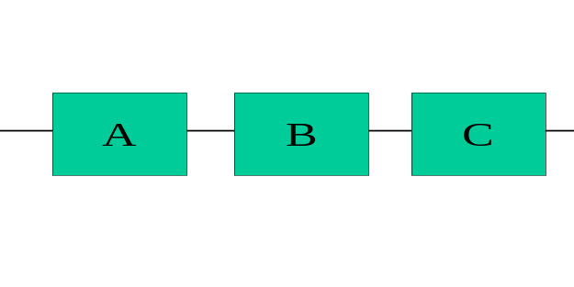
In the serial model there is only one route through the system chain. From an availability perspective components in serial are actually an anti-pattern.
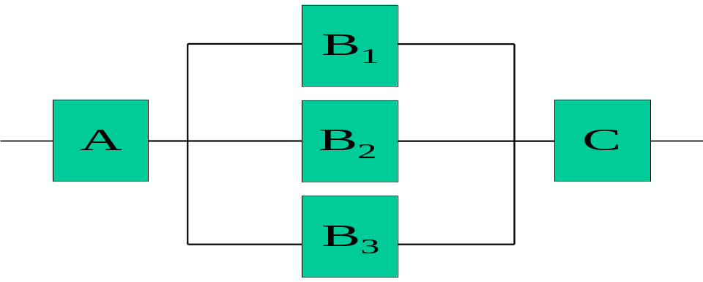
In the parallel model there are several routes through the system so long as the components in parallel execute similar function. This leads us to consider a concept of ALTERNATE ROUTING. Messages, transactions, files, etc. can follow different paths through the system and thereby the reliance on any one component can be limited or even eliminated.
In systems you sometimes inherit ALTERNATE ROUTING directly as a natural property of a component or you sometimes inherit it as an indirect property. One example of the later would be to inherit it from a load balancing function. The prime reason for having a load balancing function is to distribute a workload across components so that throughput can be maximised. In reality, so long as the total loading is not too high, you can lose one or more of the components and still have the system operating.

Active / Active configuration
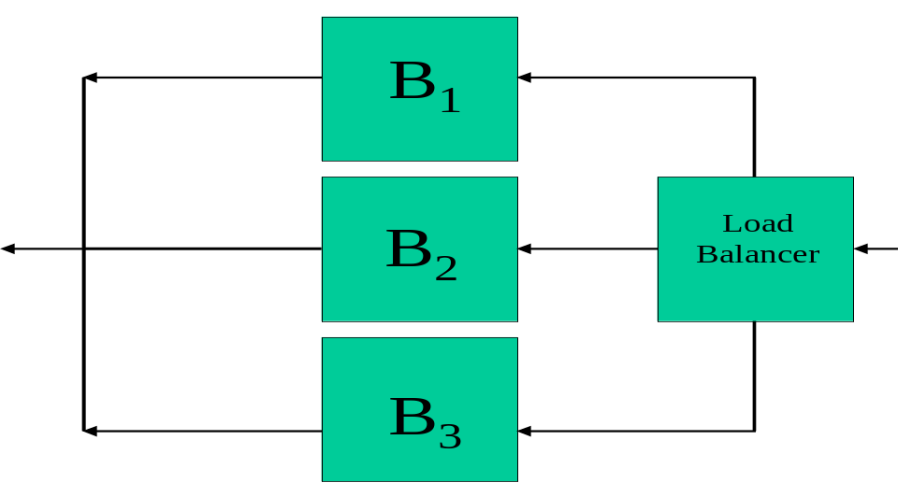
For an active / active solution all components B₁ through to B₃ will simultaneously be handling messages, only upon failure will the messages be re-routed to another component.

Active / Passive
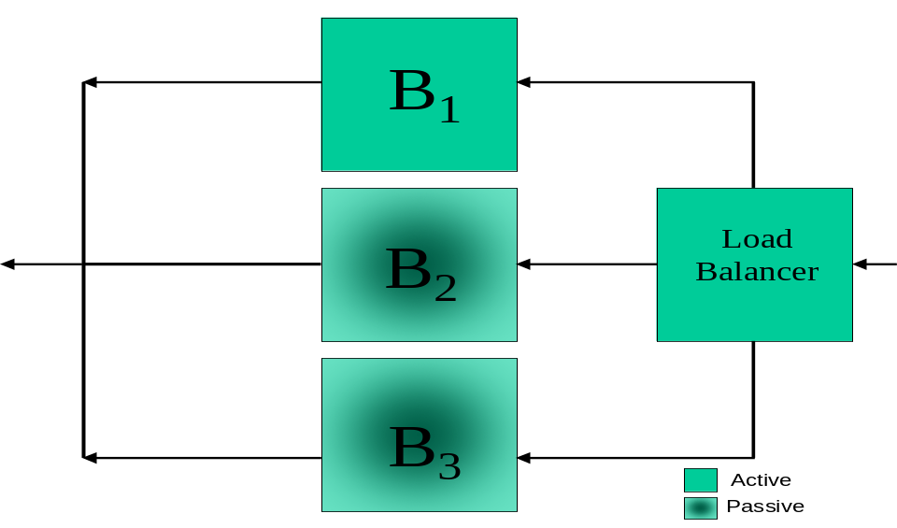
For an Active / Passive solution the load balancer will, as before, know the status of each of the components B₁ through to B₃. However in this scenario all function will start at component B₁, and only upon failure will the load balancer recover and send function to the next component, e.g. B₂.

The above discussion of the use of parallel components takes a somewhat simplistic view of the states that units of work can be in within the sets of components. For instance, if component B₁ above fails then the Load Balancer may detect this and send the next unit of work to B₂ or B₃. But there may already be a unit of work in B₁. This unit of work may have to be recovered before following units of work queued by the Load Balancer can be executed (An example of this might be the records of a file being sent from one file server to another.)
To understand this sort of consideration you quite often have to consider the design of the applications as regards availability and how the units of work of the system are handled by these applications when components fail.
You need to be careful with your design so that the Load Balancer does not itself become a single point of failure leaving the basic problem of parallel versus serial components still to be solved.

Application Patterns

Store and Forward
This technique involves determining the recovery points within the system and then at these points the messages that are passed through are stored and then forwarded on to the next component.
Depending on the importance of the data, the appropriate storage media (where the data is ‘hardened’) will have to be chosen.
As an example the diagram below shows 5 components, 3 of which are recovery points and perform store and forward.

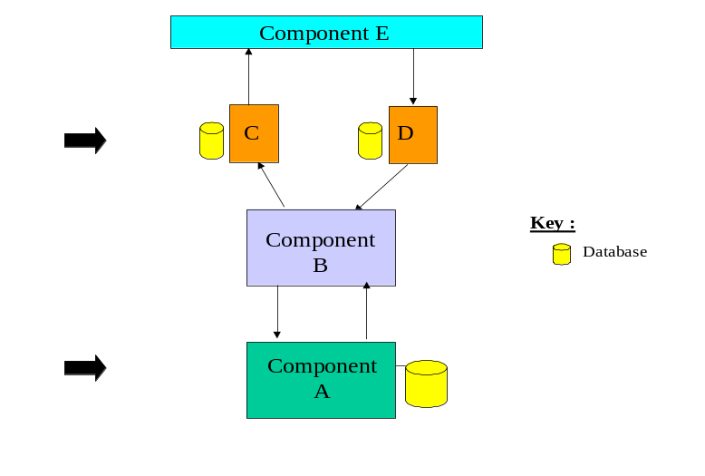
Therefore in this example messages will be logged to physical storage every time a message passes through the component.
The actual flow of the message through the component is:
- Receive message.
- Commit the logging.
- Forward the message on.
In this example neither Component B nor Component E hardens their data.
Two ways in which recovery can occur once the data has been hardened are either through acknowledgement or through sequence synchronization.

Acknowledgement
Acknowledgement is the process where the two application components that harden the data send messages to each other once the data has been committed to signify that the data is “safe”.
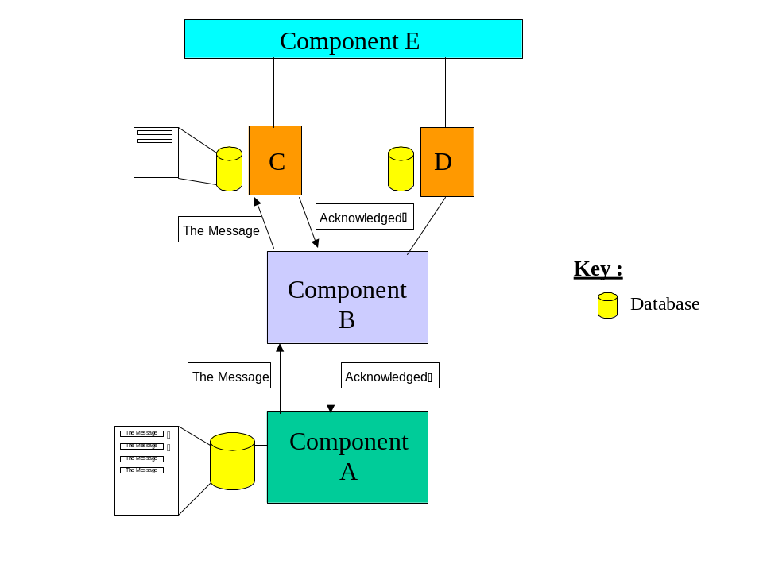
The diagram above uses the store and forward application component to demonstrate the acknowledgement technique. In this technique Component A will first receive the message and store and forward it through Component B to C. Upon successful storage Component C will send a message back to Component A that the message has been received. Component A will then record the fact that this message has hardened at Component C.
After a failure of one of the application components in the chain, the application can restart by sending the messages at Component A that have not yet received an acknowledgement. Care needs to be taken that duplicate messages are not hardened at Component A after a failure, as it is possible that although the message is hardened at Component C the acknowledgment never reaches Component A. For example, if Component B fails when the acknowledgement is being returned then the acknowledgement may not be logged at Component A.
One mechanism used to handle this is for Component A to resend the first message un-acknowledged as a possible duplicate, then when Component C gets the message it can check whether it was ever received.

Sequenced Synchronisation
Once the data has been logged to a “safe” source then it is possible to recover and synchronise. Through sending sequence numbers with each message it is possible to avoid using the acknowledgment technique and recover through interrogating the sequences at the hardened points in the application.
The diagrams below use the Store and Forward examples to explain.
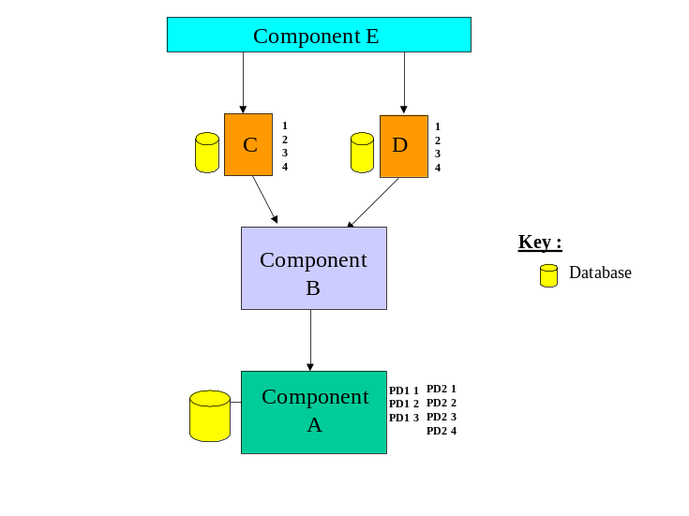
In this example Component A fails. Whilst A has failed Component C and D have continued to receive messages from Component E. When Component A is restarted it interrogates its stores and determines that the last messages hardened were C3 and D4.
The process of synchronization then will involve:
- Component A asking to resend all from C3 and D4.
- Component B forwards this to C and D
- Messages are sent from this point onward.

Note how Component B remained stateless in this case.
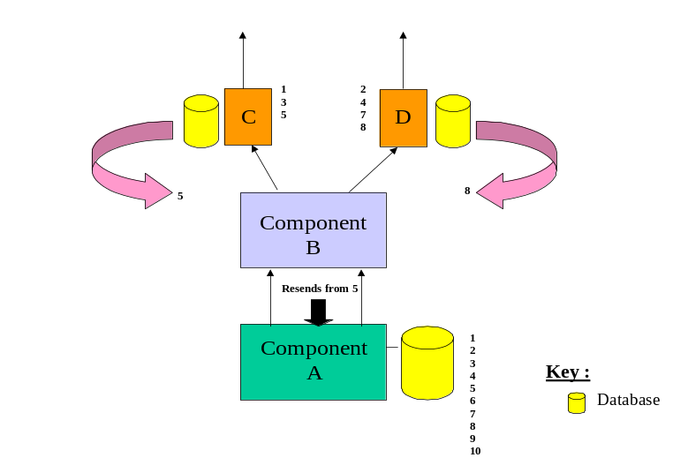
In this example Component B has failed. As Component B does not harden the data it is possible for messages to get lost within it. Therefore in this case Component C and Component D will state the last message they sent out (In this case C5 and D8). Then for the messages between this range, Component A will verify with component C and D whether that message has already been sent, until reaching the maximum number sent. Therefore in this case, only message 6 will be sent out and 7 and 8 will be ignored. Once at 9 the messages will be sent out as normal.

Sequence numbering
Sequence numbers can be used to enable recovery but can also be used to find holes in streams of messages, so that certain messages can be replayed. Careful consideration needs to be taken to choose the correct type of sequencing.
Sequence numbers can be numbers, dates, times; it will all depend on the application requirements.
Once you have determined the metric used for the sequence number you will need to think about the way in which the number is used. You will have to consider how the sequence will be numbered:
- Rollover – Will the number get to its physical limit and rollover? Can the application cope with this?
- Reset – Does the sequence number get reset? If it does, what measures are taken to insure integrity and auditability of the data? This could be through either:
- Simply starting again at one
- Deleting 1 to 10,000 and then decrementing all others by 10,000
- Continuous – Is the numbering schema you have chosen sufficient to last the application’s lifetime?
Once you have a mechanism for sequencing you will need to check your design for parallel components that require sequence numbers. In these cases special attention must be paid to ensure that the sequences remain unique, usually through some manager providing the sequence number.

Functional Isolation
Through careful separation of business function (functional decomposition) it is possible to create application components within an application that, although they rely on each other, can still function without connection.
Using the previous diagrams as an example, it is possible that the connection between Component C and B fails, but all of the other components are still able to run. In this case the applications could be designed such that:
- All messages coming into C from E are stored but not forwarded.
- That Component B can continue to forward the messages to be sent to Component D, but will store the messages that should be sent to C (in memory if Component B did not implement hardening or to disk if it did).

However when doing this you will need to consider techniques to reduce memory build up and you need to know how long you can last in this mode of operation before failure. Otherwise you are liable to kill Component B and eventually risk all other components. Two types of technique for this are:
- After a certain period of loss, write to disk.
Therefore in this example Component B would start caching the messages that should be sent to component C, but if the memory used increased past a threshold, then Component B would start to harden the messages.
- Only record the sequence numbers that need to be sent when connection comes back.
Therefore this implies that Component B can log the message sequence sent to Component C for a long period of time without fear of blowing the cache. The downside here is the Component B will then have to request that messages with sequence numbers that were missed are resent from Component A, when the connection is re-established.

Technical Isolation
When designing the application components you will need to consider how each application component uses existing components of the system and ensure that they are structured in terms of tasks so that they do not overwrite critical software or data.
As an example this could be ensuring that components are not conflicting on the uses of other components resources’, e.g. trying to access the same memory pools, or connection routes.

Maintaining State
Through maintaining the state of a process you enable the process to not only determine where it has been and what it is doing, but also allow the process to act in different ways.
For example in the above diagrams, all application components could have four states:
- Disconnected
- Initialization
- Ready
- Failed
Then based on the state the other processes will react in different ways. For example when Component B goes to the state disconnected then Components A, C and D could start caching the messages, as the expectation would be for the connection to be quickly restored. However if Component B went to state failed then the other Components would just harden the messages, whilst waiting for connection to come back.

Checkpointing
Checkpointing is the process where each recovery point (component that hardens the data) will at a set period send out a message to say it is safe up to that point and then the other recovery point will acknowledge this. Through doing this it enables the processes to be sure that up to that point that all data has reached its destination.
The frequency of checkpointing is important. A few infrequent checkpoints mean low checkpoint overheads but could mean long recovery actions. Many, frequent checkpoints can mean high checkpoint overheads but almost instant recovery since the amount of work to be recovered from the last checkpoint is always small.
Be aware that infrequent check pointing may cause performance problems, for example DB2 threads may hold locks until a COMMIT is issued; thus locks may inhibit other threads from running.
Check pointing can be by many different means, for example message numbers, units of time, etc.

Application Components in Parallel
You can create the application so that it provides a simple set of Units of Work and acts in a client/server type scenario. Therefore in this case it would be possible to have multiple versions of the server process ready waiting for a client request.
In this case if the server fails the client will lose connection. If the unit of work is not complete then the client can redirect the request to the pool of servers where another server will perform the action. This will save waiting for the server process to restart.

Infrastructure Patterns

Clustering Technologies
Clustering of servers provides a way to make multiple server resources and, in some situations, multiple data resources, appear as a single resource space. The value of this is the ability to scale capacity and establish highly available solutions.

In a highly available and redundant IT infrastructure availability can be achieved with redundancy of systems by introducing clustering technologies. A clustered system is defined as a group of individual server systems that share some resources and act as a single system. Server clusters are designed to keep applications available, rather than keeping data or the business process available. Thus, any kind of hardware based clustering is just a way to protect the physical infrastructure, but does not provide protection for logical or other data related disasters (data corruption, data loss, viruses, human errors, intruders or hackers). To protect the data and the business process against those kinds of threats, organizations need solid data protection for their companies’ crown jewels - which is the data! Therefore besides technical data protection and physical access barriers to the core systems, proven recovery plans and technologies must be in place. Cluster technology itself cannot protect the data against failures caused by viruses, software corruption, or human error. With clustered systems we differentiate between four types of clusters:
- Nothing shared cluster
- Common shared cluster
- Application clusters
- Geographical Dispersed Clusters
In the following sections of this chapter we describe the basic cluster technologies and how they can be deployed in conjunction with databases as highly available building blocks in tolerant solutions.

Nothing shared clusters (aka Shared Nothing)
A nothing shared cluster is defined as a system of independent servers (2 or more) which have access to a common storage system but operate on their own resources. A resource in a nothing shared cluster can be, for example, a disk, an application or a file share. However, the clients see the cluster as one entity and not as n individual servers. Thus, any connection from a user or application will only be executed on one individual node within the cluster.
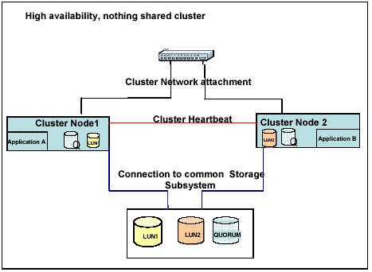
The nodes can be configured in two ways either active/active or active/passive. With an
active/active cluster both nodes operate on their own data and applications and in the event of
a problem on either cluster node, the resources will fail over to the surviving node, see
figure below. The cluster heartbeat is a dedicated network which checks the availability of the
cluster nodes and resources. High availability, nothing shared clusters are usually operating
system based clusters. With Windows.Net 2003 Enterprise Edition and Windows.Net 2003
Data centre Edition a cluster can contain up to 8 nodes. IBM AIX HACMP and Oracle RAC is another example of a nothing shared cluster.
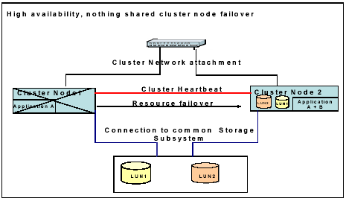
A variation on this pattern is where the load balancing is effectively distributed across nodes. For example, consider two or more stateless nodes attached to a shared MQ Queue. Each can read messages independently from the MQ Queue, whilst MQ ensures transactional queue message reads. HA and improved performance can be provided by adding more nodes.

Common shared cluster (aka Shared Everything)
Physically, a common shared cluster may consist of the same or similar building blocks as the nothing shared cluster discussed before. The major difference between the two cluster types is that within a common shared cluster all nodes have access to the same data and the same resources at any time. However, as a process modifies data on the application, the cluster must provide a specific functionality that enables data locking. Oracle Reliability Application Cluster (RAC) would be an example for a highly available and scalable common shared cluster, as is parallel sysplex with coupling facility.
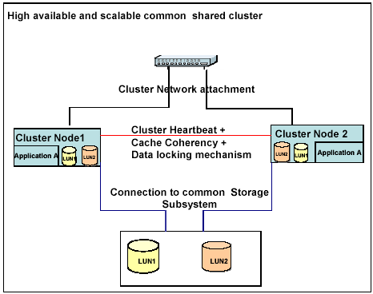

Nothing shared application cluster
In a nothing shared application cluster the users are linked to a farm of independent cluster nodes which act as one single system. Each node has its own data and the load between the nodes is being distributed and coordinated by the applications load balancing facility. In case of a node crash, the users can reconnect to the server farm and continue on the remaining nodes within the cluster. However, transactions and data in progress before the crash of the individual node might be lost depending on the application’s behavior. An example for an application server farm would be CITRIX or IBM WebSphere.
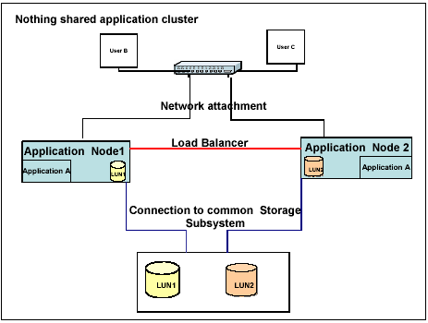

Geographical Dispersed clusters
With the introduction of disaster protection we have to keep in mind that one disaster might be a complete site loss due to fire, water, earthquake or other severe type of destruction. In this scenario a local high availability solution of any kind will not cover the availability and continuance of the data and the business process. Therefore alternatives have to be discussed on how to protect the physical infrastructure, the data and the applications available after the event of a site failure. Geographical dispersed clusters provide the physical possibilities to extend the cluster nodes (the servers) and the storage subsystems across extended distances. They do not protect the data from logical or human errors.
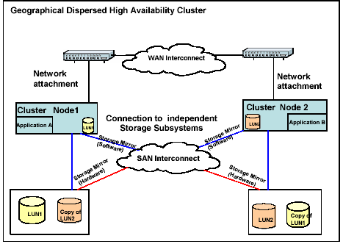
As indicated above there are two general possibilities within Geographical Dispersed Clusters for synchronization and data mirroring of the storage subsystems between the sites:
- Host based mirroring: Such as with the Logical Volume Manager, HAGEO, orZ/OS XRC
- Storage based mirroring: PPRC or Resource Volume Manager (RVM with FAStT)

Virtualization
Virtualization capabilities and techniques are employed in servers, storage, networks, operating systems and middleware. Examples are logical partitions (Virtual OS environments), Virtual LANs, storage device block virtualization, blades (Virtual server backplanes) and cluster technology (Virtual server platforms).
Recovery Oriented Computing (ROC) principles can be applied with virtualization of IT infrastructure resources to achieve High Availability targets. HA practitioners should exploit the separation of the logical view of resources from its actual implementation to create a resilient solution capable of masking failures in the infrastructure from end users or applications.

Network Virtualization
Network virtualization provides for the ability to manage and control portions of a network that may even be shared among different enterprises, as individual or virtual networks, while maintaining isolation of traffic and resource utilization. This includes technologies such as Virtual Private Networks (VPNs), HiperSockets and Virtual LANs. Virtual IP Address (VIPA) takeover, for example, abstracts the physical connection of servers to networks. VIPA takeover allows for automatic recovery of network connections between different servers.

Network virtualization also includes the ability to prioritize traffic across the network to ensure the best performance for business critical applications and processes. The use of policy to abstract the management of these services is also an element of the network virtualization support, which is being enhanced to better integrate with the other resources (server/storage) and exploited by more of the service level manager disciplines.

Storage Virtualization
Storage virtualization allows the capacity of multiple storage controllers to be combined into a single resource to provide a single view of the storage resources. This abstraction layer between the physical storage devices and the users of those devices (host applications) provides the ability to hide the physical infrastructure from the application and end user. Simple benefits of storage virtualization include the ability to easily add additional space and volumes, to move to different types of disk and to replace aging disk subsystems; all without applications or host systems having to know anything about what is going on.
There are several models for implementing virtualization in a SAN. One model that is gaining acceptance is based on the installation of a so called “Virtualization Server”. The Virtualization Server connects to the heterogeneous application server environment via the SAN fabric. The disk storage subsystems, which can be legacy storage or a latest generation product, are then connected either directly to the Virtualization Server or through the SAN, such that only the Virtualization Server can directly address the storage.
This Virtualization Server functions as an abstraction layer between the physical storage subsystems and the applications and provides the ability to hide the physical storage infrastructure from the application and the end user. Use of the Virtualization Server allows application systems to believe they have physical storage volumes allocated directly to them. The Virtualization Server may also provide replication functions, such that data can be mirrored across sites, either in real time or asynchronously. Local disk copying function may also be provided, such that a logical copy of disk data can be taken in a few seconds.

Server Virtualization
IBM has been delivering systems that have provided virtualization for many years. A simple example that is used on many platforms today is virtual memory, which allows each application to think it has its own real, dedicated memory. More sophisticated examples of server virtualization are:
- Logical partitioning (LPAR) to “slice up” a machine into virtual partitions and provides the flexibility to dynamically change the allocation of system resources for those environments. The engine resources are fully shared, which makes it possible to run the physical server at very high utilization levels. If a partition should fail, another partition on the server can pick up its work.
- Some servers within the Windows® and UNIX® platforms only support a virtualization technology called “physical partitioning”. In this case each physical partition or virtual server owns a dedicated set of resources not used by others. The affinity of the virtual servers to the physical board configuration also means that resources such as processor engines, memory and I/O interfaces have to be provisioned and re-provisioned together, thus making the implementation less efficient but still important to achieving improved partition availability through redundancy.

The diagram shows three common modes of server partitioning. Hardware partitioning uses fixed resources; software and logical partitioning have greater, more dynamic capabilities, depending on implementation and platform.
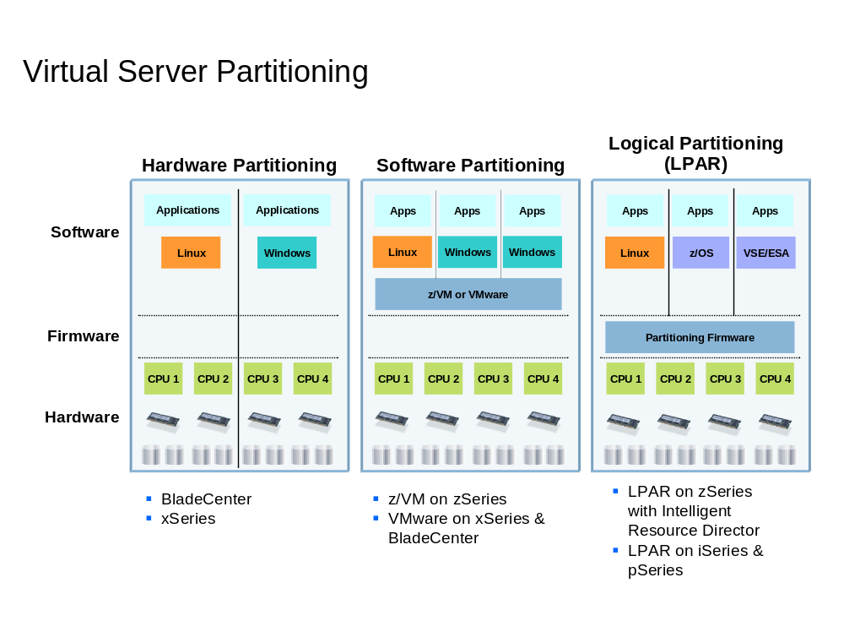

Point-in-time Copy (PIT)
A point-in-time copy is an image that reflects selected data within a disk subsystem at a particular instance in time. PIT copies are used for backups, availability and Disaster Recovery solutions. A good example of this is the FlashCopy feature on the IBM TotalStorage Enterprise Storage Server (ESS). Such images can be made from a single subsystem or across multiple subsystems.

Freeze
Freeze is a process that halts I/Os to the primary Logical Subsystem of a mirrored pair. This results in data that is consistent to the point-in-time when the freeze occurred. When combined with automation this can prevent rolling disasters and ensure that recovery site databases can be restarted. From an application perspective, the storage subsystem is seen as being in the busy state.

Fuzzy copy
A fuzzy copy is mirrored data which has been received in the remote location but which is not verified to be consistent. PPRC-XD creates a fuzzy copy to quickly move tracks of data from one disk subsystem to another.

Data Protection Patterns

Local patterns
This section will describe the two basic patterns for providing local highly available data, parallel and sequential writes.
It should be understood that there are generally a wide range of options to enhance the reliability of a given write action. Most operating systems will automatically retry a failed write activity and will appropriately handle timeouts from the devices as well as bad block relocation (writing to a new (spare) block should a block on the device be marked bad). Usually options such as “write verification” (reading the data from the device after it has been written) are also provided to ensure that individual writes complete correctly.

Parallel writes
In this pattern, following the call to perform the write there is a period of time during which all of the target devices wait until they are all able to accept the write. The writes to the different target devices are performed in parallel. There is a completion activity where the successful return of each of the write actions is checked before control is passed back to the caller.
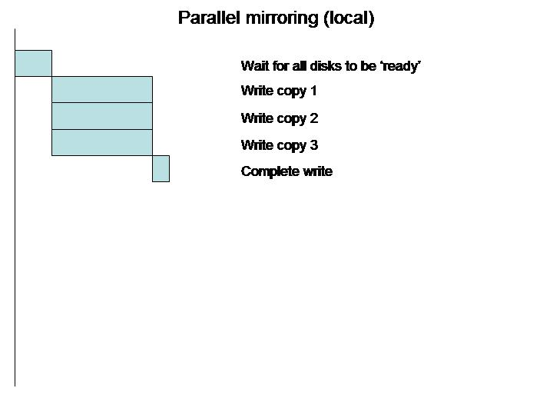
Most RAID disk devices perform in this fashion with the individual disks within the array being updated in parallel.

Sequential writes
This pattern differs from the previous in that each device is written in turn rather than all at once. Control is passed back to the caller after the first write has successfully completed. The writes to the other devices occur in turn in the background (usually with an asynchronous notification passed back to caller following the successful return of each of the write actions).
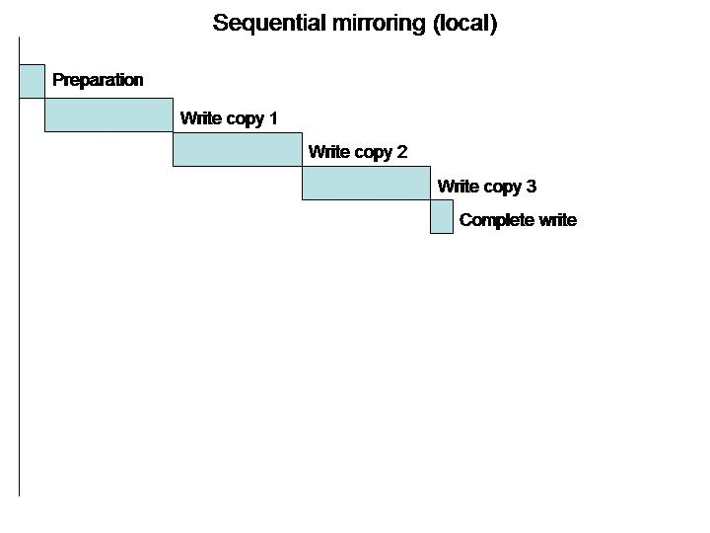
Sequential writes generally perform better than parallel writes because control is passed back to the caller sooner, allowing other activities to be performed. This performance comes at the (potential) cost of less reliability in that not all the copies can be guaranteed to be consistent at any point in time. Many operating systems provide a ‘write consistency’ option that will guarantee this by holding back the asynchronous confirmation until all writes have completed correctly. This consistency option will similarly impact performance.

Remote patterns
This section will describe the basic patterns for providing highly available data across multiple (remote) locations. In this section the term ‘network’ is used generically as a communications mechanism. Different products / technologies will use different communications techniques.
NOTE also that the ‘Local Patterns’ in Section 3.7.1 may also be used to provide some limited ‘remote’ protection. Typically in SAN or Campus environments, the protection provided by having one or more of the devices in a different building / room / floor may provide sufficient protection for some users. If ALL of the devices being mirrored to are viewed as being ‘local’ to the system then these local techniques may be applied. If one or more of the devices being mirrored to are attached to a DIFFERENT system, then these remote patterns are applicable.

Synchronous patterns
If you cannot afford to lose data then you have to use synchronous techniques to ensure that data on all sites is consistent. Doing this between two separated locations WILL BE costly in terms of performance. Any synchronous write will require the user to wait until all copies have been written before control can be passed back to the caller. If the second site fails the system will be able to continue, however it will be at risk as if the primary site fails recovery of the data will be more complicated.

Basic synchronous write
In this pattern, the write is transmitted FIRST to the remote site (with the associated network delays). Once a successful acknowledgement has been received that the data is correctly on the remote device then the local write is performed. Following the successful completion of this write, control is passed back to the user.
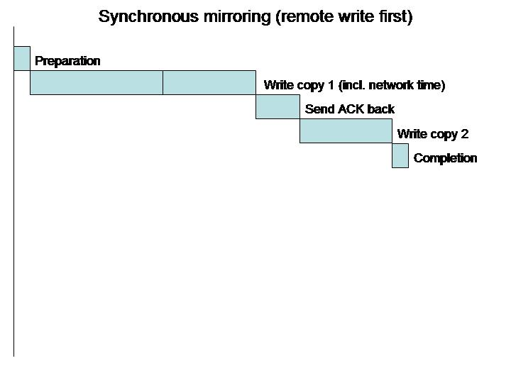
There are a couple of key points to note about this. Firstly, the bandwidth and latencies of the networks are critical in determining the overall performance. These times will generally far outweigh any time taken to write to the disk devices (especially where caches are involved). Don’t underestimate how large an effect this will be.
The remote write is performed first so that when the local write is completed, the caller is sure that BOTH sites have been updated. If the local write were performed first, there is no way to guarantee that this is the case and the data on the two sites will likely diverge in the case of a failure of any component in the chain (local site, network, remote site).

Parallel synchronous write
In this pattern, the writes to the local and remote systems are performed in parallel. Control is held back until all writes are confirmed to have been correctly performed (note that to do this properly will require the various intermediate stages of the overall synchronous write to be ‘logged’ to some persistent device (typically another disk)). Following the successful completion of all write actions (local and remote), control is passed back to the user.
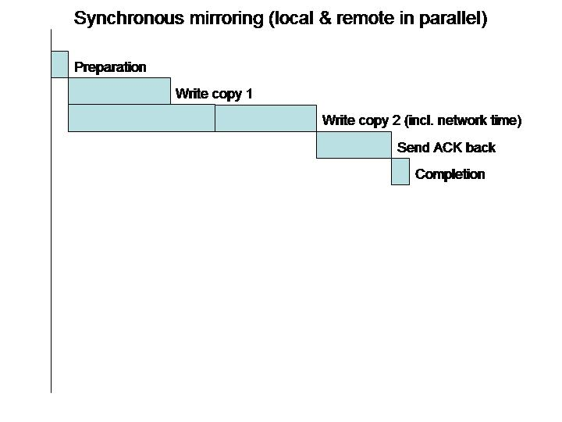
This pattern has a potential performance advantage over the basic synchronous write in that it does provide some degree of parallelism and as such should complete in a shorter time than the basic one (provided that the ‘logging’ activities do not add more time than the parallelism saves. Note that not all products typically provide an option such as this.

n-phase commit
Very rarely used where n is greater than 2, though there have been a few circumstances where customers have demanded a 3-site strategy. This is typically a variant of the parallel synchronous write (doing n-phase on >2 sites in the basic synchronous model would simply be prohibitively costly in performance terms).
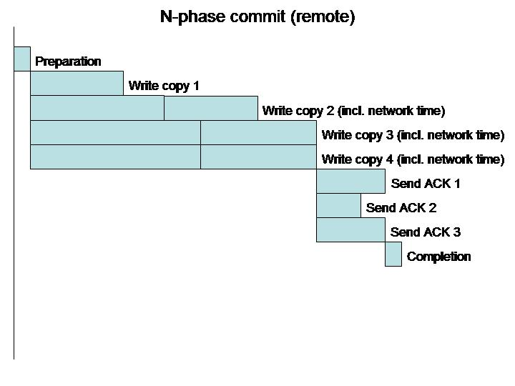

Asynchronous patterns
There is one basic asynchronous pattern whether this is being performed at a low level (say by a disk subsystem or operating system) or at a higher level (by say a database). This is ONLY suitable for organizations that can CONFIRM that they can tolerate losing data in the event of a critical failure. Yet despite this, there are still some companies who opt for this and then get upset when the worst happens!
For longer distances (because the speed of light just ISN’T fast enough) this may well be the ONLY option available to provide multi-site data protection.
In this model, the local copy of the data is updated first and a ‘log record’ is written to say that the local copy has been written. This log record must be persistently stored. Control generally passes back to the caller at this point in time.
At a later point in time (this can be usually be tuned – typically based on the size / number of the log records or on some ‘timed’ basis) the remote write is performed. Upon the receipt of acknowledgement that a successful write has been performed the log record is either updated or cleared to show that the data is now consistent on both sites.
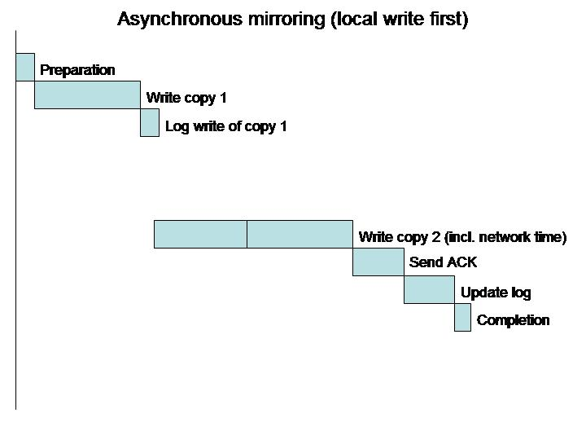

Hybrid or combined patterns
Though not specifically described here, it should be noted that some customers opt for combinations of the above patterns to provide disaster survivability for their data.
In general, ALL systems where data availability is a requirement SHOULD be performing local protection (generally mirroring or RAID).
Going multi-site to provide disaster survivability should NOT be a replacement for the above, but rather should build upon it. i.e. when we talk about say a basic synchronous mirror between sites, the individual target devices at each site should themselves be locally protected (mirroring or RAID).
It is not uncommon for an organization to synchronously mirror to a second site that is relatively close (for performance reasons) and then asynchronously mirror to a (more geographically remote) third site. In this fashion, they can provide survivability from the most common causes of site outage (power, fire, flood etc.) without losing any data and yet still provide some degree of protection against larger-scale metropolitan disasters (hurricanes, earthquakes etc), albeit with some potential data loss.

Network Patterns
The arrangement or topology of a network has a significant impact on the availability of the network infrastructure. This section will discuss, in general terms, Data Centre Point-to-Point, Ring and Mesh topologies

Data Centre Point-to-Point connectivity
Point-to-Point configurations, simply put, are direct connections between network devices located in two data centers. These configurations are simple and are the least expensive to privately build and maintain. However, they will need one backup fiber route to ensure availability for the network. Additionally appropriate dual pathing network protocols will be required for automatic failover. That way communication can continue between locations even if one fiber path is disabled for any reason. The figure below shows how communication can continue in a Point-to-Point configuration if the primary fiber route is disabled.

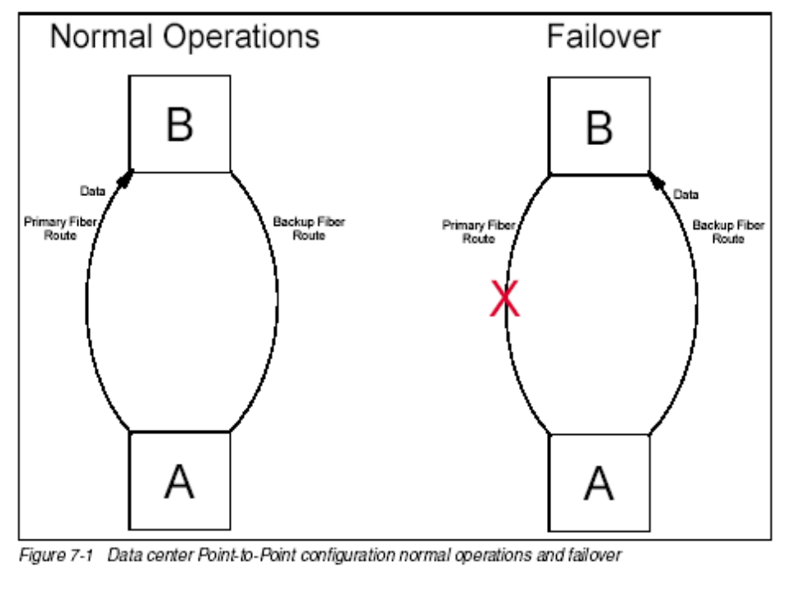

Ring configuration
Ring configurations allow three or more devices to connect together. If fiber is cut in one direction, data can continue to flow in the other direction and still reach its destination. This is demonstrated in Figure 7-2 where a cut in the fiber infrastructure between B and C does not prevent data centers A and B from transporting data to C. Because more hardware and network connections are involved, this configuration is generally more expensive than Point-to-Point, but offers greater availability. Because of its self-healing nature, this configuration is often used to build the Synchronous Optical Network infrastructures used by telecommunications and network connectivity providers.
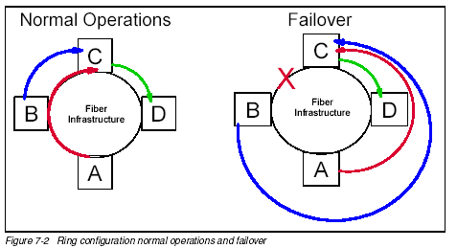

Collapsed rings
In some cases rings are configured not to be self-healing. This is typically due to the expense of additional equipment and fiber bandwidth needed to reroute signals. In these cases the ring is said to be collapsed. Data only flows in one direction in this sort of ring and will not reroute automatically if something happens to the connections.

Mesh configuration
The Mesh configuration concept allows for the highest levels of availability out of any of the topologies. Also known as any to any, a mesh is configured so that each device on the network connects directly to every other device on the network in configurations of 4 or more. As shown in the figure below, network availability is further improved because if the fiber infrastructure between A and D is damaged, data from A can still pass through B and/or C and reach the data centre at D.
In part because of the extra hardware, but mostly because of the extreme redundancy of fiber connections, this topology is by far the most expensive to build, maintain and manage. However, Disaster Recovery environments using such configurations are the least likely to lose connectivity for any reason.
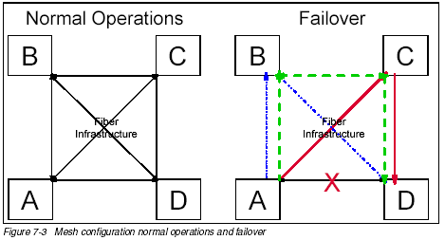

HA Techniques and Tooling

Introduction
The formal techniques described play different roles for systems with different high availability goals. These are:
- FMECA – Failure Mode, Effect and Criticality Analysis
- RBD – Reliability Block Diagram
- FTA – Fault Tree Analysis
Each is more effective at different times within a project lifecycle. If we consider systems as falling into one of four categories based on complexity and criticality, the following diagram shows the relative applicability of these techniques to the categories of systems. Higher point sizes for the font show increased applicability.
 | Non-critical | Critical
Complex | RBD  FMECA | FMECA  RBD  FTA
Simple | - | RBD  FMECA  FTA
If we consider complex, critical systems as being the major target for these analysis techniques then FMECA is of most benefit here to help analyze complexity. This can then help drive RBDs. An RBD may be impossible to do for a complex system because the diagram is itself too complex, so this technique needs to be carefully targeted at the right level. In the case of a simple but critical system, the RBD is of most value because it can be done more quickly and simply than an FMECA analysis. A level of judgment needs to be applied on whether techniques should be applied to systems that are complex but of low criticality. Use of the techniques in this category would typically be targeted to the most critical components in these systems.
There is a benefit to be realized by applying these techniques in repeatable engagements and designs. The first time a system is designed, the same criteria need to be applied as for a unique system design. From the second time onwards, reuse of the analysis model and validation of the design will be dependent upon the position in the lifecycle of a reusable solution. This will be driven by cost effectiveness considerations. The following graph shows this:
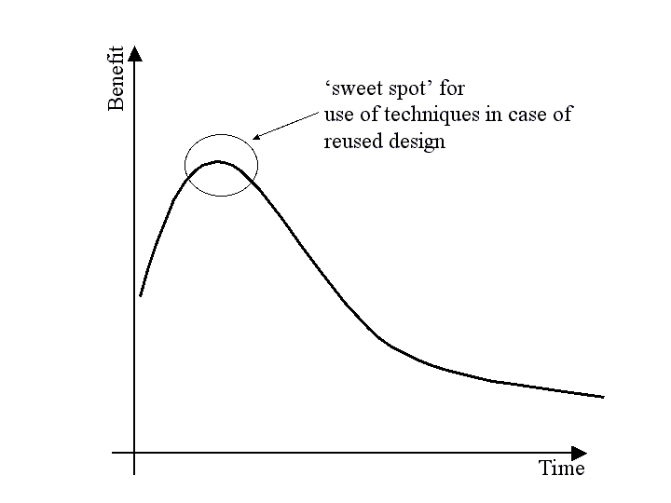
Availability Models arising from system design analysis should be placed in a shared repository to encourage reuse and aid in the design of new systems. The application of a minor change to an existing model requires significantly less effort than recreating a new model from scratch. Use of a single toolset for performing these analyses will help force consistency and reuse.
Within a given system implementation project, the applicability of the different techniques will change over the project lifetime. This is best shown on the following graph:
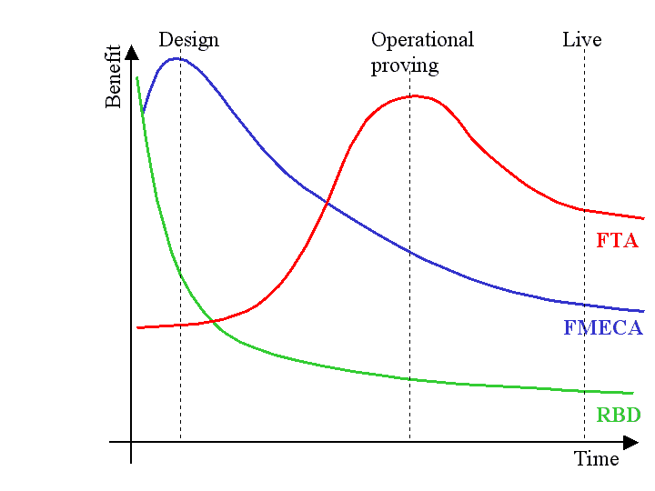
Whereas FMECA and FTA both have uses over the longer term, RBDs are only useful in the design stage of a project to provide a model of the availability and to help identify points of failure. As the following diagram shows, outputs from FMECA can be used to drive other techniques, most notably FTA, which has a direct influence on the operability of the system. Both FMECA and FTA can provide a starting point to identify and specify operational processes and procedures for identifying and dealing with failures. It should be noted that FMECA and FTA are not good at analyzing dynamically changing aspects of systems.
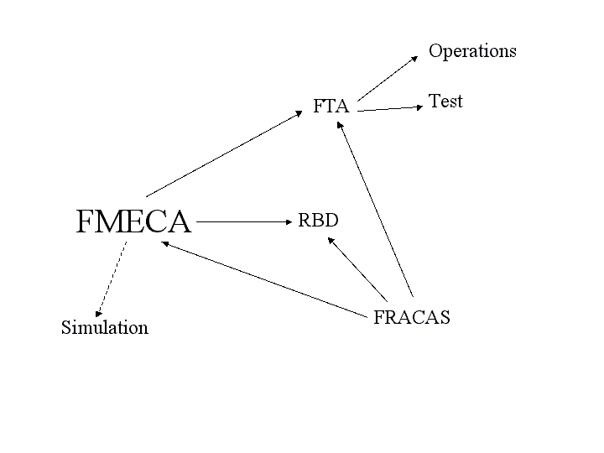
Techniques such as RBD need quantitative data on the availability of the components. It is hence very hard to use for software systems but quick to do for simple hardware systems. This data needs to be based on real-world experience rather than lab theoretical values in order to include operational and client factors. Much of this data already exists within the IBM Strategic Outsourcing organization. Utilizing FRACAS (Failure Reporting, Analysis and Corrective Action System) techniques to capture this in a timely fashion could enable this data usable for others as well as verifying the designs that are already in place.
The FMECA model can be used to improve the testing of the system by targeting tests at those areas of the system that pose the highest risk. We can then use the test results to improve the model by comparing the actual failure effects with those predicted in the model. This virtuous circle both improves confidence in the model and the resultant system. As a major cost of big projects is operational proving, anything that can be done to reduce this, by helping drive testing strategies is immediately beneficial.
In assessing these different techniques, the following table may be of use where they are compared against different criteria. In this table more ‘*s’, is better.
Assessment criteria |  | RBD | FMECA | FTA
Low cost / effort |  | *  (large systems)  ***  (small systems) | * | **
Software transient failures |  | * | ** | **
Software persistent state failures |  | - | ** | *
Infrastructure reliability |  | *** | *** | ***
High skills requirement |  | ** | * | **
Operational procedures |  | - | ** | ***
Pre-requisites: structure |  | * | * | **
Pre-requisites: metrics |  | * | ** | ***
Change impact assessment |  | *** | *** | *
Identification of operability gaps |  | - | ** | *
Completeness of scope |  | */2 | *** | **

Technique 1. Failure Mode and Effect Criticality Analysis

Description
This technique paper provides an overview of when and how to use the Failure Mode and Effect Analysis (FMECA) technique. The primary purpose is to provide enough information to decide whether this technique is suitable for the system under consideration. It is strongly recommended that the resources listed in Section 4.2.4 are studied for a deeper understanding of this technique before it is used on a client engagement.
FMECA is a qualitative reasoning approach best suited for reviews of complex systems that have stringent reliability, availability or safety requirements. The FMECA technique considers how the failure modes of each system component can result in system performance problems and ensures that appropriate safeguards against such problems are in place. It also provides an opportunity to define the detection and recovery mechanisms that are in place when failures do occur. A quantitative version of FMECA is known as failure modes, effects and criticality analysis (FMECA).
Failure Mode and Effect Analysis is:
- A systematic, highly structured assessment relying on evaluation of component failure modes and team experience to generate a comprehensive review and ensure that appropriate safeguards against system performance problems are in place.
- Used as a system-level and component-level risk assessment technique.
- Applicable to any well-defined system
- Sometimes performed by an individual working with system experts through interviews and field inspections, but can also be performed by an interdisciplinary team with diverse backgrounds and experience participating in group review meetings of system documentation and field inspections
- A technique that generates qualitative descriptions of potential performance problems (failure modes, causes, effects and safeguards) as well as lists of recommendations for reducing risks
- A technique that can provide quantitative failure frequency or consequence estimates
- Tool support available

Approaches
The following sections describe the contexts in which you can use this technique.
The FMECA technique can be used for the design of products (including software), processes and services where availability and reliability are of critical importance.
The principal objective is to anticipate the most important design issues early in the development lifecycle so that one or more of the following actions can be taken:
- Modify the design to eliminate / mitigate the problem
- Minimize the consequences by means such as early detection and well defined recovery mechanisms.
This paper describes two approaches:
Functional FMECAs can be performed while a system is in the conceptual design stage. It focuses on the functions that the system will provide and can be done before specific hardware and software information is available. For complex systems Functional FMECAs are usually performed at a high level (e.g. subsystem) and are then refined top down.
Detailed FMECAs require an understanding of the specific implementation of the system. They usually start at the component level, assessing the failure causes, effects, detection options and higher level impact. A bottom up approach is used to determine the impact of failures on the complete System. Detailed FMECAs are best done during the latter stages of Macro Design and throughout Micro Design.

Benefits of FMECAs
FMECAs provide the following benefits:
- Better system design resulting in fewer critical failures and more predictable recovery from failures
- Earlier identification of diagnostic tooling and operational procedure requirements
- Earlier identification of design weaknesses and thus fewer design changes in later phases of the life cycle
- Input to the test strategy and test case design; identifying negative test scenarios early in the project lifecycle
- Formal documentation against which future changes can be assessed
- Information that can be used (via export with most tools) to form draft fault trees that can be further analyzed using Fault Tree Analysis (FTA)
- A model against which to perform impact assessment against when changes to the system are considered

Limitations of FMECA
FMECA provides a static system analysis that does not consider the impact of
- Multiple component failures
- Latent defects that impact timing and sequencing
- Effects on redundant items (where Reliability Block Diagrams and Fault Tree Analysis can be used).

Steps
The FMECA process progresses through the following steps: Planning, Model Construction and Analysis.

Planning
FMECA should start early on in the Solution Outline phase. The first step is to plan the FMECA. The following activities need to be carried out:
Design review: To enable the availability practitioner to build an FMECA model he or she needs a good understanding of the system. The following Work Products should be studied:
- Use Cases
- Business Rule Catalog (stating time line / operating phases)
- Non-functional Requirements
- Architecture Overview Diagram
- Operational Model
- Component Model
- Interaction Diagrams
- Statechart diagrams
Some of these documents may not exist or may still be in early draft form if the FMECA is started very early. In this case information should be obtained from the Architects designing the system. It is important to get as good an understanding of the envisaged system as possible so that the FMECA can be targeted at the critical system areas and the most appropriate level of detail.
Building a complete FMECA model for a large complex system is very time consuming and the emphasis should be on identifying critical and catastrophic failure possibilities as early on as possible to focus effort on the highest risk areas of the system.
A plan should therefore be drawn up that shows what type of FMECA (Functional, Detail or both) will be produced for each area of the system and the level of detail to which each area of the model will be completed.
The plan should also describe the following:
- Work sheet formats and / or software tools that will be used. Section 4.5 Tools, page 66 contains a number of worksheet templates.
- Coding system that will be used and how this will map to the notation used in the design Work Products.
- Definition of “failure” in the system context – what constitutes a failure? For example: Consider a system where components are located physically close together. In this case temperature variations beyond certain thresholds may be considered a failure, as this may cause the system to fail due to overheating. In another system, where physical proximity is not an issue, the same condition would be quite harmless.
- Rating scales that will be used for Severity and Probability with guidance on how to use them.
The plan of the FMECA analysis needs to take into account that:
- Some Architectural Decisions will require an FMECA to be performed for two or more of the alternative options being considered.
- Multiple FMECAs may be required for different operating phases / environments if these result in different functional relationships.
- Redundant sub-systems may require an analysis with the redundant system being available and un-available. It should be noted that RBDs and FTA caters explicitly for redundant systems.
- The FMECA has to be updated when design changes are made.

Construction
Once the initial planning and data gathering activity has been completed the FMECA worksheets are filled in. This can be done using the table in Section 4.5.2 FMECA Core Process Table, page 66. For large complex systems to it is strongly recommended that this is done using a software package or, if none are available, then using the MS Access Database which is available from the HA CoP Knowledge Café. A table has been included here to show how the data is entered into the sheets.
The process follows the following steps though the sequence is not fixed and the process is usually iterative:
- Complete the FMECA Header information that identifies the FMECA project and provides configuration management information.
- Identify Items (components and nodes) that will be analyzed. Each item has to have a unique identifier assigned to it. This identifier should be the same, where possible, as that used in the system design and specification Work Products.
- List all the Functions that each item performs in the system.
- Identify all potential Failure Modes, defined as the characteristic manner in which a failure occurs, independent of the reason for failure; the condition or state which is the end result of a particular failure mechanism (e.g. program crashes).
- For each Failure Mode list the potential Causes, that can lead to that failure mode. The Cause is the underlying reason for the failure (e.g. un-initialized pointer).
- Assign a Probability of Occurrence to each cause. This is usually a quantitative value (typically range 1-5 or 1-10)
- List the Mission Phase or Operational Mode in which the failure occurs. This distinction is required if a failure has a different effect on the System depending on the use of the system at the time (e.g. the effect of a batch process crashing may be different depending on the time of day that this happens)
- Determine the consequences or Failure Effects that each failure will have in each Mission Phase. The effects the failure has at the local level (i.e. on the functions that the failing component performs) are referred to as Local Effects, the impact on parents in the system breakdown structure are Higher Level Effects and the impact on the System operation are the end Effects.
- Each failure should have a Failure Detection Method or a reason explaining why detecting the failure is not feasible or required. Detection Methods should identify tools and procedures that will be used to detect the failure.
- List Compensating Provisions that will mitigate or mask the effect of the failure. This includes designed provisions (e.g. stand by systems) as well as procedural actions that will be executed when the failure is detected.
- Allocate a Severity Classification to each Failure Mode. This provides a qualitative measure of the impact that the failure will have on the System.
- Any additional comments should be listed in the Remarks column. This could include design recommendations, concerns about input data quality that may need further work, areas that have not been fully analyzed etc.

Analysis
The most common analysis performed on FMECAs is plotting the Probability of Occurrence against the Severity for each failure mode. Attention is then focused on Failure Modes that fall into the likely / critical quadrant.
Methods such as Risk Priority Number (RPN) calculations and quantitative approaches are available but are not covered in this paper.

Tools
There are a large number of packages tools on the market that support FMECAs. The following three were identified during the Academy Study into HA design techniques:
Relex (www.relexsoftware.com)
Isograph (www.isograph-software.com)
Item Software (www.itemsoft.com)
There is also a MS Access DB Schema, available on the Business Resilience Knowledge Café, that implements the FMECA concepts.
More detailed information about this technique can be found in the following publication:
Reliability: A Practitioner’s Guide, available from Relex (http://www.relexsoftware.com/resources)

FMECA Example

Context
This example shows how FMECA can be applied to a software-based example. The example has been modeled using the demo version of the Relex Package (Version 7.6) and has been kept very simple due the limitations of the demo version.
The diagram below depicts a simple application that consists of two subsystems:
- An input processing subsystem that accepts validates and stores business transactions in a database. This subsystem should always be available.
- The transaction processing subsystem processes transactions at a given point in time as determined by the scheduler component. The transactions have to be processed in a defined time slot.
It is important to note that there are different availability requirements for the two business processes supported by the application in this example. The transaction input process needs to be available “all the time” although the business implication of a short outage is not that severe. The actual transaction processing has to happen in an allocated window. The implications of missing this window are extremely severe.

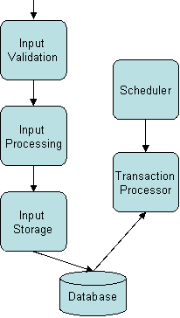
The system design has resulted in the following dependencies:
If any component in the Input Subsystem fails then the complete subsystem becomes unavailable.
If any component in the Transaction Subsystem fails then the complete subsystem becomes unavailable.
If the Input Validation component fails then the Transaction processing component becomes unavailable.
[Note: This example is loosely based on the characteristics of a system implemented by IGS.]
The components shown above were entered into the Relex System Tree. This forms the basis on which the analysis technique is built.

Relex Example
The FMECA technique requires the analyst to consider the failure modes and effects that they have. The failure effects are categorized into local effects (on the relevant component), next effects (on the higher level assembly) and end effects (on the system) that result from the failure modes. The technique also allows root causes, which may lead to the failure modes, to be captured.
The screen shot below shows the effect that an Input Validation component hang causes.
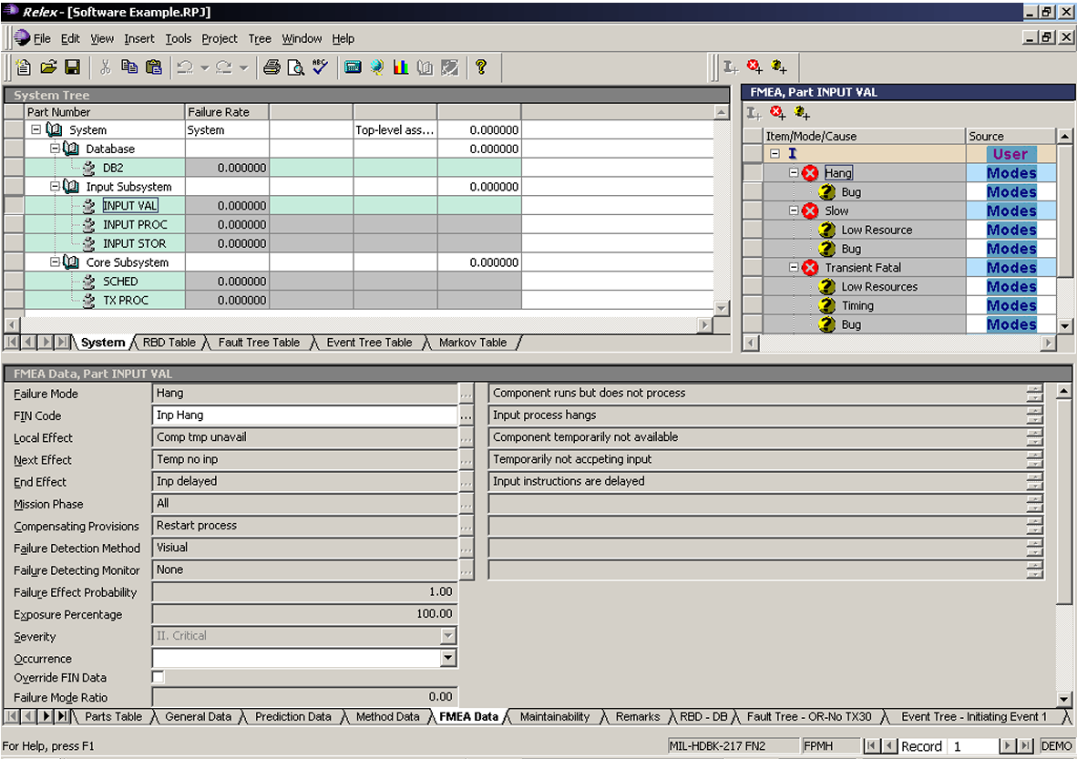

In cases where many failure modes have exactly the same effect the technique allows the analyst to create a “Fault equivalence Identification Number” (FIN) and link the FIN code to the Failure Mode rather than having to type in the effects for each one.
The FINs provide an additional feature: They allow different effects to be registered dependant on the “Mission Phase” in which they occur. In our example the system mission can be divided into two phases:
Input only: During this phase the systems is accepting transactions and stores them in the database.
Input and Transaction Processing: During this phase the system is processing transactions while still accepting inputs.
The screen shot below shows that in the latter phase a failure of the Input Validation Component has a secondary failure, which stops Transaction Processing.
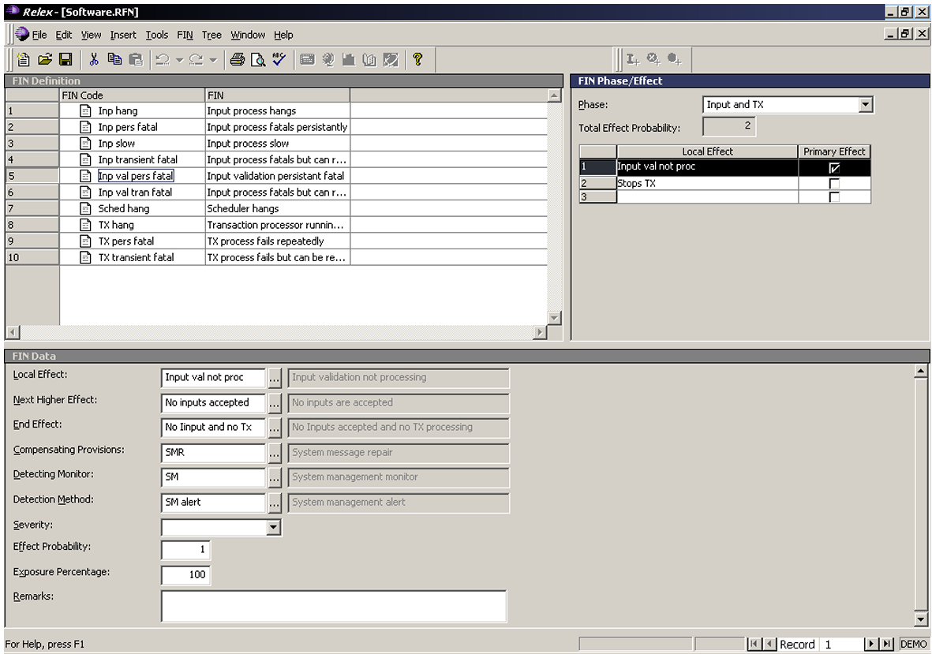
The process also encourages the analyst to define how the failure mode will be detected and what action should be taken in response to the failure. This can form a useful basis for the design of the system monitoring solution and the operational procedures.

Technique 2. Reliability Block Diagram

Description
This technique paper provides an overview of when and how to use the Reliability Block Diagram (RBD) technique. The primary purpose is to provide enough information to decide whether this technique is suitable for the system under consideration. It is strongly recommended that the resources listed in Section 4.3.4 are studied for a deeper understanding of this technique before it is used on a client engagement.
RBDs provide a graphical means for representing availability related system dependencies. While this can be useful in itself, the real value of this technique is realized when it is used to predict the overall system availability. The prediction calculations use reliability metrics that need to be specified for the individual components that make up the system under consideration.
A system may require more than one RBD if it performs different functions or if it operates in a number of operational (mission) phases.

Technique Selection

Use of Reliability Block Diagrams
RBDs can be used to predicting the reliability of systems where the reliability characteristics of the components that make up the system are known (or can be estimated to a reasonable degree of accuracy). Given the limited quantitative failure information available for software components, this technique is usually used for hardware components.
RBDs are well suited to modeling redundant systems and can also be used to model multiple operational (or mission) phases.

Benefits of RBDs
RBDs provide the following benefits:
- They provide an intuitive graphical representation of the system from a reliability perspective.
- The method is very scalable as RBDs can be nested.
- The technique can be used to predict system reliability.
- The technique help to identify components that are critical from a reliability point of view and identifies single points of failure (SPoF)
- The technique allows analysis of the impact that design changes will have on system reliability

Limitations of RBDs
Although the technique can be applied to most systems it has a number of limitations:
Data Requirements: Reliability predictions will only be as accurate as the failure data available for the components that make up the system. It should be noted that even if absolute values are not that accurate, RBD analysis can still be useful to compare alternative design options and do sensitivity analysis, as long as the relative data for the components in the system is accurate enough.
Independence of Items: RBDs assume that items fail independently of each other. This may not always be the case. If an item overheats during failure then this may have an impact on the redundant item if they are located physically close together.
Constant failure rate: Many of the prediction methods assume that components fail at a constant rate. This assumption can be problematic in mechanical systems where physical wear plays a big role. For electronic components this assumption is usually valid after an initial “bedding in” period and before components start failing due to age (bathtub curve).

Steps
RBDs require three key steps: Gathering data and defining the system, building the model and calculating the predicted availability.

System Definition
Before the RBDs can be constructed it is necessary to specify and clearly define the boundaries and initial conditions of the system for which failure information is needed. Most of this information should already be defined in the following Work Products:
- Use Cases
- Business Rule Catalogue
- Non-functional Requirements
- Architecture Overview Diagram
- Operational Model
- Component Model
- Interaction Diagrams
- State chart diagrams
The following information is critical:
- Component and node definitions
- Dependencies between them components and nodes
- Reliability parameters
- Failure mode definitions
- Operational or mission profile of the system

Model Construction
System RBDs for all but the simplest of systems are usually made up of a hierarchy of RBDs. During the Solution Outline Phase, diagrams may only span two levels: System and Sub-system. During Macro and Micro design the subsystem models can then be further developed down to node / component level.
In RBDs each block is, at any given point in time, in one of two states: Functioning correctly or failed. Lines between blocks represent relationships between blocks from an availability perspective. The diagrams do not represent the flow of information; sequence is therefore not relevant.
Blocks that need to function for the system to function are shown in series. If there are redundant blocks then they are drawn in parallel. It should be noted that the definition of failure is important. For example: Consider a system where there is load balancing across two components and both are required to be working to meet the required system throughput. They would be drawn in series if the system is considered to be in a failed state if it cannot process the full throughput. If failure is defined as not processing at all then the components should be drawn in parallel (this assumes that it is acceptable to run at reduced capacity until the failed component is repaired).
Standby blocks are modeled by connecting them with a switch. They only become active when needed (i.e. when the active component in parallel has failed).
The diagram below shows a two level model that demonstrates these configurations.
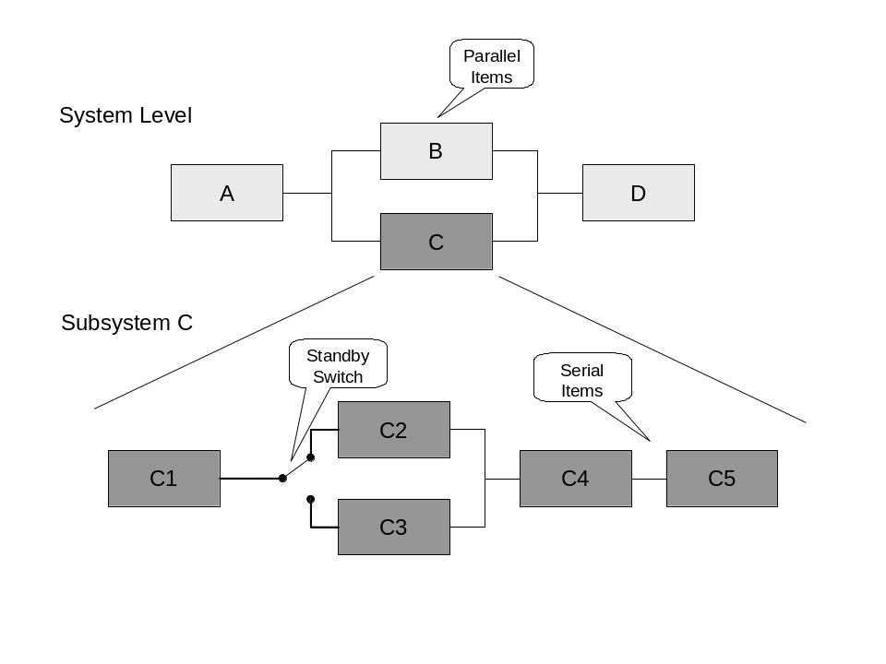

Reliability Prediction
There are a number of availability prediction methods that can be applied to RBDs. For simple RBDs the following formulae can be used:
R(t) = Reliability defined a probability that an Item will survive for time t.
e = Base of natural logarithms (ca 2.7183)
 = Item failure rate
t = The time that the item is at risk
For serial items: R(t) = e ^{–(1 + 2 + … + n)t}
For two parallel items: R(t) = e ^{–1t} + e ^{–2t} - e ^{–(1+2)t}
For more complex diagrams it is strongly recommended that a commercial package is used to perform these calculations. These packages are able to calculate reliability, availability and many other attributes for very large and complex RBDs. They also provide the option of using Monte Carlo simulation for RBDs that can not be calculated with analytical methods.

Tools and Further Reading
There are a large number of packages tools on the market that support RBDs. The following three were identified during the Academy Study into HA design techniques:
Relex (www.relexsoftware.com)
Isograph (www.isograph-software.com)
Item Software (www.itemsoft.com)
More detailed information about this technique can be found in the following publication:
Reliability: A Practitioner’s Guide, available from Relex (http://www.relexsoftware.com/resources)

RBD Example

Context
This example shows how RBDs can be applied to a software-based system.
The example has been modeled using the demo version of the Relex package (Version 7.6) and has been kept very simple due the limitations of the demo version.
The diagram below depicts a simple application that consists of two subsystems:
- An input processing subsystem that accepts validates and stores business transactions in a database. This subsystem should always be available.
- The transaction processing subsystem processes transactions at a given point in time as determined by the scheduler component. The transactions have to be processed in a defined time slot.
It is important to note that there are different availability requirements for the two business processes supported by the application in this example. The transaction input process needs to be available “all the time” although the business implication of a short outage is not that severe. The actual transaction processing has to happen in an allocated window. The implications of missing this window are extremely severe.

The system design has resulted in the following dependencies:
- If any component in the Input Subsystem fails then the complete subsystem becomes unavailable.
- If any component in the Transaction Subsystem fails then the complete subsystem becomes unavailable.
- If the Input Validation component fails then the Transaction processing component becomes unavailable.
[Note: This example is loosely based on the characteristics of a system implemented by IGS.]

Relex Example
Reliability Block Diagrams show what components need to be available for the system to meet a certain requirement. The RBD below, which shows the Database, Input Validation, Scheduler and Transaction Processing components in series, shows that all these components need to be available for transaction processing to occur.
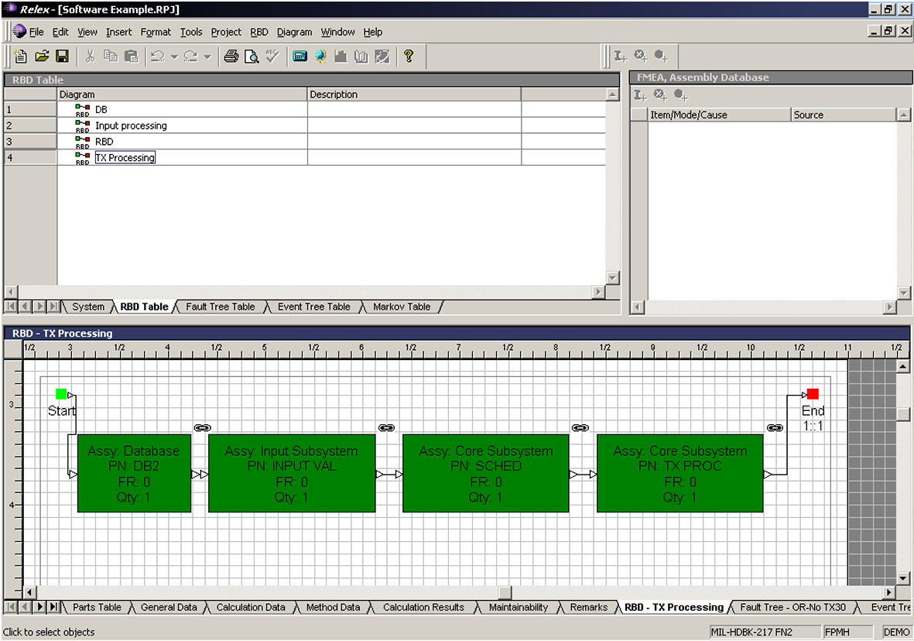

RBDs can be nested. The RBD depicted below is a lower level RBD that shows that a primary and a stand-by server support the database.
RBDs provide a graphical means for representing availability related system dependencies. While this can be useful in itself, the real value of this analysis is if it is used to calculate (possibly using Monte Carlo simulation) the overall system availability. This however relies on reliability metrics being available for the individual components. Unfortunately these are very difficult to come by for software components, which make this technique less applicable to software analysis.
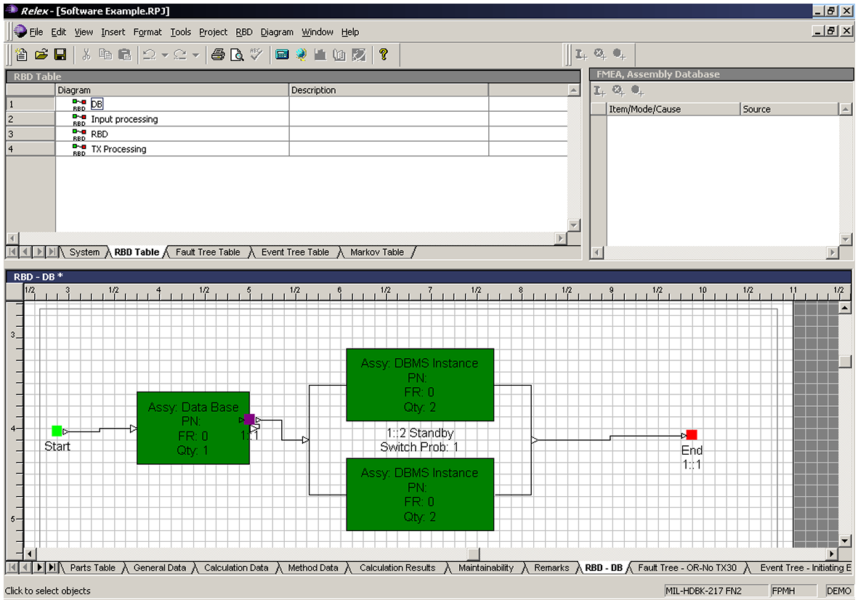

Technique 3. Fault Tree Analysis

Description
This technique paper provides an overview of when and how to use the Fault Tree Analysis (FTA) technique. The primary purpose is to provide enough information to decide whether this technique is suitable for the system under consideration. It is strongly recommended that the resources listed in Section 4.4.4 be studied for a deeper understanding of this technique before it is used on a client engagement.
FTA is a top down event-oriented analysis technique that provides a structured approach to finding the key lower level events (usually failures) that will lead to a system failure. FTA uses a graphical tree structure to represent all the events, including those caused by humans that can lead to the undesirable system level event (usually failure) that is being investigated.
The system level event is also called the top event; the lowest level events in each branch of the event tree are called basic events. The tree structure uses logic symbols to show what combination of basic events will ultimately lead to the top event.
Boolean algebra and probability theory can be used perform quantitative and qualitative analysis of the fault trees.

Technique Selection

Use of FTA
FTA can be used at any stage of the life cycle, from analyzing solution outlines to performing risk analysis on existing systems. FTA is very useful to analyze and determine the likely root cause of a number of key undesirable system events (or potential failures) that have already been identified.

Benefits of FTAs
FTAs provide the following benefits:
- Top down approach means effort is focused on the most critical undesirable top events (system failures)
- The method is very scalable. Both the number of top events that are analysed and the depth to which the analysis is carried out can be adjusted to requirements and available time and resources.
- Can take all kinds of failure (hardware, software, process and people) into account, which differentiates it from FMECA and RBDs.
- Can be used as a starting point for fault diagnosis procedures and tools
- Identifies components and events that are critical from a reliability point of view
- Allows analysis of impact that design changes will have on the system
- Enables qualitative as well as quantitative analysis to be performed.
- Better system design resulting in fewer critical failures and more predictable recovery from failures.

Limitations of FTA
Although FTA can be applied in most systems it has a number of limitations:
Narrow focus: Fault tree analysis examines only one specific top event. To analyze other types of accidents, other fault trees must be developed.
Requires experienced practitioners: The level of detail, types of events included and organization of the tree can vary significantly from analyst to analyst. Assuming two analysts have the same technical domain knowledge, there will still be notable differences in the fault trees that each would generate for the same situation. There is no right answer but the value that the FTA will add will depend on the skill and experience of the analyst.
Quantification requires accurate input data: Using fault tree analysis results to make statistical predictions about future system performance is dependant on statistical input data that is often difficult to obtain.

Steps
The FTA process progresses through the following steps: System Definition, Top Event Definition, Fault Tree Development, Fault Tree Analysis.

System Definition
Before the FTA can be carried out it is necessary to specify and clearly define the boundaries and initial conditions of the system for which failure information is needed. Most of this information should already be defined in the following Work Products:
- Use Cases
- Business Rule Catalogue
- Non-functional Requirements
- Architecture Overview Diagram
- Operational Model
- Component Model
- Interaction Diagrams
- Statechart diagrams
- FMECA (if available)
The following information is critical: Component and node definitions, dependencies between them, their reliability parameters (if quantitative analysis is to be carried out) and failure mode definitions.

Define Top Event
The next step is to specify the problem of interest that the analysis will address. This may be a specific quality problem, safety issue, etc. It is important that the definition of the top event is clear and concise otherwise the resultant fault tree will become large and unfocused. Consider defining the top event not only by what will happen but also when. Similar to FMECA analysis, the mission profile of the system may require separate analysis for each mission stage.
A system may require a number of FTAs to cover all critical undesirable top events.

Develop the Fault Tree
Determine the events and conditions (i.e., intermediate events) that most directly lead to the top event, then the events and conditions that most directly lead to each intermediate event. Repeat the process at each successive level of the tree until the fault tree model is complete. The model is complete when the lowest level event in each branch is a primary or basic event.
This results in a tree of successive levels of events such that each intermediary and the top event is generated from lower levels via various gates (logical operators).
The most commonly used types of primary events are:
Basic Event: A basic event is one that is not further resolved, possibly because it is at component level.
Undeveloped Event: Undeveloped events are similar to basic events in that the analyst has not developed them any further. These events may be used to indicate that it may become necessary to develop this event further at a later stage.
Conditional Event: A conditional event is used to specify a specific condition that must apply. They are usually used with Inhibit Gates.
The House Event and Spare Event are more advanced and will not be described further in this paper:
The most commonly used gates are described below:
AND Gate: The output occurs if and only if all inputs occur.
OR Gate: The output occurs if one or more of the input events occur.
Inhibit Gate: The output occurs if all input events occur and the input condition (see Conditional Event) is satisfied.
Transfer Gate: This gate links logic in separate areas of a fault tree. This is useful for splitting fault trees across multiple pages or re-using the same logic in different places in a fault tree.
More advanced gates include Voting, XOR, NOT, NOR, NAND, Priority AND, Sequence Enforcing and Spare. These are not discussed in this paper.

Analysis
There are two main purposes of FTA: To show what events will cause the top event to occur and to evaluate the probability of the occurrence of the top event. The former can be achieved using qualitative analysis, the latter requires reliability and maintainability information such as MTBF and MTTR to be known.

Qualitative Analysis
Qualitative analysis determines the combination of events and conditions sufficient and necessary to cause the top event to occur. Each such combination of events (that is sufficient and necessary) is called a minimal cut set. If any event is removed from a minimal cut set then the top event will not occur.
Minimal cut sets that have few events merit further investigation, as this may be an indicator that this combination of events is likely to occur. Basic events that belong to the cut sets may be single points of failures and should be investigated in more detail.

Quantitative Analysis
To determine the probability of the top event (and of each minimal cut set) occurring reliability information is required for all basic events. There are a number of methods that can be used to do the quantitative analysis. In most cases it is worthwhile to use a package to do these calculations.
The following three methods are examples of those implemented by the numerous packages that perform FTA.
Bottom-up method: This method starts at the bottom of the tree and calculates the probability of successive higher levels in the tree using the lower level failure rates and gate logic.
Top-down method: This method starts at the top event and calculates its probability using the probabilities of all events and gates connected to the top event. If any of the events are not basic events then it recurses down that branch of the tree until all the information is found to calculate the probability.
Both these methods assume that sub-trees are independent of each other and can therefore not guarantee accuracy if events are repeated in multiple branches.
Simulation: Computer simulation can be used to analyze FTs. The method generates random numbers for each event and then calculates if they occurred or not and then calculates cut set and top event occurrence. This is performed a large number of times and analyzed statistically to ensure that enough runs have been performed to obtain a stable result.

Tools
There are a large number of packages tools on the market that support FTA. The following three were identified during the Academy Study into HA design techniques:
Relex (www.relexsoftware.com)
Isograph (www.isograph-software.com)
Item Software (www.itemsoft.com)
More detailed information about this technique can be found in the following publication:
Reliability: A Practitioner’s Guide, available from Relex (http://www.relexsoftware.com/resources)

FTA Example

Context
This example shows how FTA can be applied to a software-based system.
The example has been modeled using the demo version of the Relex package (Version 7.6) and has been kept very simple due the limitations of the demo version.
The diagram below depicts a simple application that consists of two subsystems:
- An input processing subsystem that accepts, validates and stores business transactions in a database. This subsystem should always be available.
- The transaction processing subsystem processes transactions at a given point in time as determined by the scheduler component. The transactions have to be processed in a defined time slot.
It is important to note that there are different availability requirements for the two business processes supported by the application in this example. The transaction input process needs to be available “all the time” although the business implication of a short outage is not that severe. The actual transaction processing has to happen in an allocated window. The implications of missing this window are extremely severe. The system design has resulted in the following dependencies:
- If any component in the Input Subsystem fails then the complete subsystem becomes unavailable.
- If any component in the Transaction Subsystem fails then the complete subsystem becomes unavailable.
- If the Input Validation component fails then the Transaction processing component becomes unavailable.
[Note: This example is loosely based on the characteristics of a system implemented by IGS.]

Relex Example
The information entered using the bottom up FMECA analysis technique can be used to generate a top down Fault Tree. This is done for a specific End Effect / Mission Phase combination. The screen shot below shows such an automatically generated diagram.
Fault Trees are useful in evaluating availability risks during the design stage and can also be used as a starting point for problem determination procedures.
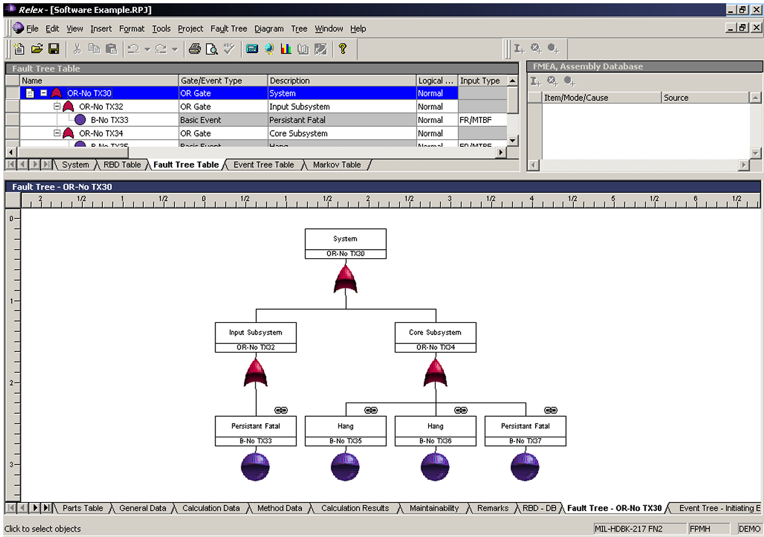

Tools

Component Availability Characteristics Table
Data captured within this table can be valuable input to:
- FMECA
- RBD
- FTA
Component | MTBF | MTTR

Note: It may be difficult to impossible to get MTBF values from hardware suppliers, so you may have to use informal measurements from situations which you have been involved in. Since there will be unofficial (and perhaps unreliable) measurements, you will need to exercise discretion about how widely they get showed, lest they will be misinterpreted as official IBM figures.

FMECA Core Process Table
FMECA Sheet
Project Name:
System Identifier:
Version:
Date:
Item # | Functions performed by item | Failure Modes | Root Cause | Probability | Operational Mode | Failure Effects  (Local, higher level and end effects) | Detection Method | Compensating Provisions | Severity

Component Management Table
Data captured within this table can be valuable input to:
- FMECA
Name of Component | < Component Name >
 | Description | Estimated Time
Detection | What component will detect the failure?(link to FMECA)
Notification | Through which mechanism will the failure be notified to the managed systems? | NOT APPLICABLE
Recovery | For the affected components what are the manual and automatic processes that will need to be performed in order to get the component back to a stable state?
Repair | Once the component has been recovered (e.g. to a secondary data centre, how can the failed component be repaired?
Reintegration | Once repaired what are the steps that have to occur to fully integrate the repaired component back in to the solution and return the solution back to its original state?

Planned Maintenance Table
Data captured within this table is valuable to determine the amount of change expected and therefore allow one to assess the possible outages required.
Component | Planned Maintenance  Frequency | Planned Maintenance  Time | Planned Maintenance  Duration
Hardware and Connections
Web Server | 1 / 6 months | Sunday 3 AM | 4 hours
Environment
Cooling plant | 1 / year | December 26 | 10 hours
C Software Middleware
UNIX | 1 / 3 months | Sunday 3 AM | 30 mins
Application Software
Call Centre Application | 1 / 1 month | Sunday 3 AM | 1 hour
Data
Customer DB refresh | 1 / year | Sunday 1 AM | 4 hours

Redundancy Table
Data captured within this table can be valuable input to:
- FTA
- RBD
Availability Feature | WEB Server | Directory and Security Server | Application Server | Back-End Data Server
Duplexed Hardware | Y | Y | Y | Y
Parallel Paths between this Server and next one | Y | Y | Y
Duplexed Data on Raid Disks | Y | Y | Y | Y
UPS to Server and DASD | N | Y | Y | Y
Automated Failure Detections and Recovery | N | N | Y | Y

Service to Component Table
Data captured within this table can be valuable input to:
- FMECA
However it can also be used when you do not have the time to perform a full FMECA.
Component | Service Type #1 | Service Type #2 | Service Type #3 | Service Type #4 | Service Type #5

Operational Phase Table
Data captured within this table can be valuable input to:
- FMECA
User Type | Service Type | Operational Phase 1 |  |  |  | Operational Phase 2 |  |  |  | Operational Phase 3
User Type | Service Type | Time Period | Avail-ability Factor | Max Outage Duration | Total Outages per month | Time Period | Avail-ability Factor | Max Outage Duration | Total Outages per month | Time Period | Avail-ability Factor | Max Outage Duration | Total Outages per month

Use Case Availability Requirements Table
This data is an enhancement to that captured for a use case. It allows one to understand availably with respect to the business function that the system has to perform.
Use Case | Service hours | Special characteristics | Impact of loss:  Critical/ High/Medium/Low |  |  |  | Fall back plan | Number of outages accept-able | Maximum Service Outage Period | Recovery Require-ment | Service Avail-ability %
 |  |  | A few secs. | 1-5 min | ½-1 hour | 3-4 hour | Fall back plan | Number of outages accept-able

Viability Assessment Table
The following risk probability, impact and urgency assessments are used as examples to illustrate the type of assessment you may make. Individual projects and clients have their own categories for these, that they will require you to use.
Risk - Red - This will cause the project to fail.
- Amber - This will affect the project to a significant extent.
- Green - Okay.
Probability - High - Greater than 50% chance of occurrence.
- Medium - 10 to 50% chance of occurrence
- Low - less than 10% chance of occurrence
Impact - High - Big impact on cost and time
- Medium - Some costs and time effected
- Low - No significant change to plan.
Urgency - High - Must be tackled immediately
- Medium - Plan to tackle
- Low - No action
Risk Area | Focus | Risk value | Probability | Impact | Urgency
Requirements | Is the architecture based upon a solid, reasonable and achievable foundation of requirements?
Technical Stability | Are the technologies chosen proven and not prone to change or instability?
Technical Complexity | Is the architecture too complex considering the state of the art, requirements, client environment, skills and client risk willingness and the timescales?
Technical Integrity | Is the architecture scope complete and all the expected pieces in place? If not is it reasonable to assume that it will be ?
Architectural Qualities | Can the architecture provide the qualities demanded of the business?
Ability to Deliver | Has the team implemented the skills, approach and support processes to deliver the architecture solution? Are the assumptions made during Solution Design still valid?
Development Approach | Does the team know how to create the work products and do they have working tools and a working environment?

Applying HA techniques in the IBM Global Services Method
The following chapter describes the six key work products taken from the Global Services Method and provides an availability focus for documenting these products.

Current IT Environment

Context
Impact of not executing this work product
Without understanding the availability characteristics of the Current IT Environment, delays caused by the following are likely to occur:
- The same information, required by different project tasks, will be gathered separately and repetitively.
- Interactions between the Current IT Environment and new developments may not be considered. This may result in failure to meet the availability characteristics of new developments and/or degradation in the characteristics of existing infrastructure.
Reasons for not needing this work product
This work product will not be required in situations where new developments do not share any physical components with the Current IT Environment. Note that in situations where Service Management components such as support staff are shared it may still be necessary to create this work product as existing component Mean Time to Repair may be impacted.

Notation
Not Applicable.

Development Approach
Completion of the Current IT Environment Availability Task is based on the collection and synthesis of data.
- Using the following steps:
- Formal/informal interviews and discussion with Users, Service Managers, Business Analysts, Architects and Operations Managers
- Additional sources are existing documentation such as architecture or design documents, service manuals, operations manuals and in the case of solutions which have been developed based on the Global Services Method from work products: Current IT Environment, Operational Model, Non-Functional Requirements and Service Level Agreement Characteristics

Data is collected around the following questions:
- Requirements
  - The Users and the Service
- Who are the users of the Current IT Environment
- What services are provided to each of the users
- What are the service level requirements for the users of the individual services
- Are there key periods of time when availability and/or performance is business critical to the users. Examples of critical periods could be a specific time of day, a certain day in the month or driven by a critical business event such as end of the financial year.
- Are the service levels as currently defined still appropriate to the business need – if not what should they be and who can agree to any changes.
- Are there any scheduled outages for the services provided and/or any of the underlying components such as data stores
- Are there any ongoing projects that may impact the characteristics of the existing services. Will these projects add new types of services and/or new types of users? Will they modify the existing availability characteristics?
  - Cost Associated with Unavailability
What is the cost of unavailability of the services provided? Costs can be of various different types:
- Lost business revenue – examples are lost share deals, lost credit card transactions, lost sales for e-businesses.
- Call-out and/or overtime charges for support and maintenance staff
- Service penalties for unavailability
- Loss of market perception of service
- Solution Design
  - The Components
- Which individual components of the infrastructure combine to deliver services to the users
- What are the availability characteristics of critical components
- Are there any high availability features in the current infrastructure such as:
- Local/Remote hot-standby facilities such as individual servers or even entire data centers
- Local/Remote disaster recovery facilities
- Local/Remote redundant components such as backup network adapters or RAID DASD arrays
- Continuous/Uninterruptible Power Supplies
- If so are the availability characteristics the same as those for the prime services – if not what are the differences
- Are these features automated/manual and what are the service levels for switching to the high availability alternative
- How are these components kept in synchronization with each other and how are they re-integrated following failure
- Are mechanisms in place to ensure that the high availability mechanisms are fully functional? If so, do they require specific downtime?
  - Techniques
- Which techniques can be used to help capture the key availability aspects of the required solution?
  - Operations and Systems Management
- What is the support and operational model in terms of number of staff, skills in place by time of day and hours of coverage and third party arrangements
- What are the support processes
- What maintenance plans are in place and do these require any specific outages
- What spares are held locally/remotely and how are these refreshed following usage
- Is there a release strategy for the current infrastructure and/or certain elements of it? How is availability incorporated within the strategy?
- How is operational testing and acceptance conducted, both for new releases and following maintenance?
- Other Factors
  - Testing for availability
- Is there a test strategy for the infrastructure? If so how is availability incorporated within the strategy?
- What test facilities are there? Do they share any components with the production services? Do they have an availability target, do they mirror the production systems and if not what are the differences and limitations?

Advice and Guidance
Not Applicable

Architectural Decisions

Context
Impact of not executing this work product
See the base work product, Architectural Decisions.
Additional considerations:
- Decisions serving high availability frequently are in conflict with cost, capacity estimates, programming approaches, timescales, and the extension of testing needs and sometimes even with security. A thorough documentation of the design decisions will prevent backing off from earlier choices under project pressures or at the least create a base for systematic risk assessment of the change.
- Since service availability is a multi-part, end-to-end concept design decisions should be considered in the context of other decisions – which then must exist in a well identified and managed document.
Reasons for not needing this work product
There are no reasons for not documenting system architecture and design decisions. Some Architectural Decisions do not need to be developed because they can be referenced.

Notation
Architectural Decisions can be documented in a table that describes the issue or problem, assumptions, motivation, alternative solutions, chosen solution, justification, implications, derived requirements and related decisions. These fields are not mandatory. For a given decision, many may be blank. Alternative textual forms are also possible.

Subject Area | Area of Concern | Topic | Topic of Interest
Architectural Decision |  | AD ID | A unique identifier
Issue or Problem | A short description of the problem—what is being decided
Assumptions | What is believed to be true about the context of the problem, constraints on the solution
Motivation | Why this decision is important
Alternatives | A list of alternatives and explanations
Decision | The decision taken, possibly with references to related work products
Justification | Why the decision was made plus a list of compliance to Architecture Principles and explanations of deviations from compliance
Implications | What impact the decision will have
Derived requirements | A list of requirements that are generated by this decision
Related Decisions | A list of related decisions

Architecture Evaluation Criteria are expressed in a template. The table categorizes the criteria, states important concerns and gives objective tests that can support decision-making. Many Architecture Evaluation Criteria are directly derived from non-functional requirements. The table below is an example of a template.

Area of Concern | Non-Functional Behavior |  |  | Quality Attribute | Service Availability
Criteria | Important considerations that should be used to evaluate architecture decisions
Test  <number> | One or more tests that can be objectively made to assess how well the criteria are satisfied. Each test must include quantifiable measures.
Objective Measures | Scale | Worst | Plan |  | Best | Now
Objective Measures | What range and units of measure will be used? | The worst acceptable situation | The planned capability or desired state |  | The best that could be achieved | The current situation
Justifying Requirements | A list of references to business and system requirements (including references, for example, to trade-off analyses)
Related Principles | A list of relevant principles that are satisfied by the evaluation criteria.

Development Approach
See base work product Architectural Decisions.
Additionally, some of the points to be considered and documented for availability are (The Availability Technique sections give you guidance in answering these questions):
- What are the key components of the system that you need to consider for availability purposes?
- Which component, or component type is the least available and most likely to limit the availability achievements of the system?
- Is redundancy required in the solution, why and where?
- How will the components be managed with respect to availability– NT clustering, HACMP for AIX, GDPS for S390?
- If data replication has been chosen then what mode and why – synchronous or asynchronous?
- Has RAID storage been chosen – if so what level and why? Do the project team understand the limitations of RAID storage?
- What mode will the components operate in for normal states and backup states?
- What happens when they fail?
- What ways can they fail and what does this mean to the other components and the end-users?
- What assumptions have been made for bespoke components and their availability characteristics?
- Have we got the right levels of disaster recovery?
- Is the testing plan adequate for this architecture with respect to availability?
- Is the system management design adequate for this architecture with respect to availability and recovery in particular?
How difficult would it be to enhance / extend the availability characteristics of the architecture say from 24*5 to 24*7 or to reduce the maximum downtime from 30 minutes to 10 minutes? What in the architecture inhibits this enhancement?

Advice and Guidance
There is a lot of advice and guidance with respect to Architecting for Availability in the Availability Technique sections. But remember:
- Availability is often achieved by having redundancy, i.e. spare or partially used components. But the architecture has to allow for these redundant components to be used at appropriate times. Just having the components on the shelf somewhere is not good architectural design if they need to be used by the system within minutes.
- Redundancy has a cost. Availability therefore costs money.
- Good availability (as perceived by the users) can only be achieved through sound system management. No matter how good your architecture and design is if the system is poorly managed it will have poor availability.
- Thorough testing is also essential if good availability is to be achieved. This is not so just for the initial system but for any change activity that significantly changes the system, especially change activity that changes the architecture.
- Today, hardware components are pretty reliable with their mean time between failures often being measured in ‘several years’. Software, if properly designed and tested can easily match and exceed this but when changed and the change is not properly tested the effects on a system’s availability achievements can be severe.
- These days, many long outages of systems are caused by corrupt or inaccessible data. Check that your architecture has been designed to deal with such a characteristic.
- Make sure that your architecture meets the requirements of the users as regards availability of service. If this is not agreed and understood by all involved it will not.

Operational Model

Context
Impact of not executing this work product
Inadequate consideration of the availability aspects of the system may result in the service level commitments defined for it not being met. It may also result in degradation of service levels on other systems that share components or resources with the one being developed.
Reasons for not needing this work product
This work product may be unnecessary if the system is subject to very moderate availability service levels.

Notation
Not Applicable

Development Approach
As defined in the main Work Product Definition the Operational Model is developed based on an iterative approach with three major levels – Conceptual, Specification and Physical. At each of these stages availability aware architecture and design decisions must be taken. The approach for availability analysis at each of the stages is the same. As the model progresses from conceptual through specification to physical stage the degree of detail in the availability analysis should increase. So also should the degree of confidence in the results.
The Operational Model provides a description of the required availability characteristics of the system as well as a high level view of the viability of achieving those characteristics. At the ‘Conceptual’ stage in the model lifecycle no technology decisions have been made about the system therefore only very high-level views of the likely availability achievable can be made. As the technology decisions are made in the ‘Specification’ stage of the lifecycle the degree of detail and the level of confidence in the analysis will increase. Finally at the ‘Physical’ stage of the model, when all components are specified, a fuller analysis of the system with the accompanying level of confidence will be possible.
Completion of the Operational Model Availability Task is based on the collection and synthesis of data.
Data Collection
Data is collected using the following steps:
- Formal/informal interviews and discussion with Users, Service Managers, Business Analysts, Architects and Operations Managers.
- Review of existing documentation such as Requests for Information (RFIs) or Requests for Proposals (RFPs) against which the solution is being developed, Proposal Documents, Services Contracts, or any existing architecture or design documents. In the case of solutions that has been developed using the Global Services Method the output from work products: Current IT Environment, Service Level Agreement Characteristics, Viability Assessment and Non-Functional Requirements should also be taken into consideration.
The following areas should be considered during data gathering.
- Requirements
  - The Users and the Service
- Who are the users of the Current IT Environment
- What services are provided to each of the users
- What are the service level requirements for the users of the individual services
- Are there key periods of time when availability and/or performance are business critical to the users? Examples of critical periods could be a specific time of day, a certain day in the month or driven by a critical business event such as end of the financial year.
- Are the service levels as currently defined still appropriate to the business need – if not what should they be and who can agree to any changes.
- Are there any scheduled outages for the services provided and/or any of the underlying components such as data stores
- Are there any ongoing projects that may impact the characteristics of the existing services? Will these projects add new types of services and/or new types of users? Will they modify the existing availability characteristics?
  - Cost Associated with Unavailability
What is the cost of unavailability of the services provided? Costs can be of various different types:
- Lost business revenue – examples are lost share deals, lost credit card transactions, lost sales for e-businesses.
- Call-out and/or overtime charges for support and maintenance staff
- Service penalties for unavailability
- Loss of market perception of service
- Solution Design
  - The Components
- Which individual components of the infrastructure combine to deliver services to the users
- What are the availability characteristics of critical components
- Are there any high availability features in the current infrastructure such as:
- Local/Remote hot-standby facilities such as individual servers or even entire data centers
- Local/Remote disaster recovery facilities
- Local/Remote redundant components such as backup network adapters or RAID DASD arrays
- Continuous/Uninterruptible Power Supplies
- If so are the availability characteristics the same as those for the prime services – if not what are the differences
- Are these features automated or manual and what are the service levels for switching to the high availability alternative
- How are these components kept in synchronization with each other and how are they re-integrated following failure
- Are mechanisms in place to ensure that the high availability mechanisms are fully functional? If so do they require specific downtime?
  - Techniques
- Which techniques can be used to help capture the key availability aspects of the required solution?
  - Operations and Systems Management
- What is the support and operational model in terms of number of staff, skills in place by time of day and hours of coverage and third party arrangements
- What are the support processes
- What maintenance plans are in place and do these require any specific outages
- What spares are held locally/remotely and how are these refreshed following usage
- Is there a release strategy for the current infrastructure and/or certain elements of it? How is availability incorporated within the strategy?
- Other Factors
  - Testing for availability
- Is there a test strategy for the infrastructure? If so how is availability incorporated within the strategy?
- What test facilities are there? Do they share any components with the production services? Do they have an availability target, do they mirror the production systems and if not what are the differences and limitations?
The data gathered above should be represented in a ‘Users and Services Availability Table’ and should be supported by a ‘Service Level Justification’ document which describes the rationale for the service levels applied together with cost justification where appropriate.
A viability analysis for each of the user services defined should be carried out. In summary the process consists of three main stages. Firstly the components that combine to provide the specific services should be identified. Secondly, the expected availability that should be achievable based on those components should be estimated. Finally a check should be made against the required service levels to see if they can be met.
Note that in certain circumstances availability budgets should be allocated. Estimates of the anticipated availability of a component may be used to facilitate the analysis. Compliance with these estimates or budgets should be verified at later stages of the development of the system.
The use of budgets is a technique used in performance and availability design that takes the overall response time or availability target and allocates to each component a target (or budget) that they must meet if the overall system is to meet its end target.
At each stage of the development process an appropriate level of review should be undertaken to ensure that the anticipated solution in terms of both computer systems and supporting organization is compatible with the business case against which the system is being built. If not then the project may need to be revisited in terms of service levels or required funding.

Advice and Guidance
Not Applicable

Service Level Agreement Characteristics

Context
Impact of not defining this work product
See base Service Level Agreement Characteristics work product.
Reasons for not needing this work product
This work product may not be required in situations where business-as-usual service availability is expected. While such a situation in contemporary designs is rare, reference or convenience services possibly backed up with manual help fall into this category.

Notation
Additional notation is suggested by the following Table, which supports the systematic evaluation of the availability aspects of the design.

Failure | Detect | Analyse/decide | Repair of the failed component | Restart of the service (component) | Consequences to a User | Outage Time
AT&T line (service restoration) | Automatic Consumer ISP DNS | Automatic | Not Applicable | DNS switches over to Bell line to CPO. | Transparent. May see slightly longer response time | None. Slight delay
AT&T line (component repair) | Handled by AT&T | Handled by AT&T | Handled by AT&T | Handled by AT&T | NOT APPLICABLE | None. Slight delay

Development Approach
The Availability SLCA WP can be created in a number of different ways, reflecting both the complexity of the design and the elevation of the availability expectations towards the system.
Some of the possible approaches include:
- Simple availability walkthrough recording the weakest component and comparing its outage against the permissible outage times
- A systematic, end-to-end analysis of all the major components, their failure characteristics and the redundancy included. This analysis is vaguely following the Failure Mode Effect Analysis technique and yields results shown in the Table above. Ultimately, both the service restoration times (compared to availability expectations) and the component restoration time representing the degree of additional exposure are determined and conclusion about the adequacy of the design and the chosen products is drawn. Note, that the evaluation is performed against the specific products chosen and their capability, as opposed to the specifications developed during system design, as documented in the Operational Model (WP 113).
- A probability theory based model, when MTBF and MTTR data is available for all the physical components comprising the solution (see WP 113 and 119).

Advice and Guidance
The approach must be carefully selected. The mathematical model, should incorrect input be chosen, is not only time consuming but also may create false comfort. The FMECA approach, while greatly enhancing the understanding of the system’s actual behavior, can be very time consuming.

Viability Assessment

Context
Impact of not executing this work product
As it is easier to design something without worrying about its viability, not having this work product sub-task increases the risk of an IT system being late or incomplete or incapable of meeting the availability requirements the business requires.
Reasons for not needing this work product
This work product will not be required in situations where there are no questions as to the viability of the solution. This will normally be where there are multiple existing solutions of a similar nature with a proven record of delivery or where the availability characteristics of the solution are trivial.

Notation

Development Approach
The Availability Viability Assessment evolves through the life of a project. It is initially created during the development of the non-functional requirements and then refined at each major architectural elaboration milestone. Conducting a viability assessment involves the steps shown below. These steps support a formal review for large projects. In most situations the availability viability assessment can be carried out in conjunction with the main Viability Assessment work product. However in the case of a very highly available and complex system it may be necessary to have a separate assessment process. For informal reviews or smaller projects where only a single individual may conduct the assessment the tasks should be scaled back accordingly. An external QA organization using the work product may expand upon these activities, for example adding kick-off meeting, etc.
- Plan the Assessment. Planning the assessment involves identifying key personnel to be interviewed, identifying the data to be gathered to support the assessment, scheduling the meeting or interviews; developing agendas and checklists; and, collecting and distributing materials for assessment participants. A key decision is the level of availability analysis that is appropriate to the situation. In complex situations where there are multiple services across multiple data centers and servers it may be appropriate to use different levels of analysis for different services depending on their criticality. Material which may contain specific availability requirements include current non-functional requirements documents, services contracts, operations manuals, service manuals and service reports for projects which are extending Current IT Environments. On a large project, participants should include the architecture team, client IT organization representatives and product specialists. Adequate time should be allocated to accommodate schedules and allow for potential rework.
- Prepare for the Assessment. Assessment participants should study the assessment material. They should document any identified findings such as issues, defects, concerns and comments. The review material should be distributed several days prior to the review to give adequate time to prepare. Review materials would include work products such as the operational model, component model and architectural decision.
- Conduct Meetings and Interviews. For a formal assessment, conduct a kick-off meeting for participants, presenting the solution, major work products and key issues. Key project team members can also be interviewed to delve deeper into the solution and uncover critical risks and issues.
- Assess Viability. Upon completion of data gathering, the architect prepares a viability assessment. This is a 5 stage process.
- A ‘Users and Services Availability Table’ should be developed which maps users onto the services they will be accessing.
- A ‘Service/Component Mapping Table’ is developed which lists the individual components of the solution that combine to supply the various services.
- The expected availability that should be achievable based on those components should be estimated.
- A check should be made against the required service levels to see if they can be met. Note that in certain circumstances budgets should be allocated or estimates of the anticipated availability of a component may be used to facilitate the analysis. Compliance with these estimates or budgets should be verified at later stages of the development of the system.
- Finally, look at each work product and compare it against the Validation and Verification requirements in the work product description. Examine if the solution is viable in light of the IBM contract and subsequent project change requests. Will it deliver the architectural qualities IBM has promised? Can this be achieved within the budget allocated?
- Present Preliminary Findings and Risks. Risks and issues identified during the review are documented and forwarded to the project manager for inclusion in the project’s risk and issue management processes. Consider the following areas when defining the risk of a technical solution.
Risk Area | Focus
Requirements | Is the architecture based upon a solid, reasonable and achievable foundation of requirements?
Technical Stability | Are the technologies chosen proven and not prone to change or instability?
Technical Complexity | Is the architecture too complex considering the state of the art, requirements, client environment, skills and client risk willingness and the timescales?
Technical Integrity | Is the architecture scope complete and all the expected pieces in place? If not is it reasonable to assume that it will be?
Architectural Qualities | Can the architecture provide the qualities demanded of the business?
Ability to Deliver | Has the team implemented the skills, approach and support processes to deliver the architecture solution? Are the assumptions made during Solution Design still valid?
Development Approach | Does the team know how to create the work products and do they have working tools and a working environment?

- Develop and Deliver Final Viability Assessment Report. The final report should summarize the recommendations and findings of the viability assessment. Risk should be stated with appropriate containment actions. Follow-up items should be stated in terms of owners and completion dates. The need for additional follow-up solution review by external reviewers needs to be confirmed and tentatively scheduled.

Validation and Verification
Consider the following points:
- Has the assessment focused on the issues that represent the greatest availability viability threat to the IT system?
- Has the assessment really asked the difficult questions and probed for viability issues? (In other words, has it taken an independent and objective view, or just presented a justification of work done?)
- Do the people performing the assessment believe that they have sufficient familiarity with the proposed system; do they have sufficient availability design experience and sufficient time, to perform an adequate viability assessment?
- Have any serious viability issues been escalated into the formal risk management process?
Viability Assessment Checklist
The following is an extensive checklist that can be used as a guide when validating the availability characteristics of technical solutions. There is a large overlap with the checklist used in the main Viability Assessment work product. For items that fail, develop a Risk Ranking Worksheet to understand the relative impact. Items that pose a significant probability of loss are addressed in the Findings and Recommendations section of the Viability Assessment report.
Requirements
Guideline / Rule
Have all the availability requirements been identified and documented?
Are the requirements reasonable considering the “state of the art”, budget, schedule, skills, or client infrastructure and capabilities?
Is it clear how the solution design supports the requirement models?
Are all of the requirements supported by the solution design?
Are requirements specific, measurable and self-consistent?
Is it clear how the solution design supports the design models?

Review Package Completeness
Guideline / Rule | Pass/Fail
Are the operational characteristics of the package understood? Are they benchmarked?
Does the package provide interfaces to integrate with other systems? If so are the availability characteristics of the integrated elements understood? Have they been considered in the assessment?
Are the architecture documents to be reviewed in the package?

Technical Stability, Complexity, Integrity and Architectural Qualities
Guideline / Rule | Pass/Fail
Has the solution design considered the main aspects of the problem?
Does the solution support the project’s goals, service levels and technical deliverables as defined in the statement of work?
Is the solution design consistent with the customer’s IT standards or IT Architecture?
Is the customer prepared to adopt all proposed and approved technologies?
Is there a customer commitment to sustain the vision of the system?
Are anticipated changes to the design addressed and supported in the solution design?
Do the architectural decisions have enough justification?
Has data integrity been considered from a solution design perspective?
Has data persistence been considered from a solution design perspective?
Has data concurrency been considered from a solution design perspective?
Have transaction processing speeds and capacities been considered from a solution design perspective, especially in failure modes?
Have transaction types such as nested and long-running transactions been considered from a solution design perspective?
Have batch-processing capabilities been considered from a solution design perspective?
Has restart and recovery been considered from a solution design perspective?
Have communications been considered from a solution design perspective?
Has networking support been considered from a solution design perspective?
Has security been considered from a solution design perspective?
Has authentication been considered from a solution design perspective?
Has scalability been considered from a solution design perspective?
Has maintenance been considered, and the impacts that it could have to the availability of the solution?
Can the tests to assess architectural options against the requirement criteria be realistically performed?
Have tests with known values been defined for benchmarking?
Are all design decisions, which require global co-ordination across the project included in architecture decisions?
Are the classic trade-off questions pertinent to this system (for example, performance, flexibility, extensibility, availability, reliability and so on) addressed?
Does the solution design foster inter-operability and data exchange?
Have the appropriate metrics been defined?
Have high-risk solution components been identified and prototyped or are they planned?
Are the selected solution components viable and generally available?
If a system management plan is necessary, is it sufficient and complete?
Are the selected solution components proven in an environment with similar requirements and constrains?

Architectural Traceability
Guideline / Rule | Pass/Fail
Check the requirements work products to ensure that enough statements were extracted to form an adequate basis for traceability.
Verify that acceptance test cases have been stated where applicable.
Verify that all tests in the Acceptance Test Plan, Usability Test Cases and System Test Plan are traceable to the requirements.
Have the traceability results been validated with the customer to show that the system is providing the required capabilities?
Has duplicate trace information been avoided?
Are all of the availability related decisions tied to their source (problem statement, non-functional requirements and so on) so that if the source elements change, the decisions derived from them can be reconsidered easily? (This provides traceability from requirements into the implemented system).

Operational Model
Guideline / Rule | Pass/Fail
Is the operational model specification complete? Does it include: hardware platforms, system requirements, operating systems, connections, network protocols, network requirements and language runtime?
Is the operational model consistent with each of the availability requirements and architectural decisions?
Was the availability approach (Ref. Chapter 1 page 8) used to verify the model’s ability to deliver the appropriate service level characteristics?
Is the operational model consistent with the Deployment Units model?
Are all the prerequisites for hardware, software and networking performance and specifications documented?
Have walkthroughs been performed to ensure that operational and system management scenarios are covered (e.g., restoring a key database, adding a new server, etc.)?
Has the operational model considered system management, backup and recovery and security needs?

Component Model
Guideline / Rule | Pass/Fail
Has the component partitioning been checked for optimal decoupling of components?
Has the frequency and size of inter-component communications been minimized?
Are the dependencies between components minimized?
Is the subsystem application independent as much as possible?
Are major component interfaces at all levels (including user interface, work station connection, local area network, distributed servers, wide area network, host and database) defined and maintained?
Openness – Can components be modified and integrated in alternate ways?

Deployment Units
Guideline / Rule | Pass/Fail
Are the availability requirements consistent with the operational model?
Are all components mapped onto deployment units?
Is the mapping between component models and deployment units clear?
Are all component interfaces defined in time to be used by the developers of other components?
Is the frequency and size of inter- component communications minimized?
Is the boundary of the system to be built explicitly represented in the deployment unit model?
Is each deployment unit understandable in isolation?
Are the deployment unit interfaces clearly and fully described?
Are major deployment unit interfaces at all levels (including user interface, work station connection, local area network, distributed servers, wide area network, host and database) defined and maintained?

Ability to Deliver and Development Approach
Guideline / Rule | Pass/Fail
Are the appropriate levels and numbers of availability aware technically skilled individuals available to the team?
Have IT organizational skills gaps been suitably addressed?
Is there a clear and viable migration path defined to get to the solution?
Given disruption to the customer's normal operation in migrating to the solution, is there a contingency plan if initial migration to the solution does not work?
Are the appropriate system management disciplines in place for the solution?
Does the client have the capability to support the solution once IBM has completed the project?
Will the solution design initial and on going costs meet client budget and ROI objectives? Does the project team understand the cost ramifications of the solution?
Remember if you assess “fail” then you will most probably be asked to propose ways in which this state can be changed to pass.

Advice and Guidance
The effectiveness of the availability viability assessment depends on the quality of the data used. If the data is inaccurate or incomplete then the assessment may be flawed.
The data that should be gathered to support the availability viability assessment includes:
- Requirements
  - The Users and the Service
- Who are the users of the Current IT Environment
- What services are provided to each of the users
- What are the service level requirements for the users of the individual services
- Are there key periods of time when availability and/or performance are business critical to the users? Examples of critical periods could be a specific time of day, a certain day in the month or driven by a critical business event such as end of the financial year.
- Are the service levels as currently defined still appropriate to the business need – if not what should they be and who can agree to any changes.
- Are there any scheduled outages for the services provided and/or any of the underlying components such as data stores
- Are there any ongoing projects that may impact the characteristics of the existing services? Will these projects add new types of services and/or new types of users? Will they modify the existing availability characteristics?
  - Cost Associated with Unavailability
What is the cost of unavailability of the services provided? Costs can be of various different types:
- Lost business revenue – examples are lost share deals, lost credit card transactions, lost sales for e-businesses.
- Call-out and/or overtime charges for support and maintenance staff
- Service penalties for unavailability
- Loss of market perception of service
- Solution Design
  - The Components
- Which individual components of the infrastructure combine to deliver services to the users
- What are the availability characteristics of critical components
- Are there any high availability features in the current infrastructure such as:
- Local/Remote hot-standby facilities such as individual servers or even entire data centers
- Local/Remote disaster recovery facilities
- Local/Remote redundant components such as backup network adapters or RAID DASD arrays
- Continuous/Uninterruptible Power Supplies
- If so are the availability characteristics the same as those for the prime services – if not what are the differences
- Are these features automated/manual and what are the service levels for switching to the high availability alternative
- How are these components kept in synchronization with each other and how are they re-integrated following failure
- Are mechanisms in place to ensure that the high availability mechanisms are fully functional? If so do they require specific downtime?
  - Techniques
- Which techniques can be used to help capture the key availability aspects of the required solution?
  - Operations and Systems Management
- What is the support and operational model in terms of number of staff, skills in place by time of day and hours of coverage and third party arrangements
- What are the support processes
- What maintenance plans are in place and do these require any specific outages
- What spares are held locally/remotely and how are these refreshed following usage
- Is there a release strategy for the current infrastructure and/or certain elements of it? How is availability incorporated within the strategy?
- Other Factors
  - Testing for availability
- Is there a test strategy for the infrastructure? If so how is availability incorporated within the strategy?
- What test facilities are there? Do they share any components with the production services? Do they have an availability target, do they mirror the production systems and if not what are the differences and limitations?

Non-Functional Requirements

Context
Impact of not defining this work product
Without understanding the availability requirements the development team is seriously impeded in delivering a well-behaved system. Availability requirements are defined around the certainty of failure and they provide the context for the complexity and sophistication of mitigating approaches.
Not defining the requirements may not cause harm to the project execution but inevitably leads to client dissatisfaction and potentially very expensive, after the fact, modification.
Reasons for not needing this work product
This work product will be required even in situations where business-as-usual service availability is expected, in order to establish and document what the client’s understanding of this term is. While such a situation is rare, reference or convenience services possibly backed up with manual help fall into this category.

Notation
Not Applicable

Development Approach
The Availability NFR sub-task is created through the collection and synthesis of data, using the following steps:
- Formal/informal interviews and discussion with Users, Service Managers, Business Analysts, Architects and Operations Managers.
- Review of the Availability Requirements of the relevant Reference Architectures or other existing designs.
- Reasonability checks when extreme values are specified (e.g. max. outage in seconds or less than 1 failure per year) and - if necessary – negotiations for the requirements defined, in view of the anticipated cost, complexity and the enterprises current capabilities. Work product Current IT Environment should be referenced for the latter, particularly if the system designed relies on existing systems.

Data is collected around the following questions:
- Requirements
  - The Users and the Service
- Who are the users of the Current IT Environment
- What services are provided to each of the users
- What are the service level requirements for the users of the individual services
- Are there key periods of time when availability and/or performance are business critical to the users? Examples of critical periods could be a specific time of day, a certain day in the month or driven by a critical business event such as end of the financial year.
- Are the service levels as currently defined still appropriate to the business need – if not what should they be and who can agree to any changes.
- Are there any scheduled outages for the services provided and/or any of the underlying components such as data stores
- Are there any ongoing projects that may impact the characteristics of the existing services? Will these projects add new types of services and/or new types of users? Will they modify the existing availability characteristics?
  - Cost Associated with Unavailability
What is the cost of unavailability of the services provided? Costs can be of various different types:
- Lost business revenue – examples are lost share deals, lost credit card transactions, lost sales for e-businesses.
- Call-out and/or overtime charges for support and maintenance staff
- Service penalties for unavailability
- Loss of market perception of service
- Solution Design
  - The Components
- Which individual components of the infrastructure combine to deliver services to the users
- What are the availability characteristics of critical components
- Are there any high availability features in the current infrastructure such as:
- Local/Remote hot-standby facilities such as individual servers or even entire data centers
- Local/Remote disaster recovery facilities
- Local/Remote redundant components such as backup network adapters or RAID DASD arrays
- Continuous/Uninterruptible Power Supplies
- If so are the availability characteristics the same as those for the prime services – if not what are the differences
- Are these features automated/manual and what are the service levels for switching to the high availability alternative
- How are these components kept in synchronization with each other and how are they re-integrated following failure
- Are mechanisms in place to ensure that the high availability mechanisms are fully functional? If so do they require specific downtime?
  - Techniques
- Which techniques can be used to help capture the key availability aspects of the required solution?
  - Operations and Systems Management
- What is the support and operational model in terms of number of staff, skills in place by time of day and hours of coverage and third party arrangements
- What are the support processes
- What maintenance plans are in place and do these require any specific outages
- What spares are held locally/remotely and how are these refreshed following usage
- Is there a release strategy for the current infrastructure and/or certain elements of it? How is availability incorporated within the strategy?
- Other Factors
  - Testing for availability
- Is there a test strategy for the infrastructure? If so how is availability incorporated within the strategy?
- What test facilities are there? Do they share any components with the production services? Do they have an availability target, do they mirror the production systems and if not what are the differences and limitations?
Synthesis of this data into a final document should be done by a qualified Availability Architect, then reviewed by the larger group of stakeholders for accuracy.

Advice and Guidance
Frequently the information provided may not be consistent between the two matrices, acquired from different constituencies. A reconciliation is required, e.g. to ascertain that the user access availability is no more constrained than that of the accessed service.
- References
Sidney Dekker: The field guide to human error investigations | ISBN 0-7546-1924-9
Recovery Oriented Computing | http://roc.cs.berkley.edu/roc_overview.html
Gregory F.Pfistee: In search of Clusters | ISBM 0-13-899709
Virtualization and the On Demand Business | IBM Red paper, REDP-9115-00 July, 2004
Reliability: A Practitioner’s Guide | http://www.relexsoftware.com/resources
John Easton: Latency Considerations | HA Community of Practice Team room
- Revision History
Revision Number | Revision Date | Summary of Changes | Authors
4.1.2 | Jul 2005 | Rewrite | Dan Bailey  Jeremy Bell  John Easton  George Galambos  Pieter Lindeque  Harriet Morrill  Maurice Perks  Erwin Frank-Schultz  Ulrich Walter  Hugh Varilly  Steve Hayes  Peter Long
1 | Oct 2000 | Removed confidentiality markings from header.
1.2 | Sep 1999 | Applied to template, spelling and grammar review.
1.1 | Feb 1999 | A standard format template was applied.
1.0 | Sep 1998 | Base Version

Appendix A – Terms & their Definitions

Term | Definition
Business Continuity | Business Continuity means the continued operation of business processes to, at least, a predetermined acceptable level in the event of a major business disruption.
Business Recovery Objective (RO) | The desired time within which business processes should be recovered, along with the minimum staff, assets and services required within this time.
Business Resilience | The ability of the business to rapidly adapt and respond to opportunities, regulations and risks, in order to maintain secure, continuous, business operations, be a more trusted partner, and enable growth.  Business Resilience spans business strategy, organizational structure, business and IT processes, IT infrastructure, applications and data, and facilities. It arises from the implementation and management of a plan that ensures high availability through monitoring and automatic adjustment of redundant or virtualized (distributed) infrastructure.
Continuous Availability (CA) | Attribute of a system to deliver non disruptive service to the end user 7 days a week, 24 hours a day (there are no planned or unplanned outages).  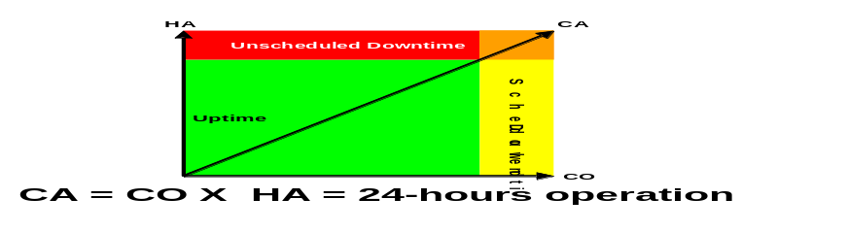
Continuous Operations (CO) | Attribute of a system to continuously operate and mask planned outages from end-users. It employs Non-disruptive hardware and software changes, non-disruptive configuration, software coexistence
Disaster Recovery | Given a major disruption caused by a disaster, fully recover essential data and operations. DR encompasses the ability of the total design to transfer data and workload offsite and to restart the workload at a new site. The switch often involves a system and service outage but in the extreme the switch can be made completely seamless to important users.
Fault Tolerance | Fault Tolerance is that property of a component, sub-system or system that means that normal service continues even though a fault has occurred within the system.
Gradual Recovery | Previously called ‘Cold stand-by’, this is applicable to organizations that can function for a period of up to 72 hours, or longer, without a re-establishment of full IT facilities.  This may come from having a stand-by empty facility fully equipped with power, environmental controls and local network cabling infrastructure, telecommunications connections, and available for an organization to install its own computer equipment.
High Availability | The attribute of a system to provide service during defined periods, at acceptable or agreed upon levels and masks unplanned outages from end-users. It employs Fault Tolerance; Automated Failure Detection, Recovery, Bypass Reconfiguration, Testing, Problem and Change Management.
Immediate Recovery | Previously called ‘Hot stand-by’, provides for the immediate restoration of services following any irrecoverable incident.  Hot stand-by previously referred to availability of services within a short timescale such as 2 or 4 hours whereas immediate recovery implies the instant availability of services.
Impact | Measure of the business criticality of an incident, problem or Request for Change. Often equal to the extent of a distortion of agreed or expected Service Levels.
Incident | An event or series of events that disrupts, or has the potential to disrupt IT production services to the user.
Intermediate Recovery | Previously called ‘Warm stand-by’, typically involves the re-establishment of the critical systems and services within a 24 to 72 hour period and is used by organizations that need to recover IT facilities within a predetermined time to prevent impacts to the business process
IT Business Resilience | Control of underlying IT Resources so as to support the Business Resilience policies of the organization.  The objective of the ODOE BR strategy is to ensure that the availability and resilience needs and actions are integrated into the everyday ongoing operations of information technology systems and therefore will lead to predictable, successful outcomes in case of planned or unplanned outage.
MTTF/MTBF Mean Time to Failure / Mean Time between Failure | The mean / average time between successive failures of a given component, sub-system or system. In the extreme MTTF is MTBF plus MTTR but since MTBF and MTTF are usually much longer than MTTR (say months as opposed to hours) for our purposes they are the same.
MTTR Mean Time to Recover | The typical time that it takes to recover (includes repair) a component, sub-system or a system. Usually seconds, minutes, hours, possibly days or even months in the case of component like a data centre.  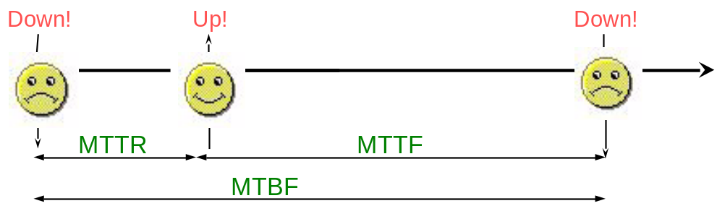
Network Recovery Objective (NRO) | How long can you afford to take to switch over the network?
Problem | A fault or defect that requires further analysis after recovery, to determine and eliminate the cause of the incident
Resilience | The ability of an IT service to maintain its specified availability in spite of the incorrect operation of one or more components.
Recovery Point Objective (RPO) | When it is recovered, how much data can you afford to re-create?
Recovery Time Objective (RTO) | How long can you afford to be without your systems?
Reliability | The reliability of an IT Service can be qualitatively stated as freedom from operational failure. Reliability is the probability that an item will perform its intended function for a specified interval under stated conditions. Simply stated, it is how long the system can work.
Scheduled Outage | A time period when the system is not ready for usage and the users do not expect it to be. That is: a planned outage. These are ‘Predefined Events’, often-repetitive calendar outages, for example the first Sunday in each month.
Unscheduled Outage | A time period when the system is not ready for usage and the users expect it to be. That is: an unplanned outage. These are ‘Random Events’.
Mission Reliability | Mission reliability is the probability that a system will perform mission-essential functions for a period of time under the conditions stated in the mission profile. Measures of mission reliability include only those incidents affecting mission accomplishment.
Logistics Reliability | Logistics reliability is the probability that no corrective maintenance or unscheduled supply demand will occur following the completion of a specific mission profile.
Reliability Prediction | A reliability prediction is the analysis of parts and components in an effort to predict the rate at which a system or subsystem will fail.
Maintainability | Maintainability is the probability that if prescribed procedures and resources are used, an item will be retained in, or restored to, a specific condition within a given period.
Availability | Ability of a component or service to perform its required function at a stated instant or over a stated period of time. It is usually expressed as the availability ratio, i.e. the proportion of time that the service is actually available for use by the customers within the agreed service hours. (Agreed-Unavailable) / Agreed * 100%)
Operational Availability | Operational Availability (Ao), covers all time segments the system is intended to be operational. Operational availability is based on a mathematical relationship among three characteristics: reliability, maintainability and the effectiveness of the logistics support system.
Inherent Availability | Inherent Availability (Ai), is a measure of the system availability with respect only to operating time and corrective maintenance. Under these idealised conditions, the time involved in preventive maintenance, the delay times associated with all types of maintenance actions and administrative delays are ignored.
Achieved Availability | Achieved Availability (Aa), is frequently used during development testing and initial production testing, when the system is not operating in its intended support environment. It is defined over a specific period of time and relates the time the equipment is in use, i.e., operating time (OT), to the sum of the OT plus the corrective maintenance time (TCM) plus the preventive maintenance time (TPM).
Redundancy | Redundancy is the use of components / nodes in parallel. It can help improve mission reliability and generally decreases logistics reliability and increases support costs.
Failure Mode, Effect and Criticality Analysis | Failure Mode, Effect and Criticality Analysis (FMECA) is a bottom-up procedure to analyze each potential failure mode, to determine its effects on the system and to classify each potential failure mode according to its severity. The purpose is to provide a safer, more reliable initial design. FMECA also helps to identify and eliminate any single points of failure in the design process.
Fault tree analysis | Fault tree analysis (FTA) is a deductive, top-down method of analyzing the causes of system failure. It involves specifying a top event, such as a system crash, followed by identifying all the probable causes for that top event. The entire system, including human interactions is analyzed when performing a fault tree analysis. Fault trees provide a convenient symbolic representation of the combination of events or failures resulting in the top-level event.
Reliability Block Diagram | A Reliability Block Diagram (RBD) is a tool for analyzing the combinations of complex components and assemblies, often designed with various redundancies in order to improve the overall reliability of the system. The analysis of these types of redundancies and failure rate calculations require the use of sophisticated mathematical algorithms to calculate failure rates, reliability and availability.

on demand Business Resilience (BR) Framework Terms/Definitions
Term | Definition
Recovery Segment | Recovery segment is a collection of resources that indicates the granularity level for attachment of policy and for specification of recovery actions and planned reconfiguration actions. Recovery segments can be composed of other recovery segments and nested. The odOE BR Framework increases the choice of recovery options by providing architected, granular recovery segments. Examples of recovery segments that have architectural support within the BR framework include: process, data, network components, middleware, OS, server, cluster, application, data centre, site and multi-site. The BR solution processes error situations using these recovery segments as scope indicators. In addition, customers will be able to attach policy on a per recovery segment basis, each of which will trigger associated sets of recovery actions.
Fault Boundary | Fault boundary is a term that describes the outer edges of a recovery segment. If the recovery segment is composed of other segments, then the fault boundary signifies the full set of affected recovery segments. Fault boundaries can intersect and overlap and are important in identifying the potential impact of recovery actions.  To determine fault boundaries accurately, it is important to understand the implications of recovery segments that are contained in other segments, in the context of recovery segment policies and desired recovery actions. When recovery segments intersect, there must be a broader scoped, composed segment which totally contains the lower level segments (i.e. a hierarchical structure). This will enable you to build recovery actions on the higher composed level that are to be driven down the lower segments in the context of the composition. The complete scope of all the involved recovery segments would be considered the fault boundary.
Containment Region | Containment region is a term that describes the set of resources affected by a failure or by a planned outage. It is the isolation scope of the outage. This will be reflected as a set of operational relationships between resources.
Recovery Action | Recovery action describes a specific step taken by the BR framework in the course of managing availability for a particular recovery segment. Examples of recovery actions include: start/stop/migrate resources, notify operator, switch data replica, provision new resource, initiate workflow and switch back. The BR framework provides a consistent framework for plug points for different recovery and planned actions.
Recovery Continuum | Recovery continuum is the abstract representation of a consistent, pluggable, policy oriented availability infrastructure that handles a range of outages from simple single process failures to complex site outages, for purposes of both planned and unplanned downtime. Within the context of ODOE, the implementation of a recovery continuum is described as the Resilience Framework.
Recovery Time Objective (RTO) | Maximum time that a given resource, or set of resources, can be non-operational in case of an outage, generally measured in hours or days.
Recovery Point Objective (RPO) | Maximum committed data that is tolerable to lose in case of an outage, generally measured in seconds, minutes and hours.
Consistency Set | A consistency set is a logical grouping of either data or storage that is required to be maintained in a time consistent state during replication or backup. Consistency sets result from application awareness and reliance on the state coherency of all members’ data or storage representations across heterogeneous environments and applications.
Appendix B – Examples: Applications of Techniques
IBM Global Services Method material examples
B1 - Current IT Environment Availability
The following example expands on the NIBCO Current IT Environment example in the main Current IT Environment WP. Two tables have been developed which describe the availability characteristics of the Current IT Environment. Firstly a ‘Users and Services Availability Table’ which illustrates the availability requirements of the various users of the services provided by the Current IT Environment:

User Type | Service Type | Time Period 1 |  |  |  | Time Period 2
User Type | Service Type | Time Period | Avail-ability Factor | Max Outage Duration | Total Outages per month | Time Period | Avail-ability Factor | Max Outage Duration | Total Outages per month
Administrator | Local Man-Man Application Services | 08:00 to 09:00 w/d | 98% |  |  | 10:00 to 15:00 w/e | 95%
Data Entry | Local Man-Man Application Services | 09:00 to 10:00 w/d | 99% |  |  | 10:00 to 15:00 w/e | 0%
Sales Executives | Remote Man-Man Application Services | 10:00 to 17:00 | 95% |  |  | 10:00 to 17:00 last day of sales month | 99%

Secondly a ‘Service/Component Mapping Table’ that identifies the components that together provides the various services for the Users:

Component | Service Type #1 | Service Type #2
Component | Local Man To Man Application Services | Remote Man-Man Application Services
H9000 Server | X | X
HP-UX | X | X
Informix | X | X
Man-Man Application | X | X
Local HP Terminal | X
Remote HP Terminal |  | X
Remote TCPIP Interface |  | X

B2 - Availability Architectural Decisions
Architectural Decisions
Subject Area | Disaster Recovery/Load Sharing | Topic | Operational Architecture
Architectural Decision | How/if to implement disaster recovery | AD ID | AD4
Problem Statement | Company has a City data centre, which is being configured for disaster recovery of enterprise applications. This decision deals with how the City data centre would be used in the architecture.
Assumptions | For this decision, we are assuming that the planned 2000 network changes and dual data centre configurations will take place.
Motivation | Estimating hardware costs for the project is highly dependent on the number of nodes in the architecture. A disaster recovery configuration can greatly influence the number of nodes.
Alternatives | 1. No additional disaster recovery or failover procedures.  This alternative would not add any infrastructure to the City data centre and would only leverage the redundancy already in place there, such as the backup mainframe.  2. Skeleton XXX infrastructure.  This alternative would place the minimum amount of infrastructure in the City to be able to run the XXX application with limited capacity. Such infrastructure would include a single web server and application server.  3. Shared load and full disaster recovery.  This alternative would place a complete infrastructure in the City for disaster recovery, such as multiple web servers and application servers. Because the infrastructure would be able to handle a good portion of the XXX load, some of the XXX traffic would be regularly routed through this infrastructure.
Decision | Alternative #3 (Shared load and full disaster recovery) is the recommended approach.
Justification | The Company is making great strides to increase availability and share load throughout the internal organization. The experience gained in this effort and the infrastructure built to support that effort ought to be leveraged to extend this concept to the Company’s Internet applications.  Alternative #1, though initially low cost, would present future risks of systems outages and resulting lost revenue. Alternative #2 provides for disaster recovery, but would have very limited capacity. Alternative #3, however, builds the basis for a full-fledged data centre. By having clusters of servers, if a disaster occurs, adding servers to the infrastructure would be relatively easy to accomplish. Also, under the alternative #3 approach, the Company can share the XXX load across data centers, providing for increased scalability.
Implications | The Company’s current disaster recovery efforts will need to be extended to support XXX, which include acquisition of the necessary hardware.
Derived requirements | None.
Related Decisions | None.

Architecture Evaluation Criteria
Area of Concern | System Performance |  |  | Quality Attribute |  | Availability
Criteria | Uptime for normal operations  Time to cut over to new releases of the system  Time to recover from malfunctions
Test 1 | Inspect operational logs for % of uptime in 24-hour periods of operation
Objective Measures | Scale | Worst | Plan |  | Best | Now
 | % uptime in 24-hr period | 95% | 98% |  | 99.9% | Unknown
Test 2 | Inspect operational logs for % downtime due to cut-over
Objective Measures | Scale | Worst | Plan |  | Best | Now
 | % downtime in 24-hr period | 40% | 30% |  | 10% | 90%
Justifying Requirements | BR-23, NFR-23
Related Principles | AP-67
Justification | The first alternative involves simpler structures and fewer classes. The second has more classes but overall fewer methods. The replication in the first alternative makes the design less modular and so less maintainable. The use of the state pattern helps manage the complexity in the second alternative.
Implications | Schedule rework
Derived Requirements | None

B3 - Operational Model for Availability
Use Cases | Service hours | Special characteristics | Impact of loss:  Critical/ High/Medium/Low |  |  |  | Fall back plan | Number of outages accept-able | Maximum Service Outage Period | Recovery Require-ment | Service Avail-ability %
 |  |  | A few secs. | 1-5 min | ½-1 hour | 3-4 hour | Fall back plan | Number of outages accept-able
U1 [mgt stats.]  U3 [maintain prices] | 08:00 – 18:00 | Over time, impact will become more serious | - | L | L | M |  |  | 30mins | Next Day
U7 [Set up account]  U8 [Account Inquiry]  U9 [Process Order] | 07:00 – 22:00 | Peak period (end Feb to mid-April) needs highest availability | M | H  (C for phone staff: U2 & U7) | H  (C for phone staff: U2 & U7) | C | Users moved if possible.  Switch to backup facility | 2/year (major)  1/month (minor) |  | 3-4 hours to get back either normal or reduced service ½ hour recovery
U6 [bulk mailing] | 24:00 –07:00 | Plan and download several days in advance | - | - | - | L |  | 1/month | 10 mins | Next night
S5 [fax]  S6 [EDI]  S7 [Internet order] | Almost 24 hours |  | - | L | M | M |  | 2/year (major)  1/month (minor) | 4 hours | Next Day
B4 - Viability Assessment for Availability
The following risk probability, impact and urgency assessments are used as examples to illustrate the type of assessment you may make. Individual projects and clients have their own categories for these, that they will require you to use.
Risk - Red - This will cause the project to fail.
- Amber - This will affect the project to a significant extent.
- Green - Okay.

Probability - High - Greater than 50% chance of occurrence.
- Medium - 10 to 50% chance of occurrence
- Low - less than 10% chance of occurrence

Impact - High - Big impact on cost and time
- Medium - Some costs and time effected
- Low - No significant change to plan.

Urgency - High - Must be tackled immediately
- Medium - Plan to tackle
- Low - No action

Risk Area | Focus | Risk value | Probability | Impact | Urgency
Requirements | Is the architecture based upon a solid, reasonable and achievable foundation of requirements? | Amber | Medium | High | Medium
Technical Stability | Are the technologies chosen proven and not prone to change or instability? | Green | Low | Low | Low
Technical Complexity | Is the architecture too complex considering the state of the art, requirements, client environment, skills and client risk willingness and the timescales? | Amber | Low | Medium | Medium
Technical Integrity | Is the architecture scope complete and all the expected pieces in place? If not is it reasonable to assume that it will be ? | Green | Medium | Low | Low
Architectural Qualities | Can the architecture provide the qualities demanded of the business? | Green | Low | Low | Low
Ability to Deliver | Has the team implemented the skills, approach and support processes to deliver the architecture solution? Are the assumptions made during Solution Design still valid? | Amber | Medium | Medium | Medium
Development Approach | Does the team know how to create the work products and do they have working tools and a working environment? | Amber | High | High | High
B5 - Availability Non-Functional Requirements
The following example expands on the NFR example in the main ARC 119 WPD. Two tables have been developed:
Availability of the user access facilities (regardless of the service used) and
Services Availability Table which illustrates the availability requirements for the various “use cases” together with the business impact of the outage.

User Type | Service Type | Time Period 1 |  |  |  | Time Period 2
User Type | Service Type | Time Period | Avail-ability Factor | Max Outage Duration | Total Outages per month | Time Period | Avail-ability Factor | Max Outage Duration | Total Outages per month
Administrator | Local Man-Man Application Services | 8:00 to 18:00 w/d |  | 20 mins | 4.8 hours | Other periods |  | 1 hour | 10 hours
Data Entry | Local Man-Man Application Services | 9:00 to 22:00 w/d |  | 10 mins | 2 hours | Other periods |  | No Service
Call Centre | Local Man-Man Application Services | 7:00 to 23:00 any day |  | 5 mins | 1 hour | 23:00 to 7:00 |  | 20 mins | 4 hours
Consumers | Remote Man-Man Application Services | 6:00 to 24:00 |  | 10 mins | 20 mins | 24:00 to 6:00 |  | 20 mins | 4 hours

Note: this example incorporates both scheduled and unscheduled outages, considering a 24 h operation.

Use Cases | Service hours | Special characteristics | Impact of loss:  Critical/ High/Medium/Low |  |  |  | Fall back plan | Number of outages accept-able | Maximum Service Outage Period | Recovery Require-ment | Service Avail-ability %
 |  |  | A few secs. | 1-5 min | ½-1 hour | 3-4 hour | Fall back plan | Number of outages accept-able
U1 [mgt stats.]  U3 [maintain prices] | 08:00 – 18:00 | Over time, impact will become more serious | - | L | L | M |  |  | 30mins | Next Day
U7 [Set up account]  U8 [Account Inquiry]  U9 [Process Order] | 07:00 – 22:00 | Peak period (end Feb to mid-April) needs highest availability | M | H  (C for phone staff: U2 & U7) | H  (C for phone staff: U2 & U7) | C | Users moved if possible.  Switch to backup facility | 2/year (major)  1/month (minor) |  | 3-4 hours to get back either normal or reduced service ½ hour recovery
U6 [bulk mailing] | 24:00 –07:00 | Plan and download several days in advance | - | - | - | L |  | 1/month | 10 mins | Next night
S5 [fax]  S6 [EDI]  S7 [Internet order] | Almost 24 hours |  | - | L | M | M |  | 2/year (major)  1/month (minor) | 4 hours | Next Day

This table may be complemented with classification of Use Case availability by user type.
Appendix C – Formulae
Raw Availability Mathematics
Probability of Failure
It is possible to calculate the probability that a component (or group of components) will fail during a specified period. What you need to b be available is:
- The hours of service operation per day
- Days of operation per week.
- Weeks of operation per year.
- Years over which you want to look at the probability of failure. (Usually one year)
- For each component that you are concerned with you will require:
- Mean time between failure.
- Mean time to recover after a failure
- You need to determine whether the components are in series or parallel
You can now use the spreadsheet (Availability Guide) to enter and determine the availability characteristics, which uses the following formulae:
The availability factor (as given above) | 
Poisson distribution for service hours: | 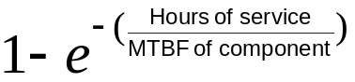
Poisson distribution for elapsed time: | 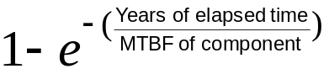
Serial Availability | 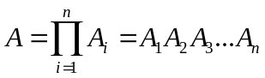  Where A_{1…n} represents the reliability value for each component in series. This is the proportion of the time that every component is up.
Parallel Availability | 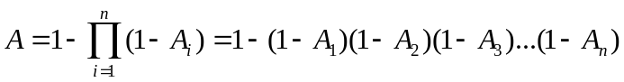  Where A_{1…n} represents the reliability value for each component in parallel. If unavailability is given as    Then parallel availability is more simply represented as  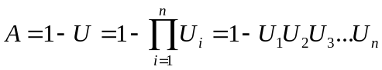

If the system consists of components that are neither series nor parallel but a combination then it must be decomposed into subsystems that can be treated as serial or parallel. So, if the system consists of four components P, Q, R and S, where Q and R are redundant, calculate the availability of Q and R in parallel and then P, {Q, R} and S in series. Thus:
P
Q
R
S
Reliability
- Reliability is based on the following maths:
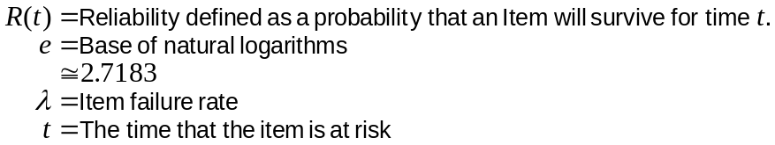
For serial items:
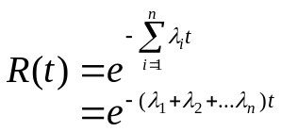
For two parallel items:
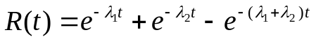

Availability
Availability is defined as the probability that an item is in an operable and commitable state at the start of a mission when the mission is called for at a random point in time. The user is most concerned about this parameter. This reflects the readiness of the system. There are a number of definitions of availability and it is important to understand the basic ones. All are based on this standard mathematical relationship, with differing definitions of the terms “Up Time;” “Down Time;” and “Total Time” :

One measure in particular, Operational Availability (A_{O}), covers all time segments the equipment is intended to be operational. As seen by the following equation, operational availability is based on a mathematical relationship among three characteristics: reliability, maintainability and the effectiveness of the logistics support system. Reliability is measured as the mean operating time plus mean standby time in an operational condition (represented by Mean Time Between Maintenance (MTBM)). Maintainability includes the mean maintenance time for both corrective and preventive actions (represented by Mean Maintenance Time (MMT)). Logistics support effectiveness is the combination of the logistics delay time plus any administrative delays (represented by Mean Logistics Down Time (MLDT)). The Mean Time Between Maintenance (MTBM) is based on all maintenance actions, whether corrective or preventative in nature.
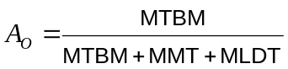
Note: There are a number of program support contracts that require the contractor to meet an A_{O} requirement. You can see that the contractor would want to control the support structure or have it precisely defined before signing up for A_{O}.
Another measure, Inherent Availability (A_{I}), is a measure of the system availability with respect only to operating time and corrective maintenance. Under these idealized conditions, the time involved in preventive maintenance; the delay times associated with all types of maintenance actions; and administrative delays are ignored. Because only unscheduled maintenance actions are considered in this definition, the mean operating time is defined as the Mean Time Between Failure (MTBF).
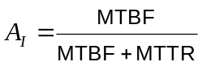
Inherent availability is useful in determining basic system operational characteristics under conditions which might include testing in a contractor’s facility or other controlled test environment. Likewise, inherent availability becomes a useful term to describe combined reliability and maintainability characteristics. Inherent availability is also used to define one characteristic in terms of the other during early conceptual phases of a program when, generally, these terms cannot be defined individually. Since this definition of availability is easily measured, it is frequently used as a contract-specified requirement.
It is not a good definition to use when estimating the true potential for most systems because it provides no indication of the time required to obtain required field support. This term should normally not be used to support an operational assessment.
A third measure, Achieved Availability (Aa), is frequently used during development testing and initial production testing, when the system is not operating in its intended support environment. It is defined over a specific period of time and relates the time the equipment is in use, i.e., operating time (OT), to the sum of the OT plus the corrective maintenance time (TCM) plus the preventive maintenance time (TPM).
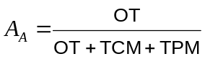
Achieved availability is much more a system hardware-oriented measure than is operational availability, which considers operating environment factors. It is, however, dependent on the preventive maintenance policy, which is greatly influenced by non-hardware considerations.
To summarize, operational availability is the most desirable form of availability to be used in helping assess a system’s potential under fielded conditions. Achieved availability and, to a lesser degree, inherent availability are primarily the concern of the developing organization in its interface with the contractor.

Failure mode is the technical term for a "way in which a component can fail". Components have multiple potential failure modes, one for each possible way that a failure can occur. For practical purposes however, failure modes that result in the same failure are typically grouped together. The failure mode space is the sum of all of the potential failures for the component or system being investigated.
The CBDI defines SOA as “The policies, practices, frameworks that enable application functionality to be provided and consumed as sets of services published at a granularity relevant to the service consumer that can be invoked, published and discovered, which are abstracted away from the implementation using a single, standards based form of interface.”
Refer to the on demand Operating Environment Concepts presented in Appendix D for more detail. Terminology and Definitions are provided in Appendix A.
Sections on Network, Storage and Server Virtualization and Web Services are excerpts from Virtualization and the On Demand Business , IBM RedPaper, REDP-9115-00 July, 2004.
Failure mode is the technical term for a "way in which a component can fail". Components have multiple potential failure modes, one for each possible way that a failure can occur. For practical purposes however, failure modes that result in the same failure are typically grouped together. The failure mode space is the sum of all of the potential failures for the component or system being investigated.

