

IBM Global Services

Developing Entity-Relationship Diagram

Technique Paper (TP)

© Copyright International Business Machines Corporation 1999, 2001
All Rights Reserved
Version 1.4 February 2001
- Outline of Entity-Relationship Diagrams
The Entity-Relationship Diagram (ERD) is a data model notation that was proposed by Peter P. Chen (of the US) in 1976. It is the data model notation most widely used today. An ERD can express data structures in simple form using the concepts of an "Entity" and a "Relationship between Entities". This method has the following features:
- The data structure can be visually expressed in an easy-to-understand form.
- The essential meaning of the data and the relationships between data can be understood.
- The structure and characteristics peculiar to the data can be expressed independently, separate from the actual physical restrictions and hardware and software technologies involved.
The use of Entity-Relationship Diagrams in data analysis makes the following possible:
- Gaining a structural understanding of the data to be managed by an application.
- Finding the structure inherently possessed by the data - an ideal structure that is highly independent and has no redundancies.
The use of the Entity-Relationship Diagram is a must for data administration. Its aim is to realize the construction and maintenance of high-quality application systems and database environments with long-term stability.
Example of an Entity-Relationship Diagram

Entity
Entity
Entity
Entity
Entity
Entity
Entity

The symbols used in an Entity-Relationship Diagram are shown in the following table:

Symbol | Name | Description
  Entity name | Entity | Things that are directly concerned with the enterprise and business and are to be managed over the long term.
(Relationship name) | Relationship  1:1 correspondence  1:M correspondence  M:M correspondence | Relationships between entities are expressed by solid lines and symbols that show their cardinalities. The name of the Relationship can be written above the solid line.
Note: M stands for Multiple.
Various Notations Used in the Entity-Relationship Diagram
Notation by P. P. Chen
Entity
Relationship
Entity
1
M

Crow's Foot Notation and Arrow Notation
 | Crow’s foot notation | Arrow notation
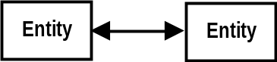  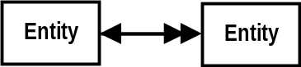  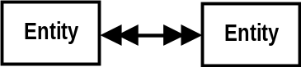  1:1 correspondence | 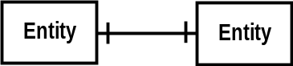  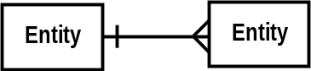  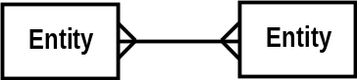
1:M correspondence
M:M correspondence
- Notation of Entity-Relationship Diagrams
Types of Entities and Their Notations
The following are the various types of entities used in the ERD and their notations.
- Kernel Entity
An entity that is independent and does not depend on other entities.
Employee
Training
course
Organization
Parts

- Attributive Entity
An entity whose very existence depends on another entity. This entity can exist only when the original entity exists. Its contents explain or characterize the original entity. The relationship with the original entity is 1:M.

Employee
Dependents
Training
Course
Class

- Associative Entity
If there is an M:M correspondence between entities, define a new entity between the two entities and then store the data pertaining to their relationship. This is called an Associative Entity. Its relationship with the original entity is 1:M.

Employee
skill
Employee
Skill
Student
Subject
Registration

Extension of Entity Notation
The Entity-Relationship Diagram can be made more readable if notations are devised to take the various types of entities into consideration.
Attributive entities and associative entities may be diagrammed as follows in some cases (examples in ADW, trademark of KnowledeWare, Inc. (US)):

Kernel entity
Attributive
entity
Associative entity

Employee
Skill
Dependent

Employee skill

Notation of Relationships
Relationships between entities are expressed with solid lines. Relationships can also be given relationship names.
The following three kinds of cardinalities are possible for a relationship. These cardinalities are expressed by adding symbols to the ends of the solid lines:
- “1:1” correspondence
Reservation
Ticket
Issues
“Only one reservation can be made for each ticket, and each reservation is based on one ticket.”

- “1:M” correspondence
Organization
Employee

“An organization is composed of multiple employees, and each employee belongs to one organization.”
Belongs to

- “M:M” correspondence
Employee
Lecture
“An employee attends multiple lectures, and each lecture is taken by multiple employees.”
Attends

Relationships may exist within the same entity.
Parts
Compose
“Each part is composed of multiple subparts, and each subpart can be used in multiple parts.”
Employee
“Each employee has one manager. One manager supervises multiple employees.”
Supervises

Multiple relationships may exist between two different entities.
Employee
Products
Sells
Produces
“An employee sells a product.”
“An employee produces a product.”

The relationships shown in an Entity-Relationship Diagram are things that are managed in the current application and things that are to be managed in the application in the future.
The relationships must be examined from the viewpoint of both entities, but the relationship name can be described with respect to either one.
Example:
Customer
Commodity
Purchases
This is not described because it is redundant.
“A customer purchases a commodity.” = “A commodity is purchased by a customer.”
It is best if the relationship name is one that expresses the specific meaning of the relationship between the entities.
Employee
Product
Handles
Employee
Product
Sells
Good example
Bad example

A relationship between a kernel entity and an attributive entity, or a relationship between a kernel entity and an associative entity, does not necessarily have to be given a relationship name.

Organization
(Kernel entity)
Employee
(Kernel entity)
Course
(Kernel entity)
Class
(Attributive
entity)
Registration
(Associate
entity)
Belongs to

Maximum and Minimum Values of Cardinalities
1:1, 1:M, and M:M indicate the maximum value (Max.) of cardinalities between entities. To express the cardinality exactly, the minimum value (Min.) can also be indicated at the same time.
Order
placement
Order
statement
Min.Max.
“An order placement must have one or more order statements. One order statement must be based on one order placement.”

Cases where the minimum value is 0, that is, where there is no corresponding entity, are called "conditional relationships."
“Employees may have many dependents, one dependent, or even no dependent.”
Employee
Dependents

When at a minimum the cardinality is two or more (multiple), only the maximum value can be indicated.
Organization
Employee
“An employee always belongs to only one organization, and one organization has multiple employees affiliated with it.”

Example of an Entity-Relationship Diagram

Job type
Organization
Employee
Necessary skill
Possessed skill
Course skill
Register
Skill
Course
Class
Assigns
Belongs
Manages
Supervises
3 Drawing Entity-Relationship Diagrams
What Is an Entity?
An entity is an object to be managed in the enterprise or business, and about which it is necessary to maintain and store information. An entity can be any object, such as person, thing, or place, or an abstract one, such as an event or concept. Whether an object is viewed as an entity or not depends on what the viewpoint of management is.
Examples of entities:
- Person: Employee, customer, student, stockholder
- Thing: Goods, product, part, raw material, facility, equipment
- Place: Head office, sales office, warehouse, plant, sales district
- Event: Order placement, order reception, arrival of goods, receipt of money, disaster
- Concept: Work, skill, objective, legal regulation
Each entity has a number of attributes. Within the same entity type, the entities can be discriminated from one another according to specific attributes (primary keys).
Example of entities and attributes (the underlined attributes are the "primary keys"):
- Employee: Employee number, name, age, address
- Customer: Customer number, customer name, location
- Commodity: Commodity number, commodity name, type name, lot No.
- Order placement: Order number, supplier, order amount, order unit
- Organization: Organization number, organization name, organization manager name, higher organization number
- Skill: Skill code, skill name
Identifying Entities
The following method can be used to identify entities:
- Normalize the data element groups of input and output forms, screens, existing files, and data stores of data flow diagrams used for requirements analysis, and define each data element group as an entity and each data element as an attribute.
- This method has proven effective in large-scale application development projects and is more effective and practical.
- Analyze enterprise strategies, goals, and functions. Then examine these from the viewpoint of what data element groups (entities) must be managed in order to realize them. For each entity, define the required data elements to be collected as its attributes.
- II actuality, it is very difficult to define all the required attributes using this method. Therefore, it is necessary for verification to compare defined attributes with the data elements of Data Stores in the data flow diagrams used in requirements analysis.

Entities and Entity Sets
"Employee," as shown in the ERD below, indicates a set of (abstracted) employees, not each individual employee. In this sense, such an entity may be called an "entity set" rather than an "entity,” and each of the employees is called an "entity."
Employee N
Entity
Entity set
Employee C
Employee B
Employee A
.
.
.

In many cases however, "entity" will often be used with the meaning of an "entity set" as long as no confusion occurs. Therefore, in this guide the term "entity" is also used with the meaning of "entity set," except in cases where there is a particular need to distinguish "entity set" from "entity."
Attributes
For each entity, there will be a number of data elements that explain it. These are called "attributes.”
Customer
Customer number
Customer name
Customer address
Customer postal code
Customer telephone number
Customer birth date
:

Attributes

The attributes are not entered onto the Entity-Relationship Diagram. They are written on separate forms for each entity, for example:
Entity name: Customer
Key | Attribute name | Length | Type | Description
 | Customer number | 06 | N
 | Customer name | 40 | C
 | Customer address | 80 | C
 | Customer postal code | 06 | C
 | Customer telephone number | 11 | C
 | Customer birth date | 08 | N
 | :
 | :
Keys
- Primary Key
The data element that can be used to identify each entity in the entity set is called the primary key.

Primary key
Employee
Dependent

Employee number
Employee name
Social security number
Employee number
Relationship code
Name of dependent
Age
Composite key

(The social security number is not used as a primary key.)

In cases where there are several data elements that could be used as the primary key, one of them is selected to be the primary key based on the meaning of the data. In some cases several data elements together may make up a primary key (also called a composite key).
- Alternate key
An alternate key is an attribute, other than the primary key, that can be used to identify each entity. There is a great possibility that this could be used as an access key in the data retrieval.

Entity | Primary key | Alternate key
Employee | Employee number | Social security number
Commodity | Commodity code | JAN code
Order Placement | Order placement number | Customer number + Commodity number + Date

- Foreign Key
When one of the attributes of a certain entity is defined as a primary key in another entity, this attribute is called a foreign key.
In any case where there is a 1:M relationship, there will be a foreign key on the M side.

Organization code
Organization name
Employee
Employee number
Employee name
Organization code
Foreign key
Organization
Contains

In some cases, a foreign key may become part of the primary key (in a composite key).
There will be a foreign key in the primary key of the attributive entity in any relationship between an attributive entity and a kernel entity.
Fright number
Departure date
Fright number
Seat number
Ticket holder
Reservation date
Primary key
Flight
Contains
Reservation
Kernel entity
Attributive entity
Foreign key

Supertype and Subtype
At the time of entity identification, sometimes several entities are identified that have the same primary key. There will be attributes that are common to all these multiple entities.
Such entities can be divided into entities that have the common attributes and entities that have attributes peculiar to them alone. In such cases, the higher-level entities with the common attributes are called "supertype" entities and the lower-level entities with the attributes peculiar to them alone are called "subtype" entities.
The reverse case also occurs, in which supertype and subtype relationships are defined by finding new subtypes when classifying the attributes of an entity.
Example
Subtype identifier
Employee
Engineer
Clerk
Salesman
Put a short line at the supertype side
Employee number
Employee name
Department code
Job code
Employee number
Territory division
Sales objectives
Job code
Attributes peculiar to the subtype

Attention must be paid to the following points in the definition of supertypes and subtypes:
- Inheritance
A supertype and its subtype have the same primary key. Therefore, one feature of their relationship is that the attributes possessed by the supertype all apply to the subtype.
This is called inheritance.
- Subtype identifier
The supertype may have an attribute (subtype identifier) that identifies the type of subtype.
- Scope
The scopes of the entities relevant to the application development are further clarified through the identification of supertype and subtype relationships.

<Example of Supertype and Subtype Relationships>
Parts
Parts ordered from outside
Parts produced
in-house
Part number Production line number
Part number
Part name
Part number Supplier number Standard lot

<Example of Supertype and Subtype Relationships>
Member
Individual member
Corporate member
Member number
Capital
Number of employees
Member number
Annual income
Member number
Member name
Date of admission
Rank
Member address
Member telephone
number
Scope of application development: Corporate members
<Example of Supertype and Subtype Relationships>
Vehicle
Bus
Passenger car
Truck
School
Public school
Private school

Domain
The set of values that an attribute (data element) of an entity can actually take is called the domain of the attribute. A domain follows specific restrictions with respect to format, range, and length. Define domains as primary concepts for the data elements, and expect that each data element will belong to one of the domains.
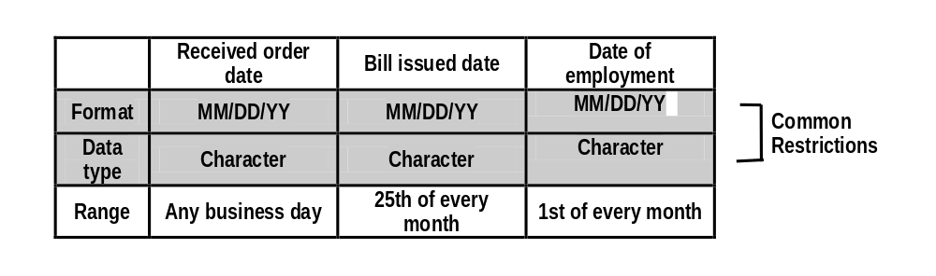
For example, assume the restrictions on the values for three data elements - "Received order date," "Bill issued date," and "Date of employment" - are defined as follows:

These data elements have common restrictions for "Format" and "Data type." Although these three data elements are totally different as attributes, they are defined as belonging to the same domain "Date".
Received order date
Received order date
Bill issued date
Date of employment
Domain
Data element

Defining domains has the following advantages:
- Simplification and consistency in definition of attributes
“Format” and “Data type” need not be separately defined with respect to each element. The format "MM/DD/YY" and the data type "Alphanumeric" are automatically determined merely by defining that an attribute belongs to the "Date" domain. This makes it possible to prevent dates from being defined in different formats such as "YY/MM/DD" and "YYMMDD" in various places in the system, and makes it easy to maintain consistency.
- Ease in making changes
In general, it is difficult to determine what data elements will be affected when the need arises to make changes in "format" or "length," for example. However, if domains are defined, the range of effect of the change can be determined by asking what data elements belong to the domain.
The following are examples of elements that are determined as parts of a domain.

Classification | Example
Data type | Integer
 | Alphanumeric
 | Character
 | Double-byte characters (DBCS)
Length | 5 digits
Format | YY/MM/DD (date)
 | ZZZ,ZZZ,ZZ9 (amount)
 | Ennnnn-n (employee number)
Value range | 0 <= x < 24
Meaning | Address in Japan

Derived Data
Derived data means the attributes in the entity can be derived from other attributes by using a specific algorithm.
Order number
Customer number
Order date
Total number of orders
Order number
Line number
Commodity number
Quantity of goods
Total number of order details lines
Order
Placement

Contains
Order details
A
B
“Total number of orders” is derived from data item because this item can be found using the following equation.
A
A
Total number of orders = Total number of order details lines
B
In general, derived data is redundant and therefore should not be included in the attributes of the entity. However, the following types of attributes should be included:
- Attributes that appear on actual forms and have an important meaning
- Elements for which the computation algorithm is so complicated that its derivation is a great burden
In such cases, indicate that the attribute is a derived data element and describe its algorithm separately.
Order number
Customer number
Order date
Total number of orders
(derived data)
Order number
Line number
Commodity number
Quantity
Total number of lines
Order
placement
Contains
Order
specifications

- Analyzing the Relationship
Relationship Analysis Procedure
Check each of the attributes that belong to an entity. If an attribute is the primary key of another entity, the two entities have a relationship. The relationship can be set up from this viewpoint. For example, using the following entities and attributes:
Entity | Attribute
Organization | Organization code + Organization name
Job type | Job code + Job name
Employee | Employee number + Employee name + Organization code  + Job code + Date of employment
Skill | Skill code + Skill name
Course | Course code + Course name + Length of course
Class | Course code + Class number + Date + Location
Necessary skill | Organization code + Job code + Skill code + Skill level
Employee skill | Employee number + Skill code + Years of experience + Skill level
Attended course | Employee number + Course code + Grade
Course skill | Course code + Skill code + Skill level
Stands for the primary key of another entity.

- Since the "Organization code" and "Job code" attributes belonging to the "Employee" entity are the primary keys of the "Organization" and "Job type" entities, the relationships exist between two entities.
- Since "Course code," which is part of the primary key of the "Class" entity, is the primary key of the "Course" entity, define a relationship between the two. ("Class" is an attributive entity.)
- Since "Employee number" and "Skill code," the primary keys of the "Employee skill" entity, are the primary keys of the "Employee" and "Skill" entities, define relationships between them. ("Employee skill" is an associative entity.)
Check all the attributes of all entities as shown in the examples mentioned above, define relationships, and put cardinalities between these entities.

Employee
Organiza
tion
Job type
Attended course
Necessary skill
Employee skill
Course skill
Skill
Course
Class

Considerations Related to "M:M" Correspondences
For entities with "M:M" correspondences, convert the correspondences into "1:M" correspondences by using "Associative entities."
Employee number
Employee name
Skill
Employee
Possesses
Skill code
Skill name
“Employee” and “Skill” have an “M:M” correspondence.
Employee number
Employee name
Skill
Employee
Possesses
Skill code
Skill name
Skill possession
Employee number
Skill code
Years of experience
Skill level

- Use an "Associative entity" that shows the relationship between the two original entities, and relate it to the original entities.
- Cardinality is determined as shown in the diagram.
- Determine whether or not the keys inherited from the original entities become a unique composite key based on the meaning of the application. (If they do not become a unique key, add another attribute as the primary key.)
Examples of special "M:M" correspondences
- Relationship between three or more entities
Employee
Skill
Project Process Skill
Process
Project code
Process number
Skill code

- An "M:M" relationship within a single entity.
Parts
Compose
Part number
Parts
Parts structure chart
Parent part
Child part
Part number
Parent part
Child part
Introduce an Associative entity such as a parts structure chart and relate the two.
Considerations Related to "1:1" Correspondences
Organization
(Department)
Sales area
Controls
“1:1” correspondence

If two entities have a "1:1" correspondence, examine them from the following viewpoints, because there is a possibility that they can be combined into one entity.
- Entities having a relationship with a name such as "is" or "means":
These two entities are synonymous with each other. Remove the redundant entity and relationship, and combine them into one entity.
- Case where either entity has only one attribute:
This should be defined as merely an attribute and not as an entity.
- Two entities having the same key:
It may be possible that they should be subtypes under the same supertype.
Even in cases that do not fall into one of the above categories, there is a high possibility that entities having a "1:1" correspondence can be combined into one entity. However, entities should not be combined into one entity in the following cases.
- If two entities are combined into one entity when one of them has a conditional cardinality, the number of attributes that can take a null value will increase.
Employee
Dependent
Supports
Employee number
Employee name
Employee number
Name of dependent
Age
• • •

- When both entities have a conditional cardinality, they should not be combined into one.
Considerations Related to Conditional Cardinalities
When entities have a conditional cardinality, it may be possible that what is really involved is the existence of subtypes. Examine them to see if subtypes should be defined.
Employee
Customer
Takes charge of
Conditional cardinality

Employee
Engineer
Salesman
Clerk
Customer
Takes charge of

Entity Volumes
Check the approximate volume of each entity (number of occurrences) when it is identified, and describe the volume.

Employee
Belongs to
Organization (Department)
2000
40

The meaning of the relationships will become easier to understand even for end users that are not accustomed to the expression of cardinality. In the following case, “Reservation” and “Ticket” have a 1:1 correspondence, but the difference in their volumes shows that there are some reservations that are not related to tickets.
Reservation
Issues
2000
1800
Ticket

This is because 10% of the reservations are canceled before tickets are issued. Add the minimum cardinality "0" to show that the entity has a conditional cardinality. This prevents omission of conditional cardinalities.
Reservation
Issues
2000
1800
Ticket

Also note that the volumes (number of occurrences) of the entities are important in the analysis of performance.
ER Diagram Development Procedure
The following data flow diagram depicts a practical Entity-Relationship Diagram preparation procedure:

DFD development
Data Store descriptions
Entity- Relationship Diagram development
Data normalization
DB system design
Normalized data stores
Entity-Relationship Diagram
DB specifications
User needs
- Relationships between ER Diagrams and the Relational Data Model
Entity-Relationship diagrams in normal form are transformed into relational data models as follows.
Table
Column
Unique index
Unique index
Non-unique
index
Entity
Attribute
Primary key
Alternate key
Primary key
Foreign key
(Candidate)
(Candidate)
This is a unique index in cases of “1:1” correspondence.

"1:M" Correspondence
When a foreign key is included at the M side:
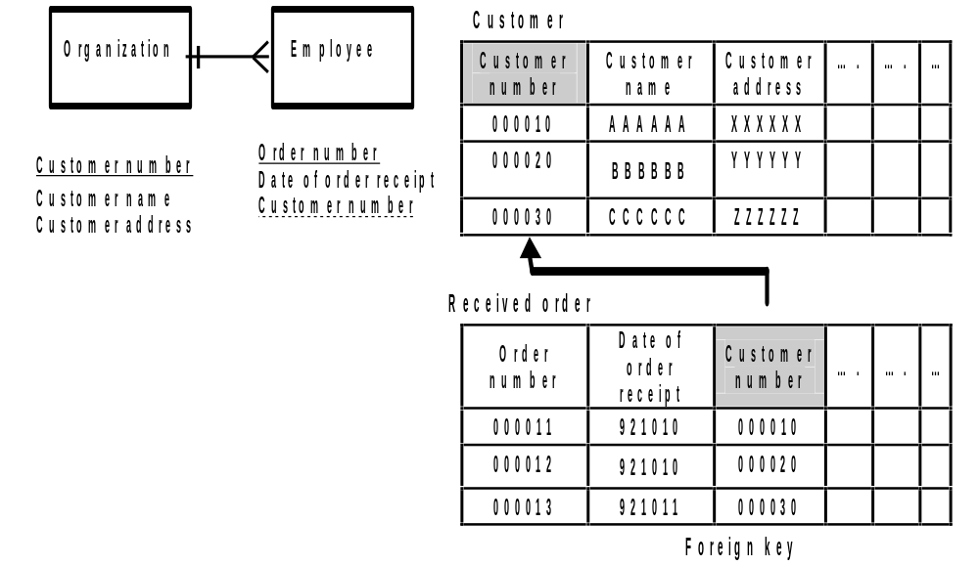
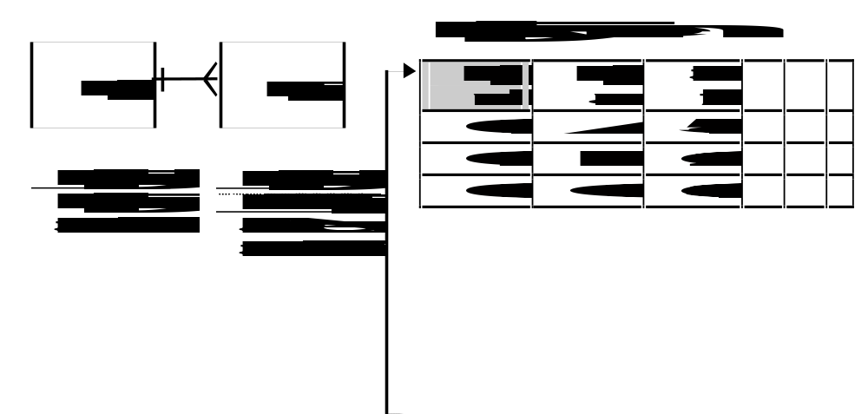
When the foreign key is a part of the primary key (a null value cannot be used for the foreign key):

Dependant
Employee number | Relationship code | Name | Date of birth | …. | …
000010 | 1B | XX | 581001
000020 | 1A | YY | 621012
000030 | 2A | ZZ | 630101
Foreign key
"1:1" Correspondence
Basically, entities with a 1:1 correspondence should be combined into one table. When they are defined in two tables in order to take expandability into account (possibility of 1:M correspondences occurring in the future), only one table should have a foreign key.
Organization
(Department)
Sales area
Contains
This should not be included in the table.
Organization code
Organization name
Sales area code
Sales area code
Sales area name
(Organization code)

<Example of combining two entities in one table>
Organization
Organization code | Organization name | Sales area code | Sales area name
0290 | XX | QXZ020 | East metropolitan
0291 | YY | QXZ011 | West metropolitan
0293 | ZZ | QXZ092 | North

<Example of using two tables>
Organization
Organization code | Organization name | Sales area code | …
0290 | XX | QXZ020
0291 | YY | QXZ011
0293 | ZZ | QXZ092
Foreign key

Sales area
Sales area code | Sales area name | …
QXZ020 | East metropolitan
QXZ011 | West metropolitan
QXZ092 | North

"M:M" Correspondence
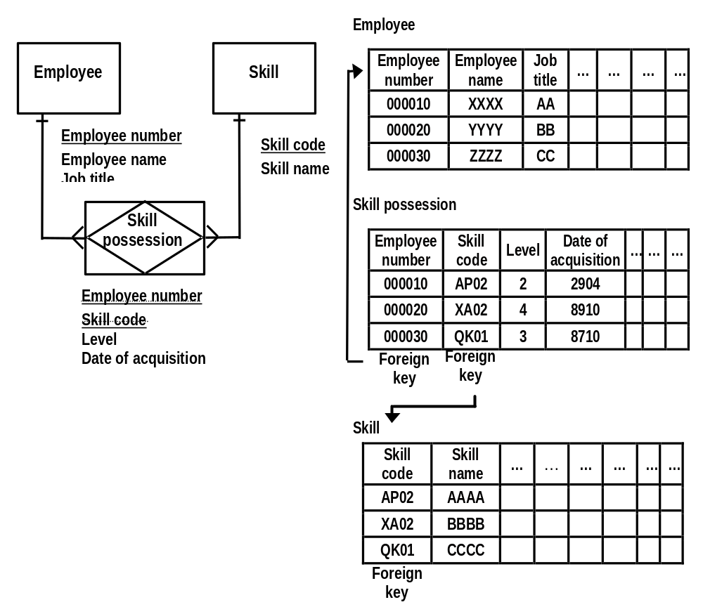
M:M correspondences can be eliminated by introducing "Associative entities." Therefore, an associative entity will also correspond to a single table, as in the case of a 1:M correspondence.

Relationships within a Single Entity
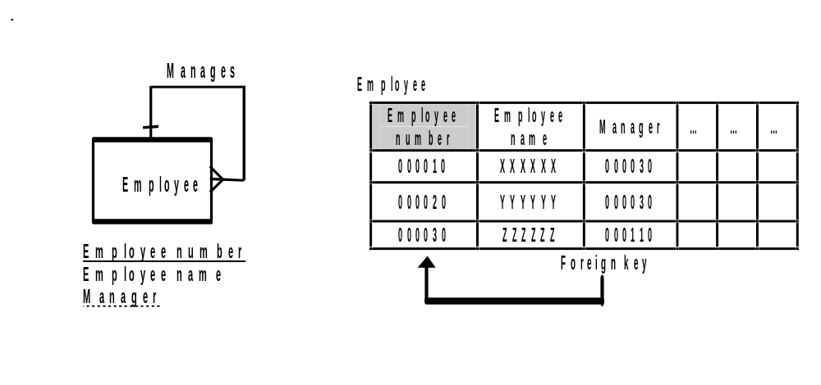
"1:M" Correspondence
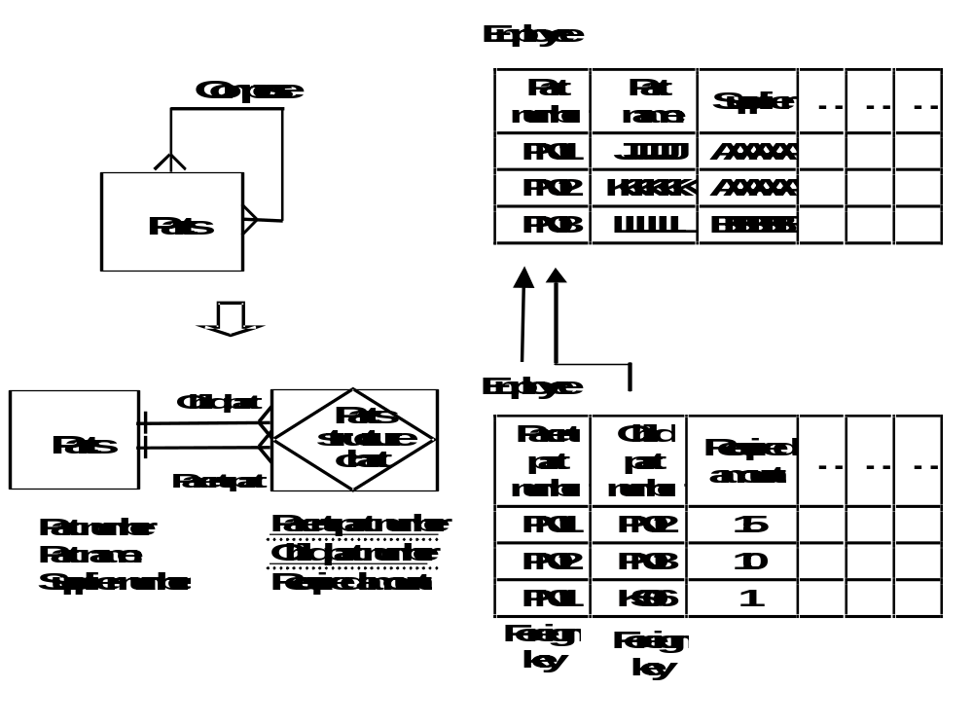
"M:M" Correspondence
Supertype and Subtype
Points to consider when exploding supertypes and subtypes into related data models:
Using the following example:
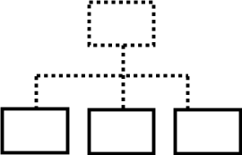Example | Everything contained within the supertype. | Everything made into subtypes. | Everything left as is.
Features | - The number of attributes that take null values increases.  - Resource contention occurs, such as access to unnecessary records.  - The structure is simple and there are fewer entities to be controlled.  Redundancy is eliminated. | - Access to multiple tables may be required in one application. For example, the multiple access may be needed for a process that relates to all employees, such as calculation of salaries and wages.  - Few attributes take null values. | - Access tables can be divided by objective.  Application development is easier.  - Few attributes take null values.  - More attention must be given to the methods used to obtain consistency because this is the most redundant type of structure.

Example
Employee
Researcher
Salesman
Clerk
Customer
Takes charge of
Employee number
Employee name
Department
Employee number
Employee number
Security ID
Research division
Employee number
Area responsibility
Industry responsibility
Customer number
Customer name
Responsible salesman

"Clerk" is included within supertype "Employee" because it does not have any attributes peculiar to it. "Researcher" and "Salesman" have attributes peculiar to them alone, and there are other entities ("Salesman" and "Customer" in the example) that have relationships with these subtypes only. Therefore, these types are refined as follows, based on the viewpoint that there will be many individually processed operations for those types.

Employee
Researcher
Salesman
Customer
Takes charge of
Employee number
Employee name
Organization code
Job code (subtype identifier)
Employee number
Security ID
Research division
Employee number
Area code
Industry code
Customer number
Customer name
Responsible salesman

Employee
Employee number | Employee name | Organization | Job code | …
000010 | XXXXXX | C2910 | KNK
000020 | YYYYYY | C2910 | JIM
000030 | ZZZZZZ | V2201 | EGY

Researcher
Employee number | Security ID | Research division | … | … | …
000010 | XASDF4 | 004
000011 | DGVBN6 | 102
000012 | FT7NK6 | 005

Salesman
Employee number | Area responsibility | Industry responsibility | … | … | …
000030 | XXXXXX | C0092
000031 | YYYYYY | C0298
000032 | ZZZZZZ | C0092

Customer
Customer number | Customer name | Responsible salesman | … | … | …
000010 | XXXXXX | 000030
000020 | YYYYYY | 000031
000030 | ZZZZZZ | 000030
Foreign key
- Reference Materials
- P. P. Chen, "The Entity-Relationship Model - Toward a Unified View of Data," ACM Transactions On Database Systems, Vol.1-No.1, March 1976.
- A thesis proposing the Entity-Relationship model.
- J. Martin and C. McClure, Structured Techniques: The basis for case (revised edition), Prentice-Hall, Inc., 1988.
- General explanation of the structured techniques and notation that is the foundation for the use of CASE tools.
- J. Martin and C. McClure, Diagramming Techniques for Analysts and Programmers, Prentice-Hall, Inc., 1985.
- General explanation of structured techniques and notation.
- J. Martin, Recommended Diagramming Standards for Analysts and Programmers – A Basis for Automation, Prentice-Hall, Inc., 1987.
- General explanation of structured techniques and notation. The contents are similar to the previous book.
- Revision History
Revision Number | Revision Date | Summary of Changes | Changes Marked?
1.01 | June 1999 | Base version.
1.1 | October 2000 | Applied new template and style, grammar and spell check.
1.2 | December 2000 | Fixed diagrams. No change in text.
1.3 | January 2001 | Adjusted chart on pg.12.
1.4 | February 2001 | Fixed chart on pg.5 and pg.24

