

IBM Global Services

Enterprise Architecture Gap Analysis

Technique Paper (TP)

© Copyright International Business Machines Corporation 2000, 2001
All Rights Reserved
Version 1.1 November 2001
- Description
The Enterprise Architecture (EA) Gap Analysis technique is used in conjunction with the ARC 004 Infrastructure Gap Analysis work product. The technique expands the scope of the work product and is used to understand the gaps between the current business and IT environment and the future desired environments as defined within an Enterprise Architecture and its application, data and infrastructure component parts. When a gap analysis of the business components of an Enterprise Architecture are required, the BUS 311 Process Gap Assessment and BUS 339 Knowledge Gap work products should be used.
Note that enterprise-level architectures have a much wider scope and content than solution architectures, which are normally focused on a single business area/solution. The Enterprise Architecture underpins the business strategy and the key capabilities required to implement the desired business and IT environment. It takes an enterprise-wide perspective of what is required, where the main integration points are and, identifies opportunities for the sharing of application function, data and infrastructure, etc. The objective of these activities (using this technique) is to understand the gaps and use this understanding to identify the initiatives needed to make the transition from the current environment, to the future desired environment. This is a key step in the translation of the theory of an enterprise-level architecture into solutions, which can be effectively implemented, in support of business objectives.
The major outputs from using this technique include:
- Documented analyses (including spreadsheets and graphs)
- Documented gaps and additional support requirements
- Analysis findings and conclusions - with relevant executive presentation material
- List of project initiatives and transition requirements
Please Note: The analyses performed are at a reasonably high level, with heavy involvement of business and IT users who understand the content of each system/development project in depth.
- Context
The Enterprise Architecture Gap Analysis technique can be used:
- Just after the initial definition of an EA – normally done towards the end of the EA engagement, once the various architectural models are in a reasonable shape
- As part of an assessment of an existing EA, where the focus is on identifying how to integrate the EA into the current development project portfolio and ensure the key desired capabilities of the business are implemented quickly.
In both instances, the technique can be used to provide an analysis of the gaps between:
- Key installed application systems, databases and infrastructure and the future desired IT environment defined in the EA – used to identify areas of future improvements.
- Planned replacement systems (infrastructure and systems that are due for replacement within 18 months) and the EA – used to guide design and product/component decisions
- New projects (either under development, or in plan to be implemented within the next 3 years) and the EA. In this instance, the analysis looks at the functional and technical fit of these new projects with the EA. The outputs from this gap analysis are used to guide requirements gathering, design and product/package selection decisions (which often happen early on in the development lifecycle). The key here is to ‘catch’ individual projects, before major design and acquisition decisions are made, which may not be in line with the overall business objectives and desired key capabilities.
In all these gap analysis activities, the principles and future application function model, data stores, data and function access and placement guidelines and enterprise technology framework components of the EA are used as key inputs.
This EA Gap Analysis technique can be used in several ways:
- As part of a joint client/IBM team project
- As a small team of consultants using a combination of interviews, surveys, document analysis and facilitated workshops – this approach is most often taken when the gap analysis is done as part of an overall EA assessment engagement. In this instance, this technique paper would be used in conjunction with the ARC 321 IT Architecture Review and Assessment WP and its associated technique paper.
Whichever approach is taken, make sure you involve a core team of client business users, AD project managers and IT Architects - people who understand business requirements and priorities, the current IS/IT environment, the existing project portfolio and the contents of the Enterprise Architecture. This will allow the analyses to be completed in a reasonably short timeframe.
In the case of a newly defined EA, these activities are an ideal opportunity to actively involve many of the future architectural stakeholders and provide an excellent communication mechanism. A proven, effective approach is to view each gap analysis activity, as one of self-assessment by each project team/team of stakeholders, with the assistance of the EA Core Team. Inevitably, at these early stages of an EA, these gap analysis activities can help to influence the style and content of what is being produced, so by being involved, the project teams are providing direct input to enable the EA to be relevant and appropriate for their needs.
- Steps
The techniques and guidance given below are fairly generic and can be used for all types and styles of gap analysis. Please note that in this guidance, the terms analyses and assessments are sometimes used interchangeably.

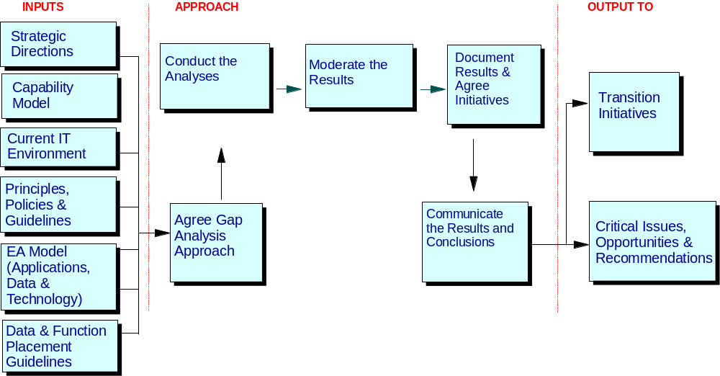

The EA Gap Analysis technique has five main steps:
- Agree gap analysis approach
- Organize and brief the gap analysis team – provides an opportunity for educating the team on the approach that will be taken and their various roles and responsibilities
- Produce a package of briefing materials
- Agree gap analysis scope
- Define the gap analysis criteria
- Conduct the analyses
- Moderate the results
- Document results and agree initiatives
- Document gaps and additional support requirements
- Agree project initiatives and transition requirements
- Communicate the results and conclusions of the gap analysis
Step 1 – Agree gap analysis approach
Agree the overall approach, which will be taken for the gap analysis with client sponsors and the project team.
Organize and brief the gap analysis team. The composition of this team is key, especially when client personnel are involved. Use a combination which includes people who are familiar with the various outputs of the architecture work (which will be used to define the analysis criteria), business area representatives and project managers.
Choose people who have a sound background in the issues, which are likely to be raised. They should have credibility within the organisation to perform this work, so avoid being obliged to take "whoever is free". The value of the conclusions will be affected by who has done the work as much as the process followed.
As it is inevitable that some parts of current environment will score badly and possibly upset the owners or developers - the team must have the experience and credibility necessary to justify any "politically difficult" messages to management.
Where possible, include business users and developers in these activities
Inevitably the depth of understanding that individual team members have for each of the criteria will vary. A "round table" discussion about each criterion is essential, at the workshop, to level set what is involved.
Dependant on the time available for this gap analysis and number of systems to be analyzed, you may choose to have multiple teams of 'pairs of assessors' - these should be chosen to balance skills, background, and experience
Produce a package of briefing materials – all business users and project owners, will need to be fully briefed on the gap analysis approach, ideally before any workshops are run. Consider the advance circulation of an "information pack" with background information, architecture descriptions, principles, requirements, and other supporting materials.
Customise the sample briefing package attached to this technique paper. The content should cover:
- Basics: date/time/place/duration etc.
- Context & Purpose of analysis activities (why this activity is needed and where it fits in the overall engagement)
- Analysis objectives and scope
- Approach/Expected level of participation (how will it actually work, what will be expected of the participants)
- Initial workshop agenda - the objective is to bring together all the people involved in the analysis and agree a number of key points:
- The scope of the analysis
- The criteria to be used
- How the analyses will be organized
Agree gap analysis scope
The composition of the list of systems/environments to be analyzed should be the responsibility of a wider group than just the analysis team. It will require discussions with senior managers (and possibly the sponsor), and functional heads within IT and the business.
Using the inventory of current applications, data and technology (output from the Current IT Environment work product) and the current development project portfolio, agree the systems and projects for which an EA gap analysis is needed. In reality, these activities will be limited by time and may often be limited to the following scope:
- Top 40 current applications and their associated infrastructure – current systems which are likely to be significant in the future
- Any major current infrastructure that is likely to be significant in the future (if not directly included in the above), for example a network infrastructure that needs to be upgraded
- Any planned replacement systems (may include 5 – 6 projects in the future project portfolio) – with infrastructure and systems that are due for replacement within, say 18 months.
- Top 2 – 3 new projects which may be under development, or in plan to be implemented within the next 3 years.
The last three items above nearly always include major development projects, which can involve multi-million dollar investments. The gap analyses for these projects will take longer than analyses of existing systems (largely because there are often a number of unknowns). Limit the development projects analyzed to the top 5 - 10 only, as they will inevitably be the ones to have the most impact on the business and IT. Make sure that you have both business representatives and IT project people together in the analysis. Early on in an engagement, it is also useful to ask development teams to do a self assessment of their projects, against the newly defined guiding principles (output from the Principles – Polices and Guidelines work product) - this is especially important, if major development decisions are being made, as the various architectures are being defined. The sooner the development teams start to understand the drivers and content of the EA, the more chance there is for influencing future directions and compliance.
Define the gap analysis criteria
Using the input materials (for example: Strategic Directions, Capability Model, Principles, Application, Data and Technology models), agree the gap analysis criteria, conformance ratings, scoring system and documentation standards. Samples are attached to this TP.
Agree analysis criteria – these could include the following, depending on the time available and level of analysis required:
- Functional quality (optional) - the extent to which the applications support the critical business functions and the quality of that support, data quality, (i.e. currency, redundancy, accuracy)
- Technical quality (optional) - technical efficiency of existing application systems e.g. their age, stability, reliability, maintainability and the longer term technical potential;, technical efficiency of the current infrastructure eg stability, reliability, maintainability, age of installed base, support for critical business functions eg availability, performance, anticipated business growth and the longer term technical potential
- Support for overall business strategic directions
- Support for the desired distinctive Business and IT Capabilities
- Conformance to the overall guiding principles (business and IT)
- Conformance to the application design principles
- Conformance to the data principles
- Conformance to the technical/infrastructure principles
- Conformance to the future application function model and data stores
- Use of future common processes and functions (if necessary, assumptions should be made on future common functions, based on application architecture activities so far)
- Conformance to the future enterprise technology framework (which includes technology/infrastructure models)
- Conformance to selected standards and reference architectures (if defined – please note, for detailed analysis of reference architectures, the Reference Architecture Fit/Gap Anaysis WP should be used)
- Flexibility of current design/requirements to meet future architectural requirements, key services and interfaces.
- Ease of change to meet future enterprise architecture models (application, data and technology/infrastructure)
- Functional suitability of existing systems/applications to meet future strategic business requirements (distinctive business and IT capabilities)
- Weight analysis criteria (optional) - the agreed analysis criteria can be weighted in terms of importance to the business, and an analysis matrix developed. As an example weightings could be assigned on a scale of 0 to 5, where 0 = not applicable and 5 = very important. Note: The use of weightings for the analysis of scores is optional. It may not be necessary (or desirable) to total the scores for a particular analysis, which renders the weights irrelevant.
- Agree documentation standards - agree how the results of the analyses will be captured and presented. From experience, the results are best captured in spreadsheets (or similar). A standard template (with the criteria and scoring system) can be constructed (see example attached to this TP). This eases transfer to summary/conclusion documents, and any arithmetic work required. Also, spreadsheets can be loaded onto laptops for direct data entry during interviews and workshops. The findings can be presented using various different graphical styles – chose one which is clear and simple and which your client is comfortable with.
Step 2 - Conduct the analysis
Analyses can be conducted in one of two ways - decide which is appropriate, based on scope, time available and gap analysis objectives:
- in workshop mode:
- each chosen project will be analysed and an analysis matrix completed
- any gaps or issues raised should be documented within the matrix, with comments to clarify the ratings given.
- based on returned surveys/questionnaires – (note; this approach is most often taken when the gap analysis is part of an overall EA assesment). In this instance, consider the following:
- As the survey forms are returned, check them for completeness.
- Briefly scan each form to check for discrepancies and omissions.
- Ensure there have been no major misunderstandings with respect to the questions.
- If there are any issues, schedule individual meetings to confirm their responses.
If you use multiple analysis teams, ensuring the consistency of scoring can be difficult - teams should be strongly encouraged to document any reasons for their score, particularly for high or low scores. If you are concerned about consistency, ensure the outputs from each gap analysis, are reviewed by a peer reviewer.
Analyze individual, chosen applications, technical areas, or development projects - for each:
- Conduct joint workshops with business and IT teams, using the agreed analysis criteria and customised templates/spreadsheets
- Summarise and plot the findings.
- Document any issues, with comments to clarify the ratings given.
Sample matrix templates and completed spreadsheets are attached to this technique paper.
Estimating Guidelines: experience has shown the following to be valid guidelines – assuming that knowledgeable business and IT users are available:
- An analysis of 40 current systems can be completed in 1 – 2 weeks working with 2 analysis teams (of 2 people each) full time – often it is possible to group systems together, because they have the same business and IT user base, so they can be reviewed in the same workshop
- We recommend a minimum of one day each per development project, although this may extend to 2 days if the area is complex.
- Make sure you give each analysis team sufficient time to document all their findings. For example, a one day workshop would normally be followed by one day of documentation.
Step 3 - Moderate the results
This step focuses on understanding the impact of the analysis findings.
- When all analyses are complete, compare and discuss the results as a team, highlighting any major observations or issues, which have become apparent. Many of the findings and identified issues will have highly political and cultural implications and you will need to handle these with care. The analysis team should discuss and agree how to move forward these – if appropriate, include development project managers/IT managers too.
- In the case of an analysis of existing application systems, it is useful to combine the analysis results into a single spreadsheet for manipulation (see example attached to this TP).
- The results can be very powerfully presented in the form of comparative graphs, showing functional versus technical ratings – Sample 1 shown in section 5 below, shows a typical output from an analysis of the top 40 current application systems, with a discussion on how the graph should be interpreted.
- In some instances, these systems / applications may be in plan for replacement by future development projects (on-going or in plan). In this case, it is important to complete a gap analysis of the replacement project(s), to ensure that the functional and technical shortcomings of the existing systems / applications, are not being replicated into the future!
- It may also be appropriate to review the current maintenance costs for these systems / applications and conduct selected interviews with the business user community to determine the impact of eliminating them from the application portfolio.
- In the case of an analysis of key development projects, the findings are normally kept in separate spreadsheets, which are used to generate graphical representations of findings for presentation. Sample 2 shown in section 5 below, shows the kind of outputs which can be produced from a gap analysis of development projects, with a discussion on how the polar charts used should be interpreted.
Step 4 - Document gaps and additional support requirements
Document gaps and additional support requirements
- Using the Distinctive Business and IT Capabilities previously defined, plus the outputs from the gap analysis highlight any major areas where current support is low, or there is application, infrastructure or product confusion.
- Areas where the business value is high and the existing coverage is poor, provide the opportunity to maximize the benefits of IT investment, and therefore should be a major focus.
- Focus also, on the analysis results of those applications with a high business value - this provides a measure of the degree to which the current applications support the business
- Identify any serious problems, current or potential, and optionally make recommendations as to how these may be addressed
- Document any important gaps, support characteristics, transition issues and requirements. For example, if many current applications clearly cover the same area in the future Application Function Model, this indicates a duplication of function, which may be due to product-oriented systems that need to be rationalized. These areas of overlap potentially provide an excellent basis for identifying areas of commonality, where application function can be shared.
- Capture these findings as an input to your conclusions and identify any new initiatives required to address these findings
Agree project initiatives and transition requirements
The conclusions from this gap analysis exercise will be used to determine a list of initiatives (including the provision of common infrastructure and common application functions) which will ensure that the implementation of components defined in the Enterprise Architecture, plus the future application development portfolio, are strategically linked to the business directions and agreed distinctive business and IT capabilities. This candidate list of initiatives will be input to the Transition Initiatives work product and associated Transition Strategy and Planning activities.
- In workshop mode (may take from one to three days, dependent on scope), the joint IBM/client team should use the all outputs from the above activities, plus the required business and IT capabilities, to produce a candidate list of initiatives. These initiatives will be a variety of types and could include:
- the definition and provision of common, shared application functions and common application services
- the definition and provision of a common technical infrastructure and services
- the functional enhancement of one or more current applications
- the technical enhancement of one or more current applications (eg restructuring, rewrite, re-engineering, modularisation, improved presentation eg GUI)
- the transfer of one or more applications to a new or more current technology base
- complete or partial replacement of current application(s) with a bespoke solution
- complete or partial replacement of current application(s) with a packaged solution
- Document any known transition issues and requirements
- Identify any potential short-term projects that can provide rapid business benefits
- Review the assessment results with the client sponsor and get agreement on how to present these findings…
Step 5 - Communicate the results and conclusions from the assessment
- All gap analysis findings should be documented in a form suitable for presentation to senior management and other interested parties (see attached samples in section 5 below).
- The political impact of the conclusions must be treated sensitively and should always be discussed and agreed with the sponsor before any presentation with other senior management. Some may see these findings as an "attack" or "slur", especially where applications or parts of the infrastructure have scored poorly. This is even more important, when the gap analysis of a major, multi-million dollar development project shows there are major flaws in direction! It should be stressed that this is a gap analysis to highlight how to refocus existing application systems, infrastructure and development projects, towards implementing the desired business and IT capabilities. It is not a quality assessment. It is possible that well designed, well performing, highly regarded systems score very low (often because the organization has never had an enterprise-level architecture before to guide design and product acquisition decisions). Likewise badly designed garbage may score high (although that is less likely). The briefing materials must stress these points, as must the conclusions.
- Tools
The following tools/templates have been attached to this TP:
- Gap Analysis Matrix – Blank.xls A blank matrix ready for customization
- Sample Polar.ppt Basic polar charts. Double click on each chart and you will find the spreadsheet behind it, ready for customization.
- Examples
The following samples, using the above templates, have been attached to this TP. In addition two samples are explained below:
- Gap Analysis Matrix – Sample.xls A completed sample – single project
- Summary Gap Analysis Sample.xls Summary of gap analysis for 40 current application
Systems ready for plotting in a graphical form.
- Technology Gap.ppt A completed sample from a gap analysis of four
Development projects.
Sample 1 – output from an assessment of the top 50 current application systems
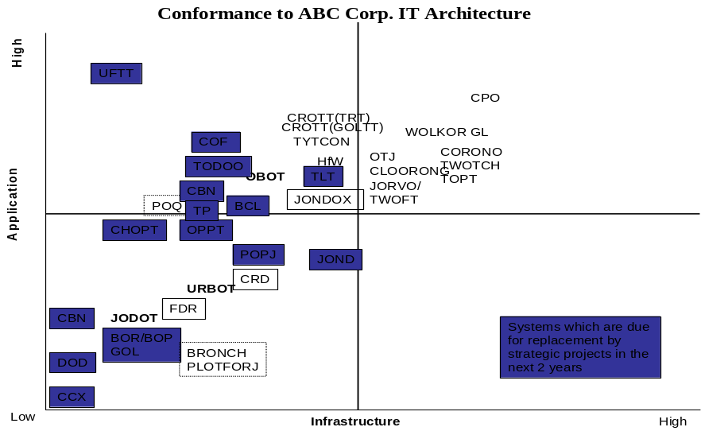

The following comments and observations provide a guideline for interpreting these graphs:
- Systems / applications which have a high functional and technical rating (appear in the upper right-hand quadrant of the matrix), have a high conformance to the (newly defined) architecture, support the strategic directions and desired capabilities of the business and are top candidates for inclusion in a new project portfolio.
- Systems / applications with a high technical but low functional rating (fall into the lower right-hand quadrant of the matrix), are candidates for enhancement to provide increased functionality.
- Systems / applications with a high functional but low technical rating (fall into the upper left-hand quadrant of the matrix), are candidates for redesign / rewrites based on technical issues.
- Systems / applications which exhibit low functional and technical ratings (fall into the lower left-hand quadrant of the matrix), are candidates for replacement.
In this specific sample, the spreadsheet which lies behind the matrix automatically plotted the position of each application system analyzed, based on the scores given. Many of the application systems scored very low in terms of their infrastructure. Much of the infrastructure was old and did not conform to many of the new principles, which related to the sharing of function, scalability and growth, availability and performance, support for the future business directions, or flexibility to change. However, those projects marked in blue, were due to be replaced by two new projects currently under development. If those two development projects could be influenced to conform to the newly defined EA, there was a very clear opportunity to replace many of the outdated systems and infrastructure within a short, 2-year period and achieve the implementation of the desired business and IT capabilities very quickly.
Sample 2 – Gap Analysis of key development projects
The diagrams below show the typical outputs from gap analyses of several key development projects. In this instance, polar charts were used to great effect.
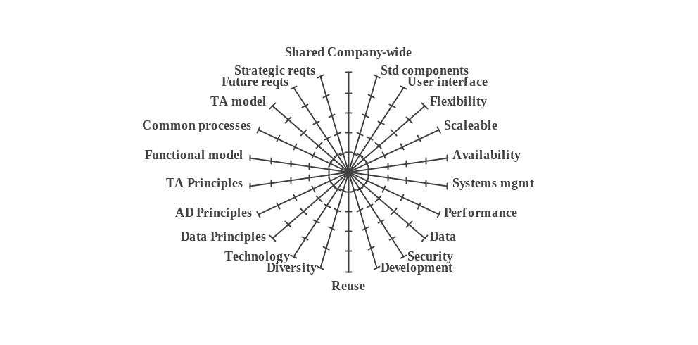The first diagram shows the basic gap analysis criteria used, displayed as a polar chart – for example, running clockwise round the chart: the first 14 criteria are the guiding principles. The gap analysis would check for conformance with/implementation of these guiding principles, application, data and technology principles and the application, data and technology models; support for the desired capabilities and business strategic directions.
Gap Analysis – Project 1 This project was based on a package solution, which scored very low from a development perspective, because the development environment and tools were different from existing standards and add-on function could not easily be developed in-house.
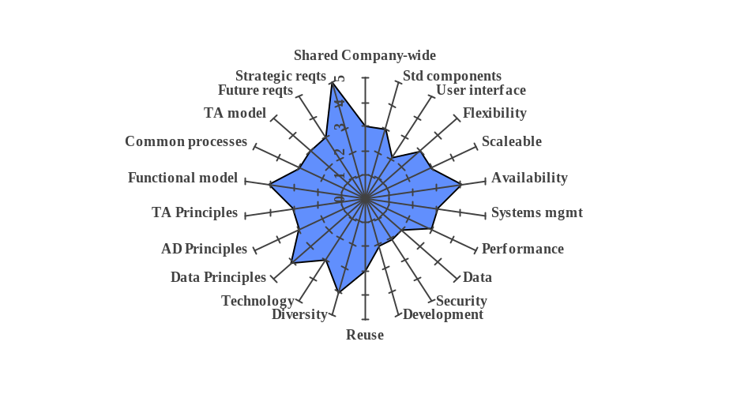

Gap Analysis – Project 2 was for another package solution. The gap analysis showed no real areas of non-conformance, but the package does not effectively meet requirements in a number of areas like data sharing, security and user interface.
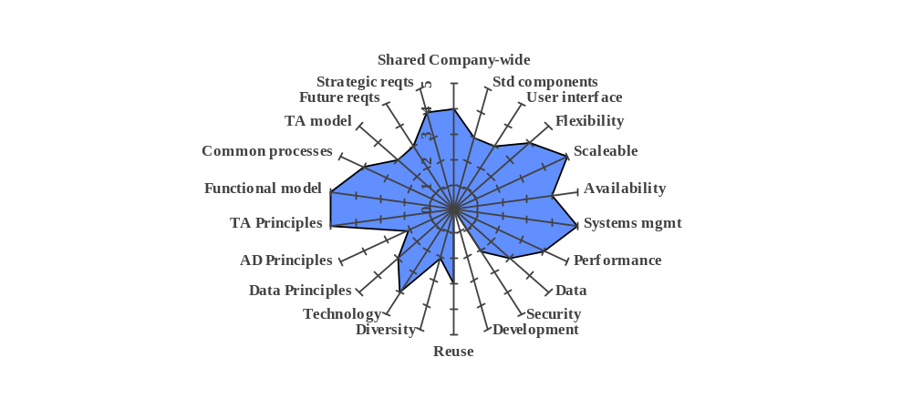
Gap Analysis – Project 3 was a large, in-house development project that was meant to replace many of the existing systems, which had appeared in the left-hand quadrants of the matrix shown in Sample 1 above. Designing and implementing this system as planned before the gap analysis, meant that the application and infrastructure deficiencies of the systems it was to replace, would be replicated into the future.
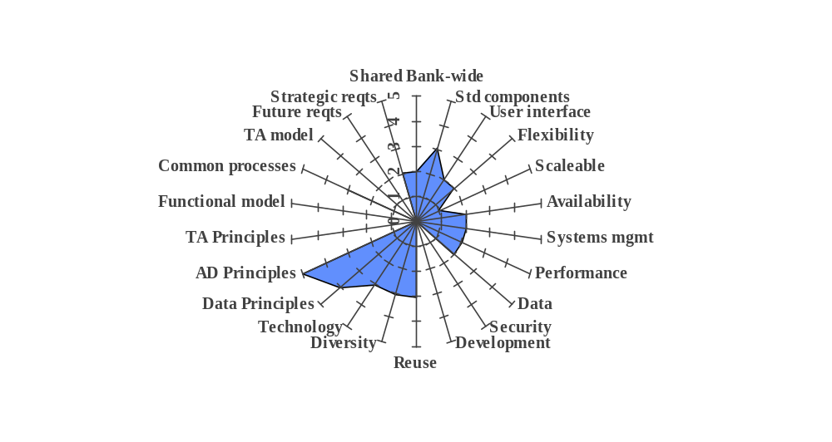

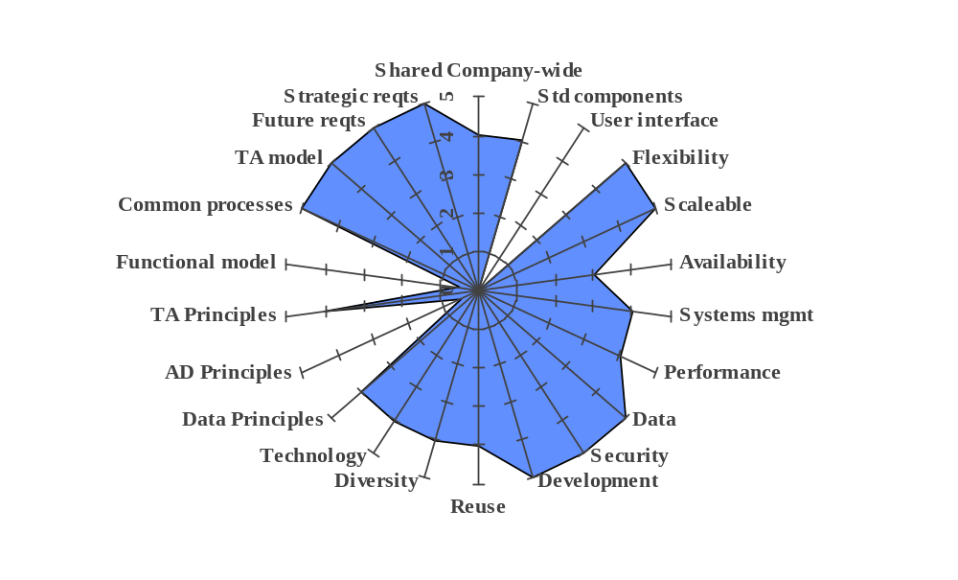Gap Analysis – Project 4 was of a fourth package, which had the highest potential. It was liked by a majority of senior business executives, because it would meet the long-term business objectives and go a long way to implementing the desired capabilities. The original plan had been to delay the implementation of this package for another 3 years, by which time the next version/release would have removed the deficiencies identified. However, after negotiation with the package supplier, he agreed to bring forward the content/functions required into an earlier release. With careful planning, this package became the environment of choice replacing planned project #3.

Based on these gap analyses, ten potential new initiatives were identified for carrying forward into the revised project portfolio. Where these new initiatives impacted existing development projects, revised business cases would be produce.
The new initiatives included:
- The selection of the package analyzed as project#4 as the basis for all future application delivery
- The rationalization of common processes within the strategic projects
- Defining and building common interface requirements and standards for the implementation of common processes
- The ongoing development of the application, data and technology/infrastructure models in the Enterprise Architecture (driven by specific project activity)
- Defining a strategy and plan for achieving a single, common, enterprise-wide base of customer and product data.
- Revision History
Revision Number | Revision Date | Summary of Changes | Changes Marked?
1.0 | August 2001 | First draft | No
1.1 | November 2001 | Updated style, spelling and grammar check.

