
IBM Global Services
Global Delivery Involvement
Technique Paper (TP)
© Copyright International Business Machines Corporation 2007
All Rights Reserved
Version 4.1.1, January 2007

Content
1 Brief Description 2
2 Usage Context 2
2.1 Definitions 2
2.2 Usage Context 2
3 Content 4
3.1 Acquisition and Project Shaping 4
Step 1: Win Customer Confidence 4
Step 2: Involve the Global Resource Entity 6
Step 3: Create Global Resource Statement 6
Step 4: Plan Project 7
3.3 Development and Delivery 8
Step 5: Define and Implement Technical Environment Plan 8
Step 6: Define Development Process 8

Brief Description
This Global Delivery Technique Paper is a brief guidance for project managers and project management assistants on how to handle the most relevant issues of using Global Delivery (GD) capacity within a development project. It describes the minimal must-do activities and must-have work products to be created. It covers the phases from project acquisition to delivery phase. It gives advice to the main pitfalls and the most common risks within GD Projects.

Usage Context

Definitions
GD: Global Delivery Resources perform project work offshore from the customer location. GD can either be a subsidiary of the service provider (IBM) or a service provider independent company (e.g. IBA Minsk).
GD-Entity: The Global Delivery Resources / Global Delivery Partner. This document uses ‘GD-Entity’ when talking about contracting, legal interaction and agreeing commitments e.g. during acquisition.
Service Provider (SP): In this document ‘service provider’ is defined as the legal entity which takes on engagement responsibility of the customer – here: IBM. This could be a combination of on/offshore resources. IBM assigns a lead partner who is responsible for coordinating the GD Team as well as customer communication. During the acquisition cycle, the Service Provider will determine if they are going to leverage a GD Team or a locally based team.

Usage Context
When delivering a Global Delivery Project, certain work is outsourced to be performed by a GD-Entity, e.g. implementation, design or even analysis. Involving GD requires that the project manager define the work the GD-Entity will perform then communicate expectations clearly and measure progress frequently.
In this context the following issues are seen as critical success factors:
Critical Success Factor | Description | Risk
Availability of GD Resources | Skilled resources are limited in number.. Prior to committing to global delivery make sure the needed are available. | Low prices are committed but delivery via global resources is not possible
Customer buy in and confidence | The customer supports the idea of GD and trusts the SP to handle the complexity of the engagement successfully. | Customer does not trust the SP in the use of GD and does not support the model of engagement.
On- and offshore team agreement | The SP and GD-Entity have the same engagement objectives, feasibility, effort and risks and agree on project success criteria. | SP and GD have different understanding of the project objectives, feasibility, etc. and therefore do not work as one team.
Development lifecycle excellence | Production of deliverables is effective, efficient, and transparent and guarantees project success. | The obstacles of remote development are not overcome and delivery within time and budget is unlikely.
Steady delivery | Demonstration of successfully meeting deliverables from the beginning of the project. Customer trust is maintained. | Project results are not delivered in adequate timeframes. Progress is not visible and or the project is delivered over budget. Customer looses trust in project success.
Table 1: Critical Success Factors for GD Projects
The steps described in this technique paper, each address the success factors found in table 1. The following table matches the steps to subset of the relevant elements of the Global Services Method (GSM).
Step | Global Services Method, respective Step here | Critical Success Factor
Step | Global Services Method, respective Step here | Customer buy in and confidence | On- and offshore team agreement | Development lifecycle excellence | Steady delivery
Step1: Win Customer Confidence | - Acquisition (non GSM) | X | X
Step2: Involve the Global Resource Entity | - Acquisition (non GSM)  - WWPMM – Project Shaping |  | X | X
Step3: Create Global Resource Agreement | - Acquisition (non GSM)  - WWPMM – Project Shaping  - CAD – Solution Outline, latest |  | X
Step4: Plan Project | - CAD – WWPMM – Project Shaping |  | X | X | X
Step5: Define and Implement Technical Environment Plan | - CAD – Solution Startup |  |  | X | X
Step6: Define Development Process | - CAD – Solution Startup |  |  | X | X
Table 2: Match Critical Success Factors to Steps described in this Document

Content
This section provides more detail information of each of the steps and identifies which phase of the project lifecycle they are addressed.

Acquisition and Project Shaping

Step 1: Win Customer Confidence

Background
GD projects increase in number when customers understand the competitive advantage of global teams. While customers want the benefits of GD they are concerned about the issues that may negatively impact project delivery. Those issues are best addressed early in the CRM process. The acquisition phase is critical is setting customer expectations because the advantages coming from GD e.g. attractive pricing, are relevant for winning the project. Many of the factors for winning customers buy in and confidence of GD are emotional and can be addressed early in the sales cycle showing the client how this has been successful in other projects.
The following aspects are critical and have to be taken into account when proposing a GD project:
- Quality
As a service provider the IBM name stands for quality. The better the IBM image is in the market place, the better the impression and stronger the confidence of the customer. Customers trust IBM will manage GD effectively and efficiently.
- IT-Security
When the project objective is software implementation, the customer has to be confident of security aspects are in considered and that there are functional backdoors to the applications that make the system open to hackers etc . Involving GD within an unknown culture suggests a certain risk because the culture is not well known and good experiences might not exist yet. IBM is respected and known and customers are confident that IBM will ensure the systems are secure.
- Efficiency and Effectiveness
Customers desire to control the progress of the project is usually higher when teams do not work onshore, because customers cannot see and experience the team working.
- Loyalty
Due to regular interaction, co-located onshore teams customers are more comfortable that all team members and sub teams have the same agenda. Additional communication effort is required to compensate when using global teams because of the reduced quantity of face-to-face interaction between service provider and customer.
- Transparency
Each customer will desire a different level of visibility to the use of GD resources. The proposal team should remain flexible and propose the model that that will allow for successful delivery within the customers comfort level.

The critical factors mentioned above can be handled by conducting a Global delivery Acceptance workshop.
This workshop is conducted with the customer. The workshop ideally is conducted in an early phase of acquisition, however, if a workshop is not conducted, GD options may be discussed during the proposal presentation.
One approach is to present the two alternatives of the project: 1. without GD and 2. with GD. The two options may be included within the proposal itself. The goal is to show that from the client perspective, there is minimal difference between local and global teams. The following information should be shared with the customer:

Actions:
- Present References
Win customer buy in and confidence by supplying good references for GD projects.
- Create Transparency of Processes
Show the customer how they will interact with IBM in both scenarios while giving them options as to how engaged they want to be in managing and/or interacting off-site resources. Customer influence has to be balanced with the project management interests of the service provider
- Plan on Delivering Early and Often
Explain to the customer what will be delivered when and how they will be kept informed of progress and issues. Weekly reports and meetings are recommended to keep the client engaged in the GD work effort.

- Present Early Risk Management
Risks inherent in GD projects are usually well known by customers. Explain the risk management process to the customer and explain how you are going to mitigate known risks.

Solution Startup and Solution Outline

Step 2: Involve the Global Resource Entity

Background
IBM assigns a lead contact person for each customer proposal. The Global Resource Entity should work closely with this proposal lead. As with all proposals, the approach and estimates are best prepared by the delivering organization. The proposal lead is responsible to co-ordinate with the appropriate GD resources in preparing the final proposal for the customer. Risk assessment will need to be conducted for each group participating in the proposal. A partial list of items to be considered in preparing a proposal are below:

Actions:
- The proposal team analyzes the information provided by the customer and establishes the scope of the proposal and desired team composition.
- The characteristics of the sub contract between service provider and GD Entity are specified. Generally two variants exist: 1) Fixed price project with clear defined deliverable or 2) Time and material project
- The technical feasibility is analyzed.
- Contained risk and mitigation strategies are identified
- Effort and implementation strategies are identified

Step 3: Create Global Resource Agreement

Background
During the phase of acquisition the characteristics of the proposal is agreed between customer and service provider (fixed price vs. time and material). At this stage the service provider assumes all engagement risk, however, may need assistance from GD to prepare the proposal. An agreement between the service provider and the GD-Entity will be required to allow the teaming necessary to complete the proposal.
At this point the contractual characteristics between service provider and GD Entity is a critical aspect, has to be clarified and fixed contractually. Generally the GD Entity will have the role of a sub contractor. Even if the GD Entity is a subsidiary of the service provider (IBM subsidiary) and not an autonomous company, an agreement should be documented which defines the rights and responsibilities or each organization. This is defined as Global Resource Agreement.
The duration of agreement should be in alignment (time, type e.g fix price or t&m) with the agreement that the service provider has with the client. The global resource agreement can be renewed if conditions change after the successful acquisition.

Actions:
- Complete a Global Resource Agreement with the GD-Entity for the project
- Renew the Global Resource Statement after successful acquisition if conditions changed (Global Resource Statement).

Step 4: Plan Project

Background
Once the opportunity is won, planning the project is the next important step. Within the planning activity it is essential to consider the risks and allow for them within the project plan. The following risks should be addressed:
- Risk: Requirements are insufficient
Usually the requirements are given to us by the customer. Experience shows that the delivery team will need more detailed requirements than the customer provides and should allow time in the plan to address this. Ensure the plan has sufficient time to document and gain customer agreement for all requirements.
- Risk: Loss of customer trust
If the customer is new to GD or has had a bad experience with GD teams it is essential to structure the plan to build confidence. Plan for frequent communication with the GR and involve the client in meetings with the GD team as appropriate. Additionally, plan for frequent deliveries (every 3 – 6 weeks) from the GR and involve the client in acceptance of those deliveries as appropriate so that they can “see” progress being made.
- Risk: Loss of steady delivery
During any delivery project it is likely that the reported progress soon reaches 80% and then stays there for a longer period of time. Generally the progress is close to zero until testing starts when the facts about delay become obvious. Plan for frequent deliveries (every 3 – 6 weeks) from the GR and involve the client in acceptance of those deliveries as appropriate.

Action
- Plan Project as described in GSM, considering the issues above.

Development and Delivery

Step 5: Define and Implement Technical Environment Plan
This step corresponds to the GSM work product ‘ENG361 Technical Environment Plan’.

Background
Within a delivery project it is important to plan for short turn-around cycles within the development process. It is likely that development the implementation tasks will be done remotely. At a minimum, the following implementation tasks will be processed within one request for service:
- implementation or bug fixing
- Code deployment to a test-, accepting- or production environment
- testing
The turn-around time can only be satisfactory when onshore infrastructure is integrated with the offshore infrastructure. Integration ideally is realized by giving the all team members transparent access to the development, test and production environments. Often connectivity to the customers legacy systems will be required. The cost of supplying, implementing and supporting the project infrastructure should be included in the customer and GD-Entity agreements.

Action
- Define and Implement Technical Environment Plan as described in GSM, considering the issues above.

Step 6: Define Development Process

Background
Successful execution of the development process requires specific definition of roles and responsibilities. The team (customer, service provider, GD-Entity) has to work in sync and need to know who will perform each step in the development process. It is important that there is a common understanding of the clearly defined inputs and outputs required for each step. The relevant segment of the development process is found within the GSM engagement model ‘CAD’, section ‘Release’.

Action
The following detailing of the method is seen as a minimum of what has to be done and can be varied from project to project.
The action Micro Design is detailed as follows:
- Use Case Review
  - Review UCs
A detailled UC specification is the basis for a correct implementation of the enterprise processes. Therefore it is essential to review the specification given by the customer directly after the signing of the contract. To do so, the service provider provides business skill to verify the correctness and detail of the specification. Often actions are initiated with the customer to redesign processes to increase the quality. Quality review should initially be conducted offline (not in workshop mode) for each document to find open questions and quality issues.
  - Workshop Service Provider and Customer
After creating a list of open issues (in step a) a workshop is initiated to clarify all open questions. It is important to clarify as much open issues as possible as all open questions will be identified again in the following discussions and therefore will involve a broader number of team members. It is recommended to have a list of open issues which is maintained together with the UC documents.
- Handover to Development
  - Translation
Customers generally prefer work in the first language but the GD-Entities preferred language is different. It is recommended to use english as the projects working language. Documents that are not already written in english will have to be translated. There are many documents such as NFRs, architectural documents etc. that may need translation.
  - Preparation GD-Entity
The GD-Team will receive translated documents. On review of the document, they will read each one and compile a list of questions or issues for clarification. A meeting will be held to address the questions or issues identified.
  - Meeting Service Provider, Customer, GD-Entity
After the GD-Team reviewed the documents a final meeting is initiated. All open issues are discussed and a common understanding is reached. The project leaders will maintain an ongoing issues/question list. These meeting will take place minimum weekly to address ongoing questions and issues.
It is important to meet in person for the first meeting to get to know each other. Cultural and personal distinctions have to be understood to reach high quality of work. After several in person meetings, ongoing meetings may be held via web meetings or telephone conferences.
  - Clarify all Open Issues
This step is mentioned separately only because of its importance. It is crucial to close development related issues before proceeding to the build cycle. Open issues generally will hinder the implementation team from being productive, effective and efficient.
The action Build Cycle and Development is detailed as follows:
- Design and Development
Development will obviously be conducted by the GD-Entity. The design activity should be at least accompanied by IT Architects of the service provider to make sure customers interests are considered within the technical solution. After the general technical setup, it is possible to hand the responsibility of design over to the GD-Entity.
- Module Test
Testing is processed as usual. Before the modules are tested within real world test environments each developer makes sure that the code he produced runs reliably and functionally correct. Not all test scenarios can be simulated on the developers machine. Therefore the runtime modules have to be deployed to a defined test environment which is often only is available within the customers domain.
- Deployment
Remote implementation brings the challenge of integrating the test environment with the customers legacy systems. (See step ‘Define and Implement Technical Environement Plan`.) Often it will be necessary to deploy the test ready system to the customers environment to have all the required systems in place to conduct the test.
- UAT
As usual the customer accepts the delivered modules by testing them against the functional requirements (represented by the UCs) and non functional requirements.
The following diagram gives an overview of Step 6: Define Development Process: 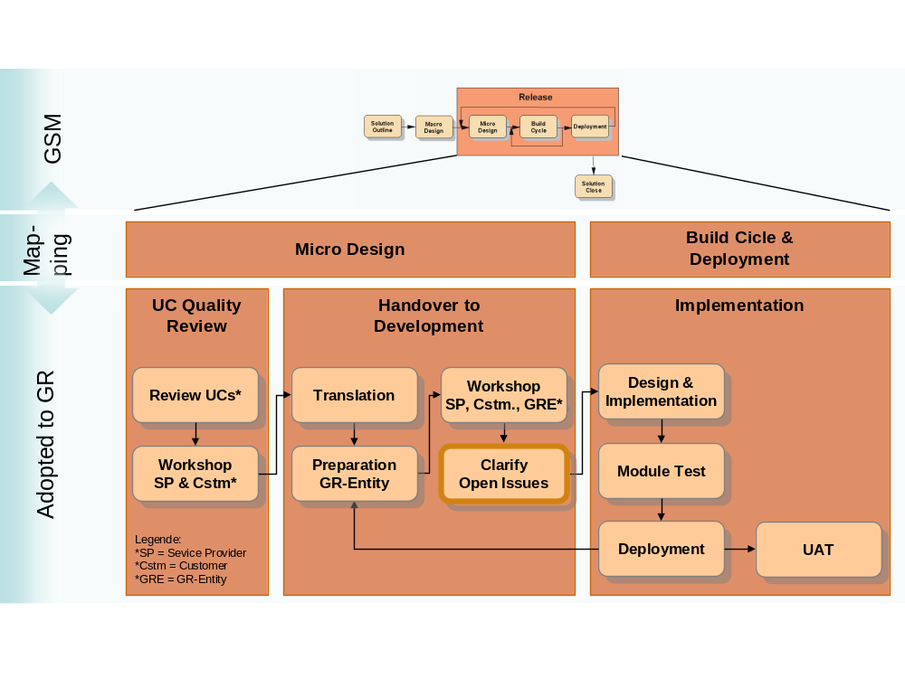
Figure 1: Mapping GD actions to the GSM development process

- Revision History

Revision Number | Revision Date | Summary of Changes | Authors
V 4.1.1 | 10 January 2007 | Created | Simon Kruse/Germany/IBM

