
IBM Global Services
Performance Testing

Technique Paper (TP)
© Copyright International Business Machines Corporation 1999, 2000
All Rights Reserved
Version 1.1 October 2000

Table of Contents
1 Introduction 2
2 Performance Testing Steps 3
2.1 Set the Test Objectives 3
2.2 Define Roles and Responsibilities 4
2.3 Clarify Assumptions and Dependencies 4
2.4 Conduct Data Gathering 5
2.5 Establish the Test Schedule 6
2.6 Develop the Workload 7
2.7 Build the Testing Environment 9
2.8 Create the Test Scenarios 11
2.9 Prepare for Testing 12
2.10 Execute the Test 13
2.11 Analyze and Document Test Results 14
2.12 Conclusion 15
Appendix A: Workload Development 16
Appendix B: Test Environment 18

Introduction
This paper will provide practical techniques for performance testing. The discussion will cover performance testing on a conceptual level so that the ideas presented here can be utilized for all tests regardless of what is being tested; i.e., different hardware platforms, systems software, applications, and/or databases.
Performance testing as described in this paper should be differentiated from other levels and types of testing. The techniques presented here are for performance tests that occur at a single point in time, normally at the end of the development life cycle; for example, after integration or acceptance testing. This kind of performance testing is different from what is sometimes called the “performance engineering” testing level that occurs throughout the entire life cycle of testing.
In this paper, performance testing is defined as understanding how a specific IT system, such as hardware, application or database, will perform under specific conditions. It is different from other types of testing, such as stress testing, where a load is placed on the system to find breaking points or bottlenecks. It is also different from capacity or load testing, where the object is to see how much throughput a system is capable of handling.
Performance testing is often similar, and sometimes overlaps, other types of testing, but is focused on understanding the performance of the system being tested, whether it is called a business, a piece of hardware, new software levels, a different database design or a larger workload. There are typically two desired results of a performance test. Understanding how a system performs is the first stage; improving that performance is often the second stage. This paper will concentrate only on the techniques surrounding the first stage of understanding performance.
This discussion follows the logical progression of steps through performance testing, as shown in the following diagram. Each step in this process is tightly linked to the previous and/or following steps, and one goal of this document is to show how this flow and interaction of steps is related and integral to a successful performance test.
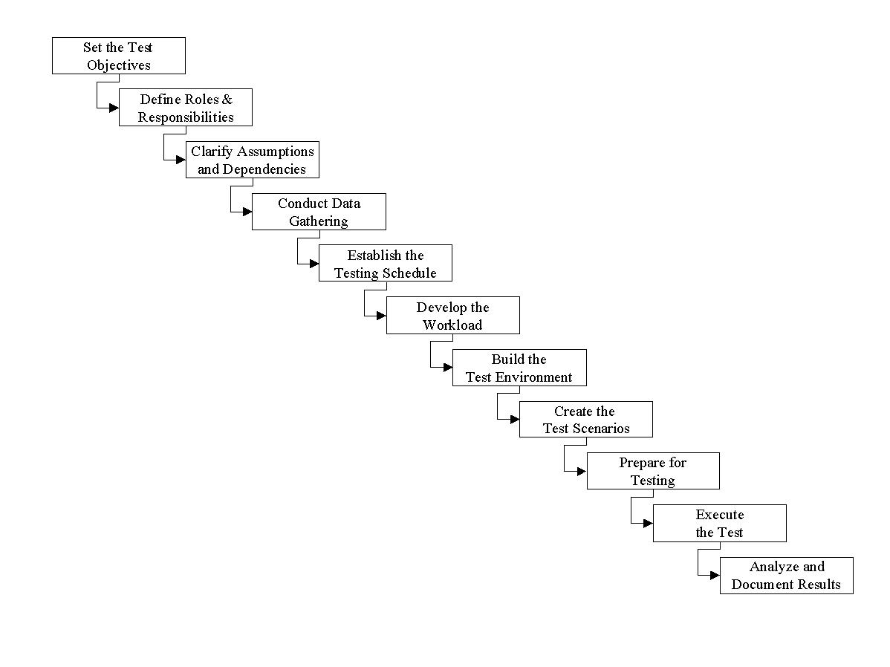
Figure 1. The Steps of Performance Testing
A major assumption of this paper is that the steps preceding a performance test have been satisfactorily carried out. A viable test strategy has been agreed to by the test team, and the customer and a thorough test plan has been documented and communicated to all parties. Because certain elements of the test strategy and planning processes (e.g., setting objectives) are critical to the successful implementation of performance testing, some strategy and planning elements will be emphasized in this paper.
Finally, there are some qualifications that should be noted about this discussion. This paper is purposely written from the perspective of how an external test team would approach performance testing on behalf of a customer. Even so, the general techniques presented are certainly applicable to work carried out by a customer’s own internal team. Furthermore, performance testing is almost always done within certain constraints (i.e., cost, time) as well as within various business or technical contexts. While these considerations are very important in preparing a strategy for testing, offering a proposal, or creating a performance test plan, they are deliberately left out of this paper for reasons of scope.

Performance Testing Steps

Set the Test Objectives
It cannot be emphasized enough that the test team should remain focused on the objectives through all phases and activities of the performance test. Each of the sections below will be tied back to objectives because objectives are the driving forces behind every aspect of a test. The end result of a performance test is some type of documentation stating whether or not the objectives have been met. Therefore, every step towards the final deliverable needs to be based on the objectives. If the team is not basing all of its work on the objectives, it is missing the point of the project and decreasing the likelihood of success.
The objectives for a performance test should be determined when writing the test plan. It is important that the objectives are specific and measurable so that the test team will have a clear idea of what their target is. While objectives should be set during the writing of the test plan, they can sometimes be considered a work-in-progress.
First of all, if the objectives are vague, they will not provide clear direction for the team and should be improved as soon as possible. For example, it will much easier for a team to achieve “a transaction rate of X transactions per second with an average response time of Y seconds” than it will be to “process an hour’s workload while meeting service levels.” The first example is specific and measurable – at the end of the project the team can say with certainty whether the objective was met. The second example is vague and cannot be measured – it would be better to specify what an “hour’s workload” consists of and what the “service levels” are.
Second, it is feasible that the objectives cannot be met for any number of reasons. An example might be false assumptions or unfulfilled dependencies, discussed next. Should the team pack up and stop the testing, or should they continue? This decision is something to be determined through discussion with the customer. If the decision is to continue, refinement of the objectives will be necessary.
This point highlights the importance of focusing on objectives. The team must communicate to the customer at any point that there is an exposure of not meeting the objectives. Not meeting the objectives of a test can be translated as a failure of the project team. It is not hard to imagine how the customer would feel if the project failed and they were not aware of it until the project was complete.
Finally, be precise when attempting to achieve objectives – coming up short or overshooting them can be counter-productive. Achieving a lower transaction rate than specified in an objective may not tell the customer what they need to know. Establishing a transaction rate higher than stated may not give the customer what they need to know either – the results may overstate performance requirements the customer needs and lead them down the wrong path.

Define Roles and Responsibilities
Moving from the setting of objectives into the rest of the steps in performance testing will require a team to accomplish the work. The work required to complete the testing will be laid out in the test plan, but an initial key piece of work is the staffing of the test team and the dividing up of roles and responsibilities.
Understanding the steps of a performance test, as well as the type and amount of work required to do a test (some of which are described in this paper), will dictate what skills and staffing are required. When selecting professionals to fulfill these roles and responsibilities, conduct a thorough examination of each of the steps, from setting objectives all the way through analysis and documentation, and be sure to account for all the varied roles that will be played in the performance test.
At times, a small set of people can perform all the roles required in a test. On the other hand, such a strong team might not be available and it will be necessary to select from a wider population in order to fulfill the roles and responsibilities adequately. It can be risky picking a team with only the initial steps in mind, neglecting the latter steps that can be just as important, while hoping the members of the team can somehow fulfill the later roles.
When looking for resources to staff all the roles in a performance test, it is prudent to take full advantage of all the options. While the focus might be on internal resources, customers are often more than willing to provide necessary assistance because they are probably more interested in the success of the testing than the test team. Also, it can be beneficial to seek out and utilize third parties and include them on the team. This is sensible when neither the test team nor the customer has the right skills (e.g., the developer of an off-the-shelf application).
When going outside the test team for help, it is critical that the roles and responsibilities are clearly defined and agreement reached on who will do what. Having members on the test team that are outside the normal hierarchy of accountability requires a documented understanding of what is expected of each party that can be referred to in case the agreed to roles and responsibilities are not met. In fact, these arrangements are typically clarified out as assumptions and dependencies, a step in performance testing that will be covered next.

Clarify Assumptions and Dependencies
Proper planning for a performance test will already have the assumptions and dependencies of a test documented. The assumptions and dependencies are tied to the objectives and state under what conditions the objectives can or cannot be met. One way to understand the difference between them is to think of assumptions as being those items that aren’t really required to satisfy an objective, while dependencies are absolutely necessary “things” without which the project team cannot satisfy the objectives.
Assumptions cover risks that are acceptable to the customer and which all parties agree likely will not impact the results of the test or are not inhibitors to achieving the objectives. From one perspective, the objectives state clearly what will be done while the assumptions state what will not be done – it can be just as important to document what will not be tested as what will be tested. One thing to keep in mind, however, is to remember the assumptions when documenting the final results. They should not be recognized at the outset of a project just to be forgotten about later. It is good practice to remain clear about the assumptions throughout, even when concluding the test objectives have been met, in order to keep expectations at the right level.
Dependencies are action items that must be completed if the objectives of a test are to be met. These can cover any facet of a performance test and should be tracked carefully throughout the project and resolved as early as possible. Failure to resolve dependencies will lead to a failure to meet the objectives. Therefore, dependencies should not be looked upon as information for information’s sake, but as a call to action.
Assumptions and dependencies are often based on the technical and/or business context in which the performance testing is to done. An example of an assumption might conclude that other work that normally runs in a customer environment is not relevant to the testing objectives, that is, it is acceptable that the workloads are tested in a vacuum. Ideally, this is probably a false type of assumption; in reality, due to cost or time considerations, leaving the “background noise” out of the testing may be acceptable assumption.
Examples of typical dependencies for performance tests include availability of new customer or vendor code, installation of equipment, or access to customer subject matter experts. These are the types of things that would put all, or part of the, testing project at risk for failure.
While the assumptions and dependencies should be documented in the test plan, more can be uncovered during actual plan execution, particularly in the next step of data gathering. In fact, one of the tasks of data gathering is to verify already documented assumptions and dependencies.

Conduct Data Gathering
To prepare the performance test plan, a certain level of data gathering has already been accomplished; but, during the test preparation, the gathering of data and information goes to a depth not possible in putting together the plan. In line with the overall strategy and test plan, data gathering is typically the initial step in a performance test and sometimes can continue up through the execution of the test.
While collecting the information and data necessary to prepare and execute a performance test, it is an essential practice to keep the objectives in mind. For any test, but especially for larger ones, there is always more data available than what a team can use. When interviewing subject matter experts, collecting data from existing systems, or designing test programs, it is helpful to let the objectives lead this effort in order to keep within the scope of the project and avoid wasted effort.
Keeping the assumptions and dependencies in mind can also be helpful. If assumptions are made that significant portions of a customer environment are not needed for the performance test, knowing this will help narrow down the extent of the search for data. Conversely, keeping the dependencies in mind as the team gathers data will push them to keep an eye out for any potential problems with satisfying the dependencies.
The information and data to be collected in this activity sets the stage for the later steps in a performance test that are discussed below. Some highlights to be aware of when collecting data and information for each step are:
- It is often the case that a test team cannot have enough data when developing the workload to be tested. The team should spend as much time as possible digging and clarifying from as many angles as possible how the workload should be built. A good principle to follow is never to assume that the workload is “bullet-proof” (in fact, this is an excellent principle for all facets of testing).
- Don’t underestimate the value of understanding the business process being tested, instead of just taking a technical perspective. Spending time to understand the purpose, the flow, and the logic of what is being tested adds value that can be beneficial to the team throughout the entire project.
- When gathering data, keep the different components of a workload clear; i.e., business functions, transaction rates, workload mix, and number of users. It is easy to confuse the various components and come up with a misrepresentative workload. The more clearly the team can present the data, the simpler later steps of the testing will be.
- Determining the workload can be helped with the use of non-technical information. One key area of exploration can be a business analyst group that thinks in terms of business throughput, not transaction rates – the key will be translating these business requirements into technical (transaction) terms.
- It is usually impossible to produce a test configuration (hardware and software) that exactly matches the requirements, so the team should remember to gather the right information to understand alternatives and document the differences.
- Spend time understanding the functional requirements of the performance test; then, based on this knowledge, choose the right tools and how they will be used before simply jumping into coding.
- One area often overlooked when testing a client’s system is operational procedures. A performance test team’s unfamiliarity with these processes can hamper a test’s effectiveness when unexpected events occur. The best time to learn about these procedures is during the data-gathering phase, rather than during the test execution.
- When the performance test team interacts with the client and/or third party teams during data gathering, some valuable relationships can be built that can be put to good use later in the project. Each member should communicate these relationships to the entire team so that any member can take advantage of a client resource when running into difficulties later in a project.
As this last bullet suggests, data collection can cover a wide spectrum and involve many different parties. Fundamentally, data and information specific to performance testing are usually gathered from three broad areas of expertise:
- Users can give the team a business perspective of what is being tested. Users can transfer skills and understanding of the business, and can help identify and build scenarios to help meet the objectives.
- Application developers can give a more technical perspective on what is being tested. The can identify potential problem areas that might be highlighted early in the development cycle.
- Operations (including systems and database support) can provide a service delivery perspective that should be included in the actual testing.

Establish the Test Schedule
A test schedule will cover the steps leading up to a performance test, the actual testing, and the subsequent documentation and analysis period. A schedule should be included in the initial test plan; however after the data gathering phase, new information might cause the team to adjust the original schedule, particularly with respect to the actual test execution. Unless the testing of the system or application has been done numerous times in the past, and the test team can use that experience, scheduling of a performance test can often be part art, part rigorous process.
In the situation where a performance test is breaking new ground, the performance team will need to draw on available testing experience and intellectual capital in estimating a schedule. The following points can be kept in mind in establishing a test schedule.
First of all, it would be helpful to keep in mind that specific performance tests are not production-like processes that have been run for years and which have had all conceivable problems ironed out. It should be assumed at the outset that errors and mistakes are bound to happen as part of a learning curve, and extra time built into the schedule accordingly.
Another point to keep in mind while building or refining the schedule is the skill level and availability of the team that has been put together. A higher skilled team should equate to a shorter timetable, for example, while a team that is busy with other work might mean a longer schedule. From a larger perspective, when setting the schedule, remember all the team dynamics.
The time required for the data gathering and workload development tasks tends to be especially difficult to project. The team should take advantage of the internal experience it has and the experience available from outside professionals to tackle this difficult scheduling issue. In the end, work is often done on a “best-effort” basis in order to complete these tasks due to time and budgetary constraints. Nevertheless, coming up short on the desired level work can still be acceptable as long as the goals and objectives of the test are met.
On the one hand, building of the test environment should be done within the context of meeting the testing schedule. On the other hand, the schedule should take a hard look at how long it will take to build the environment. Section 2.6 covers the major areas of the test environment build: hardware, software, networking, and data. Leave a comfortable amount of time in the scheduling to meet all of those requirements.
Next, allow enough time to carry out the tasks for test preparation as discussed in Section 2.8. Avoid the temptation to just jump into an environment and start testing: plan for the preparation and stick to the schedule when you get to that point. Not doing so will be a cause for not meeting the test execution schedule later, when problems that could have been resolved during preparation delay the testing.
Once the testing begins, the schedule should be gauged primarily on the test scenarios as described in Section 2.7. Things to consider when scheduling the scenarios are:
- The length of time each scenario calls for (e.g., one hour of online testing; a night’s worth of batch testing).
- Time required to reach the point where testing can begin (e.g., ramping up an online workload).
- Potentially retesting each scenario to resolve problems or implement improvements.
- Shutdown and cleanup time.
- Time required to collect data and perform analysis between test scenarios.
- Other tasks needed between test scenarios (e.g., restores).
Clearly, there are many factors to consider when putting together a schedule for the test schedule. It is acceptable to schedule by the week or day for earlier phases of a testing project, but when thinking about the test execution it is advisable to think in terms of minutes or hours, because of the many various tasks that need to be completed in a short window.
Finally, plan sufficient time after the performance test to complete a thorough analysis, document the results, and present the findings and conclusions to the customer. The deliverable is, of course, what a customer is paying for and most interested in. After a long and grueling performance test, allowing some time to regroup and refocus will help give the test team the wherewithal to produce a solid deliverable, rather than sloppily throwing something together just to meet a contractual obligation.

Develop the Workload
The workload can be considered the heart and soul of a performance test and, consequently, most of the effort will be expended on developing the workload. Throughout the workload development effort, the team should continually question whether or not the work performed would help achieve the testing objectives.
A workload can be defined as a set of programs that will be executed, or tested, in order to meet the objectives of a performance test. However, for development purposes it can be helpful to look at a workload as more than just a set of programs. In fact, strong performance testing teams document the areas described herein before jumping into coding a workload. Documents included in Appendix A show examples of how to document workloads. Online workload development will dominate this discussion, but some time will be spent on batch workloads.

Online Workloads
Consider testing in terms of “business functions.” These functions are logical pieces of work that must occur in order to complete some business process (e.g., complete an order, deposit a check, or browse a web page). For online workloads, a business function can consist of one or more transactions. Conversely, single or multiple transactions can be shared between different business functions. Additionally, to complete a business function, it often is necessary for transactions to be completed in a particular order.
A performance team should not just select a set of transactions it wants to test, code testing programs for them, and then execute them for what the team thinks is the proper number of times. Instead, basing workloads on business functions makes it easier for the team to build a workload that resembles what the customer has, or wants to have, running in production. Without keeping the concept of business functions in mind, it is easy to build a non-representative workload. The problem with this is that it becomes more difficult to meet the objectives of the test.
The next level to examine is the transaction level, but within a business function context. A business function is composed of various transactions that need to be executed in a specific order. As mentioned in the previous section on data gathering, understanding the flow of business functions from an end-user perspective is critical to creating a representative test workload.
At a lower level, understanding how each transaction within a business function works is the next critical step. This understanding can begin during the data gathering phase and can continue as the workload development phase moves forward. While gathering information and trying to grasp how each transaction works, these are typically the things a team should keep in mind:
- Fields on the screen.
- How presented data was arrived at by the system or previous scripts.
- Input values.
- Impact of input values downstream (i.e., subsequent transactions).
- Program function (PF) key or icon manipulation and results.
To understand each of these areas can certainly be time-consuming, but the benefit of this understanding will become clear at the next level of establishing the workload mix. Workload mix can be thought of as the percentage of the total workload each business function and/or transaction contributes. The mix should be established after extensive data gathering while the key to effective workload development is producing a workload that, when executed, matches the planned mix.
The key question then becomes, what can be done so that the proper mix is achieved when executing the performance test? The following list of techniques can be applied to produce the right workload mix:
- Take advantage of think-time intervals within business functions (between transactions) to establish a consistent time period over which they will finish; this method does not preclude producing a random range within business functions that, in the end, meet an average timing target.
- Code timing delays in scripts to control how many times within an execution window a business function will execute; these delays can also can be randomized around an average.
- Within the simulated end-user population (or even devices such as ATMs) spread the different business functions among groups of users or devices to allow for more control.
- Where multiple paths can be taken from a single transaction, code the simulation programs to execute each path a certain percentage of the time to meet the workload mix.
Once the basic workload has been scripted, testing of the workload itself will be enhanced by incorporating these types of techniques because they allow simple, flexible, and powerful ways of adjusting the workload to match the test objectives. In addition to these techniques, there are other coding techniques that will be handy during actual testing, beyond matching the proper workload mix:
- Code the capability in the scripts to “ramp up” the workload in order to achieve the desired flow and timings. Novices at testing online workloads tend to start everything at once and hope to achieve a desired workload rate right away. This goal is extremely difficult to achieve with large and complex workloads, and can mask problems that might show up if the workload was ramped up slowly.
- Plan to incorporate the ability to restart test scripts and programs when unforeseen errors or results, whether caused within the same script or by others. Plan for these “escape routes” to save time in restarting tests.
- Reporting capabilities can be incorporated into the code to view measurements during testing, such as response times, business function rates and workload mix. These techniques provide a useful way of determining in “real time” how the testing is going, rather than waiting until a test window is completed.
- User exits can provide powerful functionality beyond what typical products offer and, consequently, need to be planned and developed early on in the cycle.
- Taking advantage of the ability to change input transaction data (e.g., UTBLs in TPNS) can produce life-like workloads as opposed to hard coding values in scripts. Sources for this type of data should be uncovered during data gathering.

Batch Workloads
Some of the basic ideas in this section so far can also be used in developing batch workloads where necessary. The major difference between online and batch testing is that there is typically no development of simulation programs for batch. Understanding the business functions that batch jobs are set up to process, the flows and dependencies of multiple batch streams, and the resources that each batch stream requires will help the test team in two ways. First, they can develop discrete batch workloads that are repeatable and measurable as required in light of the objectives. Second, this understanding will go a long way in helping the team during data collection, analysis, and documentation.
Online workloads tend to receive most of the attention in a performance test, because it is pretty easy to simply run a batch process that is already setup (whether in a production or development environment). When it comes to performance testing there is a tendency to find the biggest “bang for the buck” when finding improvements in the batch workloads. That is why it can be beneficial to spend significant time learning the characteristics of batch workloads even when they may already be developed.

Build the Testing Environment
The test environment, as its name indicates, is the environment in which the workloads will be tested in order to meet the test objectives. In preparing for the performance test, one task of the test team is to build the test environment to match the one defined in the test plan. Careful planning and rigorous data gathering will arrive at a specific set of configurations that are required in order to meet the objectives of the test.
Building of the test environment should be careful to follow through on this planning. An example of what can be included in the test plan in shown in Appendix B. The point of putting this kind of information in the test plan is to provide something for the test team to work from; ignoring the plan and building an environment arbitrarily defeats the purpose of a plan and can, more importantly, lead to unnecessary problems or worthless results.
There are four significant areas to consider when building test environments: hardware, software, networking, and data. These areas are detailed in the following sections.

Hardware
Hardware can include processor, storage, tape, printer and network equipment. In most performance tests, the goal is to match to a certain extent the client’s own environment. Therefore, in the planning and building of the test environment, it can be crucial to work closely with the client and draw on their own intellectual capital and expertise.
Because a test team does not usually have the exact configurations needed for testing at their disposal, sufficient time should be planned to build the required configuration. This can include such activities as procuring equipment, reconfiguring the available layout, or modifying current equipment (e.g., varying storage offline).
Substitutions or carving up of hardware resources are often viable alternatives to meeting the exact configuration. These alternatives should be discussed in the planning and data gathering phases of the project, and can be taken advantage of when moving into the build phase to provide an environment quickly and cost-effectively. Substitutions can be explored when it is clear that equipment has no bearing on the objectives (this type of activity is normal when cost considerations are critical).
In those cases where the available configuration is much larger than what is required, the team should not necessarily ignore the extra capacity or resources, but can take advantage of them. For example, if there an excess of tape drives, the additional drives could perhaps be used when doing backups and restores to speed up that process, rather than relying on a minimal number of drives.

Software
Software can be provided either by the customer or built by the test team. Systems provided by the customer are preferred because they usually come closer to matching what the test plan calls for and using them is clearly more productive than building one from scratch. In either case, as with all things, the software test environment should be built according to the test plan and with the objectives in mind.
If utilizing a customer’s software configuration for a performance test, the customer’s disaster recovery plan can be used in porting to an off-site location (if there is one). When using a customer’s system in this case, the team should keep in mind that the customer may be using products that require special software keys based on processor serial numbers. Allow enough time for the customer to procure those keys and install them.
Sometimes a customer may elect to execute only a portion of its disaster recovery plan just to provide the minimum amount of resources required for testing. This choice is acceptable, but for the more complex and integrated systems, care must be taken that nothing is left out and that all dependencies are accounted. This activity, of course, requires thorough planning.
There are times where performance tests may be interested in a customer’s future environment that takes advantage of new technology, new system functions, or greater capacity. In building a test environment where new or larger resources are to be added, the team should be careful to not just install these resources haphazardly, but also synchronize the additions according to how the customer intends to install them. An overriding goal of performance testing should be to test a representative workload on a representative system.
Finally, keeping in mind the end result of a performance test (documentation on whether the objectives have been met), the team should ensure the right monitoring and reporting tools are available, whether on the test system or to be used elsewhere. When building the test environment, ensuring the right tools are being used properly (e.g., the right traces are turned on) should be part of this exercise.

Networking
For any type of online performance test, tailoring of the test network configuration to support the testing is almost always required. This involves the definition of enough network resources for test tools (i.e., driver system) to utilize in simulating a network. If the objectives refer to a certain number of simulated users, for example, the team should ensure that enough resources are defined to meet those objectives and not just make do with what’s available. Specific definitions for the test tools themselves may also be required. This type of information should come out in the planning for the test, but time for the implementation of these changes should be scheduled and customer support arranged for as well (since it is their system being tested).
Made practical by the global proliferation of network connectivity, remote access to the test environment can logistically help a customer and a test team. To achieve remote access, additional equipment may be required (e.g., routers and hubs), as well as dial-up software, tailoring of the test system, and tailoring of the customer network to connect remotely. While not directly related to the performance test objectives, some time and effort early on to set up this connectivity will allow the team and client to be more flexible in their working arrangements, and may make available a wider range of support than if a team is required to work in a central location.

Data
Test data is the final major piece of the test environment that needs to be considered. If the customer is able to port its system to the test site, the team will have a good basis for test data. Be aware of exposures incurred when data needs to be created from scratch or when the team needs to add new data to the data already ported.
Whether old or new, the team should assume the applications to be tested have relationships built throughout all their data. This assumption in itself should give the test team sufficient warning that creation of data is no trivial matter. Particularly in this area, lack of time spent on creating data properly is a cause for disaster during testing. It is always the customer who has the knowledge of the data content and the relationships, so any creation of new data should be done by the customer, if at all possible; or, if the test team must do it, obtain the customer’s strong guidance and assistance.
Some sources of data are:
- Use of testing data already created by application developers; however, the quality and quantity of data are always suspect.
- Use of data copied or extracted from production is the ideal, and provides a very life-like environment in which to test.
- If creating data from scratch, a safer method than creating build programs is to simulate the data entry process and create enough records for testing (e.g., process orders until enough records are built up in the database to begin testing).

Create the Test Scenarios
Test scenarios are defined in order to give the test team direction on how the performance testing should be executed and need to be clearly documented. They are included in the test plan, but like all things in a performance test, test scenarios are a work-in-progress and can be polished over time. The goal of having scenarios is specifying what workloads are to be run, and under what circumstances, in order to meet the test objectives.
It can be extremely helpful ahead of time if the scenarios also describe how the measurement and analysis will be carried out in order to show whether the objectives were met or not. That is, the team should consider that the determination of success is an integral part of the scenario, as opposed to being just an afterthought.
Test scenarios can have the following characteristics:
- A test scenario can use a single workload (e.g., online only)
- A single workload can be tested by multiple scenarios (e.g., different sizes of data)
- A test scenario can test multiple workloads (e.g., batch and online)
- The same set of workloads can be run across multiple scenarios (e.g., adding nodes)
- A test scenario can describe how the test environment will be used (e.g., “in a parallel sysplex”)
- Any differences in the test environment should equate to different test scenarios (e.g., adding online regions)
- A test scenario can indicate what data will be collected to show how the objective will be met (e.g., CICS response time will be reported using TMON/CICS data)
It is a good practice to ensure that each test scenario is tied back in some way to an objective. If a test scenario cannot be related to an objective in this way, the team should question why the scenario is being run. Conversely, each objective should have at least one test scenario built specifically to achieve that objective, although multiple scenarios are fine.

Prepare for Testing
At this point in a performance-testing project, the objectives are clear, thorough data gathering has prepared the team, the workload is complete, the test environment is built, and the test scenarios are refined. This section discusses the final steps that need to be taken prior to the actual execution of a performance test.
Moving into the test environment prior to testing is often the first opportunity the team has to see if they are actually ready for the performance test. Therefore, it is a good idea to pre-test the workload and the environment. The following steps can be followed to make sure everything is ready for testing:
- Execute the batch workloads in a dry run.
- Manually test each online transaction to ensure all resources are available.
- Unit test individual online scripts to help weed out errors that would be hard to isolate when running entire workloads at one time.
- Test the integrated workloads with the following in mind:
- Repeatability of the workload between tests
- The workload flow is as expected; i.e., the transaction rates and other expected results are correct
- The workload mix is correct
- Recoverability at any point in the test is possible (rather than restoring and starting from scratch)
- Look for unplanned errors not accounted for in the scripts (e.g., deadlocks).
- Finally, execute each test scenario in a dry run.
Each of these steps are mentioned because at each point in the process, various problems can arise that, if not corrected, can lead to wasted effort and rework later on. The key to this preparation is to be able make full use of the work done so far during the test execution. Large, complicated projects are costly for customers, so it is critical to make efficient use of what’s being tested.

Execute the Test
All the work prior to test execution is geared toward the building of the test scenarios that are now to be run during the performance test. It is not this simple, however, because there are many supporting activities that must take place to ensure the test scenarios are run correctly. Because there are so many activities taking place within a short time frame and under new or unique circumstances, the chances of losing control increase. This section will highlight some ideas that, if taken advantage of, would go a long way in controlling the potential chaos and help a test team deliver a superior performance test.
This technique paper has not touched on project management up to this point. During a test execution (often a chaotic and dynamic time), good project management practices can become especially crucial in delivering a quality test. Therefore, the team should make sure that regular status meetings or conference calls are held with all parties to keep everyone aware of what’s going on, provide a forum for reaching decisions, and an opportunity for problem diagnosis.
Another good idea that should be implemented early in this type of project, but which will pay dividends especially during testing, is to give every member of the test team exposure to all areas and people involved in the testing project. At critical points, familiarity among all people involved cannot but help quicken the time it takes to identify and fix problems that occur.
From a testing process point of view, the key consideration during test execution is the establishment of a baseline against which subsequent testing (where changes have been implemented) can be compared. In a performance test, the goal is to determine how well a system performs; but in order to make this determination, the test team will need to compare results against baseline information – hence the value of baseline runs. This practice of establishing a baseline will prove especially helpful later, when conducting analysis and documenting results.
In a more technical vein, one of the fundamentals of a performance testing discipline is ensuring the repeatability of tests. One key activity that takes place during test execution is the backup of the test environment prior to the testing. Backup will allow the team to recover the test system and data back to a consistent point in time and allow the next round of testing to begin.
One thing to consider when planning the backup sequence is the possibility of more than one copy of a system. As the testing moves through various scenarios, certain improvements may need to be introduced to the system. Rather than apply a growing number of changes after each restore of the system, additional backups of the pristine test environment with the changes implemented might be called for right before a new test.
One significant point of failure in a backup/recovery process can be the destruction of valuable data when the system is recovered. Data and records that are produced during testing that are needed for analysis and documentation must be collected prior to the recover of the system. The team should make sure facilities for this information (e.g., disk space) are available and that a process for this collection is in place.
Control sheets for each test executed are an invaluable aid to ensure each step in the test execution is carried out in hectic surroundings, and provide another tool that can help control the flow of the project at its potentially most confused point. Control sheets will help “force” the team to carry out all tasks necessary to complete a successful test: pre-test setup, scenario flows, shutdown, and cleanup. The contents of the control sheet can vary and depends on the circumstances under which the tests occur. The controls should be thorough enough so that nothing critical is left undone, yet not burdensome so that unnecessary effort is expended.
Execution of a test normally calls for a certain level of workload to be running when taking measurements and collecting data. This can be a steady-state workload or one that increases over time. In either case, it can be very difficult to quickly reach and maintain the levels of workloads need to take measurements. The team should take the time to “ramp up” the workload to the desired state before collecting data, while monitoring the workload after the ramp up period to ensure it is processing at the desired levels. This technique is important and can be difficult to learn and implement, but the dividends can be huge when a team has the ability to control the workloads being tested – they will produce a more realistic workload that is worth measuring.
During test execution, the team can take advantage of the tools that are available in the test environment. These tools can take several different forms: commercial products on the test system, tools developed and provided by the test team, and/or tools and modifications produced by the customer. During the stages leading up to the testing, the team can take advantage of intellectual capital and the customer’s experience to understand the variety of ways of exploiting the tools for its own advantage.
There is usually a wide range of tools available, but they generally fall into these categories:
- Automation - for backups/restores, test preparation, execution, reporting.
- Monitoring and analysis – set up the tools during the preparation phase as required.
- Reporting – ensure tools are tailored/used right to report against objectives.
- Debugging – of workload code, application code, and system problems.

Analyze and Document Test Results
Once the performance testing is complete it is time to analyze the results and to document findings and conclusions. This process should be iterative, not something done after all testing has been completed, but also during and after each test scenario. If at any point the testing has not been successful, it is critical that the team should know before proceeding.
The main focus of analysis and documentation is simple: have the objectives been met?
All the work up to this point should have been geared toward answering this fundamental question. Difficulty in answering this question can often be traced back to not following the testing process and the sort of techniques offered here; hence, the importance of focusing on the objectives from the outset.
Collecting the correct data first will help determine whether the testing has been successful. It should then be compiled in such a way (e.g., graphical, tabular) to ease the analysis and subsequent documentation. A valuable method of compilation utilizes the baseline run as a comparison point.
Upon determining the success of the testing and after the analysis of the results, the next logical step is digging down and answering several basic questions, such as:
- If the objectives were not met, why not?
- What can be done to improve the results?
- If the objectives were not met initially, what was done to improve performance?
- If objectives could not be met, what recommendations can be tried later?
- How much did performance improve over the baseline run?
- What accounted for this improvement?
- What conclusions can be reached based on the analysis?
- How can the results be documented to show improvements or failures?
Once the analysis has been completed, documentation of the findings, conclusions and/or recommendations follows. For a customer, the overriding concern is whether the test is successful or not, therefore, the documentation should begin by stating whether the testing had met the objectives. A logical presentation and discussion as to why the objectives were, or were not, met should follow. It is never a good idea to throw data at the customer and let them reach their own conclusions. The analysis is more important than the supporting documentation and that is what should be focused on.

Conclusion
At the conclusion of a successful performance test, results have been presented to the customer letting them know whether the objectives have been met or not. In an ideal world, all objectives will be met. In the real world, however, it doesn’t always work out that way. Does this mean the performance test has been a failure?
If the test team does not meet the objectives because it neglects or fails to perform the major steps discussed in this paper, then the test project cannot be considered a success. On the other hand, if the performance objectives cannot be met in spite of a flawless performance by the test team, this exercise can be valuable for the customer. It can provide them with critical insight on the direction they are heading and offer them a chance to adjust in midstream before wasting time and money on a lost cause.
With that said, however, successful performance test teams always work with the end results in mind: meeting the test objectives. Carrying out the performance testing steps as described in this paper can help make the test team successful.
Revision History
Version 1.1, October 2000 – Removed confidentiality markings from header.
Version 1.0, September 1999 – Base version.

Appendix A: Workload Development
Business Function | Transaction(s) | Program Names | Characteristics
Customer Inquiry | BCUS | CIFCP301 | Inquiry
Customer Inquiry | BCUS | CIFCP302 | Inquiry
Customer Inquiry | BCUS | CIFCP303 | Inquiry
Customer Inquiry | BCUS | CIFCP306 | Inquiry
Customer Inquiry | BCUS | CIFCP317 | Inquiry
New Customer Setup | BNEW | CIFCP301 | Inquiry
New Customer Setup | BNEW | CIFCP302 | Add
New Customer Setup | BNEW | CIFCP317 | Add
Open DDA Account | BOPN | CIFCP301 | Inquiry
Open DDA Account | BOPN | CIFCP302 | Inquiry
Open DDA Account | BOPN | CIFCP304 | Inquiry, Add
Open DDA Account | BOPN | CIFCP306 | Inquiry
Open DDA Account | BOPN | CIFCP309 | Inquiry
Open DDA Account | BOPN | CIFCP312 | Inquiry
Open DDA Account | BOPN | CIFCP378 | Add
Name Change | BNAM | CIFCP301 | Inquiry
Name Change | BNAM | CIFCP302 | Inquiry, Update
Name Change | BNAM | CIFCP303 | Inquiry
Name Change | BNAM | CIFCP304 | Add, Update, Delete
Name Change | BNAM | CIFCP309 | Inquiry, Update
Name Change | BNAM | CIFCP312 | Inquiry
Customer Profile Update | BUPD | CIFCP302 | Inquiry, Update
Table A-1. Business Function Data

Transaction | Transaction Rate | Volume | Percentage | Historical Elapsed Time | Users
BCUS | 8.6 | 31,104 | 84.1% | 1.3 | 702
BNEW | 0.29 | 1,043 | 2.8% | 1.2 | 51
BOPN | 0.86 | 3,100 | 8.4% | 0.6 | 81
BNAM | 0.17 | 612 | 1.7% | 0.5 | 22
BCHG | 0.31 | 1,129 | 3.0% | 2 | 75
Total | 10.27 | 36,988 | 100% |  | 931
Table A-2. Transaction Data
Appendix B: Test Environment

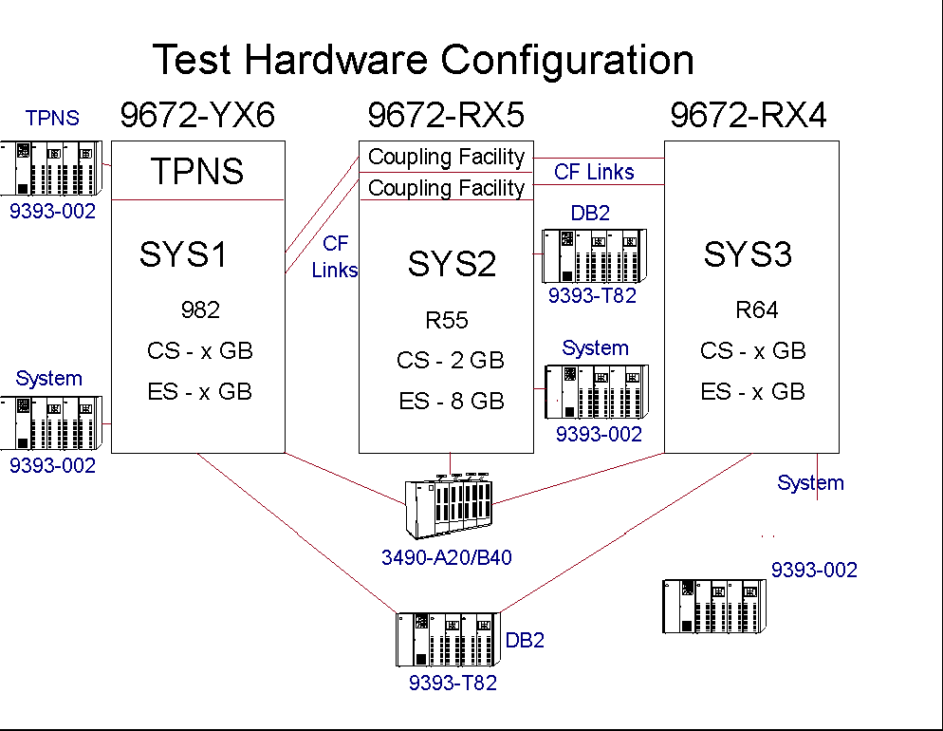
Table B-1. Mainframe Hardware Testing Environment

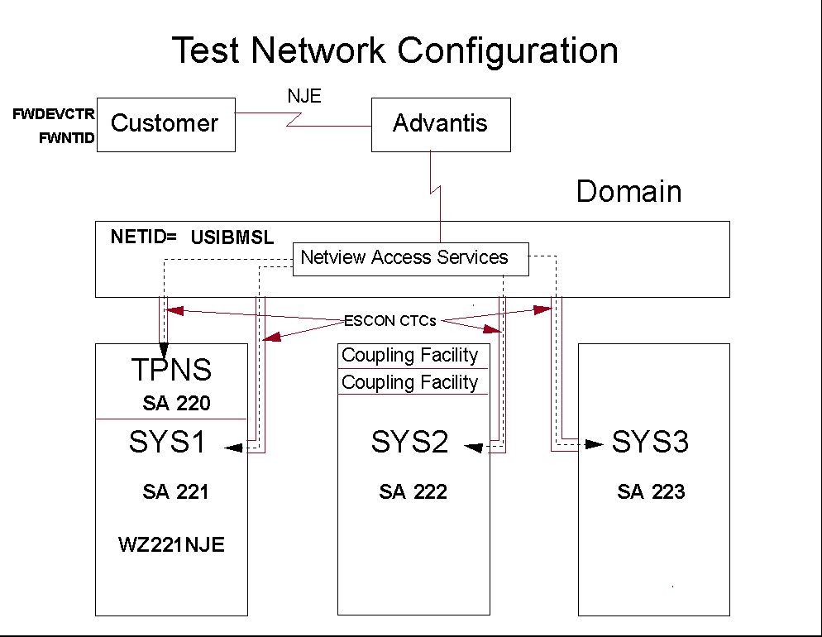
Table B-2. Host Test Network Environment

