

IBM Global Services

Performing Structured Programming

Technique Paper (TP)

© Copyright International Business Machines Corporation 1999, 2001
All Rights Reserved
Version 1.3 January 2001
- Outline of Structured Programming
Structured Programming (SP) is a programming technique proposed by Professor E. W. Dijkstra of the Netherlands between the end of the 1960s and the beginning of the 1970s. "Structuring" means step-by-step decomposition of a whole into small units whose mutual relationships and objectives are clearly defined. "Programming" means to build process logic (algorithm) for data transformation by defining the structures of related input/output data according to specified restrictions.
At present, Structured Programming is used for software development by most of the programming languages, such as COBOL, PL/I, and C.
Structured Programming is based on the following two basic ideas:
- Structure a program (Structured Theory)
- Assumption: Decompose a program into modules that form a hierarchical structure.
- Each of the modules has one entrance and one exit.
- Define the logic of a module using combinations of three structures: Sequence, Selection, and Iteration. (In principle, do not use a GOTO statement.)
- Structure the programming process (Stepwise Refinement)
- Make a program workable gradually, from functional specifications to the level that can be expressed by a programming language, by means of stepwise decomposition and refinement.
The objectives of Structured Programming are to
- Decrease the complexity of a program
- Make a program easier to read
- Raise the reliability of a program
- Raise the productivity of programming
- Improve the maintainability of a program
in order to create programs that are:
- Correct
- Efficient
- Convenient for changing
Current information systems handle great many kinds of data elements. Since a program for such a system has a complicated structure, the above objectives are difficult to accomplish only by the original ideas of Structured Programming.
To accomplish these objectives, "Programming directed to data structure" (Jackson Structured Programming (JSP)), and "Information Hiding" must also be considered.
- Structured Programming Techniques
Structured Theory
If a module has one entrance and one exit (Proper Program), its algorithm can be defined simply by combining the three basic control structures: sequence, selection, and iteration, (without using a GOTO statement).
Sequence
Execute processes (instruction sets) in the sequence in which they appear.
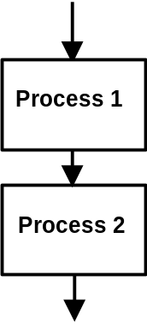

Selection
Execute the path determined by whether a specified condition is true or false.
<IF-THEN-ELSE type> <CASE (Composite selection) type>
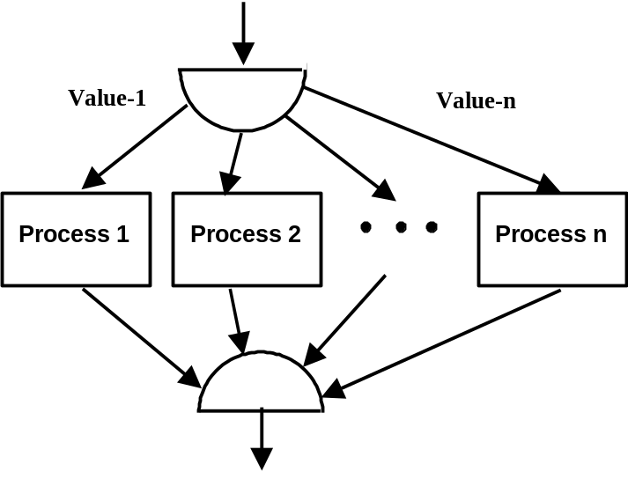
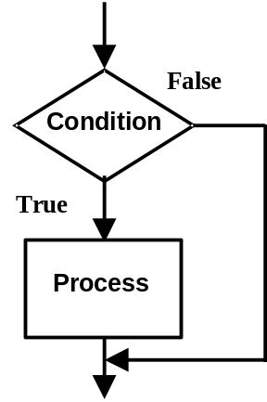

Iteration
Execute a process during a specified condition.

<DO-WHILE type> <DO-UNTIL type>
Execute while the condition is true. Execute until the condition becomes true.

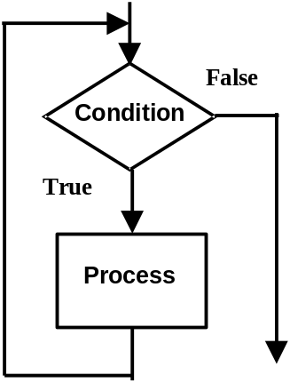
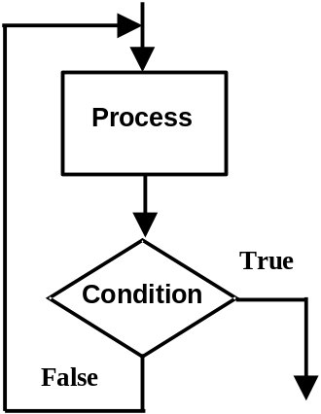

Note: The process is executed at least once because the condition is checked after the execution of the process.

Example:
Conversion from a set of instructions comprising GOTO statements to a set of instructions having the basic control structures only

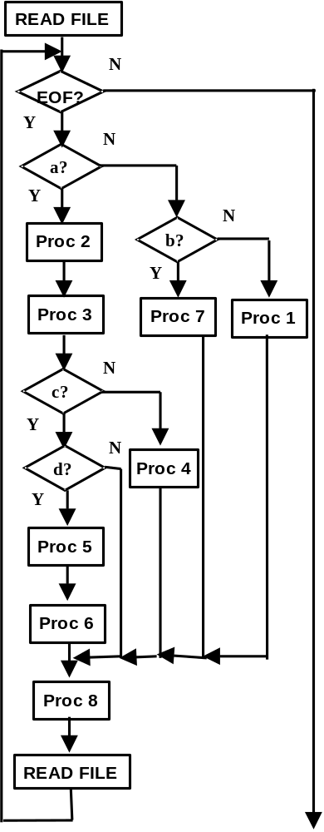
:
READ FILE… DOWHILE EOF
IF a THEN Process 2 Process 3 IF c THEN
IF d THEN Process 5 Process 6
ENDIF
ELSE Process 4
ENDIF
ELSE IF b THEN
Process 7
ELSE Process 1
ENDIF
ENDIF Process 8 READ FILE…
ENDDO
:
:
A: READ FILE…; IF EOF THEN GOTO X
B: IF a THEN GOTO C; IF a THEN GOTO E; Process 1;
C: Process 2; Process 3; IF c THEN GOTO D; Process 4; GOTO F;
D: IF NOT d THEN GOTO F; Process 5; Process 6; GOTO F;
E: Process 7;
F: Process 8; GOTO A;
X: :
:
Spaghetti code!!

Spaghetti code!!

Note: In this example, the Action Diagram is used for the process description (pseudocode) after the conversion.
Stepwise Refinement
Stepwise Refinement is a programming method proposed by N. Wirth (1971). A program is developed by a series of step-by-step refinements (firm up a program or make a program detailed) as shown below:
- First, define data and procedures for program development at a high level of abstraction instead of studying the whole program at the same level.
- Then, firm up each of the program parts gradually by lowering the level of abstraction. In firming up a part, make both the procedure and the related data into a more detailed procedure and data.
- Decrease the complexity of each part by means of abstraction and firming up instead of studying the whole at the same time.
- Develop a program having high reliability by verifying correctness at each level of abstraction before studying a problem of the next level.

Refinement
Proc C
Proc B
Proc A
Cond B1
Proc B1
Proc C
Proc A
N
Y
N
Y
Cond B2
Proc B2
Refinement

Guidelines for Stepwise Refinement
- Decompose the area of the system scope as far as possible in order to separate such aspects that seem related to the system at the beginning, but are not related in reality.
- Make a program that expresses one step as simple as possible. Do not attempt much refinement in one step.
- Postpone as much as possible a decision related to a processing method to be implemented.
- Find a substitute idea in each step.
- High efficiency, clarity, and structural consistency should be among the criteria for determining specifications in each step.
<Issues>
- In decomposing a program into more solid ones, we tend to leave the most difficult part to a later decision. In some cases, the algorithm adopted for the most difficult part creates a need for significant rework in the upper and lower levels of the decomposition. Therefore, decomposition from the viewpoint of "simpler interface" is important. Such an interface must be finalized first. This makes it possible to make the detailed contents of each process a black box.
- It often happens that the attention is directed only to functional decomposition, namely, to the algorithm of a process during refinement work. Therefore, it should not be forgotten that "the algorithm of a program is closely related to the structure of data it handles." Refer to Jackson Method and Data Abstraction discussed later.
Dijkstra's "Level of Abstraction"
Abstraction:
- Name an algorithm and ignore the mechanism of its process.
- Name data and ignore the detail of its structure.
Each level of abstraction is regarded as a Virtual Machine as shown below.
The first level is the most abstract Virtual Machine, having the data structure and the algorithm necessary for executing the program.
The subsequent levels are the products of stepwise refinement and firmed components (data structure and algorithm) of the level 1. The Virtual Machine of a low level simulates that of a high level, and is more detailed and closer to a programming language than that of a higher level.
At the lowest level, a program can be expressed in a programming language.
Step 1 Level 1 – Virtual Machine 1 Most abstract program
Step 2 Level 2 – Virtual Machine 2
• •
• •
• •
Step n Level n – Virtual Machine n Codes written by a programming language

Example of Stepwise Refinement: Seat Reservation Program
The objective of a seat reservation program is to process reservation transactions. It has the following two basic functions:
- Update the reservation file to reflect a new reservation. Delete a canceled reservation from the reservation file.
- After the reservation file is updated, print the contents of the reservation.
The program consists of a data structure and an algorithm. In this example, the components of the program of abstraction level 'Mi' is expressed as follows:
- Di: Set of data structures
- Ii: Relationship between data structure and algorithm (set of instructions)
- Ai: Algorithm
Step 1: Decompose the seat reservation program into two programs that correspond to the basic functions: update' (update the reservation file), and 'print' (print the reservation file).
Machine ‘M1’
D 1 (file)
I 1 (update (file), print (file))
A 1 :
update (reservation-file).
print (reservation-file).
stop.

Step 2: Refine and detail the data structure and algorithm of ‘M1'. Here, detail 'D1', 'I1', and 'update'.
Machine ‘M2’ D 2 (file, record)
I 2 (read (file), print(file/record),find(record),
add(record),delete(record))
A 2 :
*update reservations file.
while not file-end do
read (transaction-file);
find (reservations-record);
if reservation-record found
if add reservation
add(reservations-record);
else if delete reservation
delete(reservations-record);
else if new reservation to be added
add(reservations-record);
enddo
print (reservation-file)
stop.

Refining of data structure ‘D1’
Refining of
instruction set ‘I1’
Refining of algorithm
‘update’

Subsequently, repeat making detail sequentially down to the level at which code can be written in a programming language.
Coding Format
In standardizing a coding format, at least the following points should be considered:
- Structural sequence of source program
- Naming
- Indentation
- Comments
Structural Sequence of Source Program
Example in C:
- Comment of a source file
- Include a C standard header file
- Include a user-defined header file
- Macro definitions used in this file only, user-defined type declaration, prototype declaration in function
- Comment of function
- Process description of function
Naming
- Procedure name
Assign a name that explains the function of a procedure. When many procedures must be defined, name duplication can be prevented easily by assigning a name that expresses the category of a procedure.
Procedure name = (Category + ) Transitive verb + Object
Example in C:
DosAllocMem (OS/2 API, allocate memory)
Category : Dos (Control program)
Transitive verb : Alloc (allocate)
Object : Mem (memory)
- Variable name
Assign a name that expresses the meaning of data. (Note: Length restriction)
Example in C:
CustomerName : Customer name
OrderNumber : Order No.
Meaningless variable names, such as simple 'a' and 'a1', should be avoided.
Example in COBOL:
Component name Variable name
(4 char.) Max. 14 char.)
Order ORDR Order Number ORDR_NUMB
Number NUMB Customer Name CUST_NAME
Customer CUST
Name NAME

Indentation
The basic structure of a program can be visually made clear by indentation. Indentation makes a program easier to read and decreases bugs due to a careless mistake. Indentation of 2 to 3 characters is practical in view of a possibility of deep nesting.
Example in C:
while (loopCondition == 1) {
rc = doSomething () ;
printf ("Result of doSomething is %d$n, rc) ;
if (rc == 1) {
loopCondition = checkLoopCondition () ;
} else {
loopCondition = rc;
}
}

Example in COBOL:
A1=MAINLINE.
PERFORM B1-INITIAL-READS.
MOVE DATE-OM TO DATE-WS.
IF DATE-WS NOT = DATE-ET
THEN DISPLAY 'DATES OUT OF SEQUENCE'
PERFORM B2-FINISH-UP.
ELSE PERFORM B3-NEEDS-A-NAME-X
UNTIL (FINISH-STATUS-TARGET = FINISH-UP-PARA )
OR (RETURN-STATUS NOT = RESOLVED )
IF RETURN-STATUS = TRANS-TYPE-OUT-OF-RANGE
THEN MOVE RESOLVED TO RETURN-STATUS
PERFORM B4-VALUE-OUT-OF-RANGE
ELSE PERFORM B2-FINISH-UP
GOBACK.
*END-A1-MAINLINE
Comments
- Prologue comment
Example of C source file:
/******************************************************
* Source file name : fileio.c
* COPYRIGHT indication :
* Version : version, release, modification
* Explanation of function : (Several lines are enough.)
* Development environment : IBM C Set/2 V1
* Execution environment : OS/2 J2.0 or later
* Remarks/Restrictions :
* Functions used : List of function names
* Date, author : YY/MM/DD, author name
* Update history : Date, content, reason, staff
*******************************************************/
Example of C function and subroutine:
/********************************************************
* Function name :
* COPYRIGHT indication :
* Version : version, release, modification
* Explanation of function : (Several lines are enough.)
* Calling method : Function name (Parameter list)
* Parameter : Explanation of parameter
* (Type, meaning)
* Return value : Value and its meaning
* Remarks/Restrictions : Characteristics of algorithm,
* restrictions related to usage
* Date, author : YY/MM/DD, author name
* Update history : Date, content, reason, staff
******************************************************/
- Instruction level comments
Insert comments of an appropriate quantity in order to make source code easy to understand. Be sure to write a comment for a variable declaration, a location where a function is called, a location where a group of processes begins, immediately after a statement of specially complicated or exceptional operations. It is advised to match the format of comments to the description of module specifications from the viewpoint of maintainability as well.
- Programming Based on Data Structure - Jackson Method
The Jackson Method (or Jackson Structured Programming (JSP)) is a programming technique proposed by Michael Jackson. This technique determines the processing structure of a program according to the structure of data it handles.
- A design technique that directs attention to the structure of data is adequate for application programs that handle data of a complicated structure like many application programs used today. It is also applied to module decomposition.
- The Jackson Method expresses a data structure and the related process in the form of Jackson Diagram using three basic structures: sequence, selection, and iteration. Even a complicated data structure and a complicated logic structure are expressed as a combination of these basic structures.
Notation of Jackson Diagram
Selection
Iteration
(Execute sequentially from left to right)
(Execute either one of the two)
(Execute repeatedly)
Sequence
*

Procedure of Jackson Method
The programming procedure by the Jackson Method is described below:
- Express the structure of input data and that of output data in Jackson Diagrams and examine the correspondence between the two.
- Consider the program body as the function for transforming input data to output data. Draw the processing structure of the program in a Jackson Diagram based on the correspondence between the input data and output data.
- Make a list of the instruction sets that are necessary for transforming input to output. Assign these instruction sets to each component of the processing structure of the program.
- Based on the Jackson Diagram of the processing structure, describe the logic specifications of the entire program in the Structured English/Language (or Pseudocode).
- Convert the logic specifications to program code.
Example of Jackson Method: Warehouse Report Production Program
Produce a report of inventory fluctuations by commodity from the transaction file in which receiving and disbursing operations are recorded. The input data is the file of receiving and disbursing transactions sorted by commodity. The output is the total fluctuation by commodity printed in one line. Summary data is printed at the end of processing.
- Express the structure of the input data and that of the output data as Jackson Diagrams and examine the correspondence between the two.

Input Data Structure Output Data Structure
Sorted Transaction File
Report

Title of Report
Report Summary
Main Part of Report
Disbursing Record
Receiving Record
Transaction Record
*
Commodity Group
*
Report Line
*
:Selection
:Iteration

1 to 1
1 to 1

- Based on the correspondence between the input and output data structures, produce the processing structure of the program.
Produce Warehouse Report
Process Disbursing Record
Read Transaction Record
*
Produce One Line of Report
*
Process Receiving Record
Produce Title
Produce Main Part
Produce Summary

- Assign a set of instructions to each component of the processing structure of the program.

Clear Commodity Counter; OPEN Transaction File;
READ Transaction File;
Produce Warehouse Report
Process Disbursing Record
Read Transaction Record
*
Produce One Line of Report
*
Produce Title
Produce Main Part
Produce Summary
WRITE Title;
WRITE Summary Data; CLOSE Transaction File;
Clear Total Fluctuation Volume; Commodity Counter=Commodity Count + 1 Current Commodity=Commodity Read; Execute “Read Transaction Record”; WRITE Commodity Name,Total Fluctuation Volume; “Process Receiving Record” or “Process Disbursing Record “READ Transaction File;
Total Fluctuation Volume = Total Fluctuation Volume + Receiving Volume;
Process Receiving Record
Total Fluctuation Volume = Total Fluctuation Volume - Disbursing Volume;

- Produce the logic specifications in pseudocode based on the processing structure of the program.
Produce Warehouse Report PROC seq Clear Commodity Counter; open Transaction File; read Transaction File; write Title;
Produce Program Body PROC itr until (end of Transaction File)
Produce One Line of Report PROC seq Clear Total Fluctuation Volume; Commodity Counter = Commodity Counter + 1; Current Commodity = Commodity Read; Read Transaction Record PROC
itr while (Commodity Read = Current Commodity)
Process Receiving Record sel (code = R) Total Fluctuation Volume = Total Fluctuation Volume + Receiving Volume;
Process Disbursing Record sel (code = R) Total Fluctuation Volume = Total Fluctuation Volume - Disbursing Volume;
Process Receiving/Disbursing Record end read Transaction File;
Read Transaction Record PROC end write Commodity Name,Total Fluctuation;
Produce One Line of Report PROC end
Produce Program Body PROC end

Write Summary Data close Transaction File;
Produce Warehouse Report PROC end
Produce Warehouse Report

Write Title
Produce Program Body
Write One Line of Report

Read Transaction
Record
Process Receiving Record
Process Disbursing Record

Write Summary Data

- Finally, convert the pseudocode to a program.
- Information Hiding and Data Abstraction
Information Hiding
Information hiding means that a program module should be designed so that information used only within the module is not freely accessible to external modules not needing such information. "Information" in this context means detailed data structure and detailed operation procedures for the data structure. This was proposed by D. Parnas (1972).
- Disclose only the interface (subroutine or function calling procedure, input/output parameter format) of each module.
- A module is used (operation on data) only through the disclosed interface.
- As a result, an internal change of a module does not exert an unnecessary influence on other modules.
- Information hiding (Encapsulation) implements modules of higher informational strength. It is one of the basic concepts of the object-oriented approach.
External
Module
External
Module
External
Module
External
Module
Operation Proc for Data struc
Data Structure
Data Structure
Information is not hidden
Information is hidden
*Access via specific interface only (data or message)
(Encapsulation of data structure and procedure)

Example of Information Hiding in C Language
- Provide a file that defines only a data STRUCT (data type: data attribute (integer, character) and structure) separately from an ordinary INCLUDE file.
- Only a source file (module) that directly performs the processing for this data type includes the above file.
- The detailed data structure is not disclosed to external modules that use the data type.

emp.ih [INCLUDE file that defines a data STRUCT (data type).
Only the module that performs the processing for this
data type includes this file.]
#ifndef EMP_IH
#define EMP_IH
struct _Employee {
char *name;
int age;
} ;
#endif /* EMP_IH */

emp.h [INCLUDE file describing the interface of procedure.
The module that uses this data type includes this file.]
#ifndef EMP_H
#define EMP_H
struct _Employee;
typedef struct _Employee Employee;
Employee *EmployeeNew (char *name, int age) ;
void EmployeeFree (Employee *this) ;
int Employee_age (Employee *this) ;
#endif /* EMP_H */
emp.c [Module that implements the processing for the data
type. Only the function/subroutine in this module
can directly access the details (data type members)
of the data structure.]
#include <stdio.h>
#include <stdlib.h>
#include <string.h>
#include "emp.ih"
#include "emp.h"
Employee *EmployeeNew (char *name, int age)
{
Employee *this ;
this = malloc (sizeof (Employee)) ;
this->name = malloc (strlen(name)+1) ;
strcpy(this->name, name) ;
this->age = age ;
return this;
}
void EmployeeFree (Employee *this)
{
free (this->name) ;
free (this) ;
}
int Employee_age (Employee *this)
{
return this->age;
}
main.c [Module using the data type. This module cannot
directly access the details (data type members) of
the data structure. In other words, information
hiding is implemented.]
#include <stdio.h>
#include <string.h>
#include "emp.h"
int main()
{
Employee *emp;
char *str;
emp = EmployeeNew ("Emp1",30) ;
printf("age is %d$n", Employee_age(emp)) ;
emp->age = 30 ; /*Syntax error: Cannot
directly access a member
of the STRUCT */
EmployeeFree(emp) ;
return 0 ;
}

(Source File)

Module:
main.c
Module:
emp.c

include
include

include
Data Type:
emp.ih
emp.h
Interface:
emp.h

(Include file)
(Include file)
- Data Abstraction
Data Abstraction is a programming technique that raises the localization of information by describing the detailed definition of a data structure and the definition of a related procedure in the same location on a source file.
- Once a data structure and its operation are implemented in detail (like a macro function), detailed implementation information is unnecessary for higher level operations that use it. Abstract information of its usage is sufficient for them. In other words, information hiding can be realized.
- Since the location where a data structure and its operation are defined is separate from the location where they are used, the data structure or the access method can be changed without referring to the location where they are used.
Data Abstraction Design means to implement the above data abstraction at the module level. In other words, data and a closely related procedure are encapsulated in one module and decomposed into modules so that this module can be accessed by an external module without detailed information of its data structure or other attributes (information hiding).
- A module that accesses this module can use this module without detailed information of its data structures, such as the structures of a common table, a file, or a database, or the method of implementing operations for them. Therefore, the complexity of module development can be decreased.
- A data structure can be directly changed or referenced only by the procedure that is defined with the data structure. Therefore, the overall module structure is not easily influenced by a data structure change. Even if the algorithm of a procedure is changed, the other modules are not directly influenced by the change as long as the specifications of the interface that calls the procedure are unchanged.
Classification of Programming Languages for Implementing Data Abstraction
- User-Defined Type
- Abstract Data Type
User-Defined Type
A data structure handled by a user program is defined as "Type" (data type). In the subsequent programming process, a User-Defined Data Type can be handled like data types (attributes), such as integers and characters, that the programming language provides in advance.
- Method of implementing User-Defined Type in Structured Programming language (An example follows.)
- C: Definition of a data structure
- Redefinition of a data type using 'typedef'
- PL/I: Definition of a data structure
- Restrictions of User-Defined Type
- Information hiding is not guaranteed. (It depends on the design method.)
- (Note that information hiding can be realized to some extent by establishing programming rules like the example in " Information Hiding".)
- Only data types can be defined. Processing (procedures) for data types and functions must be defined separately as subroutines.
- No arithmetic operation can be defined for a data type.
Example of User-Defined Type: STRUCT and 'typedef' in C
- Definition of STRUCT (data type)
struct _Customer {
long id;
char name [30] ;
char address [100] ;
} ;
- Redefinition of data type using 'typedef'
typedef
Data
type of STRUCT
struct_Customer
Customer
Redefined data type

In the subsequent programming process, a User-Defined data type can be handled like attributes (data types), such as integers and characters, that the programming language provides in advance.
- A variable of the attribute (data type) of a User-Defined type can be used by making a declaration as shown below:
Data type
Customer
Variable name STRUCT
customer

- The procedure that uses a data type is defined separately.
- void printCustomer (Customer *customer)
{
........
}
Abstract Data Type
An input/output data structure, a procedure for processing the data, and an arithmetic operation are defined as "Type". A "Type" can be handled like data types (attributes), such as integers and characters, that the programming language provides in advance. Clu, developed by B. Liskov of MIT in the US (1974), formed the foundation of a programming language that supports Abstract Data Types.
- A 'data structure' and a 'procedure' for operating the data structure are defined as one unit (encapsulated). It guarantees that the 'data structure' cannot be directly changed or referenced (information hiding) by any method except this 'procedure'.
- Many of the recently developed programming languages have a mechanism for implementing information hiding by Abstract Data Types. However, conventional Structured Programming languages, such as C, COBOL, and PL/I, do not have this mechanism. However, even these languages can implement information hiding to some extent by establishing programming rules to create User-Defined Types.
Programming Languages Implementing Abstract Data Types
- Simula 67 (simulation language): Class
- Initial form of Abstract Data Type
- Clu: Cluster
- Ada: Package
- The contents of an Ada package are divided into specifications and body, and the body is isolated from users as far as possible.
- Object Oriented Programming Languages, such as Smalltalk and C++: Class
- Data structures and procedures that use the data are encapsulated. They can be used from the outside only through a disclosed interface.
Example of Abstract Data Type: Type Stack in C++
A Type Stack is a typical example of Abstract Data Type. A Stack is explained below with an example that shows how it is implemented in C++.
- A Stack needs a procedure for putting data into a stack, called 'push', and a procedure for taking data out, called 'pop'.
- A Stack user is permitted to perform 'push' and 'pop' only.
Definition of Abstract Data Type 'IntStack'
- The following information must be described for defining an Abstract Data Type:
- Type name ( 'IntStack' )
- Procedure ( 'push', 'pop' )
- Data structure
In C++, the above information is described as follows.
class IntStack { // Name of the Type
public: // Procedure that can be used from
// other modules
void push(const int number);
int pop();
IntStack (const int stackSize);
-IntStack();
private: // Actual data structure
int* contents; // Data array
int size; // Stack size
int pointer; // Initial indicator of array
} ;

- Then, the logic of the procedure is described.
In C++, the procedure ' push ' can be coded as follows:
void IntStack : :push (const int number)
{contents (pointer++) = number ; }
- To use the 'IntStack' Type defined as shown above, a variable of 'IntStack' should be declared as shown below.
IntStack stack(10);
- This procedure can be called by the following procedure.
stack.push(10); Put 10 into the Stack.
stack.pop(); Take out the beginning of the Stack.
- The data structure of the Stack cannot be directly changed or referenced (Information hiding). For example, the following statement will be judged as a syntax error during compilation.
stack.contents[1] = 10;
- Example of Information Hiding and Data Abstraction - Curve Printing Program
Develop a program that prints curves on a line printer.
- The Y-axis is numbered from top to bottom, from HEIGHT to 0, and the X-axis is numbered from left to right, from 0 to WIDTH. Curves within the numbered range are to be printed. HEIGHT and WIDTH are given as parameters.
- A curve is expressed discretely by the following conditions. There are two functions having an integer argument. They are 0<=fx(i)<=WIDTH and 0<=fy(i)<=HEIGHT for 0<=i<DOTS. A '*' mark is printed in the coordinate position of (fx(i), fy(i)). DOTS is given as a parameter.
- The printing operation of a line printer is controlled by the following two commands:
- Command ‘NLCR’, which makes the left end of the next line "current printable position".
- Command ‘PRSYM(n)’, which prints the character expressed by the parameter n in the currently printable position and makes the position immediately on the right side of the printed position "currently printable position".
The data type and the procedures are gradually refined to more concrete forms as illustrated below. The process of refinement follows.
Data Type
Produre
Image_clear
Image_markpos
Image_print
Image
PRSYM
NLCR
char
Line_clear
Line_markpos
Line_print
Line
draw
Refinement
(Function of printing a curve)

Step 1: Definition of Data Type 'Image'
- Since a program should produce as many points as DOTS and print a discrete curve produced by calculating the x-coordinate and y-coordinate, Data Type ‘Image’, which has a printed output image as the value, should be defined.
- Initially, the program is expressed in the most abstract form. (Refer to "Stepwise Refinement".)
- Output image production
- Output image printing
- Output image production can be implemented by the following procedure:
- Make the coordinate points of (HEIGHT+1) x (WIDTH+1) completely blank
‘Image_clear’
- Then, replace DOTS points by a '*' mark.
‘Image_markpos'
- The Data Type ‘Image’ and the procedures for it ‘Image_clear’, ‘Image_markpos', and ‘Image_print' are encapsulated and defined as an Abstract Data Type.
- A module that uses ‘Image’ does not need information of the data structure of ‘Image’.
- ‘Image’ is accessed only through a disclosed interface. Its data structure cannot be directly accessed.
- Therefore, the function of printing a curve, 'draw', can be expressed as shown below.
draw ()
{
Image v;
int i=0;
Image_clear(&v);
for (i=0;i<DOTS; I++) Image_markpos(&v,fx(i),fy(i));
Image_print(&v);
}
Step 2: Refinement of Data Type 'Image'
- Since the Data Type ‘Image' cannot be expressed by a programming language in this form, it must be more refined. If (HEIGHT+1) lines are output sequentially, it can be regarded that 'Image' consists of sequenced lines.
- If the Data Type ‘Line’ is defined, ‘Image’ can be expressed as shown below as an array of ‘Line’.
typedef struct {
Line line[HEIGHT+1] ;
} Image;
- If ‘Line' is an Abstract Data Type as well, the procedures for ‘Image', ‘Image_clear', ‘Image_markpos' and ‘Image_print' do not directly operate the data structure of ‘Line’, but can be implemented using the procedures of ‘Line’, 'Line_clear’, 'Line_mark', and 'Line_print'.
For example, ‘Image_print' can be expressed as shown below.
Image_print(Image *v) {
int j;
for j=0; j<=HEIGHT; j++) Line_print(&(v->line[j]));
}
Step 3: Refinement of Data Type ‘Line’
- Since the Data Type ‘Line’ cannot be expressed directly by a programming language, it must be more refined. Since it can be assumed that ‘Line’ consists of an array of (WIDTH+1) characters, it can be expressed as shown below.
typedef Line {
char symbol [WIDTH+1];
}
- The procedures of ‘Line’, 'Line_clear’, 'Line_mark', and 'Line_print' can be implemented using a character array. For example, 'Line_print' can be expressed as shown below.
Line_print(Line *line) {
int k;
for (k=0; k<=WIDTH; k++) PRSYM (line->symbol[k]);
NLCR();
}
Since a character array can be expressed by a programming language, no more data decomposition is necessary.
- Reference Materials
- J. Dahl, E. W. Dijkstra and C. A. R. Hoare: Structured Programming, Academic Press, 1972.
- N. Wirth: Algorithm + Data Structure = Programs, Prentice-Hall, 1976.
- M. A. Jackson: Principles of Program Design, Academic Press, 1976.
- E. Yourdon and L. L. Constantine: Structured Design, Prentice-Hall, Inc., 1979.

- Revision History
Revision Number | Revision Date | Summary of Changes | Changes Marked?
1.01 | June 1999 | Base version.
1.1 | October 2000 | Applied new template and style, grammar and spell check.
1.2 | December 2000 | Fixed diagrams. No change in text. Corrected page numbering | No
1.3 | January 2001 | Adjusted charts.

