

IBM Global Services

Roll Out Strategy Analysis (ROSA)

Technique Paper (TP)

© Copyright International Business Machines Corporation 2001, 2004

All Rights Reserved
Version 4.1.2 August 2004
- Description
This Technique Paper is designed to guide you through the Roll Out Strategy Analysis (ROSA) and its step-by-step process. The Technique Paper will teach you about ROSA, its benefits and uses. It will take you step-by-step through building a ROSA workbook with a detailed explanation of the ROSA spreadsheet and its formulas. Upon completion, you will be able to build a basic ROSA workbook, add information to the spreadsheet, make changes and correct formula errors. You will also learn how to apply ROSA techniques to scope and size a training project. This Technique Paper will assist you as a valuable resource when you are implementing the Roll Out Strategy Analysis Capability Pattern in the IBM Global Services Method.

Who Should Use This Technique Paper
Training professionals involved in identifying and scoping, sizing and prioritizing blended solution training, including:
- Performance Consultants
- Instructional Designers
- Training Engagement and Project Managers

Prerequisites
Proficiency with spreadsheet software. To effectively work with the formulas and worksheets in the ROSA Workbook Template, the user must have intermediate to advanced knowledge of spreadsheets.
Training and/or familiarity with training and instructional design methodologies, including conducting a Training Needs Analysis and Content Analysis.

Technique Paper Objectives
After completing the tasks and exercises outlined in this Technique Paper, you will be able to:
- Understand ROSA purpose, benefits and uses.
- Define the tasks and steps of ROSA.
- Perform the pre-work required to integrate ROSA into the Requirements.
- Identify and break down the function/tasks/topics for the target course
- Select the three critical factors to build a ROSA workbook.
- Define the training strategies and blended solutions.
- Understand the elements of the ROSA Workbook.
- Create a ROSA worksheet.
- Update and edit the six standard spreadsheets in a ROSA Workbook.
- Update the Training Development Metrics LookUp Table.
- Use spreadsheets to assure the accuracy of the formulas and the resulting recommendations.
- Context

What Is IBM’s Roll Out Strategy Analysis (ROSA)?

For any major training effort that involves new/changing processes and procedures, the roll out of new applications, and/or new/changing job roles, we recommend beginning the training and job performance support requirements with IBM’s Roll Out Strategy Analysis (ROSA). The ROSA process is a key component for ensuring that not only will the most appropriate strategies be identified, but that the right training and support is provided in the appropriate format for each job role. During the ROSA process we identify each job role and the related processes and tasks performed by people in their day-to-day job. One key differentiating factor of the ROSA process is that it is based on client Subject Matter Experts rating all the features, functions, topics and/or tasks of the training content according to the top three most appropriate critical factors from the following list:
Degree of Change from Old to New. At the low end of the scale the task/function has not changed at all or very little; at the high end of the scale the task/function is either new or has changed significantly.
Task Learning Difficulty. At the low end of the scale the task/function is not difficult to understand for end users; at the middle end of the scale the user will require extra effort, skill or thought; and, at the high end of the scale the user will require rigorous concentration to assimilate.
Importance to Job Role Success. At the low end of the scale the task/function is either not applicable or has very little importance to job role success; at the high end of the scale the task/function is critical to job role success.
Probability of Deficient Performance. At the low end of the scale the likelihood that someone would make a mistake is not very likely; at the high end of the scale the likelihood of someone making a mistake is very high (often due to the complexity of the task and/or the design of the feature/function).
Consequences of Inadequate Performance. At the low end of the scale the consequence of making an error is not serious; at the high end of the scale there are serious consequences to making an error (to the end-user and/or other users).
Frequency of Performance. At the low end of the scale the task is performed weekly or less; at the middle end of the scale the task is performed once a day; at the high end of the scale the task is performed several times a day.
The details of the Roll Out Strategy Analysis Matrix are used to:
- identify appropriate training and performance support strategies and delivery formats for each end-user group or job role,
- prioritize training and performance support of specific tasks/functions for different user groups,
- create knowledge and skills objectives for training materials and cognitive components for testing, and
- scope and size the training and performance support effort.

From our experience approximately:
- 15% of the tasks will not require any (or minimal) training or performance support,
- 70% will require some form of technology-based training and/or on-the-job performance support (e.g., WBT/CBT with Overviews, step-by-step ‘Show Me’, ‘Try It’, Practice), and
- 15% of those tasks that rate high on all critical factors will require additional practice, expert/mentoring support, etc.

When to Use ROSA?
- If clients are not sure what blended strategies to use and which ones would be best for their audience.
- If clients are not sure who the audience should be and what they should learn first.
- If clients are not sure how long or large the course(s) should be, how to prioritize the content and how much it would cost them.
- If clients are not sure about the reusability of an existing course (can it be repurposed to fit a CBT or WBT).
- If clients want to support just-in-time, on-the-job-support.

Why Use ROSA?

The primary benefits of ROSA include:

- A more accurate estimation of the scope and size for the development of a blended training solution for the client.

Using ROSA, training professionals can come within 10% or less of the estimated development time during the analysis phase.

- A decrease in the actual development time. Using ROSA, a performance consultant would be able to combine two development stages into one. Instead of performing the course breakdown of the tasks, functions and features during the Design phase of a traditional development project cycle, it would be completed during the Analysis phase. The Development phase can begin at the end of the Analysis phase with minimum time spent on the Design phase. With ROSA, the Instructional Designer is involved from the Analysis phase to validate the course design.

The secondary benefits of ROSA include:

- decreases the margin of error
- increases the client’s confidence in the project, and
- reduces future awkward scope and budget changes to the project.
- Steps

Activity 1: Validate/Define Requirements and Gather Assessment Information
- Build the business case based on organizational and human performance needs.
- Identify client training goals.
- Define technical requirements for blended solutions building blocks and infrastructure.
- Identify and profile the job roles or target audience for future training.
- Identify and break down the tasks/functions and processes for the client application or process.
- Select the Three Critical Factors.
- Define training strategies and blended solutions. Identify with the customer the high level training and support strategies to be used, to what degree/level, and timing/sizing.

Activity 2: Develop Roll Out Strategy Analysis Workbook
- Take an existing ROSA template and modify.
- Add the topics in the overall ratings and recommendations worksheet.
- Create a separate rating worksheet for SMEs.
- Meet with SMEs to review the rating worksheet and walk them through the process.
- Collect the rating sheets and copy the results into the ROSA workbook.
- Create the Training Development Metrics LookUp Table by mapping the ratings combinations with recommended blended solutions and strategies.
- ROSA will calculate the results.
- Review the results to ensure their accuracy.

Activity 3: Generate ROSA Results and Recommendations

- Interpret the results from Activities 1 and 2 and include them in the project deliverable(s).
- Examples
The following example will walk you through the steps of creating and completing a ROSA. The scenario provides all the information needed to assemble the components of a ROSA.

Background on Company A:
The Company A Training Development Division handles all functions relating to requirement analysis, project management, and the design, development and delivery of training. The Division is comprised of Project Managers, Senior Instructional Designers and Performance Consultants. The employees come from varying backgrounds with extensive training development experience. Few of them have had formal project management training specifically relating to training development.
While these employees are highly competent with no visible performance problems, the lack of standardized project management skills decreases their efficiency and ability to perform many project tasks. Management is focused on the importance of project management skills within their organization to improve productivity, provide the most cost effective solutions and mitigate risk. Management wants to increase accuracy of project plans and their management, and to decrease risk and scope creep.
Company A would like to develop a Project Management for Training Development course and a beginner’s Project Scheduling Tools course. Company A would like to implement a blended web-based solution with minimum classroom delivery. The course would be made up of Web Based Training with Web Based Support and one hour of virtual live classroom. Company A estimates the entire training at about 3 hours.

Activity 1 Validate/Define Requirements and Gather Assessment Information (Exercise)
The information in this section is normally gathered during Requirements Analysis. Working with the information provided in the Background on Company A above, fill in the sections below. (Refer to the end of this section for the answers.)
NOTE: An underlying assumption of this exercise is that the user is already trained and familiar with training and instructional design methodologies, including conducting a Training Needs Analysis. The Goal of the exercise is to identify the critical information and elements that need to be identified for conducting the ROSA.
1.1) Build the business case based on organizational and human performance needs.
Company A’s business case:
1.2) Identify client training goals.
Company A’s learning/training goals:

1.3) Define technical requirements for blended solutions building blocks and infrastructure.
Assume that the technical requirements have been identified and the client has the infrastructure in place to support the blended solutions that might be recommended.

) Identify and profile the job roles or target audience for future training.
Company A’s job roles:

1.5) Identify and break down the topics for the client application or work process.
This information is gathered through observation, working with the application/process, and/or review of existing documentation.
Company A’s courses are:
Refer to Appendix A for a full list of topics for these courses.

1.6) Select the Three Critical Factors.
Only the top three critical factors are used in the ROSA ratings. This reduces the complexity of both the ratings process for the SMEs, as well as the combinations of ratings that are linked to the recommended training strategies and scoping/sizing metrics in the Workbook.
A list of the Critical Factors can be found on Page 4 of this Workbook.
Company A’s Three Critical Factors are:

1.7) Define the training strategies and blended solutions.
The training strategies and solutions depend on the client requirements and are further identified and refined by a team of Performance Consultants, Instructional Designers and development experts. Note that the accuracy of the ROSA for scoping/sizing the development effort depends on determining several training design strategies for the high level design. For CBT/WBT, for example, the strategies and design will contribute to more accurate scoping and sizing metrics for a ‘Show Me’ or ‘Try It’ training intervention that may include sync screens or AVIs with audio.
Company A’s training strategies and blended solutions:

Activity 1 Validate/Define Requirements and Gather Assessment Information (Answers)

1.1) Build the business case based on organizational and human performance needs.
Company A’s business case:
The lack of standardized project management skills decreases the employee’s efficiency and ability to perform many project tasks.
To improve productivity.
To provide the most cost effective solutions.
To increase accuracy of project plans and their management.
To decrease risk and scope creep.

1.2) Identify client training goals
Company A’s learning/training goals:
To train the employees to fulfill the project management needs of the Training Development Division.
Company A would like to implement a blended web-based solution with minimum classroom delivery.
The course would be made up of Web Based Training with Web Based Support and one hour of virtual live classroom. Company A estimates the entire training at about 3 hours.

1.3) Define technical requirements for blended solutions building blocks and infrastructure
The technical requirements have been identified and the client has the infrastructure in place to support the blended solutions that might be recommended.

1.4) Identify and profile the job roles or target audience for future training
Company A’s job roles:
Project Managers
Senior Instructional Designers
Performance Consultants

1.5) Identify and break down the tasks/functions and processes for the client application or work process
Company A’s courses are:
Project Management for Training Development
Project Scheduling Tools for Beginners
The breakdown of topics can be found in Appendix A.
1.6) Select the Three Critical Factors
Company A’s Three Critical Factors are:
Importance to job role success
Consequences of inadequate performance
Frequency of Performance

1.7) Define the training strategies and blended solutions
Company A’s training strategies and blended solutions:
Est. Total 1 Hour Instructor-Led Training
ILT1: Est. 10 min. critical topic
ILT2: Est. 5 min. moderate importance topic
Est. Total 2 Hours Web-Based Training
Show Me: Screen cam w/ audio for mid-range criticality topics/ tasks/
features/functions (approx. 5 screens)

Try It: Screen cam w/ audio for highly critical topics/ tasks/
features/functions (approx. 10 screens)

Practice: A multi-task exercise for the student to practice the
concepts learned in the Show Me and Show Me/Try It
activities (approx. 20 screens)

Activity 2 Develop Roll Out Strategy Analysis Workbook
In this section you will learn how to open, navigate and modify a ROSA Workbook.

2.1 Understanding spreadsheet terminology
ROSA uses spreadsheet programs to record and calculate data. You can enter and edit the data in the worksheet and use formulas to calculate totals. The various spreadsheets also contains many built-in formulas known as functions that can be used to perform simple or complex calculations.
When you start a spreadsheet tool, a blank workbook is displayed. A workbook is the file in which you work and store your data; it is similar to a paper notebook. A workbook contains sheets, which are similar to paper sheets in a notebook. Sheets can store data, charts, and macros. For example, you enter data on sheets in a workbook. Since each workbook can contain many sheets, you can organize many types of related information in a single file. A worksheet that stores data such as text, numbers, and formulas is called a worksheet.

2.2 Open an existing ROSA template and understand its elements.

In the following section, you will open an existing ROSA Template and understand its elements.

- Start the spreadsheet tool and open the file: ROSA_Template.xls.

  - Note: The spreadsheet displays the dialog box warning you that the Template contains macros and that they may contain viruses. The dialog box gives you three options:
    - Disable Macros
    - Enable Macros
    - More Info
  - Click on Enable Macros in the Dialog Box. This will allow the formulas and written macros to calculate the ratings and provide the ROSA results.

- The ROSA Workbook Template consists of 6 (six) standard worksheets.

  - Instructions & Definitions
  - Overall Ratings Recommendations
  - Summary Blended Training Solution Estimates
  - Detailed Blended Training Solution Estimates
  - Job Role Training Estimates (one worksheet for each target audience)
  - Training Development Metrics LookUp Table

- As a ROSA Workbook is being built for a specific project, you will add additional sheets that will represent the recommended solutions and estimates for each of the job roles identified for the client.

In the Company A Scenario, the ROSA Workbook would contain three additional sheets for each of the identified job groups:

- Project Mangers worksheet
- Instructional Designers worksheet
- Performance Consultants worksheet

Since all formulas in the ROSA Workbook have been created, the majority of the work performed on the ROSA Workbook during a project consists of manipulating the existing formulas and ensuring cell references to the LookUp table are accurate.

Except for the Instructions & Definition worksheet (first worksheet in the workbook), the data in the rest of the workbook are linked to two key sheets, the Overall Ratings and Recommendations and the Training Development Metrics LookUp Table sheets.

The following section will review each of the ROSA Workbook sheets in detail.

Changing/Adding Information in the Instructions & Definition Worksheet
- The Instructions & Definition worksheet is similar to a cover page for the ROSA Workbook. It contains information about the client and the ROSA project, which include:

- The goals of ROSA. This is a general definition about ROSA and does not change.
- The three selected Critical Factors for the client’s ROSA. The Critical Factors are different for each client’s ROSA. Make sure to add the Critical Factors that relate to the client’s project.
- The selected Training and Support Strategies and an explanation of each Strategy. The Training and Support Strategies are different for each client’s ROSA. Make sure to add the Training and Support Strategies agreed upon with the client and the Instructional Designer.
- The selected job roles for the client’s ROSA. The job roles are different for each client’s ROSA. Make sure to add the job roles identified during the Analysis phase.
- The Metrics used in the recommendations formula. This metric is copied from the LookUp worksheet and is client-specific. Usually, the Training Development Metrics LookUp Table is completed after the tasks have been broken down and the SMEs have rated the tasks against the Critical Factors.

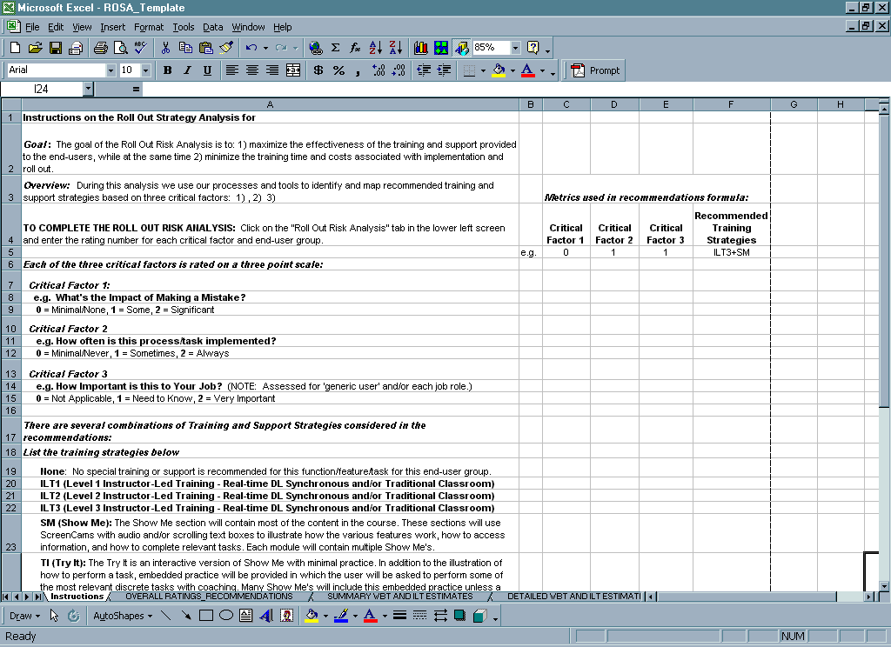

Instructions & Definition Worksheet

Exercise 2a
Complete the Instructions & Definition Worksheet for Company A by adding the following information into the ROSA_Template.xls:
- Click in cell A1 to select it. Double click at the end of the word “for” to display the blinking cursor. Type “Company A” and press Enter.
- In Cell A20, type in the following Information: ILT1 (Level 1 Instructor-Led Training - Real-time DL Synchronous and/or Traditional Classroom): 10 min. to explain/demo very important features/functions/topics/tasks - "Let me show you this very important feature/function that is critical to your job success…"
- In Cell A21, type in the following information: ILT2 (Level 2 Instructor-Led Training - Real-time DL Synchronous and/or Traditional Classroom): 5 min. 'light touch' explanation/demo of feature/function/topic/task - "Here's a neat topic that is nice for you to know about..."
- Click on the row 22 heading. The entire row is selected. Select Edit on the Menu Bar and select Delete. The entire row is deleted.
- In Cell A28 type “Project Manager”
- In Cell A29 type “Senior Instructional Designer”
- In Cell A30 type “Performance Consultant”
- Click on File on the Menu Bar and select Save As. The Save As dialog box appears. Type Instructions & Definition Worksheet in the File Name box. Click Save.

Adding Topics in the Overall Ratings and Recommendations Worksheet
- The Overall Ratings and Recommendations Worksheet is the core worksheet that feeds information into the other spreadsheets of the ROSA Template. Once the performance consultant and the instructional designer complete the breakdown of the Course topic rows, the client SME’s will use this worksheet to rate each of the Course topic rows against each of the Critical Factors.
- Note: To protect IBM Intellectual Property, the client NEVER receives the ROSA Workbook. Normally, the SMEs receive a printed copy of this worksheet and use a pencil/pen to fill the ratings in the columns. If the SMEs are remote, they receive an electronic copy of the worksheet without all the formulas and job role recommended strategy columns. The electronic copy would contain the contain the course breakdowns and the Critical Factors columns.
- The Overall Ratings and Recommendations worksheet contains:
  - Columns for the Course Number, Module Number, Course Name, Module Name, and Topics.
  - The Critical Factor columns. There are two critical factors that all the SMEs have to agree on and the third critical factor usually relates to their specific job role. The ratings will vary according to those job roles. The Template contains a rating column for four job roles. The number of job roles differ for each client and columns have to be added or removed accordingly.
  - The job role recommended strategies. These columns represent the learning strategies for each of the job roles based on the ratings that were entered by the SMEs. The values in those cells are automatically populated from the Training Development Metrics LookUp Table. The Performance Consultant does not make changes to those cells. The formulas in those cells calculate the combination of the ratings for each of the Course topics and finds the strategy blend for that combination from the Training Development Metrics LookUp Table.

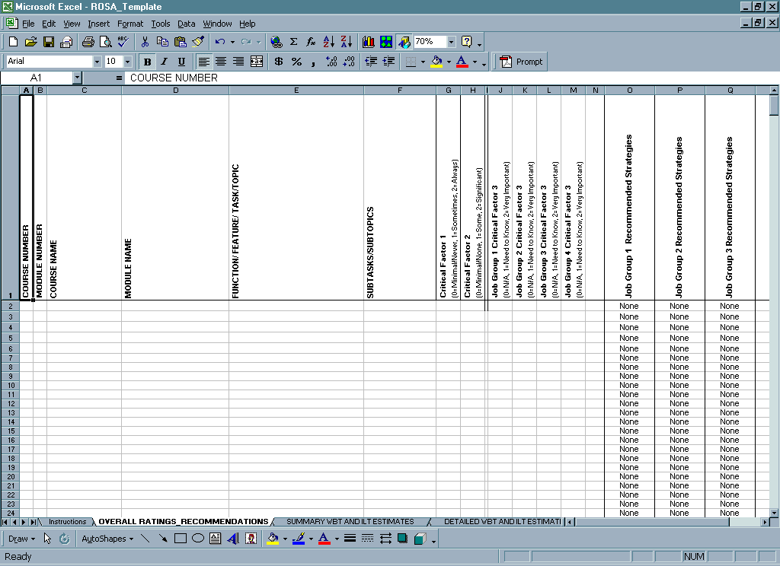
Overall Ratings and Recommendations Worksheet

Exercise 2b
In this Exercise, you will add the Course Number, Module Number, Course Name, Module Name, and Topics for Company A.

- Open the file Company A_Ratings1
- Note that the second row of the Overall Ratings and Recommendations Worksheet has been filled with the first course function/feature/task. Referring to Appendix A of this Workbook, add the second topic into the third row of the Overall Ratings and Recommendation Worksheet. Normally, you would continue adding the rest of the course breakdown into the subsequent rows.
  - Note: Columns N through P will contain the recommended strategies for each of the identified job groups for the client and the course topics. At this time, the columns contain “None” for Training Strategies. When the client SMEs complete the ratings and as those ratings are entered into columns G through L, columns N through P will become populated.
  - Click on cell N2. Notice that while the value in that cell says “None”, the Formula Bar shows =lookup1($G2,$H2,J2). This indicates that this cell calculates the ratings from columns G through J, match the rating combination sum to the Training Development Metrics LookUp Table and insert the corresponding training strategy from the Training Development Metrics LookUp Table into that cell. For example, for Company A, if the Project Manager SME rates 1, 0, 2 for the critical factors, the training strategy for the project managers for that one function or task is a 5 minutes of ILT with a Try It and Practice component (ILT2+TI+P).
- Close the file Company A_Ratings1.

2.3 Create a separate rating worksheet for SMEs.
Once the course function/feature/task breakdown has been completed, The Client SMEs have to rate each function/feature/task according to the three critical factors. Make sure to remove all formulas and job role recommendations columns so that they do not distract the SMEs. Since the client should not receive the ROSA workbook, there are two ways of providing them with the ratings worksheet without compromising IBM Intellectual Property:
  - Using Pen and Paper: On the Overall Ratings and Recommendations Worksheet, hide all the columns pertaining to the recommended strategies for each job group. Keep only the columns that contain the breakdown of the course function/feature/tasks and those columns that contain the three critical factors. You can then print out the Overall Ratings and Recommendations Worksheet and have the client rate each of the function/feature/tasks using a pen/pencil. When the results are returned, you can enter each of the ratings into the ROSA Workbook.
  - Electronically: Use the Save As function in to create a second ROSA workbook. Delete all the other sheets from the Workbook except for the Overall Ratings and Recommendations Worksheet. Delete the columns that contain the recommended strategies for each job group. Give the client an electronic copy and ask them to rate the function/feature/tasks for each of the critical factors by typing 0, 1 or 2 into the cells. When the results are returned, you can then copy and paste the information into the ROSA Workbook.
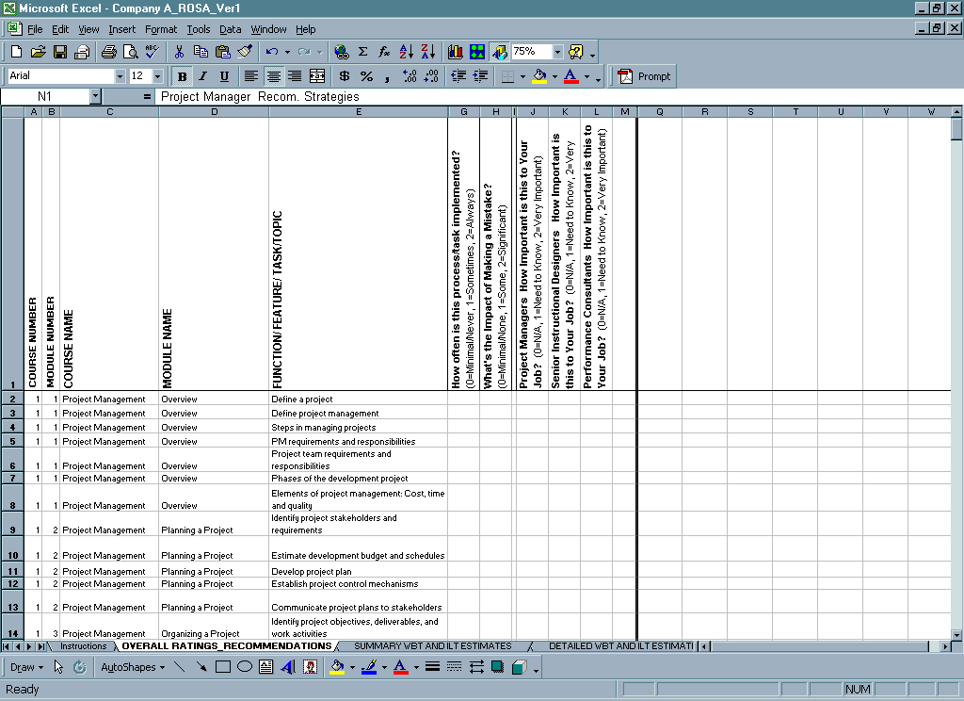
Ratings Worksheet for the SMEs

2.4 Meet with the SMEs to review the rating worksheet and walk them through the process.
The SMEs must agree on the ratings for the first two critical factors. The Performance Consultant should collaborate with the SMEs to reach an agreement on the ratings. The SMEs representing each of the job roles are responsible for providing the best possible rating for the third critical factor which relates to their specific job roles.
To clarify the process and simplify the steps, provide an instruction worksheet to the SMEs on how to complete their ratings on their worksheet.

Understanding the Summary, Detailed and Job Role Estimate Worksheets.
The Summary Blended Training Solution Estimates Worksheet: This worksheet contains the summary of the recommendations that ROSA calculated from the Overall Ratings and Recommendations Worksheet. You should not make any changes to any of the values in this spreadsheet. The summary information is extracted from the Overall Ratings and Recommendations Worksheet. However, sometimes, it’s necessary to examine the results in its cells, especially if you are modifying an existing client ROSA with the new client information. You want to make sure that the number of rows it’s calculating are correct and that the formulas are adding the correct cells. This spreadsheet contains the following:

- The course is collapsed to show only the course and module names excluding the topics information in the Overall Ratings and Recommendations. The Overall Ratings and Recommendations worksheet provides the course and module names and places them in the appropriate rows. The course and module name rows usually add up the information from the detailed topic rows. Therefore, it is very important that the collapsed course and module name rows are adding the correct number of rows that relate to its section in the Overall Ratings and Recommendations Worksheet.

For example, if a course and module contain 10 topics, the course and module name row that appear in this worksheet should add the information from the 10 rows above it.

- The worksheet contains the breakdown and total number of screens and ILT minutes for each learning strategy per course and module.

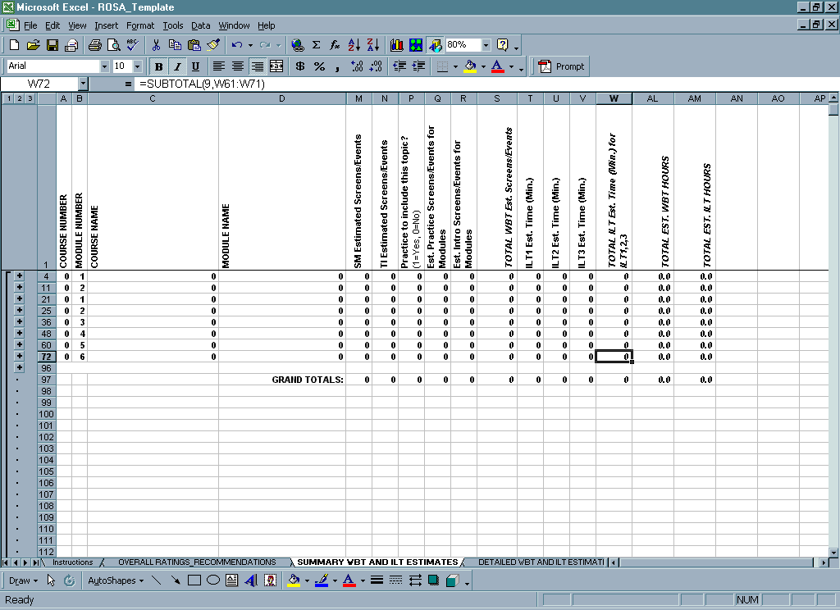
Summary Blended Training Solution Estimates Worksheet

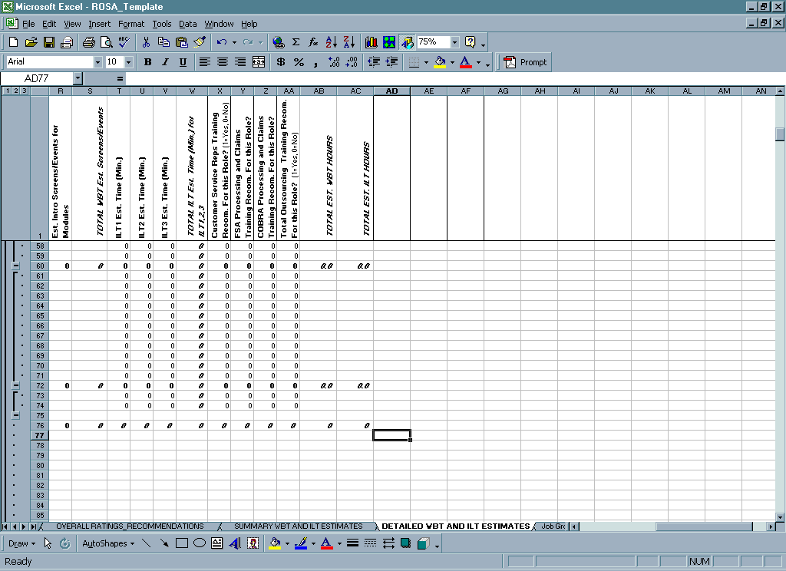
Detailed Blended Training Solution Estimates
Detailed Blended Training Solution Estimates: This worksheet is similar to the summary except that it is expanded to show the detailed number of screens and ILT minutes for each topics. The type of formulas in this worksheet are similar to the ones in the Summary Worksheet and they should add the correct number of rows and cells.

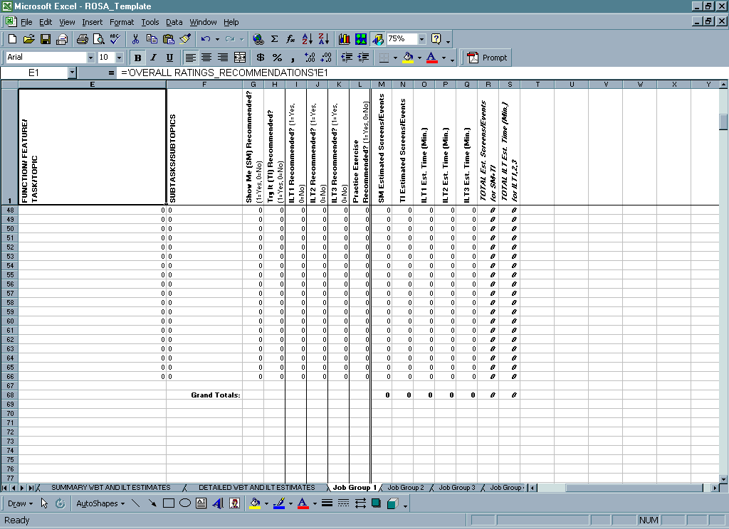
Job Role Training Estimates
Job Role Training Estimates: This worksheet breaks down the number of screens and ILT minutes for the learning strategies for each specific job role. Each job role for the client has its own Job Role Training Estimates Worksheet.
The information in this worksheet is taken from the Overall Ratings and Recommendations Worksheet and specifically relates to the column that contains the ratings and recommended strategies for the specific job role.

The Training Development Metrics LookUp Table
The Training Development Metrics LookUp Table and the Overall Ratings and Recommendations Worksheet make up the core of the ROSA Template. The entire ROSA Template pulls its information from these two sheets. Therefore, the information has to be accurate. The rating combinations translate into a unique learning strategy and for each rating combination, the Instructional Designer and Performance Consultant collaborate to create the Training Development Metrics LookUp Table. The recommended solution for the client is based on the learning strategy for each of the rating combinations and should be selected carefully.
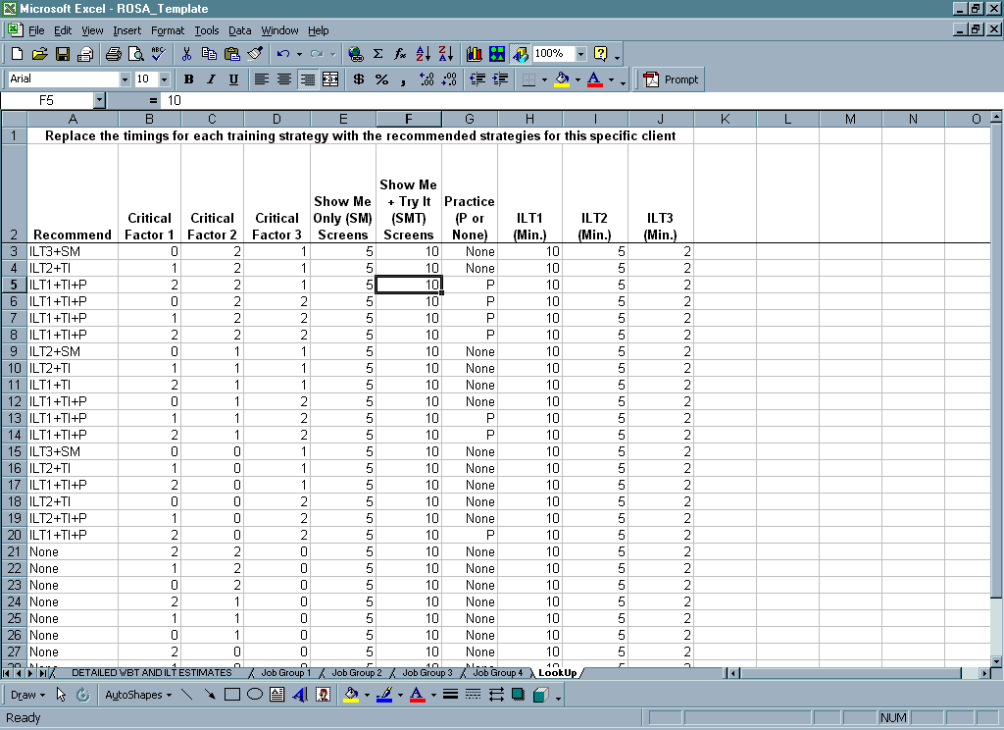
Training Development Metrics LookUp Table

2.6 Create the Training Development Metrics LookUp Table by mapping the ratings combinations with recommended blended solutions and strategies.

One of the most critical steps in creating the ROSA Workbook for a project is determining the best combination of training strategies/options for each of the critical factors rating combinations (e.g., 0-1-2, 0-0-1, 2-2-2). For example, if the three critical factors used are Frequency of Performance, Impact of Making a Mistake and Importance to Job Role Success, the team must determine the recommended strategies when the SMEs rate a function/feature/topic/task as 2 (Always), 1 (Some), and 2 (Very Important).
The ROSA Workbook Template contains a programmed macro for extracting the correct data/metrics from the Training Development Metrics LookUp Table. By changing the recommendations and/or the sizing metrics in the LookUp table for the ratings combinations, you can quickly re-scope the project for all job roles within a few minutes. Compare the Training Development Metrics LookUp Table in Company A_ROSA ver1.xls to the one in Company A_ROSA ver2.xls.
NOTE: This step requires input from experienced training consultants/developers who can collaborate and come to consensus on the recommended blend of training strategies for each combination of ratings. In the case of Company A, review the Training Development Metrics LookUp Table to see if you agree with the team’s ratings combinations and recommendations.

2.7 ROSA will calculate the results

Once the Training Development Metrics LookUp Table is complete, the ROSA Template will automatically calculate the results and the cells in all the spreadsheets of the Workbook will be updated. One benefit of working with a Spreadsheet and the programmed macros is that this supports the ability to update all referenced cells throughout the workbook when any of the values are changed in the two core sheets: the Overall Ratings and Recommendation Worksheet and the Training Development Metrics LookUp Table.

2.8 Review the results to ensure their accuracy
Once the ROSA Workbook is complete, the Performance Consultant and the Instructional Designer must review the results to ensure their accuracy and ensure that the formulas are referencing the correct cells, rows and columns. One inaccurate formula could change the results of the entire ROSA Workbook.
To view the completed ROSA for Company A, open the two example files — Company A_ROSA Ver1.xls and Company A_ROSA Ver2.xls.

Activity 3 Generate ROSA Results and Recommendations

Use the results from the Requirements Analysis and the Roll Out Strategy Analysis as valuable data for a variety of project deliverables based on the work product instances developed and the client agreement. Depending on the content and presentation media selected for the major deliverable(s), the team develops narratives, diagrams, matrices, spreadsheets, and/or prototypes of the proposed blended training solution and produces an initial version of the major deliverable(s) for review. The team completes as many edit cycles as necessary to produce the deliverable(s) to the degree of quality specified by the contract with the client. Relevant major deliverables may include any combination of the following:
- Training Needs Analysis and Recommendations: This deliverable includes a summary of the training requirements, including — the business case and goals of the training, the content to be addressed, the target audiences, technical requirements, as well as the recommended blended training solution as interpreted from the Roll Out Strategy Analysis results.
- High Level Design Document: This optional deliverable includes descriptions, examples and/or prototypes of the blended training strategies included in the recommended solution. (NOTE: The content in the high level design document often overlaps with the content in the training needs analysis and recommendations deliverable, so the client often does not require both of these deliverables.)
- Training Development Project Plan: This optional deliverable includes the training development project plan of development resources, hours, timeline, and costs based on the sizing and scoping metrics from the Roll Out Strategy Analysis results.
- Delivered Proposal: This optional deliverable is the proposal, or the Statement of Work (SOW), for the training development work as interpreted from the results of the Roll Out Strategy Analysis. The training development proposal may include content from the Training Needs Analysis and Recommendations report, the High Level Design Document and/or the Training Development Project Plan.
Appendix A: Breakdown of Topics for the Selected Courses

COURSE NO. | MODULE NO. | COURSE NAME | MODULE NAME | FUNCTION/ FEATURE/ TASK/TOPIC
1 | 1 | Project Management | Overview | Define a project
1 | 1 | Project Management | Overview | Define project management
1 | 1 | Project Management | Overview | Steps in managing projects
1 | 1 | Project Management | Overview | PM requirements and responsibilities
1 | 1 | Project Management | Overview | Project team requirements and responsibilities
1 | 1 | Project Management | Overview | Phases of the development project
1 | 1 | Project Management | Overview | Elements of project management: Cost, time and quality
1 | 2 | Project Management | Planning a Project | Identify project stakeholders and requirements
1 | 2 | Project Management | Planning a Project | Estimate development budget and schedules
1 | 2 | Project Management | Planning a Project | Develop project plan
1 | 2 | Project Management | Planning a Project | Establish project control mechanisms
1 | 2 | Project Management | Planning a Project | Communicate project plans to stakeholders
1 | 3 | Project Management | Organizing a Project | Identify project objectives, deliverables, and work activities
1 | 3 | Project Management | Organizing a Project | Determine resource requirements
1 | 3 | Project Management | Organizing a Project | Establish project organization and structure
1 | 3 | Project Management | Organizing a Project | Create a Work Breakdown Structure (WBS)
1 | 4 | Project Management | Managing a Project | Monitor development schedules and budgets
1 | 4 | Project Management | Managing a Project | Monitor tasks and deliverables
1 | 4 | Project Management | Managing a Project | Coordinate and manage the work of project team members
2 | 1 | Project Scheduling Tools | Exploring Project Schedulers | Start Project
2 | 1 | Project Scheduling Tools | Exploring Project Schedulers | Open an existing project file
2 | 1 | Project Scheduling Tools | Exploring Project Schedulers | Display Views
2 | 1 | Project Scheduling Tools | Exploring Project Schedulers | Use the View Bar
2 | 1 | Project Scheduling Tools | Exploring Project Schedulers | Hide and display the View Bar
2 | 1 | Project Scheduling Tools | Exploring Project Schedulers | Use the Office Assistant for Help
2 | 2 | Project Scheduling Tools | Getting Started | Create a new project file
2 | 2 | Project Scheduling Tools | Getting Started | Enter project properties information
2 | 2 | Project Scheduling Tools | Getting Started | Enter task names
2 | 2 | Project Scheduling Tools | Getting Started | Save a project file without a baseline
2 | 2 | Project Scheduling Tools | Getting Started | Enter task durations
2 | 2 | Project Scheduling Tools | Getting Started | Create a milestone task
2 | 2 | Project Scheduling Tools | Getting Started | Create a recurring task
2 | 3 | Project Scheduling Tools | Shaping the Project Plan | Link tasks
2 | 3 | Project Scheduling Tools | Shaping the Project Plan | Unlink tasks
2 | 3 | Project Scheduling Tools | Shaping the Project Plan | Link nonadjacent tasks
2 | 3 | Project Scheduling Tools | Shaping the Project Plan | Format the critical path
2 | 3 | Project Scheduling Tools | Shaping the Project Plan | Establish a finish-to-finish dependency
2 | 3 | Project Scheduling Tools | Shaping the Project Plan | Establish a start-to-start dependency

- Revision History
Revision Number | Revision Date | Summary of Changes
4.1.2 | August 2004 | Removed quotes to conform with COO guidelines
1.1 | December 2001 | Updated to conform to standard template and remove third party information
1.0 | November 2001 | Base Version
NOTE: The training Roll Out Strategy Analysis (ROSA) methodology, toolset, and templates are proprietary to IBM. ROSA is to be used by trained IBM project teams for customer-related and internal projects only. Do not distribute this document and/or the ROSA toolset and templates to unauthorized, non-IBM personnel.

