

IBM Global Services
Using Job LOVEM Charts
Technique
© Copyright International Business Machines Corporation 1999
All Rights Reserved

Version 1.0

Preface

The ‘Using Job LOVEM charts’ technique can be used to create the following work products
•To-Be Organization Design
•Role and Job Design

Using Job LOVEM Charts

Table of Contents
1 Job LOVEM Introduction 3

- 2 Major Uses of the JLOVC 4 42
- 3 Structure and Main Components of the JLOVC 5 44
- 3.1 The Bands of the JLOVC Template
- 3.2 JLOVC Symbols
- 3.3 Symbols on the JLOVC Template
- 4 What to Do and What to Avoid 10
- 5 Creating an As Is JLOVC 10
- 6 Creating a To Be JLOVC 13
- 7 Example of a JLOVC 15
- 8 Applications of the JLOVC 16
- 9 Blueprinting Introduction 18
- 10 Job Costing 18
- 10.1 Activity Based Costing (ABC)
- 10.2 Other Focus Areas for Job Costing
- 11 Time Duration Details (TDD) 21
- 12 Subjobs 22
- 13 Job Decomposition 25
- 14 System Requirements 26
- 15 Repetitive Activities (Loops) 28
- 16 Job Skills 29
- 16.1 Skills Matrix
- 17 Job Proficiency Education 33
- 18 Job Redesign 33

- 19 Summary 36

The Job Line of Visibility Chart (JLOVC) - Introduction

The Job Line of Visibilty Chart is a specialized form of the IBM Line of Visibility Chart modeling technique. For a general introduction to the technique, and a definition of the symbol set, see the ‘Using Physical LOVEM Charts’ technique.

The JLOVC is at the lowest level of abstraction. It shows all physical aspects of a job sequentially. The result is a model or blueprint of a job, which shows how it is, how it could be, or how it will be implemented under the constraints of business.

A JLOVC is like a map of a city showing roads, highways, subways, railroads, airports, and bridges. You could view each activity on the JLOVC as an intersection and each information flow as a connecting road, subway,
or railway.

A JLOVC is:
Similar to a PLOVC, but it focuses on one job at a time.
The graphical representation of one particular job showing the manual activities and their interfaces to:
— Customer activities
— Internal organizations, such as departments and jobs
— External organizations, such as vendors, financial institutions,
or government agencies
— Systems.
A charting technique for developing models or blueprints for a job.
A mapping of physical constraints to one particular job. Following are examples of physical constraints:
— Organizations, departments, and jobs
— Office equipment, such as telephones, fax machines, systems, and document storage's
— Time factors, such as cycle time and process time
— Cost of performing the manual activities
— Automated systems, such as EDI, the Internet, and order entry
or billing systems
— Process quality factors, such as process defects and bottlenecks.
A means to establish key indicators for a job.
A means to determine a detailed process maturity rating for your As Is job and to set a target maturity level for your To Be job.
A mapping of the latest customer research results to individual job blueprints.
A communication and education tool for management, employees performing the job, and upstream and downstream interfaces.

Major Uses of the JLOVC

While the PLOVC is a context diagram of all departments and jobs of a process path, the JLOVC is at the implementation level. It can be used as:
The final step in a top-down process design.
You can expand the PLOVC into multiple individual jobs. For each job, you can build several alternative job models before designing the detailed job blueprint, from which you will implement the new job.
Note: The design of a job should be fully integrated into the process path
design to which it belongs.
A blueprint to make day-to-day business decisions, such as:
— Can the order-fulfillment of a new product or service be handled by the existing procedures and systems?
— Can you combine this job, or portions of it, with other jobs? Can you add more responsibilities?
— Where can you apply new tools and system functions?
Note: You should develop system requirements from job blueprints,
because it is the employees performing the job that use the
systems.
— Do you use the most effective media for information and material flows?
— What activities can you move to the customer for better customer service?
— How can you improve the cycle time to become more competitive?
— What areas are most in need of re-engineering?
An interface diagram to document, analyze, and redesign internal and external hand-offs and dependencies.
A diagram to document, analyze, and redesign systems interfaces.
A graphical means to establish key indicators for individual jobs, which must be aligned with the business goals and key indicators for other jobs across the process path.
A framework to determine skills and educational requirements and to help select employees with the right skills for a particular job.
Note: This also ensures, from a human resources point of view, that the
right people are in the right jobs.
A framework for job redesign through skills aggregation.
A communication and education tool for new employees. It can also be used to communicate with internal and external organizations, or to introduce new automation to the employees performing the job.
A framework for building a total job profile for all aspects of a job, such as skills, tools, systems, ergonomics, future direction, and job levels.
An operational procedures diagram for employees performing day-to-day jobs.

As a means for designing solutions for:
— Work flow management
— Image processing
— Document and folder management
— Call flow management.

Structure and Main Components of the JLOVC

The JLOVC template is similar to the PLOVC, but it has only one internal band.

Figure 1 shows a template for a JLOVC.

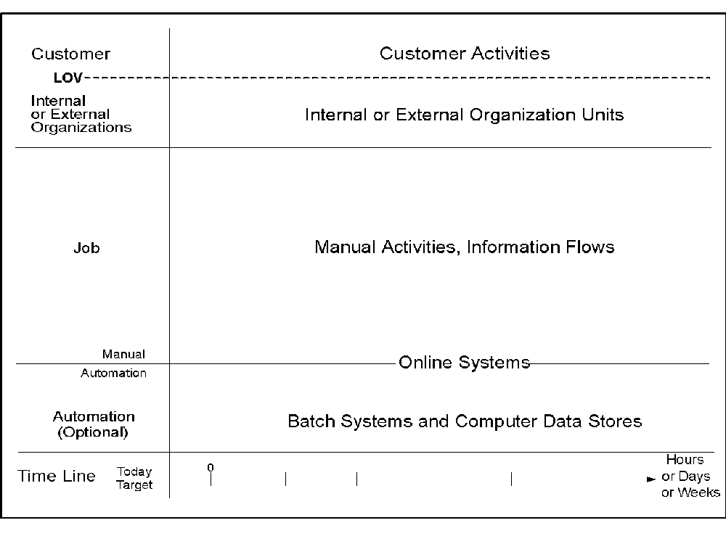
Figure 1. JLOVC Template

The Bands of the JLOVC Template

Following is a description of the bands of the JLOVC template.

Customer Band
The customer band shows the customer activities that interface with internal activities.

Line of Visibility
The interface between customer activities and internal activities or systems. The LOV represents:
• What the customer sees
• Service encounters
• Moments of truth
• The company's image.

Internal or External Organizations Band
Directly below the LOV is a band that shows the interfaces to internal and external organizations, but not the customer, for the job.

The interface line between this band and the main job band shows internal and external service encounters; it represents:
What others see
Moments of truth
Where hand-offs take place
Where dependencies are shown.

Manual-to-Automation Band
It represents the interface between systems and:
— Customer activities
— Internal activities
— Internal or external organizations.
Online systems that interface with activities are placed partly above and partly below the manual-to-automation interface line.
Note: Batch systems, that do not directly interface with activities, are
shown below the manual-to-automation interface line in the automa-
tion band.

Automation Band
Batch systems that do not directly interface with activities are shown in this band.

Time Line
On the time line, you can show:
The time from one activity to another
The cycle time for the entire process path
Current and target time measurements.
Units of measure on the time line can be expressed in any relevant unit of time, for example, in hours, business or calendar days, weeks, months.

JLOVC Symbols
“LOVEM Symbols Summary Matrix” on page 55 shows the symbols that can be used on the JLOVC. For a detailed description of each symbol, refer to ”Symbols for Physical Modeling Techniques” on page 41.

3.3 Symbols on the JLOVC Template

Figure 2 shows how the symbols are placed on the template.

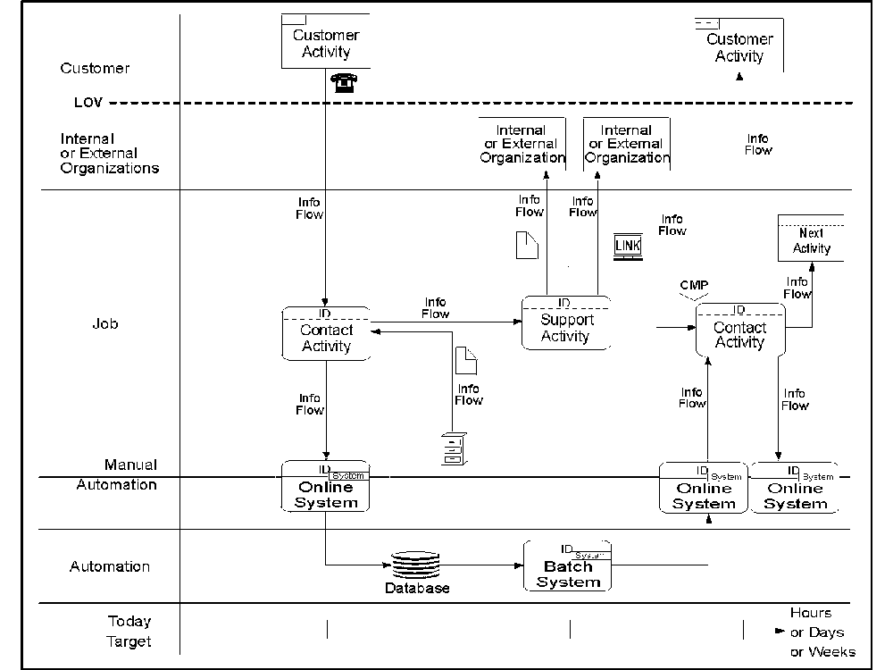
Figure 2. Symbols on the JLOVC Template

What to Do and What to Avoid

The following lists some general guidelines to consider when creating JLOVCs.
Keep the JLOVC physical but simple.
Keep it at the job or sub job level.
Use actual physical names for all components on the chart.
Do not put more than one activity into an activity box.
Use common and well-defined terms and definitions.
Use a different JLOVC for each sub job.
Sequentially connect all activities for the job to show continuity.
You can achieve this connection through systems or internal or external organization units.
Each component on the diagram must have an associated description for future reference.
Differentiate information, material, and control flows; do not show branching and keep them one-directional.
Make sure each activity generates at least one output.
Make sure each activity has at least one input.
The output of an activity can only be produced according to the input; avoid spontaneous creation.
Make sure an activity receives only the essential input to produce the output; avoid redundant input.

Creating an As Is JLOVC

An As Is JLOVC shows one job at its current level of implementation. This section explains the procedure for building an As Is JLOVC. Before you can build your JLOVC, you must determine the important aspects of the job.

Collecting Information about the Job
Use the following set of questions to collect information for the As Is job. It helps you to determine the most important aspects of your job. You can supplement it with questions unique to your circumstances.

Note: If you already created an LLOVC or a PLOVC for the process path
where this job belongs, you can use some of the information directly
and transform other information into job terms.
What is the scope of your project?
What business are you in?
Briefly describe the job; give the job name, responsibilities, the LOB and process path it belongs to, and the products and services that are handled by this job.
Who is your customer?
List all the types of customers that this job deals with.
What are your customer's expectations?
Support this with customer research information.
What are the competing best-of-breed factors?
How does your company compare?
What are the key business rules, goals, policies, and strategies that should be expressed by the resulting job blueprint?
What are the key indicators for this job? Are they aligned with the business goals and key indicators of other jobs across the entire process path?
What are the service level targets for this job?
What is the process maturity rating for this job?
What are the service encounters that are owned by this job? Examples of service encounters are:
— Ordering a product or service
— Inquiring about delivery schedule
— Sending the product and invoice.
What are the customer activities and the internal activities involved in each service encounter?
List them sequentially by service encounter as they occur in a relationship with a customer.
What are the support activities that are not directly involved in service encounters?
What are the internal or external organizations that interface with this job?
What are the required input information, material, and control flows and the expected output flows?
What systems are used? Online or batch systems?
What are the process quality and business control parameters for this job, such as CMPs, CSFs, or AIRs.

Building an As Is JLOVC
To build a JLOVC, do the following:
- Use a JLOVC template.
Note: Blank templates are given in Figure 1 on page 8.
- Place the individual components on the template in time sequence.
• You can start with a customer activity requesting information or ordering a product; or start with an internal activity offering information, such as advertising.
• Add other customer activities and internal activities.
• Add internal or external organizations in the internal or external organizations band.
• Add the online systems on the manual-to-automation interface line and the batch systems in the automation band. Connect them to activities through information flows.
- If you want to highlight some systems functions, add systems function symbols in the automation band. This procedure is also used to create systems requirements at the job level.
- Connect all symbols on the chart with information, material, and control flows.
- Label the time line with the time it takes to complete the activities. Show both, today's time, as well as the target time.
Note: The time marks on the time line correspond to the elapsed time.
For more information about time parameters, refer to ”Time Duration Details (TDD)” on page 59 .
- Add the process quality and the business control parameters to the chart.
- Describe each component on the chart for future reference.
Note: In some instances, you have to repeat parts of the job and create a
loop. For more information on loops, see “Repetitive Activities
(Loops)” on page 66.

Creating a To Be JLOVC

When you have blueprinted your current job on an As Is JLOVC, you can start the creative design work by building one or more To Be alternatives using the JLOVC.

The objectives of your design work should be:
To build the most effective internal and external service encounters from the point of view of your customers, suppliers, and employees.
To simplify your company's procedures and data processing applications in order to reduce the potential for errors.
To shorten cycle times by eliminating duplicate activities and upgrading the skills of your employees.
To reduce the cost of your operations by analyzing the cost parameter on your To Be JLOVC.
To integrate the job design with your process path design.
The following questions are intended to help you to validate your To Be JLOVC models and blueprints. They can also help to generate ideas and thoughts as you do the creative analysis and design work.
- Do you have all service encounters that you need? Do you have too many?
- Did you capture all interfaces for this job? Are there too many?
- Do you have all internal support activities? Do you have too many?
- Do you have all information, material, and control flows? Do you have too many?
- Can the sequence and flow be rearranged for better customer service or internal efficiency?
- Did you apply all business rules, policies, and directions?
- Are all the key indicators aligned with the business goals and with key indicators for other jobs across the process path? Are they addressed by action plans?
- What is the target maturity level that you envision for this job?
- Did you address all the best-of-breed factors?
- What quality measurements do you want to add and at what points?
- How did you affect customer satisfaction?
- How did you affect internal productivity and effectiveness through redesigning the job?
- Have you eliminated all operational defects?
- Have you identified all bottlenecks, especially those attributable to paper constraints?
- Do you have the optimum mix of manual activities, tools, and systems?
Note: Make a conscious design decision to give those activities that are
involved in service encounters and those that require creativity to
the employees and automate all data-intensive and repetitive
activities.

Example of a JLOVC

The example in Figure 3 illustrates an As Is JLOVC.

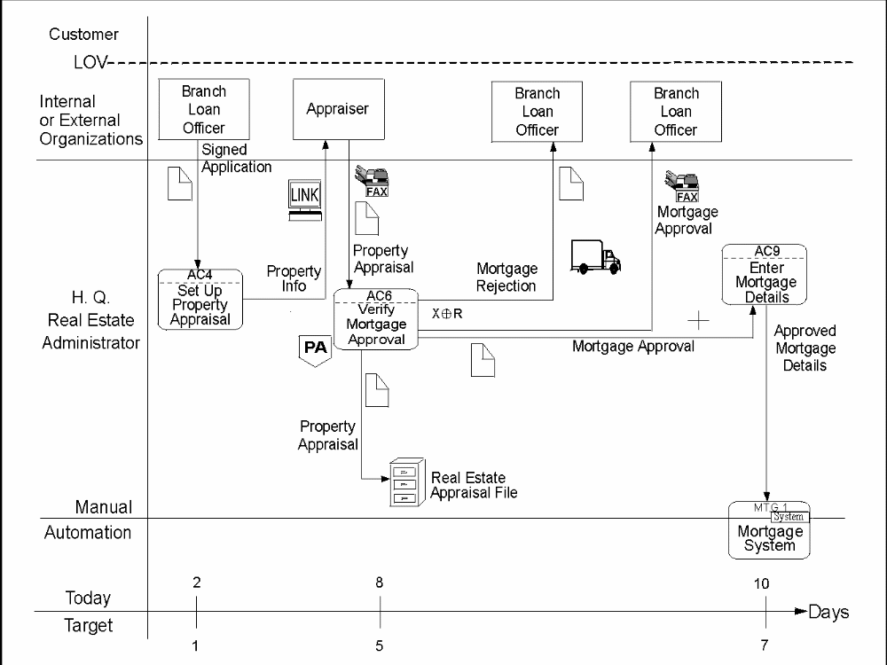

Figure 3. Example of an As Is JLOVC for the H.Q. Real Estate Administrator Job

In Figure 3, the H.Q. Real Estate Administrator has no contact with the customer but interfaces with two internal jobs:
The Branch Loan Officer
The Appraiser.
The H.Q. Real Estate Administrator sets up the property appraisal after receiving the signed application from the Branch Loan Officer.

Once the Appraiser receives the property information through electronic link, and the property has been appraised, a property appraisal report is faxed to the H.Q. Real Estate Administrator, who then verifies the mortgage approval, sends the approved mortgage document to the Bank Loan Officer via fax and enters the approved mortgage details into the mortgage system.

If, however, the mortgage application is rejected, the H.Q. Real Estate Administrator sends a mortgage rejection document to the Branch Loan Officer by courier. In either case, the property appraisal report is filed in the real estate appraisal File.

The time line shows that it takes eight days 'Today' from when the H.Q. Real Estate Administrator receives the signed application until the approved mortgage details are entered into the mortgage system. The desired 'Target' is six days. Therefore, some re-engineering of the job and its interfaces is required.

Applications of the JLOVC

Because a JLOVC provides you with a very detailed blueprint of one job, it has a number of applications, including:
Job costing
Time duration details
Subjobs
Job decomposition
Systems requirements
Repetitive activities and loops
Job skills
Job proficiency education
Job redesign.
Each of these applications is explained in detail in Chapter 8, “Applications of Blueprinting with the JLOVC”.

Success Factors
Building various implementation alternatives for individual jobs will greatly enhance the probability of arriving at the best design for customer satisfaction and employee morale.
Customer satisfaction and employee morale are the two pillars of business success!
Integrating all aspects of the job design with the process path design minimizes the risk of problems with upstream and downstream dependencies.

Summary
The JLOVC helps you to design individual jobs and assists in making day-to-day decisions on the operations and management of jobs. The most important features are:
The service encounters of jobs with customers
Internal and external interfaces
Interfaces to systems
Cycle and process time
Process quality and business control parameters
Job maturity ratings and key indicators
Media for information and material flow
Costs for the entire job and for individual components
Job skills.

The JLOVC is:
A graphical means for validating your understanding of the As Is job.
An aid for building To Be scenarios and blueprints.
Readily understood by business professionals, because it deals with physical realities.
A means for communication and education.
The basis for building a total job profile for all aspects of a job.

Applications of Blueprinting with the JLOVC - Introduction

The JLOVC is a very detailed mapping of one job. At this level of abstraction, you are at the implementation level. As a result, the JLOVC has a number of specific applications. This section explains how you use the various JLOVC applications to determine the efficiency and operating cost of a job, as well as the required personnel skills and system requirements.

Although you can use general JLOVCs for a variety of purposes, sometimes you create JLOVCs for a specific purpose. Just as an elevation map would not be very useful when trying to determine the major roadways of a city, a JLOVC for determining the manual operating costs for a job does not have to contain the systems or personnel skills requirements.

Job Costing

Blueprinting with the JLOVC helps to determine the cost of implementing and operating a job. Because the JLOVC blueprint contains all the necessary components, such as activities, service encounters, internal and external interfaces, systems, and media for information and material flows, you can determine the costs for these individual components and, thus, determine the cost-effectiveness of the job.

When you design a new job, you can also estimate the cost of implementing this job and its operating cost. This is important when you establish a business case and when you want to develop various "what if" scenarios.

If you want to know the current operating costs and what contributes to them, you can use the JLOVC blueprint to determine the cost of each component and then add it up for the entire job. You can now determine what components you can eliminate or change to decrease the cost. You can also use this procedure to determine your staffing requirements and to balance the existing staff.

Activity Based Costing (ABC)

With ABC you focus on the operating cost of individual activities. You can follow this procedure:
Count or estimate the average number of transactions that are processed by an activity over a specific unit of time, such as an hour or a day
For each transaction, establish the average process time
Write the number of transactions and the process time in or below the activity box (see Figure 4 on page 22).
Figure 4 on Page 22 shows an example of ABC. At the bottom of the three activity symbols you see the number of transactions on the left and the process time per transaction on the right. Multiply the number of transactions with the process time and add the resulting products up across the job to establish the number of hours it takes to perform the job. Multiply this number by the hourly rate to determine the manual cost for this job.

In Figure 4, there are 40 transactions per day for activity ‘Set up Property Appraisal’; each transaction requires 30 minutes, for a total of 1200 minutes, or 20 hours, per day. The total effort for this job is 35 hours per day, when you add in the amount of time it takes to verify a mortgage approval and enter the approved mortgage details into the mortgage system. If employees work 7 hours per day, then you need 5 employees for this job. If the average hourly rate is $15.00, then the manual cost for this job is $525.00 per day.

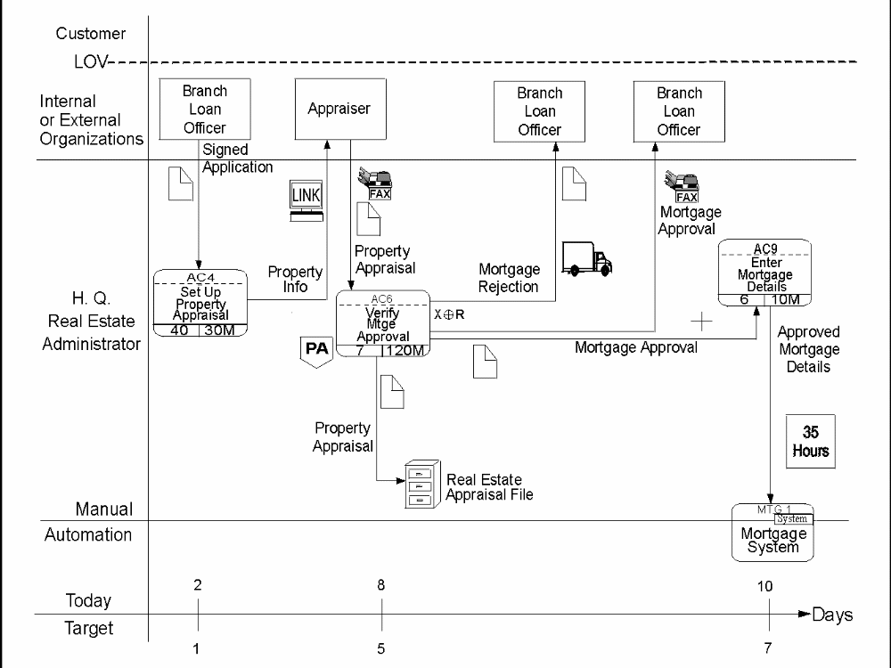
Figure 4. Job Costing Using Activity-Based Costing

Other Focus Areas for Job Costing

You can also determine the media cost for the information and material flows.

For example, if you focus on invoices, you can determine:
The cost of sending invoice forms to your customer
The effectiveness of this method; or would it be better to replace the forms with EDI or some other electronic means?
— Better from a cost point-of-view?
— Better for customer satisfaction?
— Better for billing cycle time?
The service encounters and interfaces to internal or external organizations are other cost parameters that you can analyze. For example, you can determine:
How much it costs to send a Marketing or Sales Representative to call on your customers.
How much you would save by dealing with your customers or vendor using the telephone, fax machines, electronic mail, or EDI.

— Would a change impact your customer in a negative way?
Important

You should not make these decisions based on cost savings alone.
Customer research information should help to determine if changing your jobs would improve customer satisfaction.

Time Duration Details (TDD)

One of the most important characteristics of a job is the amount of time required to perform the job. There are several aspects to this:

Process Time
This is the time required to process one transaction; for example, it takes 30 minutes to prepare an invoice.

Cycle Time
This is the elapsed time required to receive, process, and forward a transaction; for example, it takes five days for an invoice to be sent to the customer.

Hand-off Time
This is the difference between cycle time and process time. The hand-off time is equal to the transit time plus the wait time.
Transit Time
This is the time it takes for a transaction to be passed from one activity to another; for example, it takes 2 days for the information to arrive at the workstation where the actual invoice is prepared.

Wait Time
This is the time the transaction has to wait because of backlog plus the time it has to wait before it is sent on.

When designing a new job, therefore, it is important to minimize the hand-off time and make the cycle time as close to the process time as possible. The job blueprint helps you to identify process, cycle, and hand-off times for each activity or for an entire process path or job. Unnecessary or redundant steps can be eliminated and the cycle time can be reduced.

Subjobs

Very few jobs are homogeneous either by design or by evolution. For example, a manager's job can have the following independent sub jobs which are not sequential:
Personnel management
Project management
Financial management.
Many jobs also work for several LOBs. Therefore, they appear on several process paths. For example, a marketing representative can sell for one or several LOBs.

In either case, you can build blueprints for only the sub jobs that you are interested in, rather than create one blueprint for an entire job which is not homogeneous.

To understand what sub jobs make up a job, you can start with a hierarchical structure diagram (HSD) and decompose the job into its sub jobs.
See Figure 5 on page 26.

Once you understand the breakdown of the job, you can:
Build a composite JLOVC showing each sub job with the most important service encounters, internal and external interfaces, systems interfaces, and percent of time spent; then build a detailed JLOVC for each sub job, as shown in Figure 5 on page 26 .
Build a detailed JLOVC only for those sub jobs that you want to focus on, without developing a composite JLOVC.
By understanding the individual sub jobs of several related jobs that are not homogeneous, you can compose new jobs from related sub jobs to address customer satisfaction and internal efficiency.

Scenario 1: If you find, by blueprinting, that one job deals with different types of customers, and that the job requires knowledge and information about many unrelated products and services, including access to different systems, you might want to analyze the individual job components, with the goal of re-engineering them with other jobs with similar characteristics.

Scenario 2: If, by analyzing the internal and external interfaces, you detect that certain aspects of a job could be handled more effectively by another department, or that the given job could handle aspects of another job more effectively, you could use this technique of blueprinting for sub jobs, or you could use the technique of job decomposition, as discussed in ”Job Decomposition” on page 63.

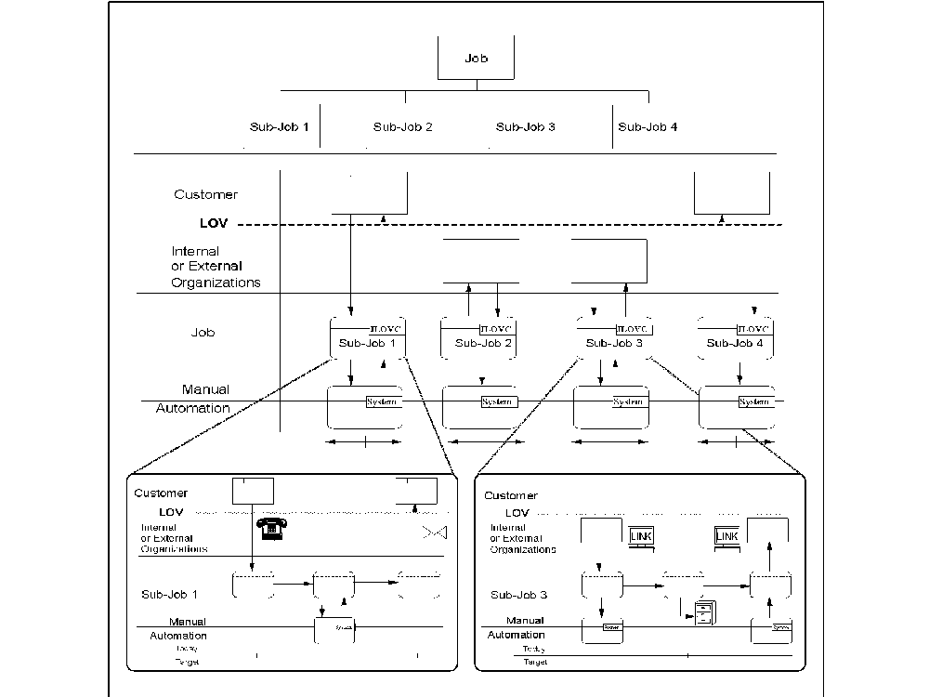

Figure 5. JLOVCs with Subjobs

Job Decomposition

Rather than blueprinting an entire job, you can focus only on one or two aspects of the job. Decomposing a job will help you achieve what you need with less effort and time. You could do this if:
You have a problem with a service encounter or with an internal or external interface
You have a problem with a system, a tool, or an information or material flow
You want to re-engineer certain aspects of a job, combine two jobs, or eliminate some job responsibilities.
Even though you are only interested in a particular part of a job, you should still create a high-level JLOVC for the entire job. This gives you the context for the part of the job that you are working with. This high-level chart should include:
High-level service encounters
Internal and external organizations
Systems
Major information and material flows.
You can usually create a high-level JLOVC quickly. Keep it to about two pages. This technique of decomposing job blueprints saves time and effort.

Using the high-level JLOVC, you can focus on the area that needs assessment. Follow these steps:
- Decompose high-level activities into lower-level components using the IFD or HSD.
- Assess if you really need to focus on all details of the area under study.
- Determine if you want to eliminate even more detail and focus only on the problem area, which you then decompose even further.
- Create a new, low-level JLOVC using the detailed components from the IFD or HSD, and leave the other components at their higher levels for context. On the high-level JLOVC you can now replace the activities that were decomposed with JLOVC symbols.
See Figure 6 on Page 28 for an example of high-level and low-level JLOVCs.

Make sure that the high-level JLOVC and the low-level JLOVC are balanced; this means, when you create the low-level JLOVC, do not leave out any important components that exist on the high-level chart.
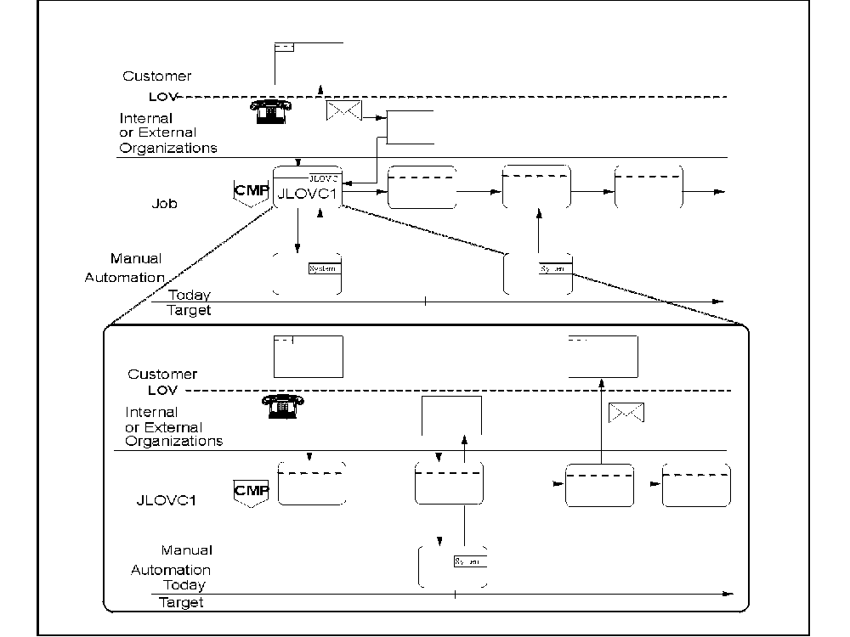
Figure 6. Job Decomposition

System Requirements

System requirements should be established at the job level, because it is the employees who perform the jobs, and who work with the systems. The following outlines conditions that might suggest a need for new system requirements:
To improve customer satisfaction or internal efficiency
To integrate jobs or systems
To implement new system functions for new job responsibilities
To take advantage of new technology.
To show the system requirements on a JLOVC, you use the system function or the system symbols. Place new online systems on the manual-to-automation interface line and batch systems and system functions in the automation band. If you need a new file or database, you use the symbol for a computer data store and place it in the automation band.

Because most jobs work with existing systems, you should show these systems on the JLOVC where you show the new systems. This helps to integrate new systems requirements with existing systems and prevents systems proliferation.

For an example, see Figure 7.

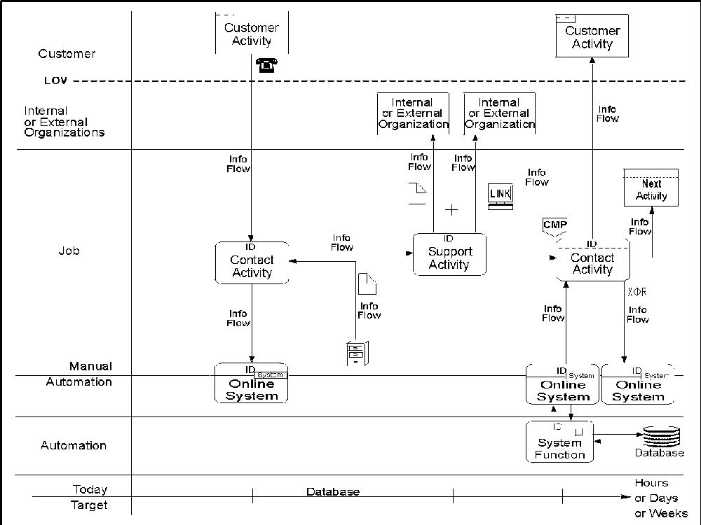
Figure 7. JLOVC with System Requirements

Repetitive Activities (Loops)

Occasionally, a portion of a process path or job must be repeated before you can continue with the rest of the path or job. To avoid repeating the activities and internal or external organizations, you can use a loop connector symbol, which shows the name of the activity where the path of job will be repeated. You are, in effect, creating a loop, for which you have to define exit criteria.

For example, in Figure 8 the customer, who has received a mortgage rejection notice, makes changes to the application and resubmits it to the Branch Loan Officer, who performs activity ‘Forward Mortgage Application’ again. The activities within the loop are repeated until the application is accepted, at

which time activity ‘Notify of Mortgage Acceptance’ is performed. Other exits from the loop could be if:
The customer stops sending revised applications
A predefined number of iterations through the loop has been reached.
In these two cases, you have to specify where the path or job continues after the loop. When you create a loop, the elapsed time will also be affected. Therefore, you can add a set of numbers to the time line called ‘After Loop’ to indicate the total time after the loop has been completed.

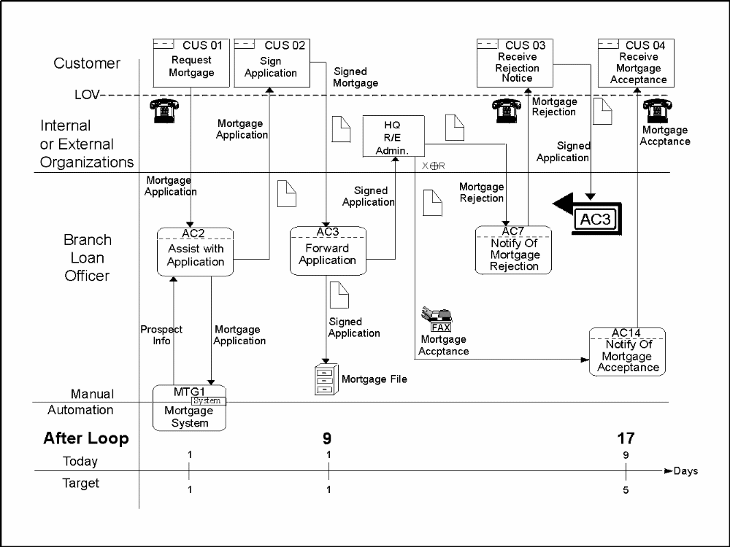
Figure 8. JLOVC with Loop

For more information about loops, refer to “Loop Connector” on page 83.

Job Skills

All employees need specific skills to do their jobs, to ensure:
The best customer satisfaction
Personal satisfaction and growth
High efficiency and productivity.

Therefore, it is important to assess the optimum skills at the job level. Skills are required in many different areas of a job. For example, a marketing representative might need the following skills:
Service encounter skills
— Knowing customers and their businesses, products and services
— Communications and interpersonal skills
— Selling and consulting skills.
Operational skills
— Communications, such as letter writing and telephone etiquette
— PC-based applications
—Office systems
—Operational systems; such as a mortgage system.
For an example, see Figure 9.

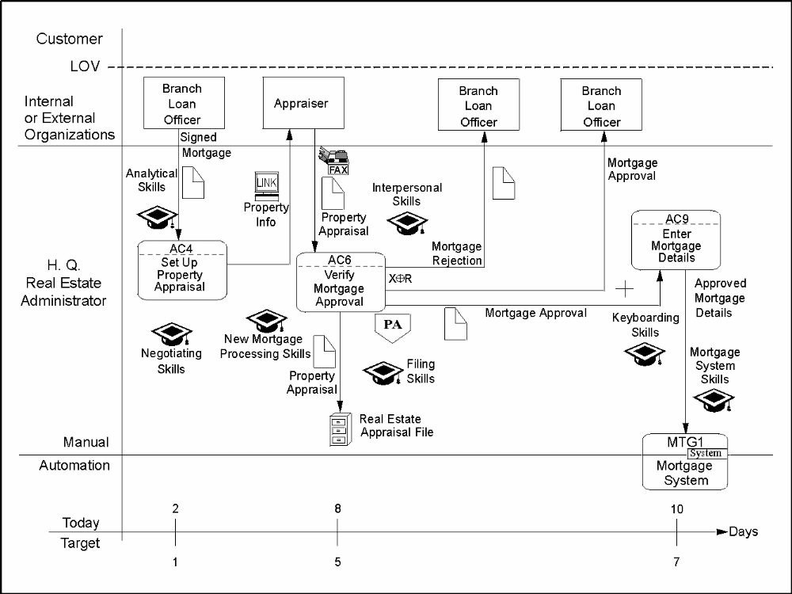

Figure 9. JLOVC Showing H.Q. Real Estate Administrator Skills

Skills Matrix

To determine what skills are required for a job, you can build a skills matrix with key job components from the job blueprint on one axis and the required skills on the other. Figure 10 shows the skills requirements by activity for the H.Q. Real Estate Administrator.

You can use this skills matrix for many purposes, such as:
To define an education plan for a job
To define prerequisite skills for new people
To determine criteria for hiring
To compare a job with other jobs
To determine who has the required skills to back fill a job.
Once the job is implemented, employees can use the skills matrix to ensure their skills are up to date and to track to the current and target skill levels for each activity.

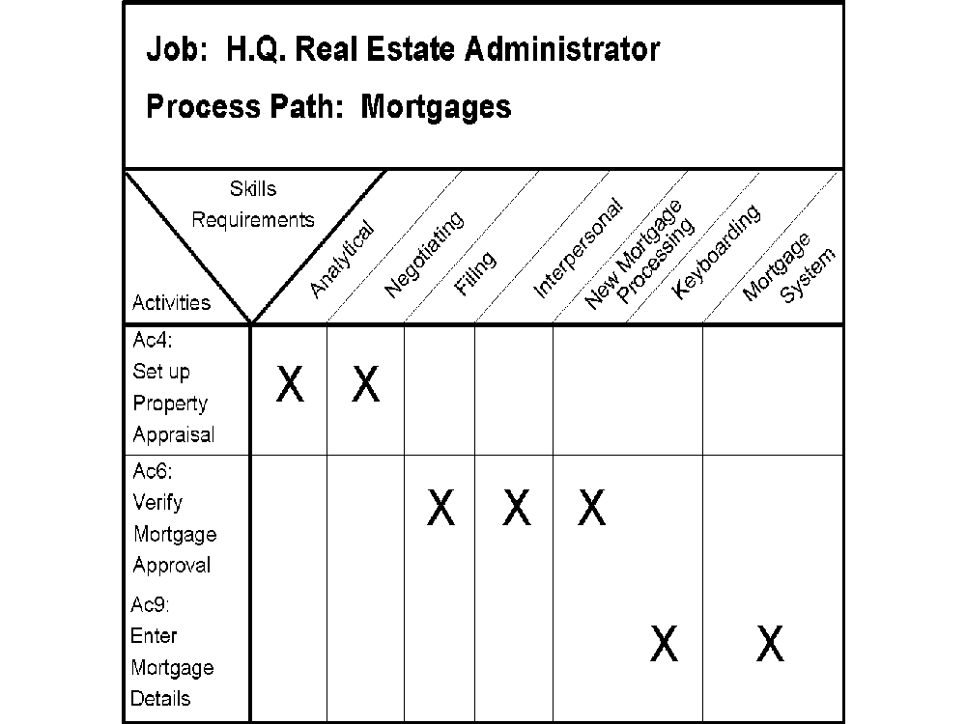

Figure 10. Example of a Skills Matrix

Job Proficiency Education

Knowing all aspects of a job is one of the critical success factors for effectively executing job responsibilities. Such factors include:
Service encounters
Interfaces to internal and external organizations
Systems
Manual procedures
Tools
Skills and education.
Because the job blueprint contains all aspects of a job, it can help with job proficiency education. The physical process path blueprints can also be used for educating employees, because they put the job in context of the entire process path. This also ensures that employees understand where they fit in the overall picture.
After the education and training, employees can use the blueprints as a process map or as operational procedures diagrams.

Job Redesign
After you have completed your As Is JLOVCs, you may discover that certain jobs are less demanding or are less efficient than others. Some jobs may seem overly complicated and intertwined. If this is the case, you should consider redesigning these jobs. Job redesign can mean reorganizing the current sub jobs to create more efficient and meaningful jobs or to discard the existing job designs and come up with new ones.
Often jobs evolve over time to meet new needs. This ad hoc approach to job creation can mean inefficiency and frustration for employees. For example, in Figure 4 on page 22, the H.Q. Real Estate Administrator has three more or less independent sub jobs or activities to perform. The total time to complete these activities for one mortgage transaction is 160 minutes. The elapsed time, however, is 8 days. The activities in the overall process path are not consecutive. The H.Q. Real Estate Administrator has a dependency on the Appraiser before being able to perform the next activity in the process path. As a result, the H.Q. Real Estate Administrator does not have any way to improve the elapsed time. In fact, this job is more clerical than administrative and should be redesigned.
You should have a PLOVC and JLOVCs for the area you wish to examine. This allows you to integrate the job design with the overall process path design. To do this, you can:
Identify all sub jobs on the PLOVC
Analyze the PLOVC and JLOVCs for the following:

— Customer sets
These are customers with similar needs that request products and services. Also similar service encounters should be performed by the same job to reduce the number of different employees that a customer must deal with. Combine sub jobs that deal with the same customers to provide seamless service to the customer.
— Internal or external organizations
These are hand-offs to and from other internal or external organizations. Too many hand-offs and dependencies will reduce the efficiency of the process path and should be minimized. This can be done by either combining components of different jobs or eliminating the need for such dependencies.
— Systems
The JLOVC indicates the systems that each job uses. This will determine if you have the optimum systems environment with the minimum number of systems interfaces. You can now analyze your PLOVC and JLOVCs for systems integration, creating new systems, eliminating redundant systems, or determining whether you simply need more or better systems proficiency training.
A job that uses too many systems could be inefficient and requires a high level of skills.
— Document handling
The handling of paper documents, such as forms and reports, requires attention when redesigning a job, because this is often a source for errors and bottlenecks.
— Workload balancing
A job should have a sufficient amount and variety of work to keep it manageable and interesting. This will increase productivity and keep overtime to a minimum.
— Percentage of time spent for sub jobs
When analyzing a job for the amount of time spent on each sub job, it becomes apparent that some sub jobs require a very small percentage of the overall time and are, therefore, quite often neglected. These sub jobs may fit better with another job, where they can be combined with other sub jobs to form more significant entities, and will no longer be neglected.
— Skills requirements
Analyze each sub job for the skills required. Group sub jobs with similar skills together into one homogeneous job. Keep in mind that depth of skill and knowledge is different from breadth.

— Job levels
The job levels depend on the complexity and responsibilities of a job, which in turn dictate the skills, experience, and seniority of the employee that is needed to fill the job.
Job levels include:
– Technical
– Clerical
– Administrative
– Managerial
– Marketing
– Analytical.
Subjobs that make up a job should relate to the appropriate, overall job level. For example, a clerical job requiring skills in many different systems is still at a clerical job level and may not be filled with a high-level technical employee.
Taking the output from the analysis of the previous step into consideration, decide which sub jobs work together to make up a homogeneous, effective, and productive job.
Keep in mind the following guidelines when designing jobs:
— Ensure the job supports similar customer sets. For example, combine roles that service the same customer set to provide seamless and responsive service to customers.
— Provide accountability and span of control for the life cycle of a promise made to a customer. A job that makes a promise should be accountable to deliver and follow up.
— Use similar automation, such as telephony, imaging, information systems, or work flow management tools.
— Reduce interfaces with other jobs and departments.
— Design interfaces that naturally belong together.
— Design jobs for similar outcomes and results. For example, outcomes vary from satisfying customers to developing new products.
— Keep customer-driven roles separate from internal support roles.
— Align the key indicators for a job with the job level and incentives.
— Make jobs interesting by varying the job content and, thereby, giving employees the opportunity to develop a broader skill set.
Create JLOVCs and job profiles for these new jobs.

Success Factors

Detailed job designs, including all implementation parameters,
guarantee a smooth implementation and operation of the new process path. Stopping the process path design short of detailed job designs requires many assumptions, which will result in implementation and operational problems.
Job satisfaction and employee morale should be guiding principles when you design jobs.

Summary

The JLOVC helps you to analyze and design individual jobs and assists you in making day-to-day decisions on the operations and management of one job. Applications include the following:
Establishing the cost of implementing and operating a job
Determining the amount of time it takes to perform a job
Breaking down a job into sub jobs
Focusing on specific aspects of a job through decomposition
Determining the system requirements
Mapping repetitive activities (loops)
Performing job proficiency education
Redesigning jobs.

