

IBM Global Services

e-business Infrastructure Assessment – Leading Practices Template

Technique Paper (TP)

© Copyright International Business Machines Corporation 2001, 2002
Version 1.1 May 2002
Description
This document is an appendix to the “Assessing e-business Infrastructure against Leading Practices” technique paper. It contains the e-business infrastructure design leading practices that are to be used as the baseline against which the client infrastructure can be assessed. This document also provides a template for capturing the attributes of the client infrastructure and the corresponding implications.
The leading practices reflect a four-tiered e-business infrastructure reference design.
Tier 1 e-business Infrastructure Design Guiding Principles

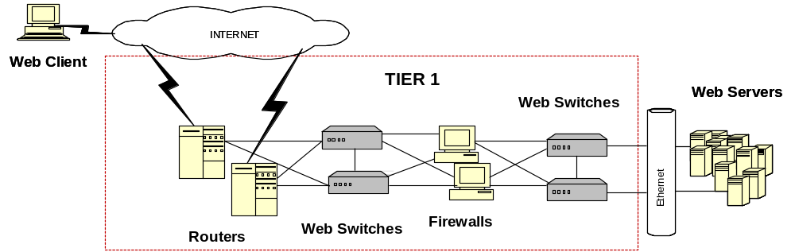

Best Practices e-business Infrastructure Guiding Principles
- Components are configured for hot fail-over
- ISP Connections, routers and firewalls are redundant
- Additional routers and firewalls can be added to scale capacity
- Routers can be upgraded to support additional processing

Best of Breed  Design Points | Business Benefits | Client | Impact
- All components are redundant | - Ensures there are no single points of failure that would impact site availability
- Components are throttled at 60% capacity | - Ensures that all components can handle momentary spikes in volume with out failure
- Tier receives, manages and allocates IP traffic to the infrastructure | - Ensures optimal distribution of IP traffic to e-business components
- Tier facilitates Global Load Balancing | - Provides additional capacity  - Eliminates single point of failure
- The enterprise network is connected to the Internet is through redundant Internet Service Providers (ISPs) | - The enterprise has multiple points of contact to the internet and increased availability for it’s customers  - The outage of a single ISP will not impact availability and service
- Physical network connections to TELCO exchanges enter at different points in the facility | - Provides redundant physical connections to the internet increasing the resiliency of the communications infrastructure
- Internet Bandwidth connections should be at least two DS-1 circuits (equiv. to 1.5 megabits x 2) for heavily trafficked sites  - Major web hosting companies with heavily trafficked facilities should utilize at least 2 DS-3 circuits | - Provides high quality response time for users by ensuring that performance is not degraded by overloaded bandwidth connections
- Internet Bandwidth is dedicated and not intermixed with other types of enterprise data/voice traffic | - Ensures that the web environment is not affected by other company network traffic problems or outages
- IP addressing should be consistent with uniform IP and netmask ranges throughout and segmentation of IP addresses and netmasks into logical units | - Makes troubleshooting easier and allows the site to be more easily replicated or moved
- LAN in web environment is at least 100 mbs Ethernet | - Provides quicker response time resulting in a better overall experience for customer which increases chances of repeat business
- Network is below 60% utilization | - Ensures there is sufficient capacity to handle spikes
- Routers should be redundant | - Eliminates a single point of failure
- Routers should be connected to the Internet from at least two separate ISPs | - If one router goes out connectivity to Internet will not be effected
- Horizontal Scalability | - Site is able to handle increased traffic by adding new routers into service
- Vertical Scalability | - Ability to handle increased volumes by upgrading equipment
- Routers should limit inbound TCP/IP traffic to only services needed (HTTP, FTP, SSL) | - Limiting the services available on the routers reduces the threat of potential security exposure and unwanted access points on the network
- Firewalls secure the site and filter IP traffic through easily | - The security design and micro code of the firewall are specialized to it’s security/filtering tasks, allowing it to more efficiently secure and buffer the site from unwanted access  - Security is flexible, detailed and modular without increasing administrative and network overhead
- Firewalls are remotely and centrally managed using GUI or menu driven configuration | - Security policies are easily configurable  - Remote management minimizes administration efforts and lowers cost
- Horizontal Scalability | - Site is able to handle increased traffic by easily adding additional firewalls to the infrastructure
- Vertical Scalability | - Not usually used as it is easier to add another firewall
- Network address translation (NAT) that provides both Network address translation (NAT) that provides both | - Allows flexibility in design by allowing the site addressing to be more available to the entity  - Isolates the web environment from any IP address changes and also hides the structure of the web site from the outside
- Implement Web Switch to balance web traffic in the infrastructure | - Web Switch can support both load balancing and typical switch functions (e.g. VLANS)  - Web Switches are optimized to perform these tasks more efficiently than separate components
- Redundant web switch implementation with active fail over | - Improves the resiliency of the infrastructure by assuring that web switches do not cause outages
- An initial tier of web switches should be implemented to balance the load to the firewalls | - Web switches will balance the incoming traffic across the firewalls and optimize the throughput for incoming requests and increase reliability
- A second tier of web switches behind the firewall serve to balance the web traffic load to web servers | - Web switches provide resiliency to the network and optimize the distribution of incoming web traffic across web server resources  - Ensures that SSL connections go back to the same Web server when user access the web site during the same session by tagging the SSL identification to a specific web server
- Web switches should load balance Universal Resource Locator (URL’s) to a group of web servers | - Improves operational efficiency by directing user requests at a lower , more efficient level (link level) , conserving server resources
- Vertical Scalability | - Ability to add additional processing capacity to the web switch to handle increased volumes
- Horizontal Scalability | - Ability to bring additional resources into service to support increasing volumes

Tier 2 e-business Infrastructure Design Leading Practices

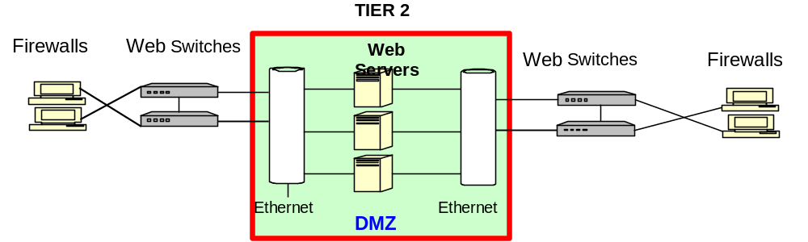

Best Practices e-business Infrastructure Guiding Principles
- Web servers, e-mail servers are placed in a de-militarized zone to filter harmful traffic
- Components are configured for hot fail-over
- Routers and firewalls are redundant
- Additional routers and firewalls can be added to scale capacity
- Routers can be upgraded to support additional topologies

Best of Breed Design Points | Business Benefits | Client | Impact
- Utilize inexpensive machines to deploy web servers | - Balances the investment to the simple level of functionality provided by this tier  - A simplified web server configuration provides the necessary level of function, lower investment and management costs  - Servers are designed to be more expendable, because of their exposure to security attacks  - Lower investment required to develop backup servers that can be easily built and held off-line for horizontal scalability  - Expensive, large, heavy duty servers
- Content is common to all servers in this tier | - A common configuration across all web servers, simplifies scalability and systems management because all Internet access devices are the same
- Web servers pass a web request to the application tier to trigger business logic application activity and hand-off the user to an application server | - This technique allows the web servers to handle and screen incoming requests exclusively, optimizing their performance and security effectiveness for these tasks. Application intensive functions are then directed to specialized business logic servers
- Content stored at this tier is static and fed from a higher tier | - Increases the efficiency of the web servers
- User sessions are established and managed by web servers | - Reduces the number of update requests sent to other infrastructure tiers, reducing network and system usage and increasing performance
- In high traffic environments, LDAP directories are usually installed on separate servers to facilitate and manage user registration and access | - LDAP directory server is a specialized machine that is more easily maintained and optimizes the performance of the tier
- In a high volume, highly secure environment, SSL outboard processors may be implemented on the web server or other internet facing components | - Hardware cryptography components can perform SSL functions much faster than software based encoding, thereby increasing performance
- Application and database functions are not deployed in this tier | - The web server workload is segmented to achieve optimum performance  - Security risks are minimized by eliminating database id’s, user specific information and payment data and placing it in a more secure tier  - Specialized machines allow for faster scaling of the infrastructure
- The tier acts as a demilitarized zone screening and sanitizing potentially harmful data or user traffic with dual firewalls, security and user access criteria | - Harmful data is filtered out  - Multiple tiers of security must be breached in order to access Client’s business and customer data  - Security is managed more efficiently by specialized machines, so performance is increased
- User access is controlled by the web servers | - Manages access to the application and database servers, providing increased security to the infrastructure
- Web server vertical scalability | - Vertical scalability is the capability to upgrade the processors CPU, Memory or disk capabilities, by either adding resources or upgrading to faster system
- Web server horizontal scalability | - Horizontal scalability is the capability to add additional processing units to the infrastructure, by placing more systems into production  - Simplified web server configurations on low-end machines, allows for additional web servers to be dynamically added to the infrastructure at minimum cost  - Infrastructure capabilities can be expanded to handle greater volumes of requests and increase fault tolerance
- Cache user access information in web server memory | - Static information on the servers can be cached to increase performance and avoid database calls that would degrade performance
- Establish email on a separate server | - Proper implementation of email can significantly increase server security and performance.  - Separate e-mail servers can more efficiently process electronic mail and scrub and verify prior to transmission over the internal network
- E-mail should not be sent from web server | - Allowing programs to make systems execs is a security risk. Hackers look for CGI’s that implement system execs
- Web switches are positioned between web servers and Tier 3 | - Web switches are positioned between the web servers and Tier 3 application servers  - Web switches balance traffic from web servers across a pool of available application servers optimizing performance of app servers and ensuring available resources to users
- Firewalls are positioned between web servers and Tier 3 | - Firewalls are positioned between the web servers and Tier 3 application servers  - Implementing Firewalls in the second tier of the infrastructure provides an additional layer of security between the apps servers and the database servers and the internet  - In the event of a security attack, this additional layer of firewall protection can allow the business more time to resist a security, hacker or packet attack and develop procedures to close off the security breach
Tier 3 e-business Infrastructure Design Leading Practices

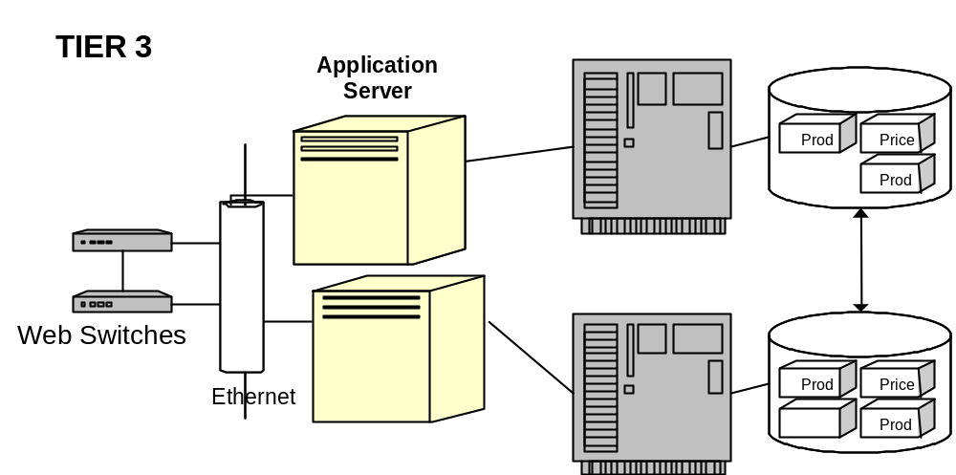
Best Practices e-business Infrastructure Guiding Principles
- Staging environment is created for application and database servers
- Transaction servers interface with Enterprise ERP systems
- Components are configured for hot fail-over and are redundant
- Routers and firewalls are redundant

Best of Breed  Design Points | Business Benefits | Client | Impact
- Database and Application Servers should be large systems capable of handling processing intensive and I/O intensive operations | - All of the real e-business application work will be performed by the Application and the Database servers.  - The configuration of these systems should match their anticipated workload and generally the largest servers are dedicated to theses tasks, creating an efficient processing environment
- Application Servers and Database servers should be implemented on separate machines | - Application logic is processing intensive. Database operations are I/O intensive and drive different resources on the system.  - Implementing them on separate servers allows the servers to be optimized the specific tasks of application or database operations and improves the efficiency of the infrastructure.  - Deploying these servers as separate components also increases the flexibility of the infrastructure configuration and its scalability. It also increases the resiliency of the network by allowing for multiple fail-over nodes
- All e-business application and database operations that support the completion of an e-business customer transaction are performed in this Tier | - Co-locating the database and the application servers in this enhances business and database logic interaction, by eliminating the constraints of routers, security filtering or additional access devices. It optimizes the efficiency of the interaction between the application servers and the database servers  - Linkage to other systems outside the tier should be avoided. It is inefficient and increases the dependency of e-business application and database components on other systems. This creates the potential for outages or constraints in these linkages that can slow application response or create an outage
- Application and Database servers are insulated from web servers and mainframe systems by additional layers of firewalls | - Firewalls between the application/ database servers inhibit intrusion from web server layer and the risk of unwanted access  - Legacy systems generally handle more secure transactions and contain confidential data that the e-business application layer will not. Therefore, a best practices solution will insulate the Tier 3 e-business components from the legacy environment with a firewall system
- Large specialized systems dedicated to processing business logic | - Intensive business logic processing requires larger scale systems for processing, so dedicate systems to application logic enhances performance  - Specialized systems can be more easily scaled within the infrastructure within the infrastructure
- Specialized application servers dedicated to special user communities (Extranets) | - The members of Extranet communities are usually known, allowing for their members to be directed towards systems dedicated to servicing the Extranet.  - Distributing Extranet communities to specialized processors allows performance and capacity to be more predictable and provides assured levels of service, performance and availability to these communities
- Avoid sharing e-business logic processing across multiple platforms, especially interaction with older applications that  - support other business applications  - are batch processing oriented  - are not real-time oriented  - have capacity constraints  - or contain confidential data | - Splitting E-business logic processing between multiple application platforms can prolong completion of a transaction and delay user response.  - Placing all e-business logic at the application server allows user to complete a transaction at a single resource and improves performance and the timeliness of transactions for consumers  - It is easier to scale a single point of presence for e-business logic than attempting to scale multiple application e-business application modules distributed across multiple processing platforms
- Vertical Scalability | - Application servers should allow for additional CPU, Disk or memory capacity to be added dynamically
- Horizontal scalability | - Scaling of the infrastructure is enhanced by specialized machines with segmented function, allowing additional application servers to be brought into service as needed to increase availability and performance of the solution
- Database systems are segmented onto separate platforms from the other e-business functions | - Database operations are processing and I/O intensive, due to the high system requirements of relational databases.  - Dedicating a separate server to database functions optimizes their performance and availability. It simplifies scalability
- Database Servers are located on high performance systems | - Providing database systems with sufficient capacity will optimize other aspects of the e-business solution
- Distribute Database functions across multiple servers | - Distributing databases across multiple servers increases their resiliency and their resource availability for application servers  - Placing the database servers in the same functional tier as application increases efficiency of transaction processing  - The infrastructure flexibility is increased and with it the ease of scaling for performance
- Utilize system caching to aggregate commonly accessed data for applications or static content | - Caching is the ability to store most commonly accessed information and data so that it can be accessed and used by multiple users in a rapid and timely manner
- Batch requests between application servers and database servers | - Minimize interaction between application and database server with fewer calls
- Implement distributed database servers that support sets of application servers | - Brings the data into closer proximity to the application servers using it.  - Allows data to be more readily available to the application servers, distributing the processing workload and improving performance.  - Increases the resiliency of the system
- Database servers utilize caching and request batching techniques improve performance | - Caching stores often requested data in memory allowing database servers to respond to data requests more efficiently. This improves processing performance  - Batching requests consolidates the number of calls to the database, conserving system resources and optimizing performance. This prevents bottlenecks from occurring at key resource points (database, network) and improves availability
- Horizontal Scalability | - The ability to add additional database servers to the network dynamically as demand grows. This ensures the scaling of the databases servers on the network to meet growing availability requirements
- Vertical Scalability | - The ability to add additional resources to database servers dynamically to improve their processing capabilities
- Perform specific, performance intensive tasks for e-business application | - Specialized transaction servers can off-load tasks requiring high-performance processing from the e-business application servers. This increases the performance of the application servers and optimizes the performance of the overall networks  - However, this should be a specific focused application task that requires a specialized high-performance environment for processing. If the function can be performed on the application server with no impact to performance, then a distribution of the application logic can degrade performance
- Optimized for high performance and real-time response or designed to provide post-transaction support | - If the high-performance transaction server must be completed in real-time (i.e. integral to the completion of transaction)  - Otherwise the transaction should be positioned to accept completed transactions and prepare them for insertion into the Enterprise fulfillment system. Utilizing the transaction server in this way off-loads the impact of closing out orders and negotiations with the Enterprise systems to another server, thereby improving performance to e-business servers directly serving customers
- Horizontally Scalable | - The ability to add additional transaction servers to the network dynamically as demand grows. This ensures the scaling of the transaction servers on the network to meet growing availability requirements
- Vertically Scalable | - The ability to add additional resources to transaction servers dynamically to improving their processing capabilities
- Firewalls are positioned between e-business systems and Enterprise system platforms in Tier 4 | - Firewalls prevent traffic from going past the web server farm

Tier 4 e-business Infrastructure Design Leading Practices

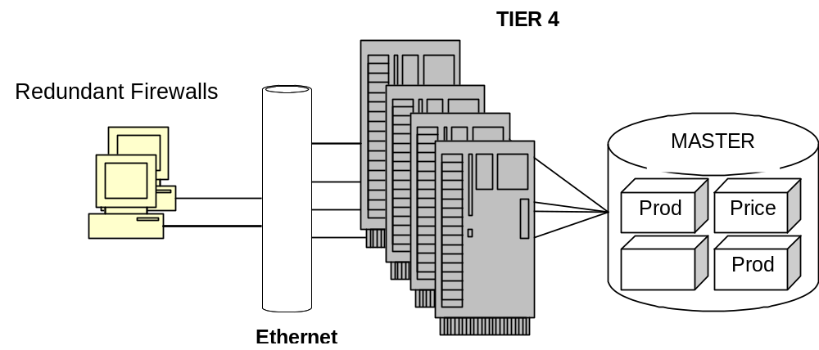
Best Practices e-business Infrastructure Guiding Principles
- Tier 4 should not be integral to the completion of e-business transactions
- All resources in Tier 4 critical to e-business transactions should be migrated to e-business applications servers or transaction servers for high performance
- All data essential for e-business transactions should be pushed forward onto distributed database servers that can directly service e-business application servers

Best of Breed  Design Points | Business Benefits | Client | Impact
- Migrate all application and database logic onto e-business servers | - Allows e-business systems to operate in a self-sufficient manner and complete customer transactions without invoking application or data logic on Enterprise systems this reduces processing overhead, increases performance and availability  - Scaling is simplified because Enterprise systems processing capacity is not central
- E-business systems should be designed to front-end Enterprise systems and comprise customer  - Transactions without dependency on enterprise systems | - This loosely coupled approach allows e-business systems to optimize their performance without the need to redesign the legacy environment
- All enterprise system database should be distributed onto database servers supporting e-business application severs | - This allows critical data to be distributed in close proximity to e-business application servers improving performance and availability
- Perform fulfillment and settlement functions | - Fulfillment, settlement and other “back-end” functions are not integral to e-business processing.  - Allowing enterprise systems to perform them optimizes e-business processing and scalability

Revision History
Revision Number | Revision Date | Summary of Changes | Changes Marked?
1.1 | May 2002 | Spelling and grammar check.
1.0 | Nov 2001 | Initial Version

