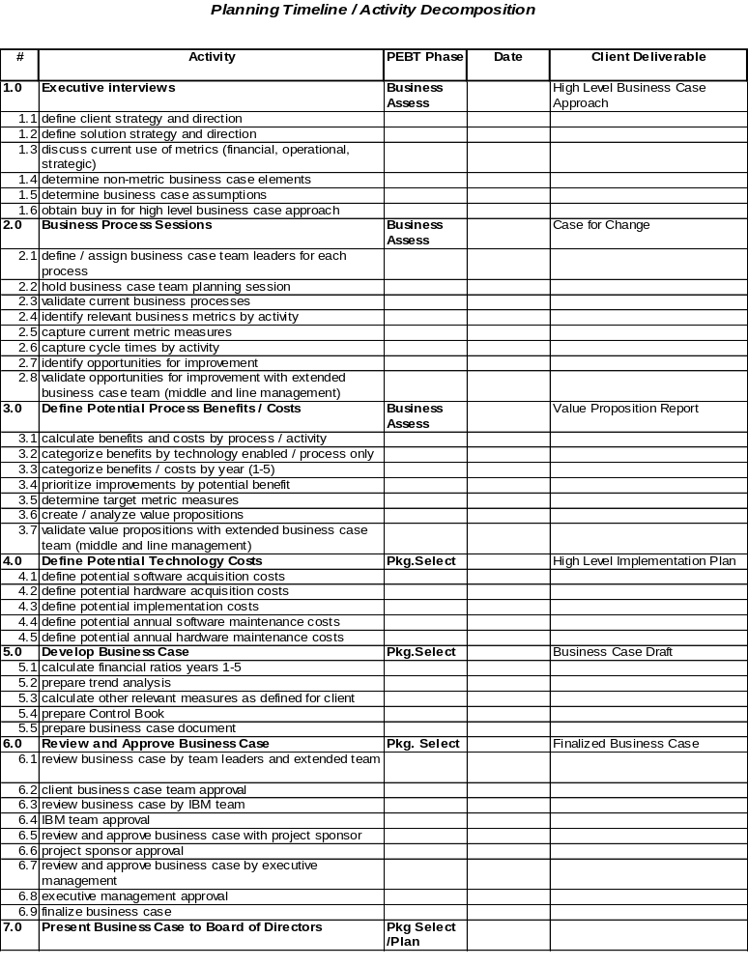Planning Timeline / Activity Decomposition

