Quality Plan – XXX Project
May 12, 1999

Author:
Senior Consultant
IBM Consulting Group
IBM Global Services

Document Summary

Preface
This document was created by IBM Canada Ltd. and the client, on April 22, 1999.

Location
This file is currently located at /tmp/lo/0000.doc on the XYZ file server.

Revision History
Date of this revision: May 12, 1999 | Date of next revision:

Revision Number | Revision Date | Summary of Changes | Changes Marked
DRAFT 0.1.0 | May 12, 1999 | Draft of Quality Plan – Project | No

Distribution
This document has been distributed to the following:
Name | Title
 | Project Director
 | IBM Project Manager
 | IBM Test Manager
 | Test Manager

Table of contents

1 Document Summary 2
1.1 Preface 2
1.2 Location 2
1.3 Revision History 2
1.4 Distribution 2
2 Introduction 4
2.1 Scope 4
2.2 Project overview and background 4
2.3 Business Context Diagram 5
3 Quality Strategy 7
3.1 Quality Objectives 7
3.2 Target Level of Quality 8
3.3 Risk-Based Approach to Quality 8
3.3.1 Business Risks 8
3.3.2 Technical Risks 9
3.3.3 Other Risks 9
3.4 Quality Strategy 10
3.5 Quality Assurance 10
3.6 Quality Control (Full Lifecycle Testing) 10
3.6.1 Static Testing 10
3.6.2 Dynamic Testing 11
4 Quality Model 12
4.1 Quality Metrics 12
4.2 Quality Tracking 12
4.3 Quality Achievement 13
5 Appendix 14
5.1 Appendix A – Work Products List 14
5.2 Appendix B – Test Progress Tracking 15
5.3 Appendix 3 – Variance Reporting 16

Introduction
A Quality Plan is used to define the approach to be taken when planning and tracking the quality of the project deliverables.
Quality can be defined as:
- conformance to specified requirements, and
- meeting of customers expectations

In order to ensure that the deliverables produced by XYZ project meet required standards of quality, a formal process is needed to:

- ensure that the process standards are adhered to
- find defects in deliverables using a defined review process
- ensure defects are removed as early in the development lifecycle as possible.

Quality management demonstrates that the project is being performed to prescribed standards. It is important to distinguish between Quality Assurance and Quality Control.

Quality assurance focuses on process control and defect prevention activities. Quality control focuses on defect detection and correction activities. The techniques that will be deployed will be described in detail in subsequent sections of the plan.

Scope
The scope of this document is focused on the quality of the Application Development and Testing work products relating to the XYZ Project. The quality of the Project Management work products and the project deliverables is addressed through the Quality Management process maintained by the Project Control Office.

Project overview and background
The project overview is reproduced here from the Application Development Scope document to provide completeness to the reader.
The business of the XYZ is to provide notice to the world of liens, held by secured parties against collateral owned by debtors. Secured parties are typically financial institutions such as banks or credit unions, but they can also be individuals. Similarly, debtors may also be either businesses or individuals.
The XYZ can be likened to a public bulletin board that holds notices of liens. A registration of a lien in the XYZ does not constitute a legal record of the lien.
For the purposes of the XYZ, collateral is defined as almost anything but real estate and items tied to real estate (such as a building). Within the XYZ, collateral is divided into two categories: serial numbered goods, such as automobiles, or home electronics, and general description goods, such as furniture, the assets of a company, or the rights to a software patent.
A lien against a piece, or pieces, of collateral or notice (notice may not involve collateral) is registered in the XYZ by the secured party (or parties), or an agent acting on their behalf, referred to as a registering agent. Since the XYZ is not a legal registry, i.e. there are no requirements on the part of the Government of Manitoba that either debtors or collateral be legally, or even correctly identified, it is the responsibility of the secured party, or their agent, to correctly identify and describe both the debtors, and the items being held as collateral as required by legislation. To help secured parties properly identify collateral, the XYZ includes the ability to verify the serial number for late model vehicles.
Once a registration is made, it can be amended or fully discharged by the secured party, or the registering agent, if one was used. An amendment to a registration is simply a change to the debtor, secured party, or collateral information, or an addition or removal of debtor, secured party or collateral. A full discharge occurs when the secured party releases all collateral and debtors from the lien. When a lien is fully discharged, the registration is logically removed from the registry, i.e. it no longer appears in the registry but a record of the registration is kept. Similarly, whenever a registration is amended, there is a requirement to keep an audit trail so that the state of the registration can be reconstructed at any point in time. Registrations and amendments are performed for a fee, while discharges are provided free of cost.
For a fee, anyone can search the XYZ for registered liens. Four types of searches are supported: by individual debtor name, by business debtor name, by registration number, and by collateral serial number (applies to serial numbered goods only). In addition to searches the XYZ also offers the ability, for an additional fee, to provide a “printed search result. For example, someone purchasing a used car may desire a “printed search result” that the car is free and clear of liens. For another additional fee, customers of the XYZ may request reproductions of off-line documents attached to a registration.
External dependencies are pictured in the Business Context diagram. Government initiatives that impact Personal Property Registry processes are Desktop Management, POS, Better Methods, and Better Systems Initiative.

Business Context Diagram
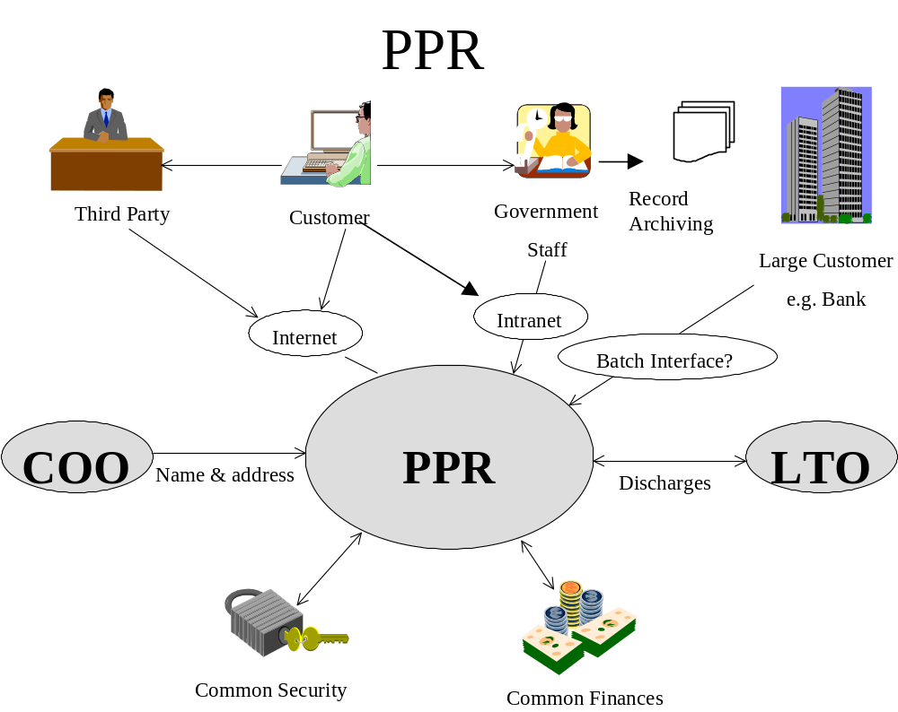The interfaces to Companies Office (COO) and Land titles (LTO) will not be provided in the first release as these systems will not be available in time for integration with XYZ.

Figure 1 Business Context Diagram

The scope outlined in the overview will be developed and deployed over 2 releases.
For further information please contact the Application Development Project Manager Kevin.

Quality Strategy

The purpose of the Quality Strategy is to:
• Identify the areas of risk
• Select the defect prevention and defect removal activities to be performed through development of the project deliverables.
• Develop quality plan tracking methods

The quality strategy is mainly driven by the quality objectives. As the XYZ project is a Manitoba government project that involves the use of leading edge technology, tools and methods, and the application users are the general public, it is also a high visibility project. This means that the quality and credibility are major factors to keep in mind while developing the quality strategy for the engagement. As the technology is evolving, the technical environment risks also have to be assessed and taken into consideration.

Quality Objectives

Quality objectives vary based on the individual perspective of the viewer. There are three different perspectives:

- End user perspective – quality means that the system meets the user needs or expectations i.e. the “right system has been built”.

In terms of application software and environment, application users include the general public and they are moving to Internet, Web-based technology which is quite different from the main frame, legacy based systems. Therefore, the usability and user interface become key factors for design consideration. In turn, when setting quality objectives, these receive higher priority both in terms of development and testing. Thus any areas which could impact public perception of quality, and credibility will be given a higher weightage.

- Developer perspective – quality refers to the way the “system”, which is the technical solution to a business problem has been “built right”.

As the technology is evolving at a faster pace than applications are getting developed, the technical components that make up the development and operating environment are also changing frequently. It is therefore critical that the development and test environments be set up as close to the operational environment as possible to ensure that the application (which is a technical solution to a business problem) will perform as expected.

- Sponsor’s view – quality is the ability of the system to function without failing – minimizing the risks and thereby reducing the risk and therefore the impact of failure.

The preceding two sections together highlight the collective risks from the business and technical point of view. It is therefore imperative that the risks be assessed carefully to focus the testing effort where it is most required.

This poses a challenge to the project, as the project manager has to balance the conflicts against the trade offs. This means that in order to deliver a quality product the different stakeholders must agree on a collective, common set of priorities to ensure the project resources are applied carefully and cost effectively.

Target Level of Quality

Contrary to popular belief, quality is not free. The cost of quality is made up of the following components:

- Cost of failure – this includes not only the cost of system abends and outages but also the cost of lost business and missed opportunities
- Cost of defect detection – this includes the cost of testing, inspections, walkthroughs etc.
- Cost of prevention – this includes the cost of instituting methods, standards and procedures.

The target level of quality is therefore determined jointly by the stakeholders to:

- meet the quality objectives from different perspectives
- manage the process and the product quality in a cost effective manner
- reduce cycle time while managing risks and costs.

Risk-Based Approach to Quality

As technology advances and businesses get more complex, the cost of software errors goes up. As can be expected, the cost of finding and fixing errors goes up exponentially as we progress through the development lifecycle. The later the errors are found the higher the cost. It is also not difficult to establish that exhaustive testing is not feasible. Even if it were, it is not cost effective. Therefore an effective quality management plan is based on effective risk management methods and includes using techniques to perform necessary and sufficient quality reviews and testing. As seen earlier Quality assurance focuses on the processes that are used to develop the product and the management of the development process itself. Quality control made up of Static and Dynamic testing is focused on the quality of the product and how well the product meets the quality objectives of the different stakeholders. With risk-based approach to quality assurance and testing, the focus areas are identified using risk as the main driver. In other words, the goals are to reduce project risks and manage testing risks. The key is risk assessment and acceptance versus avoidance. Quality strategy is based on an understanding of risks and associated costs.

The following are the key risks that were identified so far by the various teams. The major risks grouped by business and technical risks are:

Business Risks

- Completeness of user documentation
(Document Management system)
- Completeness of user requirements
- Understanding of user requirements
- User approval of requirements
- Application knowledge not being available
- Interface requirements may not be completely identified
- Skills availability
- Computer skills
- Data entry skills
- Cross function knowledge
- Public exposures arising from usability and reliability are addressed
- Initial Registration (paper or electronic) be correctly and retrievably stored
- Fuzzy search should produce correct results – there could be legal liability
- Expiry – inaccurate results could lead to legal liabilities
- Printed search reports should be accurate as these are point in time search
- Accurate display of status of search is an Audit & Control requirement

Technical Risks

- Ability to fulfill mission during hardware or software failure
- New hardware or environment
- Lead time required to set up the environment
- Software
- New products
- Design documentation
- Complexity of system
- Usability
- Availability
- Familiarity of team (customers, programmers, testers, operations)
- operating software
- system environment
- application area
- Performance criteria not clear
- Understanding of how the system solution addresses the business needs
- Traceability of functionality to business requirements (and business benefits)
- Integration testing responsibility needs to be clearly defined
- Technical integration of products
- Infrastructure new and not tested
- Things can fall through the cracks

Other Risks

- Financial, credit card, pre-authorized payment – interfaces to an accounting system
- Thoroughness of testing
- Complexity of interface
- New information coming up
- Technical interfaces not nailed down – Environment issue
- Timely availability of interface requirements – Application Development issue
- Clear definition of interface requirements – Application Development issue
- Ability to reprint and distribution
- Business part
- Cross team boundary
- New technology
- Interface to the package – custom code may be required?
- Distribution mechanism
- Infrastructure team responsibility?
- Availability of French text translations
- Availability of files to test
- SWIT interface
- Inter project dependency
- Development environment is different from deployment
- (Targeted clients will be supported – client configuration – high prob. Low impact)
- Consistency
- Performance threshold not known / clear
- Internet
- Intranet
- Different machines and different configurations

Quality Strategy

Based on the quality objectives for the XYZ project, and based on the initial set of risks assessed by the stakeholder groups, the testing and quality have to be focused in the following general areas:

- User Interface
- Application responses and messages to the user both in valid and error situations
- Help screens and other business support functions to assist the user
- Reliability, recoverability and continuity of processing from a technical point of view
- Performance
- Areas with high traffic i.e. high frequency of transactions
- Sections of code involving complex logic and untested technology components

Quality Assurance

Quality assurance includes the standards and guidelines as well as the defect management and prevention techniques. SI/AD methodology will be used on the XYZ project. These development methods and standards govern the process for quality assurance of the development process itself. This implies that each individual on the development team is responsible for ensuring that the standards and guidelines are adhered to and that all team members apply the process diligently towards production of quality work products.

The defect management steps are described in the Quality Metrics and Quality Tracking sections of this document.

Quality Control (Full Lifecycle Testing)

IBM’s Full lifecycle approach to testing will be used to verify the quality of application development and testing work products. Full lifecycle testing includes both static testing and dynamic testing methods and techniques. The table in Appendix A includes the development and testing work products to be developed as part of the XYZ project and the proposed static and dynamic (if applicable) testing technique to be applied against each.

Static Testing

Static testing involves testing of the development work products before any code is developed. The following techniques will be used throughout the project and the selection of the technique is based on the work product it is applied to. The techniques are:
Prototyping
Desk checks
Checklists
Mapping
Reviews
Walk-throughs
Inspections

Static Testing Guidelines will describe both the techniques as well as guidelines for recommended use of each technique and is issued as a separate document.

Dynamic Testing

Dynamic testing is what is generally known as application testing. This involves finding defects in the application by executing code. Dynamic testing includes all the following testing levels:

- Development Test
- System Test
- User Acceptance Test
- Operability Test
- Environment Test

The Master Test Plan will cover the dynamic testing standards for all levels of dynamic testing. The master test plan is a document of understanding on testing between the various stakeholders of the project. It documents the "what" (the scope and objectives), the "why" (purpose), the "when" (the key milestones), and the "who" (the organizational roles and responsibilities) of testing. It points to the various detailed test plans. Each testing level represents a known level of physical integration and quality of the system solution under development. The table of contents of a Master Test Plan includes the following sections:
Test Objectives
Test Scope
Assumptions
Test Team
Test Focus
Test Objectives
Test Strategy
Test Data Strategy
Types of Tests
Levels of Testing with entry and exit criteria
Test Schedules - major milestones
Problem / Change Management Procedures
Test Facility Requirements

Master Test Plan will point to the following detailed test plans:

Development Test Plan
System Test Plan
User Acceptance Test Plan

A joint Master Test Planning facilitated workshop will be conducted where the stake holders will come to a consensus on a common set of priorities for quality and testing. The scope of the Quality Plan does not include the Operability or the Environment testing. However, the risks assessment and the test planning steps will take into considerations those attributes of the application as well and the information collected will be passed on to the right projects.

Quality Model

The purpose of the quality model is to quantify the defect levels expected in the interim work products at each phase of development and test and, finally, the defect level expected when delivered to the client. To estimate the number defects to be expected at the end of each phase, industry benchmarks are generally used from projects of similar type and technology environment. Since XYZ project is using leading development technology, products and methods, models are not available today to forecast the defect levels for the XYZ project. Therefore, it is suggested that defect statistics be collected through the development builds and releases which can later be used as baseline for the subsequent releases and other XYZ projects.

Quality Metrics

There are two types of measurements used in quality management through static and dynamic testing. They are:

- In-Process - Decision Assist
- Product Measures - Planning and Forecast

The in-process measurements help to make management decisions during the process of testing. The second set of measurements help to better plan and estimate the future testing effort. The metrics also help to assess the quality of product as it evolves through the development lifecycle and provide the ability identify the areas for improvement. It is recommended that the metrics to be collected be kept simple and meaningful so that there is no significant overhead on collecting, tracking and managing the progress.

Quality Tracking

The following measurements are suggested for building the baseline of the defect model. These should be used to track quality during the various levels of dynamic testing:

- Number of defects left in the product at the end of development into system test
- Number of defects by severity left in the product from one release to the next
- Number of defects left in the product when it is moved to production

The following measurements should be tracked to assist with future planning and estimating of test effort

- Estimated number of test cases at project commencement
- Actual number of test cases developed
- Estimated effort for preparation of each test case
- Actual time spent to prepare the test cases (average)
- Estimated number of test scripts at project commencement
- Actual number of test scripts developed
- Estimated effort for preparation of each test scripts
- Actual time spent to prepare the test scripts (average)
- Total number of test scripts run
- Average number of test runs to get successful test results
- Number of test scripts executed successfully
- Number of test scripts not run
- Number of defects found by build / release
- Number of defects found by development phase (Test Case walkthrough, design inspection, code review etc.)
- Number of defects removed by build / release
- Number of defects removed by development phase (Test Case walkthrough, design inspection, code review etc..)
- Average to fix a problem

Quality Achievement

Once enough baseline information has been gathered from the initial builds or releases of the XYZ project, the defect statistics can be analyzed to forecast expected defect rates for future releases of the project. The defect data also helps to identify areas for improvement. This initiates the continuous improvement cycle.

Some templates and examples of progress tracking and variance reports for management purposes are included in the Appendix B and C.

Appendix

Appendix A – Work Products List

Work Product | Design | Create | First QA | Final  QA | Client Review | Client Signoff | Signoff Required?
PROJECT WORK PRODUCTS
Requirement Definition
Acceptance Test Cases |  |  |  |  |  |  | Yes
Component Model
UI Design
Data Migration Requirements
Design
Component Descriptions
UML
State Diagrams
DB Design
Internal Interfaces
External Interfaces
Data Conversion Map & Plan
Build
Build 1 Walkthrough Log
Build 2 Walkthrough Log
Build 3 Walkthrough Log (Missing from Plan)
Testing
Master Test Plan
System Test Scripts
UAT Test Scripts
Build 1 Test Log
Build 1 Problem/Variance Log
Build 2 Test Log
Build 2 Problem/Variance Log
System Test Log
System Problem/Variance Log
UAT Test Log |  |  |  |  |  |  | Yes
UAT Problem/Variance Log |  |  |  |  |  |  | Yes

Appendix B – Test Progress Tracking

Function | Testing Cycle Date | Cumulative Number  Of  Test Cases | Attempted |  | Successful
 |  |  | Number | Percent | Number | Percent
Total

Appendix 3 – Variance Reporting

 | Reported |  | Closed |  | Open
Problem / Incident Impact | No. | % | No. | % | No. | %
Severity 1
Severity 2
Severity 3
Total

