

Enterprise Information Modeling

Guidance - Guideline

© Copyright International Business Machines Corporation 2000, 2001
All Rights Reserved
Version 1.2 November 2001
- Description
The Enterprise Information Modeling technique is aimed at the identification and definition of the major "entities" and "subject areas" of business information that are of strategic and architectural importance to the enterprise. These high-level groupings of information are identified in order to understand the scope and scale of the information used by the entire enterprise. Such an understanding of the key information assets and needs is fundamental if the subsequent Enterprise Architecture is to achieve cross-enterprise integration and co-ordination.
The Enterprise Information Model is developed using a mixture of interviews, workshops and analytical techniques and will usually comprise several related components:
- An Entity Relationship Diagram (ERD) showing the network of major entities, or groupings of entities, and the relationships between them.
- Entity definitions
- Relationship definitions
- Context
The core of this technique is the development of an Entity Relationship diagram (ERD).
The following table summarizes the different levels to which the technique may be used:
 | Strategy | Enterprise-level Architecture | Project level (SI or BPR)
Scope - Breadth | Extended Value System | Whole Enterprise | Individual System or Business Area
Scope - Depth | 20-25 entities | 30 - 50 entities | 500 entities
What is modeled | Business Terms, Classes of business things | Subject Areas, Major Entities & Relationships | All entities and relationships
Relationships |  | Many to many allowed. Basic cardinality and optionality | Many to many not allowed. Full cardinality & optionality
Attributes |  | Key attributes only | Fully attributed, including keys
Such ERD diagrams may also be developed as part of application development projects where they are used to represent a complete definition of the data requirements of the business area within scope. In such projects the ERD must fully define every data item including all the properties or attributes of each item and all relationships between the data items. By contrast, the ERD developed at the enterprise level is not concerned with the detailed specifics of any one group of information but rather that a grouping exists and that it is important to the business. A detailed definition of the information is not required and in fact, is inappropriate. At this level, we are usually dealing with the entire enterprise scope but in a compact form.
- Steps
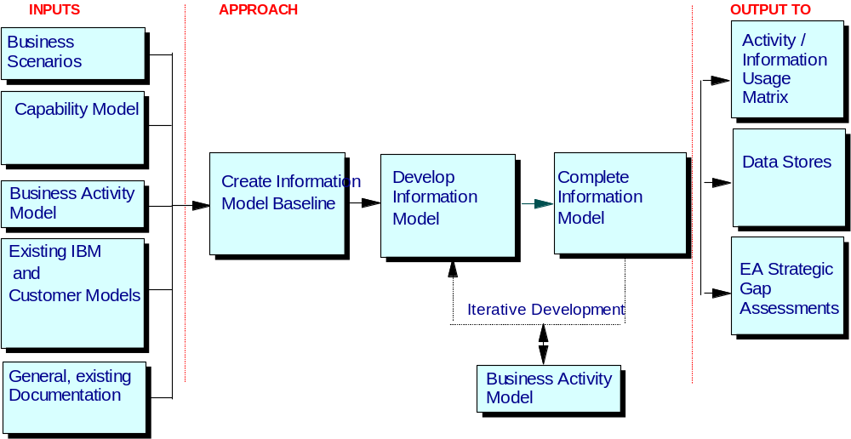
A high level view of the approach used in this technique is given below. Although these steps and their associated tasks are roughly linear in sequence, there will be some degree of overlap, or parallel execution. There will also be some iteration, with some activities causing earlier ones to be revisited and reworked. In addition, an Enterprise Information Model should always be defined in conjunction with the processes/activities that use the information entities. Taking this approach ensures a more rigorous deliverable is produced.

The Enterprise Information Modeling technique involves 3 main steps with associated tasks:
Step 1 - Create Information Model Baseline
- Identify Candidate Information Entities / Subject Areas
- Build Information Model Baseline
- Create quality criteria for evaluating the defined Information Model
Step 2 - Develop Information Model
- Identify & Define the major Information Entities / Subject Areas
- Identify & Define the Information Entity and Subject Area relationships
Step 3 - Complete Information Model
- Refine & Complete Information Model
- Present Information Model
Step 1 - Create Information Model Baseline
A lot of material relating to an organisation's information requirements will already exist. This should be reviewed and analysed and candidate business information entities / subject areas identified. These are then used to develop a baseline (or "straw-man") Information Model. This baseline will provide a good starting point for the model development activity, and by introducing the consultancy team to the main elements of the enterprise business, will maximise their contribution during the modeling workshops. In addition, developing the baseline model often stimulates discussion and highlights potential issues, particularly in relation to scope.
Identify Candidate Information Entities / Subject Areas: The objective of this task is to provide a "flying start" to the information modeling by making best use of the materials that already exist. For the purposes of this technique an Information Entity is:
“a person, place, thing, concept or event that the business needs to manage and about which it needs to hold information about”,
Whilst an Information Subject Area is:
“a high level grouping of entities, grouped for the purposes of model management and ownership”.
In reality, the model will contain both entities and subject areas. Regard these terms as interchangeable in the remainder of the technique.
Potential sources of such information include:
- existing information / data models developed from the customer organisation,
- existing models developed by IBM in previous engagements
- general documentation relating to the customer and their business environment, (e.g. product literature, markets analysis, organisation charts. annual reports, business plans, executive reports, etc.)
- industry models, (e.g. IBM's "IAA Gold" for the Insurance Industry)
- material from previous activities in the engagement relating to strategy (Mission, Objectives, Locations etc.)
- descriptions of current applications
- descriptions of current databases
- documents relating to the business processes and procedures.
- industry knowledge and experience of the consultants
- team brainstorming session

- Gather what materials exist and review these to identify candidate entities or subject areas, ideally using teams of two or more to produce initial lists. These lists should then be combined and reviewed to produce a consolidated list of candidates.
- When reviewing the material, (and particularly when brainstorming), it is useful to consider certain generic categories of information that are common to all enterprises. Potential categories and examples are:
- People or Agents (e.g. Customers, Employees, Organisations)
- Externals or Places (e.g. Geographies, Location Types, Places)
- Things or Physical Objects (e.g. Vehicles, Part, Product)
- Abstract or Concepts (e.g. Skill, Price, Exchange Rate)
- Product/Service Structure (e.g. Product Part, Savings Component)
- Event (e.g. Deal, Order, Booking, Shipment, Quote)
If these candidates are brainstormed on to separate pieces of paper ("yellow post-its") they can be usefully grouped by business participants. The grouping often results in suggestions for an 'information subject area'.
Typical questions which help to identify candidate information subject areas include:
- What external organisations are involved?
- What individuals are involved?
- What are the major interfaces with each of these?
- What physical things are used or produced?
- What are the major events?
- What aspects of its performance does the business measure?
- What responsibilities does each organisation have?
- What financial aspects are important to the business?
- When reviewing the materials, (particularly textual), look for the categories given above. This can be done by simply picking out nouns from the material. When lots of documents have been reviewed, some degree of consolidation will be required to eliminate duplicates and synonyms.
- If previously developed customer models exist, these will normally have been produced as outputs from individual development projects. As such, they will tend to be at a very detailed level and will not have taken a cross-enterprise view. The currency of these models requires to be checked, however they can still be very useful.
- Existing, low-level entities should be "levelled-up" to reflect the higher-level entities and subject areas to which they belong. To do this; firstly identify the fundamental entities, (also sometimes referred to as "core", "kernel" or "independent" entities). These are the ones that all the other entities owe their existence to and they are of interest in their own right. Examples are Person, Product, Warehouse, Skill. Most Information subject areas are based around one or, occasionally, two fundamental entities. Having identified these, derive the information subject area that the entity would most sensibly belong to.
- Lastly, consider the major associative entities. Many of these will have been created to resolve many to many relationships, however, some will represent business significant concepts in their own right, for example; Orders and Course Enrolments.
- If some form of enterprise data model already exists this must be reviewed and its currency checked. There is a danger of being overwhelmed when there is a lot of existing material available. The consultant must exercise his/her judgement and use only the material that he/she thinks will yield the most candidate entities or subject areas.
Build Information Model Baseline: The baseline information model is a starting point from which the Enterprise Information Model work product will be developed. As such it is a "straw-man" and will be used as a conceptual basis in the interviews / workshops.
The consolidated list of candidate entities and subject areas should be reviewed and those identified as having the highest strategic importance and of being fundamental to the business are picked out. These should then be represented using some form of graphical notation, as a means of effective communication with the business stakeholders. A recommended notation is that used for entity relationship diagrams. The concepts and constructs of this diagramming technique are relatively standard in the IT industry and detailed rules and guidance can be found in the references given in the Reference Section of this technique paper.
The number of entities in the baseline model will vary, with both the scope of the engagement and the complexity of the business, however somewhere between 10 – 25 subject areas or 40 – 100 entities would be expected.
Create quality criteria for evaluating the defined Information Model: A set of "quality criteria" for the business information model should be developed. These will be used by the business representatives, (or whoever is responsible for agreeing the sign/off / acceptance of the work product) as a basis for reviewing the Information Model, once it has been defined. Potential criteria are as follows:
- The entities / subject areas cover all the major areas that are important to the business
- The entities / subject areas are distinct and do not overlap
- The names and descriptions of the entities / subject areas are clearly understood and recognisable by the all areas of the enterprise
- The model represents the information requirements of the enterprise
Advice & Guidance
- The output from this activity should not be too detailed. The objective is to provide a starting point for the modeling workshops, in which the baseline will be further developed.
- When naming entities / subject areas, use terminology that the business would understand.
- The collection of the existing documentation can be time-consuming, however, if the materials are immediately available, then no longer than one to three days should be spent on this activity.
- Although existing materials can be useful in building the baseline model, they must be used intelligently and must not impose constraints on the teams thinking. They should be used simply as an aid to the consultancy team.
- This activity can benefit from the involvement of staff from the customer organisation, however remember that this is solely aimed at developing a baseline and is not the main modeling activity.
- Once created, get someone from the client organisation to review the baseline model for obvious and major omissions.
- When time and/or effort is an issue on the engagement, this whole activity could be omitted. The Enterprise Information Model should then be developed using existing models, or intellectual capital produced on previous engagements. Whilst it is possible to start with a "blank sheet" at the workshops, this can be very much more time consuming, especially when client team members are unsure of what they are being asked to define.
Step 2 - Develop Information Model
In this activity, the previously developed baseline model is extended and refined, based on input from representatives of all parts of the business, within the engagement scope. The cross-enterprise nature of the work product means that the objective is to produce a model that represents the information requirements of all the business areas. As this requires a degree of cross-enterprise agreement, the best approach is to use facilitated, modeling workshops, attended by representatives from all parts of the business concerned. These representatives must have a strategic, and not just a tactical / operational, view.
Identify & define the major Information Subject Areas: Use the baseline model, (if developed) as a starting point. Review each candidate entity / subject area with the business participants. The areas of focus should be:
- Is this a valid grouping of information (i.e. is it recognisable as a piece of strategic business information)?
- Is this entity / subject area of significance to all parts of the business?
- Does each business area have the same view, or perspective, of this information? (I.e. does it mean the same thing to different people?)
- Are there any major types of information that are missing
- Is there any overlap between the entities / subject areas?
- When the list of entities / subject areas becomes stable, start to define their key properties. These are:
- Entity / Subject Area Name
- Entity / Subject Area Description
- Examples (Entity only)
- Volumes (Current, Max, Growth rate)
An Enterprise Information Model is one of the foundations of an Enterprise Architecture. As such, it is important that it is developed with a degree of rigour. Each entity defined should be clearly defined with the definitions being complete and unambiguous. Even when the engagement is being carried out on a subset of the enterprise, it is important that where possible, definitions are created which could equally apply to other parts of the organisation.
This task will ideally involve two consultants, particularly when conducting the facilitated workshops. In addition to the facilitator, the workshop requires a scribe and may also involve consultants with specific industry knowledge and experience.
When doing the modeling, it is important that the team do not restrict themselves solely to the information needs of the enterprise as they stand today, (although these will tend to dominate the modeling activity). A visionary approach should also be adopted; identifying the types of information that will be required to support future goals and objectives. For example; "If there is currently no need for market research information, will this still be the case in 5 years?" .A visionary approach requires hard work, a lot of management time (and thought), and a skilled facilitator.
If an enterprise level definition of the major processes / activities is available (either developed as part of this engagement, or pre-existing), then it can be used to identify potential entities, by considering what types of information are important to, or involved in, the defined processes / activities. For example, the activity of Sales would obviously involve Salespersons (Employees), Sales Territories, Regional offices, Promotions, Customers and several more. You should also consider the information requirements for each role that has been defined.
- Consolidate these information requirements to eliminate duplicates and overlaps
- Create matrices showing the relationship / interaction that the business information has with other constructs. The most common are: role / information entity and location / entity.
Identify & define the Information Subject Area Relationships: Having identified and defined, the major entities, it is important to also identify the relationship between them. The relationships are, by definition, aggregates of data. It is not possible to show every relationship between every entity or subject area, as all the lower level entities are not yet known. Naming of the relationships at this level can be difficult but should be attempted. These relationships help refine the Process / Activity Model by highlighting relationships that need to be managed by identified activities.
Define the relationships, including the participating entities, the business rule or fact that necessitates the relationship, and the cardinality associated with the entities’ participating in the relationship.
Advice & Guidance
- The number of information entities and subject areas defined will vary with the level of detail, scope of the engagement and complexity of the business. However an average number of subject areas would be 10 – 25 and 40 – 100 entities.
- Before running the workshops, issue a briefing document to the participants, covering such topics as:
- Basics: date/time/place/duration etc.
- Context & Purpose of workshop, (why do we need this workshop and where does it fit into the overall engagement)
- Workshop Objectives and scope
- Approach/Expected level of participation (how will it actually work, what will be expected of the participants)
- Agenda
- It is important to recognise, as early as possible, information that needs to be shared across the enterprise, as these provide a potentially high return for the enterprise-wide development work which will be needed.
- When defining the key properties of the agreed information, significant differences may exist in different parts of the enterprise. Where these differences have a business significance, they should be recorded in the entity definition. For example, one division of an organisation may only deal with, or be interested in a small subset of the enterprise customer base.
- The Consultant and Facilitator should consider the advantages and disadvantages of using the ‘straw-man’ model directly with the workshop participants. There is often the danger that it will constrain their thinking and result in a model based on current preconceptions. A skilled facilitator will be able to use the “straw-man” as a ‘back pocket’ model to provoke discussion and ensure coverage and completeness.
- When identifying and defining the entities / subject areas, the team will come across information that is known by several different names, in different parts of the business. They will also encounter the same name being used for slightly different information. A SALES department, for example, may define a Customer as someone who has placed an order, even if the order is subsequently cancelled The Warehousing department may define Customer as someone who has placed an order and is awaiting delivery. Marketing may regard any person who is directly targeted by a marketing campaign as a Customer. The names in these two situations are "Business Terms" and should be recorded. It is important that different parts of the business retain their use of particular terms and that the terms are related to a single stable definition that can be shared across the business.
- Estimation Guidance: For a one day workshop - preparation 2-3 days, 1 day for the workshop, 2-3 days to follow-up. The major problem is usually finding a date that is suitable for all/most of the attendees.
- If the scope of the enterprise is large, or if the different parts of the organisation are fundamentally different in nature, then it may be of more value to run several modeling workshops, each for a different part of the business. In such a case, the different models must be consolidated to produce one enterprise-wide information model
- Although more rigour is required in this activity than when developing the baseline - it is still important to use terminology that will be understood by the business
- Ensure the whole scope of the architecture is covered
- Split subject areas if this will help address an issue, otherwise combine under groups that have an independent existence - e.g. order = order and the items on it.
- Standard "best practice" should be adopted when organising and running these workshops, namely:
- Involve representatives from all the business areas within scope
- Select the participants carefully, taking into consideration both the scope of the modeling exercise and the position / knowledge of the individuals.
- Be aware of political issues.
- Involve (ideally) a facilitator that has experience of producing these models
- Provide briefing material to the participants before the workshop
Step 3 - Complete the Business Information Model
This activity takes the output from the modeling workshop(s), conducts a final quality review of the model and the entity definitions, completes the work product packaging and finally achieves its sign-off / acceptance.
Refine & Complete Information Model: Refining and completing the model is about checking that it is fit for purpose, is presented in a format appropriate for the intended audience (client and IBM), and that opportunities for follow on work have been identified. This activity usually identifies issues and solutions that are of interest to the client at an executive level. Completing this task includes initiating these links and making sure the work product can be used as effectively as possible.
Due to the dynamic nature of the workshop environment, it is not always possible to complete all the formal documentation. In this instance, use the outputs from the workshops to complete the model documentation and resolve any outstanding issues.
- Cross-check the information model against the Process / Activity definitions (e.g. look for any information which has no clear association with an activity,)
- Review names & descriptions.
- Ensure the level of detail is fit for purpose and appropriate for any follow-on activity required
- Compare with industry norms e.g. what would we expect, what would we not expect,
- Test the model against existing practice and ‘What if?’ scenarios to check that it is robust
- Perform peer (Subject Matter Expert) reviews from outside the project, to check for mistakes made through familiarity
- Review with sponsor - pick examples of insights that have been gained during the WP development.
- Consolidate outstanding issues, risks, questions, etc
- Outline any follow-on activities which have been identified or are required - these will be input to the Transition Initiatives Work product
Present & Agree Information Model: The Enterprise Information Model should be reviewed and agreed by the major business representatives that have been involved in its development. Using the quality criteria that have been previously defined, the business representatives (or whoever is responsible for agreeing the sign/off / acceptance of the work product), should review the information model. This will help to facilitate client sign-off and satisfaction with these Information Modeling activities and ensure a consistent approach has been taken throughout.
Advice & Guidance
- It is essential that the completed model have the support of the highest level sponsor possible so that it can be used across the business in future engagements. The process of developing an Enterprise Information Model almost always identifies issues and potential solutions that are of interest and value to senior executives. Consider producing a short summary presentation covering the findings of the activity and use the issue/solution to gain support for the model's further use. Follow on engagements can be identified at this meeting.
- Whilst the Entity Relationship Diagram (ERD) provides a very rigorous format for representing the information of architectural importance, it is rarely an appropriate format for using with senior executives. Consider developing presentation material (in “rich picture” format), that will clearly and simply indicate what the major information related issues are and how they are addressed in the newly developed Information Model.
- Consider presenting the results in different formats for different audiences. A business glossary is often a good way of communicating the results to a wide audience across the business.
- Communicate the results to interested parties inside IBM. Add material to the ICM database Project profile so that the model can be reused.
- Tools
There are many data modeling tools available for documenting Entity Relationship Diagrams. If the client has a preference, that will of course be the one chosen. If there is no preference, the IBM SI level default is Rational Rose.
In addition, if the Enterprise Information Model is to be documented as part of a wider Enterprise Architecture, there are several tools that have been successfully used in a number of client situations:
- Ptech FrameWork from Ptech Inc. http://www.ptechinc.com/products.htm additional information on IBM’s use of the Ptech Framework is available on the ITAD KN ICM database, under Tools.
- E-Design Delivery Environment – an internal IBM tool for documenting the contents of an Enterprise architecture, plus all linkages to business strategic directions, capabilities, organizational considerations and development projects. Additional information about this IC asset can be found on the ITAD KN ICM database, under Tools.
- Examples
Example 1 – Insurance company
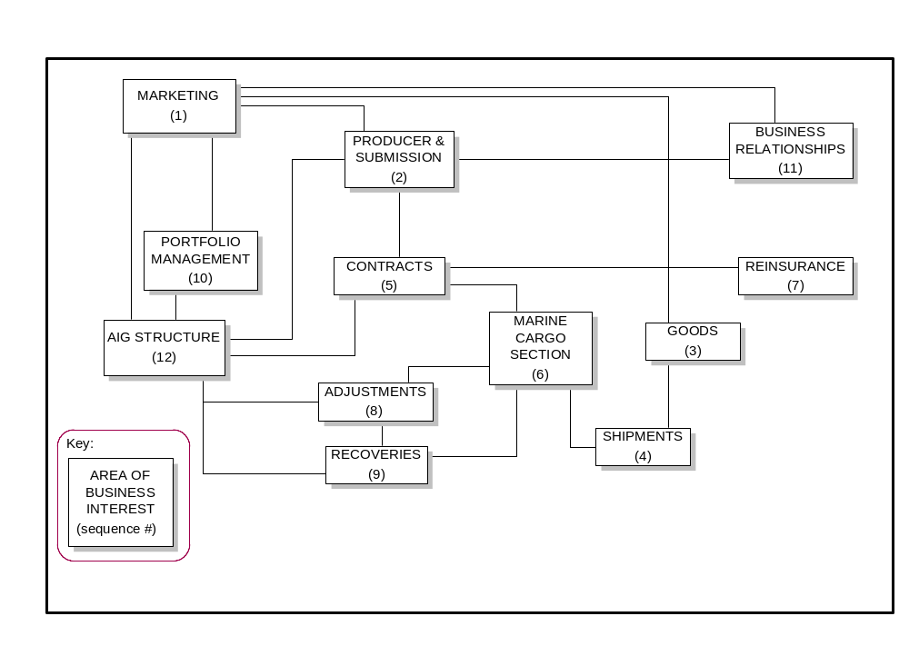
This example identifies the major subject areas, or groupings of information, of interest to the business organization and indicates the major relationships between these areas. This diagram would be used primarily to understand and validate the scope of subsequent analysis.
Example 2 – Customer Service
The following example identifies the specific data groupings (entities) about which information is needed in order to support the business processes and specifies the cardinality of the relationships.
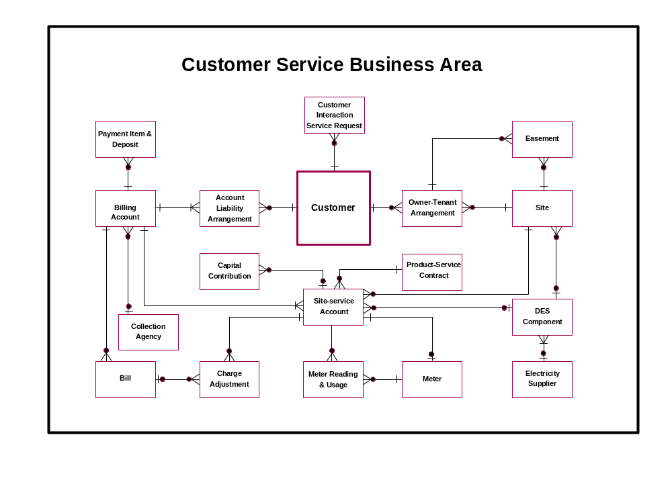
- Revision History
Revision Number | Revision Date | Summary of Changes | Changes Marked?
1.0 | October 2000 | Minor content revisions | No
1.1 | August 2001 | Restructuring to new TP template, additional graphics added, tools section completed | No
1.2 | November 2001 | Updated style, spelling and grammar check.

