Governance Model Appendix
Working Together
In dealing with this large, complex, long-term relationship IBM realizes the importance of establishing a governance model that is aligned to the strategies and goals of CLIENT and supports the overall IBM/CLIENT relationship. To achieve this, IBM is proposing a governance model that will provide a management framework for our relationship. This framework is based on the concept that organizational relationships must be founded on trust, support rapid execution, and provide strategic value. In addition, a “Strategic Partnership” must also provide flexibility, adaptability and responsiveness.
The governance model also needs to recognize and build on CLIENT’s current technology investments and provide for seamless integration into CLIENT’s current organization and governance structure. To achieve this we are proposing a program entitled, “Customer Value Relationship Management” (CVRM). This program, which is described at the end of this section, is designed to align relationships and validate mutual objectives. It is proposed that CLIENT and IBM will first implement this process before the official start date of the relationship and continue to use it throughout the life of the agreement, to enhance the possibility of optimal performance.
The conceptual model that we would propose to CLIENT and use as input into a Customer Value Relationship Management workshop is outlined below:

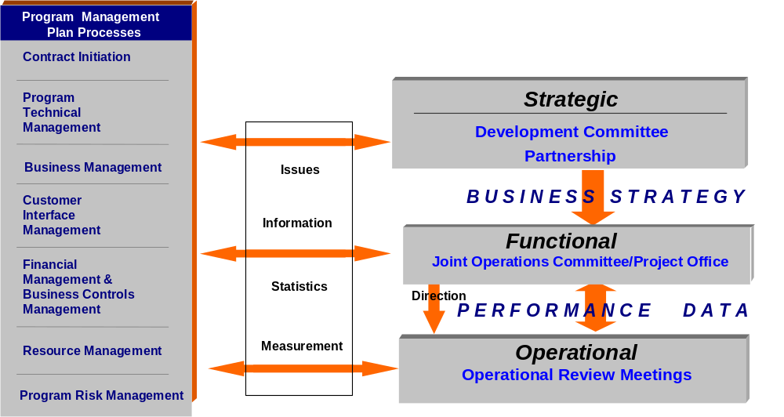
Proposed Governance Model
The proposed model addresses governance at three levels, each of which has specific roles and responsibilities, and is supported by key members of CLIENT and IBM. The three levels and their key areas of focus are:
- Strategic: Business strategy and direction, technology improvements, industry advancements, overall governance and relationship performance
- Functional: IT strategy and direction, and overall project performance
- Operational: Day-to-day delivery and operational excellence
Below is a detail description of the three levels of our proposed Working Together governance model:
Strategic
This level consists of the Development Committee and IBM’s Partnership Executive Program (PEP).
The Development Committee is intended to be an overseeing body appointed to manage the overall relationship between CLIENT and IBM. The objectives of this group are to:
- Review relationship performance
- Review CLIENT’s organizational priorities and strategic plans
- Resolve program level issues
- Review and approve long term IT investments decisions
- Communicate Executive Management strategies and direction
- Support ongoing CLIENT business strategy and plans
- Verify that technology is being exploited
- Enhance knowledge of senior CLIENT personnel on key technology trends
- Drive ongoing relationship benefits and opportunities
IBM’s Partnership Executive Program (PEP) identifies a senior IBM executive who will interface with a senior CLIENT Executive to ensure CLIENT is obtaining the expected value from the partnership and has the opportunity to utilize the strategic initiatives from the relationship that are described in a later appendix.
Functional
The focus of the Functional level of our proposed governance model is on IT strategic direction and overall project performance. The Functional Level consists of the Joint Operating Committee and the Project Office.
The Joint Operating Committee receives strategic direction from the Development Committee. This organization is focused on the performance of the contract, the delivery of the services and customer satisfaction. It also reviews technology strategies and business requirements, prioritizes initiatives and feeds directions to IT operations management.
The Project Office (PO) role is to provide an integrated view of program status to CLIENT on a regular basis. Inter-dependencies are reviewed, project status provided, and risks are assessed and mitigated. The PO also reviews all transition activities to ensure that all critical processes and systems are smoothly and efficiently integrated or transitioned. The PO supports the operations function by regularly reviewing the service performance of key systems. The Project Office also has resources assigned to support the various management disciplines including contract administration, financial analysis, human resources, architecture, and PO administration.
Operational
The focus of the Operational level of our proposed governance model is day-to-day service delivery. The IT Operations Management team will provide proactive monitoring of service performance, manage trends, provide capacity projections, review major project initiatives and their impact on the production environment, execute on strategic initiatives and generally maintain and execute all system management control disciplines.
IT Operations Management is led by IBM’s Delivery Executives and has senior members of the IBM delivery team as functional reports. This group’s responsibilities include the management and integration of all operational and development processes. The group will be responsible for and will participate in the following types of activities:
- Review service deliverables, operational status reporting, development/ maintenance/enhancement activity, and service performance
- Ongoing review of the status of all key projects
- Strategic and architectural compliance
- Verify that IBM activity is interlocked with CLIENT’s businesses.
Summary
Pictorially this relationship can be described in the following chart.

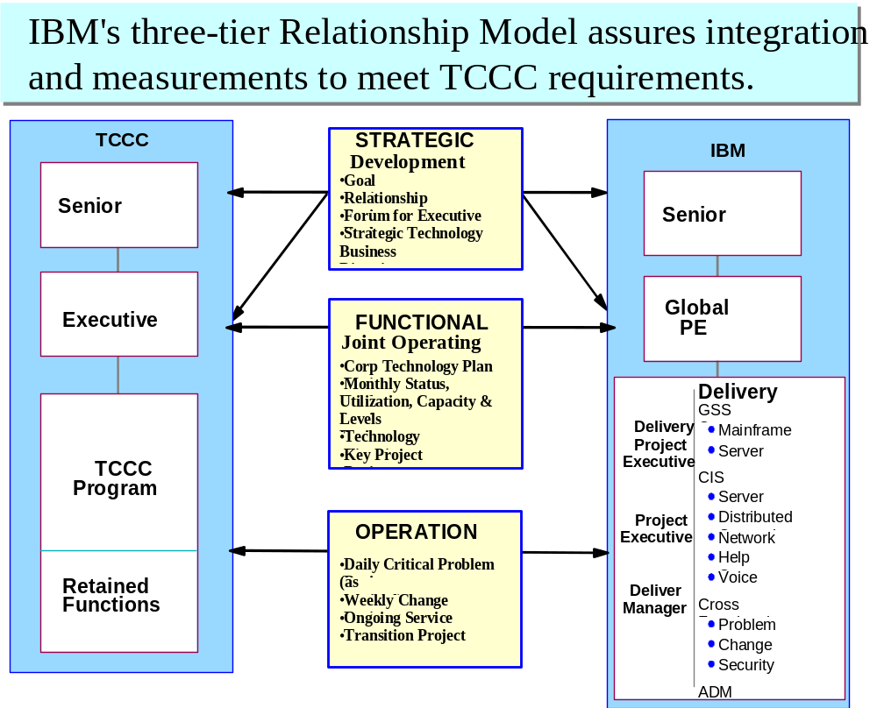

IBM Management Organization
Key IBM Personnel
Senior Project Executive
The IBM Senior Project Executive (PE) is the single point of contact for overall performance of the IBM team. The PE will be responsible for the success of the overall relationship and the strategic value it represents to CLIENT. The PE will focus on customer satisfaction, contract compliance, financial reporting and reconciliation, service performance and continuous improvement.
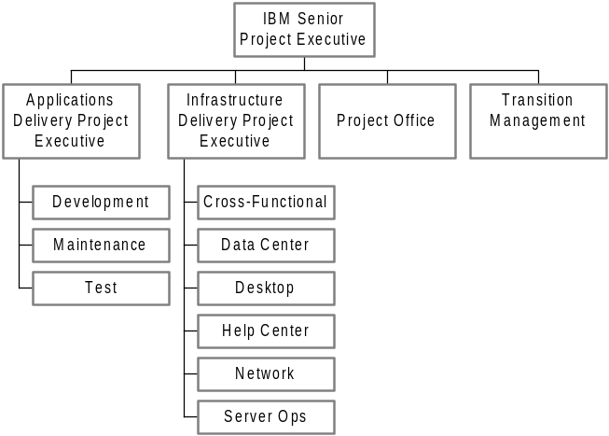Delivery Executive(s)
Reporting directly to the PE, the Delivery Executives are accountable for the delivery of all services. In this role, they will monitor trends verifying that service levels are met and issues are dealt with. They will enforce system management disciplines and be responsible for regular service reporting.
Transition Manager
Reporting directly to the PE, the Transition Manager (TM) is responsible for managing the transition from CLIENT to IBM in a seamless manner. The TM works with the CLIENT and IBM teams to develop the transition plan, establish success criteria, and oversee all transition activities.
Proposed CLIENT/IBM Governance Organization
We have outlined an organizational structure for CLIENT’s consideration. The discussion below outlines the key roles and a potential structure to facilitate communication, management and overall success.
Linkages Between IBM and CLIENT
In our proposed governance model, we have proposed linkages between IBM and CLIENT at the Strategic, Functional and Operational levels. The linkages are described in our Detailed Meeting Description section below. In addition there will be informal day-to-day interactions taking place at the Functional and Operational levels.
At the Functional level, regular communication will take place between the IBM Senior Project Executive and the CLIENT’s Contract Executive and their associated organizations. In addition, we would expect regular communication between the IBM Project Office personnel, CLIENT’s Project Office organization and the individual business units. We would also expect significant interaction through the Transition phase between the appropriate CLIENT representative and the IBM Transition Manager.
On the Operational level, the delivery of infrastructure services under this outsourcing agreement will require the close coordination of the IBM team with CLIENT’s Project Office Organization.
The business unit focus is accomplished through the CLIENT Project Office supported by personnel in the IBM Project Office. These combined IBM/ CLIENT teams will be tasked with understanding individual business unit needs, emerging challenges and opportunities, and will translate those into support requirements by the service delivery team. The team members will monitor progress on business unit related project activity and initiatives, and will work with the respective CLIENT and IBM Project offices to identify alternatives to address specific needs. Also, day-to-day issues, problems, and support requests can be escalated by the business units through these teams to ensure that CLIENT’s priorities are well understood by the infrastructure delivery organization.
The CLIENT PO staff and IBM Delivery Executives will, in addition to daily interaction, conduct a weekly Service Management Review (SMR). This forum is intended to bring together all of the key parties involved in the delivery of infrastructure services in the CLIENT environment. Led by the IBM Delivery Executives, the meeting will be attended by key functional delivery managers from both teams. The primary focus of the SMR would be to review operational performance, highlight key issues, discuss upcoming key activities, and identify emerging needs. Specific discussion items may cover things like planned outages, significant unplanned outages, application deployments, problem trends, usage volumes (support center calls, IMAC requests, etc.), and customer satisfaction results. The SMR framework will provide the basis for information that is assimilated on a monthly basis for reporting to the Joint Operations Committee. Some of the CLIENT / IBM touch points are indicated below.

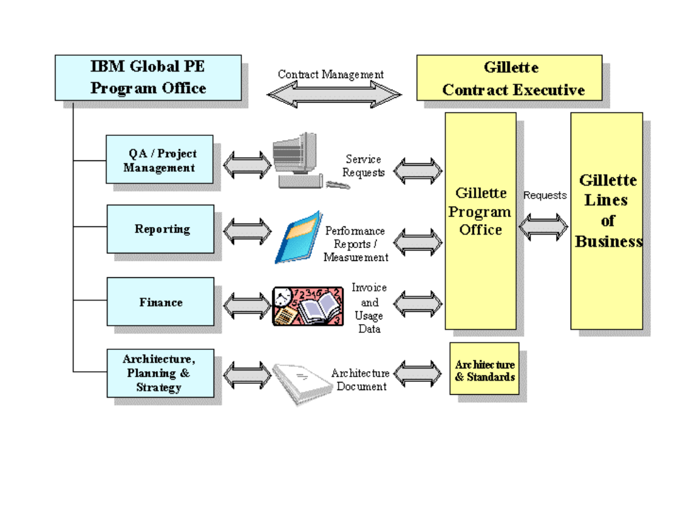

Proposed CLIENT Contract Management Organization
As requested, we have briefly outlined a potential organizational structure for CLIENT's consideration. The diagram below outlines the key areas and taken with the chart on the previous page indicates a potential structure for communication, management and overall success of our relationship. As we proceed with the recommended implementation of the Program Management Plan (PMP) and using an early start to the Customer Value Relationship Management (CVRM) model the organizational details, and the number of linkage points will become evident. At this point we estimate this proposed structure would require an additional five headcount besides the CLIENT Contract Executive to enhance optimal relationship performance.

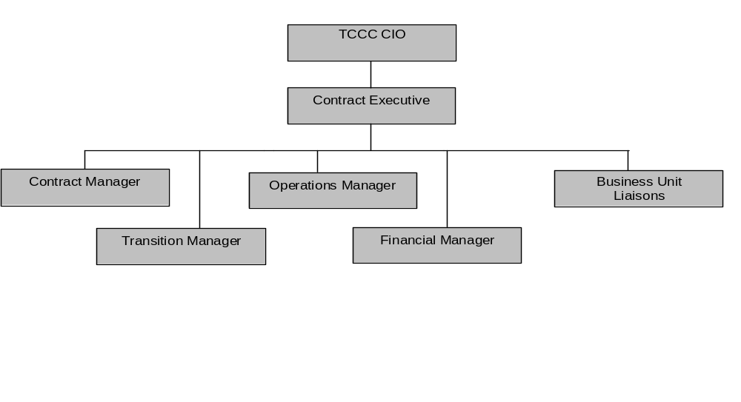
Detailed Meeting Description
The following charts provide a template and a draft proposal for the key meetings outlined in the governance model. These are provided with a view to facilitate discussion and would be developed further as part of the Customer Value Relationship Management workshops.
Development Committee
Frequency | Quarterly
Attendees | CLIENT Executive Vice President and CIO  CLIENT Business Executives  IBM Global Services VP of CPG  IBM VP Service Executive  IBM Senior Project Executive
Purpose | Review overall relationship, contract, and performance. Review and approve overall organizational priorities, strategic plans and risks. Determine long-term IT investments. Resolve issues between the parties. Ensure that overall Senior Management strategic directions are being consistently communicated and implemented. Ensure strategic initiatives are planned and implemented.
Agenda | Performance Issues  - Contract deliverables, including Service Level Agreements (SLAs), Key Projects, Customer Satisfaction, etc.  - New requirements and potential impact on existing infrastructure  - Issues requiring joint or CLIENT direct assistance to resolve  Corporate Programs  - Progress of selected infrastructure and corporate critical projects  - Operating and strategic plans focusing on the next four quarters  - Review of calendar driven reports and their impact, e.g. IT Strategy, etc.  - Issues requiring IBM, joint, and/or CLIENT resolution  Strategic Investment Plan  - Review priorities for IT investments  - Allocate appropriate funding to meet long-term (1-3 year) objectives
Chairperson | IBM Senior Project Executive
Inputs | Minutes from prior meeting. Contract and delivery management summary reports. Input from related reports and plans, e.g. IT Strategy Plan, etc.
Outputs | Minutes to be taken by: Assigned IBM individual  To be distributed to: Attendees, agreed associated parties  File reference copy held by: IBM Project Office

Joint Operations Committee
Frequency | Monthly
Attendees | CLIENT Contract Executive  CLIENT Project Office Representatives  IBM Senior Project Executive  IBM Delivery Project Executive  IBM Delivery Managers
Purpose | To review overall monthly performance against contract and resolution of escalated issues. This also is a forum for strategic planning discussions and recommendations for action. To review customer satisfaction results.
Agenda | Performance reports against agreed SLAs  New initiatives  Major program updates  Review of calendar of deliverables and impact, e.g. IT Strategy, etc.  Issues requiring IBM, joint, and/or CLIENT actions to resolve  Customer satisfaction survey, results, action plans and plan implementation status
Chairperson | IBM Senior Project Executive
Inputs | Monthly performance report, change reports, plus other relevant outputs
Outputs | Minutes to be taken by IBM Delivery Project Executive  To be distributed to Attendees, IBM Deputy Project Executives, CLIENT Senior Management (as appropriate)  File reference copy held by: IBM Project Office

Service Management Review
Frequency | Weekly
Attendees | CLIENT Governance Managers  IBM Delivery Project Executive  IBM Delivery Managers
Purpose | Review operational performance, discuss weekly highlights, review change management, problem management. Discuss upcoming events and review upcoming business initiatives.
Agenda | Performance reports against agreed to SLAs  New initiatives  Major program updates  Review calendar of deliverables and impact  Issues requiring IBM, joint, and/or CLIENT action to resolve  Operational optimization activities
Chairperson | IBM Delivery Project Executive
Inputs | Monthly performance report, change reports, plus any other relevant output
Outputs | Minutes to be taken by IBM Delivery Project Executive  To be distributed to Attendees, IBM Senior Project Executive, IBM Deputy Project Executives, CLIENT Senior Management  File reference copy held by: IBM Project Office

Project Review
Frequency | Periodic as required
Attendees | IBM Delivery Project Executive  IBM Architect: Various  IBM Project Managers: Various  CLIENT personnel (as appropriate)
Purpose | Review status of IBM managed projects covering scope, schedule, and financial measures
Agenda | Individual review and assessment of current and new projects  Upcoming business unit priorities and programs  Review of selected long term business unit initiatives  Outstanding issues requiring IBM, CLIENT or joint action to resolve
Chairperson | IBM Delivery Project Executive
Inputs | IBM project status reports  CLIENT architecture document  IT technology plan
Outputs | Minutes to be taken by IBM  To be distributed to Attendees, IBM Senior Project Executive, IBM Deputy CLIENT contacts as appropriate  File reference copy held by: IBM Project Office

Change Review
Frequency | Current CLIENT Schedule
Attendees | IBM Delivery Project Executive  IBM Delivery Managers  CLIENT attendees (as appropriate)
Purpose | Review all system changes scheduled for the following week for adherence to process, fallback plans, review and signoff, etc.
Agenda | CLIENT initiated changes  IBM initiated changes
Chairperson | IBM Delivery Project Executive
Inputs | IBM change request system
Outputs | Minutes to be taken by the IBM Delivery Project Executive  To be distributed to: Attendees, IBM Senior Project Executive, IBM Business Unit Project Executives, CLIENT contracts as appropriate  File reference copy held by: IBM Project Office

Program Management Plan
IBM has developed an integrated framework for the support of governance for large scale outsourcing customers that is based on our global experience and best practices. This framework is called Program Management Plan (PMP). This plan would be jointly established by CLIENT and IBM and tailored to CLIENT’s needs. The Program Management Plan provides a set of processes and a plan for management of the overall relationship and contract. It sets out a communication framework, establishes management control mechanisms, and integrates with operational processes.
IBM’s intent will be to leverage the existing operational processes established by CLIENT. Where applicable, and in conjunction with CLIENT, IBM will leverage our intellectual capital and experience for potential process improvements. Confirmed through transition with CLIENT, these processes become the mechanism by which the Governance Model will operate.
Listed below are the seven key groupings of the Program Management Plan and their supporting processes.

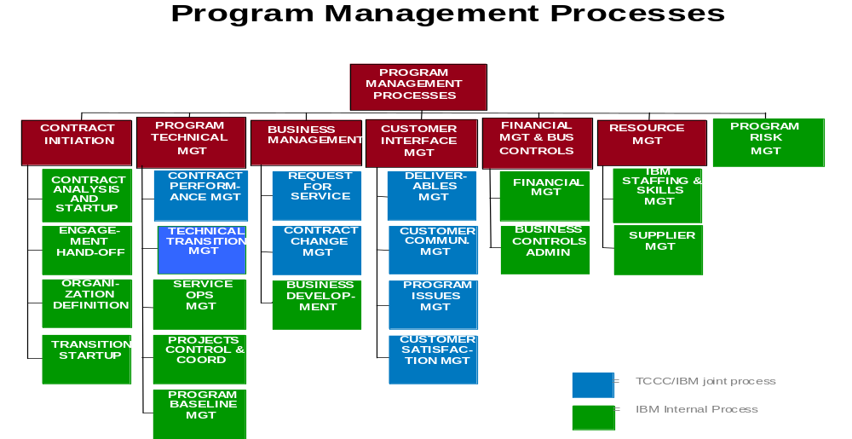

Contract Initiation Process
- Facilitate a smooth transfer from Engagement to Delivery
- Facilitate engagement of the resources needed to achieve technical, human resources, and financial transition
- Facilitate a common understanding of contract scope
- Define and initiate all management processes
- Define and communicate roles and responsibilities
- Produce a set of deliverables for use by other processes
Program Technical Management
- Meet performance requirements and quickly resolve any performance issues
- Manage implementation projects, changes and additions in an integrated fashion to meet CLIENT’s expectations
- See that comprehensive management processes are established and followed to deliver contracted services that will exceed CLIENT’s expectations
- Promote dialogue to jointly address service and project requirements consistent with performance objectives
Business Management
- Establish process for submission and handling of CLIENT requests for service
- Manage the processing of new CLIENT requests
Customer Interface Management
- Establish procedures for the delivery and acceptance of contract specific deliverables from IBM to CLIENT
- Establish procedures for communications between the IBM Team and CLIENT
- Capture and resolve any outstanding issues in a timely manner
- Coordinate all IBM activities to enhance CLIENT’s customer satisfaction
Financial Management and Business Controls
- Establish and implement financial control mechanisms to facilitate monthly CLIENT financial reviews
- Review actual financial results against planned measurements and prepare outlook projections
- Perform required financial planning activities
- Establish and implement business controls such as records retention, program management and audit preparation
Resource Management
- Manage the staffing and skills requirements on the IBM team.
Program Risk Management
- Identify all project risks early
- Analyze each risk thoroughly analyzed and develop and approve a comprehensive mitigation plan
- Prioritize significant risks on a regular basis
- Execute each mitigation plan effectively

Customer Value Relationship Management (CVRM)
As part of the establishment of the governance model between IBM and CLIENT, IBM will utilize a CVRM approach to assist with verifying that the governance model is structured to accurately reflect and act in a manner consistent with the importance of the relationship.
IBM has worked for many years with John Henderson, of Boston University, who has described a need in today’s global environment for organizations to move from managing a ‘Portfolio of Products’ to managing a ‘Portfolio of Relationships’ in order to improve competitiveness. This has implications for business context, how to effectively gain leverage, organization structure and measurement systems.

Traditional Focus
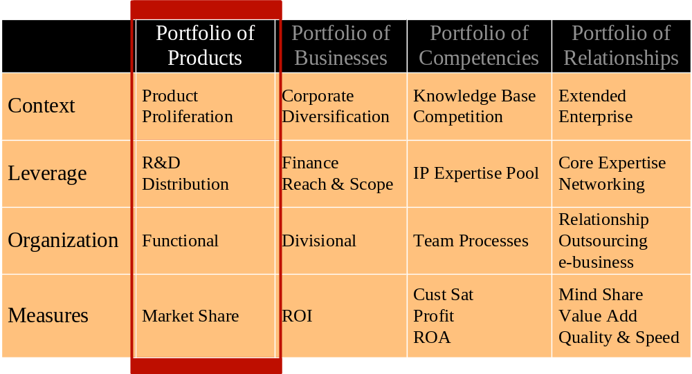
Portfolio of Traditional Products

Current Focus- Managing in a Different Time

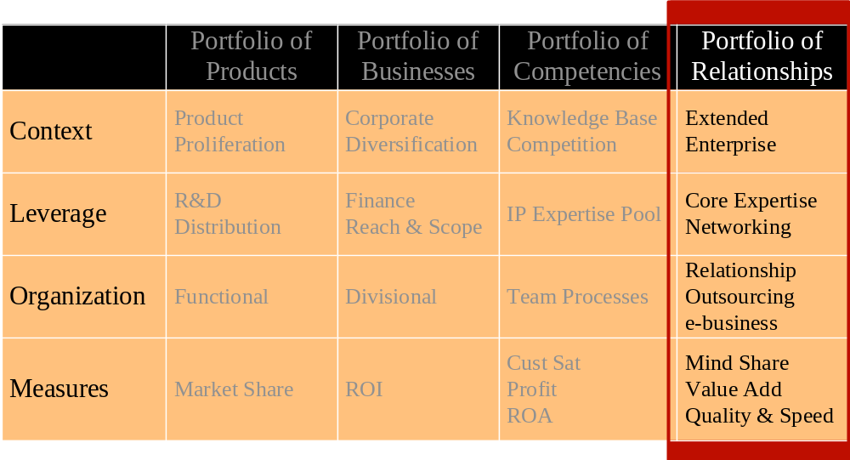
Portfolio of Relationships
John Henderson and IBM further describe a spectrum of relationships ranging from ‘Market Exchange’ or ‘Transaction driven’ through ‘Unique’ or ‘Strategic Partnerships’. Organizations should plan their relationship portfolio, including an appropriate mix of relationships for their needs. Relationship types should vary based on the value they create and a portfolio of relationships must be managed to maximize value. Transactional and unique relationships are neither good nor bad but provide different values and need to be managed differently. In fact, Henderson identified a set of ‘Relationship Determinants’, or variables that can be used to design a new relationship or to assess the status and quality of an existing relationship.
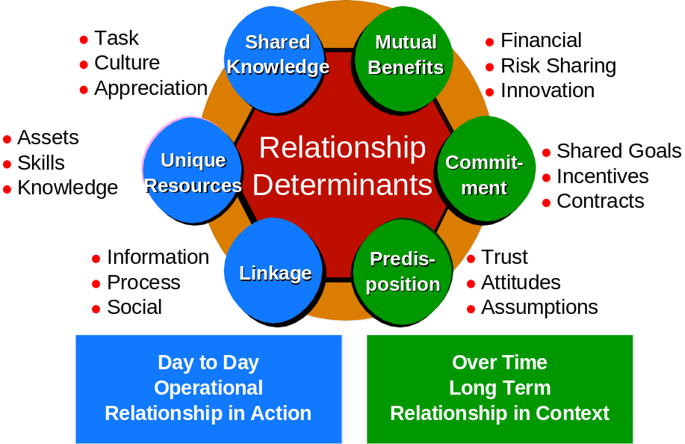
Each of these determinants has an impact on both the type and quality of the relationship and should be considered when designing a new relationship. The most effective relationships are those that have each of these determinants aligned with the goals of the parties and with each other. As a result the determinants can be effectively used also to evaluate the current status of a relationship and to use as levers to guide course changes.
Equally important, relationships left unmanaged will deteriorate over time. This deterioration is often tied to:
- Misaligned expectations
- A gap between perceived value and what was actually delivered
- Limited capability to manage organizational relationships (different from personal relationships)
- Complexity and disparate cultures
- Divergent management policies
- Poor communications.
Strategic Outsourcing in particular is a continuous cycle and partnerships can falter because of neglecting regular recommitment. Operating protocols should be established early so that when the inevitable conflict does arise, management energy can be focused on resolving the conflict rather than on deciding how to resolve it. IBM has developed a set of approaches to support relationship development and ongoing relationship management, translating research and experience into proven methods.

Objective | Approach
Joint Development of Mechanisms to Manage the New Relationship | Relationship Launch
Demonstrate Value Proposition Achievement | Value Validation Study
Align Performance Expectations | Collaborative Performance Alignment
Align IT & Business Units, Aligning IT & Providers | Relationship Alignment

These approaches have provided our clients considerable benefits including:
- Confirming ‘Why you did the deal’ is still valid
- Demonstrating mutual focus on value exchange
- Proactively approaching managing long term relationships
- Reducing frictional/coordination costs
- Applying relationship management for business alignment
They also allow IBM to serve clients more effectively through formalization of organization alignment and better leverage of the relationship resources.
Each of these approaches is tailored to the specific situation and requires commitment and sponsorship from both parties to implement a disciplined approach to relationship management. Activities include document review, interviews, surveys, and workshops. Deliverables vary with the service and include documentation of shared plans for the relationship.

