A

Request for Proposal
for an

Enterprise Distribution Application Solution

March 10, 1997

Prepared by

IBM Global Services
2707 Butterfield Road
Oak Brook, IL
Table of Contents

1.0 Introduction 4
1.1 Project Scope 4
1.2 RFP Purpose 4
1.3 Statement of Confidentiality 4
1.4 Client Profile 5
2.0 Application Software Evaluation and Selection Process 7
2.1 RFP Response Evaluation 7
2.2 Application Software Demonstrations 7
2.3 Reference Site Surveys and/or Visits 8
2.4 Technical Assessment 8
2.5 Final Selection 8
2.6 Schedule of Key Project Activities 9
2.7 Costs Incurred 9
2.8 Acceptance and Rejection of Proposals 9
3.0 RFP Completion Instructions 10
3.1 General Information 10
3.2 Questionnaire Overviews 11
4.0 Business Process Questionnaire 12
4.1 Purchase Products 13
4.2 Perform Value-Added Services 17
4.3 Manage Customer Orders 20
4.4) Fulfill Customer Orders 23
5.0 Vendor Business Profile Questionnaire 25
5.1 Company Profile 25
5.2 Customer Installations and User Groups 26
5.3 Customer References 26
5.4 Application Development and Architecture 27
5.5 Application Software Support 28
5.6 Security, Restart, Backup and Recovery 28
5.7 Interfaces and Integration 29
5.8 Training and Education 29
5.9 Documentation 30
6.0 Costs 31
6.1 Application Pricing 31
6.2 Prerequisite Software 32

1.0 Introduction

1.1 Project Scope
The Management Consulting group of IBM Global Services is currently engaged in a software evaluation and selection project with a unique distribution enterprise. The objective of this project is to select an integrated, application software solution that will provide distribution enterprise capabilities. The software solution functional capabilities need to address our client's business process requirements in the following areas:

Purchase Products
Perform Value-added Services
Manage Customer Orders
Fulfill Customer Orders

In support of these core business processes, it has been determined that the applications needed would include customer service and order management, inventory management, distribution requirements planning, forecasting, purchasing, and warehouse management.

1.2 RFP Purpose
The purpose of this Request for Proposal (RFP) is to provide the distribution enterprise application software providers with sufficient information to prepare a comprehensive application solution response for consideration by our client. This RFP will be used to help in the evaluation and selection of a few application solutions to be qualified for further detailed evaluation.

Our client retains the right to include any RFP responses or sections of this RFP as part of the contract signed with the selected vendor.

1.3 Statement of Confidentiality
This document is distributed to you for your express use only. It is not to be duplicated or distributed, in any form, to any other company. Should you choose not to participate in this evaluation, please destroy the electronic/paper form of this RFP.

Your responses to the RFP questions will be held in the strictest of confidence. Only select client and IBM Consulting personnel will evaluate your responses. Under no circumstances will your response be wholly or in-part be made available to other organizations without your permission.

1.4 Client Profile
Our Client is a unique, industrial distribution enterprise headquartered in the Chicago area. This Company’s annual sales revenue is approximately $250 million, the majority of which is generated by three main subsidiaries. This Company is a distributor (both domestic, 85%, and international, 15%) of maintenance, repair and replacement fasteners, parts, specialty chemicals , welding rods and supplies, hydraulics and other flexible hose fittings, and electrical and shop supplies. These products are used for the repair and maintenance of all types of capital equipment in the industrial, heavy-duty equipment, in-plant, buildings and grounds maintenance, and transportation areas

This Company is comprised of several different, independently operated businesses (designated by the term “subsidiary”) and each one has at least one distribution facility.

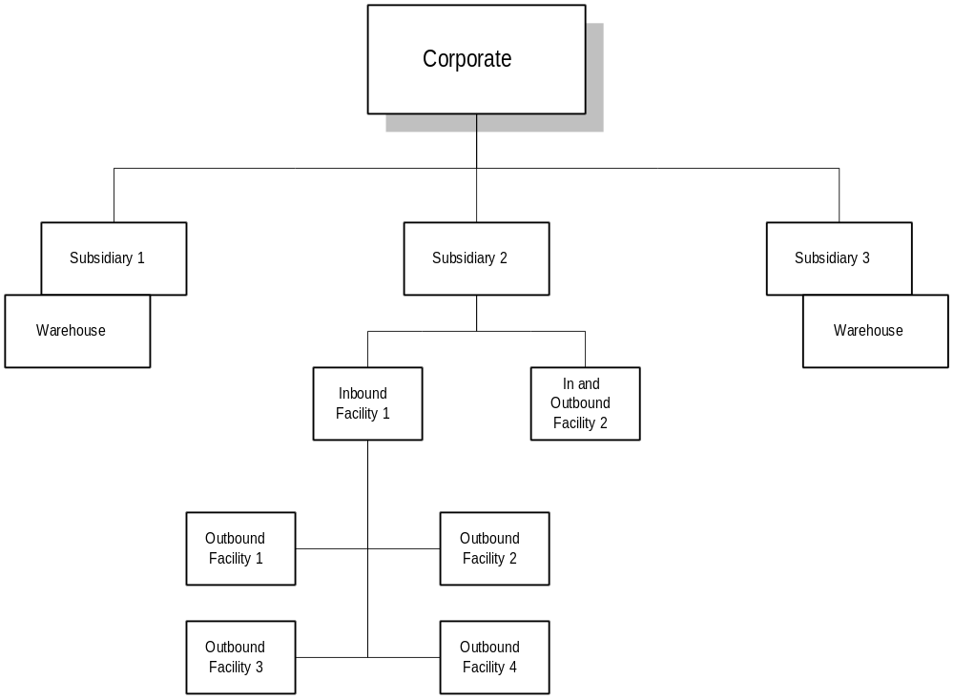

The three subsidiaries are within the scope of this project. In other words, the application solution our client seeks must be able to support the needs of a distribution enterprise. As such, a multi-company, multi-division and multi-branch/warehouse infrastructure needs to be supported.

Even though each subsidiary performs some type of key, value-added service (e.g. blending, repackaging and redistributing products), these are still primarily wholesale distribution companies. Following is a brief overview of each subsidiary:

“Subsidiary 1” distributes specialty chemicals. Some chemicals may be blended to specific customer needs and/or to create regularly stock items. Some of these products are designated as hazardous materials.

The largest subsidiary, “Subsidiary 2”, has two inbound distribution facilities where bulk products (e.g. maintenance, repair and replacement fasteners and parts) are received (i.e. from vendors), repackaged, and redistributed to the other four “outbound”, distribution facilities. One inbound facility also serves as an outbound facility. These outbound facilities are used for customer order fulfillment and are located across the United States. In addition, custom assembly work usually takes place at the inbound facilities and these products would thereafter be distributed to the outbound facilities as regular stock items. Most non-custom assembly work takes place at the outbound warehouse facilities.

“Subsidiary 3” is primarily a welding and maintenance parts distributor. Some fabrication of welding plates also takes place.

Currently, our client has an IBM System/390 computer installed. Certain applications (e.g. invoicing, accounts receivable, accounts payable, general ledger, commissions compensation) will continue to reside and operate on this mainframe. The selected solution will need to be able to create the necessary business transactions that would subsequently be transferred to these legacy, mainframe applications. Secondly, it is intended that the selected application solution would also reside and operate on this system in order to continue to leverage this investment. Therefore, please be cognizant of these prerequisites and respond accordingly.

2.0 Application Software Evaluation and Selection Process
This section will describe the associated tasks that need to be performed as part of this application software evaluation and selection process.

2.1 RFP Response Evaluation
RFP responses will be evaluated by the client and IBM consulting team members. Criteria for the evaluation of vendor responses will include, but not be limited to, the following:
Overall ability to satisfy key business process/functional requirements,
Overall functional capabilities of software vendor’s complete application suite,
Software vendor’s business profile, and
Estimated costs.

2.2 Application Software Demonstrations
After careful review of the RFP responses, a select, few application software solutions will be chosen for further consideration. These designated vendors will be asked to prepare for an actual demonstration of their respective application software solution. These demonstrations are required to be conducted at the IBM facilities in Rolling Meadows, Illinois (a suburb of Chicago). Demonstrations are currently scheduled from April 28th through May 15th. The demonstration schedule is as follows:

- April 28 - 29

- May 5 - 6

- May 7 - 8

- May 12 -13

- May 14 - 15

Prior to performing their application software demonstrations, these selected vendors will be given the opportunity for an individual, 3-hour site visit at the client’s main location during the April 20th - 22nd time frame.

Users will evaluate your software business process/functional support capabilities. They will use demonstration guides or scripts that will serve as the demonstration “road map” and allow them to evaluate each selected vendor’s software capabilities impartially. These scripts will be provided to the selected vendors in advance of the demonstrations.
These software demonstration scripts will be segmented by process (and application), and a certain amount of time will be allocated to each of these demo segments. After presenting the required application functionality and time permitting, each selected vendor will still have opportunities to highlight their additional application “bells and whistles” during each demonstration segment.

Given the numerous client personnel schedules that need to be coordinated, you are strongly encouraged to reserve the above dates in the event that you do qualify to present a software demonstration. It will be very difficult to change these dates given the number of users who will be traveling from out of town to attend these demonstrations. Thank you in advance for your cooperation.

2.3 Reference Site Surveys and/or Visits
Application software vendors will be asked to provide installed customer references using their proposed solution. These sites should be similar (as much as possible) in size and business structure to this Enterprise, profiled in Section 1.4. Eventually, representatives from our client will contact and/or visit these reference sites.

2.4 Technical Assessment
Members of the client’s information systems staff will perform a technical assessment of selected vendors’ applications. This activity will include the vendor presenting application architectural and database design characteristics, modification/enhancement approach, and addressing general questions.

Application software vendor finalists will be asked to prepare and present a sample, implementation plan. Included should be an overview of your implementation methodology, project team organization, percentage of time each team member would be dedicated to the implementation project, and cover such activities like the application pilot, data migration and conversion, application customization, systems integration, training, etc.. Thoroughness of this implementation plan will be evaluated as part of this selection process. This plan will need to be submitted by May 22nd by the designated vendor semi-finalists.

2.5 Final Selection
After any final review of the client’s environment, the software vendor semi-finalists would need to prepare an updated proposal, if applicable, and associated contracts by May 29th.

The preferred application software vendor is expected to be chosen in June, 1998.

2.6 Schedule of Key Project Activities
The planned schedule of activities relating to this software selection project are:

March 16th Vendor notification of intent to respond to RFP
March 31st Vendors return completed RFP
April 7th Selection of vendors (semi-finalists) for demonstration
April 9th Notification of software vendor semi-finalists
April 20th - 22nd Software vendor site visits at client location
April 28th - May 15th Vendor software demonstrations
May 18th - May 29th Technical assessments
May 22nd Receipt of sample software implementation plan
May 29th Receipt of updated proposal and contracts
May - June Review of vendors’ customer references
June Final evaluation and vendor selection; negotiations

2.7 Costs Incurred
This RFP does not commit our client to award a contract or to pay for any costs incurred by vendors in the RFP response preparation or any associated application evaluation activity. In addition, our client and IBM are not liable for costs incurred by vendors prior to issuance of a contract.

2.8 Acceptance and Rejection of Proposals
Our client reserves the right to accept or reject any or all vendor responses received as part of this RFP, to negotiate all terms and conditions with any qualified source, or to cancel or amend in part, or entirety, this RFP. All or part of your response will be incorporated into the final contract. Failure of software providers to truthfully respond to this RFP will eliminate that provider from further consideration.

Our client reserves the right to award this contract to one vendor in its entirety, or to award the system software, hardware, and maintenance separately.

Our client reserves the right to award any contract to the vendor(s) they feel best serve their business needs.

3.0 RFP Completion Instructions

3.1 General Information
All correspondence, questions, and comments regarding the content of this document should be directed to Joe Smith or Bob Jones, IBM Consultants. Prior to completing the RFP, any additional clarification of said document will be made by an addendum sent by electronic mail or delivered to each vendor. Contact one of the following individuals at the associated phone numbers for verbal responses to any questions concerning this RFP. Your calls will be returned within one business day.

Joe Smith 630/xxx-xxxx
Bob Jones 314/xxx-xxxx

It is the software vendor's responsibility to advise the assigned IBM consultants, before the RFP response due date, of any conflicting specifications or requirements, or omissions of information required for clarification.

It is preferred that you respond to the RFP electronically via a Microsoft Word document format (Version 6.0 or later). Should you choose this approach, please direct your responses to:

bobjones@US.IBM.COM

If need be, please direct any hard-copy correspondence concerning this document, any of your solution materials, and/or the completed hard-copy RFP response to:

Bob Jones
IBM Corporation - 3rd floor
2707 Butterfield Road
Oak Brook, IL 60523

Please provide us with as much non-proprietary information about your company and application solution to help us fairly assess your software, personnel, and company strengths. Specifically, we request your answers to the questions contained in the Business Process/Functional Requirements Questionnaire and the Vendor Business Profile Questionnaire.

3.2 Questionnaire Overviews
This RFP is comprised of two primary questionnaires: a business process/functional requirements and a vendor business profile. Response to the business process/functional requirements will provide us with a better understanding of “how well” your application solution can support the client’s “to-be” business process environment. In some cases, a detailed description of the desired, ”to-be” business process is provided.

There are just four questions in this section of the RFP. It is recommended that you expound upon those application solution features that directly support the business process, as well as those that may be indirectly related. Note: Although some/much of your response might be contained in your various executive application brochures, we do not intend to review any of your company/solution publications as part of evaluating your responses. So, please do not request the RFP evaluation team to “refer to document ...., pages ....”.

In the vendor business profile section, your responses to these questions are designed to provide us with more of a general overview of your company.

In responding to any question, please be as concise as possible.

Again, thank you for your efforts and consideration; they are very much appreciated.

4.0 Business Process Questionnaire
Our client’s intent, with the implementation of the selected vendor’s software solution, is to significantly improve current business operations efficiency and effectiveness. Some of the expected benefits of package implementation are to: eliminate redundant data entry, reduce/eliminate time consuming, manual processes, improve management information quality, access and flow, increase inventory turns, position the business for significant growth, maintain or increase order fulfillment rate, improve inventory management capabilities, and lastly, provide maximum flexibility for changing business requirements. The software solution must provide or be able to support the following:

- Multi-company, multi-division, and multi-branch organization support
- On-line (vs. batch or report) orientation
- Real-time, company-wide information
- Integrated forecasting, purchasing, and distribution requirements planning application tools
- Ad-hoc, decision support tools
- Interfacing to/from key, legacy applications (i.e. Automated Stocking and Picking (ASAP) warehouse control system; and Walker Accounts Receivable, Accounts Payable, and General Ledger)

There are only four questions to be answered in this section. After describing each core business process, the same question is asked. Each answer needs to describe “how” each process and its respective sub-processes and key, application functional requirements would be supported. Also, please state “what” additional, if any, expected benefits might be gained. Please be concise, but as explanative as reasonably possible.

The client’s core business processes will not change; however, sub-processes and their associated activities are expected to change and be improved. The following depicts our client’s core business processes:

- Purchase Products
- Perform Value-Added Services
- Manage Customer Orders
- Fulfill Customer Orders

Note: the value-added services primarily performed at Subsidiaries 1 and 3 pertain to some “light” assembly and blending activities. For Subsidiary 2, the primary value-added activities include receiving bulk shipments of products, repackaging and/or re-boxing these products, and redistributing these products to the outbound distribution facilities for customer order fulfillment. Some kitting activities are also performed at each subsidiary.

4.1 Purchase Products
The Research and Development department determines which products will be carried in inventory. After research and analysis, potential product lines will be added. Some products will be discontinued after analyzing product movement over a 12-month period. All outbound facilities (Subsidiary 2; Subsidiaries 1 and 3 only have 1 distribution facility each) usually carry the same full product lines due to the client’s business strategy. For every line dropped (approximately 200) , 1,500 - 2,000 lines are added each year.

The client’s philosophy is to be the market leader in customer service and order fulfillment rate. In doing so, a large inventory investment exists; not only “A” and “B” products, but also “C”, “D”... products. Some items may not have moved in last 12 months.

Products are purchased from over 1,000 vendors (500 vendors are used on a regular basis). Average product lead time is 10 - 12 days; some products require up to 30 days. The purchasing philosophy is to partner with key vendors and for these partners to conduct some “client brand” packaging and stocking of the client’s items. Also, some buys are initiated for the year in January with key vendors to potentially reduce costs and vendor lead times. Throughout the year, product releases would be requested. Note: no one vendor can supply 20%+ of a particular inventory line.

The Purchase Products to-be business process includes the following major sub-processes:

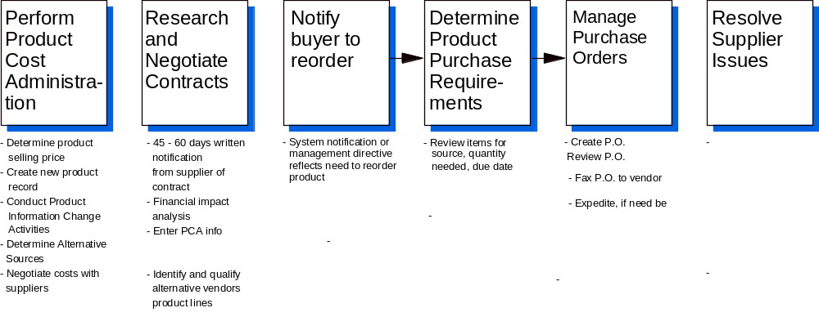
In addition, key capabilities that are required to support these sub-processes include the following:
- Product Cost Administration
- New vendor and vendor item master information which could include branch or subsidiary specific vendor/vendor item information
- “Not for resale” products (i.e. supplies)
- Re-buy vs. one-time (special) buy product information
- Product Cost Administration (continued)
- “Standard test and demonstration” items (STDs) - used primarily for internal purposes
- Multiple units of measure per item
- Multiple units of measure conversion factors
- Weight, size and volume product information per unit of measure
- Start and end (discontinue) sales dates for purchasing and sales
- Substitutions (multiple per item, and with “greater than” and “equal” value designations)
- Supercessions (replacements)
- Stock vs. non-stock (must issue purchase order) designation
- Purchasing vendor item unlimited descriptive fields
- Sales item unlimited descriptive fields
- Other item unlimited descriptive fields
- Item number cross referencing - item to vendor item
- Item number cross referencing - item to engineering number
- Multiple sales items cross referenced to same vendor item
- Sales item cross referenced to multiple vendors’ items (primary, secondary, etc. sources)
- Multiple purchase sources per item
- Item packaging instructions (internal information)
- Vendor item quantity break pricing (minimum of 5 tiers)
- Internal vendor and vendor item comments
- Internal item comments
- Vendor line mass updating
- Vendor line selection and copy
- Multiple number of item and vendor item product classes/categories
- Multiple vendor classes (e.g. primary, secondary, etc.)
- Contract Administration
- Effective and end dates and pricing per negotiated vendor item
- Vendor item contract pricing (with start and end dates)
- Reordering Notification
- System initiated - “alerts”
- Sales promotions (item specific, expected promotion impact information, and with start and end dates)

- Purchase Products Determination
- Forecasting
- Multiple forecasting methods
- Multiple replenishment rules
- Item level forecasting and replenishment rules designation
- Vendor and vendor item lead time tracking
- Item demand (dependent and independent) tracking and demand filters
- Item class/family demand tracking
- Item and item class/family seasonality factors
- Item and item class/family trend factors
- Item and item class/family service level
- Buyer overrides
- New item designation
- Manual forecast
- What-if analyses
- Forecast exception reporting
- Performance analyses and reporting
- Vendor , vendor item, and vendor item class/family purchasing criteria
- One-time buys
- User defined planning horizon
- Relationship dependent purchasing (based upon system suggesting to buy item A, item B needs to ordered as well)
- Stock and assembled/blended items
- Purchase order search and inquiry
- Internal vendor and vendor item comments
- Vendor and vendor item “alerts”
- Suggested inter-warehouse transfer creation
- Suggested purchase order creation
- Vendor, vendor item, and vendor item class/family performance analyses
- Buyer analyses
- Purchase Order Management
- Requisitions
- Multiple purchase order types
- Purchase order for “internal use only” products
- Blanket purchase order with multiple, user defined releases
- Vendor item due date (on purchase order line)
- Purchase order “header” and line item comments
- Drop shipment
- Multiple ship-tos per purchase order
- Sales order to purchase order cross reference
- Work order to purchase order cross reference
- Standard purchase order comments
- Vendor and vendor item internal comments
- Purchase order approval and release (to vendor) controls
- Purchase order tracking and reporting
- Fax Electronic Data Interchange (EDI) support
- Vendor and Vendor Item Management
- Vendor and vendor item communications tracking
- Comment code and unlimited comments
- User id tracking
- Date and time stamp
- Vendor and vendor item performance tracking and reporting
- Vendor and vendor item quality tracking and reporting
- Backorder tracking
- Product quality incident tracking (reason code and comments, date/time stamp, user, etc.
- Incorrect invoicing
- Short/over shipments
- Late shipments
- Follow-up and resolution

4.1) Given the to-be process description and the related process - application functional requirements, how would your application solution support and/or enhance this business process?

4.2 Perform Value-Added Services
All subsidiaries will perform some type of internal, value-added services. All perform kitting activities. In most cases, regularly stocked products are assembled “ahead of time”, typically driven by expected demand. Custom made kits can also be ordered; these would represent assemble-to-order products.

Subsidiaries 1 and 3 do perform other “light” manufacturing such as blending different chemicals and welding different metal products, respectively. To a large degree, “strong” kitting support of a distribution software solution would be sufficient to address the needs of these subsidiaries (as oppose to requiring traditional manufacturing applications).

Subsidiary 2’s environment is a relatively much larger operation and represents a significant business investment. This subsidiary has 2 “inbound” distribution facilities. These facilities will receive purchased bulk products. The mission of these inbound facilities is to repackage (in smaller box quantities and/or relabel) and redistibute the inventory to the other 5 “outbound” facilities (it’s mission is to perform customer order fulfillment). These inbound facilities will also assemble the kits normally stocked in inventory and redistribute those to the outbound facilities in order to meet expected product demand. Most received inventory will be redistributed to the outbound distribution facilities. However, some inventory is maintained at the inbound facilities in order to meet the needs of assembling kits. Inventory control management oversees the planning and the redistribution of inventory.

The focus of the Perform Value-Added Services to-be business process needs to stress the multi-stage, inventory management requirements of Subsidiary 2. Therefore, its core business process would be Repackage and Redistribute Products , and it includes the following major sub-processes:

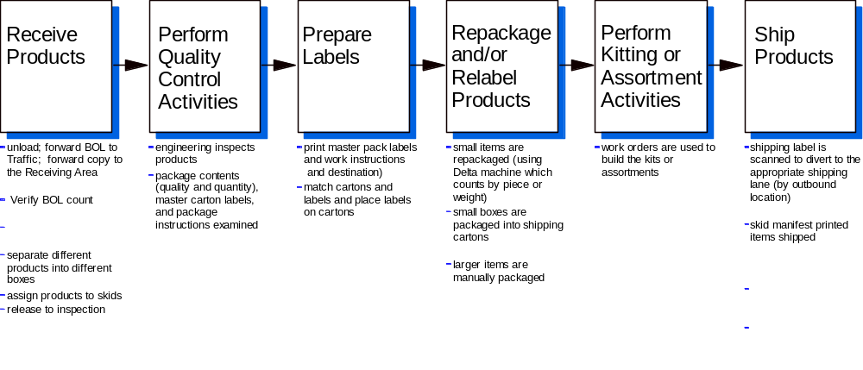
Other key capabilities that are required to support these sub-processes include the following:
- Distribution requirements planning tools
- System-generated suggested work orders (i.e. to meet expected demand for kits)
- Work (orders, routing, etc.) planning and management tools (required to support all sub-processes)
- Work status tracking, inquiry, and reporting (required to support all sub-processes)
- Inventory status and location (i.e. basic) control (required to support all sub-processes)
- Multiple warehouse locations per item
- Product Receipt
- Visibility of all expected inventory shipments, highlighting “hot/rush” items
- Inbound shipment scheduling
- Unloading of shipment (to staging area) with verification of actual product received to follow
- On-line, bar code supported receiving
- Receiving and handling instructions
- Real-time visibility of item quantity received (initial)
- Quantity received update by actual piece count (verified later)
- Bar coded label (e.g. shipment id, product, handling instructions, routing, etc.) printing
- On-line open purchase order (PO), inter-warehouse transfer (IWT) and returned goods authorization (RGA) search and inquiry
- Item and vendor item cross referencing
- Receipt cross reference to work order, IWT and/or customer sales order
- Multiple units of measure
- Multiple units of measure conversion factors
- On-line product search and inquiry
- Receipt verification against advance ship notice (ASN), PO, IWT, and/or RGA
- Entry/maintenance of product comments
- User initiated hold support
- Quality Control Support
- Inspection support
- Quality control (QC) tracking and reporting
- Vendor and vendor item quality controls
- QC incident tracking
- Random QC test alerts
- Item QC transaction history search and inquiry
- User initiated QC holds, capturing reason code, comments, user, date and time stamp, incident status, etc.
- Label Preparation
- On-demand, bar coded master pack and box label printing
- Destination location’s put-away label printing
- Product Repackaging and/or Relabeling
- Work order summarizing total item quantity (and work to be performed) with detail item quantity by outbound facility
- Update of verified received quantity (based upon actual piece count)
- Update of actual quantity received
- Over and under-shipment tracking
- Over and under incident tracking (part of quality performance tracking)
- Minimum package quantity support
- Quantity multiple (multiple of x) support, with rounding
- Kit/Assortment Assembling
- Build planning and management tools
- Dependent and independent components support
- Work instructions
- Related documentation printing (e.g. when work order is released)
- Forecast support for dependent and independent demand of parent items and components
- Assembly cost and time tracking
- Component substitution (with “equal to or greater than value” items)
- Product Shipping (to outbound facilities)
- Shipping labels and manifest creation

4.2) Given the to-be process description and the related process - application functional requirements, how would your application solution support and/or enhance this business process?

4.3 Manage Customer Orders
The mode used to primarily take orders will vary by subsidiary. Many orders (especially for Subsidiaries 1 and 3) will be taken via telephone, mail and/or fax. Subsidiary 2 will receive the majority (75%+) of its orders from the field force (independent sales agents) via laptop systems. Orders are entered into the laptop computer systems using a custom agent order entry application. Later, these transactions would be transmitted to the Enterprise for processing. In the to-be business environment, field orders for any subsidiary can be transferred to the Enterprise for processing.

The Manage Customer Orders business process would include the following major sub-processes:
- Receive and Enter Orders
- Perform Customer Services
- Close Customer Orders

Other key capabilities that are required to support these sub-processes include the following:
- Batch entry and editing of order transactions (i.e. from Agent’s field system)
- On-line, real-time entry/maintenance of order transactions
- Order Receipt and Entry
- Multiple order types (including quotation, regular, “sample” - re-supply Agent, drop shipment, returns, etc.)
- Quotation management controls
- Customer account search by account name, city, state and/or user defined search fields
- Ship-to location search by name, city and/or state
- Open order/invoice history search and inquiry by Agent, customer number, purchase order number, item number, etc.
- Order transaction copy
- Customer purchase order number requirement checking
- Unlimited customer account internal comments. Comments need to have a user assigned comment code to facilitate grouping (e.g. credit, complaint, etc.) similar comments. Each comment also needs to be user id, date, and time stamped.
- Separate account bill-to, sold-to and ship-to fields on the order
- Parent and sub-account customer structure needs to be supported
- Various customer account “holds”. Each “hold” needs to be classified (to reflect severity) by a hold code, identifying the reason for the hold, accompanied by the user id of person placing the customer account on hold, the date the hold was initiated, and associated user comments. Certain levels of hold should cause any follow-on customer order processed to be placed on hold and would need to be released by an authorized personnel
- Order holds (including credit, profit margin, user initiated)
- Backorder controls at customer account (default) and order levels
- Order ship complete controls at customer account (default) and order levels
- Credit limit checking
- Order fulfillment distribution center assignment controls
- Internal and external order comments
- Item searching using partial item number, description, etc.
- Item and customer item (or competitor) cross-referencing
- Internal and external item comments
- Unlimited item comments. These comments would be associated with a particular product. Comments need to have a user assigned comment code to facilitate grouping similar comments. Each comment also needs to be user id, date, and time stamped.
- Multiple order lines per order need to be supported
- Line item due date
- Line item fulfillment distribution center assignment controls
- Line item ship complete and backorder controls
- Item substitution controls (default at customer account level)
- Item substitutions (with “equal to” or “greater than” value visibility)
- Item supercessions
- Item complements and companions
- Item kits
- Item inventory allocation and available-to-promise
- Restricted sales item (item can not be sold/shipped to customer’s ship-to location)
- Non-stock item (purchase order required to be created)
- Non-stock item
- Item pricing (including contract with start and end dates, promotion with start and end dates, price book, quantity break, matrix, “best price selection”, user override, etc.)
- Item deals - “buy this, get this for free or $x”
- Item special charges
- Taxable and non-taxable items support
- Estimated freight charge calculations
- Invoice tax calculations
- Order acknowledgment generation
- Fax enabled output (i.e. for order transaction)
- EDI enabled output
- Credit card payment option
- On-line credit card payment verification
- Customer Services
- Order status tracking and inquiry
- Customer account communications/contact management
- Credit management

- Customer Orders Closing
- Actual freight charge (generated from manifest system) capture
- Invoice data generation (to be transferred to Corporate)
- Fax and/or EDI transaction enabled output for invoice, credit memo, returned goods authorization
- Invoice commissions reporting support

  - Given the to-be process description and the related process - application functional requirements, how would your application solution support and/or enhance this business process?

4.4) Fulfill Customer Orders
Released customer orders (or return goods authorization) will be transferred to the assigned distribution center for fulfillment processing. In the case of Subsidiary 2, 2 of its 5 outbound facilities will use ASAP as their order fulfillment processing tool of choice. Therefore, order transactions need only be transferred to these fulfillment distribution centers. Inventory status and order shipment data would be transferred from ASAP to the main business operations application (i.e. application software solution to be chosen).

For the remainder of the Enterprise’s order fulfillment activities, the Fulfill Customer Orders business process would include the following major sub-processes:
- Manage Inventory
- Perform Value-Added Services (e.g. assembling non-standard kits)
- Receive and Put-away Products
- Pick Products
- Pack and Ship Products

The effective management of key process will require complete and comprehensive visibility of all inventory, regardless of its present stage (i.e. work-in-progress, finished goods), by distribution facility and Enterprise-wide, incoming from vendors (e.g. drop shipments), incoming from another distribution facility, incoming from customers, and outgoing to customers, other distribution facilities, and/or vendors, etc..

Throughout this entire process, inventory must be tracked accurately. As inventory is affected, appropriate adjustments to the inventory balances must be reflected real-time. Other key capabilities that are required to support these sub-processes include the following:
- Inventory management
- Bar coding
- Cycle counting
- Multiple item locations/item
- Multiple units of measure support
- Multiple units of measure conversion factors
- Location management
- Hazardous material controls
- Resource utilization analysis and reporting
- Velocity tracking and reporting
- Performance reporting
- Inventory transaction tracking

- Perform Value-Added Services
- Item kit assembling support
- “Light” manufacturing or blending support
- Relabeling boxes and products support
- Receive and Put-away Products
- Bar coding
- System directed operations
- Pick Products
- Order selection and management
- Bar coding
- System directed operations
- Material Safety Data Sheets management
- Pack and Ship Products
- Bar coding
- System directed operations
- Manifest generation
- Shipment information creation (to be used for updating the invoice)
- ASN generation

4.4) Given the to-be process description and the related process - application functional requirements, how would your application solution support and/or enhance this business process?

5.0 Vendor Business Profile Questionnaire

5.1 Company Profile
In responding to these questions, please create a separate document and identify your response with the appropriate RFP question number. Also, please start on a new page for each section (e.g. 5.1, 5.2, 5.3, etc.).
- When was your company founded and how many years have you been delivering application solutions to the distribution industry?
- Is your company publicly or privately held?
- What has been your company's revenues for each of the last 3 years: 1997? 1996? 1995?
- Where are the locations of your headquarters, regional and branch offices? Which location(s) would provide support services for training (i.e. for companies head quartered in the Chicago area), implementation, technical support (i.e. problem identification and resolution), etc.?
- Indicate the number of employees (in United States only) your company has by functional area:
Implementation ____________
Technical support (e.g. response line) ____________
Research and development ____________
Sales and Marketing ____________
Total number of employees ____________
- Would your company and/or your business partner(s) be directly responsible for the implementation of your solution at our client’s locations, geographically dispersed across the country? If any business partner(s) would be possibly be involved, please provide an overview of the compani(es).

5.2 Customer Installations and User Groups
- Please indicate the number of customer installations of your application solution by year of installation: 1997, 1996, and 1995.
- What is the total number of customer installations in the United States, distributors only, and those companies using the business functions our client intends to implement (i.e. sales order management, inventory management, forecasting, purchasing, distribution requirements planning)?
- Please describe your user group organization by providing information on date established, structure, meeting frequency, number of members, etc.

5.3 Customer References
- Provide a reference list of at least 10 customers at whose companies you have installed your application solution. For each reference, specify company name, a brief company business description, location, install date, installed application software modules (if applicable), contact name, contact's title and telephone number. Please highlight those references that are operating your solution on an IBM System/390 mainframe. None of these references will be contacted until you/your solution has been selected as one of the software solution finalists and not without your prior knowledge and your initial reference notification contact.

5.4 Application Development and Architecture
- What programming languages and/or development tools (e.g. CASE, 4GL) have been used in the development of your product? What percentage of your product has been developed using these advanced development languages and/or tools? If so, which one(s)?
- Are these tools (listed above) available to your customers for the development of enhancements or independent custom applications? If so, include the cost of these development tools in Cost Section.
- Does your application solution make use of a relational database? If so, which one?
- Does your application support user-defined fields? If so, please list master file name and number of user defined fields associated with each file.
- What tools are provided (i.e. within your application solution) to facilitate the ad hoc extraction and download of your application database data to PC-based tools?
- To what extent is your application solution parameter-driven to allow for company, division and/or branch specific customization?
- What tailoring capabilities (by user or user group) are supported for the application menus and screens?
- How is the use of function keys standardized throughout your application solution?
- What standard user interface (e.g. SAA CUA, X-Windows) was used in the development of your application solution?
- How does your application facilitate (e.g. provide “hooks”) supporting user-developed enhancements?
- Is all of the application source code available to customers? If your source code is not available, is it placed in escrow? If all or part of the application source code is not available, please describe the source code that is not available.
- What custom programming services does your company offer and how do you charge?
- Please describe the on-line help system provided by your application solution. How is the text customized?

5.5 Application Software Support
- How are programming fixes, enhancements and new releases of your application software delivered to your customers?
- Please describe software support services (both standard and optional) that your company provides for your application solution. Please include a description of end-user (i.e. telephone response line) support services and hours/time zone of operations.
- What services does your company provide that would be covered by a “software maintenance fee” paid by your customer?
- List the dates, by application module/subsystem, of the last set of enhancements delivered(from most current to oldest) within the last two years.
- What enhancements (those which you can announce) are planned to be delivered in 1998 and 1999? OR what is your announced application solution "statement of direction"?
- How do you support custom modifications developed (for a customer) by your programming staff?
- What is the warranty period for custom modifications developed (for a customer) by your programming staff?

5.6 Security, Restart, Backup and Recovery
- Please describe the application security features of your application solution.
- Please describe the application restart features of your application solution.
- Please describe the application backup and recovery features of your application solution.

5.7 Interfaces and Integration
- Has your software been successfully integrated, by your company to fax technology? If so, please provide description(s) of the integration performed and the application function(s) provided.
- Has your software been successfully integrated, by your company, to data collection or bar code scanning devices (e.g. for job and materials tracking)? If so, please provide description(s) of the integration performed and the application function(s) provided.
- Has your application software been successfully integrated, by your company, to radio frequency devices? If so, please provide description(s) of the integration performed and the business process(es)/application function(s) enabled.
- What shipping manifest system(s) have you interfaced to your software? How is this shipping information "linked" back to the originating sales order and invoice to support any needed subsequent inquiry?
- Describe any features or components of your application solution which facilitates the integration of your software with other applications (not part of your application suite).

5.8 Training and Education
- List and describe the training available to information systems personnel that will enable them to support and modify the proposed application solution.
- List and describe the training available to end-user personnel that will enable them to effectively utilize the proposed application software. Identify location(s) where training would normally be delivered. Also, indicate if on-site training would be an option for any educational offering.
- Please describe how one could establish an “education” company environment to facilitate training for new personnel.

5.9 Documentation
- List the documentation that is normally provided with your application solution for a new installation. Please specify the quantity initially provided at no charge and the charge per document, if more are needed.

6.0 Costs
The purpose of this section is to develop an understanding of the estimated costs associated with the licensing and implementation of your proposed application solution. Final pricing will need to be determined by the selected vendor(s) prior to contract award and will be subject to our client's terms and conditions.

6.1 Application Pricing
- How do you currently price your application solution?
- Given the business process descriptions, please specify those “modules” you would recommend to support the Enterprise. Please indicate an estimated application module cost to support the current business environment (approximately 300 concurrent, enterprise users). If more space is needed, please update the following table accordingly.

Application Module | Source Code Cost | Initial License Charge | Annual Maintenance Fee
1
2
3
4
5
6
7
8
9
10
11
12
13
14
15
16
17
18
19
20
TOTALS

6.2 Prerequisite Software
- Please provide a list of any prerequisite system software, utilities, data base, application and/or development tools, etc. necessary to support your application solution. Include both main system (M) and any personal computer (P) system requirements.

Software | System  M or P | Initial License Charge | Annual Maintenance Fee
1
2
3
4
5
6
7
8
9
10
11
12
13
14
15
16
17
18
19
20
21
22
23
24
25
TOTALS

